Travelling the Silk Road-
Ishmali Music Lessons
Clinicians:
Lesley Pontarini
membership@omea.on.ca
Gena Norbury
spiritosomusic1@gmail.com

This workshop will showcase one set of lessons from the joint writing project between the Ontario Music Educators’ Association, The Aga Khan Museum, and the Ministry of Education.

The lesson set we are using can be found on the OMEA website at Silk Road.

These curriculum-linked resources were inspired by the Museum’s Permanent Collection and the entire resource project was developed to “expand students’ knowledge and understanding of the traditional music of Asia and the Islamic world as well as their contemporary expression.” (Aga Khan Museum)

Lesson 1:
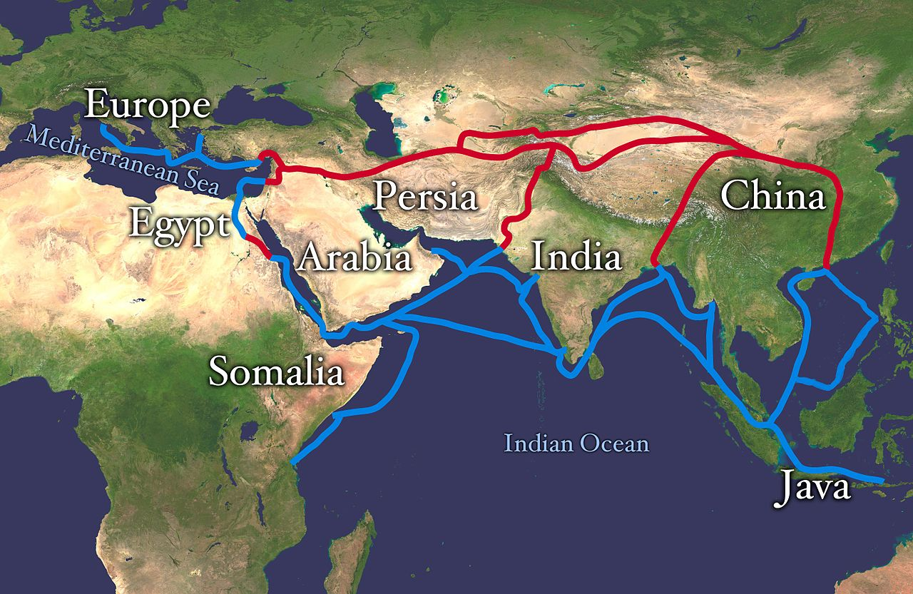

Begin by displaying a map of The Silk Road and ask the students the following questions:

- What do you think this is?
- What places do you see?
- Do any of you recognize any of these places?
- What do you know or have you heard about these places?
- Have you ever travelled to any of these places?
- What is silk?
- What is the relationship between silk and a road? Why do you think it is named the Silk Road?
- How do you think people travelled between the places? What kind of transportation might they have used? How might it have been different from how we travel today?

Take time to explain what the Silk Road was.

You can introduce the Silk Road by showing one or both of the YouTube links below:

The Silk Road: Connecting the ancient world through trade - Shannon Harris Castelo - Retrieved from You Tube, April 2017 http://www.youtube.com/watch?v=vn3e37VWc0k

The Silk Route -Retrieved from You Tube, April 2017 http://www.youtube.com/watch?v=55YYTZew3aw

Students will have the following learning goals to achieve during lesson 1
- I can represent a shape or pattern using my body and voice
- I can understand different styles of music

Project the artefacts, one by one, from Aga Khan Collection listed in the lesson plan. Ask questions like-
(artefact pictures can be found at www.omea.on.ca or the SILK ROAD link above)
- What are these artefacts?
- How might people have used them?
- What are their shapes?
- What pattern(s) do you see on them?
- Do you see any sign of nature on them like an animal or a flower?
- What else do you see?

Identify the locations from which the artefacts come from on the map. The Aga Khan Museum has included all of the locations and other information pertaining to the items. (Please see the lesson plans on the OMEA website for more details.)

Next, scatter the students around the room and show them the printed artefact cards one by one.

After each picture ask the students to make the shape or pattern they see, using their body.

Repeat this until all of the cards have been shown and the shapes have been created.

Next, hand each student a silk scarf or similar article. We like to play ‘Arabian Nights’ by the Silk Road Ensemble, taken from their recording called New Impossibilities. Play the recording and ask your students to move freely around the room to the music. At random points, play finger cymbals, and tell the students to freeze and look at an artefact on the screen. (or that you are holding) ‘Try to make a shape to represent the artefact you see.’ Continue changing the pictures upon playing finger cymbals.

Lesson 2
Before students enter the class tape a simple path on the floor with four empty squares that will be used to represent Turkey, Syria, Iran and India. Here is a picture from one of our previous workshops.
The squares are not all visible in this photo.

Teacher prompts:
  - Did you notice the path created as you entered the class today?
  - What do you think it could represent?
  - Do you remember anything about the Silk Road from our last class?
  - Is it a path that could be like the Silk Road?

Briefly review the Silk Road, places on the map, and the artefacts from the last class.
Write the name of the four important places on the board in which most of these artifacts have come: Turkey, Syria, Iran and China. Then, link them together using a marker (indicating the simple path of the Silk Road on the board).

Teacher Prompts:
  - Did you notice that we have a taped our own Silk path on the floor today?
  - What do you think those squares might represent? What places could they be?
  - What kind of transportation would we be using on the Silk Road?
  - What is a caravan?
  - What kind of animals might we have been riding through the Silk Road?

Have the students look at the cover of the book, We’re Riding on a Caravan: An Adventure on the Silk Road, and predict what the story is about. You can help guide them by asking….
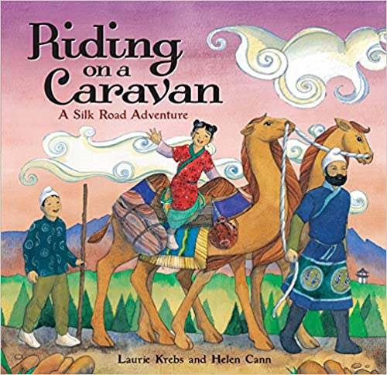
Teacher prompts:
  - What do you see on the cover?
  - Do you see any animals?
  - What are they doing?

Sing the chorus created by Gena before reading. Teach it by rote or solfege to your students. Then, read aloud, the book We’re Riding on a Caravan: An Adventure on the Silk Road. The students should sing the chorus each time it appears.

While reading, show the students the location of each place on the map on the wall.

As well, place cards with Turkey, Syria, Iran and India on them in their correct place on the taped route along with a non-pitched percussion instrument.

Have each student pick a non-pitched percussion instrument from the classroom and line up at one end of the taped pathway. One student only enters the Silk Road map on the floor e while keeping the beat on their instrument. When the chorus ends, they stop walking and play a rhythmic pattern for 16 beats (the length of the chorus). Alternatively, you can have a four-beat rhythmic on the floor already that they play four times. Begin singing the chorus again, student number 2 enters the Silk Road and student 1 trades their instrument with the instrument on the floor (country). Student 1 walks the path until they come out and sit on the open floor, playing the beat. Continue until all students have had a chance to walk the Silk Road, play the 16-beat pattern, and trade an instrument.

Lesson 3
Review the chorus ‘We’re riding on a caravan, a bumpy, humpy caravan. We’re riding on a caravan to places far away’ and then divide the class into two groups.

While singing the chorus, have the students walk to the beat on the taped route again, but this time we will do it in a canon and all students will take the journey at the same time.

The students in group 1 will all walk on the Silk Road, group 2 will begin from the other side of the route, in canon. The canon begins on the anacrusis to bar 3. Once the canon begins, group 2 enters the path.

Optional Orff accompaniment.

Begin with the bass metallophone part. Teach this using the words ‘SILK ROAD’
Stomp, stomp
Transfer to BX

Soprano xylophone. ‘CARAVAN-A’
Patsch
Transfer to AX
Mallets

Sand blocks. ‘BUMPY, HUMPY’
Clap
Transfer to SB

Alto Xylophone. ‘LET’S GO.’
Snap
Transfer to AX

You can use as many parts or as little of the arrangement as it fits for your classroom setting.

We strongly encourage to look up the remainder of this set of lessons where many other ideas, video clips, and instrument learning can be used.

