Title: Natural Beat – Discovering Natural Stickings  Lesson #1 |  | Grade 7 Music
Critical Learning |  | Guiding Questions
“Natural sticking” is the combination of rights and lefts that a performer uses for each basic sixteenth note rhythm. |  | What rhythms variations are possible using only basic (right-left) sixteenth note stickings.

Curriculum Expectations
C1. Creating and Performing: apply the creative process to create and perform music for a variety of purposes, using the elements and techniques of music  C1.1 sing/and or play, in tune, from musical notation, unison music and music in two or more parts from a wide variety of cultures, styles, and historical periods  C1.2 apply the elements of music when singing and/or playing, composing, and arranging music to create a specific effect  C1.4 use the tools and techniques of musicianship in musical performances  C1.5 demonstrate an understanding of standard and other types of musical notation through performance and composition |  | Learning Goals  At the end of this lesson,  I can  - Identify the basic variations in sixteenth note rhythms  - Identify the introduction, groove build, solo/soli, & ending sections of the song  - play the rhythms on a given instrument with proper technique and expression

Instructional Components and Context
Readiness  Basic Sixteenth Note Variations  Terminology  Beat, rhythm, dynamics, harmony, polyphony, syncopation,  (http://www.edu.gov.on.ca/eng/curriculum/elementary/arts18b09curr.pdf) | Materials  Sheet Music for Natural Beat  Drumline and Pitched percussion instruments
Minds On Approximately 15 minutes |  |  | Pause and Ponder
Students use the ‘Think/Pair/Share’ strategy to consider these questions: How many different variations of rhythm are there in a single grouping of four sixteenth notes?  Teacher Tip: Once students have identified the four possible rhythms you can discuss as a class the best way to write them out, count them (ie: 1E+, 1EA, 1+A, E+A) and what stickings will be used for each. Both pitched and non-pitched percussion instruments use the same stickings. The following exercise can be used to practice these rhythms as a group. (Note that the fourth rhythm does not appear in the song ‘Natural Beat’).  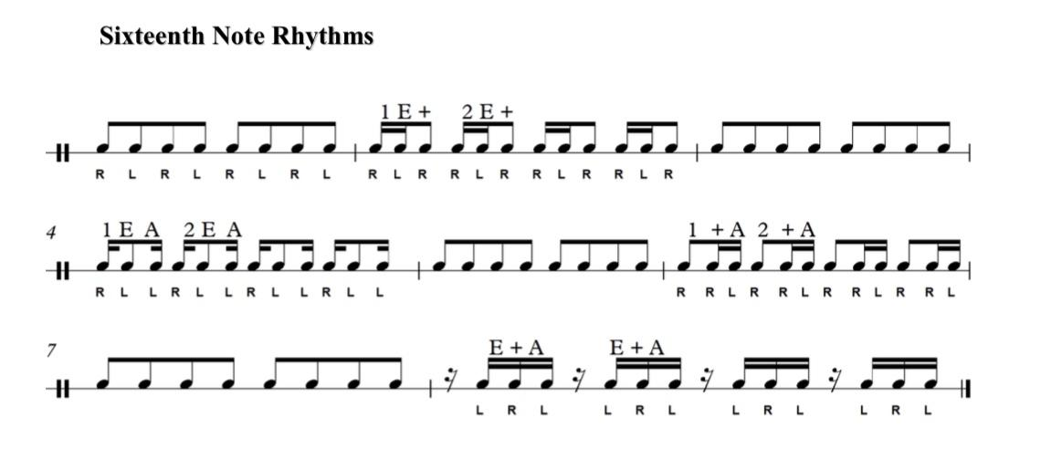 |  |  | Assessment for Learning (AfL)  Assess student’s ability to identify each rhythm: can students recognize where each rhythm fits in relation to the beat.
Action! Approximately 30 minutes
The first two bars represent a call and response introduction. Note the dynamic contrast between them.  With the class while building the groove in the next section, explore and discover:  - how the snare drum and bass drum polyrhythms interact with each other as they repeat,  - how the tenor drum and pitched percussion polyrhythms interact with each other in much the same way as the snare drum and bass drum.  The end of the soli/solo section is punctuated with a unison rhythm for maximum effect. The reintroduction of the full groove takes place over the next two bars. Finally, a repeat of the two bar introduction to bookend the piece |  |  | Assessment for Learning (AfL)  Assess student’s ability to identify the following: Beat, rhythm, dynamics, harmony, polyphony, & syncopation

Consolidation Approximately 5 minutes
Perform the full song with proper dynamics at full tempo.

