Title: Baterista – Discovering Samba Rhythms with Accents and Taps  Lesson #1 |  | Grade 10 Music
Critical Learning |  | Guiding Questions
Accurately playing accents using both hands while executing a variety of samba rhythm interpretations. |  | Can the various rhythms found in “Baterista” be understood in relation to a traditional samba groove.

Curriculum Expectations
A2. The Elements of Music: apply elements of music when performing notated and improvised music  and composing and/or arranging music;  A2.1 apply the elements of music and related concepts appropriately when interpreting and performing notated music  A3. Techniques and Technologies: use a variety of techniques and technological tools when performing music and composing and/or arranging music.  A3.1 demonstrate technical skill when performing notated and/or improvised music |  | Learning Goals  At the end of this lesson,  I can  - Identify the basic variations in sixteenth note rhythms and the samba rhythm as played in a whole group setting  - Identify the introduction, groove build, groove, & ending sections of the song  - play the rhythms on a given instrument with proper technique and expression

Instructional Components and Context
Readiness  Basic samba rhythms, basic accent and tap rhythms  Terminology  Beat, rhythm, dynamics, harmony, polyphony, syncopation,  (http://www.edu.gov.on.ca/eng/curriculum/elementary/arts18b09curr.pdf) | Materials  Sheet Music for Baterista  Drumline and Pitched percussion instruments
Minds On Approximately 15 minutes |  |  | Pause and Ponder
Students use the ‘Think/Pair/Share’ strategy to consider these questions: How does the samba rhythm pictured below relate to the rhythms found in “Baterista”?  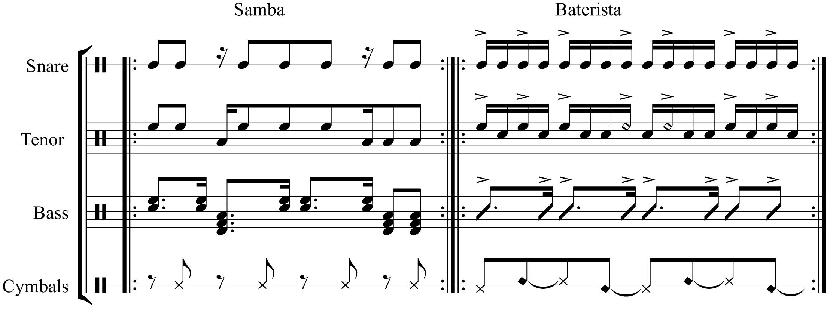  Teacher Tip: Once students have identified how the accents in “Baterista” line up with a samba rhythm, have the snare and tenor musicians examine which hand the accents will land on. The pattern is RRRLLRR and for tenors the left handed accents will also be cross-over strokes. |  |  | Assessment for Learning (AfL)  Assess student’s ability to identify each rhythm: can students recognize where each rhythm fits in relation to the beat.
Action! Approximately 30 minutes
The first two bars represent a call and response introduction.  With the class while building the groove in the next section, explore and discover how each instrument enters over the next four bars building up to the samba rhythm along with the dynamic contrast leading into bar 7.  Bars 7-10 encapsulate the full samba rhythm as well as a transition into letter B. In letter B the snares and tenors alternate between sixteenth note accent and tap rhythms and playing just the accent pattern. The bass drums and pitched percussion alternate between running eighth and sixteenth notes.  In letter C the snares and tenor finally play the accent and tap rhythms in unison while the bass drums and pitched percussion play the accent pattern also in unison. This is followed by the reintroduction of the full groove over the next two bars. Finally, there is a repeat of the two bar introduction to bookend the piece. |  |  | Assessment for Learning (AfL)  Assess student’s ability to identify the following: Beat, rhythm, dynamics, harmony, polyphony, & syncopation

Consolidation Approximately 5 minutes
Perform the full song with proper dynamics at full tempo.

