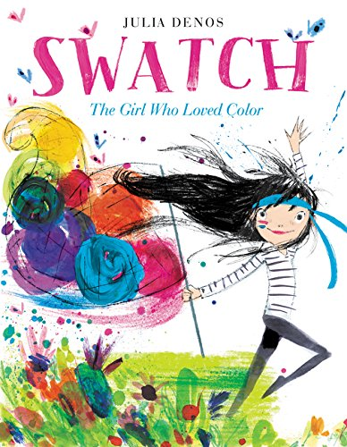

Swatch: The Girl Who Loved Color

  - Presented by Rose Suter and Angela Warren
  - OMEA Conference: Opus 100
  - November 8, 2019

This book will quickly engage your students’ imaginations with a beautiful story of a colour tamer and her attempts to capture the illusive “yellow”.

Presentation  - Read Swatch: The Girl Who Loved Color by Julia Denos.  ISBN 9780062366382  - Create a colour poem using the following Cinquain template. |  | www.tes.com

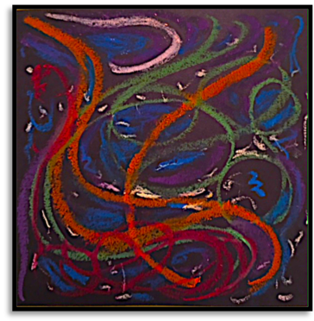 |  | Using the colour poems as inspiration, participates will become their own colour tamers by creating an abstract picture that reflects the emotion and colour choice for their poem.
- In small groups, have participants select one of the art pieces and create movement that represents the emotion of the colours found in the art. You may choose more than one piece to create a larger performance form. A musical soundscape should be added to the movement piece.  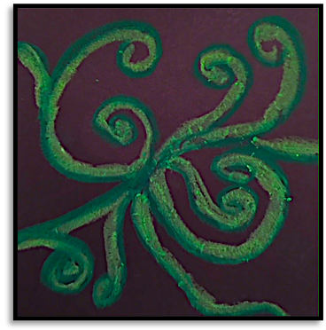 |  | - Learn the song Colors by Kira Willey (kirawilley.com).  - Divide participates into three smaller groups: singers, musicians, dancers and actors.  Actors:  Have this group dramatize the story and be sure to have lots of colourful scarves on hand. When the colours have been taken into possession by the colour tamer, you may choose to place them in mason jars to symbolize their captivity.  Musicians/Singers:  This group will perform the song Colors by Kira Willey, as well as add soundscape to the story  Dancers/Musicians:  Perform the movement piece and add a soundscape.

Final Performance:
Incorporate the song, as well as the movement piece during your final performance of the story. Have participants decide where to place the song and movement in the dramatization of the story.

