Teaching Ukulele: Success from the Start
OMEA 2019 Friday November 8, session 2
Shanda Lee slee@kcs.on.ca
The ukulele is fun, easy to play, allows for quick progress and does not require years of study by you the teacher in order to develop success in your students. Here are a few easy steps toward developing a solid foundation for ukulele playing.

Getting ready to play
Hold the instrument properly.
- Right hand thumb should be over the fret wire where the body and neck of the ukulele meet. This location produces the nicest sound and feels most natural when you hold the instrument.
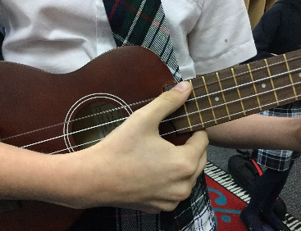

b) Left hand position “silent coyote”. This solves left hand problems and allows students to play with proper left hand technique.

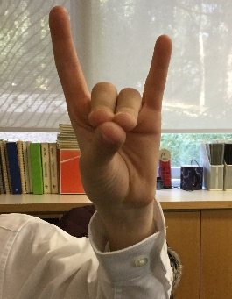
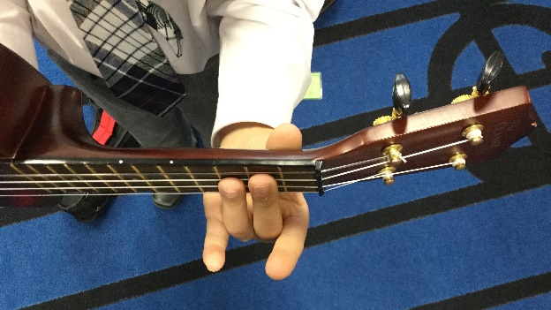

Teaching Tip: After teaching the proper right hand and left hand set up to the class, have the students take turns teaching each other how to hold the instrument properly. Doing this allows them to verbalize what they have just learned, gives them a talking break and reinforces their understanding of the concept.

Tuning
The ukulele is available in C6 tuning (traditional G C E A) and D6 tuning (A D F# B). The teacher will decide which tuning to use and make it consistent for all the students in your class.
When ready to play, it is important to play with strings that are in tune. The teacher needs to tune the instruments until the students are able to do this on their own. Use the piano, a tuning app, or a clip on uke tuner, and encourage students to let you know when their strings fall out of tune. Find whatever works best for you, getting this done quickly is your goal.

Ready to play!
Strumming
- Thumb strum – Use with beginners, strum in a downward motion over all strings.
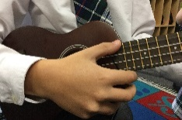

Have the kids practice thumb strum over all the open strings. Try strumming 8 times together with the goal to start and stop at the exact same time.

- Finger strum – More advanced, thumb touches middle knuckle of index finger. Use the nail of the index finger and imagine flicking a drop a paint off the tip.
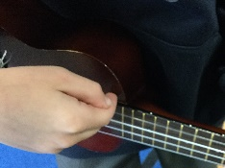

Open string names and numbers. (This is really important to know)
Teaching Tip: Make a little song out of it and use it as their first playing test. Pick the open strings one at a time and sing “A is the 4th string, D is the 3rd string, F# is the second string, B is the 1st string. Then pick and sing it backwards.
A D F# B G C E A
4 3 2 1 4 3 2 1

Thumb picking on open strings
Echo picking – My turn, your turn. Use open strings and later on add scale notes. Teacher plays, students echo. When they are beginning, tell them the string you are starting on. When they are more familiar with the instrument, don’t tell them the starting string. This is a great way to develop ear training.
First Chords
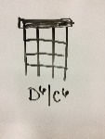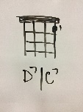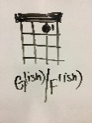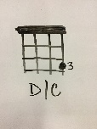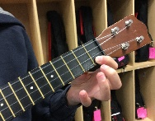
Thanks to James Hill for the G/F(ish) chord. This is a fantastic accessible option in your first few weeks, or for those students who continue to struggle with chord shapes. When kids become more comfortable with the left hand, this cheater chord will easily move into the proper G/ F chord. Keep a chord chart on the whiteboard or wall and have students keep a blank chord chart in their music books that they fill in as they learn new chords.

Teaching Tip: Use “ukulele language” when teaching the kids how to form chord shapes. For example, the D7/C7 chord is: first finger, first fret, first string. Or, first finger, first fret B/A string. Have students figure out where to place their fingers as you describe the chord, and then draw it on the board.

Teaching Tip: Mark chord shapes on the neck of the uke with stickers for students who have difficulty placing their fingers or have trouble remembering. Remove stickers when they can consistently perform the chord.

First Songs
Frere Jacques: Uses open strings, sing as a round and add the D chord at the end. (Will give you a totally impressive performance in no time!)
Wheels on the Bus: G/F(ish) and D7/C7
Old MacDonald Had a Farm: G/F(ish) and D7/C7
Riverside: G/F(ish) and D7/C7
Baby Shark: G/Fish and D/C
Despacito (chorus): the first 3 chords students can play with 1 finger Bm Gish D A or, in C tuning, Am Fish C G
The Lava Song: A little more advanced with the 3 finger G/A chord but the entire song only uses C, G and F chords in C tuning or D, A, G in D tuning

Teaching Tip: Make sure students always play with the proper fingers in the proper frets. If they don’t do this they will have a great deal of difficulty forming chord shapes and learning to place their fingers for individual notes and melody playing.

Fun stuff to try
Blues improv with solos
Accessible for all students, and you can give options for individual level of challenge. Gets kids thinking creatively, listening for rhythm, applies technical skill and is fun!
Teacher plays these chords: B, E7 bar, B, F#7 (or E7 bar shape in the 4th fret) E7, B, D6
Students choose:
Easy - any simple repeated rhythm, for example ta ta ti-ti ta and pick this on their B/A string
Medium – improv own rhythm over teacher chords on the B/A String
Advanced - own rhythm using the 1st and 2nd strings and throw in some other pentatonic scale notes.

Hand clap chord practice with a partner
Stand across from your partner. Using counts of 8, students will strum the chord on 1, then take their left hand off their uke and clap the left hand of their partner. They must get their left hand back in place to strum the chord again by count 1. Teacher calls out chords they are to strum and depending on your playing ability, you can also play chords behind the exercise. More advanced students clap 2X (Thanks to Melanie Doane for the blues improv and hand clap exercise)
Think like this: Strum…… Clap… 5, 6, 7, 8, Strum…. Clap… 5, 6, 7, 8

Moving ahead
When should they start reading notes? AS SOON as you can name the open strings.
Pentatonic Scale O 2 O 2 O 3 O 3 Descending 3 O 3 O 2 O 2 O
D/C major scale (starts on open 3rd string)

Where to look for help
James Hill & Chalmers Doane Ukulele in the Classroom. Fantastic resources and website, James also gives clinics and workshops and has online tutorials.
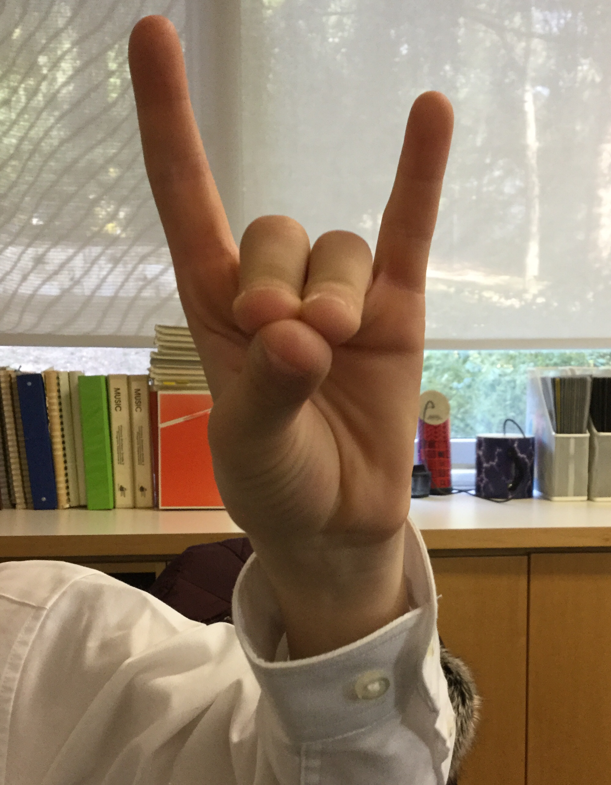
Melanie Doane Uschool TDSB,TCDSB huge program, website and support
Ukulele Yes! Great educational e-magazine and resource for teachers.

Have fun! If you do your students will too!

