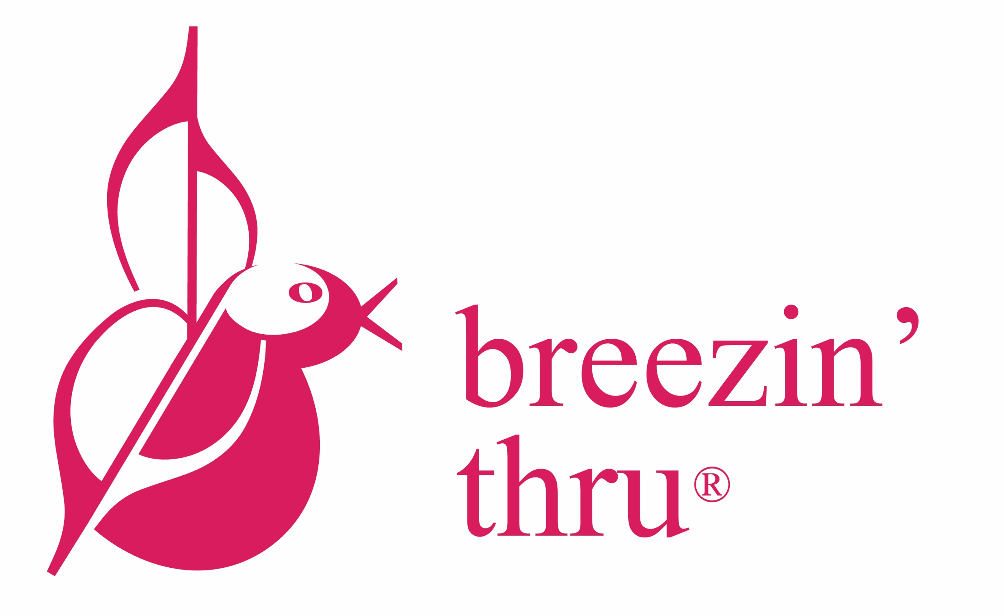
1. What would I like to achieve with my music program?

This Yr: _____________________________________________________________________________________________
In 3 Yrs: ______________________________________________________________________________________________

2. What Additional Resources do I need?

Now: ____________________________________ Next Year: ______________________________________

3. Where / How to get Support :

 | Currently, how supportive is my ..  (1 is not at all …. 5 is very supportive) |  |  |  |  | What could I do to build their support? | Potential Funding Sources?
Principal | 1 | 2 | 3 | 4 | 5
District | 1 | 2 | 3 | 4 | 5
Community | 1 | 2 | 3 | 4 | 5

Other Potential Sources of Funding? ___________________________________________________________________________
(eg. Grants, Selling Unused Instruments, Partnerships etc)

4. What will I do next week to start moving this forward _____________________________________________________

