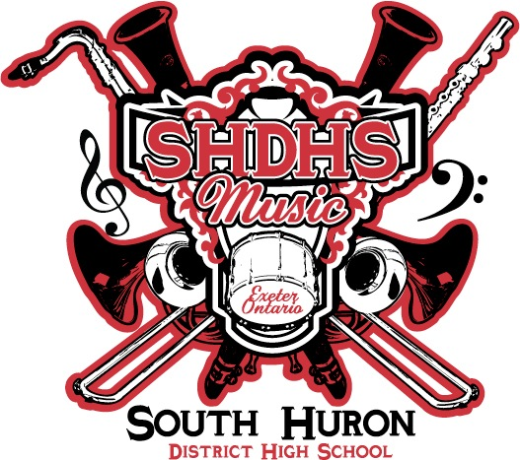
The SHDHS Music Council Executive
Code of Conduct

By becoming a member of the Music Council Executive I understand that I am committing to be a leader and a role model in the South Huron Music Program. Therefore, in addition to the duties outlined for me in the Music Council Constitution, I also agree and commit to the following:

- I will demonstrate leadership and appropriate behaviour during all school activities and trips.
- I will arrive early and help with the setup and the clean-up of rehearsal spaces
- I will demonstrate and model positive ensemble skills by being warmed up, tuned and having all required materials (music, pencil etc.) before rehearsal begins.
- I will be prepared for rehearsals by practicing my music ahead of time
- I will be attentive and focussed in rehearsals and help others in my section whenever possible
- I will have an exemplary attendance record in all of my classes and rehearsals
- I will exhibit leadership by maintaining all commitments I have made to the music program for the duration of my time at SHDHS.
- I will be attentive and focussed in all Music Council General and Executive meetings.
- I will actively participate in all Music Council led events.
- I will read the minutes of each meeting and check the music council bulletin board and Facebook page each day.
- I will complete all assigned tasks by the date given. If I am unable to complete a task on time, I will ask for help from my fellow music council executive members and speak with Mr. Moore or the Music Council President BEFORE the due date.
- Above all, I commit to uphold the pillars of the SHDHS Music Program
- If I do not fulfill the above requirements, I understand that I might be removed from my music council executive position.

I, _________________________ have read, understand and agree to the Music Council Executive Code of Conduct listed above.

______________________________________
Signature

