100 Teaching Tips, Tricks and Shortcuts for the Elementary Music Classroom
Judith Bean (Waterloo Region District School Board) - Judith_Bean@wrdsb.ca
OMEA - November 2019

1. Teaching Songs (12)
- Lean Forwards Lean Backwards https://dsmusic.com.au/blog/lean-forward/
- Today is Monday #25 (Gr. 1 Music Play)
- This Land is Your Land (Michael Mitchell recording)
- Our Old Sow #28 (Gr. 5 Music Play)
- My Bonnie Lies Over the Ocean – actions on letters
- Got a Hat Hat #57 (Gr. 3 Music Play)
- Austrian Went Yodelling #62 (Gr. 3 Music Play) - avalanche, skier, grizzly bear, Saint Bernard, dinosaur, jersey cow https://campsongs.wordpress.com/2012/05/03/an-austrian-went-yodeling/
- Reflections of a Lad at Sea – Ghost Ship
- Song for the Mira (SSA or SATB)– Allister MacGillivray
- When Billy Was One #99 (Sail Away 155 American Folk Songs –E. G. Locke)
- The Wind – Cecil Sharman (Royal Conservatory of Music Grade 1 - 1998)
- Snowflake - Cyril Hamshire (Royal Conservatory of Music Introductory - 2005)

2. Music Reading Ideas (6)
- Introduce the concept of line, bar, word
- Show movement of musical line
- Shakers for beat or ostinatos
- Teach part of the song to solfege then students identify which parts are sung
- Teacher and students show movement up and down on the staff when singing a line
- 5 skipping ropes for staff

3. Organizational Ideas (10)
- Colour code duo tangs per grade
- Use double pocket folders
- Colour code pages
- Clipboard with class lists – use short hand codes (add date)
- Leave 2 extra copies in bottom of bin
- Cup games – dollar store children’s cups
- Cup games –move desks to create a standing circle
- Music Bin police
- Photocopy song in miniature
- Create Google classroom for choir

4. Favourite Story Song Books & Resources (22) –see music resources list

5. Favourite Games & Singing Games (9)
GAMES:
- Music Memory – rhythms, solfege
- Halloween colouring spider
- Halloween pumpkin colouring of notes
SINGING GAMES:
- Our Old Sow – Music Play Grade 5
- Lean Forwards Lean Backwards - actions
- Al Citron (120 Singing Games and Dances)
- Austrian Went Yodelling (Music –different words)
- My Landlord (120 Singing Games and Dances – do in groups of 4)
- Old Brass Wagon - #28 (Gr. 3 Music Play)

6. Evaluation Ideas (9)
- Perform verses that they wrote in a circle -small groups perform verse & class sings the chorus
- Clipboard with class lists stapled in a booklet
- Rhythm snakes –each write a bar –perform in groups
- Write new words to Fish and Chips and Vinegar
- A Pizza Hut –write new words and actions
- “Class assistants” - lead Welcome to Music and The Music Time is Over
- Music games as class where have to clap a rhythm before turning over next card
- Mystery rhythms cards (solfege or rhythms) (make their own set) -reveal the final answer
- Have beat leaders with a song – “Beat Leader”

7. Integrating the Arts (5)
- Book: Jungle Drums by Graeme Base –puppets, storytelling (write new story or a play), composition (create songs for the animals or create a musical) or book Magic Beads
- The Wheels on the Bus – (music and drama)
- On Top of Spaghetti - music and drama
- There Was an Old Lady that Swallowed a Fly – make a map of the progression of who swallowed who (also Composition when write new songs)
- My Old Sow – use for DPA

8. Online Teaching Sites (5)
- Musictechteacher.com - can sign on in pairs and play games together –no account needed http://www.musictechteacher.com/music_quizzes/music_quizzes.htm
- Use add on in Google Docs “Flat for Docs” – composition
- San Francisco Kids http://www.sfskids.org/
- Sphinx Kids http://www.sphinxkids.org/
- Music Teacher’s National Association https://www.mtna.org/MTNA/Learn/Parent_and_Student_Resources/Websites_for_Kids.aspx

9. Cool Ideas for Instruments (6)
- Ice cream spoons for rhythm sticks
- Chopsticks
- Create own shakers with plastic bottles - different sounds
- Markers or highlighters as rhythm sticks
- Salad containers as drums

10. Compositions and Performance (12)
SONGS TO CHANGE THE WORDS:
- Hey Lidee – Music Play Gr. 4 (write new verses)
- Fish and Chips (also known as One Bottle of Pop) #16 Gr. 6 Music Play
- Froggie Went a Courting
- The Twelve Dogs of Christmas – The 12 Days of Winter, Halloween, school
- There’s a Hole in the Bucket – ex. flat tire on my car
- On Top of Spaghetti
- Twinkle Twinkle
OTHER:
- Shaker sound compositions – each student writes a bar of rhythm – rondo form – different sounds
- Create different sound effects using shakers
- Rondo Rhythms
- Add actions to songs
- Twinkle Twinkle – add actions to first letters

11. Extras (4)
- Change words of song: ”Where is (name), Where is (name)” (primary song) – omit “ma’am and sir”
- Teaching songs in different grades – Use Music Play Kindergarten in Grade 1 & 2 Ex. Dinosaur Diddy-Wa, Canada in My Pocket
- Improv games - count 8 beats
- Use songs that you want them to eventually learn to move to the beat, count and feel length of beats (feet=1 beat, spread hands with kicking feet=2, circle around the head = 4 beats)

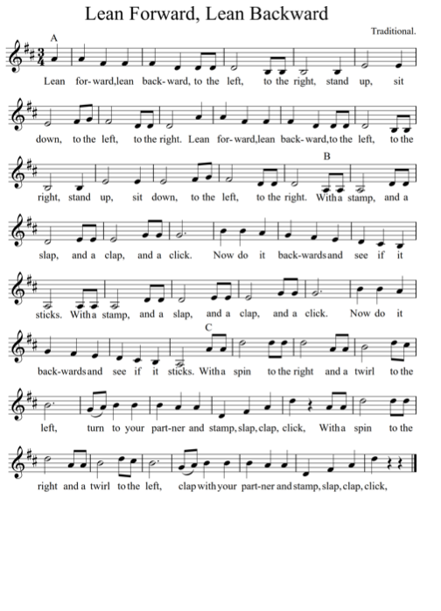
Music Resources

Baum, M., & Paschkis, J. (2007). I have a little dreidel. New York: Scholastic.

Becker, H., & Zimmermann, H. W. (2015). A porcupine in a pine tree: a Canadian 12 days of Christmas. Toronto, Ontario: Scholastic Canada Ltd.

Becker, H., & Zimmermann, H. W. (2018). Dashing through the snow: a Canadian jingle bells. Toronto: Scholastic Canada Ltd.

Bullock, K. (1993). She’ll be comin’ round the mountain. New York: Simon & Schuster Books for Young Readers.

Choksy, L., & Brummitt, D. (1987). 120 Singing games and dances for elementary schools. Englewood Cliffs, NJ: Prentice-Hall.

Colandro,L., & Lee, J. D. (2014). There was an old lady who swallowed a desk! NY,
NY: Scholastic Inc.

Colandro, L., & Lee, J. (2018). There was an old lady who swallowed a chick! New York, NY: Scholastic.

Creighton, H., & DeCoste, W. (2009). Farewell to Nova Scotia. Waverley, N.S.: Tall Ships Trading.

Davis, D., & Galey, C. (2007). Jazz cats. Gretna, LA: Pelican Pub. Co.

Gagne, D. (1997). Musicplay: grade 4 music program. Red Deer, Alta.: Themes & Variations.

Gagne, D. (1997). Musicplay: grade 5 music program. Red Deer, Alta.: Themes & Variations.

Gagne, D. (2003). Musicplay grade 2: music program. Red Deer, Alta.: Themes & Variations.

Gagne, D. (2003). Musicplay grade 6: music program. Red Deer, Alta.: Themes & Variations.

Gagne, D. (2004). Musicplay grade 1: music program. Red Deer, Alta.: Themes & Variations.

Gagne, D. (2005). Musicplay grade 3: music program. Red Deer, Alta.: Themes & Variations.

Garriel, B. S., & OBrien, J. (2012). I know a shy fellow who swallowed a cello. Honesdale, PA: Boyds Mills Press.

Grasso, S. P., Jones, C., & Jones, C. B. (2017). Take me out to the ice rink. Toronto, Ontario: Scholastic Canada Ltd.

Hawkins, C., & Hawkins, J. (2003). I know an old lady who swallowed a fly: a hilarious lift-the-flap book. London: Egmont.

Johnson, P. B., & Glazer, T. (2008). On top of spaghetti. New York: Scholastic Press.

Katz, A., & Catrow, D. (2001). Take me out of the bathtub: and other silly dilly songs. New York: McElderry.

Kragen, E., Fuller, D., Collins, S., & Moore, K. A. (2010). The twelve dogs of Christmas. Nashville, TN: Tommy Nelson.

Locke, E. G., & Goodfellow, R. (1989). Sail away: 155 American folk songs to sing, read, and play. New York: Boosey & Hawkes.

MacGillivray, A., & DeCoste, W. (2008). Song for the Mira. Waverley, N.S.: Tall Ships Trading Co.

Nielsen-Fernlund, S., & Côté Geneviève. (2020). The magic beads. Vancouver, British Columbia: Simply Read Books.

Noordhof, G., & Peddle, D. (2014). Puffin playing by the sea: the twelve day of Christmas in Newfoundland and Labrador. Newfoundland: Gina Noordhof.

Priceman, M., Hoty, D., & Abravanel, W. (2001). Froggie went a-courting: Boston, MA: Little, Brown.

Turner, T. N., & Rice, J. (2016). Country music night before Christmas. Gretna: Pelican Publishing Company.

Westcott, N. B. (1995). There’s a hole in the bucket. New York: Trumpet Club.

