Feedback from Aga Khan Museum Fact Checking

Please see suggestions below.

Please note: For Gr 11-12 Unit: Music Education and Islam: An Examination of Equity and Accommodation in Ontario’s Publicly Funded Schools, Lesson Template for Gr 1-2, Unit Set 4A & B: Water: The Element of Life; Exploring Water’s Dynamics, and the whole Gr 3 unit on the Aga Khan Park, the content is now with the Council for Ontario. Please do not post this until they have approved. They are really trying to keep the focus on all Muslims and not just Ismailis, so they may have some suggested changes. We will let you know as soon as we hear back from them.

OMEA  Aga Khan Museum Project | Grade: 1-2 | Unit Set 7A: Building Music Community; Exploring ensemble play with elements of music. (Lesson 1 of 2)

Resources | Comments
Aga Khan Quran Image AKM824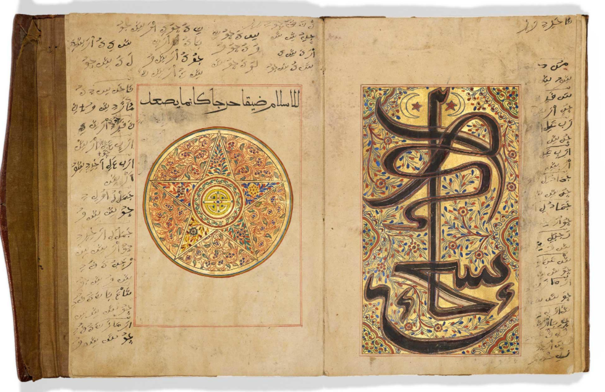 | 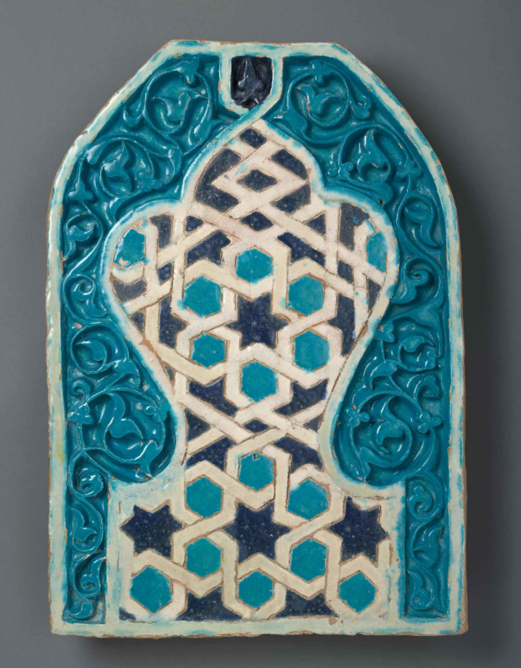  Since this lesson plan is covering music from Central Asia, specifically Uzbekistan, I would recommend using an artifact from that region that is not religious such as a tile panel. Tile Panel AKM572 would work here as it reflects different artistic styles (geometric shapes, vegetal patterns, arches) and colours (Two Blues) from the regions coming together to form a single piece of architectural decorative art.  Instead of looking at the two sides of the Quran example, here students can look at the Vegetal light blue elements as PART A, and the dark Blue geometric shapes and PART B, when creating their rhythmic patterns. Students can pick out design elements to represent PART A and PART B.
Excerpt from performance of Ovlyakuli Hojakuli’s Mavrigi.  http://www.musicofcentralasia.org/tracks/chapter/34 | One of the missions of the museum is to highlight the diversity found in Islamic cultures. To achieve this, it is important to avoid essentializing diversity using ‘Islamic Music’ and/or ‘Islamic Art’ without highlighting the regions were the music/art comes from. In this example, the music is from Uzbekistan, an Islamic country/region with its own cultural traditions. Discuss Uzbek and Central Asian culture. (See below comment on using AKDN videos)
Excerpts from Rapshee concert.  http://www.musicofcentralasia.org/tracks/chapter/34 | I would also recommend the use of the Aga Khan Music Initiative-Music of Central Asia collection on Youtube for examples. The following link offers great visuals of traditional Uzbek music ensembles, food, architecture, cities, and folk dress. Can also highlight different music styles from different Uzbek regions.  https://www.youtube.com/watch?v=uSbDuMOoHoI

OMEA  Aga Khan Museum Project | Grade: 1-2 | Unit Set 7B: Building Music Community; Exploring ensemble play with elements of music. (Lesson 2 of 2)

Resources | Comments
Aga Khan Quran Image AKM824  Suggested  Tile Panel AKM572 OR Tile Panel AKM827  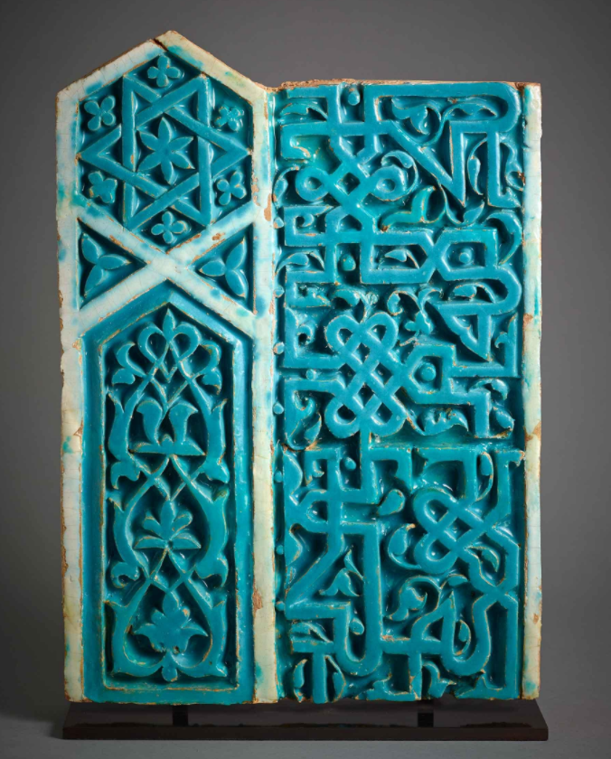 | The advantages of using the alternative Tile Panels AKM572 or AKM827, is that the lesson plan remains secular and explores the artistic styles of Uzbekistan (Central Asia). Here we avoid essentializing Islamic cultures as religious and homogenous. The Tile Panel represents a specific and unique region of the Islamic world, Uzbekistan. Students can explore the colours (turquois, blue and white, important colours in the region) but also the artistic styles (geometric, vegetal motifs, arches, calligraphy).  While the spiritual and secular elements are important to many Islamic art forms, it is important in our context to highlight the secular aspects in order to reframe from essentializing the vast and diverse artistic elements of the Islamic world.
Excerpts from Rapshee concert.  http://www.musicofcentralasia.org/tracks/chapter/34 | Again, as an alternative I would recommend using Aga Khan Music Initiative-Music of Central Asia Collection for examples. They can be found on the Aga Khan Development Network (AKDN) YouTube page or the Aga Khan Music Initiative (AKMI) YouTube page https://www.youtube.com/channel/UCq2a2B38dTDMKW7rgDf0LIA  These videos offer performances and fantastic visuals from the regions the music originates (Uzbekistan, Kyrgyzstan, Tajikistan, Turkmenistan, Afghanistan)

OMEA  Aga Khan Museum Project | Grade: 2 | Unit: Cultural Celebrations and Traditions  Lesson 1 of 1

Sections | Comments
Learning Goals | Spelling Eid al-Fitr
-The Night of the Moon-Chaand Raat (Celebration in Pakistan)  Resource: A Muslim Holiday Book: The Night of the Moon by Hena Khan. | After explaining Islam (The 5 Pillars, and the importance of Celebrations of Ramadan and Eid al-Fitr) focus should be on diversity and use of music in celebrations.  Avoid using vague regional references like South Asia/Central Asia and highlight the countries representing the music, art, and traditions.  Chaand Raat is celebrated in Pakistan, India, Bangladesh. Instead of focusing on the prayer aspect of Yasmeen, look at the more secular aspects of the holiday like family, charity, community, feasts, music.
-Highlight that the tile is from modern day Turkey, but highlight the Kaaba which is in Mecca, Saudi Arabia. This is the religious centre of Islamic faith. The rectangular black box at the centre of the tile is inside the most sacred Mosque. Two of the five pillars centre on this image. Salat (prayer) and hajj (pilgrimage).

-Instead of showing Mosque of Muhammad Ali in Cairo show the Great Mosque of Mecca which is shown in the tile.

-What is missing here is also a discussion that there are many interpretations of Islam which also are reflected in the diverse cultures, traditions, and celebrations across the world. While all Muslims follow the 5 pillars of Islam there are many cultural differences. In Pakistan, we have seen the celebration of Chaand Raat. In Iran, Uzbekistan, Tajikistan, Afghanistan, Kyrgyzstan people celebrate Navrus (Nowruz).

‘Azan’ | -Instead of listening to ‘Azan’ show secular examples of music during cultural celebrations across the Muslim world. Again, the problem is by using the ‘Azan’ example we are essentializing Muslims, and falling into stereotypes, by focusing on the spiritual aspects of cultures.  -Alternative is Music example can be found in ‘Celebrating Navrus’. Here student can listen to music from various regions and compare the instruments, sounds, and dress https://www.youtube.com/watch?v=wQSpy2AbLMQ  https://vimeo.com/159611158 (NAVRUS)  -Poet Rumi Celebrations (Sufi traditions). Here student can see the whirling dancers known as dervishes in Turkey. https://www.youtube.com/watch?time_continue=216&v=jzmT66bSZ1g  Students can review the celebrations all Muslims celebrate (Ramadan and Eid al-Fitr) but also review the other regional celebrations that make Islam diverse (Chaand Raat, Navrus, Rumi).

OMEA  Aga Khan Museum Project | Grade: 1-2 | Unit Set 5: Exploring Texture and Form using Timbre, Dynamics and Expressive Controls

‘Musical Gathering’ AKM218  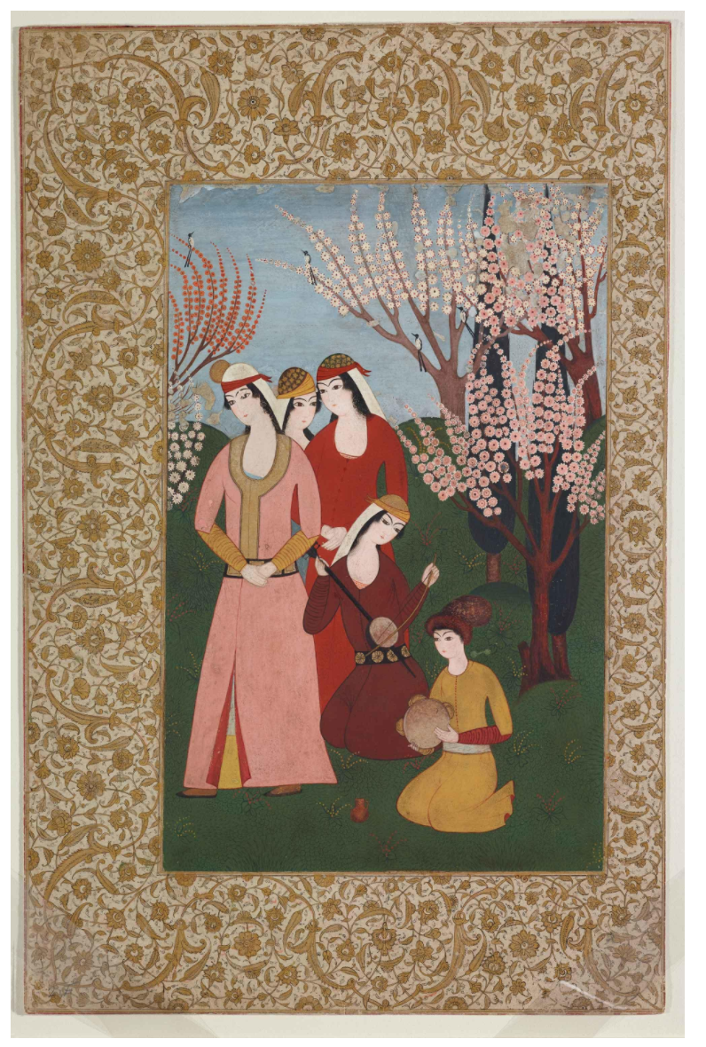 | -Woman on knees playing ektar, a one stringed lute.  -Young boy playing tambourine.  -Emphasis that this represents Royal taste of music in the Ottoman Empire, Modern Day Turkey.
Music of Central Asia | -Focus here should be on instruments, but also on the diversity of styles. It is important reference were these music types come from and avoid using ‘Islamic Music’. The video 6-minute mark highlights Tajikistan, Uzbekistan, Afghanistan, Azerbaijan.

OMEA  Aga Khan Museum Project | Grade: 1-2 | Unit Set 3A: Exploring Texture and Preserving Community using Afghan Music and Its Instruments

Sections | Comments
Use of ‘Western’ instruments / music | -The use of ‘Western’ can carry a lot of baggage, I would recommend avoiding its use. Also avoid comparisons between Western music/instruments versus and ‘Others’ or Eastern’. Instead I would reference instruments found in Classical music orchestras versus Afghan Music ensembles. Focus on how musical instrument express a shared experience by examining how music is used and similarities in instruments.  -The connotation of using ‘Western’ is that it is somehow more modern/advanced, thus it should be avoided.  -Video from the Aga Khan Music Initiative performance at the Ismaili Centre, Dubai. Shows use of Classical instruments with traditional instruments from Africa, the Middle East, and Asia.  https://www.youtube.com/watch?v=umi-OEy0XTk
Extended Learning Opportunities and Hijab. | -It is suggested that student might have questions about how the girls are dressed and their head dress. It is not necessary to discuss hijabs here because the girls are wearing a traditional Afghan outfit knows as a firaq partug.  -It is important here to discuss that the style of clothes reflect the different cultures/regions/ethnicities that people come from. What the women are wearing is a firaq partug, which consists of three pieces. The chador (head scarf), firaq (upper garment), and the partug lower garment.)  -Sometimes we can tell where a person is from the type of clothing they wear. For example, if you see a person in a kilt they come from Britain.

OMEA  Aga Khan Museum Project | Grade: 1-2 | Unit Set 3A: Exploring Timbre using the Traditional Baladi Rhythm Pattern with Non-Pitched Instruments (Membranophones)

Jaya Shiva Shankara by Amber Field Student Resource and guided exploration. | -This example is not secular, and asks student to sing a mantra and play a mantra. An alternative is the following video which shows close up of drum and hands in the baladi rhythm https://www.youtube.com/watch?v=fQWZomKTHo8  -not sure what the tambourine guided questions refer to when asking about the differences and similarities between non-Western and Western playing?

OMEA  Aga Khan Museum Project | Grade: 1-2 | Unit Set 3B: Exploring Timbre using the Traditional Baladi Rhythm Pattern with Non-Pitched Instruments (Membranophones)

Belly Dancing | -Do not use belly dancing as an example. This does not reflect traditional Middle Eastern or Islamic cultures. What is referred to as belly dance today is a westernized, orientalised and sexualized version of Arabic and central Asian solo dancing.  -Use of belly dancing and referring to it as most recognizable is essentializing the Middle East and supporting stereotypes of the region, especially the sexualisation of dance and people.  -Use the following video to show examples of Uzbek folk improvised solo dancers https://www.youtube.com/watch?v=e3k0gHmppUQ  Example of Uyghur solo dance:  http://videodw.com/view/24714034/uyghur-dance-1959-china-ethnic-minority-dance.html  -Dance examples above can also link to the collection of Central Asian and Chinese robes in the Museum. Student can explore the types of dress worn in dance and see how robes are wore and important cultural traditions in the region.  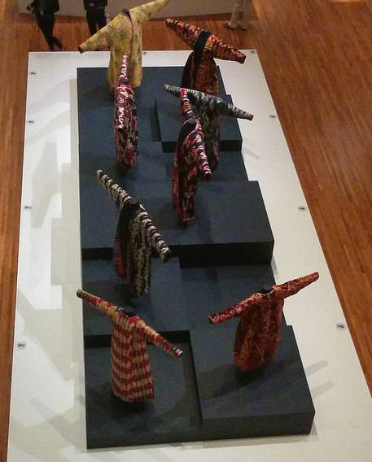  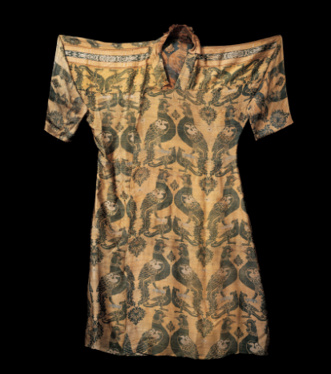  AKM676
“Islamic Culture” | -Using this is very vague, see written suggestions.

OMEA  Aga Khan Museum Project | Grade: 3-4 | Unit: The Silk Road  Lesson 1 and 2

Need to include African example in these lesson plans. | -Lesson plan omits Africa was significantly impacted by the silk route trade and travel. Most notable example is the 14th century Kingdom of Mali and Mansa Musa see TED Ed YouTube link.  https://www.youtube.com/watch?v=O3YJMaL55TM  -Great sea route of India and China changed the coast of East Africa. Importance of Dhow. Swahili cities of Somalia to Mozambique reflects the influence of Arab and Islam on Africa. The following video from the Smithsonian National Museum of African Art highlights this influence.  https://www.youtube.com/watch?v=AaTX1Hf74XY  -Sample of Quran from North Africa, shows early influence of Islam on the continent:  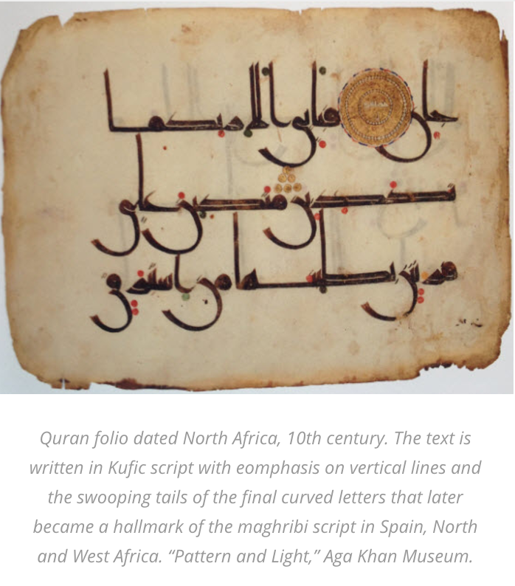  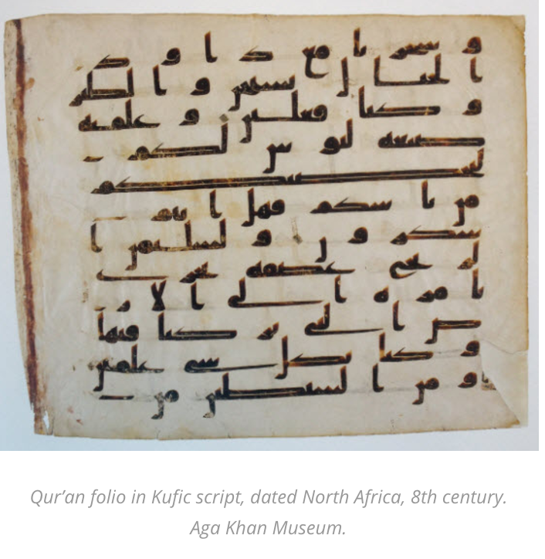
Discussion about Caravans and Travel | -Here are two ceramic dishes from Iran about 11th and 12 centuries. Middle is of man on horse circled by caravan of camels. (AKM00557 & AKM00558) see on next page.  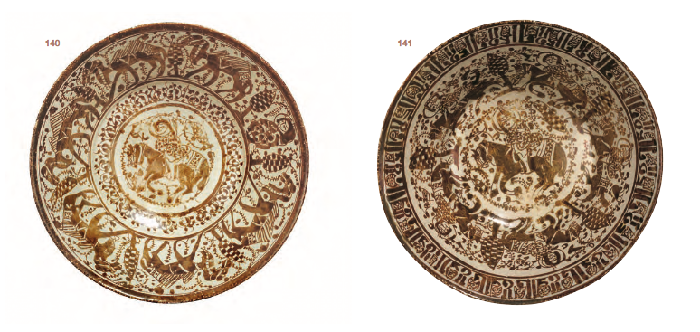

OMEA  Aga Khan Museum Project | Grade: 1-2 | Unit Set 2A-B-C: Vessel Shakers and Movement Timbre and Tempo

-8:35 an example of a homemade ghijak made from tin can being played. Another example of a vessel being used as instrument. https://www.youtube.com/watch?v=pefOTWUtkzA

-Here is a picture of the tin can ghaychak (ghijak) from Tajikistan.
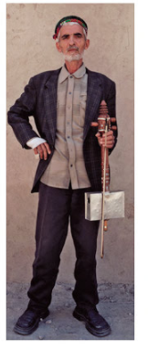

-An improvised ghaychak in Afghanistan made from an old vessel.
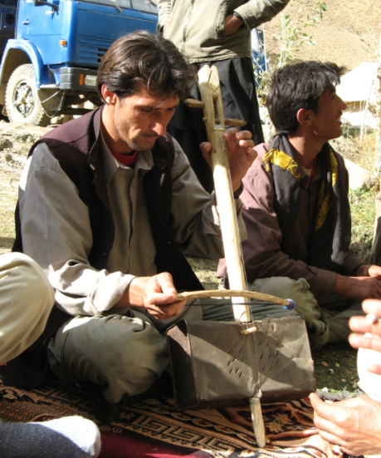
(Source: http://thewanderingscot.com/wp-content/uploads/2009/10/Ghaychak.jpg)

OMEA  Aga Khan Museum Project | Grade: 1-2 | Unit Set 4A: Water the Element of Life; Exploring Water’s Dynamics

-Consider including Aga Khan Museum garden reflection pools.

OMEA  Aga Khan Museum Project | Grade: 1-2 | Unit Set 1: Pitch Using Vocal Exploration with the Arabic Design/Calligraphy and the Arabic Alphabet

Section | Comments
Arabic Alphabet

OMEA  Aga Khan Museum Project | Grade: 3 | Unit: The Aga Khan Park (Islamic Gardens) - Soundscapes

Section | Comments
Garden | -Chahar Bagh or Persian Garden should be discussed. Quadrilateral garden with four symmetrical gardens divided by walkway or flowing water into a centre fountain.  -The garden between the Aga Khan Museum and the Ismaili Centre is a modern interpretation of a Chahar Bagh.  -Pattern is also prevalent in Persian rugs. Inspiration for Aisha Khalid’s contemporary art piece, “Your way begins on the other side”.  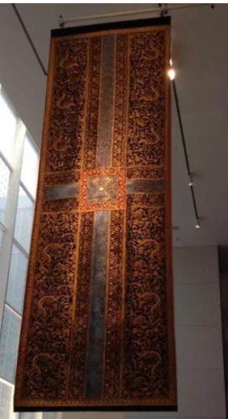

OMEA  Aga Khan Museum Project | Grade: 4 | Unit: Instruments of the Middle East  9 Lessons Total

Section | Comments
For Lesson 4-6 of 9 | -8:35 an example of a homemade ghijak made from tin can being played. Another example of a vessel being used as instrument. https://www.youtube.com/watch?v=pefOTWUtkzA  -Here is a picture of the tin can ghaychak (ghijak) from Tajikistan.  -An improvised ghaychak in Afghanistan made from an old vessel.  (Source: http://thewanderingscot.com/wp-content/uploads/2009/10/Ghaychak.jpg)

OMEA  Aga Khan Museum Project | Grade: 4 | Unit: Music in Cultural Art  Lesson 1

Section | Comments
Lesson 2 of 3 | -check links, could not access some of them.
Lesson 3 ‘Hazrat Bibi Maryam” song | -Description on last page states, “western woman”. Try to avoid these generalizations when possible. State where she is actually from.

OMEA  Aga Khan Museum Project | Grade: 4 | Unit: Music through the Shahnameh  Lesson 1

Section | Comments
Discussion of Shahnameh | -Discuss that many cultures document the history of their ancestors and origins in epic stories/poems. In India, there is the Ramayana and Mahabharata; In Greece, the Iliad and Odyssey; In Mesopotamia, the epic of Gilgamesh; In Rome, the Aeneid; In England and Scandinavia Beowulf; in France, the Songs of Roland.  -Explain how the Shahnameh comes from the Iranian oral tradition of reciting poetry. How the repetition and music forms in poetry help bards to remember and recite the stories.
Shahnameh Images | The images should include captions letting student know the story being told in them.

OMEA  Aga Khan Museum Project | Grade: 4 | Unit: Music through the Shahnameh  Lesson 2

Section | Comments
Listening example of SHUR-Mugham East Music Gevorg Dabaghyan | -Not sure how this Armenian example relates to the Shahnameh?  -Suggest using the following musical rendition of the Shahnameh battle between Rostam and Sohrab.  https://www.youtube.com/watch?v=4QpUZ9Czf0Q&list=PLnKZvd6RMCIGOA2gse7RMvwsr3DMUQcno  -See the Haftkhan Group website for English captions to performances. The group was formed in 2009 to share musical performances based on the stories of the Shahnameh. The website is a great resource for Iranian instruments and the Shahnameh. http://haftkhan.com/stPage.aspx?pId=1309  -Can show the influence of Shahnameh on contemporary Iranian culture by discussing the tradition of wrestling. Rostam was a great warrior and known for his wrestling skills. Today the wrestling tradition is vibrant in Iran, the following video shows wrestlers training to music, known as the ‘Zurkhaneh Ritual’. Student can be prompted to think about the type of instruments being used and the feeling they get from the sounds.  https://www.youtube.com/watch?v=BTHvXX-Qicw
Show Shahnameh folios with representations of music to highlight the association of music in art with courtly culture and to emphasis courtly ambience.

AKM274 (Women playing at wedding) AKM496
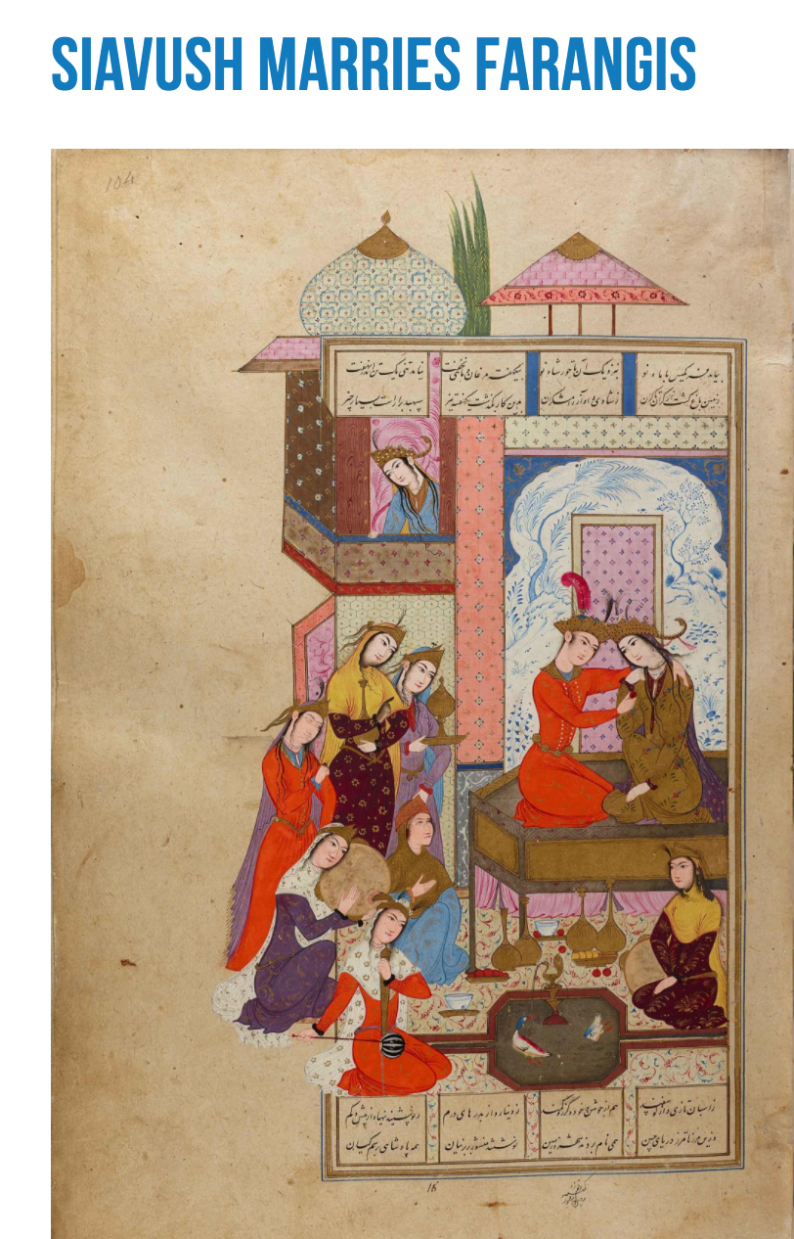
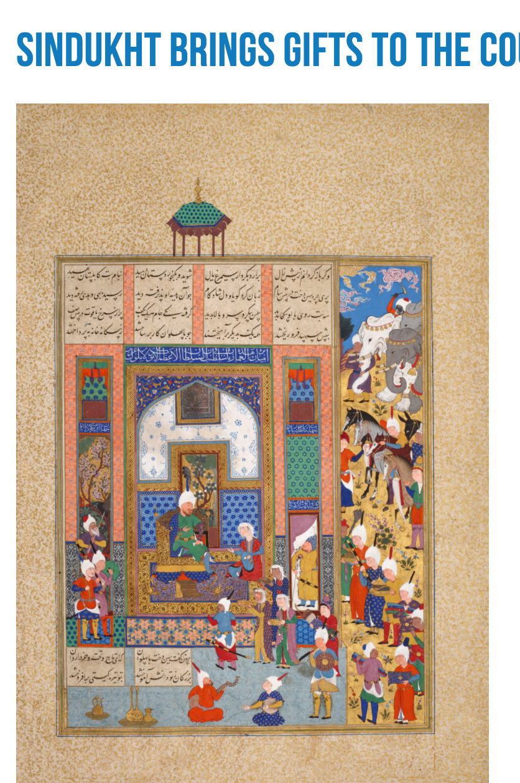

AKM155 (Musicians in the background emphasis courtly ambience)
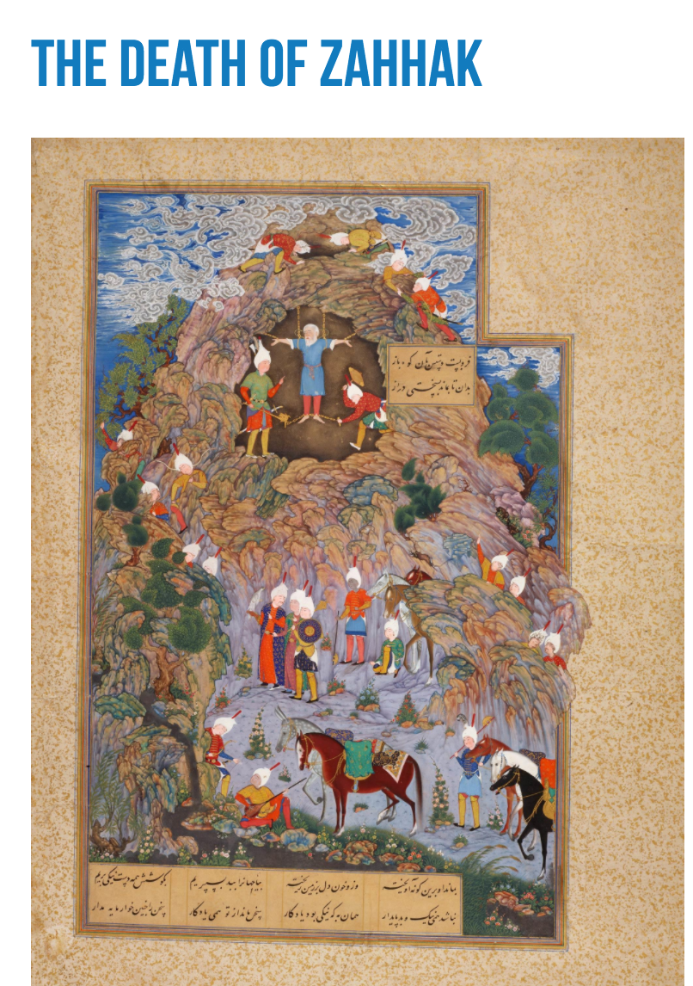

OMEA  Aga Khan Museum Project | Grade: 9-10 | Unit: Composing from, for, with Nasta’liq Calligraphy  Lesson 1 of 4

Section | Comments
Rostam Rescues Bizhan from Pit | - See the Haftkhan Group website for English captions to performances. The group was formed in 2009 to share musical performances based on the stories of the Shahnameh. The website is a great resource for Iranian instruments and the Shahnameh. Choose a video as an example of how Shahnameh stories influence music performance. http://haftkhan.com/stPage.aspx?pId=1309

OMEA  Aga Khan Museum Project | Grade: 9-10 | Unit: Composing from, for, with Nasta’liq Calligraphy  Lesson 2 of 4

Section | Comments
Researching Nasta’liq | -Additional questions to consider asking student.  1. What languages and regions use this form?  2. How can we explain the diverse use of this form?  -Show example of Mughal Nasta’liq Calligraphy and Compart it to the uses of Iranian Shahnameh folios.  1. What are the differences? (Diagonal art style)  2.What do these artifacts tell us about the people they were made for? (Interested in nature as reflected in animals and flowers in borders)  3. What does it say about the cultural traditions of the time they were made? (Mughal rulers were interested in art and literature)  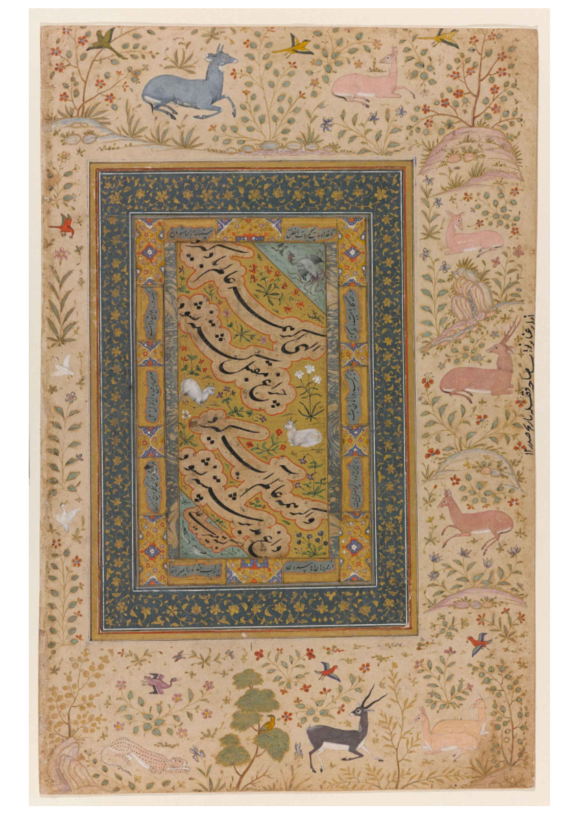  AKM 145 AKM526 (Zoomorphic Calligraphy)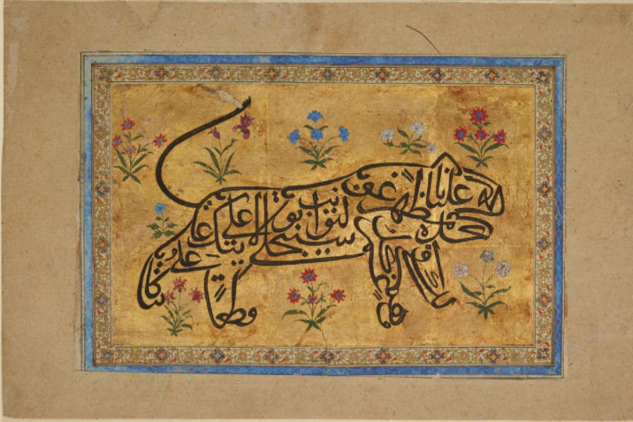
Calligraphy | -An additional emphasis in the lesson should be how Calligraphy reflects the diversity and pluralism of various cultures.

OMEA  Aga Khan Museum Project | Grade: 9-10 | Unit: Composing from, for, with Nasta’liq Calligraphy  Lesson 3 of 4

Section | Comments
Kufic use on ceramics | 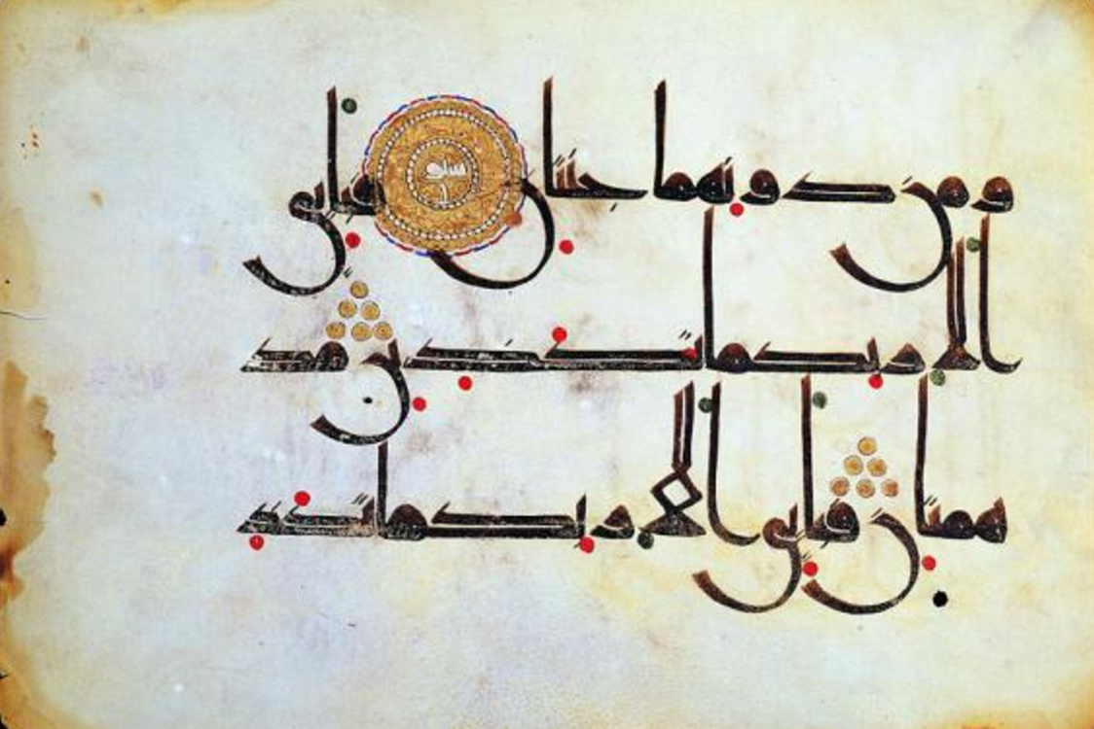  -Explore the artistic benefits of Kufic Calligraphy for ceramics, versus the more complicated Nasta’liq.  -Kufic long horizontal and vertical usage.
-Referrence from Book “ Treasures of the Aga Khan Museum” page 348- 350.
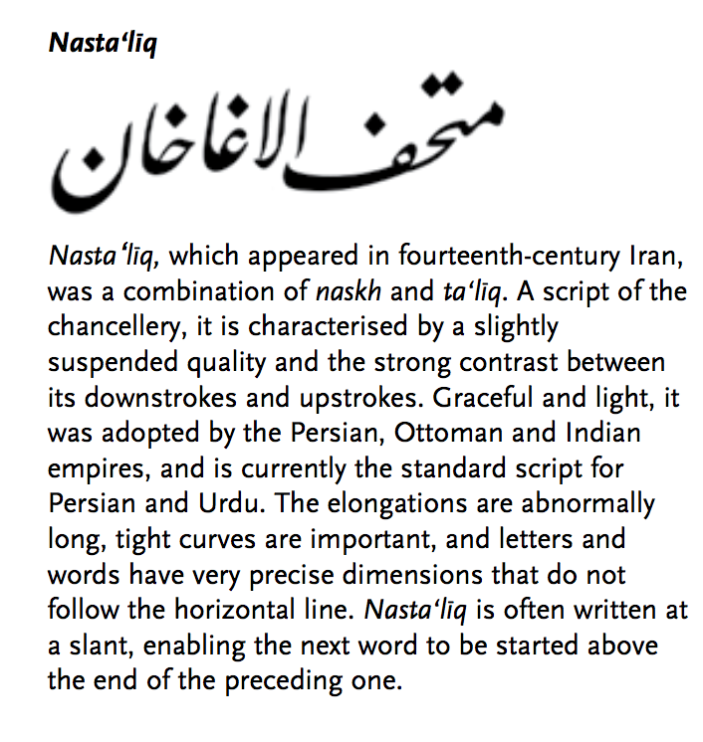
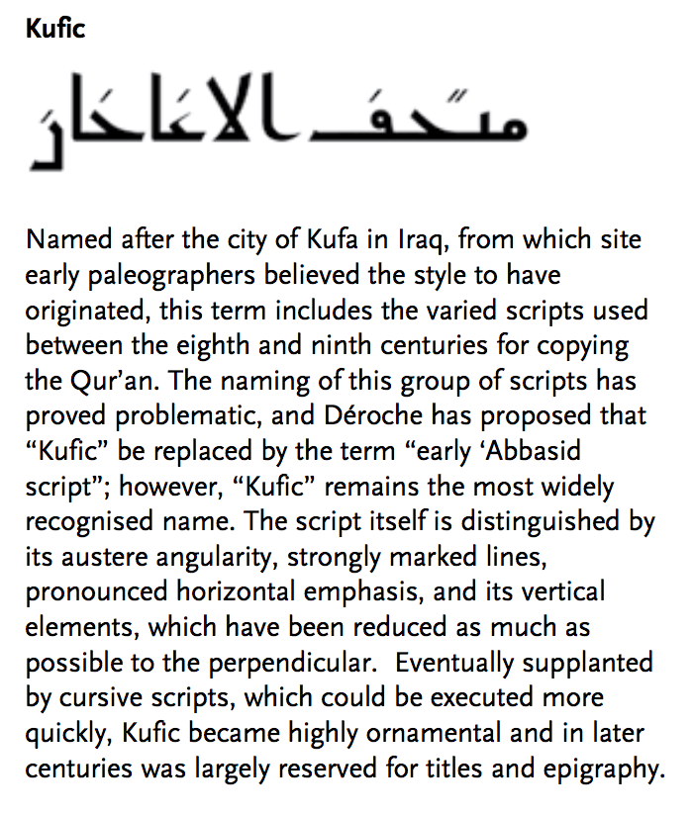

OMEA  Aga Khan Museum Project | Grade: 9-10 | Unit: Music for a Purpose: The Music of Zurkhaneh Marital Arts

Section | Comments
Power Point Slides | -Highlight the story of Rostam and Sohrab, to trace tradition of wrestling in Iran.  -Zurkhaneh and the importance Shia and Sufi traditions. Highlight the diverse interpretations of Islam and how this influences pluralism.  -Sufi influence and whirling. See the examples below (AKM451, AKM00104)  AKM451 (Dervish sitting under Tree)  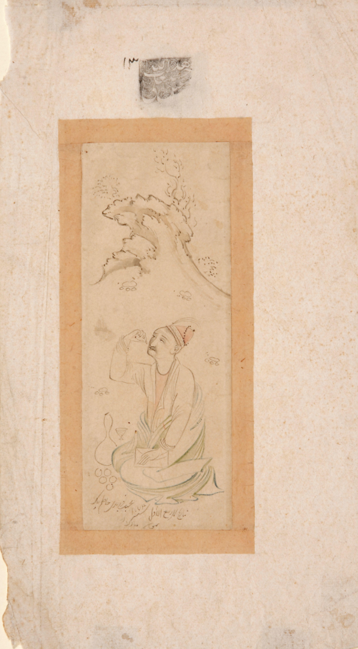  AKM00104 (Gathering of the Dervishes)  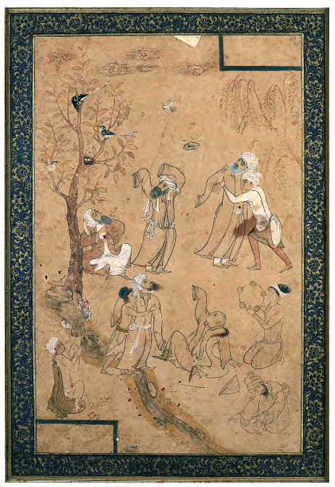  -Warrior weapons used as training tools in Zurkhaneh ritual. Example of importance of the bow in Iranian culture, here Indian Kings asks for help to defeat dragon. AKM80  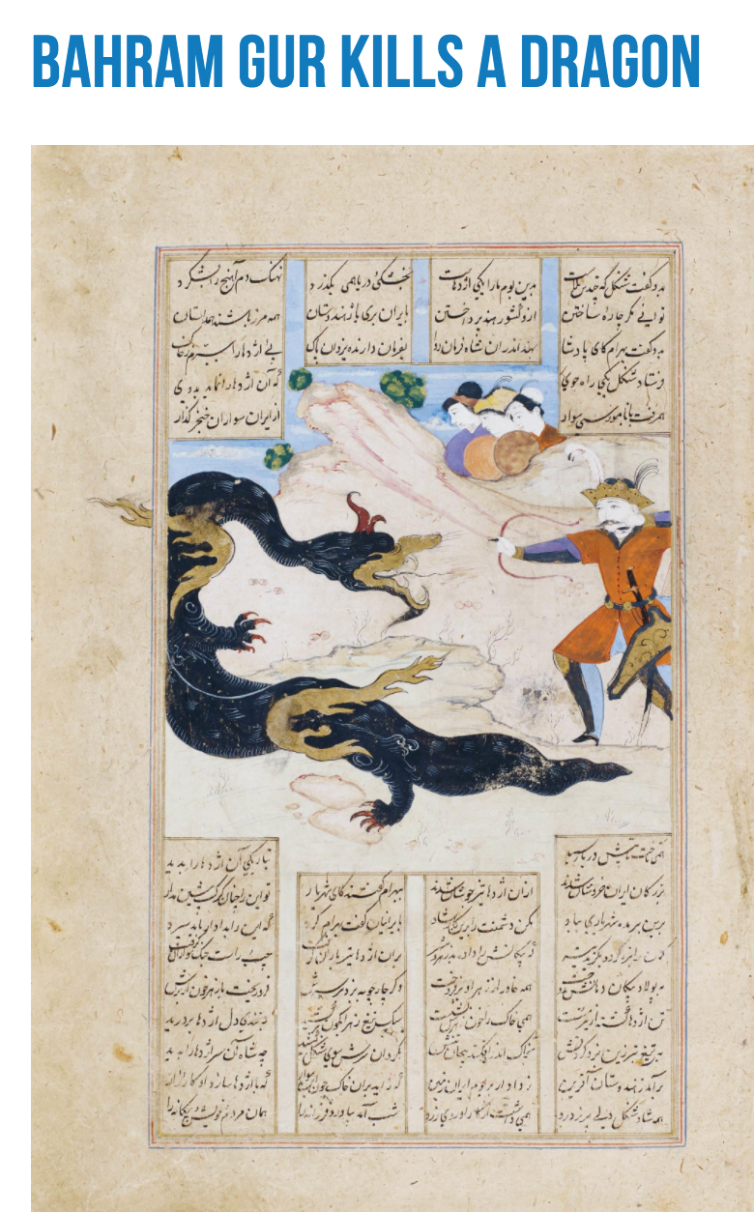  AKM92  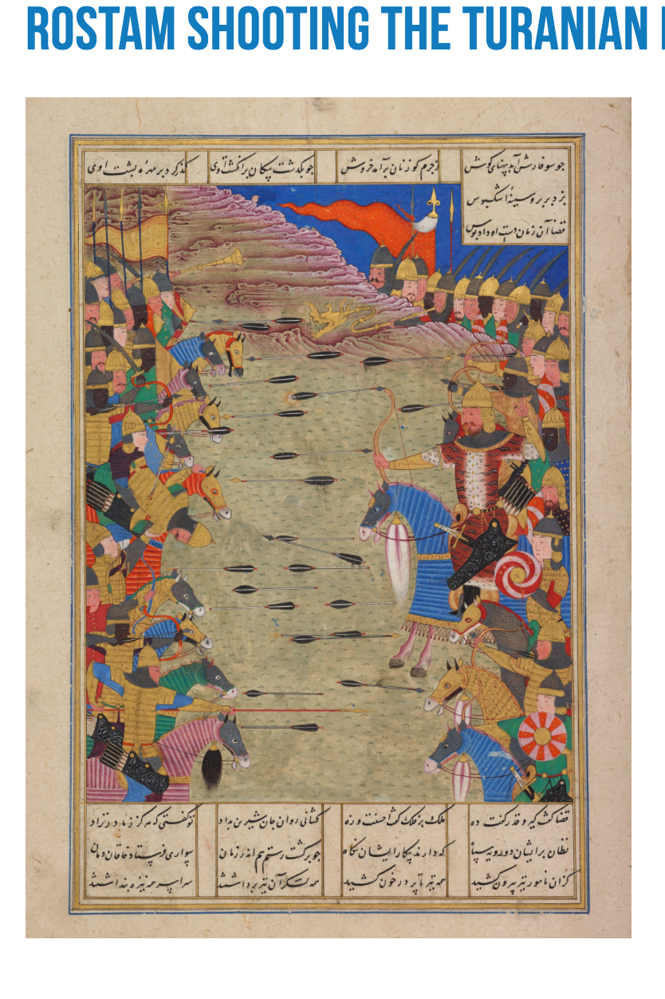  -https://www.youtube.com/watch?v=BTHvXX-Qicw  Video highlights the various performance elements including the tools and whirling.  -AKM449 (Example of wrestling in Shahnameh.  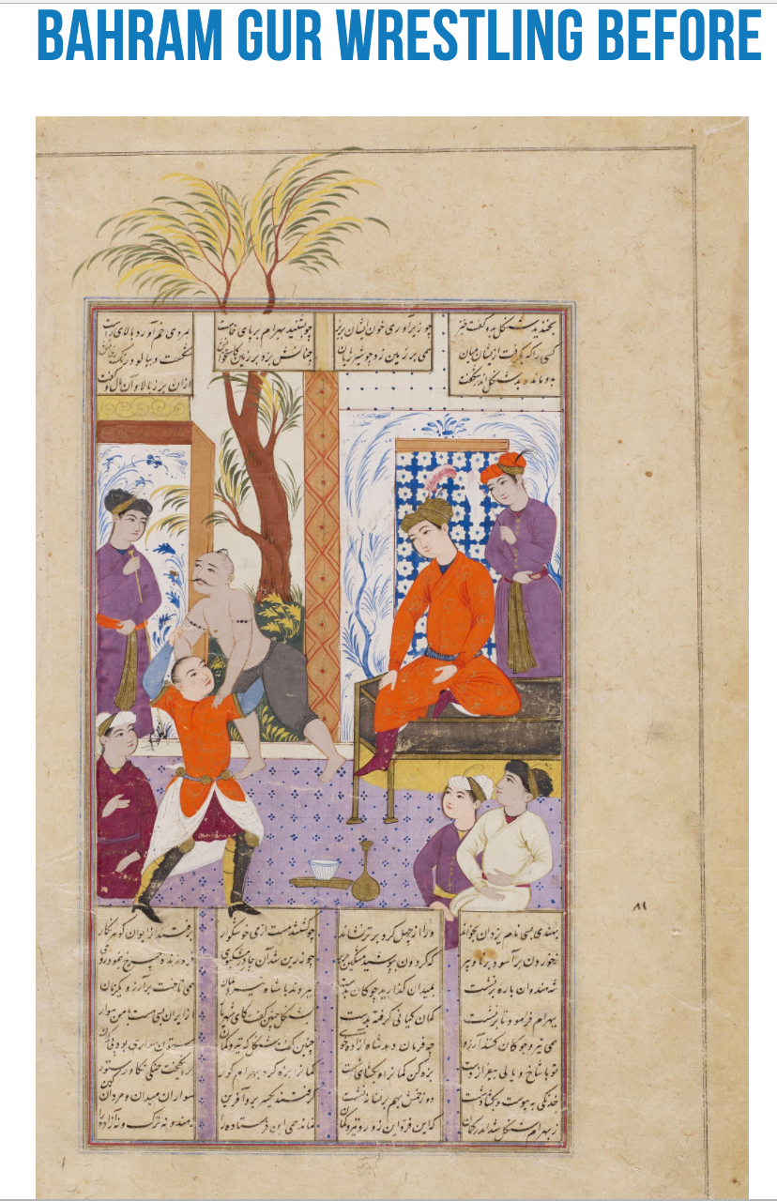  -Choose any one of the Aga Khan Museum’s folios showing Rostam defeating Divs.

OMEA  Aga Khan Museum Project | Grade: 9-10 | Unit: Islamic Art, Architecture and Music: An Introduction and Appreciation through the Compositional Process

Section | Comments
Examining ceramics and architecture from Syria, Egypt, Spain and Turkey | -When referencing Turkey make sure to highlight that historically it is the Ottoman Empire, which was a multicultural empire and artistic styles reflect that.  Syria and Egypt eventually were also part of the Empire.  Would it be more accurate to describe ‘Western Music’ as Classical or German, French, Italian?

OMEA  Aga Khan Museum Project | Grade: 9-10 | Unit: Open our Ears  Lesson 1 of 1

Section | Comments
Islamic/Muslim Hip Hop Music | -Why is this referred to as Muslim/Islamic hip hop? Because there are religious and spiritual elements to the lyrics.  -It is important here to highlight that this music is created in Europe and North America where Muslims are a minority. They use music to find identity within their surroundings. As a minority, their focus is about being Muslim. How is hip hop used in other countries with majority Muslim populations?  -Clip of CNN interview with DAM a Palestinian hip hop group. What is the difference here?  https://www.youtube.com/watch?v=iioCyIKbEpI  -Again, avoid focus on religious aspect of Muslim cultures, while this is important there is a risk of essentializing the spiritual aspect of the culture. Emphasis here should be on the diverse use of Hip Hop by Muslims across the globe, not just the religious aspect.

OMEA  Aga Khan Museum Project | Grade: 11-12 | Unit: Music Education and Islam: An Examination of Equity and Accommodation in Ontario’s Publicly Funded Schools

Section | Comments
His Highness Aga Khan Quote: “I believe in the power of plurality, without which there is no possibility of exchange” | This section is with the Council for Canada as they have requested specific references to His Higness and Ismailis to be removed from the content. They want the resource to focus on the greater Ummah (all Muslims) rather than Ismailis specifically. Please remove this section until we have the Council’s feedback.

OMEA  Aga Khan Museum Project | Grade: 6 | Unit: The Conference of the Birds  2 Lessons

Section | Comments
-The Aga Khan Museum has many artifacts depicting birds. Some include the following, which may be shown to students:

AKM213
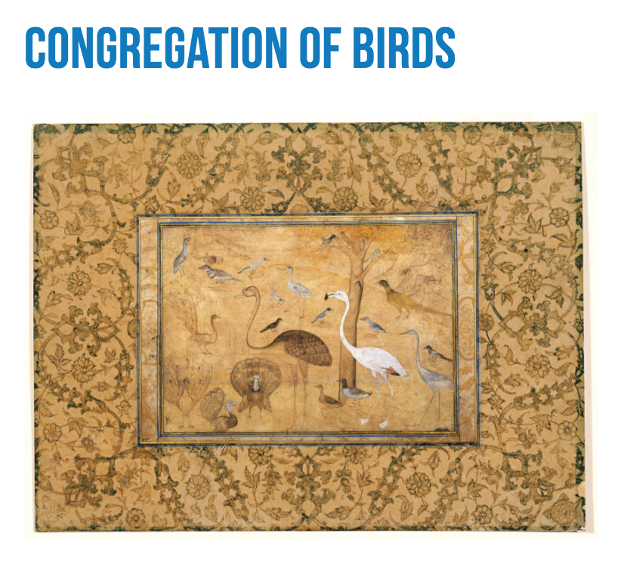

AKM140 (Simurgh)
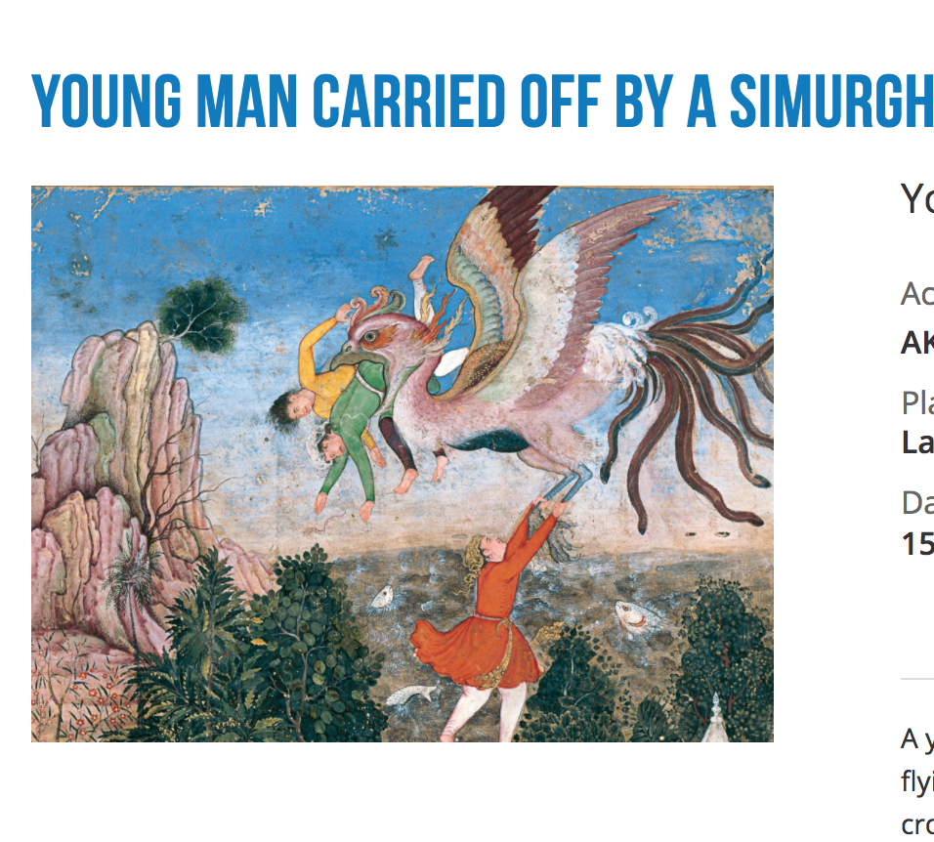

AKM289 (Animal Fable of the Battle between the Owl and Crows)
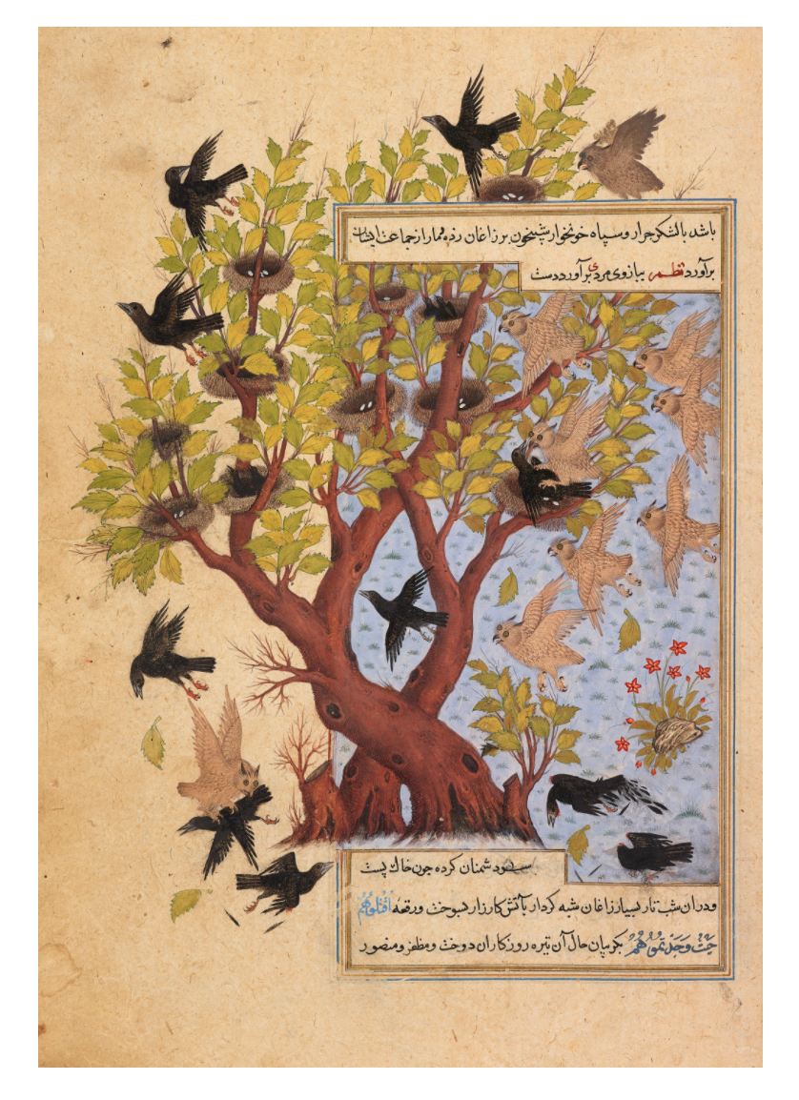

AKM145 (Birds on border of Nasta’liq Folio)
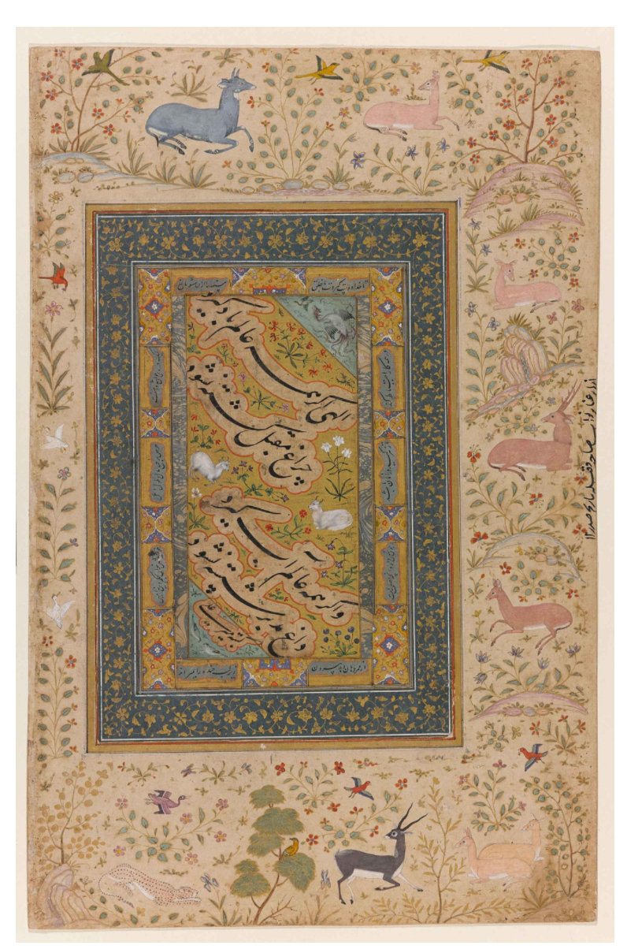

-More Birds AKM00579 (North African Example, Peacock)

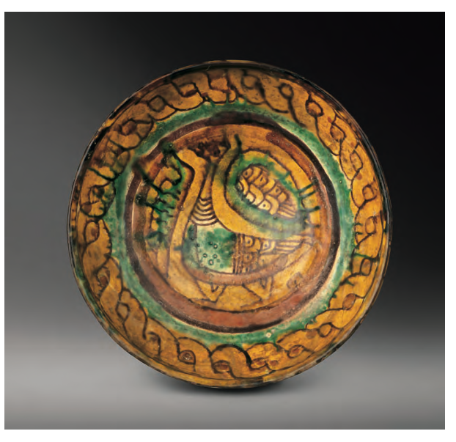

-Another peacock, this time from Syria. AKM00550

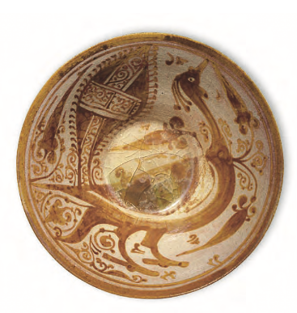

-More examples of Simurgh can be seen in the behind the scene trailer of Feather of Fire (from Shahnameh). Example of contemporary music, dance and Shahnameh.
https://www.youtube.com/watch?v=MlnmPwYeZBw

OMEA  Aga Khan Museum Project | Grade: 5 | Unit: Design in Music Culture

Section | Comments

