Teacher Resource 1
Ideas for Beginning String Lessons
Lesson 1  Beginning Strings | Entry Task:  - Tuning: Students sit on floor with case in front. Students carefully remove the instrument, pass it to the teacher for tuning and then place the instrument on the floor between the case and themselves. The bow remains in the case.  - Shoulder rest: Students are taught to put the rest on the instrument and the teacher circulates to check placement  Theory:  - Students are taught the names of the parts of the violin and bow (this makes the description of set-up much easier) and instrument care. Students complete a worksheet. Quiz tomorrow.  Standing instrument position without bow –count using numbers below:  Rest Position: feet shoulder width apart, flexible knees, hips and shoulders aligned, head on top of spine, violin under right arm  - Hold violin by its shoulder in upright position, front facing the “audience”  - Turn violin  - Place correctly on shoulder  - Turn head (without leaning) until jaw touches chin rest.  - Place left hand on right shoulder to put left shoulder into position.  Instrument Position Exercises (standing):  - Write your name with the scroll, write your neighbour’s name Knee bends, swaying, stand on tiptoes  Bow hold (without violin):  - Bunny without bow (thumb touches middle fingers, index and little fingers are ears), bunny eating, wiggle ears, hopping, bunny hole “When we teach little children…”  - Tighten bow, hold the bow upside down (this hold allows students to experience the successful contact with the bow that produces good tone quality): upper half of bow, hold frog with LH to support the weight of the bow while developing the bow hold.  - Stick of bow must fit in the curved crease between the middle and lower finger joints, thumb bent opposite middle fingers, little finger curved on top of the stick, bent thumb is “a hill not a valley”  - Turn hand to the left until the side of the index finger contacts the bow.  Bow hold exercises:  - Stirring: a pot of soup, both directions –keep frog in the air and bow vertical  - Rocket: Lower arm and fingers send frog upwards while keeping the bow vertical, bow on the floor, bow on top of head  - “strong thumb”  - pencil “jiggles”  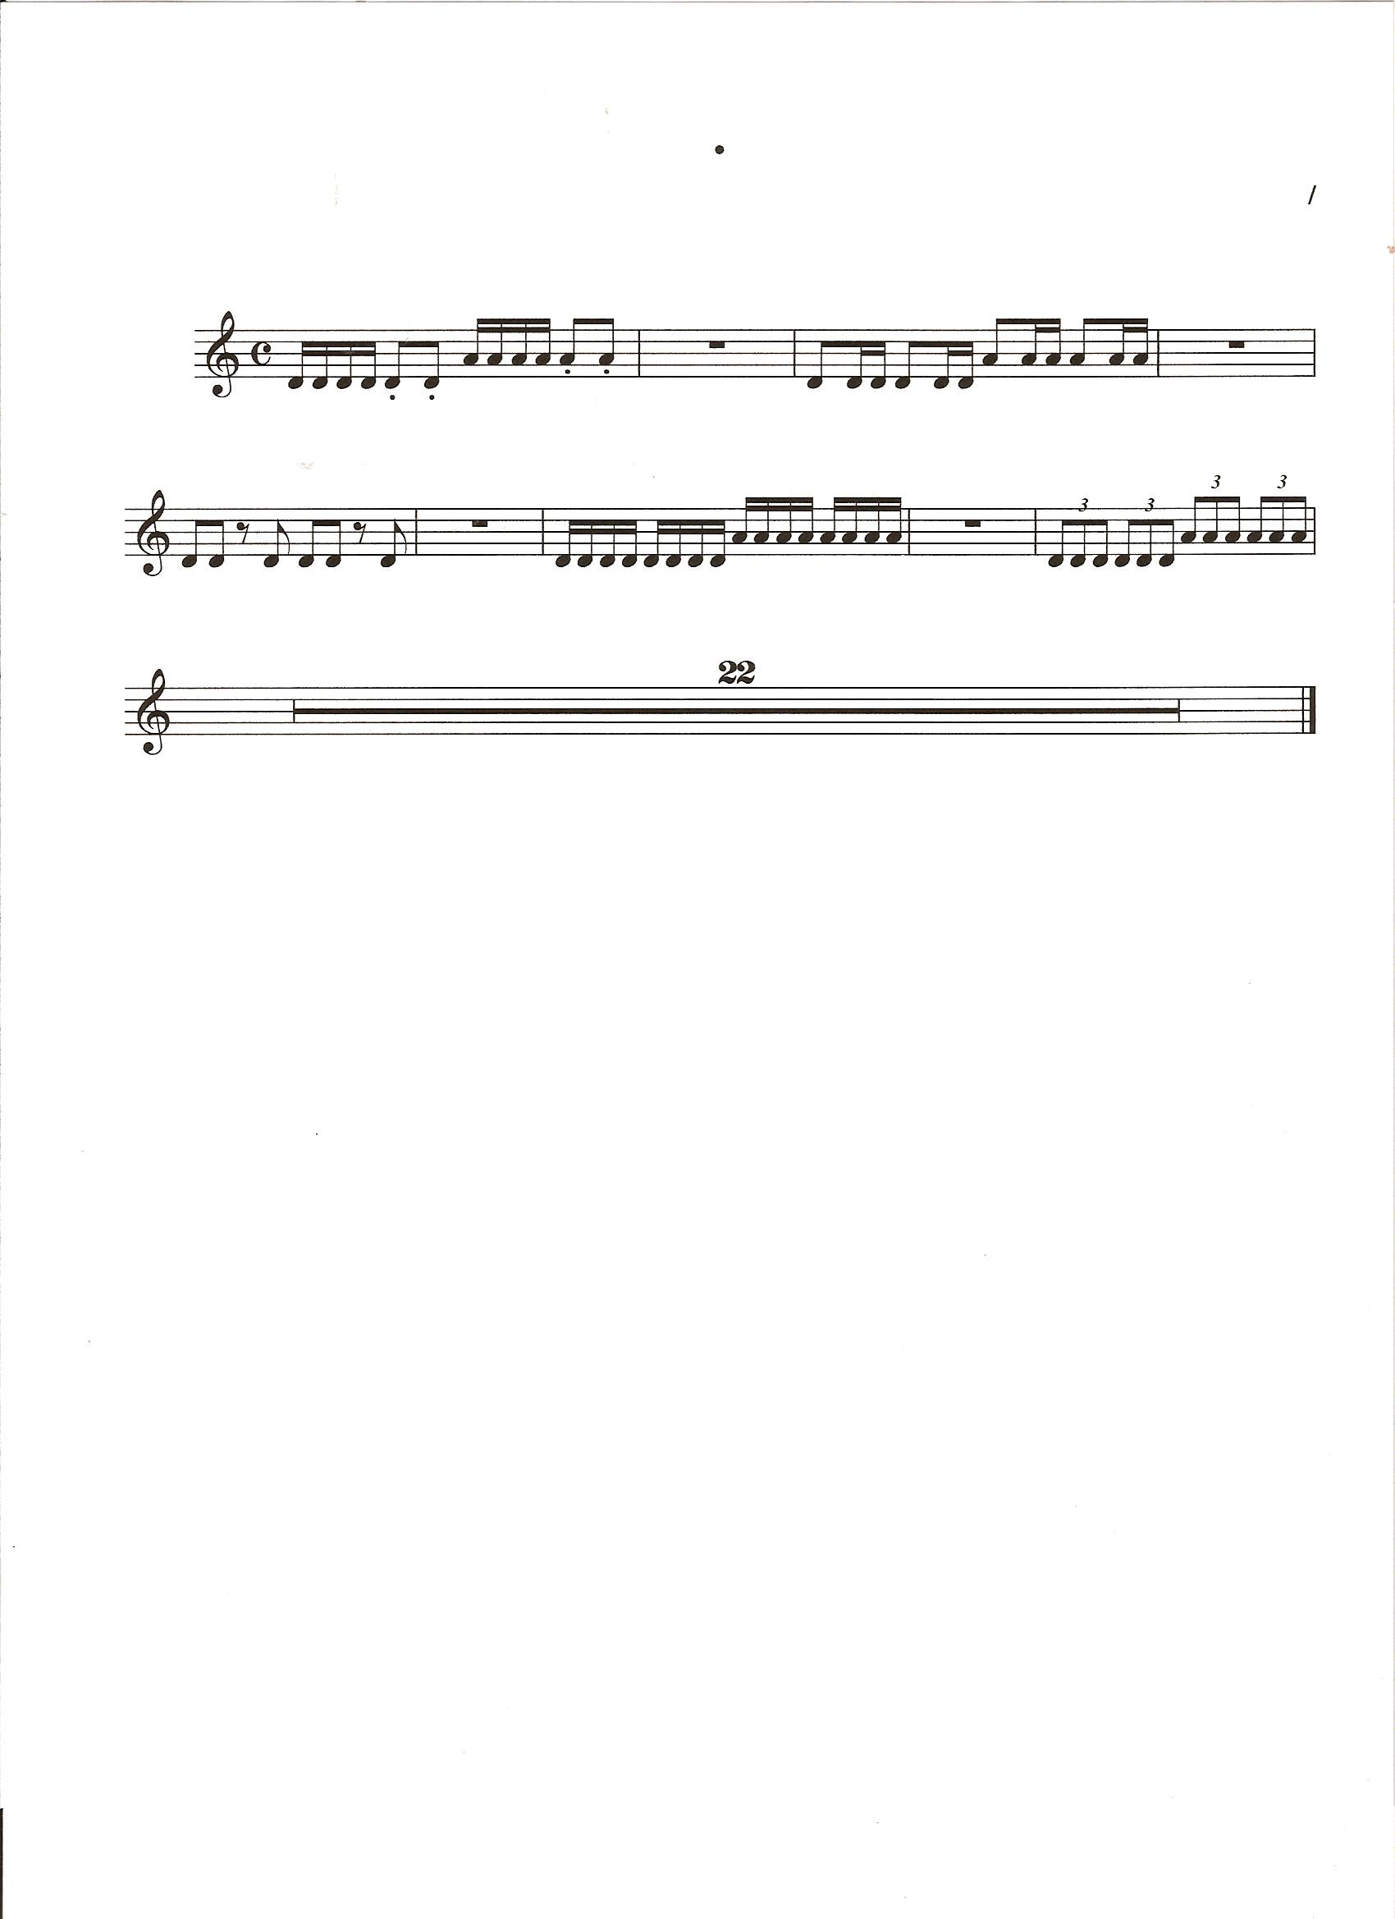  Open strings:  1. No matter how far we progressed with the above exercises, our goal is to get the bow on D string by the end of the lesson and make a sound with the upside down bow.  End of Lesson:  - Wipe violin and bow stick with soft cloth. Loosen bow, put into case; remove shoulder rest, put violin in case,  - Teacher checks and then cases are closed and put away.  Evaluation: participation, group observation  Follow-up: Quiz tomorrow “The Parts of the Violin and Bow” | Creating and Performing  Foundations
Resources/ Technology  Violin/viola bow/rosin  Kun rest  Handout: parts of the instrument  Homework:  Memorize the parts of the violin/viola and bow.  Pencil jiiggles  The instrument does not go home |  | Creating and Performing  Foundations

Lesson 2  Beginning Strings | Entry Tasks  - Quiz –parts of violin and bow  - Tuning: teacher, (while students put on shoulder rests and take out bows)  Standing instrument position without bow –count using numbers:  - Review position, teacher checks instrument position and adjusts shoulder rest if necessary.  Instrument Position Exercises (standing):  - Write your name and neighbour’s name with the scroll  - Knee bends, swaying, stand on tiptoes  - Learn LH finger pattern 1 23 4 position (on R arm and then on fingerboard) -curved fingers, finger taps, helicopters  Bow hold (without violin):  - Review upside down bow hold.  Bow hold exercises:  - Stirring, rocket, bow on the floor, bow on top of head, draw circle around face, wrist bends with hold on sponge ball, trace a line from L shoulder to R knee, “strong thumb”  Open strings and rhythm:  - Middle of the bow (younger students may need tapes): echo teacher  - Hinge at elbow and wrist, shoulder raises and lowers bow for string changes.  End of Lesson:  1. Teacher checks for loosened bow and correct instrument storage.  Evaluation: participation, informal observation of individuals | Creating and Performing  Foundations
Resources/ Technology  Violin/viola bow/rosin  shoulder rest  Handout: Test: parts of the instrument  Homework:  Pencil jiggles  and bow hold exercises  The instrument does not go home |  | Creating and Performing  Foundations

Lesson 3  Beginning Strings | LISTENING LESSON: Young Person’s Guide to the Orchestra (variations)  Connect the form of this piece to the Theme and Variation form of the Twinkle Variations.  PERFORMANCE LESSON:  - Tuning: teacher  Standing instrument position with bow –count using numbers:  - Review bow hold and instrument position  Instrument Position Exercises (standing):  - Review LH finger pattern 1 23 4 position (on R arm and then on fingerboard)  Open strings and rhythm:  - Middle of the bow: echo teacher  Twinkle Twinkle Little Star Variation A:  1. Learn “A” section by rote.  D A A¹ A  D¹ ²³ D¹ ² D¹ D  2. Add the piano and make it a performance!  End of Lesson:  1. Teacher checks for loosened bow and correct instrument storage.  Evaluation: participation, informal observation of individuals | Creating and Performing  Reflecting, Responding, Analysing
Resources/ Technology  Violin/viola bow/rosin  shoulder rest  Handout: Young Person’s Guide to the Orchestra  Homework:  Pencil jjggles  and bow hold exercises  The instrument does not go home |  | Creating and Performing  Reflecting, Responding, Analysing

Lesson 4  Beginning Strings | Entry Tasks  - Tuning: teacher  Standing instrument position without and with bow:  1. Rest position, 1, 2, 3, 4, 5  Instrument Position Exercises (without bow):  - Write with the scroll  - Knee bends, swaying, stand on tiptoes  - Do finger patterns (palm facing student):1 23 4 12 3 4 1 2 34  - Review LH position 1 23 4 (on R arm and then on fingerboard)  Bow hold (without violin):  - Review upside down bow hold.  Bow hold exercises:  - Stirring, rocket, bow on the floor, bow on top of head, draw circle around face, wrist bends with hold on sponge ball, trace a line from L shoulder to R knee, “strong thumb”.  - Peers check bow holds.  Open strings and rhythm from rest position:  - Middle of the bow: echo teacher  - Hinge at elbow and wrist, shoulder raises and lowers bow for string changes.  Twinkle Twinkle Little Star Variation A:  1. Review “A” section by rote.  D A A¹ A Mississippi hot dog  D¹ ²³ D¹ ² D¹ D  End of Lesson: Teacher checks for loosened bow and correct instrument storage.  Evaluation: completed handout, informal observation of individuals | Creating and Performing  Reflecting, Responding, Analysing  Foundations
Resources/ Technology

Violin/viola bow/rosin
shoulder rest

Homework:
Pencil jjggles
and bow hold exercises, finger patterns

The instrument does not go home

Lesson 5  Beginning Strings | EAR TRAINING:  - Introduce interval identification PU, P4, P5  - Sing note names and have students play back.  PERFORMANCE:  - Tuning: teacher, practise bow holds  Standing instrument position with bow:  - Review upside down bow hold.  2. Rest position, 1, 2, 3, 4, 5  Instrument Position Exercises without bow (standing):  1. Write with the scroll  - Knee bends, swaying, stand on tiptoes  - Review LH position 1 23 4 (on R arm and then on fingerboard) -stress space between 1st and 2nd fingers  Bow hold exercises (without violin):  - Stirring, rocket, bow on the floor, bow on top of head, draw circle around face, wrist bends with hold on sponge ball, trace a line from L shoulder to R knee, “strong thumb”  Open strings and rhythm:  - Middle of the bow: echo teacher  - Staccato notes  Twinkle Twinkle Little Star Variation A:  1. Review “A”; learn “B” section by rote.  A D¹ ²³ D¹ ² D¹ Mississippi hot dog  A D¹ ²³ D¹ ² D¹  Evaluation: participation, informal observation of individuals, interval results | Creating and Performing  Foundations
Resources/ Technology  Violin/viola bow/rosin  shoulder rest  Homework:  Pencil jjggles  and bow hold exercises, finger patterns  The instrument does not go home |  | Creating and Performing  Foundations

Lesson 6  Beginning Strings | THEORY LESSON: Piano keyboard, naming notes  PERFORMANCE LESSON  - Tuning: teacher  Standing instrument position with bow:  1. Rest position, 1, 2, 3, 4, 5  Bow hold:  - Review upside down bow hold.  Bow hold exercises:  - Stirring, rocket, bow on the floor, bow on top of head, draw circle around face, wrist bends with hold on sponge ball, trace a line from L shoulder to R knee, “strong thumb”  Open strings and rhythm:  - Middle of the bow: echo teacher  - Staccato notes  Mississippi hot dog  Twinkle Twinkle Little Star Variation A:  1. Review all, discuss form.  D A A¹ A  D¹ ²³ D¹ ² D¹ D  A D¹ ²³ D¹ ² D¹  A D¹ ²³ D¹ ² D¹ Mississippi hot dog  D A A¹ A  D¹ ²³ D¹ ² D¹ D  2. Play with the piano, as a group, row by row, in ensembles, individually  Evaluation: participation, informal observation of individuals  Follow-up: Quiz Twinkle Variation A (in small groups) tomorrow | Creating and Performing  Reflecting, Responding, Analysing  Foundations
Resources/ Technology

Violin/viola bow/rosin
shoulder rest

Homework:
Pencil jjggles
and bow hold exercises, finger patterns

The instrument goes home.

Lesson 7  Beginning Strings | Entry Tasks  - Tuning: teacher, students check A  Standing instrument position with bow:  1. Rest position, 1, 2, 3, 4, 5  Bow hold:  - Review upside down bow hold.  Open strings and rhythm:  Mississippi hot dog run pony  1. Middle of the bow: echo teacher  - Staccato notes  Twinkle Twinkle Little Star Variation A:  1. Review A, TEST in small groups, learn Variation B  D A A¹ A  D¹ ²³ D¹ ² D¹ D  A D¹ ²³ D¹ ² D¹  A D¹ ²³ D¹ ² D ¹  D A A¹ A  D¹ ²³ D¹ ² D¹ D  Evaluation: participation, TEST in small groups | Strands:  Creating and Performing
Resources/ Technology  Violin/viola bow/rosin  shoulder rest  Homework:  Pencil jjggles  and bow hold exercises, finger patterns  Twinkle Variation A and B |  | Strands:  Creating and Performing

Lesson 8  Beginning Strings | LISTENING LESSON: Young Person’s Guide to the Orchestra (fugue)  - Tuning: teacher, students check A  Standing instrument position with bow:  1. Rest position, 1, 2, 3, 4, 5  Bow hold:  - Review upside down bow hold.  Open strings and rhythm:  Mississippi hot dog run pony  1. Middle of the bow: echo teacher  - Staccato notes  Twinkle Twinkle Little Star Variation B:  1. Review Variations A and B  D A A¹ A  D¹ ²³ D¹ ² D¹ D  A D¹ ²³ D¹ ² D¹  A D¹ ²³ D¹ ² D ¹  D A A¹ A  D¹ ²³ D¹ ² D¹ D  Evaluation: participation, informal observation of individuals, hand in completed Young Person’s Guide assignment. | Creating and Performing  Reflecting, Responding, Analysing
Resources/ Technology  Violin/viola bow/rosin  shoulder rest  Handout: Young Person’s Guide to the Orchestra  Homework:  Pencil jjggles  and bow hold exercises, finger patterns  Twinkle Variations A, B |  | Creating and Performing  Reflecting, Responding, Analysing

Lesson 9  Beginning Strings | Entry Task  - Tuning: teacher, students play A  Standing instrument position with bow:  1. Rest position, 1, 2, 3, 4, 5  Bow hold:  - Review upside down bow hold.  Open strings and rhythm:  Mississippi hot dog run pony down bow and up bow and  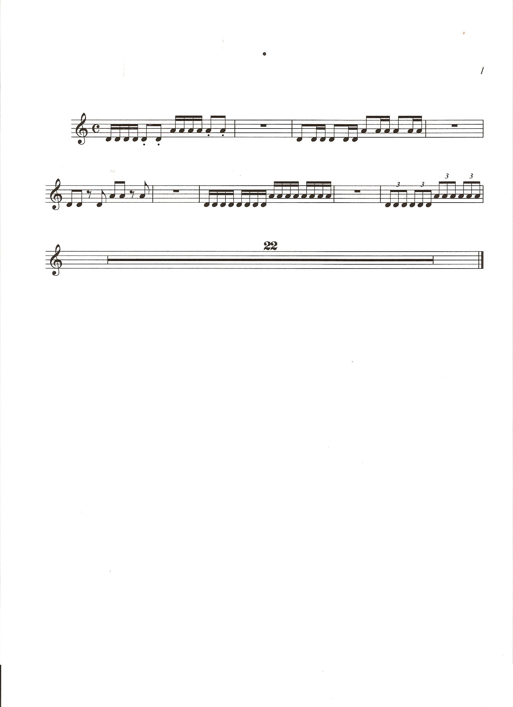  1. Middle of the bow: echo teacher  Twinkle Twinkle Little Star Variation C:  1. Review Variations A and B, add C  D A A¹ A  D¹ ²³ D¹ ² D¹ D  A D¹ ²³ D¹ ² D¹  A D¹ ²³ D¹ ² D ¹  D A A¹ A  D¹ ²³ D¹ ² D¹ D  2. Play Variations in small ensembles  Evaluation: participation, informal observation of individuals  Follow-up: Test Twinkle Variation A (individuals) | Creating and Performing  Reflecting, Responding, Analysing
Resources/ Technology  Violin/viola bow/rosin  shoulder rest  Homework:  Pencil jjggles  and bow hold exercises, finger patterns  Twinkle Variations A, B, C |  | Creating and Performing  Reflecting, Responding, Analysing

Beginning Strings  Follow-up lessons | Continue to review Variations. Add D, E, and the Theme. Perform class concert with piano accompaniment for parents.  Mississippi hot dog  Run Pony  Down bow and up bow  Animated alligator  Strawberry, strawberry  NEXT STEPS: Teach bow hold at frog and begin using method book to learn to read notes. Continue theory and analysis lessons and small ensembles. Start selected students on cello and bass. | Creating and Performing  Reflecting, Responding, Analysing
Resources/ Technology  Violin/viola bow/rosin  shoulder rest  Homework:  Pencil jjggles  and bow hold exercises, finger patterns  Practise  Twinkle Variations |  | Creating and Performing  Reflecting, Responding, Analysing

WEEKLY PLAN

75 minute periods

Monday: Ear Training, Performance
Tuesday: Theory, Performance
Wednesday: Theory, Performance, individual testing and/or ensembles
Thursday: Listening (Analysis), Performance
Friday: Written Test and/or Performance

