BLM 2
Name _____________________
RED LIGHT...................GREEN LIGHT

Check for your understanding: If you’ve “got it”, give yourself a green light. If you’re not sure, choose the yellow light. If you need more work on this idea, pick the red light.

Red Light | 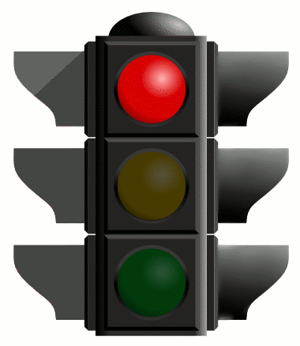 | Yellow Light | 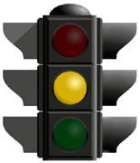 | Green Light | 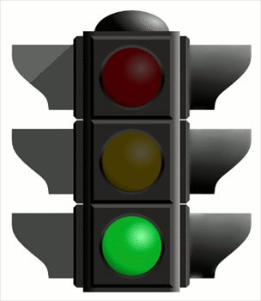

 |  | Red | Yellow | Green
Rhythm | Note Values
 | Meter
Melody | Shape
 | Repetition
Texture | Monophonic
 | Homophonic
Form | Repetition/Variety

