Teacher Resource 1
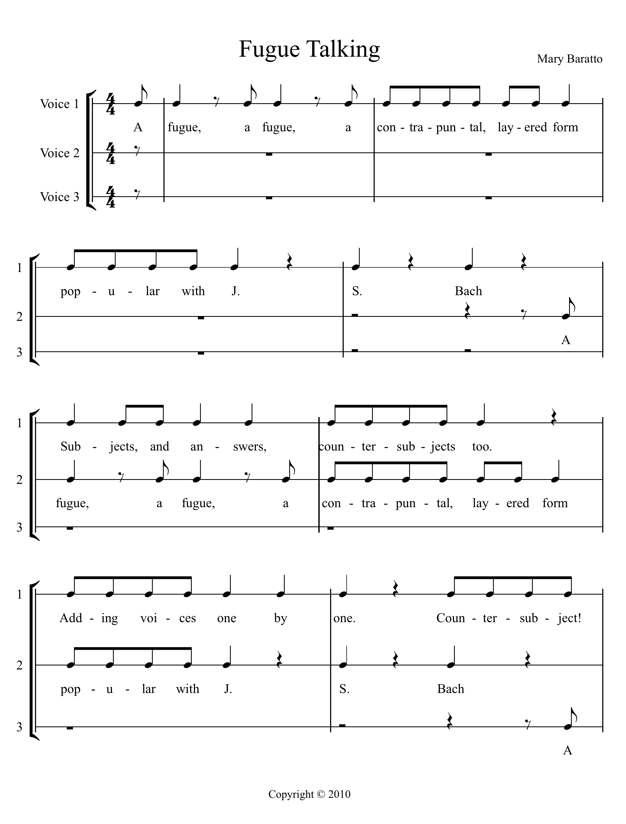
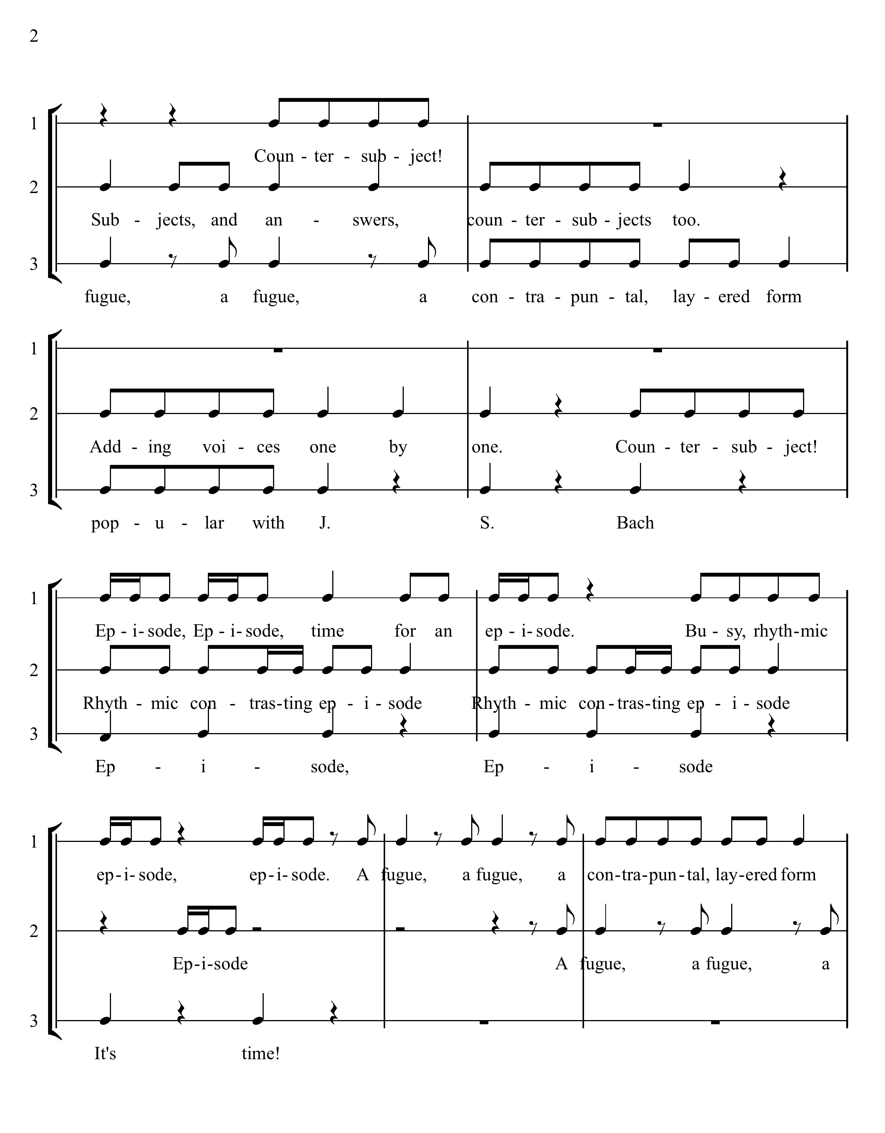

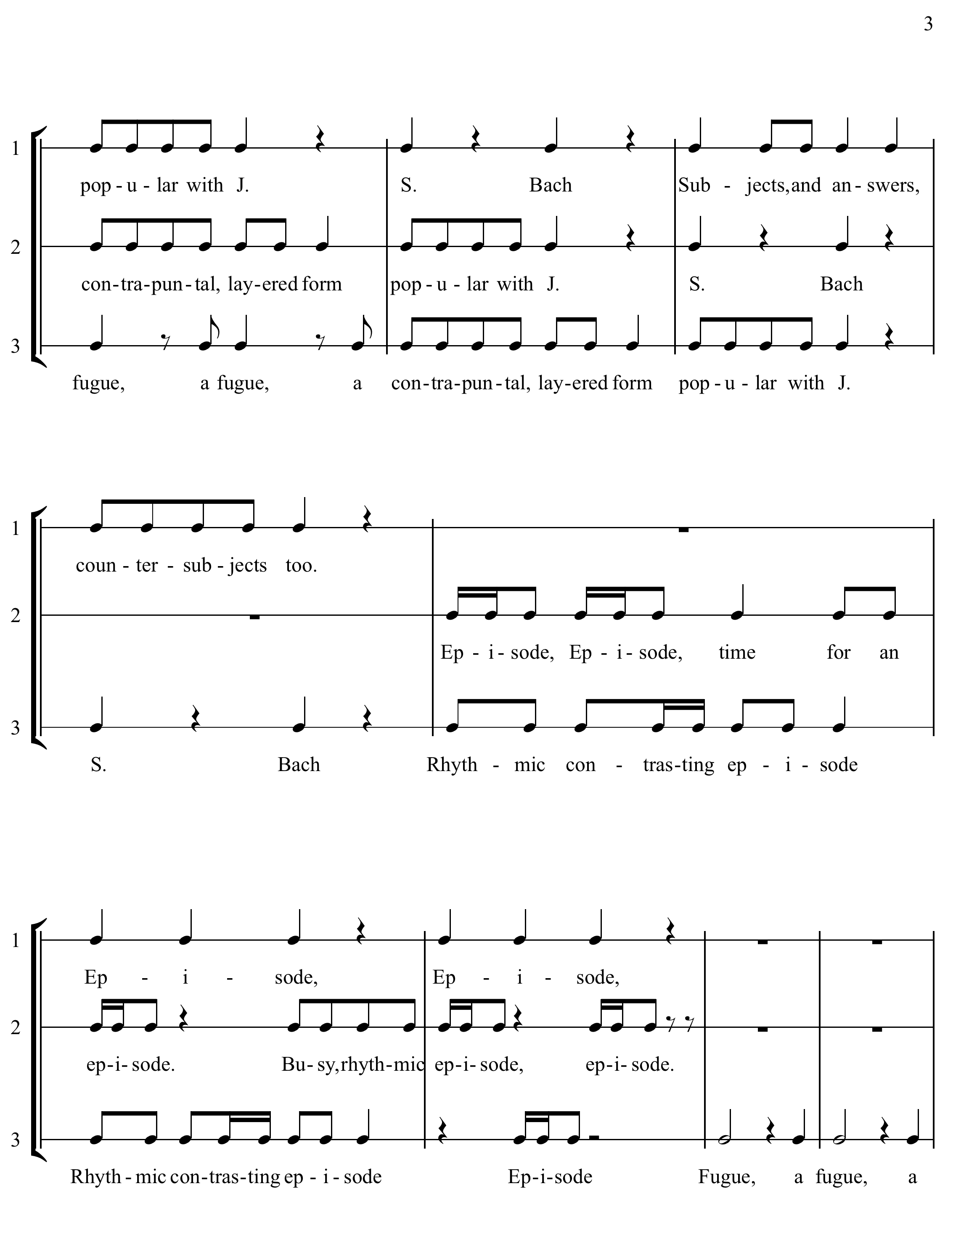

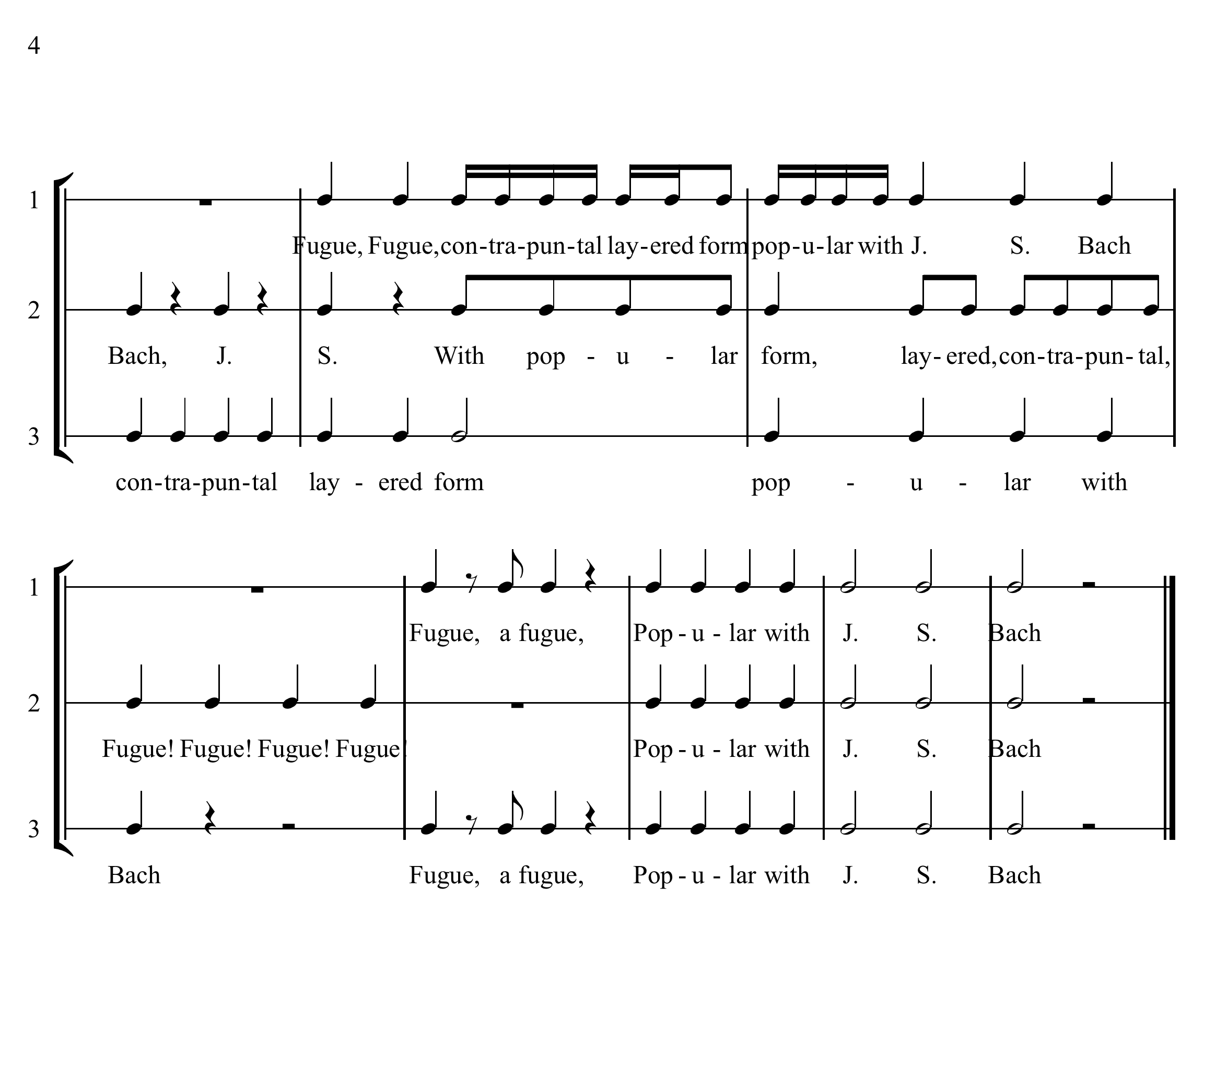
Fugue Talking is a choral speaking piece patterned in the structure of a Fugue – a complex form of contrapuntal composition. The fugue has specific parts that make up its structure or pattern.

The Subject as seen in bars 1-4 is the theme of this piece. Each voice will enter with the subject one at a time. A new voice enters when the subject is completed. (See bars 1-12)
The Countersubject is a new musical idea meant to accompany the new subject entries and is not as important or as interesting as the subject.
The Exposition is the name given to the first 12 bars of this piece. The subject or theme is exposed or stated once in each voice.
The Episode follows the exposition. This section contains new material not seen in the exposition. It is used to give variety or contrast to the composition.
Sections of Subject Material will reappear in the different voices and will alternate between sections of the episode.
Stretto is a device where the voices stating the subject will overlap as in bars 13-22.
The Coda is the ending of the fugue and the rhythm becomes simpler and the texture more homophonic at the approach to the final cadence.

