BLM #1
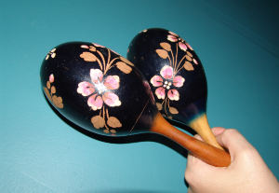  sha-kers | 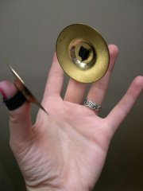  cym-bals | 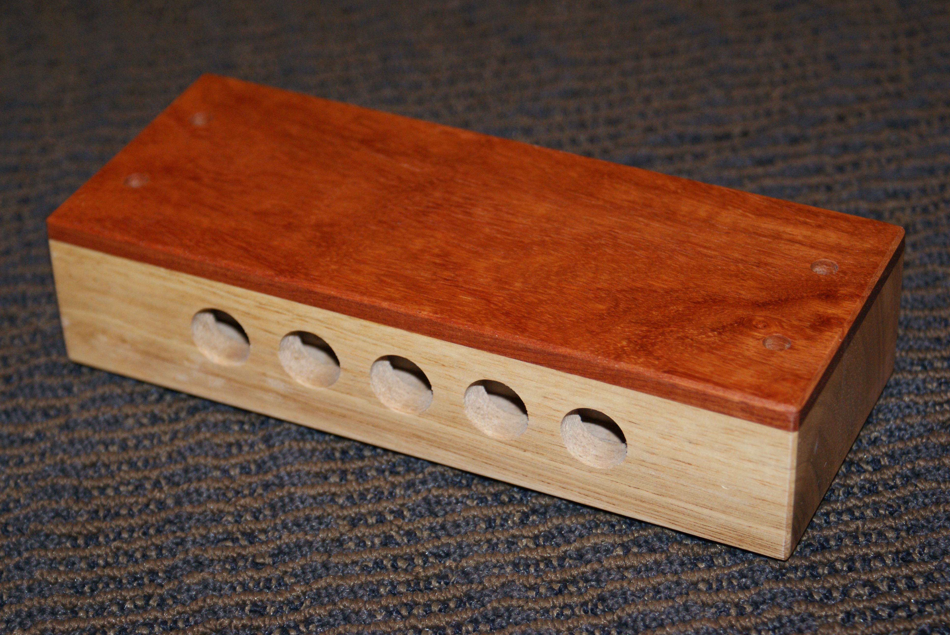  wood-blocks | 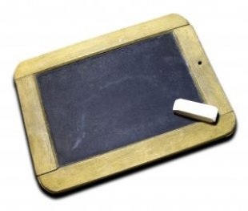  chalk board
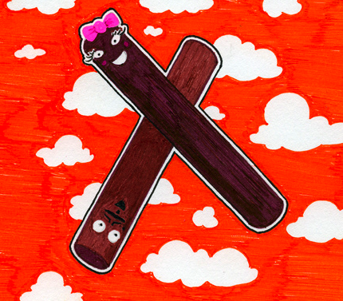  cla-ves | 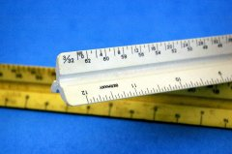  rul-ers | 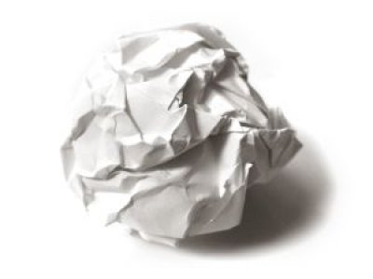  pa-per | 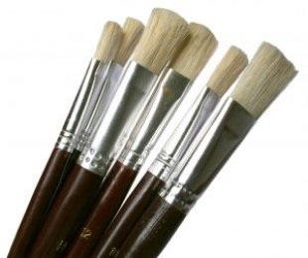  brush-es
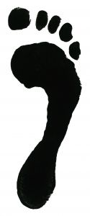  stomp | 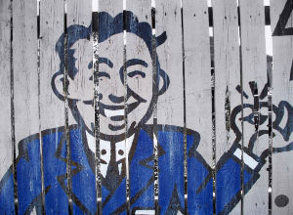  snap | 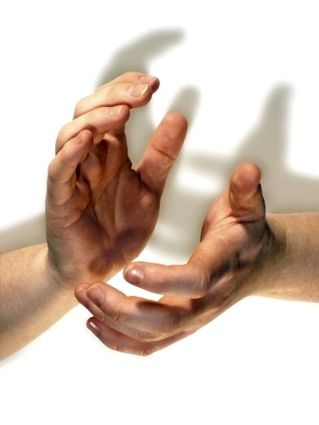  clap
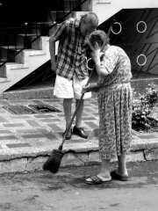  swish | 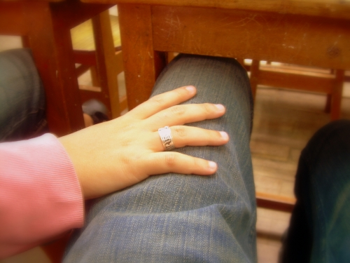  pat | 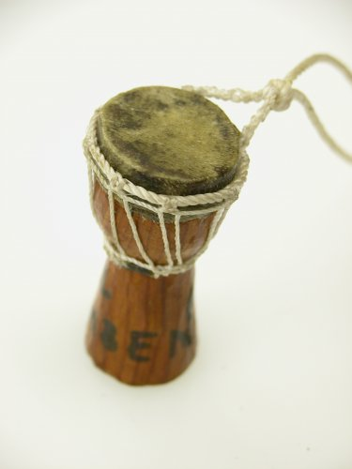  drum | 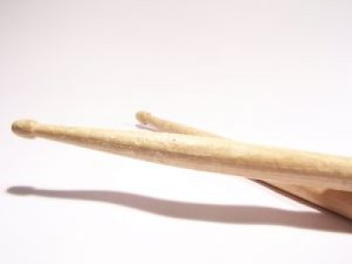  sticks

Picture Attributions:

Shakers - rattle-114553-m (Morgue File by Chelle)
Cymbals - everystockphoto_148569_m (MorgueFile by sideshowmom)
Wood Block – Kevin Merkley (thank you Cosmo Music)
Chalkboards - chalk_black_board_261343_l www.sxc.hu (sxu license – Plusverde)

Claves – Claves, ruff (Flickr Creative Commons by Alkaline Samurai)
Rulers – everystockphoto_124901_m (MorgueFile by earl53)
Paper – paper_toss_throwaway_224091_l l www.sxc.hu (sxu license – asolario)
Brushes - Pinceaux_brushes_brush_261799_l www.sxc.hu (sxu license – Gastonmag)

Stomp - 442691_footprint (sxu license – Plusverde)
Snap – everystockphoto-180878-m (MorgueFile by Grafixar)
Clap – Kevin Flanagan (Flickr.com)
Quarter rest – Jane Wamsley

Swish – everystockphoto_172494_m (MorgueFile by daisukerman)
Pat - hand-thigh-fingers-647403-l (Said & Done, Flickr.com)
Drum – djembe_drum_african_281974_1 (www.imageafter.com)
Sticks - drums_sticks_drum_224691_l www.sxc.hu (sxu license – cambuur)

