BLM 5
RED LIGHT.........GREEN LIGHT
Need It, Want It, Got It – Financial Literacy Terms

Check for your understanding: If you’ve “got it”, give yourself a green light. If you’re not sure, choose the yellow light. If you need more work on this idea, pick the red light.
Red Light | 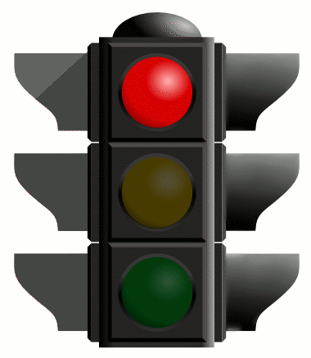 | Yellow Light | 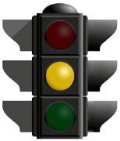 | Green Light | 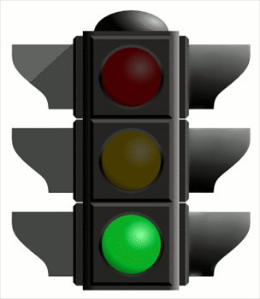

 |  | Red | Yellow | Green
1. | Financial Literacy
2. | Needs
3. | Wants
4. | Budgeting
5. | Brand
6. | Rent-to-own
7. | Resale Value
Comments:

Name___________________________________________________________

