Teachers, before you copy this booklet for your students...
⬰ Have you read the GPS Overview? The GPS Overview provides guidance about how these Recorder tasks can support and enhance the Grade 5 Vocal GPS Tasks.
⬰ Have you taught these students before? If not, please take the time to work with your students to determine their strengths and needs before deciding which tasks will be appropriate..
⬰ Have you gone through the appropriate start up steps with your students? For example; the basics on putting together their instrument, care and maintenance of their instrument, posture and breathing.
⬰ If you have taught these students before...go through the entire program task-by-task to confirm that the sequence and challenge level of the tasks, is appropriate.
⬰ Refer to the Q and A section of the GPS Overview.
⬰ Do you need to reduce the number of tasks...how will you need to change the evaluation by term?
⬰ The Junior Recorder GPS task progression chart is available by clicking here. You can see how these tasks align and can support the Grade 5 Vocal GPS Tasks.

⬰ If you have questions, please contact:
Lynnette Charters: lcharters@rogers.com

GPS (Grade Performance Steps)

The Road to Musical Success!
Grade 5 Recorder Performance Tasks




Ontario Music Educators’ Association
www.omea.on.ca
Task # 1
Task # 2
Task # 4
Task # 5
Task # 7
Task # 9
Task # 10
Task # 3
Task # 6
Task #8

Recorder Tracking Sheet

C D E F F# G

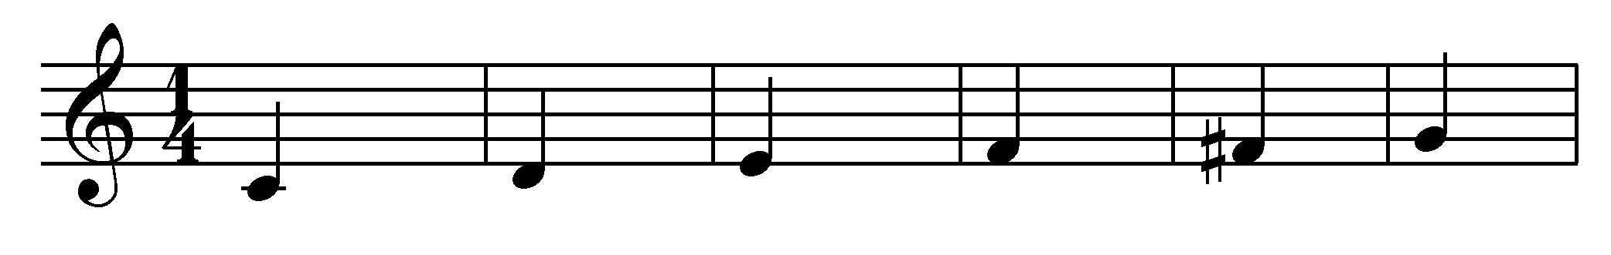
A B B^{à} C^{I} D^{I} E^{I **}

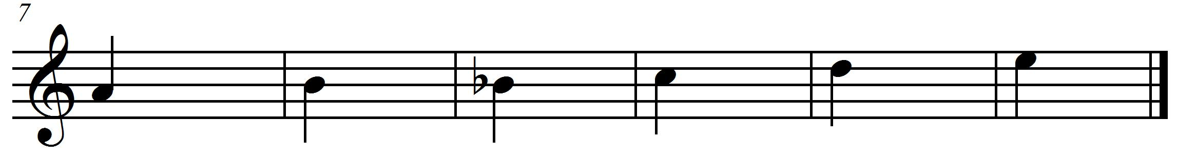
** E^{I} is played by covering only half of the thumbhole on the back.

Important steps to playing the recorder

- Blow lightly into the recorder.
- When you are practising, blowing lightly, if the sound isn’t coming out very well, blow a bit more, but never blow hard. Use a gentle stream of air at all times.
- Hold your recorder with your left hand at the top. Use your thumb to cover the back hole and your first three fingers to cover the top three holes on the recorder.
- Use your right hand at the bottom of the recorder. Use your thumb to hold the back and all four fingers to cover the bottom four holes on the recorder. Yes, you are covering two little holes with your third and fourth fingers at the bottom of the recorder.
- Keep your fingers flat when putting them across the holes.
- Cover the holes with the flat fleshy part of your fingers. Do not use your fingertips or air will leak out when you play.
- Press down on the holes firmly to seal up the holes.
- If the recorder is making a squeaking sound when you play, then you are either blowing too hard, or you are not covering the proper holes with the fleshy part of your fingers.
- Place the recorder on your lips not in your mouth. You will have better control over the sound that way.
- Use your tongue behind your teeth to make a “T” sound. This is called tonguing.
- Start each note by making the “T” sound at the beginning of your note. This is called tonguing your note.

1. KEEP THE BEAT! FOCUS: BEAT
NOTES: E, G, A, B, C^{I} D^{I}

LEARNING GOAL: You will be learning to keep a steady beat. While playing a long tone for 12 beats (tempo = 90 *bpm)
*beats per minute

MINDS ON! We learned about beat last year. Beat is one of the basic components of music. It is a steady pulse that can be found in many musical forms. It is part of an element called duration. Can you find the beat in a piece of music? Can you follow the beat and keep a steady pulse? How long can you conserve your breath? Why do you think that this might be important?

RECORDER ACTION! In order to be successful with this task, you will need to:
- Keep a steady beat by tapping your toe inside your shoe to the beat.
- Take in a deep (low) breath.
- Consistently let the air out in a steady but controlled stream.
- Keep a steady tone on the note B for 12 beats.
- Listen carefully to your group to hear if you are playing the same pitch.
- Refer to the “important steps” to making a good sound.
- Keep a steady tone on the notes E, G, A, B, C^{I} and D^{I} for 12 beats

CONSOLIDATION! In order to move on to the next task, you will need to show your teacher that you can keep a steady tone on the notes; E, G, A, B, C^{I} and D^{I} for 12 beats.

2. CREATE A RHYTHM! FOCUS: RHYTHM
NOTES: G, A, B, C^{I}, D^{I} and E^{I}

LEARNING GOAL: You will keep a rhythmic pattern consistent for 30 seconds.

MINDS ON! Rhythm is an aspect of the element called duration. It is similar to beat except that it is made up of patterns of long and short sounds and/or silences. It is different than beat because beat is made up of a steady repeated pulse. Rhythm changes everything up! Can you create a rhythm? Can a rhythm sometimes sound like the beat? What do you use to start and stop the sound on the recorder? How do you make long and short sounds and create silences when blowing through the recorder?
Try creating a rhythm with a friend and keep the pattern going for 30 seconds.

RECORDER ACTION! In order to be successful with this task, you will need to:
- Use your tongue to separate each note this will create the rhythm.
- Play the note B in ta (, quarter notes) for 8 beats. Repeat this with the notes A and G.
- Play the note C^{I} in ti ti (, eighth notes) for 8 beats. Repeat this with the notes D^{I} and E^{I}.
- When you are ready, use any notes you wish to create a pattern using ta (, quarter notes) and ti ti (, eighth notes) on the note B for 8 beats.
- Challenge: Use tika tika (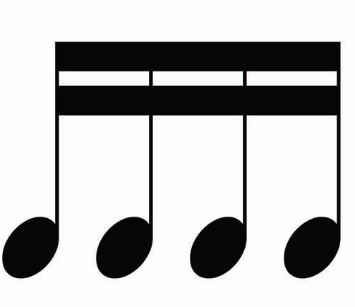, sixteenth notes) as part of your rhythm.
- Play your rhythm for a friend; ask them to clap a steady beat for you to help practise your rhythm.
- Play your rhythm on B and have your friend play their rhythm on G.
- Keep your 8-beat rhythms repeating for 30 seconds.
- Draw your rhythm in the space below.

Draw rhythm here

CONSOLIDATION! In order to move on to the next task, you will need to play your rhythmic pattern on one of the following notes: G, A, B, C^{I}, D^{I} and E^{I}. Play your rhythm with a friend. Choose two different notes to play together (B and G, G and D^{I}, C^{I} and E^{I} or A and C^{I}). Use your tongue to separate each note. When you are done, complete the self reflection below.

SELF-REFLECTION: What I found challenging about task two was...

3. C MAJOR SCALE FOCUS: PITCH
NOTES: C, D, E, F, G, A, B, C^{I}

LEARNING GOAL: You will demonstrate how to play a major scale in quarter notes.

MINDS ON! You have now been practising many notes with rhythms. In music, there are always patterns that emerge. One type of pattern is the scale. This is a series of notes that move up or down in a stepwise motion. What do you think is the first and last note of the C major scale? Scales help to develop skill in playing notes. Work slowly on this to increase your accuracy.

RECORDER ACTION! In order to be successful with this task, you will need to:
- Practise playing the C major scale on your recorder until you can play it smoothly with 90% accuracy.
- The Solfege names have been included to help you make connections to the vocal tasks.
- Keep a steady beat by moving your big toe inside your shoe.
- Play the rhythm of the scale accurately and at a slow tempo.
- Use your tongue to separate your notes.

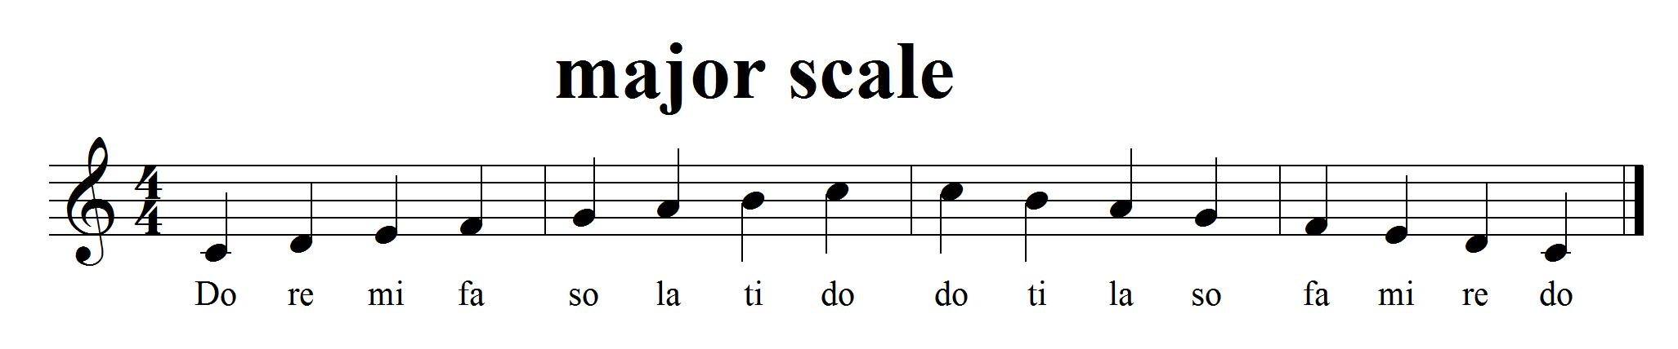

CONSOLIDATION! In order to move on to the next task, you will need to play the C major scale for your teacher with accurate rhythm and a steady beat.


Congratulations! You have reached your first GPS marker – NORTH!
Ask your teacher how you are to acknowledge this accomplishment on your GPS task tracker!
WAY TO GO!!

4. CAN YOU FIND THE STRONG BEATS? FOCUS: COMPOUND TIME
NOTES: D, E, F#, G, A, B

LEARNING GOAL: Put the knowledge you have learned about duration to work. You will be playing a song in compound time/metre).

MINDS ON! You have been learning about beat and rhythm as part of the element duration. Rhythm, beat, metre! In music, the beats are separated into groups to help the musician keep track of them (sometimes groups of 2, 3 or 4). Musicians create a strong accent on the first beat of each grouping. When we count beats in time, we are counting ti (eighth) notes. Counting in in words would be like this “one-and-a-two-and-a”, even though there are 6 eighth notes it feels like there are only 2 strong beats.
RECORDER ACTION! In order to be successful with this task, you will need to:
- Practise playing “Hickory Dickory Dock” on your recorder until you can play it smoothly with 90% accuracy.
- Keep the beat with your big toe. Only accent 2 main beats with your toe.
- Play the rhythm of the song accurately while keeping a steady beat with your big toe inside your shoe.
- Can you feel the sway of the music?
- There are pick-up notes in this song. Feeling how the music moves will help you when you are playing them. They will lead you to the strong beat in the next bar.

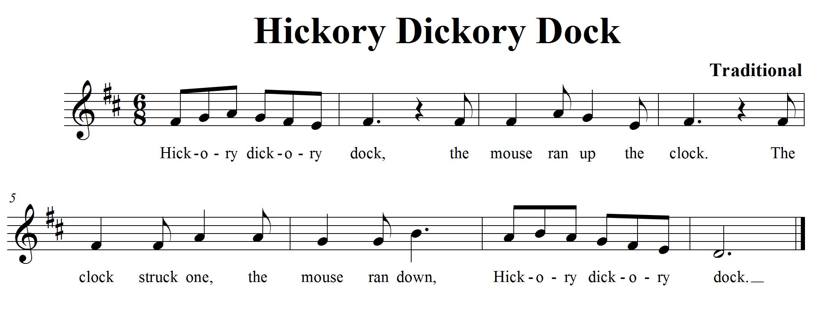
CONSOLIDATION! In order to move on to the next task, you will need to show that you can keep the strong beat (remember to only count two strong beats when playing in time) with your toe and play “Hickory Dickory Dock” on your recorder for your teacher.

5. PLAY IT HIGH! FOCUS: PITCH
NOTES: G, A, B, C^{I}, D^{I}, E^{I}

LEARNING GOAL: Let’s expand your knowledge about the recorder by learning how to make a gentle high sound.

MINDS ON! Playing instruments can sometimes be difficult. When you play notes in the higher range you don’t need to blow very hard to make a nice sound. It is important to understand how much air you need to make a good sound. Playing in the higher range requires you to blow lightly. How lightly do you need to blow to make a good sound?

RECORDER ACTION! In order to be successful with this task, you will need to:
- Keep a steady beat by tapping your toe inside your shoe.
- Practise “Twinkle, Twinkle Little Star”.
- There is a new note E^{I}, look at the fingering chart to learn how to play it. You only cover half of the thumbhole when playing this high E.
- Blow gently; it doesn’t take a lot of air to play this high note.
- Play the song smoothly with 90% accuracy.

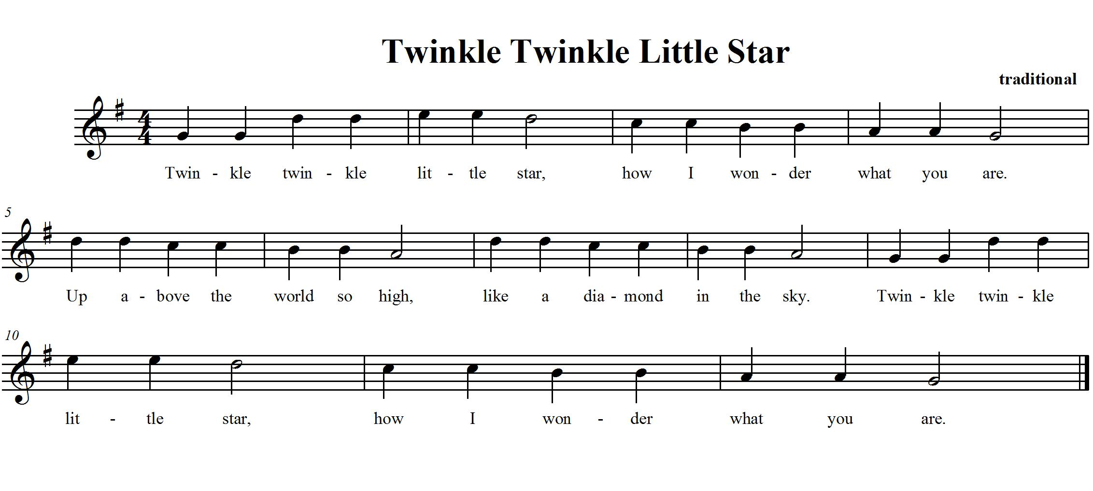

CONSOLIDATION! In order to move on to the next task, you will need to show that you can play “Twinkle Twinkle Little Star” for your teacher.

6. WHAT MAKES A MELODY? FOCUS: PITCH/SYNCOPATION
NOTES: D, E, F#, G, A, B, D^{I}

LEARNING GOAL: You will be learning more about melody, syncopation and how the pitches move through time.

MINDS ON! What is a melody? What does it mean if the melody is syncopated? In a song, when the accented beat is not a strong beat, it creates syncopation. Can you hear the strong beat?
ACTION! In order to be successful with this task, you will need to:
- Look at the Recorder Fingering chart to make sure you know where your fingers need to go for this song.
- Practise playing “Bassez Down”.
- Play the entire song softly; watch your posture and how you blow through your instrument.
- Remember to tongue each note lightly especially when you are playing the eighth notes or sixteenth notes. Your tongue will need to move quickly to get the correct rhythm!
- D.C. al Fine means to go back to the beginning and play to the word Fine.
- Listen for the accented beats. There is some syncopation happening.

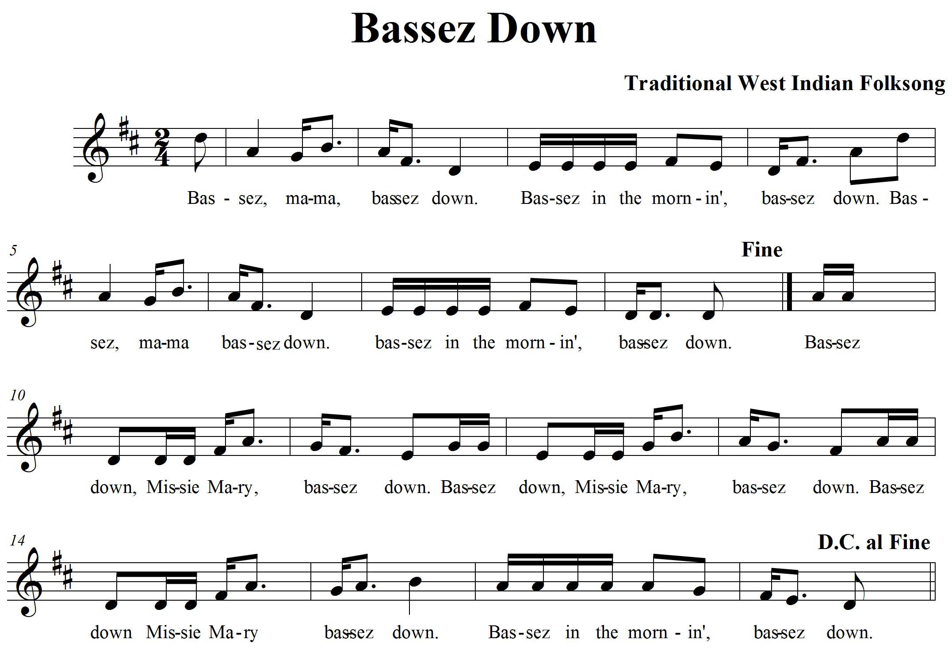

CONSOLIDATION! In order to move on to the next task, you will need to show that you can play “Bassez Down”. Keep the beat with your big toe and play with proper tonguing. Don’t forget that D.C. al Fine means to go back to the beginning and play to the word Fine.


Congratulations! You have reached your second GPS marker – EAST! Ask your teacher how you are to acknowledge this accomplishment on your GPS task tracker! WAY TO GO!!

7. LET’S PLAY THE SCALE IN A SONG! FOCUS: PITCH/REPEAT SIGN
NOTES: C, D, E, F, G, A, C^{I}, D^{I}, E^{I}

LEARNING GOAL: You will be playing a song that uses every note in the C major scale. You will be learning about repeat signs.

MINDS ON! Repeat signs help show us where notes are repeated and saves on paper. Let’s learn how to read them! You know about the C major scale; now let’s have some fun playing a song with the notes from the scale. When you have repeats, how can you make the repeated section sound more interesting?
ACTION! In order to be successful with this task, you will need to:
- Learn to play “African Noel” with 90% accuracy.
- Watch the repeat signs; they are there to remind you to repeat the measures inside the repeat signs more than once.
- If there are no repeat signs, then only perform those measures once.
- Play each repeated section with different dynamics to bring more interest to your playing.
- There is a section in “African Noel” that isn’t repeated. Can you find the measures?
- Know the following rules for repeat signs:
  - If there is a repeat sign, then a section of the music is repeated.
  - If there is only a right repeat sign, then go back to the beginning and repeat the music back to the repeat sign. 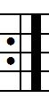 Then continue on...
  - If there are two repeat signs, one on the left and one on the right, then repeat the music inside the two signs. 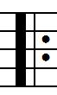

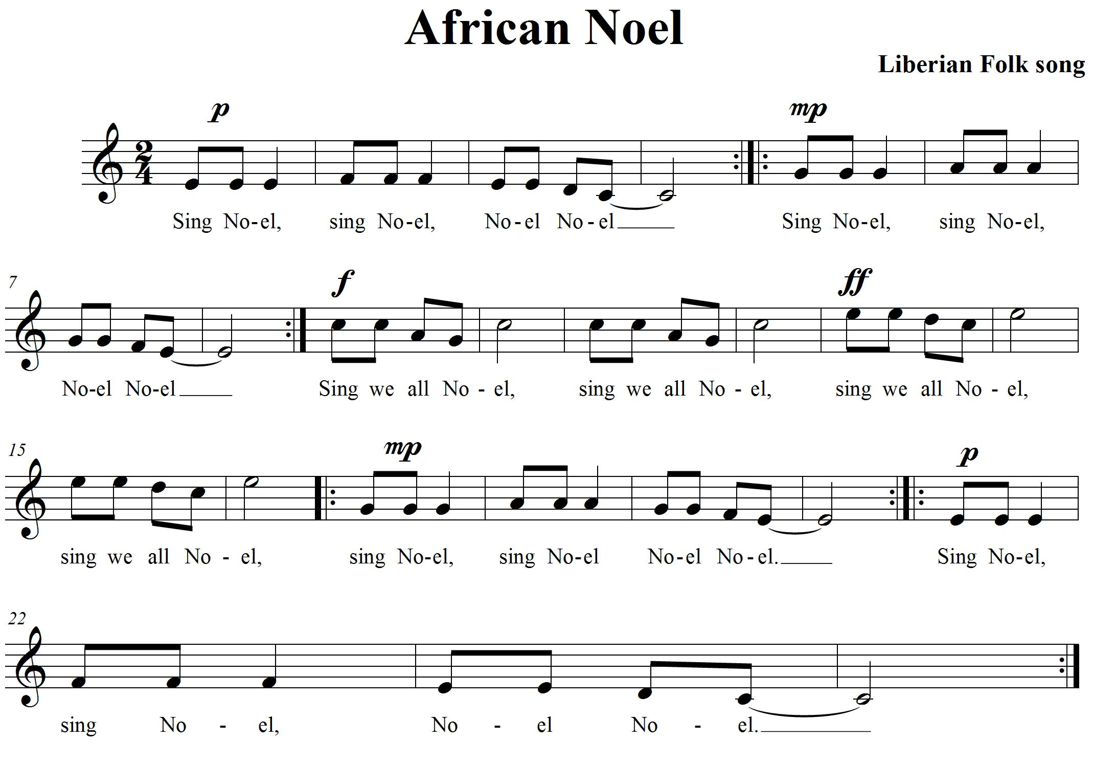

CONSOLIDATION! In order to move on to the next task, you will need to show that you can play “African Noel” while keeping a steady beat. Remember to play all the repeats in the song and then complete the self-reflection box below.

SELF-REFLECTION: What I think of my recorder playing... (explain your thinking with an example)

8. LET’S DUET! FOCUS: TEXTURE/HARMONY
NOTES: D, F#, G, A, B, C^{I}, D^{I}, E^{I}

LEARNING GOAL: You will demonstrate your understanding of pitch while playing “Alouette” with a steady beat. You will demonstrate the use of harmony to create texture.

MINDS ON! Texture in music can be created by adding instrumentation. Usually the sounds are not exactly the same so they create layers in the music that our ears are able to distinguish as different. Harmony is one way composers use to add more texture to music. Adding instrumentation is another way. Let’s learn a song that has a single line melody and create texture by adding instrumentation and harmony to it. Can you hear the difference between music that has one part and music that includes many parts?
RECORDER ACTION! In order to be successful with this task, you will need to:
- Learn either the first part (the melody) or the second part (the harmony) to “Alouette”.
- Practise playing “Alouette” on your recorder until you can play it smoothly with 90% accuracy.
- When you know how to play your part, match up with another student who can play the other part.
- Practise with your partner. Together you create harmony.
- Together with your partner, work out where you need to take a breath while playing this song.
- Keep the beat with your toe moving inside your shoe.
- Watch your repeat signs and play them with your partner.

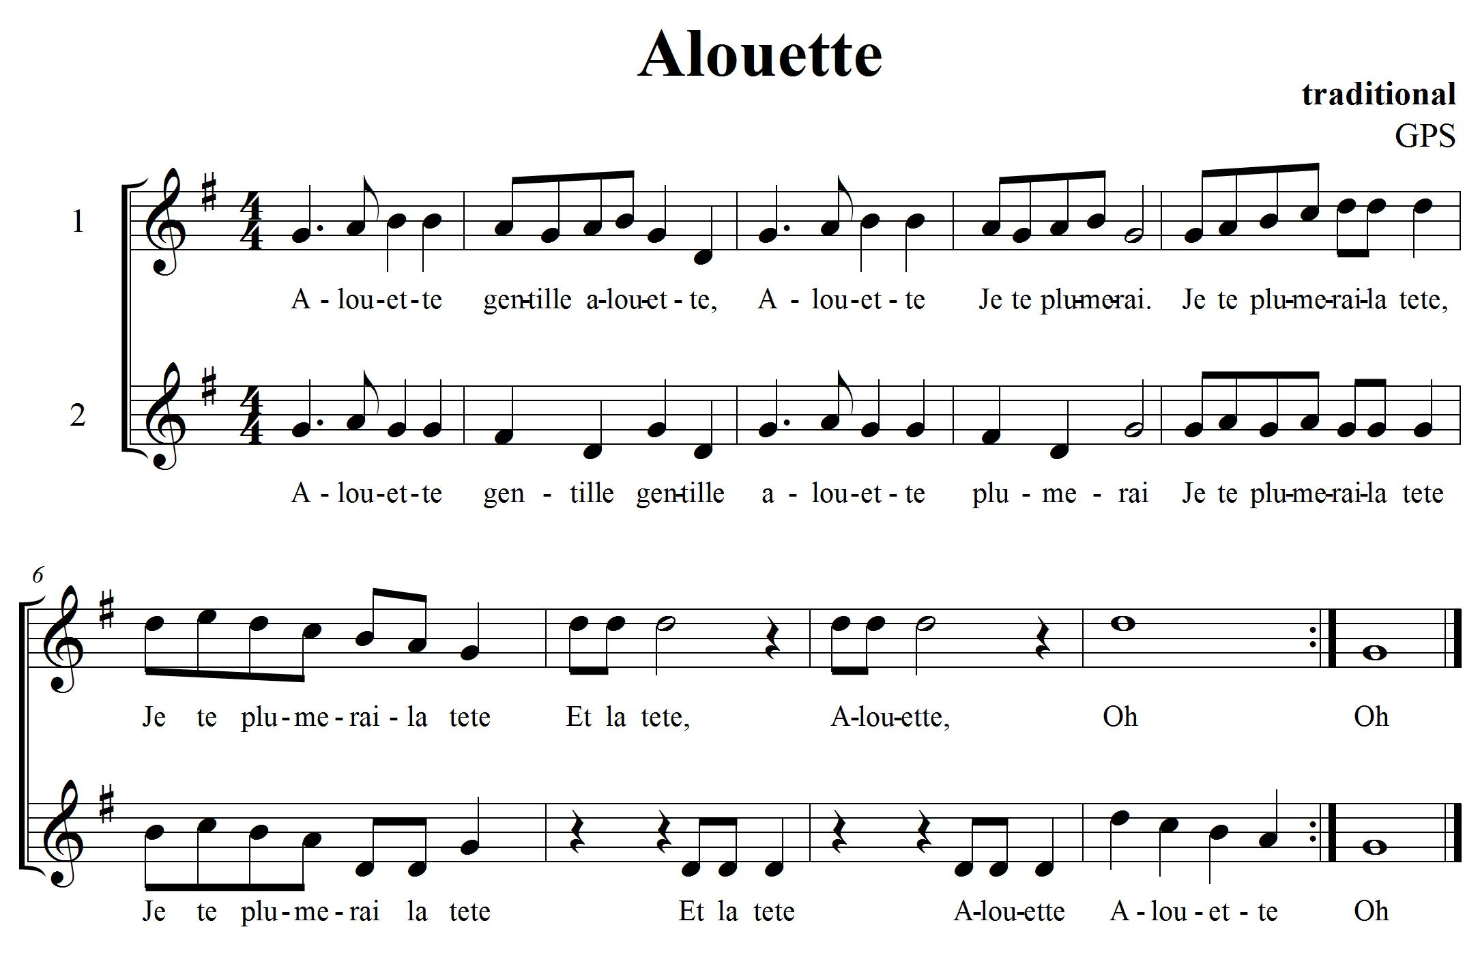

CONSOLIDATION! In order to move on to the next task, you will need to play “Alouette” with a partner for your teacher with accurate rhythm and a steady beat. Don’t forget to play with repeats.


Congratulations! You have reached your third GPS marker – SOUTH! Ask your teacher how you are to acknowledge this accomplishment on your GPS task tracker! WAY TO GO!

9. MORE DYNAMICS FOCUS: DYNAMICS/EXPRESSIVE MARKINGS

LEARNING GOAL: Demonstrate dynamics in music that you are creating and learning.

MINDS ON! There are markings on standard notation that show us how loud or soft to play the music. There are also articulation markings that are added to tell us to play a note short or long. These are called staccato and tenuto. Look at different kinds of music. Look for the different expressive markings that can be found. Can you create a rhythmic composition that uses a variety of expressive markings?

ACTION! In order to be successful with this task, you will need to:
- Pick a song that you have learned from this year.
- Make some decisions on how you want to play it.
- Pick 2 different expressive markings that you would like to use in your performance (e.g. staccato, slur).
- Play your song piano then crescendo to forte.
- Practise playing your song with the expressive controls you have chosen to play.
CONSOLIDATION! In order to move on to the next task, you will need to show that you can perform a song while using two different expressive markings for your teacher. You should be able to articulate what the markings are and what they mean.

10. LET’S COMPOSE A PIECE OF RECORDER MUSIC FOCUS: COMPOSITION NOTES: D, E, F#, G, A, B, C

LEARNING GOAL: Create a piece of music 8 bars long using standard notation. Perform it for the class.

MINDS ON! We have been learning about music all year, we have looked at different pieces of music and now it’s time to put all that knowledge into creating our own piece of music that you get to perform for the class! What rhythms do you want to use? What kind of dynamics are you going to use to show contrasts? Do you have an idea for a how you want it to sound? Many composers have something that inspires them to write. What is your inspiration going to be? Think about the form your music is going to take... there is so much to think about! Let’s give composition a try!

RECORDER ACTION! In order to be successful with this task, you will need to:
- Take a look at The Creative Process chart in your class. This will help you focus your learning as you go through the steps of composition.
- Work with an elbow partner and brainstorm about what you want your composition to sound like.
- Use any of the notes D, E, F#, G, A, B and C on your recorder. If you want, you can add high or low notes, your choice.
- Use the notes and rhythms you know from your playing of the recorder. Use ta (, quarter notes), ti-ti (, eighth notes) and rests (). Start thinking about what you want it to sound like. Create rhythms and melodies using the notes above. Explore your ideas and experiment with them on your recorder. Play your ideas for a partner until you find something you both like.
- What form is your music going to take? How are you going to show the beginning, middle and end of your song? Try starting your composition and ending it on G or D.
- When you think you have a rhythm and melody that you like, think about the order and form you want your music to take. Start planning and focusing your thinking using the planning sheet. (see planning template with hearts below)
- Remember to ask for feedback from your peers and teacher as you work through this process. They will help give you ideas and open up new learning experiences for you as you are composing.
- Write down the rhythms you are going to use on the planning template underneath the beats shown. Remember each heart represents one beat.
- Once you have your rhythm worked out, add your melody by writing the letter names of the notes you want to use underneath your rhythm.
- Practise playing your composition with your partner until you can play it with a steady beat.
- When you think you have your preliminary work completed (that means your composition is pretty close to finished) then it is time to perform it for your class to get more feedback on how it sounds.
- Once you have performed think about the following questions and reflect on them, what did you like? What do you want to change? Now is your chance. Discuss the changes with your partner and change what you want, revise it and make it better!
- When you think you are ready, let your teacher know that you are now ready to present, perform and share your composition with the class!

Composition Planning Template:
Place note names here
Place note names here
Place rhythm here
Place rhythm here
Place note names here
Place note names here
Place rhythm here
Place rhythm here

For task 10:
CONSOLIDATION! This is the last task! To accomplish it you must show that you can perform and share your recorder composition with the class. Write your composition down on the staff paper provided. When you are done, reflect and evaluate your learning. Write up a paragraph explaining the following:
- Do you like your composition?
- What would you change if you were to do this composition again?
- What were your challenges?
- What did you do that was lots of fun?
- What other GPS tasks helped prepare you for this one?


Congratulations! You have reached your final GPS marker – WEST!
Ask your teacher how you are to acknowledge this accomplishment on your GPS task tracker!
WAY TO GO!!

