BLM 1

Produce Preliminary Work | 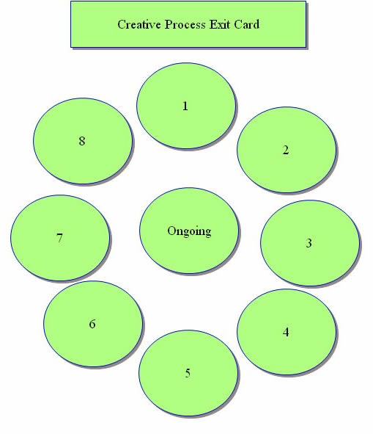
Feedback
(from Peers and Teacher)
and Reflection
Revising
and
Refining
Presenting,
Performing,
and Sharing
Reflecting
and
Evaluating
Planning
and
Focusing
Exploring
and
Experimenting
Imagining
and
Generating
 | Label the stage of the Creative Process Wheel with the matching title

