Teacher Resource 4
Non-Chord Tones

Passing Tones (PT) are those non-chord tones that take a melody from the original chord tone to a nearby but different chord tone by passing step-wise between the appropriate chord tones in a half- or whole-step pattern (e.g. based on a C chord, the melody moves in a G-F-E pattern; the ‘F’ is a non-chord tone.).
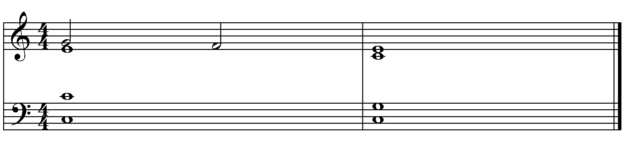

Neighbour Tones are used when a melody passes from the original chord tone back to the same chord tone, with a non-chord tone between, in a half- or whole-step pattern (e.g. based on a C chord, the melody moves in a G-A-G pattern.). It is an Upper Neighbouring Tone (UNT) if it is above the original chord tone, and a Lower Neighbouring Tone (LNT) when it is below the original chord tone (e.g. G-F-G).
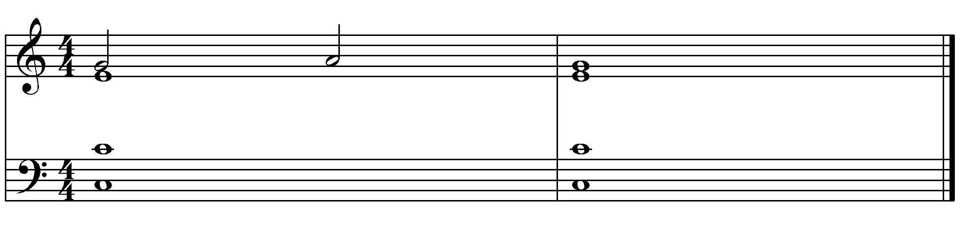

An Escape Tone (ET) is approached by step and then skips in the opposite direction. Escape tones are not accented. They occur in between the two chords. (e.g. E-F-D when moving from a I (root) chord to a V (dominant) chord in C+ harmonic progression).
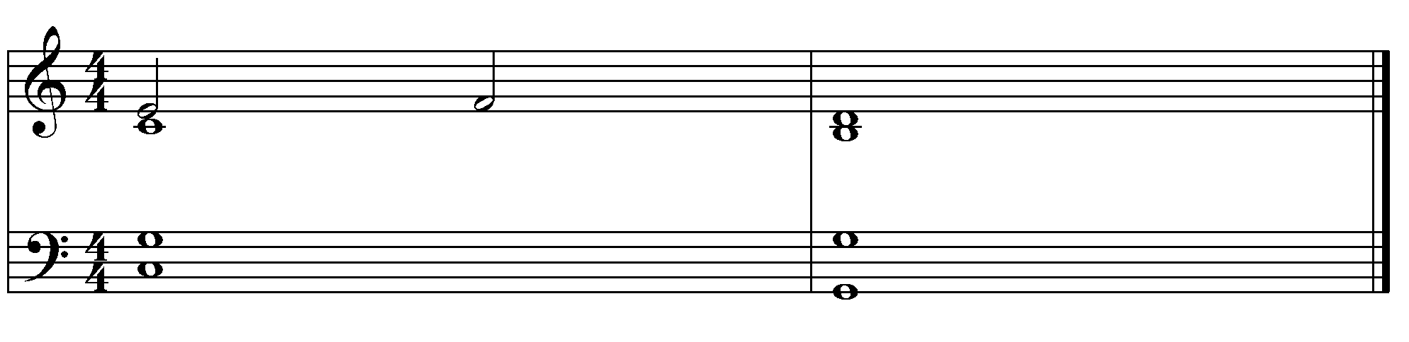
An appoggiatura (App.) is the exact opposite of an Escape Tone (ET). It is approached by skip and then steps in the opposite direction. It is commonly placed on the accented beat, unlike other Non-Chord Tones.

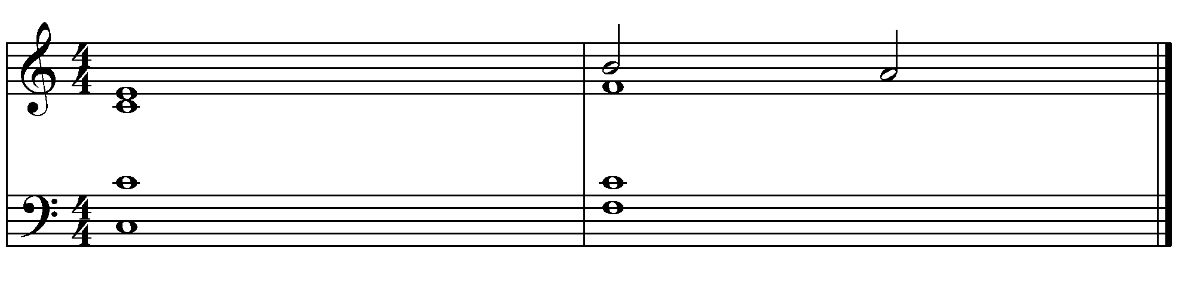

An anticipation (Ant.) is approached by step and then remains the same. It is basically a note of the second chord played early. Anticipations are unaccented.
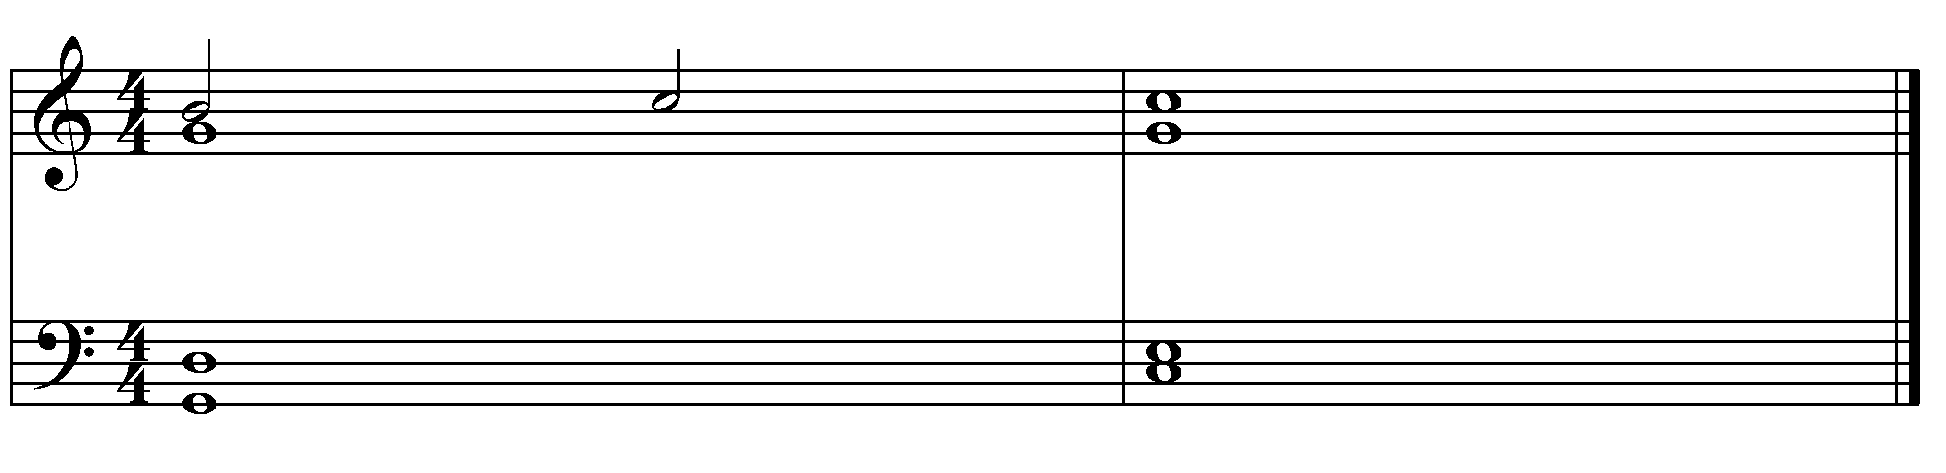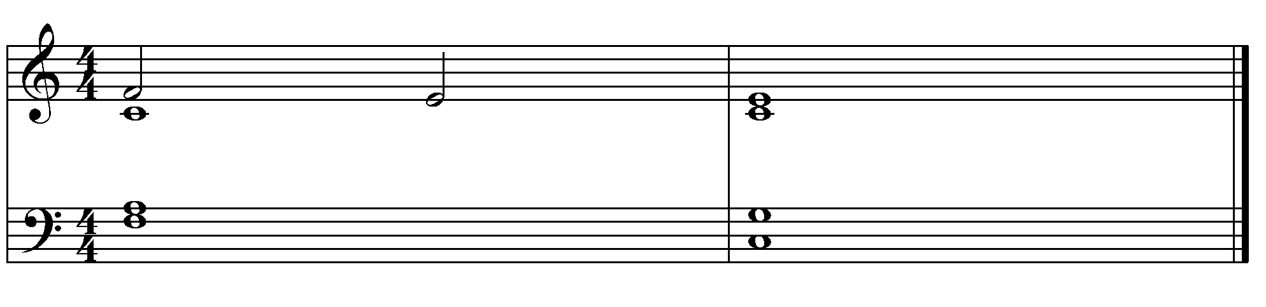

The next two nonharmonic tones are the opposite of an anticipation. They sustain a note from the first chord.
• A Retardation (Ret.) keeps a note the same and then steps upward.
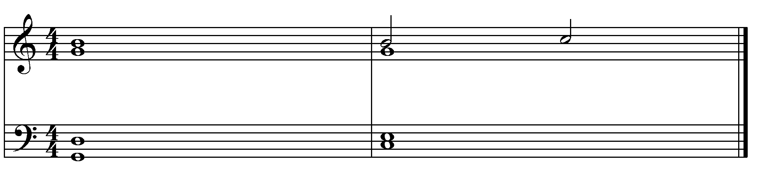
• A Suspension (Sus.) keeps a note the same and then steps downward.
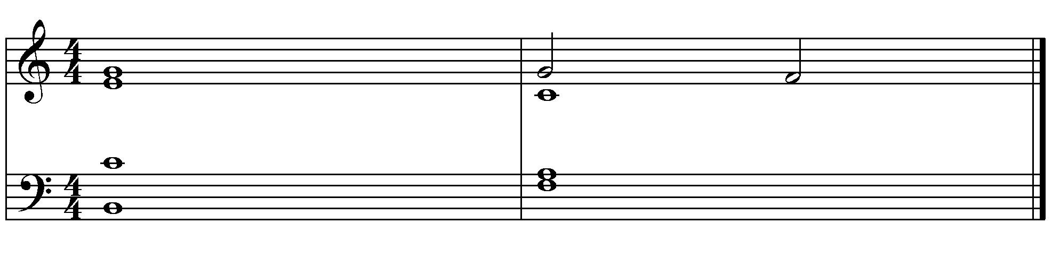

Finally, a changing tone (CT) is actually two nonharmonic tones.
• The first nonharmonic tone is approached by step and then jumps a generic third to the second nonharmonic tone.
• The second nonharmonic tone then resolves by step.

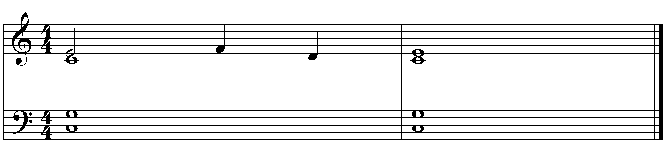

Non-Chord Tones are typically unaccented and occur on weak beats in any given bar. The Appoggiatura is the standard exception to this.

