BLM 1
Name ______________________
RED LIGHT...................GREEN LIGHT

Check for your understanding: If you’ve “got it”, give yourself a green light. If you’re not sure, choose the yellow light. If you need more work on this idea, pick the red light.

Red Light | 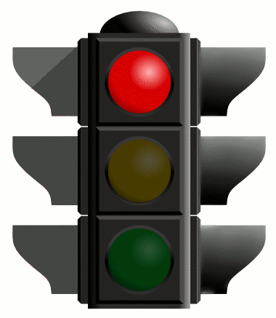 | Yellow Light | 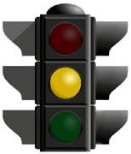 | Green Light | 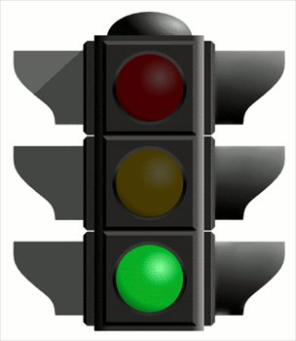

 |  | Red | Yellow | Green
Rhythm | Note Values
 | Meter
Melody | Shape
 | Tonality
Timbre | Tone Colour
 | Range
Form | Repetition/Variety
 | Theme and Variation
 | Binary AB
 | Ternary

