BLM 11
RED LIGHT.........GREEN LIGHT The Rhythm Changes
Check for your understanding: If you’ve “got it”, give yourself a green light. If you’re not sure, choose the yellow light. If you need more work on this idea, pick the red light.
Red Light | 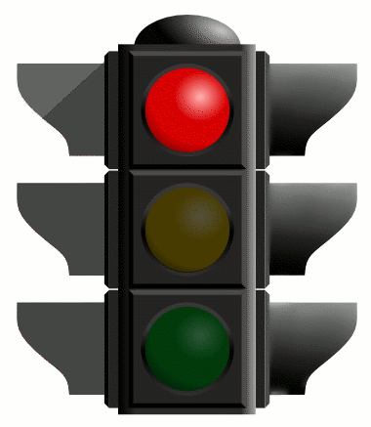 | Yellow Light | 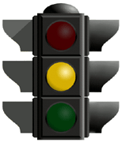 | Green Light | 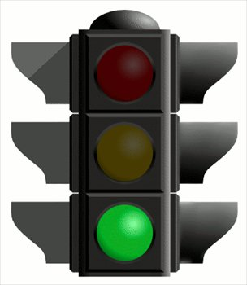

 |  | Red | Yellow | Green
Scales for the A Section | I can identify and construct a major scale.
 | I can identify and construct a blues scale.
 | I can identify and construct a pentatonic scale.
Scales for the B Section | I can identify and construct a mixolydian scale.
Improvising | I can use the various scales to improvise over the A section.
 | I can use the mixolydian scales to improvise of the B section.
 | I understand why Mixolydian scales work over dominant 7th chords
Comments:

Name___________________________________________________________

