The II-V-I Progression BLM 9
The II-V-I progression is one of the most commonly used and important chord progressions in jazz largely due to its strong sense on tonality. The three chords involved are the IIm7, the V7 and the IMaj7. 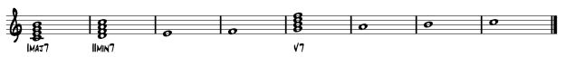
When arranged in a tune the, pattern appears as follows: 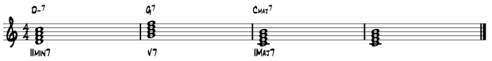
It may also appear as:
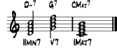
Play the pattern on your instrument or the piano to get used to the sound.
The scales used in the II-V-I progression are as follows:
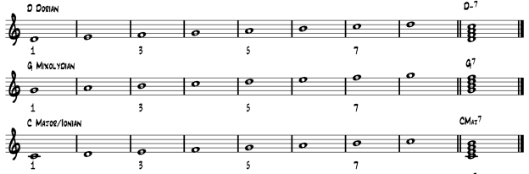

Although all the scales are made up of the same notes (from the major scale), each creates its own unique sound. To improvise effectively, it is important to work towards using the appropriate scale chord.
Playing the Progression
- In the space provided below, write the chords and scales used in the II-V-I pattern in the key of concert Bb major. Use the appropriate clef and transposition for your instrument.
IImin7: ________________________________________

V7: _________________________________________
Imaj7: _______________________________________
- Using the sheet Suggested Patterns for the II-V-I progression and additional manuscript paper, write out a few patterns for your instrument, using the correct clef and key signature.

- Program the II-V-I progression Bb major into band in a box and play the patterns you have written, experimenting with various tempos and styles.

- Create some of your own patterns and share them with the class.

- Transpose your patterns into different keys.

Analyzing a Tune:
Identifying II-V-I patterns in a jazz tune will tell you which scales/key centers to focus on. The following example is from Miles Davis’ Tune-Up, a piece largely based around the II-V-I progression:
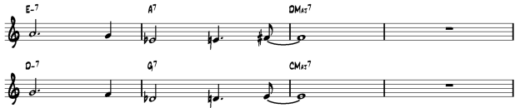
The first four bars of the tune are based on a II-V-I progression in the key of D major, while the second four bars of the tune are based on a II-V-I progression in the key of C major.
Using the appropriate lead sheet for your instrument, analyse Tune-Up to determine the various II-V-I progression and the chords/scales you will need to improvise (there will be three of them). In the first ending, you will come across chords that do not “fit” the II-V-I progression (this is quite common in jazz). As an improviser, you must determine how to approach these chords by deciding what type of scale to use (Hint: they are all chords that have appeared in other II-V-I progressions). Remember: Major 7th chords use Major scales, dominant 7th chords use Mixolydian scales, and minor 7th chords use Aeolian or Dorian scales.
- Key:___________________________________
IIm7: ________________________________________
V7: _________________________________________
IMaj7: _______________________________________
2. Key: ______________________________
IIm7: ___________________________________
V7: ____________________________________
IMaj7: __________________________________
- Key: _______________________________
IIm7: __________________________________
V7: ___________________________________
IMaj7: _________________________________

- Chords in the first ending:

Chord/Scale:

Chord/Scale:

Chord/Scale:

Chord/Scale:

