BLM 6
RED LIGHT.........GREEN LIGHT

II-V-I Progressions

Check for your understanding: If you’ve “got it”, give yourself a green light. If you’re not sure, choose the yellow light. If you need more work on this idea, pick the red light.

Red Light | 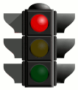 | Yellow Light |  | Green Light | 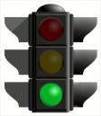

 |  | Red | Yellow | Green
Chords | I can identify and construct a major 7th chord.
 | I can identify and construct a dominant 7th chord.
 | I can identify and construct a minor 7th chord.
Progressions | I can identify and construct II-V-I progressions in various keys.
Scales | I can identify and construct a major scale.
 | I can identify and construct a mixolydian scale.
 | I can identify and construct a dorian scale.

Comments:

Name___________________________________________________________

