BLM 5
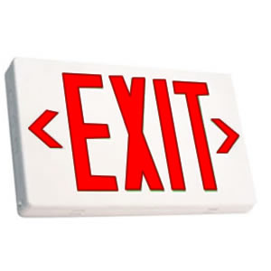

Reflecting on the learning goals for this lesson, please complete the following:
Recommendations
One thing I want to learn (or learn more) about is:

Something I learned today:

1.

2.

