BLM 3
Jazz Chords and Diatonic Progressions

Jazz chords are constructed by stacking intervals (most often 3rds) over top of a given tonic. The notes in the chord are called (from the bottom up): root. 3rd, 5th, and 7th. By examining the major scale, we can see where the names come from.
There are four main types of chords commonly used in jazz:
The Major 7th: (CMaj7) – Intervals from the root are M3, P5 and M7 (1,3,5,7)
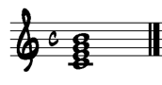

The dominant 7th: (C7) – Intervals from the root are M3, P5 and m7 (1,3,5,b7)
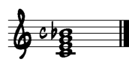
The minor 7th: (C-7) – Intervals from the root are m3, P5 and m7 (1,b3,5,b7)

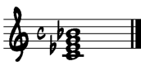

The minor 7th, flat 5: (C-7b5) – Intervals from the root are m3, d5, and m7 (1,b3,b5,b7).
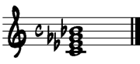
Try playing each chord on your instrument (arpeggios 1 3 5 7 5 3 1), or on the piano to get used to the sound of each chord.

If we build 7th chords on each note of the major scale, the following diatonic chords appear:
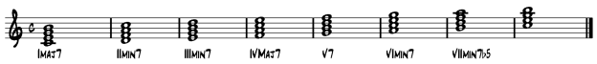
When chords move from one to another, this is called a progression. In jazz, chords often progress in the following order:
I – IV – VII – III – VI – II – V – I
The most important progression is jazz is the II – V – I as it creates a very strong sense of tonality.

- On the blank staves below, write out the concert Bb scale using the correct transposition and clef for your instrument. Construct 7th chords on each note of the scale and label them correctly using letter names (i.e. BbMaj7).



- Using Band-In-A-Box, experiment with programming different diatonic progressions. It is best (though not essential) to start a progression with the tonic (I) chord and end with a dominant to tonic motion (V-I). Though the above mentioned progression is common, your ear is the final judge. Share your progression with the class.

- Improvising over the progression. As the progression that you have developed is diatonic (all the notes “fit” within the scale), the concert Bb scale will work over the entire progression. Using Band-In-A-Box, try improvising over your progression. Experiment with different tempos and styles. Remember that you must transpose your progression in Band In A Box back to concert Bb in order for it to work (select Bb major in the transposition window).

