BLM 8
RED LIGHT...................GREEN LIGHT

Check for your understanding: If you’ve “got it”, give yourself a green light. If you’re not sure, choose the yellow light. If you need more work on this idea, pick the red light.

Red Light | 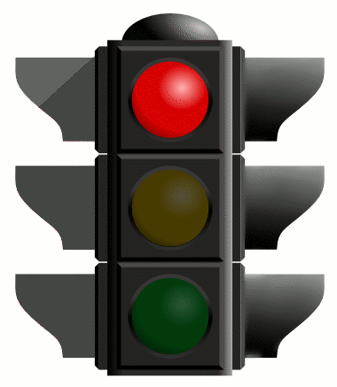 | Yellow Light | 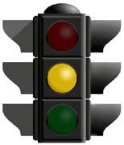 | Green Light | 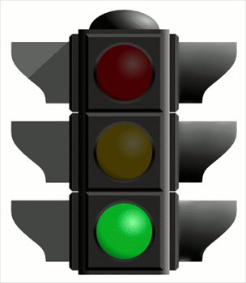

 |  | Red | Yellow | Green
Types of notation | Standard notation
 | Graphic notation
 | Electronic notation
 | Hybrid notation
Use of Elements of Music in Composition | Melody
 | Rhythm
 | Harmony
 | Dynamics
 | Timbre
Technology | Ability to use technology to document composition
Connection to Film | Visuals to Musical Gesture

