BLM 7
IMAGES and MOODS

Link images below with a corresponding mood.

Image Mood

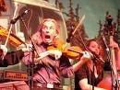

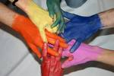



Faces in flowers (film clip)

