BLM 3
Matching Images

For the images below:
- identify descriptive words of the mood of the picture
- Indicate two elements of music that you would use and how you would use them in a musical accompaniment that you would create as background to the image.

Image #1:

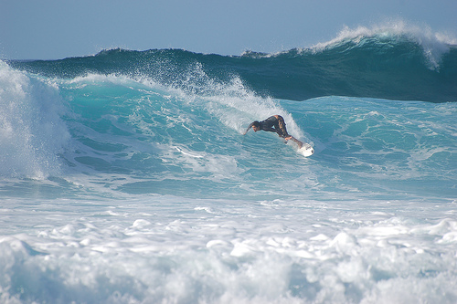

- _______________________________________________________________
- ________________________________________________________________________________________________________________________________

Image #2:

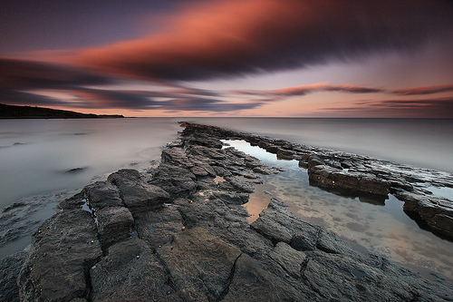

- _______________________________________________________________
- ________________________________________________________________________________________________________________________________

Image #3:

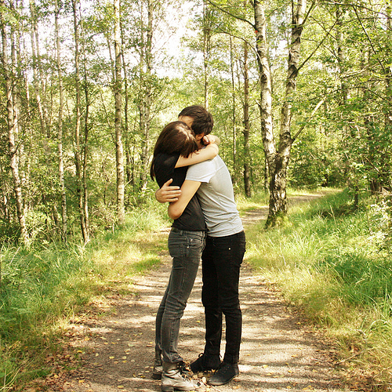

- _______________________________________________________________
- ________________________________________________________________________________________________________________________________

Image #4:

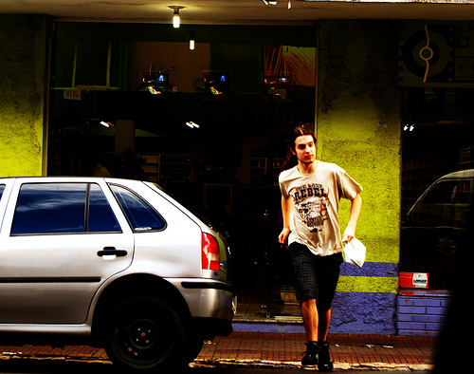

- _______________________________________________________________
- ________________________________________________________________________________________________________________________________

Image #5:



 
 

