Teachers, before you copy this booklet for your students...
⬰ Have you read the GPS Overview?
⬰ Have you taught these students before? If not, please take the time to work with your students to determine their strengths and needs before deciding which tasks will be appropriate.
⬰ Have you gone through the appropriate start-up steps with your students? For example; the basics on setting up their instrument, care and maintenance of their instrument, posture and bow grip.
⬰ If you have taught these students before...go through the entire program task-by-task to confirm that the sequence and challenge level of the tasks, is appropriate.
⬰ Refer to the Q and A section of the GPS Overview.
⬰ Do you need to reduce the number of tasks...how will you need to change the evaluation by term?
⬰ If you have questions, please contact:
Justina So: justina_so@yahoo.ca

GPS Task Evaluation Chart
TEACHER REFERNCE
Year Three String

This is assuming that this program starts in late October early November

Tasks  (Completion of “X” task number equals “Y” %) | Term 1 (September to February) | Term 2 (February to June)
1 | 52% | 32%(R)
2 | 55% | 35%(R)
3 | 58% | 38%(R)
4 | 62% | 42%(R)
5 | 65% | 45%(R)
6 | 68% | 48%(R)
7 | 72% | 52%
8 (taught to) | 75% | 55%
9 | 78% | 58%
10 | 82% | 62%
11 | 88% | 65%
12 | 92% | 68%
13 | 98% | 72%
14 (taught to) | 100% | 75%
15 |  | 78%
16 |  | 82%
17 |  | 88%
18 |  | 92%
19 |  | 98%
20 |  | 100%

Tasks 15 to 20 serve as extensions and culminating activities which encompass the concepts learned or introduced in Tasks 1 to 14. If you are following this evaluation scheme, you should teach at least the first 14 tasks by the end of the year.

GPS
(Grade Performance Steps)

The Road to Musical Success!

Intermediate String Performance Tasks
YEAR THREE





Ontario Music Educators’ Association
www.omea.on.ca

GPS Task STUDENT Evaluation Chart
Year Three String

In order to be successful this year, you will need to plan out how many tasks you think you can complete, and the mark you want to receive for performing on your instrument! Below is a summary of the number of tasks per term, and the mark you will receive for the tasks you complete:

Tasks  (Completion of “X” task number equals “Y” %) | Term 1 (September to February) | Term 2 (February to June)
1 | 52% | 32%(R)
2 | 55% | 35%(R)
3 | 58% | 38%(R)
4 | 62% | 42%(R)
5 | 65% | 45%(R)
6 | 68% | 48%(R)
7 | 72% | 52%
8( taught to) | 75% | 55%
9 | 78% | 58%
10 | 82% | 62%
11 | 88% | 65%
12 | 92% | 68%
13 | 98% | 72%
14 (taught to) | 100% | 75%
15 |  | 78%
16 |  | 82%
17 |  | 88%
18 |  | 92%
19 |  | 98%
20 |  | 100%
Performance is just one part of your Music evaluation this year. Your teacher will let you know what the other aspects of your program are on your two summative report cards.

Remember that with the GPS tasks:
- we will be learning concepts introduced as a class
- you will have time in class to practice and receive feedback from your teacher and classmates.
- you will have multiple opportunities to demonstrate these tasks
- you need to demonstrate at least a Level 3 performance (your teacher will talk with you about what a Level 3 demonstration would sound like)
- in order to be successful, you will need to work independently in class, and outside of class time (recess, lunch, after school and practice at home)
- you can track your progress with the task tracker found at the end of the booklet
GPS YEAR THREE
STRINGS

THE NORTH SECTION
FOCUS: RHYTHM

1. REVIEW THE FAMILIAR FOCUS: QUARTER AND HALF NOTES

LEARNING GOAL: This is a review from last year’s GPS task 4. The purpose of this task is to review and demonstrate your understanding of quarter and half notes.

MINDS ON! When you play quarter and half notes, how do you make sure that they fill the entire length of the beat? When you have the same rhythm repeated, how do you maintain an equal quality of sound?

ACTION! To be successful with this task, you will need to:

- Pick a tempo which will allow you to play with accuracy and a good quality of sound;
- Move your toe inside your shoes to make sure you hold each note for its full value;
- Look for patterns, identify the form of this piece, perform with phrasing; and
- Remember to change the way you play in order to demonstrate the different dynamic markings as we did last year.

CONSOLIDATION: In order to move on to the next task, perform the below piece for your teacher and receive feedback.

Twinkle, Twinkle, Little Star
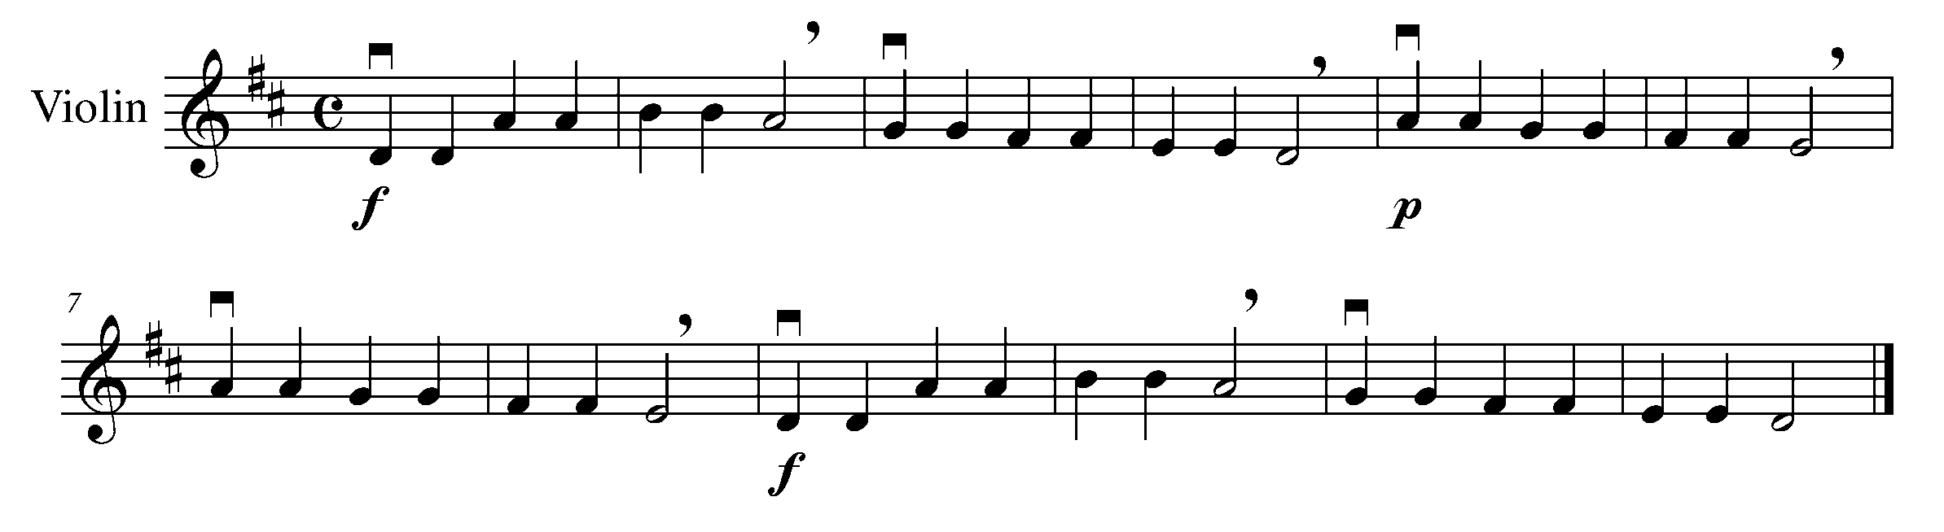
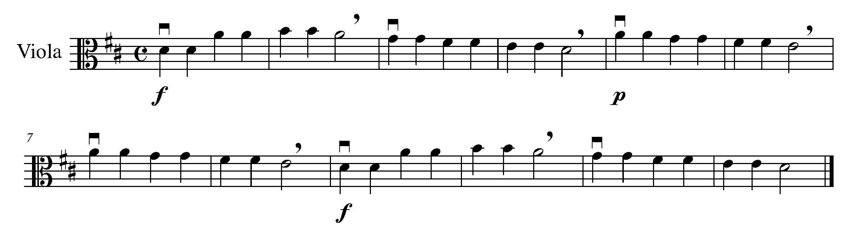
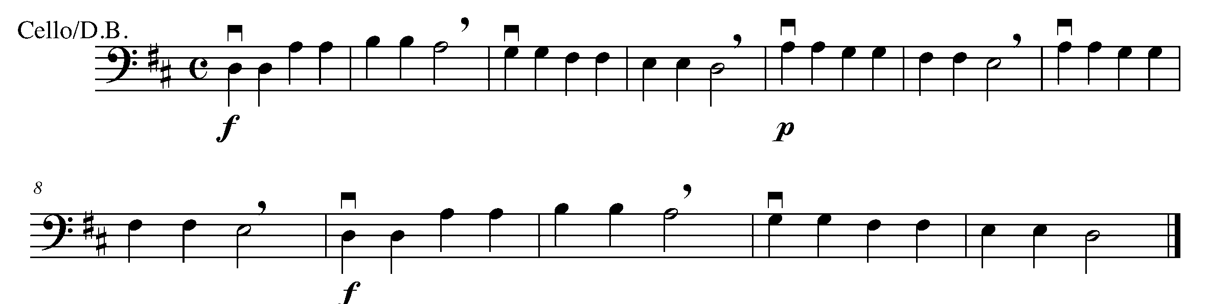

2. “SYN – CO – PA” FOCUS: EIGHTH/QUARTER/EIGHTH NOTES

LEARNING GOAL: The purpose of this task is to recognize an eighth note, quarter note, and eighth note combo – known as syncopation.

MINDS ON! How do you count the rhythm labeled “syncopation”? How will you balance your quality of sound throughout the syncopation? Where do you feel the accent when you play “syn-co-pa”?

ACTION! In order to be successful with this task, you will need to:

- Circle all of the syncopations in the piece below; and
- Write in the beat numbers (1 + 2 + 3 + 4 +) for the piece below.
CONSOLIDATION: In order to move on to the next task, complete the above action items, show them to your teacher and receive feedback.
Cheki Morena
- Traditional Spanish Folk Song

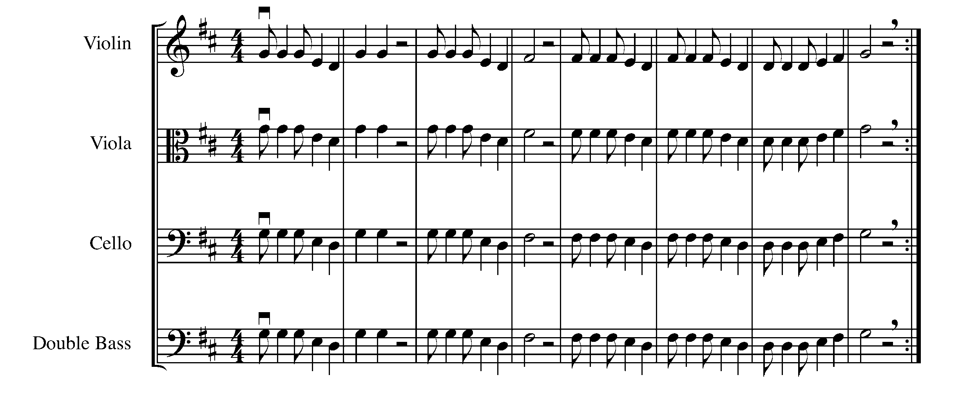

3. PERFORMING SHORT, LONG, SHORT FOCUS: SYNCOPATION

LEARNING GOAL: The purpose of this task is to perform the syncopation rhythm on your instrument.

MINDS ON! How do you articulate the syncopation below? Do all of your notes have a good quality of sound? Are you moving your toe inside of your shoe to help you keep a steady beat?

ACTION! To be successful with this task, you will need to:

- Maintain proper posture when performing;
- Play the above piece found in task 2 with good sound, rhythm, and a consistent tempo; and
- Be sure to demonstrate where the accents lie when performing syn-co-pa rhythms.

CONSOLIDATION: In order to move on to the next task, perform the piece found in task 2 for your teacher and receive feedback.

4. LONG, SHORT, LONG, SHORT FOCUS: DOTTED QUARTER/
EIGHTH NOTE COMBINATION

LEARNING GOAL: The purpose of this task is to review and perform the dotted quarter note - eighth note combination.

MINDS ON! When you play the rhythm combination of a dotted quarter note and an eighth note, is the eighth note getting the full ½ beat value? How does this combination change the feel of a piece? Do you recognize this piece from Year 1?

ACTION! To be successful with this task, you will need to:

- Scan the piece before you begin to play. Look for new rhythms, notes, and symbols;
- Be aware this piece is in G major;
- Accurately perform the rhythms with stresses on strong beats or “off” beats where appropriate

CONSOLIDATION: In order to move on to the next task, you will need to perform the following piece for your teacher and receive feedback.

Swingin’ an Old Favourite
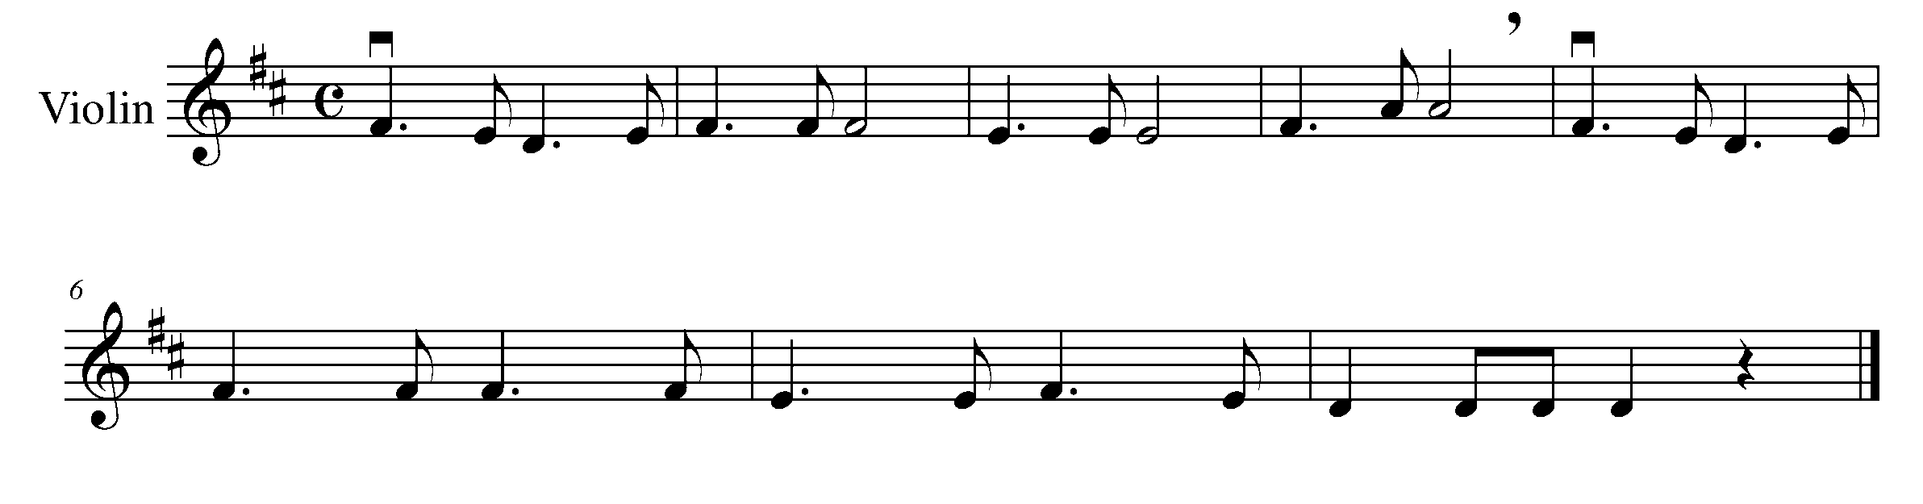
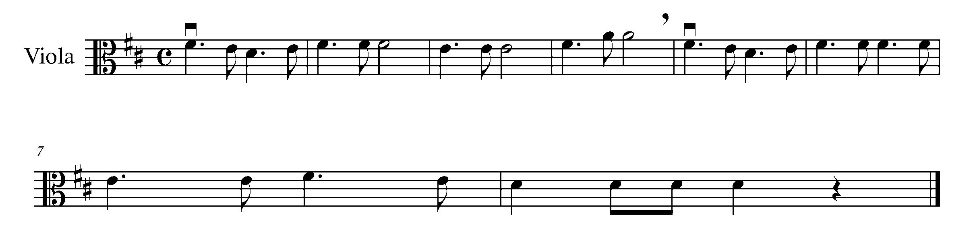
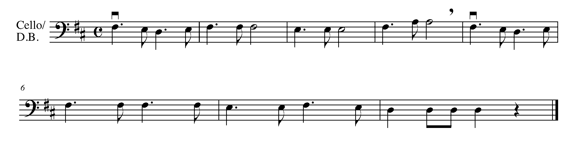

5. PUTTING IT TOGETHER IN A THEME AND VARIATIONS
FOCUS: CULMINATING TASK

LEARNING GOAL: Last year, we learned what theme and variations are. The purpose of this task is to play a rhythmic theme and variations of “Twinkle, Twinkle, Little Star”. The variations will include the rhythms learned in Tasks 2, 3, and 4.

MINDS ON! What preparation do you need to do in order to have a successful performance? What does it mean when a piece is labeled, “Theme and Variations”? How will you practice the rhythms in the variations of the below piece?

ACTION! To be successful with this task, you will need to:
- Review the variety of rhythms found in the theme and variations below (circle or label any that are tricky to you);
- Demonstrate your understanding on what theme and variations are; and
- Perform with proper posture, phrasing, articulation, and accuracy.

CONSOLIDATION: In order to move on to the next section and task, you will need to perform the following “Variations on Twinkle, Twinkle, Little Star” for your teacher and receive feedback.

Variations on Twinkle, Twinkle, Little Star
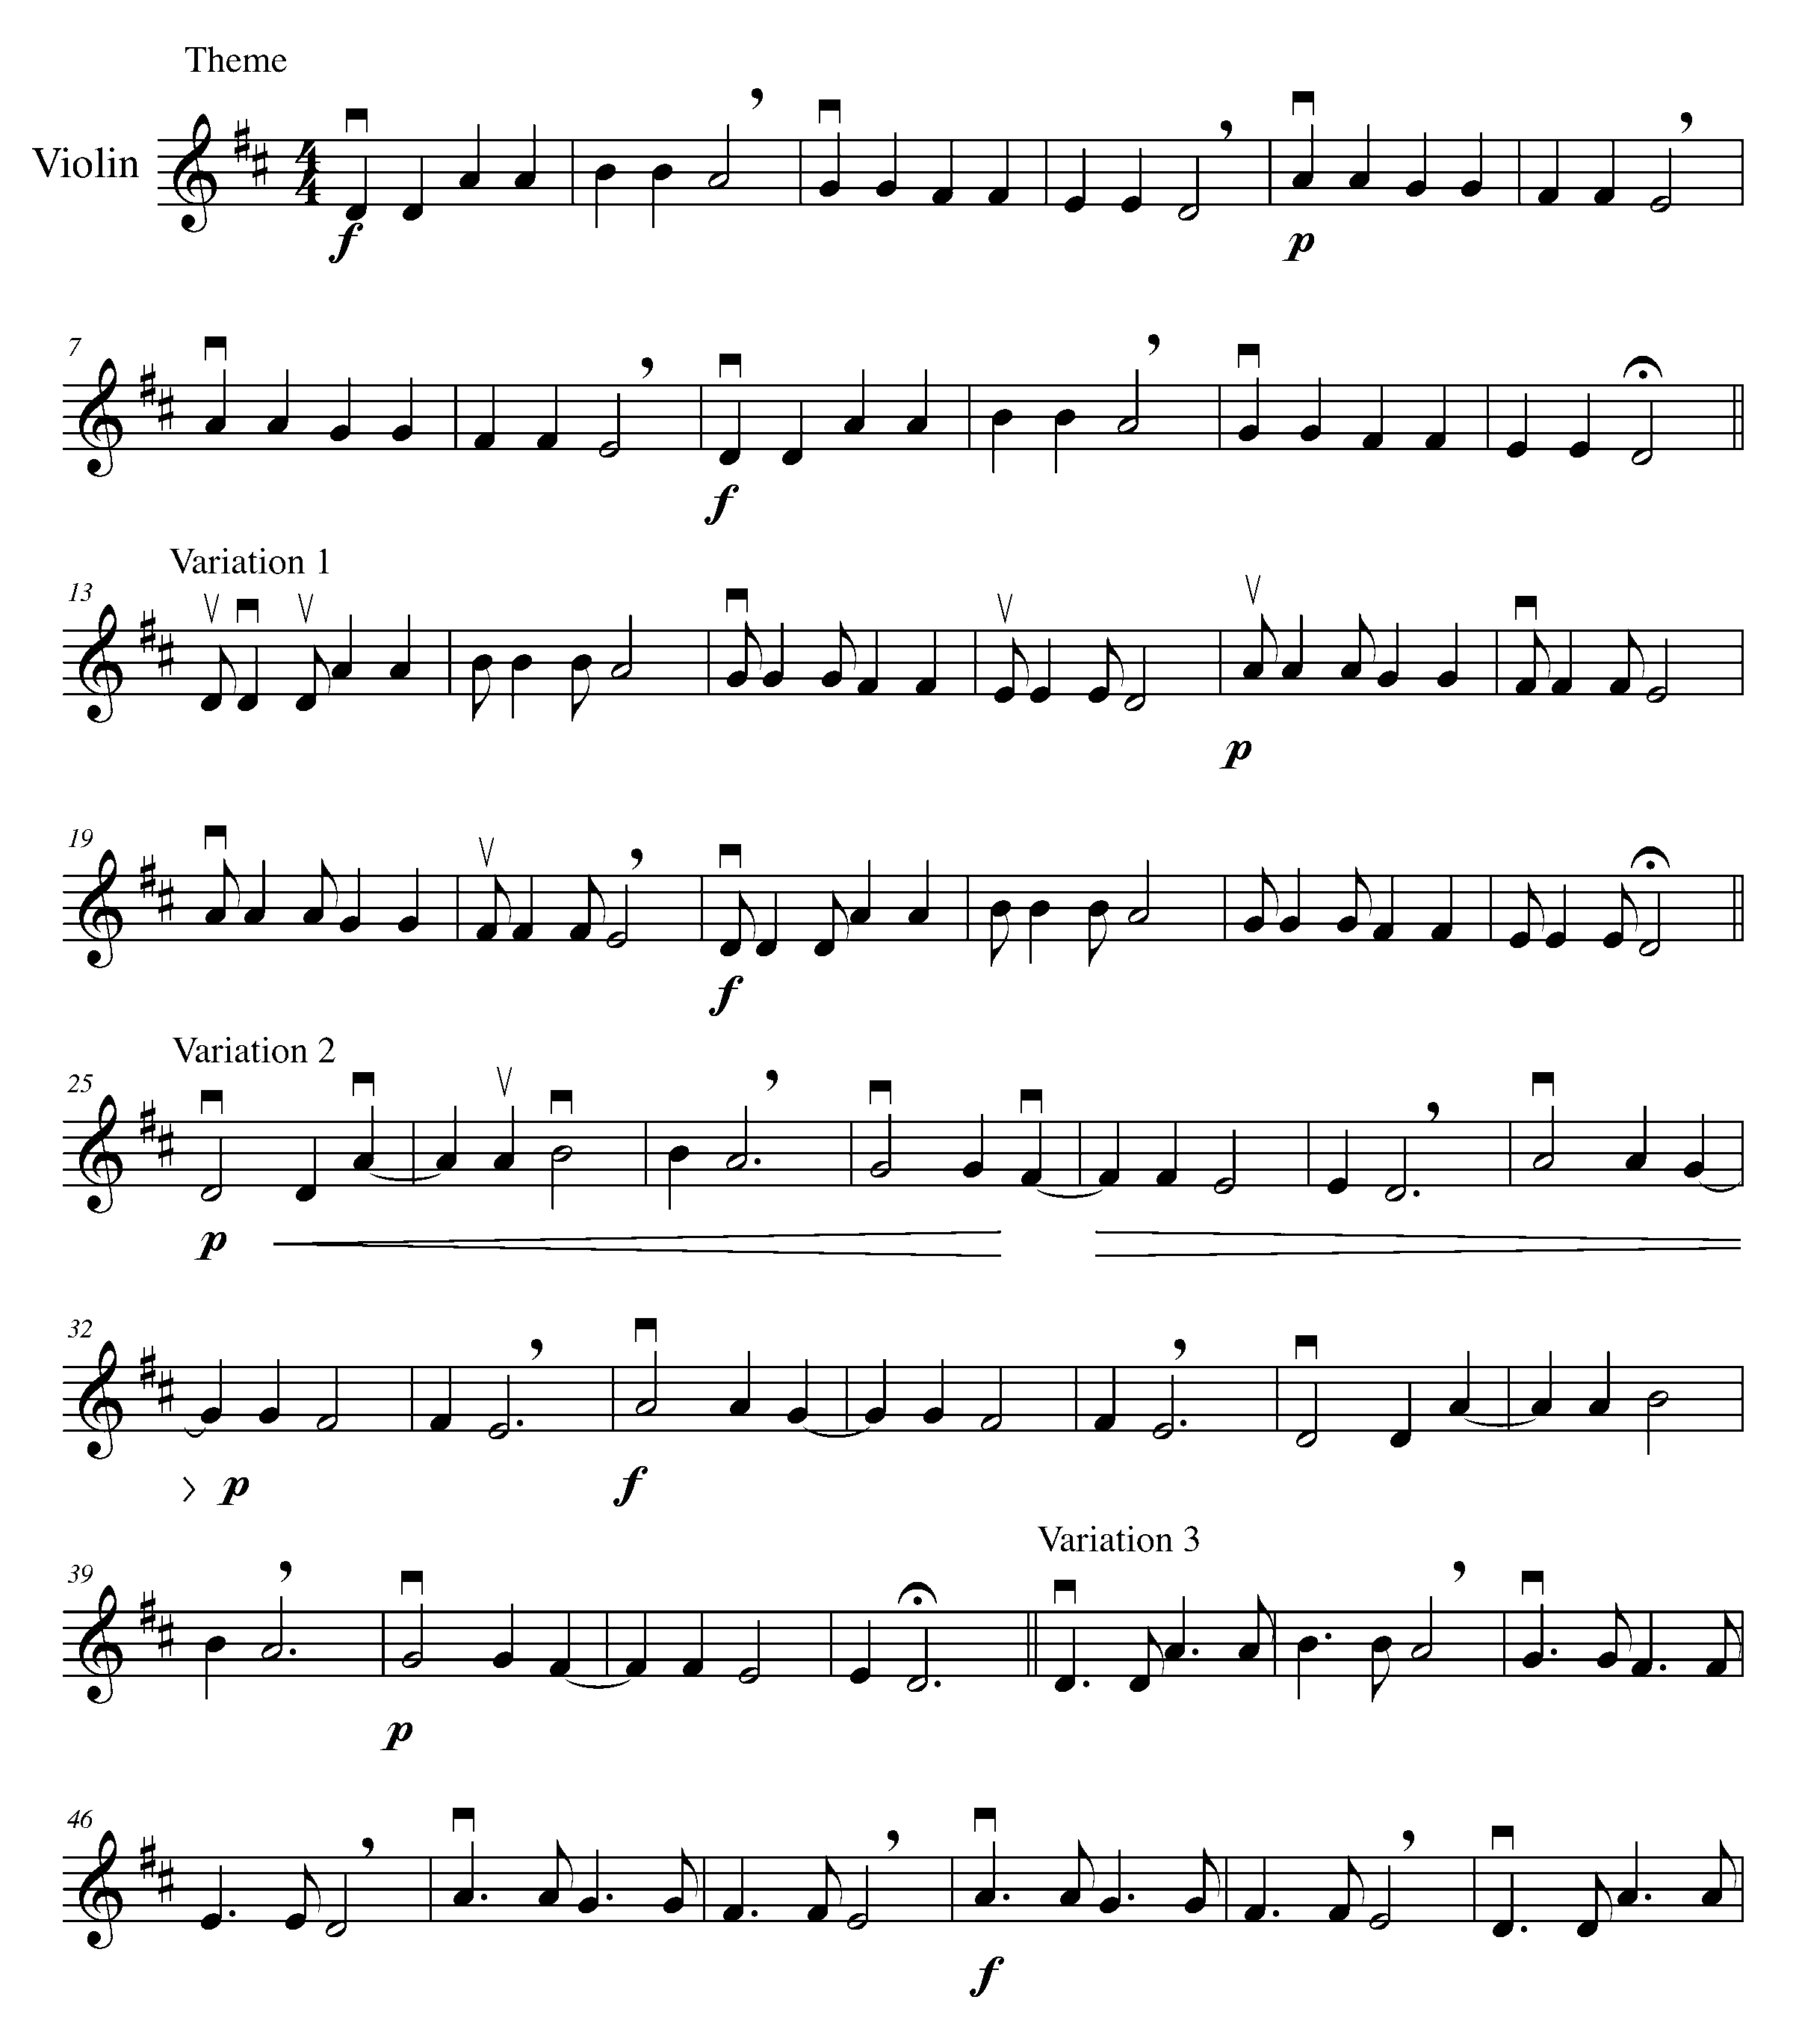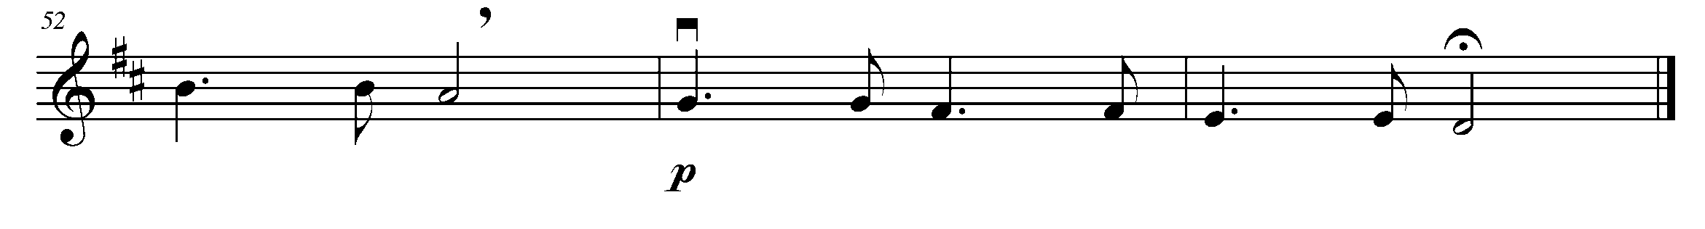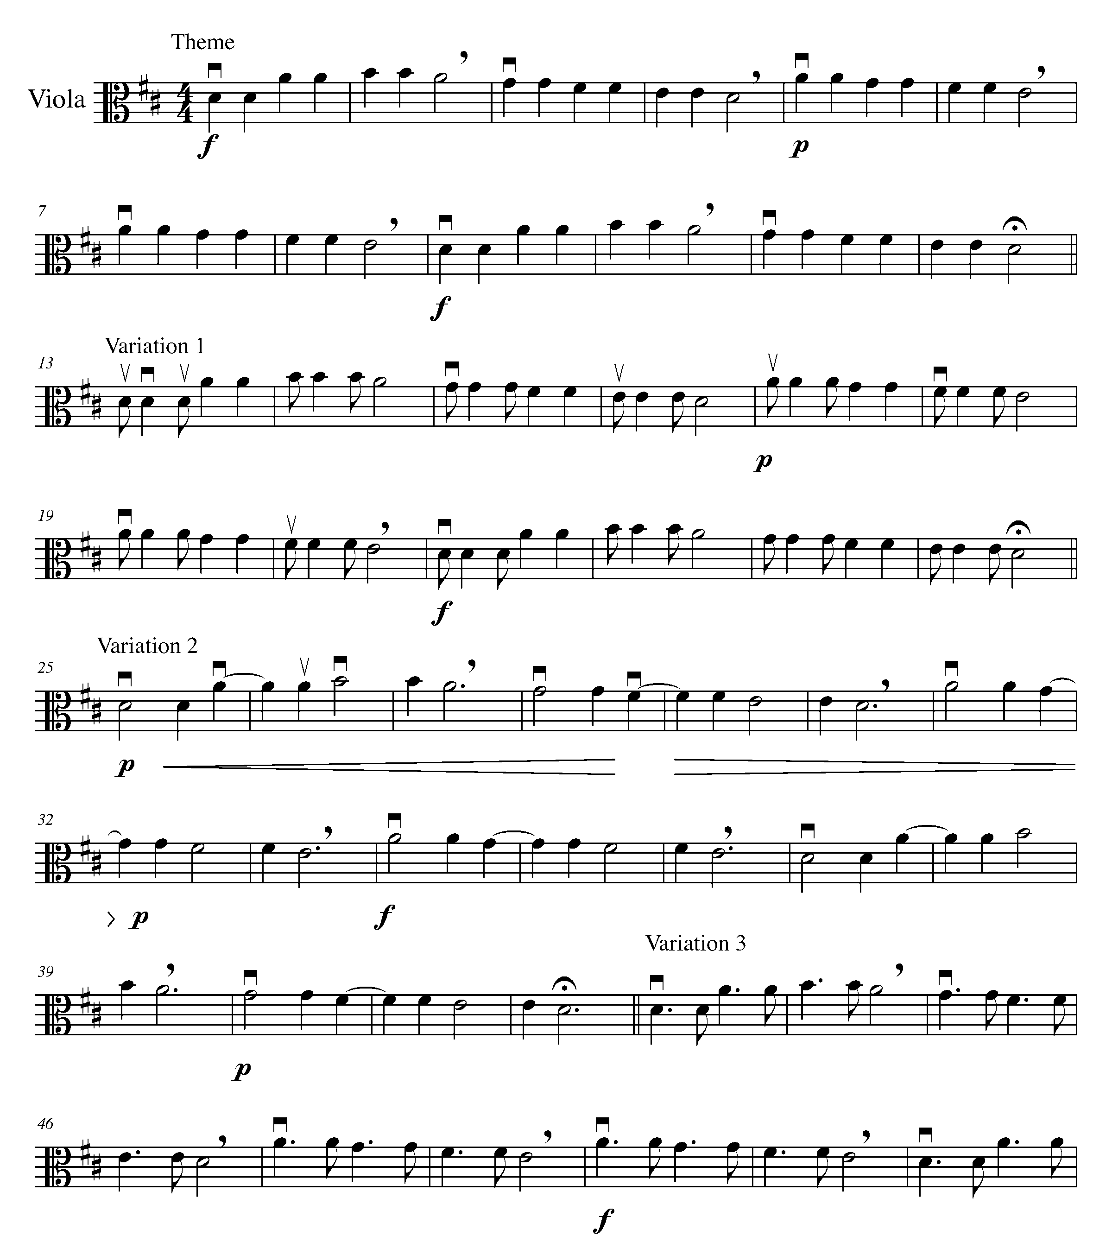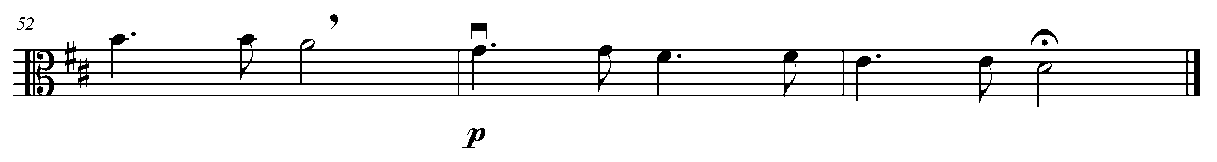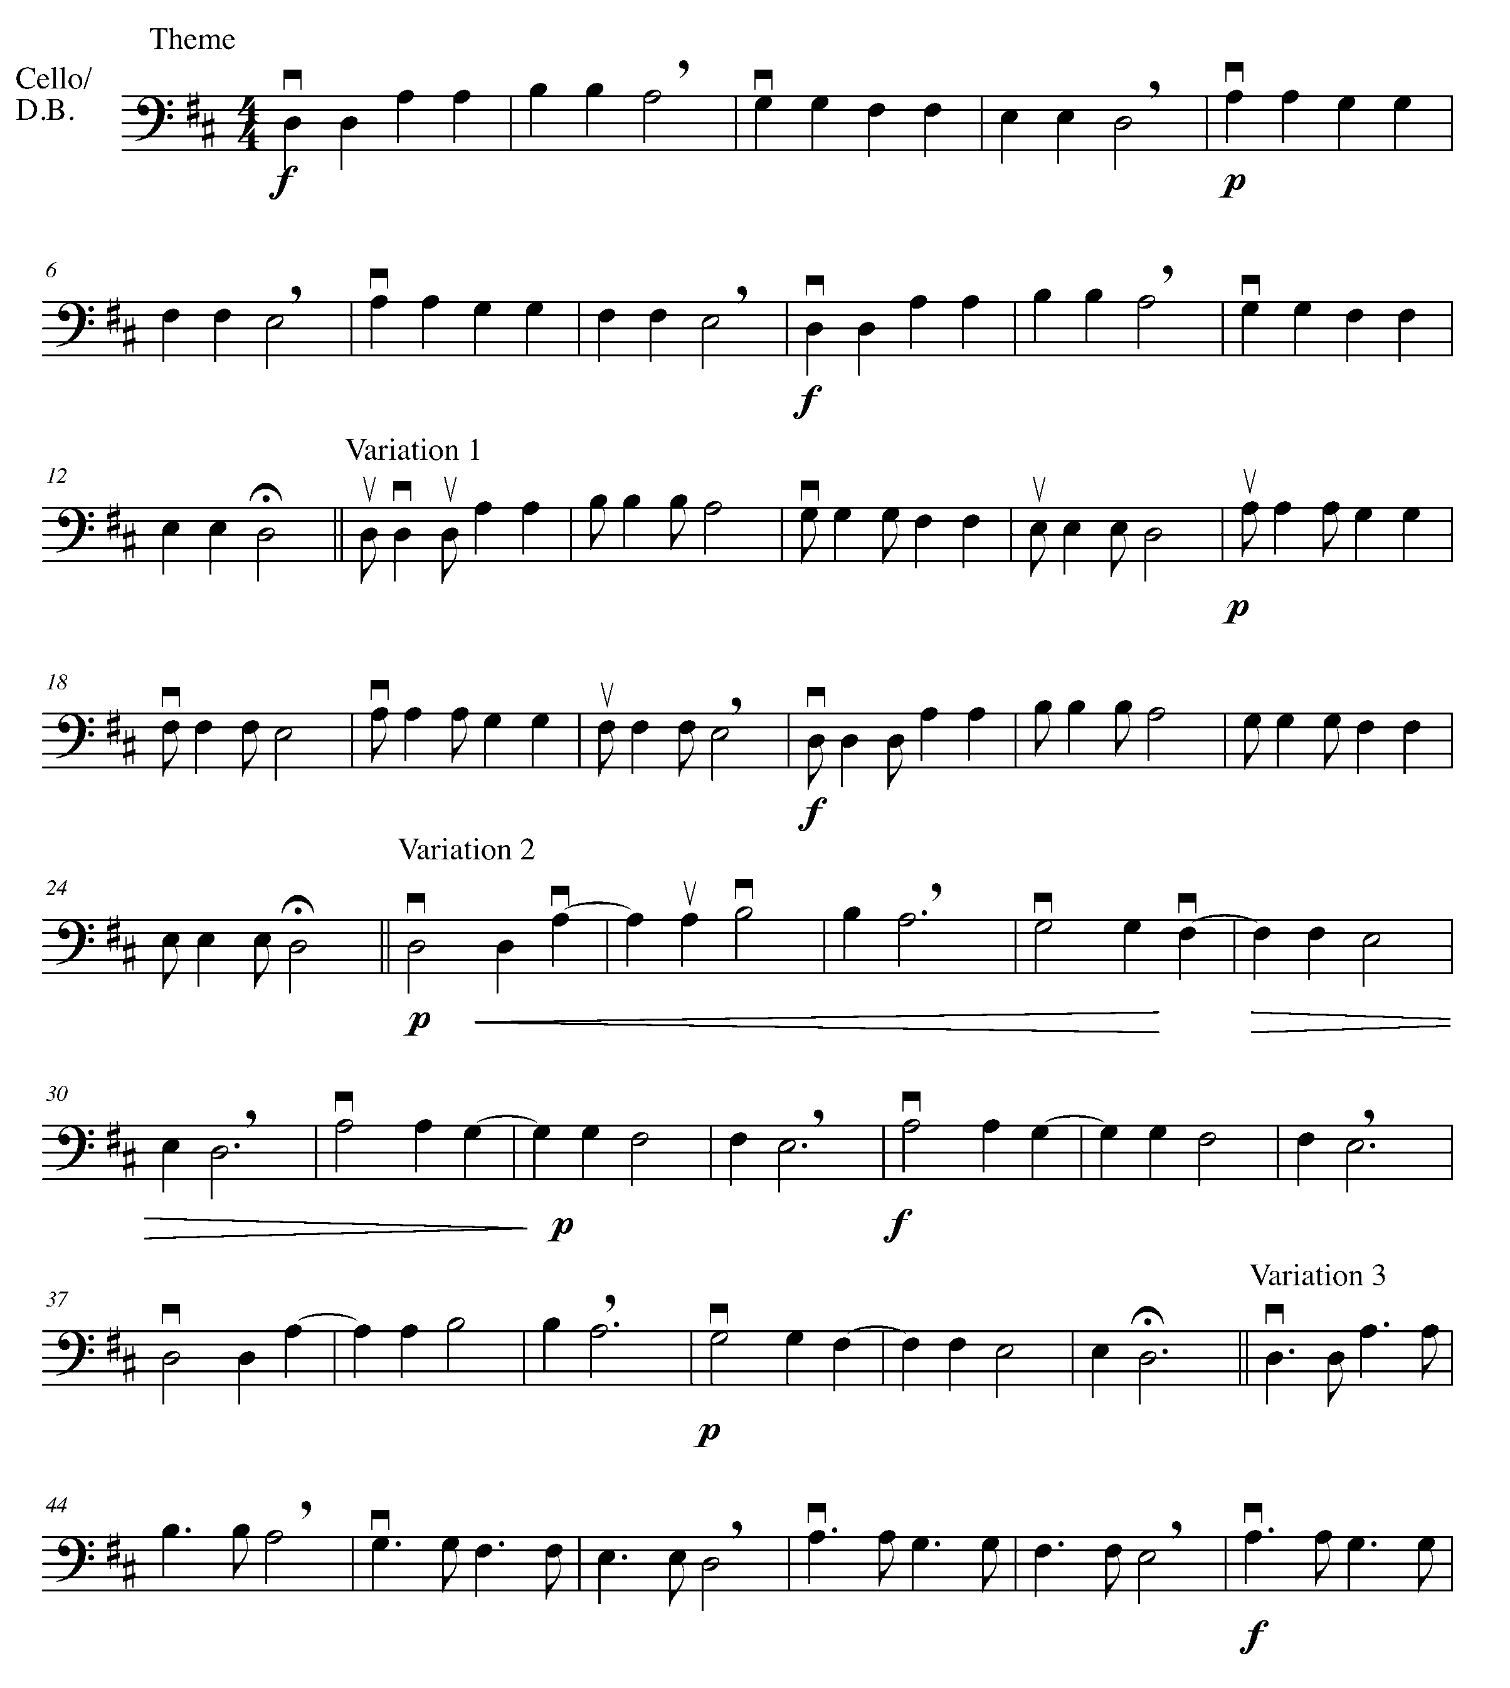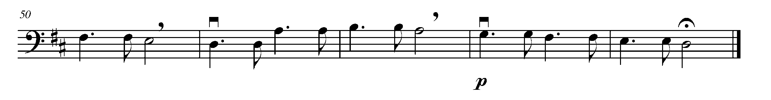

CONGRATULATIONS – YOU HAVE REACHED THE FIRST GOAL AND COMPLETED THE NORTH SECTION! ASK YOUR TEACHER HOW YOU ARE TO RECOGNIZE THIS ACHIEVEMENT!
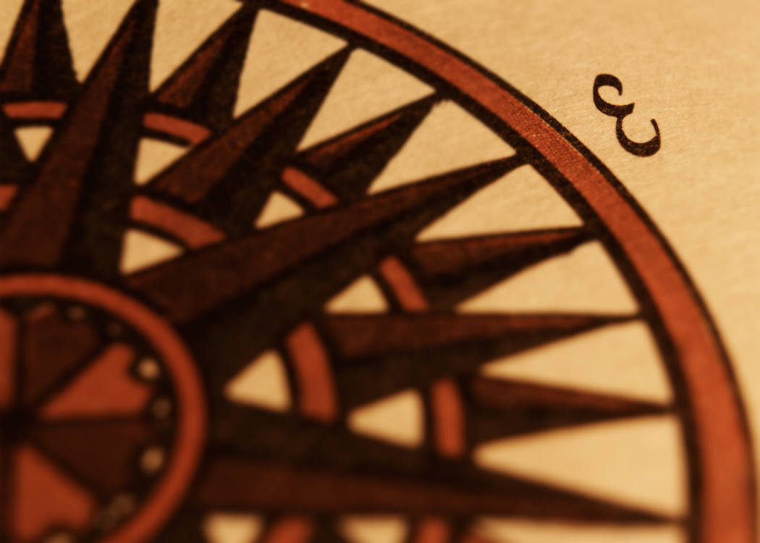

THE EAST SECTION
FOCUS: FORM

6. AB OR ABA? FOCUS: BINARY FORM VS. TERNARY FORM

LEARNING GOAL: The purpose of this task is to realize that most pieces of music have a particular structure or form. You will also be introduced to the dotted eighth note/sixteenth note combination.

MINDS ON! Why is it helpful to recognize the form of a piece? What is the difference between binary and ternary form?

ACTION! To be successful with this task, you will need to:

- Learn the difference between binary form and ternary form;
- Write the definitions for binary and ternary form in the provided space;
- Realize the labels for binary (AB) and ternary (ABA) form;
- Determine the correct “counting” for the eighth note-sixteenth note combination (on your music, label 1 e + a, 2 e + a, 3 e + a, 4 e + a);
- Compare the two pieces below and label them as binary or ternary; and
- Label the sections within each piece.

CONSOLIDATION: In order to move on to the next task, you will need to complete the above action steps and show them to your teacher to receive feedback.

Binary:

Ternary:

Do You Know the Muffin Man?
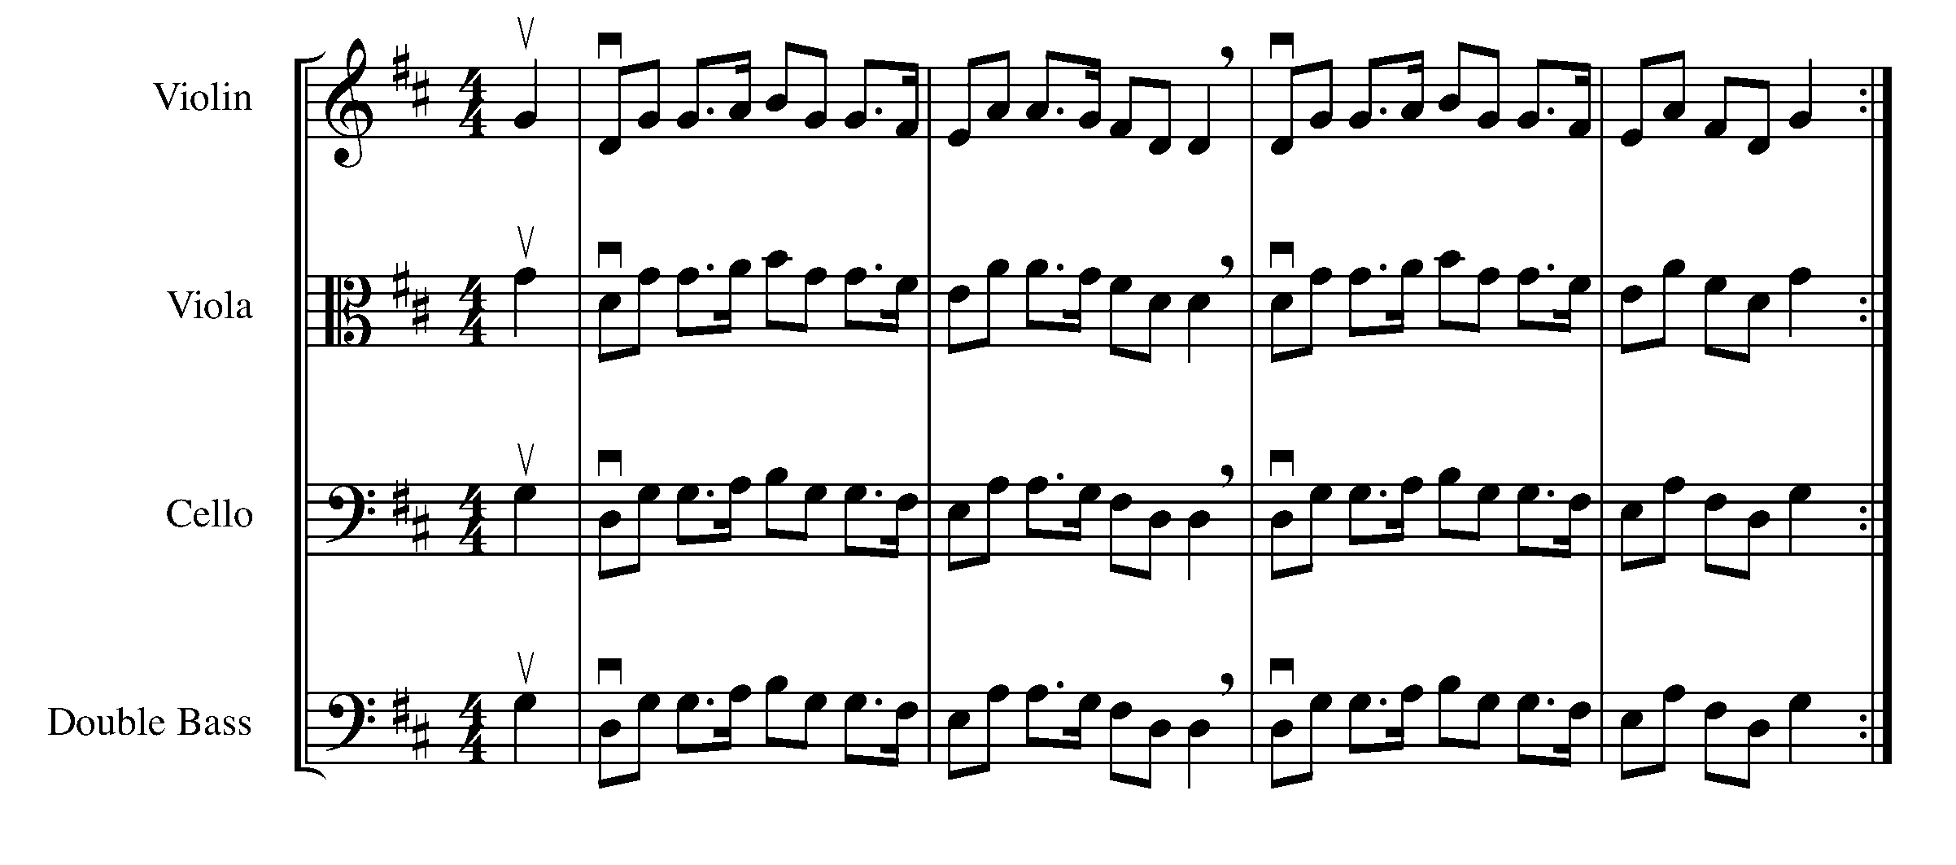
Largo
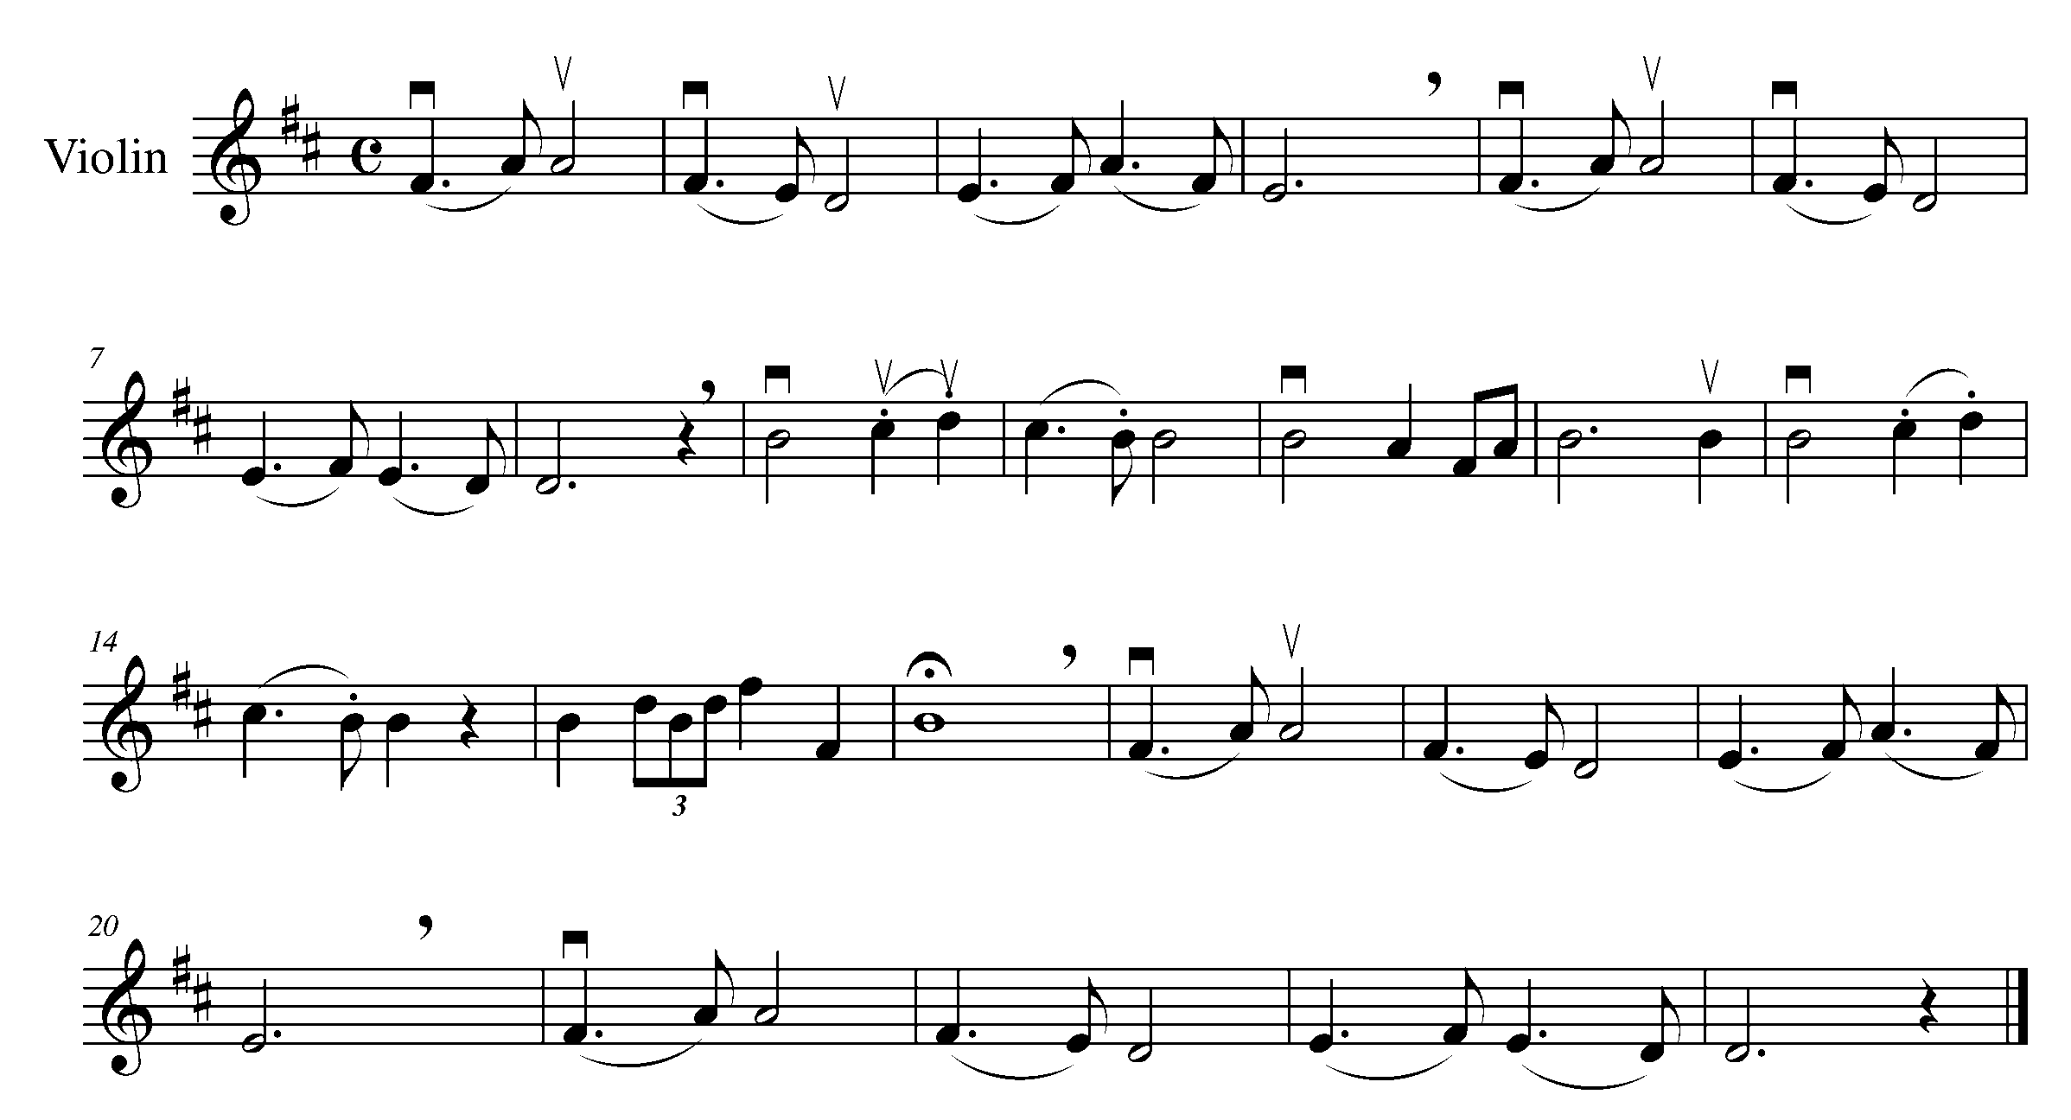
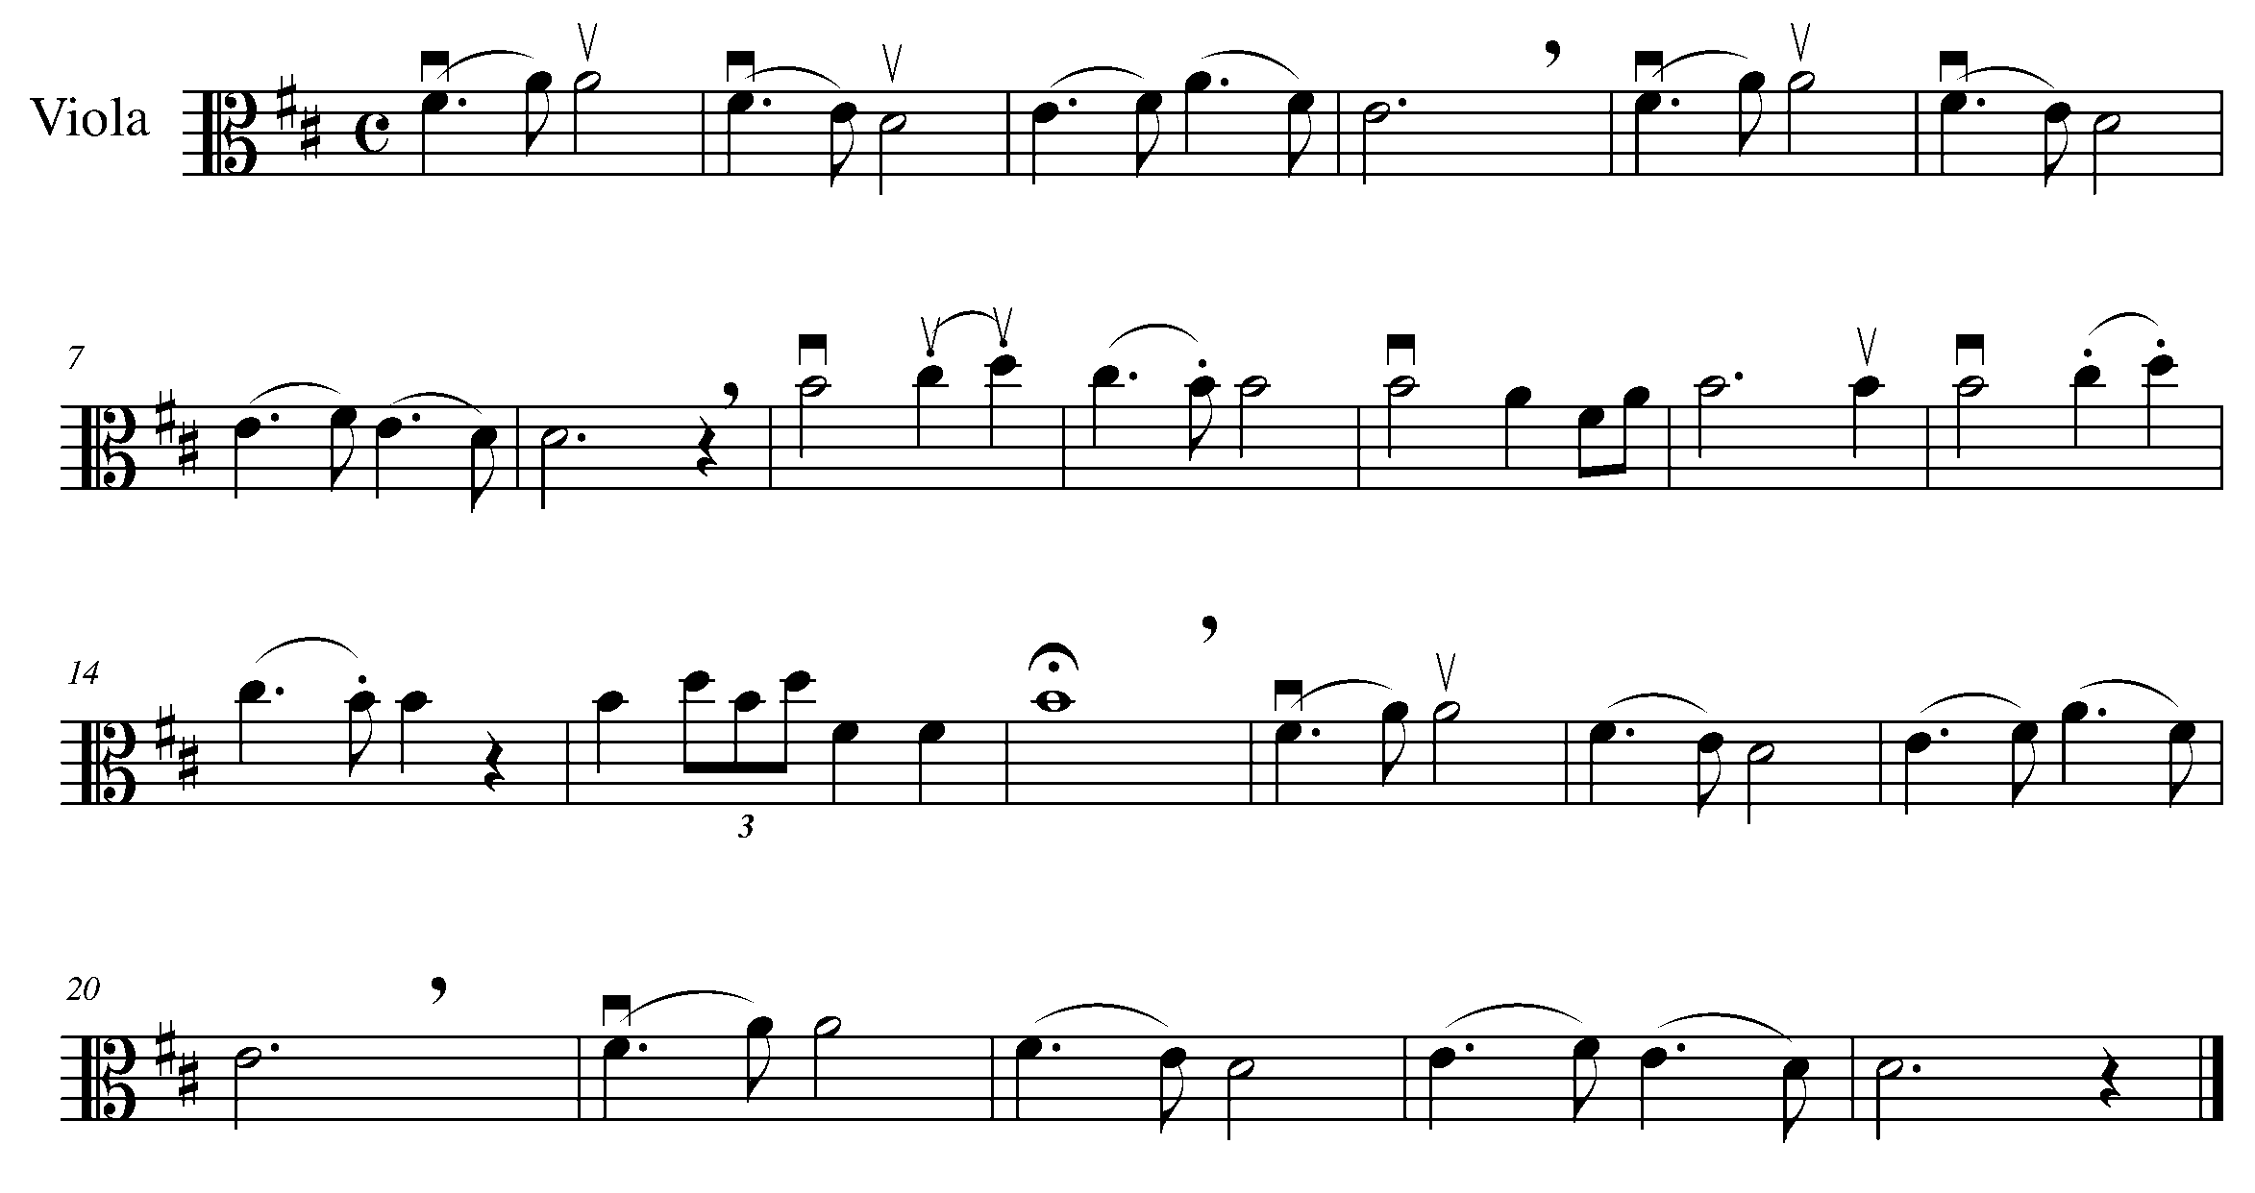
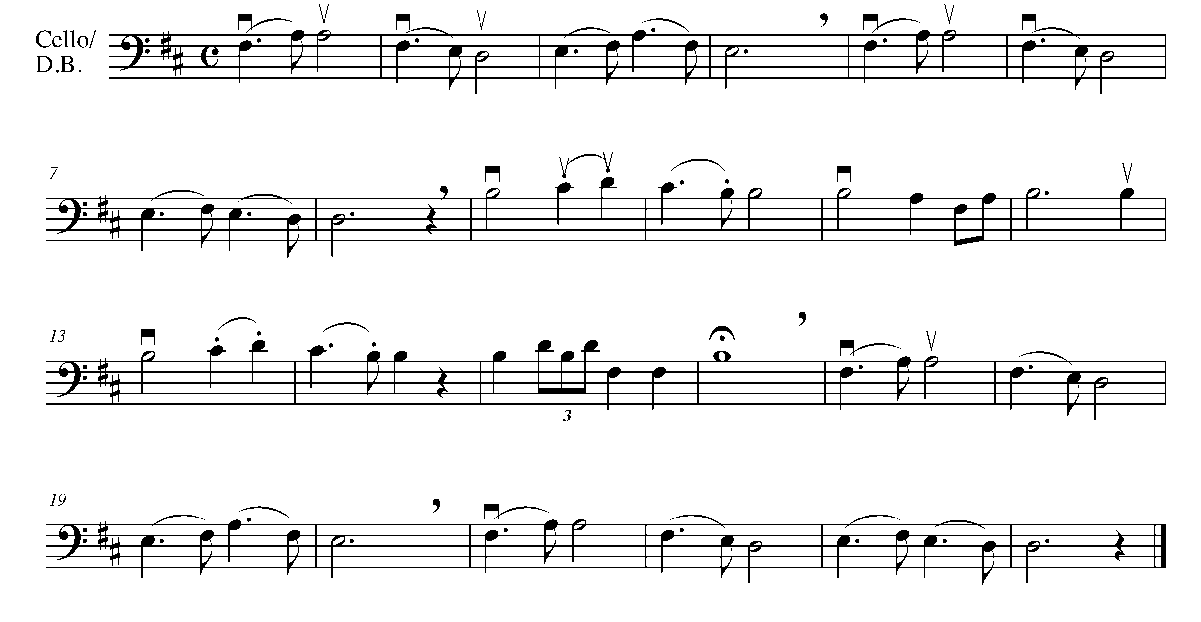

7. HEAR THE DIFFERENCE FOCUS: BINARY FORM VS. TERNARY FORM

LEARNING GOAL: The purpose of this task is to perform the pieces from Task 6 so that you can hear the difference between binary and ternary form.

MINDS ON! Listen to the structure of this piece – can you hear the difference between binary and ternary form? Do you need to perform differently when you have a repeated section? Can you think of other pieces you have encountered that have binary form? ternary form?

ACTION! To be successful with this task, you will need to perform the pieces in task 6 and:

- Scan through the piece and look for any potential “problem” areas (new notes, challenging rhythms, symbols);
- Realize how the form of a piece can affect a performance;
- Demonstrate good musicianship (posture, phrasing and accuracy);
- Perform the pieces for a friend first to receive feedback before performing for your teacher;
- Go back the “Twinkle, Twinkle, Little Star” in Task 1, label it as binary or ternary form.

CONSOLIDATION: In order to move on to the next task, perform the pieces in task 6 for your teacher and receive feedback.

Peer Feedback:
Name of friend:

Things you did well were:

One thing you should work on:

Signed : _________________________
(peer evaluator)

8. BECOME A TERNARY COMPOSER FOCUS: COMPOSITION

LEARNING GOAL: In this task, you will create your own ternary rhythmic composition, which you will use later in task 9 to create a ternary composition.

MINDS ON! What variety of rhythms can you play and will you use in this composition? How will you make the A section different from the B section?

ACTION! To be successful with this task, you will need to:

- USE A PENCIL! – do not create this composition in anything other than pencil;
- Create only the rhythms for an eight bar “A” section, which you write in twice in the given location;
- Create only the rhythm for an eight bar “B” section, which is different from the “A” section;
- Use a variety of rhythms that you know you can play. Go back to task 2, 4, and 6 to help you brainstorm ideas.

CONSOLIDATION: In order to move on to the next task, you need to create a 24-bar rhythm, in ternary form. When completed, show this task to your teacher and receive feedback.

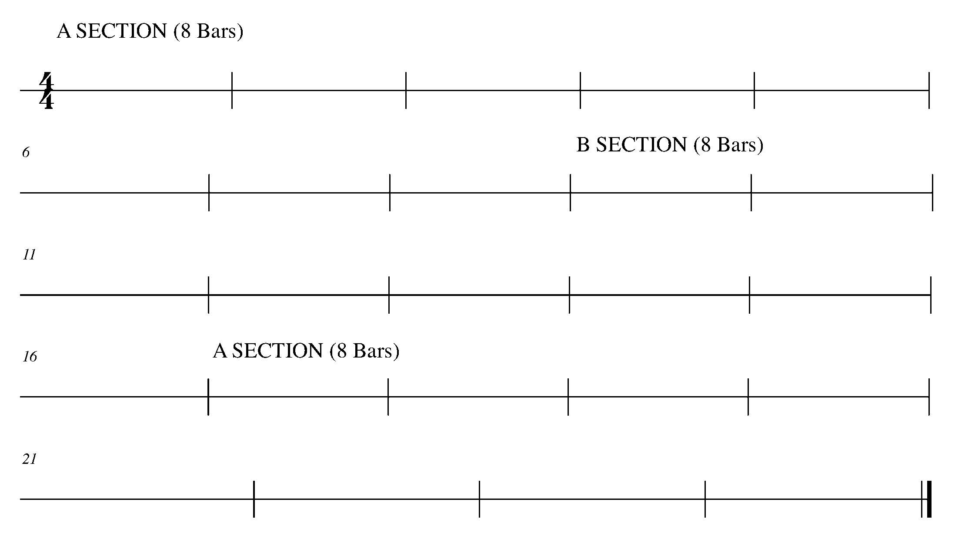

9. ADDING PITCH FOCUS: COMPOSITION

LEARNING GOAL: The purpose of this task is to add pitch to the rhythm created in Task 8.

MINDS ON! What decisions do you need to make when adding pitch to a rhythm? Knowing that you will need to perform this piece in Task 10, consider the following: range, first and last note, and melodic line.

ACTION! To be successful with this task, you will need to:

- USE A PENCIL!!!
- Draw your clef (treble, alto, or bass) at the beginning of the staff;
- Add your time signature;
- Divide each stave evenly so you have 4 bars in each stave, making a total of 24 bars;
- Use the D major key signature (F# and C #);
- Decide upon your starting and ending note;
- Start with Section A – Add pitch to your 8-bar rhythm created in Task 8;
- Move to Section B – Add pitch to your 8-bar rhythm created in Task 8.
- Make sure that the melody between Section A and Section B transition well;
- Complete the final 8 bars with Section A again;
- Make sure you have chosen notes and a range that you can perform on your instrument;
- Give your composition a title; and
- Choose a tempo and add articulation and/or dynamics if so desired.

CONSOLIDATION: In order to move on to the next task, make sure you have completed the items in the ACTION! checklist, then show and perform your composition to your teacher and receive feedback

Title: ______________________________
Section A
________________________________________________________________________________________________________________________________________________________________________________________________________________________________________________________________________________________________________________________________

________________________________________________________________________________________________________________________________________________________________________________________________________________________________________________________________________________________________________________________________

Secton B
________________________________________________________________________________________________________________________________________________________________________________________________________________________________________________________________________________________________________________________________

________________________________________________________________________________________________________________________________________________________________________________________________________________________________________________________________________________________________________________________________

Section A
________________________________________________________________________________________________________________________________________________________________________________________________________________________________________________________________________________________________________________________________

________________________________________________________________________________________________________________________________________________________________________________________________________________________________________________________________________________________________________________________________

10. YOUR TERNARY COMPOSITION FOCUS: CULMINATING TASK

LEARNING GOAL: In this task, you will perform your ternary composition for your teacher and either a small peer group or a class.

MINDS ON! How must you prepare differently when performing your own composition? How will you introduce your composition to your audience? Where will you stand or sit?

ACTION! To be successful with this task, you will need to:
- Organize who your audience will be with your teacher;
- Introduce your composition to your audience;
- Demonstrate good musicianship throughout this piece; and
- Acknowledge the audience after your performance with either a nod of your head or a bow.

CONSOLIDATION: In order to move on to the next task, perform your ternary composition for your teacher and either a class or small peer group, complete the below self –reflection questions and receive feedback.

Self-Reflection:

- When performing this task, I was especially proud of (list 3 things)…
1.

2.

3.

- I was proud of these things because…

- From this performance, I learned that…

- If I were to have another performance again, one thing I would do differently is…

CONGRATULATIONS – YOU HAVE REACHED THE END OF THE SECOND GPS MARKER. BE SURE TO FILL IN YOUR TASK TRACKER.

 DYNAMICS, ARTICULATIONS, SHIFTING, VIBRATO,
THE SOUTH SECTION
FOCUS: EXPRESSIVE CONTROLS
PUTTING IT ALL TOGETHER!!!

11. DYNAMICLY SPEAKING…IN 6/8 TIME FOCUS: DYNAMICS

LEARNING GOAL: In this task, you will review and demonstrate your understanding of a variety of dynamic markings through performance while learning to read and perform rhythms is 6/8 time.

MINDS ON! How do you maintain a good quality of sound while performing a variety of dynamics? How will you demonstrate a range of dynamic levels? What do the numbers in 6/8 time mean? In 6/8 time, how many beats does an eighth note receive? How about a quarter note? How about a dotted quarter note?

ACTION! To be successful with this task, you will need to:

- Be aware this piece is written in G major;
- Think about and determine the rhythm of this piece, how you would count it, and where you should feel the pulse when you play;
- Decide what your forte and your piano should sound like;
- Practice all of the different dynamics, make sure there is an obvious and gradual difference between p, mp, mf and f;
- Demonstrate rhythmic and pitch accuracy;
- Perform the piece below with dynamic and rhythmic accuracy.

CONSOLIDATION: In order to move on to the next task, perform “I’se the B’y” for your teacher and receive feedback.

I’se the B’y
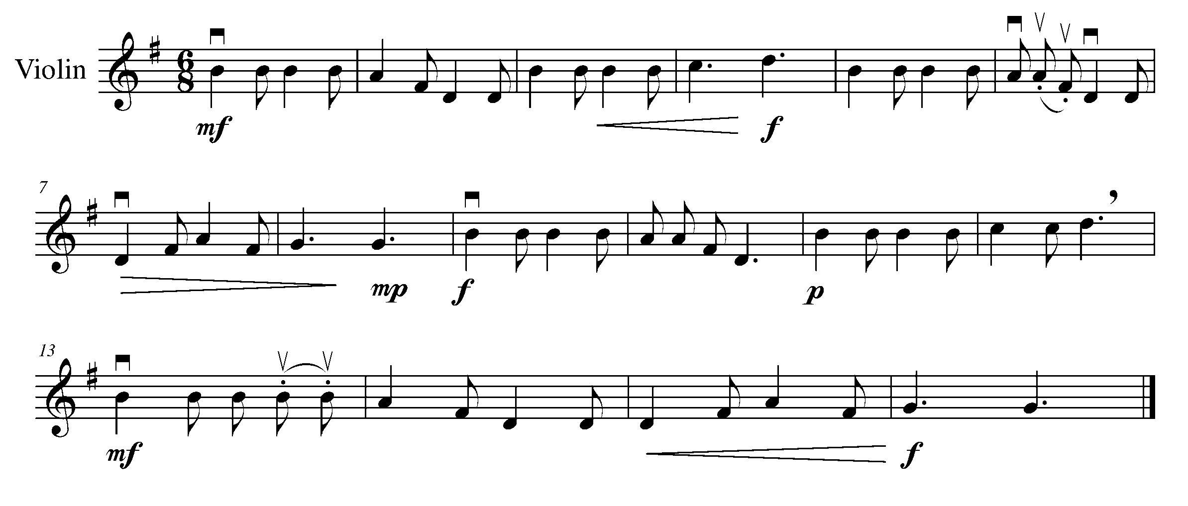
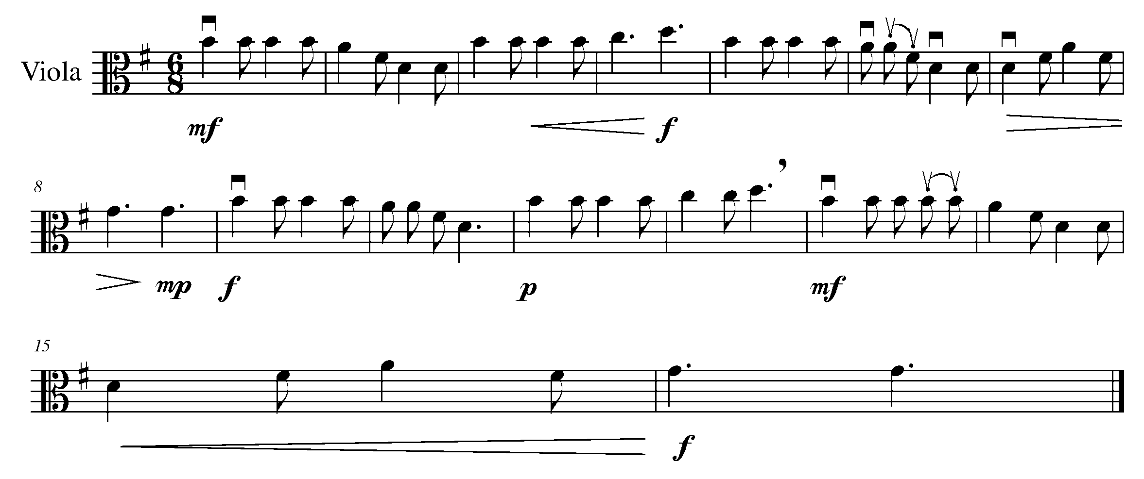
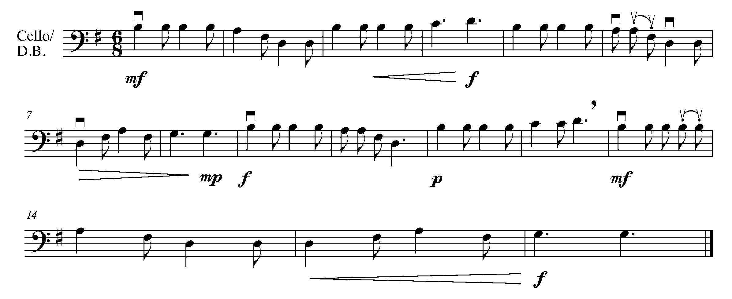

12. ARTICULATING THE DIFFERENCE FOCUS: ARTICULATION

LEARNING GOAL: In this task, you will review and demonstrate the difference of a variety of articulations.

MINDS ON! How do you change the way you play (consider placement of bow, weight, how much bow to use, and other techniques to do with your bow arm) in order to demonstrate the different articulation markings in this piece?

ACTION! To be successful with this task, you will need to:

- Be aware to use your G major finger pattern for this piece;
- Recognize the different articulation markings in the below piece;
- Demonstrate an understanding of proper posture and bow grip; and
- Perform with accuracy and phrasing.

CONSOLIDATION: In order to move on to the next task, perform “Skip to My Lou” for your teacher and receive feedback.

Skip to my Lou
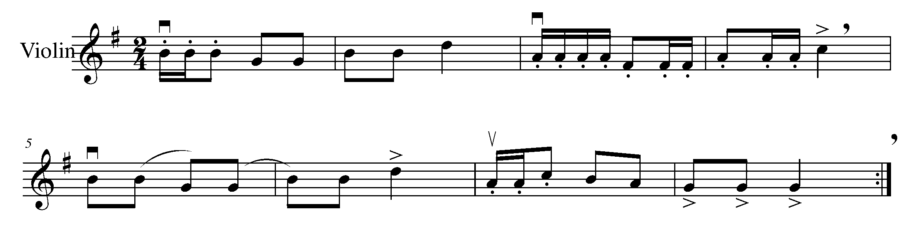
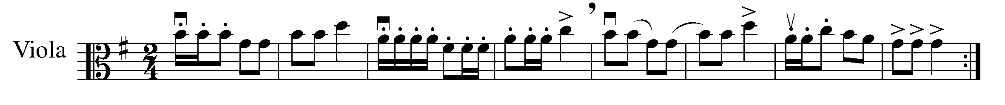
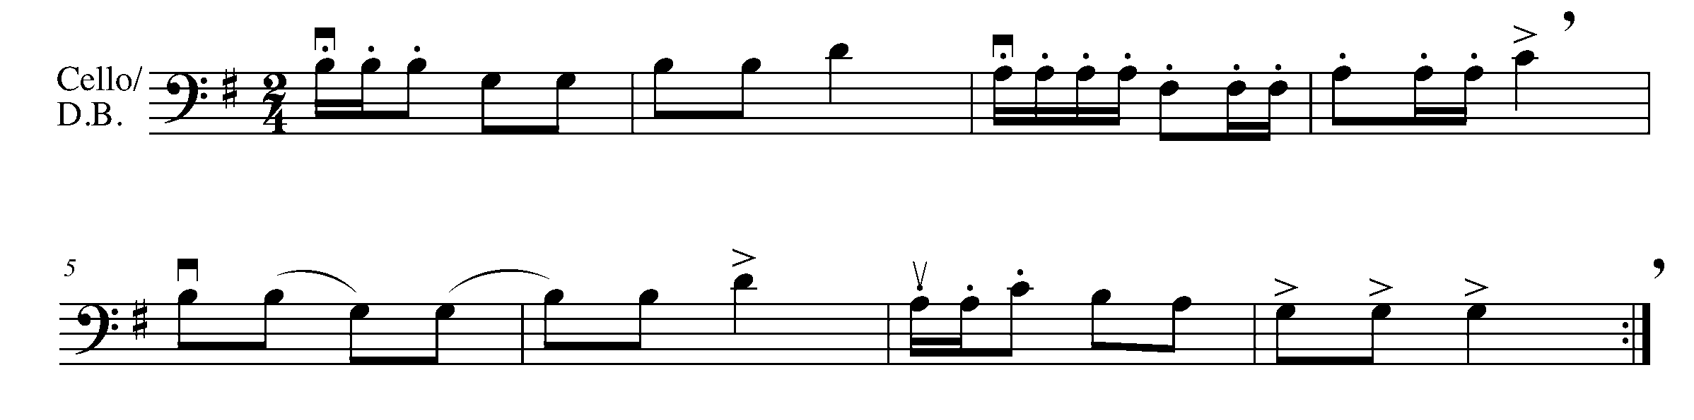

13. FLUID WITH SHIFTING FOCUS: PHRASING/PITCH

LEARNING GOAL: You will learn to shift from 1st position on your instrument to increase your range and fluency while understanding alternative ways of playing the same notes on different strings.

MINDS ON! Why is it important to learn different ways of playing the same notes other than in first position? How will shifting help when performing more advanced pieces?

PAUSE AND PONDER:

On your music, the shifting positions will be written using Roman Numerals. For example, 1st position will be written as: I; third position will be written as III, fourth position will be written as IV, and so on. The numbers on top of the music indicated which finger you should be using.

SHIFTING FROM 1ST POSITION
When first learning a shift, it is helpful to play the shift with an exaggerated glissando so that you hear the notes when going from one position to another. Also, slurring the notes during the shift may help you develop a smooth shift. After the left hand and arm have learned how far they must move, the shift can be refined and played without the exaggerated glissando. The shift is made with the entire hand as a unit. The thumb must shift along with the fingers.

SHIFTING INSTRUCTIONS
1. Move your hand, thumb, fingers and forearm together.
2. Lead with your wrist in the direction of the shift.
3. Slightly release the pressure of the sliding finger during the shift.
4. Keep the sliding finger in contact with the string during the shift.
5. Keep your hand, thumb and forearm relaxed.
6. Slow down the bow speed and lighten the bow pressure during the shift.

ACTION! To be successful in this task, you will need to:
- Perform the Exercise 1 for a friend and receive feedback while demonstrating the proper way of shifting while finding the correct pitch;
- Complete the self-reflection below before moving on to Exercise 2;
- In the Exercise 2, mark the tones and semi-tones for the G major scale in two octaves; and
- Perform the G major scale in two octaves for your teacher using the shifting technique (Be careful as you practise because the G major scale in two octaves uses finger patterns from both the G major and C major scale).

CONSOLIDATION: Perform Exercise 1 for a friend; record how you are going to use their feedback. Then, use shifting to perform the G major scale in two octaves for your teacher and receive feedback.

Exercise 1
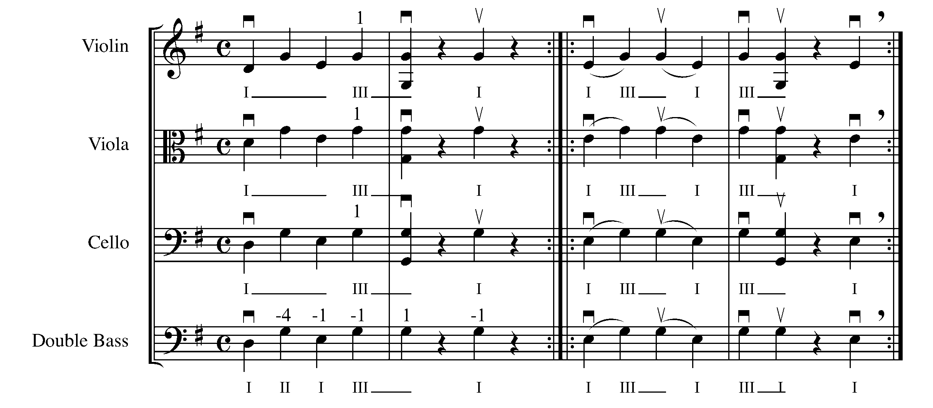

Exercise 2
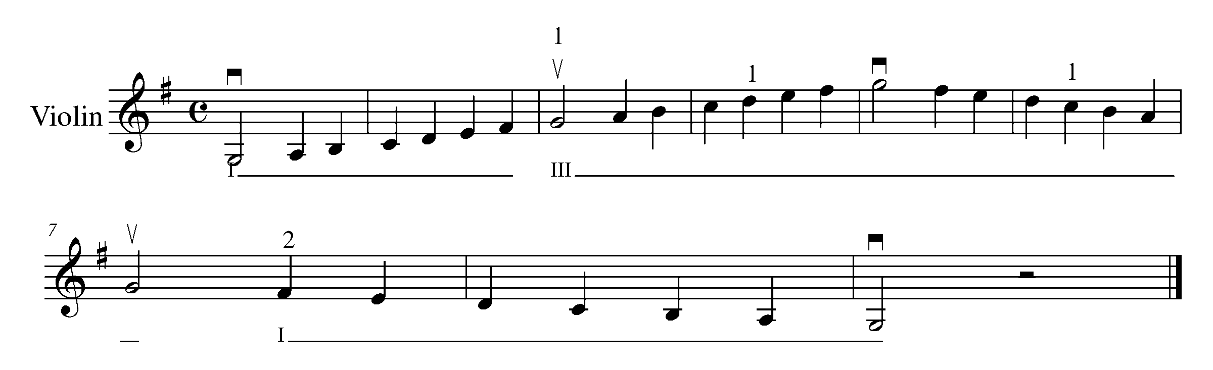
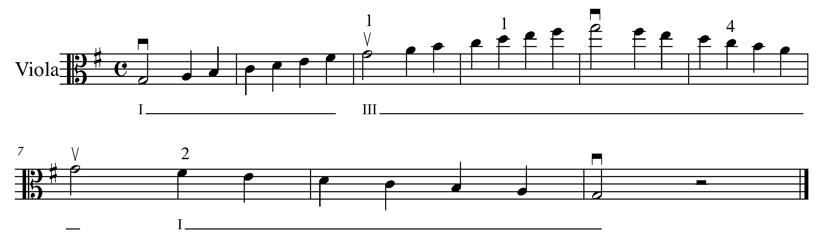
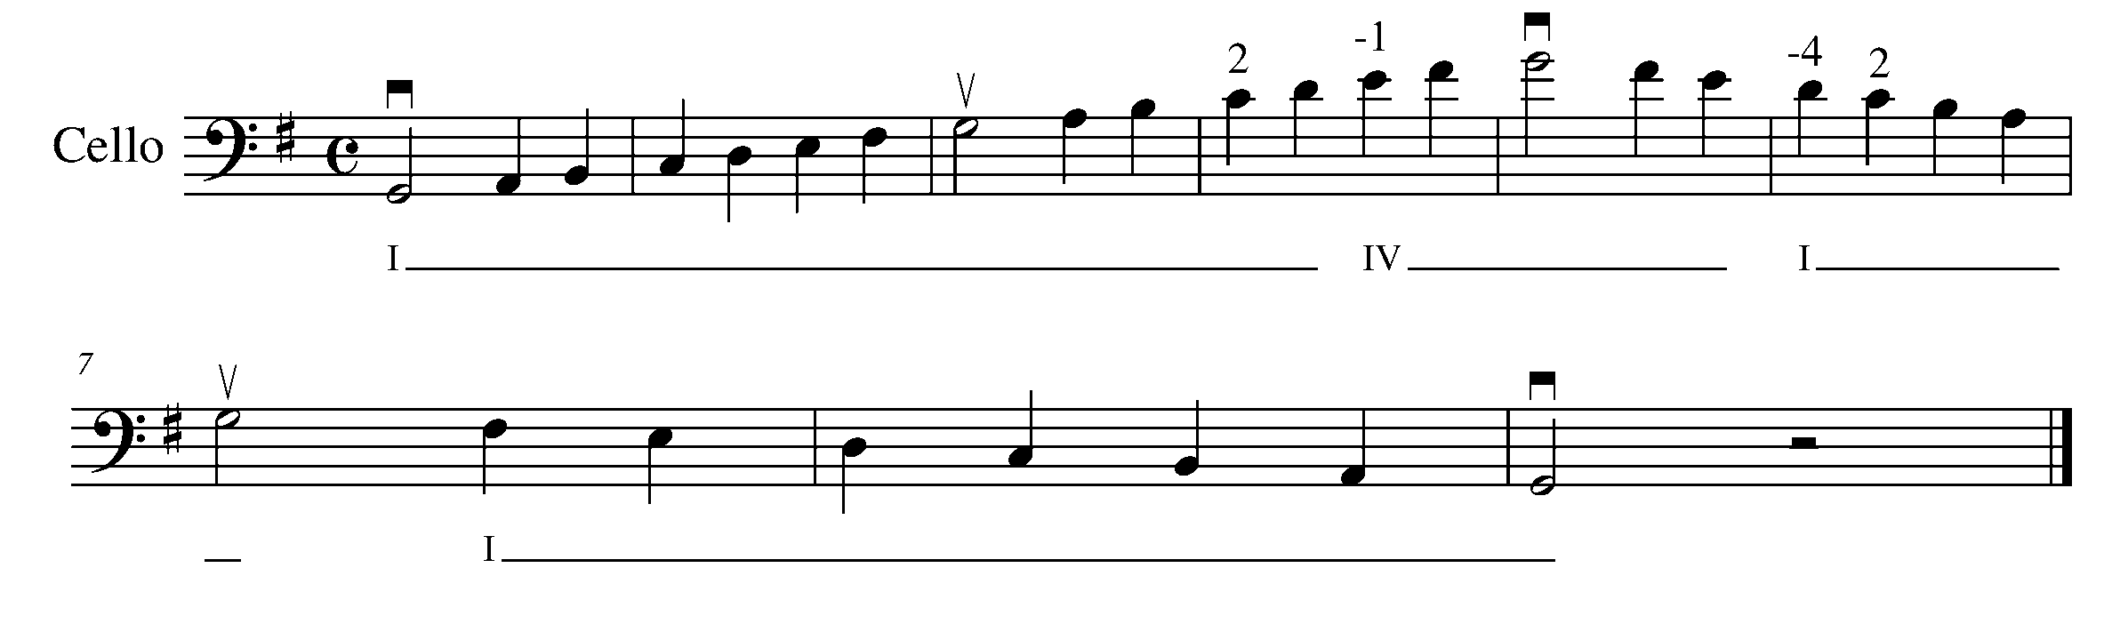
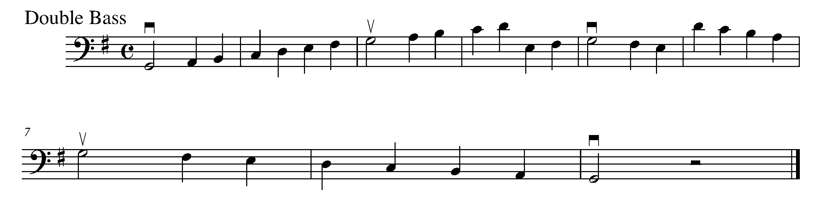

Self-Reflection:
After receiving feedback from ___________________, I need to work on…
(name of friend)
____________________________________________________________________________________________________________________________________________________________________________________________________________________________

14. VIBRATO WITH LEGATO FOCUS: VIBRATO

LEARNING GOAL: You will learn to perform with vibrato to add expression and phrasing to a piece of music.

PAUSE AND PONDER:

Vibrato is a common device used by string players which causes the pitch of a note to change up and down quickly. This is done by moving the finger pressing on the string slightly forwards and backwards. Vibrato is generally used to create a more emotional or expressive sound.

First practise vibrato by putting your first finger down on D string to make the pitch E. Remember to use your finger tip when placing fingers down on your fingerboard. Now keeping your finger on the spot where you would make the pitch E, flatten your finger while pulling your wrist back, so you would make the pitch D#. Starting at the frog of your bow and using legato bowing, play E D# E D# E D# E D# all in one bow while keeping the same finger down, alternating between finger tip and flat finger. Do the same using up-bow. Practise the same technique with your next finger, playing F# F F# F F# F F# F, and your next finger, playing G F# G F# G F# G F#. Once you get the feeling of pulling your finger and wrist back, creating these semi-tone sounds, you may start this exercise over again, moving your fingers faster. Eventually, you will be able to move your fingers on your fingerboard fast enough to make an even vibrato sound.

MINDS ON! How does vibrato change the mood of a piece? Can you use vibrato on music that is not legato? Can you do vibrato on notes played on open strings? How do you know when to use vibrato?

ACTION! To be successful with this piece, you will need to:
- Recognize the different articulation markings in the below piece;
- First learn the piece using proper posture and good phrasing with no vibrato; and
- Choose certain notes (usually notes with longer note values) and add vibrato to them while performing.

CONSOLIDATION: Perform “Land of the Silver Birch” for your teacher and receive feedback.

Land of the Silver Birch
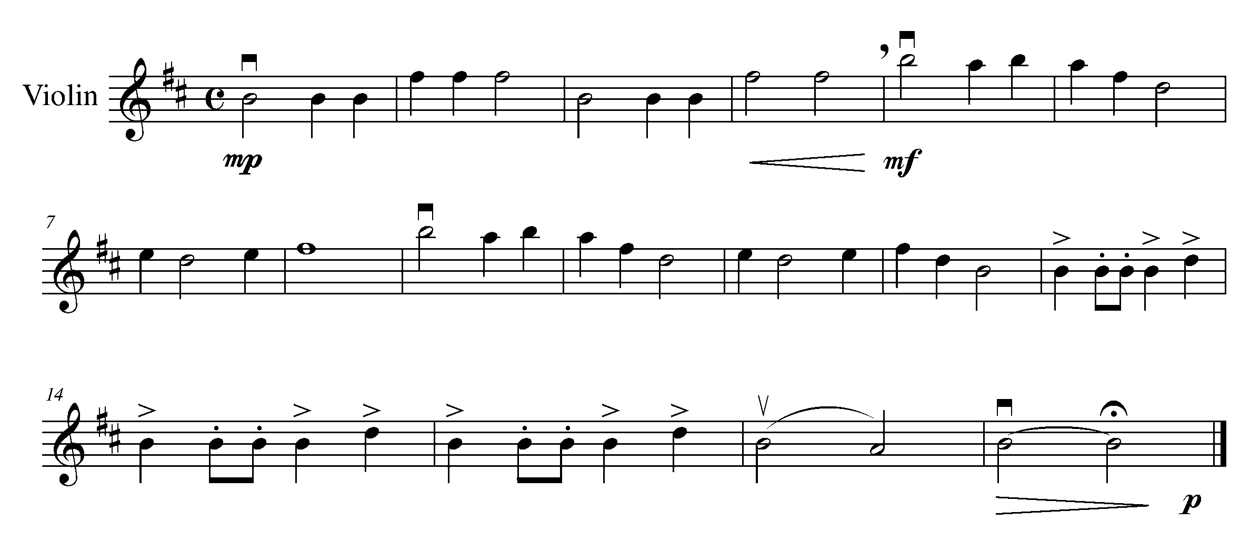
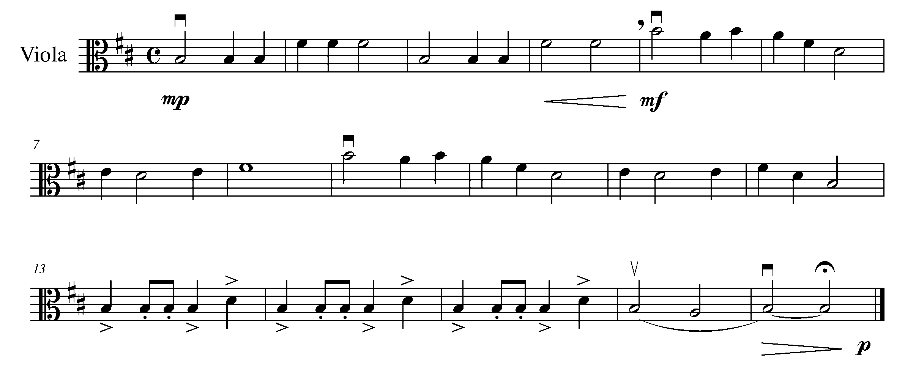
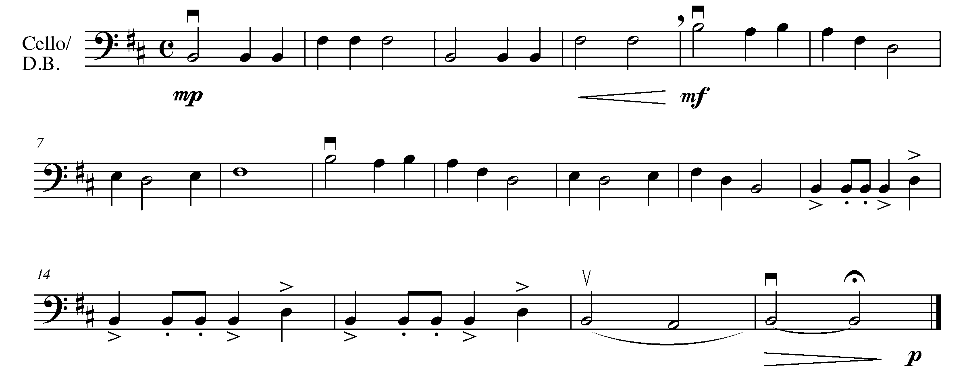

15. TIME TO PUT THINGS TOGETHER FOCUS: CULMINATING TASK

LEARNING GOAL: In this task, you will demonstrate your understanding of a variety of expressive controls introduced in tasks 11 to 14. You will perform “Alouette” with shifting.

MINDS ON! When rehearsing this piece, how will you remember to perform all of expressive controls markings? What should you do first? How important are proper posture and bow arm control within this task?

ACTION! To be successful with this task, you will need to:

- Identify the variety of expressive control markings, try vibrato where appropriate;
- Decide on the phrasing of this piece;
- Choose a tempo at which you can manage all of the expressive controls;
- Practice in chunks, then put it all together; and
- Consider performing this piece for a friend before your teacher.

CONSOLIDATION: In order to move on to the next task, perform the following piece for your teacher and receive feedback.

Shifting with Alouette!!!
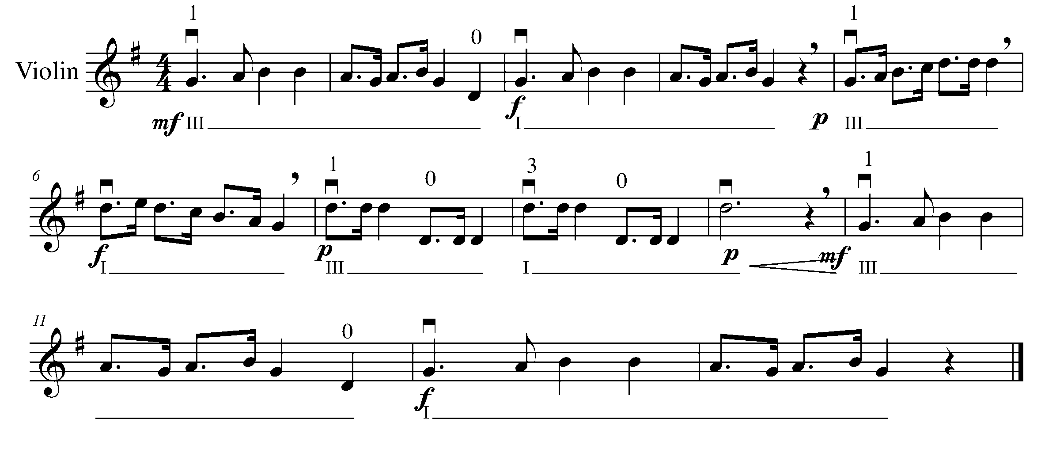
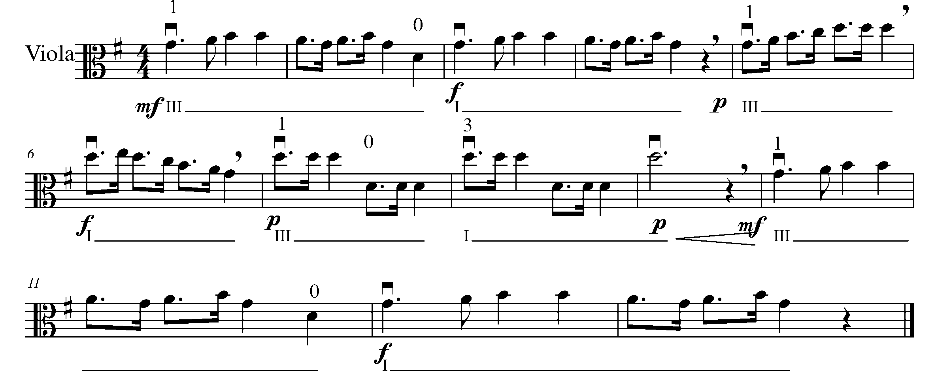
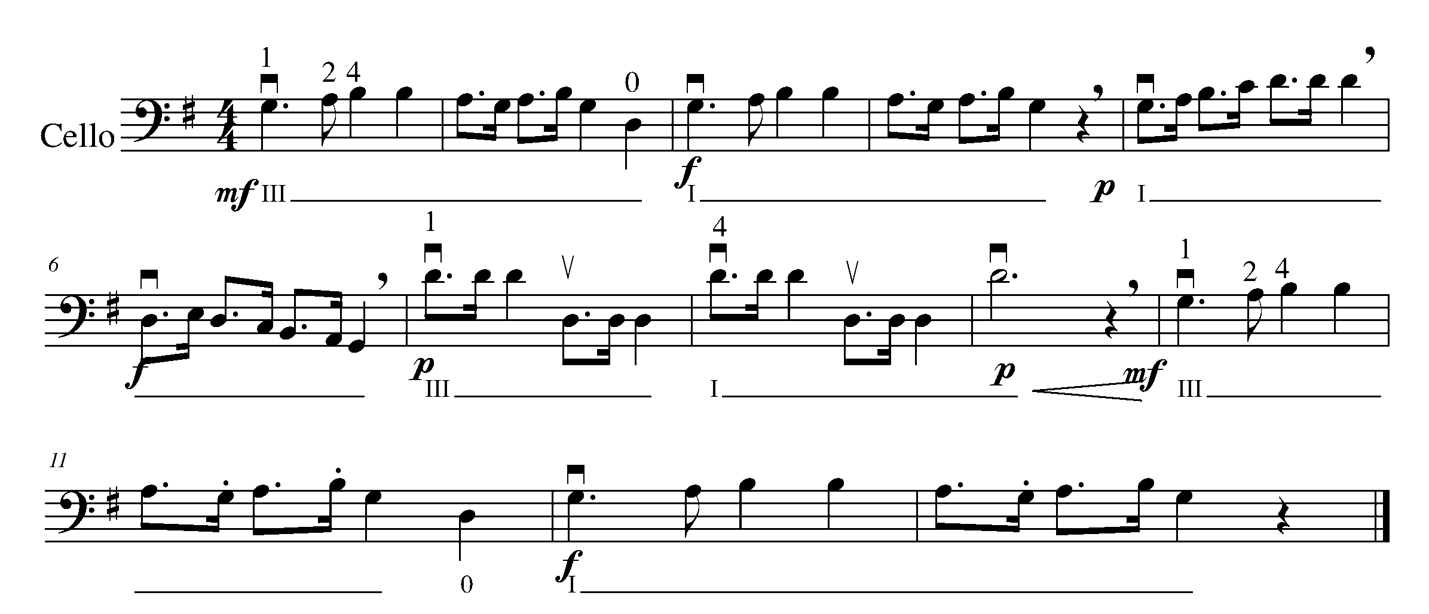
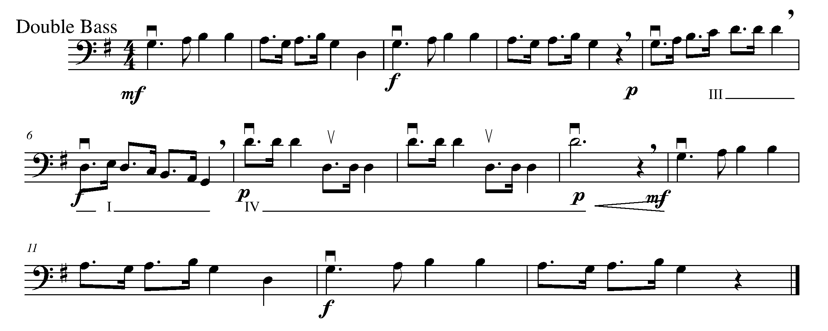

CONGRATULATIONS – YOU HAVE REACHED THE END OF THE THIRD GPS MARKER. CELEBRATE WITH A FAMILY MEMBER, CLASSMATE OR PEER. BE SURE TO FILL IN YOUR TASK TRACKER.

THE WEST SECTION
FOCUS: FORM (ENDINGS)

D.C. AL FINE, D.C. AL CODA, D.S. AL CODA,
1st and 2nd ENDINGS, CULMINATING

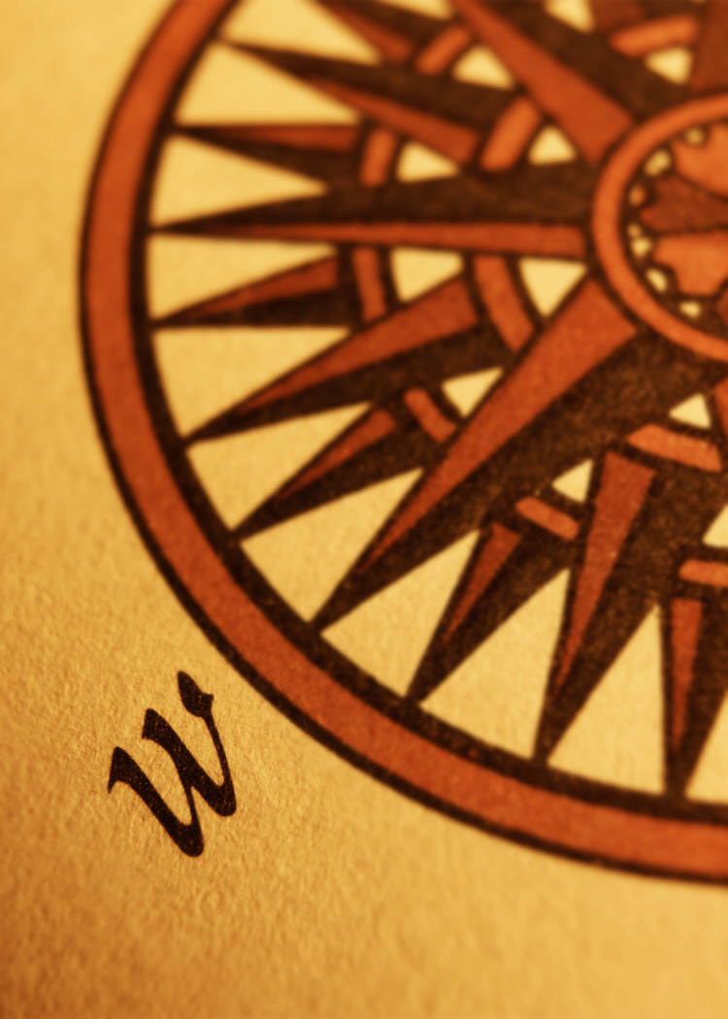

16. FOLLOWING THE ROAD MAP FOCUS: DC AL FINE

LEARNING GOAL: In this task you will learn how to follow the instructions of “da capo” (D.C.) and “al fine”.

MINDS ON! What does da capo and al fine mean in English? Why would composers decide to use these terms in a piece of music? Consider highlighting these words on your music help you to follow the “road map”.

ACTION! To be successful with this task, you will need to:

- Write the definition for “da capo” and “al Fine”;
- Identify where both the “D.C. al Fine” and the “Fine” are in the piece;
- Perform the following piece with proper posture and accuracy in rhythm and pitch as well as following the D.C. al Fine direction;
- Demonstrate an understanding of marked articulation and dynamics; and
- Go back to “Alouette” in Task 15, if you were to cross out the last 4 bars, where would you place D.C. al Fine and Fine on the music to make it sound the same?

CONSOLIDATION: In order to move on to the next task, write the definitions for D.C. and Fine below, and perform “Aura Lee” for your teacher and receive feedback.

D.C. :

Fine:

Aura Lee

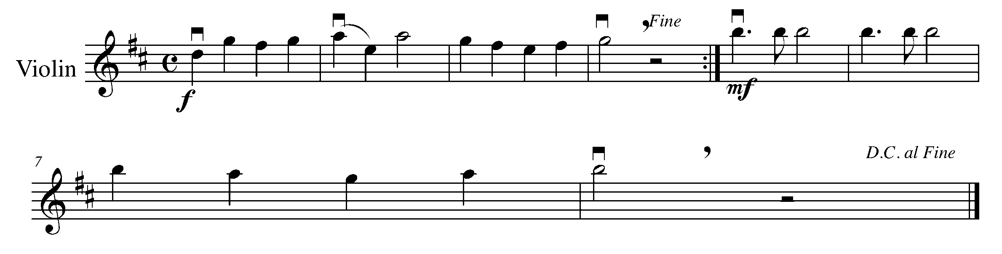
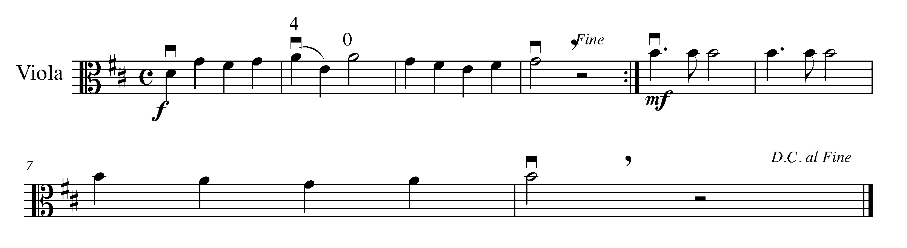
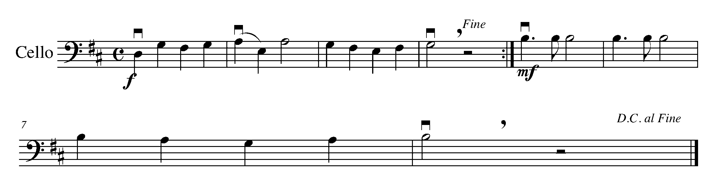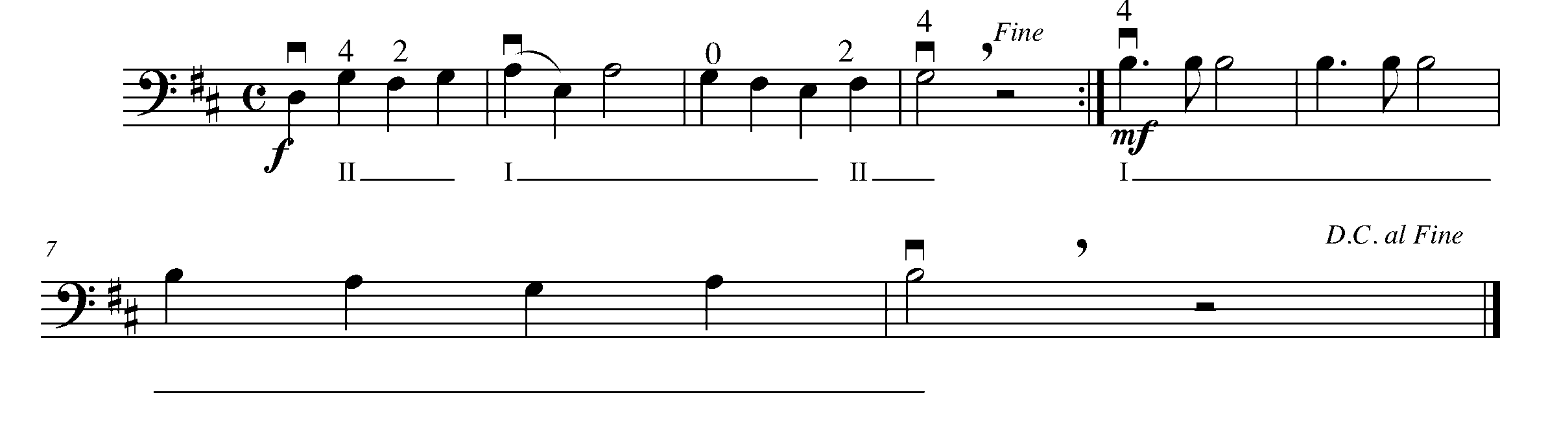

17. INTRODUCING…THE CODA! FOCUS: D.C. AL CODA

LEARNING GOAL: In this task you will be introduced to a section of music called the “coda”. You will also learn how to perform a coda section following the instructions of D.C. al Coda.

The symbol for the Coda is:

MINDS ON! Where is the coda in your music? What is the purpose of a coda? When a piece of music is marked, “D.C. al Coda” what is the composer asking you to do?

ACTION! To be successful with this task, you will need to:

- Identify the “Coda” in your music;
- Determine what is the expectation of D.C. al Coda;
- Accurately demonstrate an understanding of all fundamental music concepts (rhythm, pitch, articulation, dynamics, posture, etc.). Violin, Viola, and Cello players: extend your finger for C# on G string; and
- Perform the following piece with the D.C. al Coda.

CONSOLIDATION: In order to move on to the next task, perform the following piece for your teacher and receive feedback.

Drill, Ye Tarriers
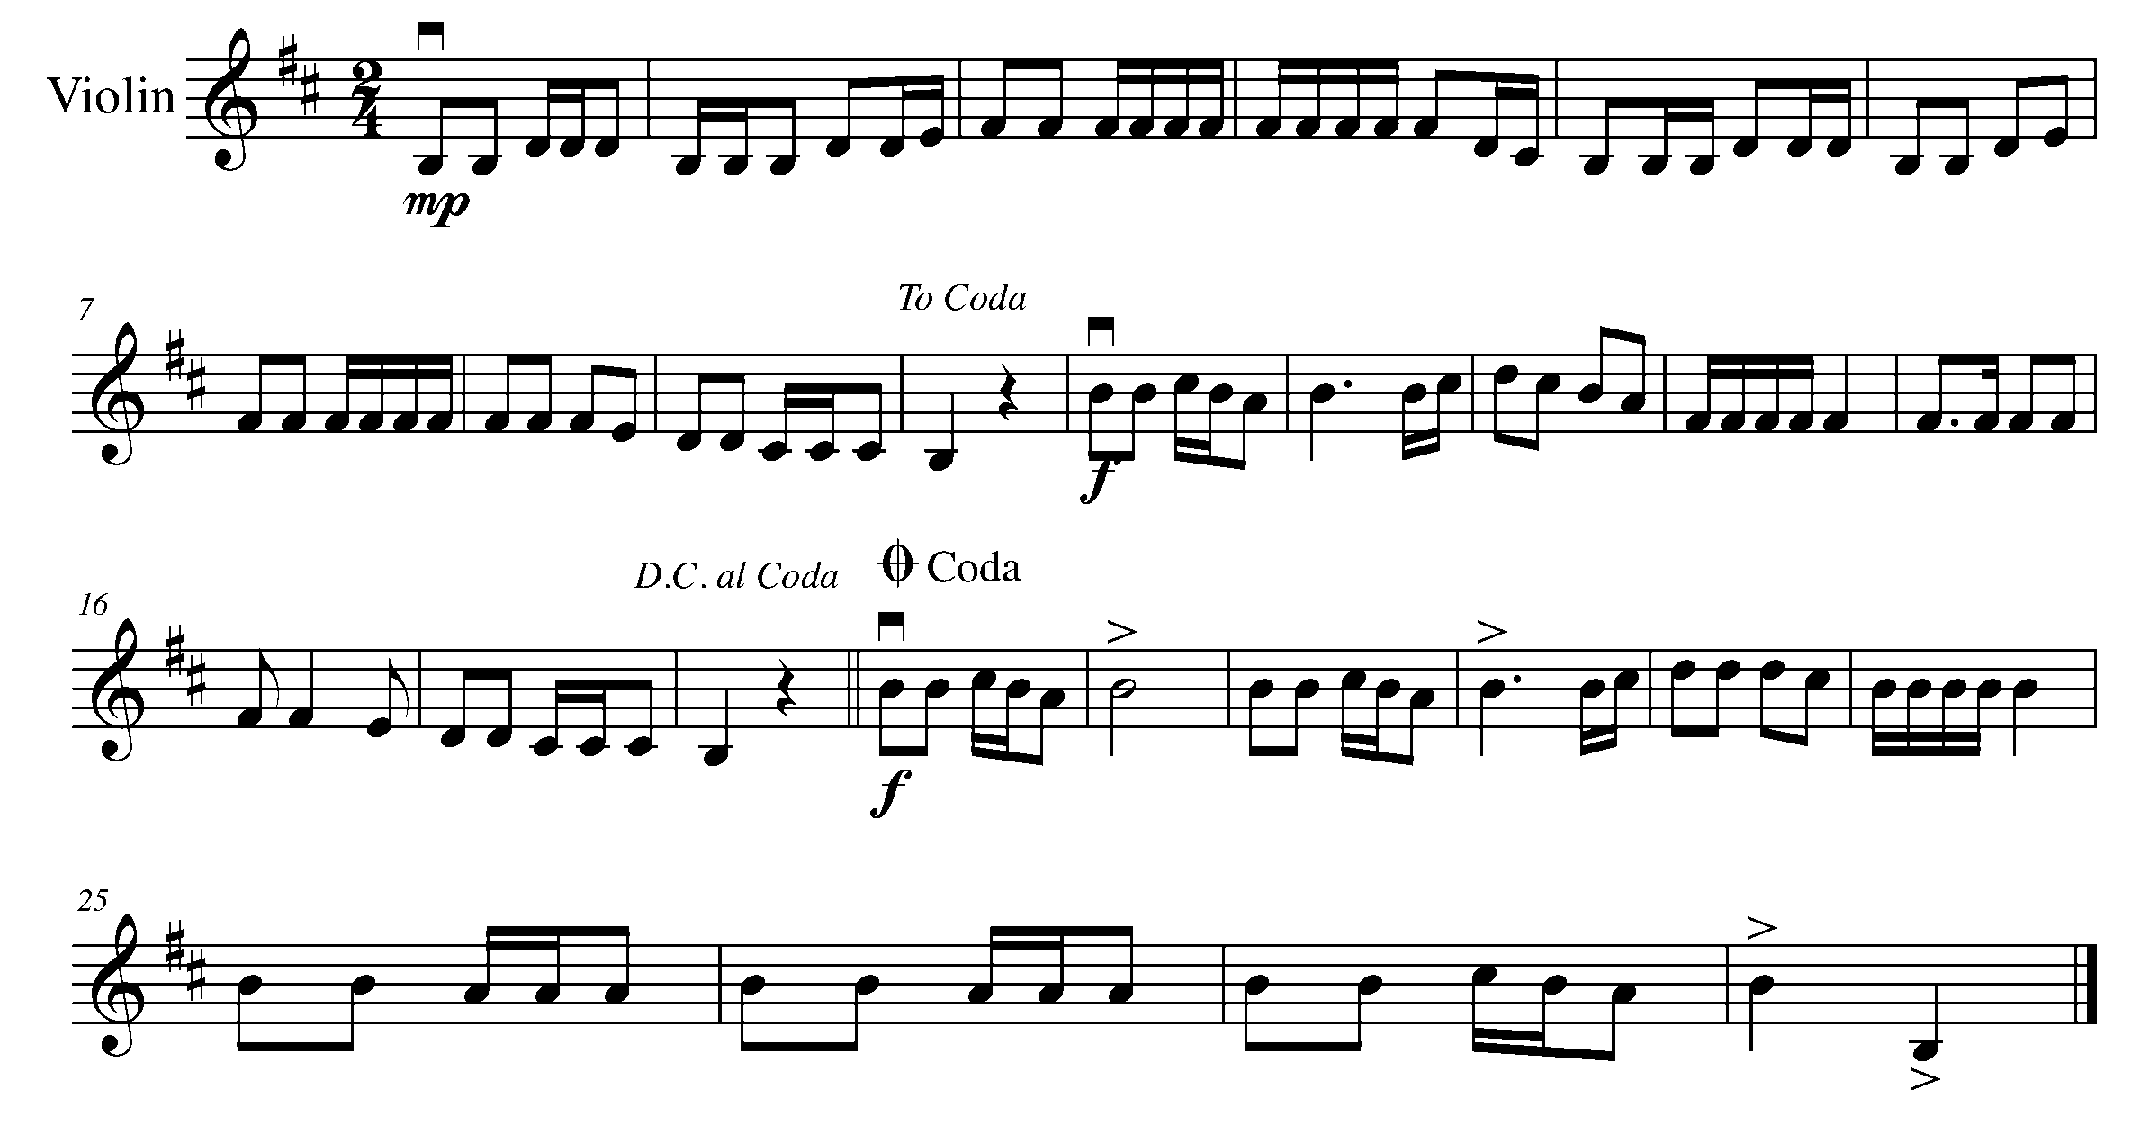
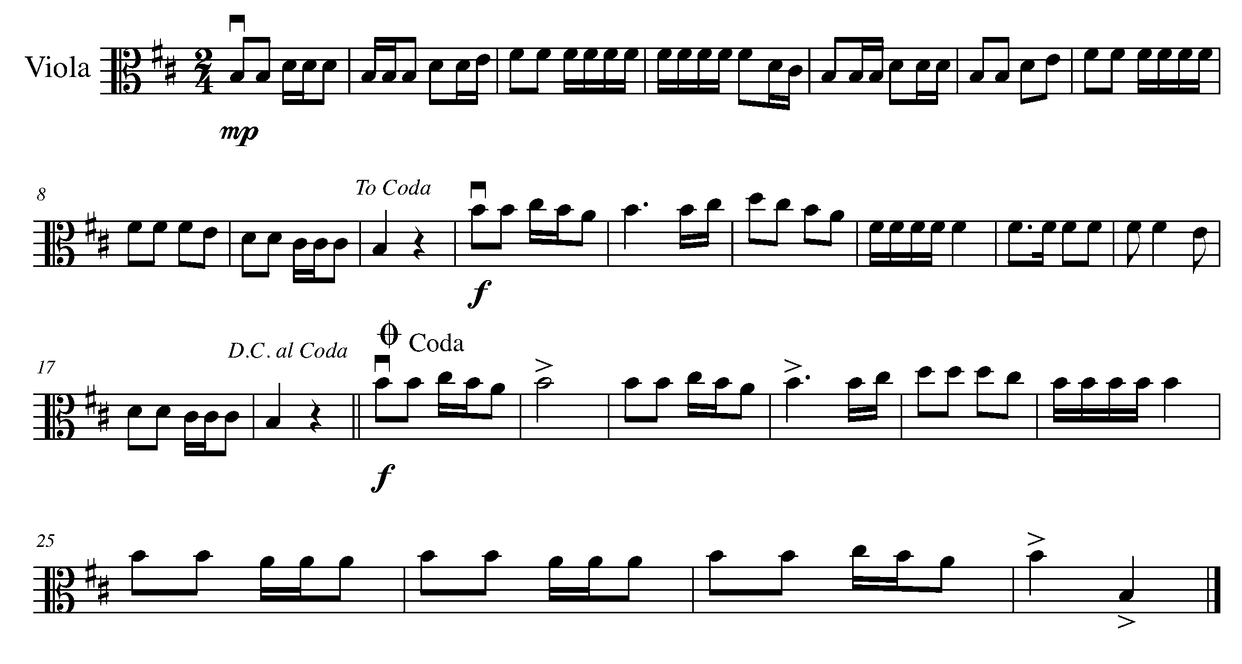
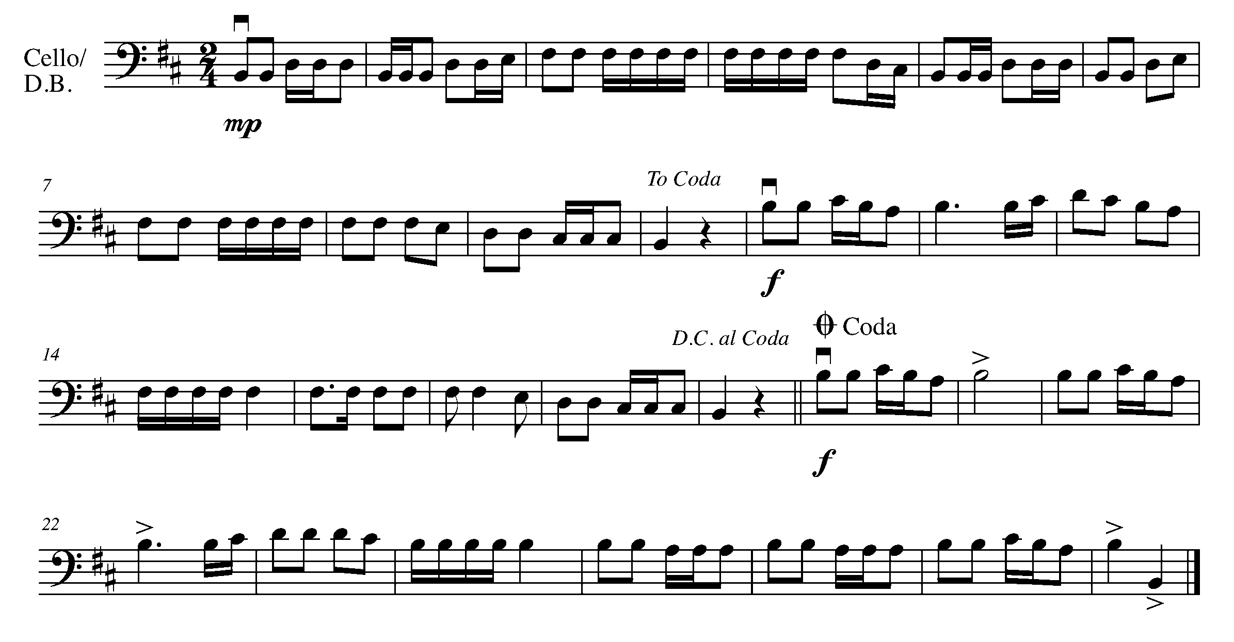

18. AND NOW..DAL SEGNO! (also known as D.S.) FOCUS: D.S. AL CODA

LEARNING GOAL: In this task you will learn about the “dal segno (D.S.)” and how it works when pared with “al coda”.

The sign that you return to when you get to a D.S. is:

MINDS ON! How is D.S. different from D.C.? Why might a composer choose D.S. instead of D.C.? How do you know when to go to the coda? What is the common language that your teacher uses when asking you to observe the D.S. and/or the coda?

ACTION! To be successful with this task, you will need to:

- Figure out the “road map” of this piece, including D.S. al Coda;
- Perform the fundamentals of music with awareness and excellence
- Make sure you hold the ties for their full value

CONSOLIDATION: In order to move on to the next task, perform the following piece for you teacher and receive feedback.

Task 18
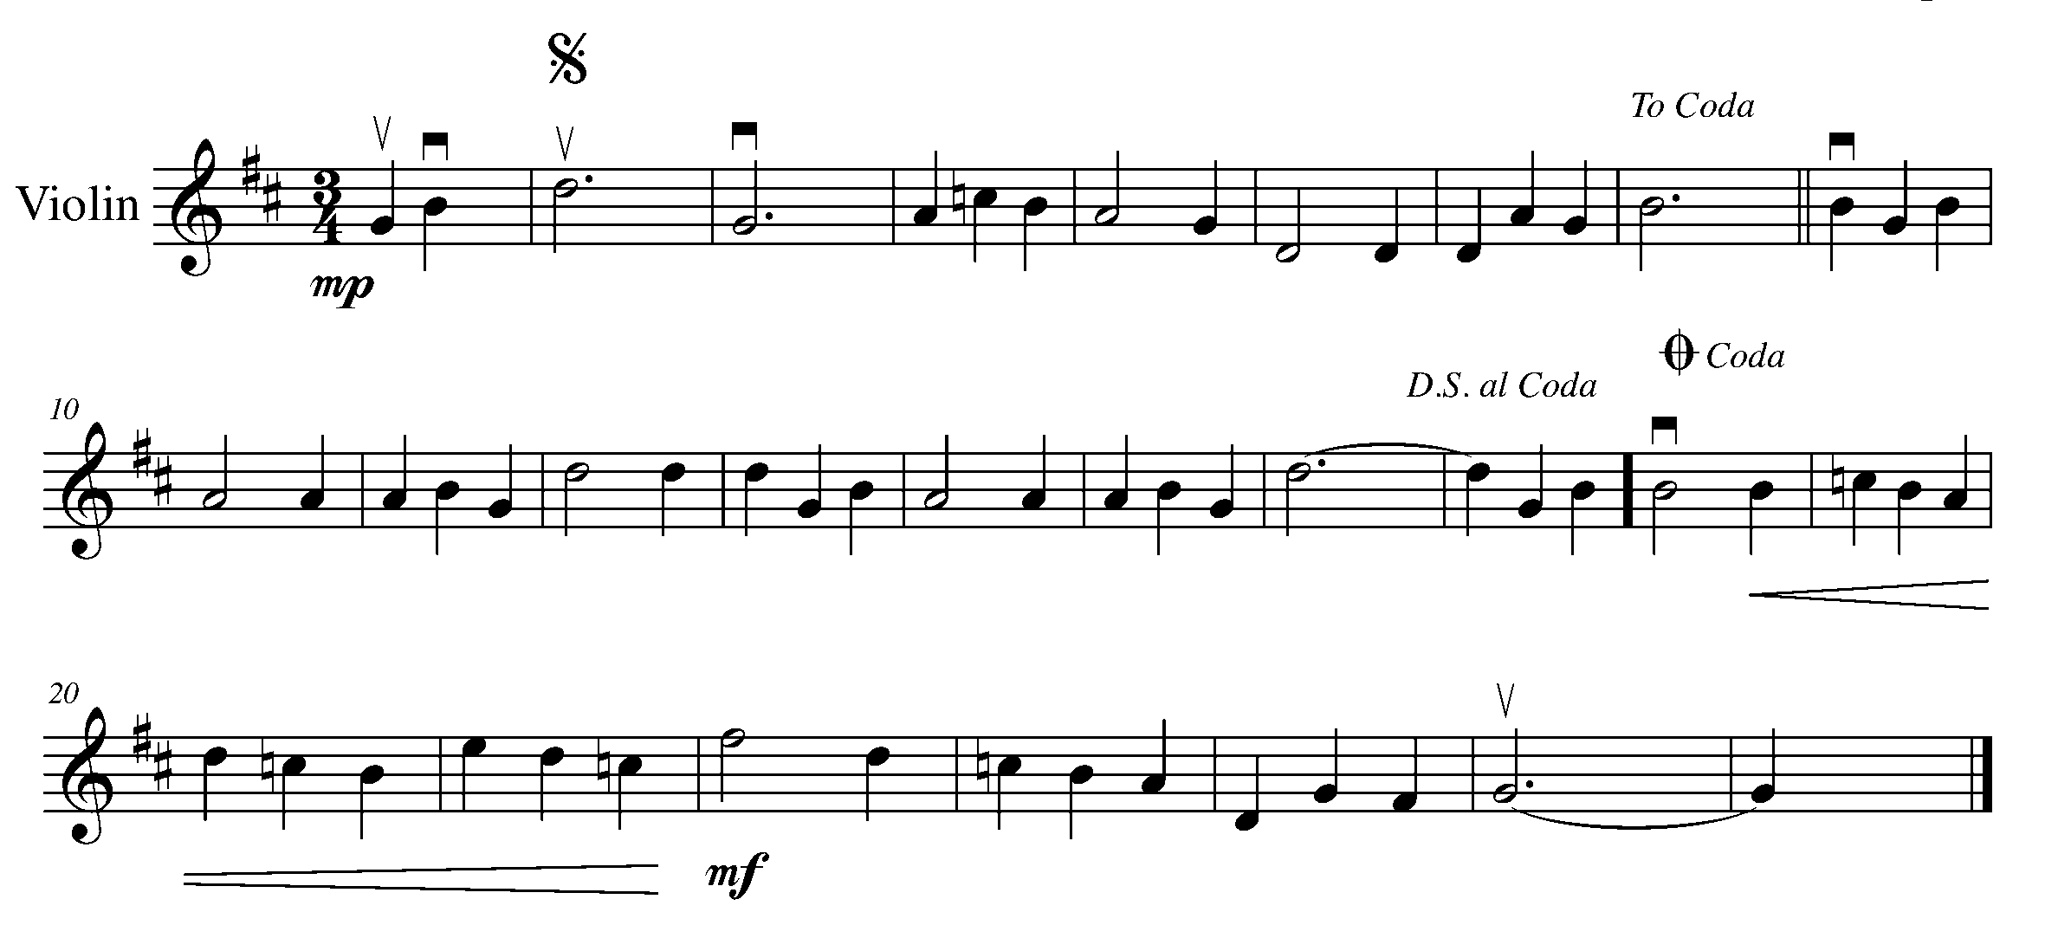

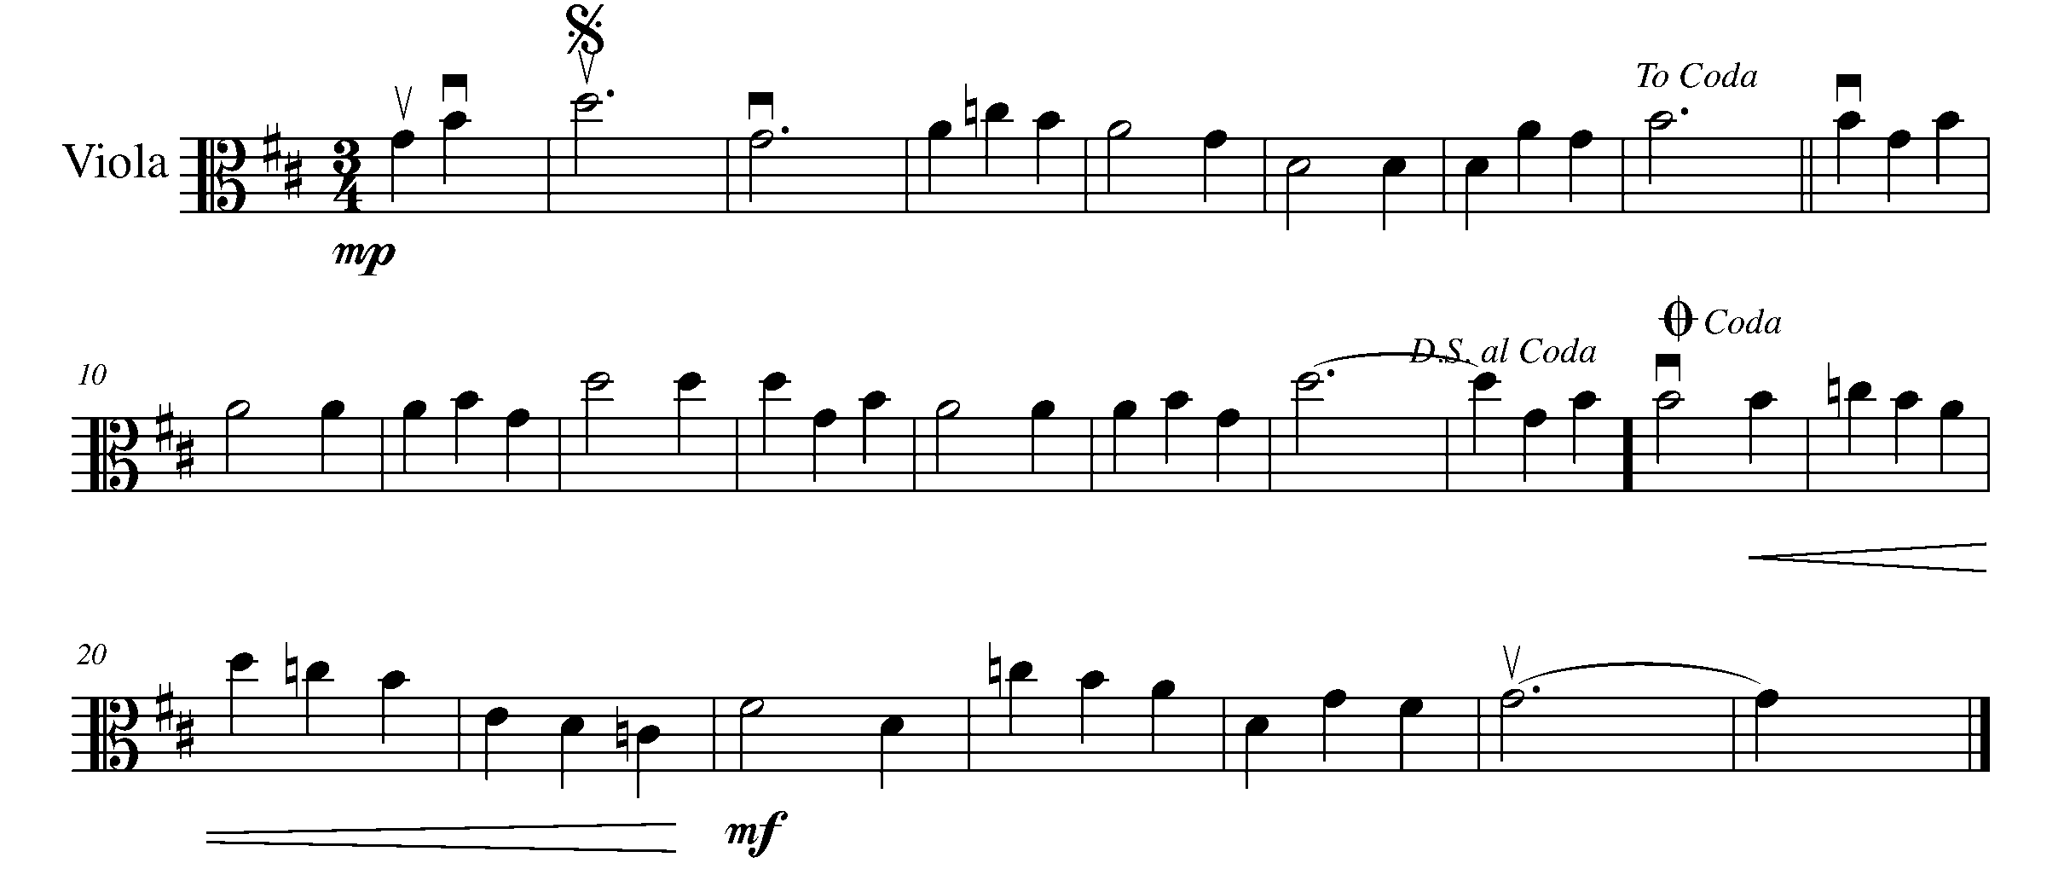
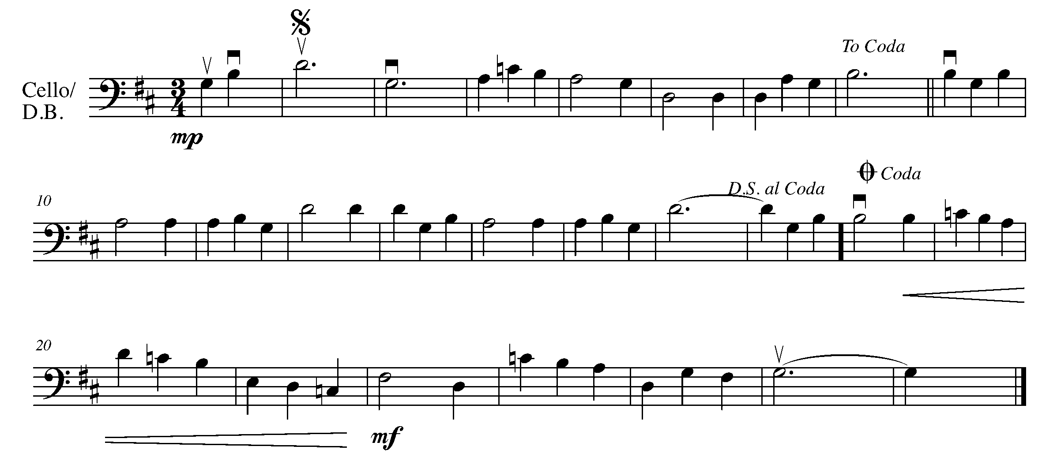

19. YES! ANOTHER ENDING OPTION! FOCUS: 1ST AND 2ND ENDINGS

LEARNING GOAL: In this task, you will understand the concept of 1st and 2nd endings and how it is different then just the normal repeat sign we have learned from Year 1 and Year 2.

MINDS ON! How do you perform 1st and 2nd endings? Why do you think this compositional “shortcut” was created?

ACTION! To be successful with this task, you will need to:

- Identify the 1st and 2nd endings in the following piece of music;
- Be prepared to explain in words how to perform a 1st and 2nd ending – you may look and even trace your music while explaining this to your teacher;
- Be aware this piece is in C Major;
- Following the appropriate tempo marking; and
- Perform the fundamentals of music with awareness and excellence.

CONSOLIDATION: In order to move on to the next task you must:

- Explain in words how to perform 1st and 2nd endings – this might be easier if you look at the piece below and trace your music with your finger while explaining the road map; and
- Perform the following piece for your teacher and receive feedback.

Clementine
American Folk Song

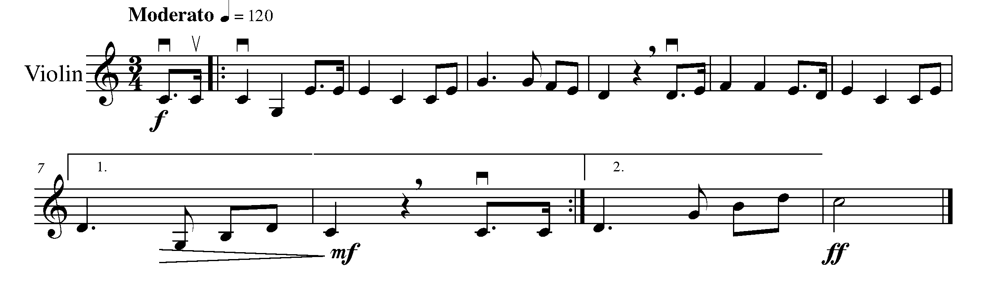
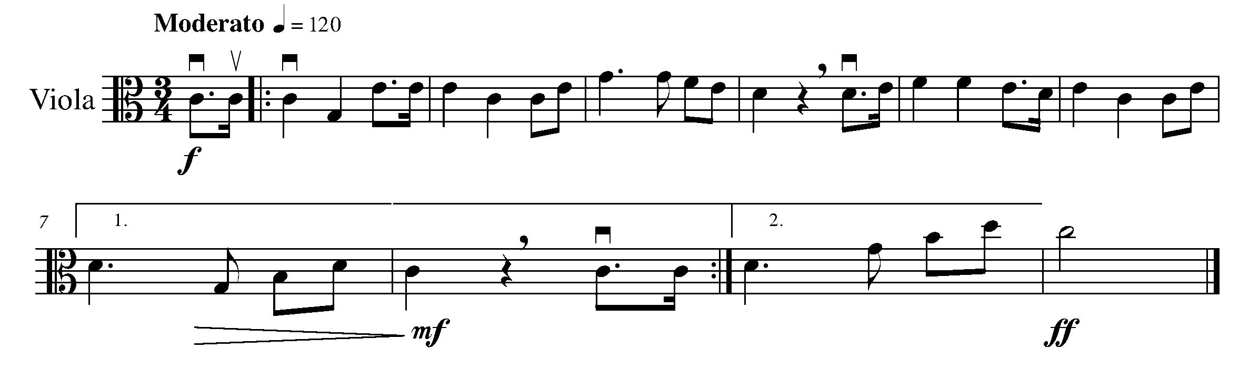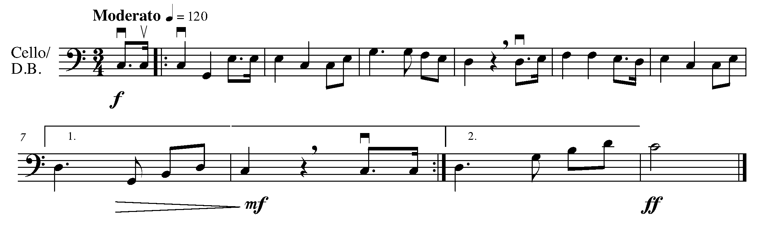

20. THE GPS FINISH LINE! FOCUS: CULMINATING TASK

LEARNING GOAL: The purpose of this task is to perform a piece with a variety of endings as introduced in the final West section of GPS Year Three. You will perform this piece for your teacher and either one friend, a small group or a class.

MINDS ON! What is the road map of the below piece? Are there any rhythms or pitches, which you think might need extra attention? Are you familiar with how to perform all of the articulations and dynamics?

ACTION! To be successful with this task, you will need to:

- Determine the road map of this piece;
- Identify articulations and dynamics;
- Perform the fundamentals of music with excellence; and
- First perform this piece for your teacher and then for either a friend, a small group or a class – as decided by you and your teacher.

CONSOLIDATION: In order to complete the GPS Year Three String Program you must:

- Perform the piece below for your teacher and receive feedback;

- With your teacher, organize a final performance time for a friend, a small group or a class; and

- Perform the following piece for the audience on which you decide in the previous consolidation step. Receive peer feedback from your friend(s).

Grand March from Aida
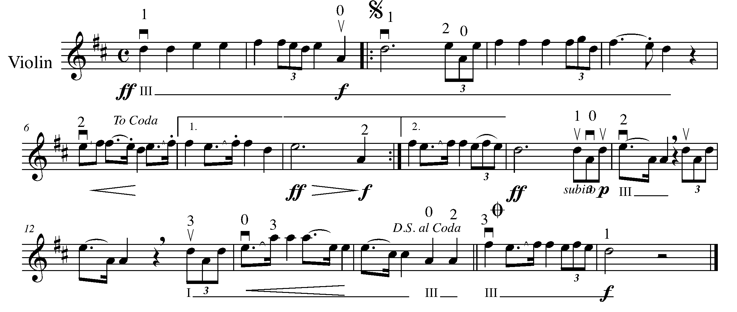
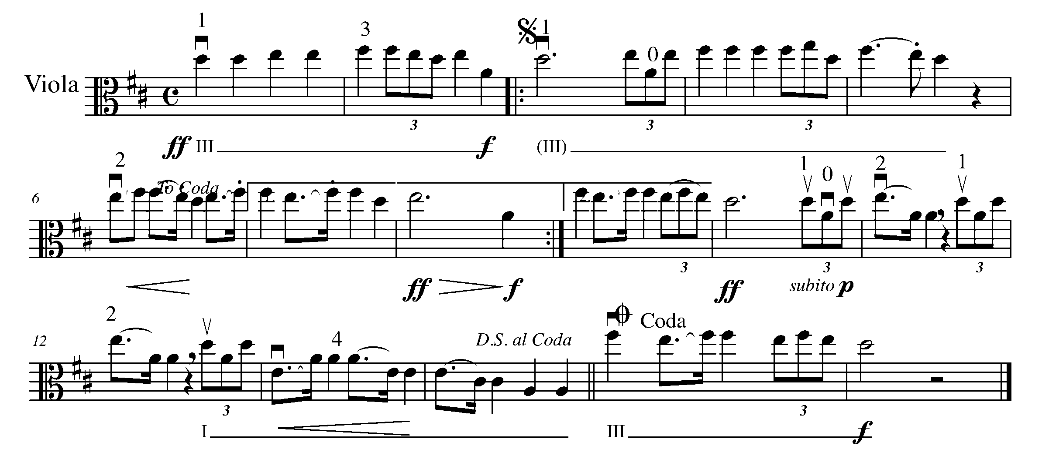
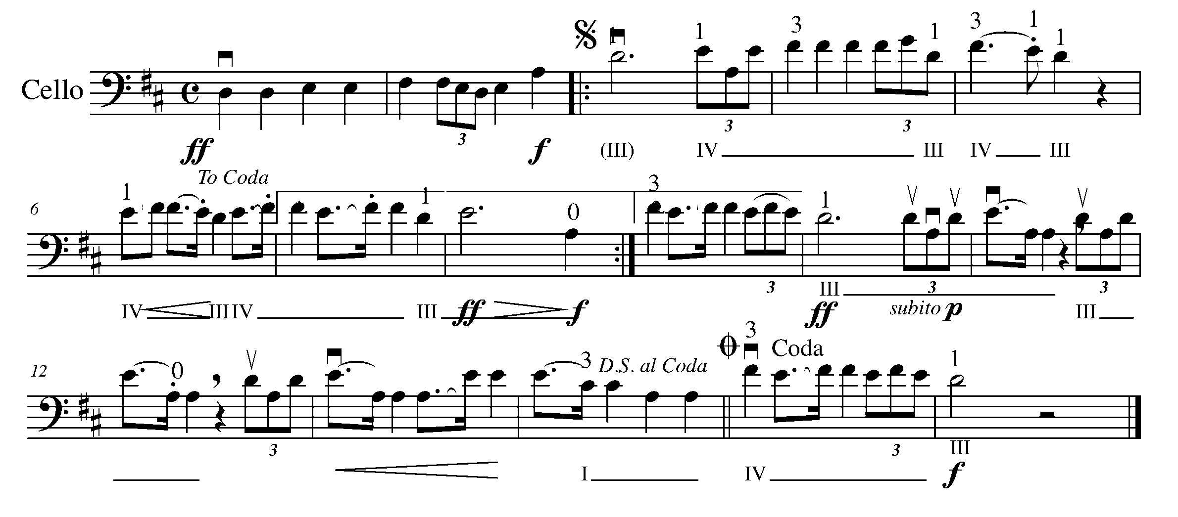
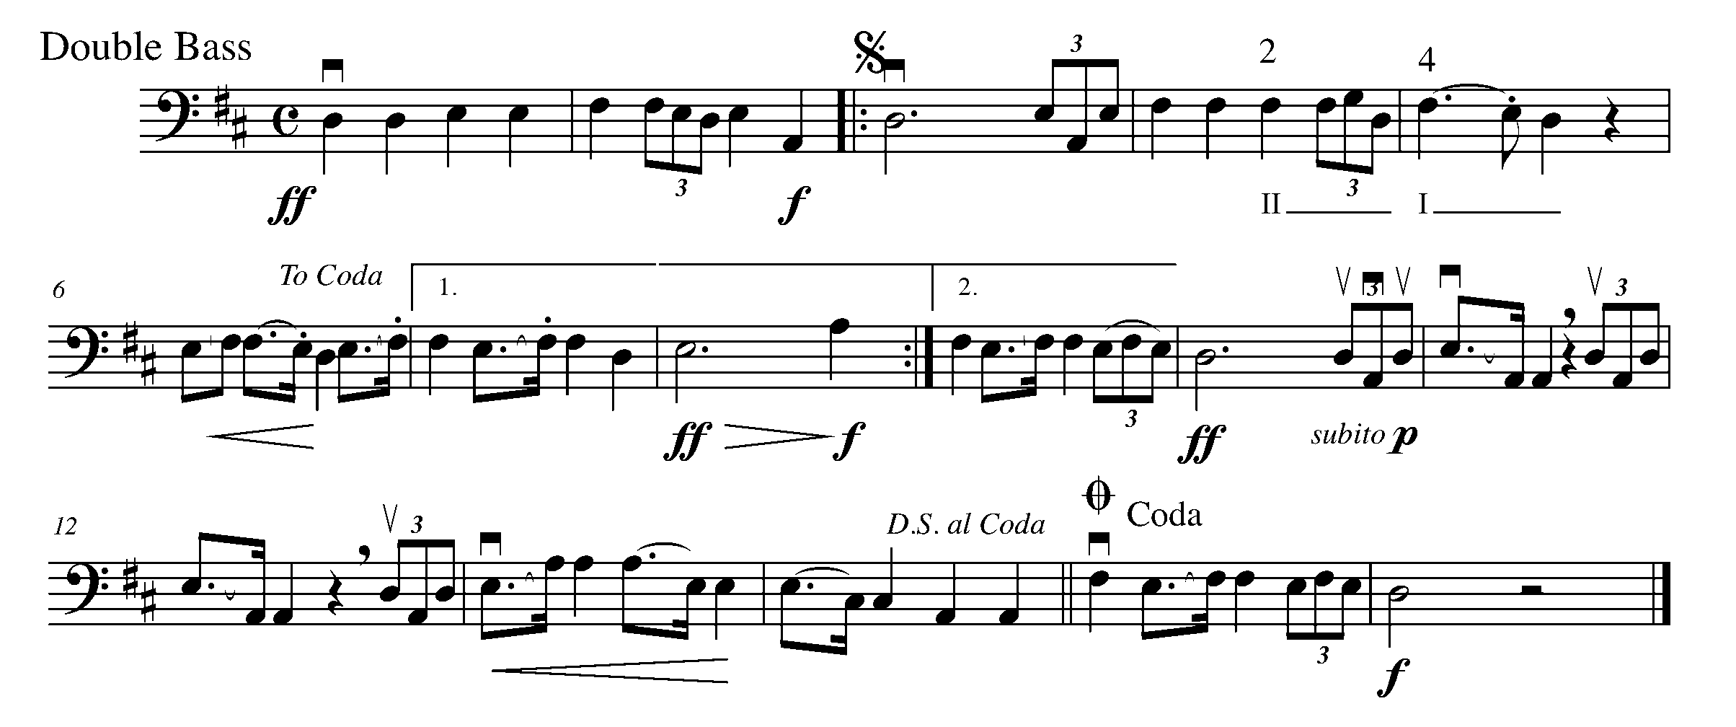

To be completed by one of your audience members.

Name of evaluator:

In this performance, I especially liked:

One special thing I noticed:

Now that I have heard someone perform this task, one thing I would do differently at my own performance:

CONGRATULATIONS YOU HAVE COMPLETED THE WEST SECTION AND THE YEAR THREE GPS PROGRAM. BE SURE TO COMPLETE YOUR TASK TRACKER AND CELEBRATE YOUR ACCOMPLISHMENTS!!

TASK TRACKER
East
East
North
Task # 3
Task # 1
Task # 2
Task # 4
Task # 6
Task # 7
Task # 8
Task # 9
Task # 5
Task # 10

South
West
Task # 13
Task # 12
Task # 11
Task # 14
Task # 18
Task # 17
Task # 16
Task # 19
Task # 20
Task #15

Congratulations!

__________________ has reached the North GPS Marker in the 3rd Year String Program.

_________________________________
Teacher Signature

_________________________________
Principal Signature

Congratulations!

__________________ has reached the East GPS Marker in the 3rd Year String Program.

_________________________________
Teacher Signature

_________________________________
Principal Signature

Congratulations!

__________________ has reached the South GPS Marker in the 3rd Year String Program.

_________________________________
Teacher Signature

_________________________________
Principal Signature

Congratulations!

__________________ has reached the FINAL (West) GPS Marker in the 3rd Year String Program.

You’re Done!!

_________________________________
Teacher Signature

_________________________________
Principal Signature

