Teachers, before you copy this booklet for your students...
⬰ Have you read the GPS Overview?
⬰ Have you taught these students before? If not, please take the time to work with your students to determine their strengths and needs before deciding which tasks will be appropriate.
⬰ Have you gone through the appropriate start-up steps with your students? For example; the basics on setting up their instrument, care and maintenance of their instrument, posture and bow grip.
⬰ If you have taught these students before...go through the entire program task-by-task to confirm that the sequence and challenge level of the tasks, is appropriate.
⬰ Refer to the Q and A section of the GPS Overview.
⬰ Do you need to reduce the number of tasks...how will you need to change the evaluation by term?
⬰ If you have questions, please contact:
Justina So: justina_so@yahoo.ca

GPS Task Evaluation Chart
TEACHER REFERNCE
Year Two Strings

This is assuming that this program starts in late October early November

Tasks  (Completion of “X” task number equals “Y” %) | Term 1 (September to February) | Term 2 (February to June)
1 | 52% | 32%(R)
2 | 55% | 35%(R)
3 | 58% | 38%(R)
4 | 62% | 42%(R)
5 | 65% | 45%(R)
6 | 68% | 48%(R)
7 | 72% | 52%
8 (taught to) | 75% | 55%
9 | 78% | 58%
10 | 82% | 62%
11 | 88% | 65%
12 | 92% | 68%
13 | 98% | 72%
14 (taught to) | 100% | 75%
15 |  | 78%
16 |  | 82%
17 |  | 88%
18 |  | 92%
19 |  | 98%
20 |  | 100%

Tasks 15 to 20 serve as extensions and culminating activities which encompass the concepts learned or introduced in Tasks 1 to 14. What you must teach are the 14 tasks by the end of the year.

GPS
(Grade Performance Steps)

The Road to Musical Success!

Intermediate Strings Performance Tasks
YEAR TWO





Ontario Music Educators’ Association
www.omea.on.ca

GPS Task STUDENT Evaluation Chart
Year Two Strings

In order to be successful this year, you will need to plan out how many tasks you think you can complete, and the mark you want to receive for performing on your instrument! Below is a summary of the number of tasks per term, and the mark you will receive for the tasks you complete:

Tasks  (Completion of “X” task number equals “Y” %) | Term 1 (September to February) | Term 2 (February to June)
1 | 52% | 32%(R)
2 | 55% | 35%(R)
3 | 58% | 38%(R)
4 | 62% | 42%(R)
5 | 65% | 45%(R)
6 | 68% | 48%(R)
7 | 72% | 52%
8( taught to) | 75% | 55%
9 | 78% | 58%
10 | 82% | 62%
11 | 88% | 65%
12 | 92% | 68%
13 | 98% | 72%
14 (taught to) | 100% | 75%
15 |  | 78%
16 |  | 82%
17 |  | 88%
18 |  | 92%
19 |  | 98%
20 |  | 100%

Performance is just one part of your music evaluation this year. Your teacher will let you know what the other aspects of your program are on your two summative report cards.

Remember that with the GPS tasks:
- we will be learning concepts introduced as a class;
- you will have time in class to practice and receive feedback from your teacher and classmates;
- you will have multiple opportunities to demonstrate these tasks;
- you need to demonstrate at least a Level 3 performance (your teacher will talk with you about what a Level 3 demonstration would sound like);
- in order to be successful, you will need to work independently in class, and outside of class time (recess, lunch, after school and practice at home); and
- you can track your progress with the task tracker found at the end of the booklet.
GPS Year Two Strings

1. BOW GRIP AND INSTRUMENT POSITION FOCUS: BEAT

Learning Goal: This is a review from last year’s GPS program. You will practice correct bow grip and proper playing position on your open strings while using different rhythms.

Minds On: How do you make sure you have a correct bow grip and playing position? Even professionals are constantly revising their bow grip and how they hold their instrument to refine their playing. This activity should be part of your daily practice routine.

Action! In order to be successful with this task, you will need to:
- Play down-bow and up-bow for each string starting from the lowest pitched string;
- Play this example using half notes, legato quarter notes, legato eighth notes and sixteenth notes in the middle of the bow;
- Keep your shoulder and elbow relaxed; and
- Play with your bow at least half way between the bridge and the fingerboard.

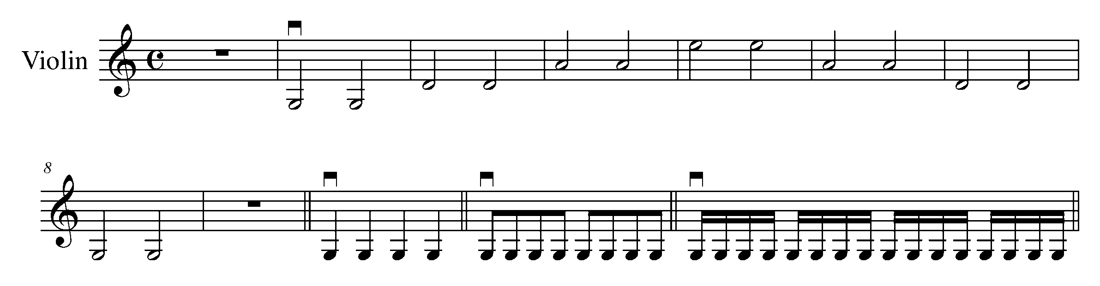
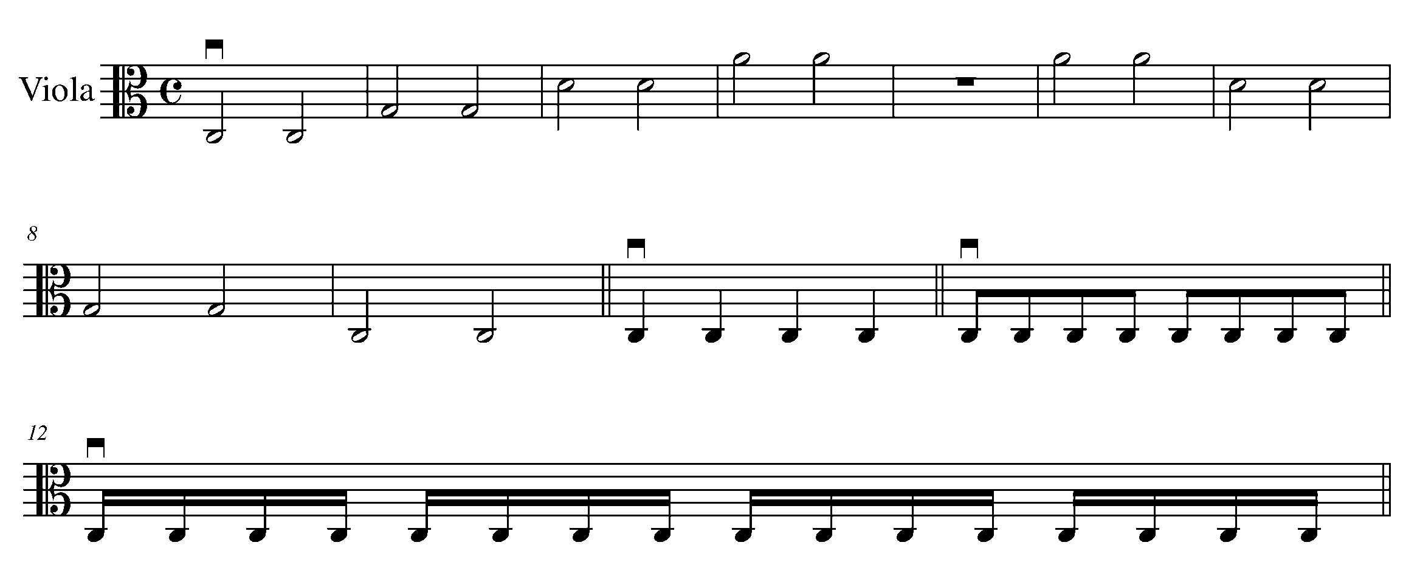
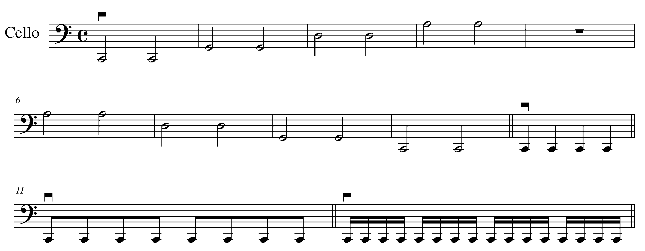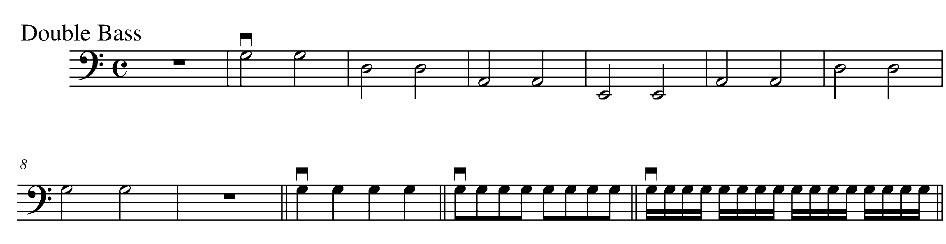

Consolidation: We will be playing this in class as a warm-up. When you are ready, perform this for your teacher to receive feedback.

2. D MAJOR SCALE AND B MINOR SCALE AND ARPEGGIOS FOCUS: PITCH

Learning Goal: You will understand the finger pattern and perform the D major scale and its relative harmonic minor and arpeggios using legato bowing.

Minds On: What do you notice about the key signature for the D major scale and the B harmonic minor scale? Why does the minor scale sound so different? How is the 7th note of the scale unique?

Action! In order to be successful with this task, you will need to:
- Look at the key signatures and accidentals in each scale; and
- Play the scales and arpeggios with legato bowing.

D Major and B Minor Harmonic Scales and Arpeggios
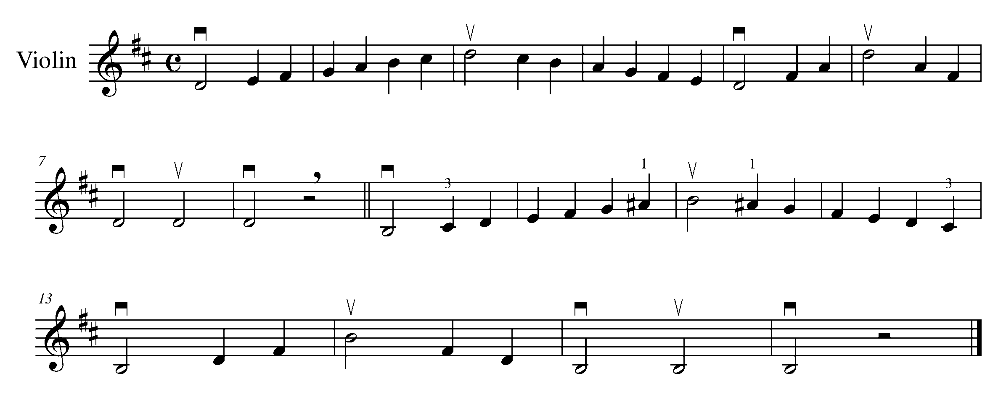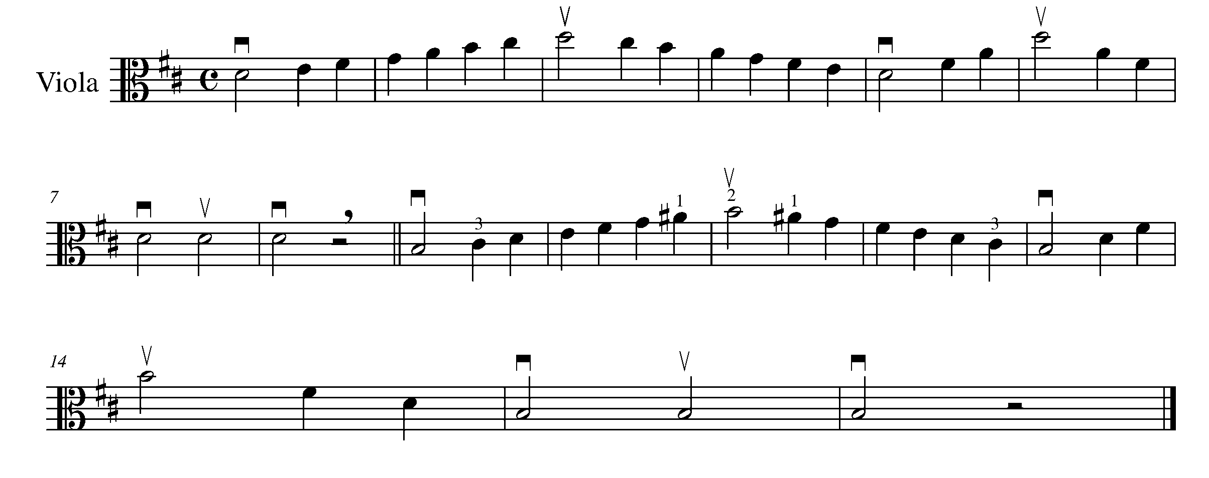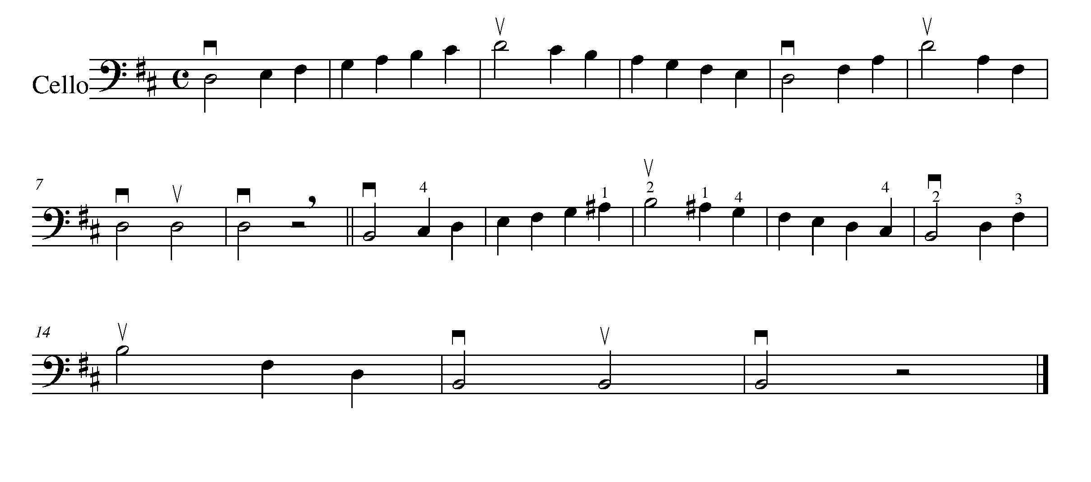
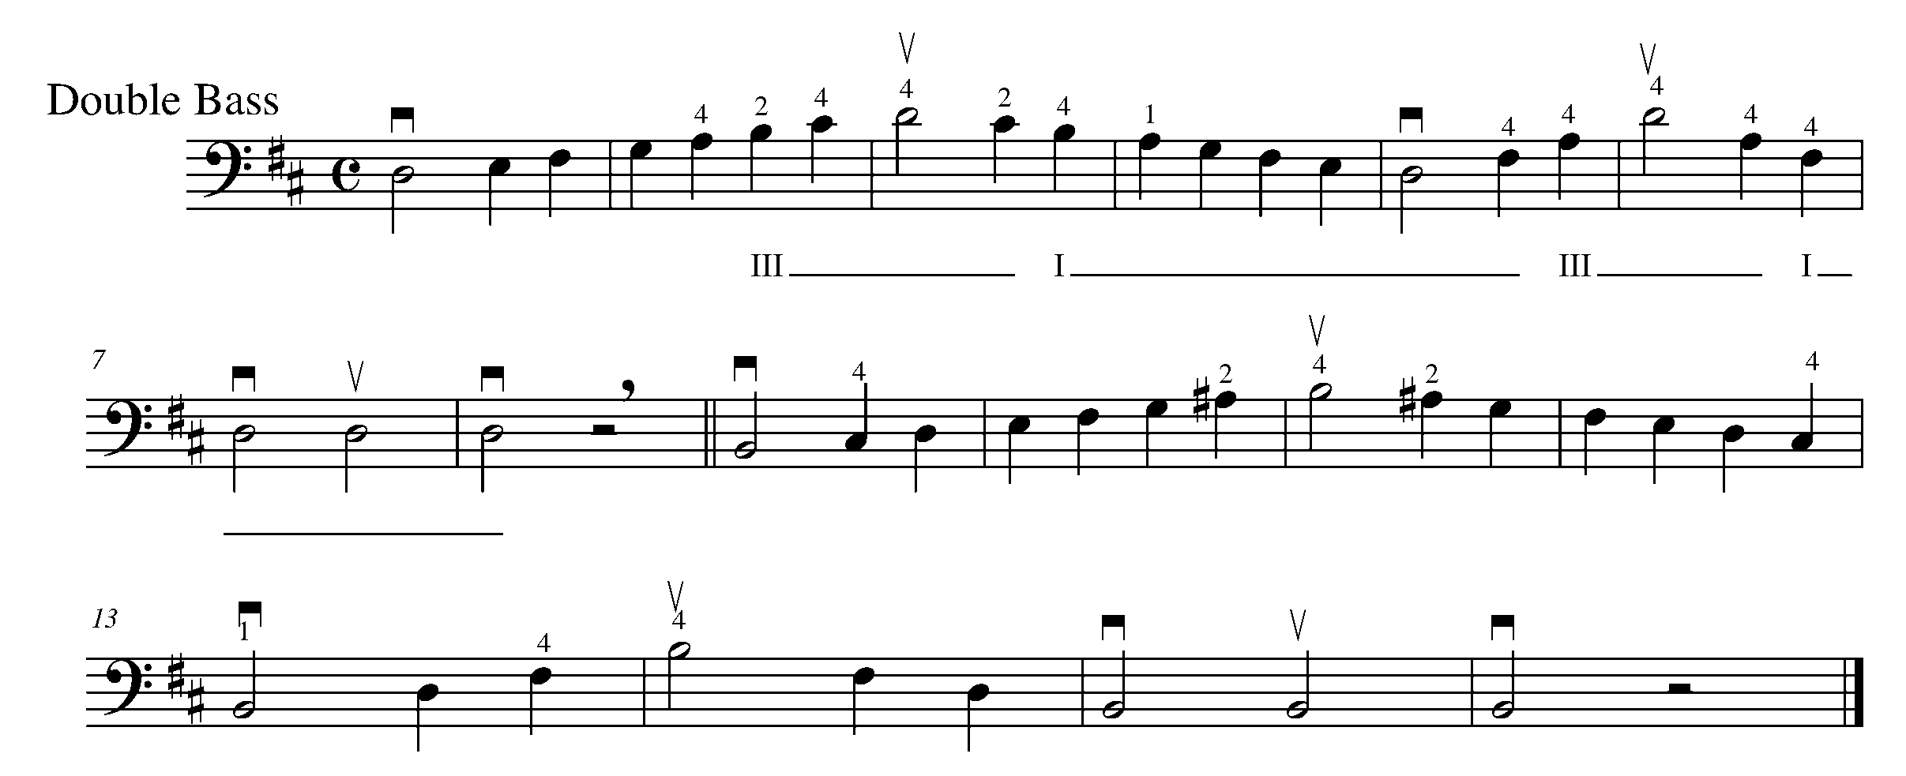

Consolidation: Perform the above scales and arpeggios for your teacher to receive feedback.

3. LIGHTLY ROW FOCUS: ARTICULTION- LEGATO BOWING

Learning Goal: You will learn to memorize and perform “Lightly Row” using legato bow.

Minds On! Have you ever forgotten to bring your music? What would you do? Why is it important for musicians to look for patterns in their music? Musicians often look for patterns in music to help them learn, remember, and understand the form.

Action! In order to be successful with this task, you will need to:
- Scan the music for patterns;
- Scan the music for the time signature, key signature and tempo marking;
- Hold the half note for its full value;
- Play the first four bars from the book a few times. Close the book and play the four bars;
- Do the same with the next four bars until you reach the end of the piece; and
- Receive feedback from a friend.

Lightly Row
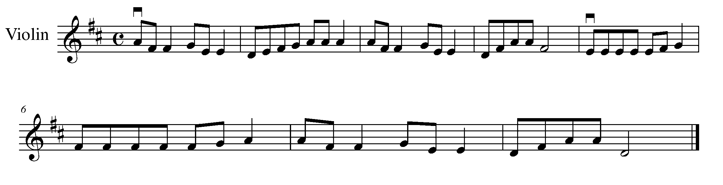
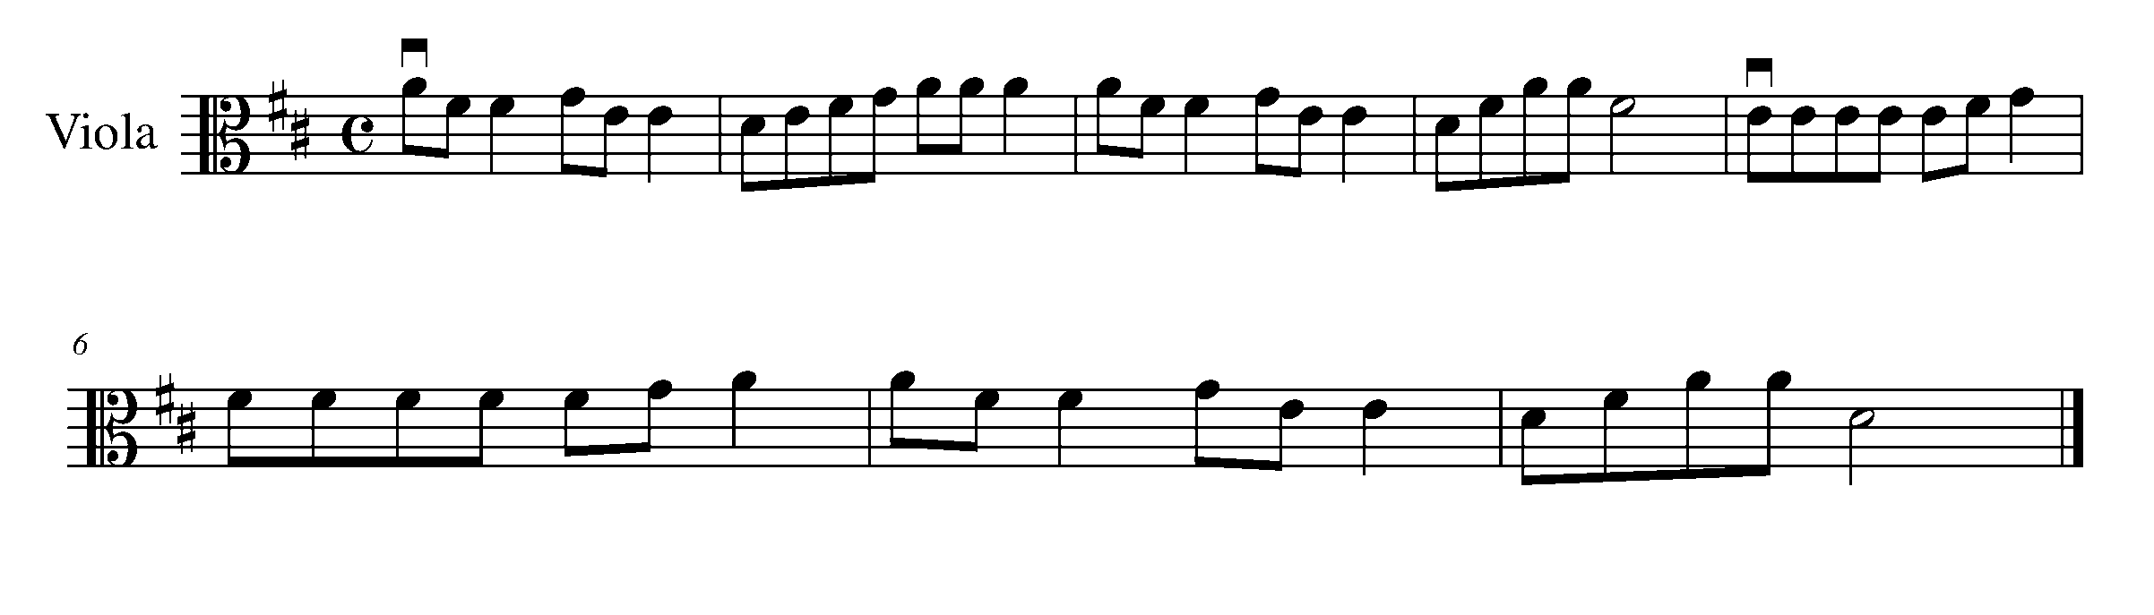
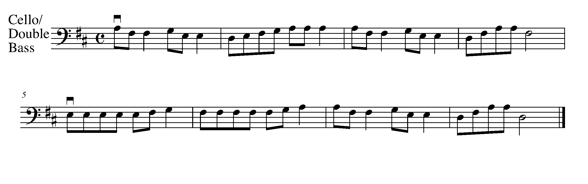
Consolidation: Perform “Lightly Row” for a friend, receive feedback and have them complete the following and sign your book, then perform it to your teacher for additional feedback.

Name of evaluator: __________________

Something I thought you did really well was… _________________________________________________

Something you should work on before performing this for the teacher is . . .

________________________________________________________________

Signed by ___________________
(name of evaluator)

4. MAKING CONNECTIONS
FOCUS: ARTICULATIONS, TEMPO, DYNAMICS

Learning Goal: This is a continuation from last year’s GPS Task 14. You will perform, “Twinkle, Twinkle, Little Star”, and change the mood of the piece by changing one or more of the elements of music.

Minds On: If you change the tempo of a piece from quick (allegro) to slow (adagio), how does it change the overall effect of the piece? How does changing dynamics from loud (forte) to soft (piano) change the mood? How does changing something from legato to staccato change the overall purpose of the piece?

Action! In order to be successful with this task, you will need to:
- Review how to play “Twinkle, Twinkle, Little Star” with legato bowing and phrasing; and
- Decide what elements of music you would like to change in order to change the mood of the piece for a specific purpose. Here are a few examples:
  - Play it as a lullaby (consider playing piano, legato, and adagio)
  - Play it for a chasing scene in a movie (consider playing forte, staccato, and presto).

Twinkle, Twinkle, Little Star

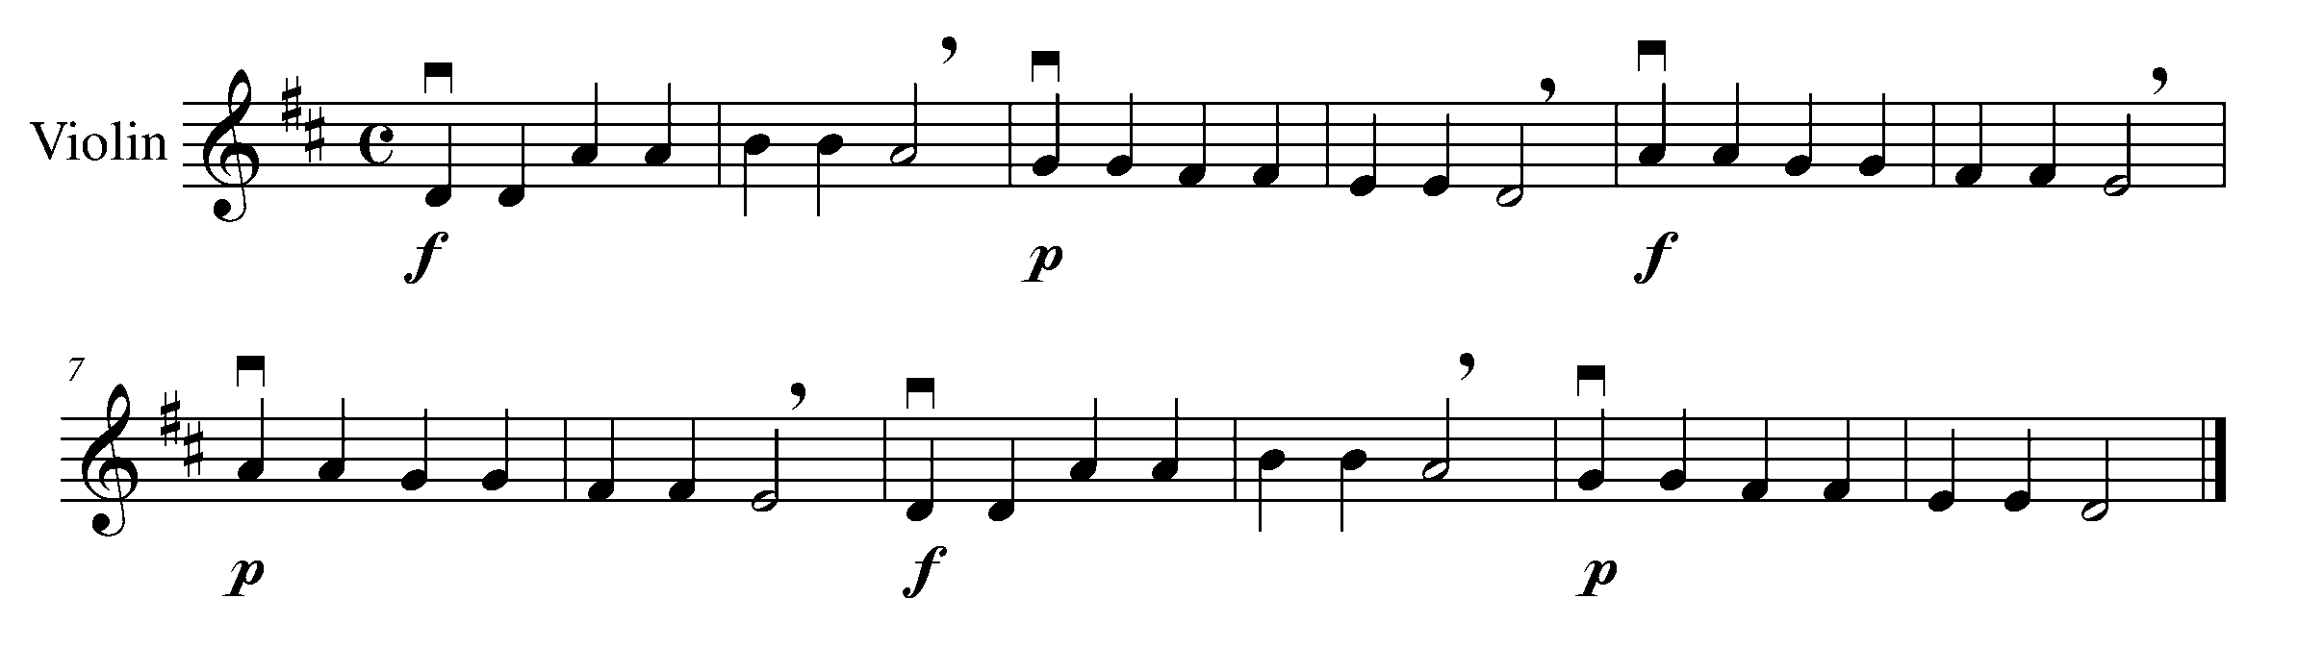
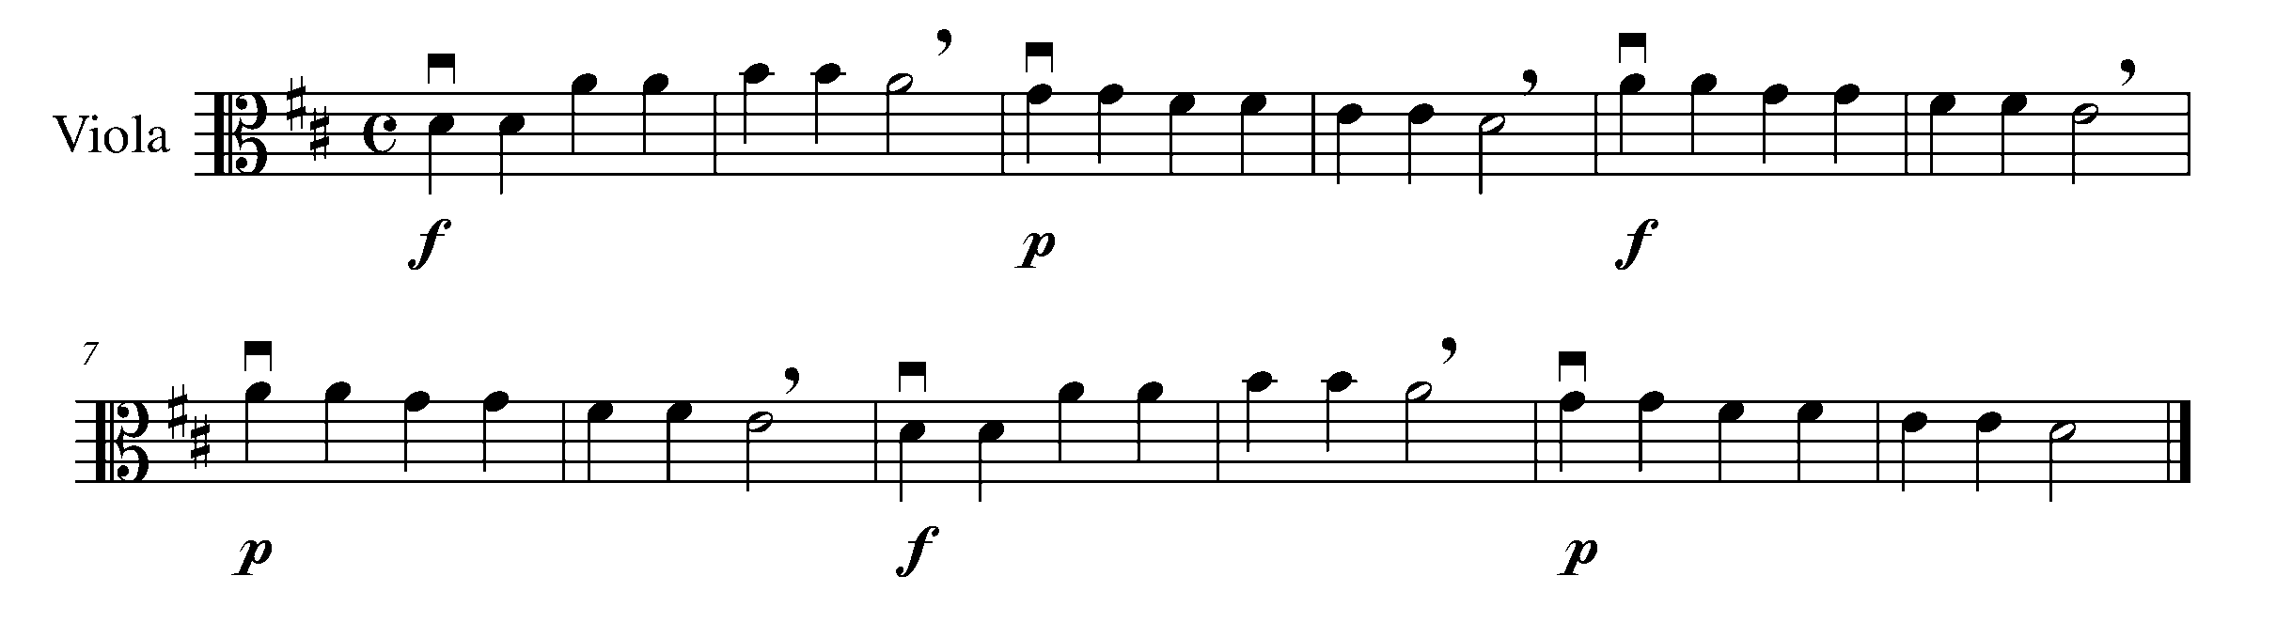
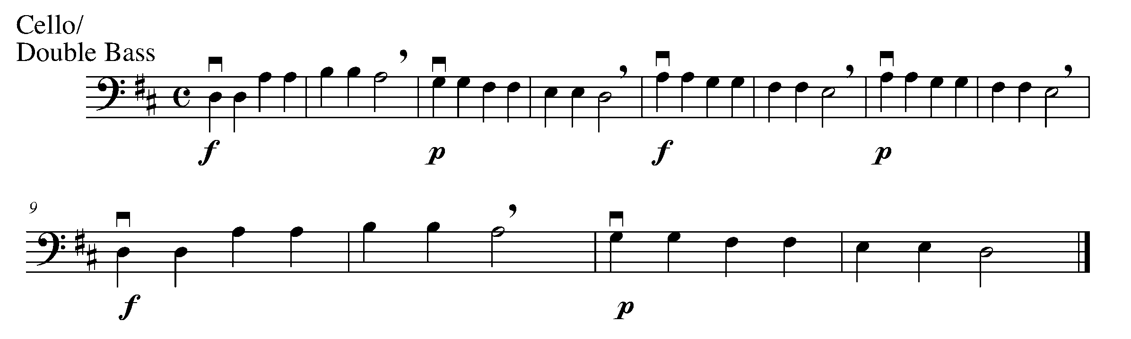

Consolidation: Decide on a specific purpose; change at least one element of music and perform this for your teacher for feedback. Remember to play with good phrasing.

5. GETTING STARTED AS A COMPOSER! FOCUS: NOTATION

Learning Goal: Last year, you learned how to set up your staff and create rhythm compositions in 4/4 time to create your own music. Now you will do the same as you get ready to create a variation from a given theme later.

Minds On! Why do we need to write the key signature again each time we start a new line but we only need to write the time signature once? Why is it useful to number the bars in music?

Action! In order to be successful with this task, you will need to:

- USE A PENCIL and set up your staff. Include…
- A treble, alto, or bass clef (the one that is appropriate for your instrument);
- A 4/4 time signature;
- The appropriate key signature;
- Create 8 empty bars of music, label them 1, 2, 3, and so on; and
- Add a double bar line at the end of the piece.

________________________________________________________________________________________________________________________________________________________________________________________________________________________________________________________________________________________________________________________________

________________________________________________________________________________________________________________________________________________________________________________________________________________________________________________________________________________________________________________________________

- Create 8 bars of 4/4 time rhythms here that you could use for your composition later. Remember to write down rhythms you can play.

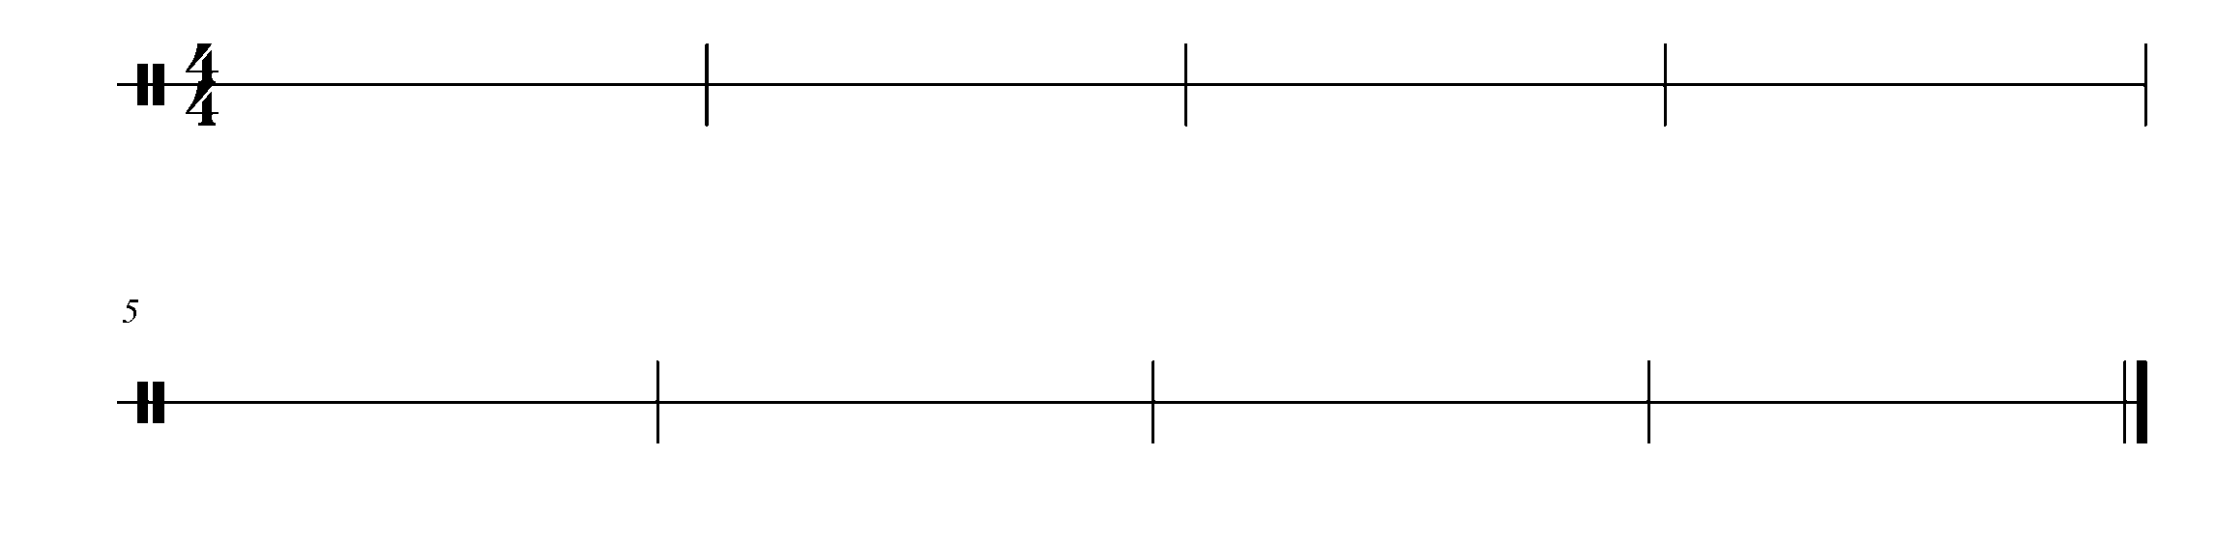

Consolidation: Set up your page and show this task to your teacher for feedback before moving on.

CONGRATULATIONS! YOU HAVE REACHED YOUR FIRST GPS MARKER – NORTH!
ASK YOUR TEACHER HOW YOU ARE TO ACKNOWLEDGE THIS ACCOMPLISHMENT ON YOUR GPS TASK TRACKER!

6. LET’S HEAR YOU FOCUS: BEAT

Learning Goal: You will play a long tone on an open string of your teacher’s choice for 12 seconds.

Minds On! Why is playing with your entire bow important for string players? Why is having even bow speed important? How do you retain an even sound on a stringed instrument?

Action! In order to be successful with this task, you will need to:

- Focus on how you start your note. Have the feeling like your arm is already in motion before your start your down-bow.
- Keep your shoulder, neck, elbow, and bow grip relaxed. Use the weight of your entire arm to draw the sound from your instrument. Keep everything relaxed.
- Even bow speed. You need to keep an even bow speed, planning out 1/12 of the bow for each second on the clock.
- Practice your 12-second long tone both up-bow and down-bow many, many times on every open string until your bow speed, sound quality, and relaxation are consistent.
- Sustain a great sound for 12 seconds both down-bow and up-bow (no squeaking). Remember that second “12” does not stop until you would count second “13”.
- Apply rosin on your bow so that the entire length of the hair is a “frosty” white if needed.

You should play this example mezzo forte - mf (moderately loud). We will talk about how to play with different dynamics in class.

Consolidation: Perform a 12-second long tone both up-bow and down-bow on an open string of your teacher’s choice to receive feedback before going on to the next task.

7. VARIETY IS THE KEY! FOCUS: FORM & NOTATION

Learning Goal: You will use the staff you set up in Task 5 and create a rhythmic variation from the “Hot Cross Buns” theme.

Minds On: What does variety mean? In music, what do you think a variation is? Composers sometimes use ideas and music from another composers to create a new piece that have similar characteristics to the original piece.

Action: In order to be successful with this task, you will need to:

- Take a look at the sample “Hot Cross Buns Theme and Variations” below and look for patterns. Compare the theme and the variations, do you see similarities and differences in the:
- Time signature?
- Key signature?
- Number of bars?
- The notes used in each bar?
- The rhythms?
Hot Cross Buns Theme and Variations
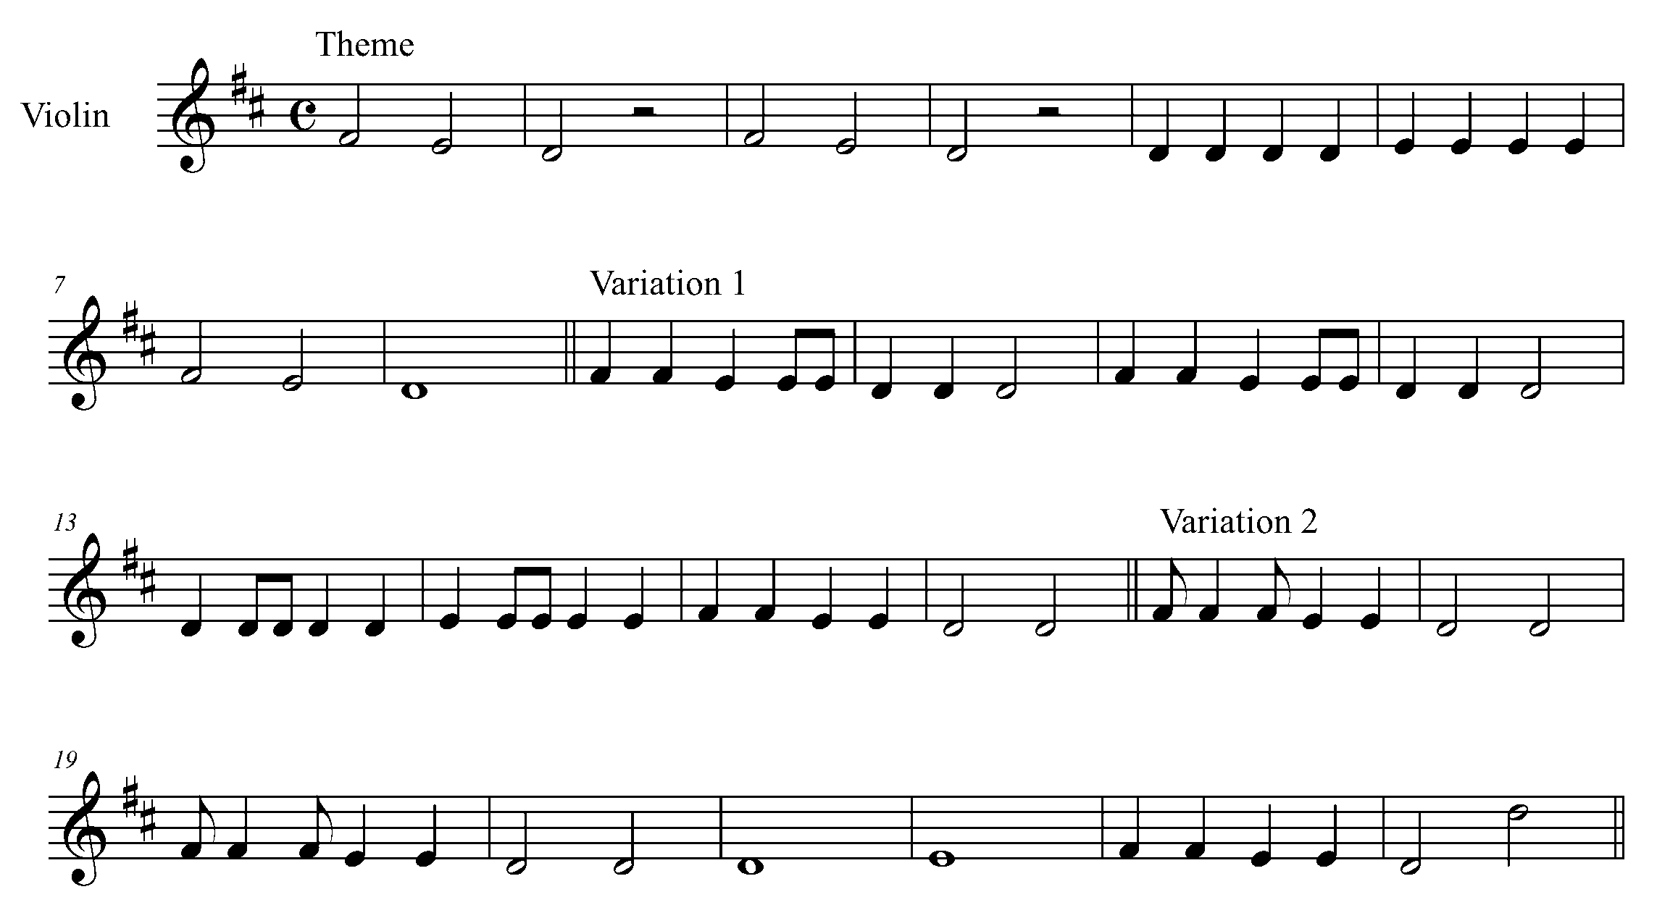

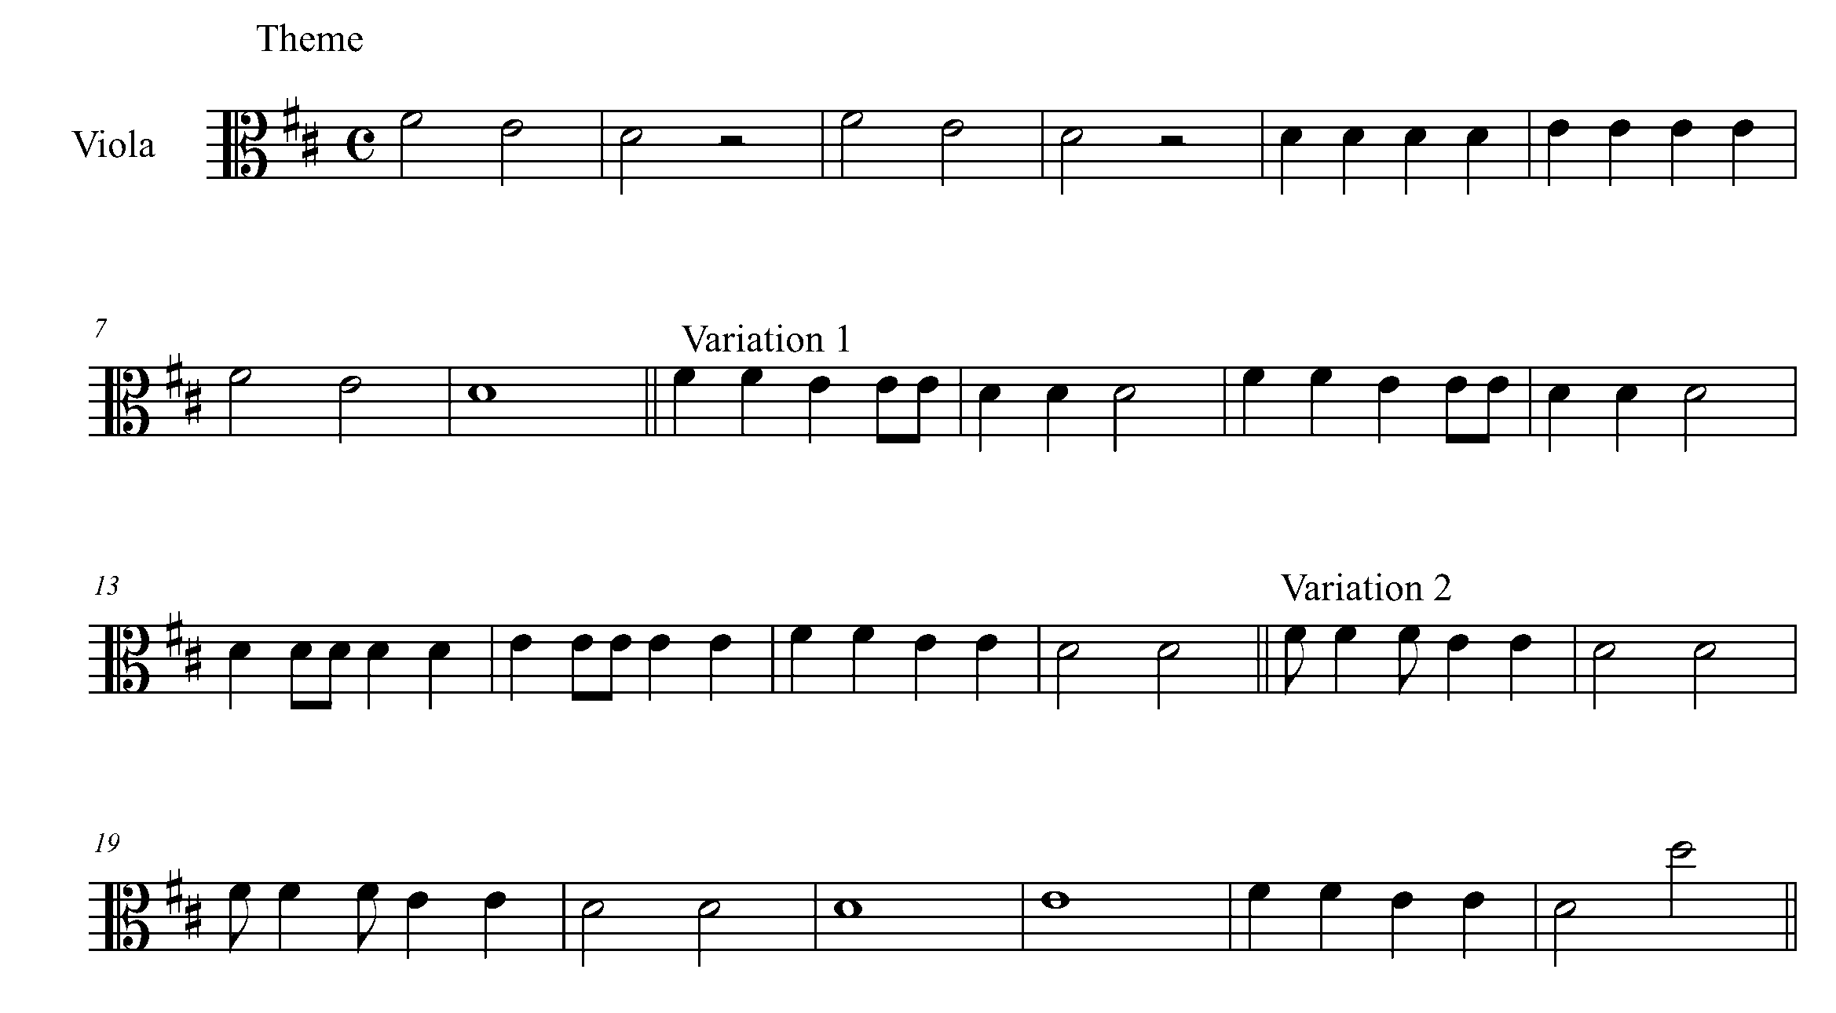
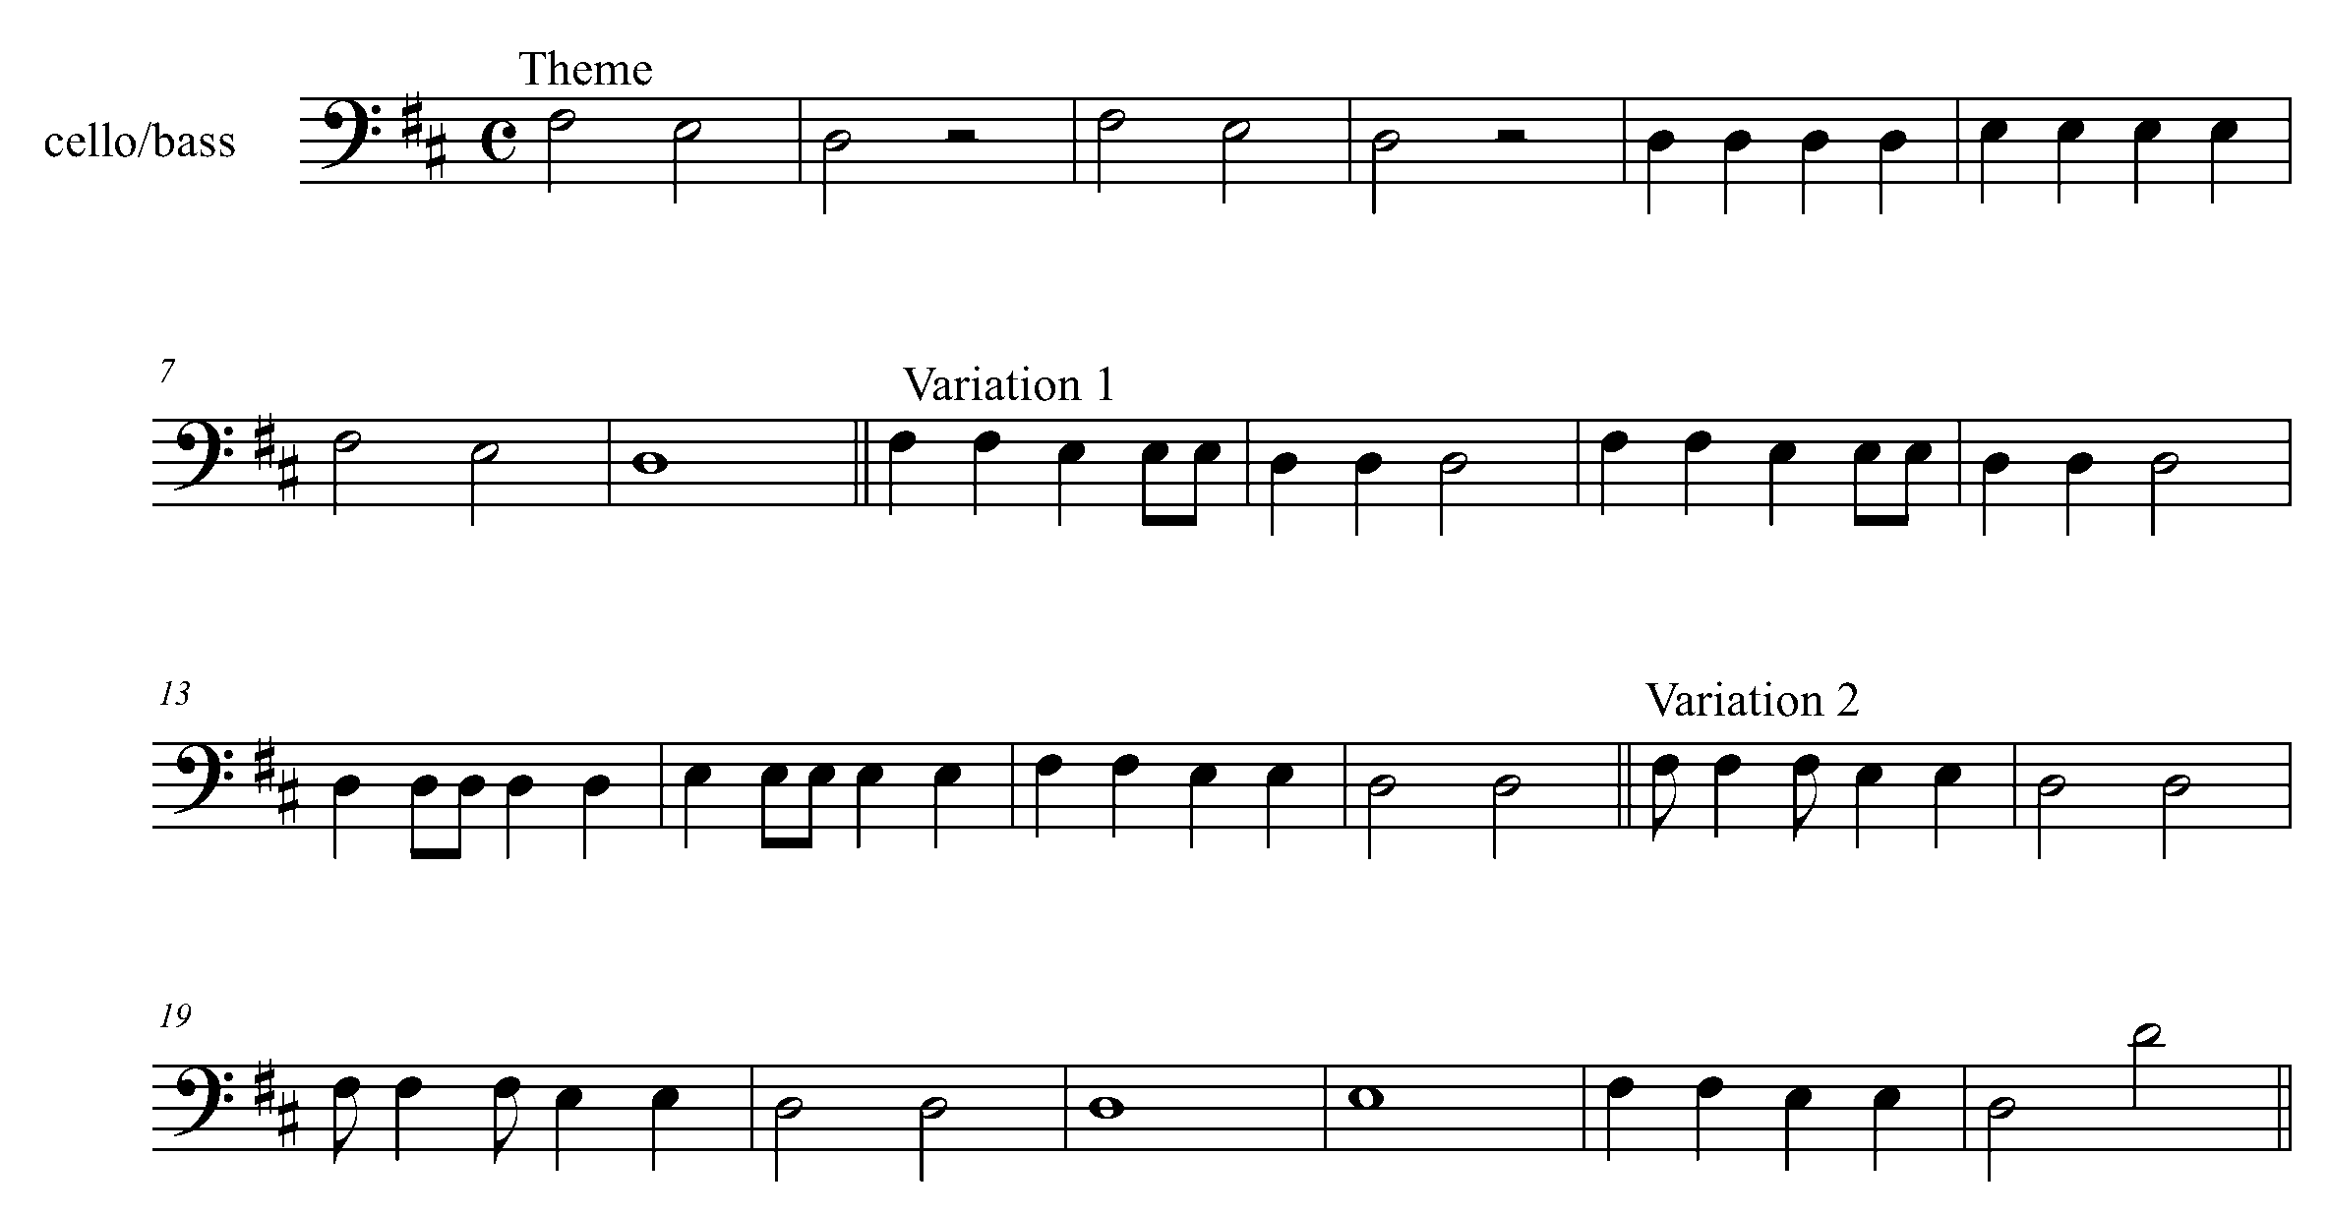
- Now using the 8 empty bars you have set up in Task 5, beneath each bar, write down the notes names of the notes you are allowed to use in order for it to sound like a variation of “Hot Cross Buns” (e.g. You can only use F# and E in the first bar, you can only use D in the second bar, etc).

- Notice the patterns. Using the 4/4 time rhythms you have created in Task 5, insert the correct notes for each bar. You may choose to use certain rhythmic patterns more than once to continue the pattern in the music when writing your variation (e.g. you may want to do the same pattern for bars 1, 3 and 7; bars 2, 4, and 8; bars 5 and 6).

- Create a title for your variation.

Title: _____________________________

________________________________________________________________________________________________________________________________________________________________________________________________________________________________________________________________________________________________________________________________

________________________________________________________________________________________________________________________________________________________________________________________________________________________________________________________________________________________________________________________________

Consolidation: Complete this task, making sure you have gone through steps 1 through 4. Perform this task for your teacher for feedback.

8. SLURRING IT ALL TOGETHER! FOCUS: ARTICULATION

Learning Goal: You will learn to perform slurs by linking two or more notes in one bow.

Minds On: Last year, we learned what a tie is. Looking at your music, what is the difference between a slur and a tie? How is your sound affected by the slur, compared to no slur?

Action! In order to be successful with this task, you will need to:
- Identify the slurs in your music;
- Connect the notes and play them in one bow;
- Remember to divide up your bow evenly when playing slurs;
- Watch your bowing level when crossing strings; make your string crossing a smooth transition by having your bow lean towards the D string as you play the open A;
- Keep your fingers down wherever possible; and
- Maintain good posture, sound, pitch, and rhythmic knowledge.

Slurring It All Together
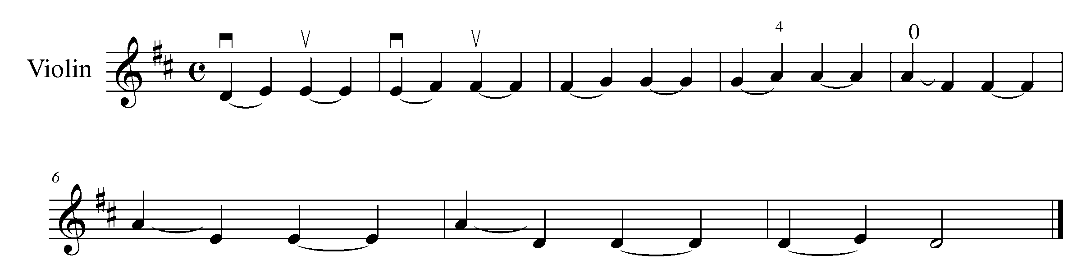
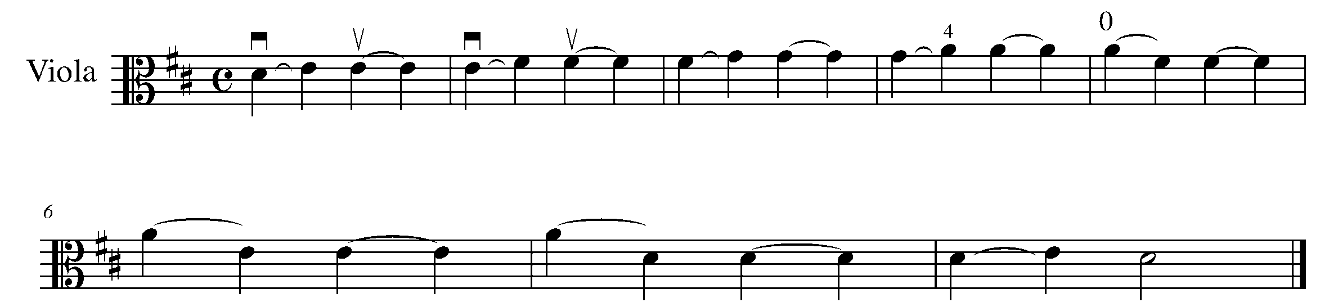

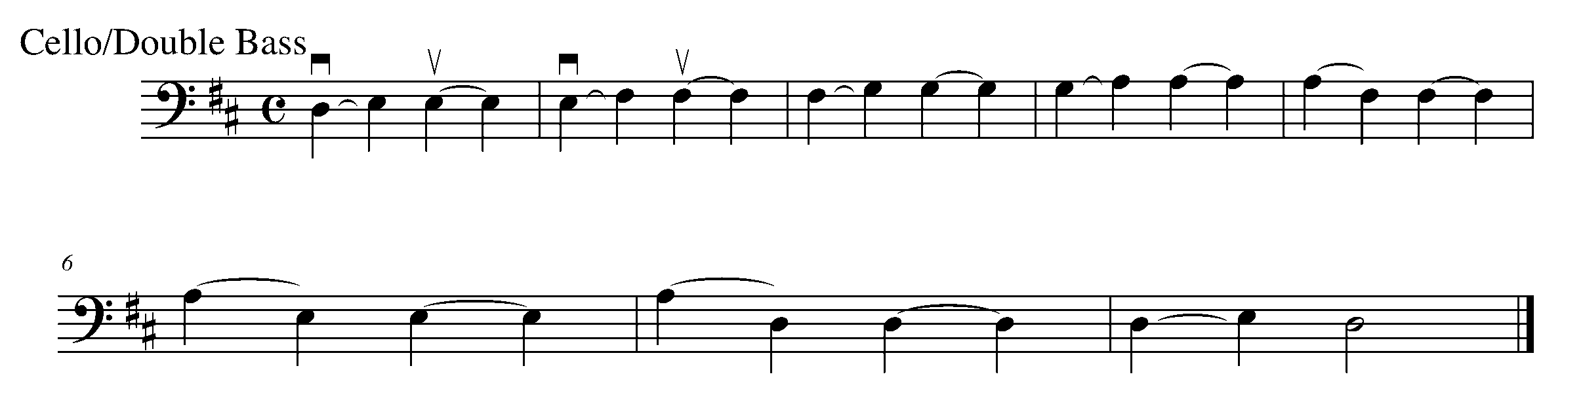
Consolidation: Perform this piece for your teacher and receive feedback.

9. TWO BEATS IN A BAR! FOCUS: DURATION

Learning Goal: Four beats in a bar is not the only option! Now that you are more musically experienced on your instrument, you will be introduced to a variety of time signatures.

Minds on: Does music in 2/4 time signature have a different feel then 4/4 time? Are you going to treat your approach to 2/4 any differently then other time signatures? Which beat is the strongest in 2/4 time?

Action! In order to be successful with this task, you will need to:

- Analyze the notes and rhythms of “Bah, Bah, Black Sheep”; and
- Demonstrate your understanding of the 2/4 time signature.

Bah, Bah, Black Sheep

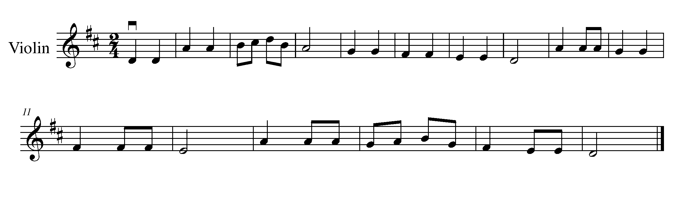
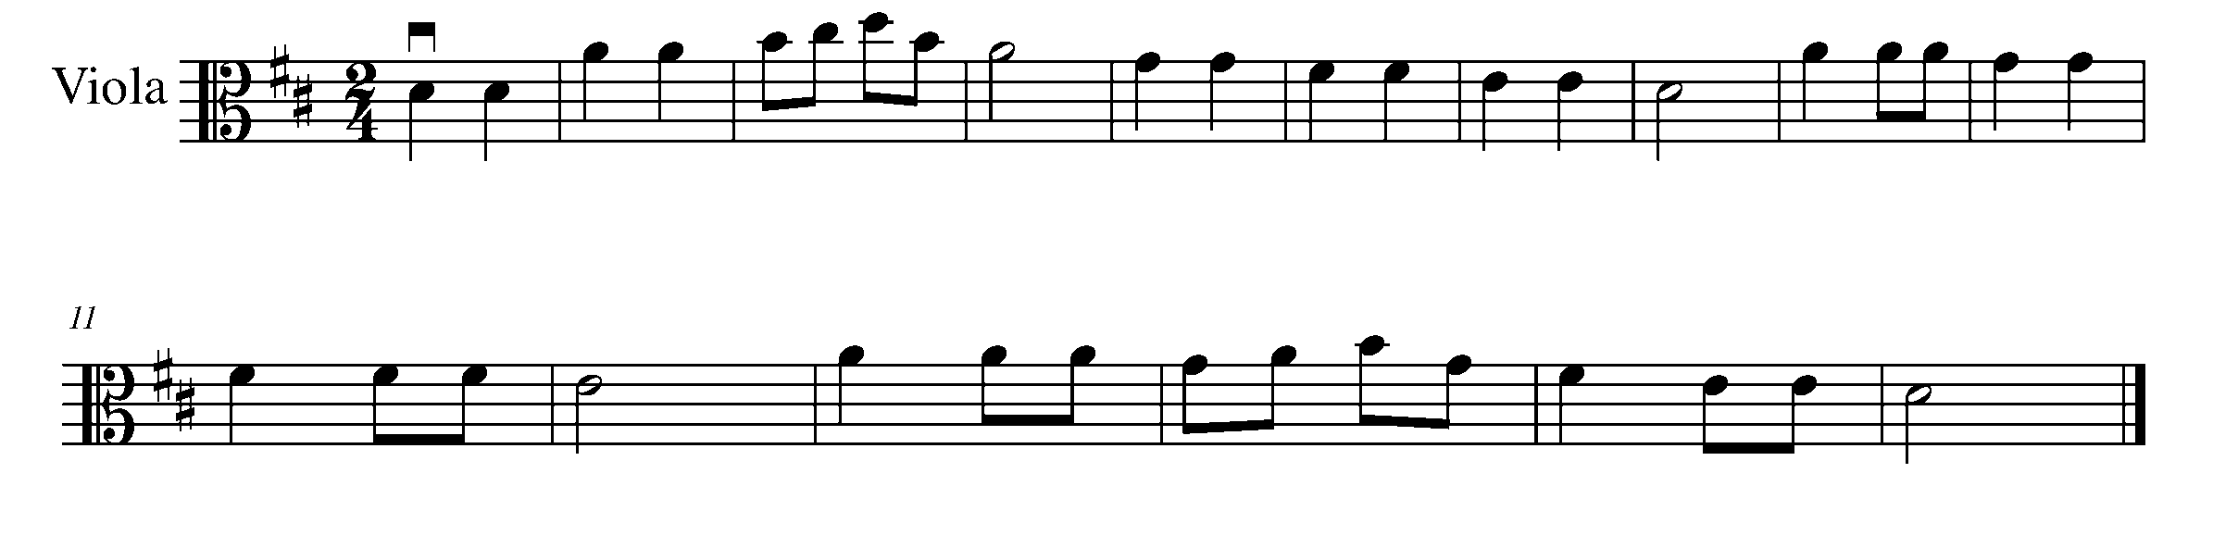
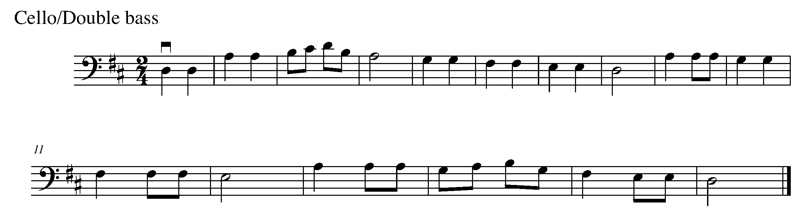

Consolidation: Perform “Bah, Bah, Black Sheep” for your teacher and receive feedback.

10. HURRAY, MORE SCALES AND ARPPEGIOS! FOCUS: PITCH

Learning Goal: As you become more experienced on your instrument, you will begin to perform in a variety of key signatures and finger patterns. This task introduces the C major scale and the A minor harmonic scale and arpeggios.

Minds On: Scales are very useful for improving range and fluency. Be aware of the key signature, notice there are no sharps or flats. How is this going to change your finger pattern?

Action! In order to be successful with this task, you will need to:
- Identify the notes which are affected by the new key signature;
- Be aware of how the 7th note in the harmonic minor scale is different;
- Correctly perform these scales using correct articulations and legato bowing; and
- Demonstrate a balance in your sound from the bottom to the top of the scales and arpeggios.

C Major and A Minor Harmonic Scale and Arpeggios

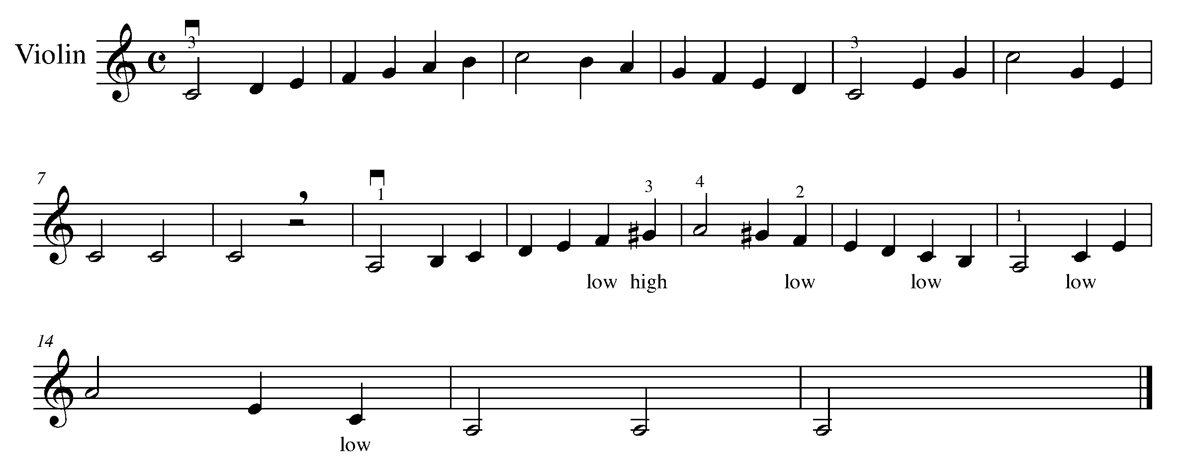
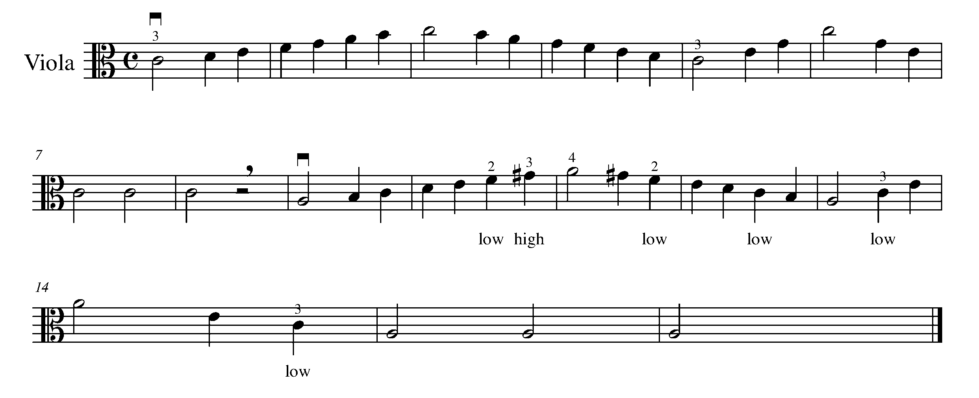
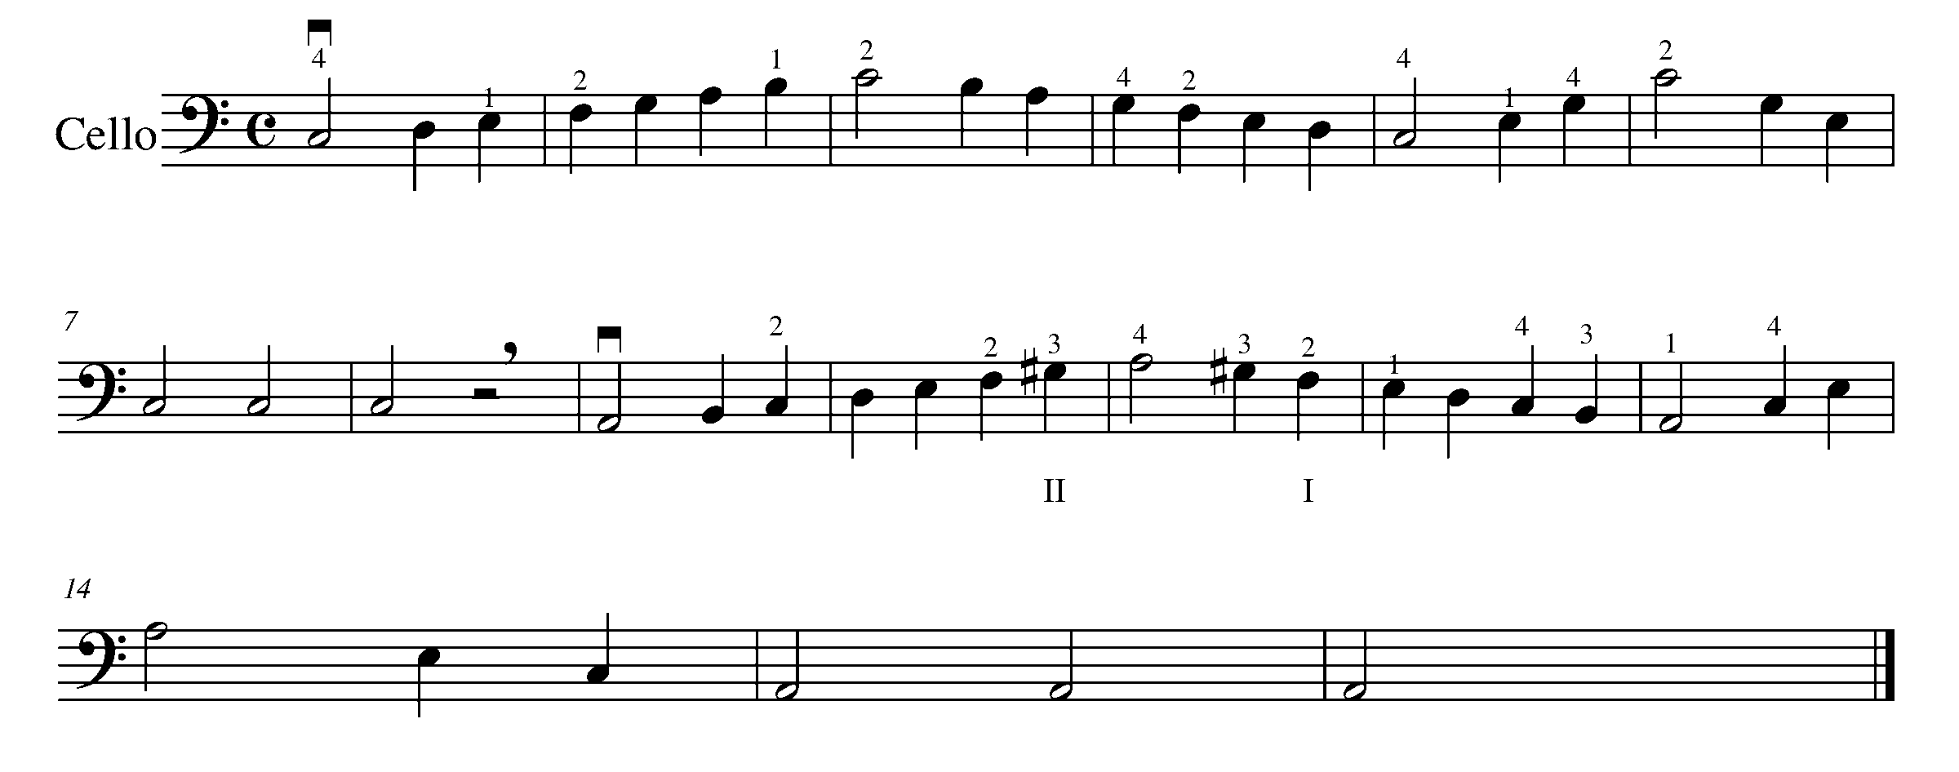
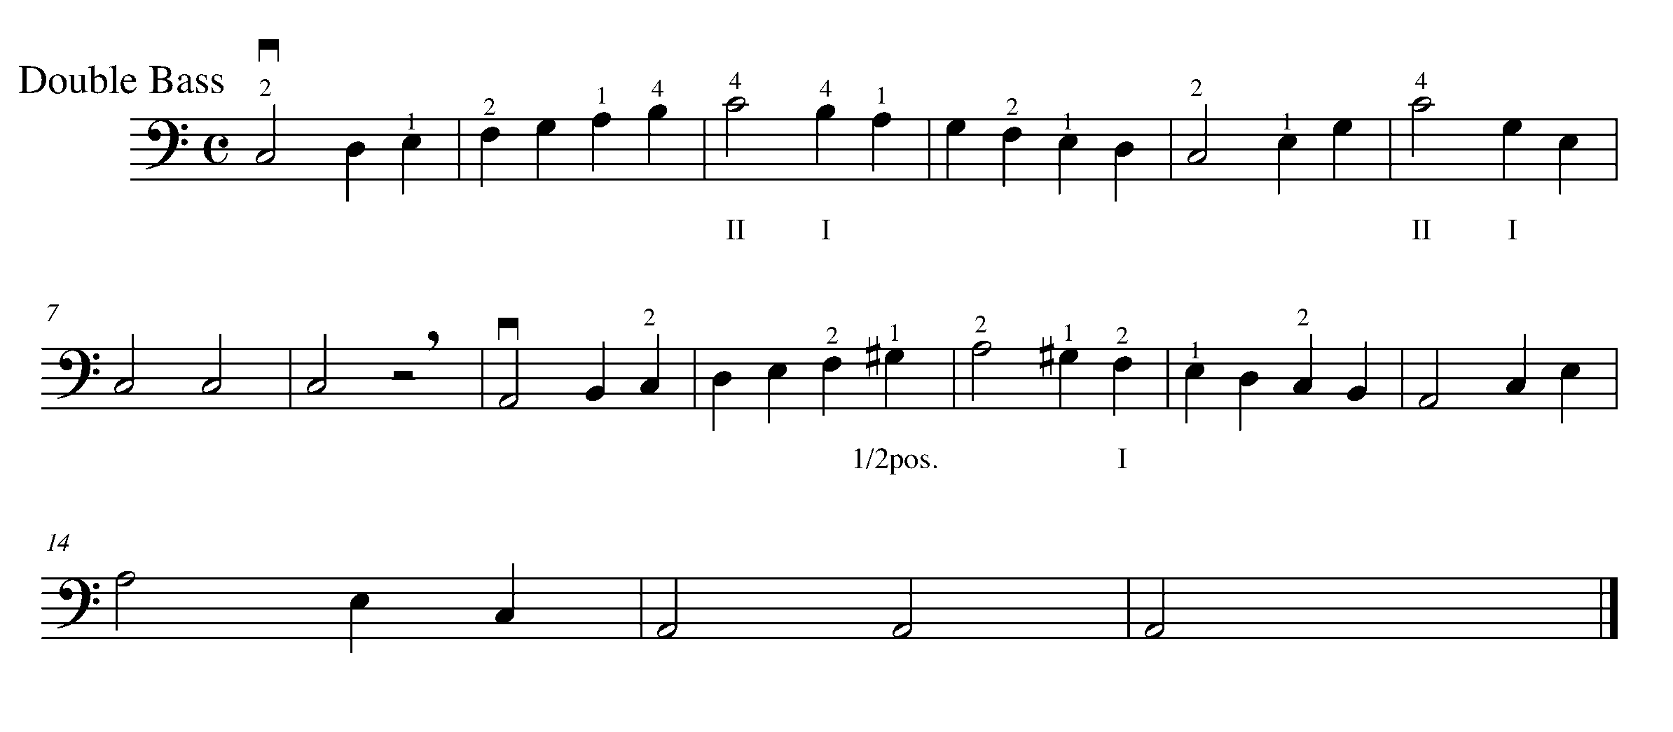

Consolidation: Perform both scales and arpeggios for your teacher to receive feedback.

CONGRATULATIONS! YOU HAVE REACHED THE SECOND GPS MARKER -EAST!

YOU ARE HALFWAY TO THE FINAL GPS DESTINATION
DON’T FORGET TO FILL IN YOUR TASK TRACKER!

11. THREE BEATS IN A BAR! FOCUS: DURATION

Learning Goal: Performing 3 beats in a bar definitely has a different feel then music in a 2/4 and 4/4 time signature. The first beat of each bar is the strong beat in 3/4 time, be sure to demonstrate this when performing this task.

Minds On: The waltz is a dance, which uses music in 3/4 time. As the first step of a waltz is your largest and leading step, so is the first beat of the bar in 3/4 time. How does music performed in 3/4 time sound and feel different from music written in 2/4 or 4/4 time?

Action! In order to be successful with this task, you will need to:
- Think about how the beats in a 3/4 bar are stressed differently from a bar of 4/4 music;
- Violin and Viola players, use your 4th finger A on D string;
- Demonstrate musical phrasing and expressive controls; and
- Demonstrate accuracy in rhythm and pitch when performing.

‘Morning’ from Peer Gynt Suite

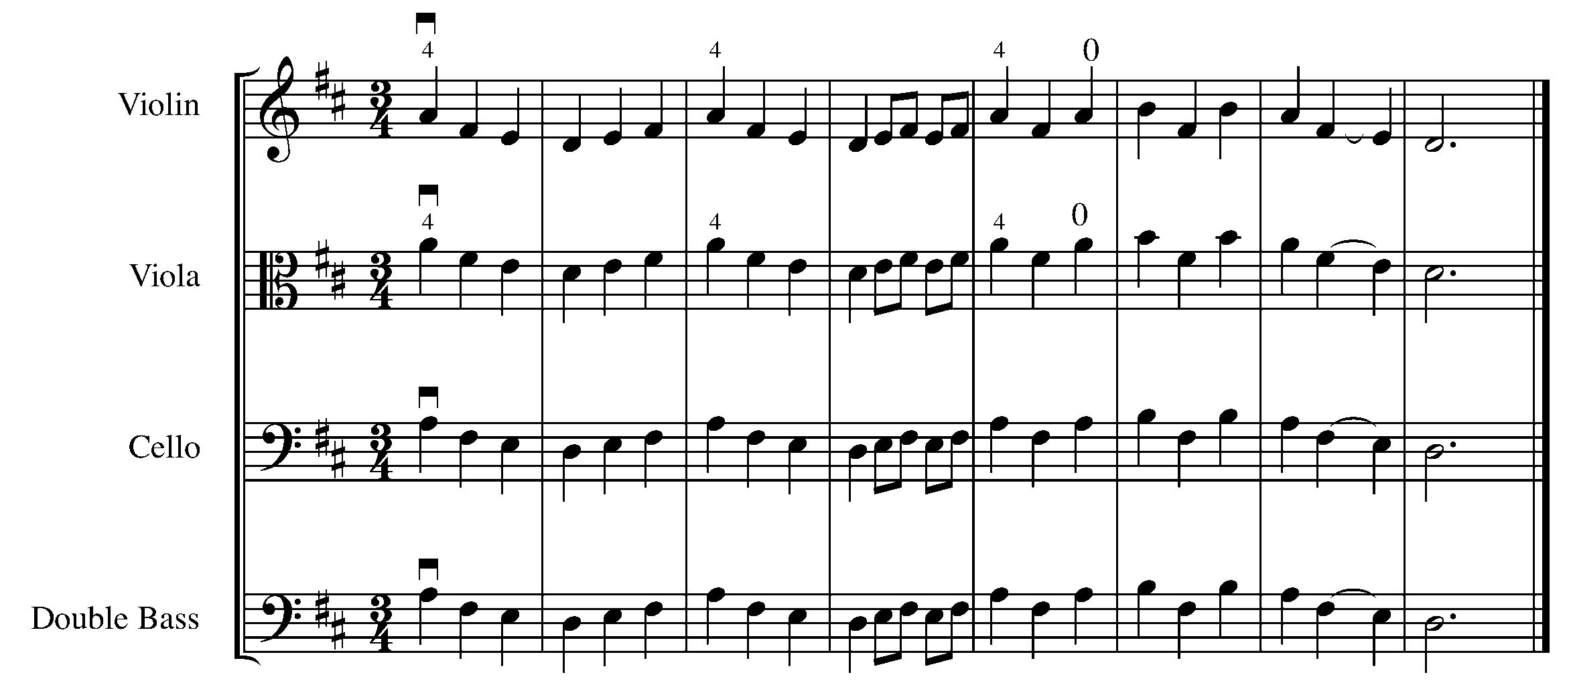

Consolidation: Perform the above piece for your teacher and receive feedback.

12. LET’S PLAY SOME STACCATO! FOCUS: ARTICULATION

Learning goal: You will demonstrate the difference between legato and staccato bowing and the technique needed to perform them on your stringed instrument.

Minds On: When would you use staccato notes? How does playing staccato change a piece that is originally in legato? Composers use articulation to say what they need to say in different ways.

Action! In order to be successful with this task, you will need to:
- Be aware this piece uses the C major scale finger pattern;
- Perform the staccato notes detached as indicated on the music;
- Stop the bow on the string by applying a bit of pressure so that the bow does not make any sound once the bow has stopped; and
- Use the middle part of your bow.

Staccato!
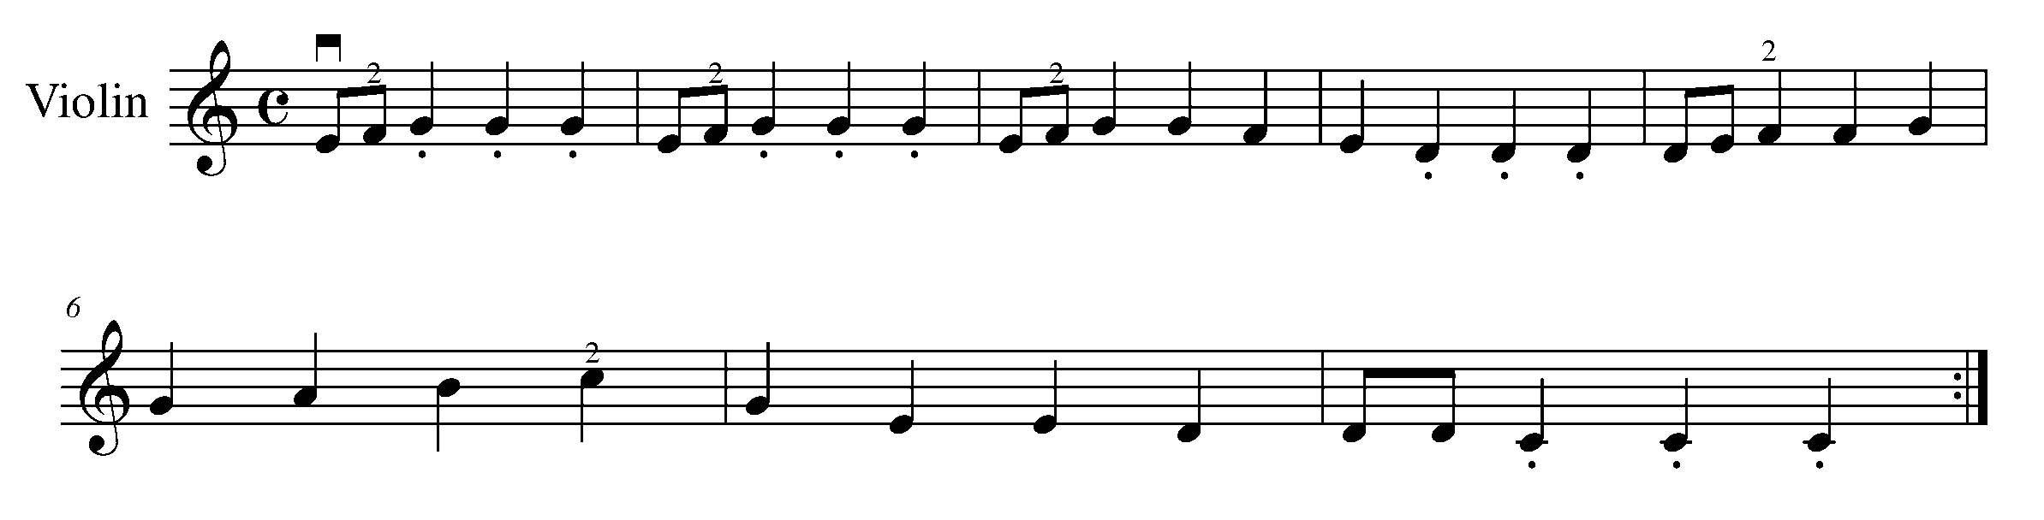

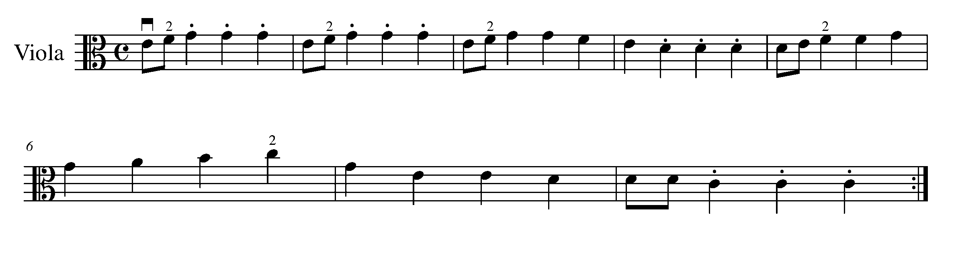
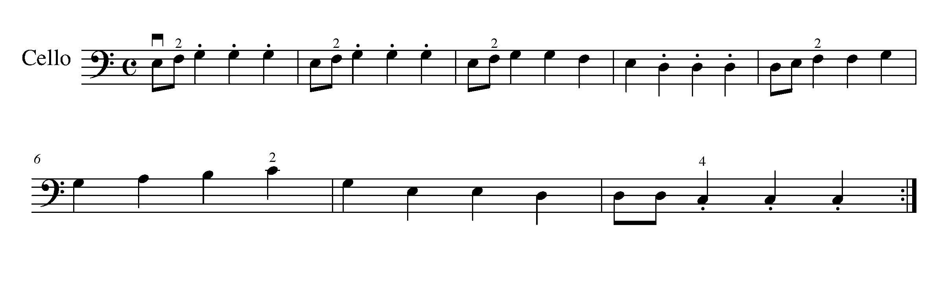
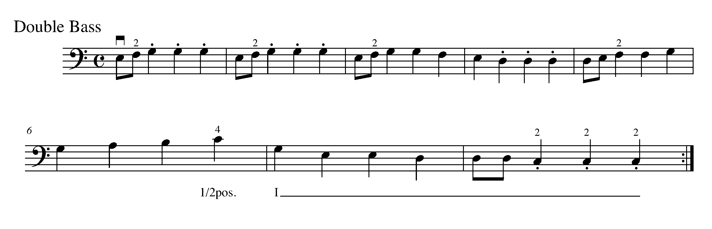
Consolidation: Perform the above piece for your teacher and receive feedback.

13. SIXTEENTH NOTES FOCUS: RHYTHM

Learning Goal: When performing four sixteenth notes, you are dividing one beat into four equal parts. In this task, you will learn to accurately perform sixteenth notes in combination with other known rhythms.

Minds On! How will you “speak” through sixteenth notes so that four even sounds happen within one beat? Will you be able to use your entire bow when playing sixteenth notes?

Action! In order to be successful with this task, you will need to:
- Check the key signature;
- Use words with 4 syllables to help you keep the sixteenth notes even (e.g. Mississippi, one-e-and-a, avocado, etc);
- Move your big toe inside your shoe to keep the beat and a consistent tempo;
- Play with a smooth legato bowing;
- Play in the middle of the bowing using a short bow stroke and a relaxed wrist;
- Practice your scales using sixteenth notes to help work on the division of the bow;
- Choose an appropriate tempo which allows you to accurately perform the marked articulations, rhythms and notes; and
- Complete the following reflection before you perform this for your teacher.

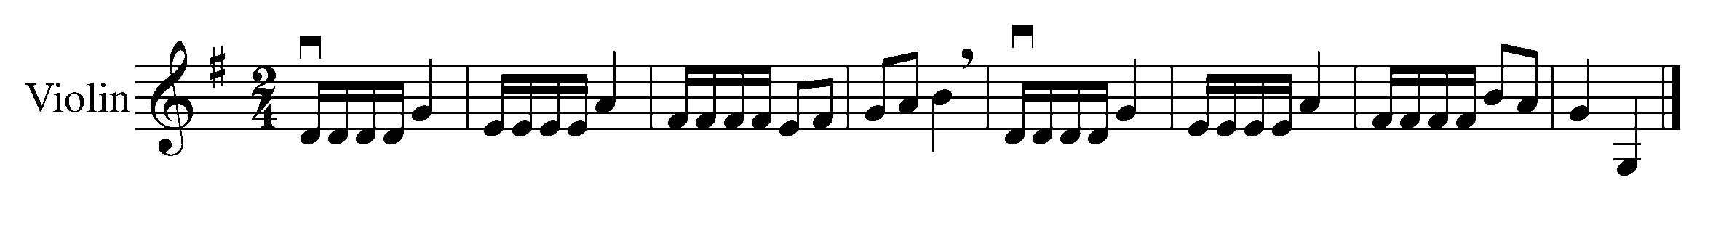
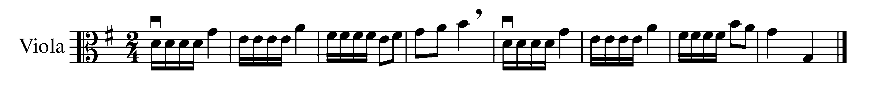
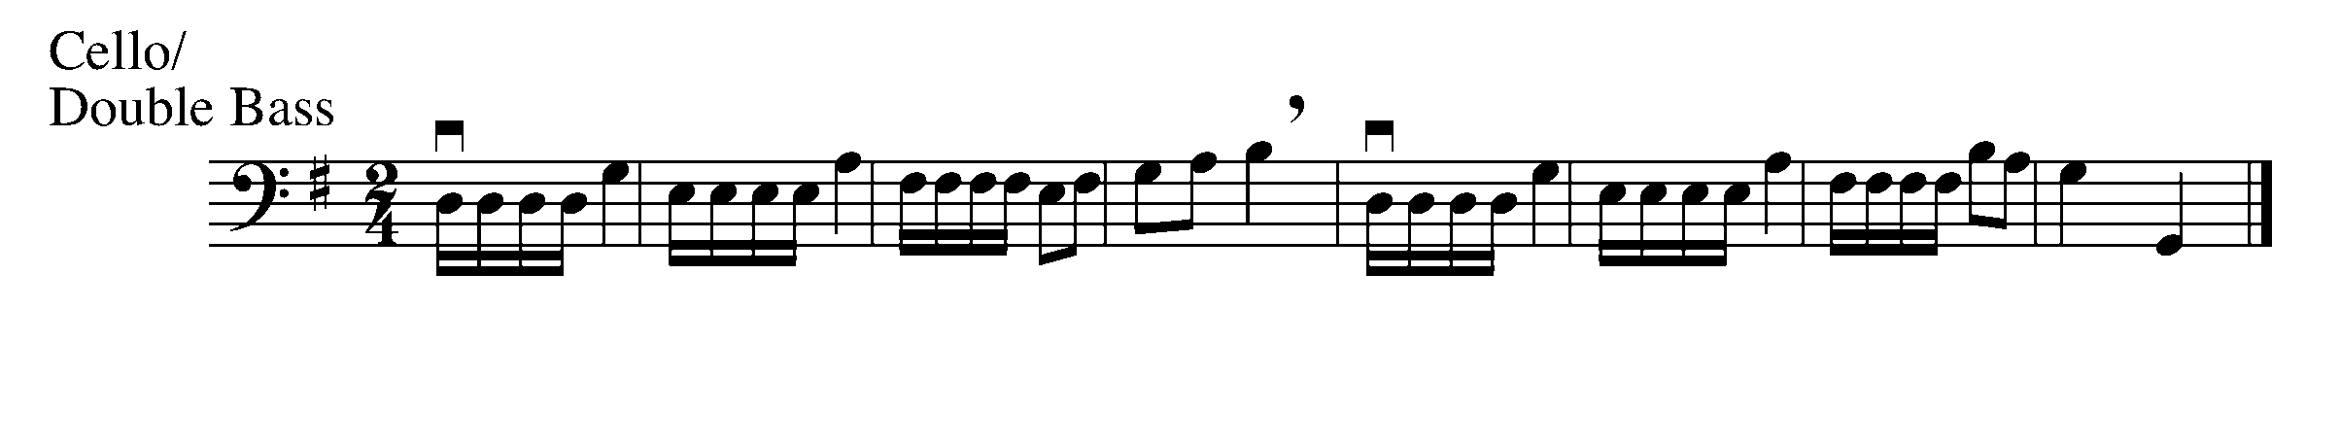
Consolidation: Complete the self-reflection below and perform this task for your teacher to receive feedback.

Student Self-Reflection: Comment on what you found easy, what you had difficulties with, and your next steps…
- When preparing for this task, I found that…

- Difficulties I had…

- Next Steps (what I need to do to improve)….

14. READY FOR SOME DYNAMICS SURPRISES! FOCUS: DYNAMICS

Learning Goal: You are now starting to take control of your instrument. This task will teach you the different bowing techniques needed to demonstrate a variety of dynamics.

Minds On: Where do you place your bow when you want to play loud? soft? What amount of bow would you use for playing loud? soft? How would you change the way you play to demonstrate a crescendo and decrescendo? Dynamics are concerned with the degree of loudness or softness of the music.

Action! In order to be successful with this task, you will need to:
- First, practice playing on an open strings at a variety of different dynamic levels;
- Play close to the fingerboard and use less bow and less weight on your bow when playing piano;
- Play close to the bridge and use more bow and more weight on you bow when playing forte;
- Gradually change your bowing techniques (above three points) when practicing crescendos and decrescendos;
- Identify the different dynamics markings in the piece below;
- Apply your knowledge of how to control and perform a variety of dynamics in the piece below; and
- Be aware the piece is written in C major.

Buffalo Gals
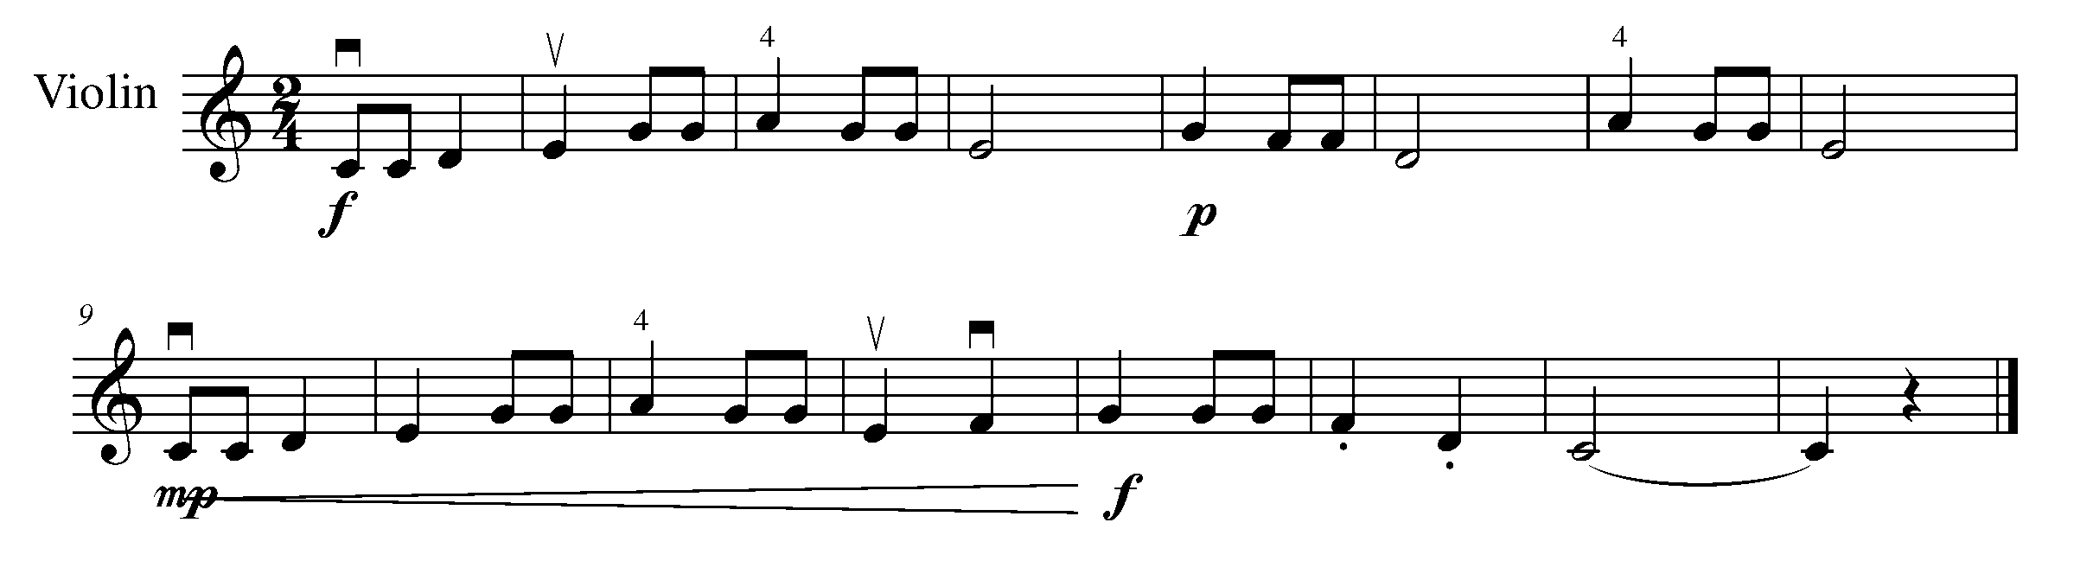
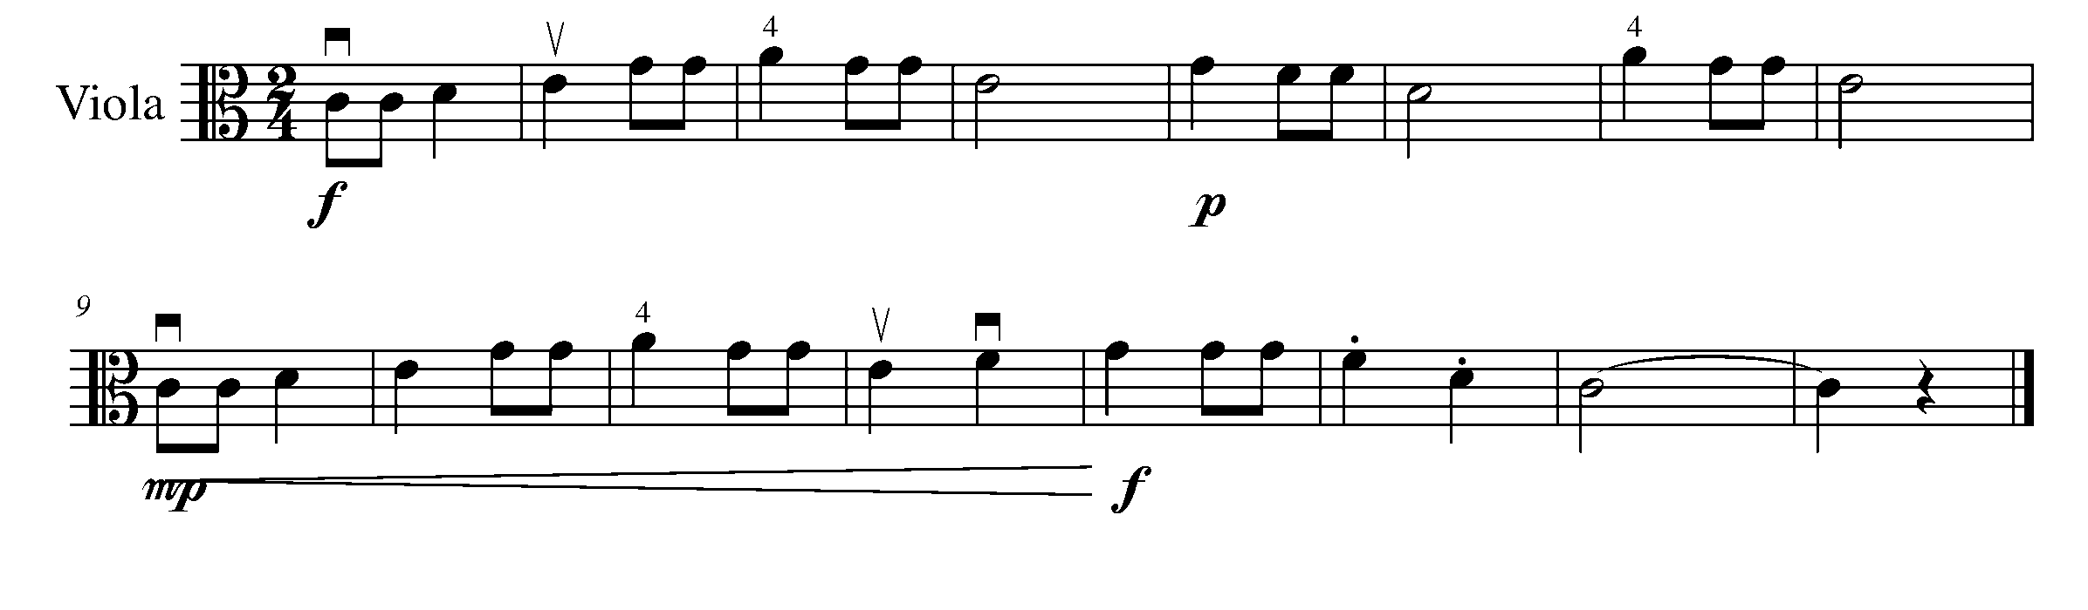
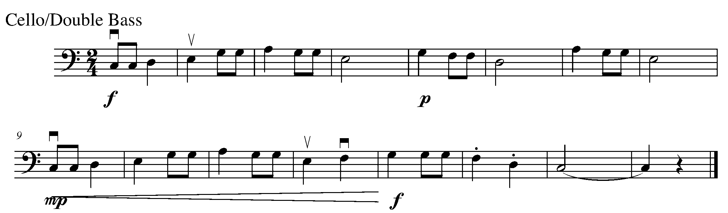

Consolidation: Perform the above piece for your teacher and receive feedback.

15. BLUES IT UP! FOCUS: FORM

Learning Goals: You will compose a jazzy accompaniment based on the 12-bar blues progression you learned last year.

12-Bar Blues Progression
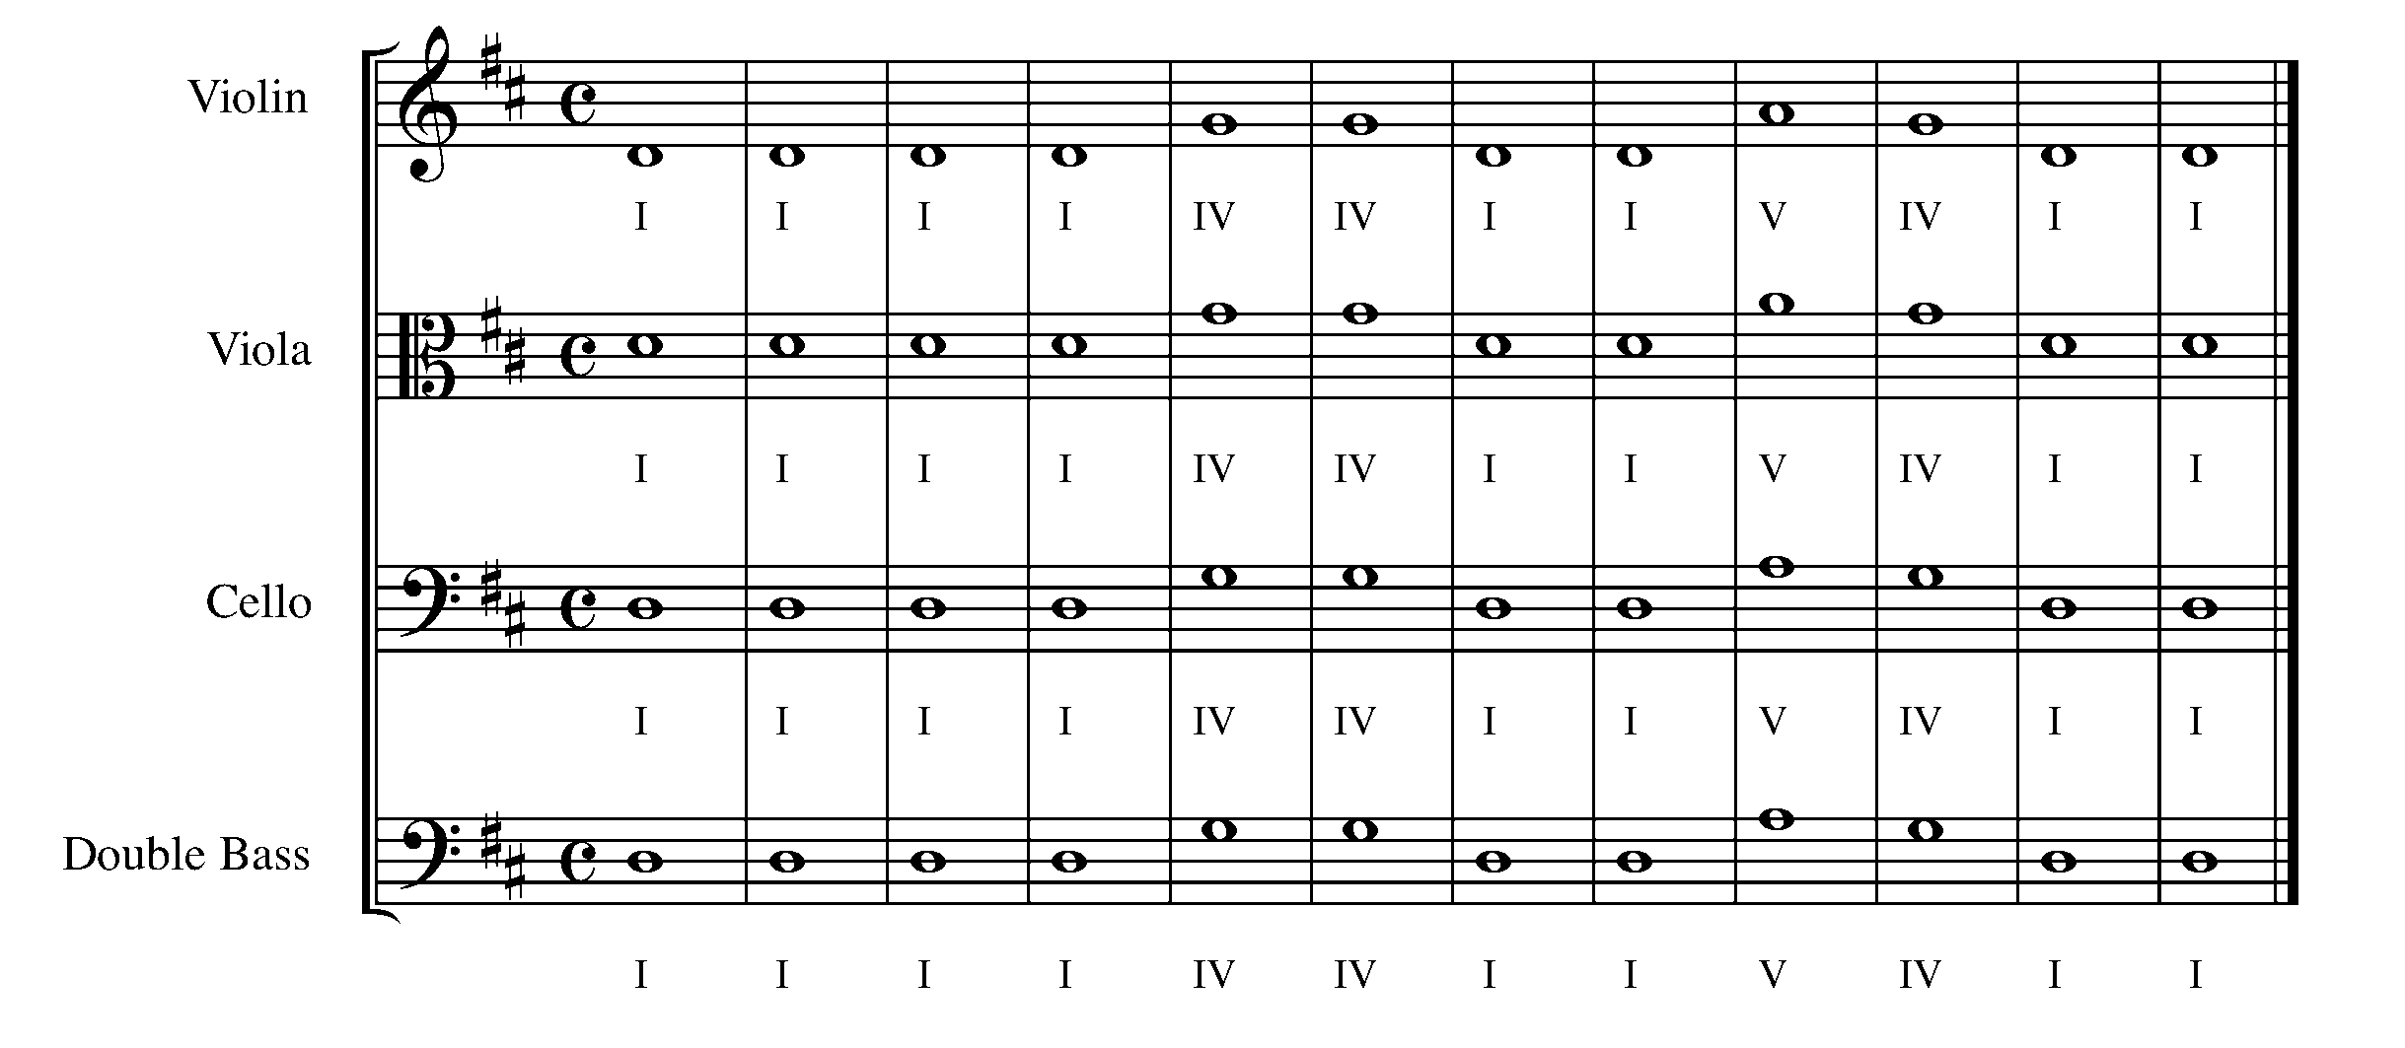
Minds On! What kind of rhythmic feel should you create to support the 12-bar blues? If you’ve never heard music that is categorized as “the blues”, find some recordings to listen to before writing your 12 bars of rhythmic accompaniment.

Action! In order to be successful with this task, you will need to:
Part I
- Scan the pattern of the above progression;
- Understand that the above series of notes create a 12-bar blues progression; and
- Play this on your instrument for a friend to refresh you memory from last year.

Part II
- Using the appropriate notes (I, IV, or V) from the 12-bar blues progression and using examples of the jazzy rhythms below to help you, create your own jazzy rhythm to create an accompaniment for the 12-bar blues. Remember to include:
  - All 12 bars with the correct progression;
  - An appropriate clef for your instrument;
  - Correct key signature for D major;
  - 4/4 time signature;
  - A double bar line at the end of your composition; and
  - Have a friend check over your accompaniment and practice.

Examples of Jazzy rhythms:

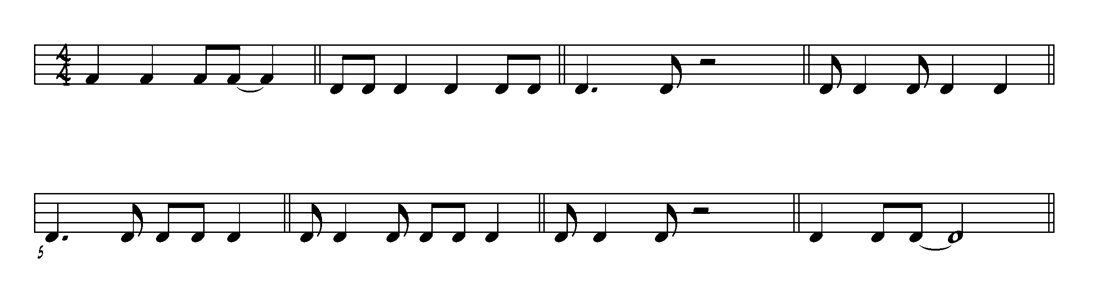

Part III
- Perform your arrangement for your teacher with accurate rhythm and pitch

________________________________________________________________________________________________________________________________________________________________________________________________________________________________________________________________________________________________________________________________

________________________________________________________________________________________________________________________________________________________________________________________________________________________________________________________________________________________________________________________________

________________________________________________________________________________________________________________________________________________________________________________________________________________________________________________________________________________________________________________________________

________________________________________________________________________________________________________________________________________________________________________________________________________________________________________________________________________________________________________________________________

Consolidation: Have a friend check over your composition and listen to you perform, then show this task to your teacher.
Name of friend _______________________.

CONGRATULATIONS! YOU HAVE REACHED THE THIRD GPS MARKER -SOUTH!

YOU ARE VERY CLOSE TO THE FINAL GPS DESTINATION
DON’T FORGET TO FILL IN YOUR TASK TRACKER!

16. SINGLE, DOUBLE, TRIP-O-LET! FOCUS: RHYTHM

Learning Goal: A triplet is a group of three notes having the same value of two notes of the same kind. For this task, you will learn to perform triplets in the form of eighth notes evenly, which has the same value as a quarter note.

Minds On: Why is it important to perform triplets evenly? What can you do in order to make sure you even out the three notes when performing? Find a recording of “Star Wars” or ask your teacher for a copy. Can you hear the triplets in the piece?

Action! In order to be successful with this task, you will need to:
- Give a slight accent to the first note of each triplet;
- Remember that the three notes are being played to the time of only two notes;
- Demonstrate that each group of triplets alternates between down-bow and up-bow; and
- Move your toe inside your shoe to help you perform your triplets evenly.

Trip-o-lets!!!

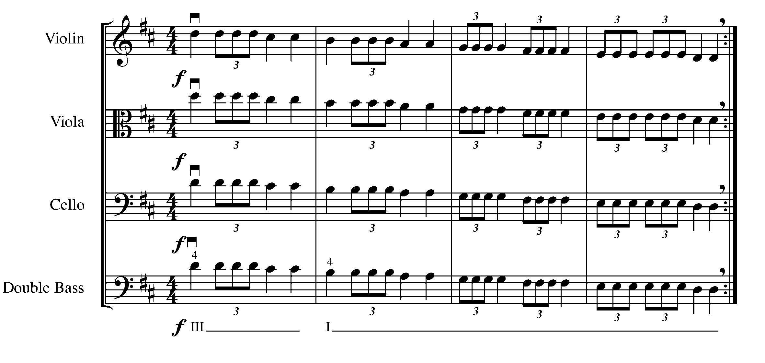

Consolidation: Perform this task for your teacher and receive feedback.

17. “PICKING UP” A NEW SKILL FOCUS: RHYTHM

Learning Goal: The purpose of this task is to understand and perform a song which begins with a pick-up note.

Minds On: When a piece of music is in 4/4 time, do some beats get a stronger pulse then others? If so, then how does a pick up note affect the “feel” of a piece? Another name for pick-up notes is anacrusis.

Action! In order to be successful with this task, you will need to:
- Be aware of the finger pattern for G major;
- Figure out on which beat the pickup note lies;
- Demonstrate an understanding of how the pickup note is performed;
- Consider the correct bow direction, use down-bow for a strong beat; and
- Hold the tie for its full value.

The Man on the Flying Trapeze
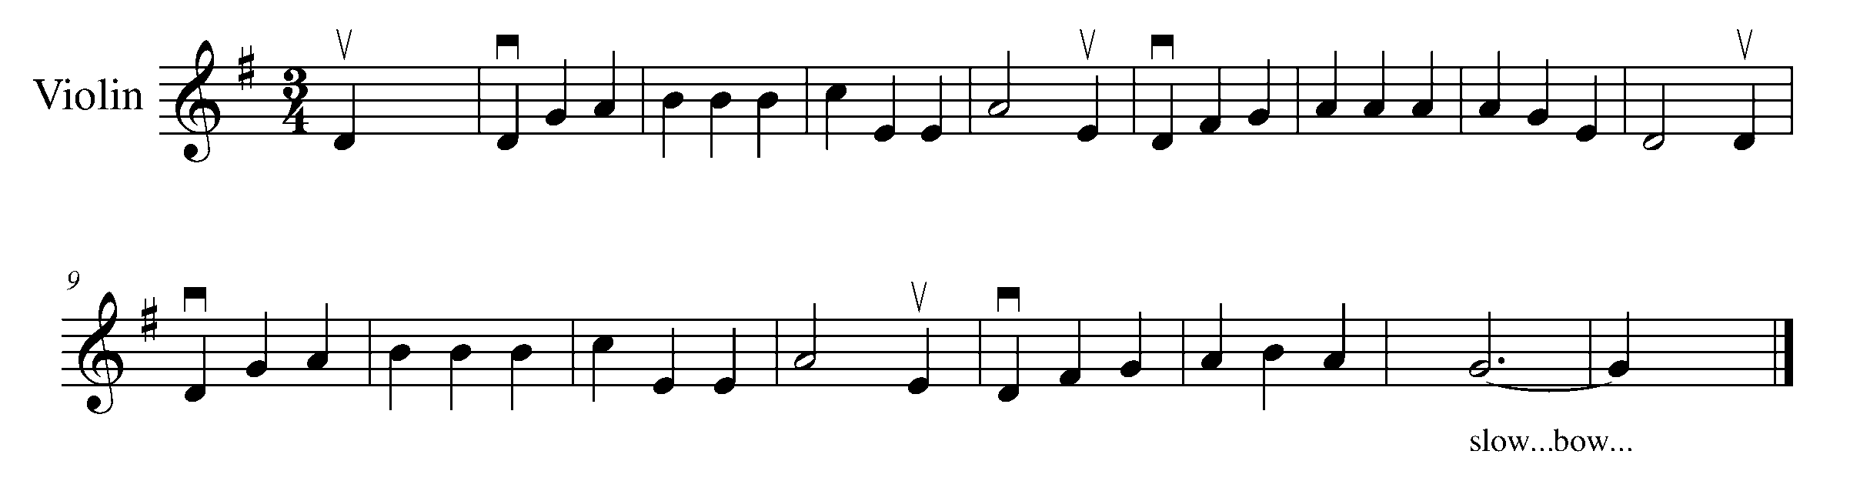
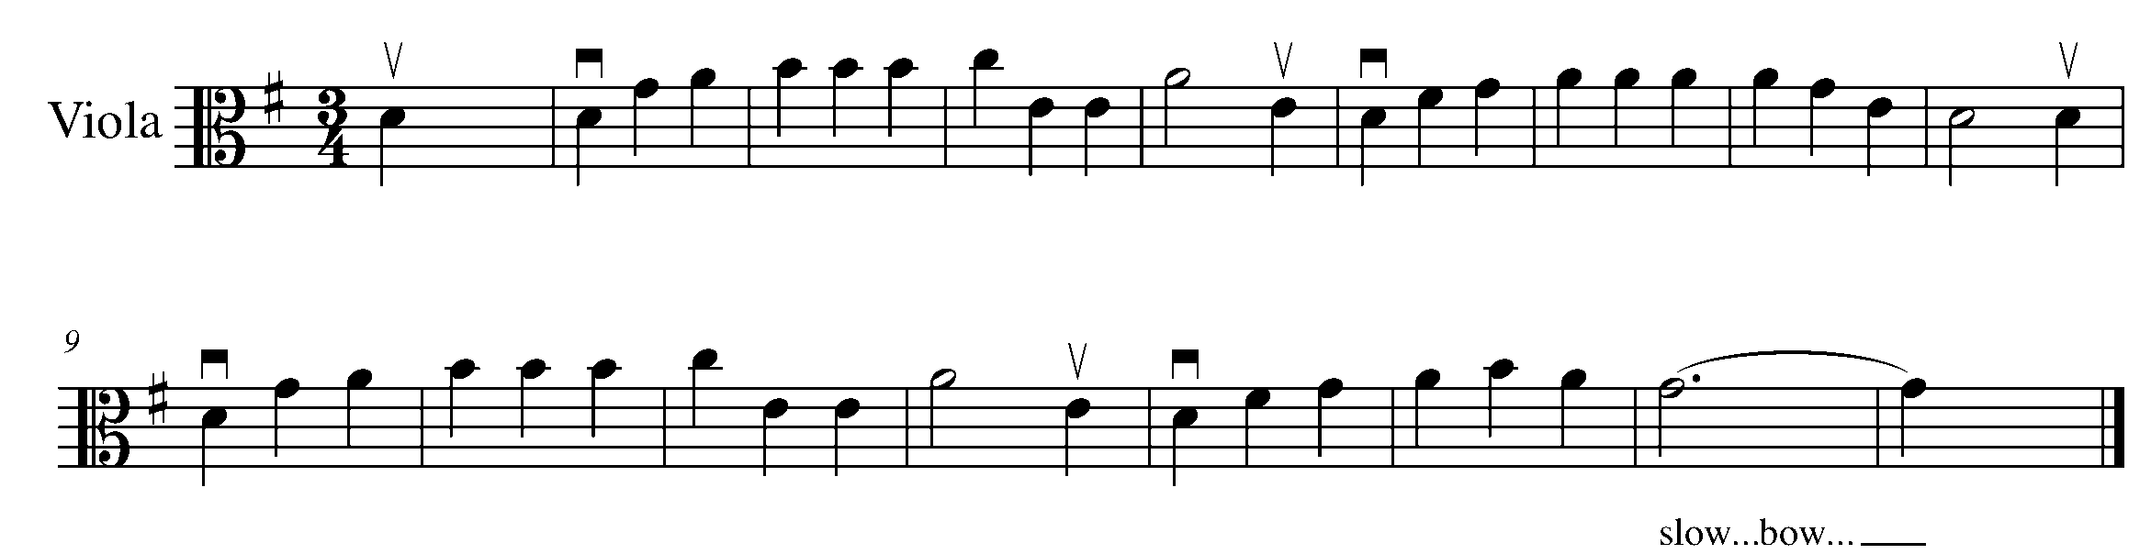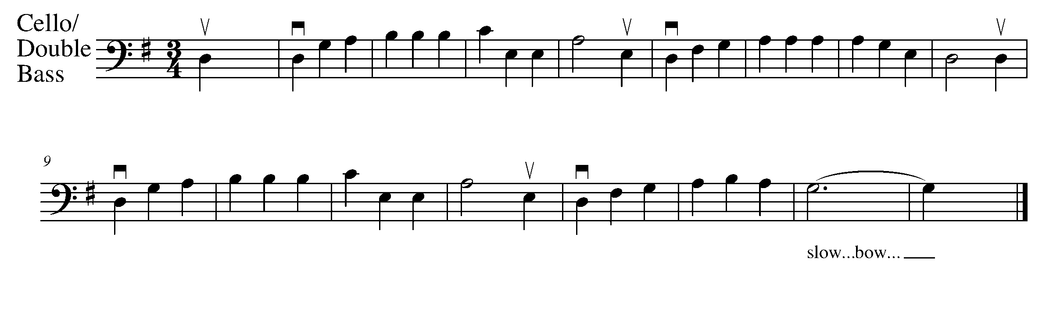
Consolidation: Perform this task for your teacher to receive feedback.

18. PARTNER UP! FOCUS: FORM/BEAT

Learning Goal: The purpose of this task is to learn to play in a small ensemble while applying your knowledge on dynamics, balance, phrasing, and articulation with your partner. You can perform this round with any stringed instrument, it does not need to be two of the same instrument.

Minds On! What is a round? How do you perform one? As musicians, why is listening to each other an important skill to have when performing in an ensemble? Why is it important to tune our instruments before a performance?

Action! In order to be successful with this task, you will need to:
- Use the chromatic tuner before you practice to tune your open strings to make sure both instruments are in tune;
- Discuss dynamics, balance, phrasing, and articulation with your partner and how you are going to approach each of these musical aspects in your duet;
- First, practice with your partner, playing together;
- When you a confident you know the piece well and can keep a steady tempo, practice playing your own parts;
- Perform “Frère Jacques” as a round with a partner for your teacher with excellent intonation. Violin and viola players, remember to use your 4th finger A on the D string; and
- Move your toe inside your shoe, listen to each other, and feel the pulse to ensure you keep together during the performance.

Frère Jacques

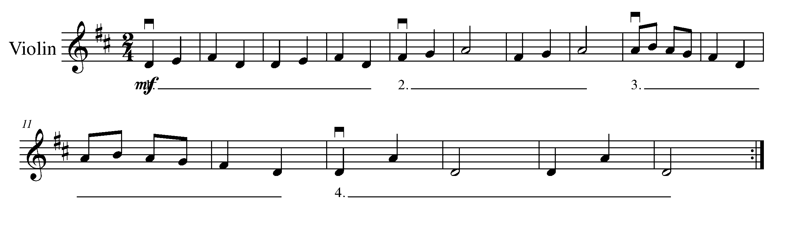
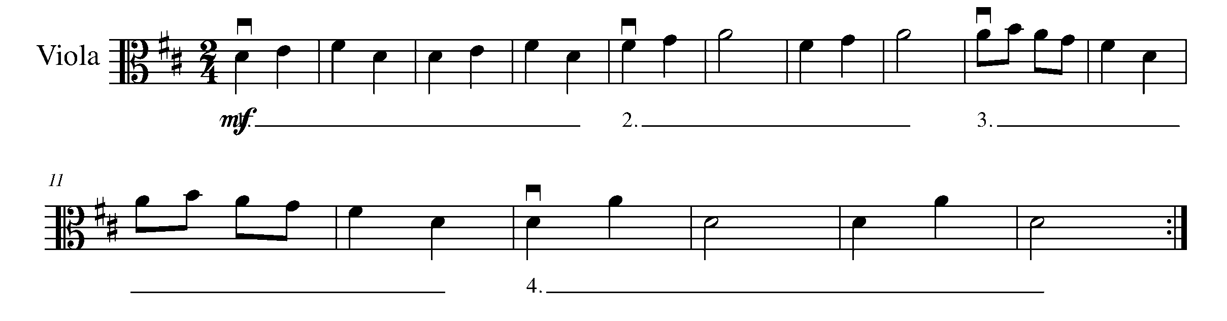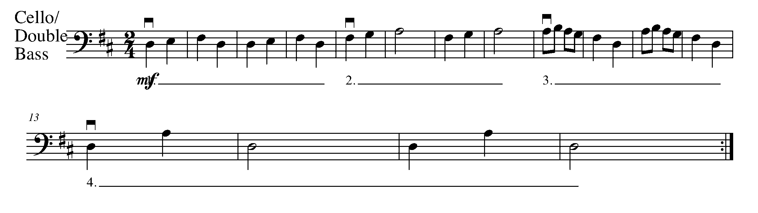
Consolidation: Perform this task for your teacher with a partner to receive feedback.

19. CREATING THE BLUES FOCUS: COMPOSITION

Learning Goal: With a partner, you will create your own melody to go with the 12-bar blues accompaniment you created in Task 15. You will add pitches to the rhythm you have chosen to use in Task 15.

Minds On: What should the melody of a 12-bar blues progression sound like? Are there certain notes you should start and end on? Knowing that you already have the harmony for this melody (the harmony is the accompaniment you created in task 15), what you write has to sound good with this given progression. How should you determine what notes might sound good with the given harmony?

Action! In order to be successful with this task, you will need to:

- Use A PENCIL!
- Decide between your partner and you, whose accompaniment from task 15 you are going to use for this task;
- Now use the rhythm from the other accompaniment (the one you have not chosen to use as the accompaniment for this task), decide what pitches will “work” with the given blues progression. Starting and ending with the tonic is a good place to begin;
- Write your melody on the staff below using the rhythm you have chosen; and
- Make sure you write a melody that you can play.

Checklist:
___ Appropriate clef
___ Key signature
___ Time signature
___ 12 bars
___ Correct 12-bar blues progression labeled
___ Double bar line
___ Title

Title: ______________________

________________________________________________________________________________________________________________________________________________________________________________________________________________________________________________________________________________________________________________________________

________________________________________________________________________________________________________________________________________________________________________________________________________________________________________________________________________________________________________________________________

________________________________________________________________________________________________________________________________________________________________________________________________________________________________________________________________________________________________________________________________

________________________________________________________________________________________________________________________________________________________________________________________________________________________________________________________________________________________________________________________________

Consolidation: Show this piece to your teacher and receive feedback.

20. WRAPPING IT UP WITH THE BLUES FOCUS: EXPRESSIVE CONTROLS

Learning Goal: During this task, you and your partner from Task 19 will perform the accompaniment you have chosen to use from task 15 and melody you have created from 19 as a duet.

Minds On: How will you and your partner go about preparing for this performance? How will you know when to start?

Action! In order to be successful with this task, you will need to:
- Go back to task 18. What were some of the things you needed to do to make you sure your instruments are in tune before you start?
- Discuss dynamics, balance, phrasing, and articulation with your partner and how you are going to approach each of these musical aspects in your duet;
- First, practice both parts separately with your partner, playing together;
- When you are confident you know the piece well and can keep a steady tempo, practice playing your own parts;
- Practice switching parts. Remember both partners should be able to play both the melody and the accompaniment; and
- Move your toe inside your shoe, listen to each other, and feel the pulse to ensure you keep together during the performance.

Consolidation: Perform your 12-bar blues duet for your teacher and receive feedback.

CONGRATULATIONS! YOU HAVE REACHED
YOUR DESTINATION!
THE FINAL WEST GPS MARKER.

DON’T FORGET TO FILL IN YOUR TASK TRACKER AND CELEBRATE YOUR ACCOMPLISHMENTS!

North
South
West
Task # 3
Task # 1
Task # 2
Task # 4
Task # 6
Task # 7
Task # 8
Task # 9
Task # 13
Task # 12
Task # 11
Task # 14
Task # 18
Task # 17
Task # 16
Task # 19
Task # 20
Task # 5
Task # 10
Task #15
TASK TRACKER
East

Congratulations!

__________________ has reached the North GPS Marker in the 2nd Year String Program.

_________________________________
Teacher Signature

_________________________________
Principal Signature

Congratulations!

__________________ has reached the East GPS Marker in the 2nd Year String Program.

_________________________________
Teacher Signature

_________________________________
Principal Signature

Congratulations!

__________________ has reached the South GPS Marker in the 2nd Year String Program.

_________________________________
Teacher Signature

_________________________________
Principal Signature

Congratulations!

__________________ has reached the FINAL West GPS Marker in the 2nd Year String Program.

You’re Done!!

_________________________________
Teacher Signature

_________________________________
Principal Signature

