Teachers, before you copy this booklet for your students...
⬰ Have you read the GPS Overview?
⬰ Have you taught these students before? If not, please take the time to work with your students to determine their strengths and needs before deciding which tasks will be appropriate..
⬰ Have you gone through the appropriate start up steps with your students? For example; the basics on putting together their instrument, care and maintenance of their instrument, posture and breathing.
⬰ If you have taught these students before...go through the entire program task-by-task to confirm that the sequence and challenge level of the tasks, is appropriate.
⬰ Refer to the Q and A section of the GPS Overview.
⬰ Do you need to reduce the number of tasks...how will you need to change the evaluation by term?
⬰ If you have questions, please contact:
Sarah Arcand: sarahwylie@hotmail.com

GPS Task Evaluation Chart
TEACHER REFERNCE
Year Two Band

This is assuming that this program starts in late October / early November

Tasks  (Completion of “X” task number equals “Y” %) | Term 1 (September to February) | Term 2 (February to June)
1 | 52% | 32%(R)
2 | 55% | 35%(R)
3 | 58% | 38%(R)
4 | 62% | 42%(R)
5 | 65% | 45%(R)
6 | 68% | 48%(R)
7 | 72% | 52%
8 (taught to) | 75% | 55%
9 | 78% | 58%
10 | 82% | 62%
11 | 88% | 65%
12 | 92% | 68%
13 | 98% | 72%
14 (taught to) | 100% | 75%
15 |  | 78%
16 |  | 82%
17 |  | 88%
18 |  | 92%
19 |  | 98%
20 |  | 100%

Tasks 15 to 20 serve as extensions and culminating activities which encompass the concepts learned or introduced in Tasks 1 to 14. What you must teach are the14 tasks by the end of the year.

GPS
(Grade Performance Steps)

The Road to Musical Success!

Intermediate Band Performance Tasks
YEAR TWO





Ontario Music Educators’ Association
www.omea.on.ca

GPS Task STUDENT Evaluation Chart
Year Two Band

In order to be successful this year, you will need to plan out how many tasks you think you can complete, and the mark you want to receive for performing on your instrument! Below is a summary of the number of tasks per term, and the mark you will receive for the tasks you complete:

Tasks  (Completion of “X” task number equals “Y” %) | Term 1 (September to February) | Term 2 (February to June)
1 | 52% | 32%(R)
2 | 55% | 35%(R)
3 | 58% | 38%(R)
4 | 62% | 42%(R)
5 | 65% | 45%(R)
6 | 68% | 48%(R)
7 | 72% | 52%
8 | 75% | 55%
9 | 78% | 58%
10 | 82% | 62%
11 | 88% | 65%
12 | 92% | 68%
13 | 98% | 72%
14 | 100% | 75%
15 |  | 78%
16 |  | 82%
17 |  | 88%
18 |  | 92%
19 |  | 98%
20 |  | 100%

Performance is just one part of your music evaluation this year. Your teacher will let you know what the other aspects of your program are on your two summative report cards. Remember that with the GPS tasks:
- we will be learning concepts introduced as a class;
- you will have time in class to practice and receive feedback from your teacher and classmates;
- you will have multiple opportunities to demonstrate these tasks;
- you need to demonstrate at least a Level 3 performance (your teacher will talk with you about what a Level 3 demonstration would sound like; and
- in order to be successful, you will need to work independently in class, and outside of class time (recess, lunch, after school and practice at home).

YEAR TWO - INTERMEDIATE BAND
GPS PROGRAM

1. THE FUNDAMENTALS FOCUS: BEAT/RHYTHM
Wind Instruments and Mallets

LEARNING GOAL: In this task, you will review and demonstrate your understanding of beat, a variety of fundamental rhythms and first 5 notes of the
B-Flat Concert Scale.

MINDS ON! Why is it so important to internalize the beat when performing music? You may want to move your toe inside your shoe when first reading through the below passage. Don’t forget to apply your knowledge of good performance skills: breathing, posture and articulation.

ACTION! In order to be successful with this task, you will need to:

- Choose a tempo at which you are comfortable performing.
- Think about phrasing – where are the musical places to breathe in this piece?
- Count out the rhythms, placing rhythms on the appropriate beat.

CONSOLIDATION: In order to move to the next task, you must perform the following piece for your teacher and receive feedback.

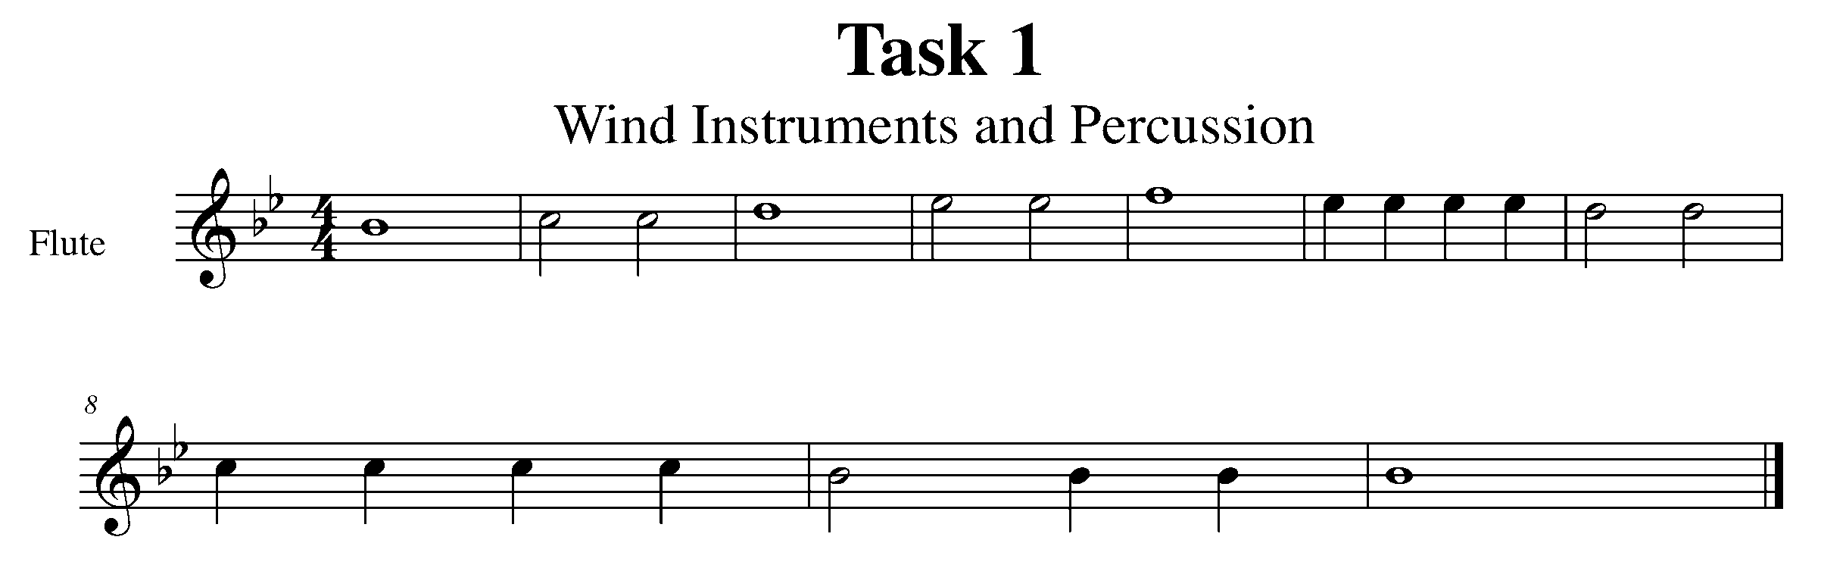
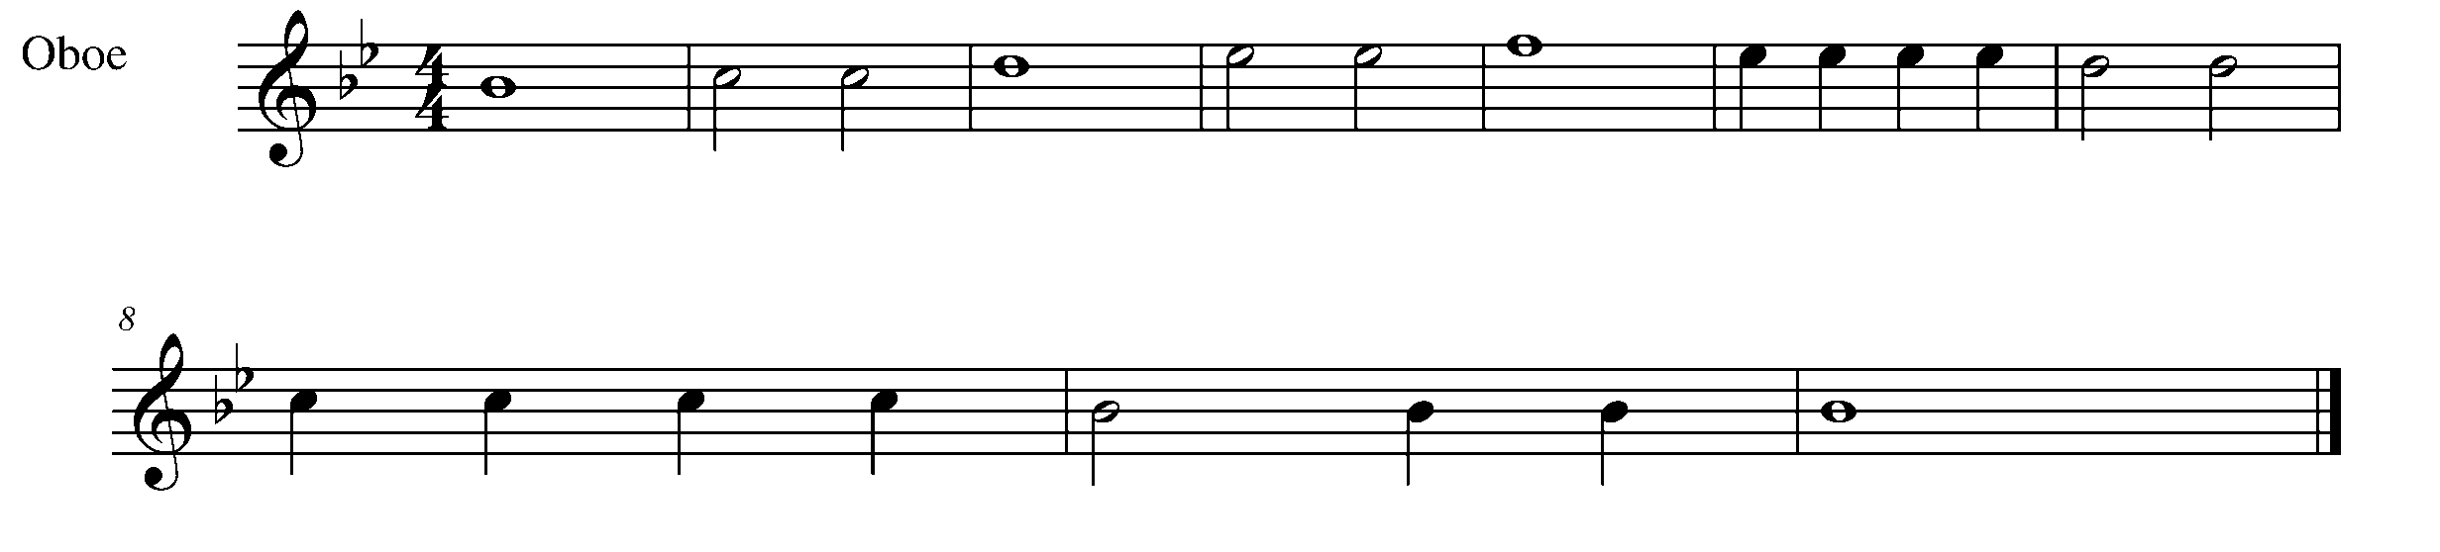

Task 1 Music Continued

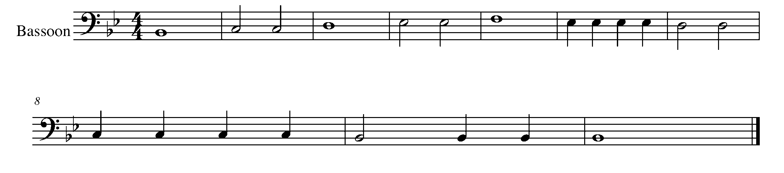
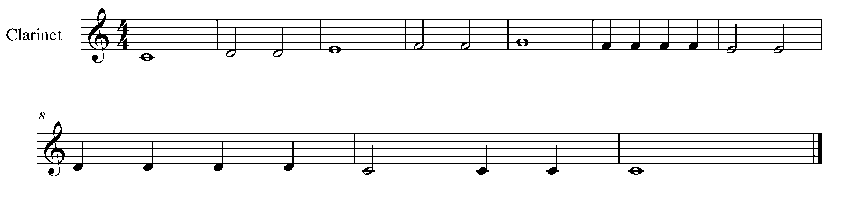
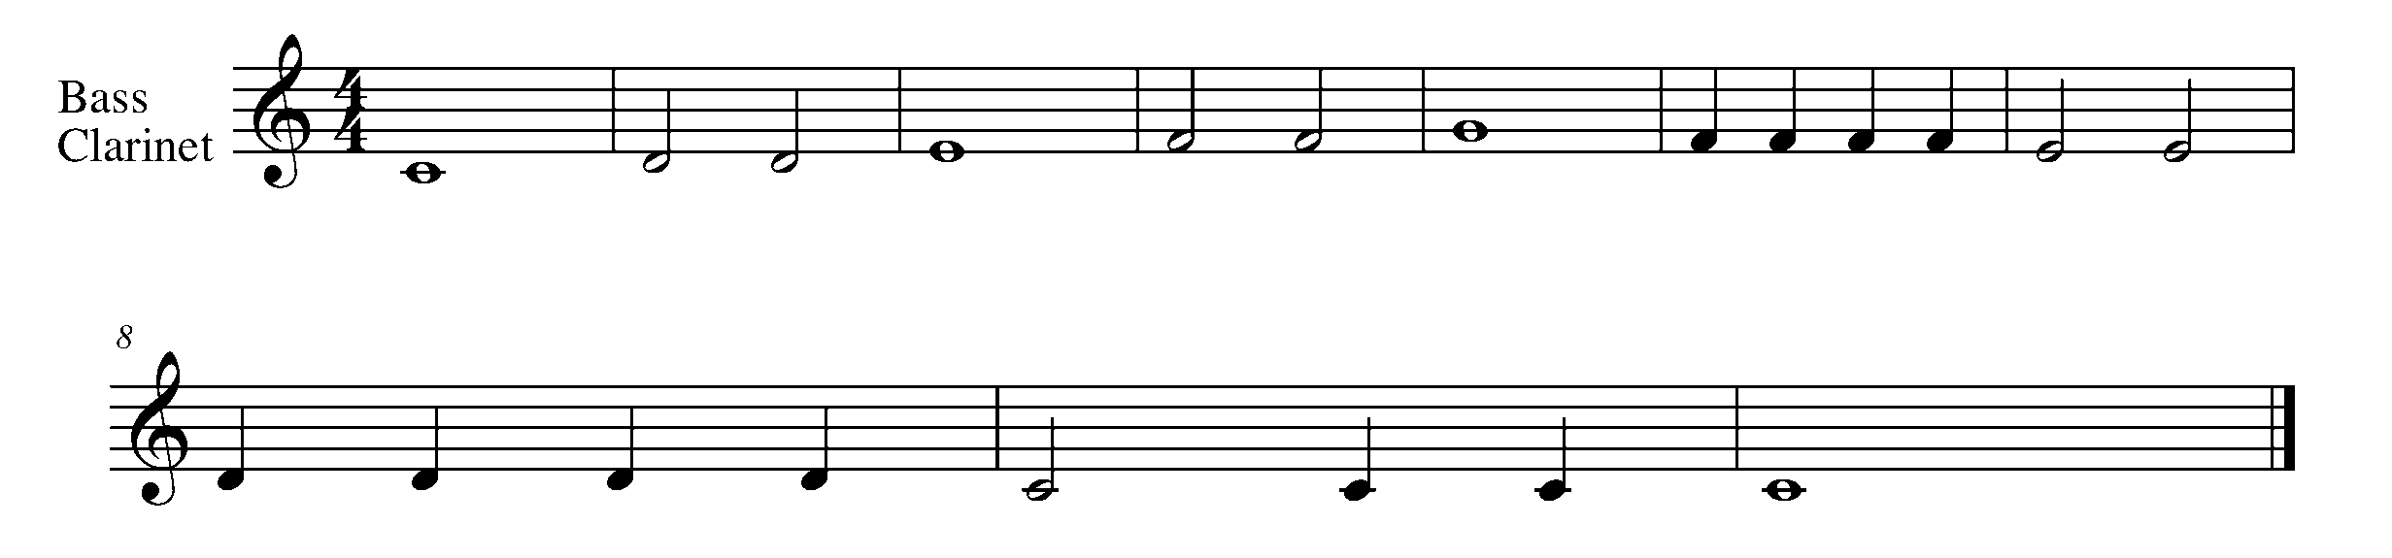
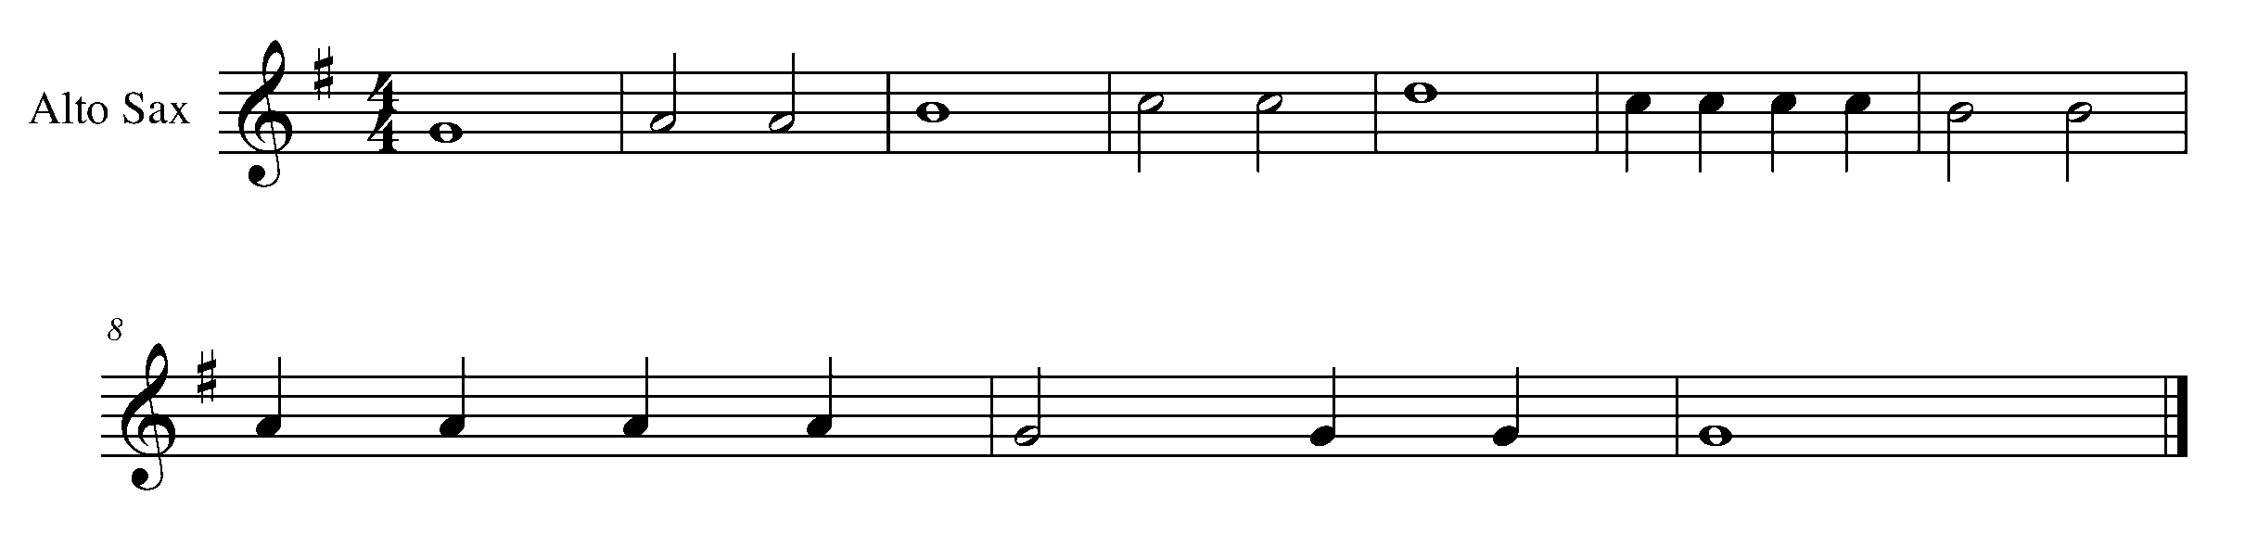
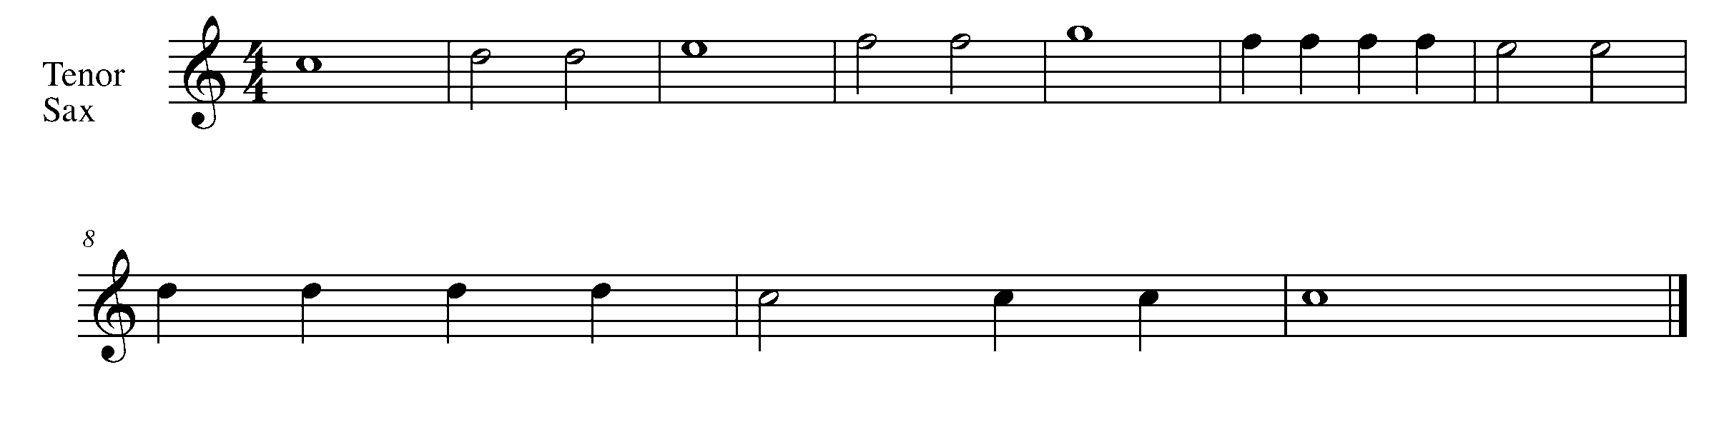

Task 1 Music Continued

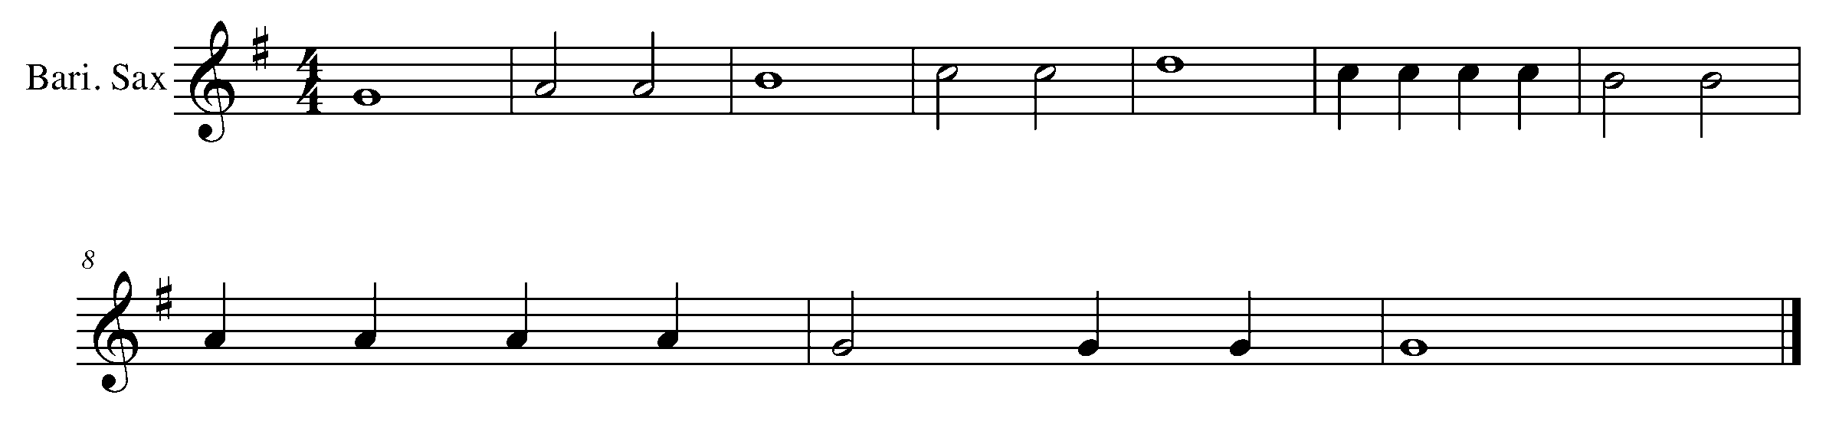
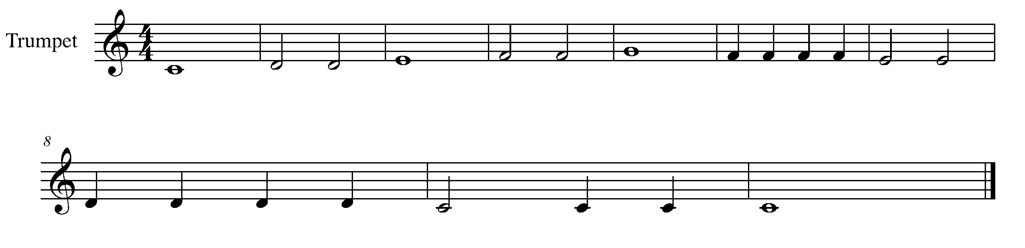
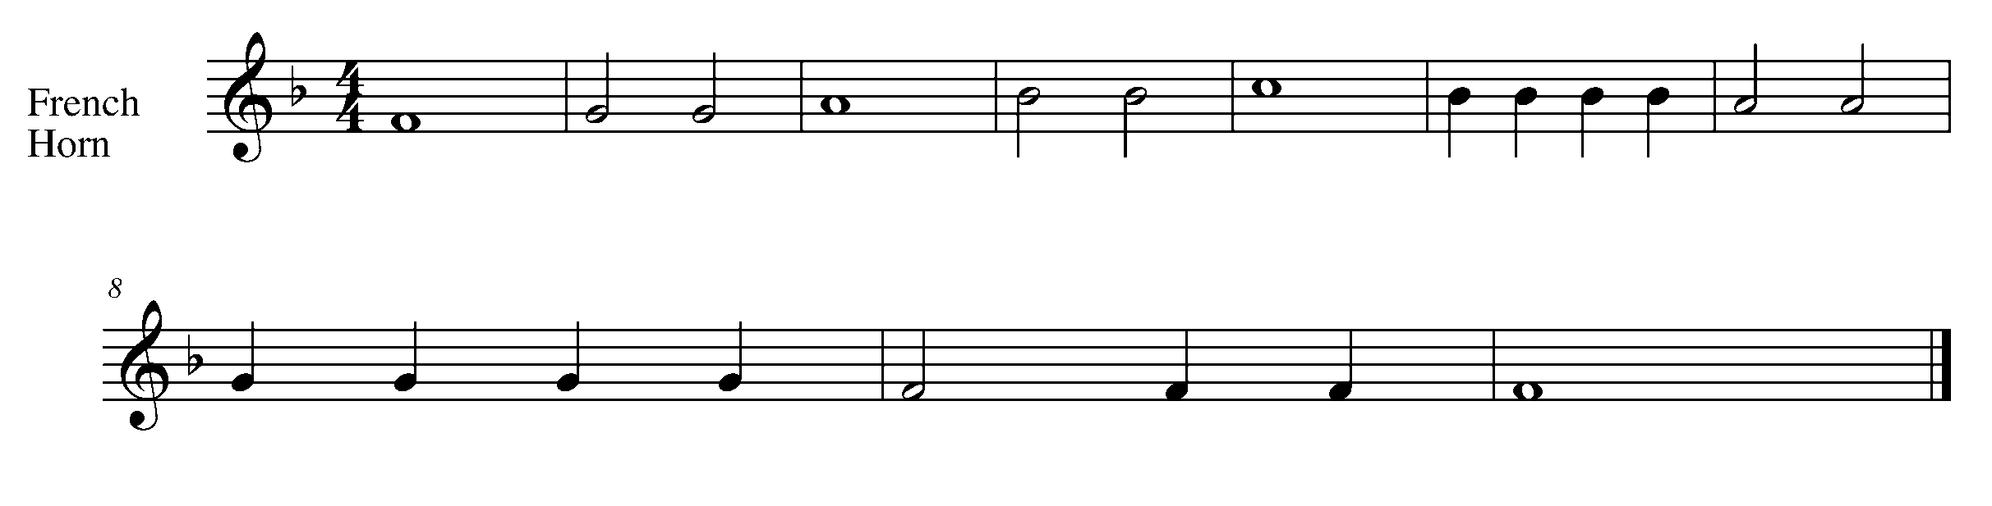
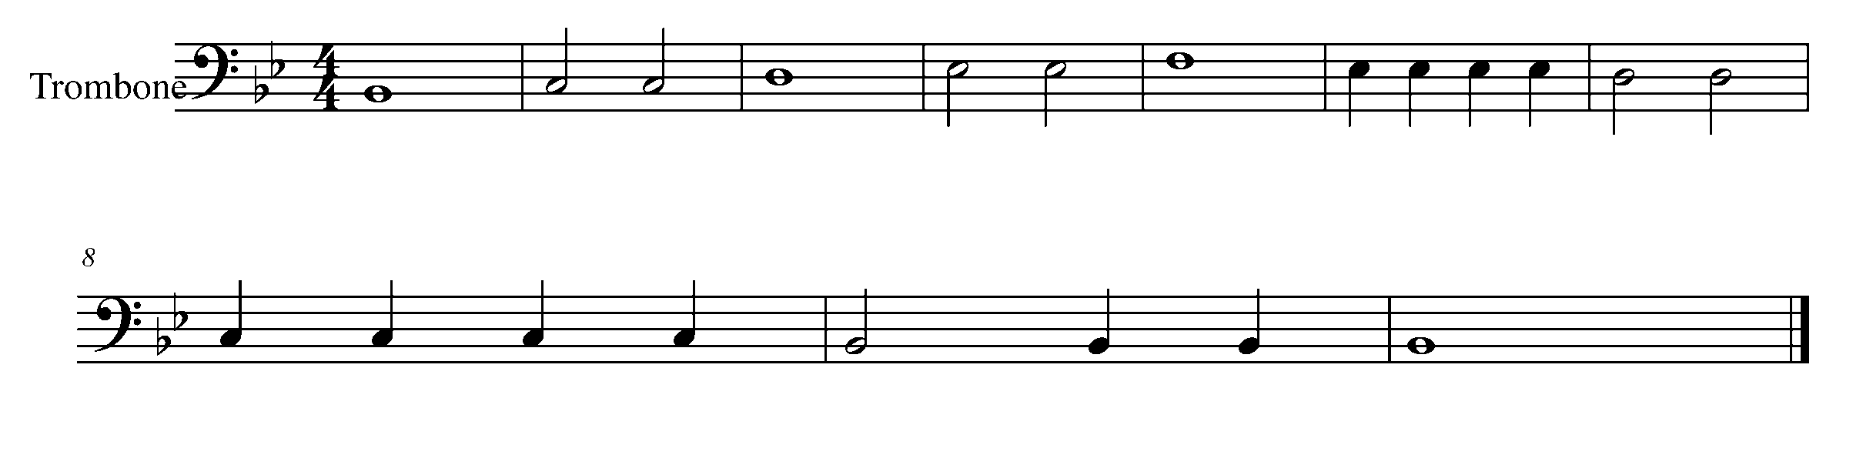
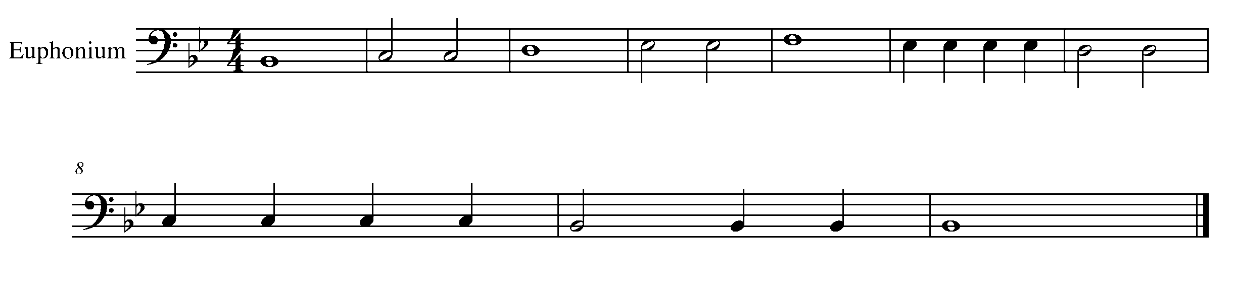

Task 1 Music Continued
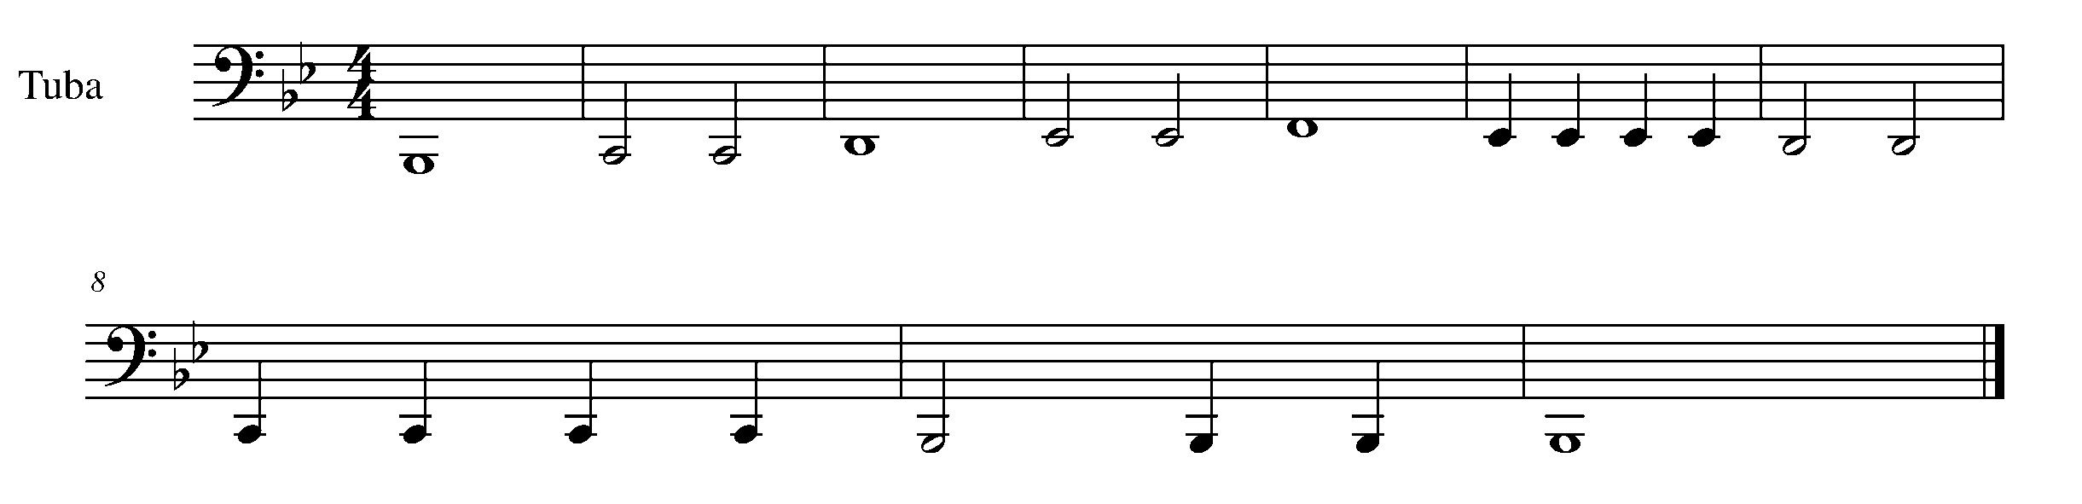
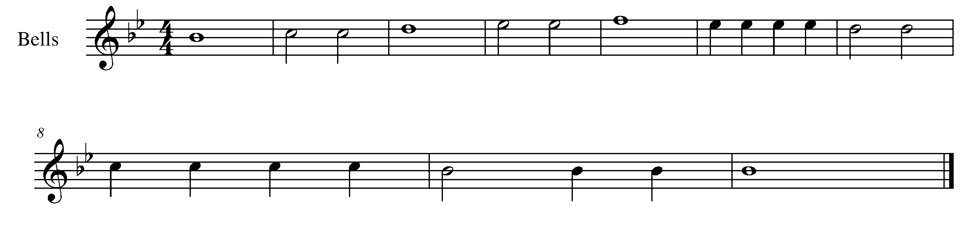

2. INTRODUCING THE RELATIVE HARMONIC MINOR FOCUS: PITCH
Wind Instruments and Mallets

LEARNING GOAL: Every major scale has a relative minor scale. Each minor scale shares the same key signature as the relative major.

MINDS ON! Knowing that the major scale shares the same key signature with it’s relative minor – why does the minor scale sound so different? How are the 3rd and 7th notes of the scale unique?

ACTION! In order to be successful with this task, you will need to:

- Look at the key signature of this scale.
- Circle the 3rd and 7th notes of the scale.
- Demonstrate the indicated articulations/sticking patterns
- Play the scale with consistent airflow and fluidness.

TASK 2 MUSIC IS FOUND ON THE NEXT PAGE

CONSOLIDATION: In order to move to the next task, you must perform the following scale for your teacher and receive feedback.
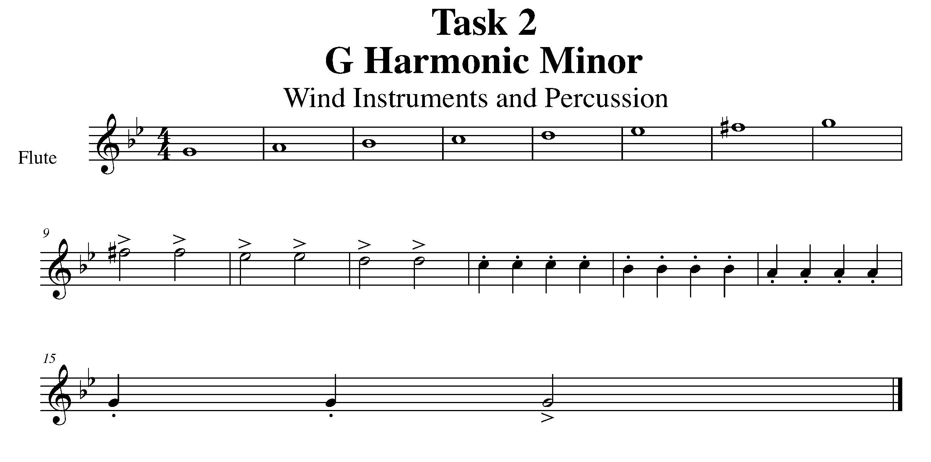
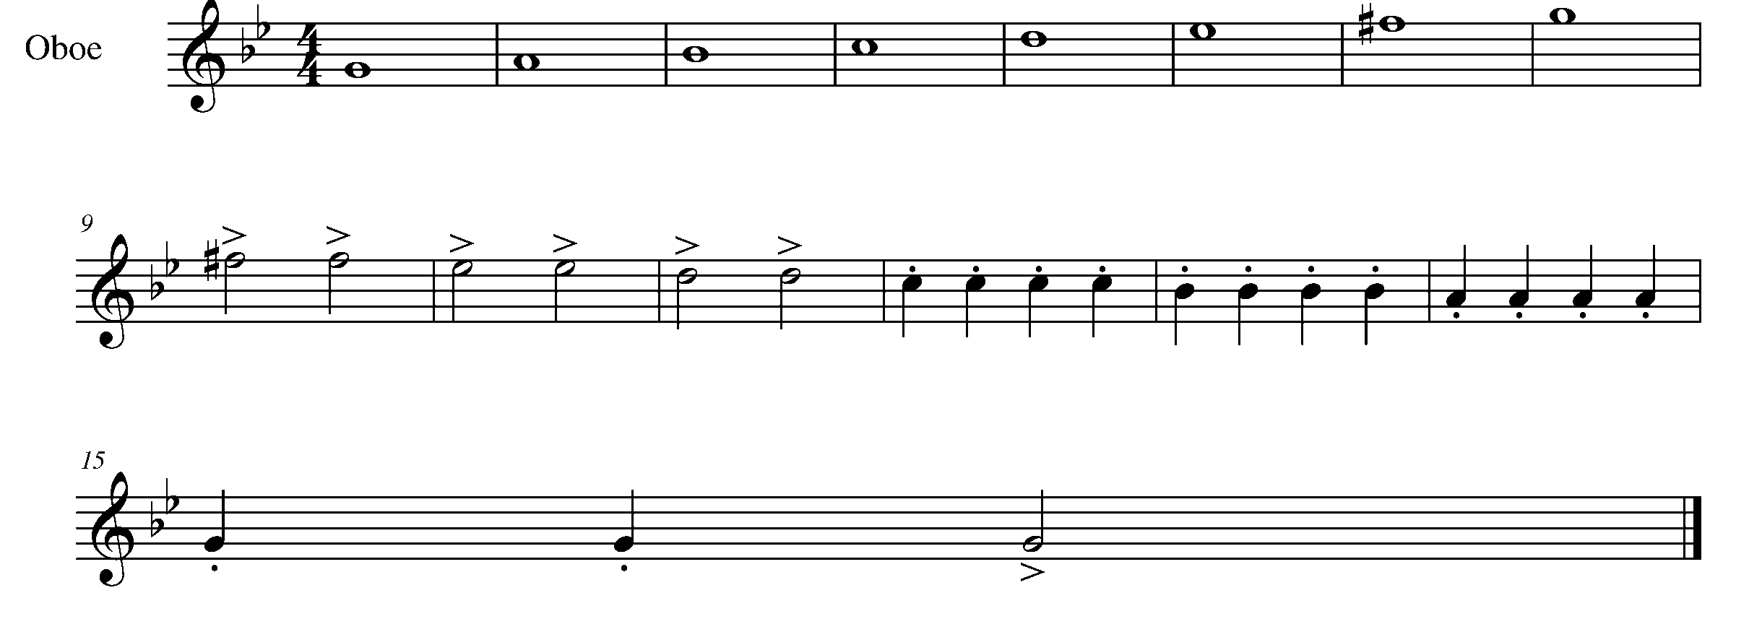
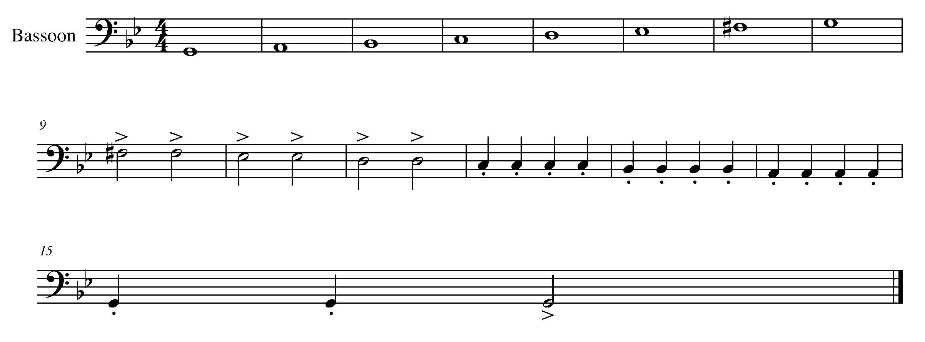

Task 2 Music Continued

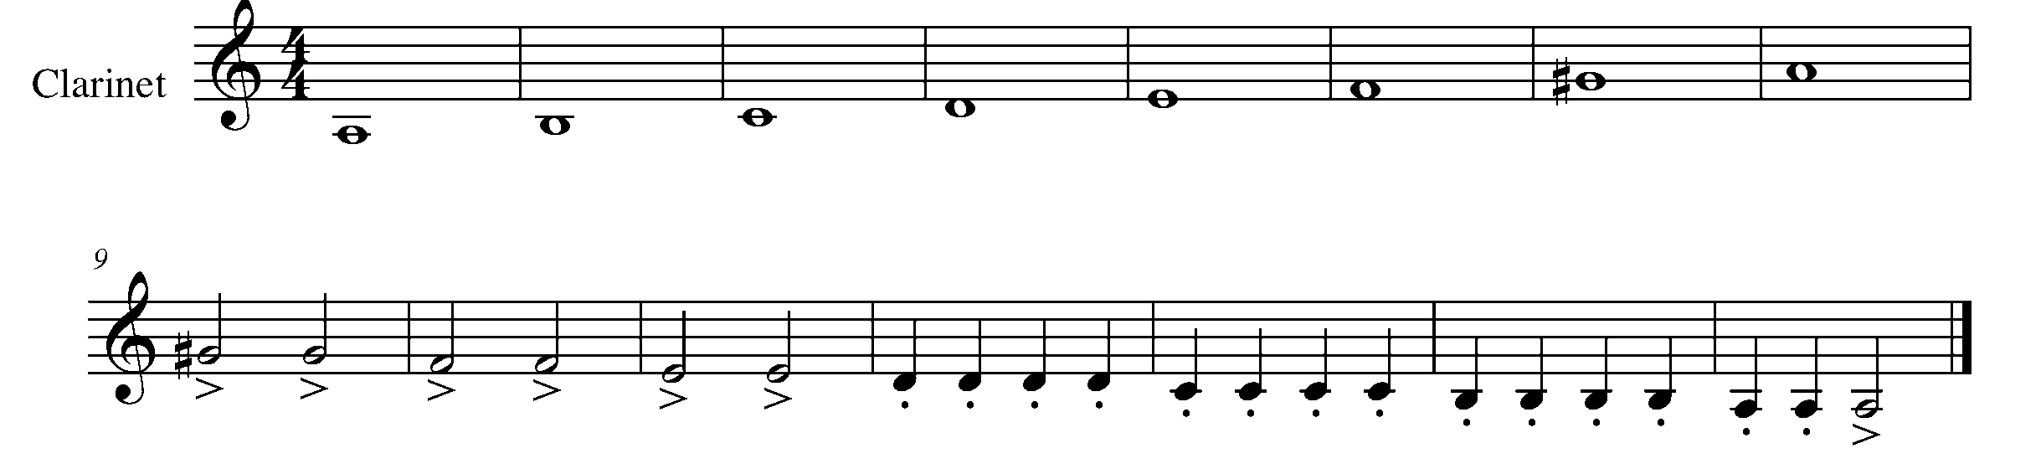
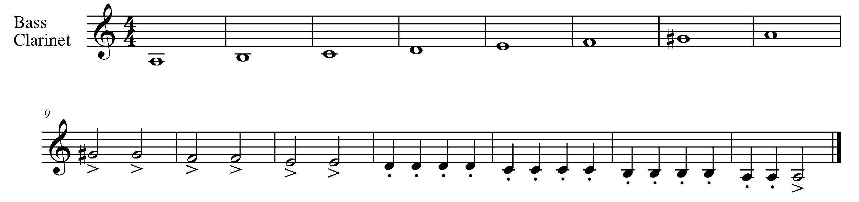
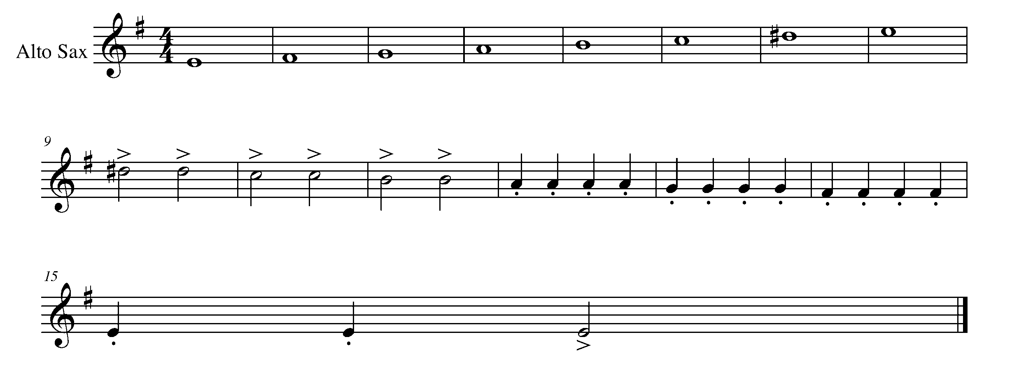
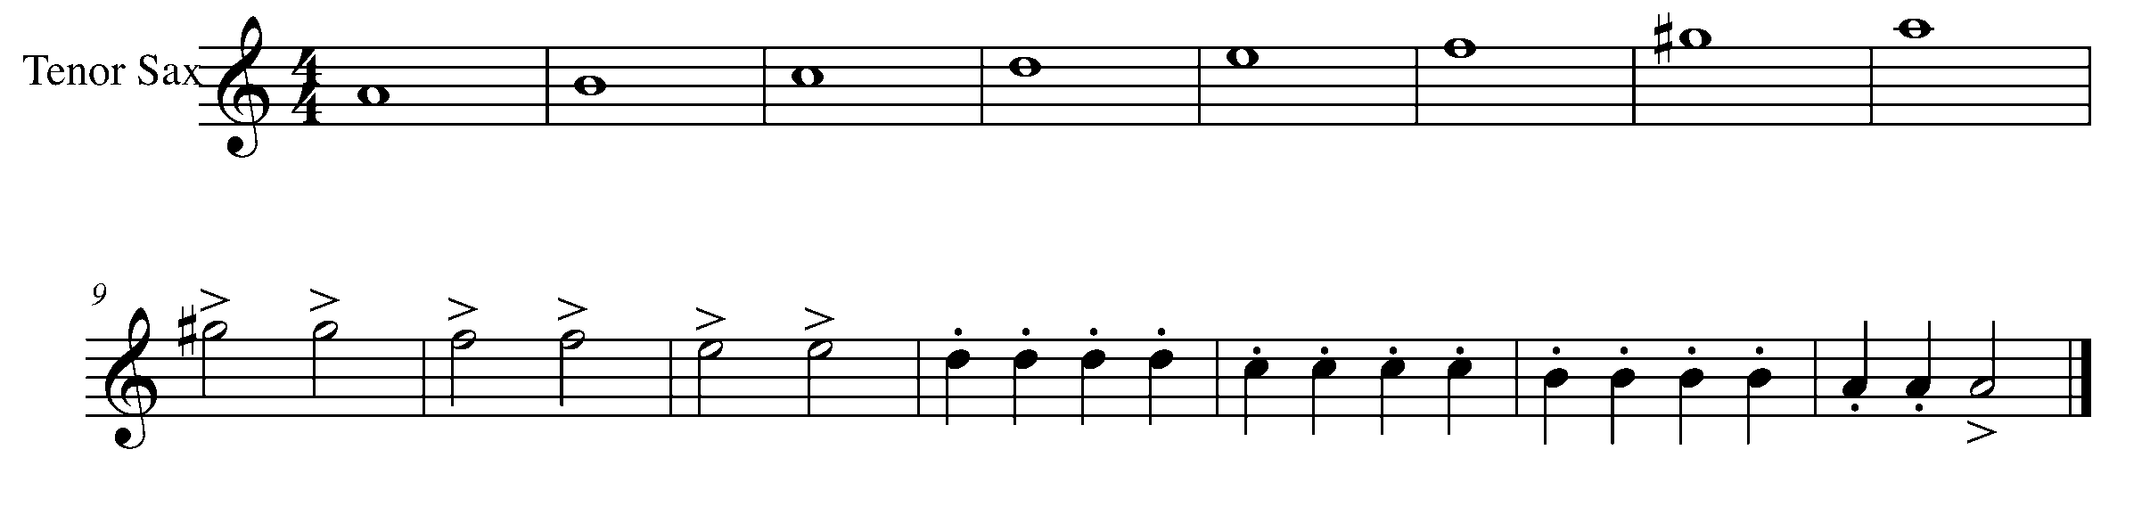

Task 2 Music Continued

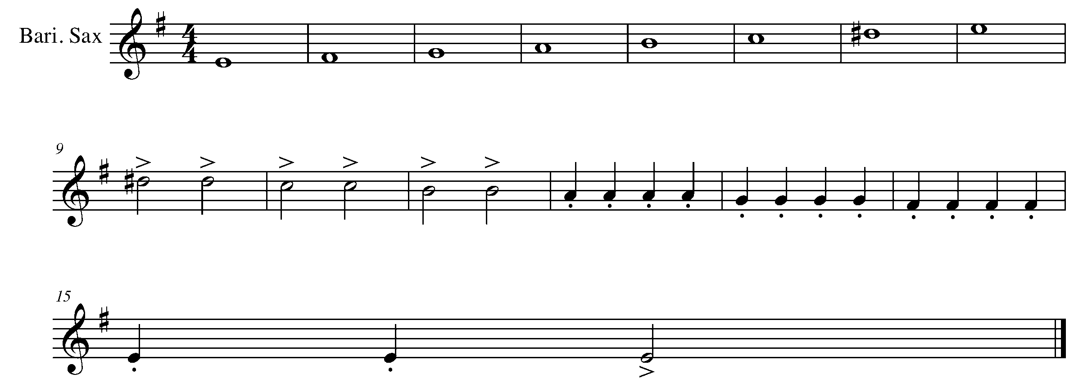
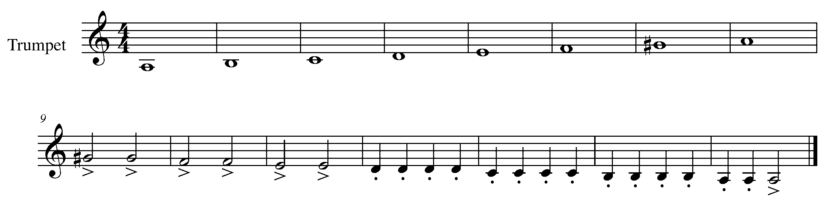
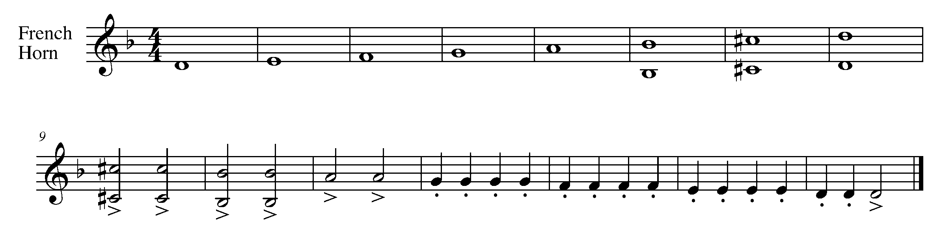

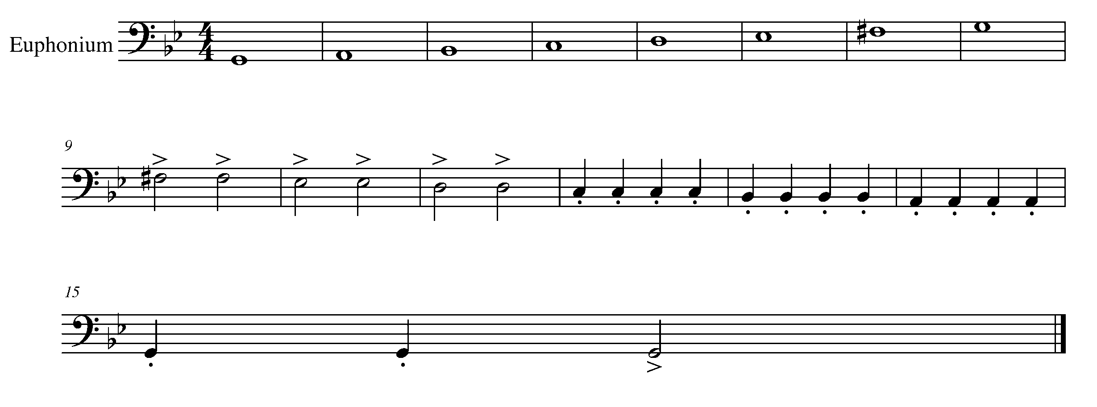

Task 2 Music Continued

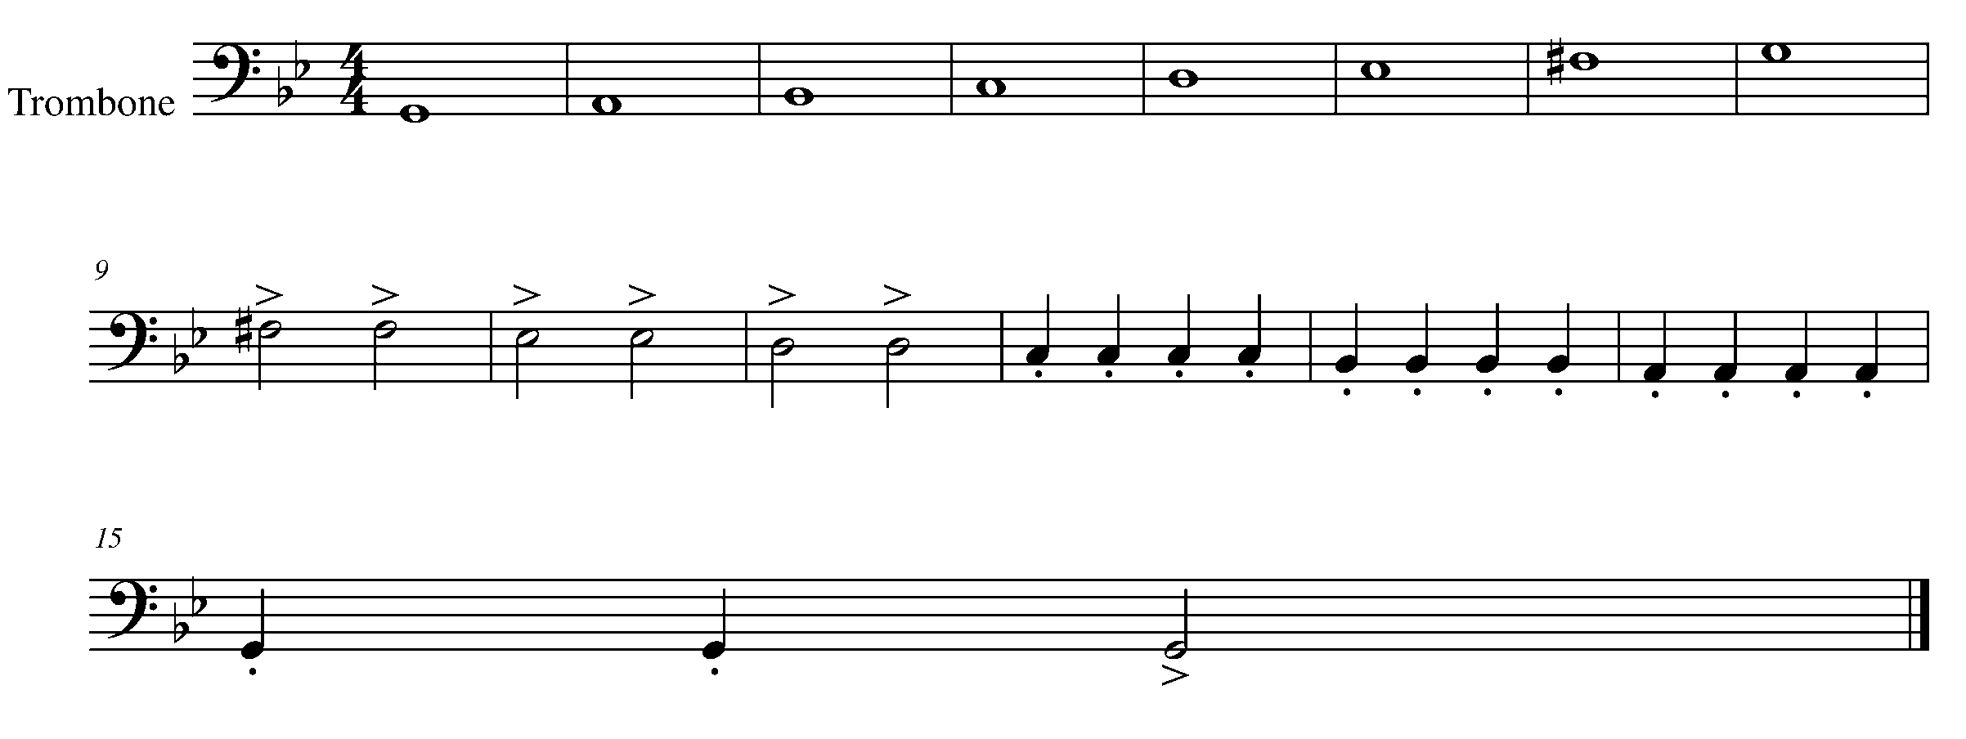
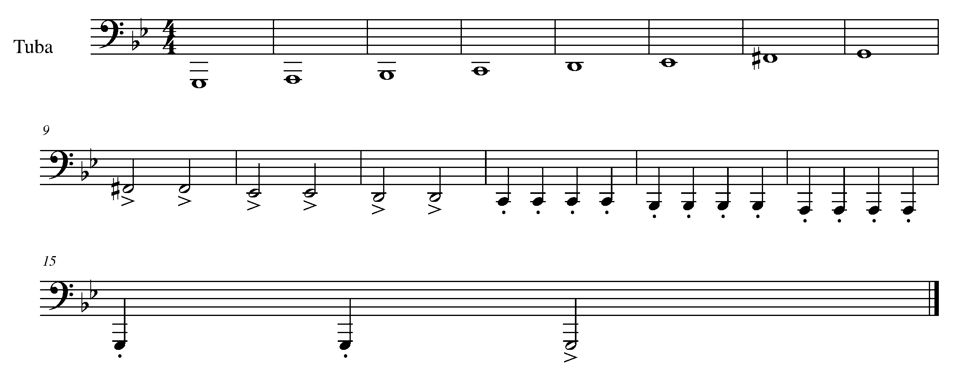
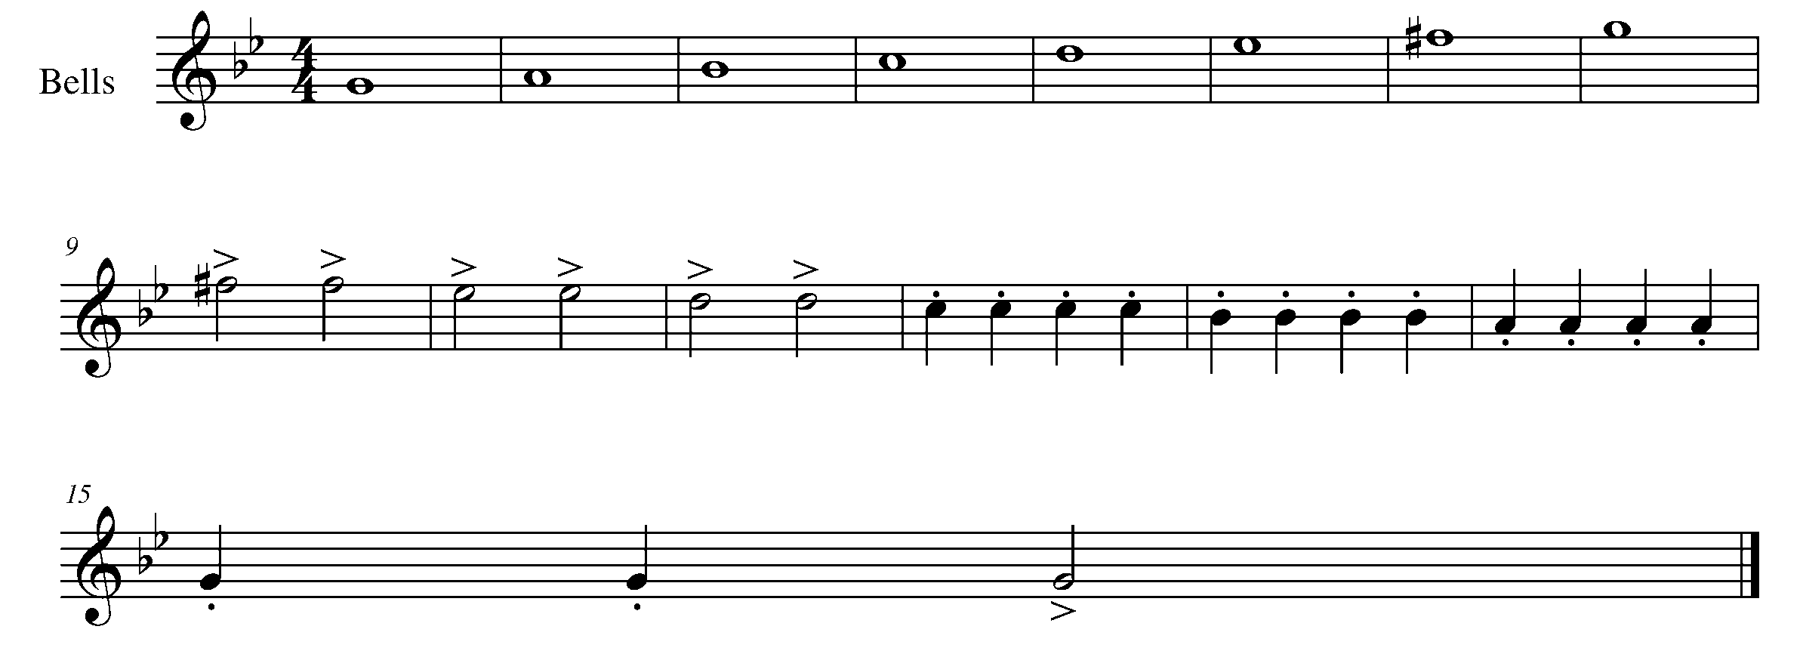

3. MAKING CONNECTIONS FOCUS: EXPRESSIVE CONTROLS
Wind Instruments and Snare Drum

Winds Task 3
LEARNING GOAL (Wind Instruments): The next step to furthering your musicality is to use your breath control to create logical phrasing within your music.

MINDS ON! When you speak, you say your words in a way that make a smooth and connected sentence. In speech you breathe so not to interrupt the thought you are trying to communicate. Apply the same principles of speech to when you would breathe when playing music. Connect the music and breathe in places where the breath does not interrupt the flow of the music.

ACTION! In order to be successful with this task, you will need to:

- Choose a tempo that allows you to play with accuracy and “make it” to the breath mark.
- Take in a deep breathe while maintaining good posture and control.
- Perform the following piece of music with musicality.

CONSOLIDATION: In order to move to the next task, you must perform the following piece for your teacher and receive feedback.

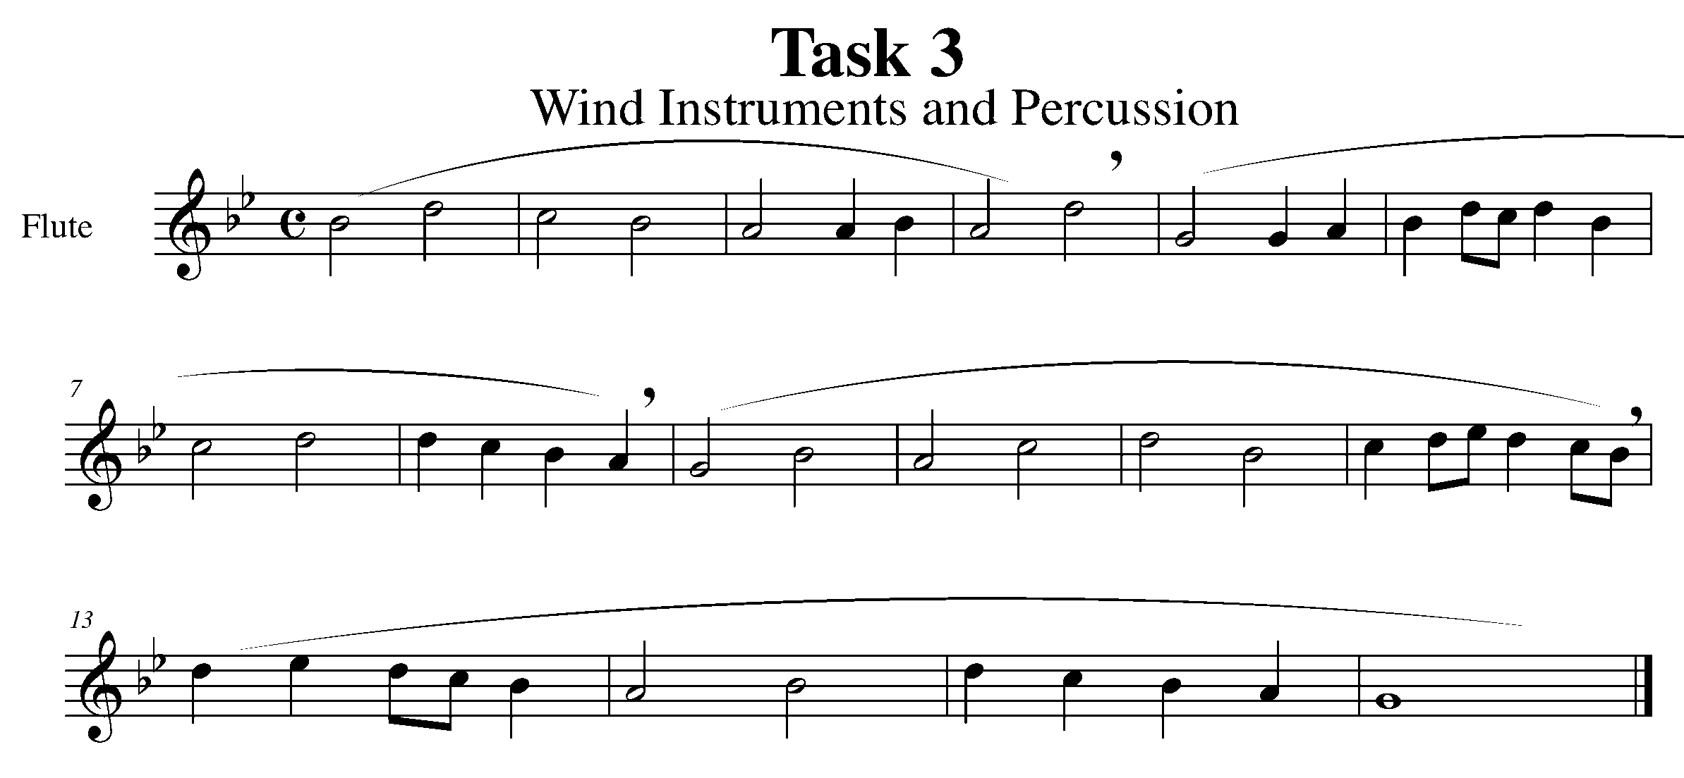

Task 3 Music Continued
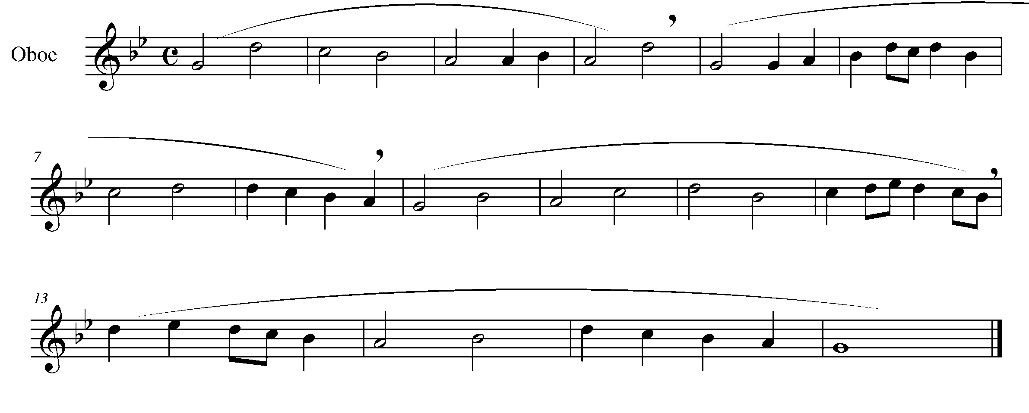
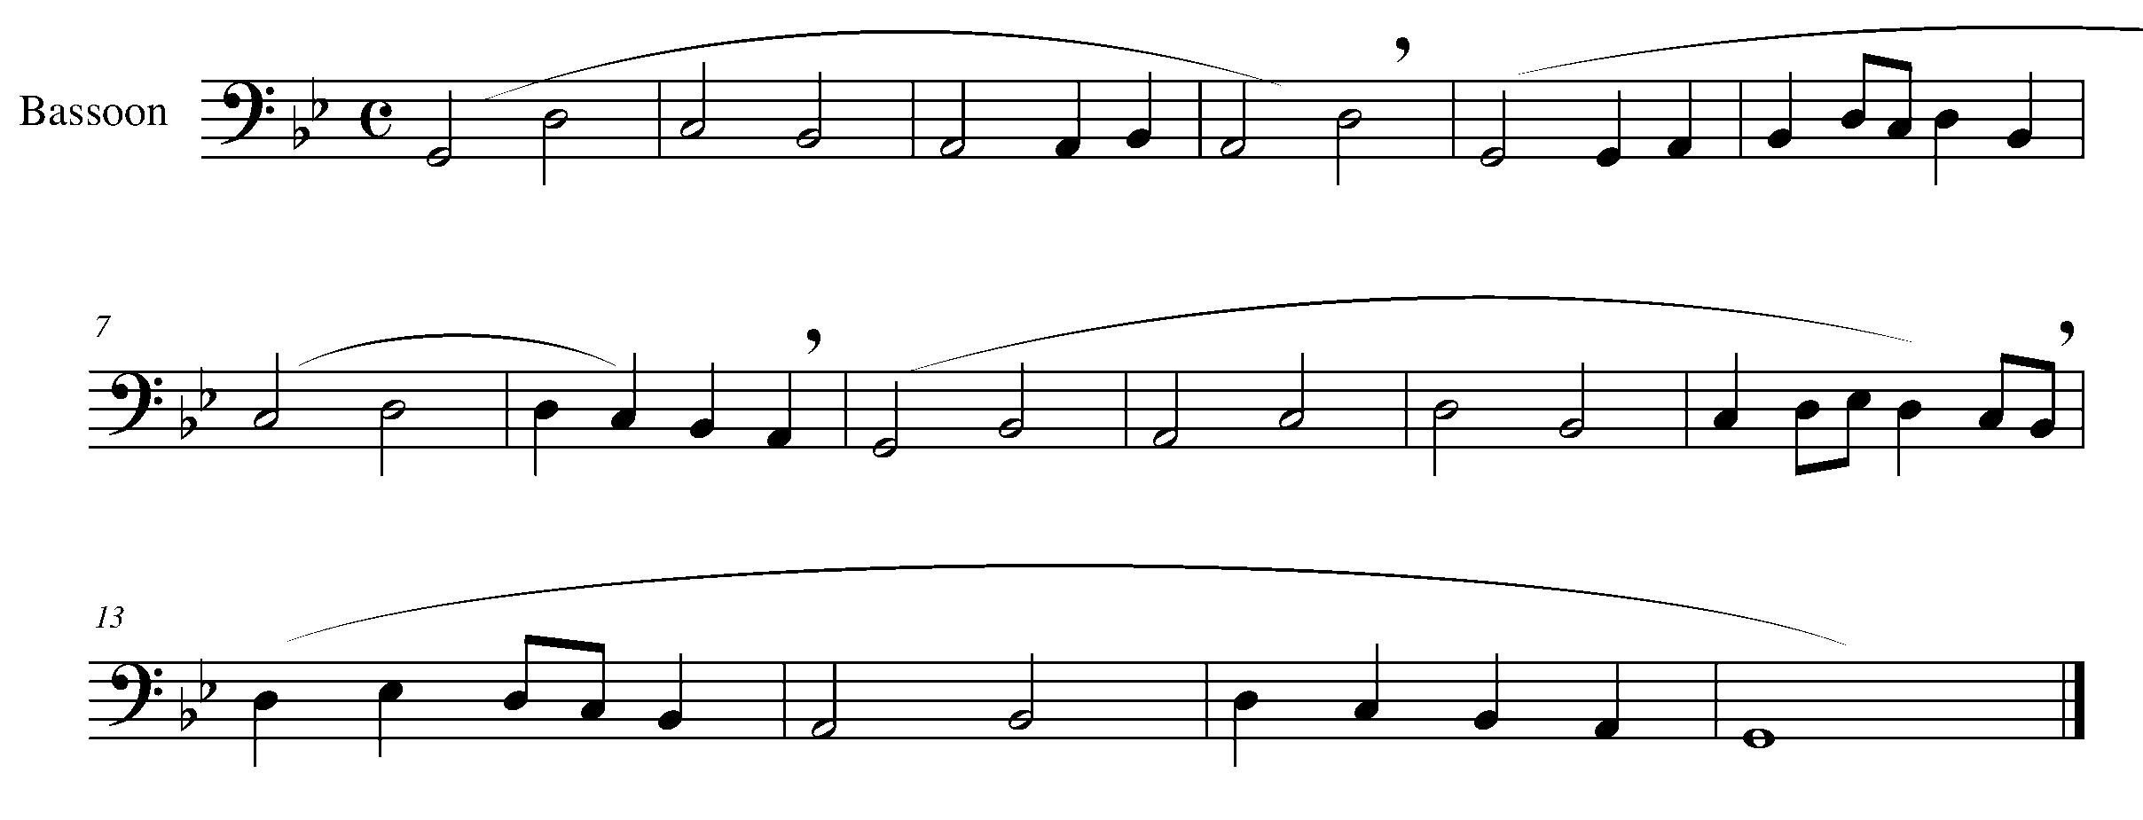
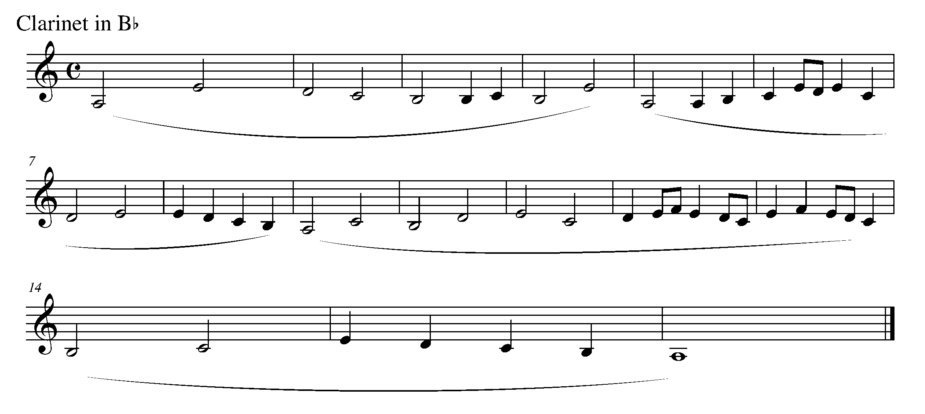

Task 3 Music Continued

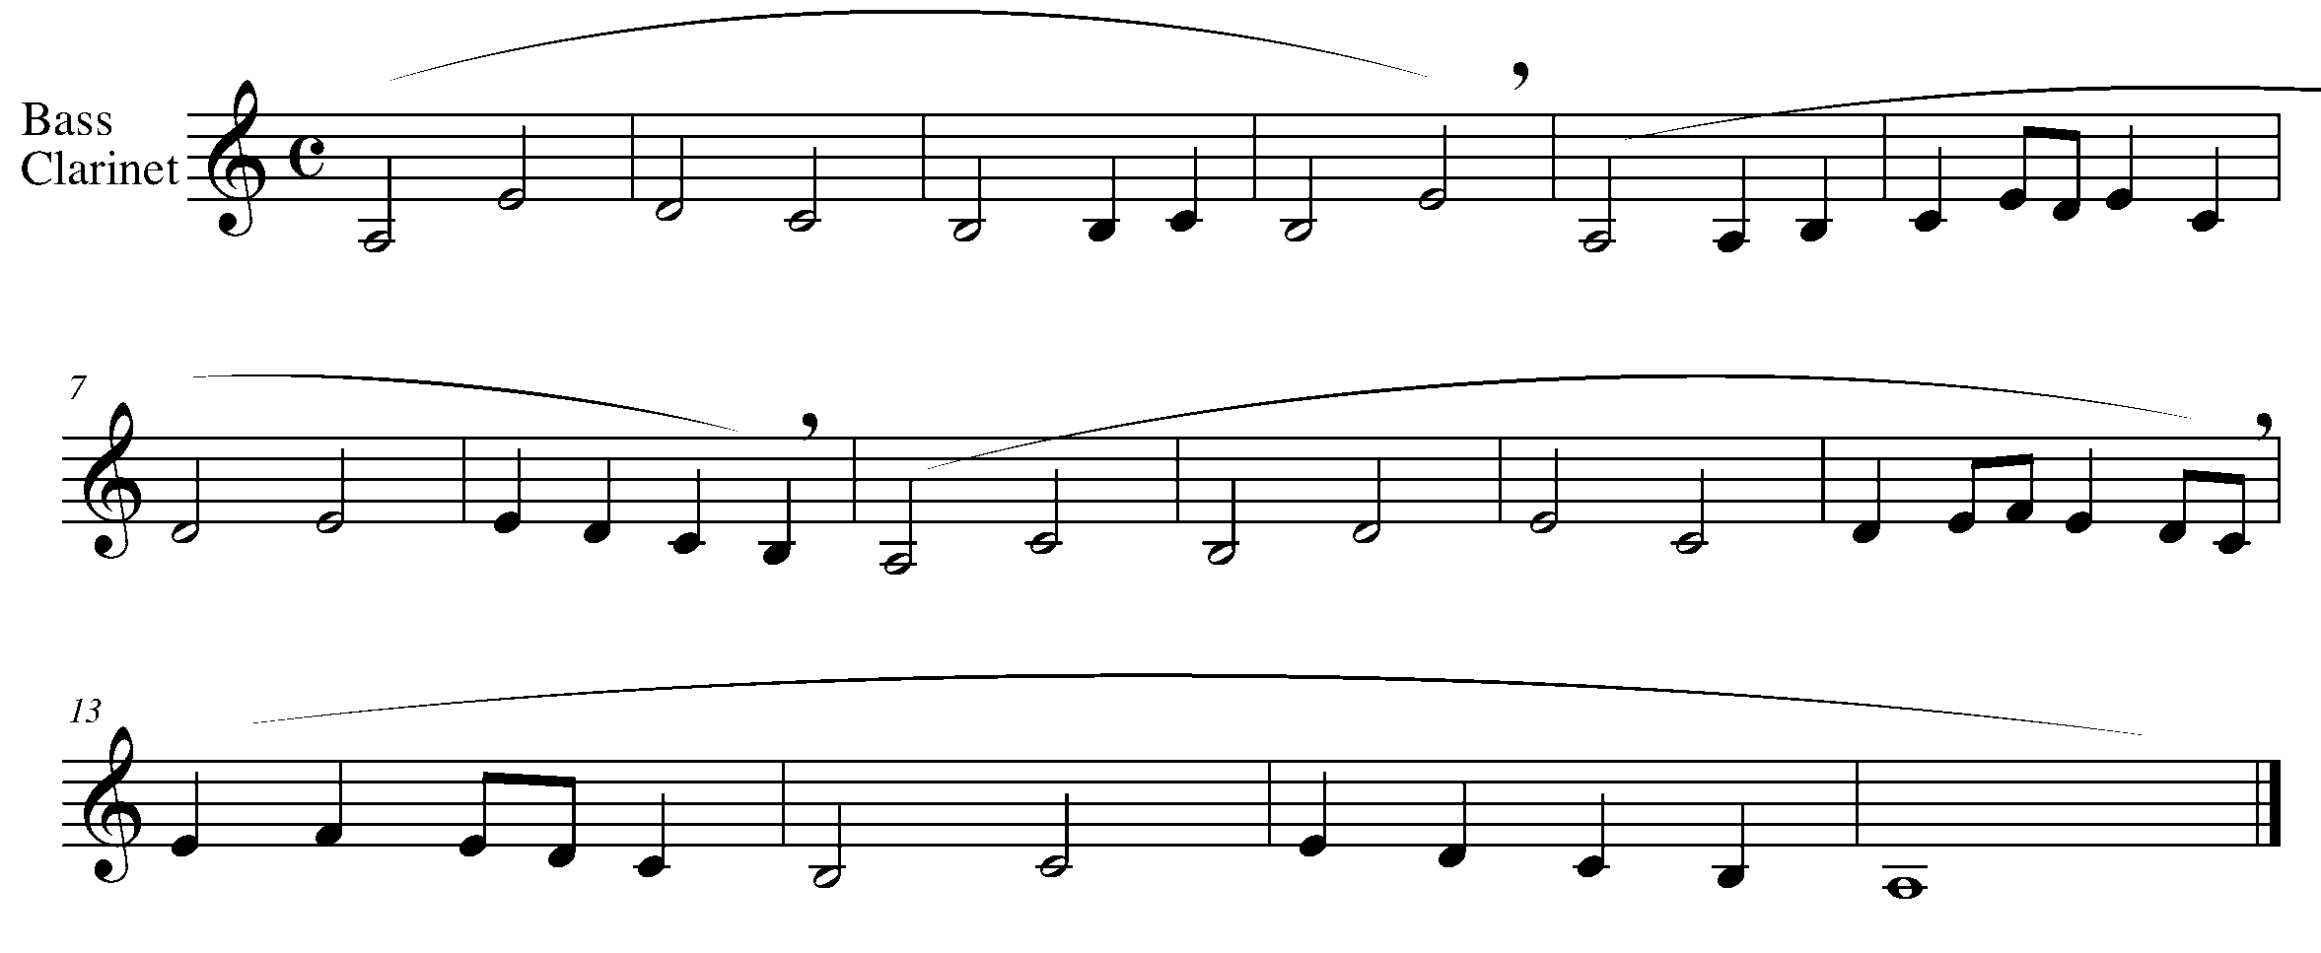

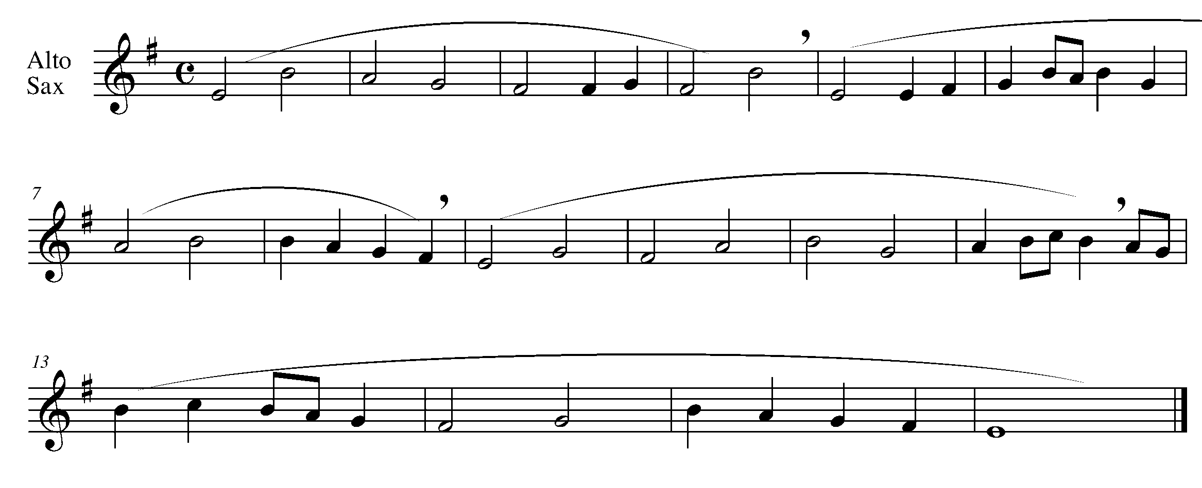

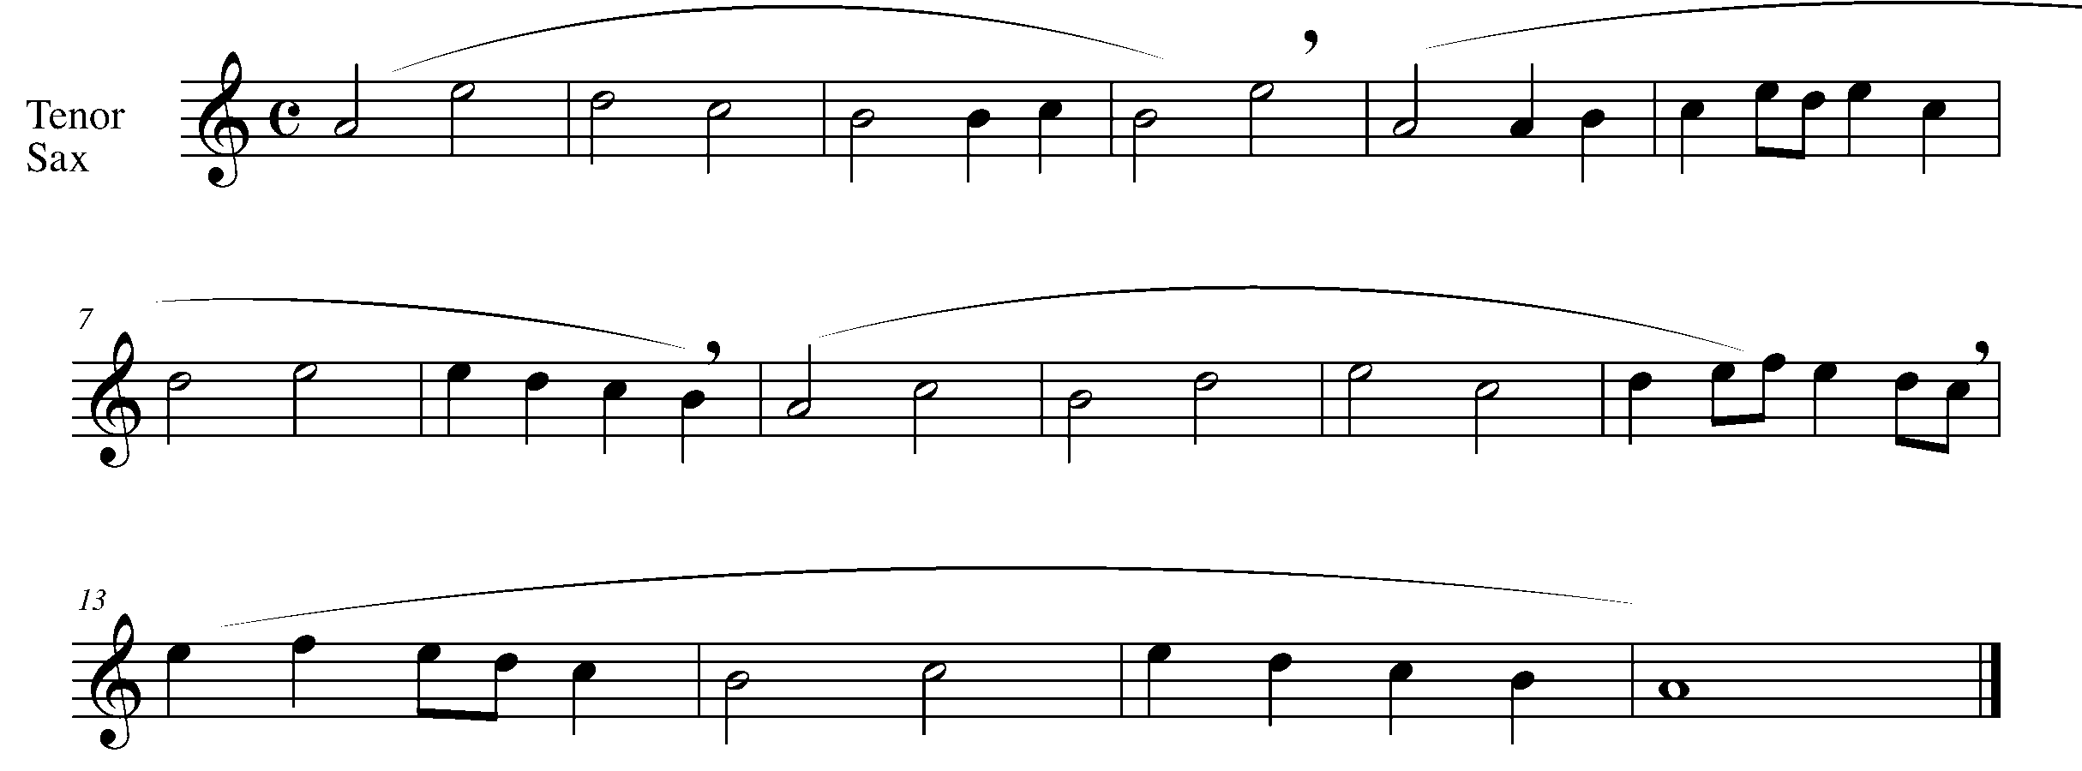

Task 3 Music Continued

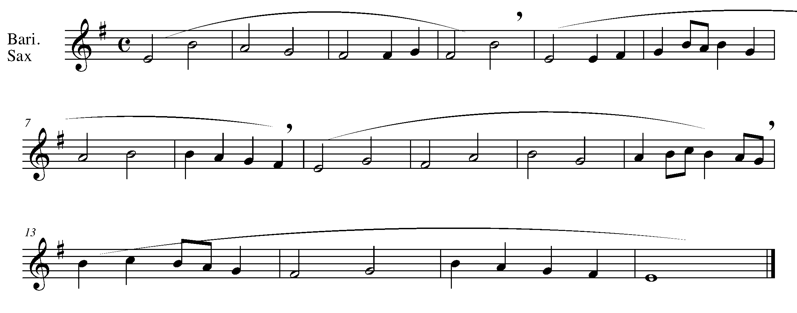
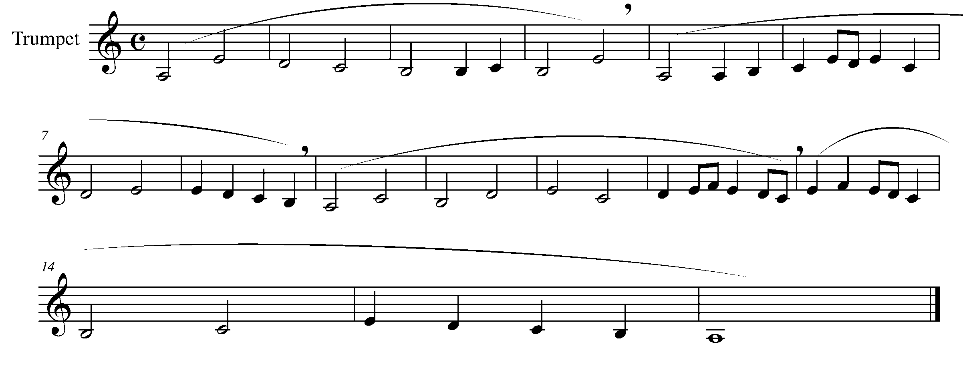
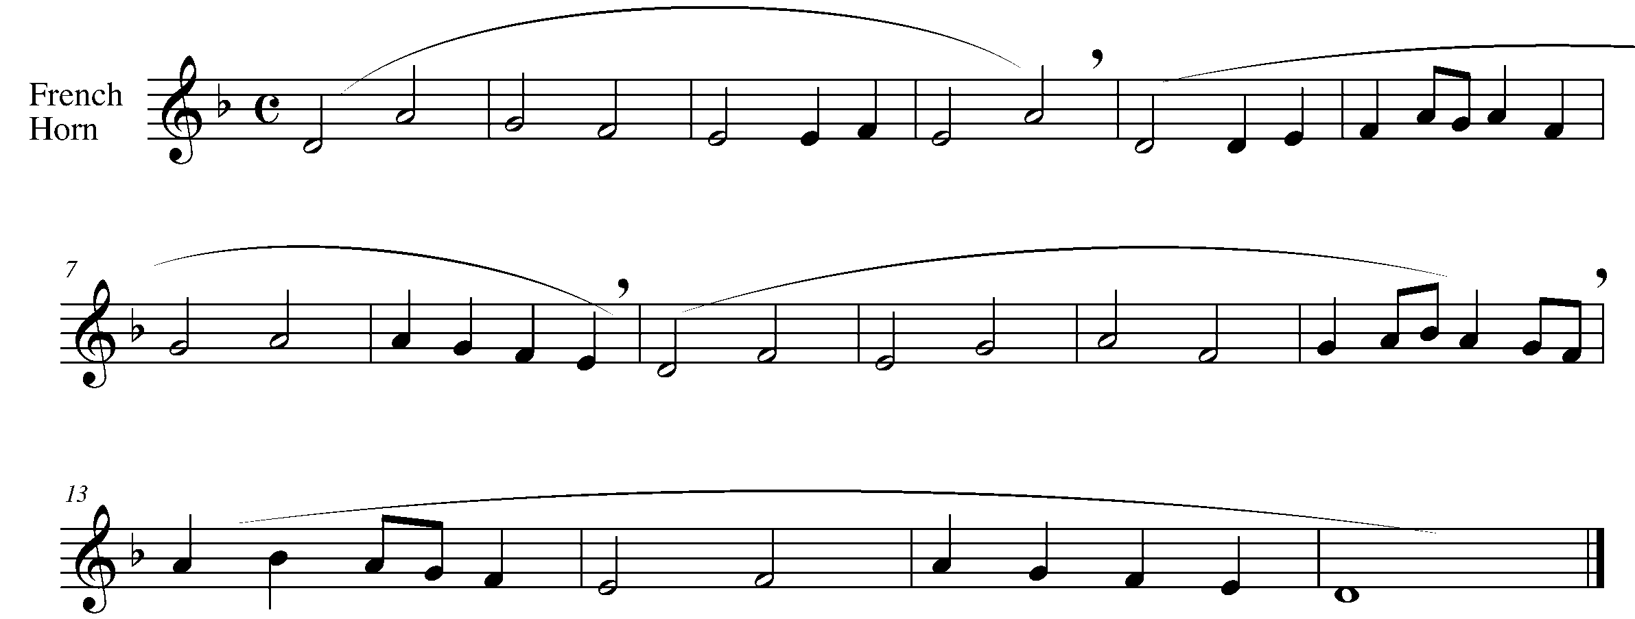

Task 3 Music Continued

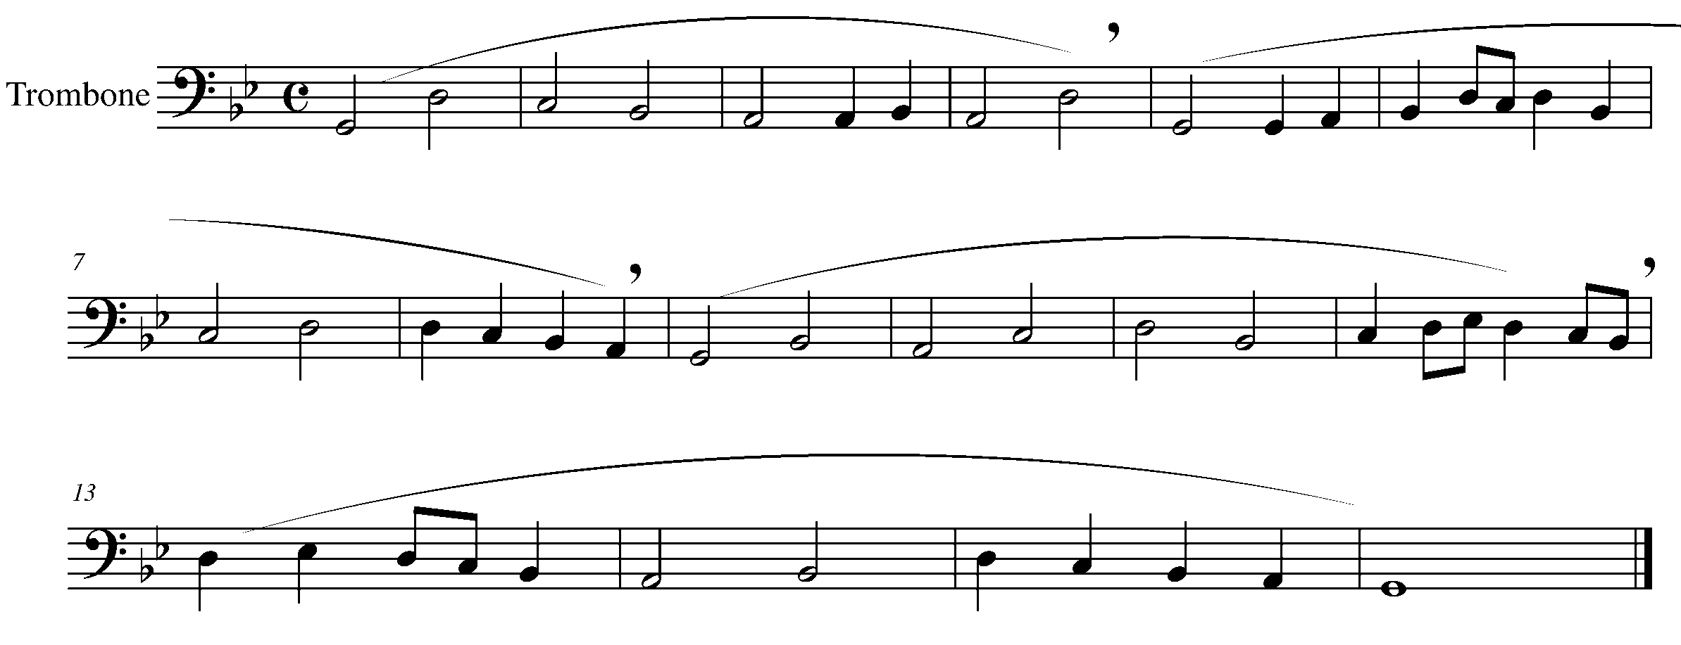

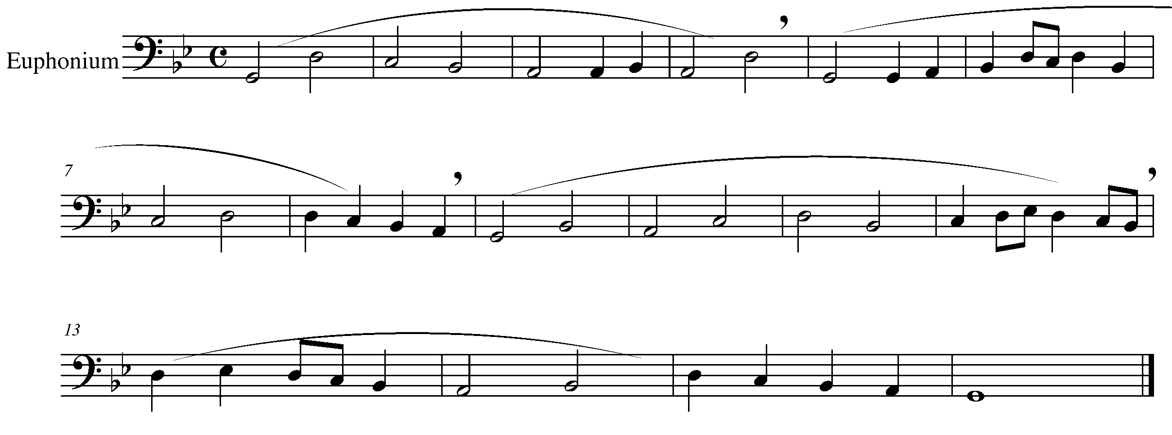
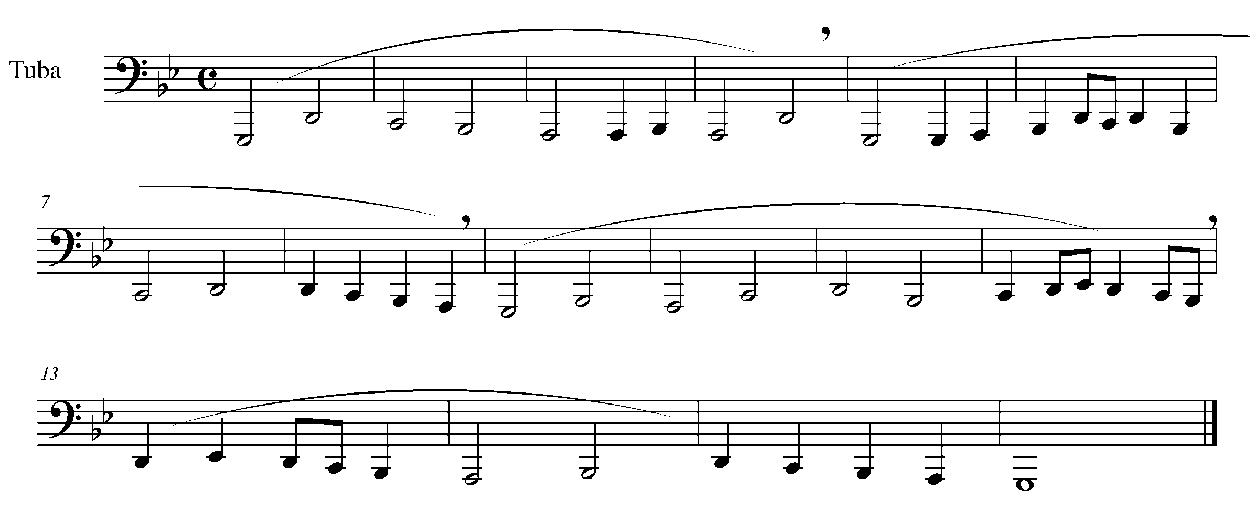

Percussion Task 3
LEARNING GOAL (SD): In furthering your musicality, transitioning in and out of the roll needs to be smooth and seamless.

MINDS ON! Grip, posture and control are fundamental to the success of an “easy” sounding roll. Why is relaxing your arms and wrists crucial when trying to play quickly on the snare drum? Don’t forget to think about the bounce of the stick and how you need control the stick for success.

ACTION! In order to be successful with this task, you will need to:

- Practice the multiple bounce of your stick.
- Be sure not to “travel” around the drum head.
- Demonstrate control of your sticks.

CONSOLIDATION: In order to move to the next task, you must perform the following piece for your teacher and receive feedback.

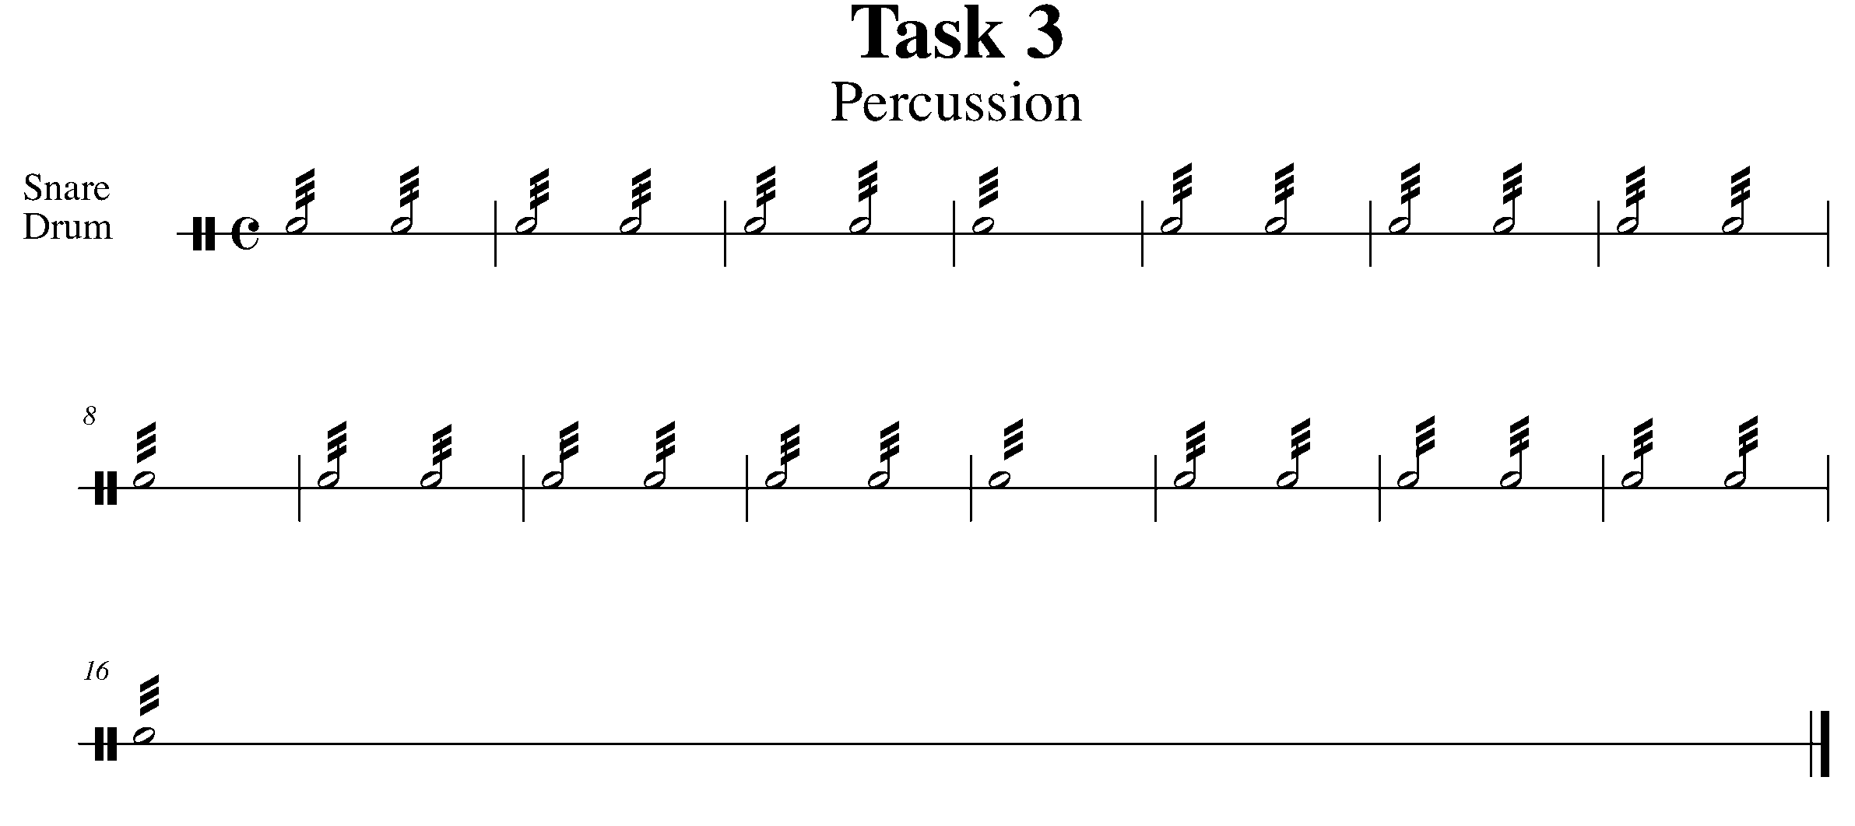

4. TWO BEATS IN A BAR! FOCUS: DURATION
Wind Instruments and Snare Drum/Bass Drum/Kit

LEARNING GOAL: Four beats in a bar is not the only option! Now that you are more musically experienced on your instrument, you will begin to be introduced to a variety of time signatures.

MINDS ON! Does music in a 2/4 time signature have a different feel then 4/4 time? Are you going to treat your approach to 2/4 any differently than other time signatures? Which beat is the strongest in 2/4 time?

ACTION! In order to be successful with this task, you will need to:

- Analyze the notes, rhythms and expressive elements of the below piece.
- Demonstrate your understanding of the 2/4 time signature.

TASK 4 MUSIC FOUND ON THE NEXT PAGE

CONSOLIDATION: In order to move to the next task, you must perform the following piece for your teacher and receive feedback.

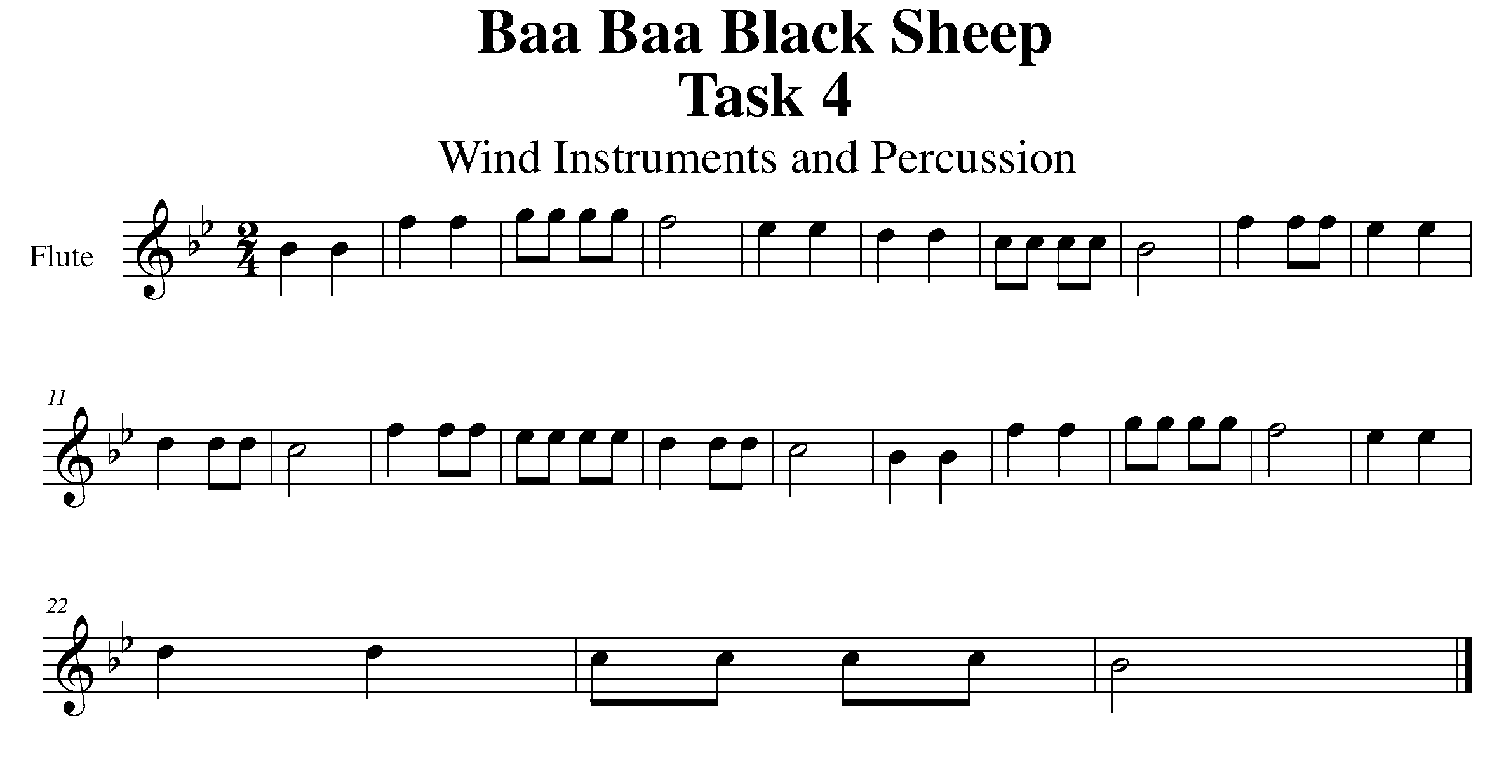

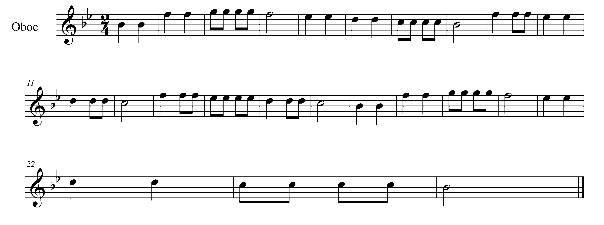

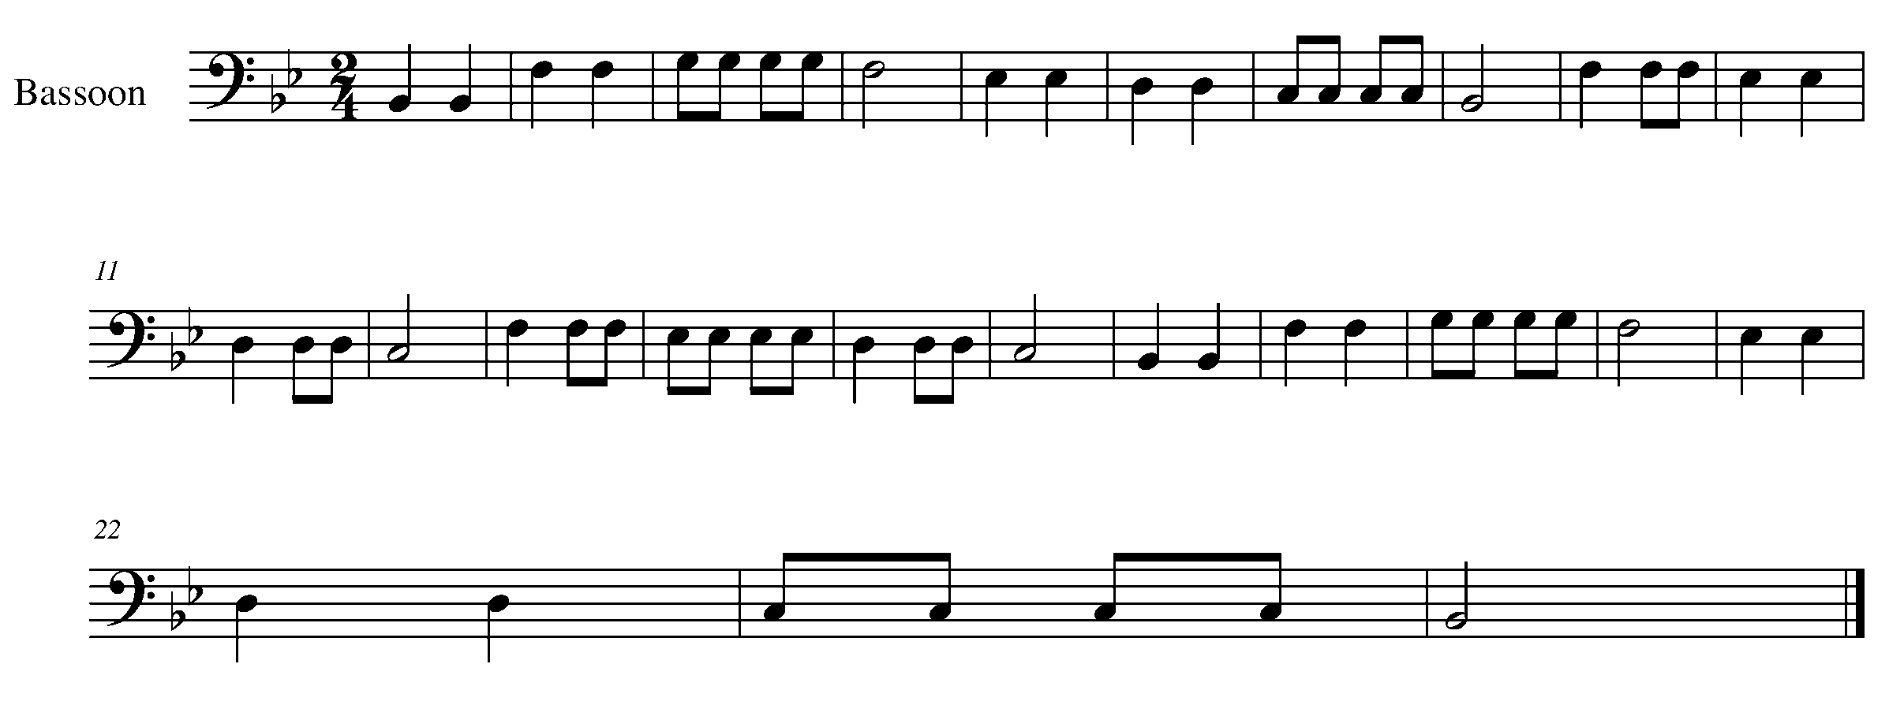

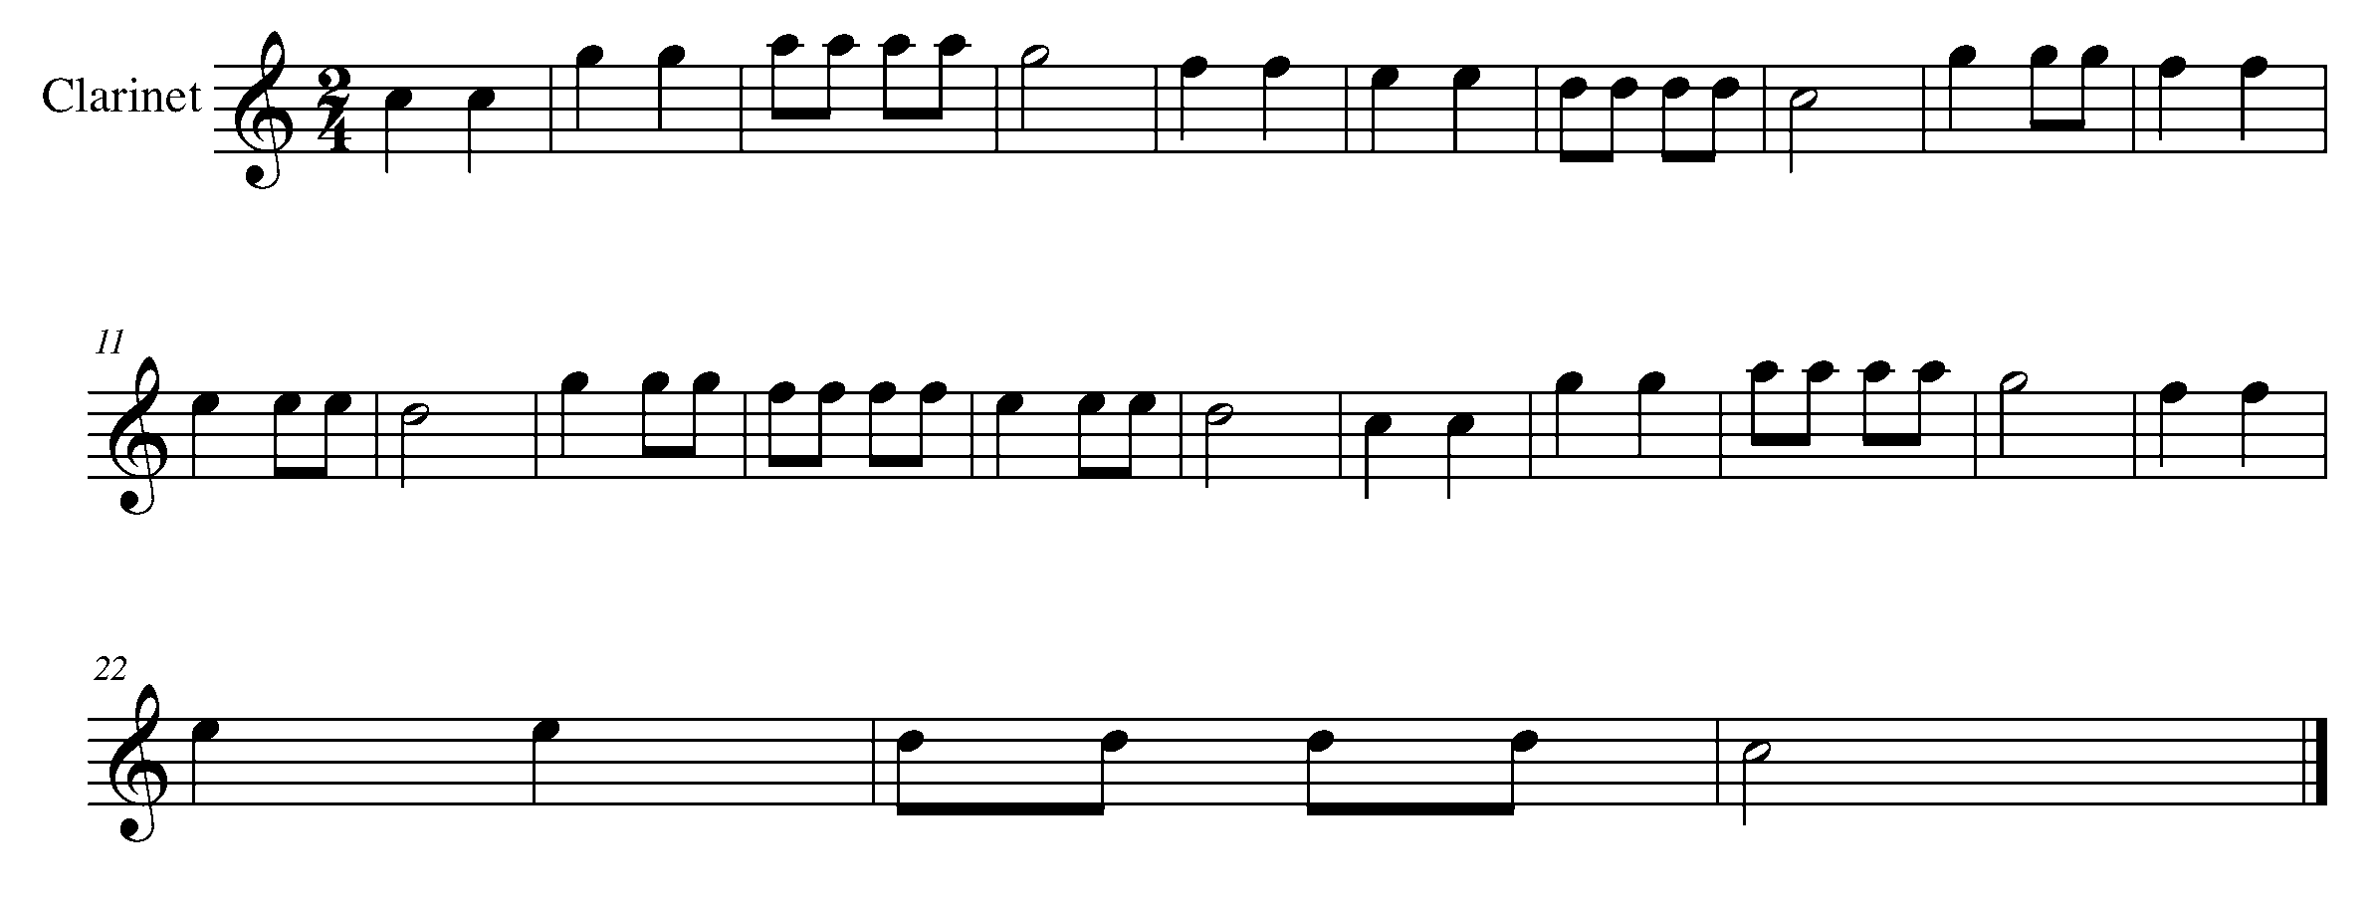

Task 4 Music Continued

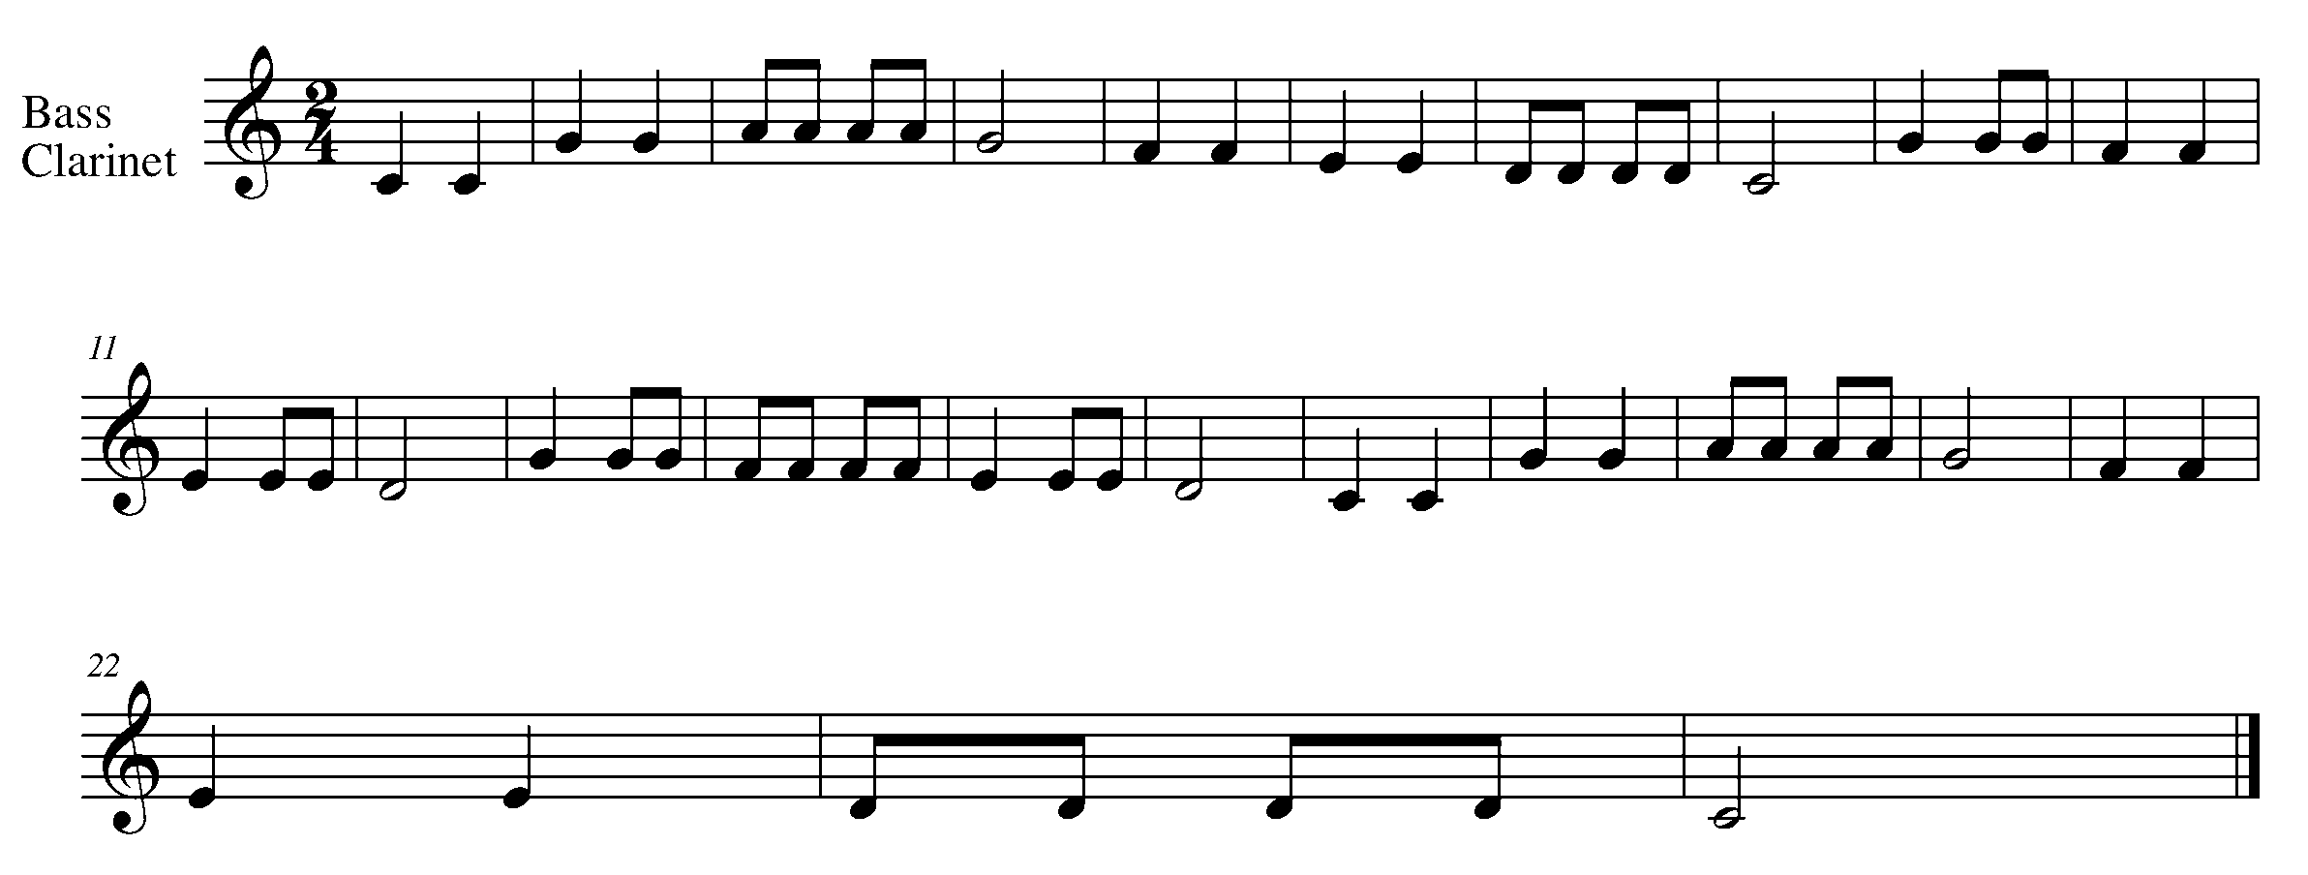
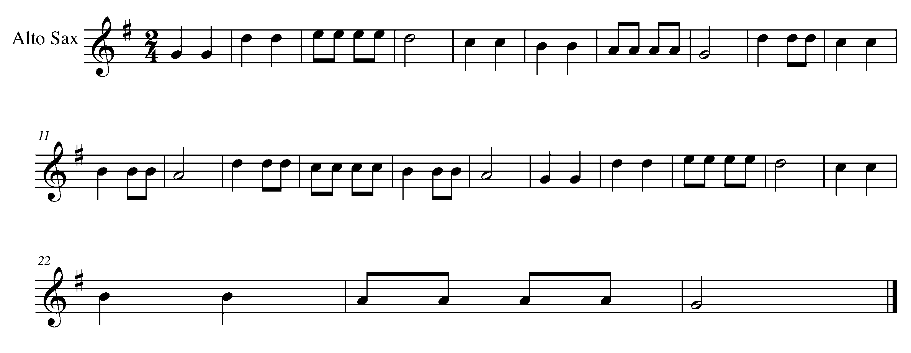

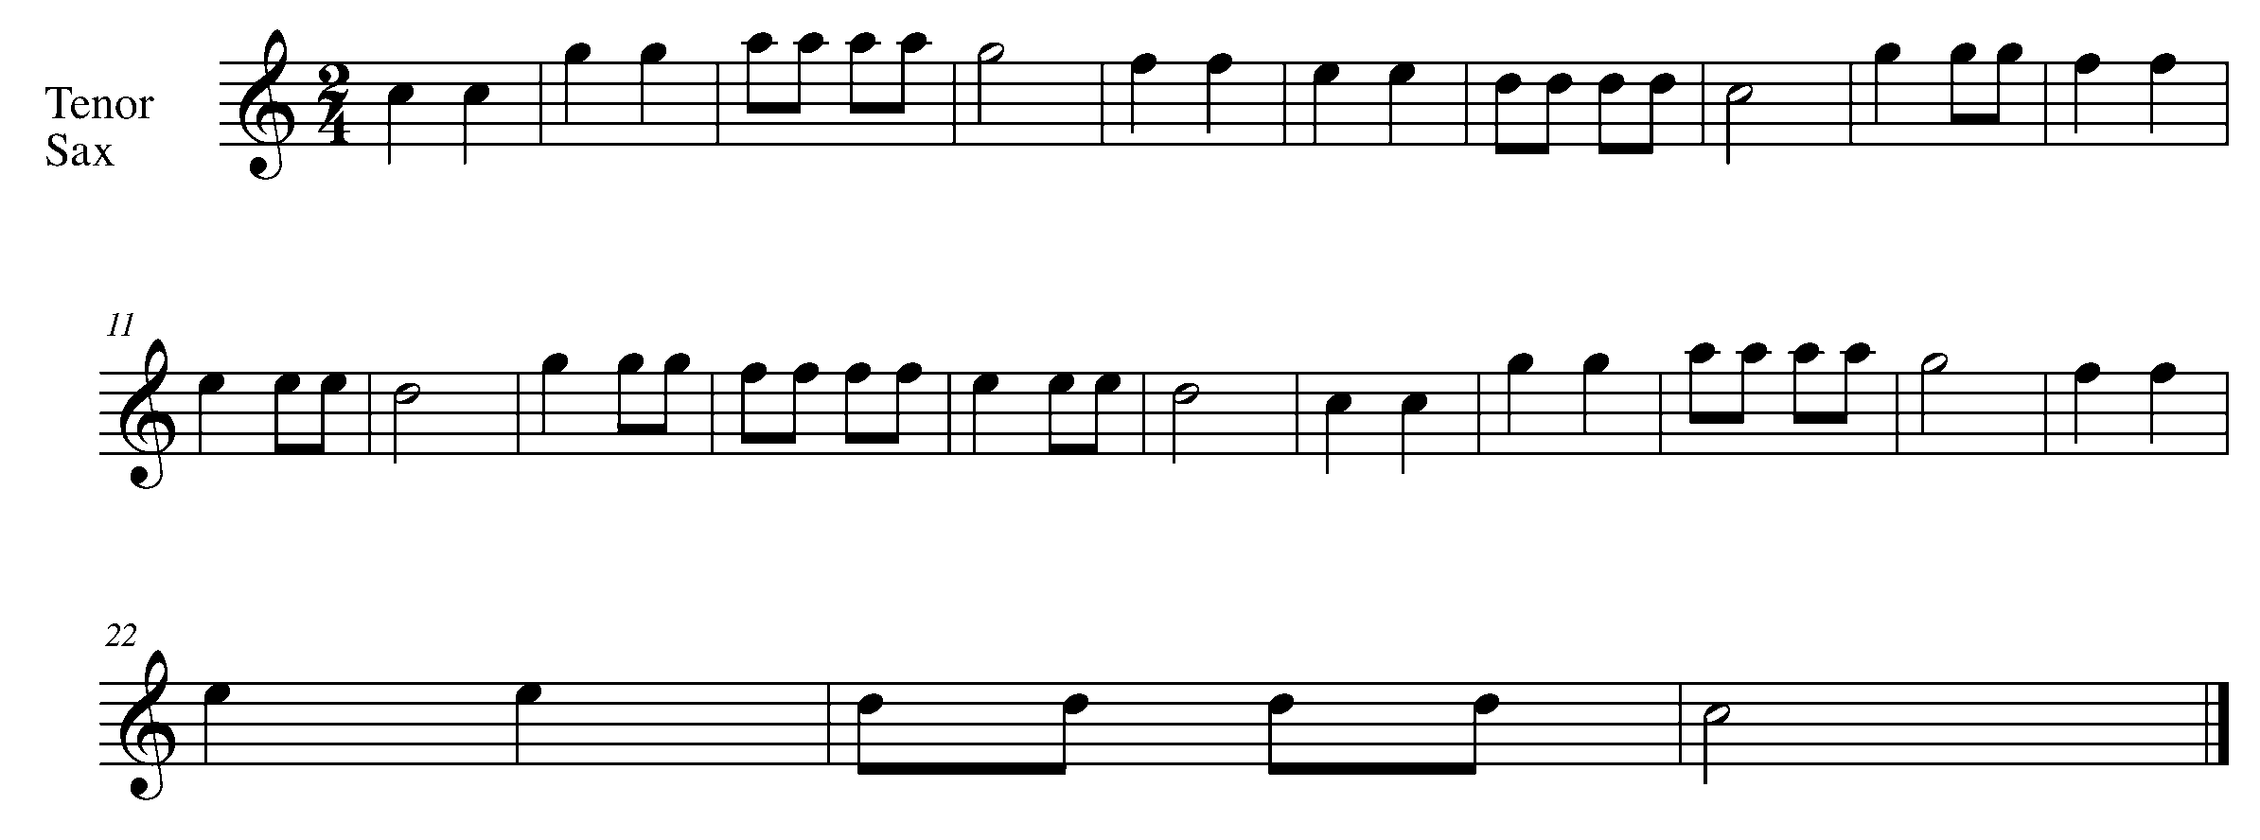

Task 4 Music Continued

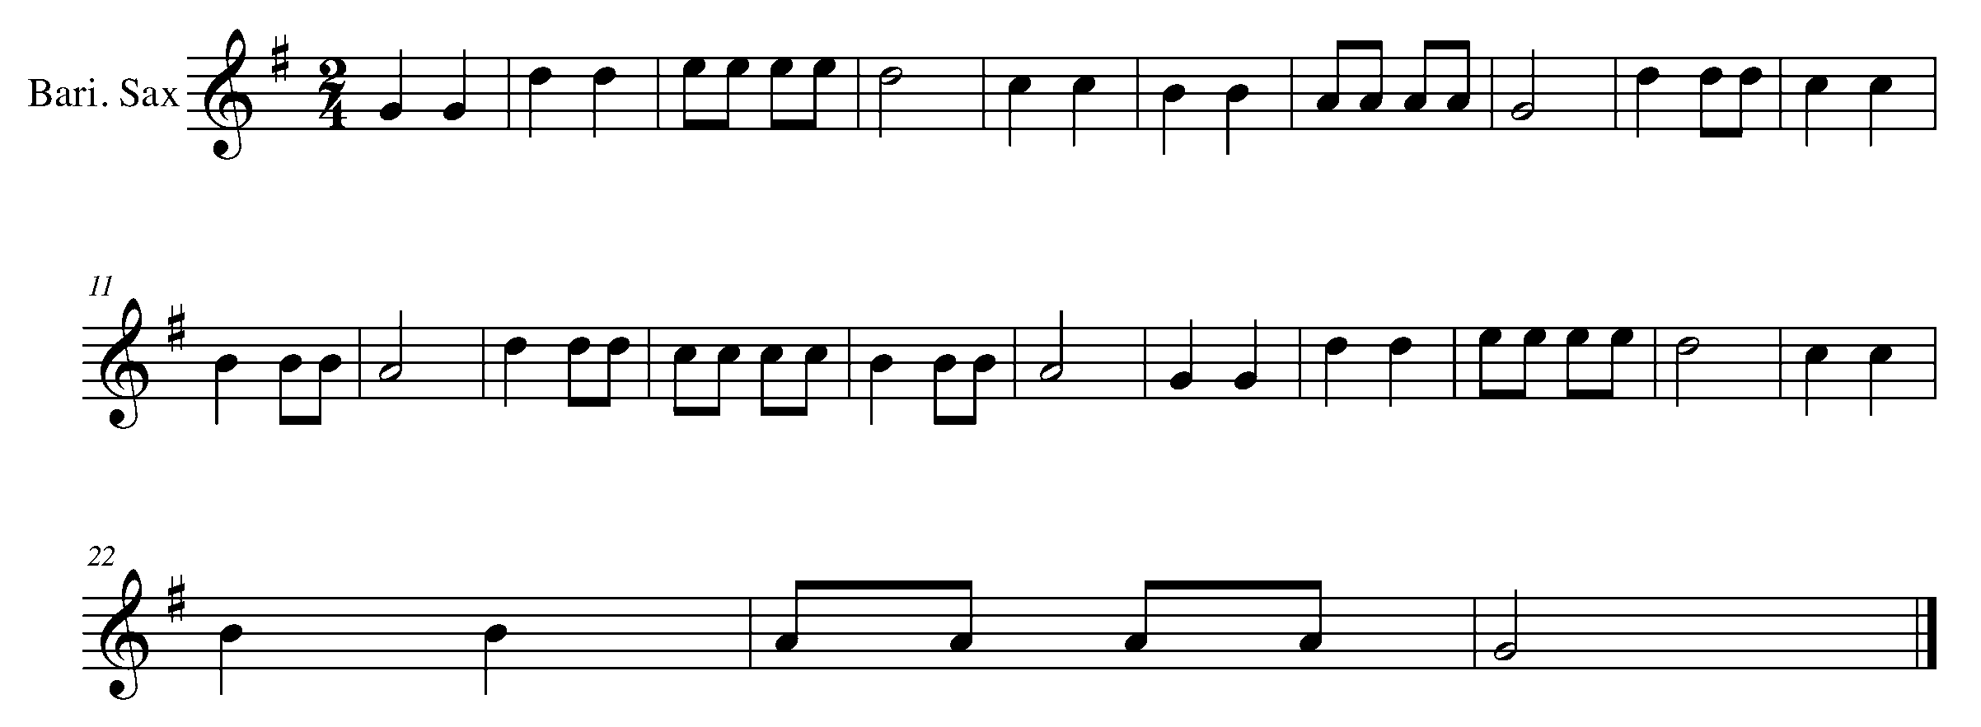

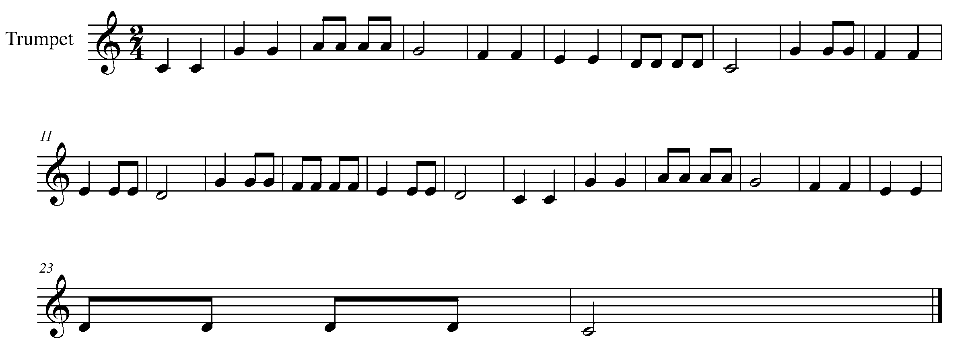

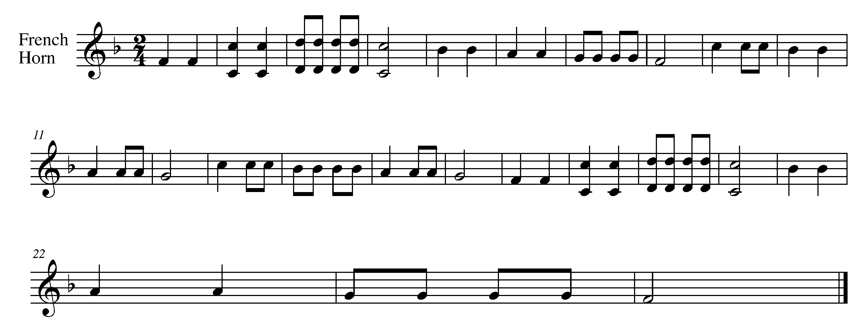

Task 4 Music Continued

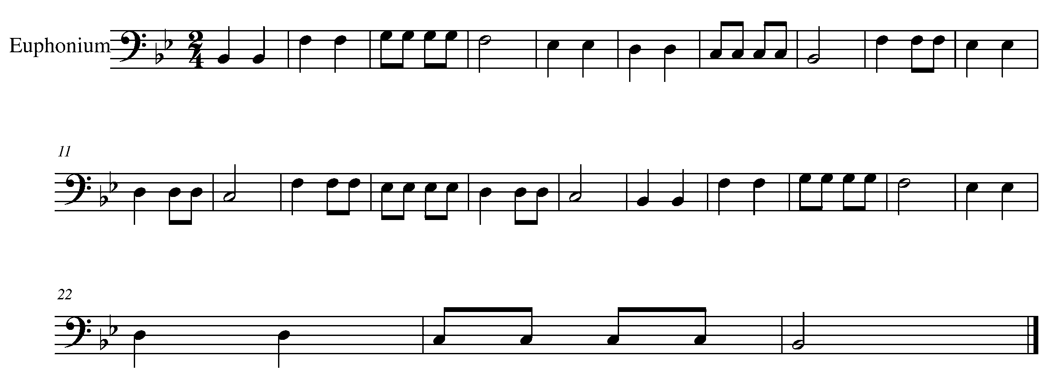
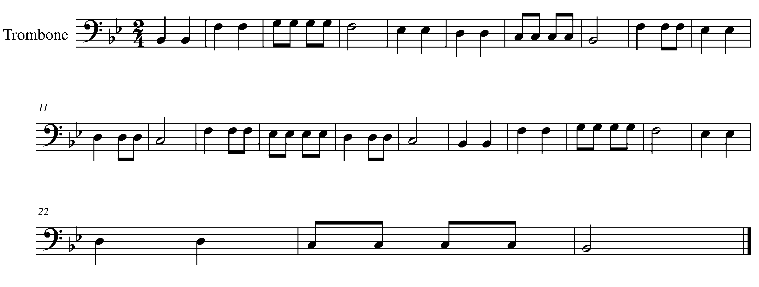

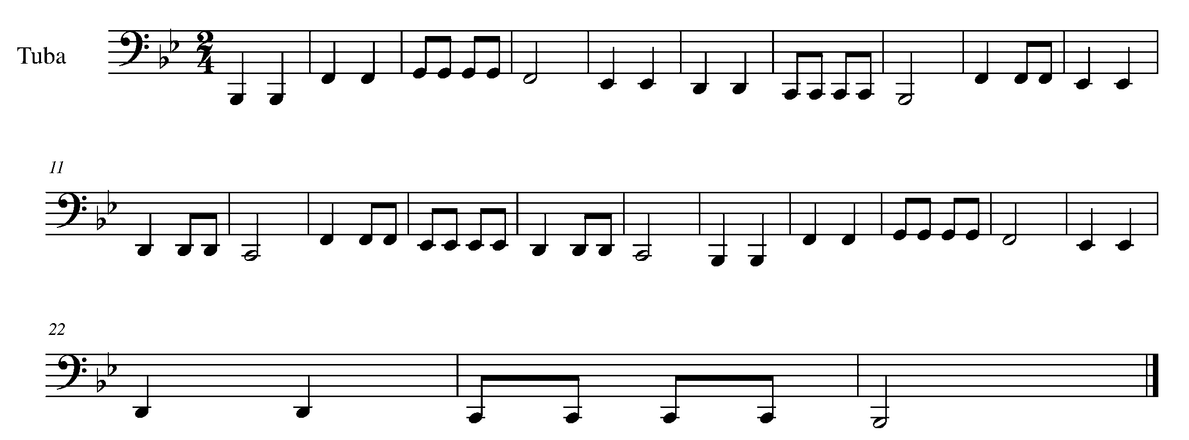

Task 4 Music Continued

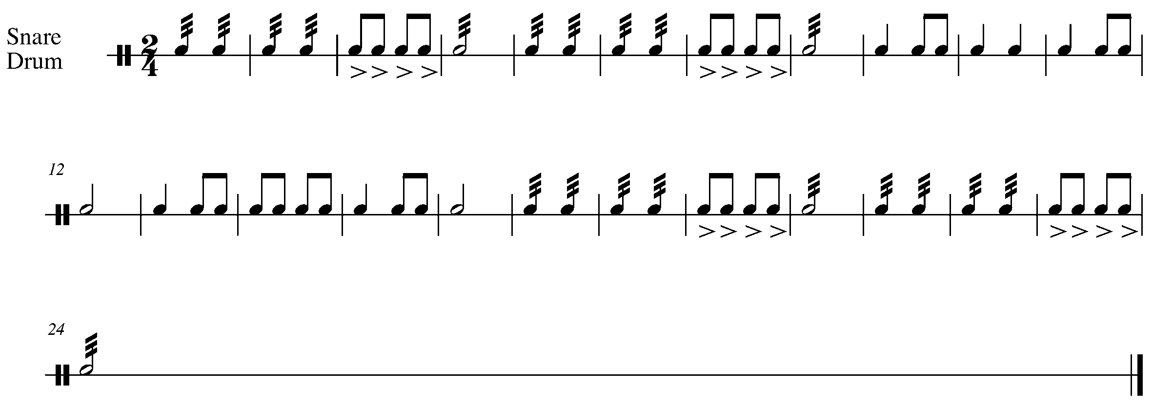
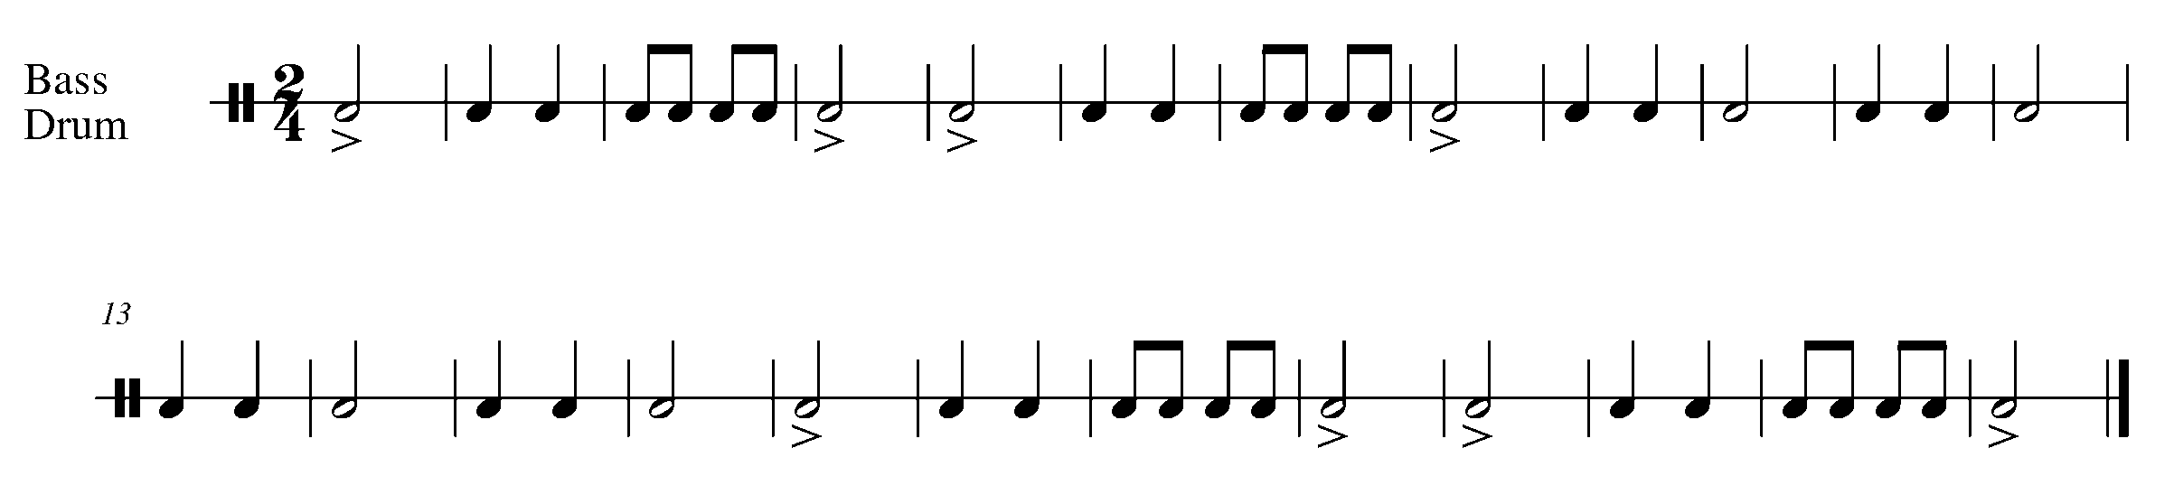
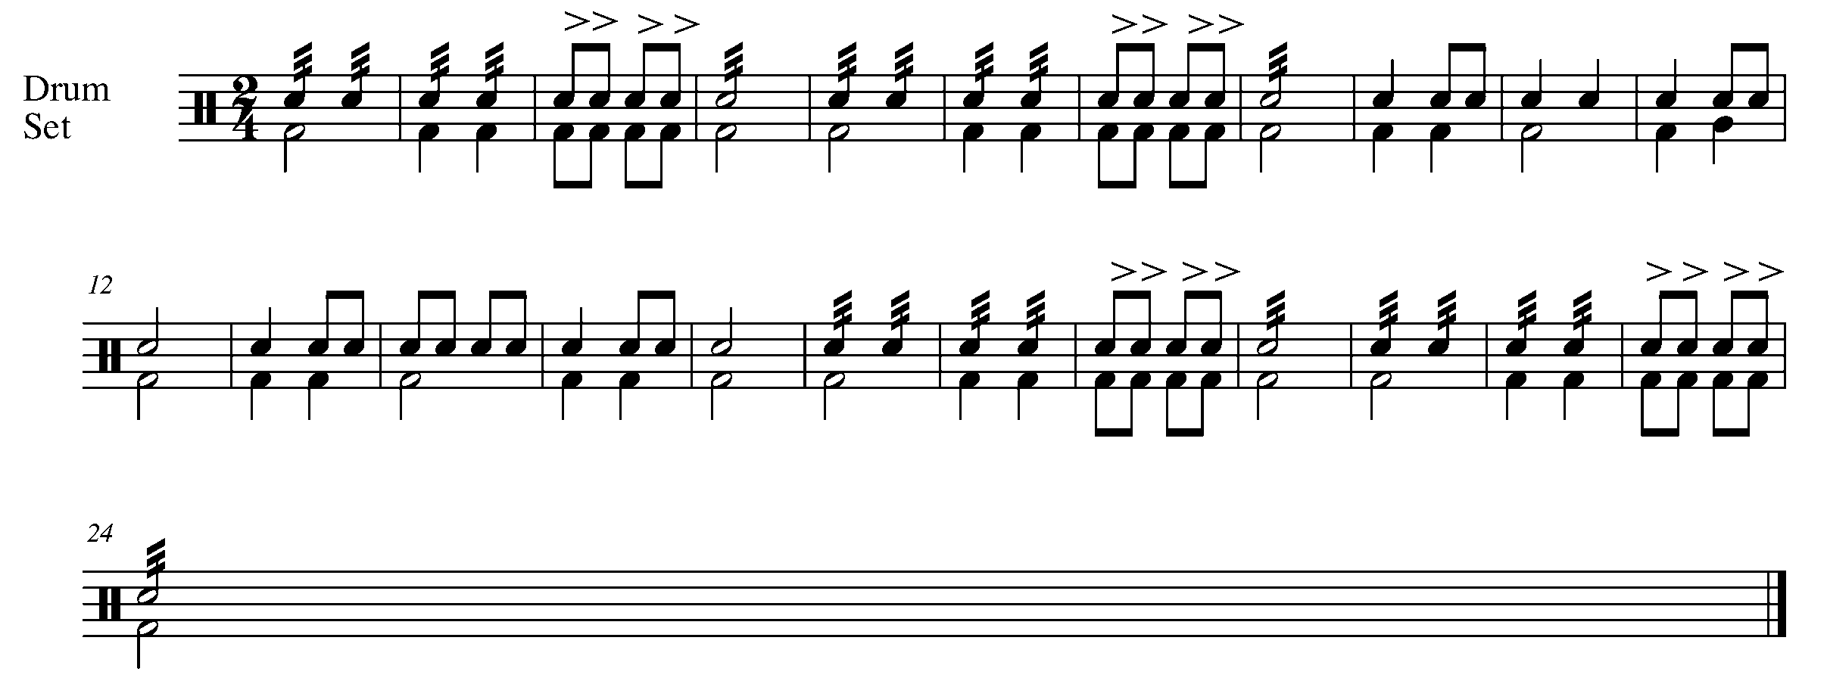

5. INTRODUCING THE BLUES FOCUS: COMPOSITION
Wind Instruments and Mallets

LEARNING GOAL: The 12-bar blues progression is an exciting part of the music history of North American Music. You will be creating 12 bars of rhythm to support a 12-bar blues progression.

MINDS ON! What kind of rhythmic feel should you create to support the 12-bar blues? If you’ve never heard music which is categorized as “the blues”, find some recordings to listen to before writing your 12 bars of rhythm.

ACTION! In order to be successful with this task, you will need to:

- Look at other samples of music and determine what symbols are needed to set up a piece of music.
- USE A PENCIL – you may need to move things around when you enter the notes.
- Do not add a clef or pitch to your rhythm at this time.
- On the staff labeled “clap”, write 12 bars of rhythm below the given blues progression.
- Find a partner.
- Have your partner play the 12-bar blues progression on their instrument while you clap the 12 bars of rhythm that you have composed.

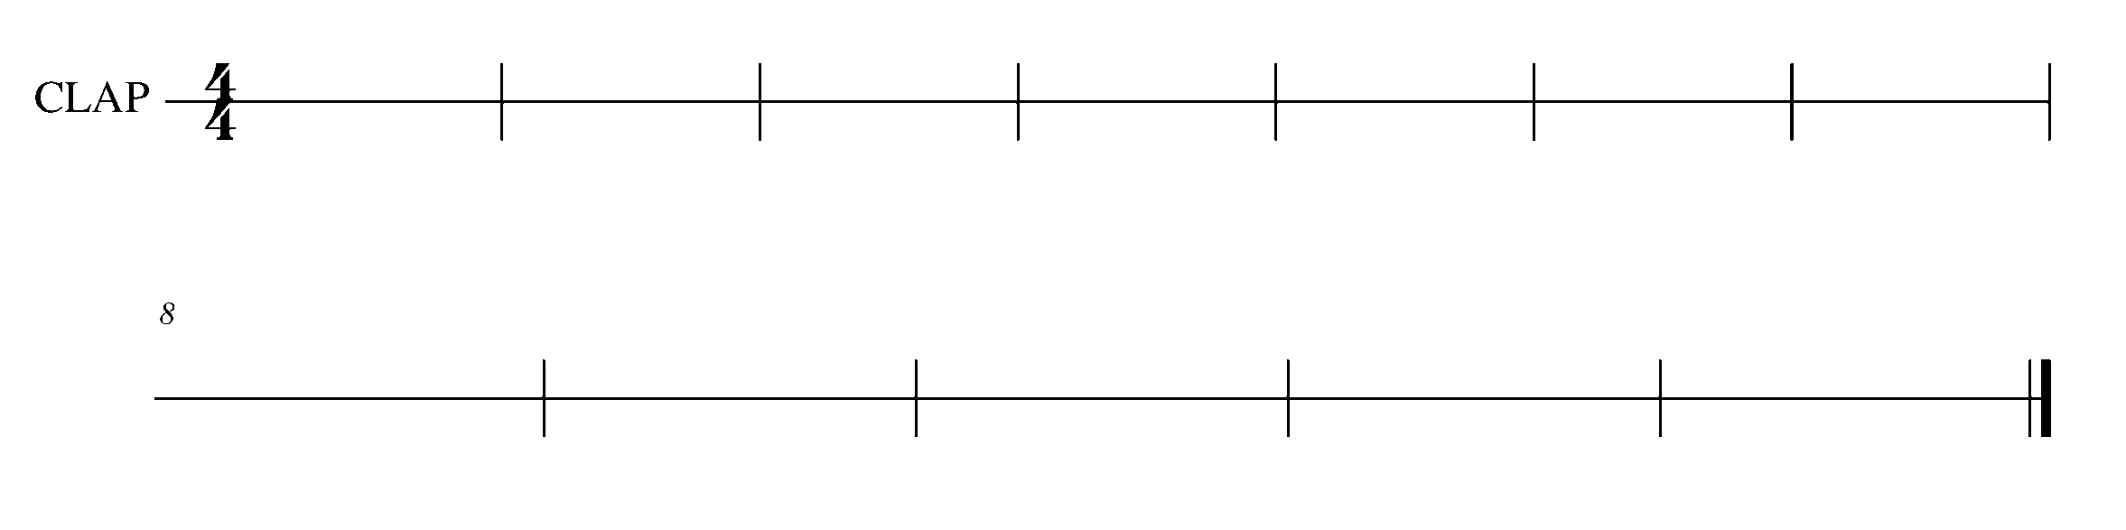
CONSOLIDATION: In order to move to the next task, you and your partner must perform the task 5 compositions for your teacher. You will clap the rhythm you wrote while, at the same time, your partner plays the 12-bar blues progression.

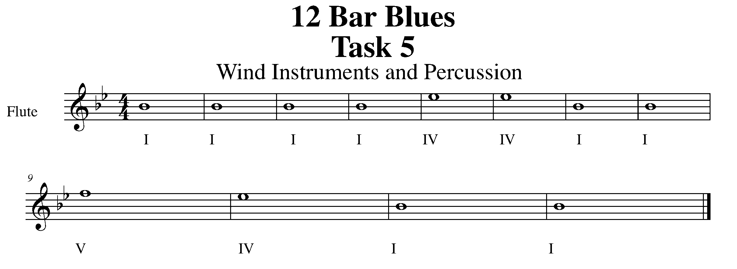

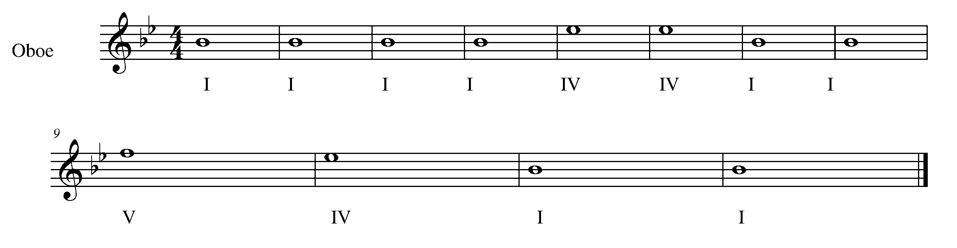

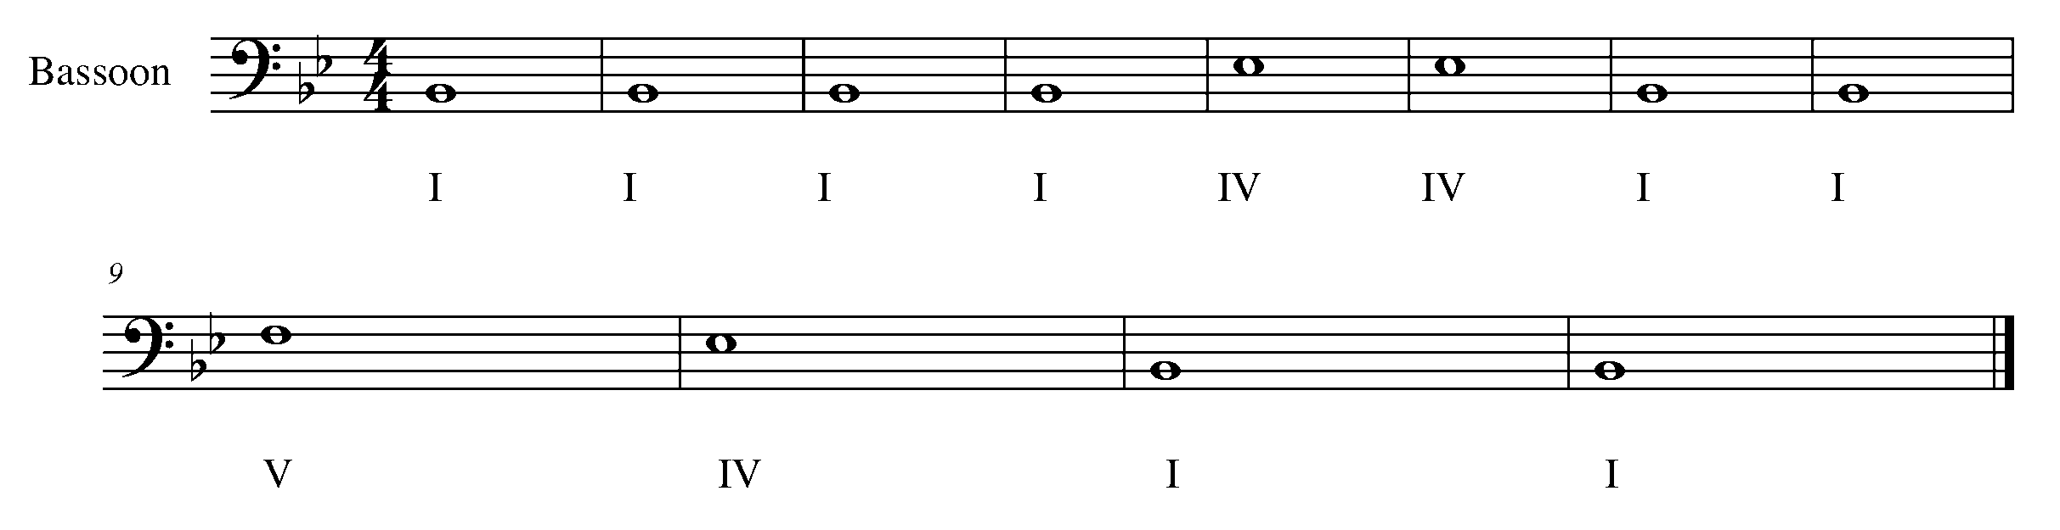
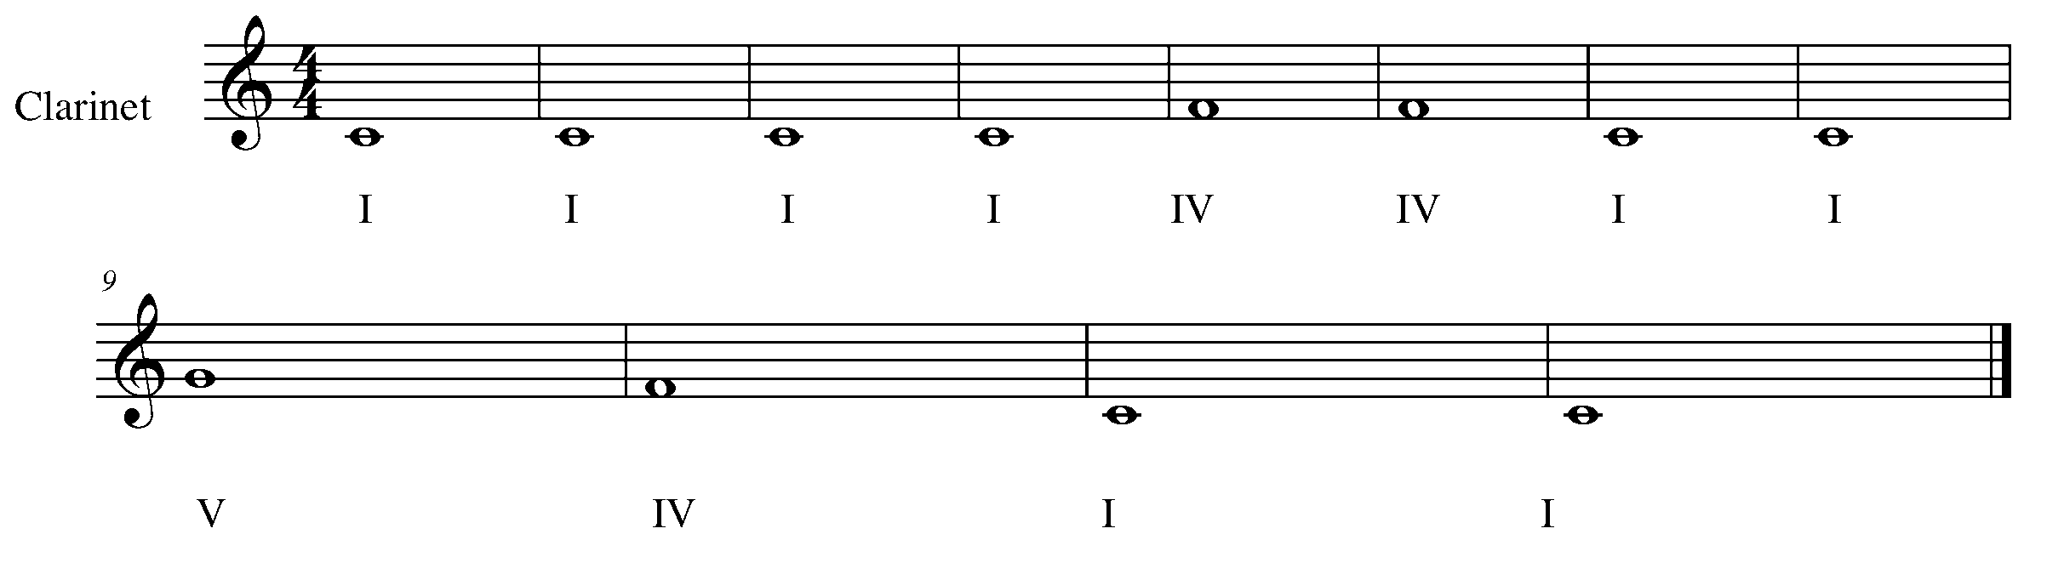

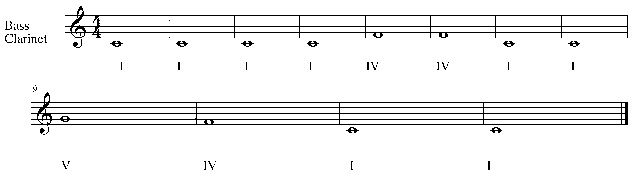
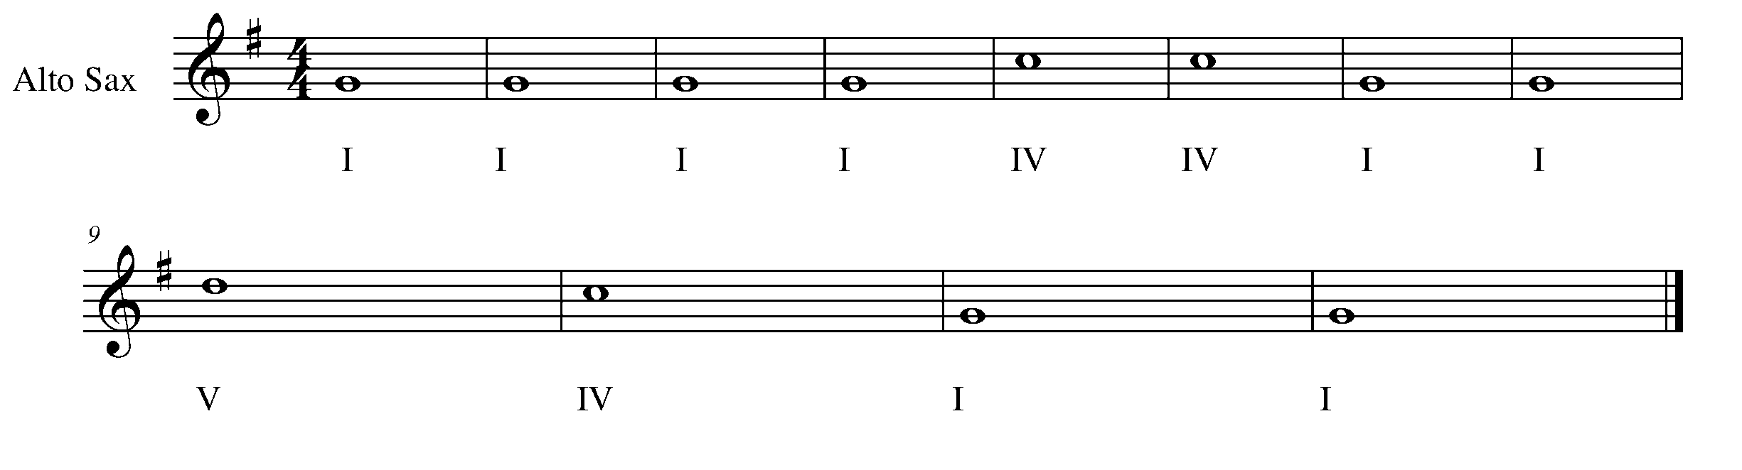

Task 5 Music Continued

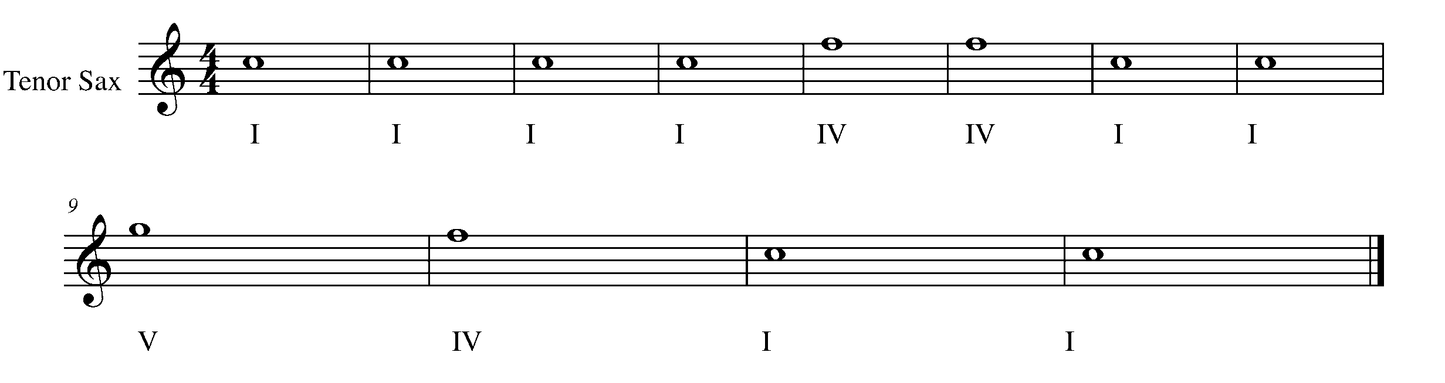

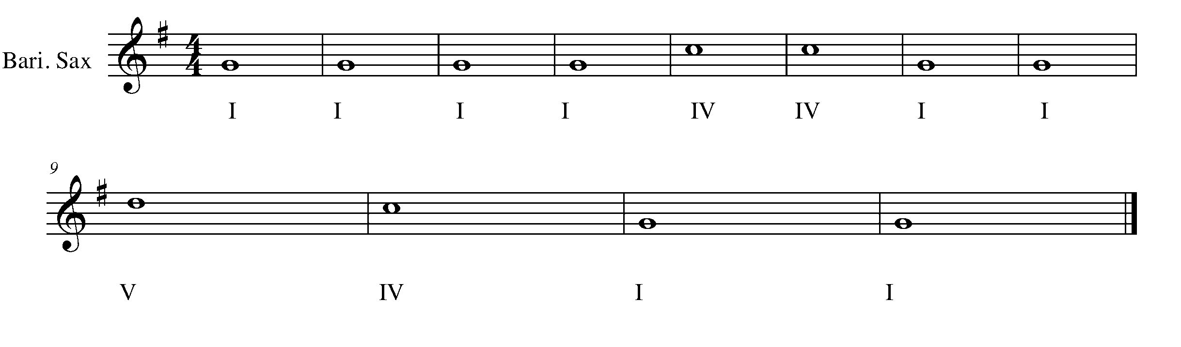
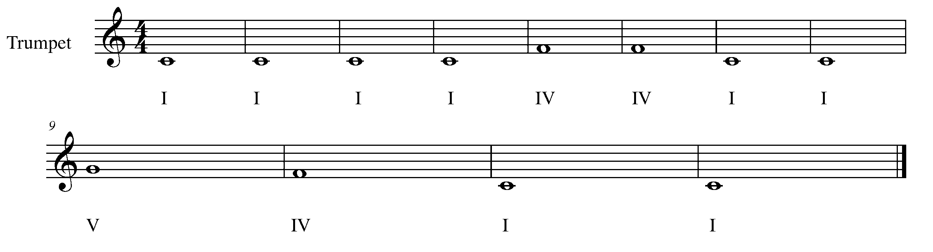
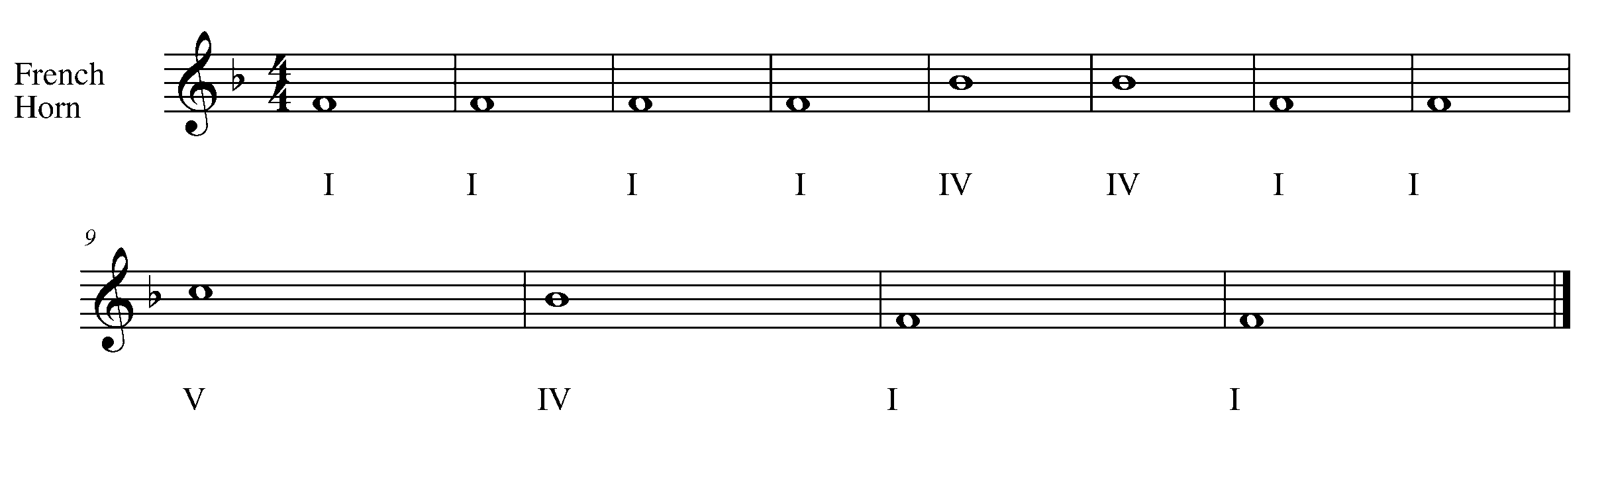
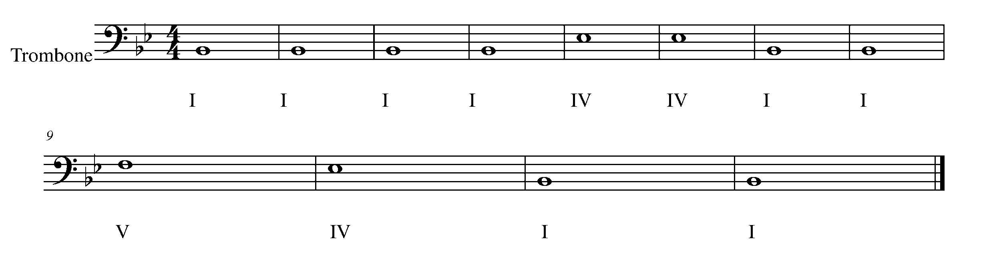
Task 5 Music Continued

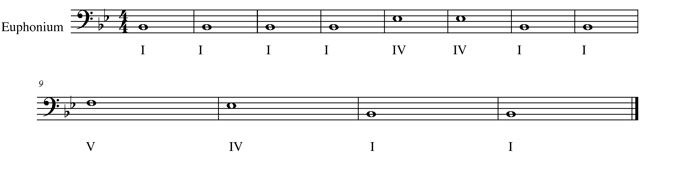
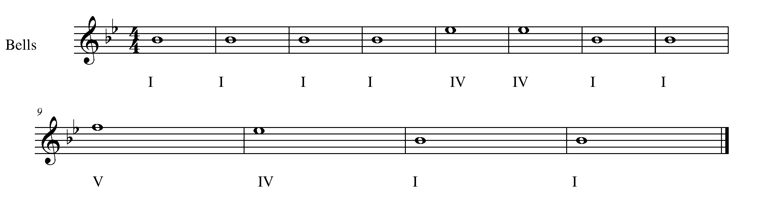

CONGRATULATIONS! YOU HAVE REACHED THE FIRST GPS MARKER – NORTH!

MAKE SURE TO ASK YOUR TEACHER HOW YOUR ARE TO ACKNOWLEDGE YOUR ACCOMPLISHMENTS ON YOUR TASK TRACKER!

6. ARTICULATE WHAT YOU MEAN! FOCUS: EXPRESSIVE CONTROLS
Wind Instruments and SD/BD/KIT

LEARNING GOAL: To articulate is to attack a note in a variety of ways, as indicated by a particular symbol. In this task you will perform staccato notes, accented notes and slurs.

MINDS ON! How do you articulate in a variety of ways? The way your strike your drum or the way you start the sound of note with your tongue creates the articulation. How is your sound affected by what your tongue does?

ACTION! In order to be successful with this task, you will need to:

- Identify the difference in sound for each of the articulation symbols.
- Demonstrate an understanding of what your tongue or sticks must do to perform the indicated articulations.
- Maintain good posture, sound, pitch and rhythmic knowledge.

CONSOLIDATION: In order to move to the next task, you must perform the following piece for your teacher and receive feedback.

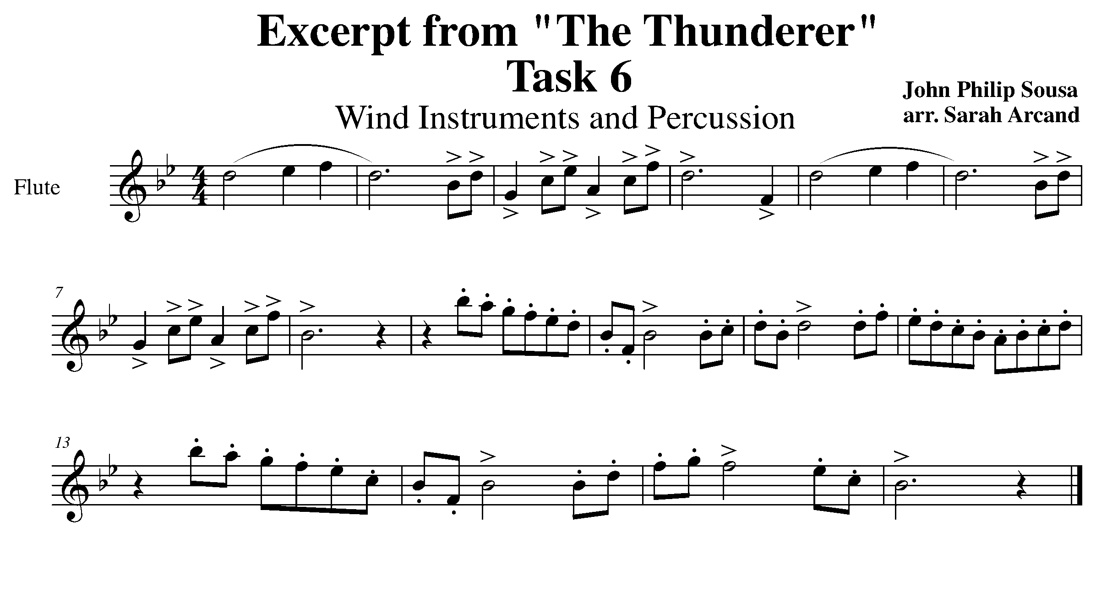
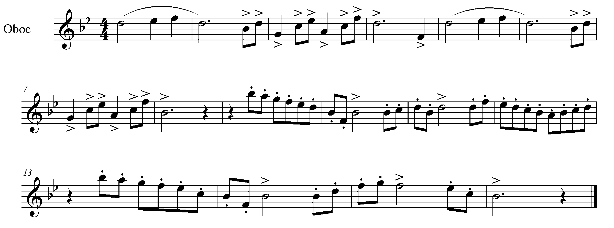

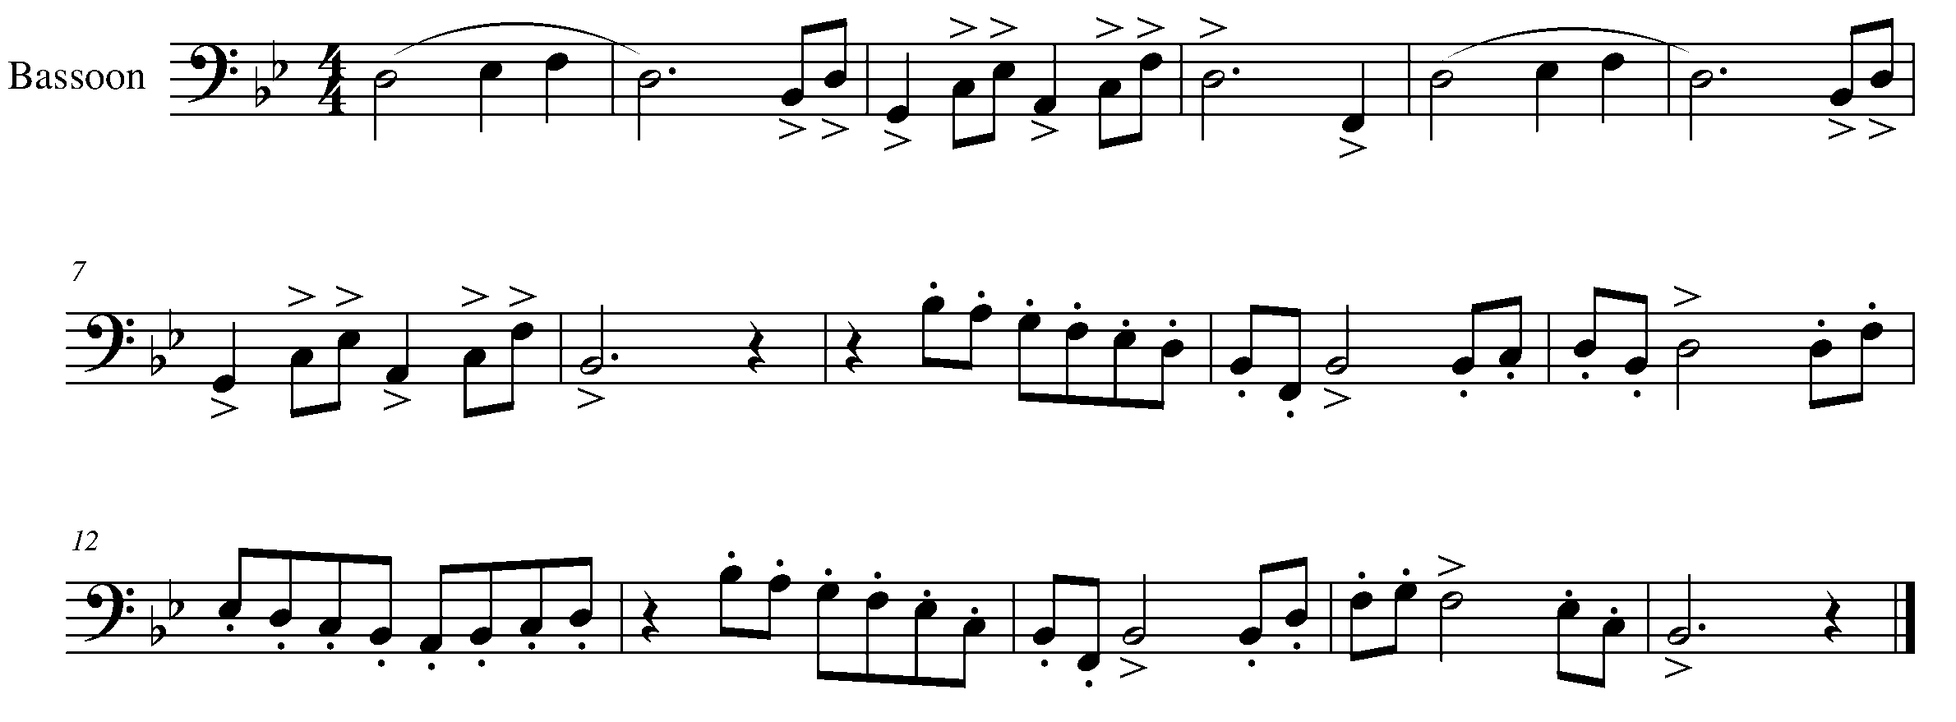
Task 6 Music Continued

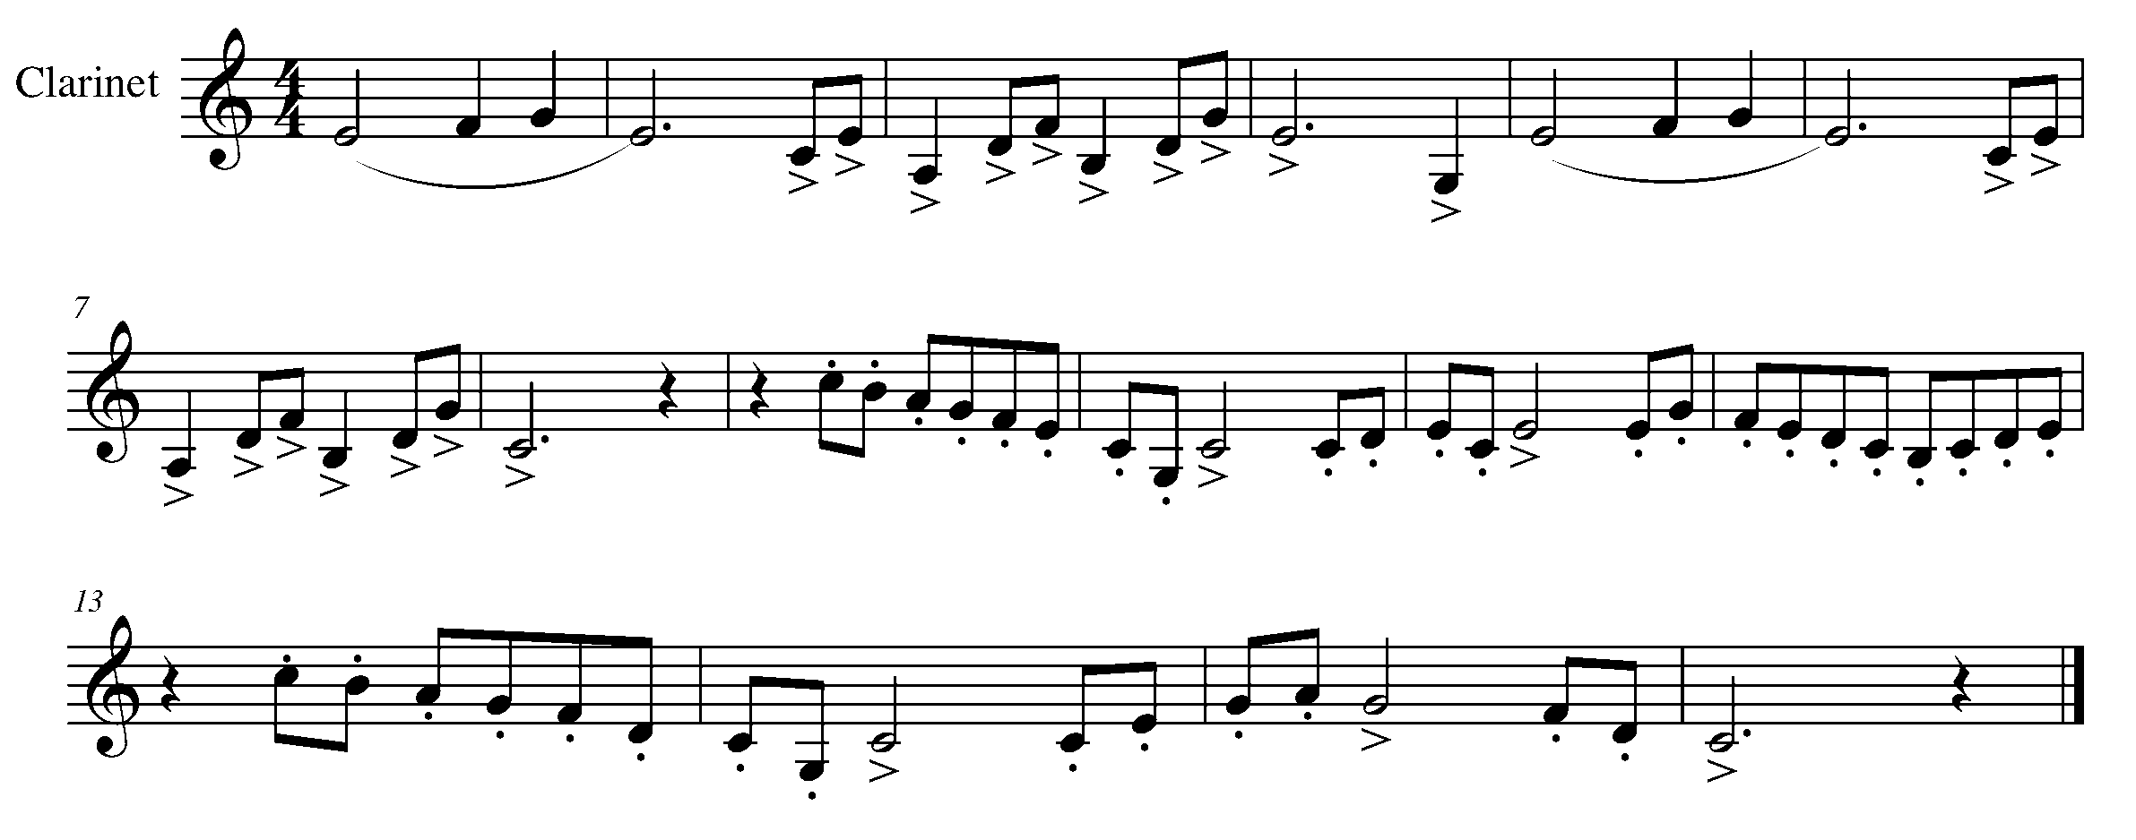
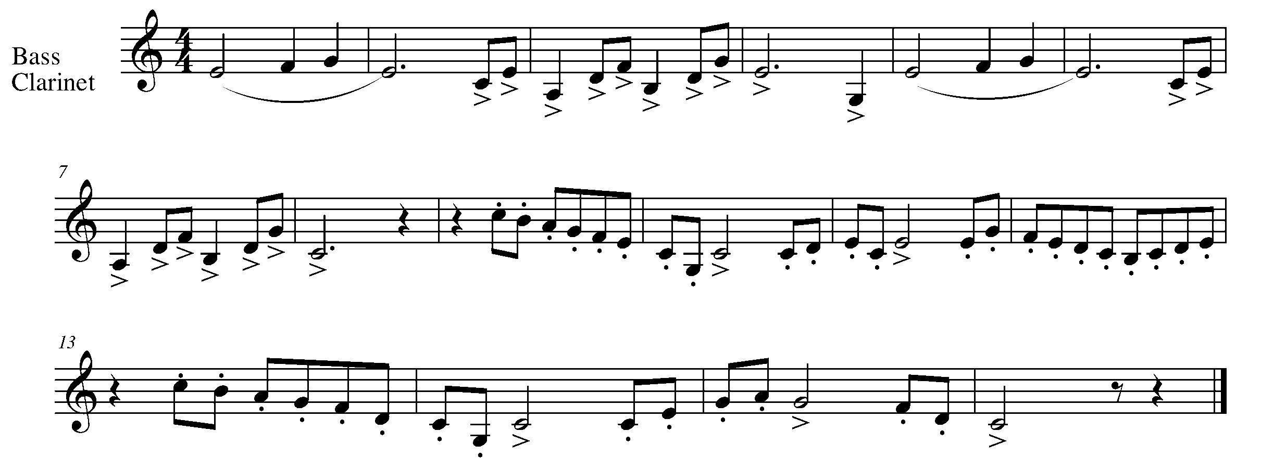

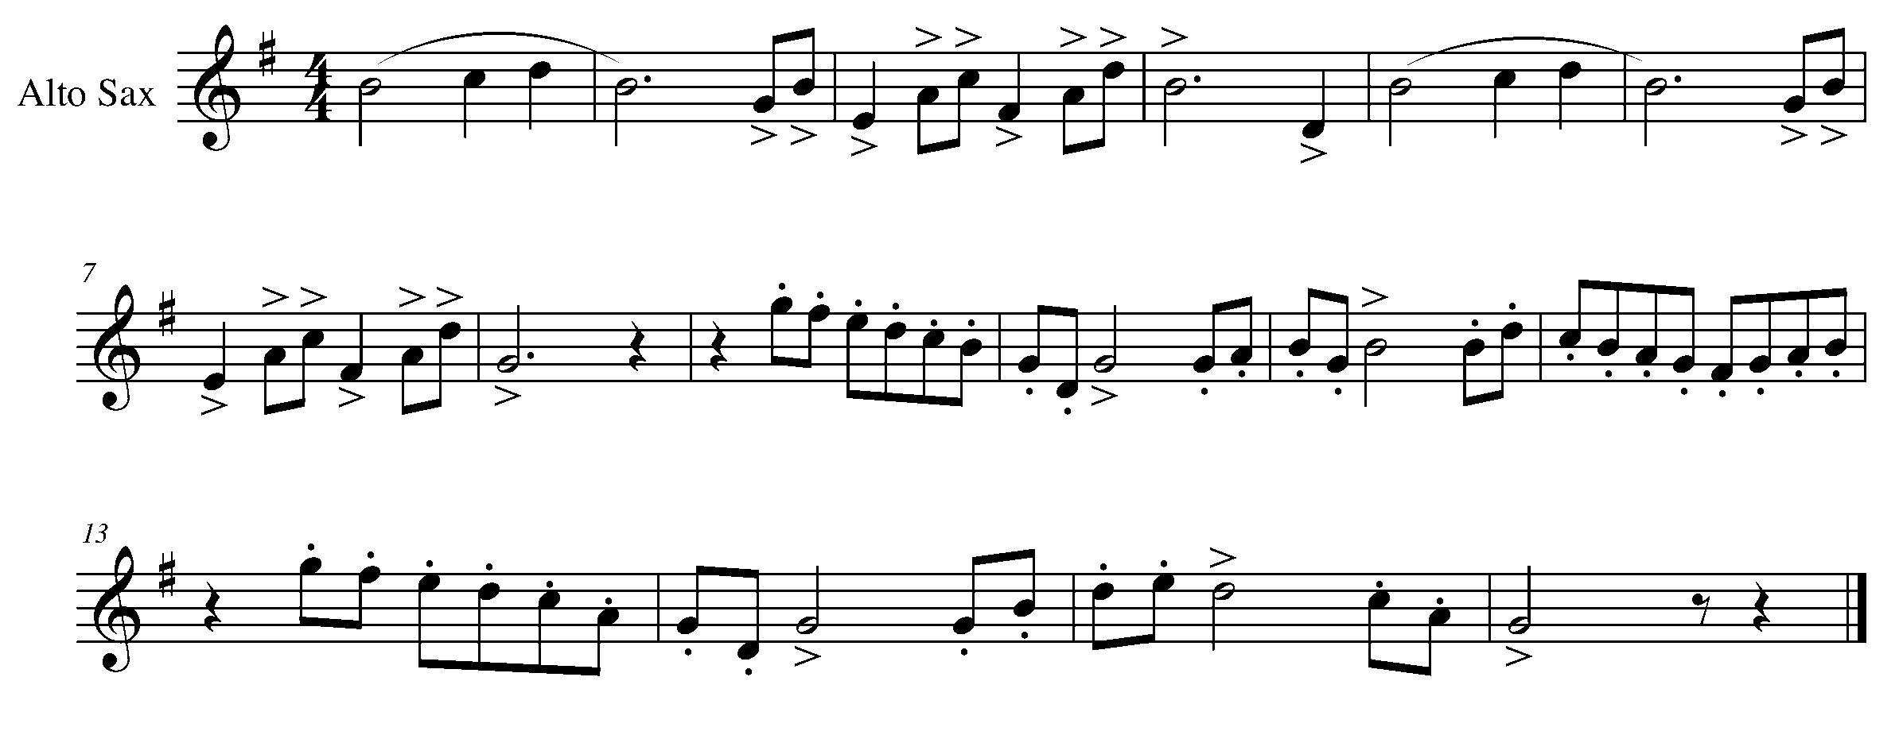

Task 6 Music Continued
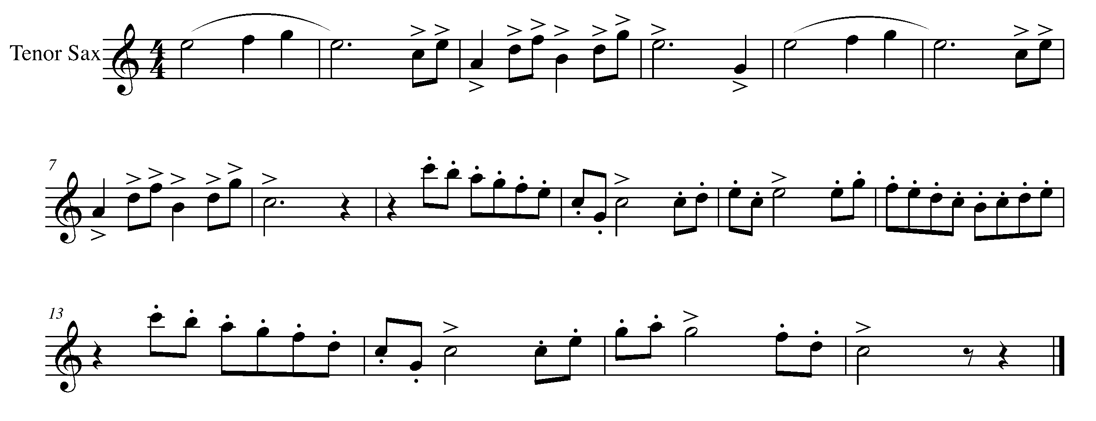

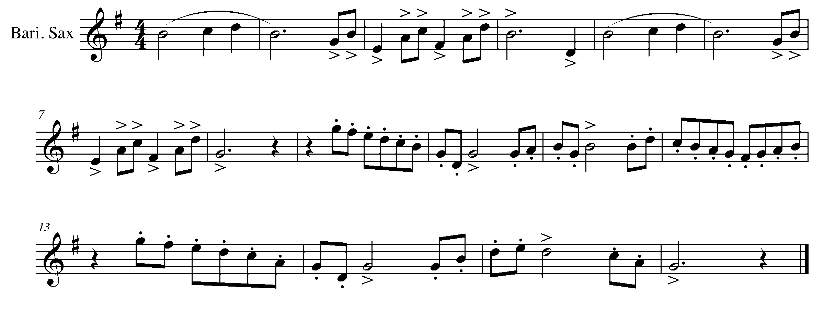

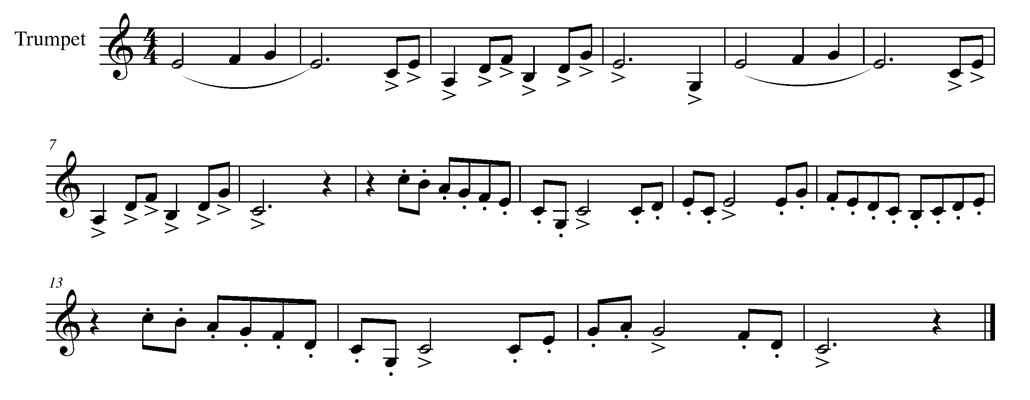

Task 6 Music Continued

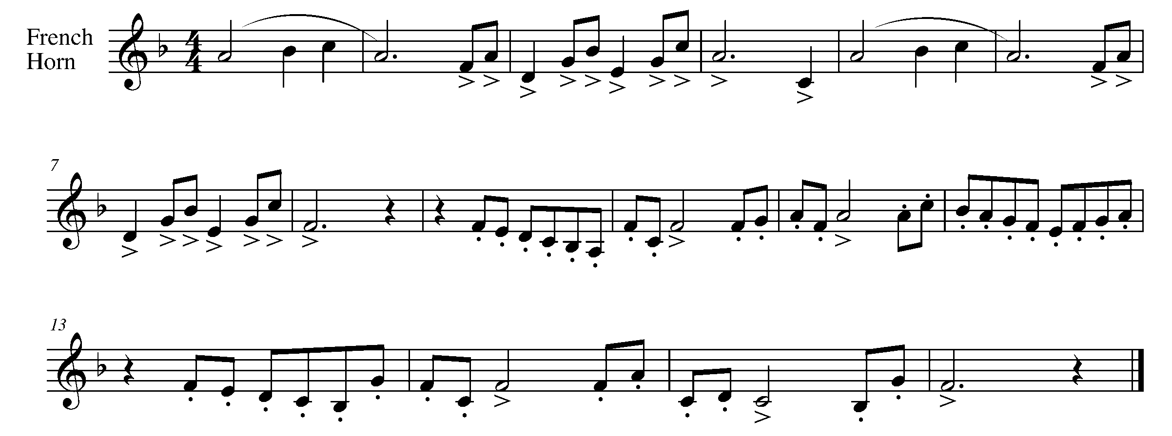
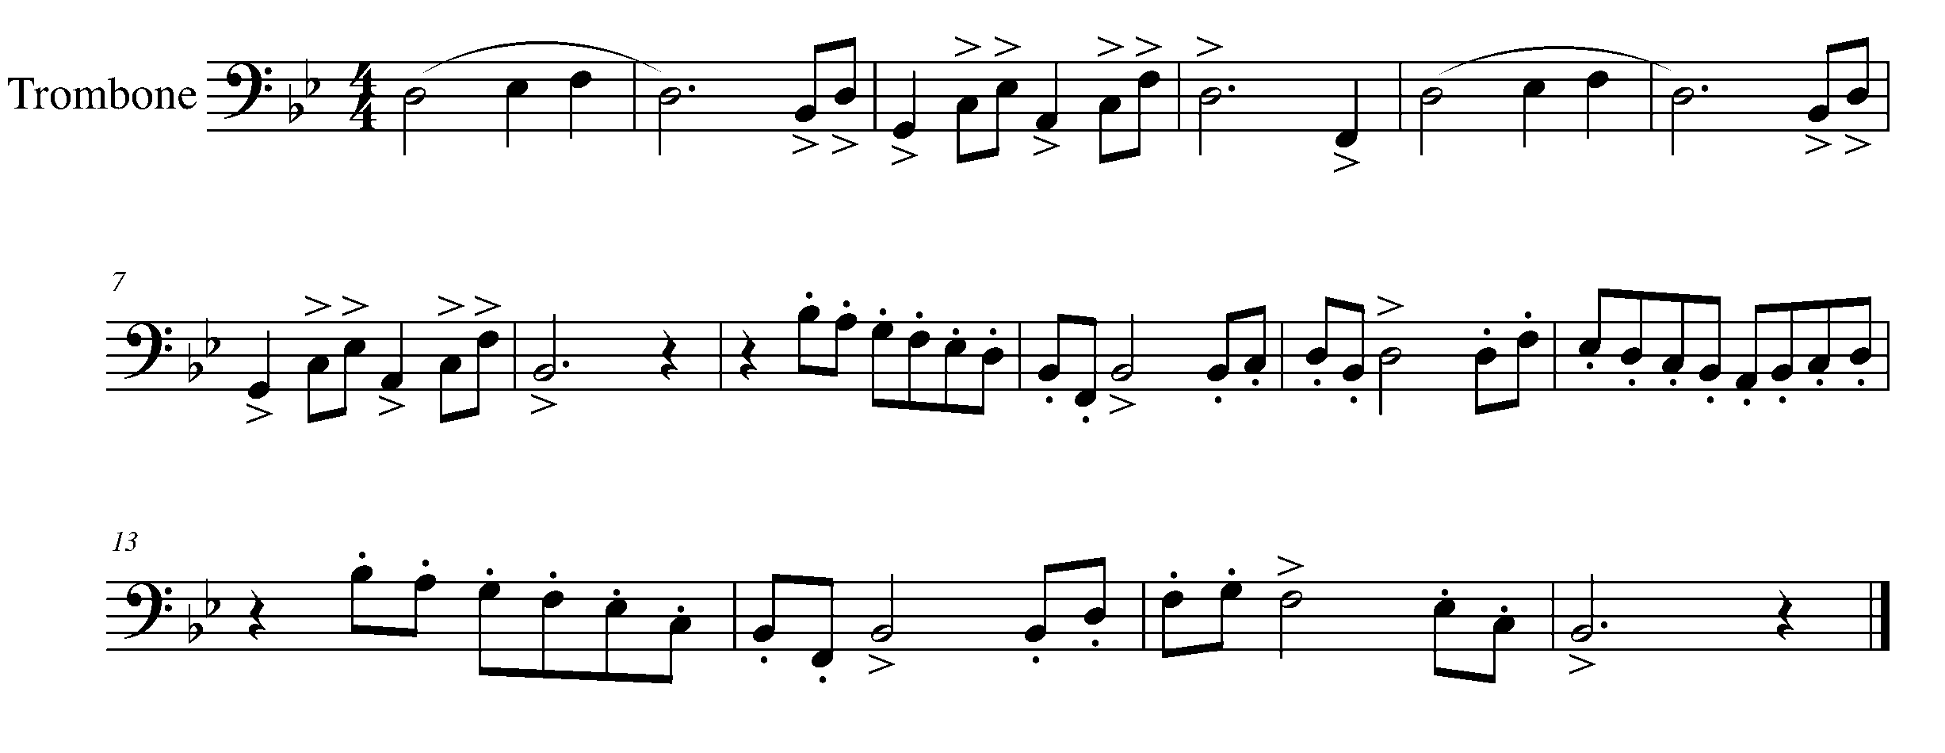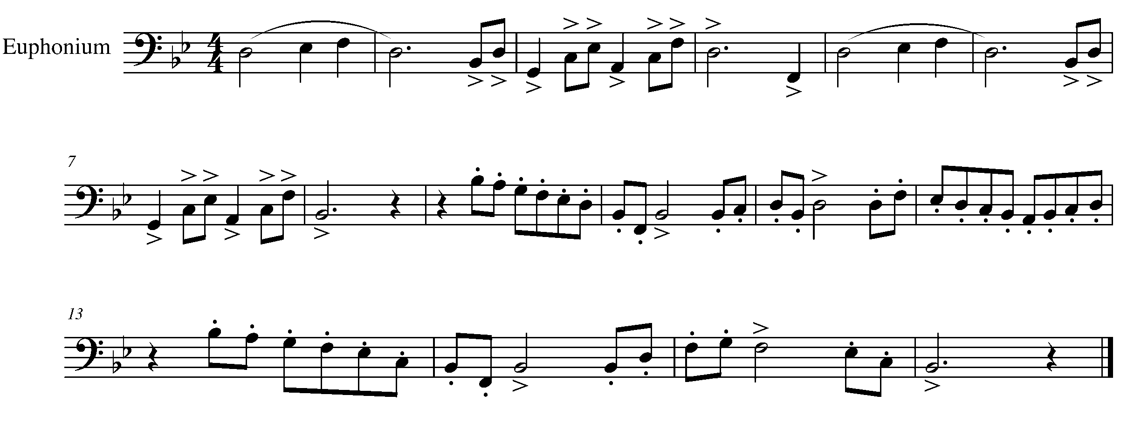

Task 6 Music Continued
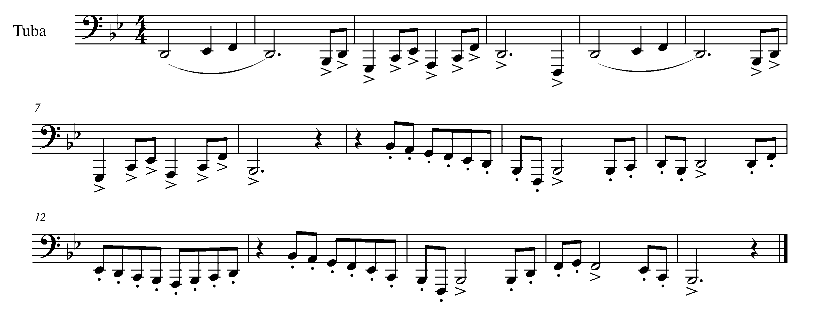

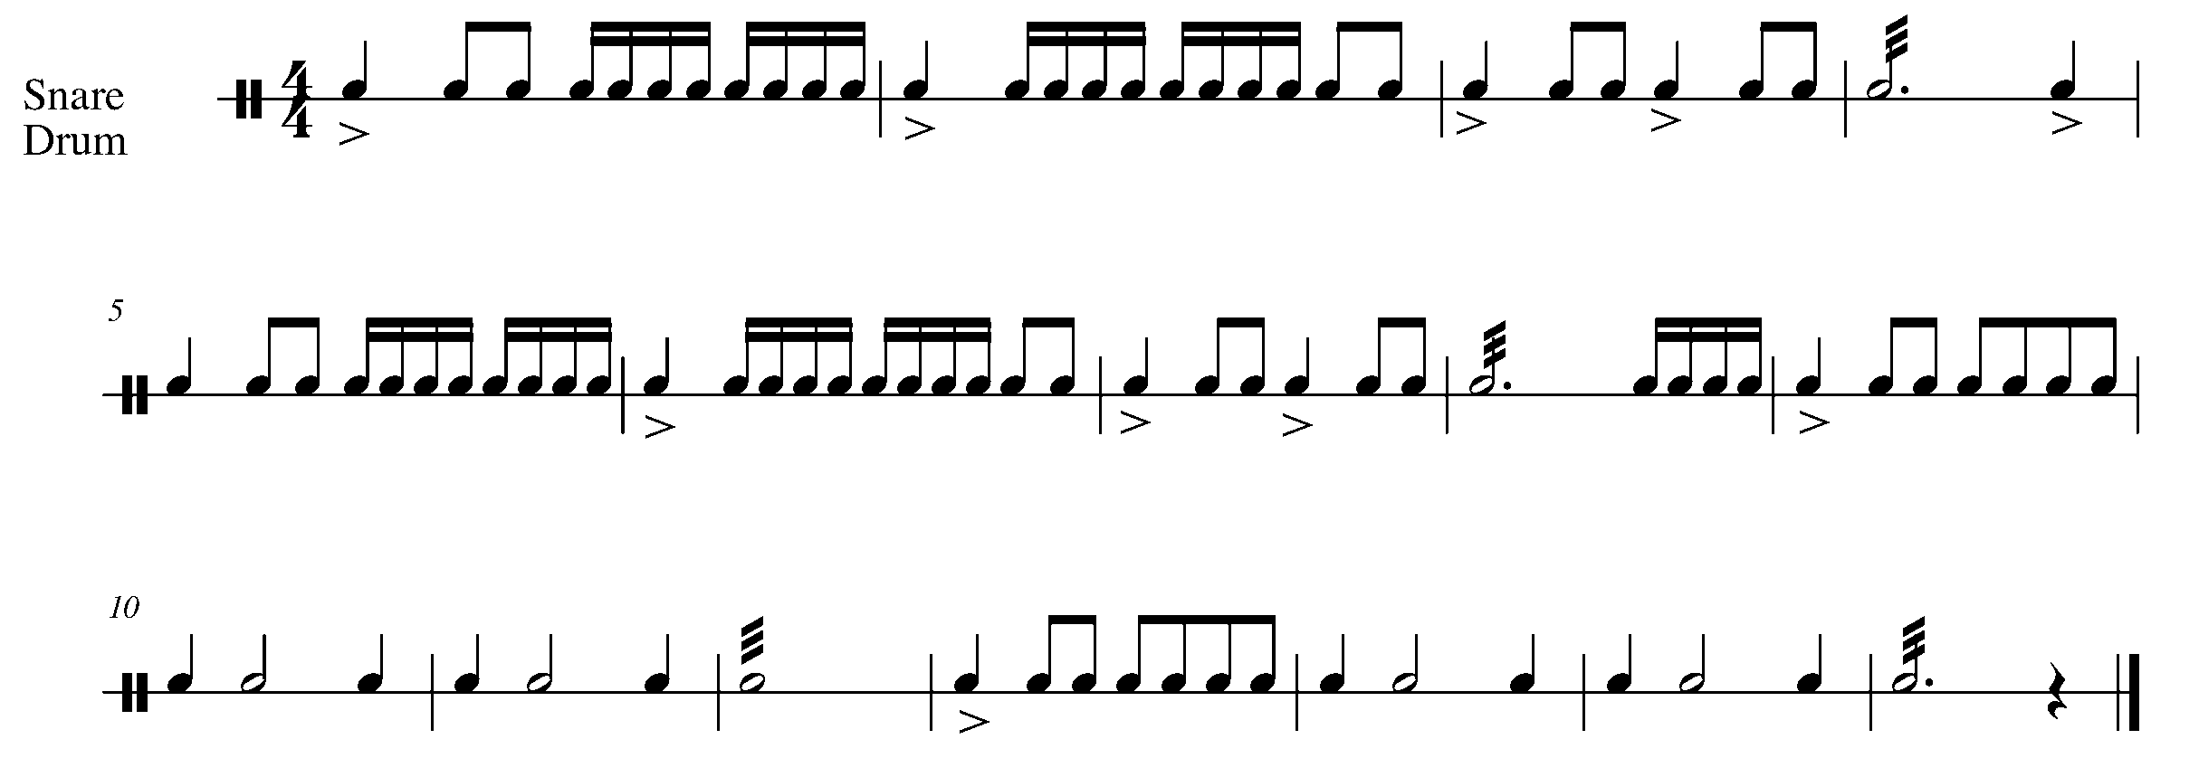
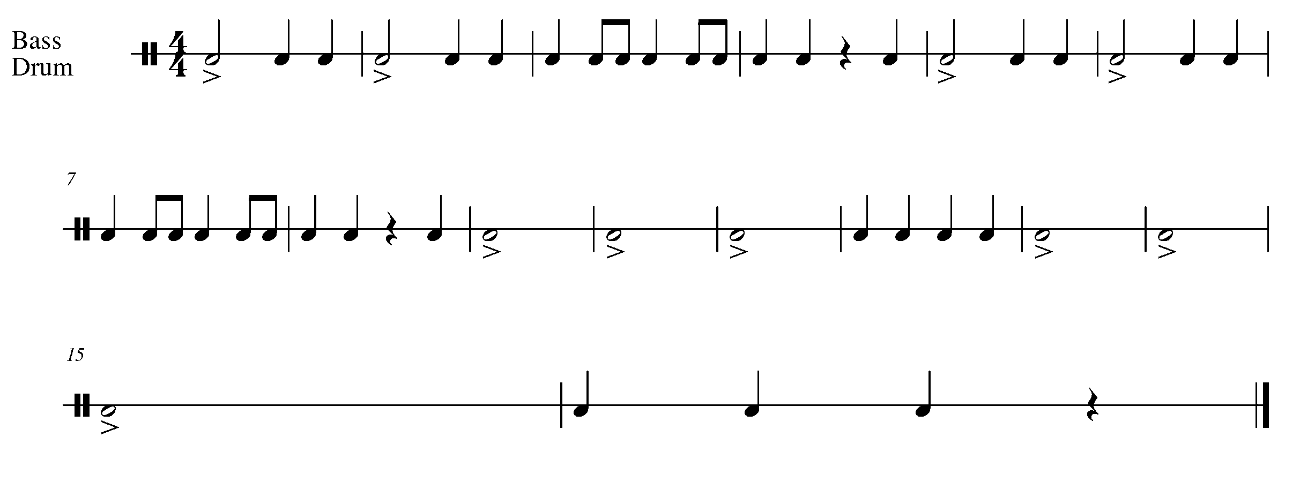

Task 6 Music Continued
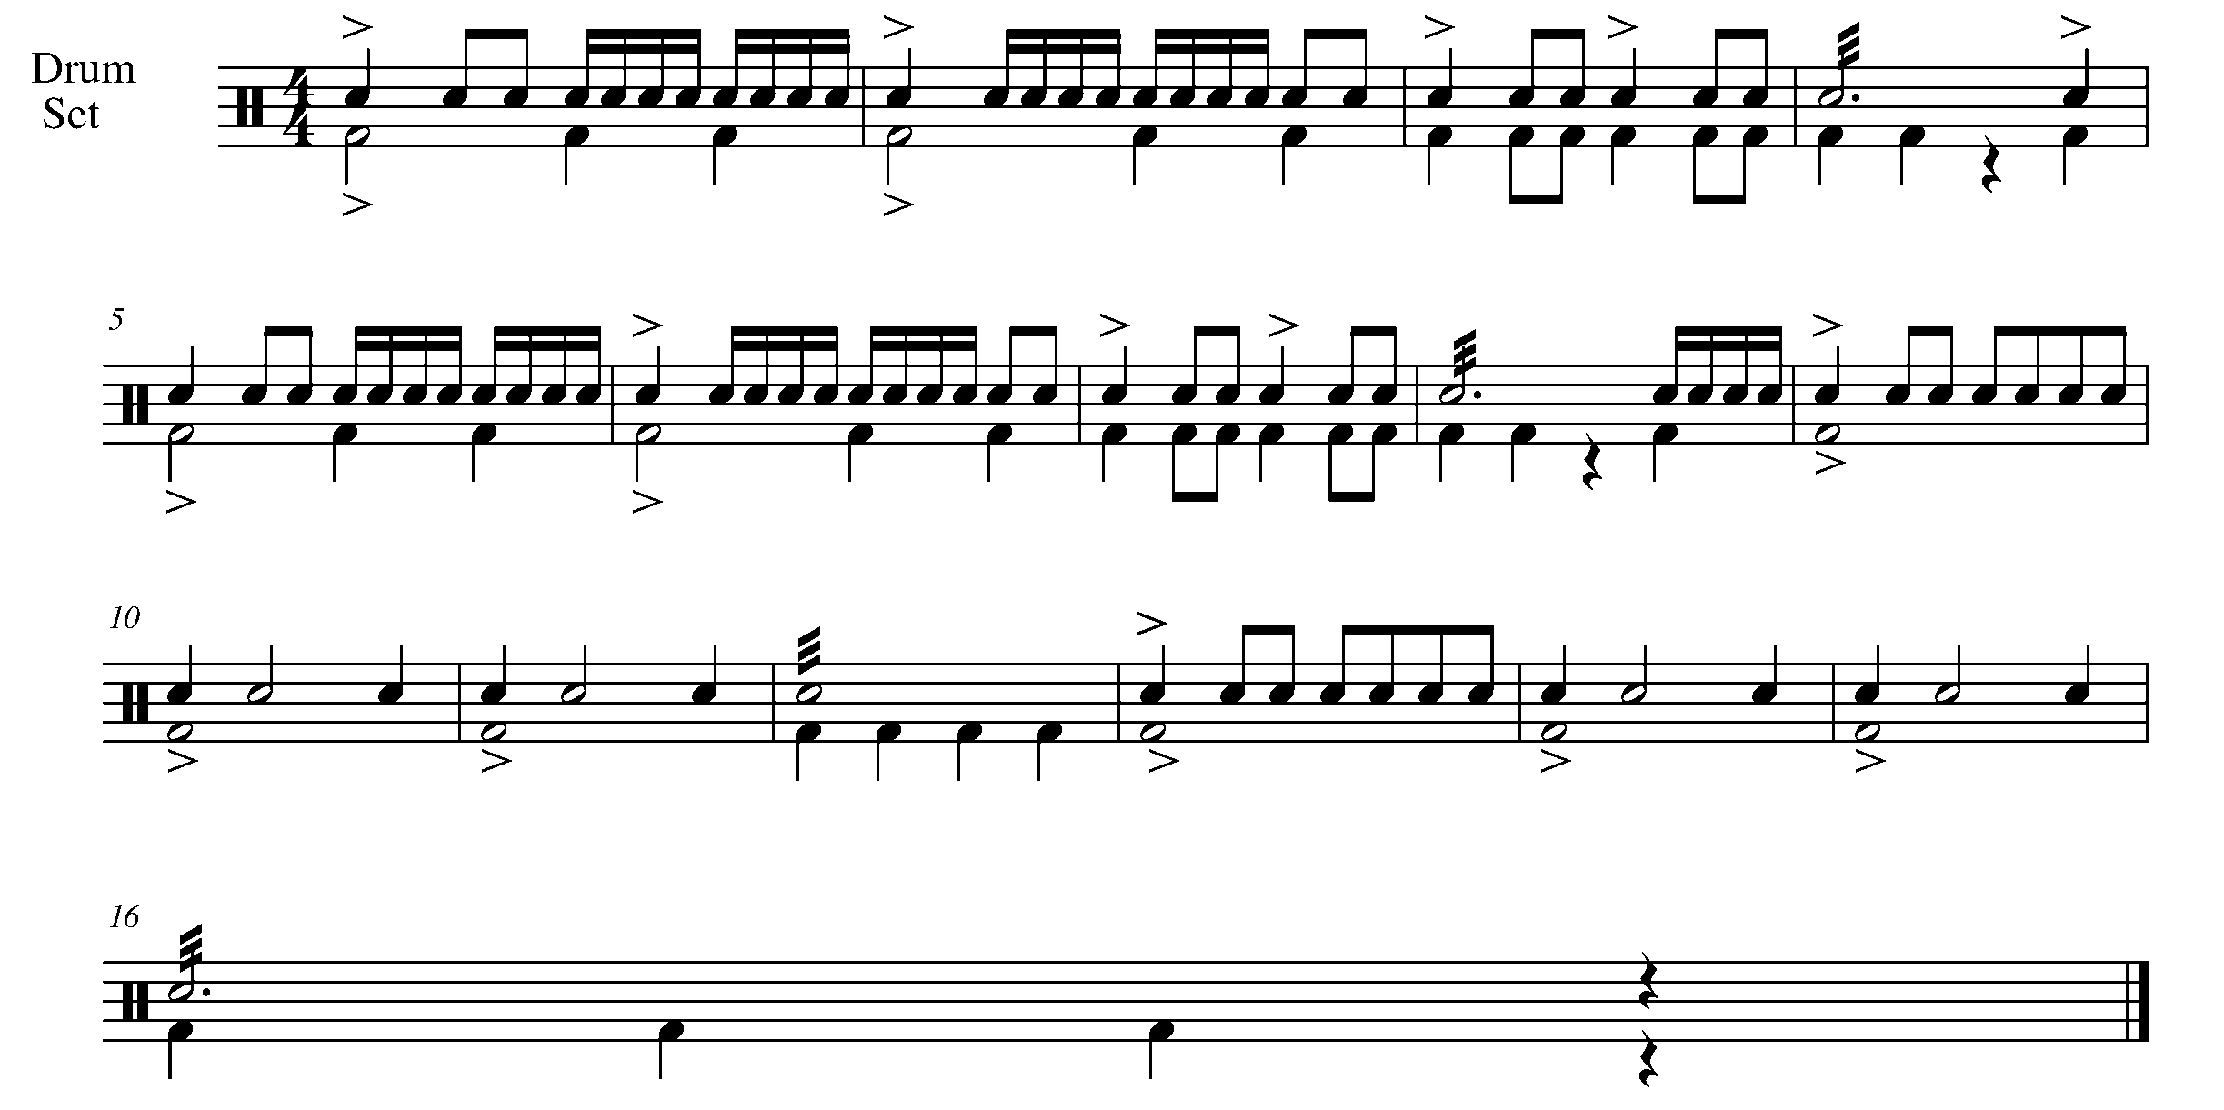

7. JUMP START FOCUS: RHYTHM
Wind Instruments and Mallets

LEARNING GOAL: The pick up note changes the feel of the start of a piece of music. During this task you will demonstrate how to perform a piece of music that begins with a pick up note.

MINDS ON! How do you identify a pick up note? How does the pick up note change the “feel” of a piece? Think about how to comfortably count yourself in when starting a piece with a pick up note. How is the last bar of music changed when there is a pick up note?

ACTION! In order to be successful wit this task, you will need to:
- Determine on which beat this piece begins.
- Demonstrate a solid understanding of the pick up note as well as the rhythms and pitches of the piece of music below.

CONSOLIDATION: In order to move to the next task, you must perform the following piece for your teacher and receive feedback.

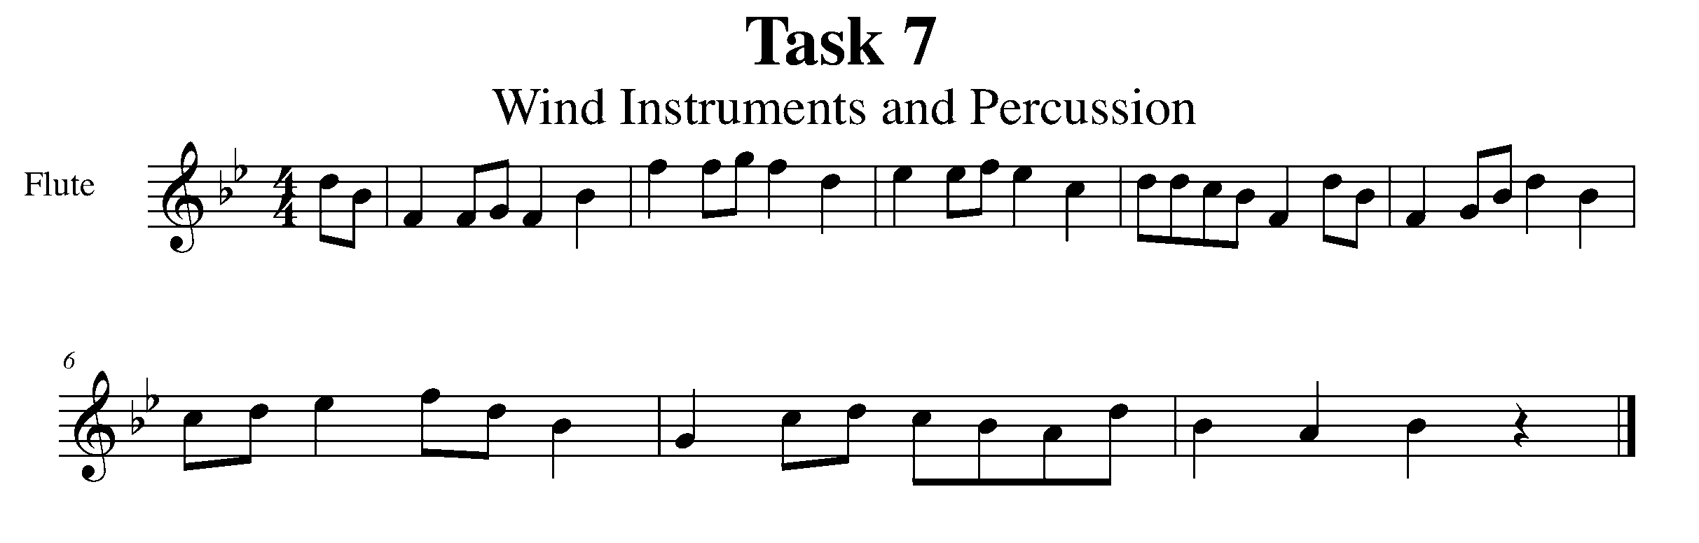
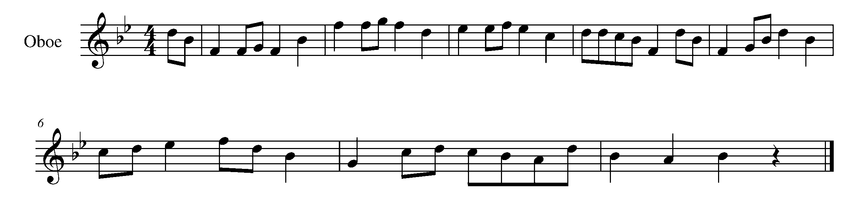

Task 7 Music Continued

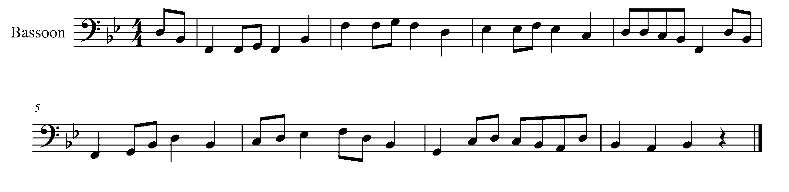
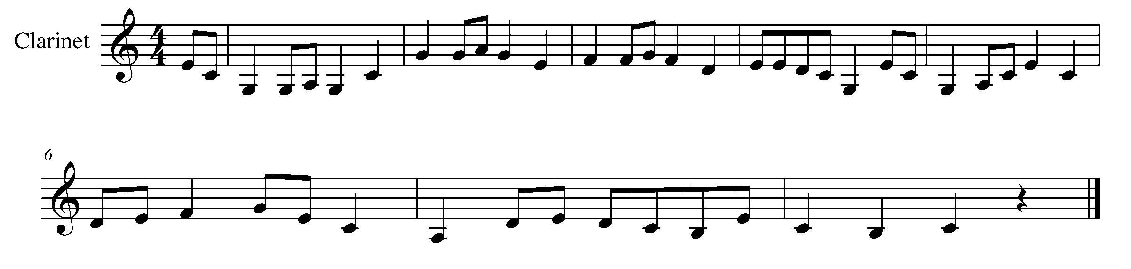
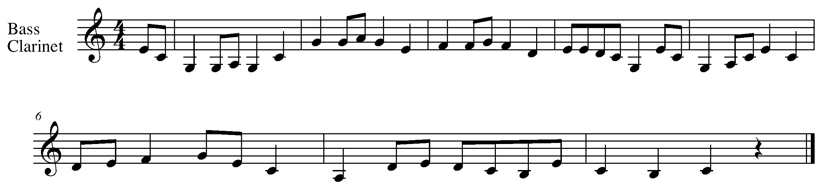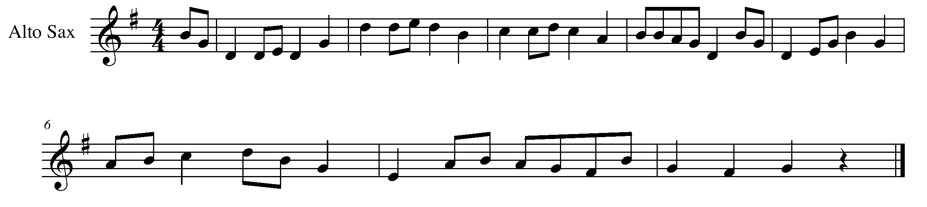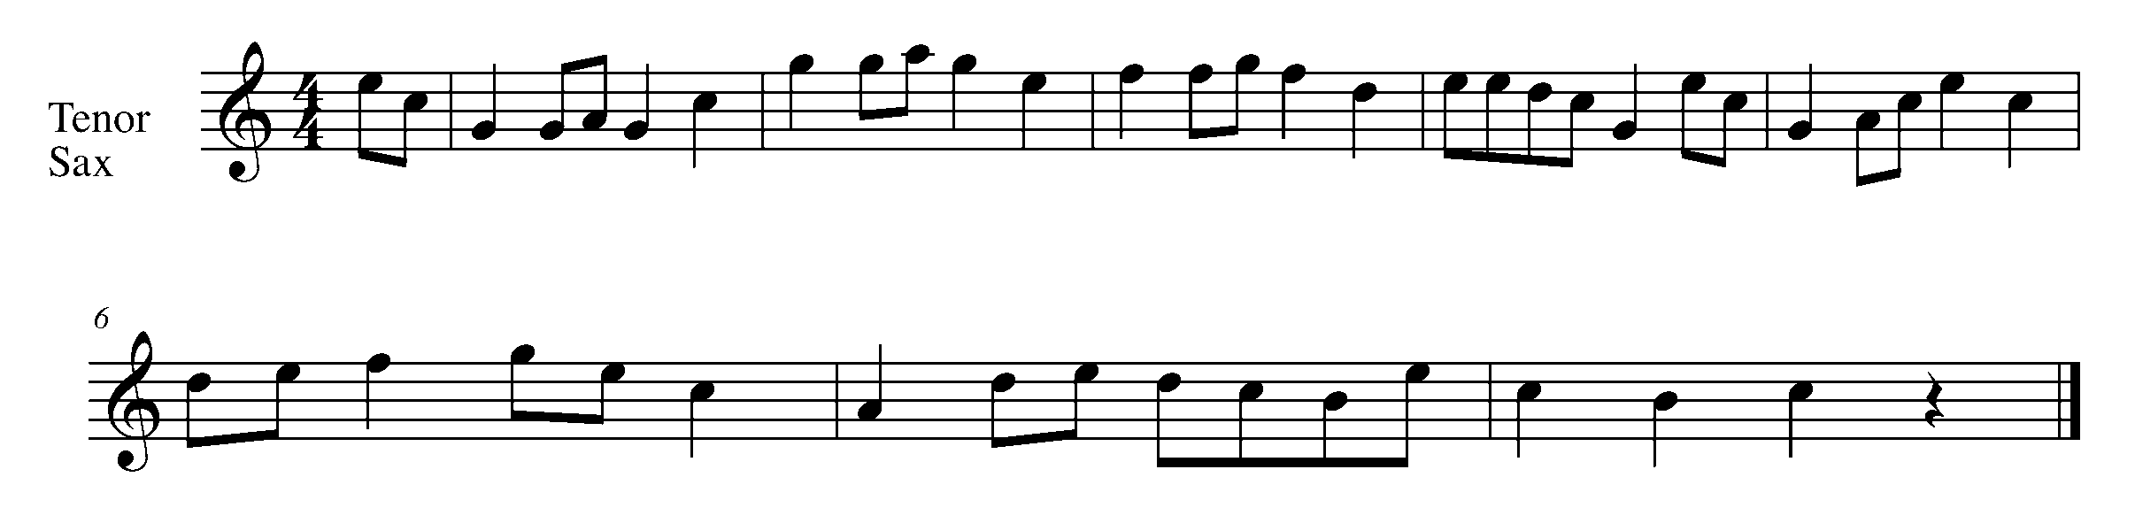

Task 7 Music Continued

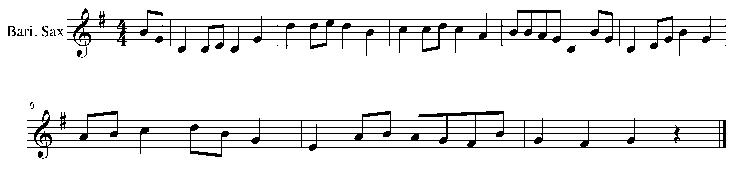
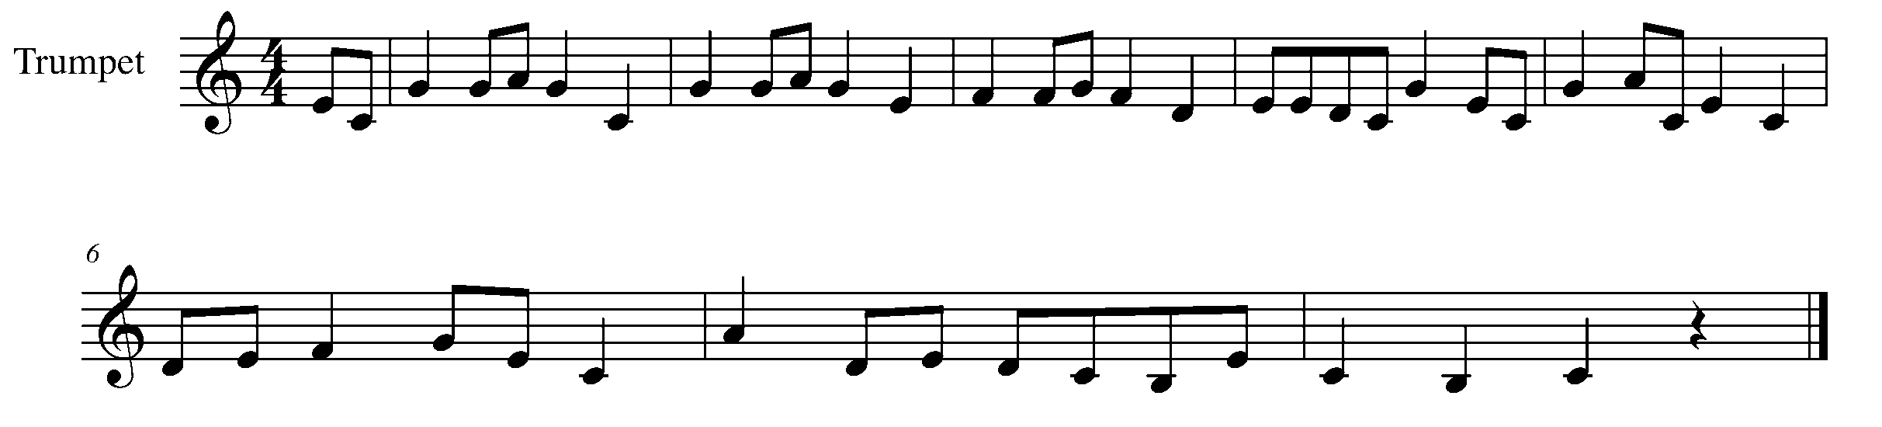
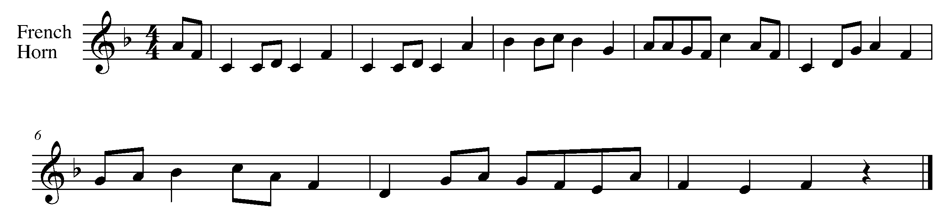
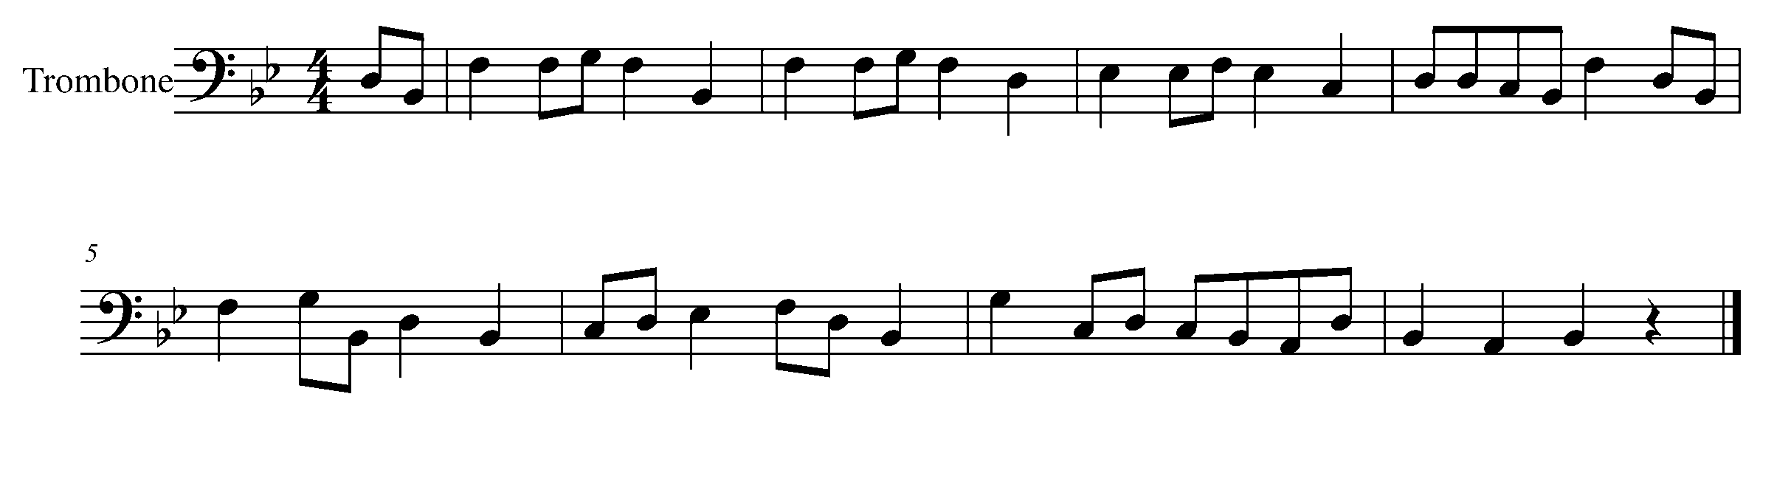
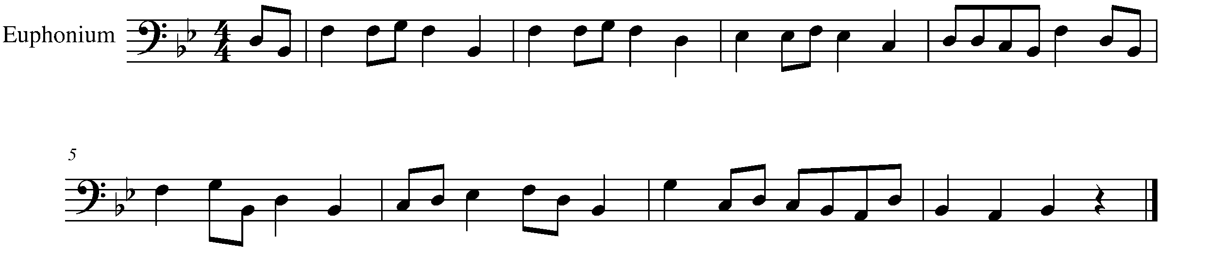

Task 7 Music Continued

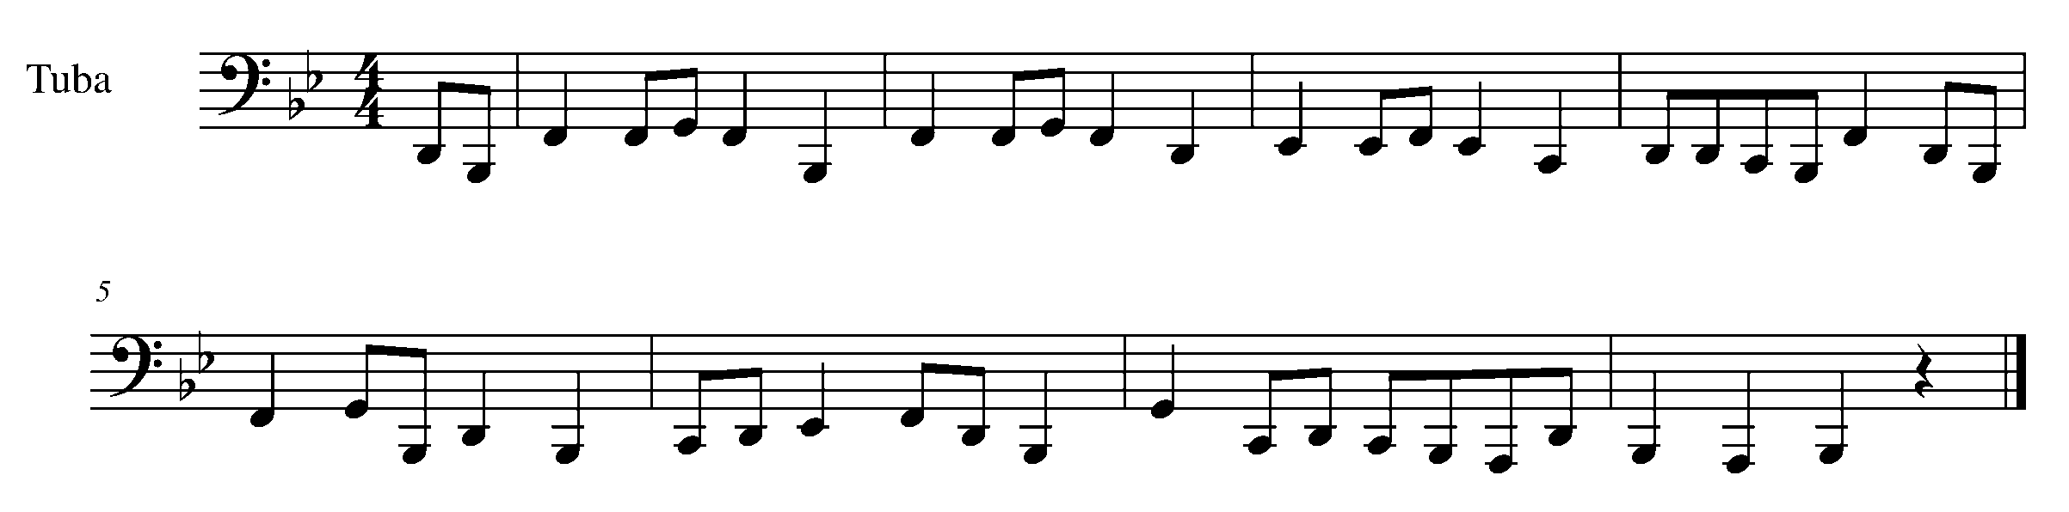
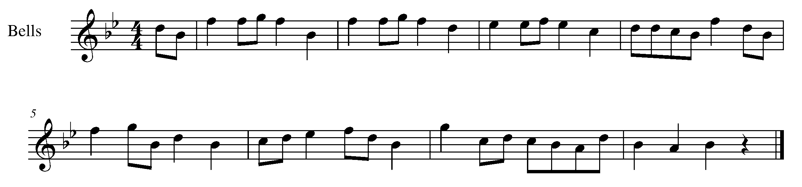
8. THREE BEATS IN A BAR! FOCUS: DURATION
Wind Instruments and SD/BD/KIT

LEARNING GOAL: Performing 3 beats in a bar definitely has a different feel then music in a 2/4 or 4/4 time signature. The first beat of each bar is the strong beat in 3/4 time – be sure to demonstrate this when performing this task.

MINDS ON! The waltz is a dance, which uses music in 3/4 time. As the first step of a waltz is your largest and leading step, so is the first beat of the bar in 3/4 time. How does music performed in 3/4 time, sound and feel different from music written in 2/4 or 4/4 time?

ACTION! In order to be successful with this task, you will need to:

- Think about how the beats in a 3/4 bar are stressed differently from a bar of 4/4 music.
- Demonstrate musical phrasing and expressive controls.
- Demonstrate accuracy in rhythm and pitch when performing.

CONSOLIDATION: In order to move to the next task, you must perform the following piece for your teacher and receive feedback.

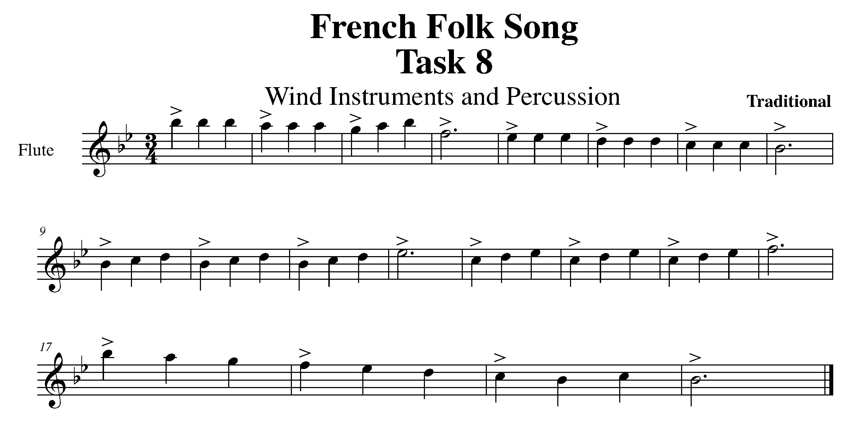

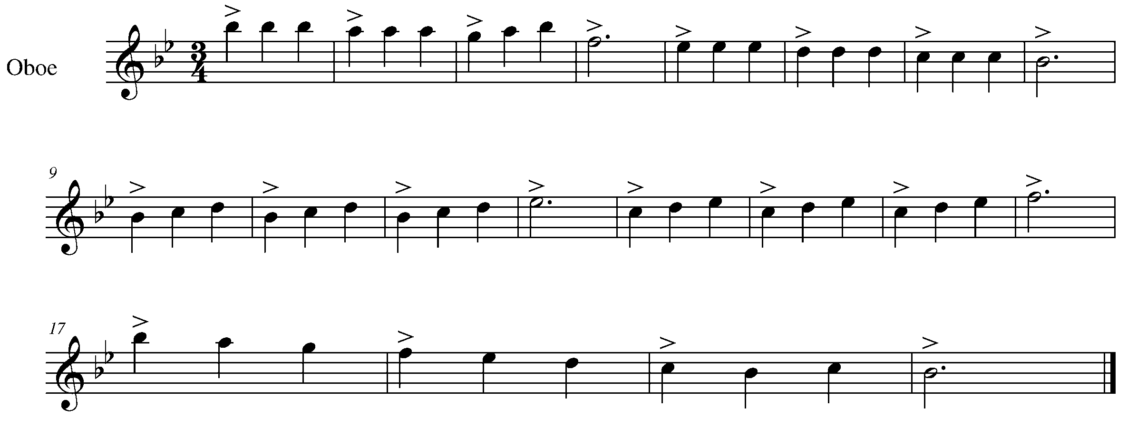

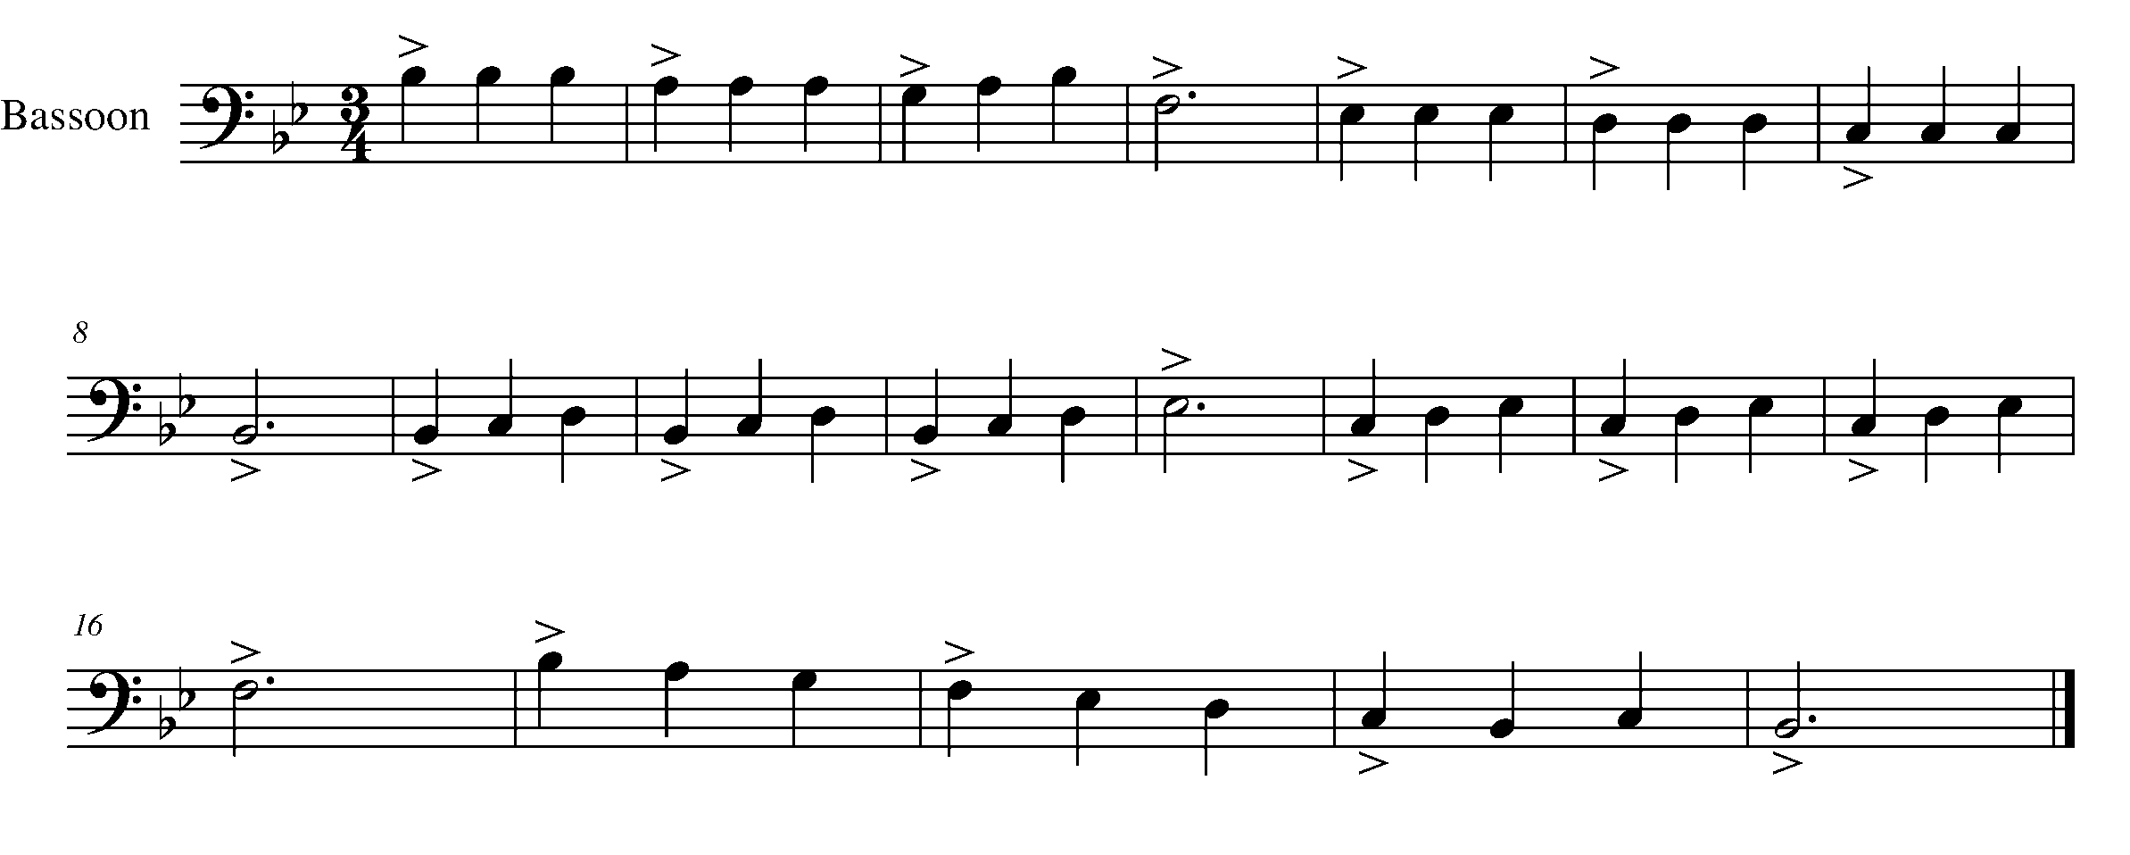

Task 8 Music Continued

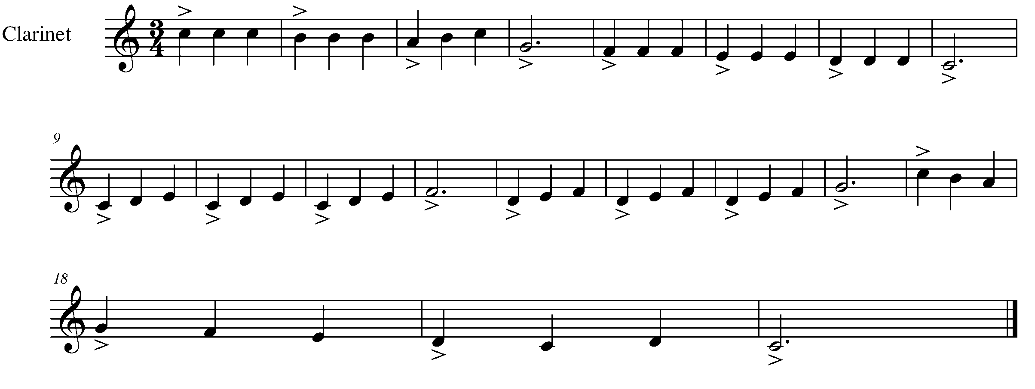
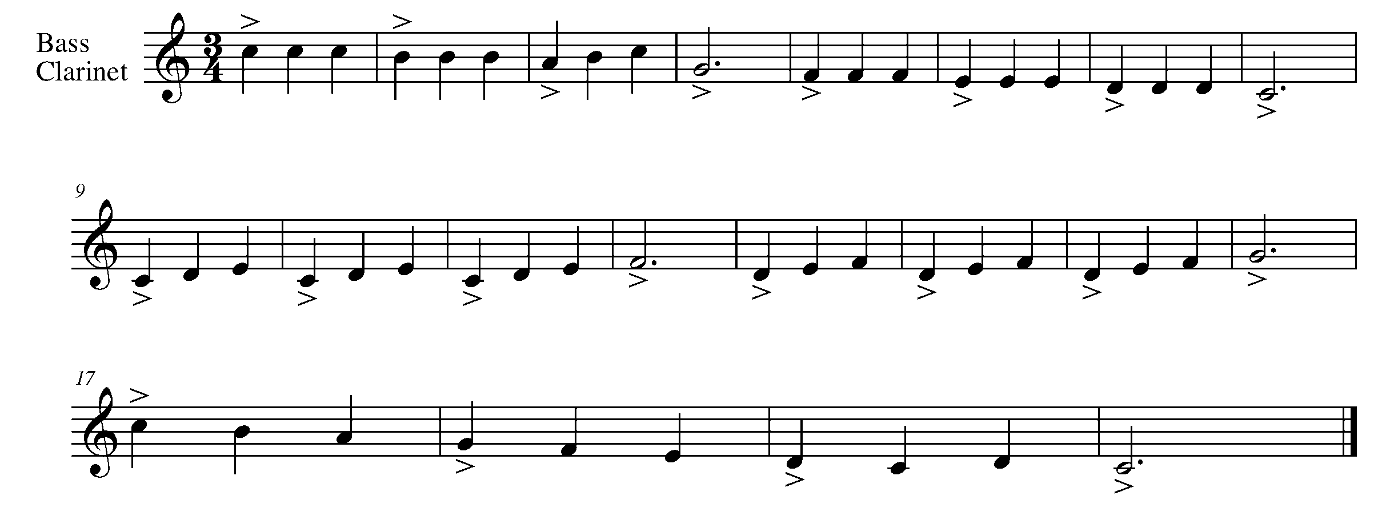

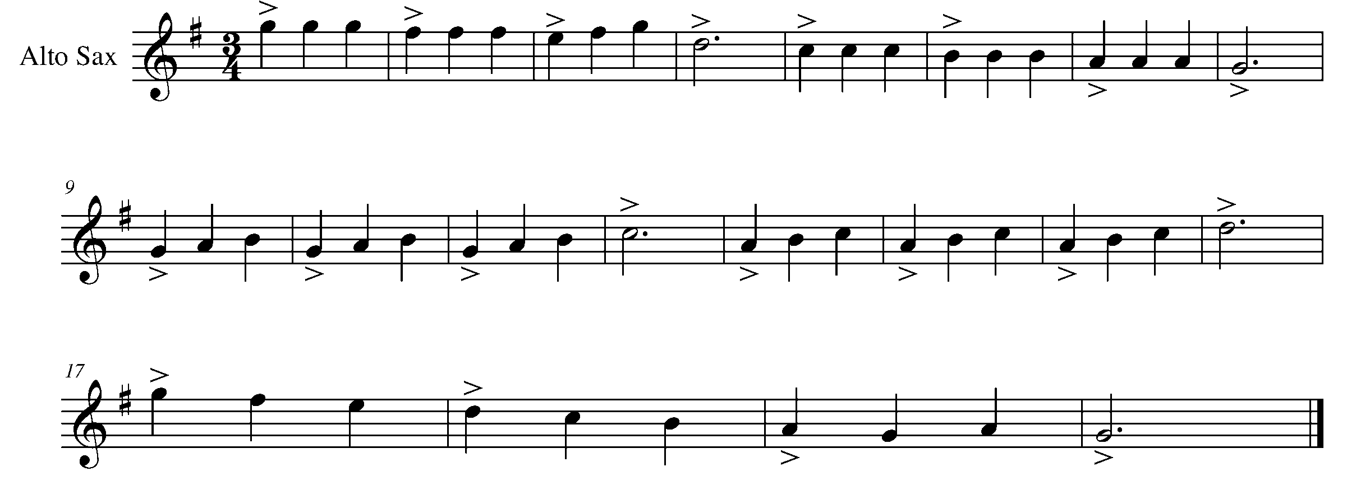

Task 8 Music Continued

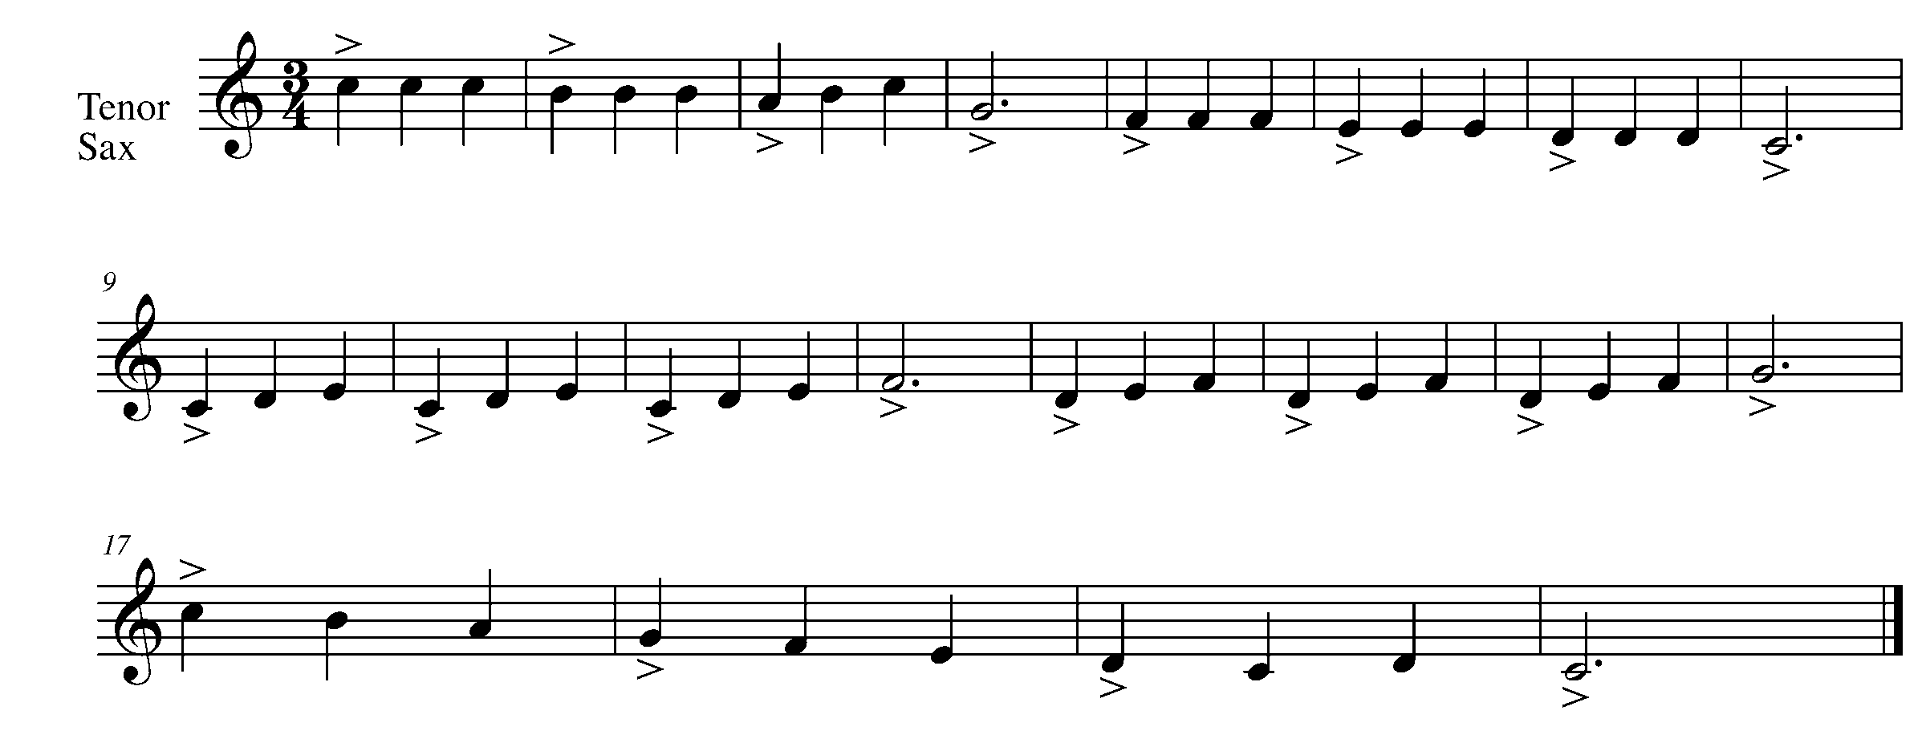
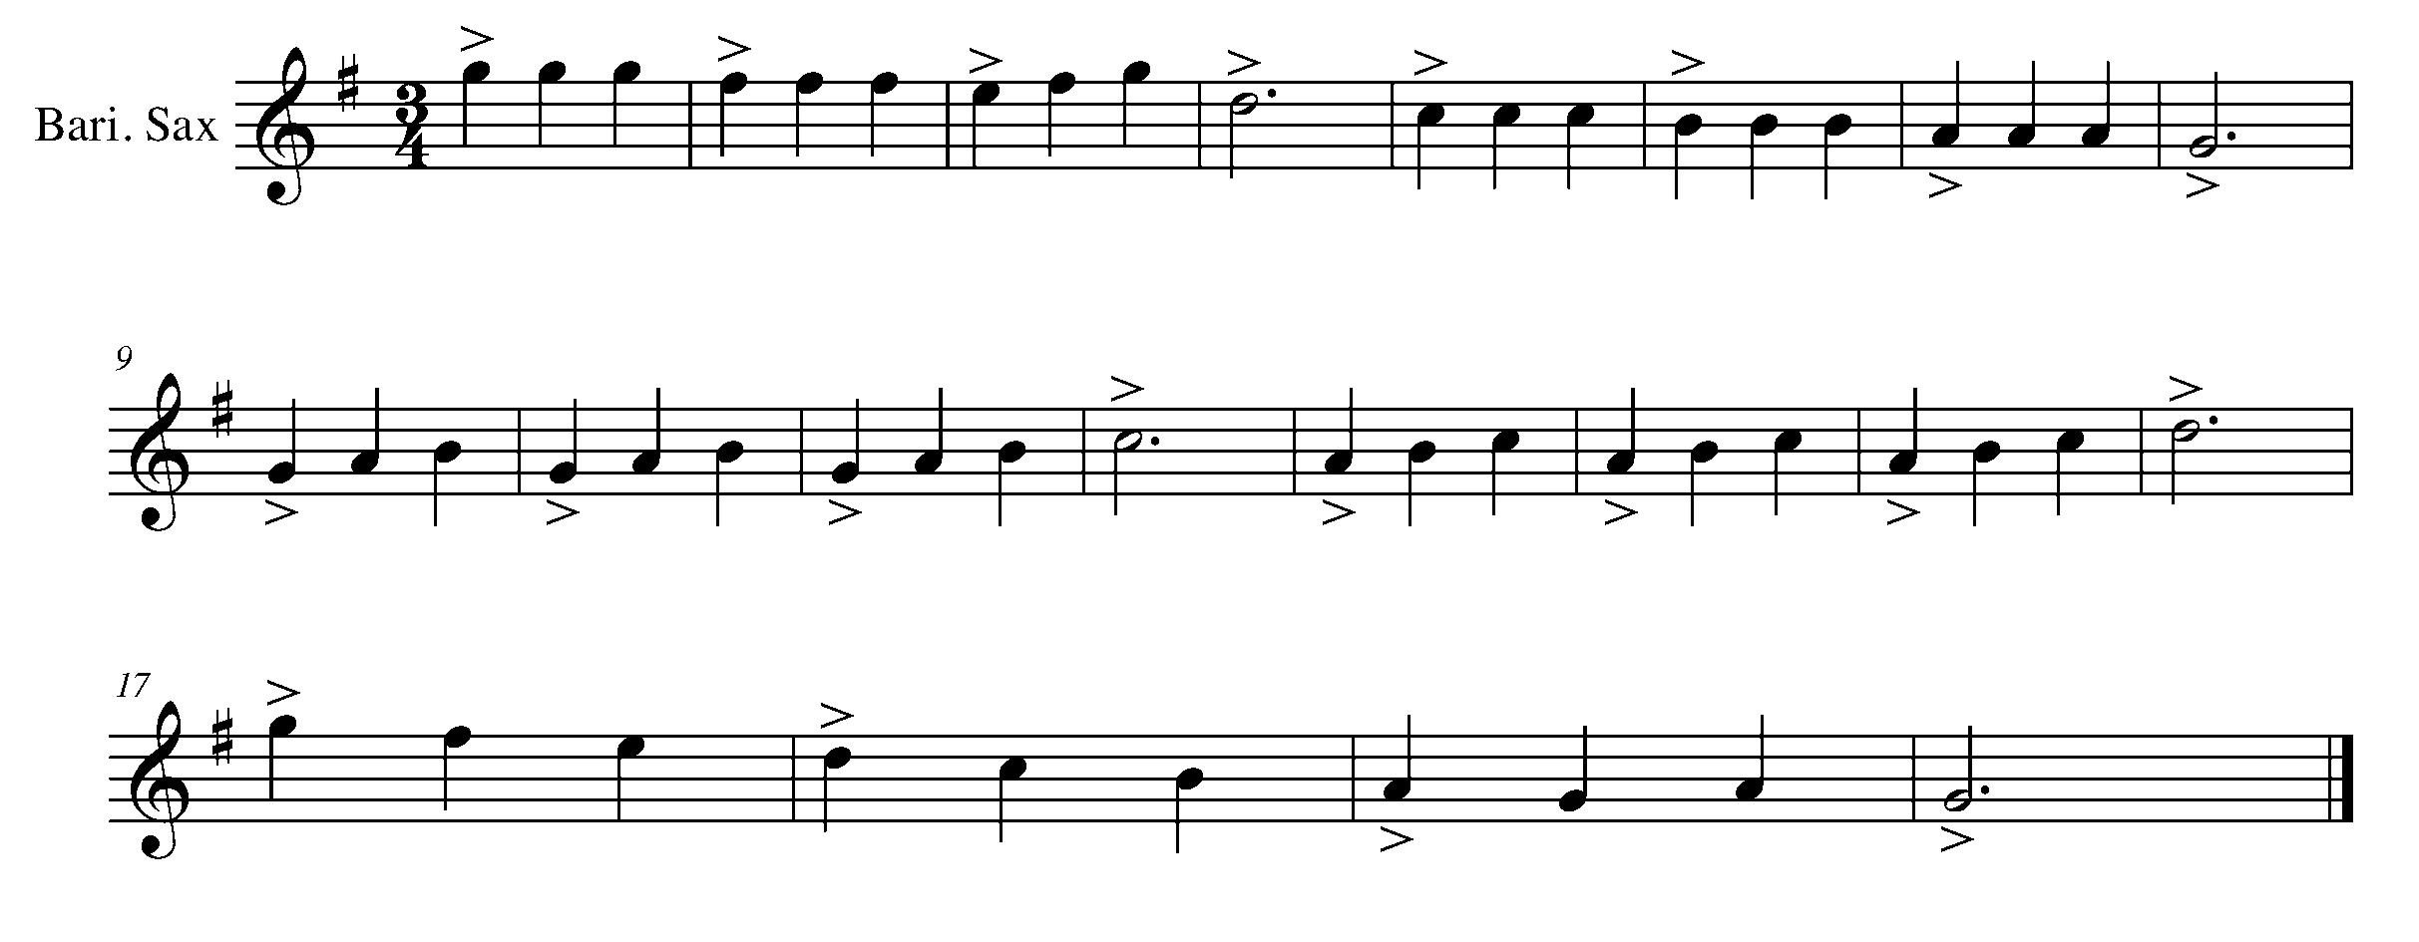
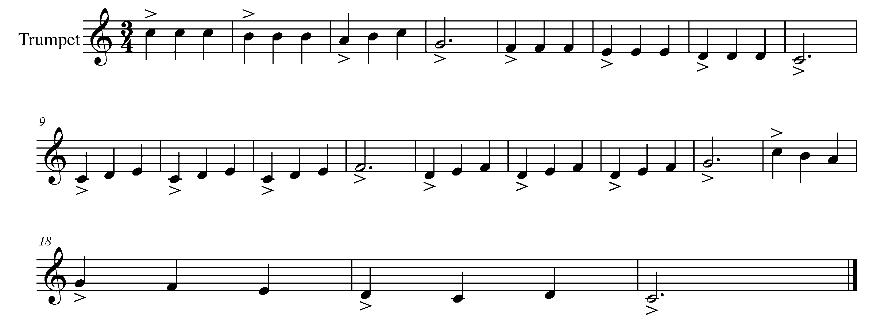

Task 8 Music Continued

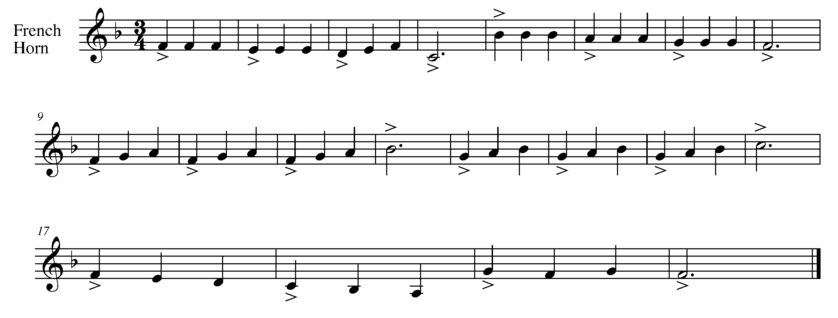
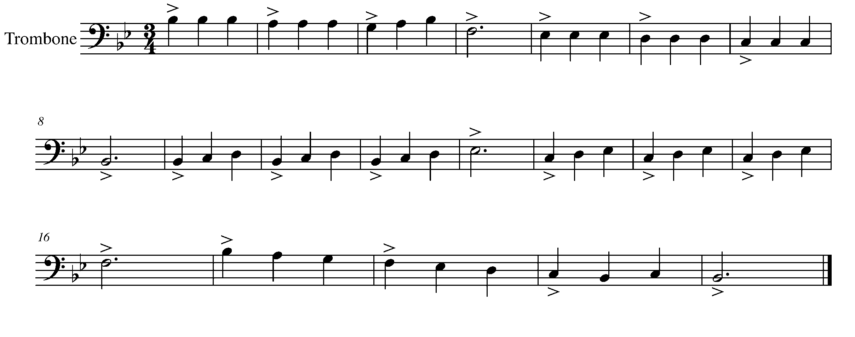
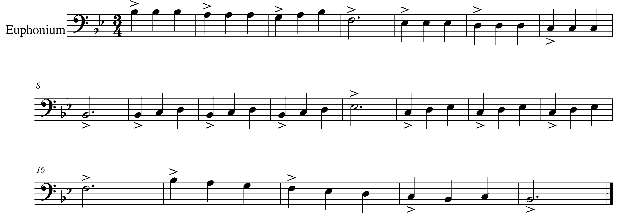

Task 8 Music Continued

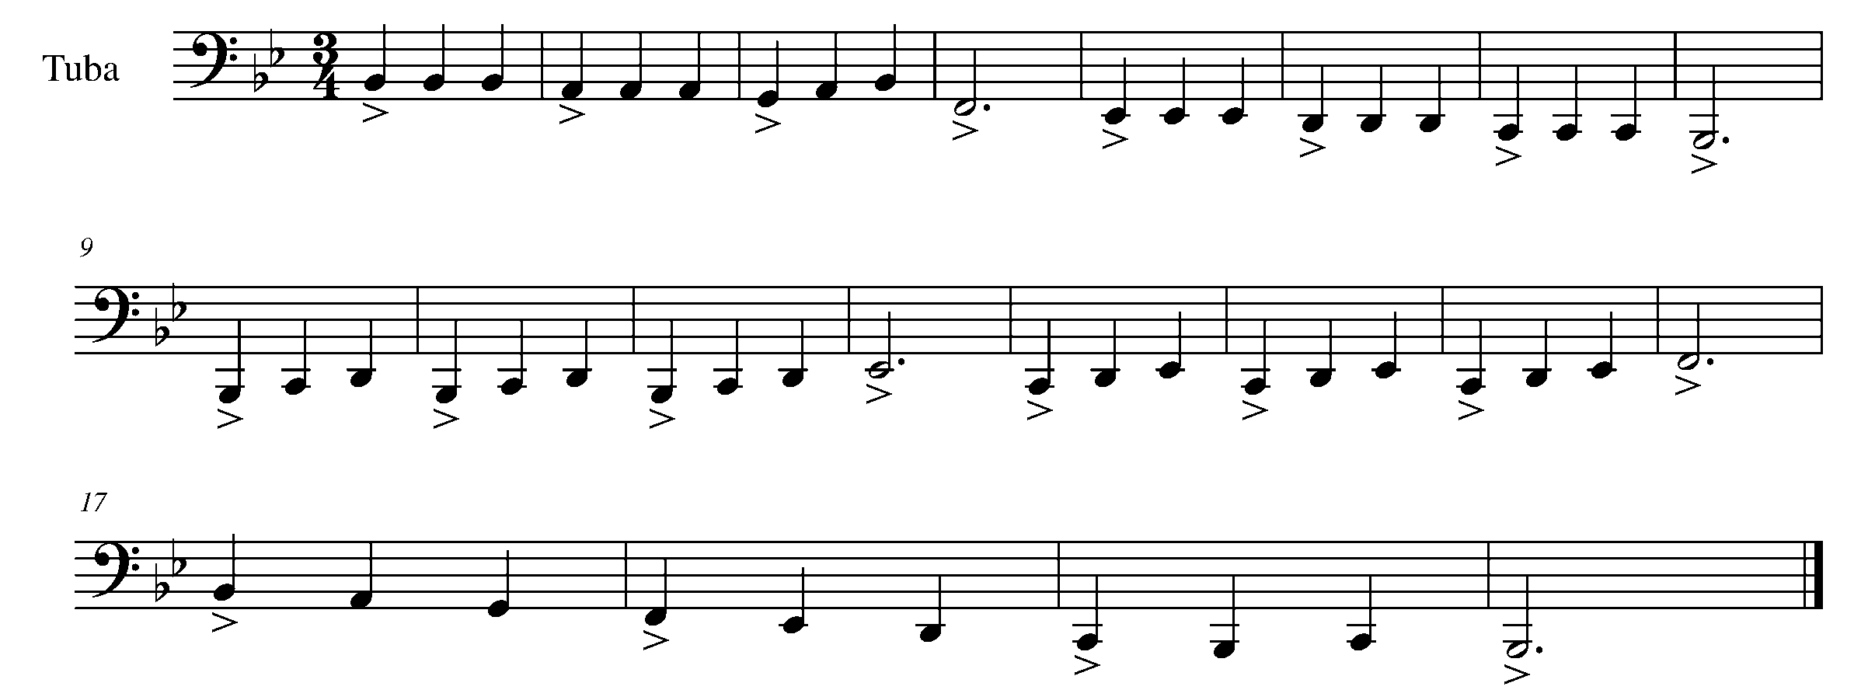
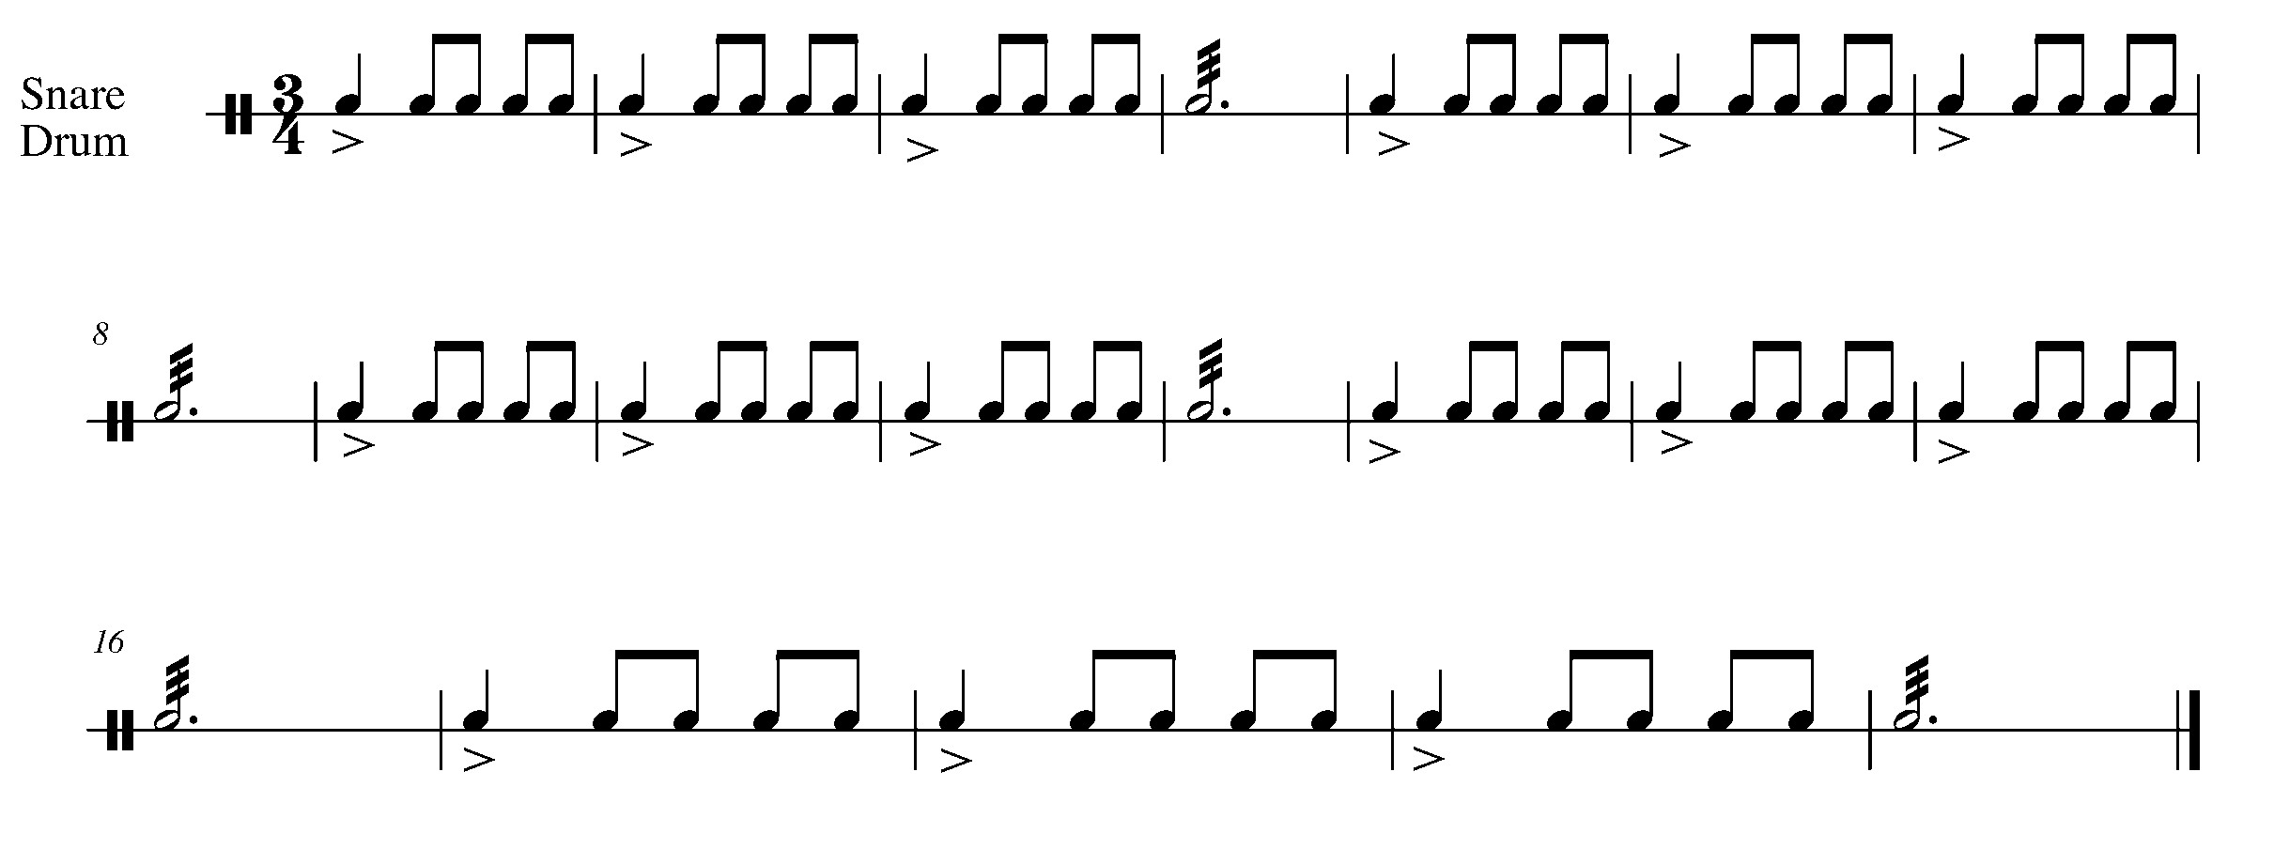
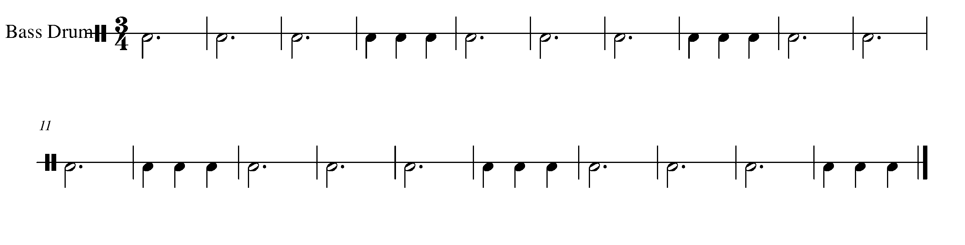
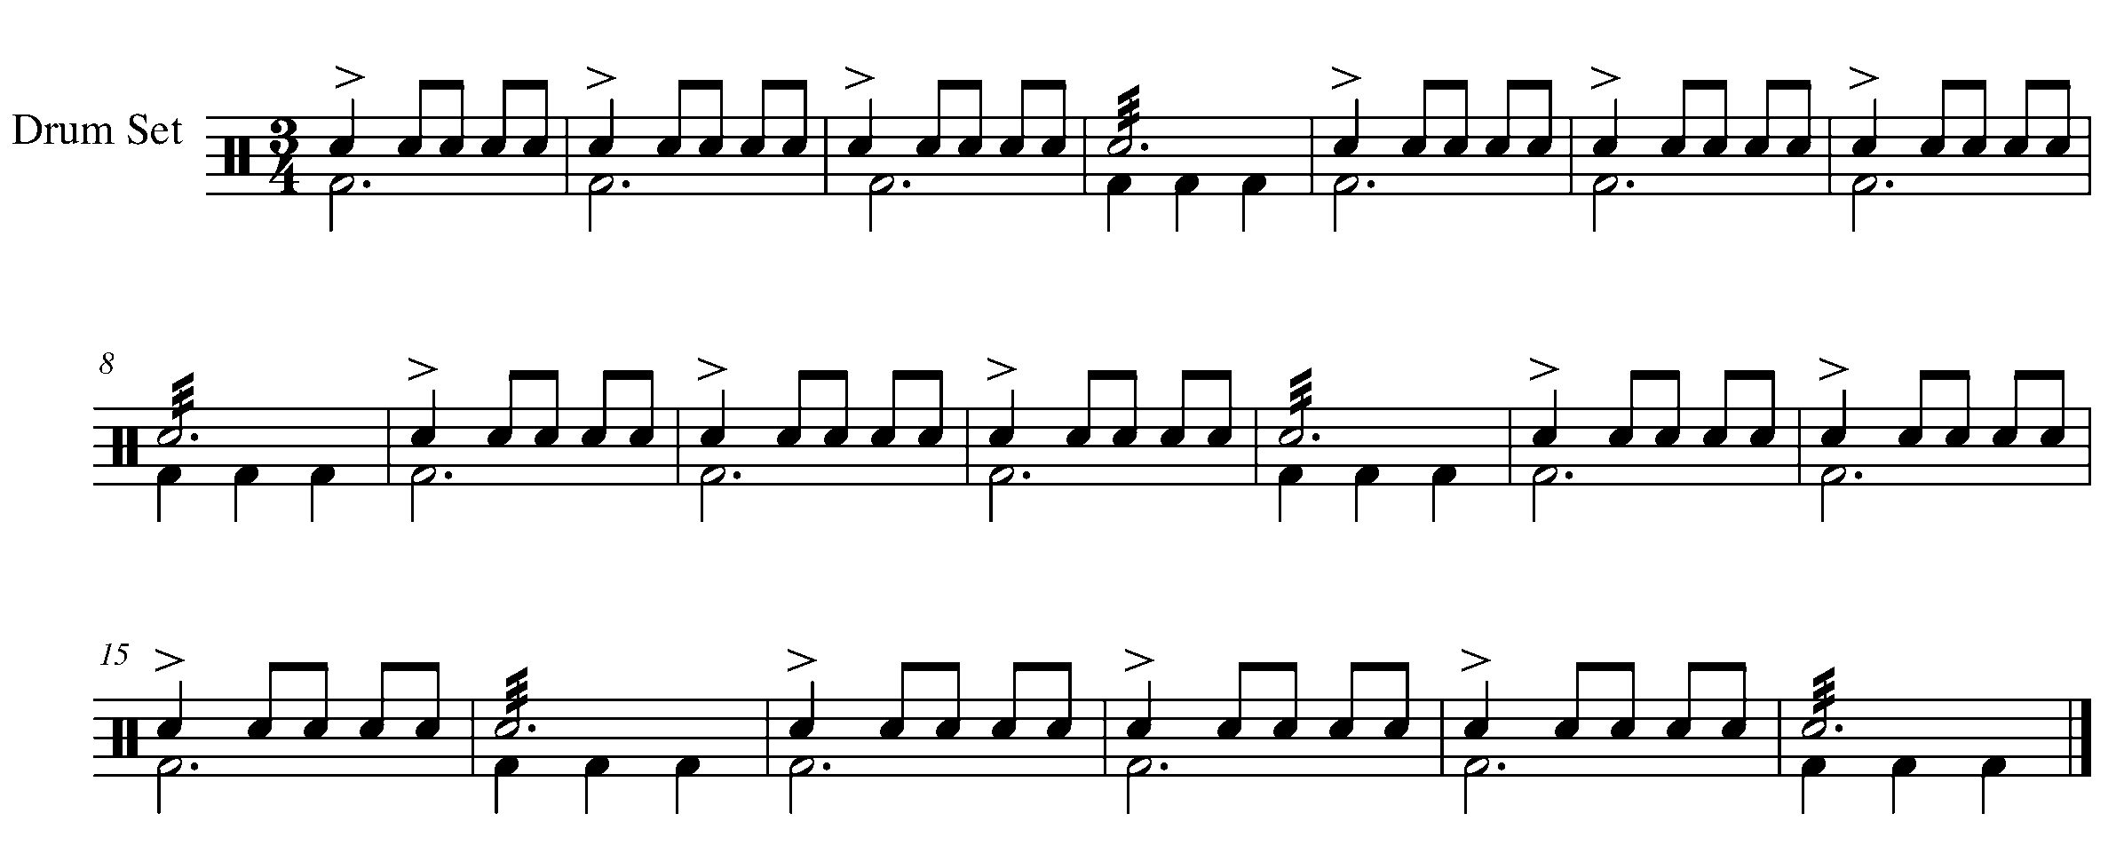
9. HURRAY, MORE SCALES! FOCUS: PITCH
Wind Instruments and Mallets

LEARNING GOAL: As you become more experienced on your instrument, you will begin to perform in a variety of key signatures. This task introduces the E-flat major scale as well as the relative C harmonic minor scale.

MINDS ON! Be aware of the new key signature – how will you remind yourself of which notes are affected by the key signature? Remember to have the sound at bottom and the top of the scale balanced.

ACTION! In order to be successful with this task, you will need to:

- Identify the notes, which are affected by the new key signature.
- Be aware of how the 7th note in the harmonic minor scale is different.
- Demonstrate the indicated articulation markings.
- Demonstrate a balance in sound from the bottom to the top of the scales.

CONSOLIDATION: In order to move to the next task, you must perform the following scales and arpeggios for your teacher and receive feedback.
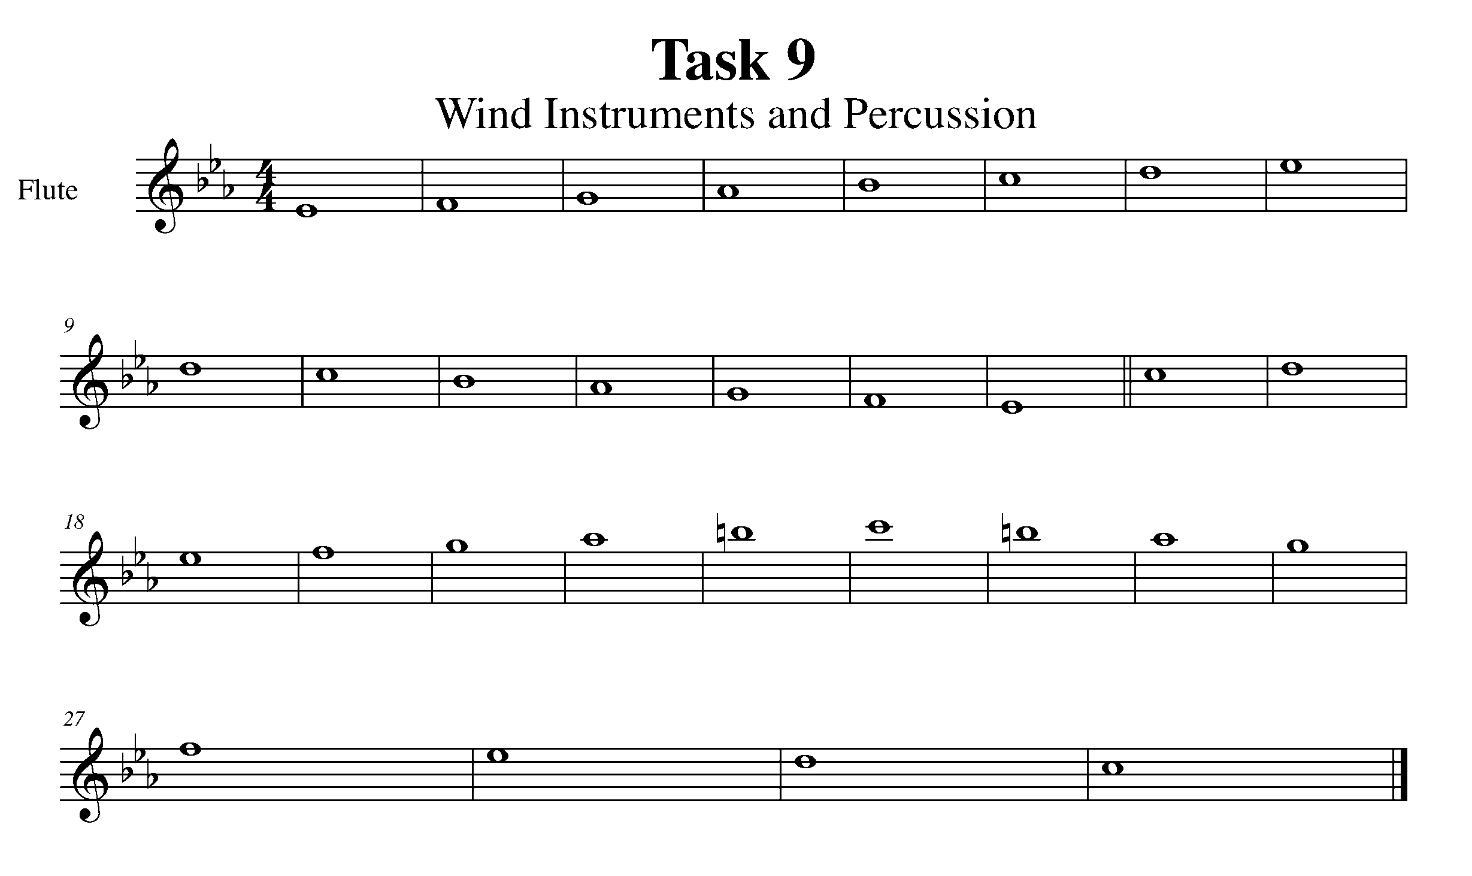

Task 9 Music Continued

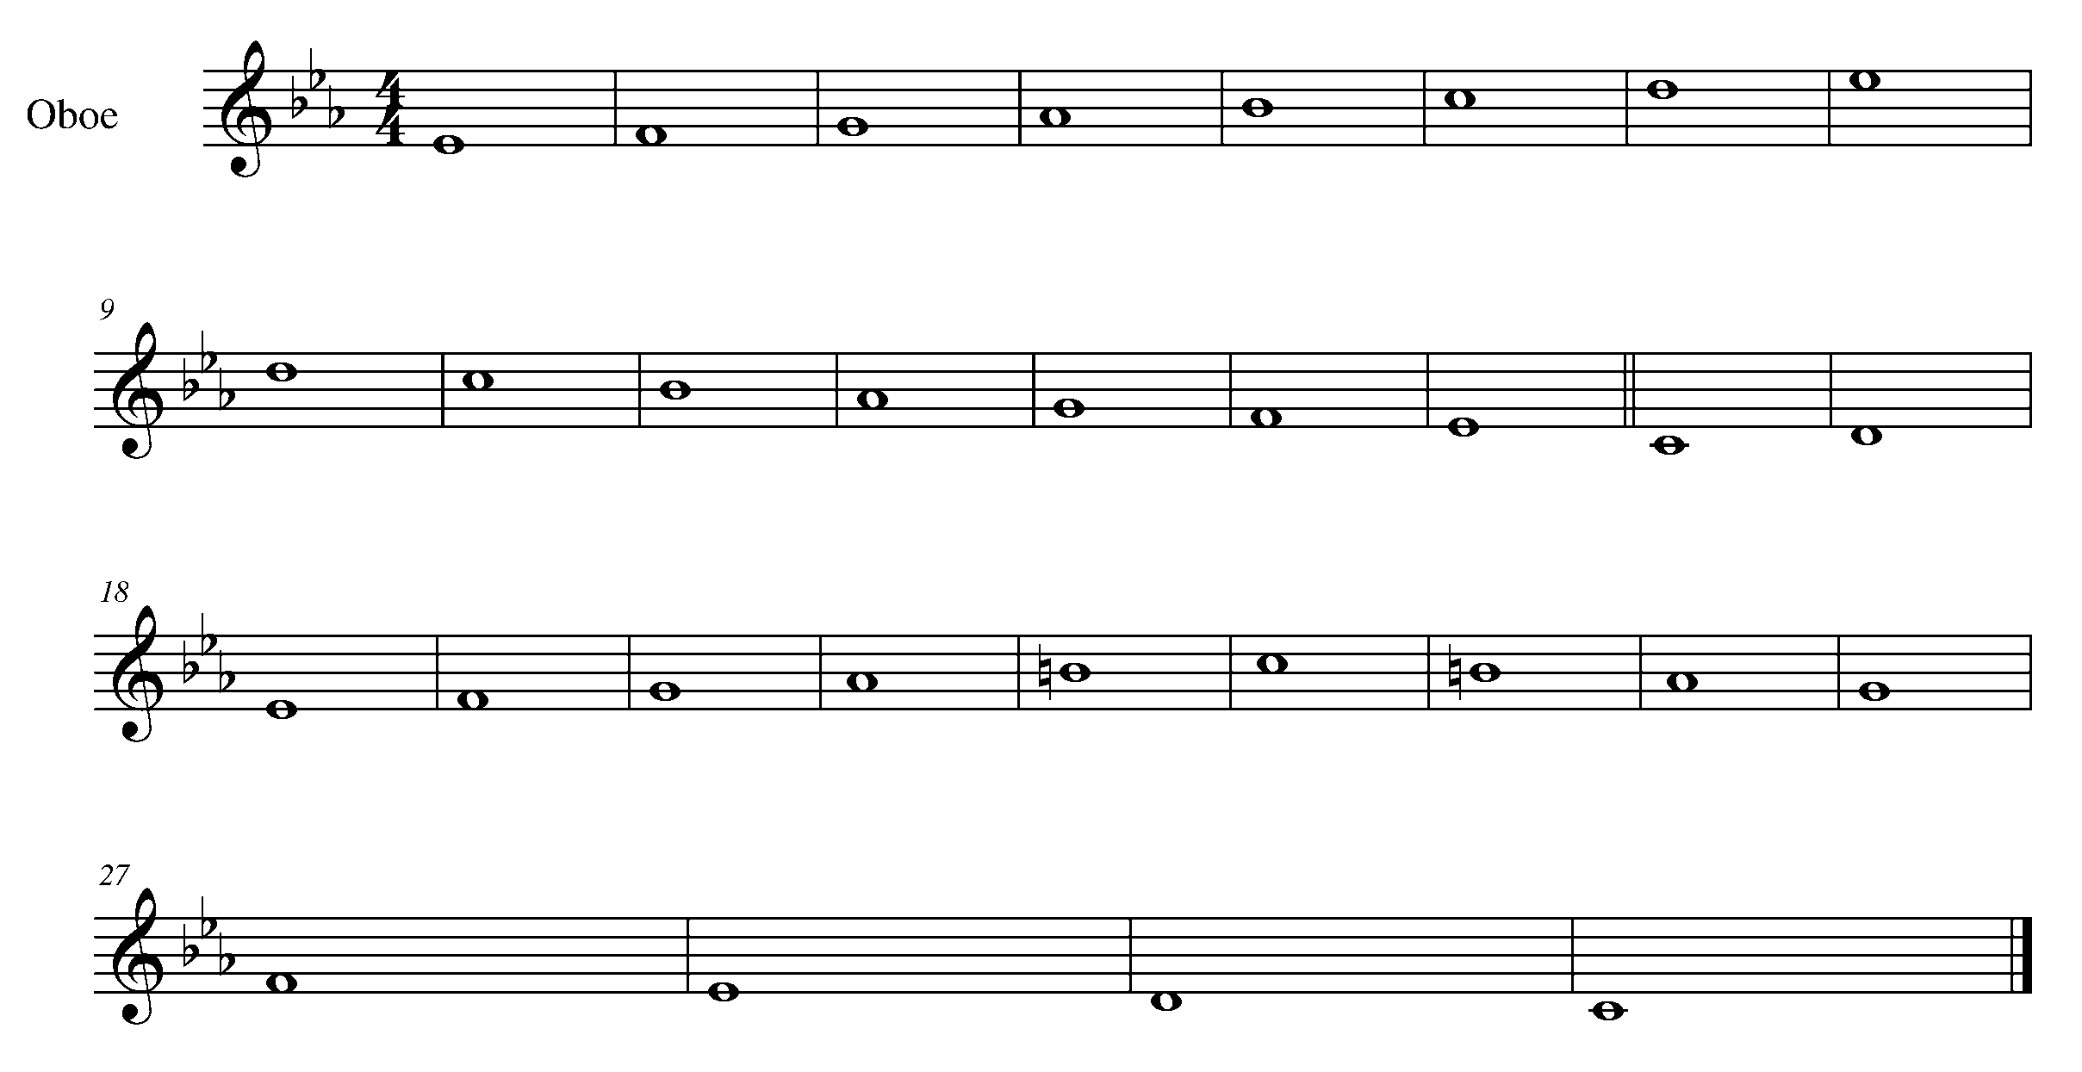

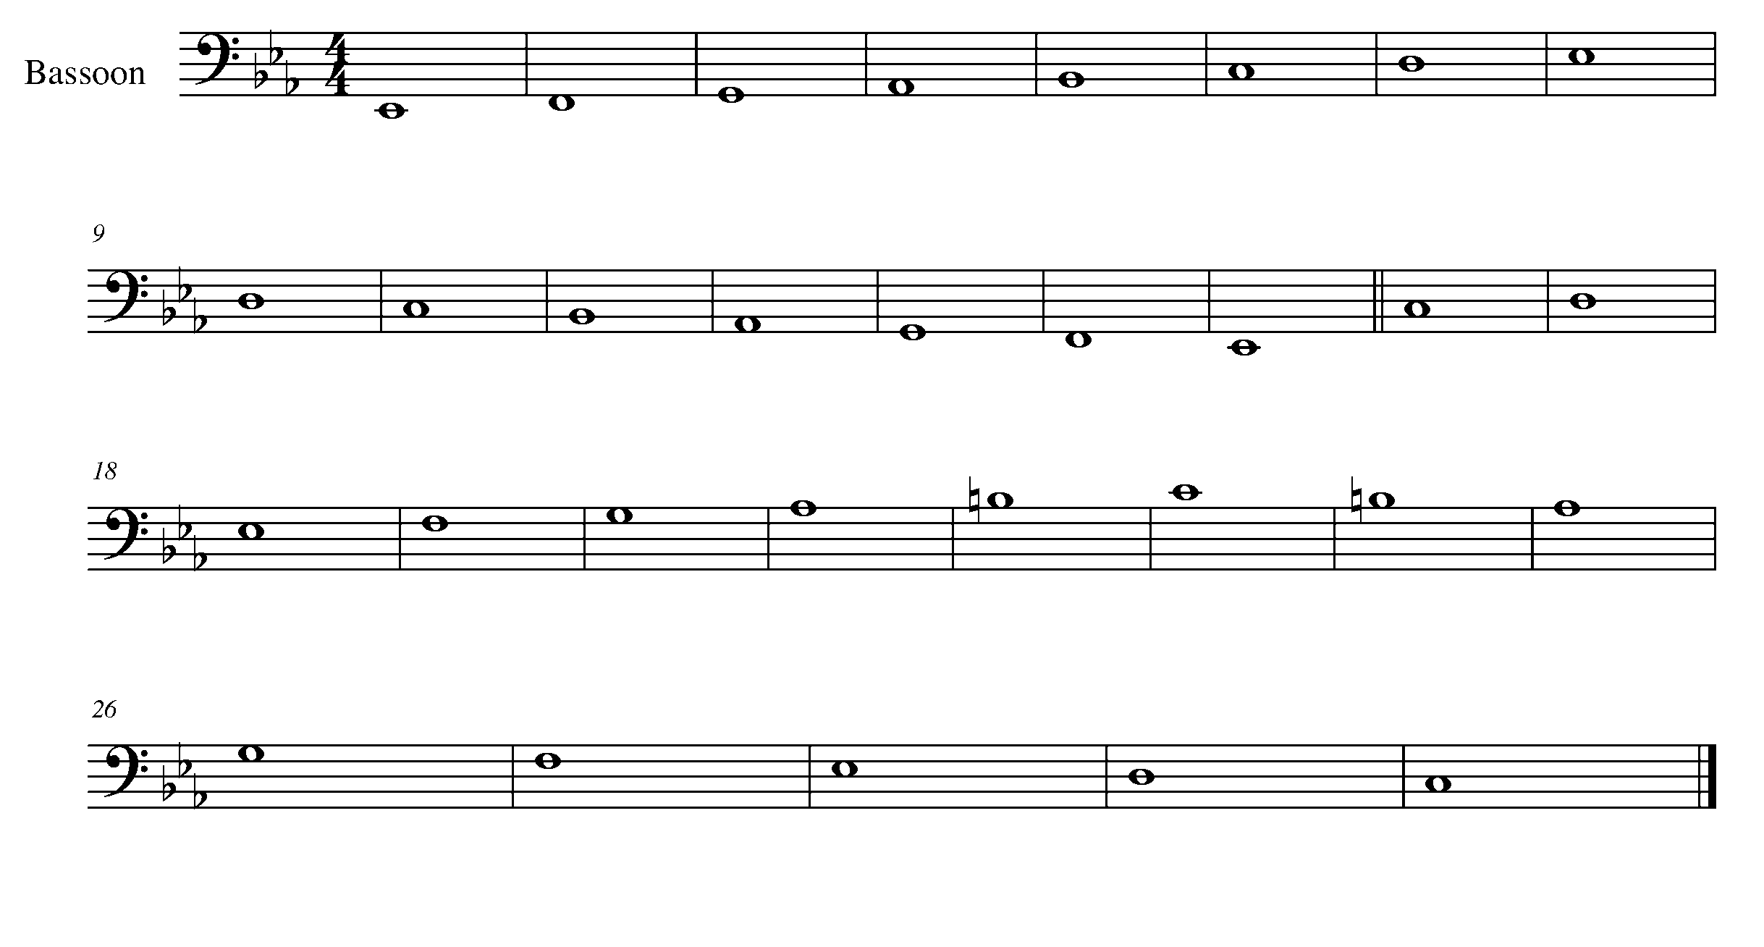

Task 9 Music Continued

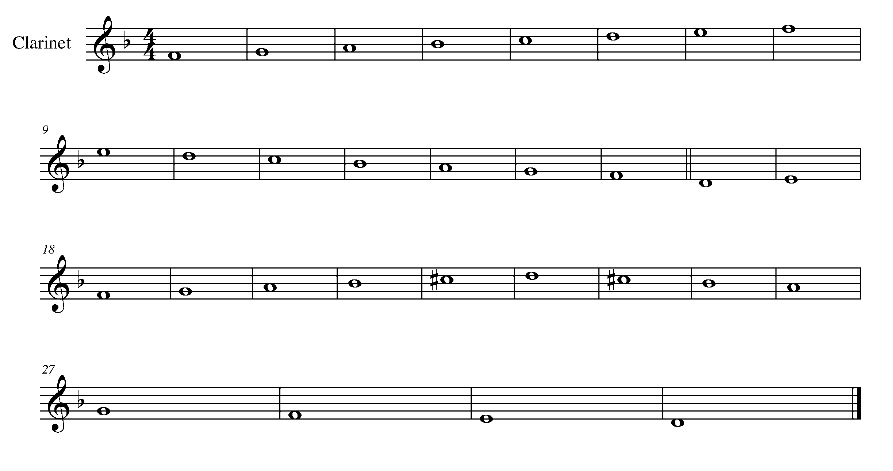

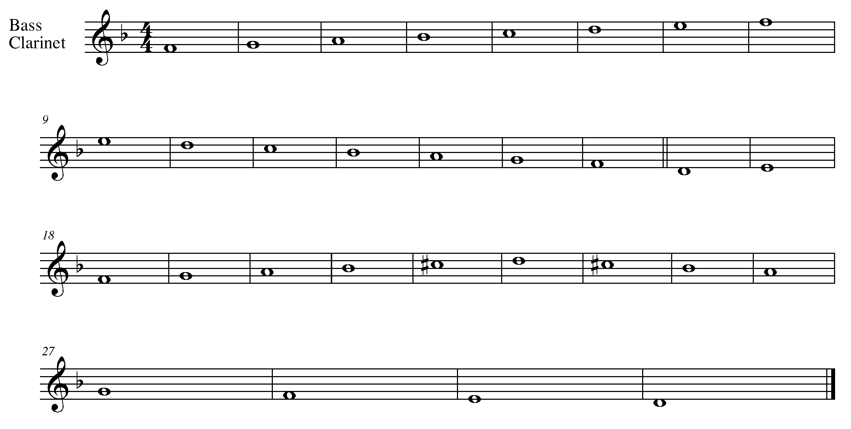

Task 9 Music Continued
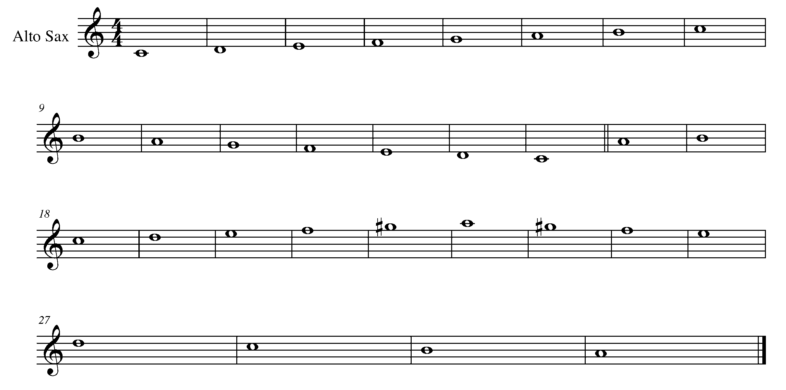

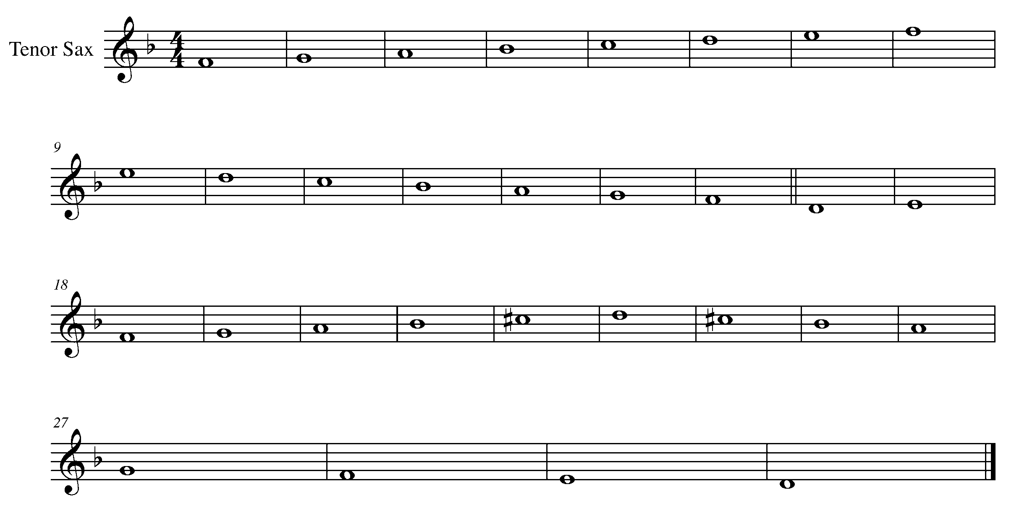

Task 9 Music Continued

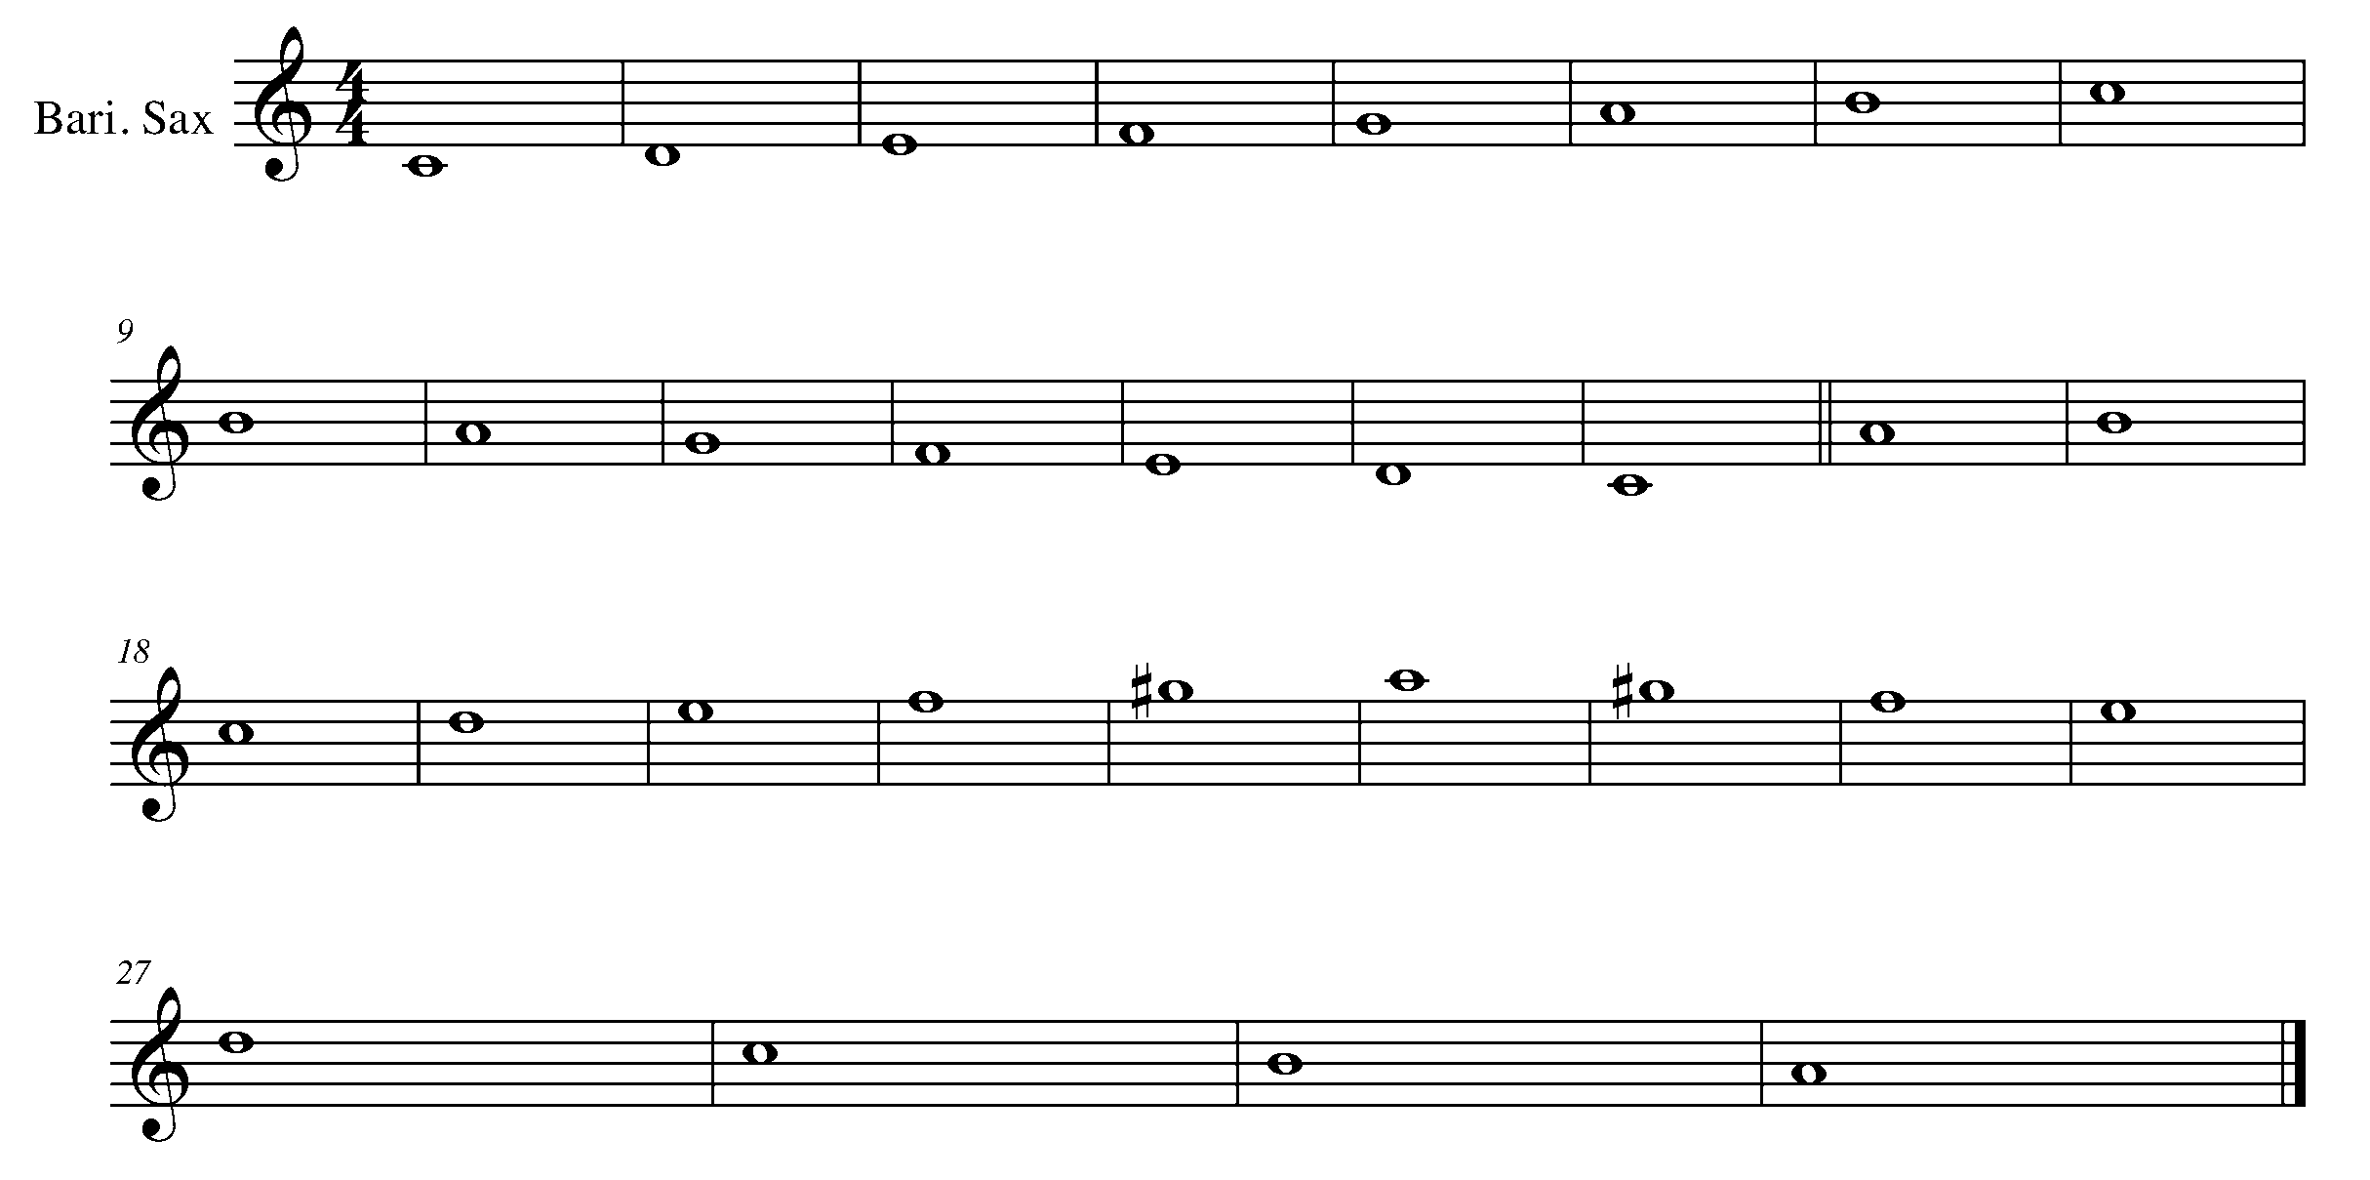

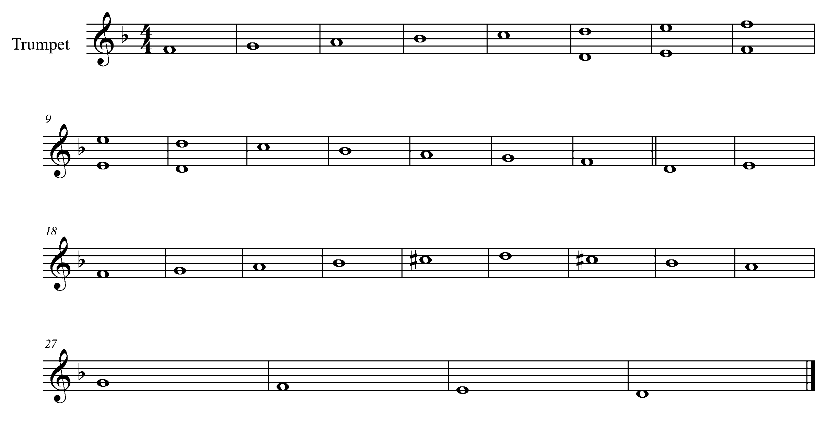

Task 9 Music Continued

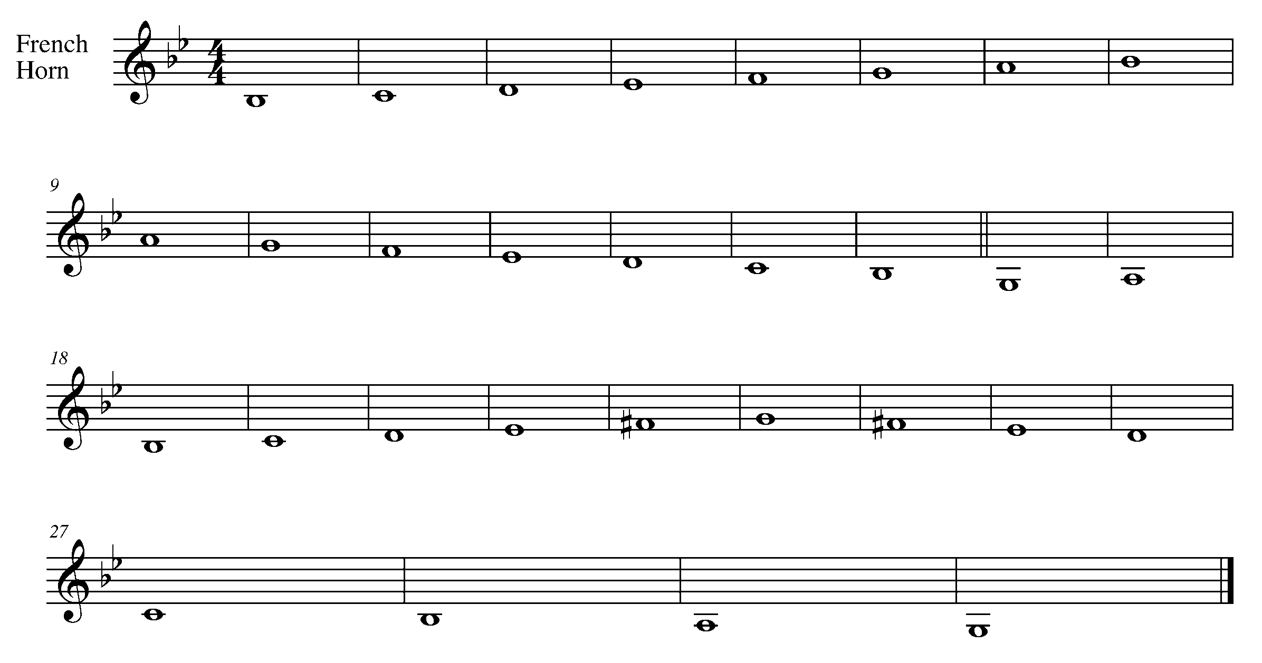

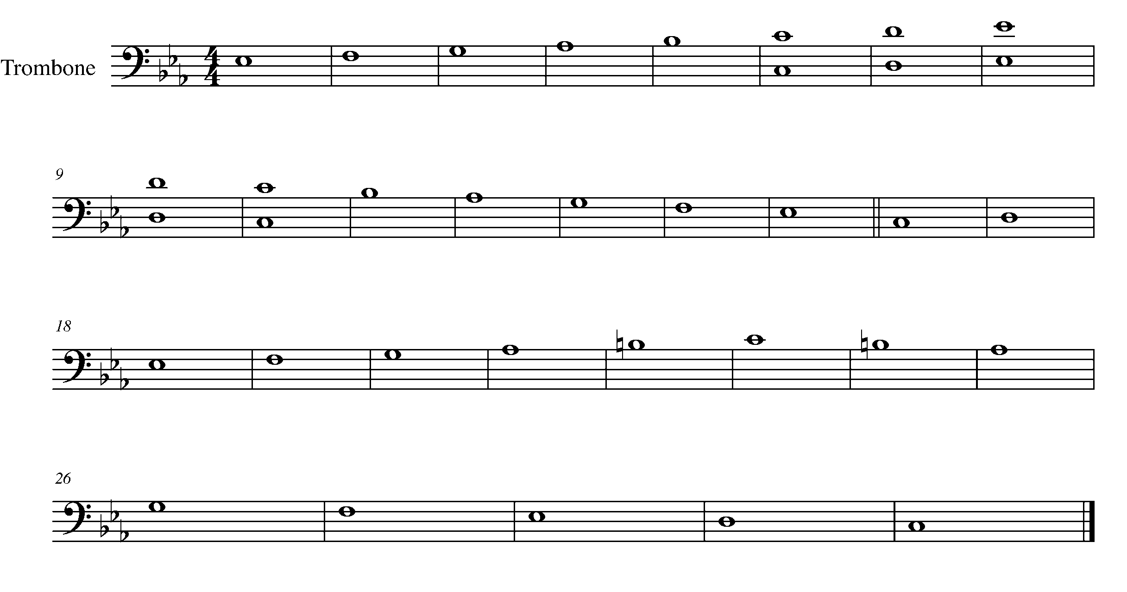

Task 9 Music Continued

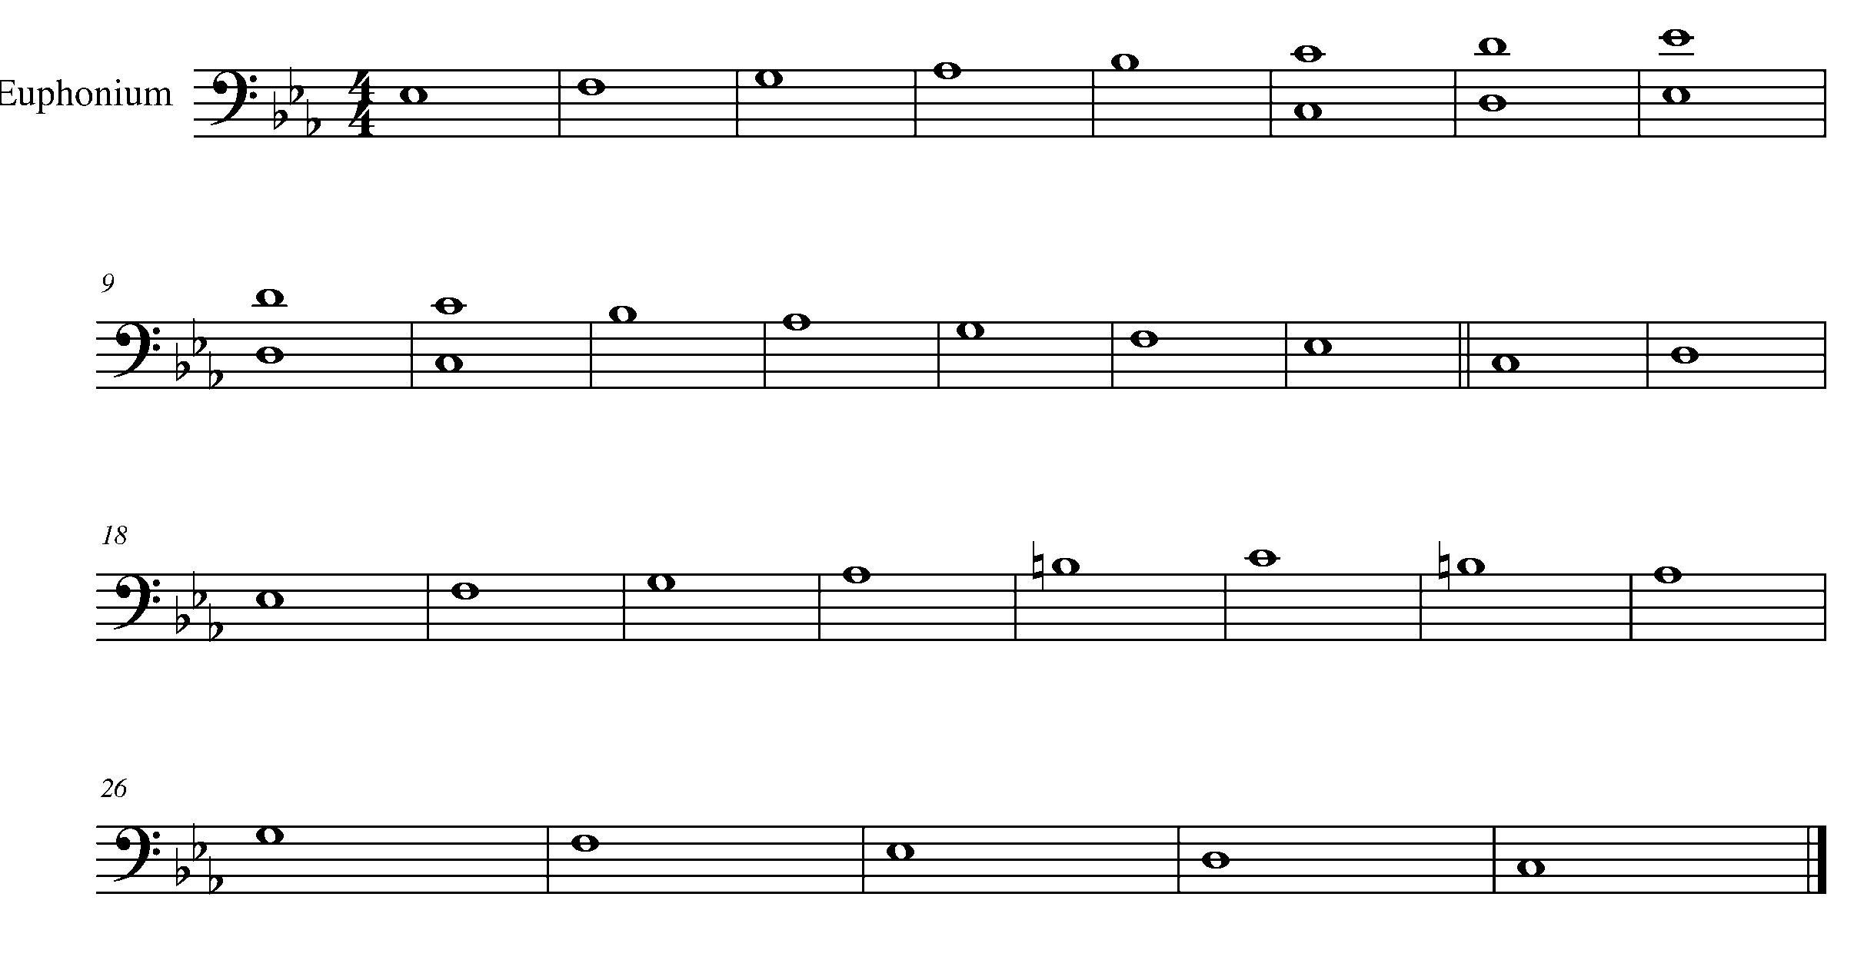

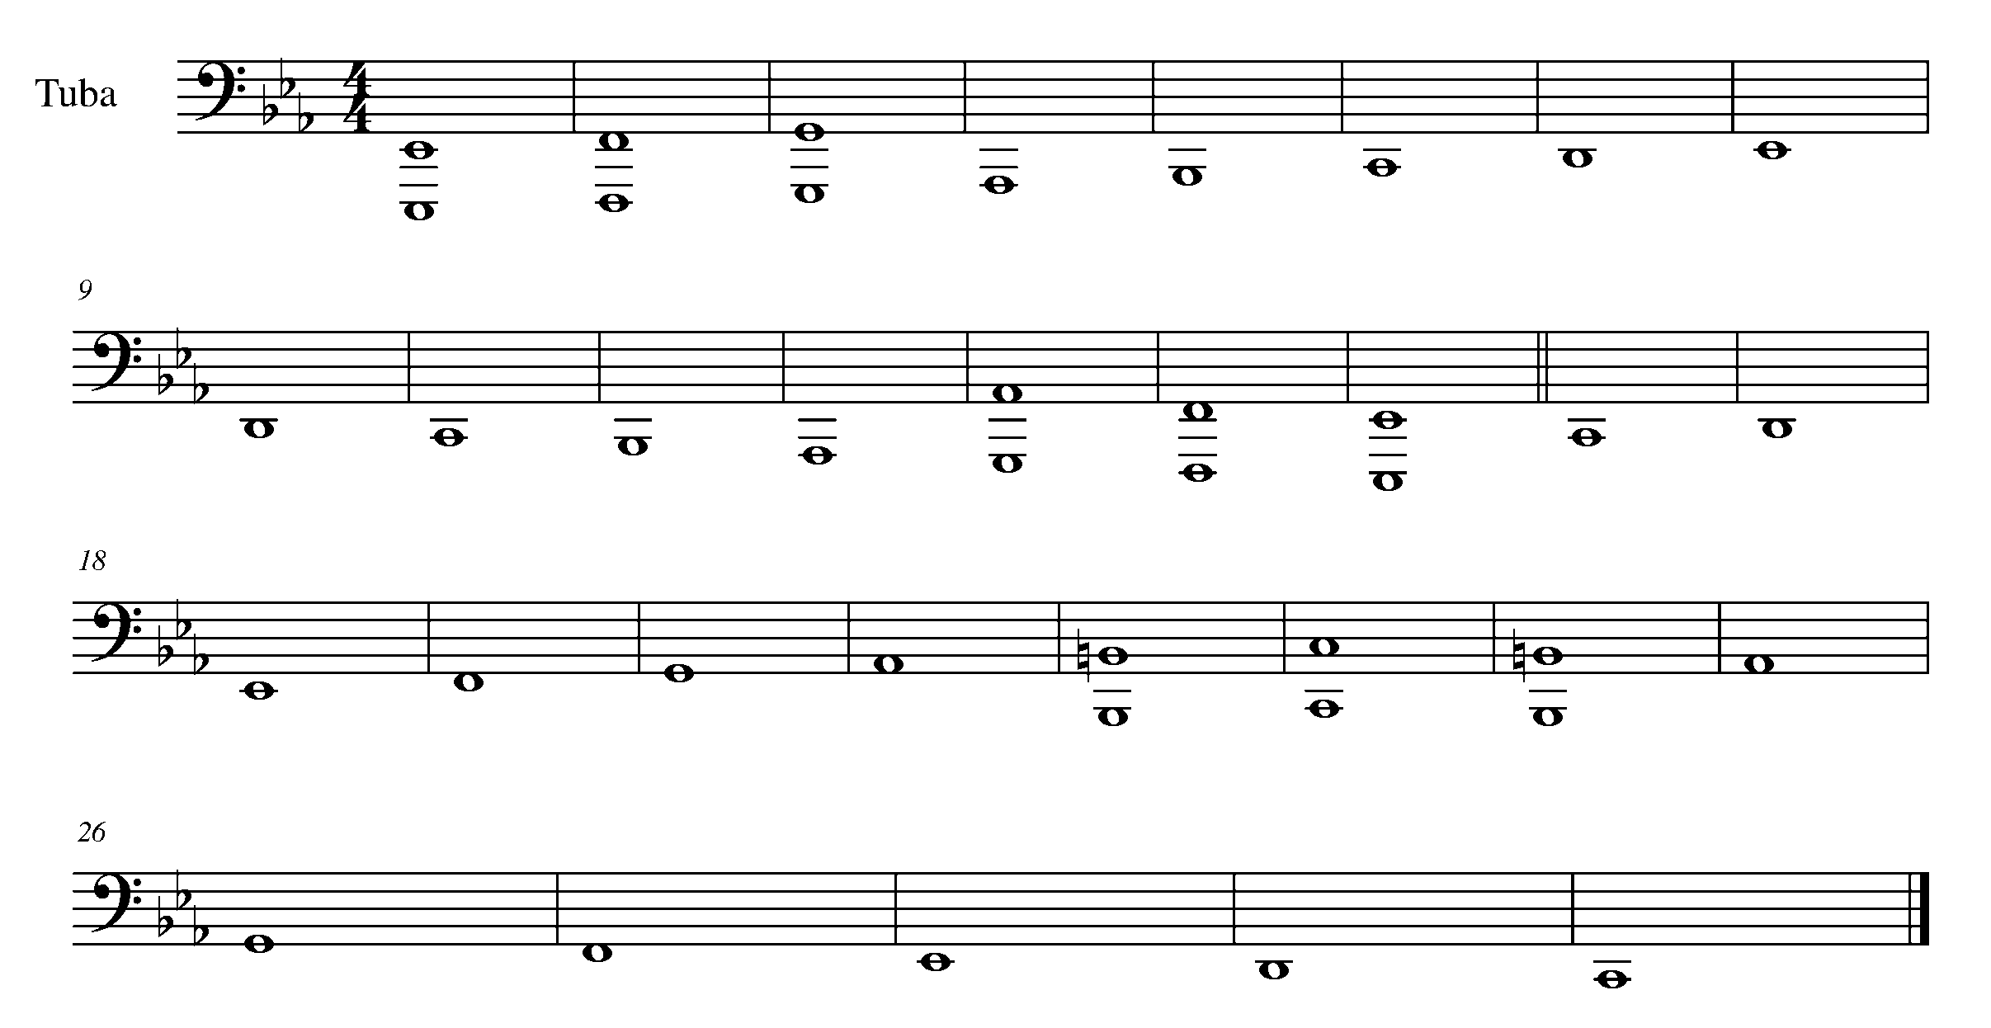

Task 9 Music Continued

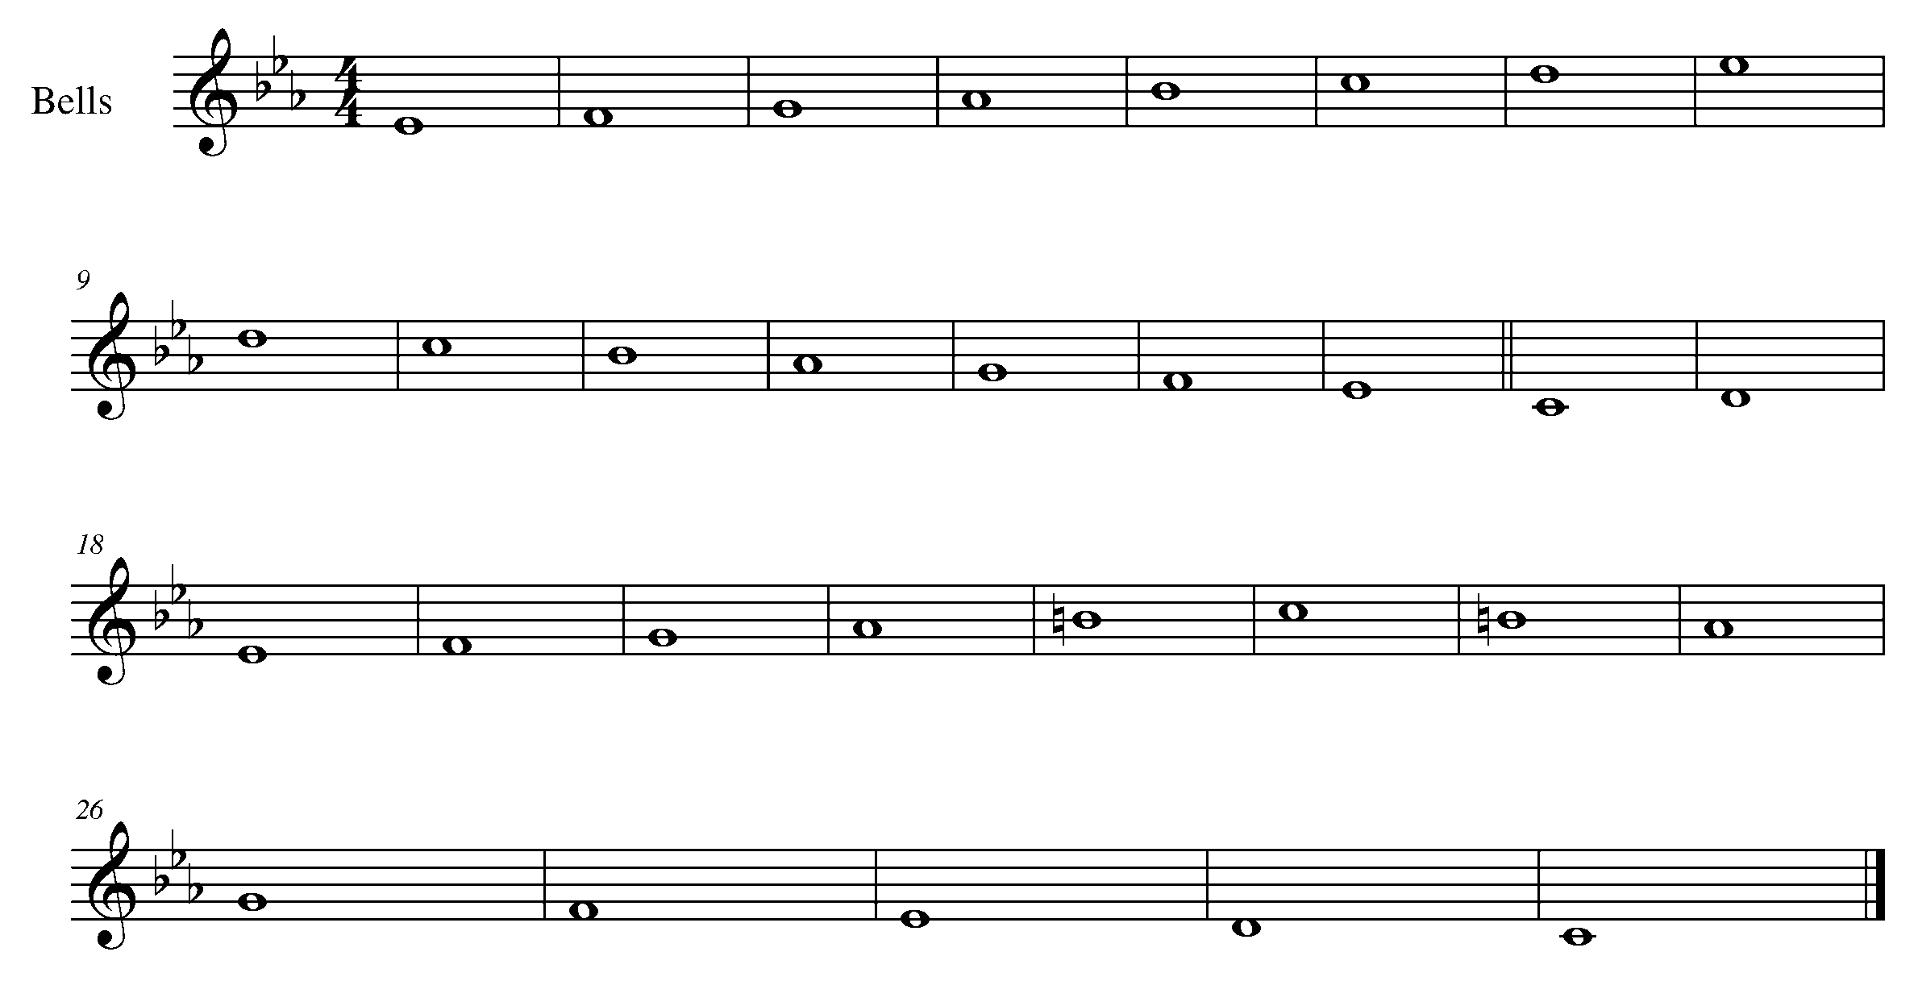

10. A “DYNAMIC” TASK! FOCUS: EXPRESSIVE CONTROLS
Wind Instruments and SD/BD/KIT

LEARNING GOAL: You are now starting to take control of your instrument. This task will teach you the muscles and air control needed to demonstrate a variety of dynamics.

MINDS ON! How do your muscles help you support your sound and airflow? Why is this muscular support crucial to dynamic control and a consistent sound? The word “gradual” is very important to the definition of crescendo and decrescendo – how do you increase and decrease your dynamic level in a gradual way without losing your sound and affecting your intonation?

ACTION! In order to be successful with this task, you will need to:

- Take in a supported breath.
- Practice playing one note at a variety of different dynamic levels.
- Practice playing one note with a crescendo and decrescendo.
- Identify the different dynamic markings in the piece below.
- Apply your knowledge of how to control and perform a variety of dynamics in the piece below.

CONSOLIDATION: In order to move to the next task, you must perform the following piece for your teacher and receive feedback.

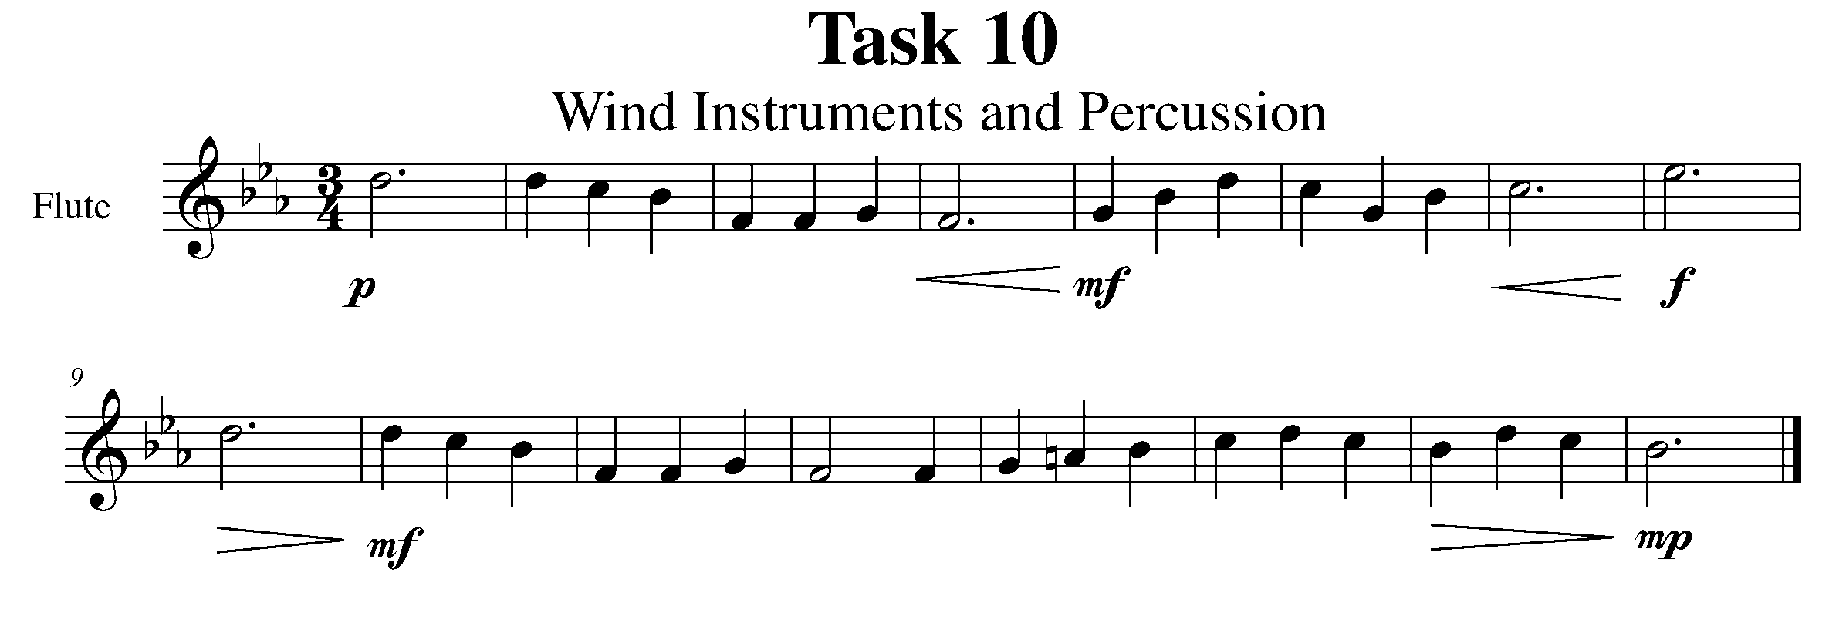
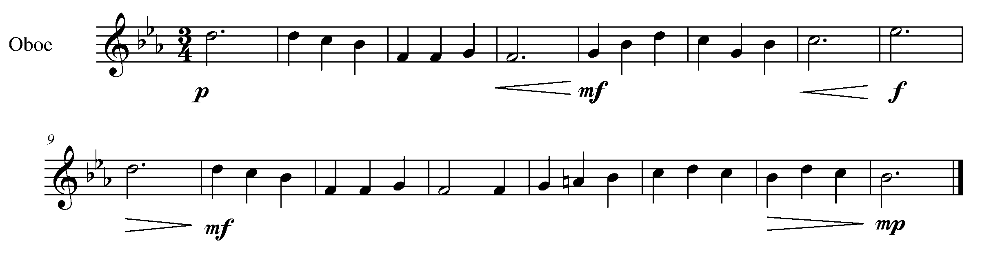

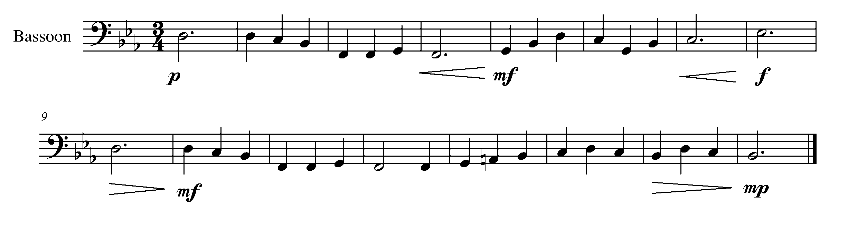
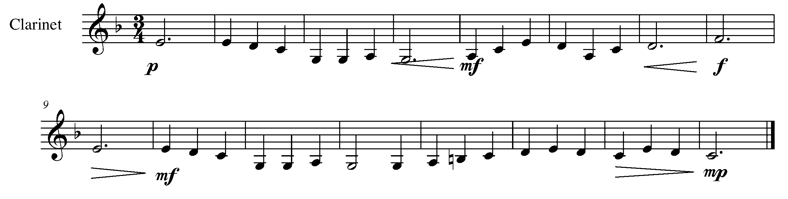
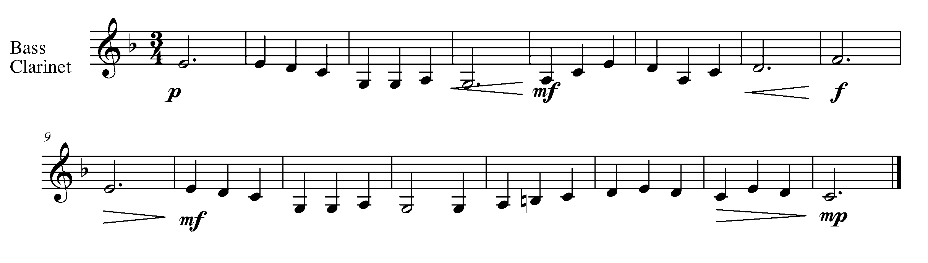
Task 10 Music Continued
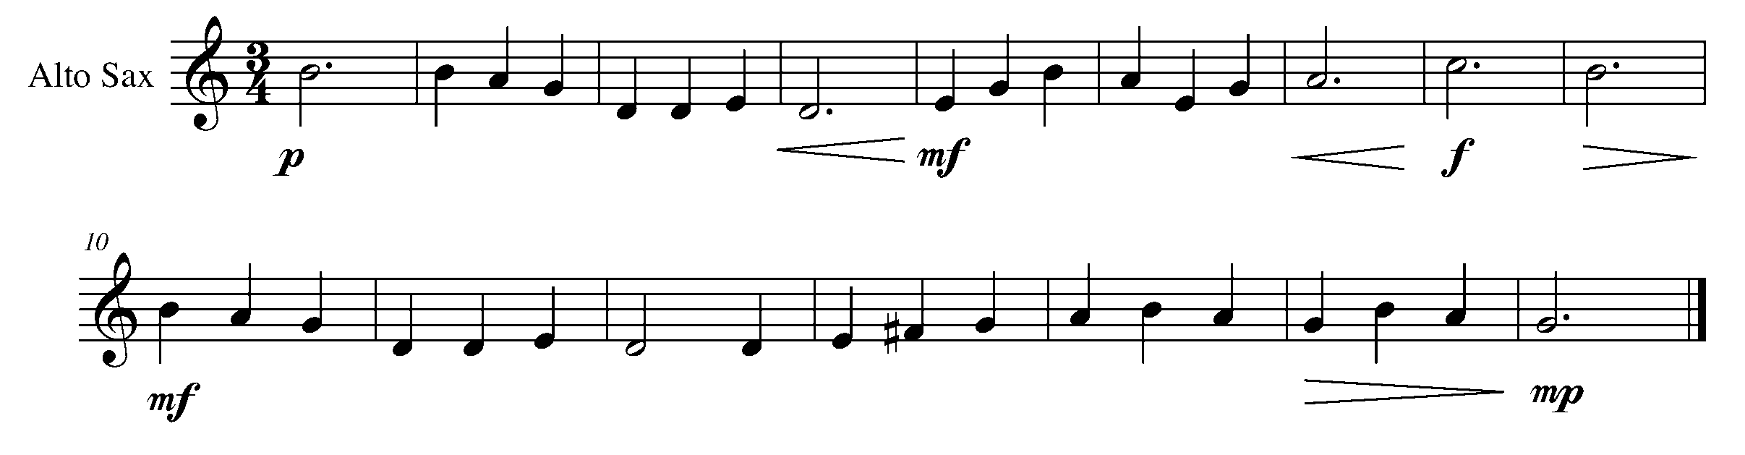
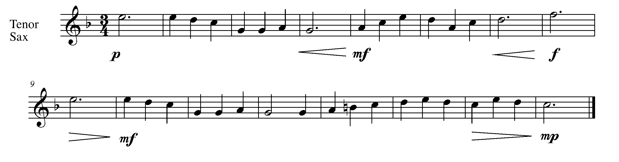
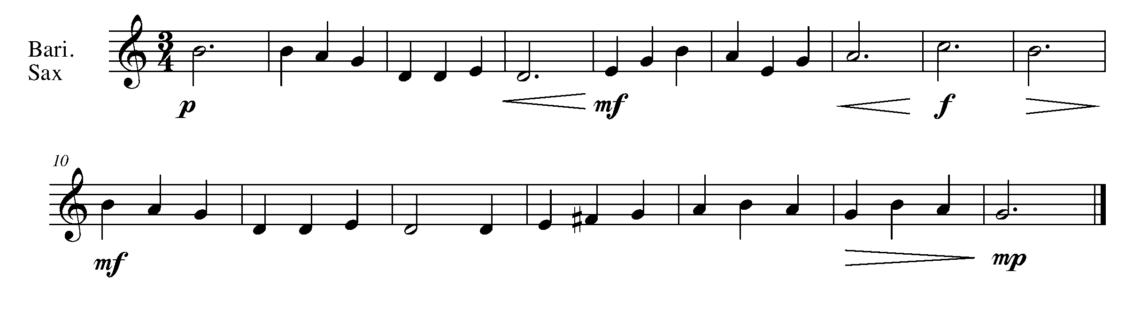
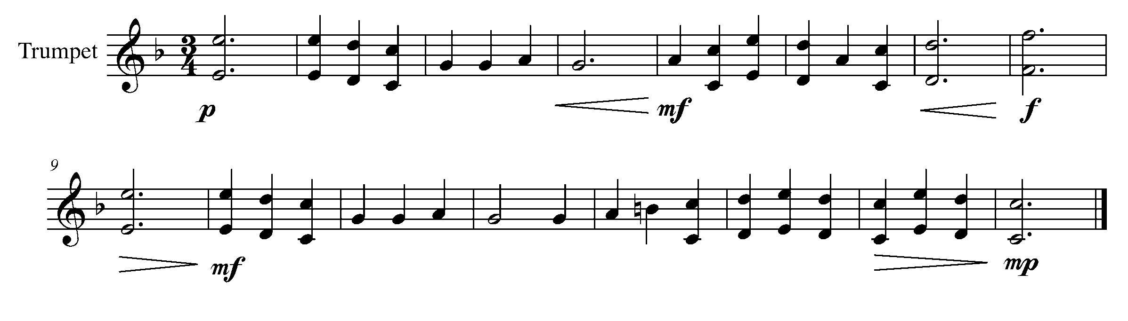
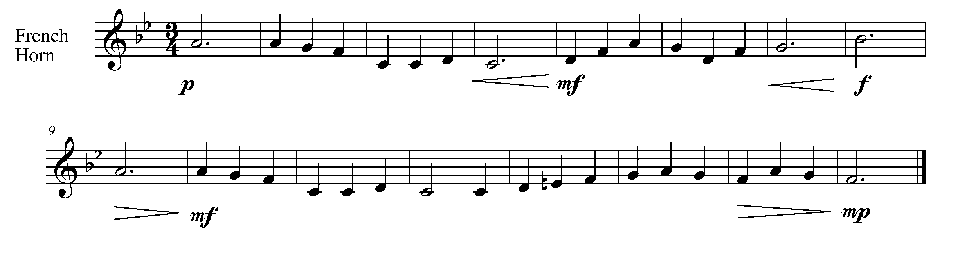

Task 10 Music Continued
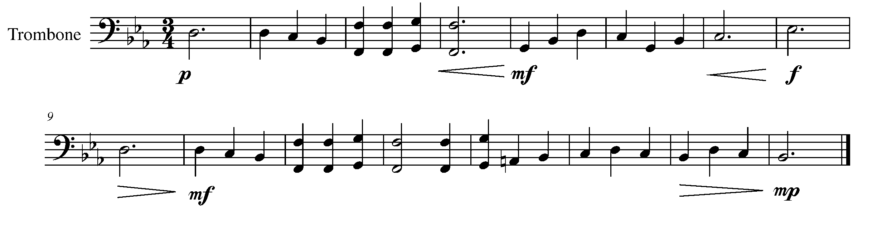
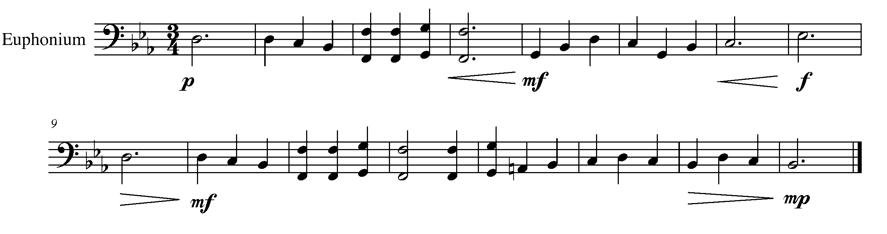
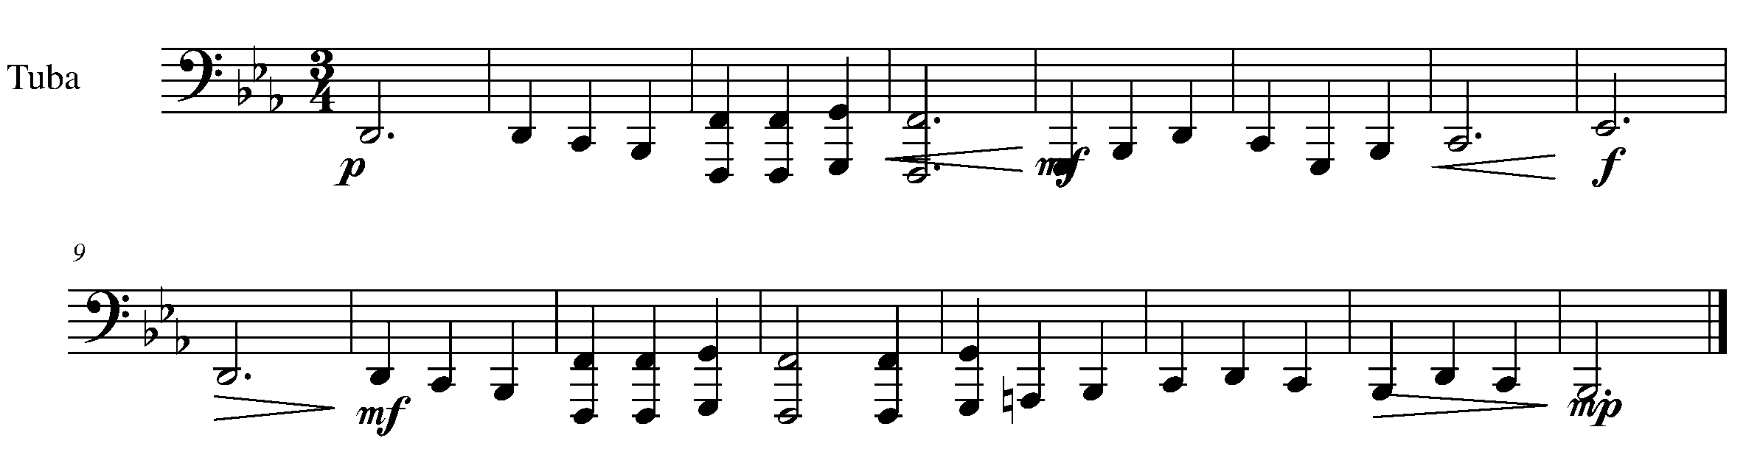
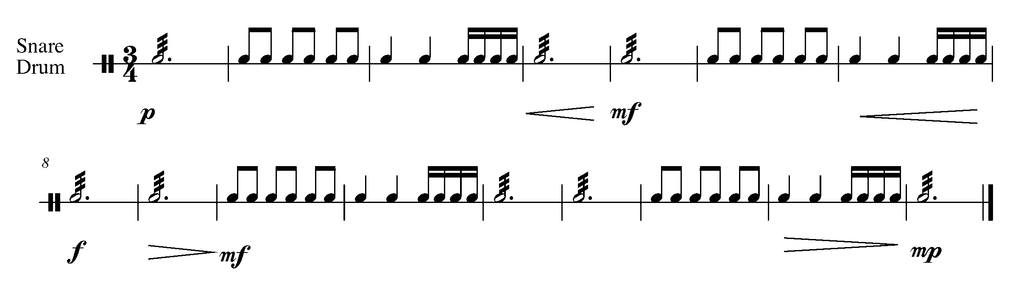
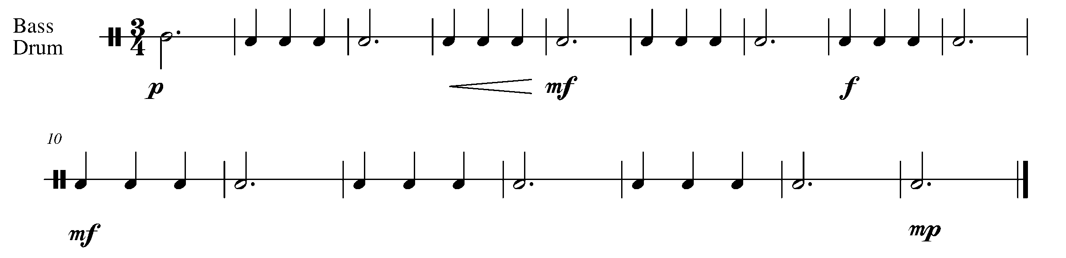

Task 10 Music Continued
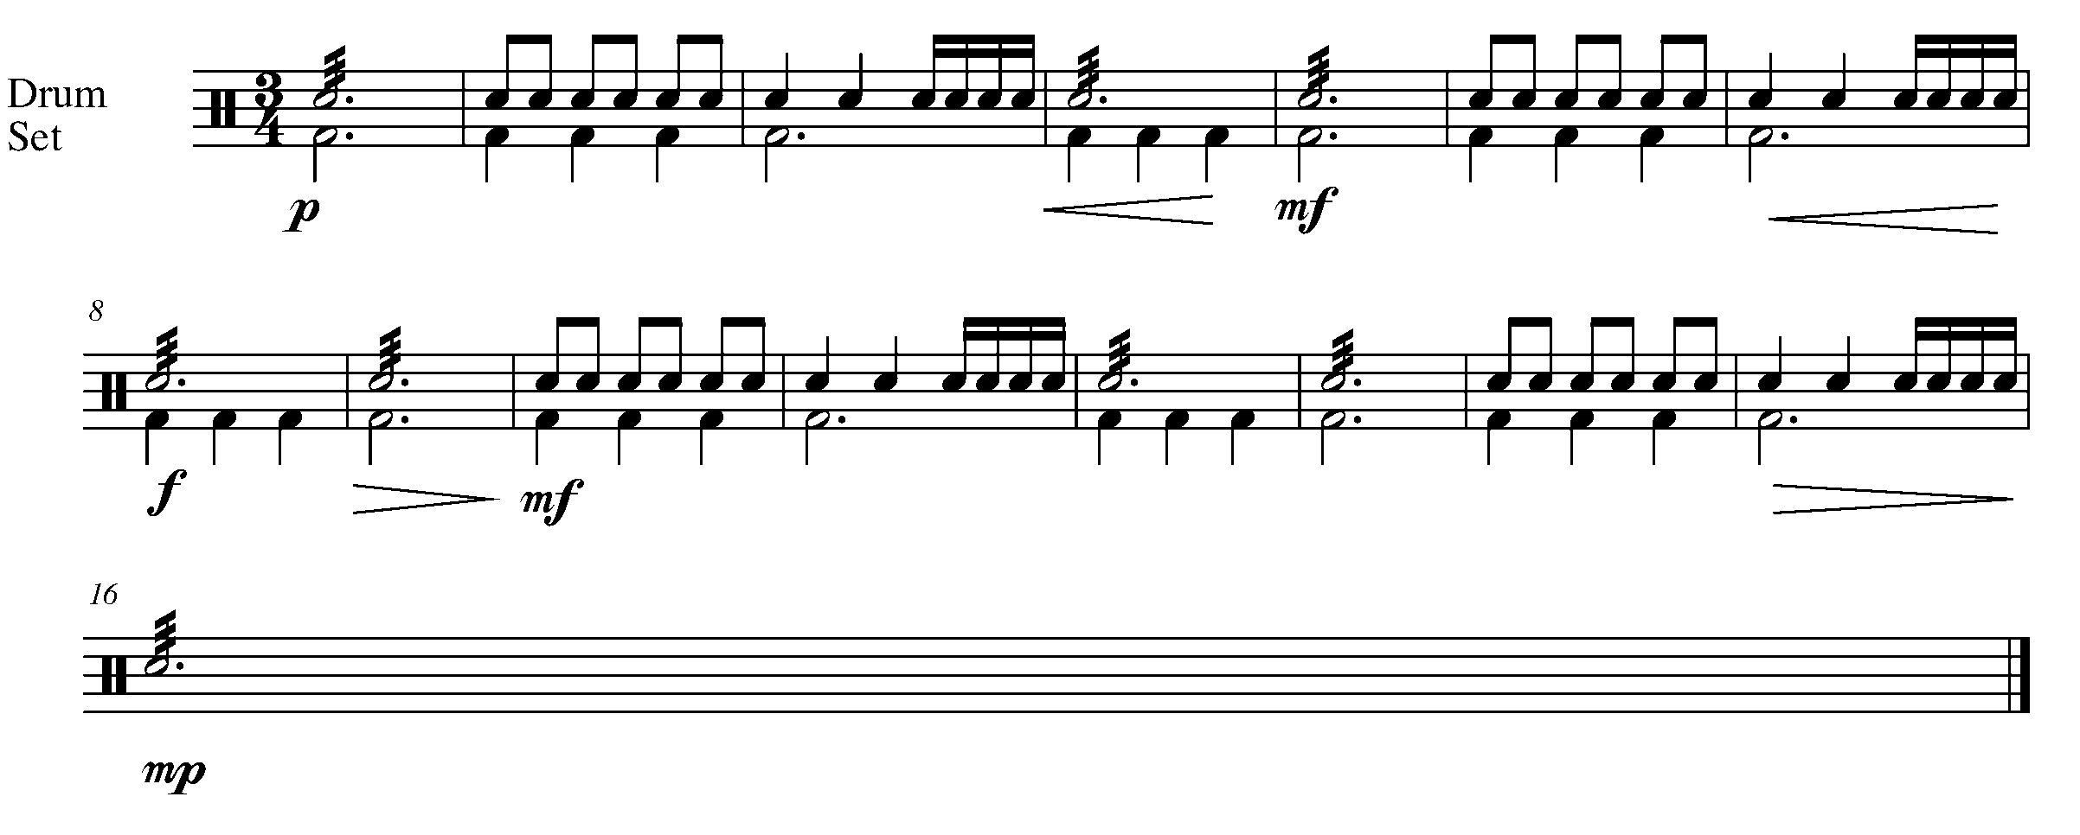

YOU HAVE REACHED THE SECOND GPS MARKER – EAST!
YOU’RE HALFWAY TO YOUR FINAL DESTINATION.

CELEBRATE BY FILLING IN YOUR TASK TRACKER!

11. YOU’VE GOT RHYTHM! FOCUS: RHYTHM
Wind Instruments and SD/BD/KIT

LEARNING GOAL: The dotted quarter note followed by an eighth note is a common combination. The purpose of the task is to solidify your understanding of notes that land on the “and” of a beat.

MINDS ON! How do you count a bar, especially when you are placing an eighth note on the off beat? Consider counting the beats out loud while clapping the rhythm to “Auld Lang Sine”.

ACTION! In order to be successful with this task, you will need to:

- Think through the rhythmic placement of all the notes below.
- Demonstrate a consistent airflow and good posture.

TASK 11 MUSIC FOUND ON THE NEXT PAGE

CONSOLIDATION: In order to move to the next task, you must perform the following piece for your teacher and receive feedback.

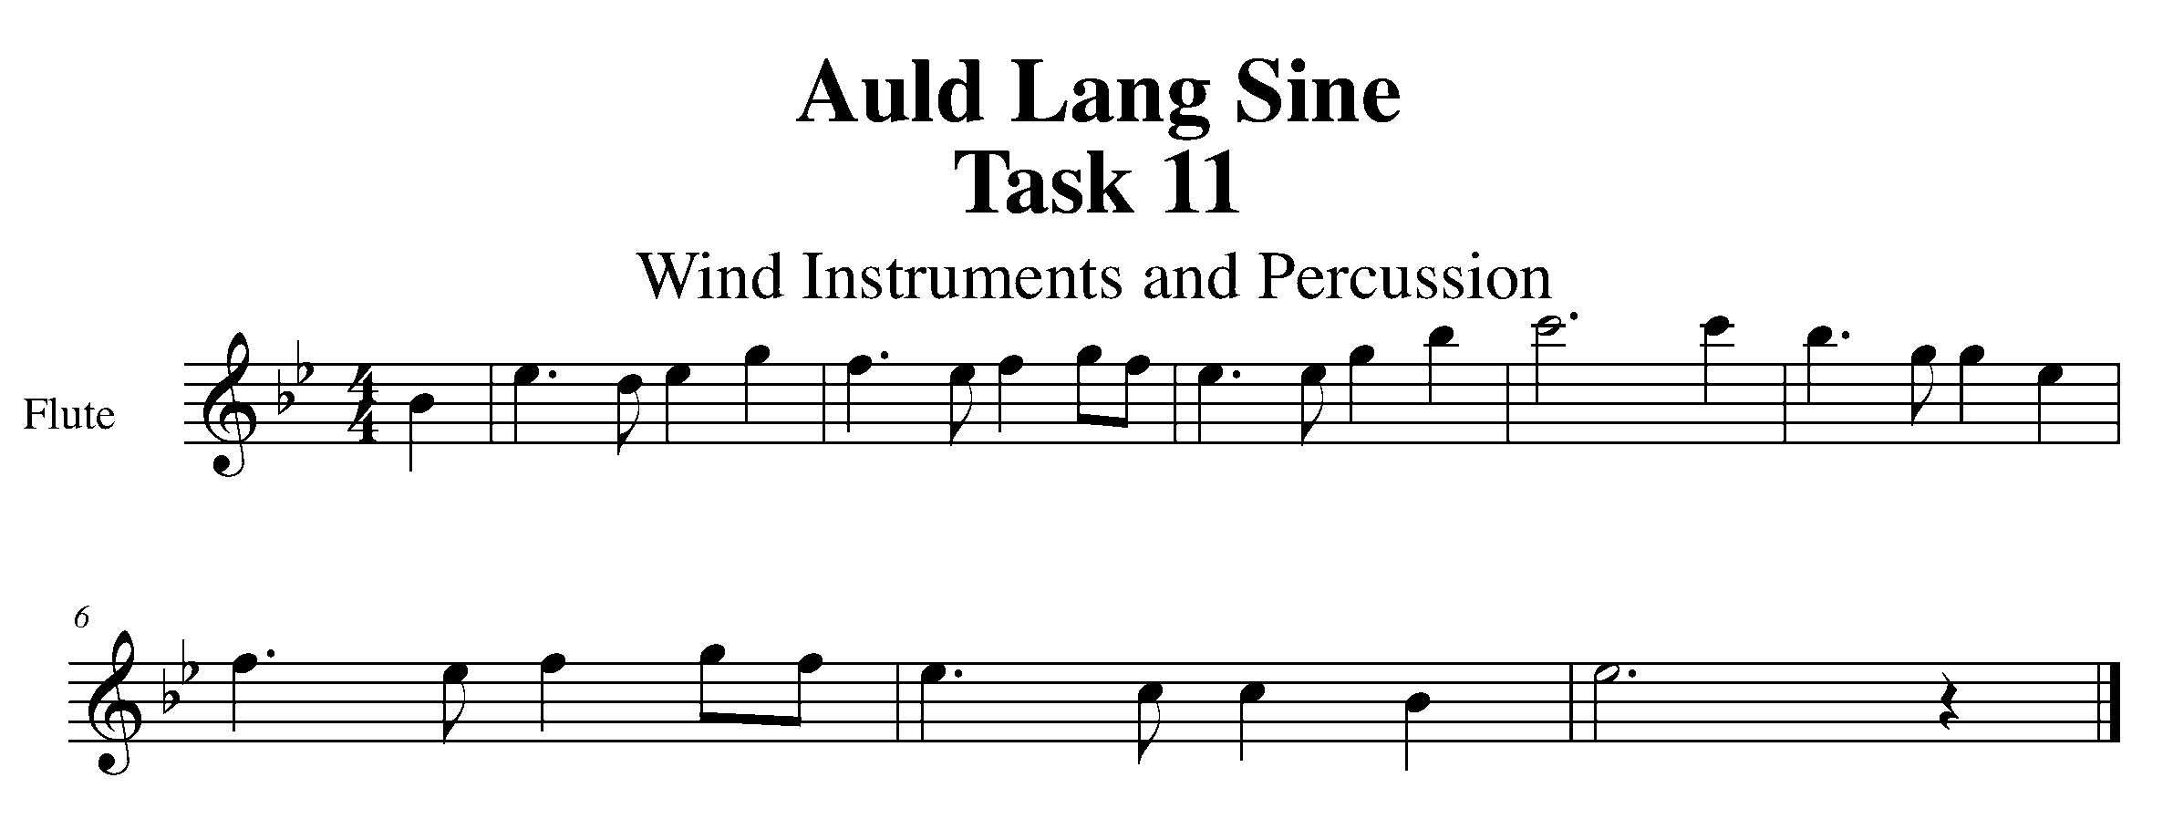
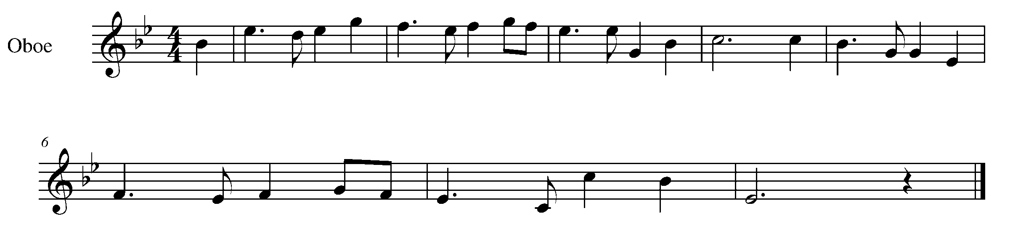
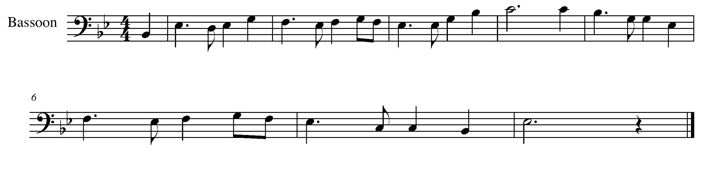
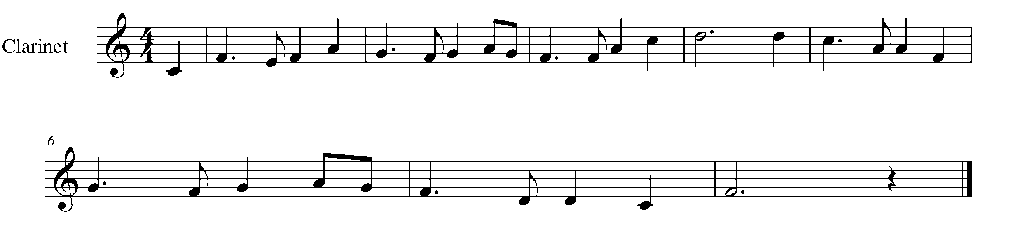

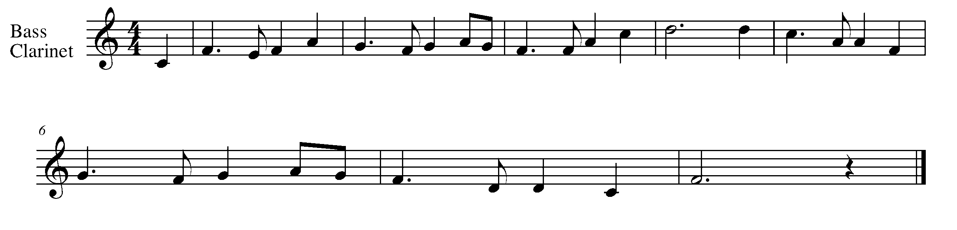

Task 11 Music Continued
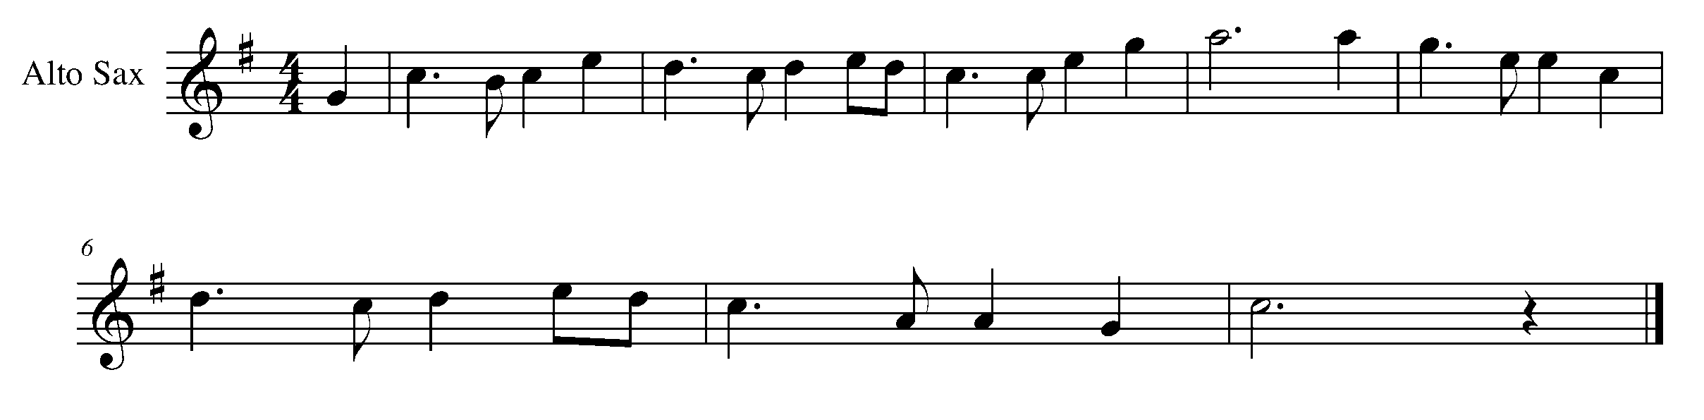
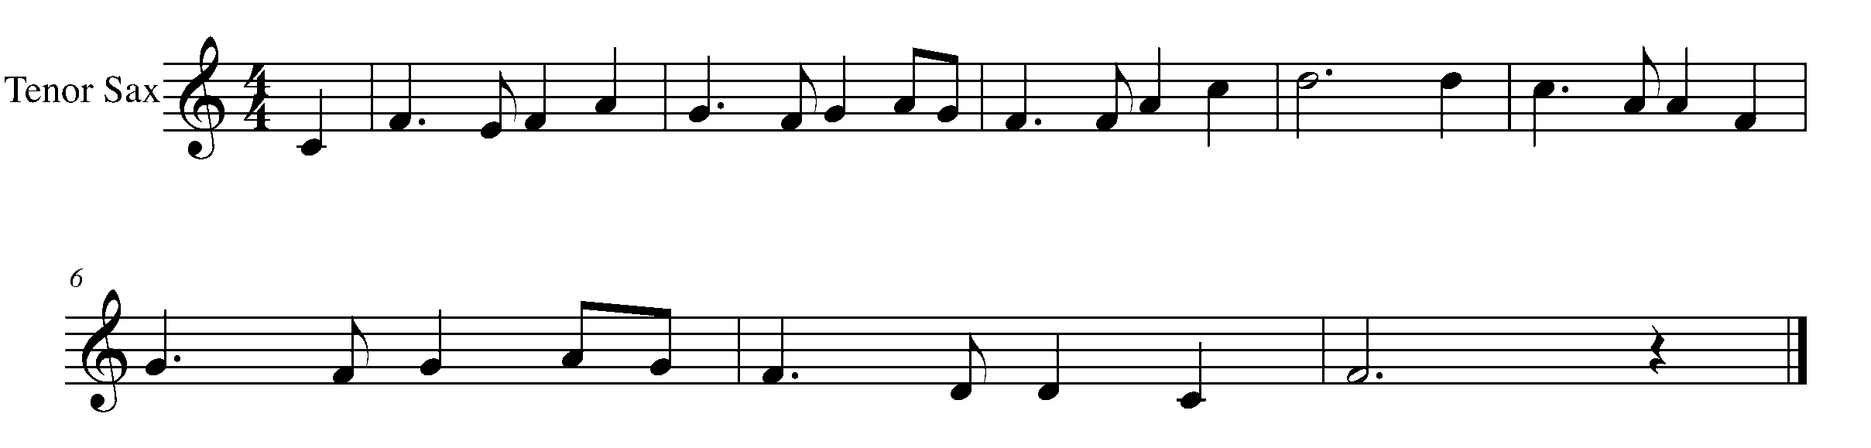
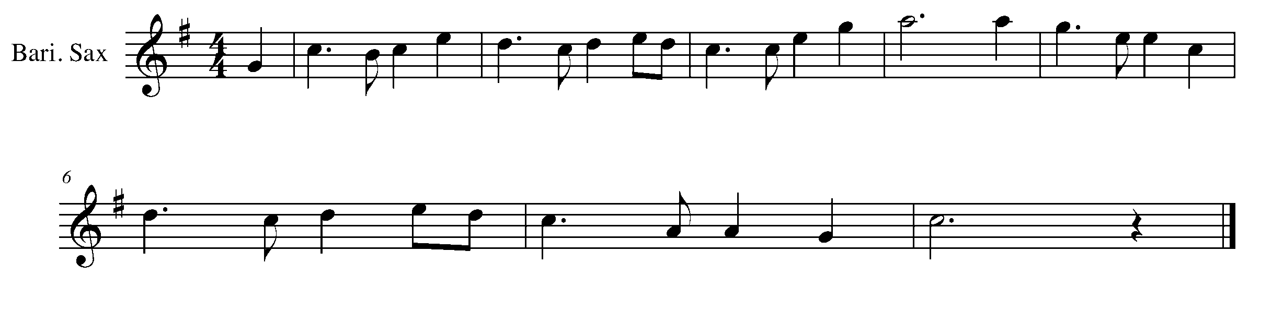
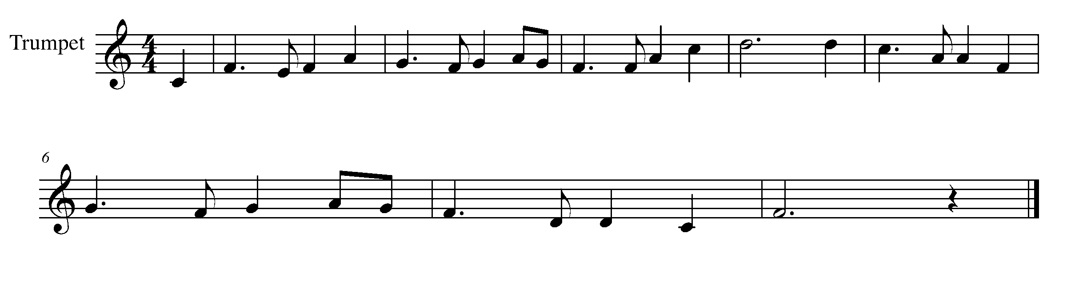
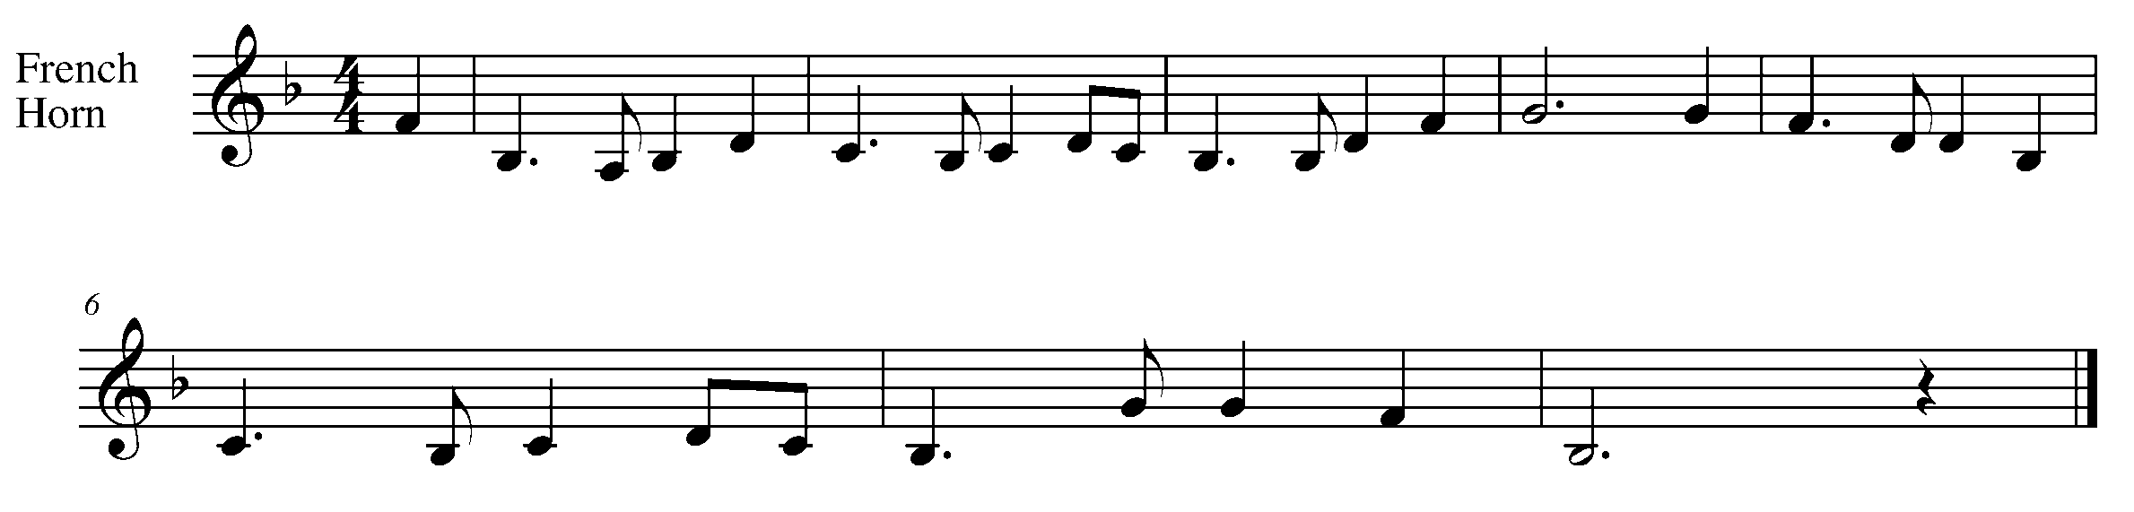

Task 11 Music Continued
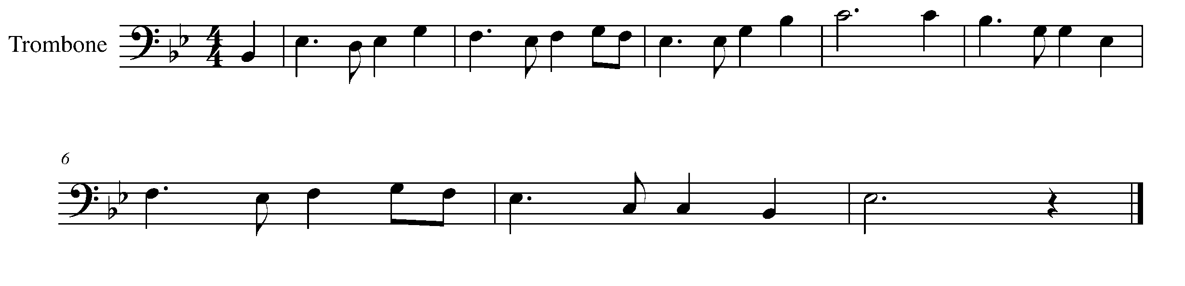
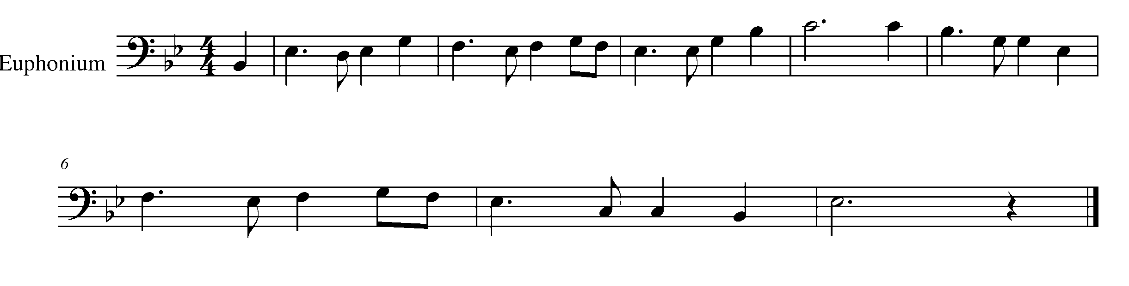
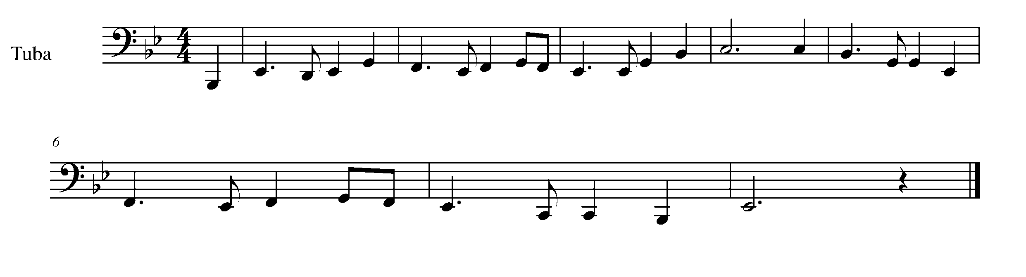
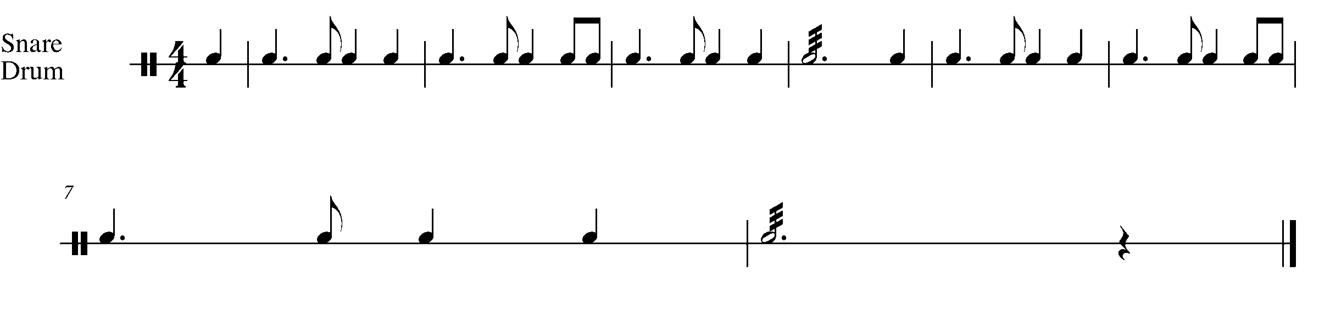
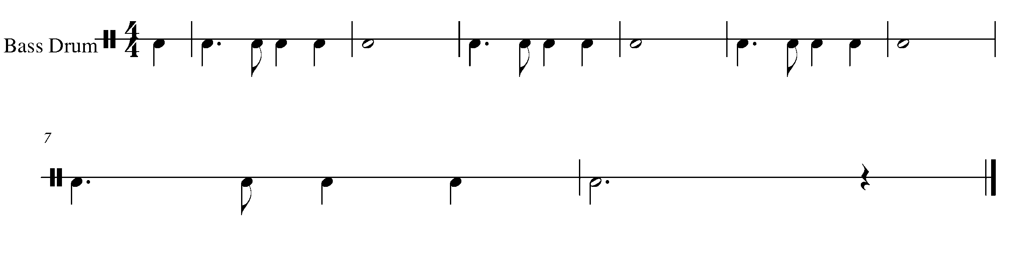

Task 11 Music Continued

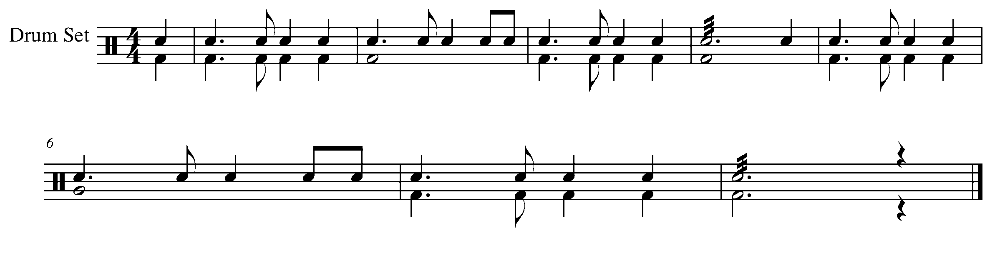

12. FOLLOWING THE MUSICAL ROAD MAP FOCUS: FORM
Wind Instruments and Mallets

LEARNING GOAL: First (1st ) Endings and Second (2nd ) Endings allow the composer to not have to write out a repeated section again. In this task, you will learn how to follow the road map of a song.

MINDS ON! Before you begin to play through this song, figure out the road map of the piece below. When you get to end of the 1st ending, where do you go? When do you play the 2nd ending?

ACTION! In order to be successful with this task, you will need to:

- Identify how to perform a song with 1st and 2nd endings.
- Demonstrate an understanding of not only the “road map” of the song below, but also demonstrate quality musical phrasing, accurate notes and pitch.

TASK 12 MUSIC IS FOUND ON THE NEXT PAGE

CONSOLIDATION: In order to move to the next task, you must perform, “London Bridge” for your teacher and receive feedback.

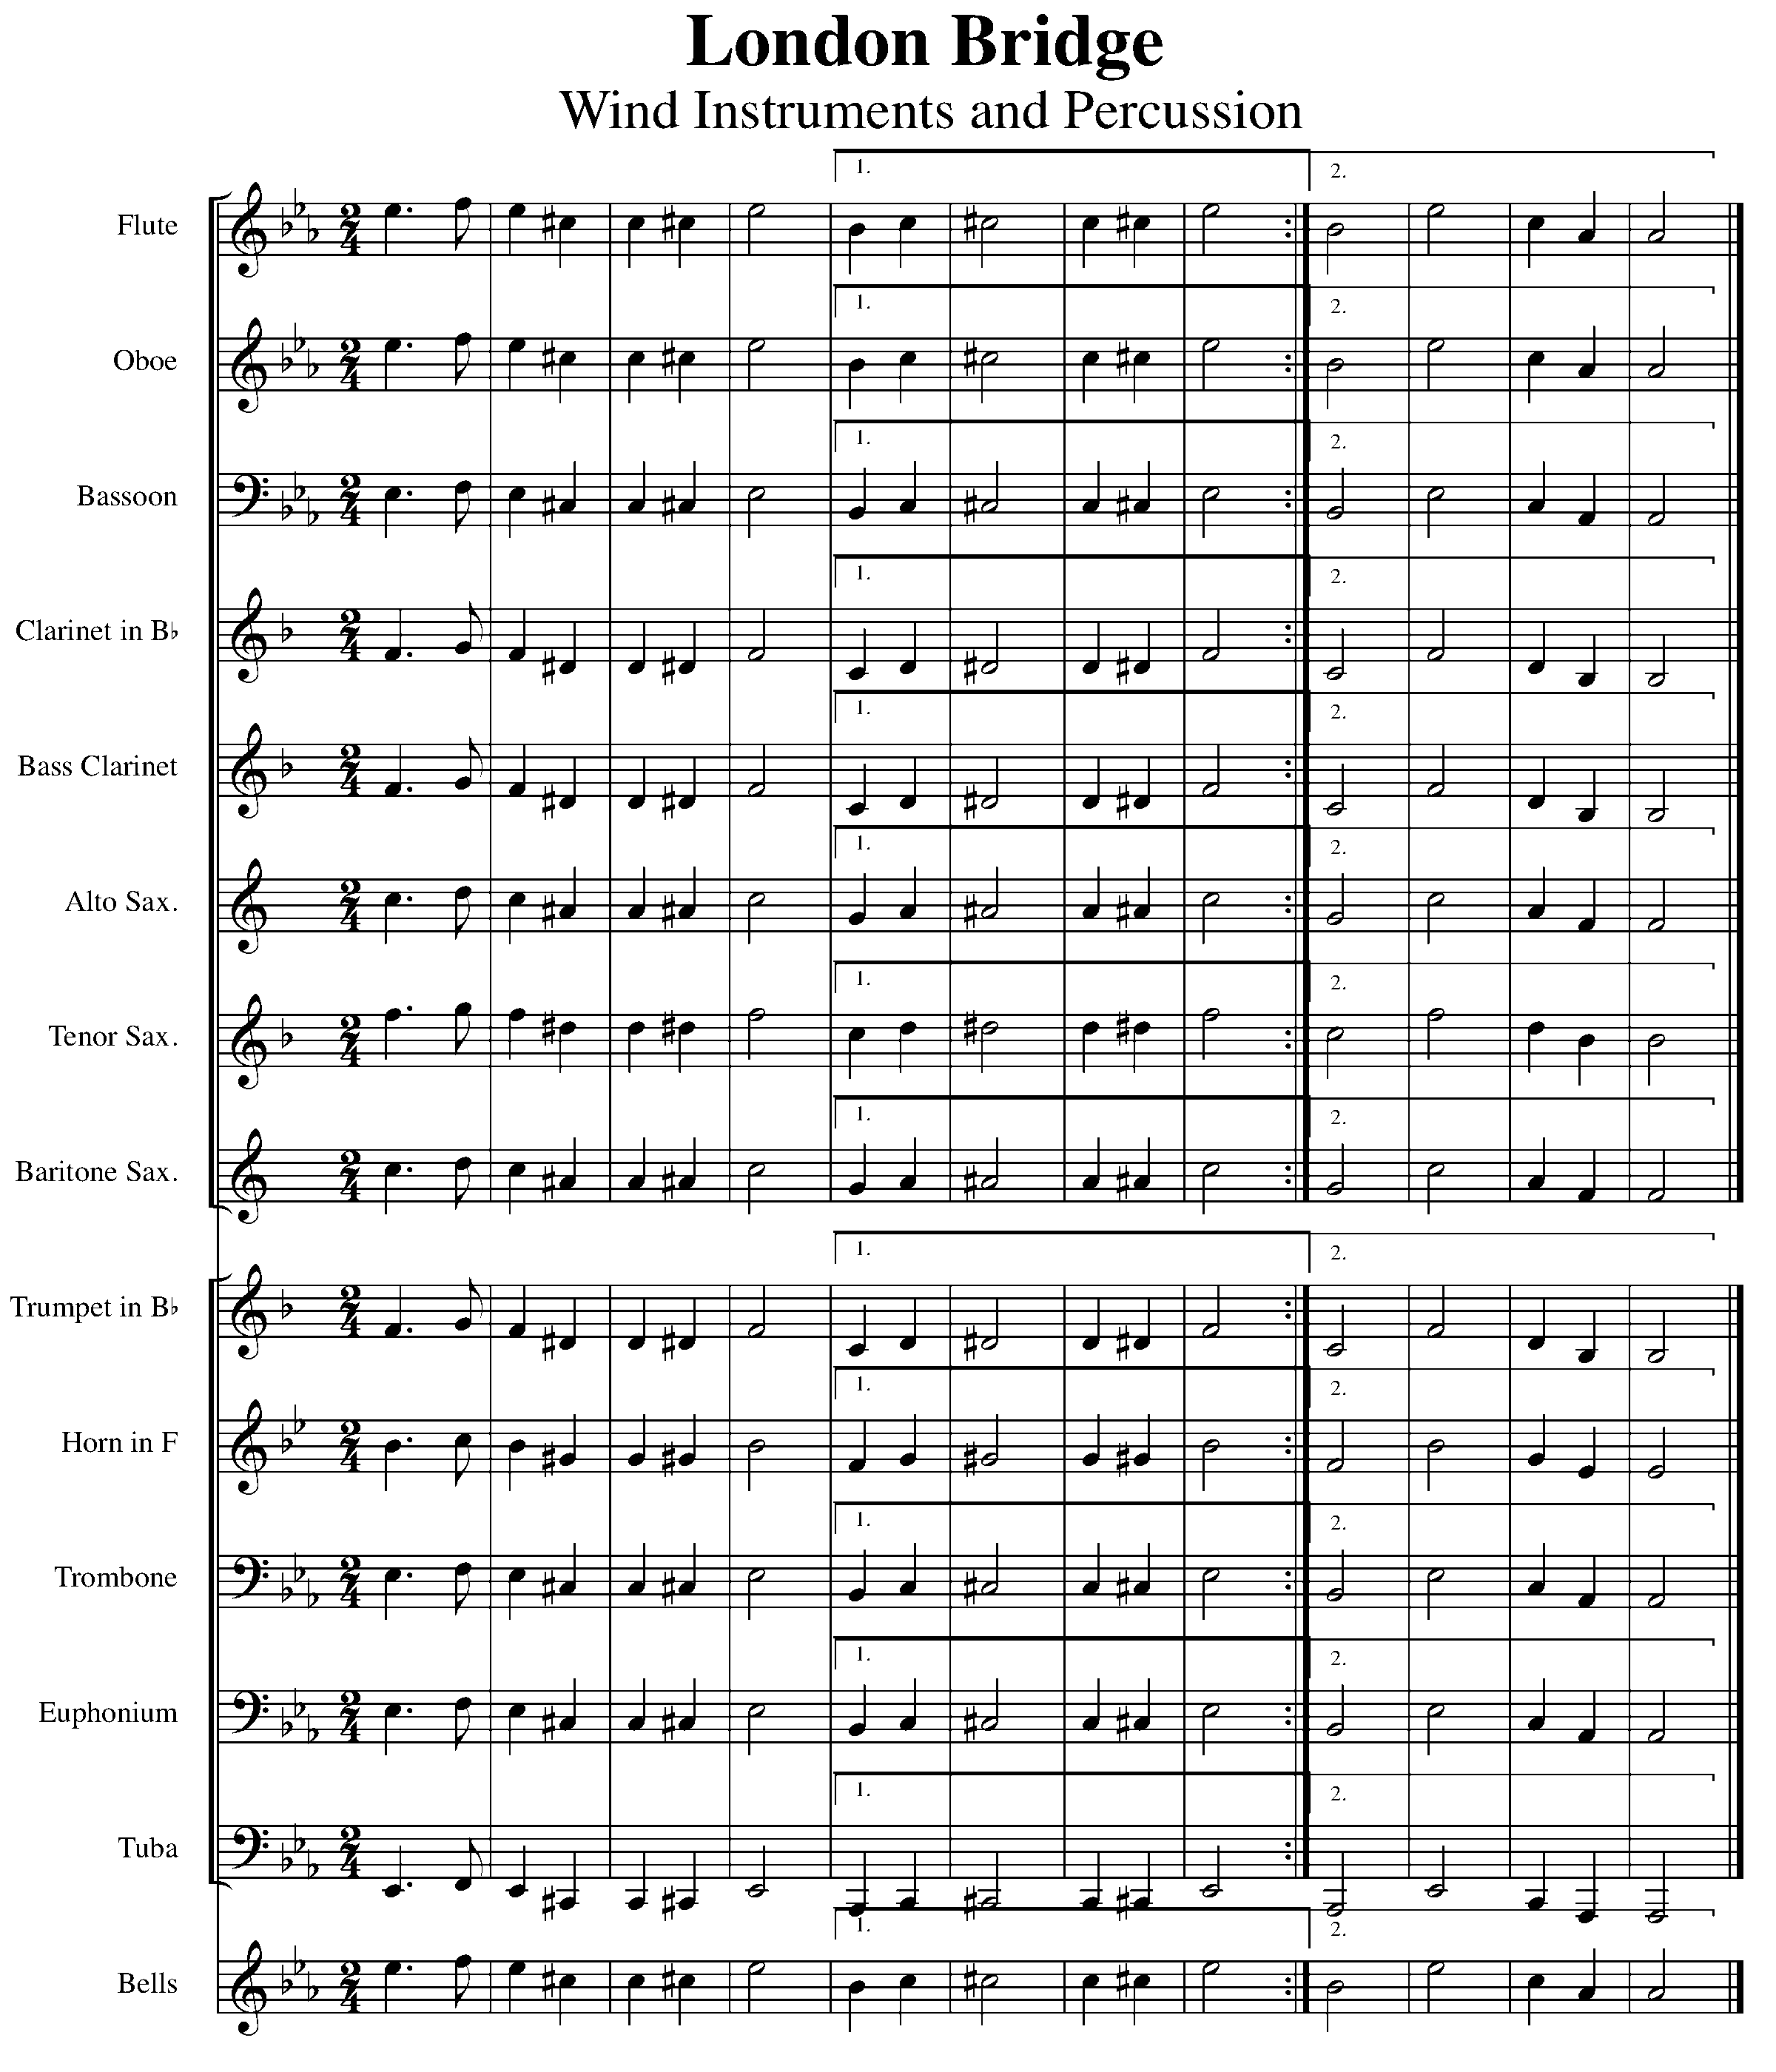

13. ADDING TO THE BLUES FOCUS: COMPOSITION
Wind Instruments and Mallets

LEARNING GOAL: The initial set up of your staff when you are composing music is very important. In this task you will transfer the 12-bar blues from task 5 as well as set up a staff, which will be needed for future composition tasks.

MINDS ON! Accuracy is the name of the game when composing. Make sure that notes are exactly on the desired line or space, rhythms are communicated correctly and other aspects of written music are properly written down. How are you going to know if you’re correct? What resources do you have that show you where to put a time signature and draw a treble clef or bass clef?

ACTION! Before you begin this task you need to:

- Find the 12-bar blues pattern for your instrument in Task 5.
- Look at other samples of music and determine what symbols are needed to set up a piece of music.
- Practice drawing your appropriate clef on the staff.
- USE A PENCIL – you may need to move things around when you enter the notes.

In order to move to the next task you need to place the following items on the above task and have it checked by your teacher:

- Copy the 12-bar blues pattern for your instrument from task 5 to the labeled staff below (Found on the next page).

- On the “new composition” staff add the following:
  - A treble clef or bass clef (the one that is appropriate for your instrument).
  - A 4/4 time signature.
  - The appropriate key signature for your instrument (Concert B-flat)
  - 12 empty bars of music – you will put in the notes and rhythms later.
  - A double bar line at the end of the piece.

BLANK STAVES FOR COMPOSITIONS ARE FOUND ON THE FOLLOWING PAGE.

NEW COMPOSITION

_________________________________________________________________________________________________________________________________________________________________________________________________________________________________________________________________________________________________________________________________________________________________________________________________

_________________________________________________________________________________________________________________________________________________________________________________________________________________________________________________________________________________________________________________________________________________________________________________________________

_________________________________________________________________________________________________________________________________________________________________________________________________________________________________________________________________________________________________________________________________________________________________________________________________

FOR YOUR INSTRUMENT – 12-bar blues (COPY FROM TASK 5)

_________________________________________________________________________________________________________________________________________________________________________________________________________________________________________________________________________________________________________________________________________________________________________________________________

_________________________________________________________________________________________________________________________________________________________________________________________________________________________________________________________________________________________________________________________________________________________________________________________________

_________________________________________________________________________________________________________________________________________________________________________________________________________________________________________________________________________________________________________________________________________________________________________________________________

CONSOLIDATION: In order to move to the next task, you will need to show this task for your teacher to receive feedback.

14. COMPOSITIONAL SHORTCUTS! FOCUS: FORM
Wind Instruments and Mallets

LEARNING GOAL: Often composers will use symbols and directional words to create a shortcut within a piece. In this task you will be introduced to the differences between da capo al coda (D.C. al Coda) and dal segno al fine (D.S. al Fine).

MINDS ON! Why might have composers and editors of the past created D.C. al Coda and D.S. al Fine? How are these two words different? What are you supposed to do when you encounter either a D.C. al Coda or a D.S. al Fine?

ACTION! In order to be successful with this task, you will need to:

- Figure out the “road map” of each piece.
- Practice a smooth transition from each directional leap within the piece.
- Demonstrate good rhythm, pitch and phrasing.

MUSIC FOR TASK 14 IS FOUND ON THE NEXT FEW PAGES

CONSOLIDATION: In order to move to the next task, you must perform the pieces below for your teacher and receive feedback.

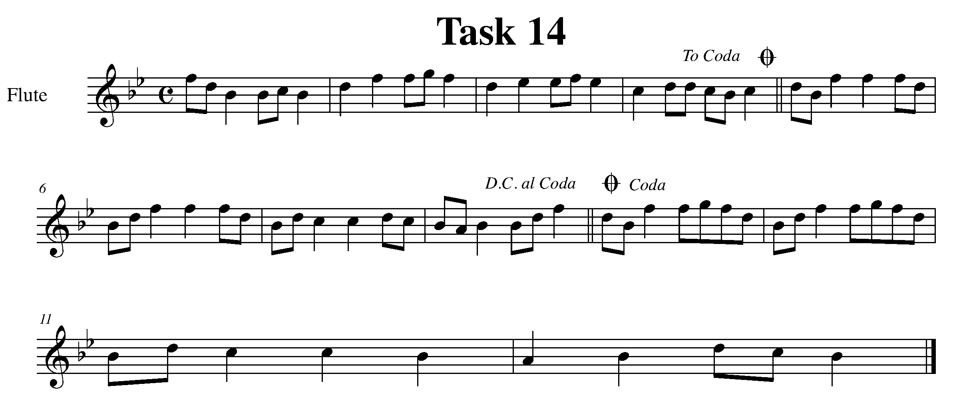

Task 14 Music Continued

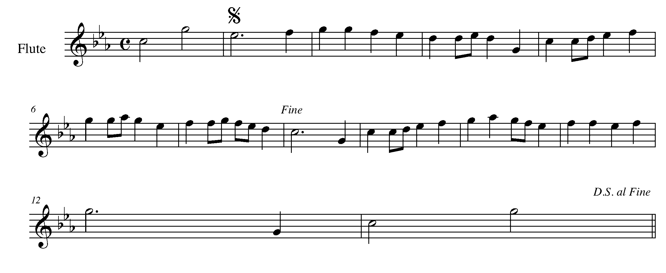
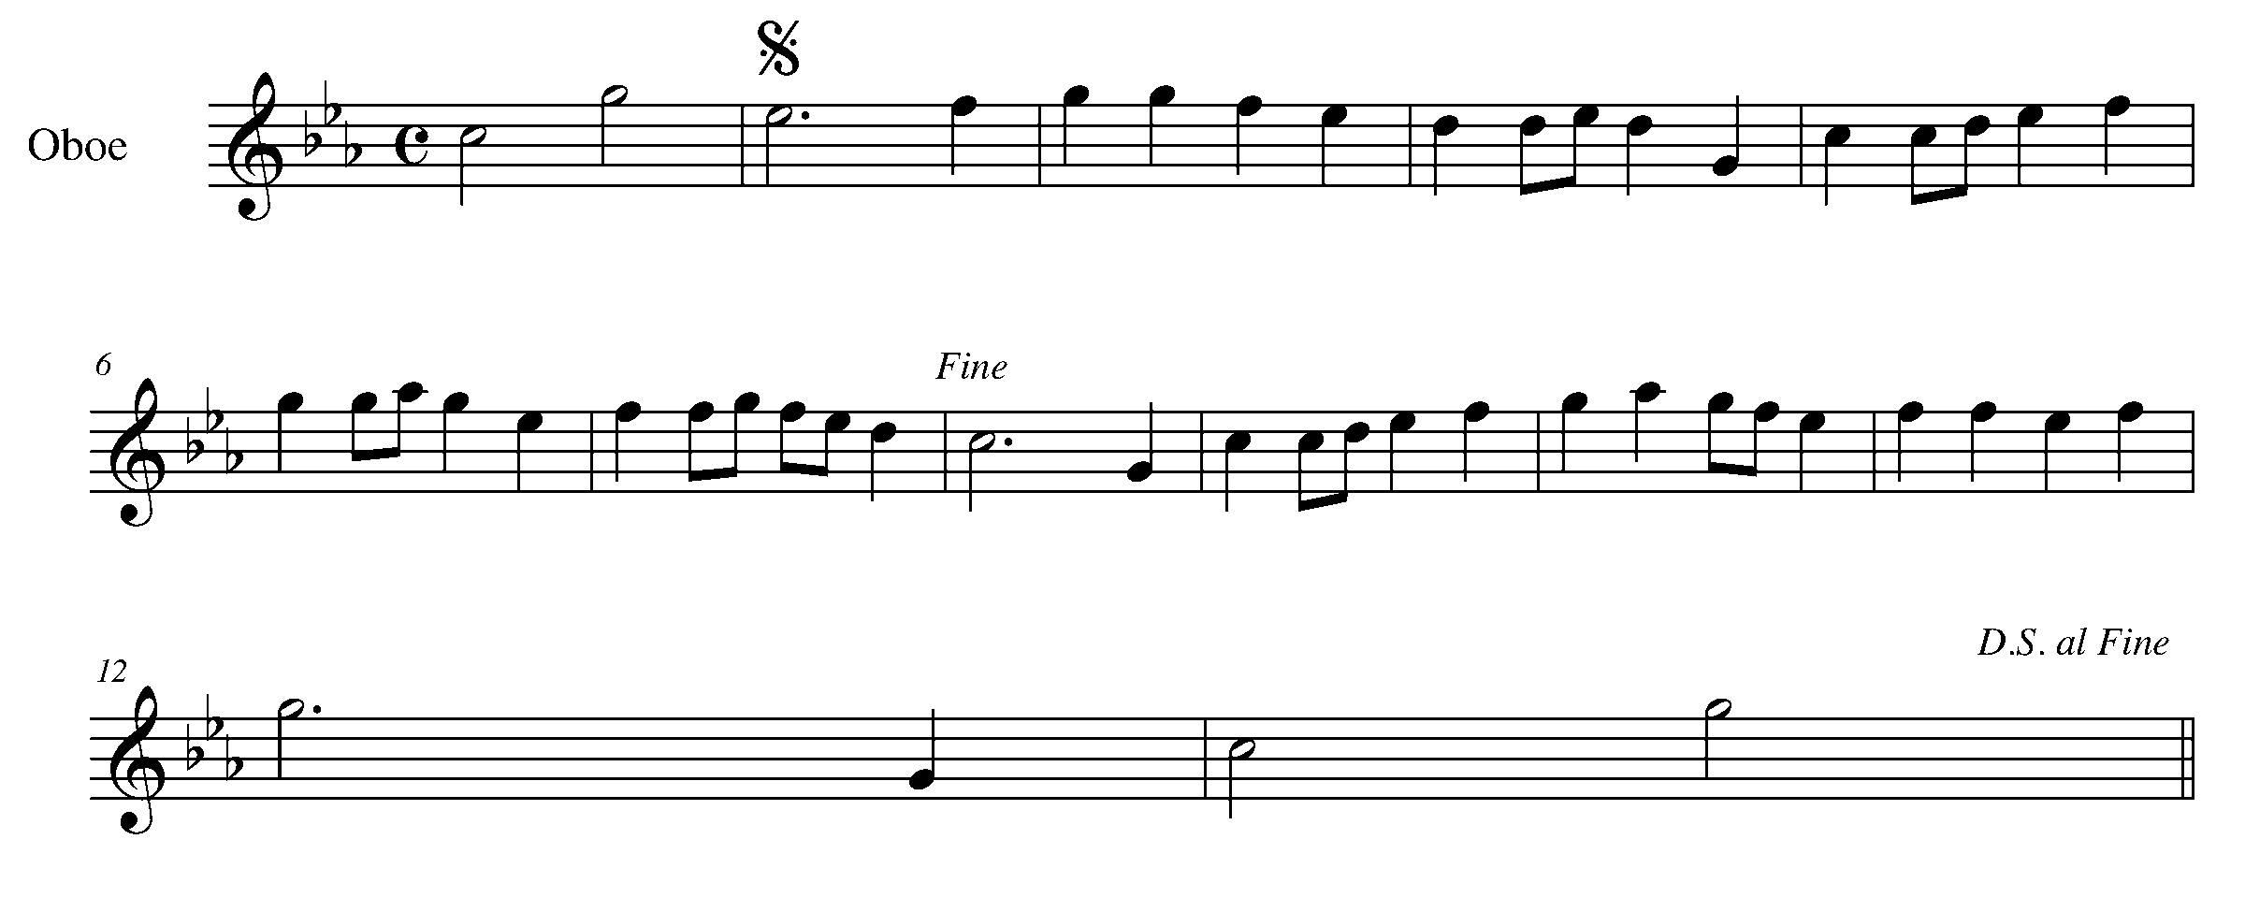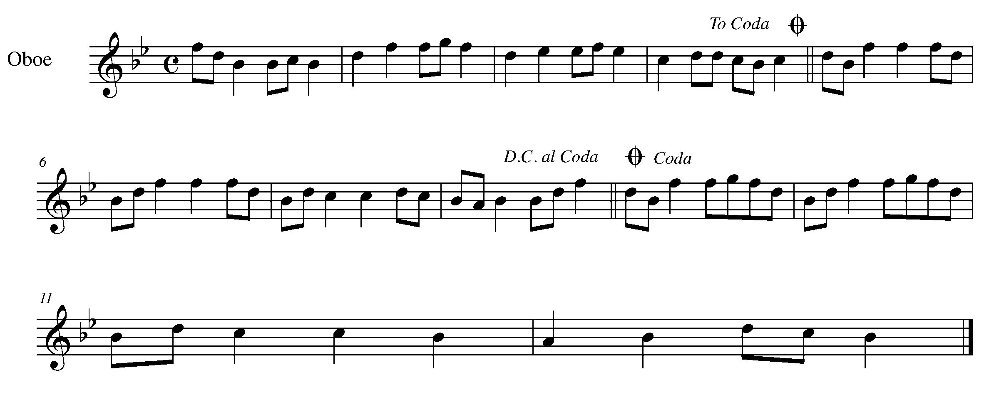

Task 14 Music Continued

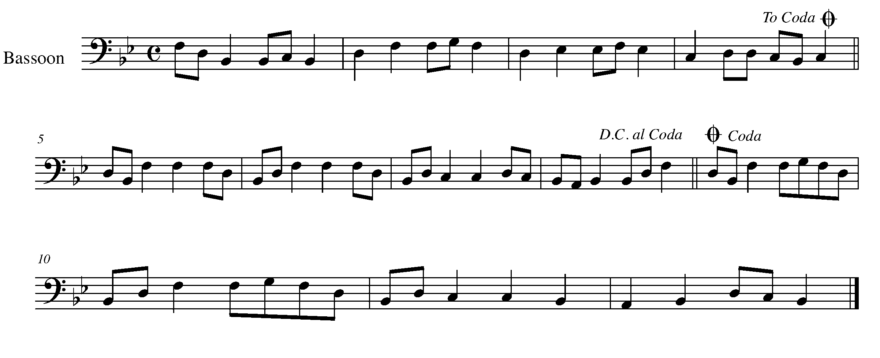

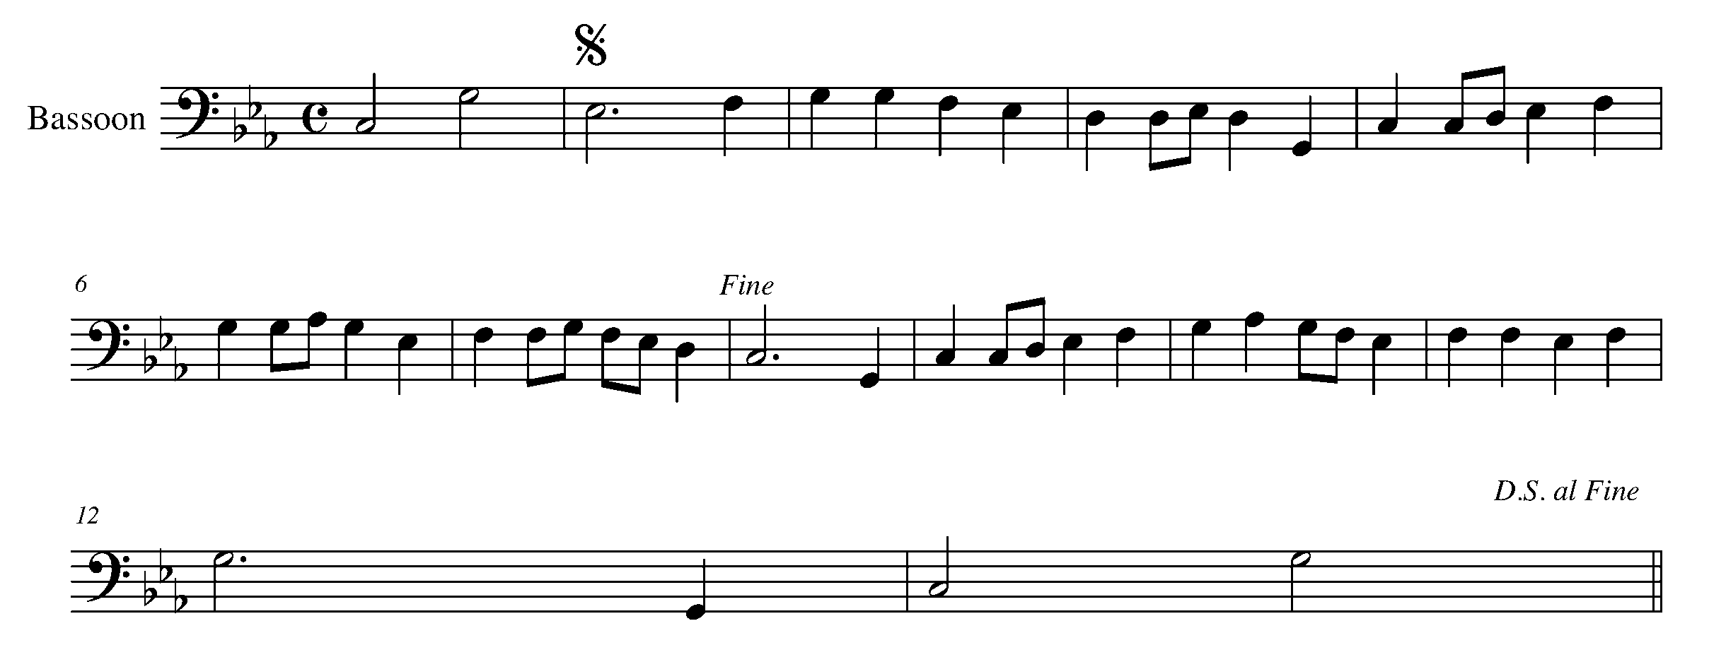

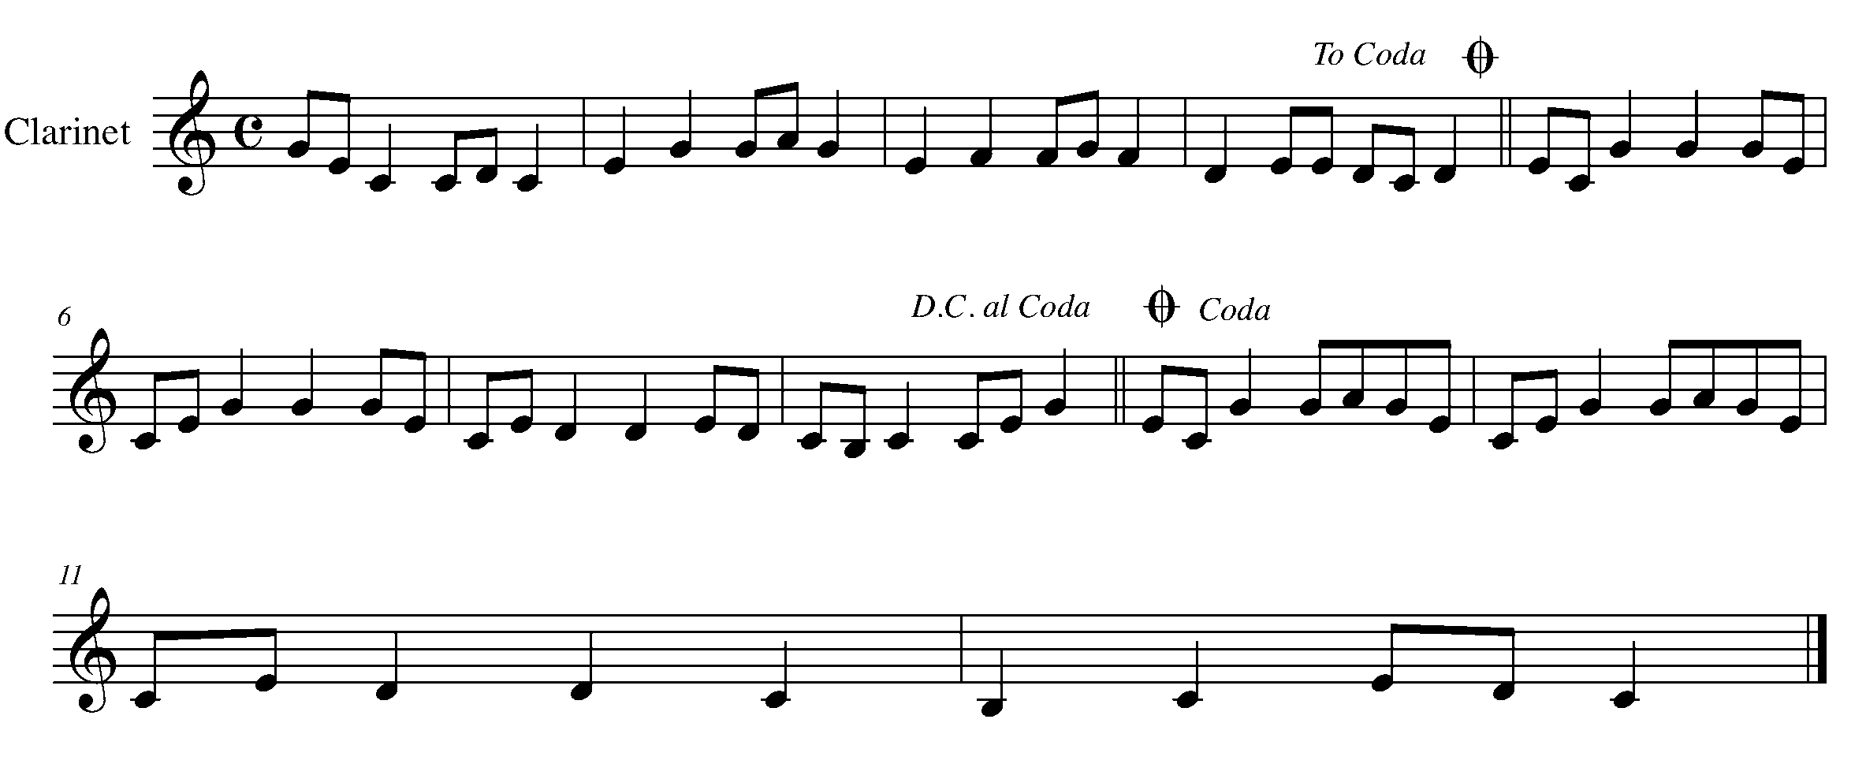

Task 14 Music Continued
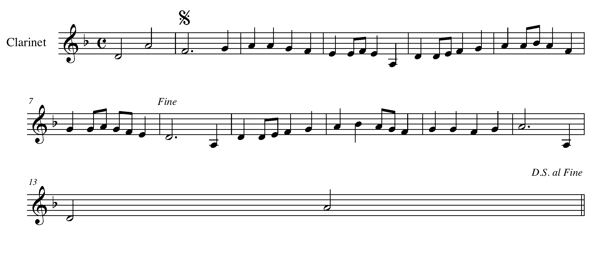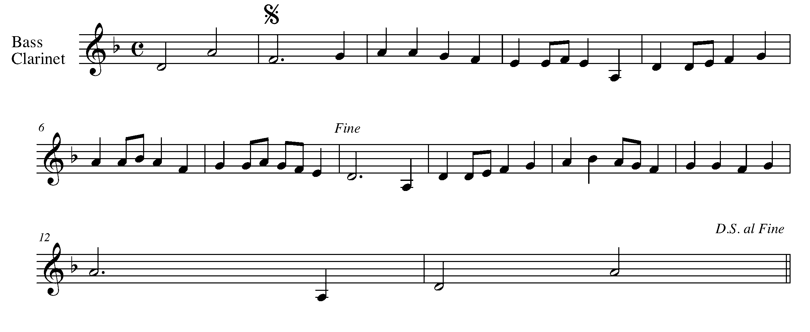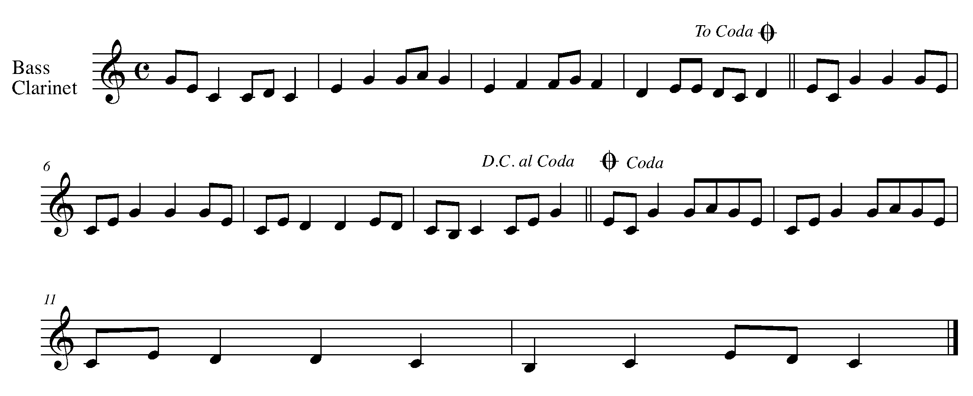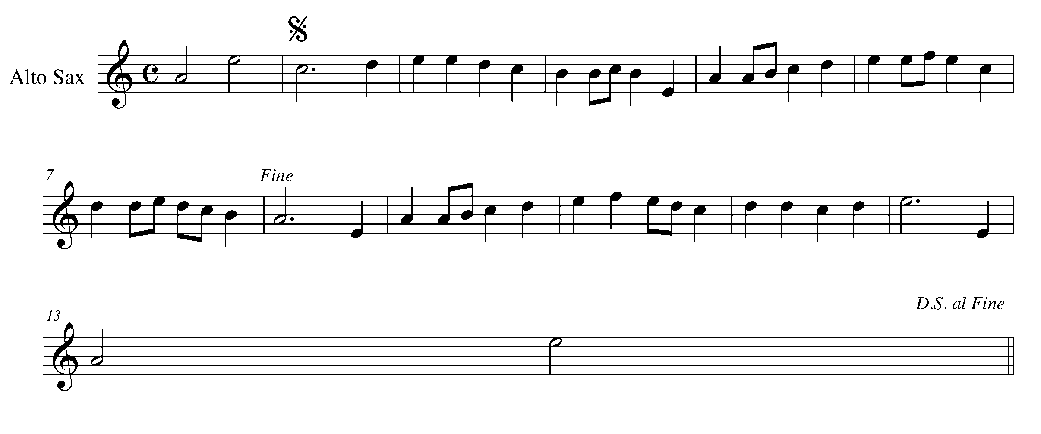

Task 14 Music Continued
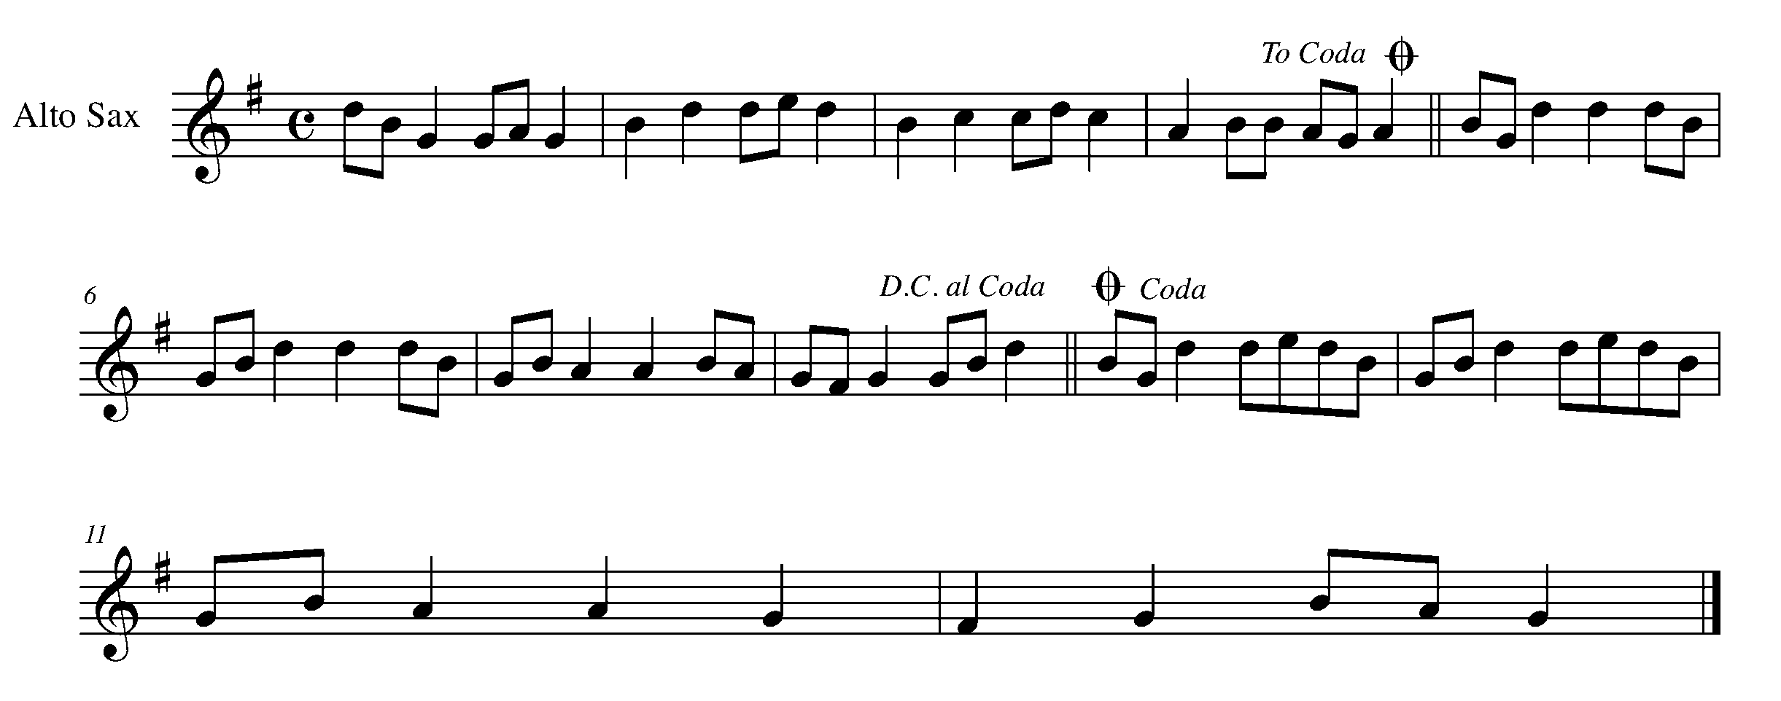
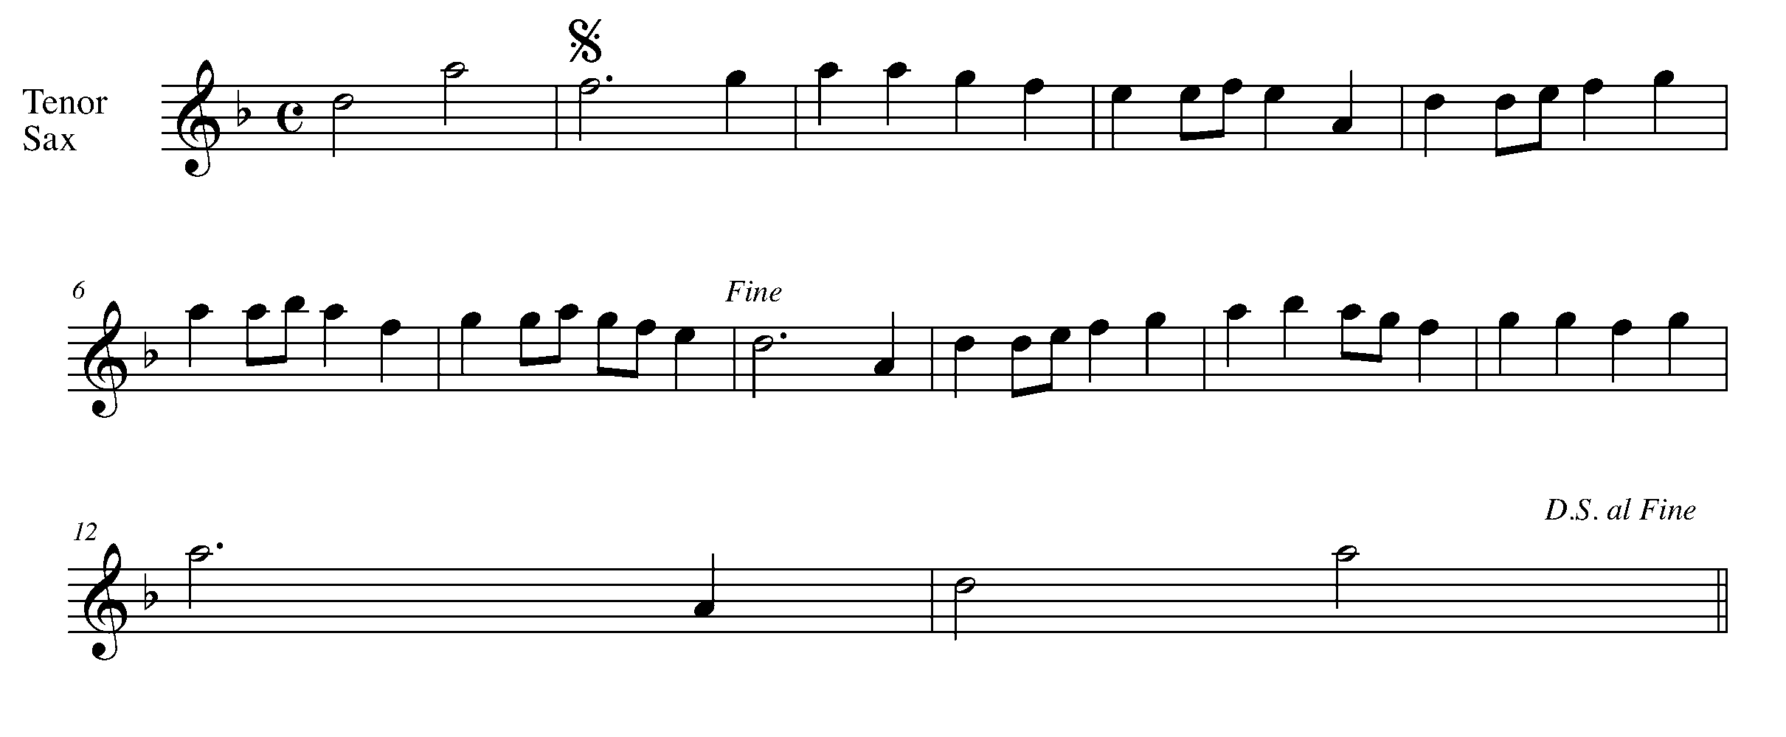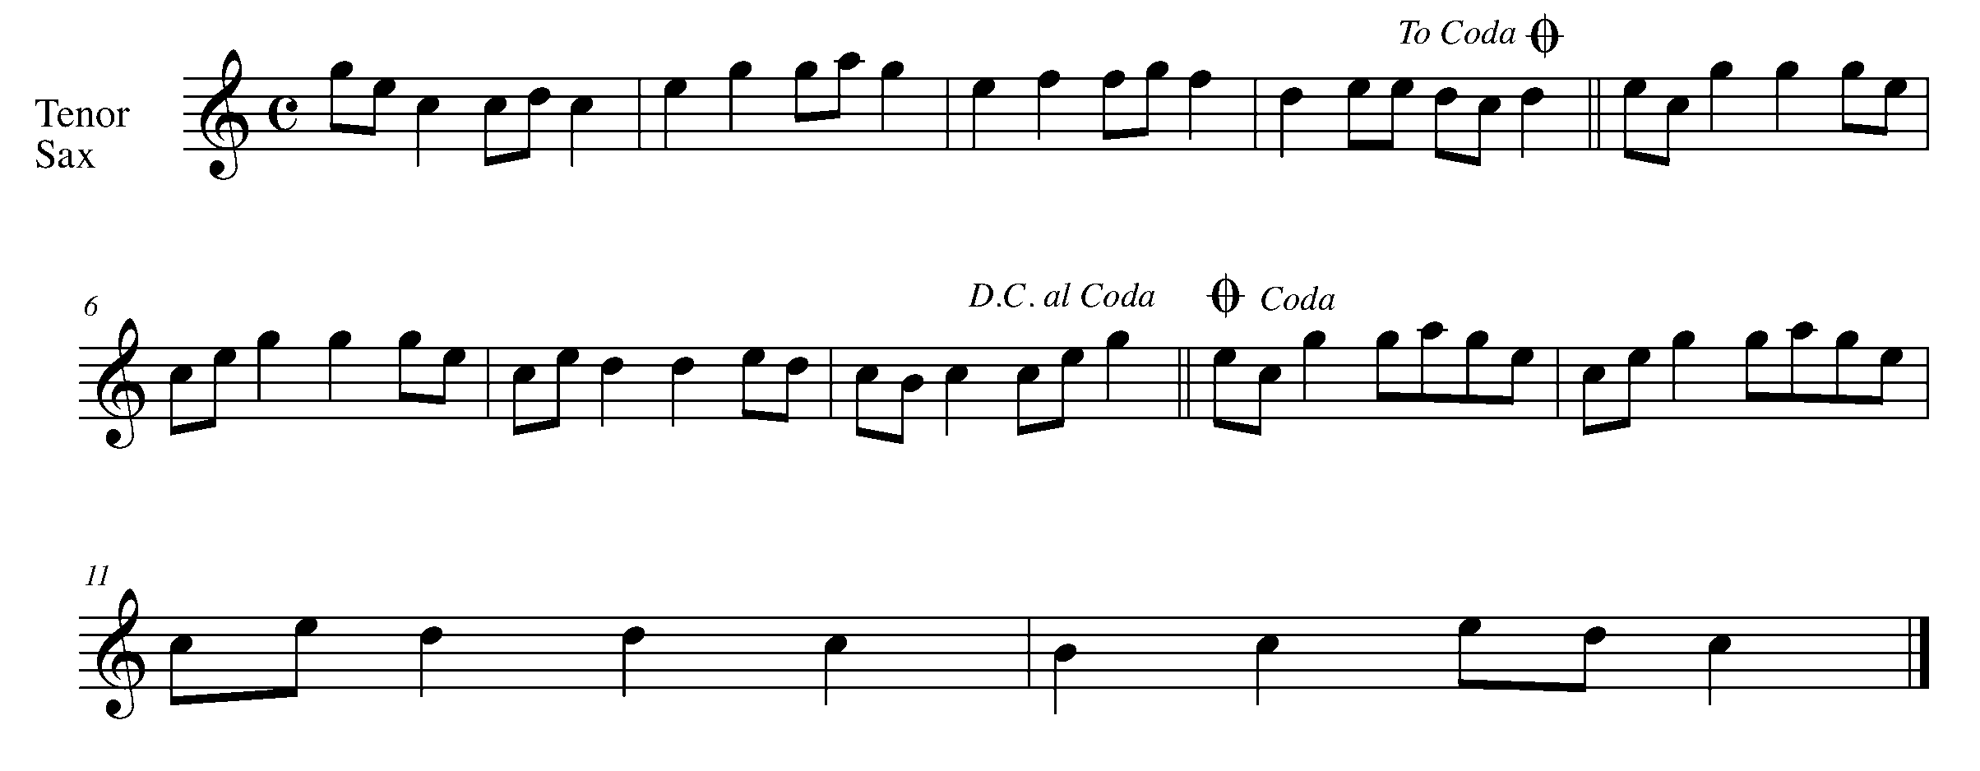

Task 14 Music Continued

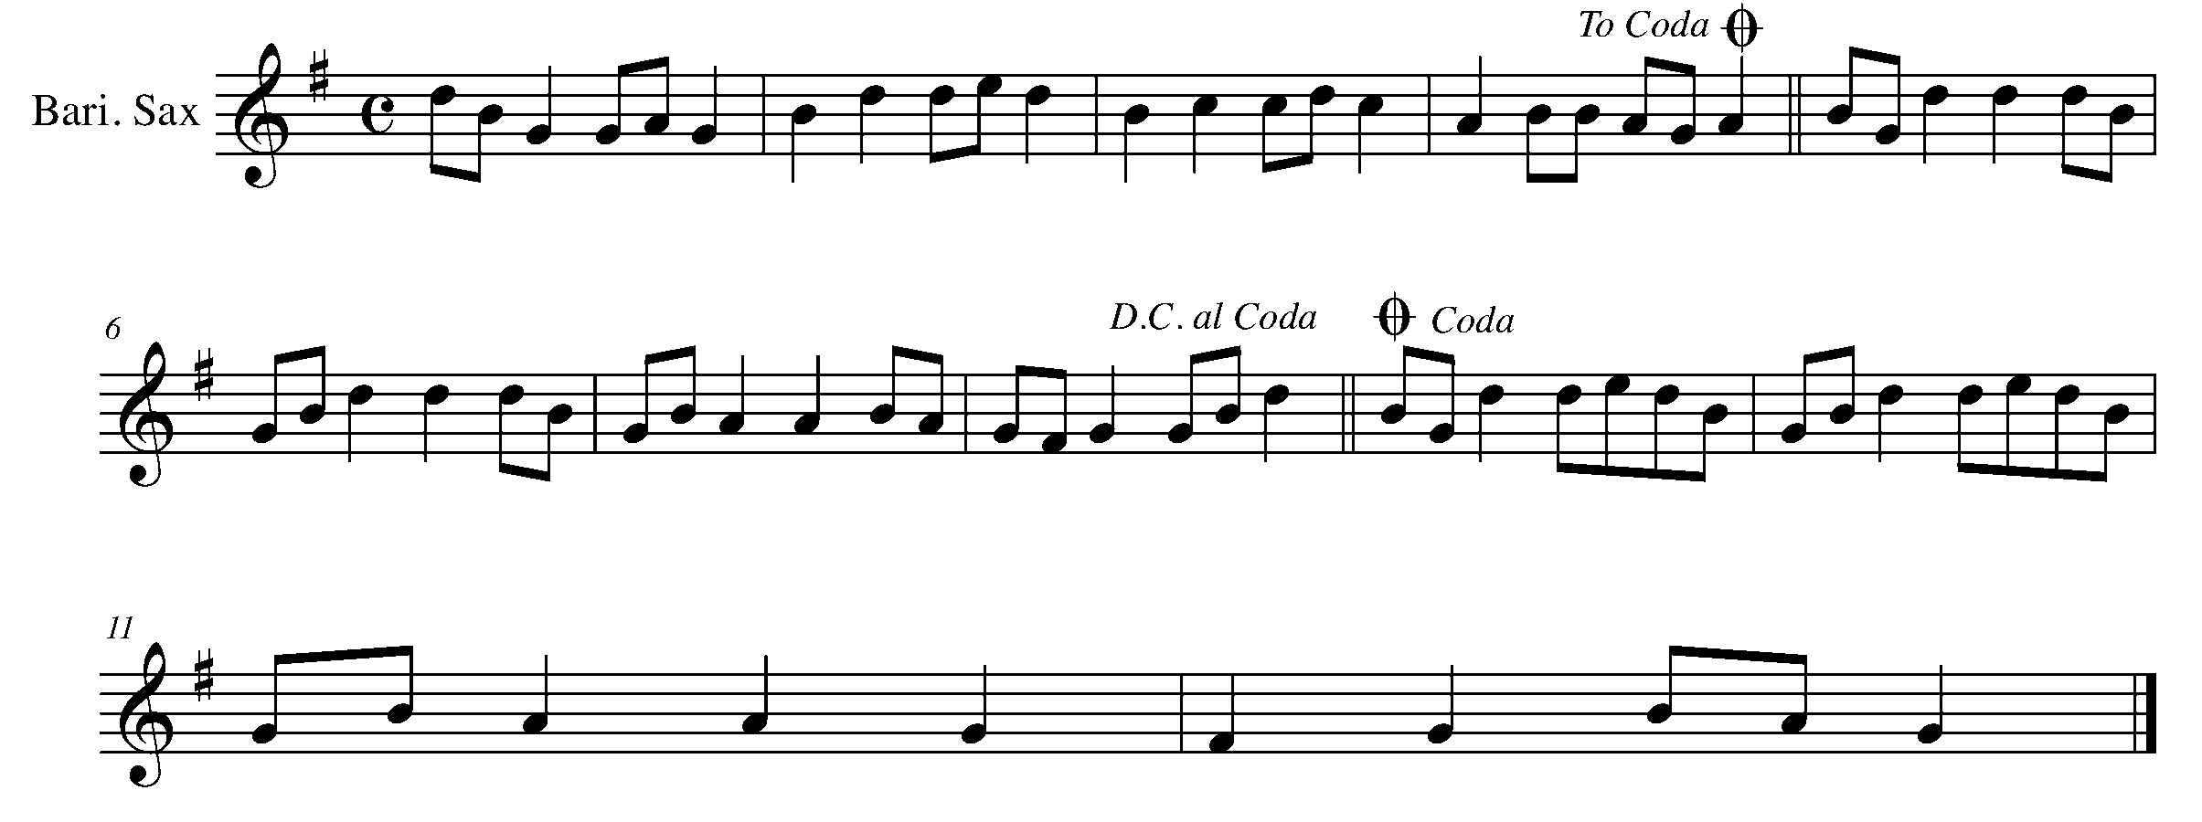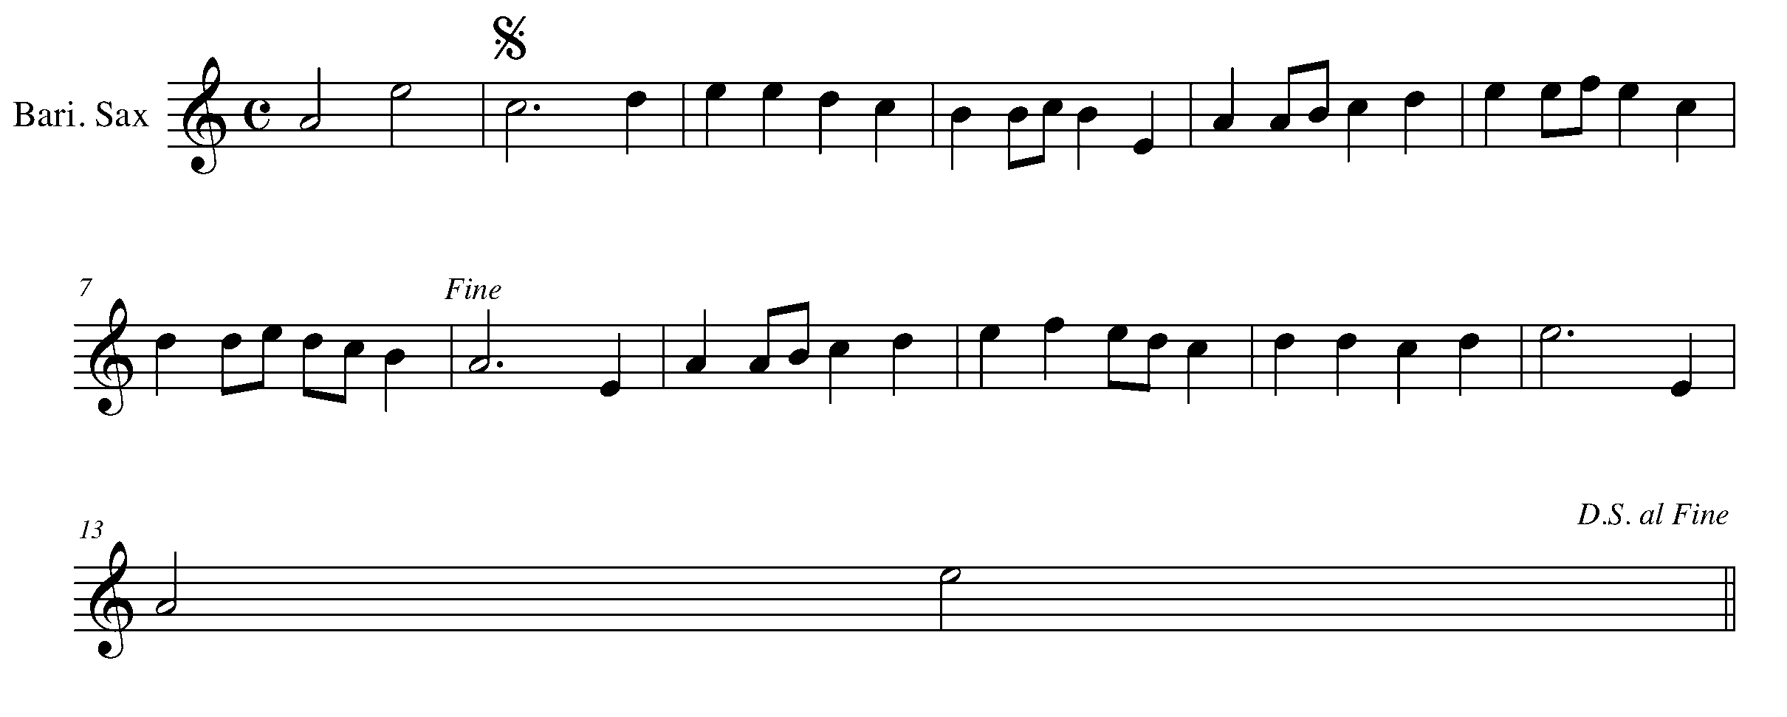
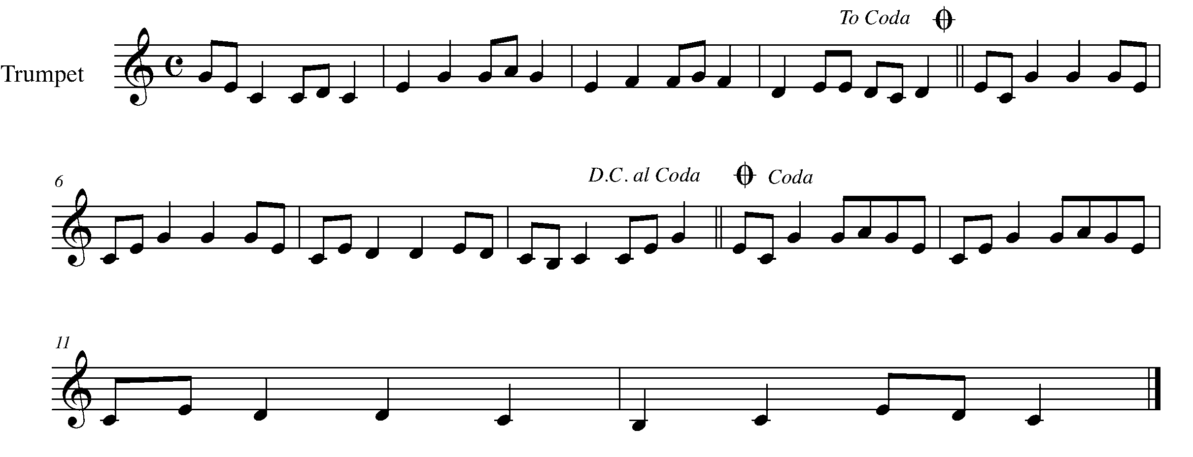

Task 14 Music Continued
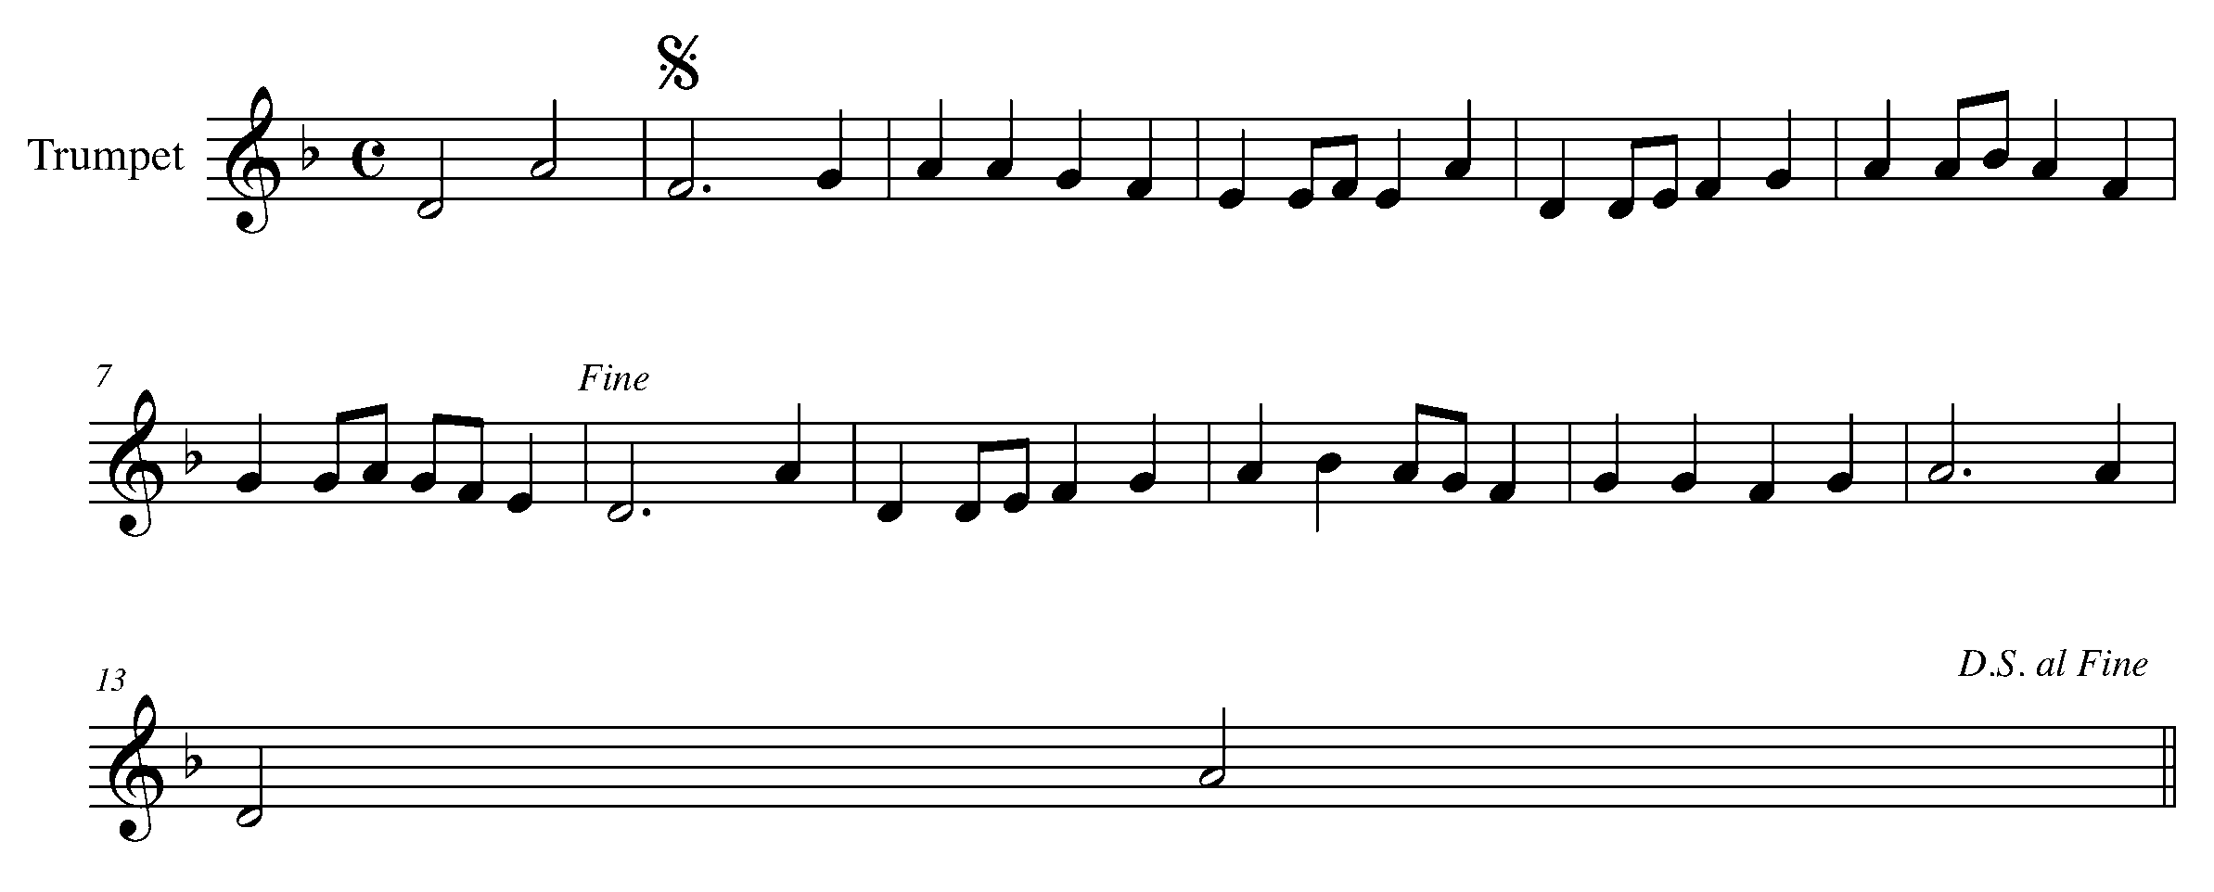

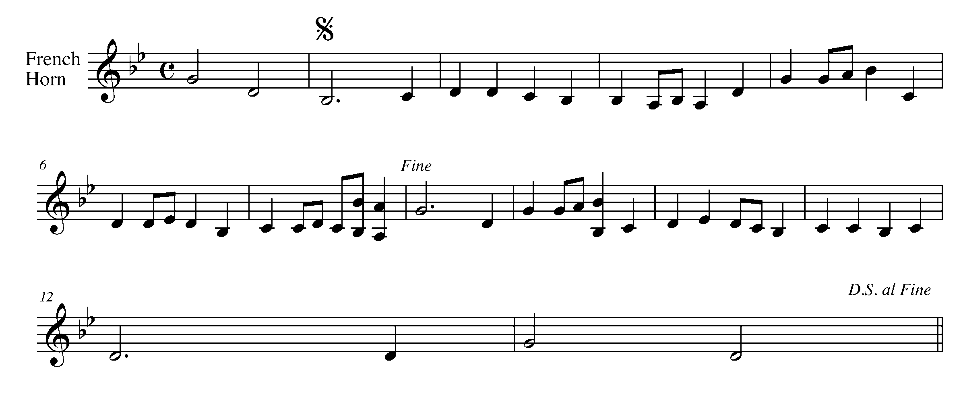

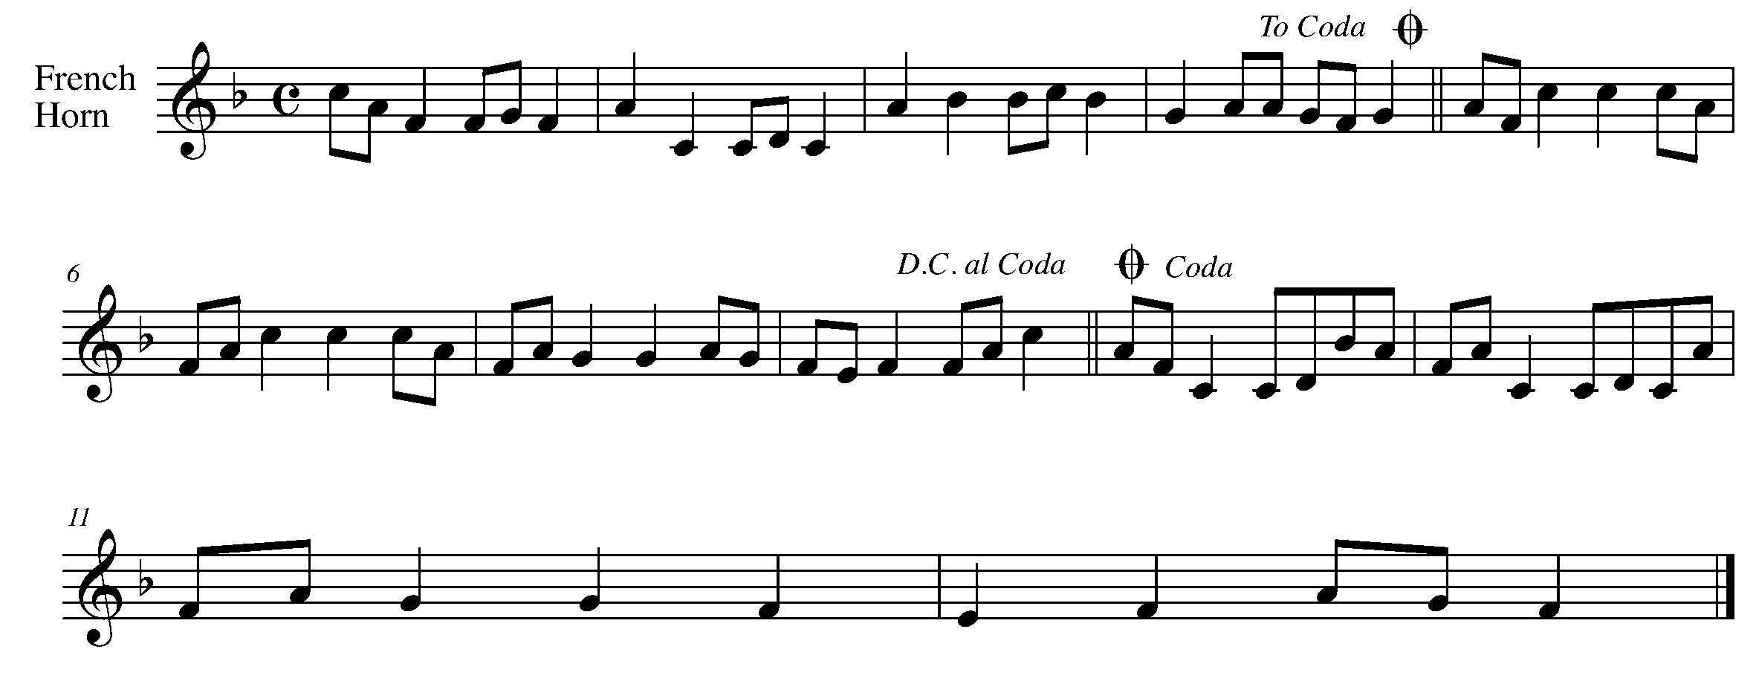

Task 14 Music Continued
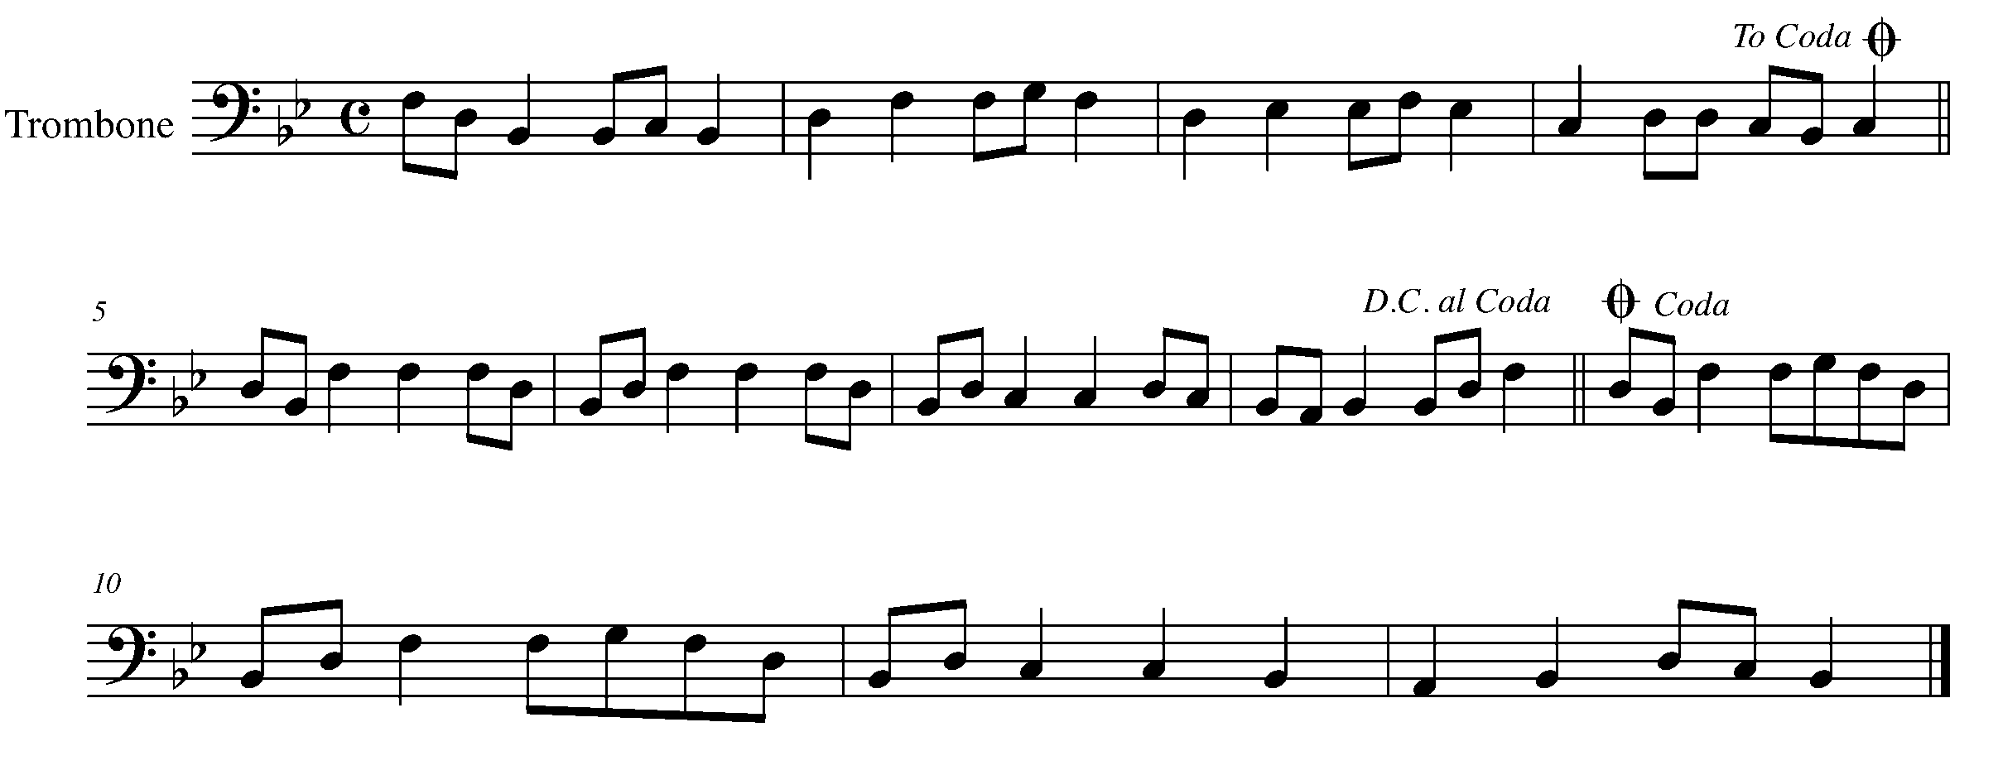

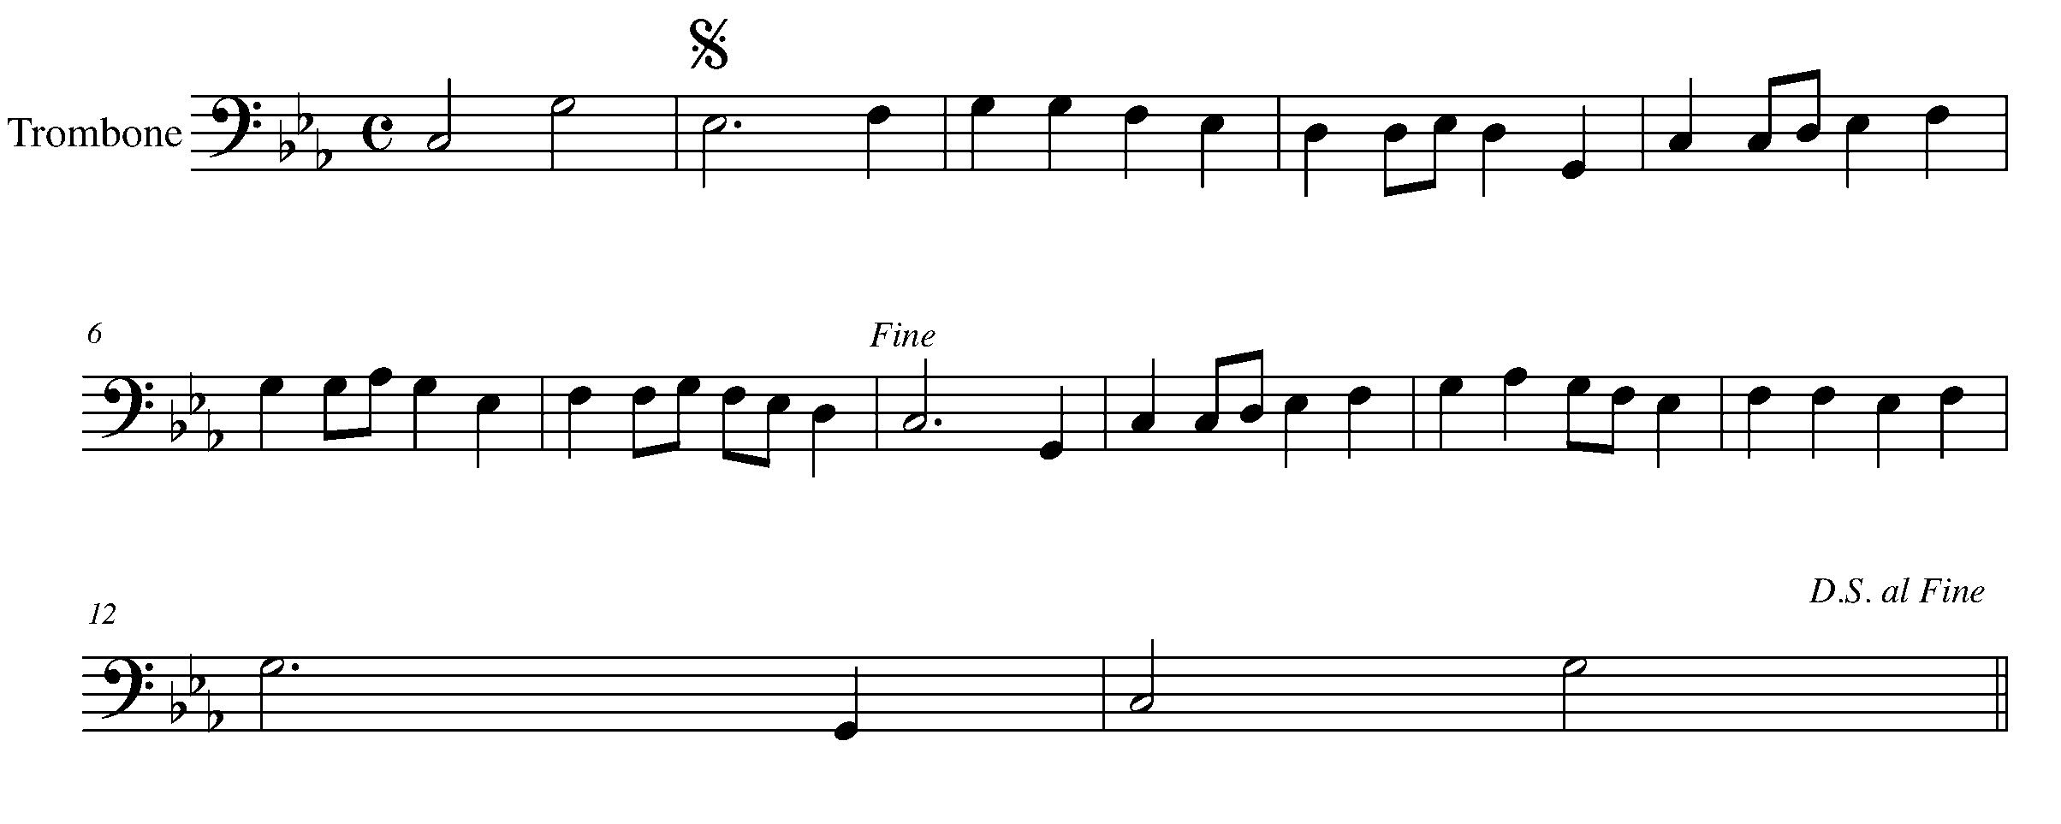

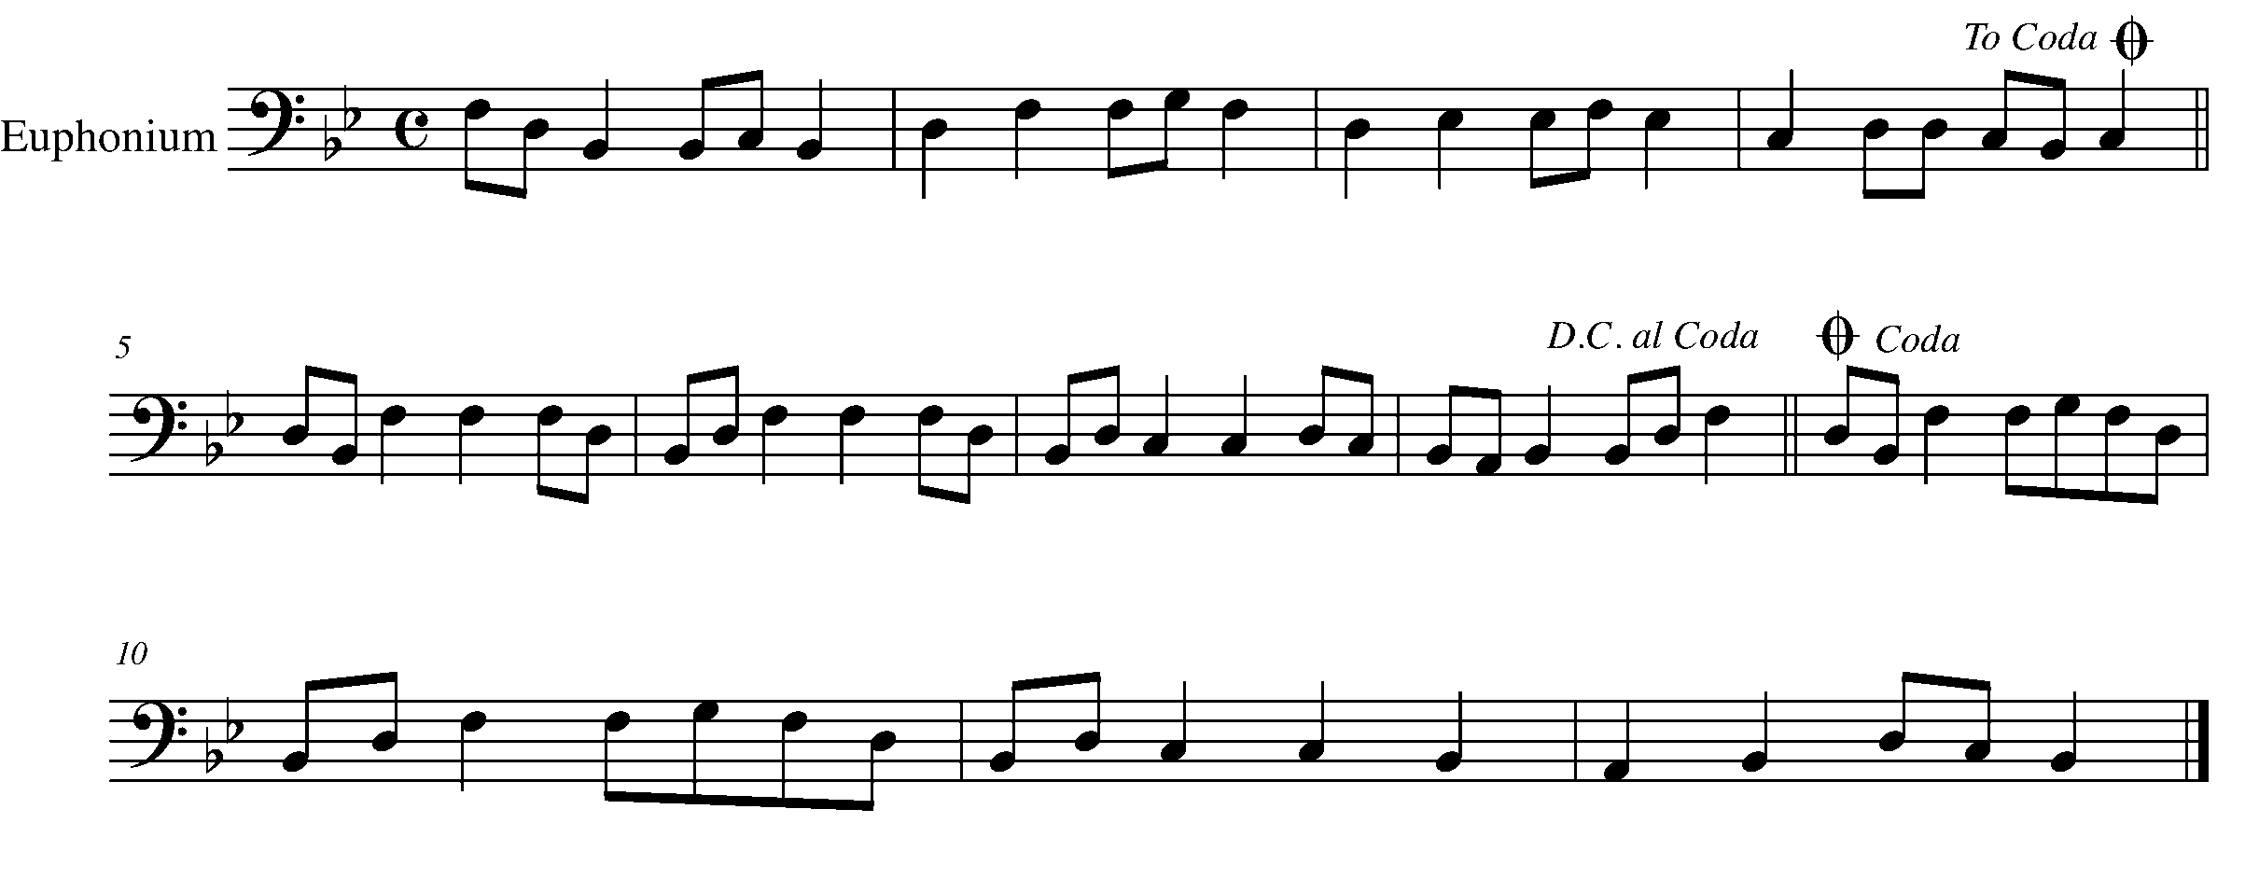

Task 14 Music Continued
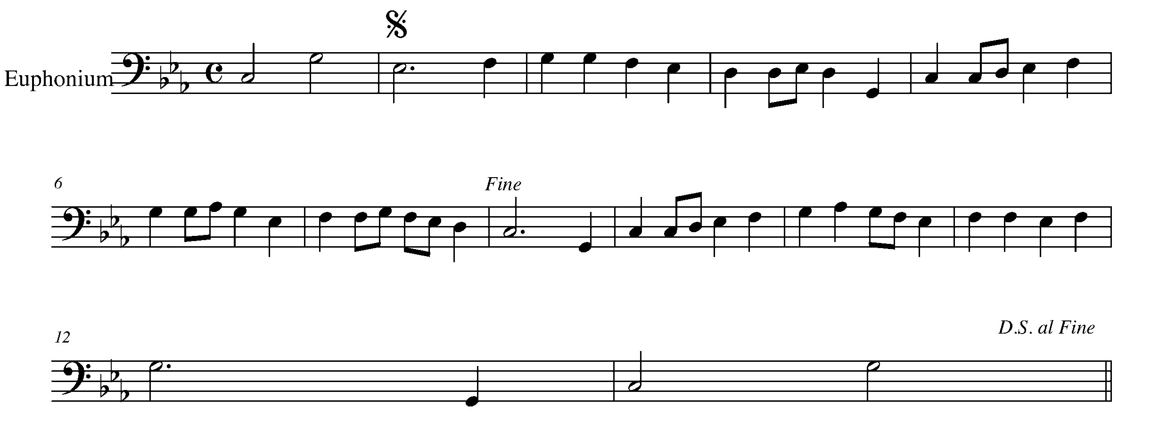

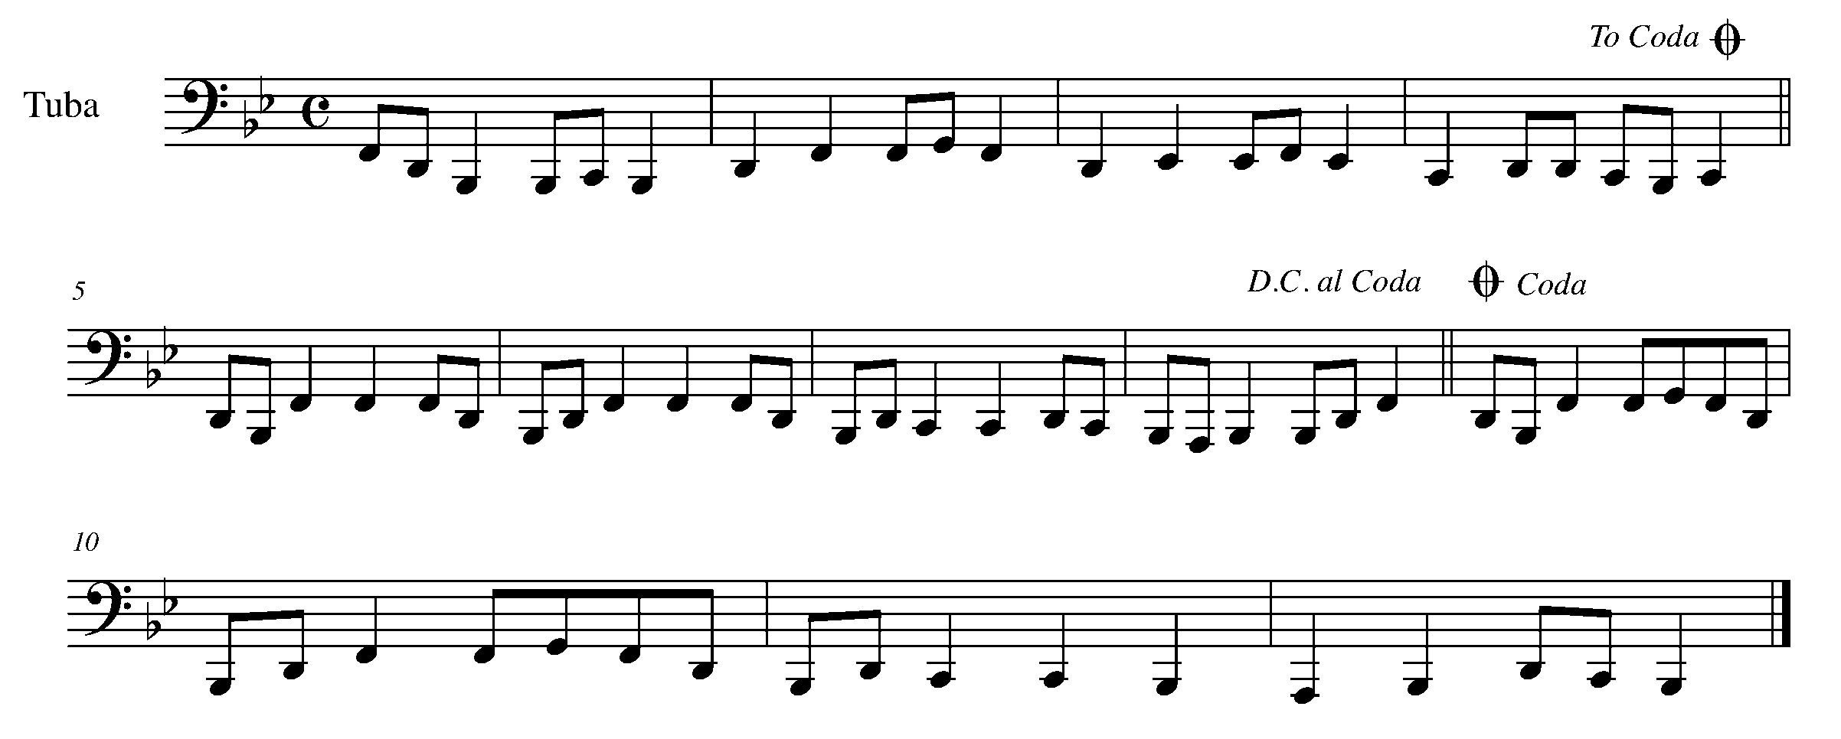
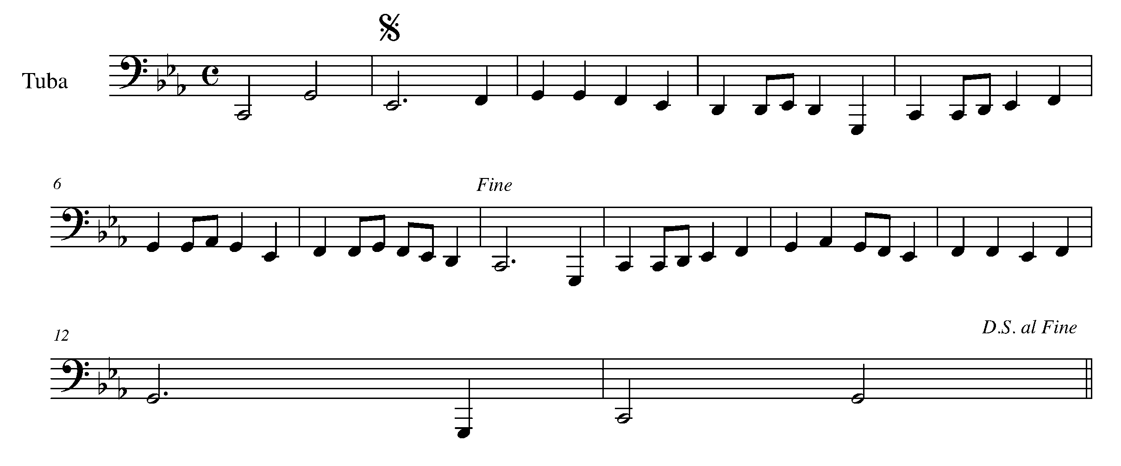

Task 14 Music Continued
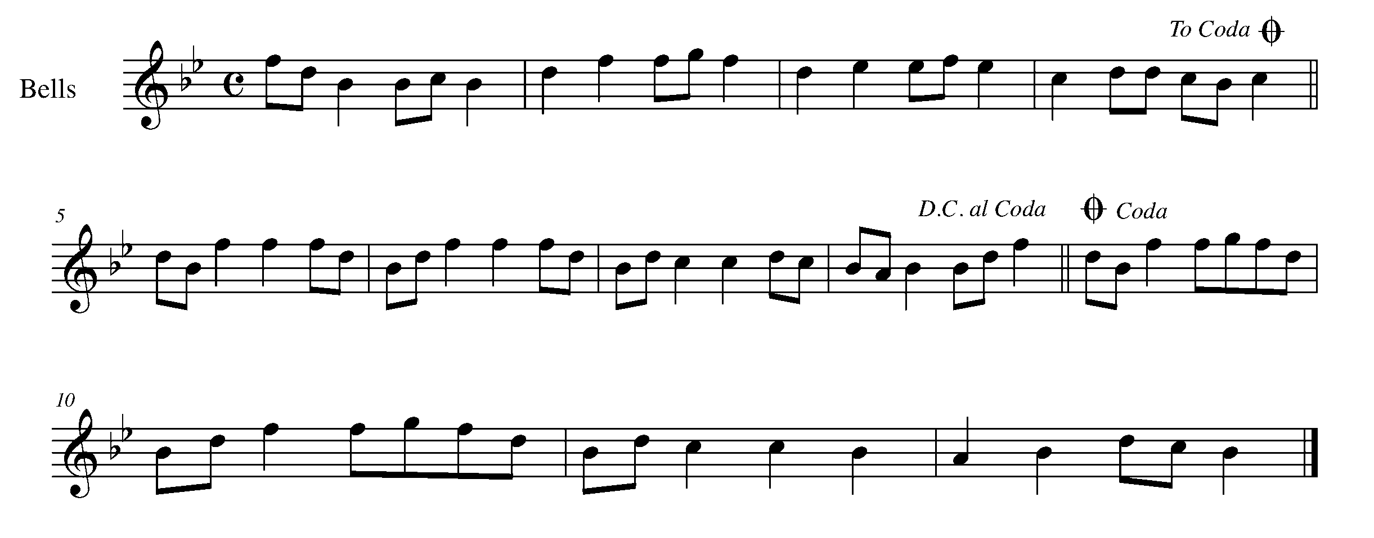
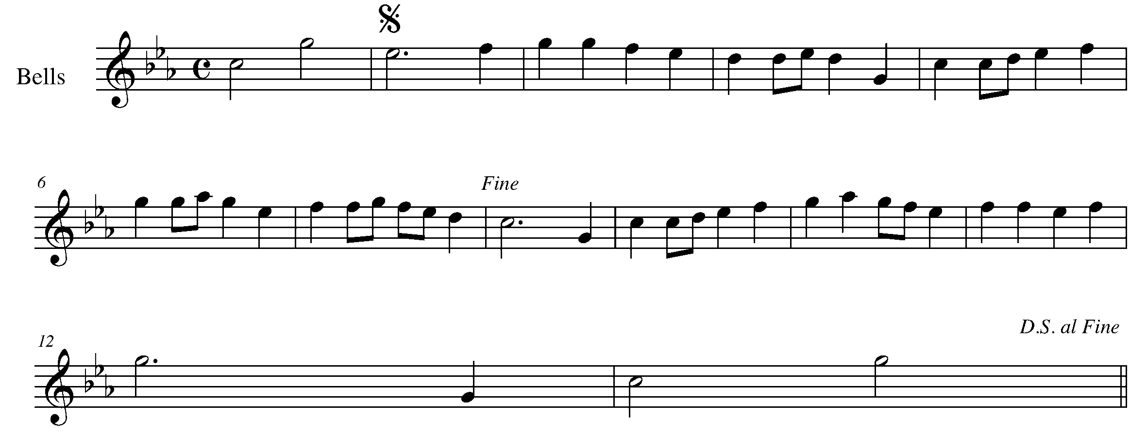

15. INTRODUCING...THE EIGHTH REST! FOCUS: RHYTHM
Wind Instruments and SD/BD/KIT

LEARNING GOAL: The eighth rest can be a tricky rest, as it is quick yet meaningful. When counting out a measure, you should always be breaking the quarter note into two equal parts. A common way to count a 4/4 bar would be ( 1 + 2 + 3 + 4 +) . The + symbol is most often said as “and”. Therefore, the above phrase would be said as, “One and Two and Three and Four and”.

MINDS ON! How can you “grab” a quick, yet meaningful, breath on an eighth rest? Would practicing the passage below at a slower tempo help correctly place all the appropriate rhythms? How does counting the beats out loud while you clap or tap the rhythm help?

ACTION! In order to be successful with this task, you will need to:

- Think through the rhythm below – count it out and place the rhythms on the appropriate beats.
- Demonstrate a consistent sound and/or airflow throughout the piece.
- Demonstrate the correct notes and symbols as marked.
CONSOLIDATION: In order to move to the next task, you must perform the following piece for your teacher and receive feedback.

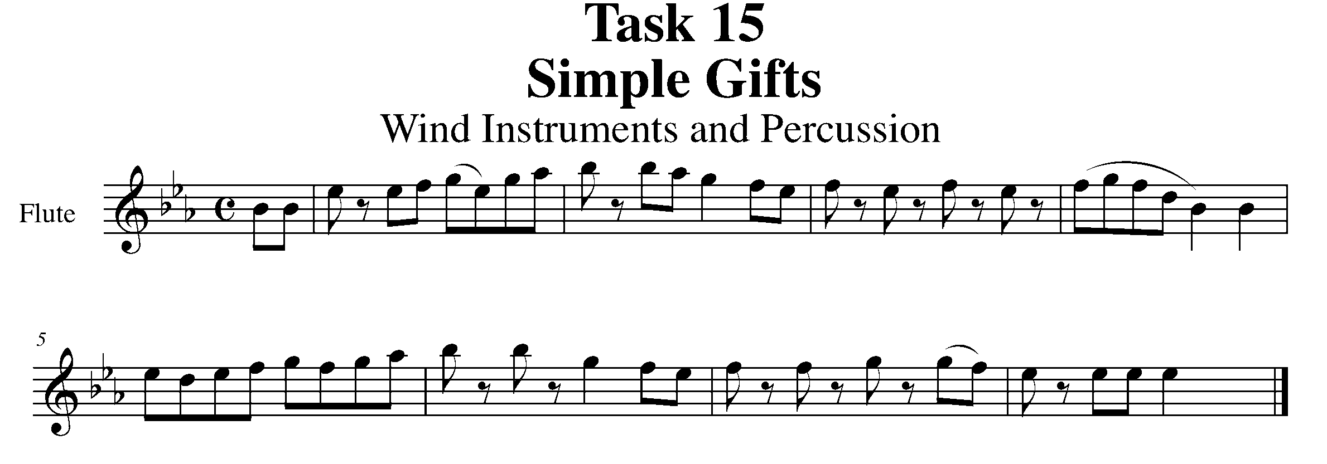
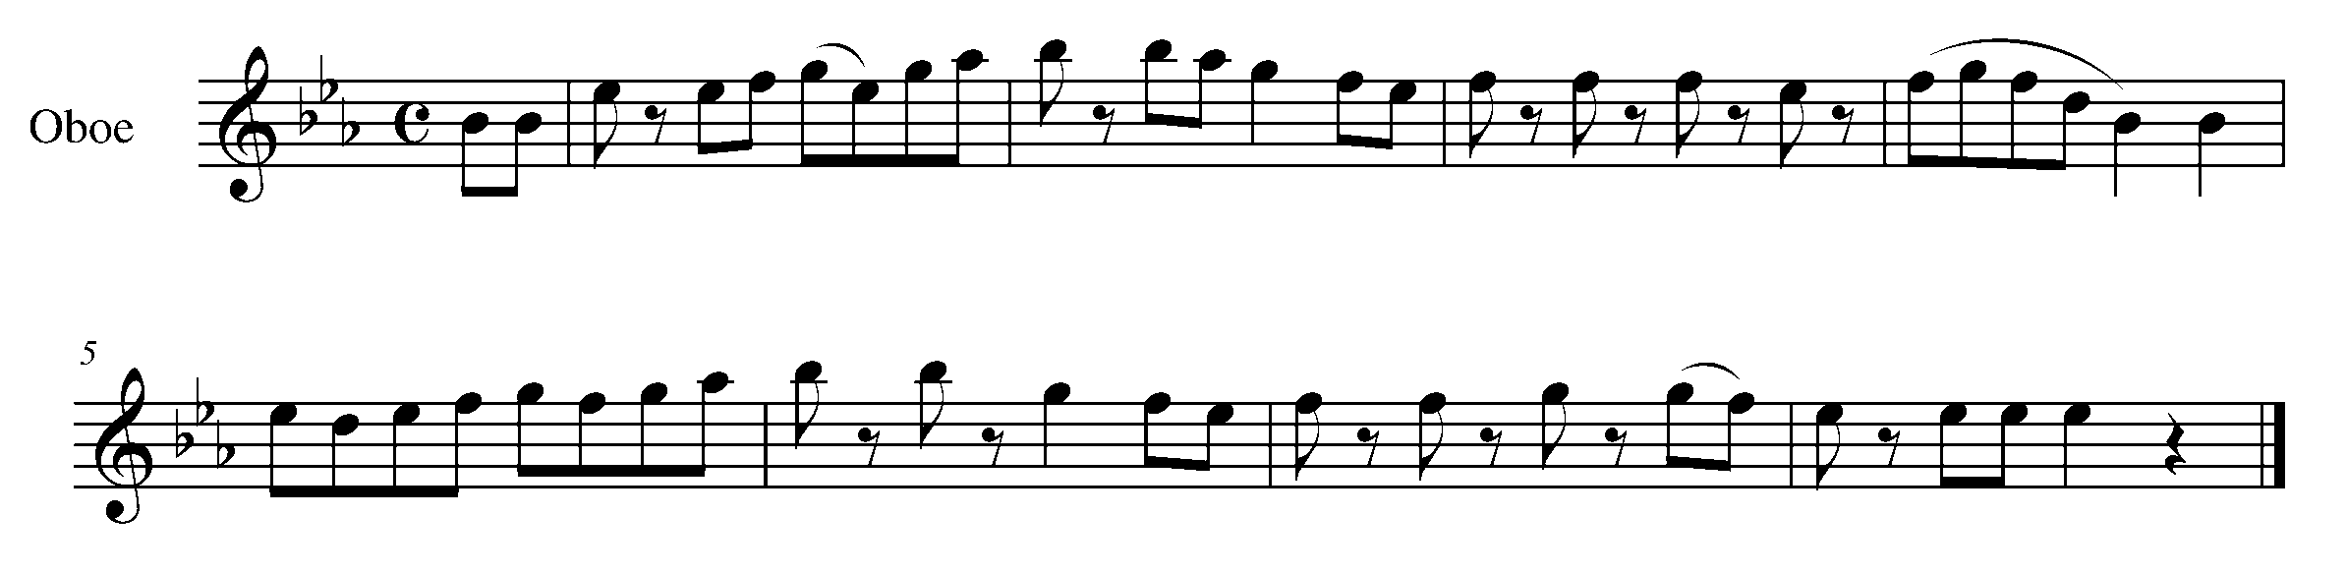
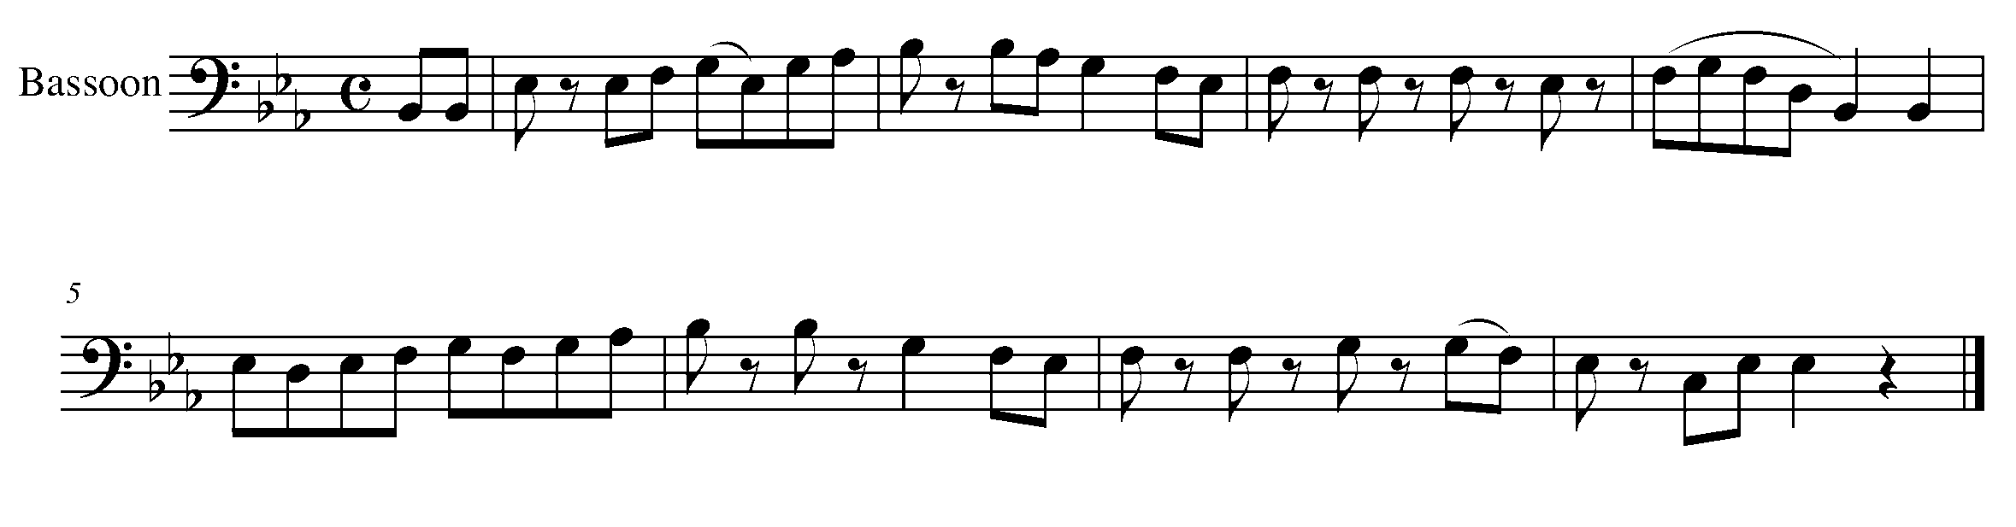
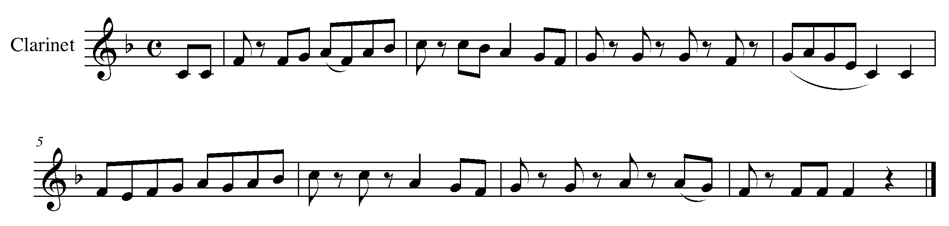

Task 15 Music Continued

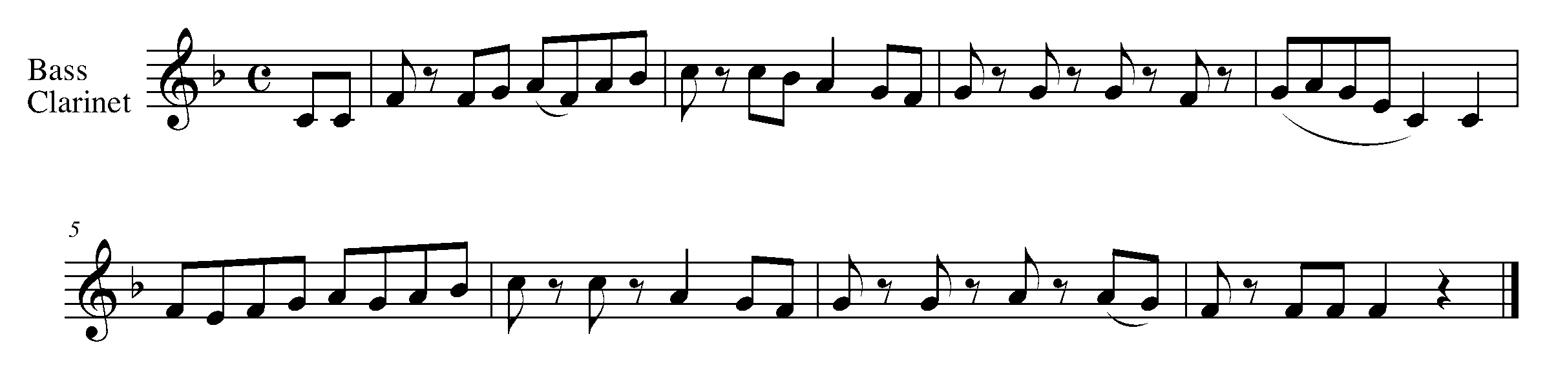
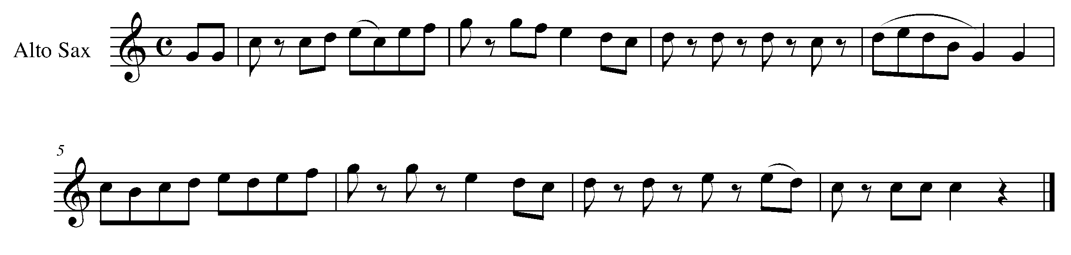
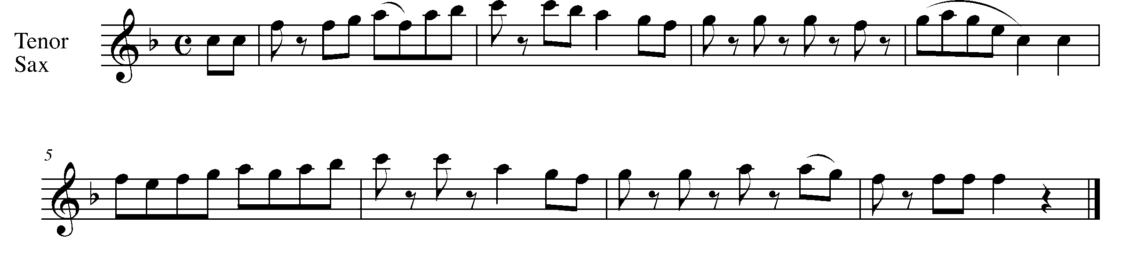
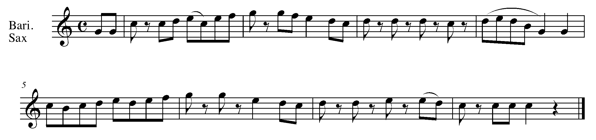
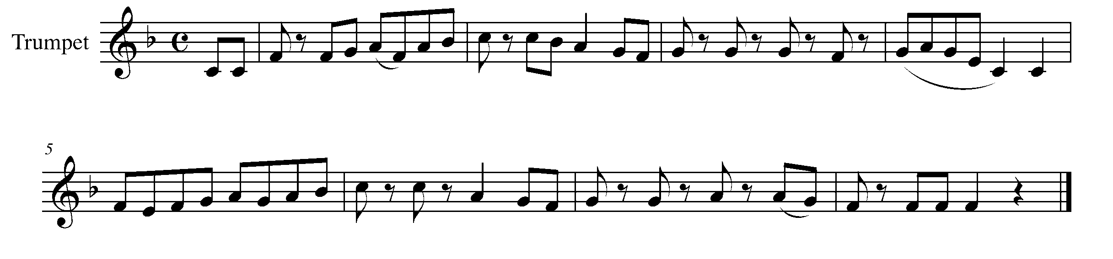

Task 15 Music Continued

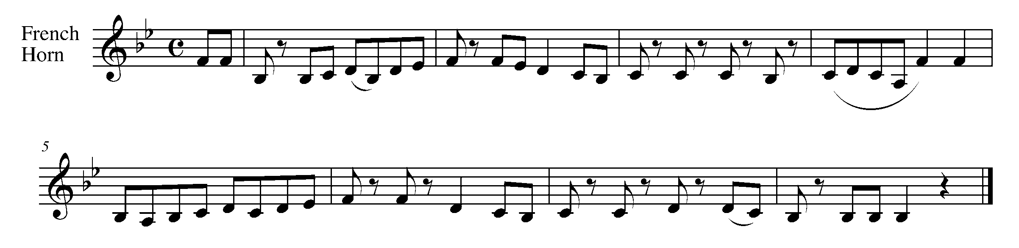
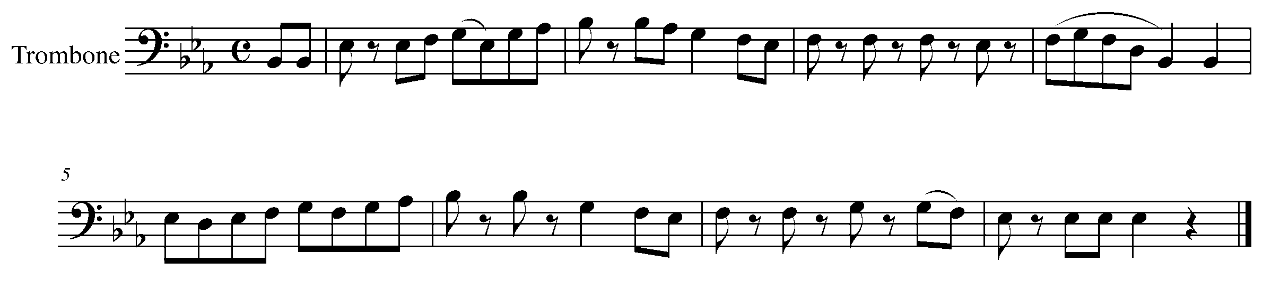
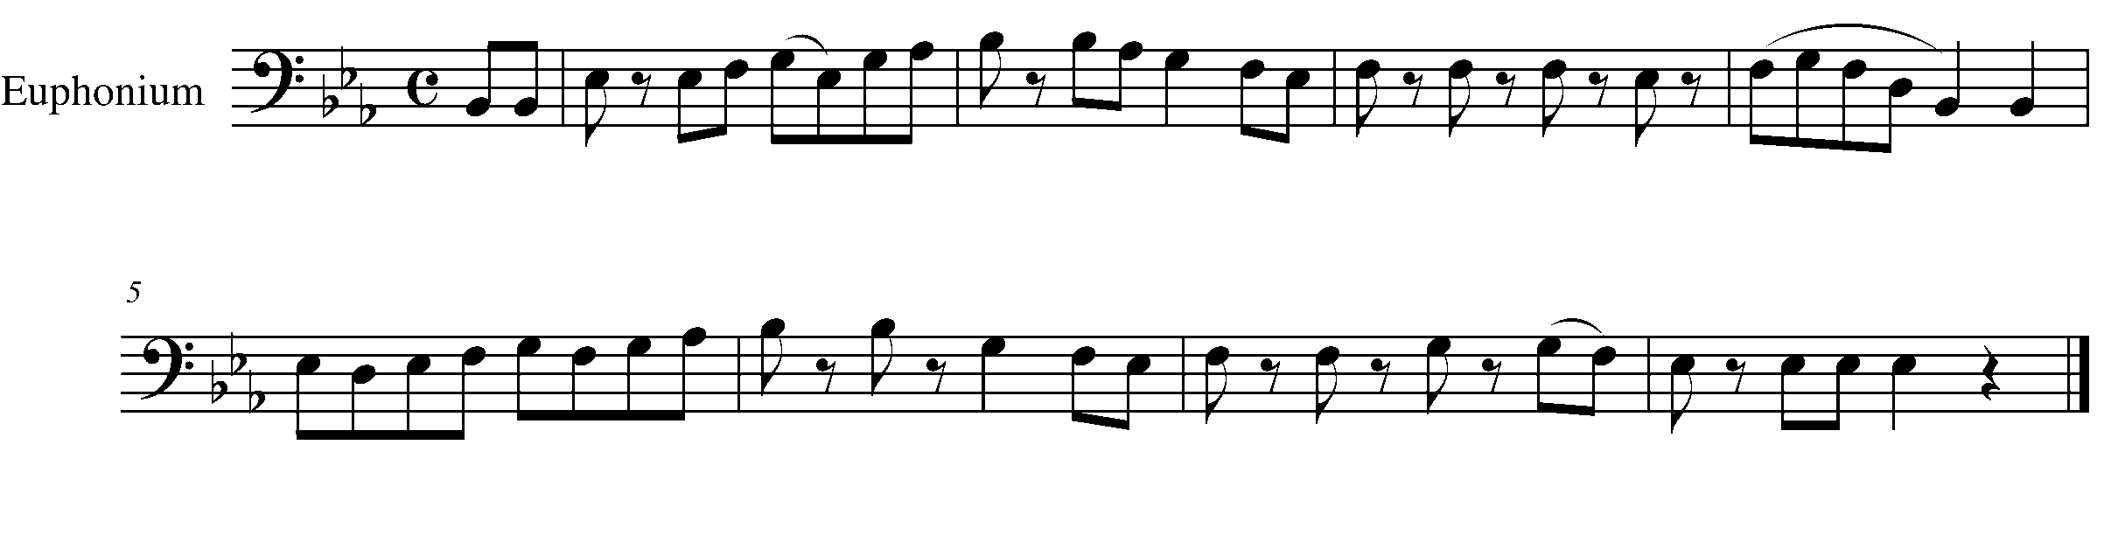
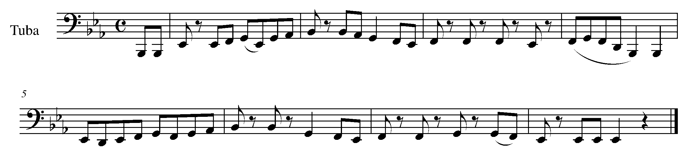
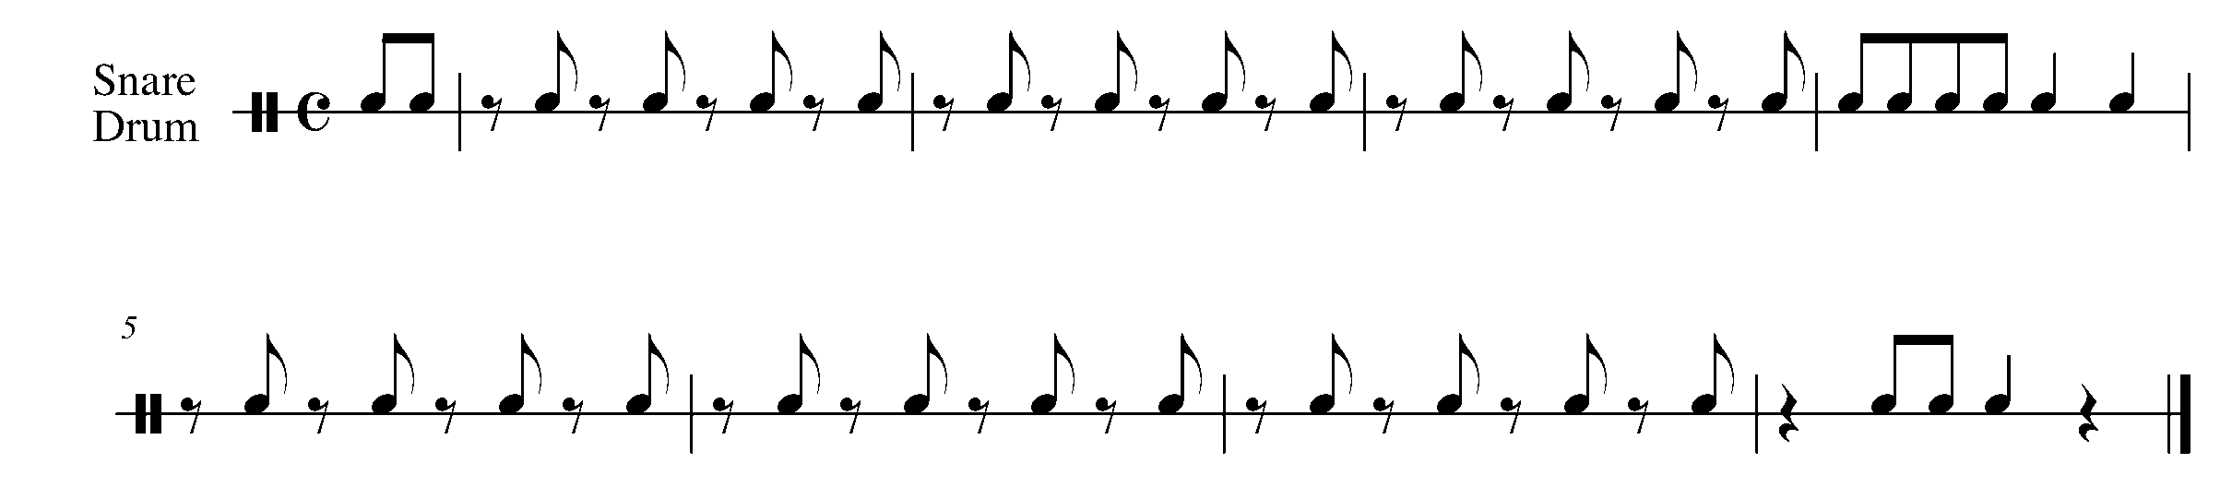

Task 15 Music Continued

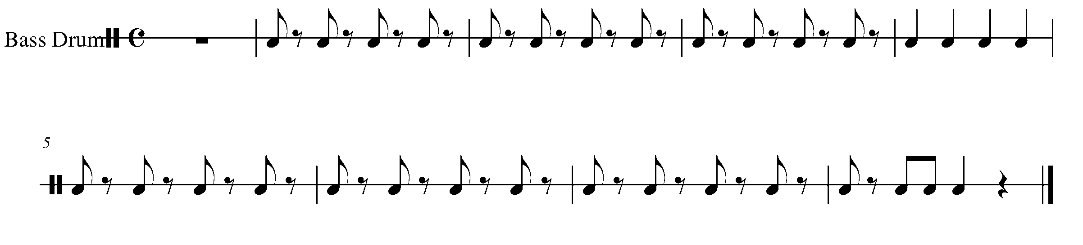
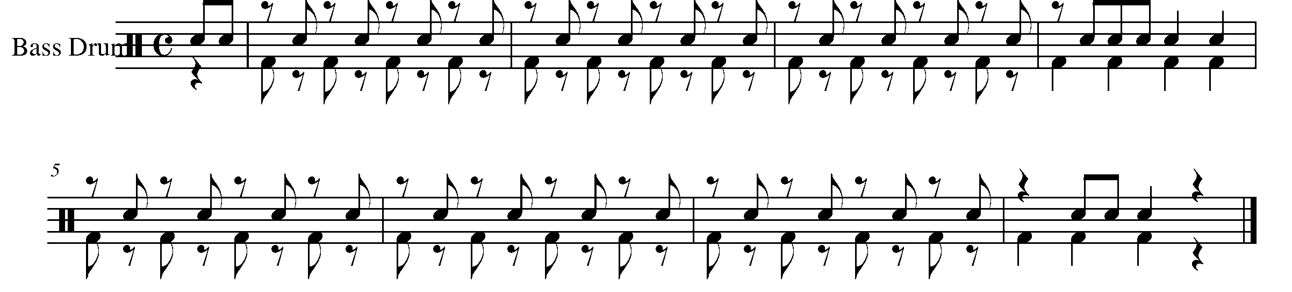

16. CREATING THE BLUES FOCUS: COMPOSITION
Wind Instruments and Mallets

LEARNING GOAL: You will now create your own melody to go with the 12-bar blues progression you wrote down in task 13. You can write your own rhythm and pitches or just add pitch to the rhythm below if you so choose.

MINDS ON! What should the melody of a 12-bar blues progression sound like? Are their certain notes you should start and end on? Knowing that you are given the harmony for this melody – what you write has to sound good with the given progression. How should you determine what notes might sound good with the given harmony?

ACTION! In order to be successful with this task, you will need to:

- Decide whether or not you would like to create your own 12-bar rhythm in the given space or use the standard rhythm found below.
- Decide what pitches will “work” with the given blues progression. Starting and ending with the tonic is a good place to begin.
- Work in pencil!
- Create a melody of 12 bars for your choice of rhythm and add it to the staff you prepared in Task 13.
- Make sure that you write a melody that you can play.

CREATE YOUR OWN RHYTHM

4_________________________________________________________________
4

4_________________________________________________________________
4

4_________________________________________________________________
4
STANDARD RHYTHM

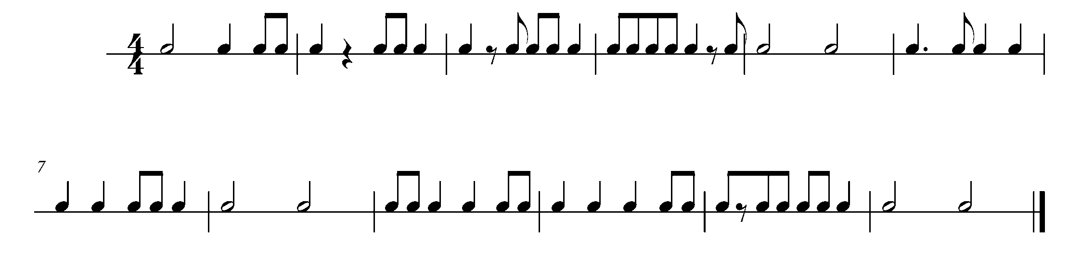

CONSOLIDATION: In order to move to the next task, you must show the above piece for your teacher and receive feedback.

17. SIXTEENTH NOTES FOCUS: RHYTHM
(Eighth note/sixteeth note for percussion) Wind Instruments and SD/BD/KIT

LEARNING GOALS: When performing four sixteenth notes, you are dividing one beat into four equal parts. In this task, you will learn to accurately perform sixteenth notes in combination with other known rhythms.

MINDS ON! How will you “speak” through sixteenth notes so that four even sounds happen within one beat? Percussionists: How do you count an eighth note paired with two sixteenth notes? Wind players: How will you articulate the sixteenth notes so that they are clean and accurate?

ACTION! In order to be successful with this task, you will need to:

- Think and count through the rhythm of the piece below.
- Choose a tempo which allows you to accurately perform the marked articulations, rhythms and notes.
- Demonstrate good posture and phrasing.

CONSOLIDATION: In order to move to the next task, you must perform the following piece for your teacher and receive feedback.

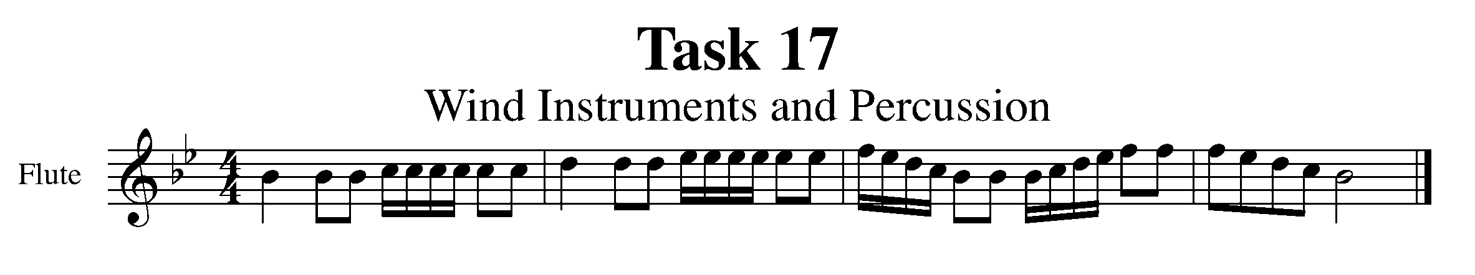
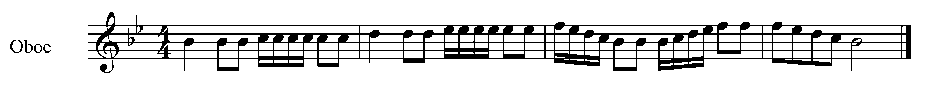
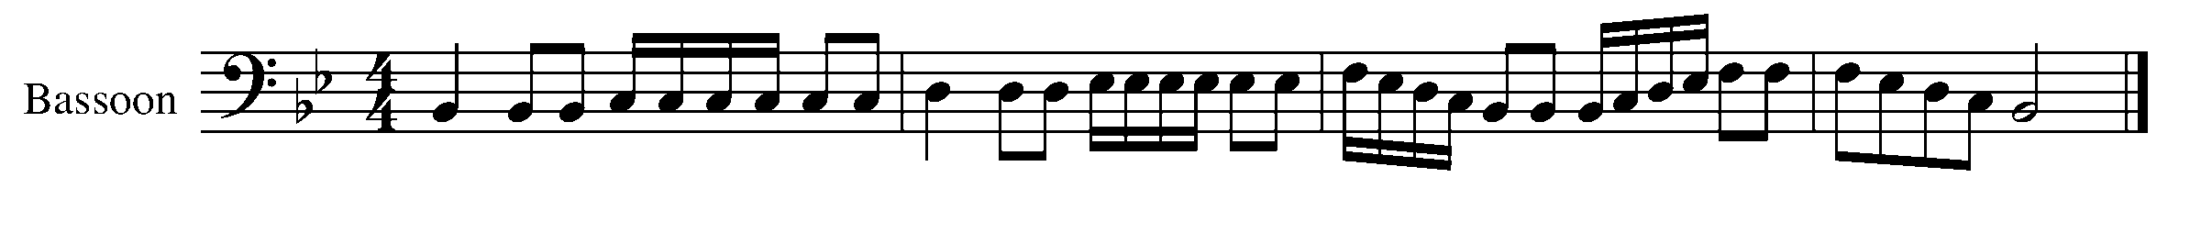
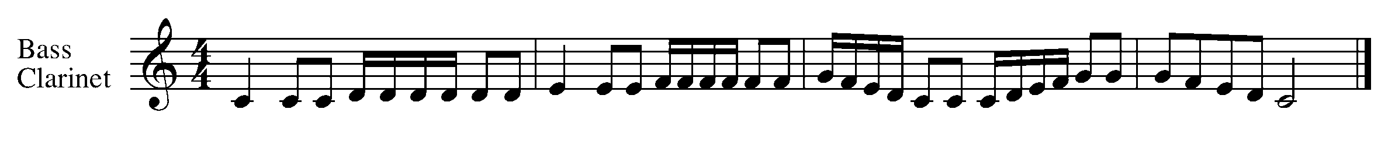
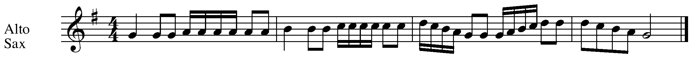
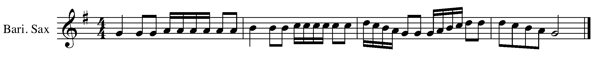
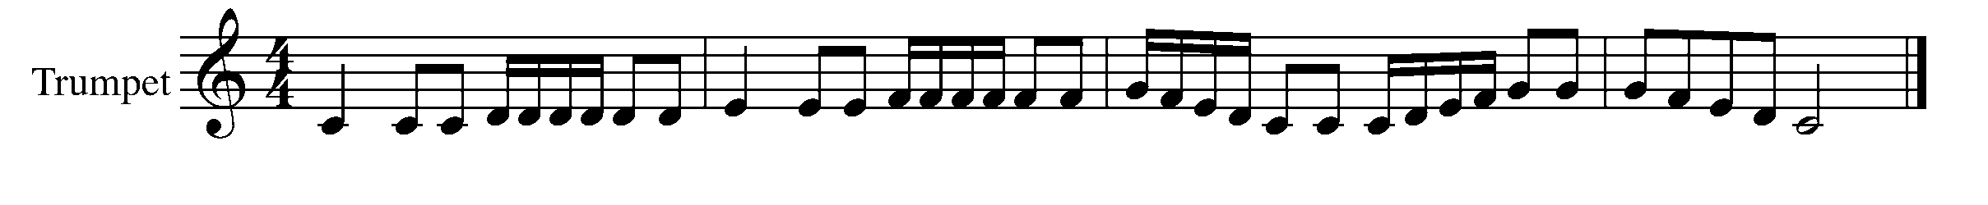
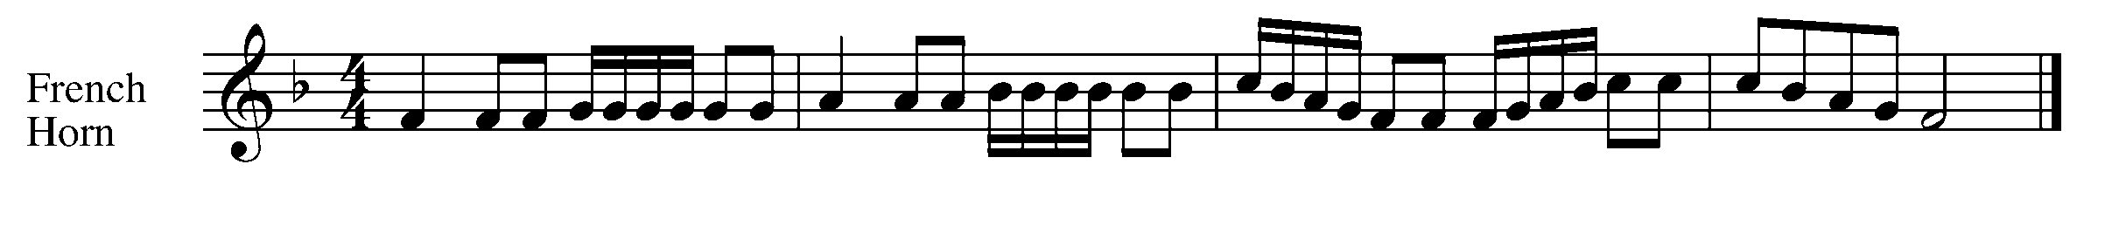
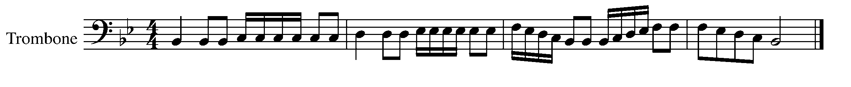
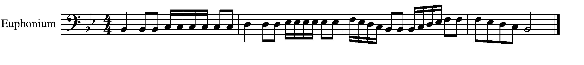

Task 17 Music Continued

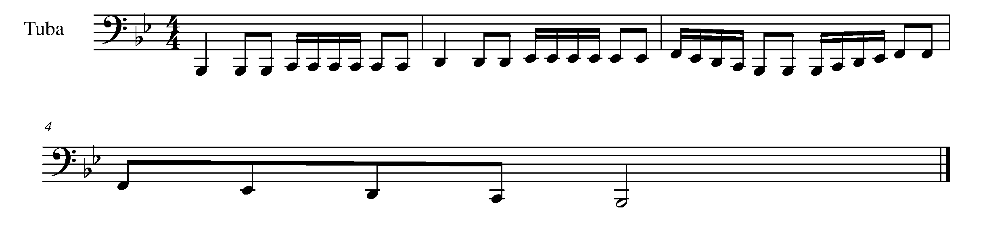
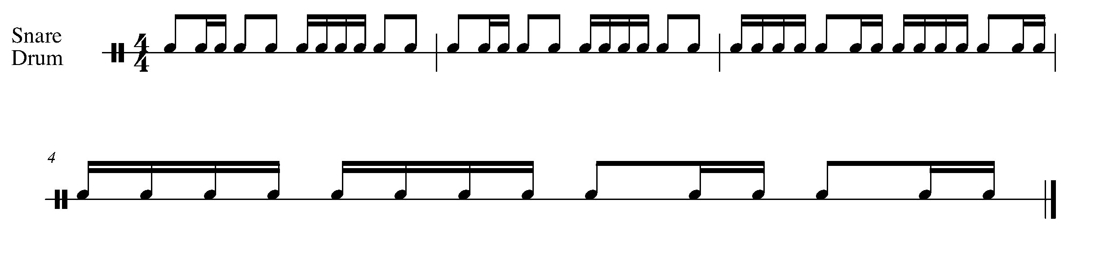
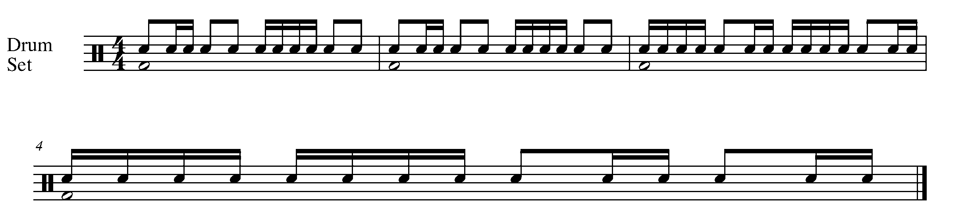

18. SHOWING OFF THE BLUES FOCUS: EXPRESSIVE CONTROLS
Wind Instruments and Mallets

LEARNING GOALS: During this task you will find a partner and perform the melody, which you have written in Task 16.

MINDS ON! With whom will you work well? Find a partner with whom you can communicate and practice. How will you and your partner go about preparing for this performance? How will you know when to start?

ACTION! In order to be successful with this task, you will need to:

- Practice the melody you wrote in task 16.
- Find a partner – your partner will play the Task 5 12-bar blues pattern for their instrument along with your melody.
- Practice with your partner before performing your composition for your teacher.

CONSOLIDATION: In order to move to the next task, you must perform the following piece for your teacher and receive feedback.

19. FINAL EXPRESSIONS FOCUS: EXPRESSIVE CONTROLS
Wind Instruments and SD/BD/KIT

LEARNING GOALS: This task will have you apply many of the concepts that you have performed throughout the GPS program.

MINDS ON! How will you perform all of the markings in the below piece? Over the course of the GPS program, you have performed a variety of expressive controls. How will you apply what you have learned to the following piece?

ACTION! In order to be successful with this task, you will need to:

- Choose a tempo that results in consistency and success.
- Demonstrate good posture and breath control.
- Apply the marked articulation and dynamics.

TASK 19 MUSIC IS FOUND ON THE NEXT PAGE

CONSOLIDATION: In order to move to the next task, you must perform the following piece for your teacher and receive feedback.

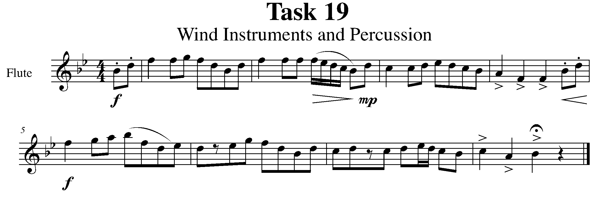

Task 19 Music Continued

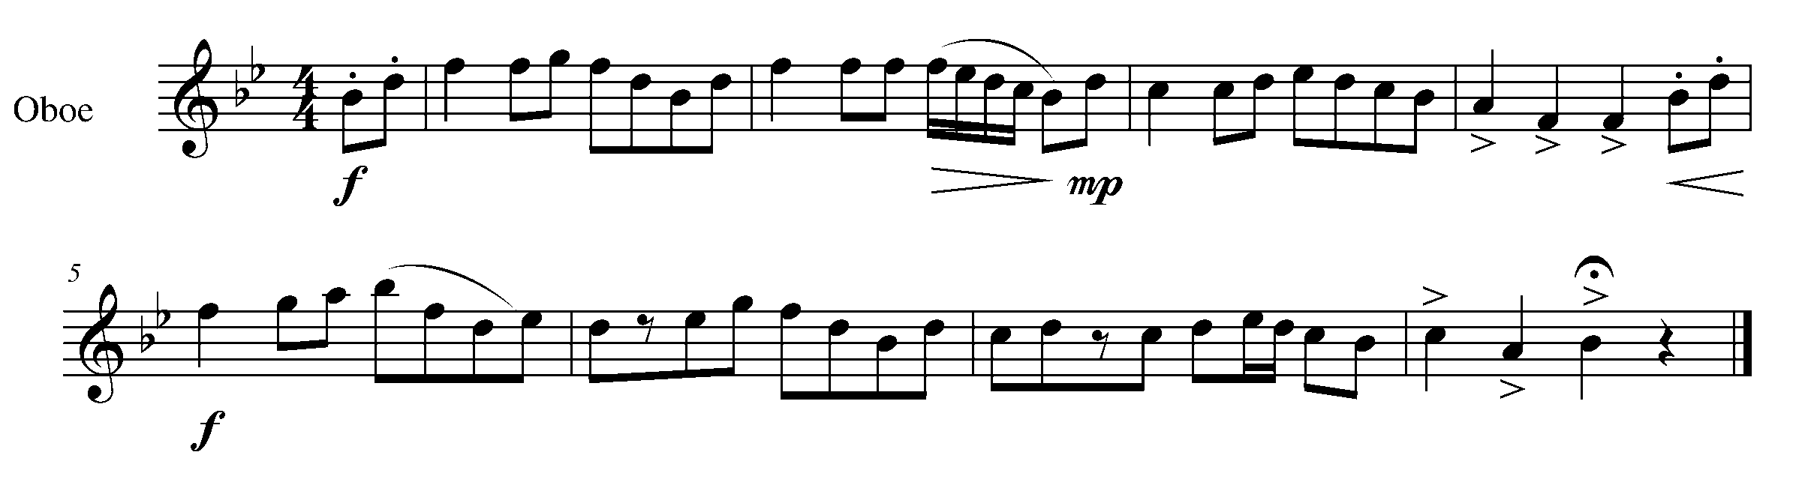
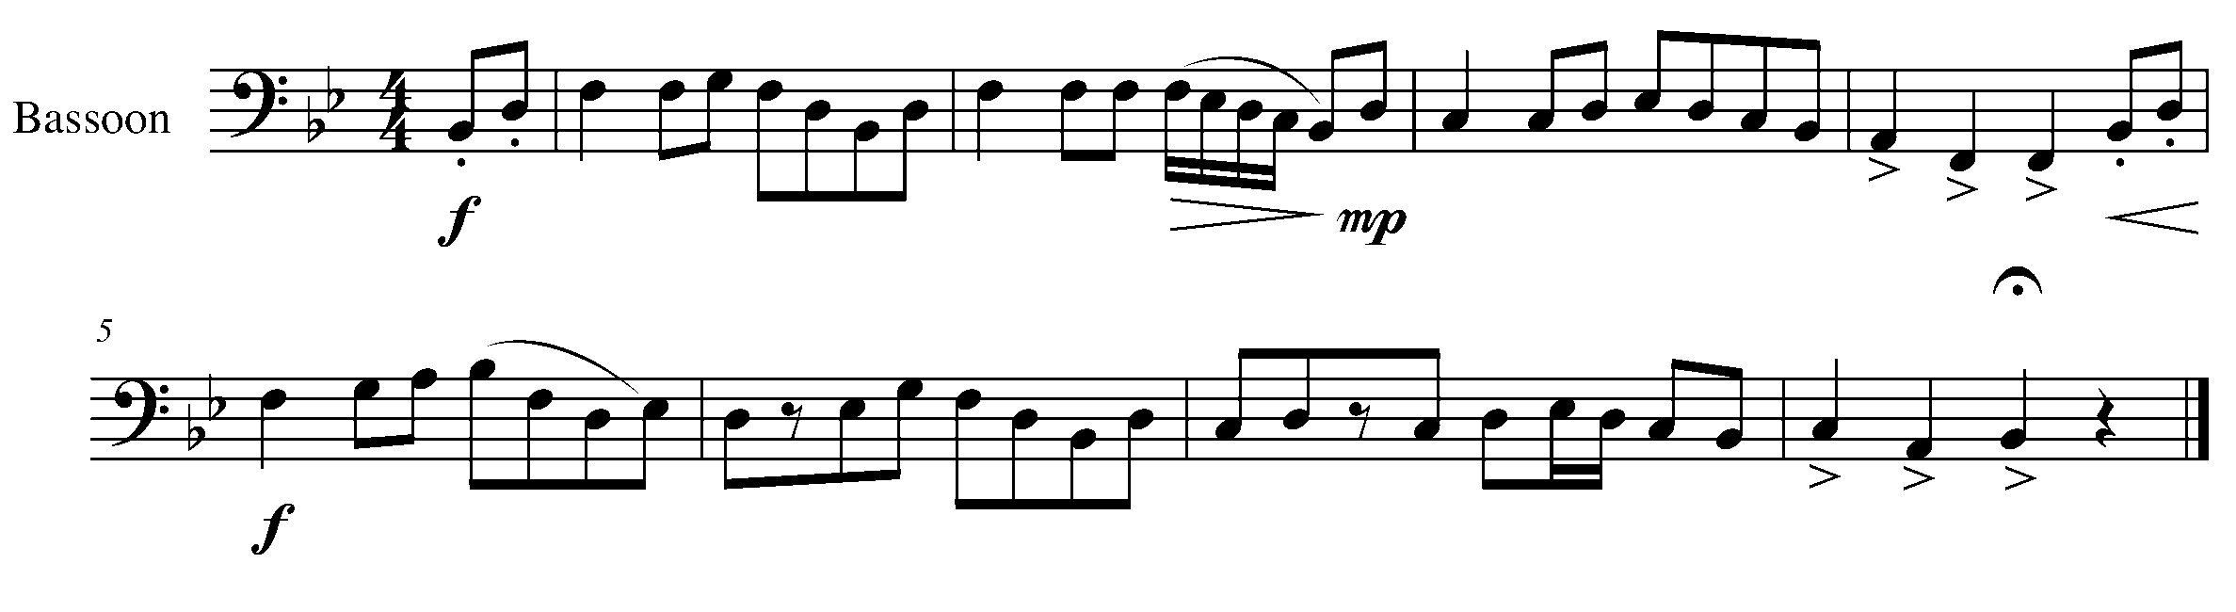
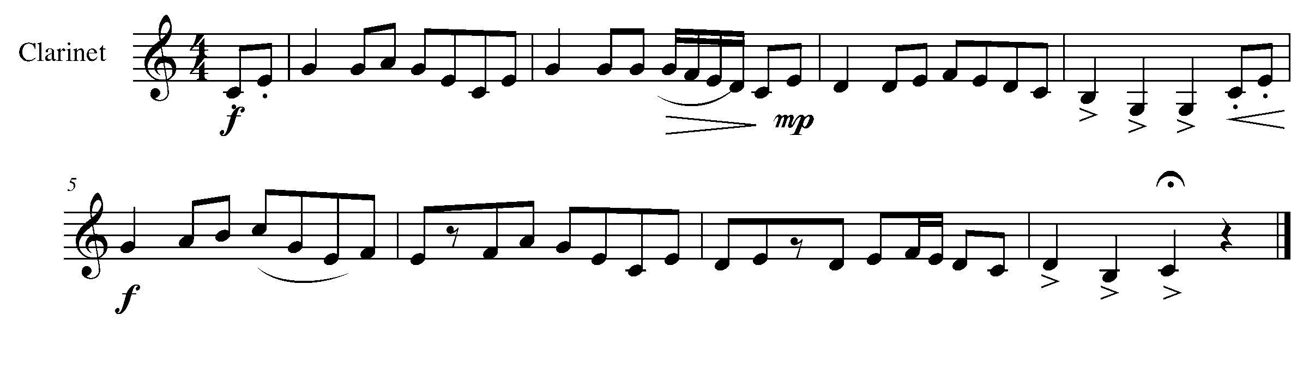
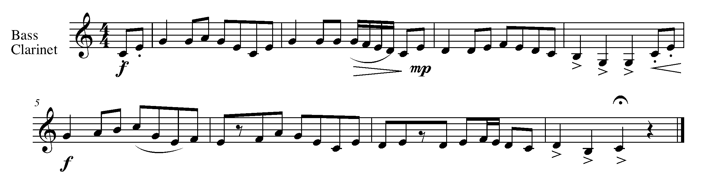
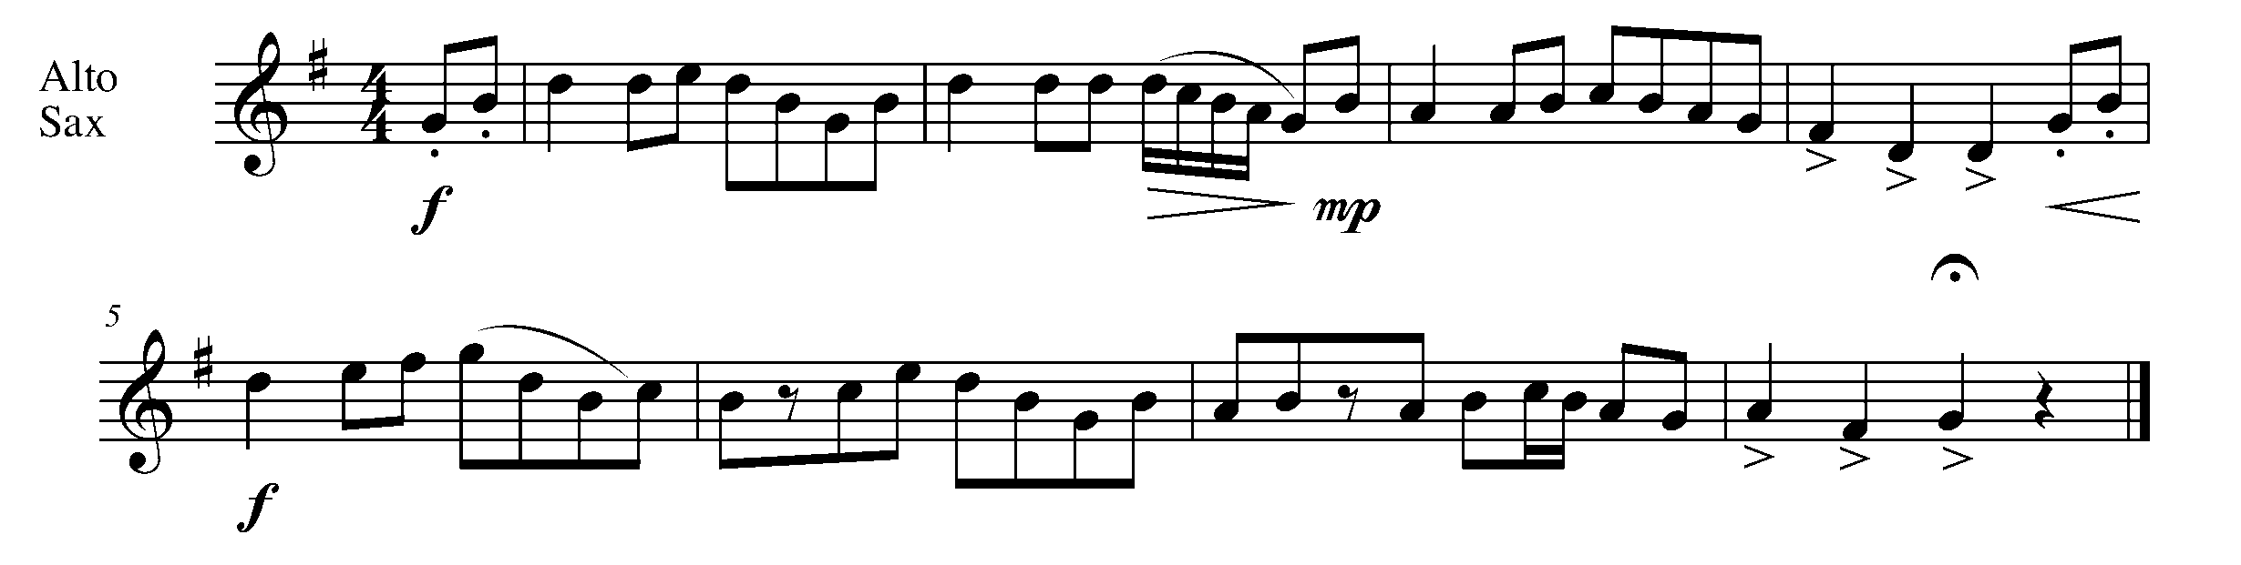

Task 19 Music Continued
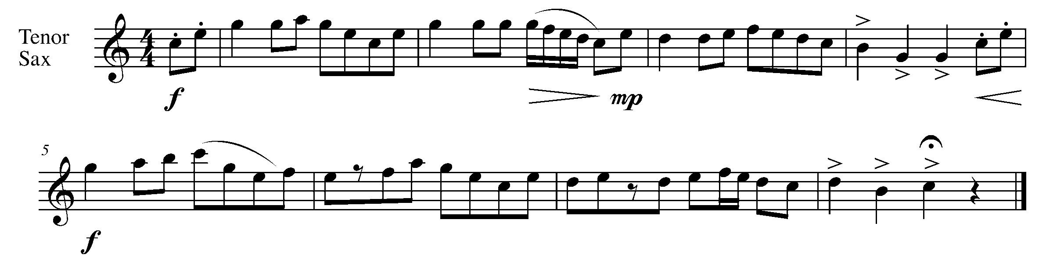
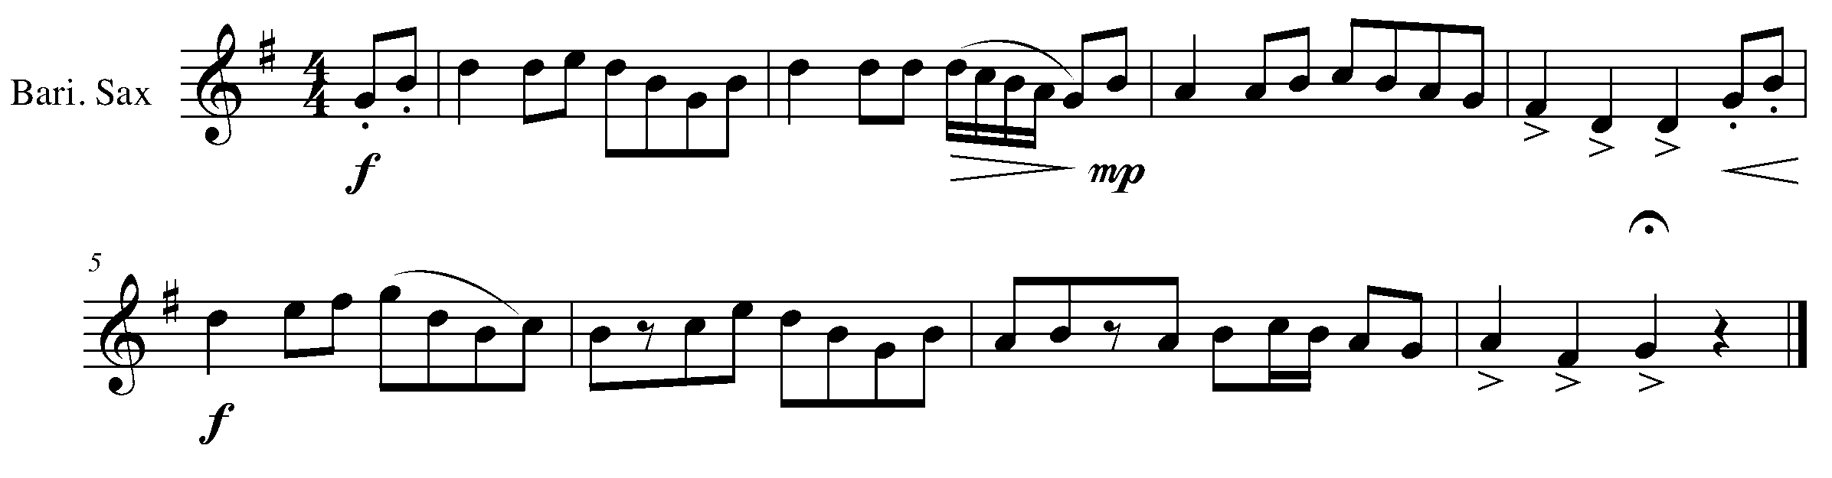
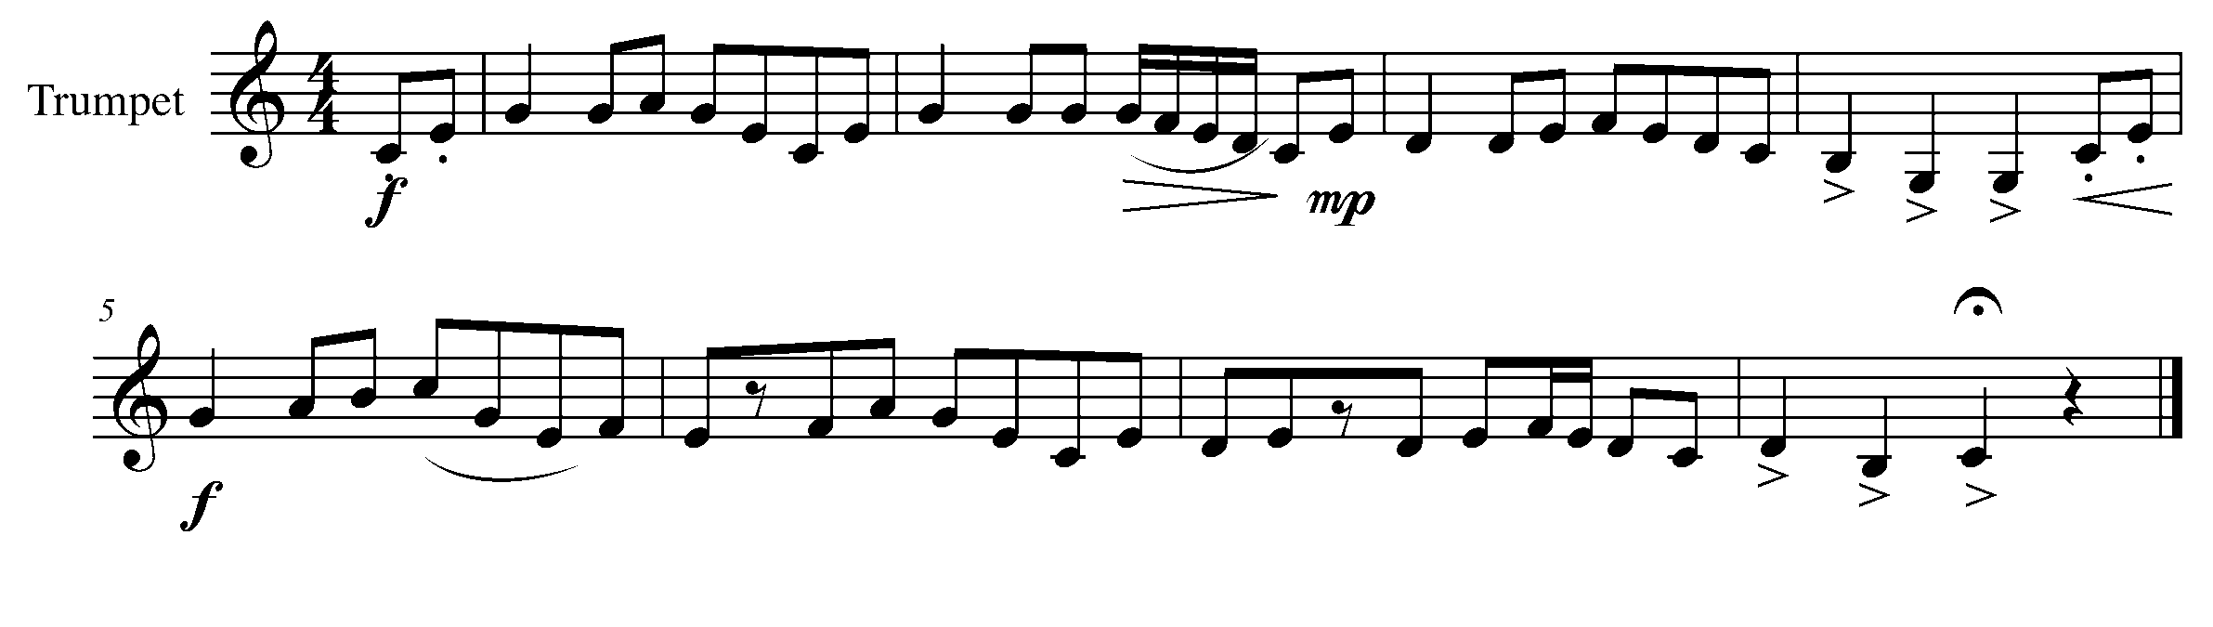
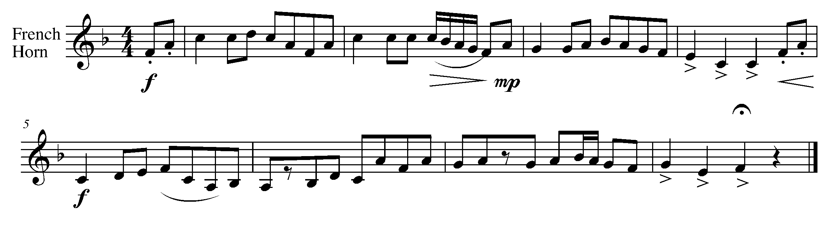

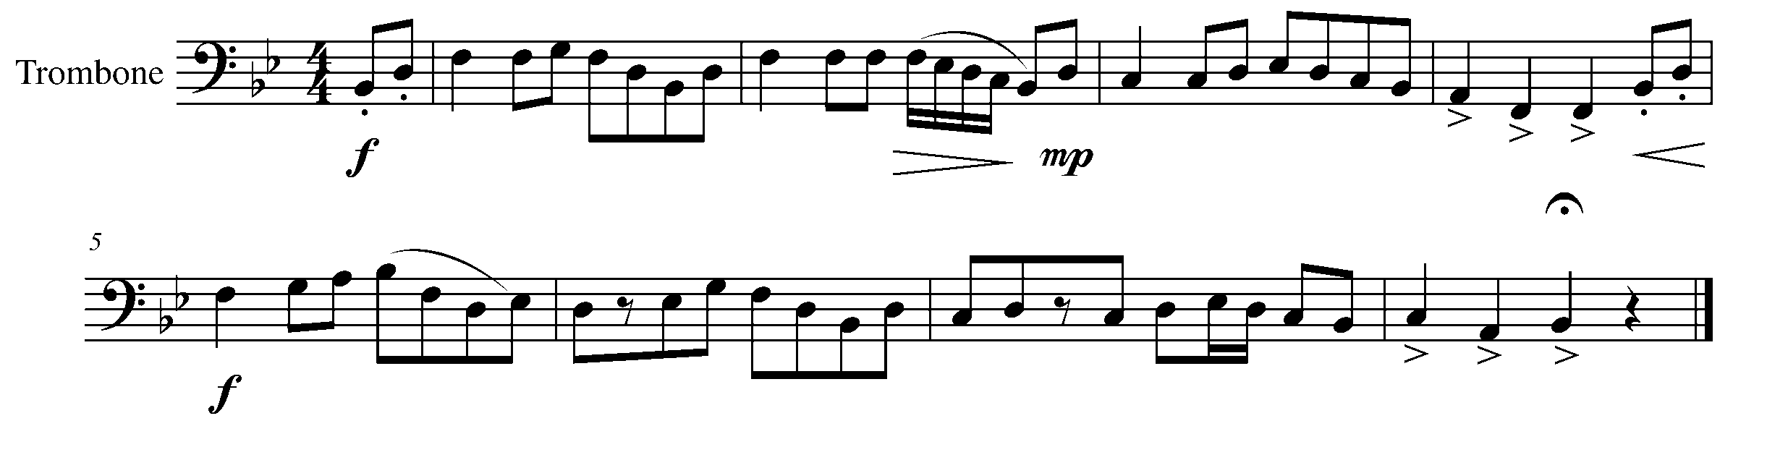

Task 19 Music Continued

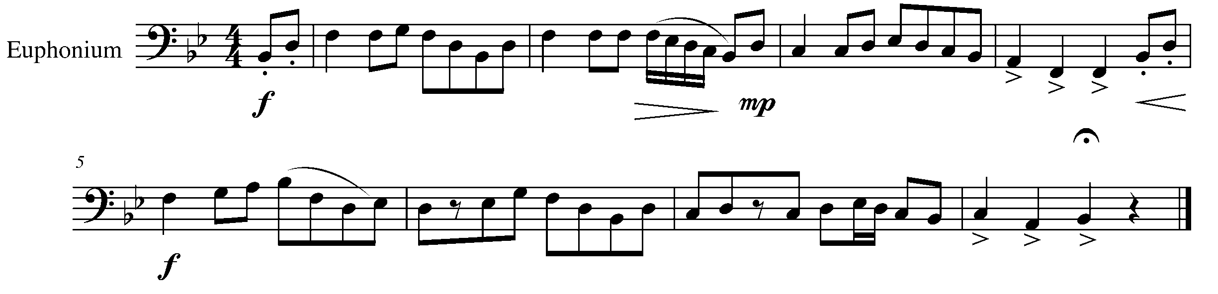
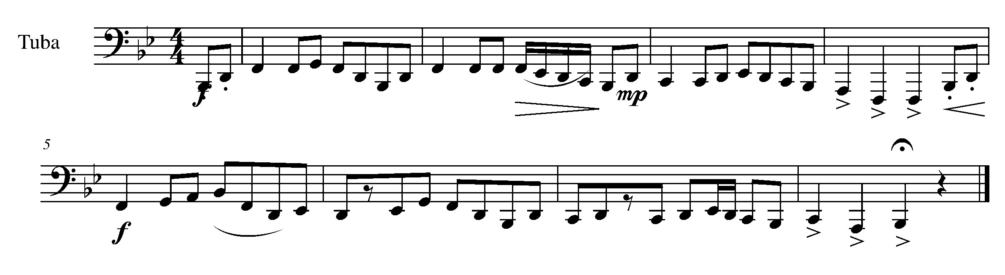
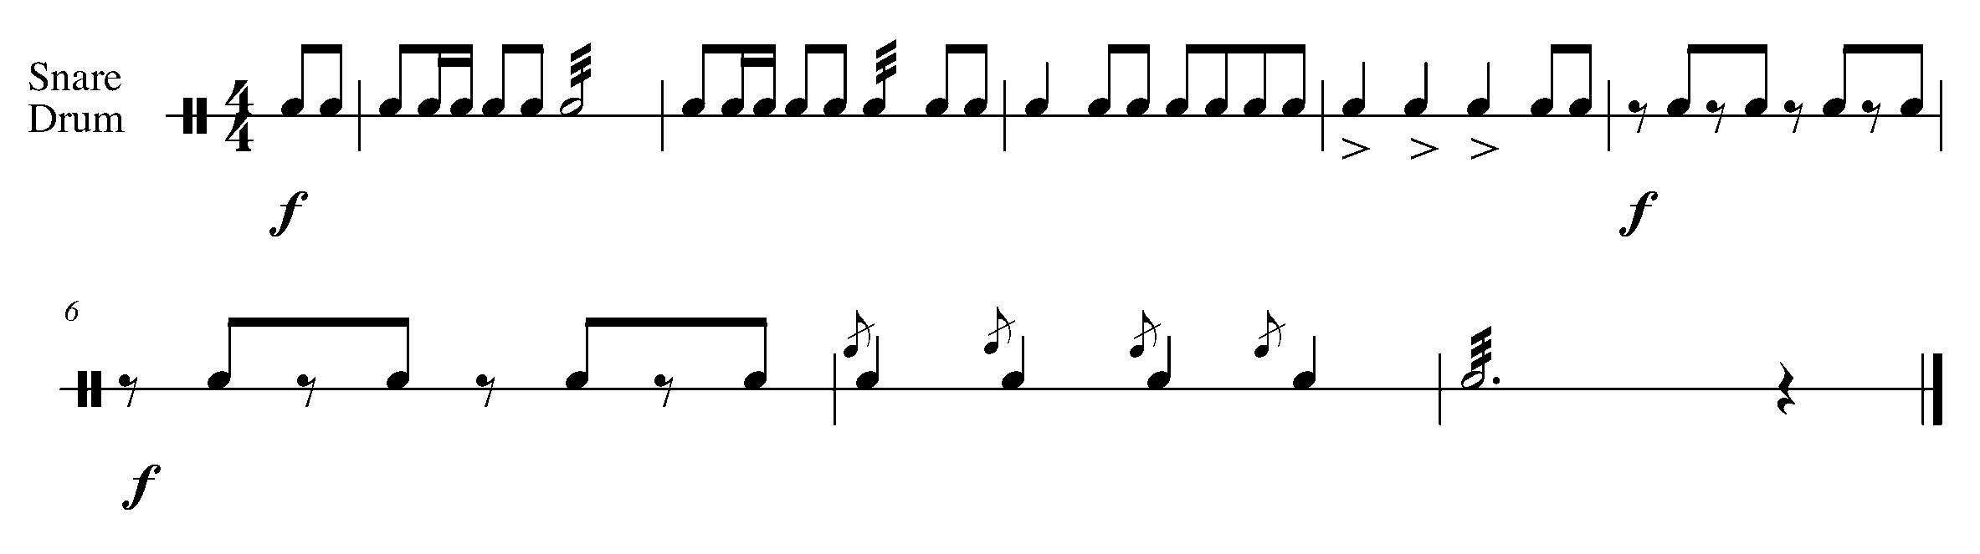
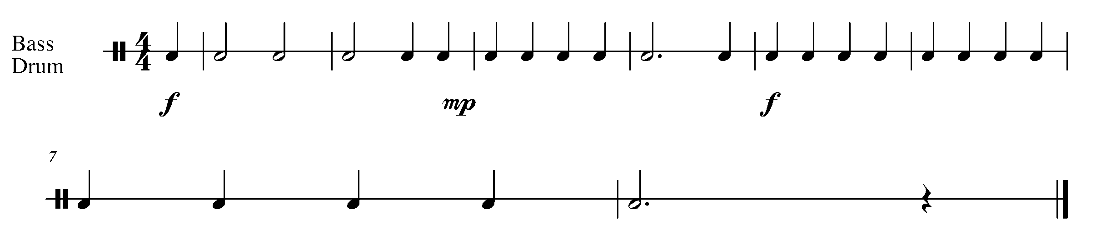

20. THE FINISH LINE! FOCUS: CULMINATING TASK
Wind Instruments, Mallets and SD/BD/KIT

LEARNING GOALS: This task will have you prepare the pieces from tasks 18 and 19 to be performed in front of either a small group or class.

MINDS ON! What musicianship skills do you need to demonstrate in a performance? How will you introduce your pieces to the class? Where will you sit/stand? Will you answer questions after the performance?

ACTION! In order to be successful with this task, you will need to:

- Arrange with your teacher and partner an audience for which you will perform.
- Prepare the pieces from task 18 and 19.
- Create an introduction for your performance which includes your song titles, performers’ names and, if necessary, your instruments.

CONSOLIDATION: Perform the pieces from task 18 and 19 for your audience.

CONGRATULATIONS!! YOU HAVE REACHED THE FINAL GPS MARKER – WEST!

CELEBRATE YOUR ACCOMPLISHMENTS WITH YOUR FAMILY OR A PEER!

North
East
South
West
Task # 3
Task # 1
Task # 2
Task # 4
Task # 6
Task # 7
Task # 8
Task # 9
Task # 13
Task # 12
Task # 11
Task # 14
Task # 18
Task # 17
Task # 16
Task # 19
Task # 20
Task # 5
Task # 10
Task #15
TASK TRACKER

Congratulations!

__________________ has reached the North GPS Marker in the 2nd Year Band Program.

_________________________________
Teacher Signature

_________________________________
Principal Signature

Congratulations!

_________________ has reached the East GPS Marker in the 2nd Year Band Program.

_________________________________
Teacher Signature

_________________________________
Principal Signature

Congratulations!

__________________ has reached the South GPS Marker in the 2nd Year Band Program.

_________________________________
Teacher Signature

_________________________________
Principal Signature

Congratulations!

__________________ has reached the FINAL (West) GPS Marker in the 2nd Year Band Program.

You’re Done!!

_________________________________
Teacher Signature

_________________________________
Principal Signature

