Teachers, before you copy this booklet for your students...
⬰ Have you read the GPS Overview?
⬰ Have you taught these students before? If not, please take the time to work with your students to determine their strengths and needs before deciding which tasks will be appropriate.
⬰ Have you gone through the appropriate start-up steps with your students? For example; the basics on setting up their instrument, care and maintenance of their instrument, posture and bow grip.
⬰ If you have taught these students before...go through the entire program task-by-task to confirm that the sequence and challenge level of the tasks, is appropriate.
⬰ Refer to the Q and A section of the GPS Overview.
⬰ Do you need to reduce the number of tasks...how will you need to change the evaluation by term?
⬰ If you have questions, please contact:
Justina So: justina_so@yahoo.ca

GPS Task Evaluation Chart
TEACHER REFERNCE
Year One Strings

This is assuming that this program starts in late October early November

Tasks  (Completion of “X” task number equals “Y” %) | Term 1 (September to February) | Term 2 (February to June)
1 | 52% | 32%(R)
2 | 55% | 35%(R)
3 | 58% | 38%(R)
4 | 62% | 42%(R)
5 | 65% | 45%(R)
6 | 68% | 48%(R)
7 | 72% | 52%
8 (taught to) | 75% | 55%
9 | 78% | 58%
10 | 82% | 62%
11 | 88% | 65%
12 | 92% | 68%
13 | 98% | 72%
14 (taught to) | 100% | 75%
15 |  | 78%
16 |  | 82%
17 |  | 88%
18 |  | 92%
19 |  | 98%
20 |  | 100%

Tasks 15 to 20 serve as extensions and culminating activities which encompass the concepts learned or introduced in Tasks 1 to 14. What you must teach are the 14 tasks by the end of the year.

GPS
(Grade Performance Steps)

The Road to Musical Success!

Intermediate Strings Performance Tasks
YEAR ONE




Ontario Music Educators’ Association
www.omea.on.ca

GPS Task Evaluation Chart
GPS Task STUDENT Evaluation Chart
Year One String

In order to be successful this year, you will need to plan out how many tasks you think you can complete, and the mark you want to receive for performing on your instrument! Below is a summary of the number of tasks per term, and the mark you will receive for the tasks you complete:

Tasks  (Completion of “X” task number equals “Y” %) | Term 1 (September to February) | Term 2 (February to June)
1 | 52% | 32%(R)
2 | 55% | 35%(R)
3 | 58% | 38%(R)
4 | 62% | 42%(R)
5 | 65% | 45%(R)
6 | 68% | 48%(R)
7 | 72% | 52%
8( taught to) | 75% | 55%
9 | 78% | 58%
10 | 82% | 62%
11 | 88% | 65%
12 | 92% | 68%
13 | 98% | 72%
14 (taught to) | 100% | 75%
15 |  | 78%
16 |  | 82%
17 |  | 88%
18 |  | 92%
19 |  | 98%
20 |  | 100%
Performance is just one part of your Music evaluation this year. Your teacher will let you know what the other aspects of your program are on your two summative report cards.

Remember that with the GPS tasks:
- we will be learning concepts introduced as a class;
- you will have time in class to practice and receive feedback from your teacher and classmates;
- you will have multiple opportunities to demonstrate these tasks;
- you need to demonstrate at least a Level 3 performance (your teacher will talk with you about what a Level 3 demonstration would sound like);
- in order to be successful, you will need to work independently in class, and outside of class time (recess, lunch, after school and practice at home); and
- you can track your progress with the task tracker found at the end of the booklet.

GPS Year One Strings

1. FUN WITH PIZZICATO FOCUS: BEAT

Learning Goal: You will explore the open strings on your instrument and have proper playing position while playing pizzicato on each string.

Minds on: How do you make sure you have an effective playing position? Why do you think that this might be important as a string player to practice on open strings? Even professionals are constantly revising how they hold their instrument to refine their playing. This activity should be part of your practice routine.

Action! In order to be successful with this task, you will need to:
- Place your thumb behind the heel of the neck, and place your fingertips squared on the shoulder of your instrument;
- Play pizzicato (pizz) on all of your open strings starting with the lowest pitched strings to familiarize yourself with the positions and sounds of the strings;
- When you become familiar, pizz in half notes while keeping beat by moving your toes inside your shoes. (e.g. Violin and Double Bass players: G G, D D, A A, E E, A A, D D, G G; Viola and Cello players: C C, G G, D D, A A, D D, G G, C C); and
- Pizz over the fingerboard of your instrument.

Consolidation: We will be playing this in class as a warm-up. When you are ready, perform this for your teacher to receive feedback.

2. THE FIRST THREE NOTES FOCUS: PITCH/RHYTHM

Learning Goal: You will apply your knowledge of the first three notes of the D major scale, use notation, and perform “Hot Cross Buns” in pizzicato.

Minds On! When encountering a new piece, why is it important to first scan the entire piece before playing? Don’t forget to maintain good posture while moving forward on to more difficult music.

Action! In order to be successful with this task, you will need to:
- Understand the value of the half note (2 beats), quarter note (1 beat), and eighth note (1/2 beat);
- Scan the music for patterns;
- Demonstrate good posture;
- Play this example pizzicato; and
- Be sure to listen carefully and adjust your fingers to make sure you are in tune while performing this task.

Hot Cross Buns
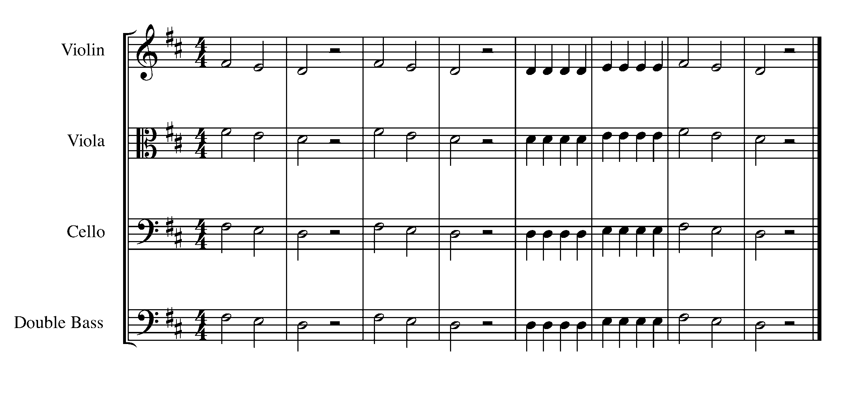
Consolidation: Perform “Hot Cross Buns” for your teacher to receive feedback.

3. BOW GRIP FOCUS: BEAT/RHYTHM

Learning Goal: You will perform arco on each open string while having correct bow grip and posture.

Minds on: How do you make sure you have a correct bow grip? How would an incorrect bow grip limit your playing? How would an incorrect playing position affect your sounds? Why do you think it might be important as a string player to practice on open strings? Even professionals are constantly revising their bow grip and how they hold their instrument to refine their playing. This activity should be part of your practice routine.

Action! In order to be successful with this task, you will need to:

- Check your bow grip and playing position in a mirror. Get a friend or your teacher to check on you as well.
- Play each string of your instrument, starting with the lowest string. Play each note for two beats both down-bow and up-bow using the entire bow. Move your toes into your shoes twice for each bow stroke.
- Keep your shoulder and elbow relaxed. Use the weight of your entire arm to draw the sound from your instrument.
- Keep your bow parallel to the bridge.
- Play with your bow at least half way between the bridge and the fingerboard.

4. KEEPING FINGERS DOWN FOCUS: RHYTHM/BEAT

Learning Goal: You will perform “Mary Had a Little Lamb” along with the written rhythms while tapping a steady beat with your toes inside your shoes.

Minds On! What is the purpose of keeping fingers down? How does moving our big toe inside our shoes help us keep a steady beat, especially when there is a rest? Legato bowing for a string player means that you make a smooth transition with your bow when you change from down- to up-bow or vice-versa.

Action! In order to move to the next task, you will need to:
- Demonstrate your understanding of the values of a quarter note (1 beat), and eighth note (1/2 beat);
- Scan the music for patterns;
- Have good posture and bow grip;
- Use continuous bow speed with good sound;
- Make sure that your bow is parallel to the bridge;
- Watch your bowing level when crossing strings; make your string crossing a smooth transition by having your bow lean towards the D string as you play the open A;
- Violin, viola, and cello players should remember to keep fingers down on D string while playing on open A string; and
- Move your toe inside your shoe.

Mary Had a Little Lamb
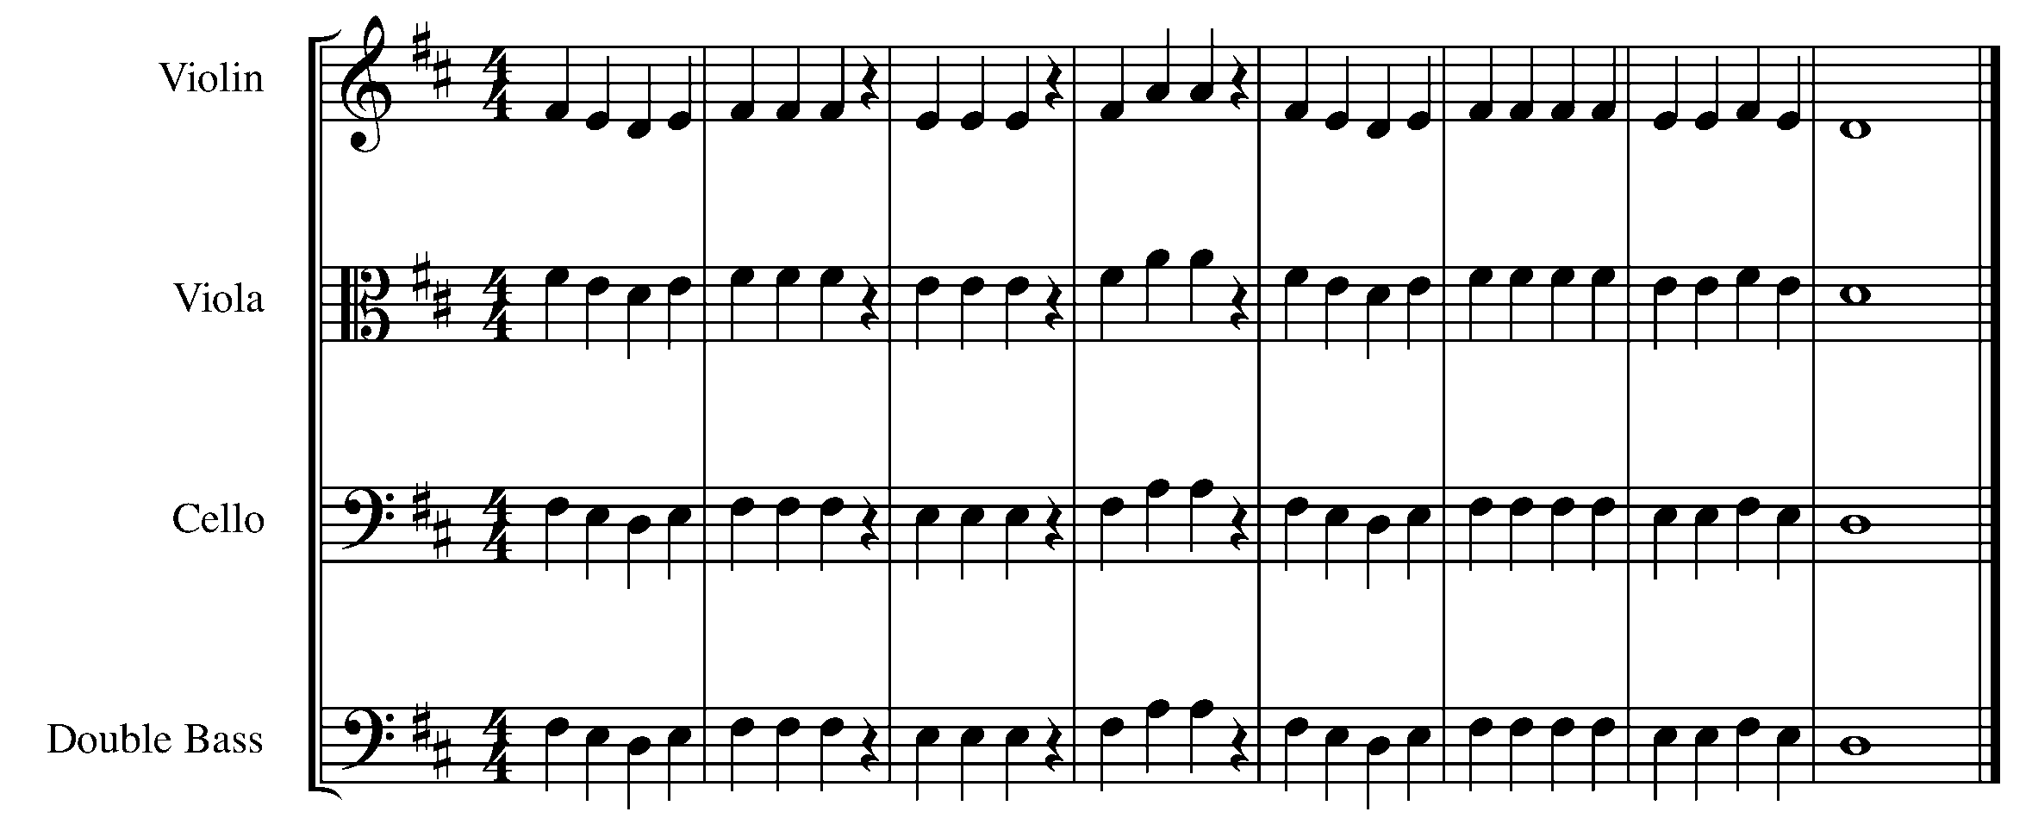

Consolidation: Perform this task first pizzicato, then arco for your teacher AND then complete the self-reflection to receive feedback.

SELF-REFLECTION (Task 4):

When working on this task, I was good at… _______________________________________
____________________________________________________________________________________________________________________________________________________

In order to be better on my next task, I should focus on ... ____________________________
____________________________________________________________________________________________________________________________________________________

5. THE GREAT COMPOSITION BEGINS! FOCUS: NOTATION

Learning Goal: You are going to start setting up your own composition. This composition will be set up in stages throughout the GPS tasks.

MINDS ON! Where does the clef sit on the staff? Where does the time signature sit? Do you need to insert any flats or sharps so that your composition will be in the key of D major?

ACTION! Before you begin this task you need to:

- Look at other samples of music and determine what symbols are needed to set up a piece of music;
- Practice drawing your appropriate clef on the staff; and
- USE A PENCIL – you may need to move things around when you enter notes later.

In order to move to the next task, you need to place the following items on the staff below and have it checked by your teacher:

- A treble clef or bass clef or alto clef (the one that is appropriate for your instrument);
- A 4/4 time signature;
- The appropriate key signature for D major;
- Create 8 empty bars of music – you will put in the note and rhythms later; and
- A double bar line at the end of the piece.

__________________________________________________________________________________________________________________________________________________________________________________________________________________________________________________________________________________________________________________________________________________________________________________

__________________________________________________________________________________________________________________________________________________________________________________________________________________________________________________________________________________________________________________________________________________________________________________

CONSOLIDATION: Show this task for your teacher to receive feedback.

CONGRATULATIONS! YOU HAVE REACHED YOUR FIRST GPS MARKER – NORTH!
ASK YOUR TEACHER HOW YOUR ARE TO ACKNOWLEDGE THIS ACCOMPLISHMENT ON YOUR GPS TASK TRACKER!

6. LET’S HEAR YOU FOCUS: BEAT

Learning Goal: You will play a long tone on an open string of your teacher’s choice for 10 seconds.

Minds On! Why is playing with your entire bow important for string players? Why is having even bow speed important? How do you retain an even sound on a stringed instrument?

Action! In order to be successful with this task, you will need to:

- Focus on the how you start your note. Have the feeling like your arm is already in motion before your start your down-bow.
- Keep your shoulder, neck, elbow, and bow grip relaxed. Use the weight of your entire arm to draw the sound from your instrument. Keep everything relaxed.
- Use even bow speed. You need to keep an even bow speed, planning out 1/10 of the bow for each second on the clock.
- Practice your 10-second long tone both up-bow and down-bow many, many times on every open string until your bow speed, sound quality, and relaxation are consistent.
- Sustain a great sound for 10 seconds both down-bow and up-bow (no squeaking). Remember that second “10” does not stop until you would count second “11”.
- Apply rosin on your bow so that the entire length of the hair is a “frosty” white if needed.

You should play this example, mezzo forte mf (moderately loud). We will talk about how to play with different dynamics in class.

Consolidation: Perform a 10-second long tone both up-bow and down-bow on any open string of your teacher’s choice to receive feedback before going on to the next task.

7. PUTTING IT ALL TOGETHER FOCUS: PITCH/BEAT/RHYTHM

Learning Goal: You will perform the D major scale in a variety of 4/4 time rhythmic patterns while keeping a steady beat by moving your big toe inside your shoes.

Minds On! Why is having fluency on scales useful as a musician?

Action! In order to move on to the next task, you will need to:
- Perform the D major scale ascending and descending in:
  - Half notes;
  - Quarter notes;
- If you want a challenge, try the scale in eighth notes and in syncopated jazz rhythmic pattern;
- Demonstrate good intonation; and
- Use great sound quality, make smooth connections between each bow change, and make sure that your bow change and placement of your finger are coordinated.

D Major Scale
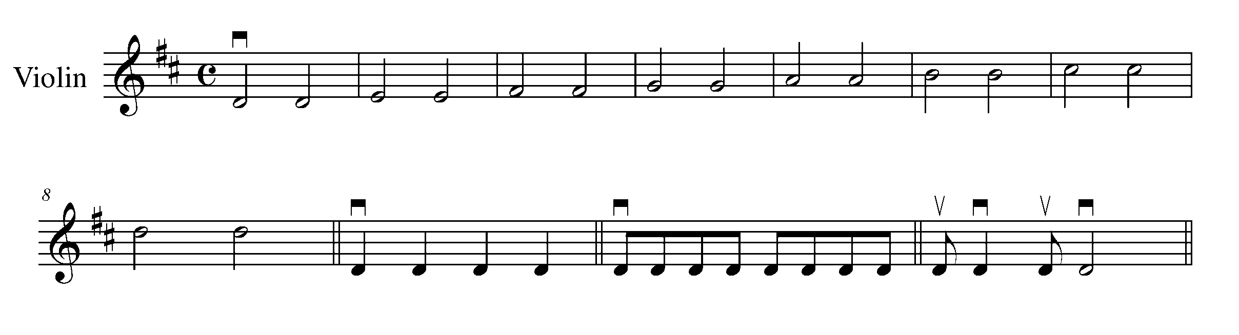
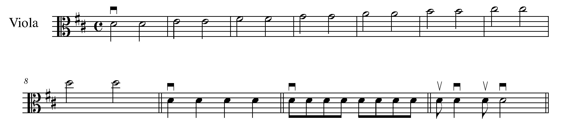
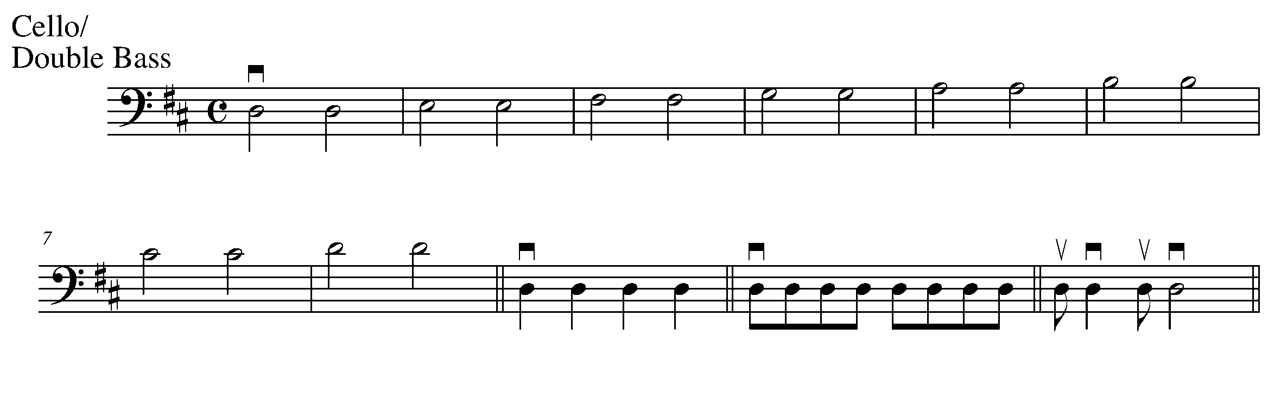
Consolidation: Perform your D major scale in the rhythmic pattern of your teacher’s choice to receive feedback.

8. FEELING THE BLUES FOCUS: FORM

LEARNING GOAL: This task will teach you how to perform a 12-bar blues progression in the key of D Major.

MINDS ON! Why are we learning the 12-bar blues progression? Why are the blues important to the evolution of music? All music has history – think about how the blues fits into the history of music.

ACTION! In order to be successful with this task, you will need to:

- Scan the pattern of the notes below
- Understand that the pattern of notes below creates a 12-bar blues progression
- Be able to demonstrate an understanding of the notes and the rhythms within the progression.

12-Bar Blues Progression
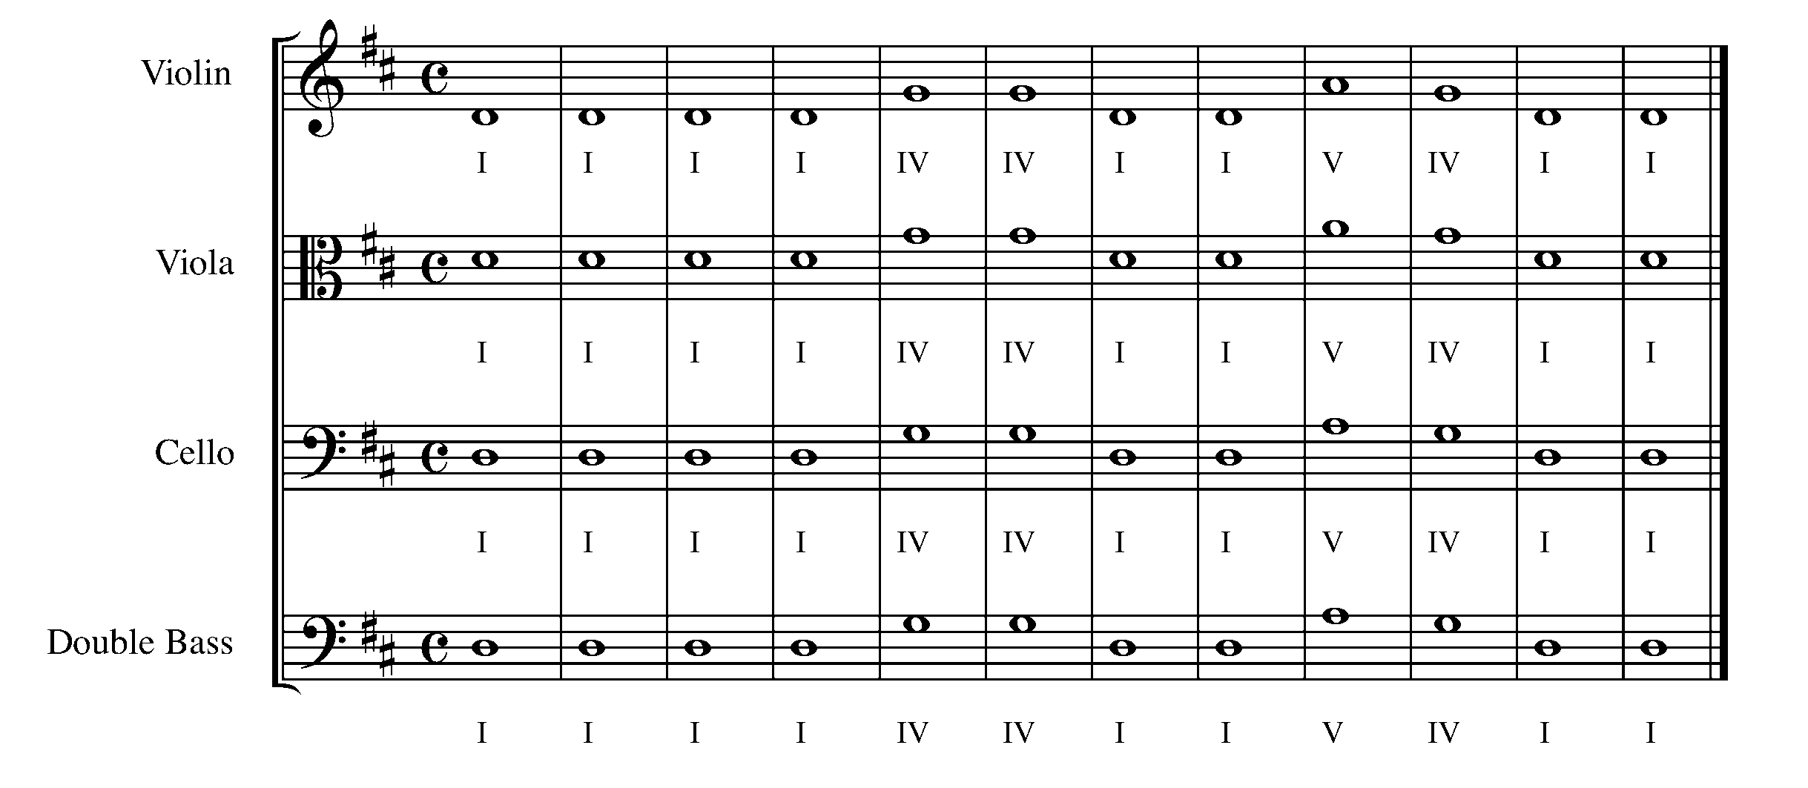
CONSOLIDATION: In order to complete this task, for year teacher you must perform the 12-bar blues progression with accurate rhythm and pitch.

9. LET’S TAKE CONTROL FOCUS: BEAT/RHYTHM/TEMPO

Learning Goal: You will perform “Au Claire De La Lune”, demonstrating the value of the half notes while controlling the tempo of your bow.

Minds On! What is another way of writing out this music if you don’t use first and second endings? What is the purpose of using repeat signs?

Action! In order to successful with this task, you will need to:
- Maintain good posture and bow grip;
- Listen to yourself and be prepared to adjust your fingers to ensure you are in tune;
- Move your big toe inside your shoe to keep a steady beat;
- Use legato bowing, place your bow in the middle between the fingerboard and bridge of your instrument;
- Make a clean retake of your bow when you repeat without bouncing your bow when you play the first note again; and
- Use slow bow for the half notes (don’t run out of bow!).

Au Clair De La Lune

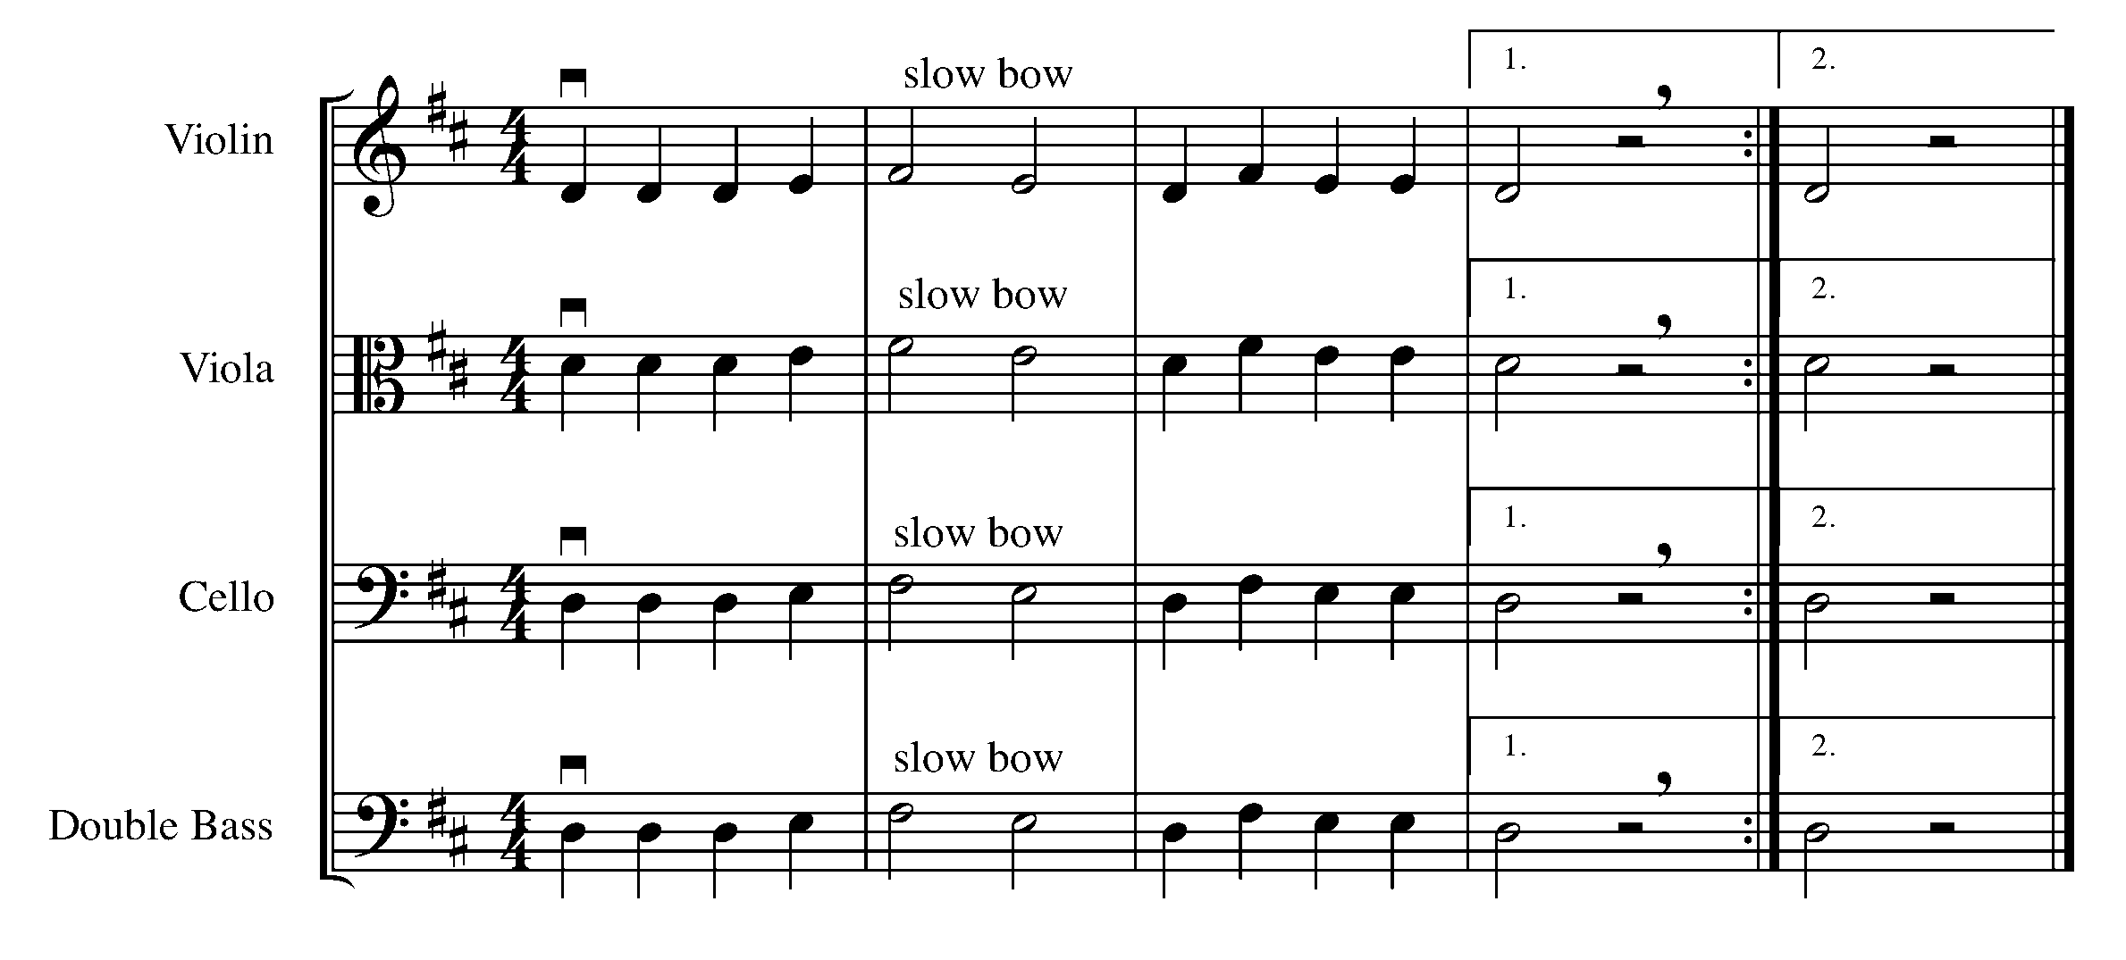
Consolidation: Perform this task for your teacher to receive feedback.

10. SING IT OUT! FOCUS: EXPRESSIVE CONTROLS

Learning Goal: You will perform “Old MacDonald” while focusing on giving shape and direction to a variety of notes, making a musical sentence. Consider a crescendo at the end of the 2nd bar and a decrescendo towards the end of the 4th bar.

Minds On! How does legato bowing help shape your music into a musical sentence? Why do you think it is important to play with a down-bow on strong beats? Where are the strong beats in this piece?
Action! In order to be successful in this task, you must:
- Scan the music for patterns;
- Keep in mind that the phrase for this example is four bars long, and that you will need to keep the phrase moving forward even though there is a rest;
- Use legato bowing;
- Use a down-bow on the strong beats;
- Maintain good posture and bow grip;
- Make a smooth string transition when crossing strings;
- Prepare your fingers so you always have excellent intonation when there are leaps in the melody; and
- Control the dynamics by the placement of the bow in relationship to the bridge.

Old MacDonald

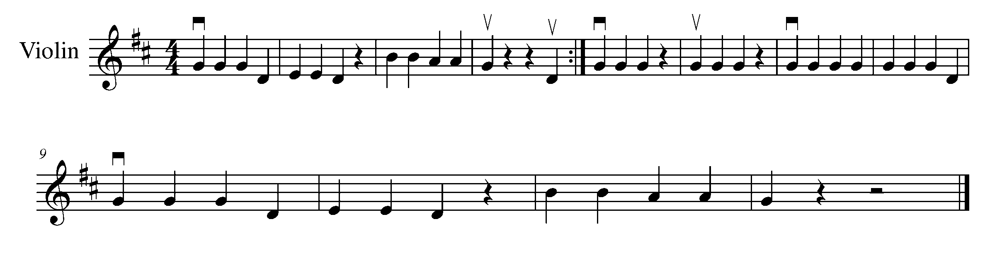
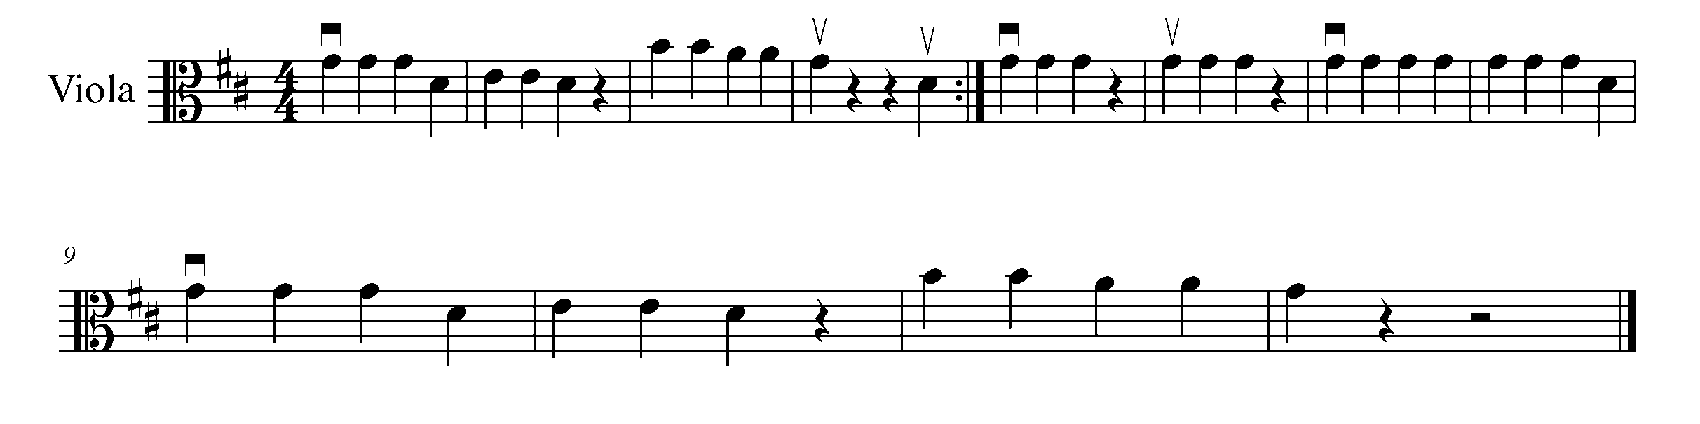
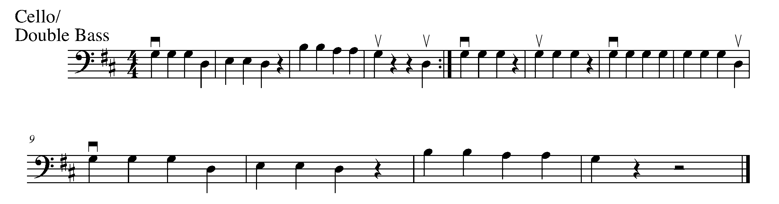
Consolidation: Perform “Old MacDonald” for your teacher to receive feedback.

CONGRATULATIONS! YOU HAVE REACHED THE SECOND GPS MARKER -EAST!

YOU ARE HALFWAY TO THE FINAL GPS DESTINATION.
DON’T FORGET TO FILL IN YOUR TASK TRACKER!

11. LET’S COUNT IN THREES! FOCUS: METRE

Learning Goal: You will perform “French Folk Song” using legato bowing, demonstrating your understanding of the quarter note and dotted half note. This task challenges your ability to use three beats in each bar by adding a pulse when playing on beat one.

Minds On! When looking at a time signature, what does the top number tell you?
What is the meaning of the bottom number? Where are the strong beats when performing in 3/4 time? What is the conducting pattern for 3/4 time signature? What might you need to do with your bow to add a pulse on beat one?

Action! In order to be successful with this task, you will need to:
- Use legato bowing;
- Slow down your bow and have even bowing when playing the dotted half note;
- Move your big toe inside your shoes to make sure you hold the dotted half note for its full value;
- Have excellent phrasing by demonstrating the pulse on the strong beat;
- Scan the music for patterns (e.g. Do you see any patterns related to the D major scale?); and
- Play with excellent tone quality.

French Folk Song

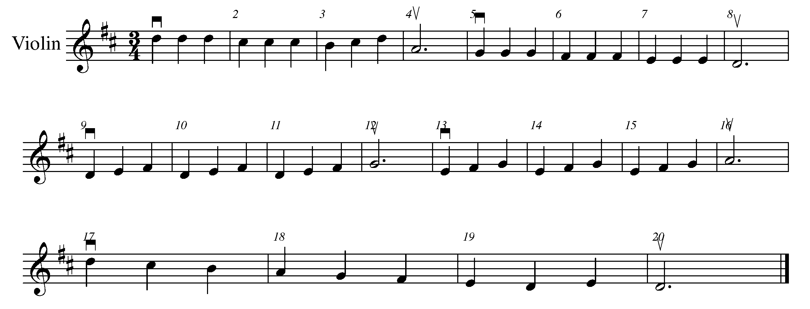
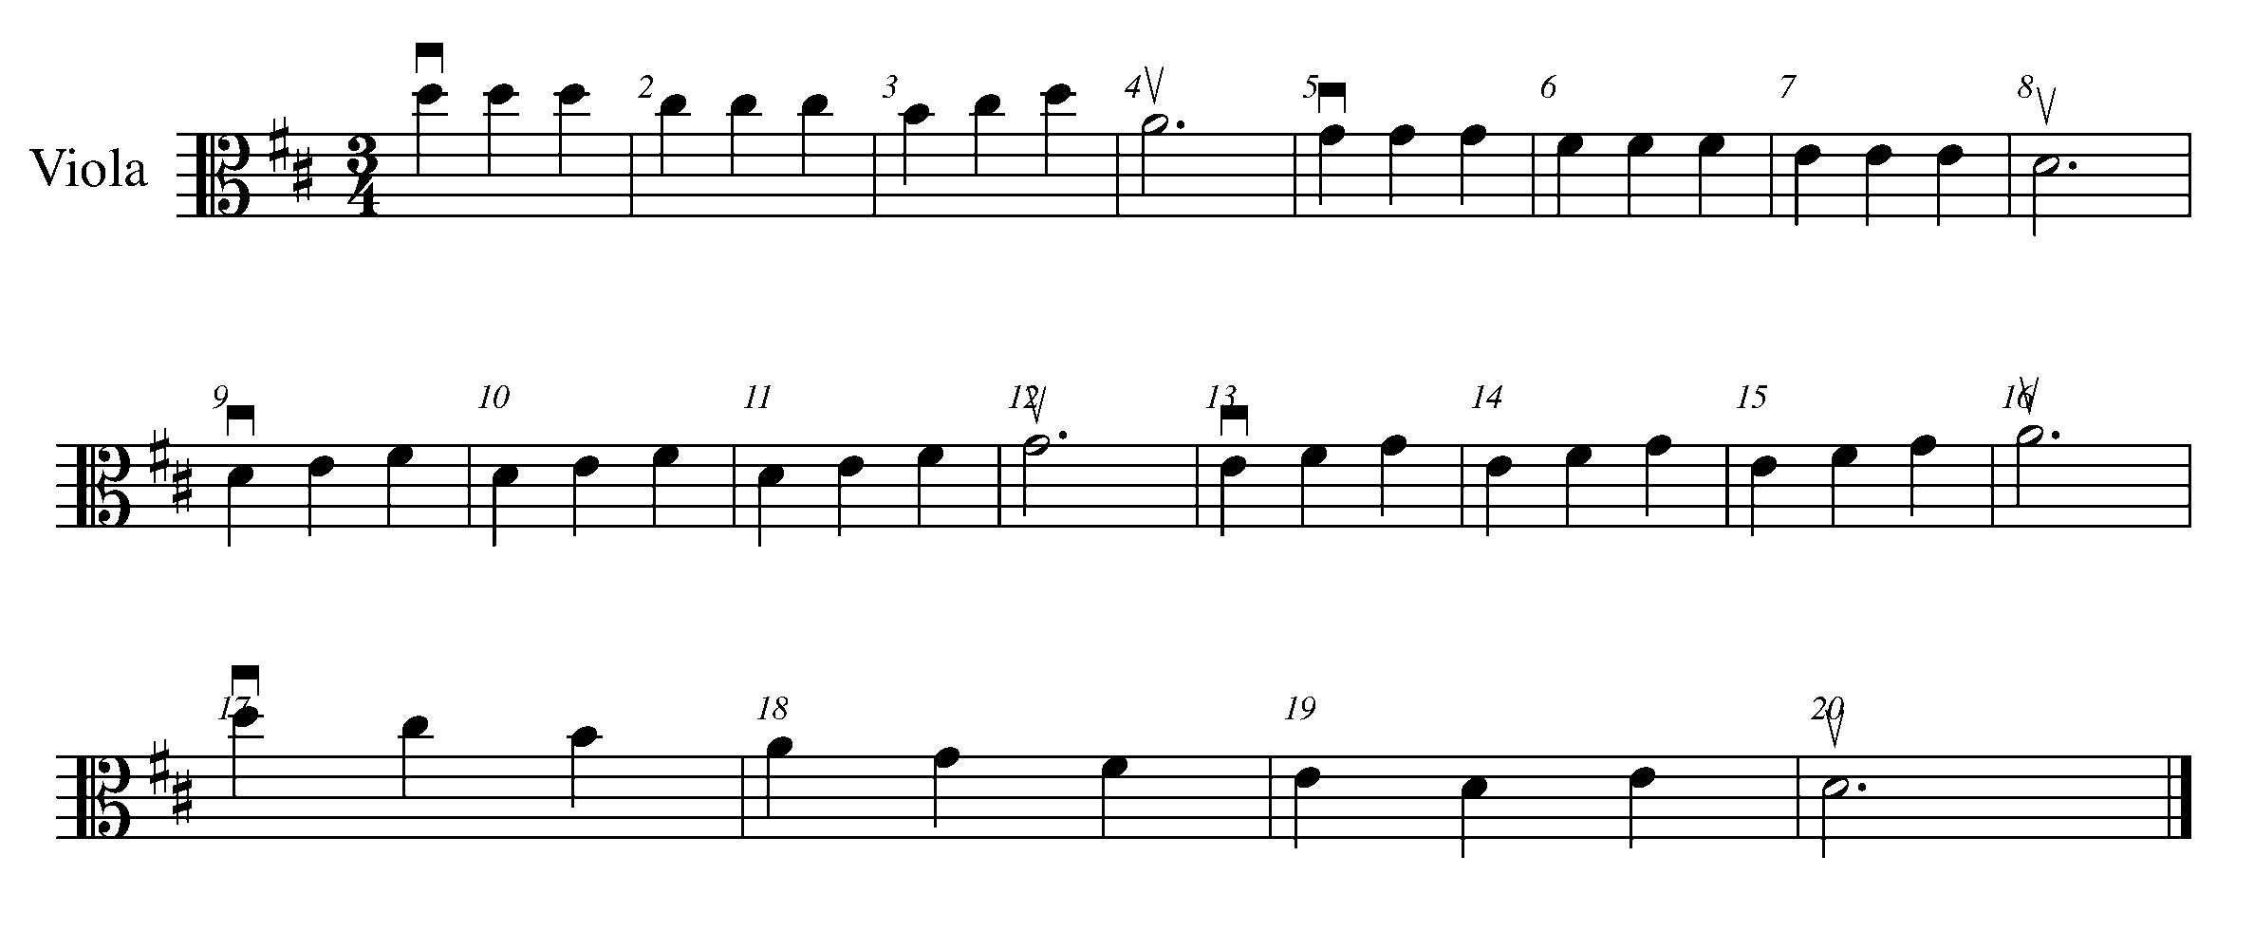
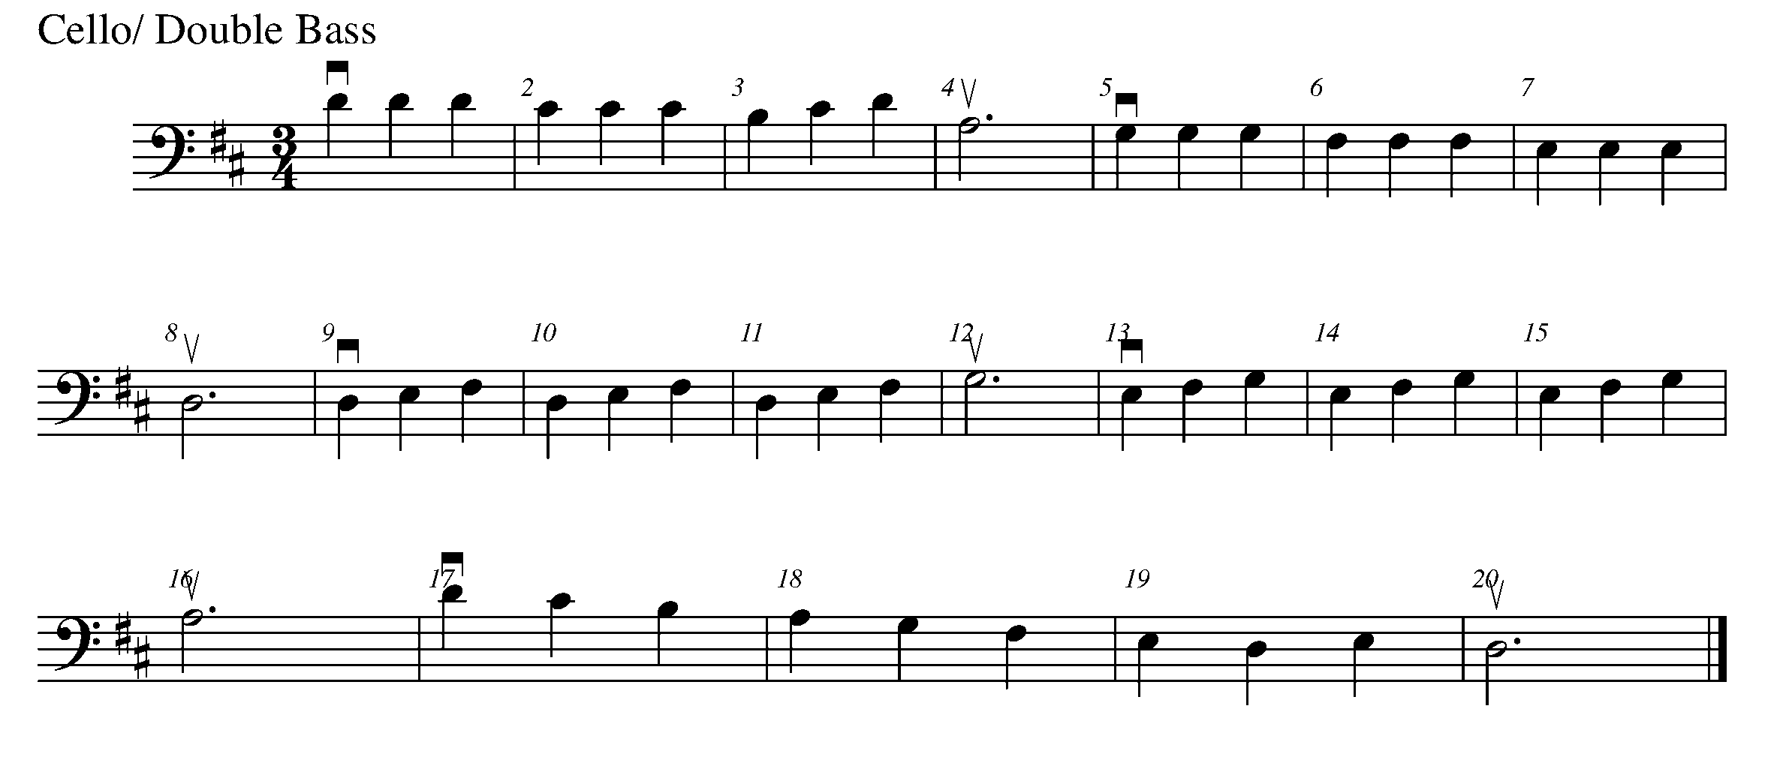
Consolidation: Perform this task for your teacher to receive feedback.

12. THE GREAT COMPOSITION CONTINUES FOCUS: NOTATION
LEARNING GOAL: The purpose of this task is to create 8 bars of a playable rhythm in 4/4 time. Use rhythms with which you are comfortable performing on your instrument.

MINDS ON! Why is it important that you are able to perform the rhythm that you are writing? Although you may be aware of how to write more difficult rhythm patterns, it is important that you think about how you will eventually play these rhythms.

ACTION! In order to be successful with this task, you will need to:

- Decide upon a variety of rhythms that you are able to play on your instrument;
- Create 8 bars of rhythm in 4/4 time and write it in the provided space;
- Make sure you use a pencil; and
- Clap out your rhythm.

Write your 8 bars on the rhythm line here.

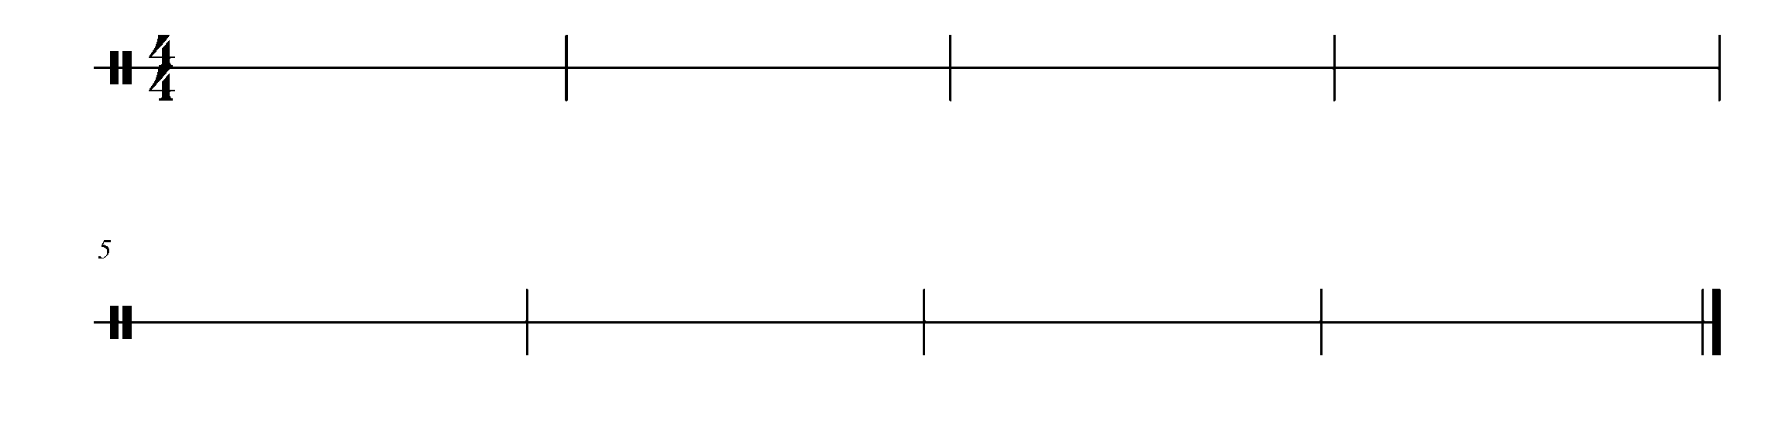

CONSOLDATION: In order to move on to the next task, you will need to complete 8 bars of playable rhythm in 4/4 time. Once written, clap your rhythms for your teacher to receive feedback.

13. “TIE” ING IT ALL TOGETHER FOCUS: EXPRESSIVE CONTROL

Learning Goal: The purpose of this task is to demonstrate an understanding of ties and how they function with a piece of music.

Minds On! If a tie adds the rhythm of notes together, why would you not just merge the notes together to be one? Why do composers use ties? What reasons would composers have to use ties? Sometimes we add symbols into music for a reason- why do you think the tie needs to exist?

Action! In order to be successful with this task, you will need to:
- Demonstrate good posture, accurate pitch and rhythms throughout this piece of music;
- For violin and viola players, understanding the relationship between the 4th finger A on D string and the open A String. Cello players should keep fingers down wherever possible. Double bass players will demonstrate the finger pattern on all 4 strings;
- Look ahead in your music so you know what is coming! and
- Give both the tie and the rest its full value when counting.

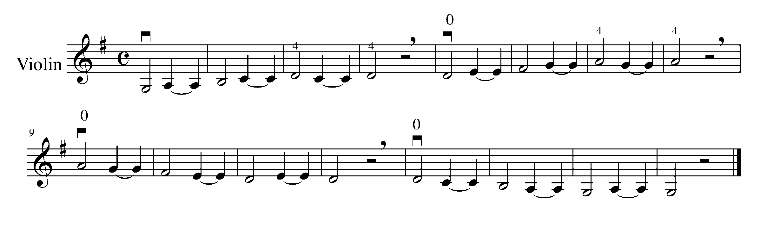
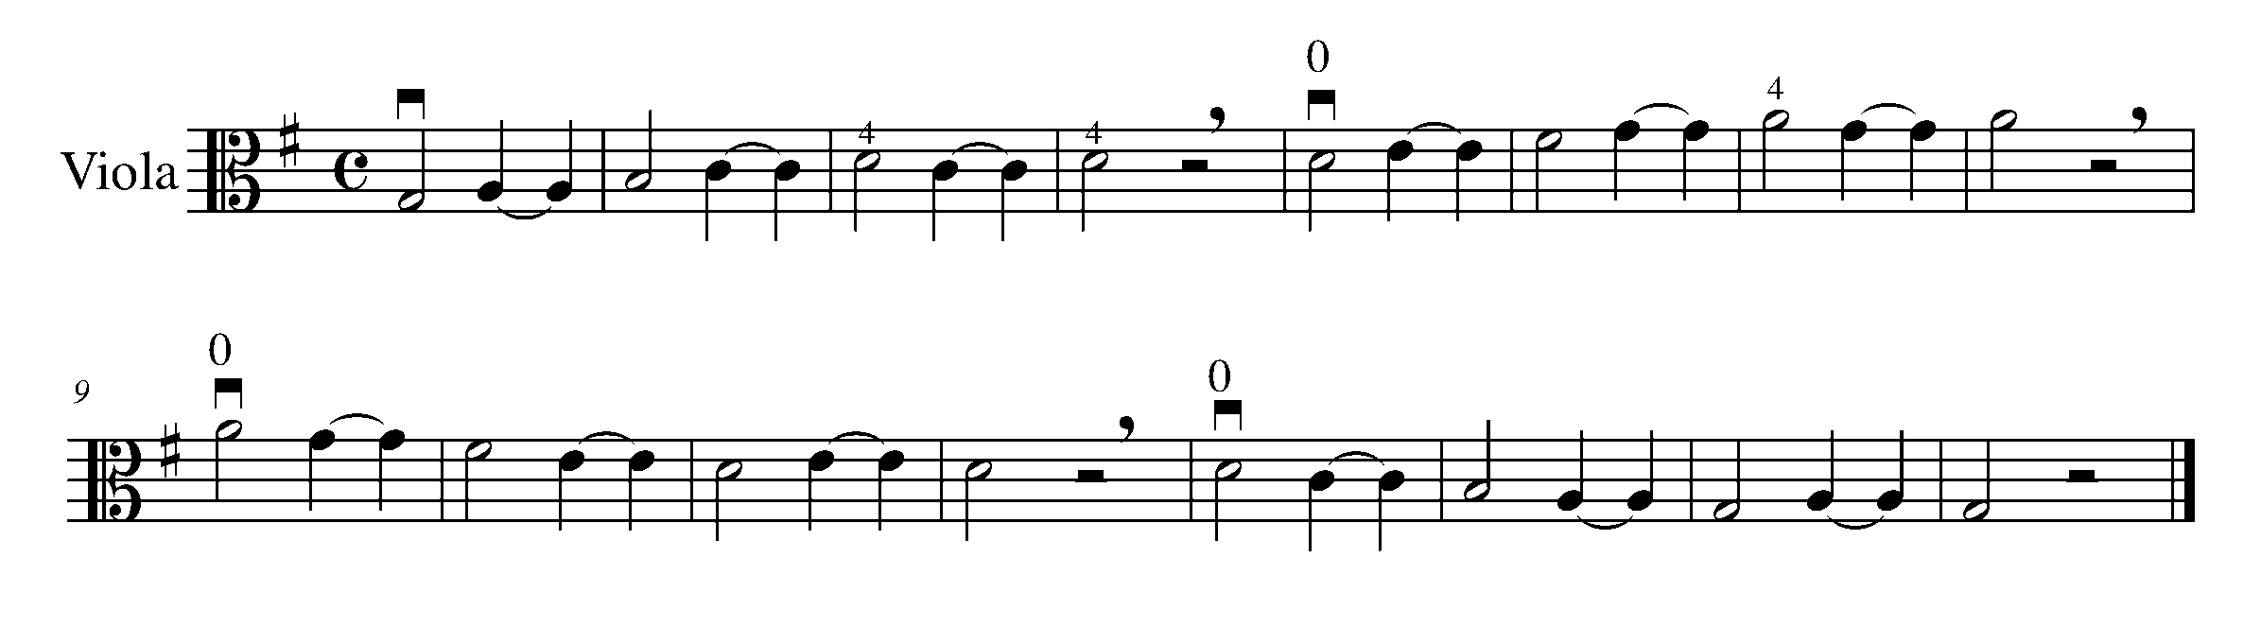
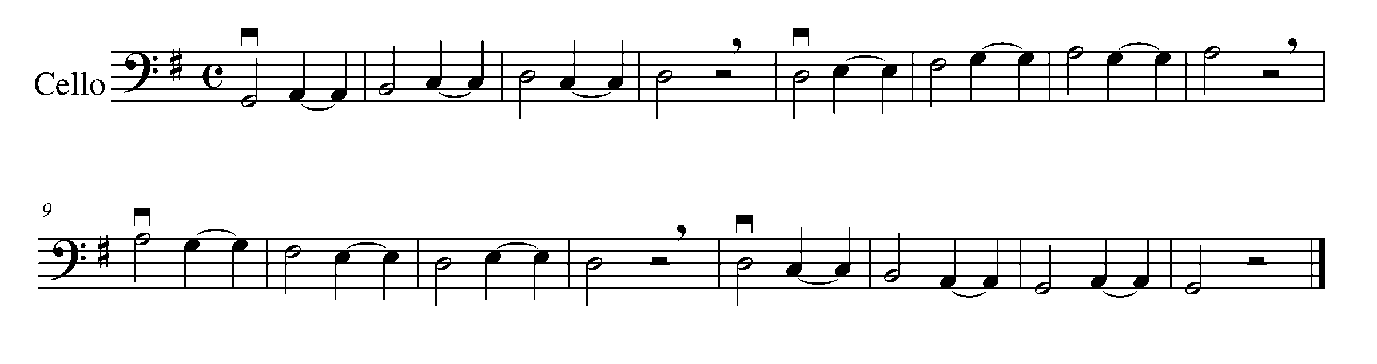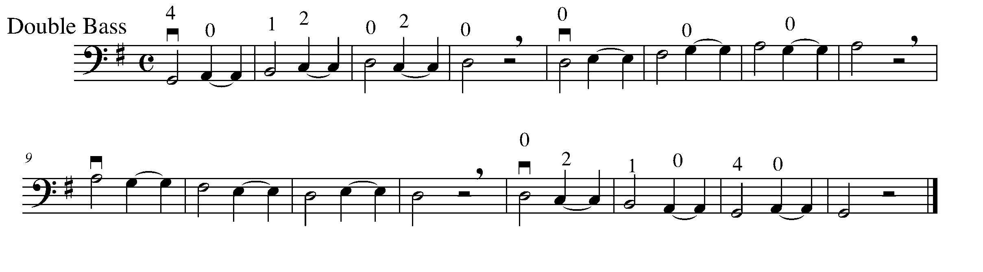
Consolidation: Perform this task for your teacher to receive feedback.

14. LOUD VS. SOFT FOCUS: EXPRESSIVE CONTROL

Learning Goal: You will perform “Twinkle, Twinkle, Little Star” demonstrating your understanding of the dynamics marking.

Minds On! Remember the three major techniques for string players when considering dynamics: amount of bow, placement of bow, and weight. How would you adjust these in order to apply the dynamics for this piece? Dynamics are concerned with the degree of loudness, or softness of the music. Music is much more expressive and interesting with various dynamic levels. The symbol f (forte) means to play a section of music loudly. If you see a p (piano), this indicates that the music should be played softly. There are other dynamic levels and combinations possible, which we will talk about in class.

Action! Musician Readiness: In order to be successful in this task, you will need to:
- Adjust your bow and the way you play in order to effectively demonstrate the dynamic changes;
- Play with excellent intonation;
- Retake every two bars to demonstrate phrasing (your goal is to sound like a singer on your instrument); and
- Use smooth legato bowing.

Twinkle, Twinkle, Little Star

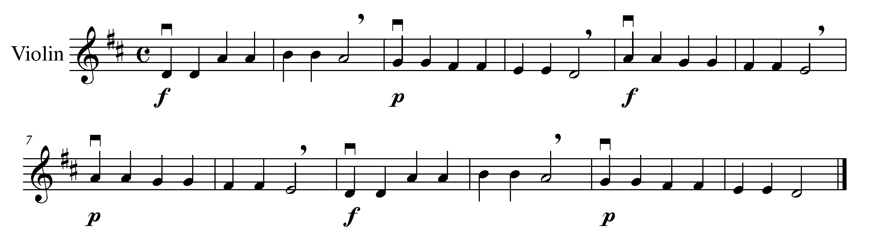

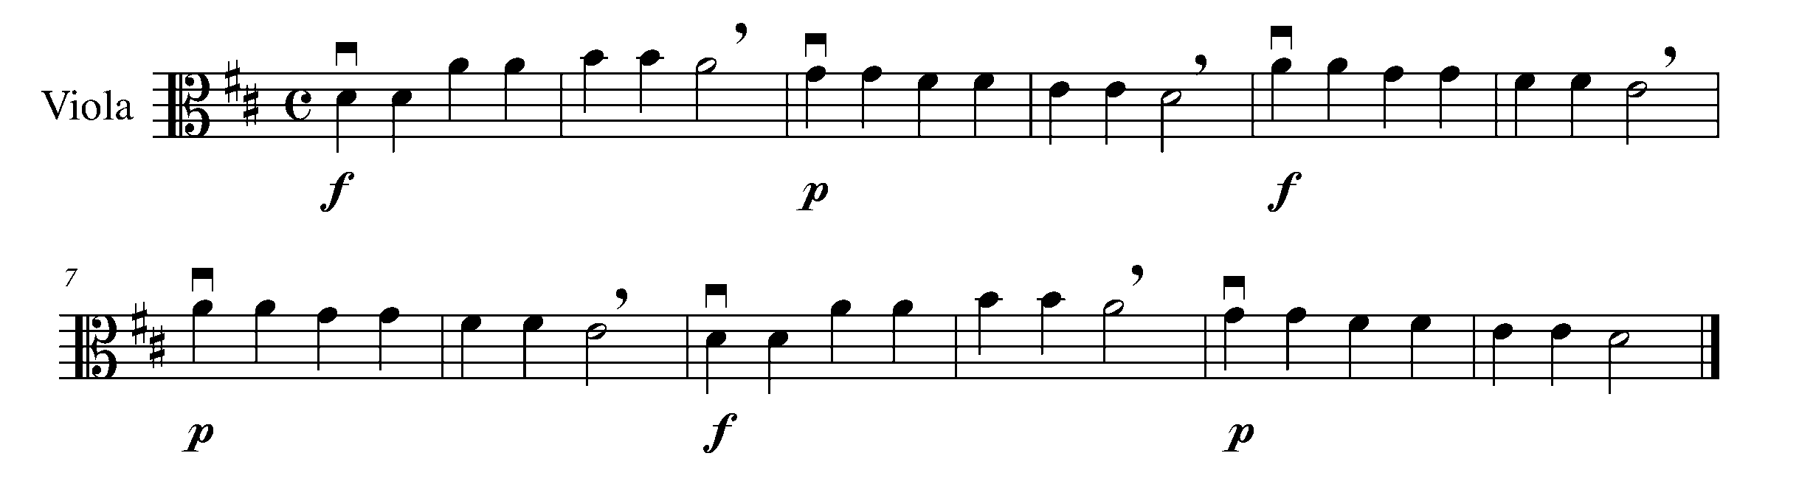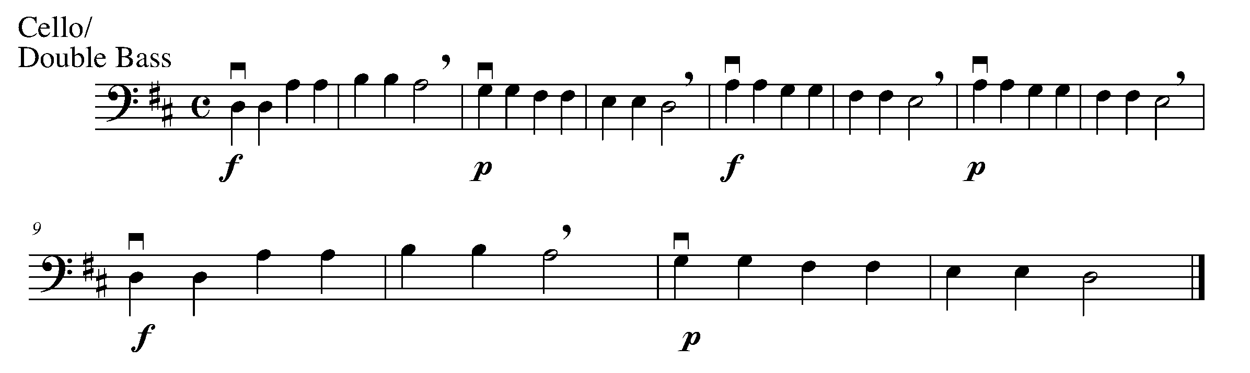

Consolidation: Perform this task for your teacher to receive feedback.

15. TRIADS: MAJOR AND MINOR FOCUS: PITCH

Learning Goal: In this task, you will be able to recognize and label the difference between a major triad and a minor triad in the key of D major and C Major.

Point of Information: A triad is a three-note chord that includes the root note of the scale (the tonic), the major (+) or minor (-) third of the scale (the mediant), and the perfect fifth note of the scale (the dominant).

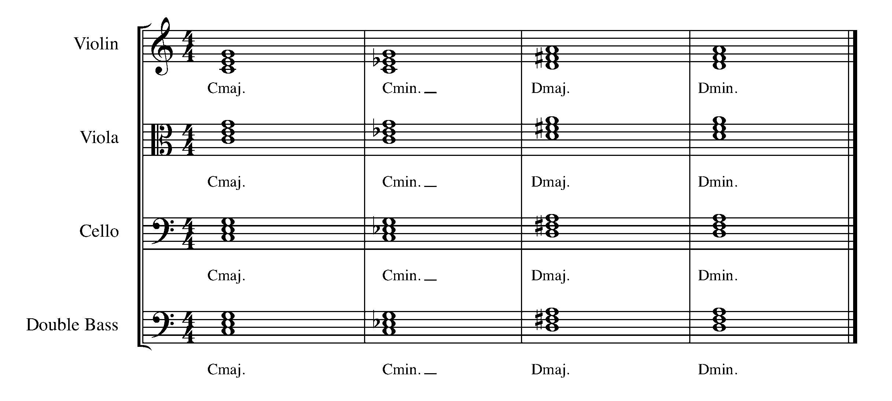
Minds On! Why is knowing the key signature of a scale important to this task? Seeing the difference between a major triad and a minor triad is the first step to being able to hear the difference as well.

Action! In order to be successful with this task, you will need to:
- Look at the root and the mediant of each chords below;
- Determine what note is the major 3rd and what note is the minor 3rd (lowered 3rd note); and
- Label the triads as either major or minor.

Label these triads as major (+) or minor (-).

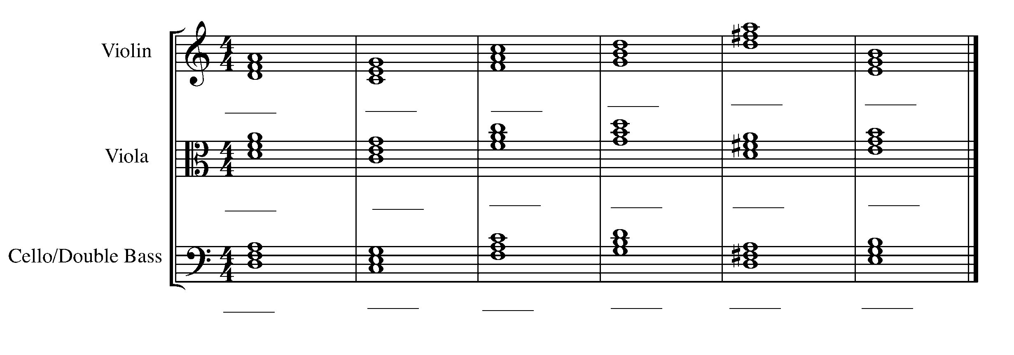
Consolidation: Complete this task and hand it in to your teacher for evaluation.

CONGRATULATIONS! YOU HAVE REACHED THE THIRD GPS MARKER -SOUTH!
YOU ARE VERY CLOSE TO THE FINAL GPS DESTINATION
DON’T FORGET TO FILL IN YOUR TASK TRACKER!

16. STACCATO FOCUS: EXPRESSIVE CONTROL- ARTICULATION

Learning Goal: So far you have been performing using legato bowing. In this task, you will learn to perform using staccato bowing and understand the differences.

Minds On! How does playing staccato contribute to the overall mood of this piece? Composers use articulation to say what they need to say in different ways. Staccato bowing is one of many types of articulation that is used in string playing. Staccato notes are notes that are played detached. What happens if you play everything legato? How would this change the overall mood of the piece?

Action! In order to be successful with this task, you will need to:
- Stop the bow on the string by applying a bit of pressure so that the bow does not make any sound once the bow has stopped;
- Pay attention to the non-staccato notes;
- Keep a steady beat by moving your big toe inside your shoes. Do not rush!
- Keep your fingers down wherever possible to ensure perfect intonation;
- Play with good posture, sit with your back straight without touching the back of your seat, and keep your feet flat upon the floor; and
- Perform this for a family member/an adult/your homeroom teacher and get their feedback before performing it for your teacher.

Staccato!
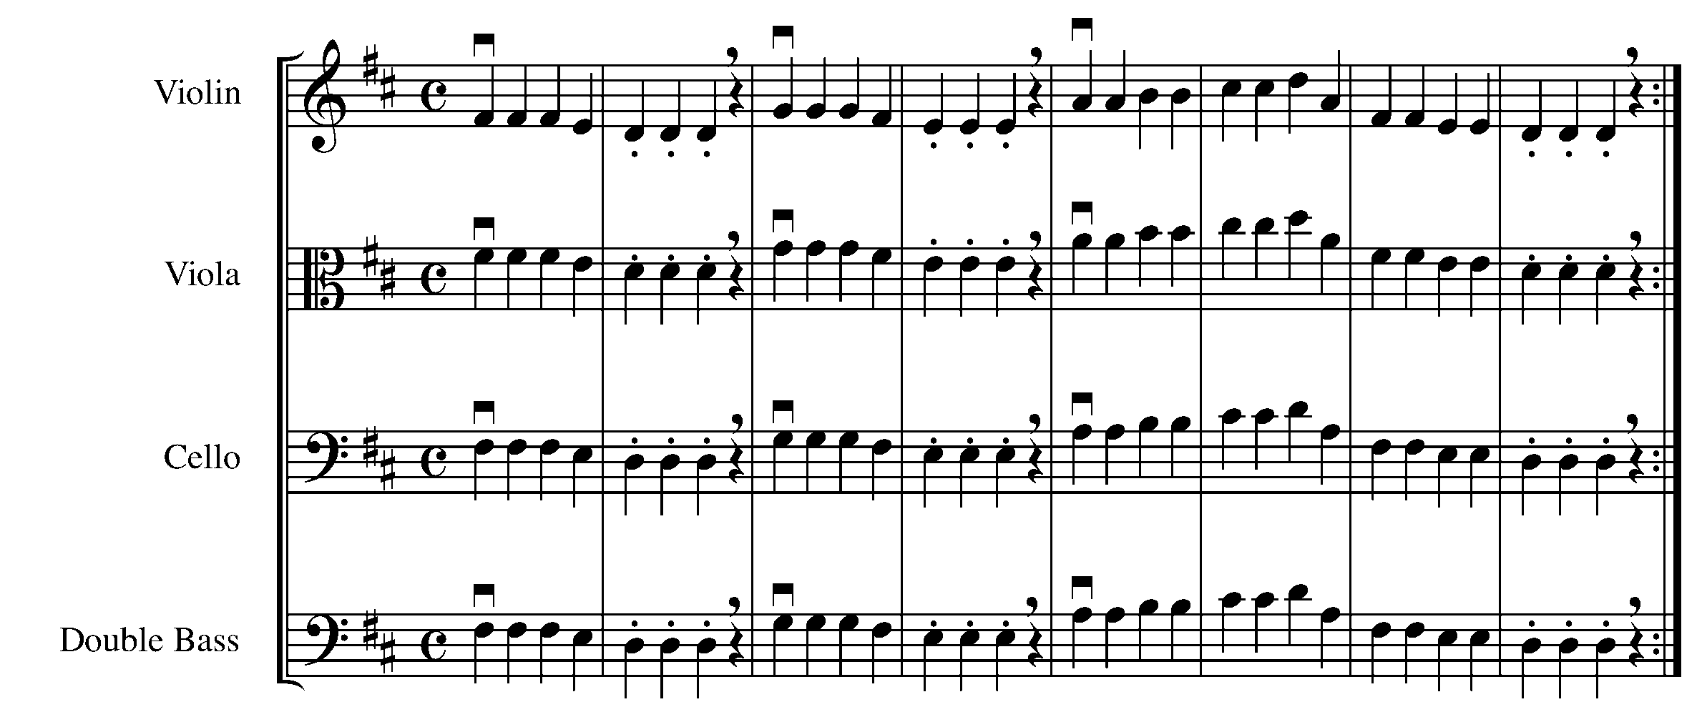

Consolidation: Perform this task for your teacher to receive feedback.

Family/Another Adult/Homeroom Teacher Feedback: ________________________________________________________________________________________________________________________________________________________________________________________________________________________________________________________________________________________________________

17. PUT IT ALL TOGETHER FOCUS: EXPRESSIVE CONTROL

Learning Goal: This year, we have been learning to apply the elements and techniques of a musician. The purpose of this task is to perform a piece, which includes many of the elements of performance and music that you have learned through this GPS program.

Minds On! As you use all of your newly discovered abilities, think about how far you have come as a musician this year. Remember how difficult it was the first time you tried to hold your bow and find the first three notes of the scale. Look at how much learning you have accomplished!

Action! In order to be successful with this task, you will need to:
- Go back and review some of the elements of music (e.g. ties, dynamics, tempo, legato vs. staccato) we learned about in this book; and
- Apply your knowledge of good posture, bow grip, phrasing, rhythm, and articulation and performance skills when performing this piece.

Put It All Together

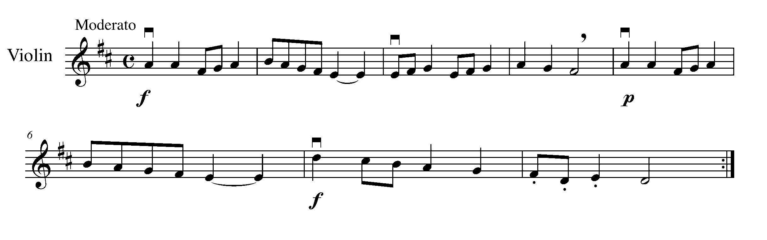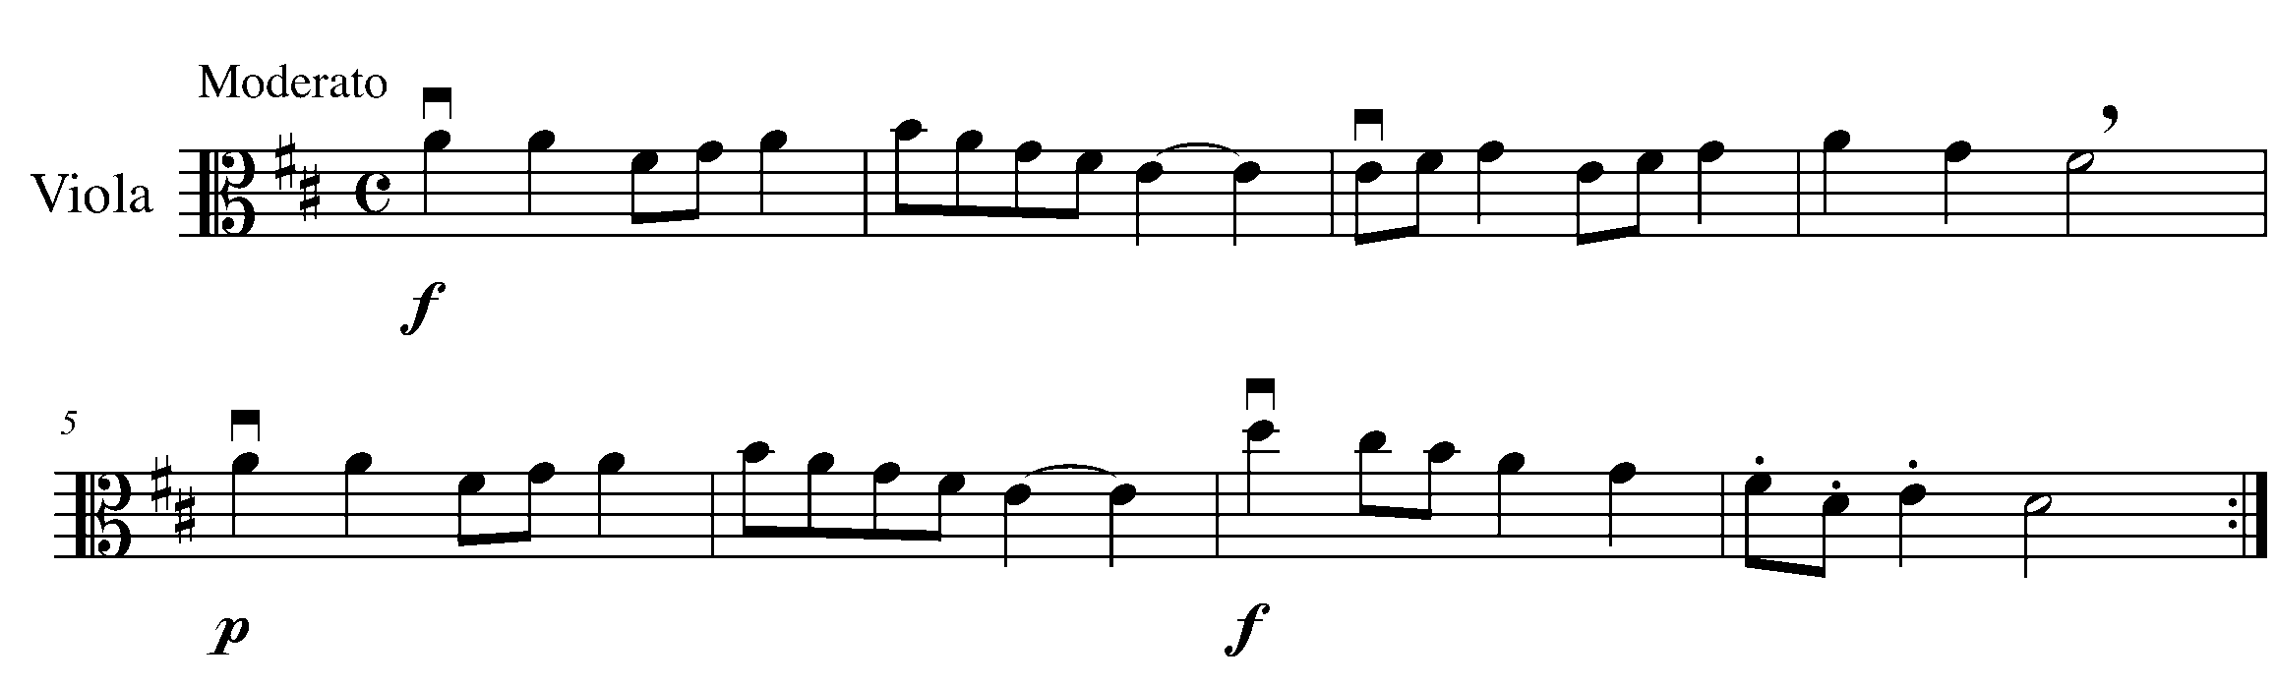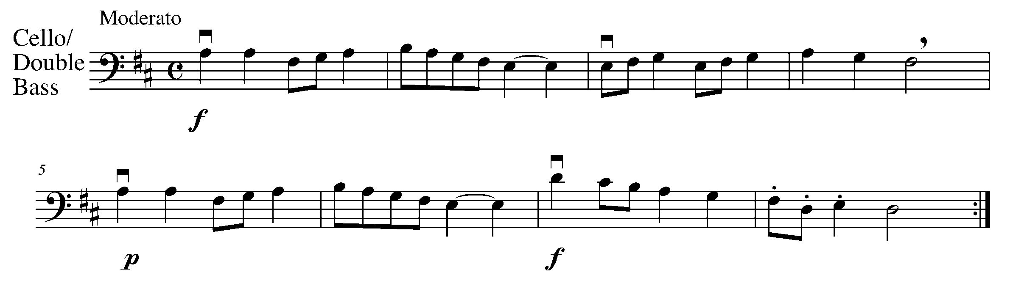
Consolidation: Perform this task for your teacher to receive feedback.

18. THE FINISHING TOUCHES FOCUS: NOTATION

LEARNING GOAL: The purpose of this task is to add pitch and the finishing touches (tempo, dynamics, articulations) to your rhythmic composition created in two previous tasks.

MINDS ON! What are the common things you see when looking at printed music? What do you notice about the stem directions, the bar lines, the beginning and the end of the song, etc.? Do you have everything you need in your composition?

ACTION! In order to be successful with this task, you will need to:

- Use a PENCIL;
- Draw the appropriate clef for your instrument;
- Write your composition in D Major;
- Place the rhythm that you created in task 12 on staff – CAUTION: remember to use notes that you can play and a pattern that sounds like a melody. Do not just put in random notes. Make sure that you can play what you have written. It’s not about difficulty; it’s about accuracy. Hint: Try to have “steps” in your melody instead of “leaps”. Also, starting and ending on the first note of the scale will nicely frame the piece.
- Give your composition a title;
- Add a tempo marking;
- Add at least one dynamic marking; and
- Add at least one articulation marking.

Title of Composition __________________________________

__________________________________________________________________________________________________________________________________________________________________________________________________________________________________________________________________________________________________________________________________________________________________________________

__________________________________________________________________________________________________________________________________________________________________________________________________________________________________________________________________________________________________________________________________________________________________________________

CONSOLIDATION: In order to move on to the next task you must add the finishing touches and pitch to complete your composition. Once complete, have a classmate peer edit your composition with you. When the peer edit is complete, have your classmate sign the below statement:

I, _________________________ have peer edited my classmate’s composition and to the (classmate’s name)
best of my ability, explained and corrected with my classmate, their composition.

––––––––––––––––––––––––––––––
(classmate’s signature)

19. ALMOST THERE... FOCUS: EXPRESSIVE CONTROLS
Learning Goal: The purpose of this task is to perform your composition for your teacher.

Minds On! Think of the 3 musical “P’s” when preparing for your performance: POSTURE, PHRASING, and PRACTICE!

ACTION! In order to be successful with this task, you will need to:

- Practice and prepare your composition to perform for your teacher; and
- Apply all of your knowledge of the elements of music and performance while preparing for completion of this task.

CONSOLDATION: Perform your composition for your teacher, receive feedback and make the appropriate changes before getting it ready for task 20.
After performing this for my teacher, things I need to work on before task 20 are:
__________________________________________________________________________
__________________________________________________________________________

20. THE GRAND FINALE! FOCUS: CULMINATING TASK
Learning Goal: Perform your composition for a small group or class as organized and supervised by your teacher then write a reflection on your experience as a solo performer (Consider performing for one of the primary or junior classes at our school).

MINDS ON! How are you going to apply the skills that you have developed up to this point? How will your confidence level, preparation, and body posture affect your final performance?

ACTION! In order to be successful with this task, you will need to:

- Consider the feedback that you received in tasks 18 and 19 – apply this feedback to your performance;
- With your teacher, organize the time and group for which you will be performing;
- Practice all aspects of your performance: the introduction of your piece, your name, how you will sit or stand and where to place your music stand; and
- Perform your composition for the assigned group or class while supervised by your teacher. After your performance, write a one-page reflection about your experience. Consider the following:

- For whom did you perform?
- What was the date and time of the performance?
- How big was the audience?
- What was the audience reaction?
- What questions did they ask? How did you answer?
- What did you enjoy about the experience?
- What did you find difficult?
- What would you do differently next time?
- What difficulties you may have had, amazing moments in your performance, your feeling, etc.

Your paper must be impeccably neat and free of spelling errors.

CONSOLDATION: Perform your composition and submit your reflection, receive feedback from your teacher and celebrate your accomplishments – CONGRATULATIONS – you’re done!!
CONGRATULATIONS! YOU HAVE REACHED
YOUR DESTINATION! THE FINAL WEST GPS MARKER. DON’T FORGET TO FILL IN YOUR TASK TRACKER AND CELEBRATE YOUR ACCOMPLISHMENTS!

TASKS TRACKER
North
South
West
Task # 3
Task # 1
Task # 2
Task # 4
Task # 6
Task # 7
Task # 8
Task # 9
Task # 13
Task # 12
Task # 11
Task # 14
Task # 18
Task # 17
Task # 16
Task # 19
Task # 20
Task # 5
Task # 10
Task #15
East

Congratulations!

__________________ has reached the North GPS Marker in the 1st Year String Program.

_________________________________
Teacher Signature

_________________________________
Principal Signature

Congratulations!

__________________ has reached the East GPS Marker in the 1st Year String Program.

_________________________________
Teacher Signature

_________________________________
Principal Signature

Congratulations!

__________________ has reached the South GPS Marker in the 1st Year String Program.

_________________________________
Teacher Signature

_________________________________
Principal Signature

Congratulations!

__________________ has reached the FINAL (West) GPS Marker in the 1st Year String Program.

You’re Done!!

_________________________________
Teacher Signature

_________________________________
Principal Signature

