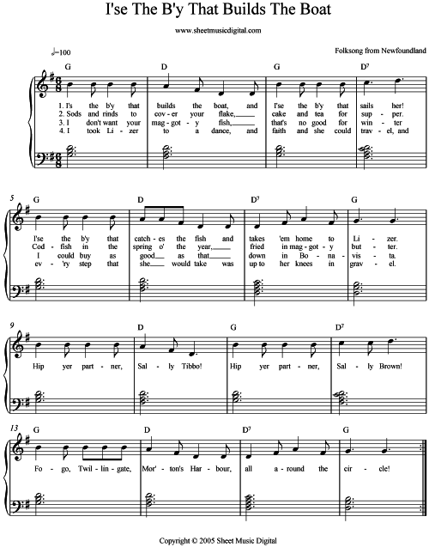

``Although our public domain sheet music and files have our copyright markings, our goal is to provide a resource library for you to use without worrying about copyright infringement or royalty fees. So please feel free to use any score that has the 'Copyright Sheet Music Digital' for your own educational, school, church, organizational or personal use.``
From… Dictionary of Newfoundland English
fish: Unless otherwise specified, "fish" in Newfoundland English almost always refers to codfish
rind: A long strip of bark, normally from a standing spruce or fir, and used for various fisheries and building purposes,
flake: A platform built on poles and spread with boughs for drying codfish on land
cake: Ship's biscuit or hardtack
maggoty fish: Fish when not cured correctly would become infested with Blow-fly larva

