Teacher Resource 1 STANDARD and GRAPHIC NOTATION
Standard Notation Version:
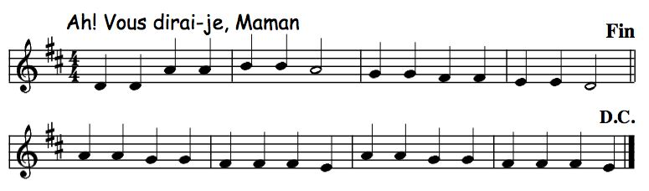
Non-standard (Graphic Notation) Version:




