Teacher Resource 1
Lesson 1:

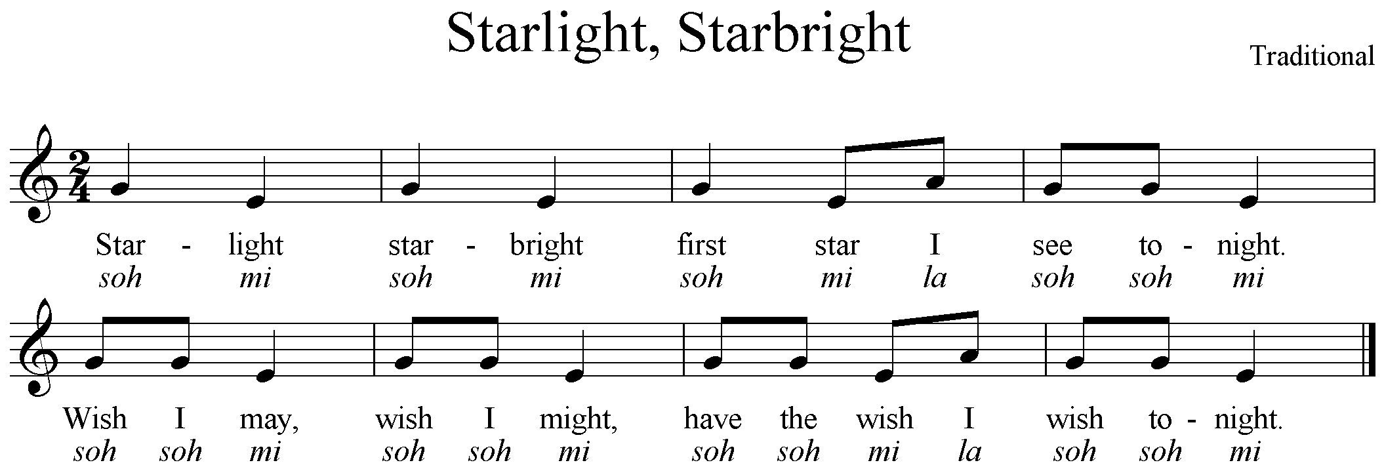

Lesson 2:
FORM of Composition:

square
red

circle
blue

square
red

