GPS Grade Seven Pause and Ponder:
The Grade 7 and 8 GPS Tasks were created in response to The Ontario Curriculum, Grade 1-8: The Arts (2009). Along with performing and creating music, the expectations for both grades “encourage students to explore issues related to personal identity and community concerns as they interact with the increasingly complex and/or challenging media” (p.131).

Students do this by examining the music to which they listen. The GPS Tasks ask students to create playlists of songs that are of interest to them. These songs are then analyzed, using criteria that includes Daniel Levitin’s (2008) theory that all songs can be sorted into six basic categories of songs: Friendship, Joy, Comfort, Knowledge, Religion, and Love. For more information on Dr. Levitin’s research read his book: The World in Six Songs: How the Musical Brain Created Human Nature (see references) and visit http://www.sixsongs.net/

Please read the first few pages of the tasks and also each task before starting them with your class. Students will need your guidance and specific teaching in order to be successful. They will also need to have access to some technology and examples of music. Please read through and adjust the tasks to suit the level of support that your school is able to provide.

In the Grade 7 GPS Tasks, students are asked to “examine the role of music in their lives, as well as the ways in which music has changed in response to a variety of historical, cultural and other influences” (Ontario Ministry of Education, 2009, p. 133).

In the Grade 8 GPS Tasks, students are asked to expand the range of songs on their playlist and to examine the roles that music can play in social and political issues, starting with the importance of national anthems.

In all tasks, encourage students to be aware of vocal hygiene, i.e., how to sing well promoting good and effective vocal health. For more information visit:

http://therapylibrary.com/Therapy.aspx?ArticleID=146

http://singoutloud.com.au/tips/vocal-hygiene/

http://www.vocalist.org.uk/singing_exercises.html

FOCUS WORDS:

There are terms beside each task to help students focus their learning:

- PERSONAL RESPONSE. Students are to add songs to their playlist and work with personal choices.
- ANALYSIS OF INFLUENCES. When students are analyzing their music, one of the aspects in which they will be involved is looking at the underlying factors.
- EXPRESSIVE ELEMENTS, TIMBRE, RHYTHM, BEAT, ETC. In the intermediate grades, the fundamental concepts require examining and applying these elements to the repertoire that they will perform. When they are examining the fundamental concepts of music, the element on which is being focused is identified.
- ELEMENTS. This term is used when it is expected that students will examine a number of musical elements.
- VOCAL. Students are to sing with an emphasis upon the expressive elements of music.
- ANALYSIS OF ELEMENTS. Students are to analyze specific musical elements and this task coincides with the overall expectation C2 and The Critical Analysis Process (The Revised Arts Curriculum, 2009, pp. 23-28).
- COMPARE AND CONTRAST. Students are to compare and contrast two different songs in terms of a variety of purposes, and musical elements, as per the expectations stated in each task.
- COMPOSING. Students are to write their own lyrics, and compose their own melodies if they have the ability to do so.
- CRITICAL ANALYSIS. Students will be involved in a culminating activity that requires them to use the full critical analysis process with regard to their own work.
The Tasks
Task #1:
Materials:
- Sheet music is necessary to cover expectation C1.5.
- There is a need for access to computers, CD’s, music, CD players. (This can be done with students bringing their own devices into the class (e.g., bringing in an ipod/mp3 player with the song of their choice.) along with the school possibly providing a few devices to assist those students without the technology available at home. Use of computers will also help. )
- The playlist is embedded in the GPS task. You may wish to have additional copies available if they begin adding additional songs to their playlists throughout the year and run out of space.
Bring students attention to The World in Six Songs chart that is embedded in task #7 to help them write in the six songs category on the playlist.
Task #2:
Materials:
- Students will need a way to listen to their song and practice along with a recording.
  - There are different ways to support this in the class. It can be done with the use of computers (laptops would allow them to find space to practice with their song),
  - Mp3 players would allow them to have the sound playing in one ear; do not encourage the students to practice with both earplugs in when using an mp3 player as this would mean they would not be listening to their own voice or the voices around them.
Encourage students to practice and listen to them sing for you on this task. In the consolidation, there is an opportunity for assessment for learning. Using the rubric at this stage is too early (which would be assessment of learning), instead use their singing for you as a form of assessment which will allow them to get immediate feedback from you on how to improve their singing for the next few tasks which will require them to sing while keeping the beat.
Task #3:
Materials:
- The sample lyrics embedded in the task.
- Their personal copy of their lyrics/notation that has the beats marked out.
There is a sample for the students; it has the beat marked but it doesn’t include the highlighting of the metre. Have students somehow group the beats (working out the timing) they have added into appropriate groupings by circling them or highlighting the group. The sample is in time and the first beat is the first beat of the bar (there is no anacrusis in this song sample)
Use the sample and have the students highlight on the sample groups of 4 beats. This will assist them in completing the task with their own song. This is an opportunity for you to cover what a pick-up note (anacrusis) is and how to group notes by the metre when dealing with a pick-up note as it is not the first beat of a bar, but the last beat of the previous bar.
Students will perform their song for you while tapping the beat as it occurs in the song. Use the rubric in this situation. Remember that a student does not pass a task unless they are performing at a level 3. This means that they will have the opportunity to do this task a few times if they are not yet performing at a level 3.
This is also an opportunity to assist students who are not singing in their head tone to learn how to do that. This teaching should be done to help students before they get to the consolidation stage.

Task #4
No materials would be necessary other than having an instrument available for students to give them a starting note (e.g., xylophone, piano, keyboard, pitch pipe...)
This task will need very specific teaching for students to accomplish it. Singing the major scale helps students develop an ear for where the music is moving. A simple song to help teach them would be “Doh a Dear”. This song would be classified as a knowledge song as it would help reinforce the major scale. Please see following link for a sample of how the task might look in action. Video task 8 for grade 4 (major scale).

Task #5
Materials:
- Their personal copy of their lyrics/notation that has the beats marked out.
- A recording of their song
- The ability to listen to it a number of times to listen for different elements
- A copy of the elements chart embedded in task 5
Here is a sample of what the students might do with their lyric sheet. This is to help you in guiding the students to place what they hear and feel is important to the music and how it sounds. They will need to do this before they can articulate what and how the music affects the meaning of the lyrics.
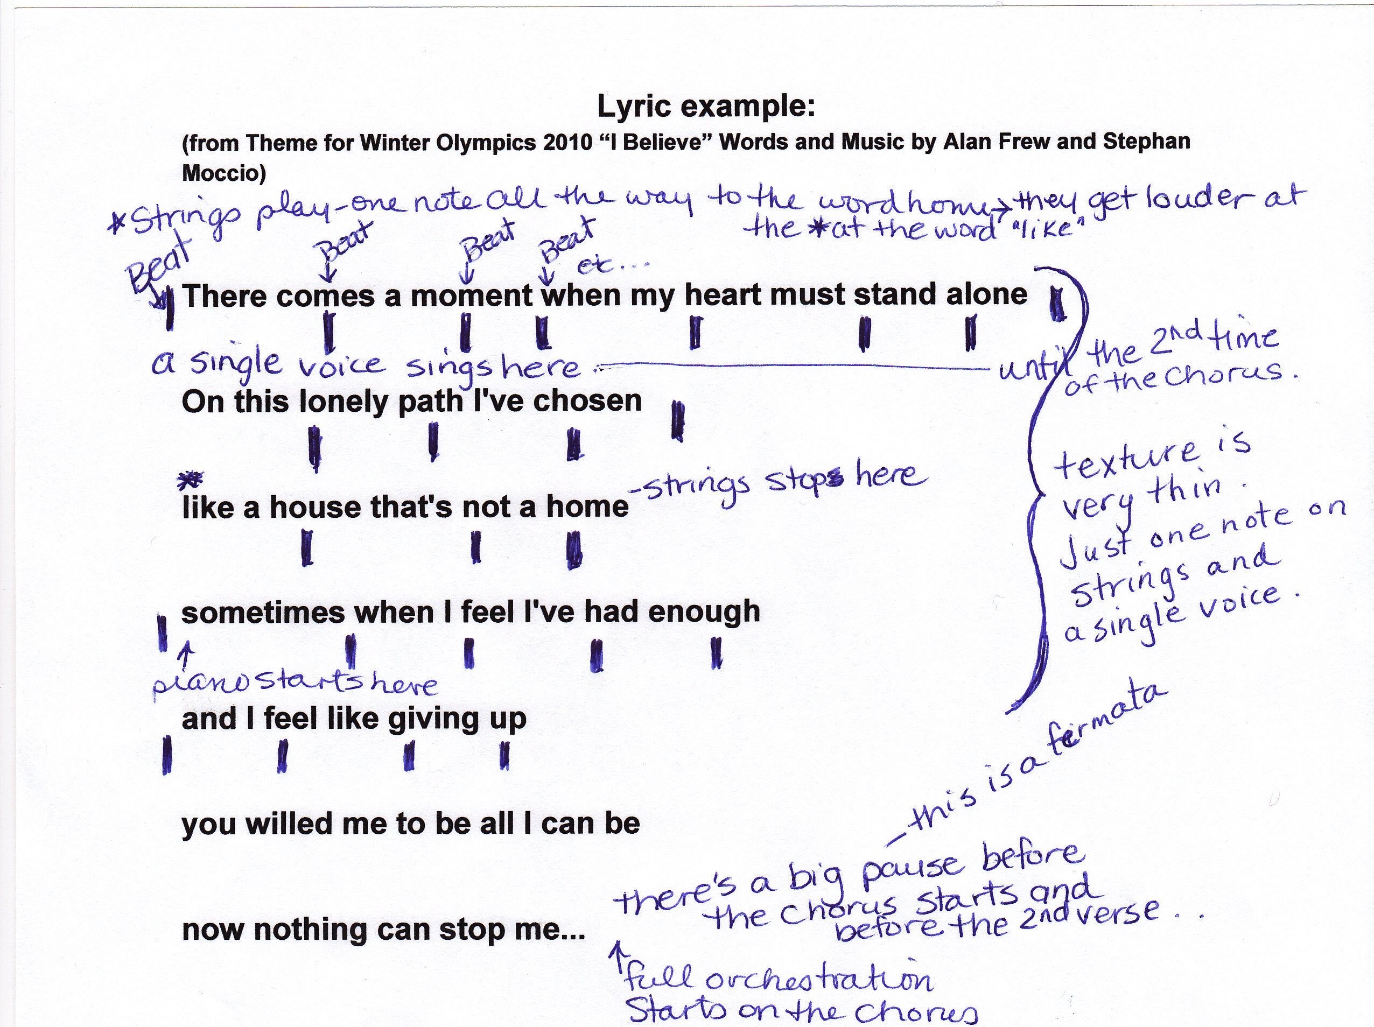

Task #6:
Materials:
- Students will need access to computers to do a Google search for possible vocal warm-ups. There are a number of books available that have vocal warm-ups (e.g. Telfer, 1996)[see references] or there is also a number of warm-ups done by a Kathie Hill that can be found on youtube.ca)
There is an option in the consolidation to allow students to do this task together with a friend in front of the class, or just in front of you if need be. The idea is that each student can be given the opportunity to warm up the class, although this may take a long time to go through if you have 30 students, so having the choice to perform with a friend or to perform for the teacher for those students with less confidence is a great option.

Task #7
Materials:
- The world in six songs reference sheet embedded in the tasks.
Go through the reference sheet with your students; make sure they have an understanding of each of the categories. It is very self-explanatory; brainstorm some possible songs that might fit into each category with them to help them attain the concept. (e.g., “The abc Song” as a knowledge song, “O’Canada” as a friendship song, “Don’t worry, Be Happy” as a joy song etc...)
Task #8
Materials:
- Students will need something to record their voice and then listen to it in playback.
- Using the computer program, Audacity, is a good option. It is available on most school computers.
- Other options are a tape recorder, or another computer program that allows for recording of voices. It can be transferred into mp3 format for students to listen on their mp3 players.
It is very important that you brainstorm appropriate words to describe sound. Keep it scientific and don’t allow for judgemental comments that can be taken as put downs.
Good scientific examples; loud, soft, bright, mellow, deep, high, low, light, thick, thin, soprano, alto, tenor, baritone... These tend to be more factual and specific.
Judgemental examples (that should not be allowed); ugly, stupid, pretty... These are influenced by personal taste rather than fact.
Task #9:
Materials:
- Students can find a variety of music on the internet, through the public library, from their home including their parent’s collections as well as other family members.
- An option is to give them some choices through yourself as well if you wish.
Use the same qualifiers that you brainstormed for task 8 for this task. The rest of the task is self-explanatory.
Task #10:
Materials:
- The six songs reference sheet will be needed
- Their playlist

Task #11:
Materials
- Go back to task #1 to remind them of what the expectations are.
Use the rubric to do an assessment of learning. Remember they can have multiple chances to sing for you to get to a level 3 competency.
Task #12:
This is a repeat of task #5 with a new focus on the instruments. This is to encourage them to listening to…..
Task #13:
Materials:
- Venn diagram embedded in task.

Task #14 - 17:
Materials:
- The grade 7 Blues unit with supporting lessons on how to teach the blues (Edugains) [coming in the fall of 2010]
- Samples of 12 bar blues songs
- Use the list of songs given in task 14
Most of the tasks are self-explanatory, but the students will need samples with which to work. There is a great deal of teaching that can be done within these 4 tasks. The blues unit, available soon on the Edugains website, has lessons on the pattern found in the music, how to write lyrics, samples of music that can be used and supporting documents to assist the teacher.
Task #18-20:
Students are finishing off the playlist. Analyzing their choices, practicing their singing, and picking a final song to sing for the teacher. It is using all the skills they have learned throughout the year and reflecting on their learning. There are no new materials needed for these tasks.
**Keep a copy of final playlist to connect up to the grade 8 program. They will need their grade 7 playlist for the grade 8 program.

References
Levitin, D. J. (2008). The world in six songs: How the musical brain created human
nature. New York: Dutton.

Telfer, N. (1996). Successful warmups. San Diego, CA: Neil A. Kjos.

* * *

If you have questions, please contact:

Jennifer Stacey: j.staceymusic@gmail.com or Lynnette Charters: lcharters@rogers.com

