Title: Exploring Notation Lesson 5  Approx. 85 minutes |  | Grade 7  “Art Comes Alive Through Music”
Critical Learning | Guiding Questions
Music notation can be standard (notes written on a staff) or can be non-standard or written in graphic form.  The Creative Process can guide the creation of non-standard notation for a musical composition.  Emerging tools and technologies can be used to create non-standard music notation (optional). | How are standard notation and non-standard (graphic) notation the same? Different?  How are the elements of music (pitch, rhythm, dynamics) written in standard notation? How could they be represented in non-standard notation?  Which stages of The Creative Process are being used when creating non-standard notation?  What tools and/or technologies could I use to produce non-standard music notation?

Curriculum Expectations Unpacked Expectations

C1. Creating and Performing: apply The Creative Process to create and perform music for a variety of purposes, using the elements and techniques of music;  C1.2 apply the elements of music when singing and/or playing, composing, and arranging music, using them for specific effects and clear purposes;  C1.3 create musical compositions in a variety of forms for specific purposes and audiences; and  C1.5 demonstrate an understanding of standard and other musical performance through performance and composition.  C2. Reflecting, Responding and Analysing: apply The Critical Analysis Process to communicate their feelings, ideas, and understandings in response to a variety of music and musical experiences; and  C2.1 express analytical, personal responses to musical performances in a variety of ways. |  | Learning Goals  At the end of this lesson, students will be able to say: At the end of this lesson I can:  - use the stages of The Creative Process to create a musical composition using non-traditional (graphic) notation;  - work with the elements of music to plan create a composition and notate it;  - use my knowledge of the elements of design to inform musical decisions; and  - make artistic decisions for a musical composition.

Instructional Components and Context
Readiness  Prior knowledge of elements of music and elements of design required for their composition.  Terminology  Non-standard (Graphic Notation) - http://www.answers.com/topic/graphic-notation-1)  Music Elements as identified and defined in Lesson 1.  Elements of Design as identified and defined in Lesson 1.  (http://www.edu.gov.on.ca/eng/curriculum/elementary/arts18b09curr.pdf) | Materials  Video:  “Toccata and Fugue in D Minor” by J. S. Bach - from Walt Disney's "Fantasia"  “Ah! Vous Dirai-Je, Maman” (also known as Twinkle, Twinkle, Little Star) by W. A. Mozart http://www.free-scores.com/download-sheet-music.php?pdf=505 – standard notation and graphic notation-copies for students (or project on screen) of “Ah! Vous Dirai-Je, Maman“ Teacher Resource 1 Standard and Graphic Notation.  Samples of recorded music, e.g., “In the Hall of the Mountain King” by Edvard Grieg, “Afternoon of a Faun” by Claude Debussy, “Carnival of the Animals” by Camille Saint-Saëns  Computer and projector with access to the internet (optional)  Devices to play recorded music  Sample lesson on graphic notation: http://www.teachingideas.co.uk/music/graphic.htm)  Examples of graphic notation/compositions: http://www.bbc.co.uk/schools/gcsebitesize/music/images/mu02014b.gif  post-it notes  large size mural paper (or smaller size paper if mural paper is not available), markers, paint, brushes, pencils, pastels, old magazines, glue, scissors  BLM #1 Listening Log (new copies, or add to logs used in Lesson 1)  Exit Pass paper (small slips)

Minds On Approximately 15 minutes | Pause and Ponder
Post the learning goals for the lesson and connect them to the creative and critical analysis processes.  Have students look at and compare the standard notation and the graphic notation of “Ah! Vous Dirai-Je, Maman”, Teacher Resource 1 Standard and Graphic Notation.  Teacher Prompts: What is similar between the two types of notation? What is different? If you were going to play the non-standard notation version, how would you read it? How would you interpret the graphics? What tone colours would you use?  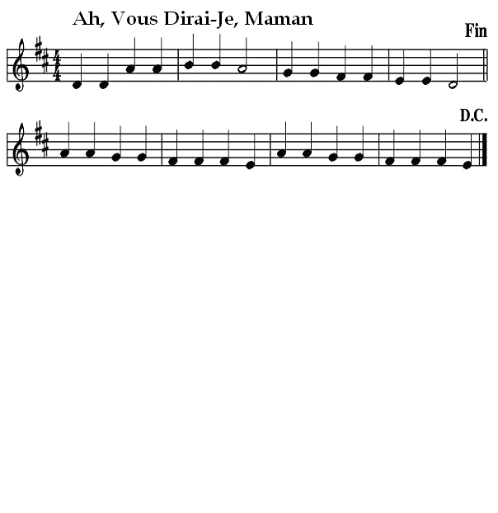  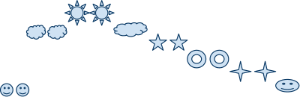   | Teacher Prompt:  From looking at the visual representation, make predictions about what the music may or may not sound like.

Action! Approximately 60 minutes
Whole Group>Think/Pair/Share>Discussion  Part I  Play the melody represented by both the standard and non-standard (graphic notation) versions. Play it twice, having students follow along with the standard music notation first and the non-standard second.  Teacher Tip: Recordings of the melody can be accessed on-line. The tune is also called “Twinkle, Twinkle Little Star” (although there may be variation in the melody in measures 6 and 8). A student may be able to play an instrument and follow the version given.  Ask the students to think about the following questions while they are listening (record each question separately and post around the room):  Teacher Prompts: Do both types of notation fit with the music? Why or why not?  In what ways does looking at the non-standard (graphic notation) affect what you expect to hear? What were you expecting? Is that what you heard?  What elements of design are primarily used in the non-standard (graphic notation) version?  Identify the elements of music heard while listening.  Using Think/Pair/Share (http://www.omea.on.ca/downloads/Think_Literacy_Music_Grades_1-6.pdf) have students write their own responses on sticky notes.  After a few minutes have elapsed, share ideas. Have students post their post-it notes next to the matching question.  Analyze another sample of graphic notation. For example: http://www.bbc.co.uk/schools/gcsebitesize/music/images/mu02014b.gif  Ask students the following questions about samples of graphic notation:  Teacher Prompts: What direction do the pitches move? Are there any repeated pitches? Do the pitches move by step or skip? Are there any repeated patterns?  How would you interpret dynamics? Tone colour?  Individual and Whole Group> Discussion  Part II  Review the example of the graphic notation used in this lesson.  Have students create their own non-standard or graphic notation for the same piece of music. How is their version the same of different than the one provided? How is it the same or different from their elbow partner? Another person in the class?  Play the video clip, “Toccata and Fugue in D Minor” by J. S. Bach from Walt Disney's “Fantasia” as a model of visual representation of a piece of music using different types of symbols and materials.  Teacher Tip: For a sample lesson on non-standard graphic notation go to: (http://www.teachingideas.co.uk/music/graphic.htm)  Play a simple, familiar melody, e.g., “Ode to Joy” theme by Beethoven.  Play as many times as is necessary in order for students to complete the BLM #1 Listening Log.  As they listen, ask students to begin to make choices about how they could create a visual representation of what they are hearing (e.g., repeating symbols to represent repetition in the melody, thick lines to represent loud sounds).  Using their choice of media, ask the students to come up with a visual or graphic representation of the melody.  Reflect on the learning:  Teacher Prompts:  What connections did we make between the elements of design and the elements of music in Lessons 1 and 2?  In what ways can the elements of music be represented visually? | Assessment for Learning (AfL)  Teacher feedback and clarification of the learning goals during Minds On and Action.  Assessment as learning (AAL)  Teacher feedback during questions and responses using sticky notes during Action.  Non-standard music sample.  Assessment of Learning (AoL)  Non-standard music sample.  Exit pass.

Consolidation Approximately 10 minutes
Collect the non-standard (graphic) notation work that the students completed to be used in Lesson 6.

Ask students to complete an exit pass, answering the question: Which elements of music did you focus the most when creating your composition? Why?

