Teachers, before you copy this booklet for your students...
⬰ Have you read the GPS Overview?
⬰ Have you taught these students before? If not, please take the time to work with your students to determine their strengths and needs before deciding which tasks will be appropriate.
⬰ You may want to take a few tasks from the grade 6 vocal program that relate to the elements and warm-ups and use them as an assessment tool. This will give you a better understanding of what your students are capable of doing vocally.
⬰ Do your students have an understanding of how to use their voice effectively? Have they sung before and are they aware of vocal hygiene?

⬰ If you have taught these students before... go through the entire program task-by-task to confirm that the sequence and challenge level of the tasks is appropriate.
Refer to the Q and A section of the GPS Overview.

⬰ Have you gone through the appropriate start-up steps with your students? Have you introduced Daniel Levitin’s Six Categories of Songs – see “The World in Six Songs” Chart (task 7, p.12) or the Elements of Music (task 5, page 9), The Creative Process and The Critical Analysis from the Arts Curriculum (2009)?

⬰ Do you have a song that you would like all the students to analyze (perhaps a school song or a song you think is important)? Should it be added to the playlist?

⬰ Do you need to reduce the number of tasks? If so, how will you need to change the evaluation by term?

⬰ Have you read the Pause and Ponder for this grade? These are important questions that you should consider before teaching each task.

⬰ The Recorder GPS task progression chart is available by clicking here. You can see how these tasks align with and can support the Grade 7 (Year 1) Recorder GPS Tasks.

⬰ There is a sample rubric that could be used for all vocal performance tasks.

If you have questions, please contact:

Jennifer Stacey: j.staceymusic@gmail.com or Lynnette Charters: lcharters@rogers.com

GPS Task Evaluation Chart
TEACHER REFERENCE
Grade 7 Vocal
This is assuming that this program starts in the beginning of the school year.
Tasks  (Completion of “X” task number equals “Y” %) | Term 1 (September to February) | Term 2 (February to June)
1 | 48%(R) | 25%(R)
2 | 52% | 28%(R)
3 | 55% | 32%(R)
4 | 58% | 35%(R)
5 | 62% | 38%(R)
6 | 65% | 42%(R)
7 | 68% | 45%(R)
8 | 68 -72% | 48%(R)
9 (taught to) | 72-75% | 52%
10 | 75-78% | 55%
11 | 75% or higher | 58%
12 | 80% or higher | 62%
13 | 90% or higher | 65%
14 |  | 68%
15 |  | 68 -72%
16 |  | 72-75%
17 |  | 75-78%
18 (taught to) |  | 75% or higher
19 |  | 80% or higher
20 |  | 90% or higher

The quality of each task is as important as the quantity of tasks therefore the marking system allows for the use of a rubric to assess the students. The above chart suggests a range of percentage marks that can be used in conjunction with the following rubric.
Tasks 19 to 20 serve as extensions and culminating activities which encompass the concepts learned or introduced in Tasks 1 to 18. What you should teach are the 18 tasks by the end of the year.
GPS (Grade Performance Steps)

The Road to Musical Success!
Grade 7 Vocal Performance Tasks





Ontario Music Educators’ Association
www.omea.on.ca
Skills | Level 1 | Level 2 | Level 3 | Level 4
Vocal Production and Melody | ♪ Limited control over vocal sound and tone. ♪ A few notes are sung accurately.  ♪ Minimal evidence of musical phrasing. | ♪ Some control over vocal sound and tone. ♪ Some of the notes are sung accurately. ♪ Some evidence of musical phrasing. | ♪ Consistent control over vocal sound and tone. ♪ Most of the notes are sung accurately.  ♪ Musical phrasing is evident. | ♪ Student has automatic and thorough control over his/her vocal sound and tone. ♪ All of the notes are sung accurately.  ♪ Musical phrasing is consistent.
Rhythm, Beat and Tempo | ♪ Limited rhythm is correct. ♪ Beat is steady for a limited time.  ♪ Limited appropriateness of tempo. | ♪ Some of the rhythm is correct. ♪ Beat is steady some of the time.  ♪ Somewhat appropriate tempo. | ♪ Most of the rhythm is correct.  ♪ Beat is steady most of the time.  ♪ Tempo appropriate most of the time. | ♪ All of the rhythm is correct.  ♪ Beat is steady all of the time.  ♪ Tempo consistently appropriate.
Expression and Interpretation | ♪ Limited awareness of song's expressive quality. ♪ Minimal evidence of the song's style, meaning or purpose. | ♪ Some awareness of song's expressive quality. ♪ Some evidence of sensitivity to the style of the song and what the song is trying to communicate. | ♪ Considerable use of expression. ♪ Considerable evidence of meaning or purpose of song and its style. | ♪ Very expressive. ♪ High degree of sensitivity to the meaning or purpose of the song and its style.
Remember that with the GPS tasks:
- We will be learning concepts introduced as a class;
- You will have time in class to practice and receive feedback from your teacher and classmates;
- You will have multiple opportunities to demonstrate these tasks;
- You need to demonstrate at least a Level 3 performance (your teacher will talk with you about what a Level 3 demonstration would sound like); and
- In order to be successful, you will need to work independently in class and outside of class time (recess, lunch, after school and practice at home).

Task # 3
Task # 1
Task # 2
Task # 4
Task # 6
Task # 7
Task # 8
Task # 9
Task # 5
Task # 10

Task # 13
Task # 12
Task # 11
Task # 14
Task # 18
Task # 17
Task # 16
Task # 19
Task # 20
Task #15
1. WHAT’S YOUR FAVOURITE SONG? FOCUS: PERSONAL RESPONSE
LEARNING GOAL: You will be choosing a song to begin a playlist. You will be looking for messages in the lyrics and finding out additional information about the song.

MINDS ON! Why are you drawn to specific pieces of music? What makes the music important to you? How does your reaction to music affect you as a listener and performer?
ACTION! In order to be successful with this task, you will need to:
- Choose a favourite song;
- Find the sheet music, lyrics (with guitar tabs) or write/type out the lyrics. Make sure you leave space between the lines for analysis;
- Place your favourite song as song #1 on your playlist; (see next page)
- Fill in the song title, artist and year;
- Describe the theme of the lyrics, add any information you think is significant in understanding them on your playlist in the spaces provided;
- Share your thoughts with an elbow partner; and
- Include why this is your favourite song in the space below.

CONSOLIDATION! In order to move on to the next task, you will need to:
- Fill in the first song on your playlist. Explain in the spaces provided the theme of the lyrics, significant information and why this is your favourite song;
- Sing your favourite song for your teacher; and
- Show your teacher your playlist, the lyrics/sheet music and why this is your favourite song. You will need these for the next task.

Why this is my favourite song:

 | Song Title and Genre | Artist and Year | Message in the Lyrics | Significant Information/Reasons for my Choice | Six Songs Category*

1

2

3

4

5

6
My Playlist
*Six Songs category choices are Friendship, Joy, Comfort, Knowledge, Religion, and Love.
Reference: Levitin, D. J. (2008). The world in six songs: How the musical brain created human nature. New York: Dutton.

 | Song Title and Genre | Artist and Year | Message in the Lyrics | Significant Information/Reasons for my Choice | Six Songs Category*
Six Songs category choices are Friendship, Joy, Comfort, Knowledge, Religion, and Love.
Reference: Levitin, D. J. (2008). The world in six songs: How the musical brain created human nature. New York: Dutton.
2. THAT’S A CATCHY SONG! FOCUS: DURATION/TEMPO
LEARNING GOAL: You will be learning more about your favourite song and its tempo. You will be analysing relationships between the theme of the song and the music itself.

MINDS ON! When you listen to a song, does the tempo affect your mood? When you listen to faster music do you feel more excited than when you are listening to slower music? We would not expect a lullaby, meant to help a child fall asleep, to have a faster tempo because it does not fit with the theme/purpose of the song. What is the purpose/theme of your favourite song?
ACTION! In order to be successful with this task, you will need to:
- Tap out the beat of the song you chose for task 1;
- Practise tapping out the beat and singing your song;
- Think about the tempo of the song;
- Tell if it is fast or slow;
- Identify if there is a stressed beat;
- Show how the tempo relates to the theme of your song; and
- Explain your thinking in the space below.

The theme / purpose of my song is...

This is how it relates to the tempo...

CONSOLIDATION! In order to move on to the next task, you will need to show your teacher your explanation of how the tempo relates to the theme of your song. Sing your song for the teacher while tapping the beat to help prepare you for the next task.
3. WHERE’S THE BEAT? FOCUS: BEAT/METRE
LEARNING GOAL: You will be finding the beat of the music.

MINDS ON! What is a pulse/beat? Most genres of music use a steady pulse to help organise the sound. Can you find the pulse/beat in your music?
ACTION! In order to be successful with this task, you will need to:
- Take the lyrics/sheet music for your song in task 1;
- Sing through the lyrics and keep track of where the beat/pulse occurs in your song by tapping, clapping or snapping;
- Highlight on the lyrics sheet where the beat/pulse occurs. Every beat should be represented with a short line going down; (See example)
- Mark or highlight the metre; and
- Describe the number of beats there are in a bar.

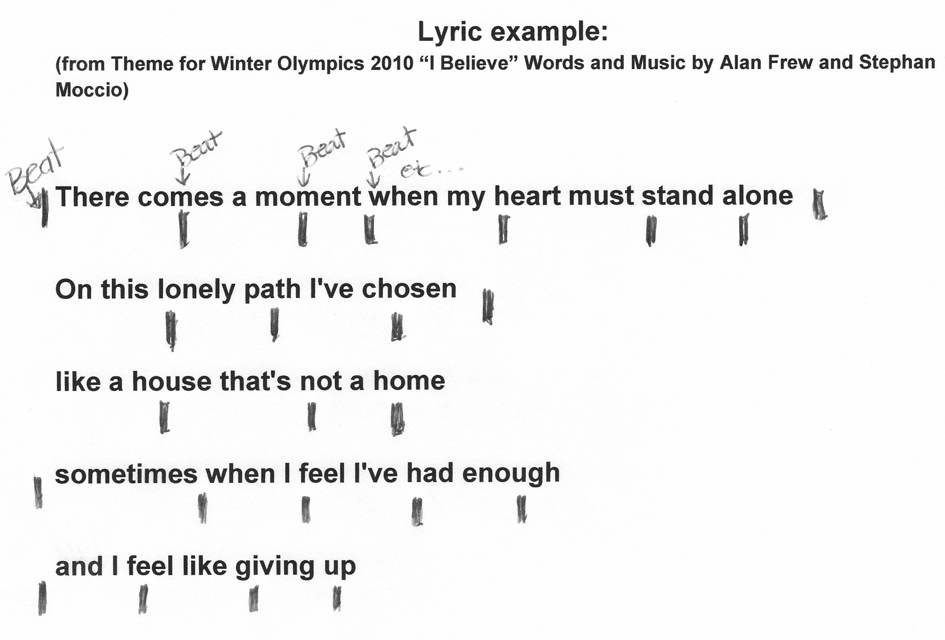
There are 4 beats per bar.

CONSOLIDATION! In order to move on to the next task, you will need to:
- Share your highlighted lyrics/sheet music with your teacher; and
- Perform your song for your teacher while tapping or clapping the pulse/beat as it occurs in the song.

4. WHAT’S YOUR PITCH? FOCUS: VOCAL / PITCH
LEARNING GOAL: You will sing a major scale within your range of singing.

MINDS ON! What is pitch? Music is created through organizing the elements of music.
Pitch is very important to vocal music as it helps to convey the message in the music. It is often the one element that we can recall the most when we think of a song, or when we hear a series of pitches in a specific order (as in a song), it can often help us to remember the other parts of the song e.g. the rhythm or lyrics. Knowing where your singing voice is and being able to sing a major scale helps to develop your listening skills as well as helping to develop a wider singing range. Think of this as a warm-up to stretch your vocal muscles and make them stronger!

ACTION! In order to be successful with this task, you will need to:
- Find a pitch that you can sing that is comfortable. This means you are not straining your voice to reach it;
- Start by singing in a soft voice, it is more important to sing accurately than to sing loud;
- Practise singing a major scale going up; (link to video from grade 4 lesson)
- Sing a major scale in solfege (do, re, mi, fa, so, la, ti, do);
- Use a piano or keyboard; can you distinguish what your first note is?
- Work with a partner. Sing your scale for your partner;
- Listen as your partner sings the scale for you; and
- Work together to practise this task.

CONSOLIDATION! In order to move on to the next task, you will need to sing the major scale for your teacher. You may sing with a partner as long as you are both singing in a similar range.

5. GO BACK TO THE BEGINNING! FOCUS: ANALYSIS OF ELEMENTS
LEARNING GOAL: You will listen to a song and make connections to musical elements.

MINDS ON! We listen to music all the time in the background and very rarely do we listen closely. Now is your chance. What are the elements of music? Why do they matter to a piece of music? Can you focus your listening so well that you can hear small things happening in the music that you never heard before?

ACTION! In order to be successful with this task, you will need to:
- Use the elements chart on the next page to help you focus your thinking as you go through this activity;
- Listen to the song you picked in task 1. Identify what you hear;
- Read through the elements chart on the next page and focus on the questions in the third column to help focus your thinking;
- On your lyrics page, write where you hear instruments and what you hear going on. Describe what the instruments are doing;
- Think about how the instruments and elements enhance the meaning of the song.

CONSOLIDATION! In order to move on to the next task, you will need to:
- Write down your analysis of the instruments and the elements on the lyrics page for your first song;
- Go through your thinking with your teacher; and
- Explain your analysis and sing your song for the teacher.

ELEMENTS OF MUSIC
Music is organized sound. Understanding the systems of organization – the elements - is the key to thinking like a musician.
Element | Definition | Prompts to listen for in the music
Beat | steady pulse or heartbeat in music | What instrument carries the beat/pulse in your song?
Rhythm | the flow of shorter and longer sounds and silences | Are there any instruments that create a rhythm within your song?
Pitch or Melody | the arrangement of higher and lower sounds | What instruments carry the melody in your song? Remember that a voice is an instrument.
Harmony | the chords progressions | Is there harmony in your song? What instruments carry the harmony?
Texture | the number of musical lines – referred to as thicker or thinner | Multiple instruments create texture. What instruments do you hear in your song?
Form | the arrangement of sections of music | Is your song created in sections? Does it have a chorus? Can you hear clear breaks in the music? What form do you think your song is in?
Tempo – Expressive Controls | the speed of the pulse | What is the tempo of your song?
Dynamics – | the loudness or softness of the music | Are there changes in the dynamics in your song? Is it mainly loud or soft?
Expressive Controls | Types of emphasis given to notes includes types of dynamics e.g.)fermatas, sforzando, slur... | Can you hear any expressive controls? Pick out the main instrument you feel is important to the song and listen carefully to its sound for any expressive changes to the sound.
Tone Colour or Timbre | the special quality of a sound that distinguishes voices and instruments from each other | Are there any special qualities that you notice about the instruments and voices in your song? What are they?
With acknowledgement to Catherine West for the elements chart


Congratulations! You have reached your first GPS marker – NORTH!
Ask your teacher how you are to acknowledge this accomplishment on your GPS task tracker! WAY TO GO!!
6. VOCAL WARMUPS! FOCUS: VOCAL / PITCH
LEARNING GOAL: You will be researching vocal warm-ups and finding one to share with the class.

MINDS ON! Vocal care and hygiene are very important. Just like an athlete needs to warm-up their muscles before they play or perform, a singer needs to warm up his/her vocal chords to prepare for singing. What do you think you need to do to warm up your voice? It’s time to search up an answer!
ACTION! In order to be successful with this task, you will need to:
- Use the computer or a resource given to you by your teacher, search for a vocal warm-up that you can share with your class;
- Practise it and prepare to present it to your class;
- Share it with another student in the class as practise and teach them how to do the warm-up; and
- Make sure you know with which aspect this warm-up is meant to help you.

CONSOLIDATION! In order to move on to the next task, you will need to have a vocal warm-up that you can share. With this task you have a choice. You may share it with the class by yourself, with your partner, or request to share it with the teacher one on one.

7. WHAT KIND OF SONG IS IT? FOCUS: ANALYSIS OF INFLUENCES
LEARNING GOAL: You will learn about The World in Six Songs by Daniel J. Levitin and begin to categorize songs based on the criteria of the Six Songs.

MINDS ON! Have you ever wondered what types of songs there are in the world and if there was a way to organise them? Daniel Levitin felt there was a way to differentiate songs through criteria. The next page gives you an idea of the six songs and a simple explanation of what each category includes.
ACTION! In order to be successful with this task, you will need to:
- Take a look at your song from task 1.
- Read through The World of Six Songs reference sheet (next page)
- Which of the six song categories do you feel your song fits into?
- Why do you feel it fits into this category?
- Explain your thinking in the space below.

My favourite song is a...

CONSOLIDATION! In order to move on to the next task, you will need to complete the explanation of how your song from task 1 fits into The World of Six Songs categories. Share your ideas with your teacher.
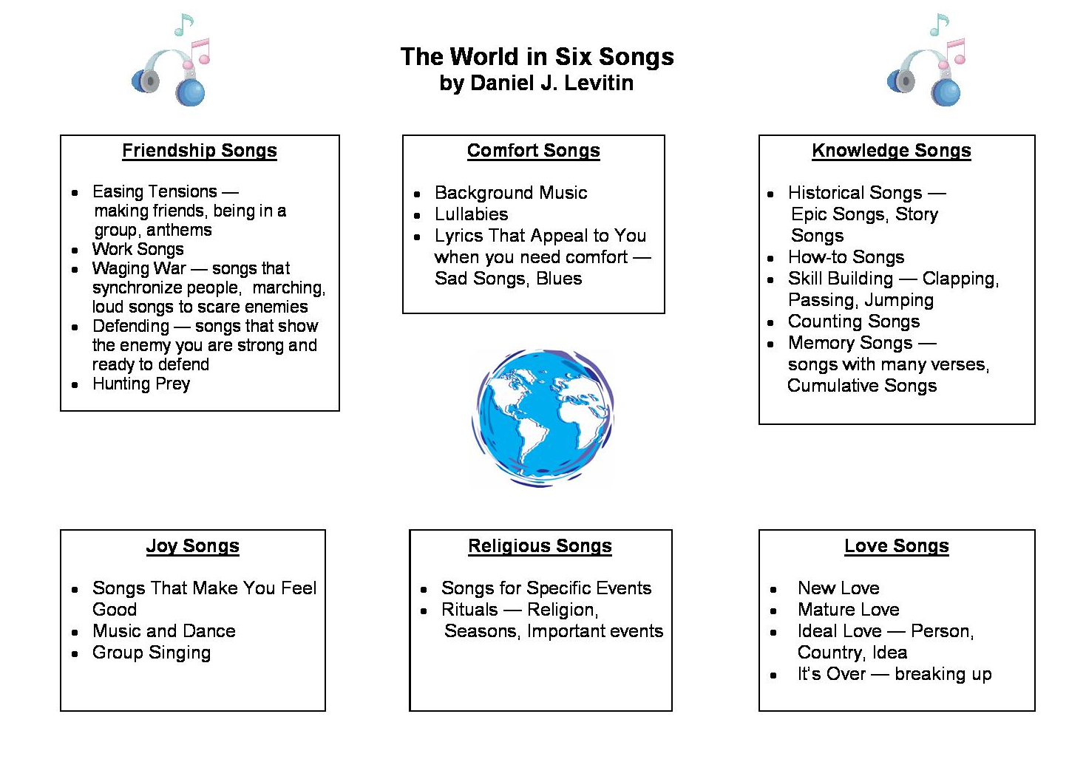
8. THE QUALITIES OF YOUR VOICE! FOCUS: TONE COLOUR / TIMBRE
LEARNING GOAL: You will learn about the sound of your own voice and learn ways to describe it.

MINDS ON! What words can you use to describe a person’s singing voice? How can a person control how their voice sounds? Are there qualities that make your voice unique? What are they?
ACTION! In order to be successful with this task, you will need to:
- Use a tape recorder or a computer; record your voice singing a song of your choice;
- Listen carefully to your recording;
- Describe the sounds that you hear in your voice;
- If you are having difficulty coming up with words, ask another student to listen and help describe some qualities of your voice;
- Try and come up with 10 different words or sentences to describe your voice; and
- Make sure your words are not judgement based, but actually are descriptive. (e.g. bright or dark sound, a mellow sound)

Words to describe my voice:

1 6
2 7
3 8
4 9
5 10

CONSOLIDATION! In order to move on to the next task, you will need to have 10 words that describe the qualities of your voice. Discuss your descriptive words with your teacher.

9. WHO HAS SIMILAR QUALITIES? FOCUS: TONE COLOUR / TIMBRE
LEARNING GOAL: You will find two or three singers that have similar qualities to your voice.

MINDS ON! Have you ever wondered if you sound like a popular singer? Here is your chance to find out! You found qualities of your own voice in the last task, now start listening! What singer sounds like you?
ACTION! In order to be successful with this task, you will need to:
- Listen to a variety of singers on CD, the radio, computer and television;
- Check out your local library for a wide selection of CD choices;
- Categorize their voices and their qualities the same way you did your own;
- Sing along with the recordings to see if you really match in your sound;
- Have a friend listen to you to help you with your choices;
- Look for two to three singers that have similar qualities to your own voice;
- Write their names below and describe how they are similar to you; and
- You will need a song sample to sing and share with your teacher along with your analysis below.

- Singer’s name:

Qualities:

- Singer’s name:

Qualities:

CONSOLIDATION! In order to move on to the next task, you will need to:
- Share your singers with your teacher;
- Explain the qualities you listed above and how they are similar to your voice; and
- Sing along with part of a recording of your singers for your teacher to support your choices.
10. WHAT KIND OF SONGS? FOCUS: PERSONAL RESPONSE
LEARNING GOAL: You will apply your learning about The World in Six Songs by Daniel J. Levitin and continue to categorize songs based on the criteria of the six songs.

MINDS ON! You have used the lyrics, musical elements and qualities of sound to analyze music. Now apply your learning from The World in Six Songs reference sheet. What qualities do you look for when deciding on the category into which a song will fit?
ACTION! In order to be successful with this task, you will need to:
- Refer back to The World in Six Songs reference page;
- Select one song from each singer you chose in task 9 and list them on your playlist;
- Look at the qualities of sound, elements of music and the lyrics to make an informed decision on which song category these songs fit into and why;
- Fill in the song title, artist and year;
- Describe the theme of the lyrics; add any information you think is significant in understanding them on your playlist. Support your thinking in the spaces provided; and
- Choose one of the songs you are adding to sing for your teacher and practice it.

CONSOLIDATION! In order to move on to the next task, you will need to:
- Add one song from each singer you chose in task 9 to your playlist;
- Fill in all columns of the playlist for each song;
- Sing one of the songs from this task for your teacher; and
- Show your teacher your choices and explain your thinking. Your playlist should be neat and legible.


Congratulations! You have reached your second GPS marker – EAST!
Ask your teacher how you are to acknowledge this accomplishment on your GPS task tracker!
WAY TO GO!!

11. PICK A SONG! FOCUS: ANALYSIS OF ELEMENTS
LEARNING GOAL: You will be analyzing a song of your choice from task 10.

MINDS ON! When we take a closer look at songs, we learn more about ourselves as learners, listeners and musicians. What qualities do you hear? What instruments do you hear? What patterns do you see? Why did the composer make the choices they did? How does that affect you as a listener and performer?
ACTION! In order to be successful with this task, you will need to:
- Choose one of the songs you added to your playlist in task 10;
- Find the sheet music, lyrics (with guitar tabs) or write/type out the lyrics. Make sure you leave space between the lines for analysis; (This is just like task#1)
- As you are working on this, if you notice anything you feel is important, add the information to the playlist or on your lyric sheet; and
- You will need to sing this song for the teacher and the rubric will be used for this song to assess how you are developing as a singer. Check out the rubric at the beginning of the booklet to remind you of the criteria.

CONSOLIDATION! In order to move on to the next task, you will need to:
- Provide the teacher with your sheet music and/or lyrics. Make sure there is space to write in your observations on your sheet music and/or lyrics sheet; and
- Sing this song for the teacher.
12. WHAT INSTRUMENTS DID THEY USE? FOCUS: EXPRESSIVE ELEMENTS / TIMBRE
LEARNING GOAL: You will be analyzing how a composer uses instruments and the elements of expressive controls and timbre to enhance the meaning in the song.

MINDS ON! How do instruments enhance the meaning of a song? Think about the ways that a composer uses instruments to create a mood. Apply this knowledge to a song from your playlist.
ACTION! In order to be successful with this task, you will need to:
- Use the song you chose in task 11, list the instruments used and where they are used on your lyrics sheet;
- Identify if there are percussion instruments and if so, where you hear them. Write down a description of what you hear in the extra spaces around the lyrics;
- Make sure you are placing the information about the instruments and their names in line with the lyrics, where you hear them being played so that you can reflect on and analyze the information;
- Use the elements of music reference sheet from task 5 to help focus your thinking when analyzing the song;
- Describe how the choice of instruments (use of texture, timbre, tone colour...) enhances the meaning of the lyrics in the song.
- Find the connections and write them in the space provided below.

How does the choice of instruments enhance the meaning of the song?

Task 12: CONSOLIDATION! In order to move on to the next task, you will need to:
- Describe the instrumentation and your thoughts on your lyrics page;
- Complete the above question with supporting examples; and
- Share a recording of your song, lyrics page, and the above answered question with your teacher.

13. SIMILARITIES AND DIFFERENCES. FOCUS: ANALYSIS OF INFLUENCES
LEARNING GOAL: You will make comparisons between the first song on your playlist and the last song you placed on your playlist in task 12.

MINDS ON! What makes songs different? What makes them similar? According to Daniel J. Levitin all songs fit into 6 different categories. Do you agree? How would you categorize songs? What criteria are important to you?
ACTION! In order to be successful with this task, you will need to:
- Look at the first song you added to your playlist and look at the last song you analyzed in task 12;
- Use the Venn diagram on the next page to compare the two songs;
- Use the circle on your left for the first song you added to your playlist and use the circle on the right for the song from task 12. Make sure you use the information you have collected through task 5 and 12 to help you;
- In the large parts of the circles, place the information that makes the two songs different;
- Place the information that makes them similar where the two circles cross in the shared space;
- Meet with another student in the class share your comparisons with them and listen to their comparisons of their two songs; and
- In the space below, write down any interesting thoughts or facts that you notice when you compare your Venn diagram with another students.

I shared my Venn diagram with ____________________________. We found the following interesting facts in our comparisons that were similar / different...

What my partner said about my findings:

CONSOLIDATION! In order to move on to the next task, you will need to:
- Complete the Venn diagram on the next page;
- Explain and discuss your findings with another student;
- Write down your thoughts about what you found in your comparison and what another student found when you discussed your songs on the lines above; and
- Share your findings with your teacher.

Song 1:
Song 2:
Task 13

14. 12 BAR BLUES. FOCUS: ANALYSIS OF ELEMENTS / FORM
LEARNING GOAL: You will add a 12-bar blues song to your playlist and learn about what the criteria are for the 12-bar blues.

MINDS ON! What are the blues? Is there a specific voice type that sings the blues? How does your voice compare?
“Blues is easy to play but hard to feel”
Jimmy Hendrix
ACTION! In order to be successful with this task, you will need to:
- Choose one song from the list of blues on the next page;
- Find a recording of the song. Use the internet to help you;
- Add it to your playlist and fill out all the criteria on your playlist;
- Describe how the vocalist’s voice and singing style compare to yours. Write about it in the space below;
- Tell if you have ever sung the blues. Try singing along with your song choice;
- Record yourself singing the song and listen to hear if your voice qualities are similar to the recording artist;
- Remember to write down what the lyrics are about on your playlist; and
- Based on what you know about The World in Six Songs categories, identify the type of song that you chose. Write it down on your playlist.

The vocalist’s voice qualities:

My voice qualities:

CONSOLIDATION! In order to move on to the next task, you will need to choose a song from the list of 12-bar blues. Listen to the song and compare the vocalist’s voice to your own. Add the song to your playlist and share your work with the teacher.
List of possible Blues songs (some songs are in the style of 12-bar blues):
- “Be Careful With a Fool” by Johnny Winter
- “Cross Roads” by Robert Johnson
- “D.J. Play My Blues” by Buddy Guy
- “I Believe I'll Dust My Broom” by Robert Johnson
- “I Can't Quit You Baby” by Willie Dixon
- “I'm Going Home” by Ten Years After
- “I'm Tore Down” by Eric Clapton
- “Let Me Love You Baby” by Buddy Guy
- “Look On Yonder Wall” by Elmore James
- “Mama, Talk To Your Daughter” by Robert Palmer
- “Jump, Jive an' Wail” by Louis Prima or Brian Seltzer
- “Shake, Rattle and Roll” by Bill Hailey and the Comets
- “Tutti Frutti” by Little Richard
- “On the Road Again” by Canned Heat
- “Phone Booth” by Robert Cray
- “Rock Me Baby” by B.B. King
- “Rollin' and Tumblin'” by Muddy Waters
- “Sinner's Prayer” by Ray Charles
- “The Sky Is Crying” by Stevie Ray Vaughan
- “(They Call It) Stormy Monday” by Cream
- “Sweet Home Chicago” by Robert Johnson
- “The Thrill Is Gone” by B.B. King
- “Wednesday Evening Blues” by John Lee Hooker
- “Bumblebee Blues” by Memphis Jug Band
- “Hound Dog” by Elvis Presley
- “Lost Your Head Blues” by Bessie Smith
15. IS THERE A PATTERN? FOCUS: FORM
LEARNING GOAL: You will be learning about the patterns found in the 12-bar blues.

MINDS ON! What are the patterns in the 12-bar blues? Let’s explore them!
“Go ahead and play the blues if it will make you happy”
Dan Castellaneta
ACTION! In order to be successful with this task, you will need to:
- Write out the lyrics of the song you chose in task 14. Leave space between the lines to write in your observations and analysis;
- Look at the chordal pattern of the 12 bar blues as provided by your teacher;
- Place the chordal pattern onto the lyrics showing where the chords change as the song is sung. Listen carefully to the song to find out where the chords change; and
- Identify the pattern that you find in the lyrics.

CONSOLIDATION! In order to move on to the next task, you will need to share your lyrics with your teacher. Make sure you have included where the chordal pattern occurs in your song. Include your explanation of the lyrics pattern that you found in your song.


Congratulations! You have reached your third GPS marker – SOUTH!
Ask your teacher how you are to acknowledge this accomplishment on your GPS task tracker!
WAY TO GO!!

16. I’VE GOT THE BLUES! FOCUS: FORM /COMPOSING
LEARNING GOAL: You will write your own lyrics in the 12-bar blues form.

MINDS ON! What kind of message did you find in the lyrics of your blues song from task 14?
This task is a partner task.
“Anybody singing the blues is in a deep pit yelling for help!”
Mahalia Jackson
ACTION! In order to be successful with this task, you will need to:
- Brainstorm with a partner different environmental issues. Create a list of options below;
- Look at your lyrics from task 15. Use the original lyrics as a guideline for writing your own lyrics;
- Create lyrics that will help to inform people about an important environmental issue;
- Work with your partner to create the lyrics and work through how you are going to present them to the class; and
- Practice singing an improvised melody along with your lyrics.

Possible environmental issues to talk about:

Your final lyrics:

A

A

B

CONSOLIDATION! In order to move on to the next task, you will need to:
- Create a list of possible environmental issues with a partner;
- Write lyrics in the 12-bar blues form; and
- When you are ready, share your lyrics with your teacher. Try singing them with an improvised melody!

17. MY BLUES. FOCUS: VOCAL / PITCH / FORM
LEARNING GOAL: You will be singing your blues.

MINDS ON! Singing the blues was a way of expressing feelings and sending a message to everyone who would listen. How will you sing your message? How will you use your voice to reflect the meaning in your lyrics?
“Hearing the blues changed my life”
Van Morrison
ACTION! In order to be successful with this task, you will need to:
- Continue to work with your partner in preparing to present your lyrics;
- If you wish, use a recording in the background to support your singing or create props that will assist you in your presentation of your lyrics;
- Use your voice in a way that helps to reflect the meaning in your lyrics;
- Give your song a title and add it to your play list;
- Based on what you know about The World in Six Songs categories, identify the type of song your 12-bar blues is? Be able to explain your thinking; and
- Fill in all the criteria on your play list.

CONSOLIDATION! In order to move on to the next task, you will need to:
- Present and sing your lyrics to the class or your teacher;
- Describe how you used your voice to reflect the meaning of your lyrics; and
- Share your playlist with your teacher.

18. LOOKING BACK! FOCUS: PERSONAL RESPONSE
LEARNING GOAL: You will be finishing off your playlist.

MINDS ON! You have been learning about different types of songs and looking at how they relate to you as a musician and listener. Now is your chance to pick your own song. What song are you going to pick? Where is it going to fit into the six song categories?
ACTION! In order to be successful with this task, you will need to:
- Look at all the songs you have on your playlist;
- Which of the six song categories are missing from your playlist?
- Find a song that will fit into one of the categories that is missing; and
- Describe the song you chose below and where it fits into The World in Six Songs categories.

My song is: _____________________________ by: __________________

It fits into the __________________________category of The World in Six Songs. This

is why:

CONSOLIDATION! In order to move on to the next task, you will need to:
- Pick a song and it add to your playlist that is in a different The World in Six Songs category than the rest of your playlist;
- Describe the song you chose and where it fits into the six song categories; and
- Sing your song and share your work with your teacher.

19. REFLECT AND ANALYZE FOCUS: ANALYSIS OF ELEMENTS
LEARNING GOAL: You will be analyzing a song of your choice from task 18.

MINDS ON! This year you have been learning how to be a critical listener and performer of music. When you analyze songs, it helps you make critical choices and also gives you more information. What instruments do you hear? What elements of music can you relate to this song?
ACTION! In order to be successful with this task, you will need to:
- Take the song you chose from task 18;
- Find the sheet music, lyrics (with guitar tabs) or write/type out the lyrics. Make sure you leave space between the lines for analysis;
- Really listen to your song;
- As you are working on this, if you notice anything you feel is important add the information to the playlist or on your lyric sheet;
- On your lyrics sheet or sheet music describe how the instruments and music reflects your category choice; and
- Use the elements chart from task 5 to help focus your thinking.

CONSOLIDATION! In order to move on to the next task, you will need to analyze your song choice (as in task 5) and share your lyrics / sheet music and findings with your teacher.

20. ALL ABOUT ME! FOCUS: CRITICAL ANALYSIS
LEARNING GOAL: You will be writing a reflection of your playlist and of your learning this year.

MINDS ON! When we reflect on our learning, we become stronger. What does your playlist say about who you are as a person?
ACTION! In order to be successful with this task, you will need to:
- Look at the information you have on your playlist; describe how you use music in your life in the space below;
- Identify if your listening has changed over the year;
- Describe if you notice certain patterns and common themes in all music now; (e.g. Music style, genre, six songs categories)
- Identify any songs you would want to add to your playlist; Why?
- Use the space below to answer these questions; and
- Pick a song to be your final song of the year to sing for your teacher and practice it.

What I notice about my playlist....

What I might add to my playlist...

Task 20 continued.

How my listening changed throughout the year:

CONSOLIDATION! In order to complete this final task, you will need to show your teacher your thoughts on what you noticed about your playlist and your thinking on how you have grown as a listener and performer of music. Sing one last song of your choice for you teacher.


Congratulations! You have reached your final GPS marker – WEST!
Ask your teacher how you are to acknowledge this accomplishment on your GPS task tracker!
WAY TO GO!!

Congratulations!

__________________ has reached the North GPS Marker in the Grade 7 GPS Vocal program.

_________________________________
Teacher Signature

_________________________________
Principal Signature

Congratulations!

__________________ has reached the East GPS Marker in the Grade 7 GPS Vocal program.

_________________________________
Teacher Signature

_________________________________
Principal Signature

Congratulations!

__________________ has reached the South GPS Marker in the Grade 7 GPS Vocal program.

_________________________________
Teacher Signature
_________________________________
Principal Signature

Congratulations!

__________________ has reached the FINAL (West) GPS Marker in the Grade 7 GPS Vocal program.
You’re Done!!

_________________________________
Teacher Signature

_________________________________
Principal Signature

