GPS (Grade Performance Steps)

The Road to Musical Success!
Grade 6 Performance Tasks




Ontario Music Educators’ Association
www.omea.on.ca
Teachers, before you copy this booklet for your students...
⬰ Have you read the GPS Overview?
⬰ Have you taught these students before? If not, please take the time to work with your students to determine their strengths and needs before deciding which tasks will be appropriate.
⬰ Have your students completed the tasks in the Grade 5 GPS tasks, or have the concepts been taught to your students?
⬰ If you have taught these students before...go through the entire program task-by-task to confirm that the sequence and challenge level of the tasks is appropriate.
Refer to the Q and A section of the GPS Overview.

⬰ Do you need to reduce the number of tasks? If so, how will you need to change the evaluation by term?

⬰ The Junior Recorder GPS task progression chart is available by clicking here. You can see how these tasks align with and can support the Grade 6 Recorder GPS Tasks.

If you have questions, please contact:

Lynnette Charters: lcharters@rogers.com

Task # 2
Task # 1
Task # 3
Task # 5
Task # 6
Task # 7
Task # 10
Task # 9
Task # 11
Task # 15
Task # 14
Task # 13
Task # 16
Task # 4
Task # 8
Task #12
1. KEEP THE BEAT! FOCUS: BEAT
LEARNING GOAL: You will be learning to keep a steady beat.

MINDS ON! Can you describe the concept of beat? Can you find the beat in a piece of music? Can you follow the beat and keep a steady pulse?

ACTION! In order to be successful with this task, you will need to:
- Listen carefully to the music chosen by your teacher for the underlying beat.
- Work together in a group to pass a rock around the circle using a cup.
- The rock should only be moved to the next person on a beat.
- Listen for when the teacher asks you to switch directions, this can be tricky so keep listening for the beat.
- Try switching direction after 3 passes, 6 passes and then 8 passes. Which one is easiest?
- Keep the movement steady and consistent, try not to miss a beat when you are passing.
- Challenge: create a rhythm that fits into the beat by tapping on the cup or adding body percussion. Continue to keep the beat while also performing the rhythm.

CONSOLIDATION! In order to move on to the next task, you will need to show that you can keep a steady beat by passing the rock on to the next student without missing a beat. You should be able to do this consistently throughout an entire song switching direction (and adding a rhythm) when the teacher asks you to without losing the beat.

2. WARM-UPS INCREASE YOUR VOCAL RANGE! FOCUS: VOCAL

LEARNING GOAL: You will be learning to increase your vocal range.

MINDS ON! Warm-ups are a part of a daily routine to keep your body and mind strong. In music, we need to warm-up before we perform to help us prepare and to make sure we don’t hurt ourselves (just like when we warm-up before exercising). Practising vocal skills will help us in our performances. Can you sing high pitches consistently? Can you sing lower pitches consistently? Most people sing pitches that are in the middle of their range well because that is where our speaking voice is and the vocal chords needed to make the sound are very strong. Now is the time to start exercising and improving our low and high sounds.
ACTION! In order to be successful with this task, you will need to:
- Practise the warm-ups your teacher gives you at the beginning of class.
- Start each warm-up with a deep breath in through your nose and then release the air throughout the warm-up by using your diaphragm to help push the air out.
- Start this warm up with a relaxed and quiet “oh” sound. Start at the highest note you can sing and slowly descend down to the lowest note you can sing. Slur through all the notes as you descend down (like a siren sound but only going down slowly.)
- Once you reach your lowest note, go back up slowly to your highest note.
- If you get to a spot where your voice disappears, that is a spot to work on getting a small sound, stay there as you try to get a singing pitch (not loud) to come out.
- Do this same warm-up with other vowel sounds.
- You will notice that as you get better at this warm-up that you will be able to sing a bit louder without having tension in your neck. That means you are building strength around your vocal chords.
- Remember to try and sing softly for this warm-up.

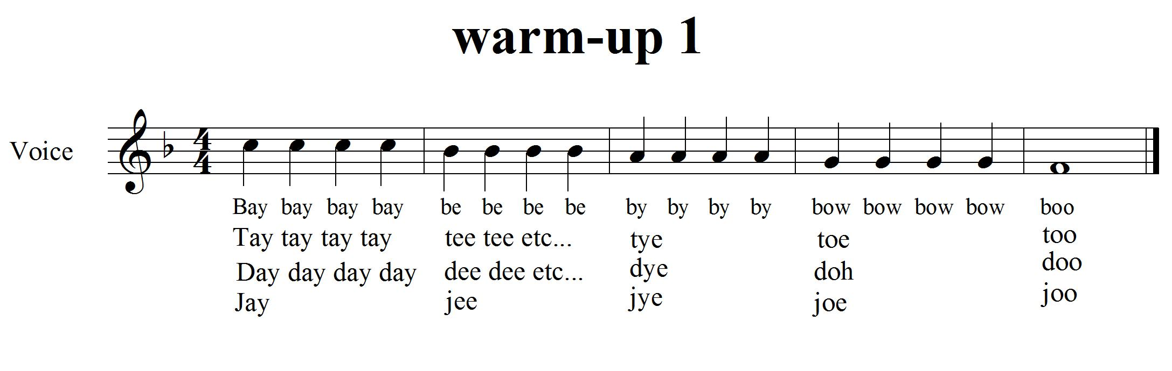

CONSOLIDATION! In order to move on to the next task, you will need to show that you can warm up your voice by doing the warm-up exercise above. You will also need to show how to push the sound out using your diaphragm.

3. RHYTHM! FOCUS: RHYTHM/METRE
LEARNING GOAL: You will be learning about compound metre and applying it to a poem.

MINDS ON! Rhythm changes everything up! Can you create a rhythm? Can a rhythm sometimes sound like the beat? What is Compound Metre? The simple way to divide beats is in groups of 2 or 4. Compound metre separates beats into groups of 3, 6 or 9. Can you create a rhythmic pattern using groups of 3? How about switching back and forth from groups of 3 to groups of 4?
ACTION! In order to be successful with this task, you will need to:
- Learn the poem “Jenny the Juggler” (by: Dennis Lee).
- It has two sections A and B. The A section is in time (Verse). The B section is in time.
- Create a repeated clapping pattern using ta () and ti () that work with the time (which is the verse).
- Clap your pattern while another student chants the poem rhythmically. Create a complementary rhythmic pattern to go with the words.
- When you feel ready, begin clapping your pattern with the poem, take turns with your partner. Write it down on the lines below to help remember it.
- Work with a partner to create a pattern that is more complex.
- Practise clapping your pattern with another student.

Jenny the Juvenile Juggler by: Dennis Lee

Jenny had hoops she could sling in the air, and she brought them along to the Summerhill Fair. And a man from the carnival side show was there who declared that he needed a juggler.
A

And it’s Oop’s! Jenny, Whoop’s! Jenny, swing along your hoop’s Jenny,
Spin a little pattern as you go;
Because it’s Oop’s! Jenny’s hoops! Jenny, sling a loop-the-loop, Jenny,
Whoop’s! Jenny, Oop’s! Jenny O!

Well the man was astonished at how the hoops flew, and he said “It’s amazing what some kids can do!” and now in the carnival Act number two, is Jenny the juvenile juggler.
A

And it’s Oop’s! Jenny, Whoop’s! Jenny, swing along your hoop’s Jenny,
Spin a little pattern as you go;
Because it’s Oop’s! Jenny’s hoops! Jenny, sling a loop-the-loop, Jenny,
Whoop’s! Jenny, Oop’s! Jenny O!

CONSOLIDATION! In order to move on to the next task, you will need to show that you can keep a rhythmic pattern in time steady while another student chants the A section of the poem.

4. DO YOU KNOW YOUR RHYTHMS? READY, SET...! FOCUS: RHYTHM

LEARNING GOAL: You will copy a rhythm that the teacher or another student claps using standard or rhythmic notation.

MINDS ON! Now that you have reviewed rhythm, let’s continue notating it. You may use rhythmic notation ( ) or standard notation (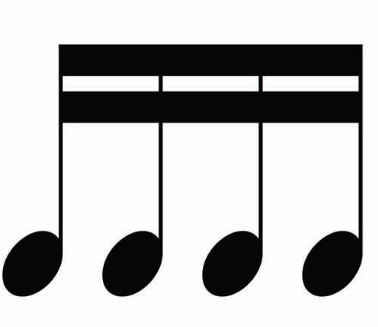 ). Create a rhythm for another student. Can they clap your rhythm back to you? Practise, with an elbow partner, creating your own rhythms and clapping their rhythms. Do you know how to use syn-co-pa (), ti-tika (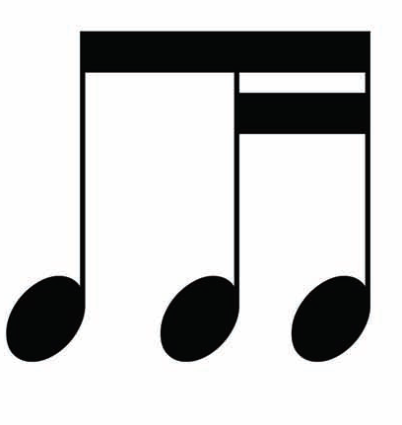), tika-ti (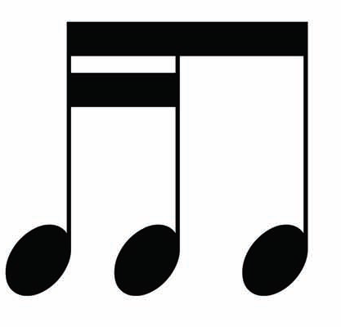), ta-ah (), sa-ah () and shh or “rest” ()?
ACTION! In order to be successful with this task, you will need to:
- Create five rhythms using standard notation. Show the correct metre for each rhythm you have written at the beginning of the line.
- Have two other students clap your rhythms to check for accuracy.
- Consistently show the correct symbols for ta, ti-ti, tika-tika, ti-tika, tika-ti, syn-co-pa, ta-a, half and quarter rest.
My five rhythms:

Checked by:____________________

Checked by:____________________

CONSOLIDATION! In order to move on to the next task, you will need to show that you can accurately create five rhythms of your own, have them checked by two other students and then clap them for your teacher.


Congratulations! You have reached your first GPS marker – NORTH!
Ask your teacher how you are to acknowledge this accomplishment on your GPS task tracker!
WAY TO GO!!
5. LET’S PUT IT TOGETHER FOCUS: BEAT/RHYTHM/ANACRUSIS

LEARNING GOAL: Put the knowledge you have learned about Beat, Rhythm to work when playing pick-up notes. You will need to show both the beat and the rhythm of a song.

MINDS ON! You know about beat and rhythm as part of the element, duration. Last year, you started to learn about pick-up notes where the musical phrase starts on the last part of an unstressed beat leading us to a strong beat. Another name for pick-up notes is anacrusis. Can you keep the beat in your feet? Can you clap the rhythm in your hands? Let’s give it a try! First, with the help of your teacher, learn to sing the song. Step with your feet to keep a beat steady while you are singing the melody. Can you clap the rhythm of the words with your hands?
ACTION! In order to be successful with this task, you will need to:
- Learn to sing the song, “John Kanakanaka”.
- Keep the beat in your feet. Keep the beat steady.
- Highlight every pick up note in your music below and share this with your teacher during the consolidation.
- Clap the rhythm of the words in “John Kanakanaka” while singing the song.
- Now keep the beat in your feet, the rhythm in your hands and sing the song all at the same time.

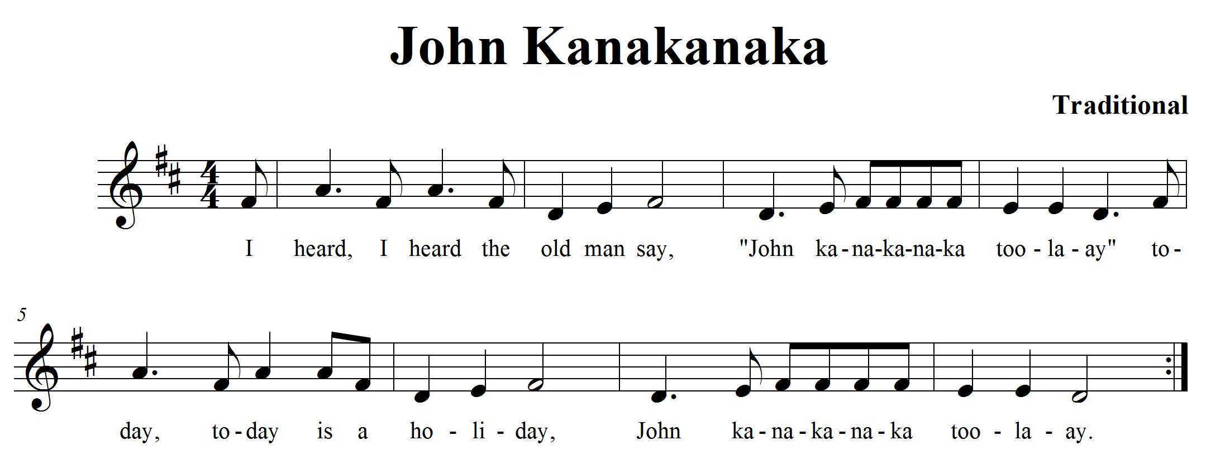

CONSOLIDATION! In order to move on to the next task, you will need to show that you can keep the beat in your feet and clap the rhythm of the words while singing John Kanakanaka. Show your teacher the pick-up notes you found in the music.

6. THERE’S MORE TO DURATION! FOCUS: METRE/ACCENT

LEARNING GOAL: Let’s expand the knowledge that you have learned so far about duration by learning more about METRE in music.

MINDS ON! What is compound metre in comparison to simple metre? Can you find the beat in a song in time? Can you find the beat in a song in time? When your teacher plays the music, walk around the room and make a big stomp when you hear a strong beat and create smaller steps on the weaker beats. How many beats do you hear? When the rhythm is more complex, can you still feel the beat? What about in music when the metre changes in the middle, can you feel the changes?
ACTION! In order to be successful with this task, you will need to:
- Work in compound metre!
- How are and time different and how are they similar?
- Say the A section of the poem, “Jenny the Juvenile Juggler” with the correct timing.
- Say the B section of the poem with the correct timing.
- How are these two sections different? How are they similar?
- Work with a partner and clap the beat in each section of the poem as you are saying the poem. Create one action for each section (e.g. clapping and stomping) and use them to show the metre change in the poem.
- When you are ready, answer the questions below.
- Be ready to perform the poem for the teacher with your two different actions.

CONSOLIDATION In order to move on to the next task, you will need to; show that you can move to the beat of the music; show your actions for part A and B of the poem while you perform it; complete the questions below.

- How are and time different? How are they the same?

- What differences and similarities to you see or hear between section A and B in the poem? Use the Venn diagram on the next page to show your answers.
Part B
Part A
Jenny the Juvenile Juggler comparison
7. PICK IT UP! FOCUS: PICK-UP NOTE

LEARNING GOAL: You will be learning about pick-up notes and how to perform them.

MINDS ON! How do you identify a pick-up note? How does the pick-up note change the “feel” of a piece? Pick-up notes are usually found on the last beat of a bar. They occur on a weak beat and lead us to a strong beat. How do you know when to start when the music starts with a pick-up note? Take a close look at the last bar... the pick note has done something to the number of beats. Can you tell what it is?
ACTION! In order to be successful with this task, you will need to:
- Learn to sing the song, “Sarasponda”.
- Figure out on what beat the song starts.
- Perform this song with the correct rhythms and pitches.
- After a few times practising this, you should be ready to complete this task.

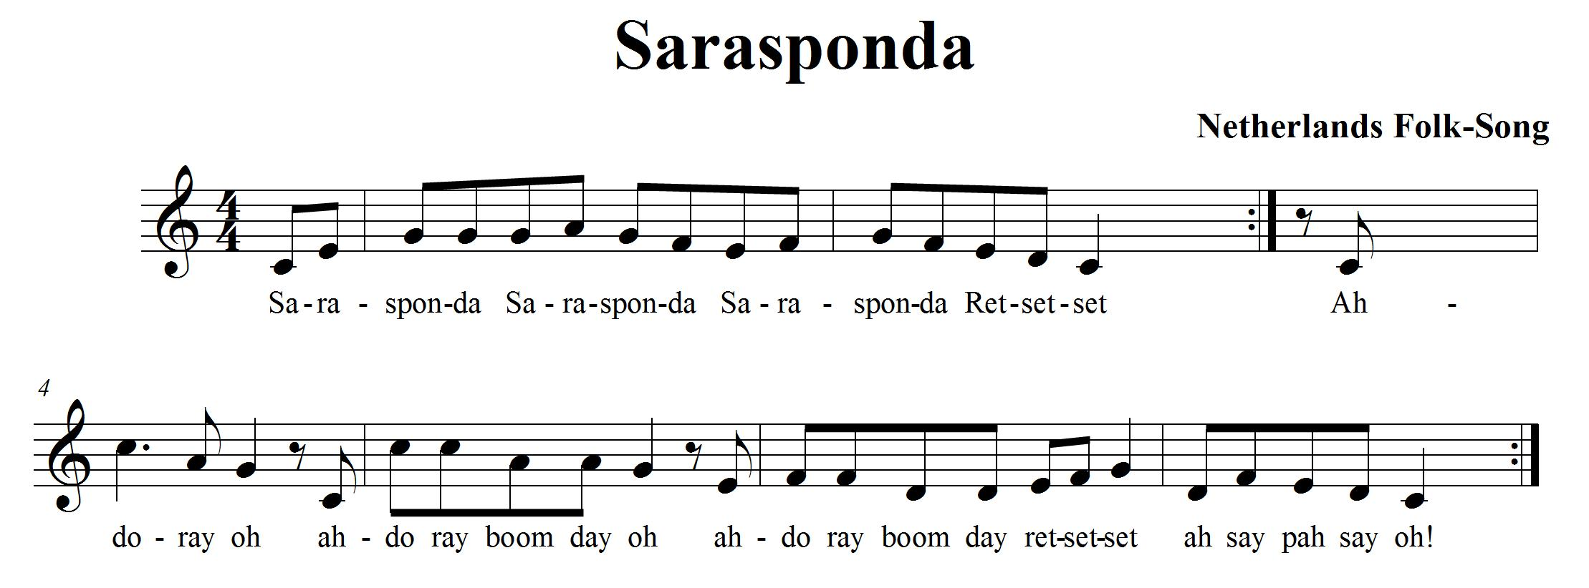

CONSOLIDATION! In order to move on to the next task, you will need to sing the song, “Sarasponda” for your teacher. Be able to show your teacher where the pick-up notes occur in the song.
8. SOLFEGE, MAJOR / MINOR SCALE? FOCUS: PITCH

LEARNING GOAL: You will review the hand signs for a major scale and learn the related natural minor scale.

MINDS ON! Do you know what a major scale is? There are eight pitches that make up a major scale. In Solfege, they are called do (pronounced doh), re, mi, fa, so, la, ti and do. Each pitch has a special hand sign to represent each syllable. Do you remember all eight hand signs from grade 5? Can you sing the syllable names in order with their assigned pitches? Give it a try! Now let’s try the natural minor scale. It is the same as the major scale except that it starts on la and goes up (or down) from there like this: la, ti, do, re, mi, fa, so, la. The syllables stay in the same order; they just start at a different spot. Can you sing the syllable names in order of their assigned pitches for the natural minor scale?
ACTION! In order to be successful with this task, you will need to:
- Sing la, ti, do, re, mi, fa, so, la, using hand signs.
- Look at the standard notation below that shows you both a major scale and a natural minor scale.
- Learn to sing the natural minor scale going up and going down. Sing it for an elbow partner. Listen as they sing it for you. Sing it together as a duet, match your pitches to other voices as you practise.
- Show the hand signs for the notes in the scale (starting on ‘la’) while you sing it in solfege syllables.

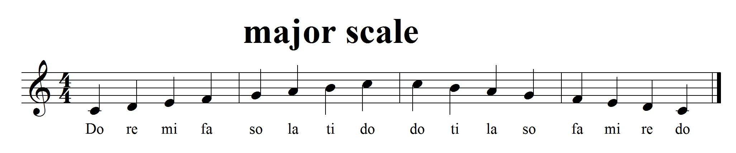
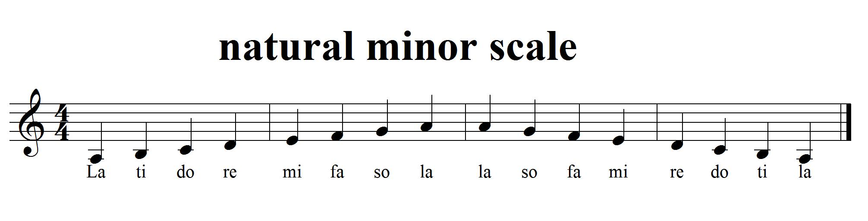

Task 8 continued
CONSOLIDATION! In order to move on to the next task, you will need to show that you can sing the natural minor scale starting on a note that is not too high or low so that you can go up the scale showing your hand signs and back down. Your teacher can provide you with help on your pitches if you want the help.


Congratulations! You have reached your second GPS marker – EAST!
Ask your teacher how you are to acknowledge this accomplishment on your GPS task tracker!
WAY TO GO!!

9. SOLFEGE, KEEP WORKING ON IT! FOCUS: PITCH

LEARNING GOAL: Learn the hand signs for eight different pitches.

MINDS ON! What is pitch? Can you hear when a sound is high or low? Do you know when to move the note you are singing to match someone else’s pitch? Music is made up of pitches. Now that you know the syllables do, re mi, fa, so la and ti and the hand signs for each syllable, it’s time to apply them to a song.
ACTION! In order to be successful with this task, you will need to:
- Practise singing la, ti, do, re, mi, fa, so, la going up and down the natural minor scale while using hand signs.
- Learn to sing the song, “Land of the Silver Birch”.
- Write the solfege names underneath the notes in the song.
- Practise “Land of the Silver Birch” until you can sing it in solfege or with words.
- Show the hand signs for the notes in the song (it starts on ‘la’) while you sing it in solfege syllables.
- Is this song written in a natural minor?

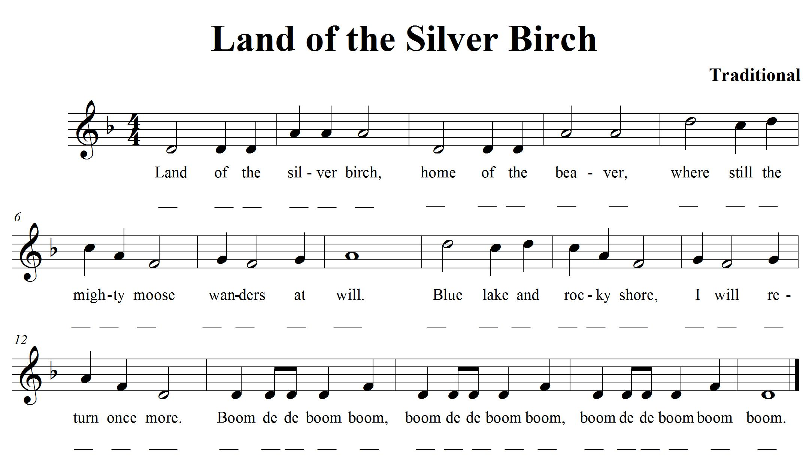
SELF-REFLECTION: My impressions of the hand signs are... describe your thinking.

CONSOLIDATION! In order to move on to the next task, you will need to sing “Land of the Silver Birch”. Sing it a second time using solfege syllables and hand signs. You must sing it while keeping a steady beat. Complete the self-reflection.

10. WHAT MAKES A MELODY? FOCUS: PITCH/SYNCOPATION

LEARNING GOAL: You will be learning more about melody, syncopation and how the pitches move through time.

MINDS ON! What is a melody? What does it mean if the melody is syncopated? Can you create a graphic representation of what the pitch is doing in a song by drawing a line or lines? Can you hear when the notes move up and when they move down? Try showing the sound movements in a picture form. Can you accent where the strong beats are in the song on your melody map? 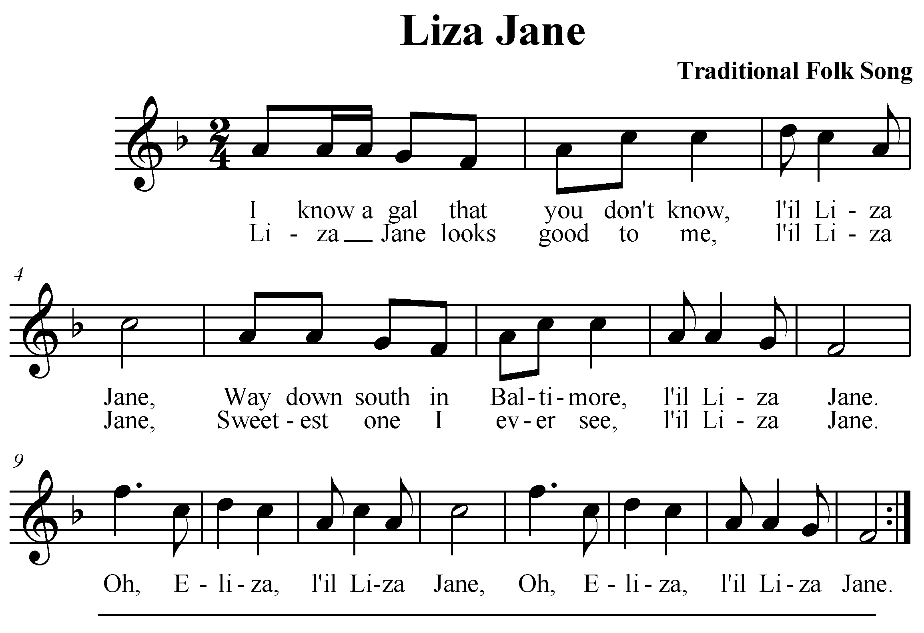
ACTION! In order to be successful with this task, you will need to:
- Learn to sing the song, “Liza Jane”.
- Listen for the accented beats. There is some syncopation happening.
- Once you know the song, without using the music, draw a melody map that shows what the melody is doing. Remember: Don’t look at the music to figure it out, try and write it from your memory. Remember that a melody map shows the contour of the melody.
- Use some standard notation to show what is happening to the melody.
- Mark in an accent > above the syncopated notes below to show that it is accented. How will you show the accents on your melody map?

CONSOLIDATION! In order to move on to the next task, you will need to show that you can sing “Liza Jane”. Without using the music above, create a melody map on paper to show the movement of the pitches in the song. Try using some standard notation to show the accented notes if you can. Follow your melody map with your finger while you are singing so your teacher will know where you are on your map.

11. ARTICULATION IS FUN! FOCUS: ARTICULATION/COMPOSITION

LEARNING GOAL: You will learn to use expressive elements to create a variation in a song and perform your variation.

MINDS ON! Composers use dynamics and other articulations to help express a mood or to accent something they want people to notice in their music. There are so many articulations! Now is your chance to compose! Learn the song below and create a variation of it by adjusting articulations and the tempo.
ACTION! In order to be successful with this task, you will need to:
- Learn to sing, “Frere Jacques”.
- Watch the dynamic markings and change your volume accordingly.
- Using standard notation, write a variation of “Frere Jacques”. Change the tempo; add articulation and accents to vary it.
- What would it sound like if you started on la instead of do? (That would be creating a minor variation... what does it do to the sound?)
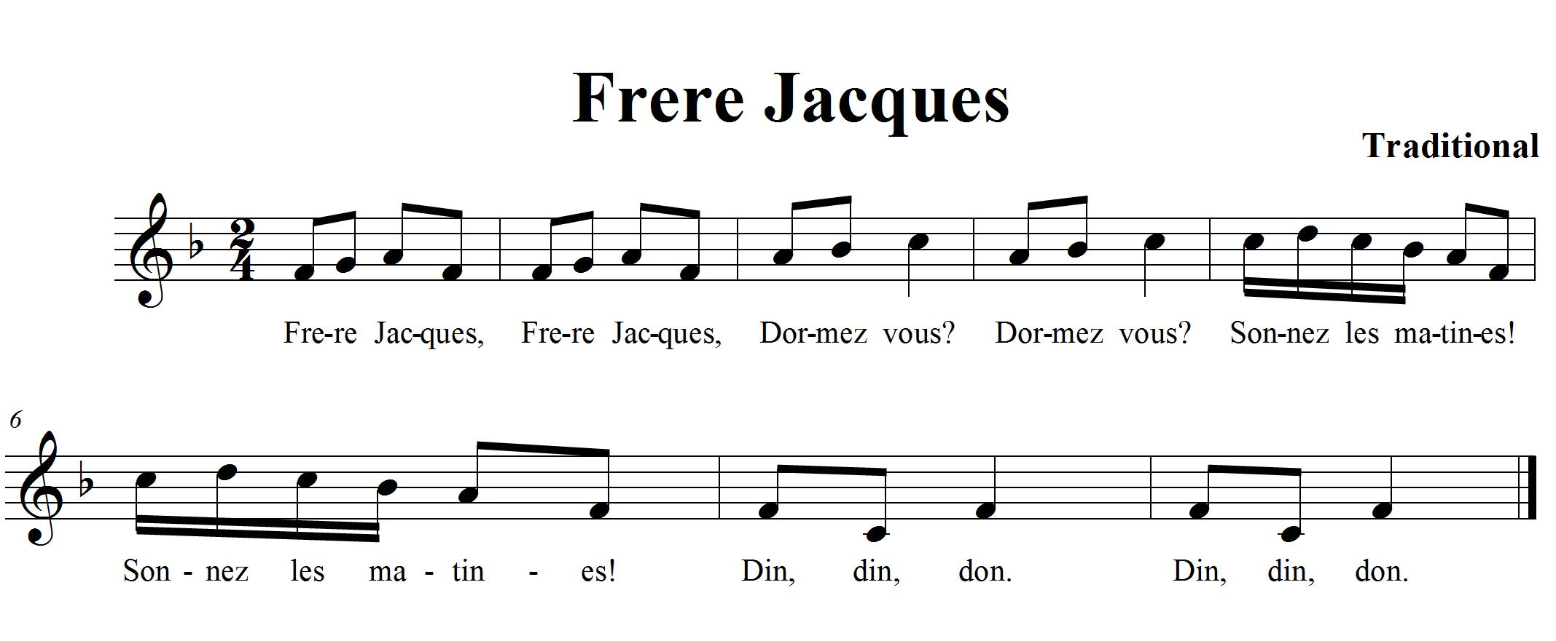

CONSOLIDATION! In order to move on to the next task, you will need to write your variation of “Frere Jacques” and perform it for your teacher.

11. Continued

Use the following staff lines to create your variation of “Frere Jacques”:
Remember your clef sign, key signature and time signature.

12. MORE DYNAMICS FOCUS: DYNAMICS/EXPRESSIVE MARKINGS

LEARNING GOAL: Demonstrate dynamics in music that you are creating and learning.

MINDS ON! There are markings on standard notation that show us how loud or soft to play or sing the music. There are also markings that are added to tell us to play a note short or long. These are called staccato and tenuto. Look at different kinds of music. Look for the different expressive markings that can be found. Can you create a rhythmic composition that uses a variety of expressive markings?
ACTION! In order to be successful with this task, you will need to:
- Find 4 different expressive markings that you would like to use in your rhythmic composition. (e.g. staccato, slur)
- Use a non-pitched percussion instrument, your voice or body percussion to create your sounds. Make it no longer than 16 beats (4 measures in time).
- Play your rhythm piano then crescendo to forte.
- When you have a rhythm you would like to share, join with another student in the class and play your rhythms together.
CONSOLIDATION! In order to move on to the next task, you will need to show that you can perform a rhythmic composition that uses four different expressive markings. You should be able to articulate what the markings are and what they mean.

The 4 expressive markings I am using are:

1. 2.
3. 4.
Use the space below to work out your rhythm and expressive markings.


Congratulations! You have reached your third GPS marker – SOUTH!
Ask your teacher how you are to acknowledge this accomplishment on your GPS task tracker!
WAY TO GO!!

13. TEXTURE AND HARMONY FOCUS: TEXTURE/HARMONY

LEARNING GOAL: Demonstrate the use of harmony in music that you are learning and create texture.

MINDS ON! Texture in music is created by layering sound. You have learned “Frere Jacques”, how can you create texture by singing the melody of the song? Can you layer the melody to create texture? What is a Canon? Can “Frere Jacques” be sung in canon?
How would you do that?
ACTION! In order to be successful with this task, you will need to:
- Practise singing “Frere Jacques”. You should know it pretty well from task 12. The words are in French, so ask your French teacher for help with pronunciation if you are not sure.
- Work with a partner to figure out where the second person would start singing to create a round (canon)?
- Add a third person to sing with you. Where would they start singing?
- Add a fourth person to sing with you.
- Practise singing the song in a four-part canon.
- How many times does the first person need to repeat the song to create four-part harmony?

SELF-REFLECTION: What I found challenging about task 13 was...

CONSOLIDATION! In order to move on to the next task, you will need to perform “Frere Jacques” with 3 other students (in a quartet) and sing it as a four-part canon.

14. PUT THE ELEMENTS TOGETHER! FOCUS: TIMBRE /COMPOSITION

LEARNING GOAL: Use music to advertise a product. Be aware of how music is used in media. Use elements of music to support a message.

MINDS ON! The element of Timbre or Tone colour is about the quality of sound that is produced by an instrument or something making a sound. When we listen to the timbre and how it relates to the other elements of music (e.g. dynamics, tempo), we can then interpret the mood the music portrays. Of what does a fanfare of trumpets make you think? What animal do you think of when you hear flutes playing? What sounds/music might influence you to buy a product? We all know that companies are always looking for ways to encourage people to buy their products. How do they use music to do that?
ACTION! In order to be successful with this task, you will need to:
- Listen to the music samples provided by your teacher.
- Can you think of a product that might be advertised using the music you hear?
- What image, mood or feeling is the music creating for you?
- Listen to different pieces of music. Distinguish the differences between the instruments. Define the moods or feelings it creates.
- With a partner, pick a product that you will need to advertise.
- Pick the type of music you are going to use. Think about the timbre, dynamics and expressive markings as you are picking. (You will need to explain your musical choices below.)
- Write your slogans and create a one-minute performance of a commercial using your own music choices to sell your product.
CONSOLIDATION! In order to move on to the next task, you will need to choose music to advertise a specific product. Explain your choices of music on the chart below. Create slogans and perform your commercial using your music choices for the teacher.

Music choice | Why we chose this music. What elements affected our choice:

15. MUSICAL FORM FOCUS: FORM/RHYTHM/COMPOSITION
LEARNING GOAL: We are learning about musical form and how to improvise a rhythmic section for a song.

MINDS ON! What is theme and variations form? Is it similar to verse and chorus or rondo? How is it different? Can you figure out the form when you are listening to it? The element of form is related to the structure of the music. It’s like the skeleton or bones of the music. How it is formed is important because people interpret music differently depending on its form.
ACTION! In order to be successful with this task, you will need to:
- Know that a theme and variation is an A, A’, A’’, A form.
- Pick any simple song you would like. Ask your teacher for assistance if you need help in picking a song.
- Using non-pitched percussion instruments and working with a partner (pick someone you haven’t worked on a task with before).
- Sing a song of your choice and work on creating 2 variations (one for you and one for your partner) of the song. This task is similar to task 11.
- Write down your variations on the staff lines below. Ask your teacher for more staff lines if you need them.
- When you are ready perform your theme and variations for the teacher.

CONSOLIDATION! In order to move on to the next task, you will need to create a variation of a theme and then perform your theme (which is the song of your choice) with the two variations you created with a partner. This should be done as a duet!

For task 15:

16. LET’S COMPOSE A PIECE OF MUSIC FOCUS: COMPOSITION
LEARNING GOAL: Create a soundscape In a theme and variations form. Use your own symbols or notation to help remember what to do for your performance. Work in groups of 3-4. Perform it for the class.

MINDS ON! We have been learning about music all year, we have looked at different pieces of music and now it’s time to put all that knowledge into creating our own piece of music that you get to perform for the class! What kind of sounds do you want to hear in your composition? What rhythms do you want to use? What kind of dynamics are you going to use to show contrasts? Do you have an idea for a theme? Many composers
ACTION! In order to be successful with this task, you will need to:

- Take a look at The Creative Process chart in your class. This will help you focus your learning as you go through the steps of composition.
- With your group, brainstorm about what qualities you want to have in your soundscape composition. Pick something from a picture book that inspires you to help generate some ideas. This is where you create your theme!
- Start thinking of sounds that you want to use and how you can create rhythms and or melodies using those sounds. Explore your ideas and experiment with them.
- When you think you have some sounds, rhythms and melodies that you like, think about the order and form you want your music to take. Start planning and focusing. Think about how you can create variations.
- Remember to ask for feedback from your peers and teacher as you work through this process. They will help give you ideas and open up new learning experiences for you as you are composing.
- Create symbols that represent the different sounds you are using in your composition.
- Once you have your symbols worked out, put them in the order you want them performed. What form is your music going to take? How are you going to show the beginning, middle and end of your song?
- When you think you have your preliminary work completed (that means your composition is pretty close to finished) then it is time to perform it for your class to get more feedback on how it sounds.
- Now that you have performed it, what did you like? What do you want to change? Now is your chance. Go ahead and change what you want, revise it and make it better!
- When you think you are ready, let your teacher know that you are now ready to present, perform and share your composition with the class!
Minds On! Continued…

have something that inspires them to write. What is your inspiration going to be? Take a look at the picture books your teacher has brought in for you to use. What sounds are inspired by what you see on the pages? What rhythms do you hear in the words? Think about the form your music is going to take... there is so much to think about! Let’s give composition a try! Use the theme and variations form you have been learning about this year.

CONSOLIDATION! In order to complete this final task, you will need to perform and share your soundscape composition with the class. When you are done, reflect on and evaluate your learning. Write a paragraph answering the following questions; Are you satisfied with your composition? Why or why not? What would you change if you were to do this task again? What were your challenges? What did you do that was lots of fun? What other GPS tasks helped prepare you for this one?


Congratulations! You have reached your final GPS marker – WEST! Ask your teacher how you are to acknowledge this accomplishment on your GPS task tracker! WAY TO GO!!

