Title: “I’se the B’y”: Applying I-V Harmonic Changes  Lesson # 6 |  | Grade 5, Music
Critical Learning |  | Guiding Questions
The bass line provides the foundation for harmony and rhythmic variations.  The I-V chord change is a basic chord progression in music.  Rondo form has sections that are the same, and sections that are different, e.g., ABACADA…The sections can be songs, rhythmic patterns, bass line progressions, etc. |  | How do you know when to change the bass line note?  How can the bass line be applied to the created rhythmic phrases?  How will you use your rhythmic patterns or your I-V bass line composition for your section of the final performance of “I’se the B’y” Rondo?

Curriculum Expectations
C1. Creating and Performing: apply the creative process to create and perform music for a variety of purposes, using the elements and techniques of music  C1.2 apply the elements of music when singing and/or playing, composing, and arranging music to create a specific effect  C1.3 create musical compositions for specific purposes and audiences  C1.4 use the tools and techniques of musicianship in musical performances  C1.5 demonstrate an understanding of standard and other types of musical notation through performance and composition  C2. Reflecting, Responding, and Analysing: apply the critical analysis process to communicate their feelings, ideas, and understandings in response to a variety of music and musical experiences.  C2.2 identify the elements of music in the music they perform, listen to, and create, and describe how they are used |  | Learning Goals  At the end of this lesson  I can  - create a new form of a bass line with the I-V, V-I progression and rhythmic patterns in 6/8 time  - sing a song and perform the accompaniment on pitched and non-pitched percussion instruments  - create and perform a rhythmic and/or melodic phrase as a section in rondo form  - reflect on the music concepts of 6/8 time, I-V chord progression and form as experienced in this unit

Instructional Components and Context
Readiness  Beat keeping  Patterning  Aural experience in 6-8 meter  Terminology  Form  Motif/motive  Beat groupings  Meter  Compound metre 6-8  Harmony  I-V chord progressions  Interlude  Rondo form (http://www.edu.gov.on.ca/eng/curriculum/elementary/arts18b09curr.pdf) | Materials  BLM 1 Rhythm Chart  BLM 2 I’se the B’y Student Worksheet  Teacher Resource 1 Forms Chart  Teacher Resource 2 Rubric  Teacher Resource 3 I’se the B’y Song  Teacher Resource 4 I’se the B’y Orchestration  Pitched and non-pitched percussion instruments (see Teacher Resource 4 Orchestration)

Minds On Approximately 5 minutes | Pause and Ponder
Perform the song “I’se the B’y” with the Orff Orchestration, Teacher Resource 4, introduced in Lesson 5.  Play the original bass line that was written out in Lesson 4: Reduced Bass Line  G D G D G D D G  “right, left, right, left, right, left, left, right.”  I V I V I V V I  Review and perform the Rhythmic Phrases that were created by students in Lesson 2 in 6/8 Meter, which will become the B, C, D, etc. sections of “I’se the B’y” Rondo Form (the song will be the A section).  Teacher Tip: Share with students that these parts from earlier lessons will become part of the larger final composition. | Assessment for Learning (AfL)  Self Assessment: Am I playing in 6/8 time?  What strategy will help me? e.g., saying the words
Action! Approximately 20 minutes
Students compose new rhythmic versions of the ‘Reduced Bass Lines’ (see Minds On):  -students gather in their Rhythmic Phrases groups (formed in Lesson 2);  -apply the rhythms they created to the Reduced Bass Line/chord progression pattern (the bass note/chords change at the beginning of each bar of 6/8 time);  -notate the bass line on their BLM 2 I‘se the B’y Worksheet. (rhythms also available on BLM 1 Rhythm Chart).  e.g., (2 bars shown)  I: G G G G V: D D D D  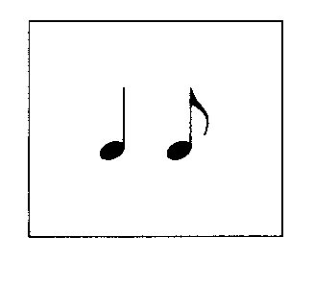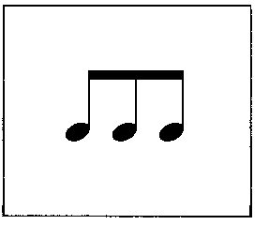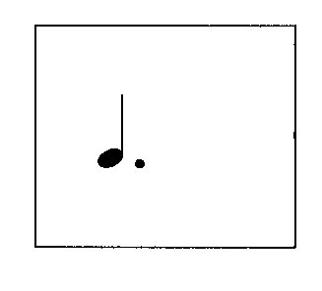  hip yer part - ner Sal–ly Ti - bo  6  8  Transfer the pattern to the pitched percussion instruments; practice performing the bass line/chord progression with the rhythmic phrases (BLM 2).  Groups play and sing the text of their new bass line while the rest of the class sings the song, “I’se the B’y”. Reflect on the effectiveness of different bass lines.  Students may also create a new form using the I-V, V-I chord progressions, notate it with their rhythmic phrases. (BLM 2) | Assessment of Learning  (AoL)  With a rubric (Teacher Resource 2 Rubric), assess the application of the I V pattern to the 6/8 rhythms  a) played  b) written notation  c) sung  Differentiation (DI)  Students have chosen their language pattern.

Consolidation Approximately 15 minutes
Create a final “I’se the B’y” performance incorporating an introduction, the Orff orchestration (Teacher Resource 4), the song and the Rhythm Phrases. The Rhythm Phrases may be performed with body percussion, non-pitched percussion instruments, or pitched instruments (the new bass lines they composed).  The song is the A section.  Each group performs their Rhythm Phrase as one of the C, D, E, F, etc. sections of the performance.  The final performance is in Rondo form: A B A C A D A E A, etc.  Students write reflections in their music journals, about the musical forms, 6-8 metre and the I-V chord change. | Assessment of Learning  (AoL)  Assess student’s understanding of the music terms and concepts.  .

