Title: “I’se the B’y”: 6/8 Metre Identified and Notated  Lesson # 3 |  | Grade 5, Music
Critical Learning |  | Guiding Questions
6/8 time has a very specific feel of 2 beats in a bar.  The uneven grouping of eighth notes provides a motion to the music that is very different from 4/4 time.  6/8 time is an example of compound metre: the organization of the rhythm is 2 groups of 3 eighth notes: ti-ti-ti, ta ti, ti ta, tum. |  | How do ta’s and ti-ti’s fit into 6/8 metre?  How are the beats and rhythm organized in 6/8 metre?  How can the rhythmic patterns from a song be organized into different forms?

Curriculum Expectations
C1. Creating and Performing: apply the creative process to create and perform music for a variety of purposes, using the elements and techniques of music.  C 1.1; sing and/or play, in tune, from musical notation, unison and two-part music with accompaniments, from a wide variety of cultures, styles and historical periods  C1.2 apply the elements of music when singing and/or playing, composing, and arranging music to create a specific effect  C1.5 demonstrate an understanding of standard and other types of musical notation through performance and composition  C2. Reflecting, Responding, and Analysing: apply the critical analysis process to communicate their feelings, ideas, and understandings in response to a variety of music and musical experiences.  C2.2 identify the elements of music in the music they perform, listen to, and create, and describe how they are used |  | Learning Goals  At the end of the lesson  I can  - Identify, read and perform the rhythms of 6/8 metre  - identify and compose a rhythmic composition in a different forms, e.g., ABBA and ABACA (rondo)

Instructional Components and Context
Readiness  A strong base of experience in 6/8 metre, e.g., through skipping and galloping songs, dances  Terminology  Form  Motif/motive  Beat groupings  Metre  Compound metre 6/8  Interlude  Rondo Form  (http://www.edu.gov.on.ca/eng/curriculum/elementary/arts18b09curr.pdf | Materials  Song “I’se the B’y” Teacher Resource 3  Rhythm Motive Chart Teacher Resource 1  Common Musical Forms Chart Teacher Resource 1  6/8 Rhythm Chart BLM 1  I’se the B’y Student Worksheet BLM 2  Teacher Resource 2 Rubric  Non-pitched percussion instruments

Minds On Approximately 5 minutes | Pause and Ponder
Perform multiple rhythm clap-backs (echoes) in 6/8 time. Use the BLM 1 for ideas!  Review/sing the song I’se the B’y.  Review the group Rhythm Phrases (see Lesson 2); identify how the ti-ti’s, ta’s and tum’s .  Review identification of 6/8 metre, looking at and clapping 6/8 rhythmic patterns from BLM 1 Rhythm Chart. | Assessment for Learning (AfL)  Can students match the rhythm motives with the rhythms on the chart?

Action! Approximately 25 minutes
With the Rhythm Chart (BLM 1), look at the “Group of 3 ti’s” section and with shared practice, identify the rhythms as either ti-ti-ti, ta-ti, or tum.  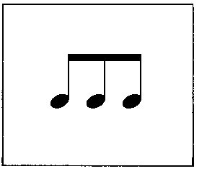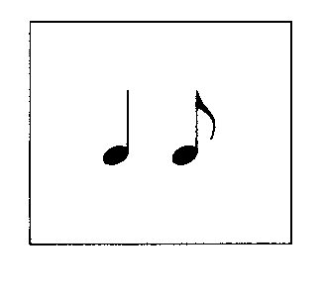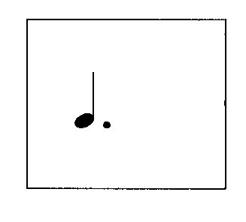  Ti-ti-ti ta ti tum  Perform all of the rhythm combinations with rhythm syllables, reading and clapping from the “All Possible Combinations” on BLM 1 Rhythm Chart.  Chant all the Rhythm Motives (Lesson 2) from the chart, Teacher Resource 1 Forms Chart. Match the Rhythm motives with the notes from the Rhythm Chart. (BLM 1). Remove this page (BLM 1) from the sight of the students.  Using the Rhythm Phrases created from Lesson 2, students identify the rhythm syllables from the Rhythm Chart (BLM 1) that apply to their Rhythm Phrase.  Students write out the rhythm for their “I’se the B’y Rhythmic Composition” on the “I’se the B’y Worksheet”, BLM 2. | Assessment as Learning  (AaL)  Assess the identification of the rhythms, and their application to 6/8 time on the BLM 2 I’se the B’y Student Worksheet.  Differentiation (DI)  Demonstrating rhythm through speech, body percussion and instruments: 3  points of entry. Student choice.

Consolidation Approximately 10 minutes | Assessment of Learning (AoL)  Self, Peer, Teacher Assessment: accuracy of reading and writing rhythmic notation in 6/8 time; Rubric Teacher Resource 2
All groups write their I’se the B’y Rhythmic Composition in the final form on the board (or on chart paper).

One group at a time performs their rhythmic composition with language.

The class repeats it, and guesses the rhythm using rhythm syllables (ta, ti-ti, tam). One student writes in the rhythm syllables, and the original group is responsible for identifying errors and making corrections.

If the unit is to end at this point, do the following:

Organize and name the groups as B, C, D, etc.

Perform the song as the A section, and each group performs their Rhythmic Phrase in 2 different ways (using language, body percussion and instruments as choices). The piece will then be in rondo form (A B A C A D A E A, etc.)

If the unit is continuing to the I-V Harmony portion, save this rondo performance for the grand finale!

