GPS (Grade Performance Steps)

The Road to Musical Success!
Grade 5 Performance Tasks




Ontario Music Educators’ Association
www.omea.on.ca
Teachers, before you copy this booklet for your students...
⬰ Have you read the GPS Overview?
⬰ Have you taught these students before? If not, please take the time to work with your students to determine their strengths and needs before deciding which tasks will be appropriate.
⬰ Have your students completed the tasks in the Grade 5 GPS tasks, or have the concepts been taught to your students?
⬰ If you have taught these students before...go through the entire program task-by-task to confirm that the sequence and challenge level of the tasks is appropriate.
Refer to the Q and A section of the GPS Overview.

⬰ Do you need to reduce the number of tasks? If so, how will you need to change the evaluation by term?

⬰ Have you read the Pause and Ponder for this grade? These are important questions that you should consider before teaching each task.

⬰ The Junior Recorder GPS task progression chart is available by clicking here. You can see how these tasks align with and can support the Grade 5 Recorder GPS Tasks.

If you have questions, please contact:

Lynnette Charters: lcharters@rogers.com

Task # 2
Task # 1
Task # 3
Task # 5
Task # 6
Task # 7
Task # 10
Task # 9
Task # 11
Task # 15
Task # 14
Task # 13
Task # 16
Task # 4
Task # 8
Task #12
1. KEEP THE BEAT! FOCUS: BEAT

LEARNING GOAL: You will be learning to keep a steady beat.

MINDS ON! We learned about beat last year. Beat is one of the basic components of music. It is a steady pulse that can be found in many musical forms. It is part of an element called duration. Can you find the beat in a piece of music? Can you follow the beat and keep a steady pulse?
ACTION! In order to be successful with this task, you will need to:
- Listen carefully to the music chosen by your teacher for the underlying beat.
- Work together in a group to pass a rock around the circle using a cup.
- Move the cups to the beat by placing your cup down on top the rock for the first beat then sliding them over to the next person for the second beat, lifting cups up on the third beat and start the pattern again even when you don’t have a rock to pass
- The rock should only be moved to the next person on a beat.
- Listen for when the teacher asks you to switch directions, this can be tricky so keep listening for the beat.
- Try switching direction after 4 passes and then 8 passes. Which one is easiest?
- Keep the movement steady and consistent; try not to miss a beat when you are passing.

CONSOLIDATION! In order to move on to the next task, you will need to show that you can keep a steady beat by passing the rock on to the next student without missing a beat. You should be able to do this consistently throughout an entire song switching direction when the teacher asks you to without losing the beat.

2. WARM-UPS MAKE YOU STRONGER! FOCUS: VOCAL

LEARNING GOAL: You will be learning to; strengthen your diaphragm (abdominal muscles); make your tongue more flexible and practise consonant sounds.

MINDS ON! Warm-ups are a part of a daily routine to keep your body and mind strong. In music we need to warm up before we perform to help us prepare and to make sure we don’t hurt ourselves (just like when we warm up before exercising). Practising vocal skills will help us in our performances. How do we articulate a consonant in our songs so that people can understand the words we are saying? The direction you open your mouth (how wide or how long) affects your sound and can sometimes create tension in your voice. How can you keep tension out of your voice? What are some strategies you have learned that help you to sing consonants clearly?
ACTION! In order to be successful with this task, you will need to:
- Practise the warm-ups your teacher gives you at the beginning of class.
- Start each warm-up with a deep breath in through your nose and then release the air throughout the warm-up by using your diaphragm to help push the air out.
- Say the letters B, T, D, J. Say only the beginning sound of the consonant. e.g.) “B” take the “e” sound off, pronounce what is left.
- Say each sound 5 times using your abdominal muscles to push the sound out.
- Drop your jaw down to create each sound. In a direction, keep your mouth, neck and jaw relaxed.
- Now let’s add the vowels A, E, I, O and U and practise the following warm-up.

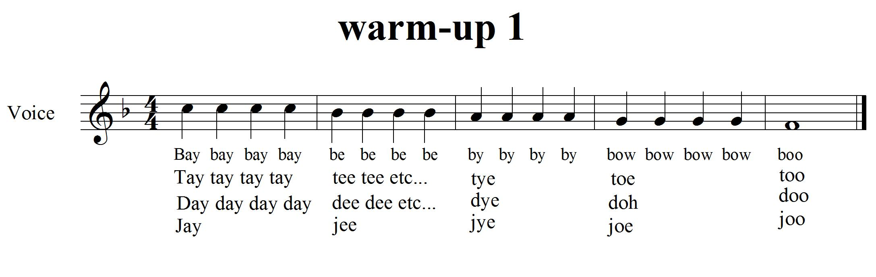

CONSOLIDATION! In order to move on to the next task, you will need to sing through this warm-up exercise above. You will also need to show how to push the sound out using your diaphragm.
3. RHYTHM! FOCUS: RHYTHM/COMPOSITION

LEARNING GOAL: You will create a rhythmic pattern that is based on your name.

MINDS ON! Rhythm is an aspect of the element called duration. It is similar to beat except that it is a series of patterns of long and short sounds and/or silences. It is different than beat because beat is made up of a steady repeated pulse. Words can create rhythms. Can you create a rhythm using your name? Try creating a repeated rhythm using your first name with a friend and keep the pattern going for 30 seconds.
ACTION! In order to be successful with this task, you will need to:
- Create a repeated body percussion pattern using ta (), ti-ti () and/or tika-tika (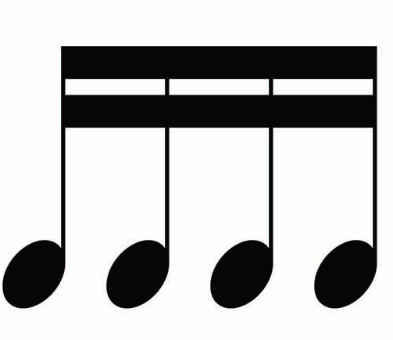). Don’t forget to use rests too!
- You could use your name and birth date to create your pattern e.g.) Jessica Cameron July twenty fourth could be
- When you feel ready, begin your pattern. Keep repeating your pattern until you think you can perform it with another student.
- Work with a partner to create a pattern that is more complex.
- Practise your pattern against another students pattern (someone you haven’t worked with before). Double check that you are both keeping the same beat.

CONSOLIDATION! In order to move on to the next task, you will need to show that you can keep a rhythmic pattern steady while another student claps a complementary rhythmic pattern.
You must articulate what rhythms you are using (,,) in your pattern and where they occur.
SELF-REFLECTION: What I found challenging about task three...

4. DO YOU KNOW YOUR RHYTHMS? READY, SET...! FOCUS: RHYTHM

LEARNING GOAL: You will copy a rhythm that the teacher or another student claps using craft sticks to show your understanding of rhythmic notation and transfer it to standard notation on your sheet.

MINDS ON! Now that you know something about rhythm, let’s start learning how to notate it. Using craft sticks, create a simple stick symbol for ta (), ti-ti () and rest (). Make sure you are using the same symbol as everyone in your class. Using the sticks, can you create a rhythm for another student? Can they clap your rhythm back to you? Practise with another student to create your own rhythms and clap their rhythms.
ACTION! In order to be successful with this task, you will need to:
- Listen carefully to the teacher/student as they clap a rhythm for you to recreate using craft sticks.
- Consistently show the correct symbols for ta (), ti-ti (), tika-tika (), ti-tika (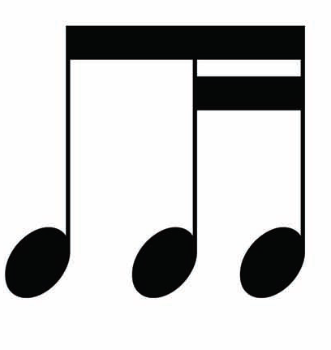), tika-ti (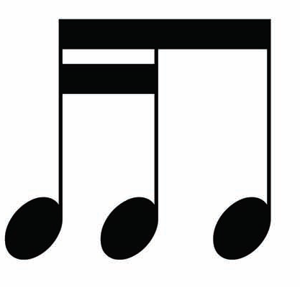), ta-ah (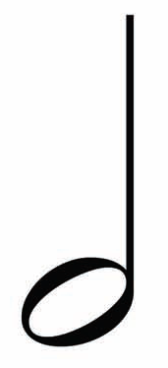= 2 beats) and rest () (= 2 beats).

CONSOLIDATION! In order to move on to the next task, you will need to show that you can accurately recreate each rhythm your teacher claps using rhythmic notation. Transfer your rhythmic notation to standard notation on the lines below. Don’t forget to add bar lines if you can. (There is no need for staff lines because we are not working with pitch).
Here is an example:

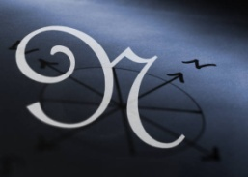
Congratulations! You have reached your first GPS marker – NORTH!
Ask your teacher how you are to acknowledge this accomplishment on your GPS task tracker! WAY TO GO!!

5. LET’S PUT IT TOGETHER FOCUS: BEAT/RHYTHM/METRE

LEARNING GOAL: You will be learning about compound metre and applying what you already know about Beat and Rhythm together. You will need to show both the beat and the rhythm in compound metre.

MINDS ON! Part 1! This task is separated into two tasks to help you feel the differences between simple and compound metre. In music, both beat and rhythm occur simultaneously which is why some people confuse them. This is where the main beat is divided into three. Can you keep the beat in your feet? Can you clap a rhythm in your hands?
ACTION! Part 1! In order to be successful with this task, you will need to:
- Find out how many beats there are in a bar.
- Learn to sing the song, “Hickory Dickory Dock”.
- Keep the beat in your feet. Keep it steady like you did in task one.
- Clap the rhythm of “Hickory Dickory Dock”. The rhythm is found in the words.
- Keep the beat in your feet and clap the rhythm of the words at the same time.
- Notice that sometimes the rhythm can match or is slower than the beat!
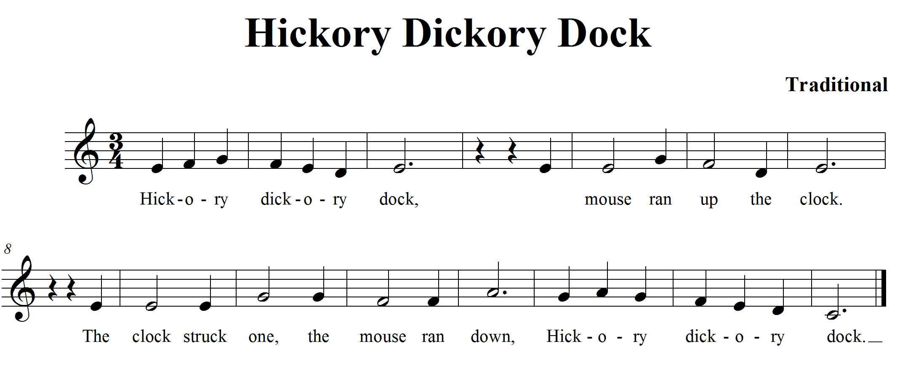

5. PART 2!
MINDS ON! Part 2! You have just learned “Hickory Dickory Dock” in time. Now let’s learn the same song in time. How is it the same? How is it different? Why do you think time is called compound and not simple?
When we count beats in time, we are counting ti (eighth) notes. Counting in in words would be like this “one-and-a-two-and-a”, even though there are 6 eighth notes it feels like there are only 2 strong beats.
ACTION! Part 2! In order to be successful with this task, you will need to:
- Learn to sing the song, “Hickory Dickory Dock” in time.
- Keep the beat in your feet. Only accent 2 main beats with your feet
- Clap the rhythm of “Hickory Dickory Dock”. The rhythm is found in the words.
- Keep the beat in your feet and clap the rhythm of the words at the same time.
- Notice the differences between and ?
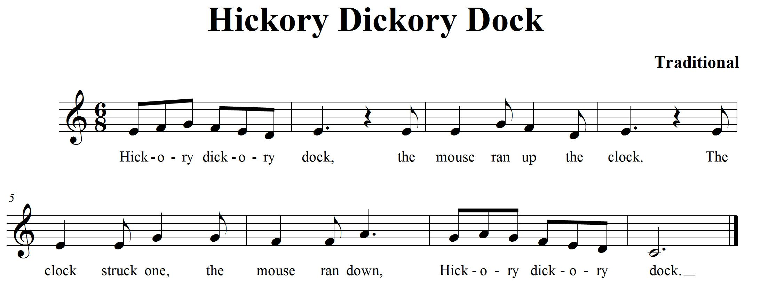

CONSOLIDATION! In order to move on to the next task, you will need to show that you can keep the beat in your feet and clap the rhythm (in the words) of the song, “Hickory Dickory Dock” in both and time.

6. THERE’S MORE TO DURATION! FOCUS: METRE/ACCENT

LEARNING GOAL: You will be learning more about compound metre and how it is different from simple metre.

MINDS ON! Rhythm, beat, metre! In music, the beats are separated into groups to help the musician keep track of them (sometimes groups of 2, 3 or 4). Musicians create a strong accent on the first beat of each grouping. To find the beat in a song, walk around the room and make a big stomp when you hear a strong beat and create smaller steps on the weaker beats. How many beats are in a bar? Can you keep a steady beat and mark the strong beats with big steps? In compound metre, each main beat is divided into groups of 3 beats. “Hickory Dickory Dock” from Task 5 has groups of 3 in every bar.
ACTION! In order to be successful with this task, you will need to:
- Work in simple metre and compound metre.
- Listen carefully to the music chosen by your teacher for the underlying beat.
- Move around the room to the beat and create a big stomp on the first beat to accent it.
- Make a big action with your arm at the same time to accent the strong beat.

SELF-REFLECTION: What qualities did I hear in the music that helped me successfully accomplish this task? When I move it helps me to...

CONSOLIDATION In order to move on to the next task, you will need to show that you can move to the beat of the music; follow the beat and accent the strong beats using a strong action or movement.

7. STILL MORE DURATION! FOCUS: TEMPO
LEARNING GOAL: Let’s expand the knowledge that you have learned so far about duration by learning about tempo in music.

MINDS ON! Tempo is a word used to describe the speed of a piece of music. There are many different speeds and each one has a musical term to describe it. Adagio (http://www.music.vt.edu/musicdictionary/) means play or sing slowly and gracefully, moderato means play or sing at a moderate speed and presto means play or sing as quickly as possible. When you change the tempo of a song it means you are changing the speed that you are singing it. Can you sing a song Largo or Adagio? Can you sing it Allegro or Presto?
ACTION! In order to be successful with this task, you will need to:
- Listen carefully to the music played by your teacher.
- Create a t-chart; place slower tempos in the first column, medium tempos in the middle column and faster tempos in the last column.
- Write down a few characteristics of each tempo at the top of the column.
- You will need to practise this with a variety of music, before completing this task to help you feel the changes in tempo.
- As your teacher plays a piece of music, write the name of the music in the column that has the tempo that best describes the tempo of the piece.
- After a few times practising this, you should be ready to complete this task.

CONSOLIDATION! In order to move on to the next task, you will need to show that you can categorize music you are listening to by the tempo it is performed on a t-chart. Place tempo names in the first row from slowest to fastest in the t-chart below. Write characteristics of the tempo in the second row. Write the titles of the music your teacher has you listen to in the correct column according to its tempo.

T-CHART OF VARIOUS TEMPOS

8. SOLFEGE, REMEMBER THE MAJOR SCALE? FOCUS: PITCH

LEARNING GOAL: You will review the hand signs for a major scale.

MINDS ON! Do you know what a major scale is? There are eight pitches that make up a major scale. In solfege, they are called do (pronounced doh), re, mi, fa, so, la, ti and do. Each pitch has a special hand sign to represent pitches of the scale (Ontario Ministry of Education; 2009).. Can you remember all eight? Can you sing the syllable names in order with their assigned pitches? Let’s give it a try!
ACTION! In order to be successful with this task, you will need to:
- Sing do, re, mi, fa, so, la, ti and do using hand signs.
- Learn to sing the scale going up and going down. Sing it for an elbow partner. Listen as they sing it for you. Sing it together as a duet, match your pitches to other voices as you practise.
- Show the hand signs for the notes in the scale (starting on ‘do’) while you sing it in solfege syllables.

CONSOLIDATION! In order to move on to the next task, you will need to show that you can sing the major scale starting on a note that is not too high so that you can go up the scale showing your hand signs and back down. Your teacher can provide you help with your pitches if necessary.


Congratulations! You have reached your second GPS marker – EAST!
Ask your teacher how you are to acknowledge this accomplishment on your GPS task tracker!
WAY TO GO!!

9. SOLFEGE, KEEP WORKING ON IT! FOCUS: PITCH/RHYTHM

LEARNING GOAL: Learn the hand signs for eight different pitches.

MINDS ON! What is pitch? Can you hear when a sound is high or low? Do you know when to move the note you are singing to match someone else’s pitch? Music is made up of pitches. Now that you know the syllables do, re mi, fa, so la and ti and the hand signs for each syllable, it’s time to apply them to a song.

ACTION! In order to be successful with this task, you will need to:
- Practise singing do, re, mi, fa, so, la, ti and do going up the scale while using hand signs.
- Learn to sing the song, “Twinkle Twinkle”.
- Write the solfege names underneath the notes in the song.
- Practise “Twinkle Twinkle”until you can sing it in solfege or with words.
- Show the hand signs for the notes in the song (it starts on ‘do’) while you sing it in solfege syllables.
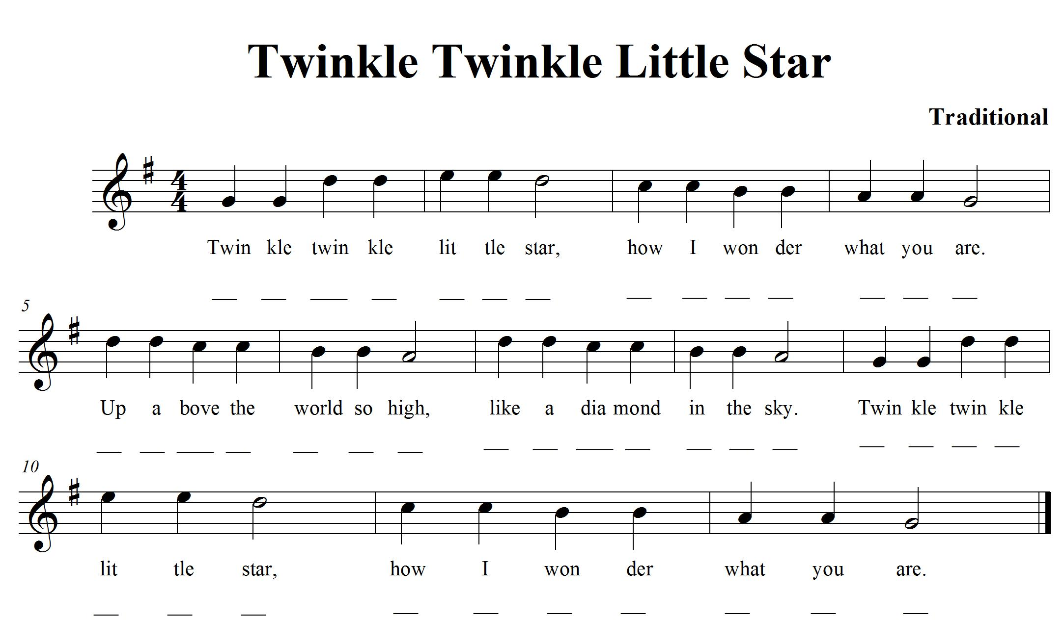

9. continued
SELF-REFLECTION: My impressions of the hand signs are... describe your thinking.

CONSOLIDATION! In order to move on to the next task, you will need to sing “Twinkle Twinkle”. Sing it a second time using solfege syllables and hand signs. You should sing it with a steady beat, but it does not need to be quick when you are using your hand signs.

10. WHAT MAKES A MELODY? FOCUS: PITCH/SYNCOPATION

LEARNING GOAL: You will be learning more about melody, syncopation and how the pitches move through time.

MINDS ON! What is a melody? What does it mean if the melody is syncopated? In a song, when the accented beat is not a strong beat, it creates syncopation. Last year, you learned how to create a melody map using string. Let’s transfer that knowledge to paper. Can you create a graphic representation of what the pitch is doing in a song by drawing a line or lines? Can you hear when the notes move up and when they move down? Try showing the sound movements in a picture form. Can you accent where the strong beats are in the song on your melody map?
ACTION! In order to be successful with this task, you will need to:
- Learn to sing the song, “Bassez Down”.
- Listen for the accented beats. There is some syncopation happening.
- Once you know the song, draw a melody map that shows what the melody is doing. Remember that a melody map shows the contour of the melody.
- Create a symbol to show all the accented beats in the song and place it on your melody map.
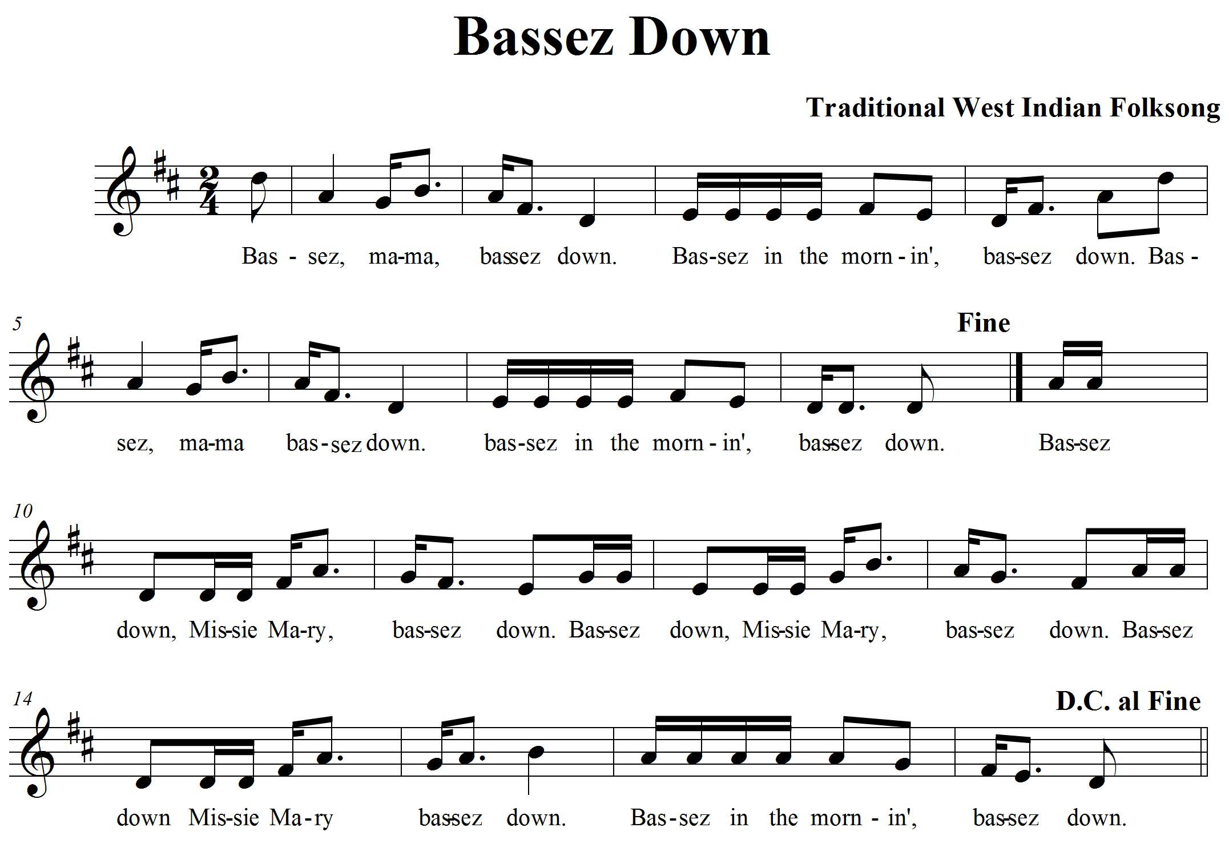
10. continued
CONSOLIDATION! In order to move on to the next task, you will need to show that you can sing “Bassez Down” and create a melody map on paper to show the movement of the pitches in the song. Move your finger along your melody map to show the teacher where you are on your map as you sing. Remember to accent the beat in the spots where you have marked.

11. DYNAMICS CAN BE FUN! FOCUS: DYNAMICS/REPEAT SIGN

LEARNING GOAL: You will learn to use dynamics as an expressive element in a song and perform repeats as they occur in the music.

MINDS ON! Composers use dynamics to help express a mood in their music. When you play very loud it is called fortissimo (ff). When you play very soft, it is called pianissimo (pp). There are also varying degrees of volume in between these two extremes. Can you sing mezzo forte (mf) which is medium loud? Can you sing mezzo piano (mp) which is medium soft? Repeat signs help show us where notes are repeated and save on paper. Let’s learn how to read them!
ACTION! In order to be successful with this task, you will need to:
- Learn to sing “African Noel”.
- Watch the dynamic markings and change your volume accordingly.
- Watch the repeat signs; they are there to remind you to repeat the measures inside the repeat signs more than once. If there are no repeat signs, then only perform those measures once.
- There is a section in “African Noel” that isn’t repeated. Can you find the measures?
- Know the following rules for repeat signs:
  - If there is a repeat sign, then a section of the music is repeated.
  - If there is only a right repeat sign then go back to the beginning and repeat the music back to the repeat sign. 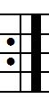 Then continue on...
  - If there are two repeat signs, one on the left and one on the right, then repeat the music inside the two signs. 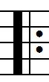

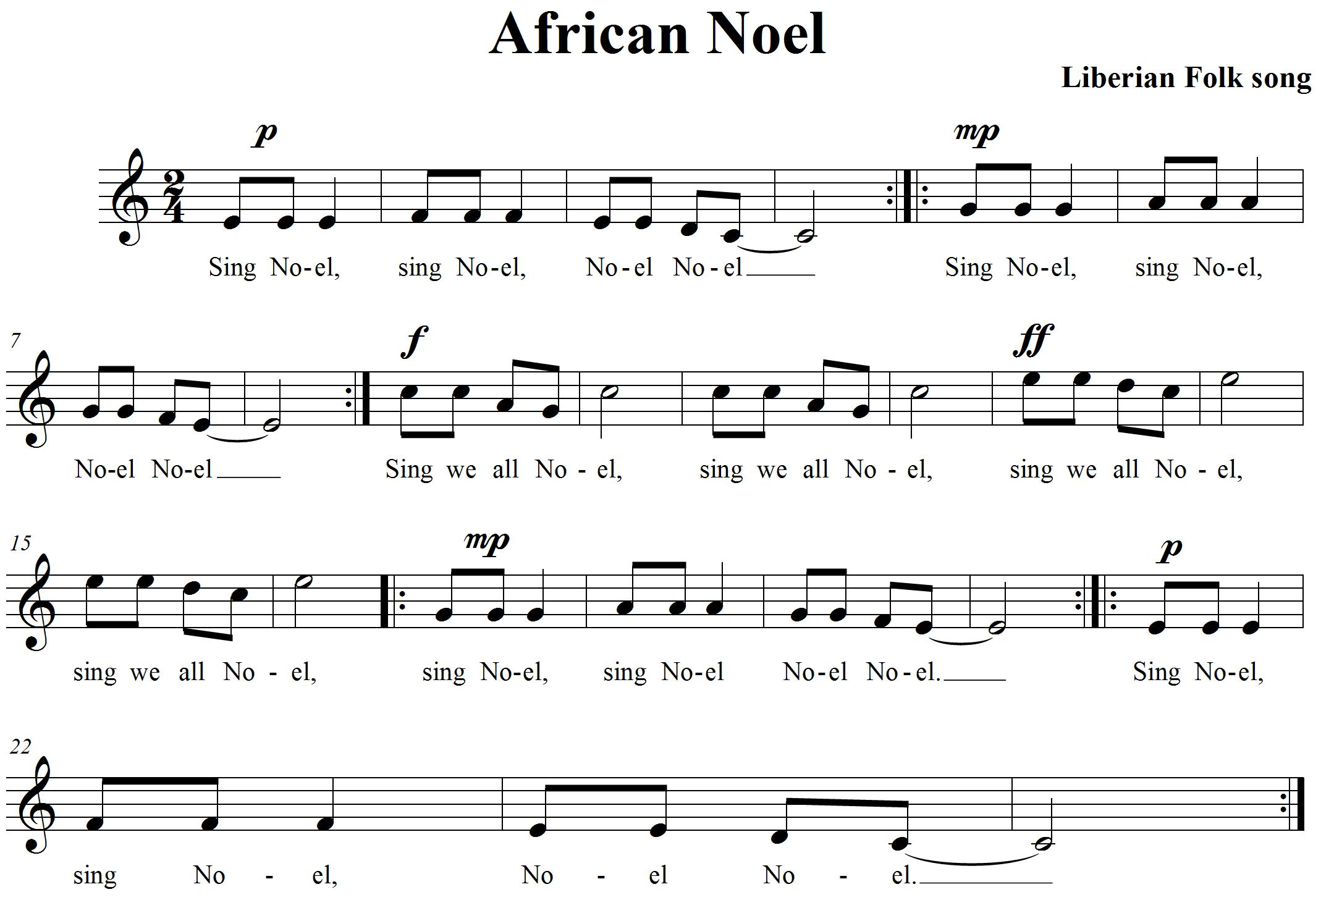

CONSOLIDATION! In order to move on to the next task, you will need to show that you can you can sing “African Noel” and perform the dynamic markings and repeats as they are found in the music.

Keep your bearings! Don’t race through the songs, just keep the groove!


12. MORE DYNAMICS FOCUS: DYNAMICS/EXPRESSIVE MARKINGS

LEARNING GOAL: Demonstrate dynamics in music that you are creating and learning.

MINDS ON! There are markings on standard notation that show us how loud or soft to play or sing the music. There are also articulation markings that are added to tell us to play a note short or long. These are called staccato and tenuto. Look at different kinds of music. Look for the different expressive markings that can be found. Can you create a rhythmic composition that uses a variety of expressive markings?
ACTION! In order to be successful with this task, you will need to:
- Find 4 different expressive markings that you would like to use in your rhythmic composition. (e.g. staccato, slur).
- Use a non-pitched percussion instrument, your voice or body percussion to create your sounds. Make it no longer than 16 beats (4 measures in time).
- Play your rhythm piano then crescendo to forte.
- When you have a rhythm you would like to share, join with another student in the class and play your rhythms together.
CONSOLIDATION! In order to move on to the next task, you will need to show that you can perform a rhythmic composition that uses four different expressive markings. You should be able to articulate what the markings are and what they mean.

The 4 expressive markings I am using are:

1. 2.
3. 4.
Use the space below to work out your rhythm and expressive markings.


Congratulations! You have reached your third GPS marker – SOUTH!
Ask your teacher how you are to acknowledge this accomplishment on your GPS task tracker!
WAY TO GO!!

13. TEXTURE AND HARMONY FOCUS: TEXTURE/HARMONY

LEARNING GOAL: Demonstrate the use of harmony in music that you are learning to create texture.

MINDS ON! Texture in music can be created by adding instrumentation. Usually the sounds are not exactly the same so they create layers in the music that our ears are able to distinguish as different. Harmony is one way of adding more texture to music. Adding instrumentation is another way. Let’s learn a song that has a single line melody and create texture by adding instrumentation to it. Can you hear the difference between music that only has one part and music that includes many parts?
ACTION! In order to be successful with this task, you will need to:
- Practise singing “Alouette”. The words are in French, so ask your French teacher for help with pronunciation if you are not sure.
- There are two parts to learn. Work with a partner to sing the two parts.
- What instruments can we add to make the texture thicker?
- Practise singing the song with a partner, match your voices (match pitches).
- Try singing the two parts together.
- Add a non-pitched percussion instrument to add more texture.

SELF-REFLECTION: What I found challenging about task 13 was...

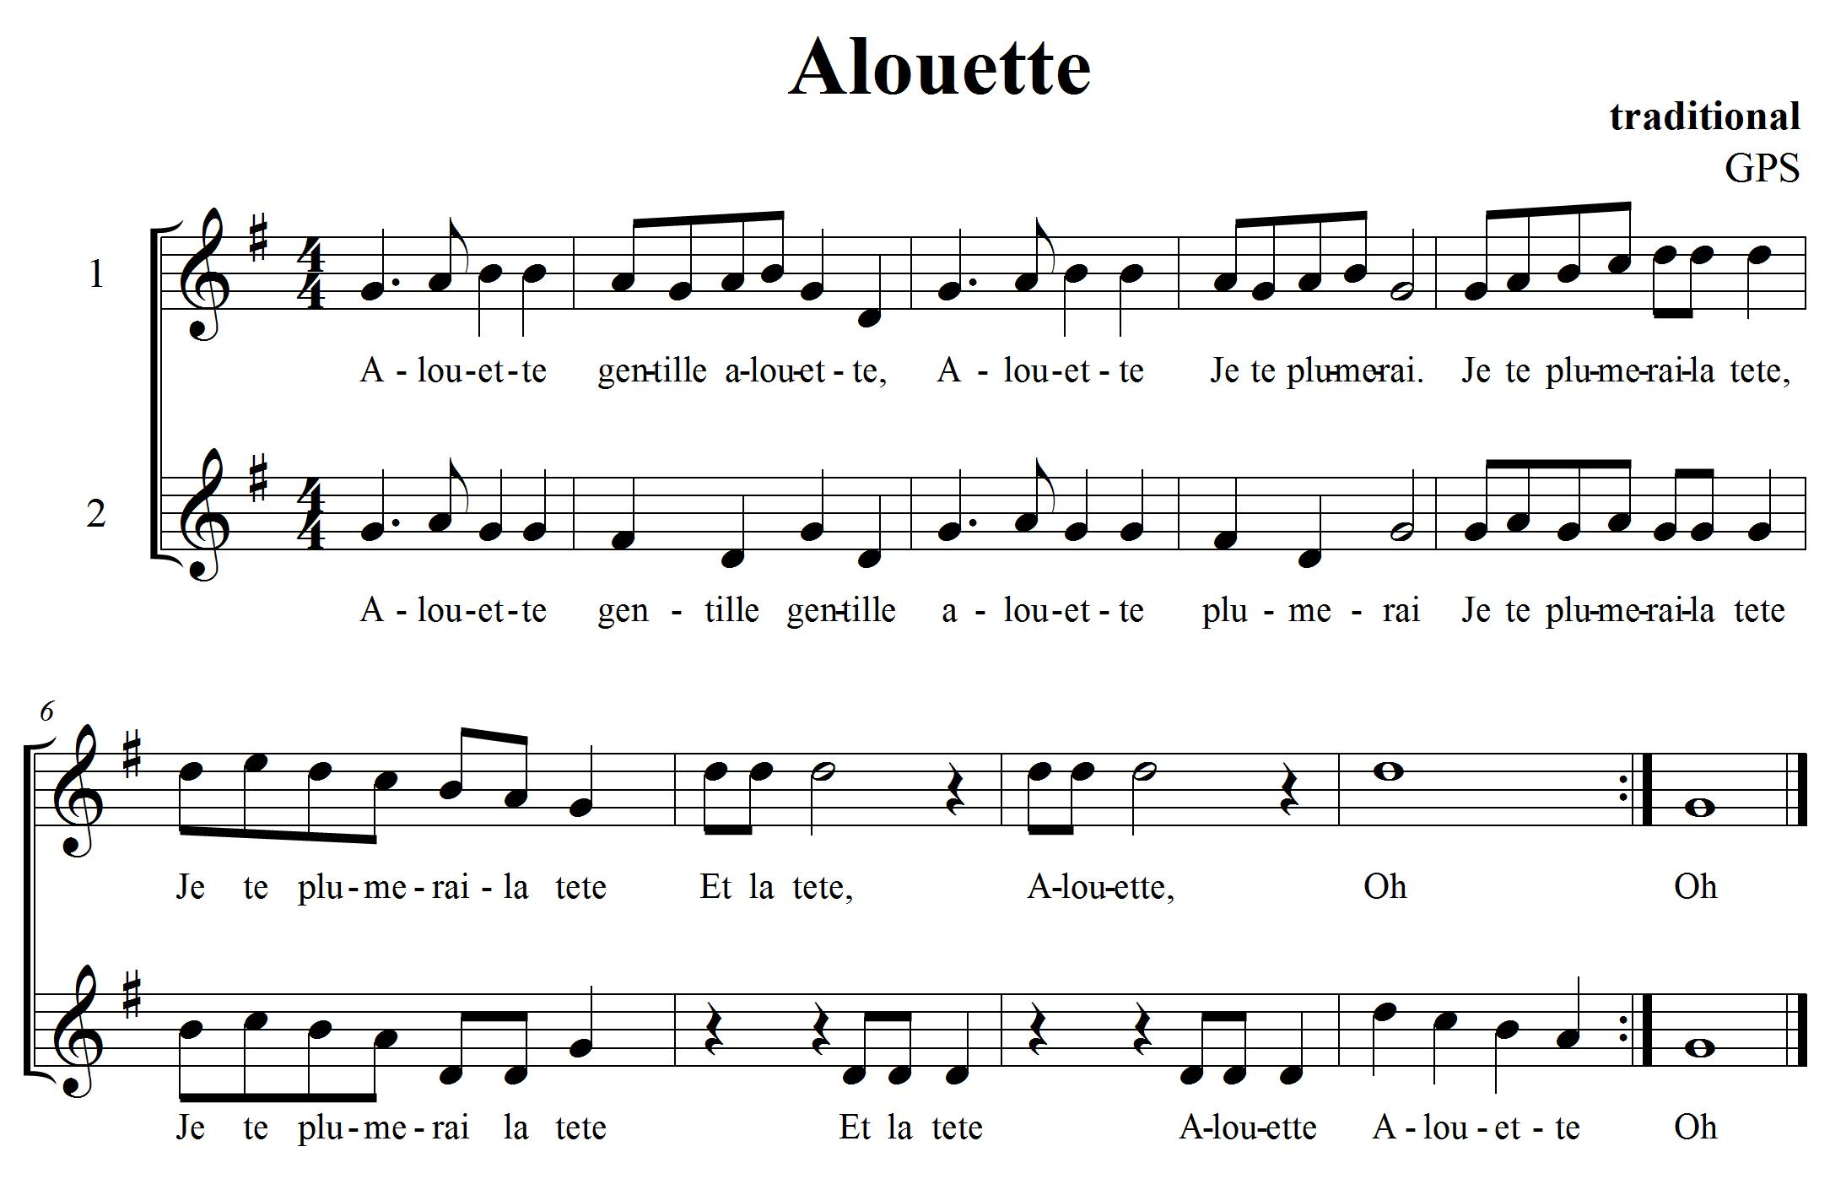

CONSOLIDATION! In order to move on to the next task, you will need to show that you can sing “Alouette” in groups with an added non-pitched percussion part. Listen carefully to each other to create a harmonic texture that is complimentary in its sound.

14. TIMBRE; WHAT IS IT? FOCUS: TIMBRE

LEARNING GOAL: Recognize the sounds of different instruments and articulate the mood that the composer is trying to portray by their choice of instruments.

MINDS ON! We know that the element of timbre or tone colour is about the quality of sound that allows us to interpret which instrument is making the sound. It also helps us to understand the feeling or mood that the composer is trying to portray. What instrument do you think best portrays an elephant walking? What instruments could create the sound of thunder and lightning?
ACTION! In order to be successful with this task, you will:

- Need lots of practice listening to different pieces of music to be able to distinguish the differences between instruments, so practise listening to different genres of music think about the mood or feelings the composer is trying to portray with their music.
- Use a piece of 8 ½ by 11 paper. Fold it in half and then half again to create 4 parts to the paper.
- Write Winter as the title in one section; Spring in the next; Summer in the next and Autumn in last section. This is your Four Seasons Organizational Chart.
- Listen to Vivaldi’s “Four Seasons” provided by your teacher.
  - When listening to Winter, write down the names of instruments you can hear in the Winter section of your page.
  - What expressive markings can you hear? Write them down in the Winter section.
  - What image, mood or feeling is Vivaldi portraying in this section?
  - Write down or draw pictures of your thoughts in the Winter section.
- Repeat the same activity in the sections for Spring, Summer and Autumn when you are listening to that part of the “Four Seasons” .
- When you have finished, make sure you go through your answers to share with the teacher.
- You should be able to name instruments used, some expressive markings (e.g. forte, piano, staccato... from task twelve) as well as draw or explain the mood being portrayed by the piece.

CONSOLIDATION! In order to move on to the next task, you will need to show your teacher your “Four Seasons” organizational sheet with examples of instrumentation, expressive markings that you can hear and your interpretations of the mood and feelings being portrayed in the music.

15. MUSICAL FORM FOCUS: FORM/RHYTHM/COMPOSITION
LEARNING GOAL: We are learning about musical form and how to improvise a rhythmic section for a song.

MINDS ON! What is rondo form? How is it the same as a verse and chorus; how is it different? Can you figure out the form when you are listening to it? The element of form is related to the structure of the music. It’s like the skeleton or bones of the music. How it is organized is important because people interpret music differently depending on its form. Let’s use “Alouette” from task 13. You know how to sing it, now let’s create some musical interludes!
ACTION! In order to be successful with this task, you will need to:
- Know that a Rondo form is an A, B, A, C, A... form
- Practise singing “Alouette” from task 13. It will be the A section of the rondo that you create with the class.
- Using non-pitched percussion instruments and working with a partner (pick someone you haven’t worked on a task with before).
- Create a rhythmic interlude that can be played as the B, C, or D... section of the class rondo.
- Practise it by first singing the song, then playing your part and going back and singing the song. Can you include the two-part harmony?

CHALLENGE: Can you find another song that has a rondo form? Does your rhythmic interlude work with the new song?

Task 15 (continued):

Use the staff lines below to organise your rhythmic interlude.

CONSOLIDATION! In order to move on to the next task, you will need to create a rhythmic interlude that you can play as part of a rondo being performed as a class.

16. LET’S COMPOSE A PIECE OF MUSIC FOCUS: COMPOSITION

LEARNING GOAL: Create a soundscape for a specific page in a picture book. Use your own symbols or notation to help remember what to do for your performance. Work in groups of 3-4. Perform it for the class.

MINDS ON! We have been learning about music all year, we have looked at different pieces of music and now it’s time to put all that knowledge into creating our own piece of music that you get to perform for the class! What kind of sounds do you want to hear in your composition? What rhythms do you want to use? What kind of dynamics are you going to use to show contrasts? Do you have an idea for a theme? Many composers have something that inspires them to write. What is your inspiration going to be? Take a look at the picture books your teacher has brought in for you to use. What sounds are inspired by what you see on the pages? What rhythms do you hear in the words? Think about the form your music is going to take... there is so much to think about! Let’s give composition a try!
ACTION! In order to be successful with this task, you will need to:

- Take a look at The Creative Process chart in your class. This will help you focus your learning as you go through the steps of composition.
- With your group, brainstorm about what qualities you want to have in your soundscape composition. Pick a page from a picture book that inspires you to help generate some ideas.
- Start thinking of sounds that you want to use and how you can create rhythms and or melodies using those sounds. Explore your ideas and experiment with them.
- When you think you have some sounds, rhythms and melodies that you like, think about the order and form you want your music to take. Start planning and focusing.
- Remember to ask for feedback from your peers and teacher as you work through this process. They will help give you ideas and open up new learning experiences for you as you are composing.
- Create symbols that represent the different sounds you are using in your composition.
- Once you have your symbols worked out, put them in the order you want them performed. What form is your music going to take? How are you going to show the beginning, middle and end of your song?
- When you think you have your preliminary work completed (that means your composition is pretty close to finished) then it is time to perform it for your class to get more feedback on how it sounds.
- Now that you have performed it, what did you like? What do you want to change? Now is your chance. Go ahead and change what you want, revise it and make it better!
- When you think you are ready, let your teacher know that you are now ready to present, perform and share your composition with the class!
CONSOLIDATION! In order to move on to the next task, you will need to show that you can perform and share your soundscape composition with the class. When you are done, reflect on and evaluate on your learning. Write a paragraph telling your teacher: Are you satisfied with your composition? Why or why not? What would you change if you were to do this task again? What were your challenges? What did you do that was lots of fun? What other GPS tasks helped prepare you for this one?


Congratulations! You have reached your final GPS marker – WEST!
Ask your teacher how you are to acknowledge this accomplishment on your GPS task tracker!
WAY TO GO!!

