Teacher Pause and Ponder for each grade 4 task:

Task 1: KEEP THE BEAT! FOCUS: BEAT

You will need:
- plastic cups, one for each student
- a number of rocks (at least 1 for every 2-3 students to allow passing)
- a piece of music that has a steady tempo (e.g. “Heard it Through the Grapevine”) the music can be in any genre you wish but the tempo should be at a walking pace.

To prepare students for this task, play a variety of songs from a variety of cultures for the students to practise this task over a number of days/weeks, keep track of the students who can complete this task on a check list. When you feel that 90% + of your students are ready to do this task, place students in groups of 4 -6, the smaller circles work better as they are moving the rock more frequently. Have students keep their own cup, but move the rocks around the circle to the beat. Move the cups by placing them down on top the rock for the first beat then sliding them over to the next person for the second beat, lifting cups up on the third beat and start the pattern again.
Even though your students will have mastered this task, revisit a few more times throughout the year to allow consolidation of the task and begin to develop a stronger sense of beat which prepares them for GPS Grade 5 task 1. Change the tempo of the music; try it at different tempos and different music genres.

Task 2: TAKE A DEEP BREATH! FOCUS: VOCAL
There are no materials for this task.
To prepare students for this task, teach them to take a deep breath from their diaphragm and release the air through their mouth as they “burr” or say “shhhhhhhh” which will engage the abdominal muscles to help push the air out. (It creates pressure, which helps to build muscle). These exercises warm up the vocal chords and muscles necessary for proper breathing. Exercises like these should be done each time before students are asked to sing. There are many resources available to assist you with vocal warm ups. This task can be assessed as you are warming up for any song that you are teaching the class. Check that they are using abdominal muscles by watching to see if their stomach is moving in and up during this exercise. Remember that students should keep their shoulders relaxed and down while singing.

Task 3: RHYTHM! FOCUS: RHYTHM
There are no materials needed for this task.
Teach students an example of what this might look like. Walk through the action activities. This is to help focus the student’s thinking and keep the learning goals visual for the students. This task is self-explanatory. Students will be able to work in groups of 2 to complete this task. Allow them independent practice time in class to prepare for this task. Give students multiple opportunities to practise and consolidate this task. Allow students to present this task to you when they feel they are ready.

You may feel compelled to try and control the chaos that will be created while students are working on this task, but as long as they are engaged in working through rhythms, resist the urge to take over and teach them by rote. This is an opportunity for you to see where the students are and how they interact with their peers. It gives you an opportunity to watch the critical thinking and creative processes that occur when students are asked to create something new. Allow time at the beginning or end of class for students to show you this task as they feel ready to complete it.

Self-reflection is placed throughout the booklet for students. Have them complete this before going on to the next task. This is an opportunity for you to have conversations about their thoughts and impressions and addresses expectation 2 in the music curriculum for this grade.

Task 4: DO YOU KNOW YOUR RHYTHMS? READY, SET...! FOCUS: RHYTHM
You will need:
- Craft sticks (at least 20)
A simple symbol for ta created with 1 stick

A simple symbol for ti-ti created with 3 sticks

A simple symbol for rest created with 3 sticks

These are very similar to rhythmic notation. To prepare students for this task, give them opportunities to make and clap a variety of rhythms that are made using the craft sticks. Teach them to group their rhythms in 3’s and 4’s to help organize them and to keep a steady beat. Clap simple rhythms for them to recreate, have students take turns to clap rhythms for the class. Use the vocalization (rhythm names/oral prompts) of the rhythms to help students while clapping.
Example:
- Clap a rhythm for them;
- Clap it a second time saying the rhythm of the notes (e.g. ta, ta, ti-ti, ta); and
- Clap it a third time without the words.

Use a checklist to keep track of students who are creating the correct rhythms. Make a note of students who are clapping simple steady rhythms for the class to follow. This will help in your assessment of this task.

When Students have completed 4, 8, 12 and 16 tasks, they reach a checkpoint like the following:
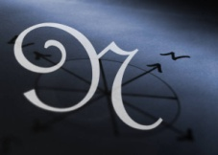
Congratulations! You have reached your first GPS marker – NORTH!
Ask your teacher how you are to acknowledge this accomplishment on your GPS task tracker!
WAY TO GO!!
What to do at each checkpoint:

There is a tracker sheet that is in the front of the student booklet. You will need to make some decisions on how to use the tracker. It is meant to give the students control over their learning and keep the learning goals evident throughout each class. As they accomplish each task, initial the square that corresponds on the tracker. Once they have completed 4 tasks, they have done a quarter of the program. See GPS Overview for ways to acknowledge this checkpoint.

Task 5: LET’S PUT IT TOGETHER FOCUS: BEAT/RHYTHM

To prepare students for this task, they must be taught “Michael Finnigan”. Only the first verse is included for the purpose of the task, feel free to teach them more verses of the song.
This task is an opportunity to create connections to language expectations. They can create new verses of their own and make connections to rhyming words. Students will need multiple opportunities to practise keeping the beat with their feet and clapping the rhythm of the words with their hands before you evaluate this task.

Task 6: THERE’S MORE TO DURATION! FOCUS: METRE/ACCENT

You will need:
- Music of any genre that you wish. Make sure you can feel a steady beat.
- Music e.g.) medieval music, Renaissance music, aboriginal powwow music, Indian classical music, music in Islamic cultures are all mentioned in the grade 4 expectations. (C1.2, C3.1, C3.2)
Choosing any of these genres for this task could allow for further discussions leading to awareness of characteristics of musical forms (C3.2)
Students walk to the beat and accent the first or strongest beat using an action that they create. While doing this activity, watch students and mark down on the checklist how they are doing. If they are moving in step with the beat and creating an action for the strong beat, they are meeting the expectation for this task. If they are not quite moving to the beat or creating an accent for the strong beat, they are still developing. If they are quick to find the beat, move to the beat, create an accent on the strong beat, and can do this fluently before other students, they are exceeding the expectation of this task.

For more music samples, visit:
freeplaymusic.com

7. STILL MORE DURATION! FOCUS: TEMPO
To prepare for this song, pick songs that you have sung throughout the year, sing them at different tempos.

8. WHAT MAKES A MELODY? FOCUS: PITCH

You will need:
- pieces of wool or string of varying lengths (Video Sample)

To prepare students for this task, they must be taught the song.
Students should create melody maps using string with other songs and music they listen to and sing to give them some experience before doing this task.
Once they know “Old Macdonald”, they can begin to figure out what the melody looks like using string. See the sample of melody map on p. 179 of The Ontario Curriculum Grades 1-8: The Arts (2009)

9. SOLFEGE, LET’S LEARN IT! FOCUS: PITCH

Look on page 186 of the new arts curriculum for pictures of all the hand signs. Use it to show students what the hand signs look like. Post it up in your classroom.
Before starting this task, students need to have been taught the hand signs for do, re, mi, fa and so. Hand signs help put the pitches into a visual context that is easier to measure. If a child is singing a pitch too low, raise their hand sign up until they match the pitch will help them attain the concept of pitch matching.
To prepare for this task, the students must be taught the song with both the words and the solfege syllables. Below is music showing the solfege letters. Have the students work on their copy and add the letters d, r, m and s under each note to help consolidate the notes. 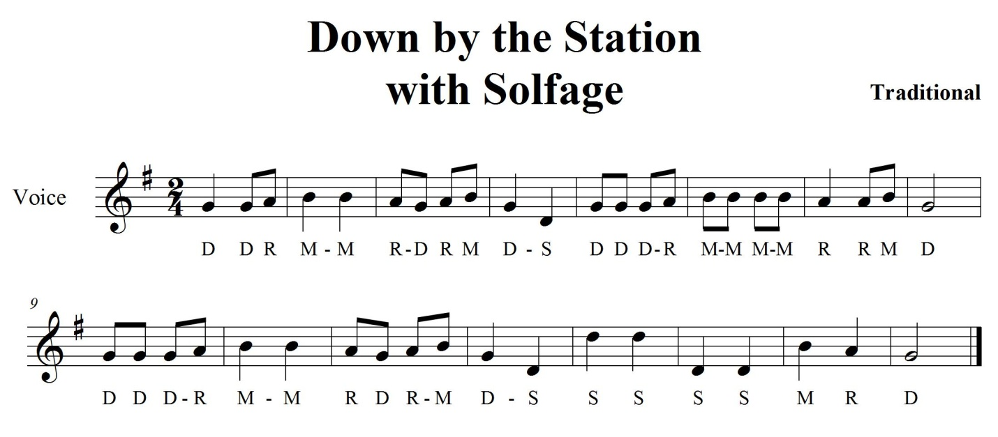

10. SOLFEGE, LET’S KEEP LEARNING IT! FOCUS: PITCH
Video Sample
Practice will prepare students for this task. This is a scale. Repeat this task over a number of classes until students are fluent in moving between hand signs before evaluating this task. The hand signs are on pg. 186 of the new arts curriculum. Learning the hand signs will help the kinesthetic and visual learners learn the movement of notes in a scale. This will also assist them with their listening skills when working with pitch. You are able to show students in a visual way the difference between two different notes by using the hand signs.

11. DYNAMICS CAN BE FUN! FOCUS: DYNAMICS
You will need:
- a variety of music genres that show big differences in dynamics.
- (e.g. Richard Strauss “Also sprach Zarathustra” (http://en.wikipedia.org/wiki/Also_sprach_Zarathustra_(Richard_Strauss) from the film: 2001: A Space Odyssey )
Raising or lowering the volume on a song that is playing is not a true example of using dynamics as it is not part of the actual music. It can be used as a sample of loud or soft and be given the musical names e.g.) loud it called Forte, soft is called Piano. It will sound approximately this loud in comparison to the normal volume of the piece of music when we listen to it.

12. MORE DYNAMICS FOCUS: DYNAMICS/EXPRESSIVE MARKINGS

To prepare students for this task, they must be taught the song.
Students can make a choice on where to add dynamic markings that show changes to the volume on this song. This can be a personal choice, but they should be able to perform the markings they have added appropriately.
A challenge is added to this task to expand the conversation with the students to include other dynamic markings that do not necessarily relate to the volume that a song is sung.

13. TEXTURE AND HARMONY FOCUS: TEXTURE/HARMONY

To prepare students for this task, they must be taught the song.
Teach this song as a large group and show them how to start at different spots in the music before they practise on their own in small groups.
The numbers on top of the music tells the performer where the first group is singing when their group needs to begin singing at the beginning of the song. For example, the first group begins singing at the number 1, when they reach the number 2, the second group begins at the beginning (where the number 1 is), when the first group reaches the number 3, then it is the third group’s turn to begin at the number 1 position. (the second group should be at the number 2 position at that time). This is how a round or canon works. The first group can sing through the song at least 2 times to allow the third group to sing with the harmony created by adding texture of more parts. When group 1 does their repeat, then group three should be at the number 2 position to make the canon work harmonically.

14. TIMBRE; WHAT IS IT? FOCUS: TIMBRE

This task will need some preparation before students do it. They will need to have multiple opportunities to hear orchestral music and orchestral instruments in a thin texture so they can pick out instruments that are being played.
Music samples to use:
- Peter and the Wolf by Sergei Prokofiev this piece of music separates up the instruments so that you can hear them. They are played alone and with other instruments, but the music is equated to an animal, which will help students visualize or make a connection to something they know when the sound is heard.
- Allow students to hear a variety of music throughout the year to help prepare them of this task.
- Choose a piece of music that has a number of different instruments they have experience listening to. Ask them to pick out a few that they can hear.
- This task can be done as a whole class and marked by you as they are going through the listening portion of the activity using your checklist or handed in.

15. MUSICAL FORM FOCUS: FORM/RHYTHM/COMPOSITION
You will need:
- Music in a chorus and verse form (e.g.) I’m a Believer)
- Rhythm sticks (drum sticks or dowelling will also work) enough for each student to have 2.
- This entire task can be done with body percussion, but is more engaging with the rhythm sticks.
This task does not need a great deal of preparation beforehand. Have the students listen carefully to the music to figure out where the changes in the form happen.
Create a rhythmical pattern that they can do while they listen for the verse (part A). Use body percussion to start with e.g.) pat their legs to the beat which can change to tap the floor with sticks to the beat. Let them know that they can transfer to rhythm sticks after they have worked out their pattern if that is an option.
Let them work with a partner to come up with a new pattern to perform during the chorus and then allow time to practise with the music to see if their pattern will work. Discuss how many beats per bar they hear in the music (4 in this music example) they can use this information to create a pattern that has 2 or 4 moves and then repeats. Once they have practised their new patterns, play the entire song and have them perform the pattern created for A during the verse (transfer it to the rhythm sticks if you are using them) and the B pattern they created when the chorus is played.
To assess their concept attainment as they go through this activity, watch to see if they can distinguish when to change their patterns. Are they adjusting the pattern right before the chorus because they are anticipating it changing? If they can change the pattern fluently between the two, they are meeting this task. Some students may need additional practice.

16. LET’S COMPOSE A PIECE OF MUSIC FOCUS: COMPOSITION
You will need:
- A copy of the creative process up in your room for students to refer to
- Paper for students to write down their ideas
- Samples of graphic notation
This task is written with the action section as a checklist to allow students to move through and check off each part as they are done. This is to give them more independence and flexibility when working on their composition.

