GPS (Grade Performance Steps)

The Road to Musical Success!
Grade 4 Performance Tasks




Ontario Music Educators’ Association
www.omea.on.ca
Teachers, before you copy this booklet for your students...
⬰ Have you read the GPS Overview?
⬰ Have you taught these students before? If not, please take the time to work with your students to determine their strengths and needs before deciding which tasks will be appropriate.
⬰ Have your students completed the tasks in the Grade 3 GPS tasks, or have the concepts been taught to your students?
⬰ If you have taught these students before...go through the entire program task-by-task to confirm that the sequence and challenge level of the tasks is appropriate.
Refer to the Q and A section of the GPS Overview.

⬰ Do you need to reduce the number of tasks? If so, how will you need to change the evaluation by term?

⬰ Have you read the Pause and Ponder for this grade? These are important questions that you should consider before teaching each task.

⬰ The Junior Recorder GPS task progression chart is available by clicking here. You can see how these tasks align with and can support the Grade 4 Recorder GPS Tasks.

If you have questions, please contact:

Lynnette Charters: lcharters@rogers.com

Task # 2
Task # 1
Task # 3
Task # 5
Task # 6
Task # 7
Task # 10
Task # 9
Task # 11
Task # 15
Task # 14
Task # 13
Task # 16
Task # 4
Task # 8
Task #12
1. KEEP THE BEAT! FOCUS: BEAT

LEARNING GOAL: You will be learning to keep a steady beat.

MINDS ON! Beat is one of the basic components of music. It is a steady pulse that can be found in many musical forms. It is part of an element called duration. Can you find the beat in a piece of music? Can you follow the beat and keep a steady pulse?
ACTION! In order to be successful with this task, you will need to:
- Listen carefully to the music chosen by your teacher for the underlying beat.
- Work together in a group to pass a rock around the circle using cups.
- Move the cups to the beat by placing your cup down on top the rock for the first beat then sliding them over to the next person for the second beat, lifting cups up on the third beat and start the pattern again even when you don’t have a rock to pass.
- The rock should only be moved to the next person on a beat.
- Keep the movement steady and consistent, try not to miss a beat when you are passing.

CONSOLIDATION! In order to move on to the next task, you will need to show that you can keep a steady beat by passing the rock on to the next person without missing a beat. You should be able to do this consistently throughout an entire song.

2. TAKE A DEEP BREATH! FOCUS: VOCAL

LEARNING GOAL: You will be learning to warm up your lungs, abdominal muscles and vocal chords to prepare yourself for singing.

MINDS ON! Why should you warm up your lungs and voice before singing? How long can you sustain a sound? Can you conserve your breath? How much air can your lungs hold? Professional athletes must train to improve their stamina, so must musicians!
ACTION! In order to be successful with this task, you will need to:
- Start each warm up with a deep breath in through your nose and hold it for 3 seconds. Then release the air through your mouth and follow with one of the warm-ups below.
- Remember to keep your neck and shoulders relaxed as you do these two warm-ups.
- 1. Slowly let the air out through your mouth while you make a (sound like when you are playing with a toy car) “burring” sound.
- Move this burring sound from low sounds up to high sounds and back to low sounds again.
- Push the air out of your mouth using the muscle in your abdomen called the diaphragm. This is really important as you build musical muscles that will help you as you sing and play instruments.
- 2. Take a deep breath in through your nose, but this time make a “shhhhhhhhhhhhhhh” sound with your mouth as loud as you can. Push the sound out until there is no more breath left in your lungs; then take a big breath, standing straight and tall ready to sing.
- Switch between the two different warm-ups a few times until you can hold a “burr” and “shhhh” for 10 – 15 seconds.

CONSOLIDATION! In order to move on to the next task, you will need to show that you can warm up your voice by doing the two breathing exercises above while releasing your air over 10 seconds.

3. RHYTHM! FOCUS: RHYTHM

LEARNING GOAL: You will keep a rhythmic pattern consistent for 30 seconds.

MINDS ON! Rhythm is an aspect of the element called duration. It is similar to beat except that it is made up of patterns of long and short sounds and/or silences. It is different than beat because beat is made up of a steady repeated pulse. Rhythm changes everything up! Can you create a rhythm? Can a rhythm sometimes sound like the beat? Try creating a rhythm with a friend and keep the pattern going for 30 seconds.
ACTION! In order to be successful with this task, you will need to:
- Clap a steady ta () for 8 beats.
- Clap ti-ti () for a steady 8 beats.
- When you feel ready, begin clapping ta () and have a friend clap ti-ti () at the same time.
- Check to see if you are matching beats with your partner.
- Create an 8-beat pattern that uses both ta and ti-ti.
- Practise clapping your pattern against another students pattern (someone you haven’t worked with before); double check that you are both keeping the same beat.

CONSOLIDATION! In order to move on to the next task, you will need to show that you can keep a rhythmic pattern steady while another student claps a complimentary rhythmic pattern. You must articulate where ta and ti-ti occurs in your pattern.
SELF REFLECTION: What I found challenging about task three...

4. DO YOU KNOW YOUR RHYTHMS? READY, SET...! FOCUS: RHYTHM

LEARNING GOAL: You will copy a rhythm that the teacher or another student claps using craft sticks to show your understanding of rhythmic notation.

MINDS ON! Now that you know something about rhythm, let’s start learning how to notate it. Using craft sticks, create a simple stick symbol for ta (), ti-ti () and rest (). Make sure you are using the same symbol as everyone in your class. Using the sticks, can you create a rhythm for another student? Can they clap your rhythm back to you? Practise with another student to create your own rhythms and clap their rhythms.
ACTION! In order to be successful with this task, you will need to:
- Listen carefully to the teacher/student as they clap a rhythm for you to recreate using craft sticks.
- Consistently show the correct symbols for what they are clapping for ta (), ti-ti () and rest ().
CONSOLIDATION! In order to move on to the next task, you will need to show that you can accurately recreate each rhythm your teacher claps using rhythmical notation.

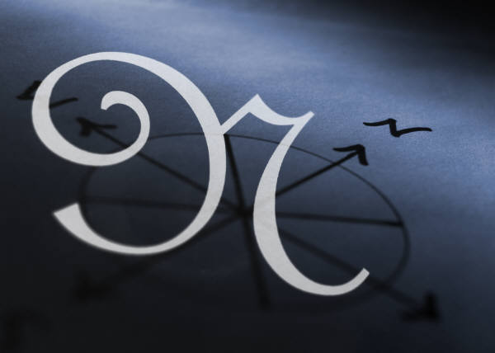
Congratulations! You have reached your first GPS marker – NORTH!
Ask your teacher how you are to acknowledge this accomplishment on your GPS task tracker!
WAY TO GO!!
5. LET’S PUT IT TOGETHER FOCUS: BEAT/RHYTHM

LEARNING GOAL: Put the knowledge you have learned about Beat and Rhythm together. You will show both the beat and the rhythm of a song.

MINDS ON! You have been learning about Beat and Rhythm as part of the element, Duration. In music, both beat and rhythm occur simultaneously which is why some people confuse them. Can you keep the beat in your feet? Can you clap a rhythm with your hands? Let’s give it a try! First with the help of your teacher, learn to sing Michael Finnigan. Step with your feet to keep a beat steady while you are singing the melody. Can you clap the rhythm of the words with your hands?
ACTION! In order to be successful with this task, you will need to:
- Keep the beat in your feet. Keep the beat steady like you did in the first task.
- Clap the rhythm of the words in “Michael Finnigan” while singing the song.
- Both these actions need to be done at the same time.
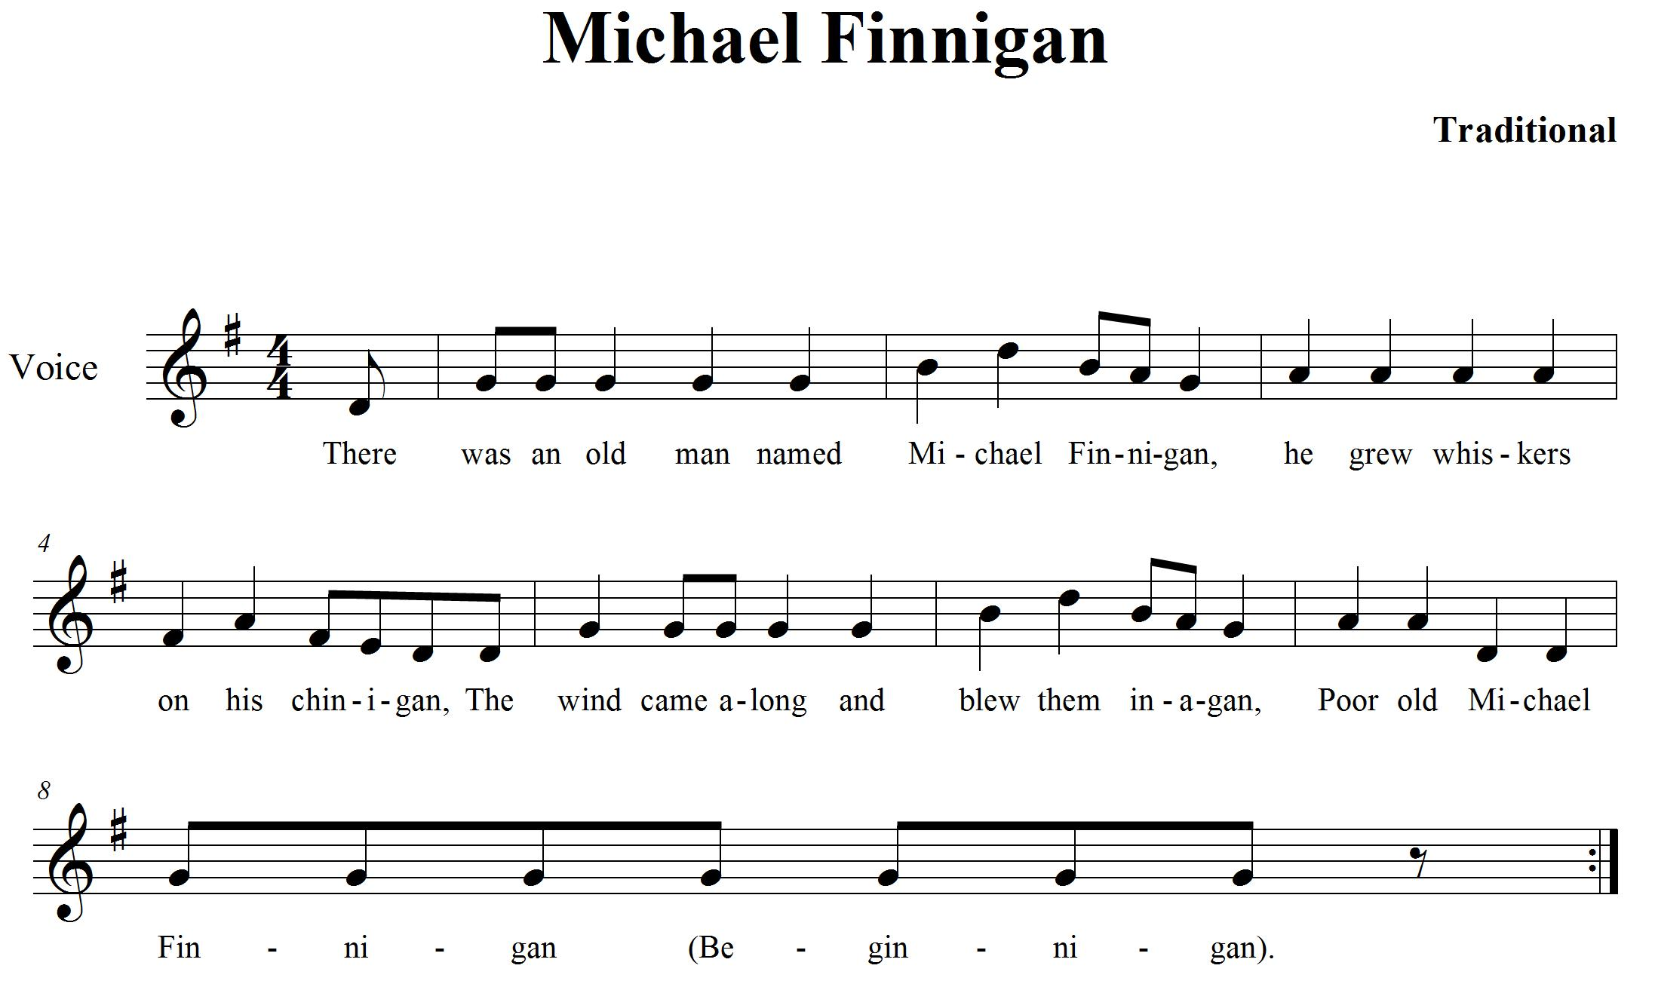

CONSOLIDATION! In order to move on to the next task, you will need to show that you can keep the beat in your feet and clap the rhythm (of the words) while singing Michael Finnigan.
6. THERE’S MORE TO DURATION! FOCUS: METRE/ACCENT

LEARNING GOAL: In this task, you will be expanding your knowledge about duration by learning about metre in music.

MINDS ON! Rhythm, beat, now metre! There is a lot to this duration element! In music, the beats are separated into groups to help the musician keep track of them (sometimes groups of 3 or 4). We also create a strong accent on the first beat of each grouping. Practise finding the beat in a song. Walk around the room and make a big stomp when you hear a strong beat. Create smaller steps on the weaker beats. Can you keep a steady beat and mark the strong beats with big steps?
ACTION! In order to be successful with this task, you will need to:
- Listen carefully to the music chosen by your teacher for the underlying beat.
- Move around the room to the beat and create an accented stomp on the first beat.
- Make a big action with your arm at the same time to accent the first strong beat in a measure.

SELF REFLECTION: What qualities did I hear in the music that helped me successfully accomplish this task? When I move, it helps me to...

CONSOLIDATION In order to move on to the next task, you will need to show that you can move to the beat in the music; follow the beat and accent the strong beats using a big action or movement.
7. STILL MORE DURATION! FOCUS: TEMPO

LEARNING GOAL: In this task, you will be expanding your knowledge about duration by learning about tempo in music.

MINDS ON! Tempo is a word used to describe the speed of a piece of music. There are many different speeds and each one has a musical term to describe it. Largo means play or sing slowly, allegro means play or sing quickly and in a lively way. When you change the tempo of a song it means you are changing the speed that you are playing or singing it. Can you sing a song largo? Can you sing a song allegro?
ACTION! In order to be successful with this task, you will need to:
- Keep the beat steady when singing a song chosen by your teacher.
- Sing this song with different tempos: largo (slowly), allegro (quickly).
- Practise singing “Michael Finnigan” from task five with different tempos.

CONSOLIDATION! In order to move on to the next task, you will need to show that you can sing a song of your teacher’s choice at a slow tempo (largo) and a fast tempo (allegro).

8. WHAT MAKES A MELODY? FOCUS: PITCH

LEARNING GOAL: You will be learning more about melody and how the pitches move through time.

MINDS ON! What is a melody? How do people learn to sing the same notes at the same time? Songs are made up of a series of sounds or pitches and silences that are put in an order that the composer likes or wants to hear. Melodies can move up and/or down in pitch. We will use string to create a graphic representation of what the pitch is doing in a song. Can you hear when the notes move up and when they move down? Try showing the sound movements using a piece of string.

ACTION! In order to be successful with this task, you will need to:
- Learn to sing “Old MacDonald” with the class.
- Listen carefully to hear if the pitches in the song go up or come down.
- Use a piece of string to show the movement of the sound.
- Can you make it match the contour of the sound?

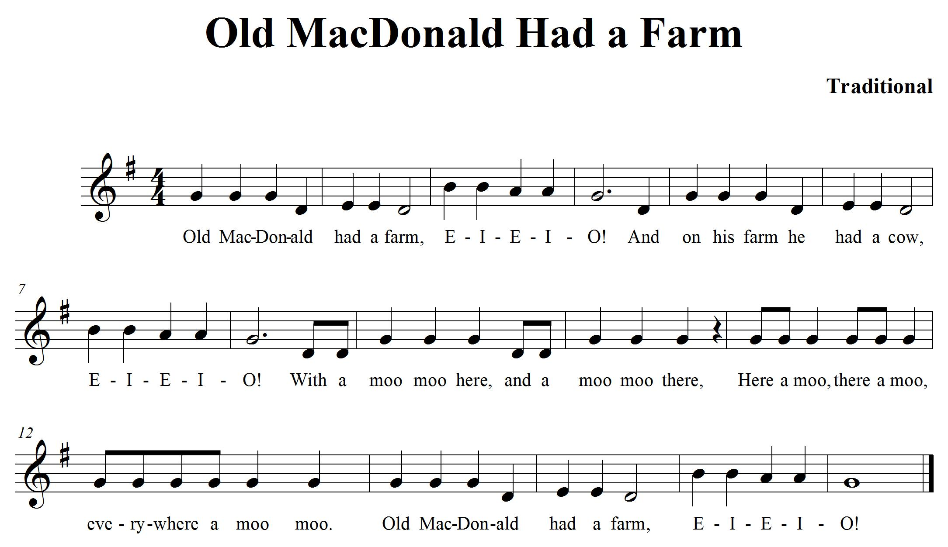

CONSOLIDATION! In order to move on to the next task, you will need to show that you can sing one verse of “Old MacDonald” and create a melody map using string to show the movement of the pitch in the song. Move your finger along your melody map to show the teacher where you are on your map as you sing.

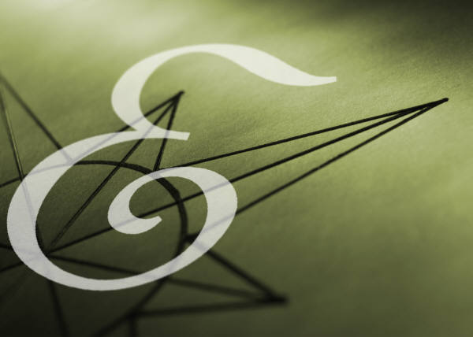
Congratulations! You have reached your second GPS marker – EAST!
Ask your teacher how you are to acknowledge this accomplishment on your GPS task tracker! WAY TO GO!!
9. SOLFEGE, LET’S LEARN IT! FOCUS: PITCH

LEARNING GOAL: Learn the hand signs for 5 different pitches.

MINDS ON! What is pitch? Can you hear when a sound is high or low? Do you know when to move the note you are singing to match someone else’s pitch? Music is made up of pitches. We often put those pitches into patterns called scales. “The syllables do, re mi, fa, so la and ti represent pitches of the scale” Ontario Ministry of Education (2009). Each syllable has a hand sign that helps us to remember them and how high or low the pitches are in relation to each other. What are the hand signs for do (pronounced as doh), re, mi and so? Can you show a friend these hand signs and sing the syllables with its related pitch?
ACTION! In order to be successful with this task, you will need to:
- Sing do, re, mi and so while using hand signs.
- Learn to sing the song, “Down by the Station”.
- Show the hand signs for the notes in the song (it starts on ‘do’) while you sing it in solfege syllables.

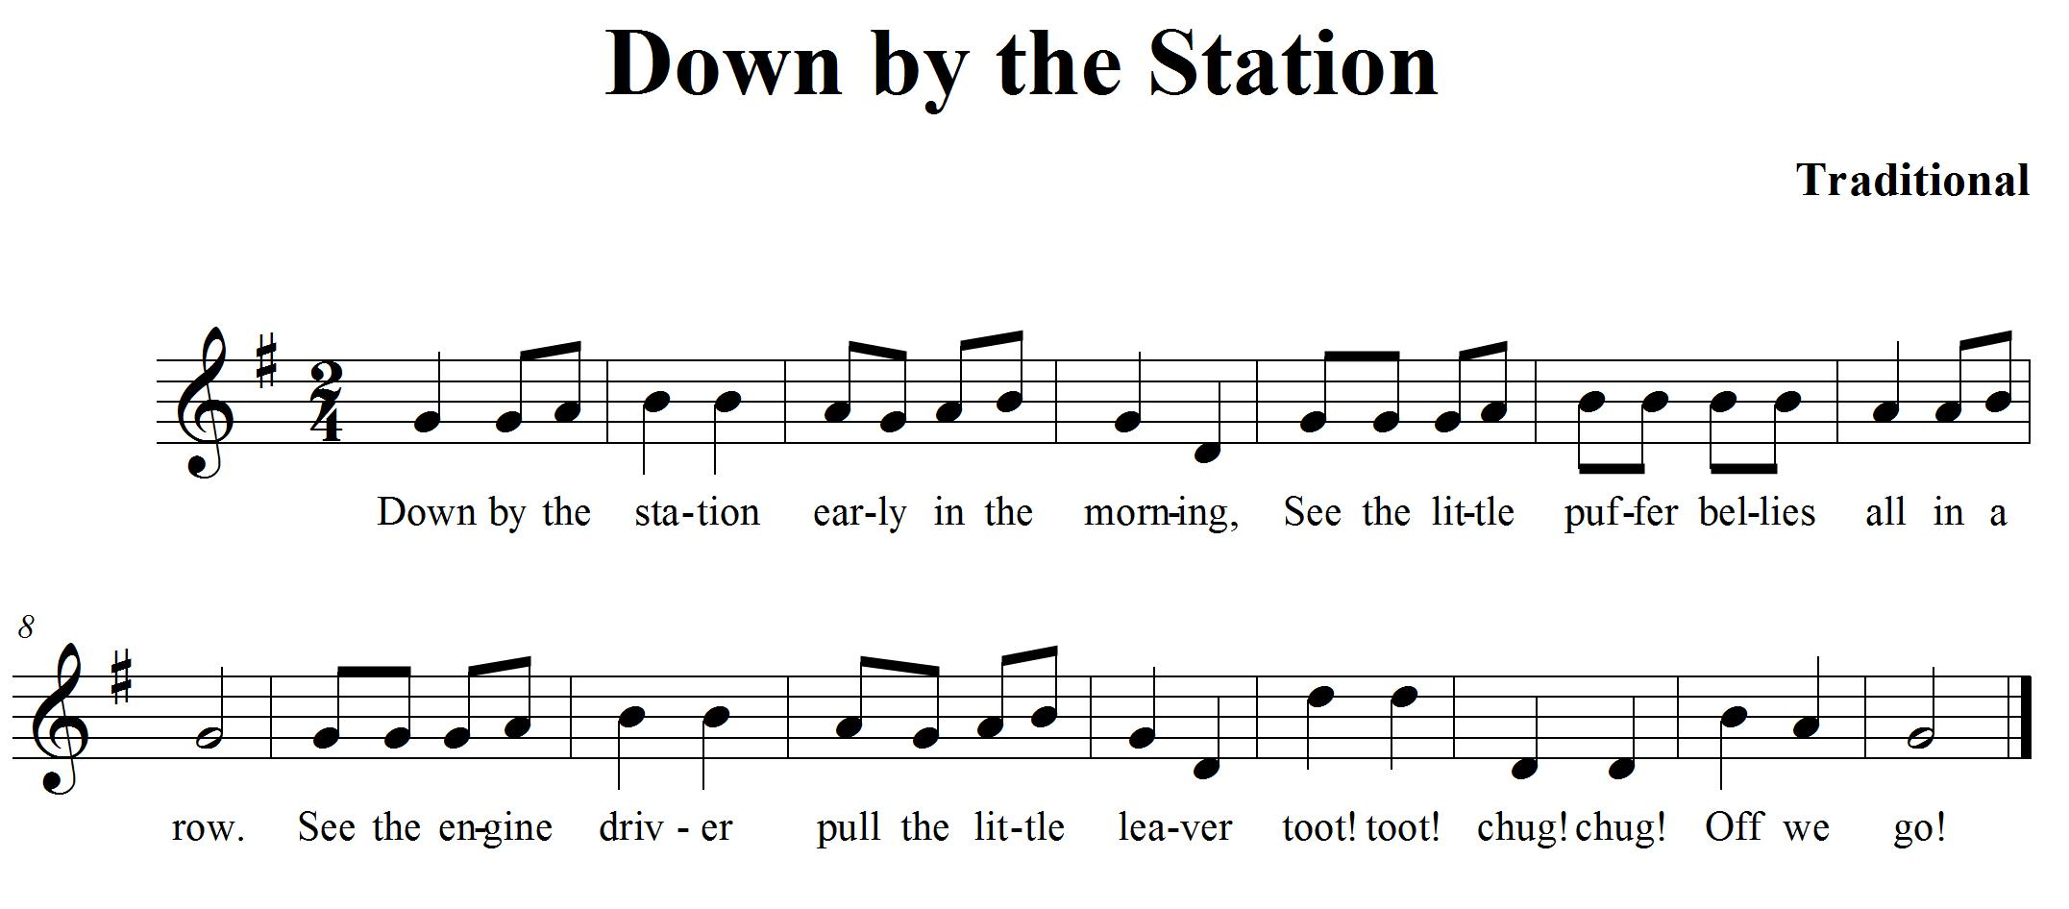

CONSOLIDATION! In order to move on to the next task, you will need to show that you can sing Down by the Station. Sing it a second time using the solfege syllables and show the hand signs for do, re, mi and so when they occur in the song.

SELF REFLECTION: My impressions of the hand signs are... Describe your thinking.

10. SOLFEGE, LET’S KEEP LEARNING IT! FOCUS: PITCH

LEARNING GOAL: You will be learning the hand signs for a major scale.

MINDS ON! Do you know what a major scale is? There are 8 pitches that make up a major scale. In Solfege, they are called do (pronounced doh), re, mi, fa, so, la, ti and do. Each pitch has a special hand sign to represent each syllable. Can you remember all eight? Can you sing the syllable names in order with their assigned pitches? Let’s give it a try!

ACTION! In order to be successful with this task, you will need to:
- Sing do, re, mi, fa, so, la, ti and do using hand signs
- Learn to sing the scale going up and going down. Sing it for an elbow partner. Listen as they sing it for you. Sing it together as a duet, match your pitches to other voices as you practise.
- Show the hand signs for the notes in the scale (starting on ‘do’) while you sing it in solfege syllables.
CONSOLIDATION! In order to move on to the next task, you will need to show that you can sing the major scale start on a note that is not too high so that you can go up the scale showing your hand signs and back down. Your teacher can provide you with help on your pitches if necessary.
11. DYNAMICS CAN BE FUN! FOCUS: DYNAMICS

LEARNING GOAL: Use dynamics as an expressive element in a song

MINDS ON! MUSIC CAN BE REALLY LOUD! Or it can be really soft. Composers use dynamics to help express a mood or accent something they want people to notice in their music. When you play very loud it is called fortissimo (ff) when you play very soft, it is called pianissimo (pp). With dynamics, there are varying degrees of volume and special names used to describe them. Can you sing forte (f) which is loud? Can you sing piano (p) which is soft? What do you have to do to physically to vary your sound?

ACTION! In order to be successful with this task, you will need to:
- Listen carefully to the music your teacher plays for you.
- Raise your hand when it is loud (forte) and lower your hand when it is soft (piano)
- When you think the music is not really loud or soft, then place your hand half way between the two other choices. There are varying degrees of loud and soft, so place your hand at the level you feel matches the sound of the music.
REFLECTION: In your opinion, why do composers use different dynamics in music?

CONSOLIDATION! In order to move on to the next task, you will need to show that you can match the movement of your hand to the changes in the dynamics and volume of the music.

12. MORE DYNAMICS FOCUS: DYNAMICS/EXPRESSIVE MARKINGS

LEARNING GOAL: You will demonstrate dynamics in music that you are learning.

MINDS ON! There are markings on standard notation that show us how loud or soft to play or sing the music. This is put there by the composer because they want a certain effect to happen when we sing or play their composition. In the song you are learning, can you adjust the dynamics so that some of the time you are singing softly and some of the time you are singing loudly? Remember singing loudly is not shouting!
ACTION! In order to be successful with this task, you will need to:
- Practise singing with the class using different dynamics.
- Sing the entire song, “Grandma Grunts” softly, then sing it loudly.
- Look for parts of the song that feel like they should be louder than other parts, mark f underneath that part of the music.
- Look for parts of the song that feel like they should be softer than other parts, mark p underneath that part of the music.
- CHALLENGE: There are also other expressive markings/controls in music that tell you to sing or play smoothly (slur) or detached (staccato). Can you sing your song using other expressive controls?

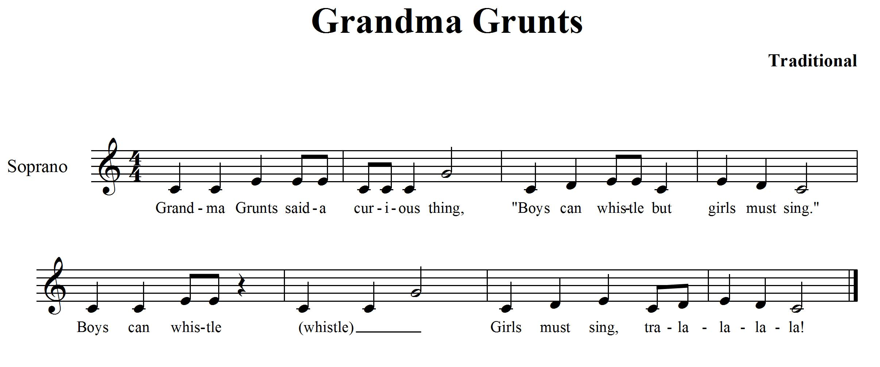

CONSOLIDATION! In order to move on to the next task, you will need to show that you can sing and/or play, “Grandma Grunts” using the dynamic markings you have added to the notation.

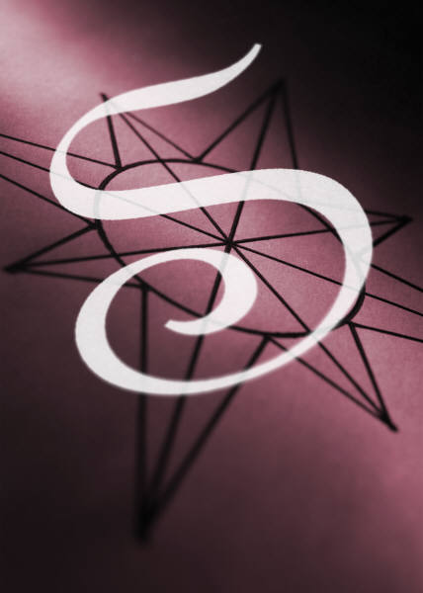
Congratulations! You have reached your third GPS marker – SOUTH! Ask your teacher how you are to acknowledge this accomplishment on your GPS task tracker! WAY TO GO!
13. TEXTURE AND HARMONY FOCUS: TEXTURE/HARMONY

LEARNING GOAL: You will demonstrate the use of harmony to create texture in music.

MINDS ON! Clothes have texture, a sweater is thick, and a t-shirt is thin. Music also has texture both thick and thin. How do we create layers of sound in music?
In music, we create texture by adding more melodies or sounds being played at the same time. Usually the sounds are not exactly the same so they create layers in the music that our ears are able to distinguish as different. Harmony is a way of adding more texture to music. Harmony is having two or more sounds or pitches playing at the same time. Let’s learn a song that has a single line melody and use it to create harmony when we sing it in canon. Can you hear how the music slowly sounds more complex and “thicker” as each part begins to sing?
ACTION! In order to be successful with this task, you will need to:
- Practise singing “Music Alone Shall Live”; work on singing it in tune and know all the words.
- Practise singing the song with a partner; match your voices by matching your pitches.
- Try singing it in canon as a class. One group of students start singing the song, when you get to the number 1, then a second group starts singing the melody from the beginning at the same time as you continue singing.
- Challenge: When the second group gets to the number 1 (and you are at the number 2), add another group to join in by singing from the beginning to create a third layer of sound.
- This sound that is created by having different layers of the same melody is called a diatonic harmony.

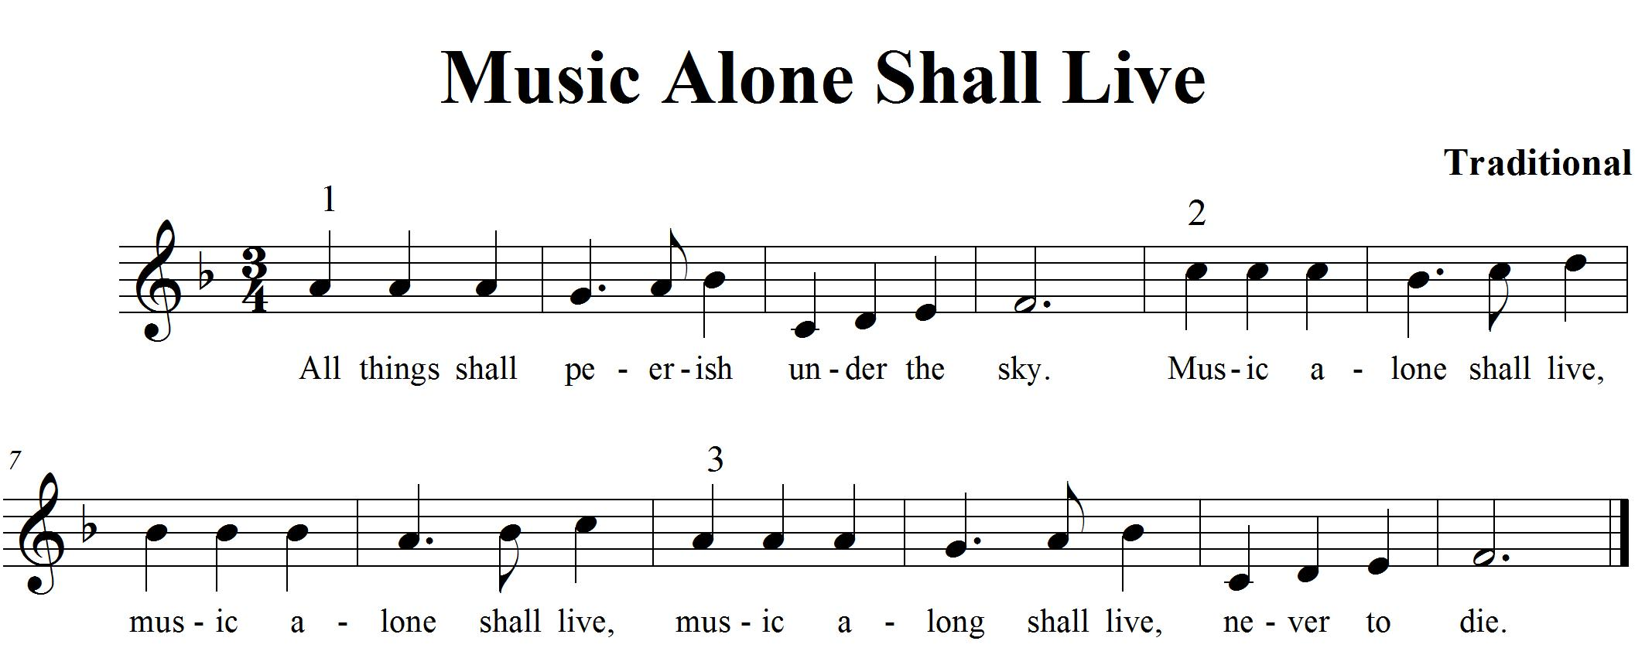

CONSOLIDATION! In order to move on to the next task, you will need to show that you can sing “Music Alone Shall Live” in groups. Listen carefully to each other to create a harmonic texture that is complimentary in its sound.

SELF REFLECTION: What I found challenging about task 13 was...

14. TIMBRE; WHAT IS IT? FOCUS: TIMBRE

LEARNING GOAL: Recognize the sounds of different instruments in the orchestra and name the instruments.

MINDS ON! How do you know it’s your Mom who is calling you and not your Dad or Brother? What do you know about their voices that help you to tell them apart? It might be how high or low the pitch of their voice is, or the soft mellow sound of their voice that helps you distinguish them. That quality that makes a sound unique is timbre or tone colour. When we are working with the element of timbre, we are asking ourselves questions about what makes that sound unique. Timbre allows us to distinguish the sound of a trumpet in comparison to the sound of a flute using our hearing without being told the differences in words.
ACTION! In order to be successful with this task, you will need to:
- Listen to the orchestral music that your teacher plays for you and try using your hearing to pick out different instrument sounds.
- Can you name the instruments that you hear?
- Challenge: How fast can you name the instruments that you hear?
- You will need lots of practice listening to different pieces of music to be able to distinguish the differences between the instruments, so practise listening to different kinds of music and name all the instruments you hear playing.

I can hear these instruments in the music:

CONSOLIDATION! In order to move on to the next task, you will need to show that you can recognize and name instruments from the orchestra that you can hear in the music that your teacher plays for you. Listen very carefully!

15. MUSICAL FORM FOCUS: FORM/RHYTHM/COMPOSITION
LEARNING GOAL: You are learning about musical form and how to create a rhythmical accompaniment for a song.

MINDS ON! How do composers choose what form their music is going to be in? Is it random? How can you figure out the form when you are listening to it? The element of form is related to the structure of the music. It’s like the skeleton or bones of the music. How it is formed is important because people interpret music differently depending on its form. What is a Verse and Chorus form? How can you tell? Is there something different about each verse? What is it?
ACTION! In order to be successful with this task, you will need to:
- Listen carefully to the music your teacher is playing for you and pat your legs to the beat during the first section of the song.
- When it sounds like a new section has started, raise your hand to show you can hear the change.
- Create a rhythmic pattern as a class that you can all perform when you hear the first part again.
- When you hear a section that sounds like the first part, perform your rhythmic pattern that your class created.
- Raise your hand when you hear the second section happening again in the song.
- With your elbow partner, create a rhythmic pattern of clapping/patting your legs/floor that will complement the second section of the song.
- Transfer your two patterns from your hands and legs to rhythm sticks.
- Practise the two different sections with your class along with the recording.
- Let your teacher know when you are ready for Consolidation!

CONSOLIDATION! In order to move on to the next task, you will need to show that you can follow the teacher’s instructions and create a rhythmic accompaniment for a song in chorus and verse form. You should be able to distinguish between the chorus and verse and explain the difference between the two.
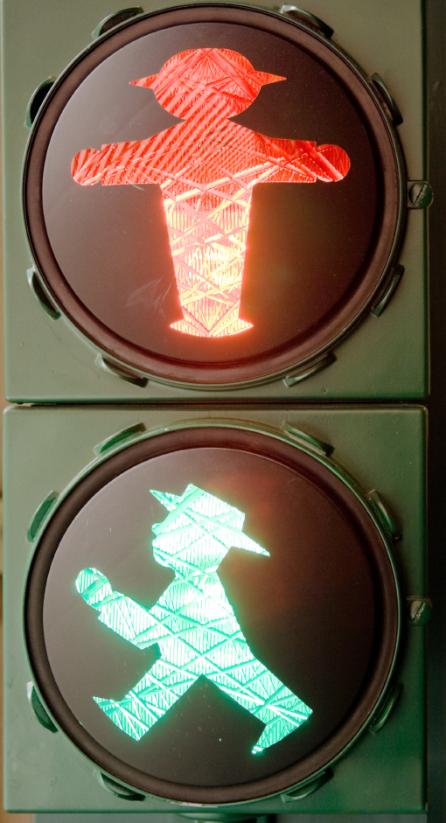

CHALLENGE: Can you find another song that has a verse and chorus form? Does your rhythmic pattern work with the new song?

16. LET’S COMPOSE A PIECE OF MUSIC FOCUS: COMPOSITION
LEARNING GOAL: Create a soundscape using your own notation or symbols with a partner. Perform it for the class.

MINDS ON! We have been learning about music all year, we have looked at different pieces of music and now it’s time to put all that knowledge to work while creating your own piece of music that you get to perform for the class! What kind of sounds do you want to hear in your composition? What rhythms do you want to use? What kind of dynamics are you going to use to show contrasts? Do you have an idea for a theme? Many composers have something that inspires them to write. What is your inspiration going to be? Think of a place you love to visit. What are the sounds you hear when you are there? Think about the form your music is going to take... there is so much to think about! Let’s give composition a try! Check off each action as it’s completed.

ACTION! In order to be successful with this task, you will need to:

- Take a look at The Creative Process chart in your class. This will help you focus your learning as you go through the steps of composition.
- With your partner, brainstorm about what qualities you want to have in your soundscape composition. Pick a place that inspires you (e.g. the playground) to help generate some ideas
- Start thinking of sounds that you want to use and how you can create rhythms and or melodies using those sounds. Explore your ideas and experiment with them.
- When you think you have some sounds, rhythms and melodies that you like, think about the order and form you want your music to take. Start planning and focusing.
- Remember to ask for feedback from your peers and teacher as you work through this process. They will help give you ideas and open up new learning experiences for you as you are composing.
- Create symbols that represent the different sounds in your composition.
- Once you have your symbols worked out, put them in the order you want them performed. What form is your music going to take? How are you going to show the beginning, middle and end of your song?
- When you think you have your preliminary work completed (that means your composition is pretty close to finished) then it is time to perform it for your class to get more feedback on how it sounds.
- Now that you have performed it, what did you like? What do you want to change? Now is your chance. Go ahead and change what you want, revise it and make it better!
- When you think you are ready, let your teacher know that you are now ready to present, perform and share your composition with the class!
CONSOLIDATION! This is the last task! To accomplish it you must show that you can perform and share your soundscape composition with the class. When you are done, reflect and evaluate your learning. Write up a paragraph answering the following questions for your teacher: What you think of your composition? What would you change if you were to do this task again? What were your challenges? What did you do that was lots of fun? What other GPS tasks helped prepare you for this task?


Congratulations! You have reached your final GPS marker – WEST!
You have completed your GPS Tracker!
WAY TO GO!!

