GPS (Grade Performance Steps) – The Road to Musical Success!

Primary/Junior/Intermediate Performance Tasks

Please note: wherever there is text underlined in blue, there is a link to sections of this document, video clips or websites. To return to this page, click on the “Home Page” link at the bottom of each page.

Introduction | •Philosophy  •How this works!  •Differentiated Instruction  •Assessment for Learning  •What it looks like for students!
Implementation | •Making the program work for your students and your school  •Student Recognition  •Before/During/After  •Connection to Fundamental Concepts  •Growth of Concepts over time
Assessment and Evaluation | •Mastery at each level  •Evaluation  •Primary Evaluation  •Junior Evaluation  •Intermediate Evaluation
FAQ’s | •Frequently asked questions about GPS and student learning!

You will find links to all of the GPS tasks and resources by clicking here.

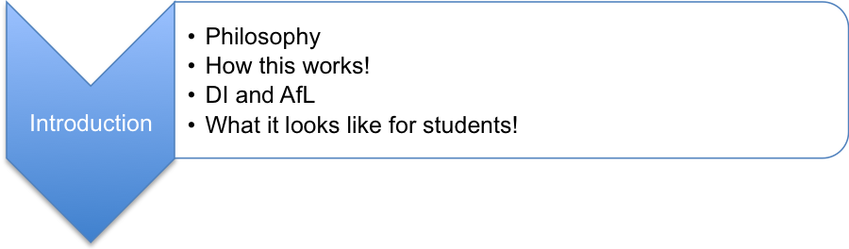

Introduction

The GPS (Grade Performance Steps) – The Road to Musical Success! are a series of performance tasks that will provide your students tasks that will teach the Fundamental Concepts from the Revised Ontario Music Curriculum Grades 1-8 required at each grade to achieve musical success!

This guide is intended to be a resource for teachers that are considering to, or are using GPS (Grade Performance Steps) – The Road to Musical Success! Many of the questions that you will have about this program, how to implement, assess and evaluate these tasks are contained in this guide. The Frequently Asked Questions at the back of this overview are very valuable and will help guide your learning and teaching. These tasks are available for the following grades and modes of delivery:

Division | Grades | # of tasks | Focus | Mode of delivery
Primary | 1 - 3 | 13 per grade | General music | Vocal, Orff
Junior | 4 - 6 | 16 per grade | General music | Vocal
Junior | 4 - 6 | 10 per grade | Instrumental | Recorder
Intermediate | Year 1, 2 or 3 | 20 per year | Instrumental | Wind and Percussion Ensemble
Intermediate | Year 1, 2 or 3 | 20 per year | Instrumental | String Ensemble
Intermediate | 7 - 8 | 20 per grade | General music | Vocal
Intermediate | 7 – 8 | 15 per grade | Instrumental | Recorder

For a summary of the tasks from Grades 1-8 with the Revised Music Curriculum Expectations connected to each task, please click here.

We associate a GPS (global positioning system) with taking a long trip, and use the GPS as a tool to get to our destination. We input our destination (learning target), the GPS determines the best route to get us to our destination (scaffolding) by giving us choice about whether we want the fastest route, the most use of highways, or by using toll roads (differentiation of process). The route that we take to get to our final destination does not matter, as long as we get to our final destination (beginning with the end in mind). This is the premise behind the title Grade Performance Steps or GPS for this program…it gives teachers and students a road map for their learning together for an entire school year and provides options as to how you might want to move through the tasks in a thoughtful manner. Remember that it is you the TEACHER, that has control of the GPS tasks, that plans the learning for your students, keeps them on your route helping them get to their final destination. Your students will have some choice in this program about when they are ready to demonstrate their learning, but they must follow the route you outline for them. Students will need to follow the GPS tasks in order (following the directions carefully so that they don’t get lost or left behind) to build upon the skills they learn to be able to get to their final destination!

This Ontario Music Educators’ Association (OMEA)/Ministry of Education (EDU) resource is now posted on the OMEA website (omea.on.ca). This overview is the guide for teachers to implement this yearlong program that provides suggestions for assessment and evaluation, and will provide guidance as to how this program is differentiated to help you learn about your students in ways that you never have before. Student packages for each grade and for the different modes of delivery are posted on the OMEA website (www.omea.on.ca) which will guide their learning!

This Primary/Junior/Intermediate resource will guide you through the tasks and show you examples of students performing and describing their learning for each task. The Primary GPS is a resource for guiding teacher planning and instruction. The Junior (Vocal and Recorder) and Intermediate (Band and Strings) programs will guide teacher planning and instruction, but also guide student learning through tasks that are written in student friendly language so that students can use the GPS as a tool to guide their learning with their classmates, but also independently. Teachers will find that the Junior and Intermediate tasks will provide opportunities for teachers to learn alongside their students.

Please note that this program is a suggestion for how you might structure the performance aspects of your music program building upon the fundamental skills for each grade, and is just one part of a balanced music program. The tasks and assessments should be modified to meet the needs of the students in your class. This program will only be successful if…the performance examples, tasks, delivery and the assessment and evaluation of these tasks are adapted where necessary to meet the needs of the students in your classroom, your teaching style and the time you have available to support the learning of your students. Teachers should read the “Before you copy this booklet for your students” page which is included with each GPS package carefully as well as the “Pause and Ponder” sections of the tasks for each grade where provided as well as this overview before making the GPS available to their students.

This program is the culmination of working within a similar framework of organizing music programs in a non-traditional manner for over 10 years. This structure and the performance tasks are a result of constantly modifying the tasks, collaboration with colleagues, talking with students, parents and teachers about how this program engages students, and close alignment to the Ontario Arts Curriculum 1-8: Music (http://www.edu.gov.on.ca/eng/curriculum/elementary/arts18b09curr.pdf). These tasks carefully consider how skills and concepts in each grade should be scaffolded and reinforced. The writers hope that this structure for your music program over the long term will provide you with an opportunity to guide your long range plans, to work along side your students (not just evaluate), provide effective feedback to your students based upon the learning goal for each task, differentiate your program, and teach the Fundamental Concepts and skills that will enable your students to enjoy making music with you and with each other!

Philosophy

The GPS (Grade Performance Steps) – The Road to Musical Success! is based upon the sequential acquisition and mastery of skills required to help build foundational skills for students. The inspiration for this program is an American publication called the Band Award System published by Barnhouse Publishing. It is a year-long course of study that promotes independent learning skills with the support of whole class, small group and individual instruction. Many Ontario music educators’ have adapted this program to meet the needs of their students, their programs and their teaching styles over the last ten years. This adaptation was originally called the Band Olympic Program (BOP) and has been modified for strings (String Olympic Program), and the recorder (Music Olympic Program) and several other modes of music instruction. This philosophy is now being applied to the primary and Junior music program to help frame learning and support the development of skills in the early years. GPS tasks start with the same Fundamental Concepts each school year so that students are able to get acquainted or re-introduced to performing and achieve success through establishing and solidifying fundamental skills in performing music throughout the school year. Each consecutive GPS task builds upon the previously completed or mastered tasks, so student success is guaranteed. Hear from Sarah Arcand about how this program is different from a traditional music class by clicking here.

This program also meets the needs of students with different learning styles and abilities in the classroom. Students in Junior and Intermediate classrooms will be encouraged to work at their own pace and perform tasks when they can achieve a level three competency (according to The Revised Ontario Curriculum, The Arts Achievement Chart) (http://www.edu.gov.on.ca/eng/curriculum/elementary/arts18b09curr.pdf). For the primary GPS tasks, tasks will be guided by the classroom teacher.

Home Page
How This Works!

The GPS (Grade Performance Steps) – The Road to Musical Success! provides for students and teachers:

- a sense of purpose;
- independence;
- regular recognition;
- critical thinking;
- Differentiated Instruction;
- multiple opportunities for continual improvement; and
- a strong assessment/evaluation structure.

Students in the Junior and Intermediate divisions are able to work at their own pace and are provided with an outline of what is expected of them from the first day of school (or early in the school year) depending upon whether students are ready for this type of structure in their program (e.g. students beginning on instruments might need to start in late October or November once instruments have been selected and initial instruction provided, while students who have completed the Grade 5 GPS tasks will be able to start at the beginning of September the next year).

Students are frequently recognized for their achievements. The more tasks they play successfully, the better their grade, the more satisfying their performance, and the higher their self-esteem. Primary students will be able to work through one or more tasks per month to help build a strong foundation of Fundamental Concepts such as beat, rhythm, the beat and rhythm connection, pitch etc. to give them a strong foundation that will be rooted in making and enjoying music with their classmates! Junior and Intermediate students may be able to work on several tasks in a month. On a regular basis in class, students are encouraged to think critically about their peer’s performances. They are learning to compare their own work with the exemplars demonstrated in class by classmates or the teacher. Students continuously learn from individual coaching, modeling, and feedback in class.

The GPS tasks are also beneficial for the music teacher. They provide structure for the school year and provide many opportunities for feedback (assessment) and multiple opportunities for evaluation. GPS tasks enable teachers to give students multiple opportunities to demonstrate their skills and best effort. For our Junior and Intermediate students, instead of asking students to perform a playing test, they often request to perform a task. As a classroom teacher you will find that you will feel more as if you are helping students through their difficulties as opposed to making a final judgment on their performance at a given moment by using a checklist or rubric.

Home Page
You will discover, that at the end of each term that you have collected more than enough data or evidence to support the evaluation of each student. In the Primary tasks, it is key that the teacher closely monitor student progress through your observations of students, and conversations with students as the class will be moving through each task together, not individually. The classroom teacher will need to take the time to make sure that most students are able to demonstrate their understanding/mastery of the task before moving on as a class to the next task (see Primary Evaluation for more details).

The GPS (Grade Performance Steps) – The Road to Musical Success! provides an example of how to structure your music program. You need to decide how to make it work for you! You will need to carefully consider what prior knowledge your students have, or need to know before modifying the tasks, or what teaching will be required before starting tasks with students (e.g. in a first year instrumental program…you will need to know the parts of the instrument, basic set-up etc. before you could start any of the performance tasks). For the primary GPS tasks, students will benefit from the repetition of the key skills and concepts and would benefit from going deeper into each concepts.

The GPS tasks will be a foundation for a quality program that will enable you and your students to experience success. The key to the GPS is that there needs to be flexibility with the tasks. As you move through the tasks, you will find that:

- students have gaps in their learning that you will need to address;
- you will need to spend more time on some tasks than others;
- you will need to constantly return to tasks already taught to reinforce fundamental skills that need continual review;
- you will need to be always teaching towards upcoming tasks (Fundamental Concepts) as these tasks and Fundamental Concepts should not be taught in isolation;
- you will need to think about the needs of each student with each task;
- you will need to change the number of tasks you are going to teach (and students demonstrate), depending upon how much time you can offer your students to demonstrate their learning (in class, outside of class time, or after school); and
- some students will get off to a slow start (or will come across “road blocks” in their learning), and you need to made accommodations to get students back on track.

Home Page

GPS Year Three Band and Strings could be used as:

- a third year program;
- extensions for students that finish the GPS Year One or Year Two programs early;
- tasks that can be substituted for tasks in the GPS Year One or Two programs that will not work for your students; or
- example tasks that can be adapted (in terms of complexity) to be flexible in nature to help support making the program work for you.

What is different about the GPS Year Three programs from the first two years?

- The 5th, 10th, 15th and 20th tasks are culminating tasks that align with the end of each marker (North, East, South and West).
- The tasks (e.g. 1 through 4) are tasks that scaffold the learning for students to be able to complete the culminating task/marker (e.g. task 5/North).

Considerations:

- Students should have completed the GPS Year One and Two programs before completing the complete GPS Year Three tasks; and
- Students will need to spend more time on these tasks in order to complete the culminating activities (these tasks are not only scaffolded like the GPS Year One and Two tasks, they are linked to enable students to complete the culminating tasks).

Intermediate Vocal program could be used as:

- a GPS Grade Seven and GPS Grade Eight Vocal program for intermediate students with a singing background;
- an alternative to an instrumental program for a group of students that may have had instrumental music and need to have a different challenge;
- the critical analysis aspect of an instrumental program (e.g. band would be performance, and the vocal program could be the part of your program that focuses on the Critical Analysis Process); and/or
- a way to differentiate for students that are not finding success in instrumental music but can express their understanding through this alternative process.

For more information about how to consider evaluating the Intermediate Vocal GPS, click here.

Home Page

Differentiated Instruction

Differentiated Instruction is just good teaching! To meet the needs of our students, we need to adapt our assessment and instructional practices. In our
music class, we also need to provide a balance of performing, listening, creating, theory, reflection and analyzing.

In Carol Ann Tomlinson’s book, The Differentiated Classroom: Responding to the Needs of All Learners, (http://www.caroltomlinson.com/) she outlines Key Principles of a Differentiated Classroom:

    - the teacher is clear about what matters in subject matter;
    - the teacher understands, appreciates, and builds upon student differences;
    - assessment and instruction are inseparable;
    - the teacher adjusts content, process, and product in response to student readiness, interests, and learning profile;
    - all students participate in respectful work;
    - students and teachers are collaborators in learning;
    - goals of a differentiated classroom are maximum growth and individual success; and
    - flexibility is the hallmark of a differentiated classroom.

The Grade Performance Steps (GPS) is built upon ongoing assessment with students (student self-reflection, teacher/student dialogue and collaboration, and teacher reflection on differentiating instructional strategies such as adjusting the content, process, and product in response to student readiness, interests, and learning profile). The GPS tasks will shape a learning environment that is focused on the strengths of the students and their individual learning needs. Below is a modified model that Carol Ann Tomlinson developed with some music examples and video clips to support you in differentiating your program:

Home Page

 | Guided by general principles of differentiation, such as
Respectful Tasks | Flexible grouping | Ongoing assessment and adjustment
 | Teachers can differentiate
Content | Process | Product
GPS examples:  - Conscious choice of repertoire (having a high, medium and low example that teaches the same concept)  Hear about how the GPS differentiate content by clicking here. | GPS examples:  - whole, small, peer  - Think/Pair/Share  - reflect/feedback  - time needed to prepare for each task in a variety of ways with varied support from teacher  Hear about how the GPS differentiate process by clicking here. | GPS examples:  Tasks: Oral/Aural/Visual/  Kinesthetic/Written through the rich performance tasks  Hear about how the GPS differentiate product by clicking here.
 | According to student’s
Readiness | Interest | Learning Profile
GPS examples:  - knowing your students and the background knowledge and experience they are bringing to each task  - minds on activity in tasks provides students an opportunity to engage with their learning | GPS examples:  - repertoire selection  - students making choices about how there are going to “chart out” their learning | GPS examples:  - variety of tasks to suit student audience (i.e. to balance between performance, composition, writing….conducting)  Hear about how you can consider your students learning styles by clicking here.

Adapted from Tomlinson, C. (1999). The differentiated classroom: Responding to
the needs of all learners. Alexandria, VA: Association for Supervision and
Curriculum Development. ,p. 15

Home Page

Assessment for Learning

In her book, Making Classroom Assessment Work (2nd ed), Anne Davies describes Assessment for Learning as “involving (es) learners receiving a considerable amount of descriptive feedback during their learning.” (p. 2). Assessment for Learning is not something that just involves the learner, it is the teacher learning along side that student learning more about the student, their needs, and how to plan instruction based upon the descriptive feedback that is received through the interaction between student and teacher. The Grade Performance Steps (GPS) will provide your students with a considerable amount of descriptive feedback, feedback that will help inform your next steps as a teacher.

Assessment for Learning is clear in the GPS when:

- conversations inform student learning, and observations and conversations inform teacher instruction;
- feedback to help students move forward is ongoing;
- we provide opportunities for peer assistance (peer assessment);
- feedback tells us that we need to re-teach a task in different ways to find the formula that will result in success for all our students;
- we engage in rich dialogue about what quality looks like, sounds like and feels like;
- we engage in opportunities to work with our students “one-on-one” to get to know them as a learner and use this opportunity to inform our next steps with our instruction;
- we recognize that learning music is a process, is sequential and requires mastery of skills before moving forward; and
- we value the process just as much as the product.

From:
Davies, A. (2007). Making Classroom Assessment Work (2nd ed). Courtenay, BC:
Connections Publishing.
Hear about how important feedback is by clicking here.

When learning new concepts:

- Students will need opportunities to practice;
- Students need to access specific, and descriptive feedback in relation to criteria that is focused on improvement (e.g. each GPS task); and
- There needs to be participation by the student, the person most able to improve the learning (being able to describe what it is that they are trying to demonstrate in their own language, and be able to compare their work to the criteria they are working towards).

From Making Classroom Assessment Work - 2nd Edition by Anne Davies
Hear about how her assessment drives her instruction by clicking here.

GPS examples of Assessment for Learning…to understand what students are thinking so you can make decisions about what to do next instructionally…
- Performing a song together in class that can be used as a diagnostic to inform instruction.
- Observing students working on an example from the method book to see if they have the strategies and knowledge to solve performance challenges.
- Providing students with descriptive feedback and multiple opportunities to help them move towards a level 3 performance.
GPS examples of Assessment as Learning…helping students develop the ability to self-assess, to monitor their own progress toward learning goals…
- Students mentoring students
- Students nominate another students to perform a GPS for the teacher based upon their understanding of the success criteria and level of mastery (level 3).
Assessment of Learning…information used for reporting to parents, students, institutions for decision making…
- Has the student mastered the task?
- Number of tasks completed will help inform performance mark

For more information about Assessment and Evaluation policy, please refer to the Growing Success: Assessment, Evaluation, and Reporting in Ontario Schools document released May 2010.
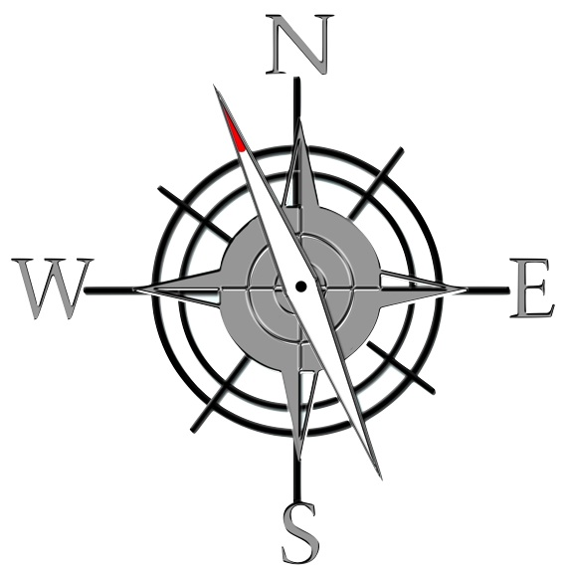

Home Page

What it looks like for students…First year band, GPS task 1:

1. LET’S HEAR YOU! FOCUS: PITCH

Wind Instruments and Mallets

Winds Task 1
LEARNING GOAL (Wind Instruments): You will play a long tone for 10 seconds (5 for flute and tuba) on your mouthpiece or head joint.

MINDS ON! How long your can conserve your breath? Why do you think that this might be important as a wind player? How much air can your lungs hold? Professional athletes must train to improve their stamina, so must musicians!

ACTION! In order to be successful with this task, you will need to:
- take in a deep (low) breath;
- consistently let this air out of your mouth with a correct playing embouchure and posture over 10 seconds (5 for flute and tuba);
- conserve air and pace yourself…this will require practice; and
- apply this process using your mouthpiece or head joint.

TASK 1 WIND INSTRUMENT MUSIC IS FOUND ON THE NEXT PAGE!

CONSOLIDATION! In order to move on to the next task, you will need to perform your long tone for 10 seconds (5 for flute and tuba) on your mouthpiece or head joint.
Percussion Task 1
LEARNING GOAL (Mallets): In quarter notes, you will play the first 5 notes of the B Flat Concert Scale. Four quarter notes per note, alternating hands.

MINDS ON! Are you striking each bar with the same amount of power? Close your eyes and play the same note over and over, alternating hands. Is every sound of the same dynamic level? Most people have a dominant hand; however as a percussionist you should leave your audience guessing as to whether you are left or right handed.

ACTION! In order to be successful with this task, you will need to:
- Balance/hold the Mallets with proper technique;
- Demonstrate proper posture;
- Alternate hands on repeated notes; and
- Strike the bar in the appropriate place.
TASK 1 PERCUSSION MUSIC IS FOUND ON THE NEXT PAGE

CONSOLIDATION! (Percussion) In order to move on to the next task, you will perform the following pattern on the mallets, for your teacher.

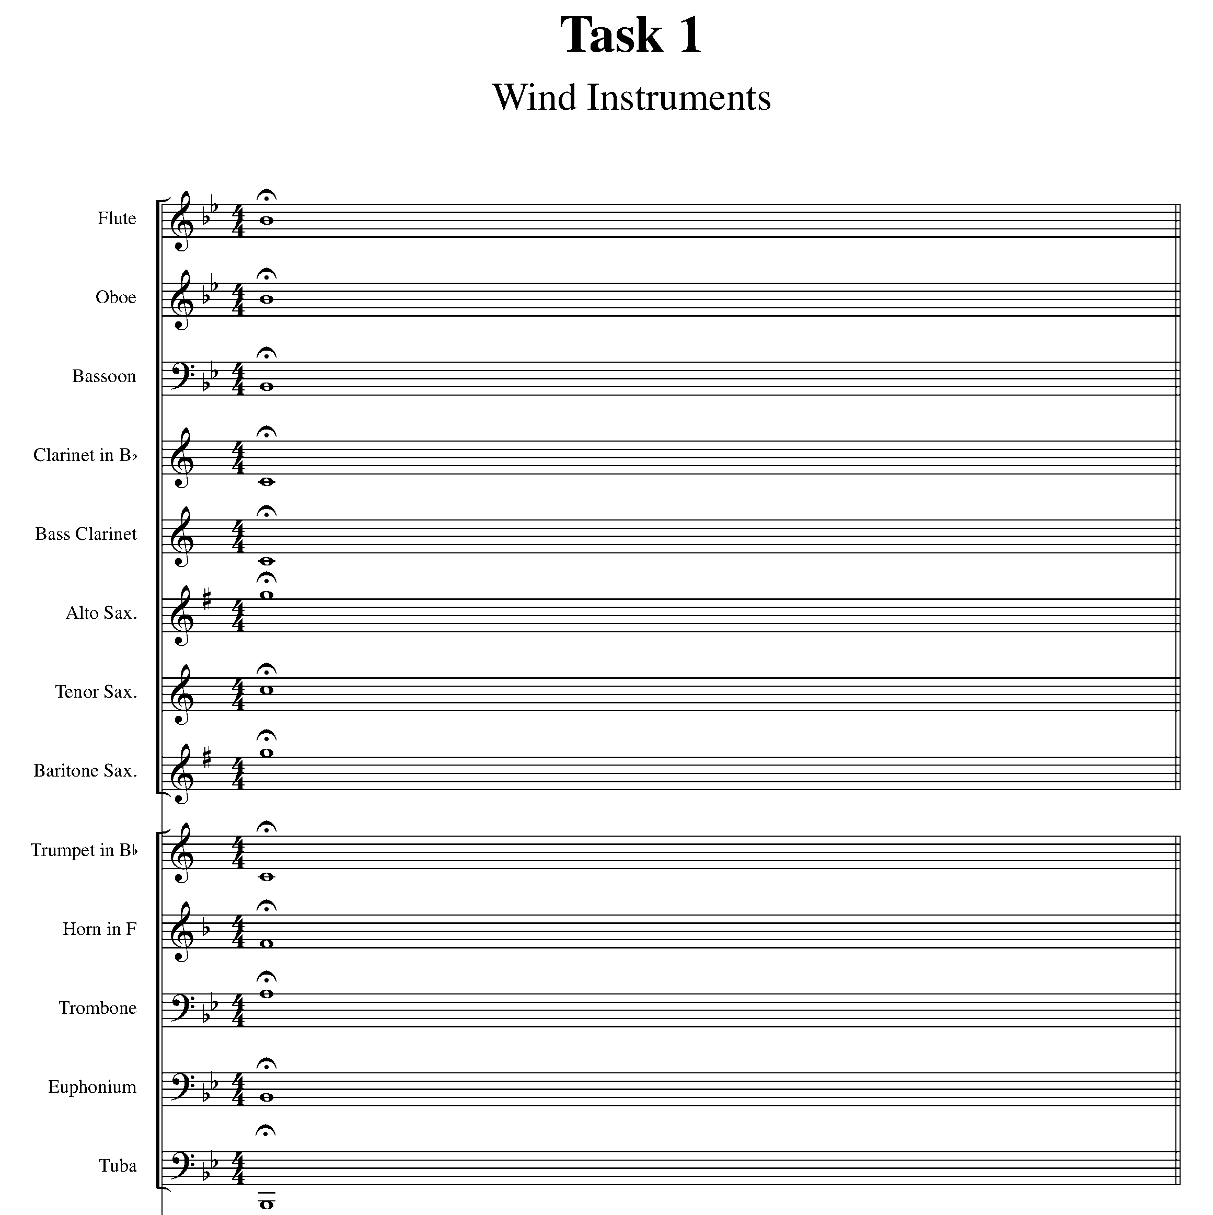
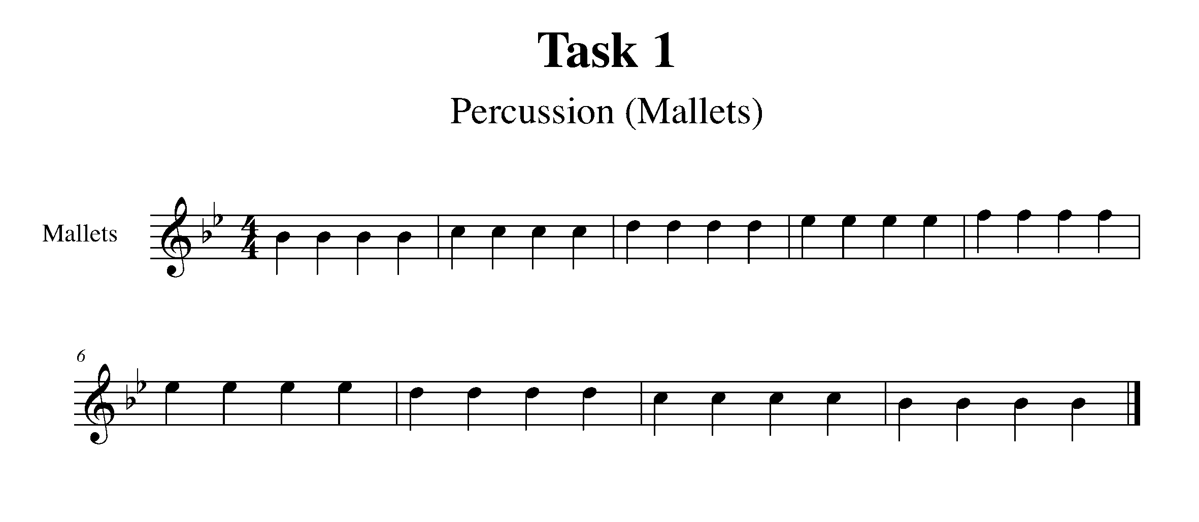
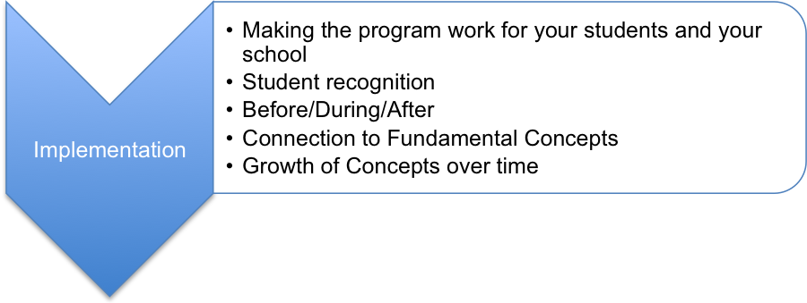

Making the program work for your students and your school!

Teachers will need to consider:

- repertoire…teachers need to decide if the performance examples are suitable for their students, will be of interest for their students, and if students are ready for these tasks;
- teachers will need to look at the tasks to determine what skills students will need to learn before starting this program, or do diagnostics to determine the areas of student need;
- depending upon prior knowledge….teachers may not be able to start this program until late fall….especially with an instrumental program where students need to be set up, routines need to be established etc.; and
- how they might modify the program to meet the needs of their classroom and their students (e.g. some tasks might be broken down into separate tasks to help scaffold the learning for students).

For teachers using the GPS Band Tasks:
- feel free to take out the band parts that don’t apply to your class to save paper when printing the student booklets;
- you could extract the individual parts from and create instrument packs to individualize the instrumentation; and
- you might want to encourage students to highlight their instrument’s part to help student that might get confused with all of the band parts listed, or tasks where the score is provided.

For teachers using the GPS String Tasks:
- you might want to encourage students to highlight their instrument’s part to help student that might get confused with all of the band parts listed, or tasks where the score is provided.

Home Page

If they are playing an instrument…consideration needs to be made for the following before the tasks can start:

- instrument selection;
- care and maintenance of…;
- instrument sign out…;
- classroom and instrument procedures to follow; and
- label parts of the instruments.

Hear about how the GPS will look from week to week by clicking here.

Student Recognition

The authors of these tasks have made a suggestion for how you might recognize students for their achievements throughout the school year:

Term 1 Midterm  September to Mid November | Term 1 Report Card  Late January to early February reflecting growth from September to Jan/Feb | Term 2 Check-in  Mid-April | Term 2 Report Card  reflecting growth from Jan/Feb to Mid June
North GPS Marker | East GPS Marker | South GPS Marker | West GPS Marker
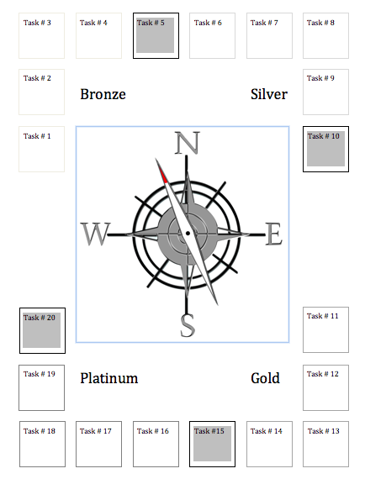
Students could be provided with a GPS Task Tracker sheet which the teacher will sign and date after each task is completed. This tracking sheet will be the student record of their work throughout the school year. The teacher will also need to note on a class list the date that the student has completed the task. These task trackers are included in the student booklets for Junior and Intermediate students.

Teachers may want to determine how students can “mark off” each section (N, E, S, W) to help students acknowledge completing each section. Students could colour in each quarter of the page as they complete their “Markers”. You can also leave it open to the students to “leave their mark”

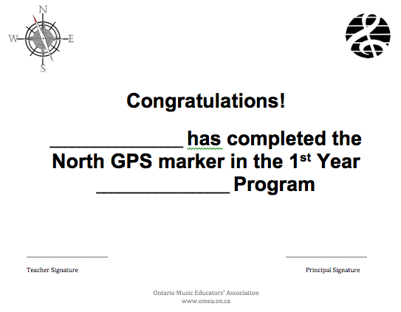
Once a student has completed up to the 4th task in the Junior GPS tasks or 5th task for the Intermediate tasks, students can receive a certificate acknowledging their accomplishments. This certificate could be signed by the music teacher and a school administrator. This certificate is included in the student booklets for Junior and Intermediate students.

Teacher Before/During/After

 | Program | Lesson
Before | Teacher will:  - read the “Teachers, before you copy this booklet for your students…” page  - start where you are (these are the guidelines)…what is your comfort level?  - read the program thinking about challenges students may have with the task, resources I will need, learning for myself  - try individual tasks to determine focus of learning  - determine what materials are needed?  - set up assessment check list  - print packages for distribution  - have a good idea of what it will “look like” in your classroom with your students  - parental awareness (monthly log/letter to parents)  - evaluation…do the suggested evaluation charts work for you and your students?  - length of reporting periods  - how are you going to recognize your students? | Teacher will:  - establish Learning Goals with students  - co-create Success Criteria for tasks with students  - be clear on what the techniques, skills and knowledge is required  - consider the task carefully and anticipate student needs  - schedule time to teach the task (whole group), have opportunities to work with students one-on-one and provide feedback to help the students move forward, and there must be time made in class, and outside of class or in other ways (such as e-mail) to allow students to demonstrate their learning
During | Teacher will:  - provide time  - reflect, refine, adapt teaching and learning  - make accommodations of time, extra feedback, adaptations for students who are struggling  - manage students who you’re not listening to  - “target” the student who seems to be getting behind | Teacher will:  - model (provide an exemplar)  - share musician thinking process (think aloud)….scaffold learning  - provide ongoing feedback relating to the Learning Goal  - make and record observations of students growth  - have and record conversations of student growth
After | Teacher will:  - reflect/refine tasks that were barriers for students  - determine how to challenge students who finish program early | Teacher will:  - reflect/refine  - give students continual support and multiple opportunities to demonstrate their learning

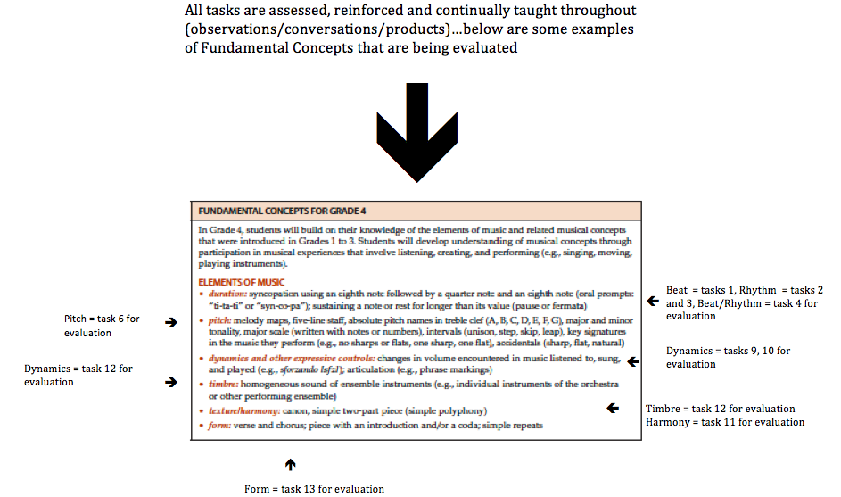
Connection to Fundamental Concepts

Hear about how this connects to the Fundamental Concepts by clicking here.

Growth of Fundamental Concepts Over Time

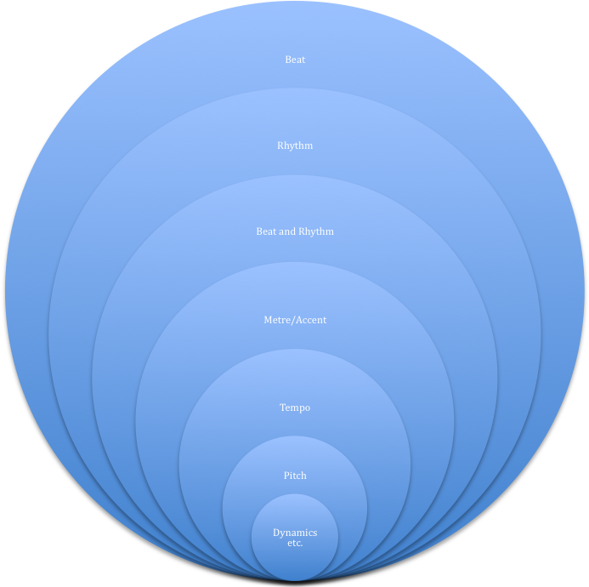

As students complete each task, they are consolidating their learning and building upon their previous knowledge. As students move throughout the year, teachers and students should be:

- constantly reviewing and re-applying learned concepts to each new task;
- reinforcing Fundamental Concepts on an ongoing basis throughout the year (i.e. pitch is not explicitly taught until task 7 in some GPS tasks, but should start at the beginning of the school year); and
- expanding on these Fundamental Concepts through other repertoire, or other OMEA lessons, or other resources and opportunities.

Students will take comfort in knowing that they have mastered a skill, and that they will be able to apply it in each upcoming GPS task. Teachers need to stay focused on the task that is being demonstrated and the concept on which is being focused, but also need to help students think as a “musician” making sure that they are considering all of the elements of music as they perform and demonstrate their understanding.

Home Page

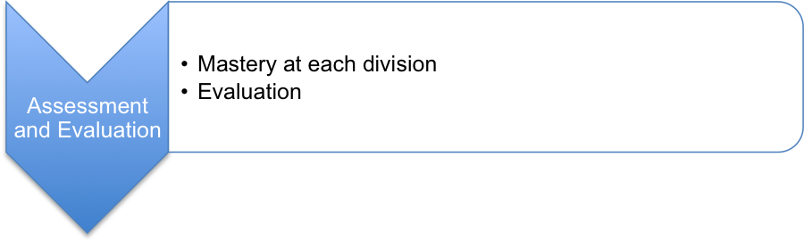

Mastery at each division

Even though these tasks are building upon skills and are outlined in this way…the skills should continue to be developed throughout the year through all performance tasks and in class learning (overall expectation is an end of year….). Mastery for each GPS task is equivalent to a level three or higher achievement in the provincial achievement chart.

Some things to consider:

- Tasks should be followed in order (flexibility needs to be demonstrated if a student is “stuck” and needs to move on to feel success knowing that they need to continue to work on the task, and demonstrate mastery at a later date);
- these tasks are carefully scaffolded so that skills are built upon as students move forward;
- students have a specific task that they will be taught, will have opportunities for practice and be provided feedback on, and will need to complete in order to move on to the next task (mastery);
- students must discuss the “How’s” and “What’s” of each of the skills that they need to accomplish when demonstrating; and
- students not successful on their first attempt will be given further opportunities to practice and improve their skills until mastery is attained.

Hear about how the GPS can engage your students by clicking here.

Evaluation

These performance tasks are a demonstration of the Fundamental Concepts for the grade. By guiding your students through this process, you are:

- differentiating the learning for your students;
- providing ongoing feedback to your students;
- receiving feedback from your students about their needs and your instructional next steps; and
- knowing your students better than you ever could know them….as learners!

Recommended number of tasks instructed per term

Overview of tasks by grade:

 | Grades | Term 1 (September to February) | Term 2 (February to June)
Primary | 1 | 1 to 6 | 4 – 13
 | 2 | 1 to 6 | 4 – 13
 | 3 | 1 to 6 | 4 – 13
Junior Vocal | 4 | 1 to 6 | 4 – 16
 | 5 | 1 to 8 | 6 – 16
 | 6 | 1 to 9 | 9 – 16
Intermediate | 7 | 1 – 10 | 7 – 20
Inst/Vocal | 8 | 1 – 12 | 10 – 20

Please note: The GPS Junior Recorder tasks can substitute vocal tasks or add to the GPS Junior Vocal tasks.

A few things to consider regarding evaluation:

- these tasks are just one part of your program;
- this program does not address all curriculum expectations…but in conjunction with other aspects of your program, and other curriculum links that you will be able to make to these tasks, you will be addressing many of the specific expectations to be able to evaluate a students’ understanding of the overall expectations;
- these tasks are the tools to achieve OE 1.0….the learning encompasses OE 2.0 and OE 3.0…through the learning, questioning and reflection you provide for your students in class;
- this is a guideline that you are encouraged to adapt;
- the GPS mark should be tied into all the assessment (observations) of student work; and
- this program will tell you a great deal about the social, emotional and academic learning of each student.

Tracking learning

Students:
- Having recorded the date of the GPS performance helps the teacher identify students who may need assistance or prompting to practice and play their next task.
- The teacher records the date of completion for tracking student progress and frequency of performance throughout the term or year.
Teachers:
- When a student has successfully finished a GPS task, the teacher initials the GPS Task Tracker.
- A class grid can be created where anecdotal comments can be made about where the student is successful and the students next steps
- Date that the task is completed should be completed on a class list template.

Primary Evaluation

In the primary music classroom, most of your assessment will be based upon the observations that you make during your music class during whole group instruction. Evaluation could take place by observing students during a whole group activity, or could take place in small groupings or in pairs if your students are able to manage these groupings without your direct supervision.

The GPS (Grade Performance Steps) – The Road to Musical Success! tasks in the Primary Division are different from what will be expected of students in the Junior and Intermediate programs. You will want to ensure that:

- tasks are introduced and taught sequentially;
- before you teach and move on to the next task that most (90%) of your students can demonstrate a strong understanding of the task;
- even though each task has a specific focus (e.g. GPS number one focuses on beat with your assessment and evaluation) you must be teaching other elements along the way and continually revisiting these concepts as the year progresses;
- skills are evaluated holistically (during task 3, a student may demonstrate a Task 6 skill); and
- you are not thinking of levels when you evaluate…your focus should be on providing differentiated approaches to help student be successful, until they are able to demonstrate mastery the task and feel success.

Term 1 Midterm  September to Mid November | Term 1 Report Card  Late January to early February reflecting growth from September to Jan/Feb | Term 2 Check-in  Mid-April | Term 2 Report Card  reflecting growth from Jan/Feb to Mid June
Tasks 1-4 | Tasks 4-8 | Tasks 7-10 | Tasks 9-13

Home Page

Primary/Junior Evaluation Sample:

 | Task 1  Beat | Task 2  Rhythm | Task 3  Metre | Task 4  Tempo | Task 5  Pitch | Task 6  Dynamics | Task 7  Tempo | Task 8  Timbre | Task 9  Phrase | Task 10  Phrase | Task II  Form | Task 12  Comp. | Task 13  Comp.
Sarah | D  M  E √ | D  M √  E | D  M √  E | D  M  E | D  M  E | D  M  E | D  M  E | D  M  E | D  M  E | D  M  E | D  M  E | D  M  E | D  M  E
Justina | D  M  E √ | D  M  E √ | D  M √  E | D  M  E | D  M  E √ | D  M  E | D  M  E | D  M  E | D  M  E | D  M  E | D  M  E | D  M  E | D  M  E
Jennifer | D  M  E √ | D  M √  E | D  M √  E | D  M  E | D  M  E | D  M  E √ | D  M  E | D  M  E | D  M  E | D  M  E | D  M  E | D  M  E | D  M  E
Lynnette | D  M √  E | D  M √  E | D  M √  E | D  M  E | D  M  E | D  M  E | D  M  E | D  M  E | D  M  E | D  M  E | D  M  E | D  M  E | D  M  E
Jim | D  M √  E | D  M √  E | D  M √  E | D  M  E √ | D  M  E √ | D  M  E | D  M  E | D  M  E | D  M  E | D  M  E | D  M  E | D  M  E | D  M  E
Kevin | D  M  E √ | D  M √  E | D  M √  E | D  M  E | D  M  E | D  M  E | D  M  E | D  M  E | D  M  E | D  M  E | D  M  E | D  M  E | D  M  E

Primary students will be evaluated using the following terms:

D = Developing
M = Meeting (is where you need to be)
E = Exceeding

A Primary Sample Evaluation:

When looking at the above chart, you, as the teacher, may have only taught up to task 3 by the end of mid-term 1. Students that have met the performance tasks up to task three, would receive a B (level 3..B-, B or B+). In your instructional time, you may have noticed that students were able to demonstrate skills of future tasks (e.g. pitch matching). Students should be recognized for the demonstration of this concept (e.g. Task 5), and, therefore, at the end of mid-term 1, may be considered having exceeded the required expectations and should receive an A-/A/A+.

Primary Junior Task Tracking Sheet

Home Page

Junior Evaluation

In the Junior classroom, it is suggested that Grade 4 and 5 be evaluated in the primary format. However, it is understood that in some cases that the intermediate format is necessary for grades 5/6, so we have provided a sample of what that would look like in the junior grades.

Tasks | Term 1 (September to February) | Term 2 (February to June)
1 | D+ | R
2 | C- | R
3 | C | R
4 | C+ | R
5 | B- | D-
6 (taught to) | B | D
7 | B+ | D+
8 | A- | C_
9 | A | C
10 | A+ | C+
11 |  | B-
12 (taught to) |  | B
13 |  | B+
14 |  | A-
15 |  | A
16 |  | A+

Intermediate Evaluation

The GPS (Grade Performance Steps) – The Road to Musical Success! you will want to ensure that:

- you modify the number of tasks based upon when students are able to start demonstrating their tasks (the chart below is assuming that this program starts in late October early November);
- the Year One, Two and Year Three Band tasks are for drum set and mallets and teachers can break them into concert snare and concert bass drum as they see fit; and
- Tasks 15 to 20 are to be extensions and culminating activities which encompass tasks 1 to 14. What you must teach are the 14 tasks by the end of the year.

Home Page

GPS Task Evaluation Chart
TEACHER REFERENCE
Year One, Two and Three Band and Strings

This is assuming that this program starts in the beginning of the school year.

Tasks | Term 1 (September to February) | Term 2 (February to June)
1 | 52 | 32 (R)
2 | 55 | 35 (R)
3 | 58 | 38(R)
4 | 62 | 42(R)
5 | 65 | 45(R)
6 | 68 | 48(R)
7 | 72 | 52
8( taught to) | 75 | 55
9 | 78 | 58
10 | 82 | 62
11 | 88 | 65
12 | 92 | 68
13 | 98 | 72
14 (taught to) | 100 | 75
15 |  | 78
16 |  | 82
17 |  | 88
18 |  | 92
19 |  | 98
20 |  | 100

Hear about how student performance is tracked by clicking here.

Hear about how students know what quality work sounds like and how they can improve by clicking here.

Many questions that you may have about evaluating your intermediate students can be answered by reading the FAQ’s at the end of this document

Home Page

Junior and Intermediate Recorder tasks

These recorder tasks have been designed to work alongside the junior vocal GPS program. Each task is connected to the Fundamental Concepts for each grade and the Grade 4, 5 and 6 vocal tasks. They can be completed alongside the vocal tasks or they can be completed separately. The order of these tasks is based on new notes and the difficulty level for the recorder. They are best completed with students once they have been introduced to the new notes for each task and have had time to practice playing them.

There are thirty recorder tasks in total that have been separated up in two different ways, one for junior and one for intermediate.

Junior Recorder Tasks:

There are ten tasks per junior grade with two tasks at the beginning of each year reinforcing basic playing skills, beat and rhythm and two tasks at the end of each year that are extensions and introducing new notes and concepts for the next year. Grade 4 works mainly in the G major pentatonic scale. Grade 5 introduces F# and C major scale. Grade 6 continues the work from Grade 4 and 5 adding B-flat and the natural E minor scale along with more complex rhythms. This set up allows the teacher to introduce the recorder tasks alongside the vocal program tasks, however, due to the new notes being introduced on the recorder, the songs for the recorder are not always in the same order as the vocal tasks. Please look at both sets of tasks before starting your program to help coordinate the tasks for the students.

This is the assessment if done in the junior grades.

Tasks | Term 1 (September to February) | Term 2 (February to June)
1 | C- | R
2 | C | R
3 | B- | C-
4(taught to) | B | C
5 | B+ | C+
6 | A- | B-
7 | A | B
8(taught to) | A+ | B+
9 |  | A
10 |  | A+

Home Page
Intermediate Recorder Tasks:

The same thirty tasks have been set up into the Intermediate Recorder Year One and Year Two; they are set up differently with the first two tasks from Grade 6 placed at the beginning of Year Two and the task separation occurring in the middle of the Grade 5 tasks.

Each task is set up to build skill level and introduces elements with increasing levels of difficulty just as in the band and strings program.
This is the assessment if done as a Year One and Year Two Intermediate Recorder programs.

Tasks | Term 1 (September to February) | Term 2 (February to June)
1 | 55 | 38 (R)
2 | 58 | 42 (R)
3 | 62 | 45(R)
4 | 65 | 48(R)
5 | 68 | 52
6( taught to) | 75 | 55
7 | 78 | 58
8 | 82 | 62
9 | 88 | 65
10 | 92 | 68
11 | 98 | 72
12(taught to) | 100 | 75
13 |  | 82
14 |  | 92
15 |  | 100

Intermediate Vocal Evaluation

The Grade Seven and Eight GPS Tasks were created in response to The Ontario Curriculum, Grade 1-8: The Arts (2009). Along with performing and creating music, the expectations for both grades “encourage students to explore issues related to personal identity and community concerns as they interact with the increasingly complex and/or challenging media” (p.131).

Students do this by examining the music to which they listen. The GPS Tasks ask students to create playlists of songs that are of interest to them. These songs are then analyzed, using criteria that includes Daniel Levitin’s (2008) theory that all songs can be sorted into six basic categories of songs: Friendship, Joy, Comfort, Knowledge, Religion, and Love. For more information on Dr. Levitin’s research read his book: The World in Six Songs: How the Musical Brain Created Human Nature (see references) and visit http://www.sixsongs.net/

Please read the first few pages of the tasks and also each task before starting them with your class. Students will need your guidance and specific teaching in order to be successful. They will also need to have access to some technology and examples of music. Please read through and adjust the tasks to suit the level of support that your school is able to provide.

In the Grade Seven GPS Tasks, students are asked to “examine the role of music in their lives, as well as the ways in which music has changed in response to a variety of historical, cultural and other influences” (Ontario Ministry of Education, 2009, p. 133).

In the Grade Eight GPS Tasks, students are asked to expand the range of songs on their playlist and to examine the roles that music can play in social and political issues, starting with the importance of national anthems.

In all tasks, encourage students to be aware of vocal hygiene, i.e., how to sing well promoting good and effective vocal health. For more information visit:

http://therapylibrary.com/Therapy.aspx?ArticleID=146

http://singoutloud.com.au/tips/vocal-hygiene/

http://www.vocalist.org.uk/singing_exercises.html

FOCUS WORDS:

There are terms beside each task to help students focus their learning:

- PERSONAL RESPONSE. Students are to add songs to their playlist and work with personal choices.
- ANALYSIS OF INFLUENCES. When students are analyzing their music, one of the aspects in which they will be involved is looking at the underlying factors.
- EXPRESSIVE ELEMENTS, TIMBRE, RHYTHM, BEAT, ETC. In the intermediate grades, the fundamental concepts require examining and applying these elements to the repertoire that they will perform. When they are examining the fundamental concepts of music, the element on which is being focused is identified.
- ELEMENTS. This term is used when it is expected that students will examine a number of musical elements.
- VOCAL. Students are to sing with an emphasis upon the expressive elements of music.
- ANALYSIS OF ELEMENTS. Students are to analyze specific musical elements and this task coincides with the overall expectation C2 and The Critical Analysis Process (The Revised Arts Curriculum, 2009, pp. 23-28).
- COMPARE AND CONTRAST. Students are to compare and contrast two different songs in terms of a variety of purposes, and musical elements, as per the expectations stated in each task.
- COMPOSING. Students are to write their own lyrics, and compose their own melodies if they have the ability to do so.
- CRITICAL ANALYSIS. Students will be involved in a culminating activity that requires them to use the full critical analysis process with regard to their own work.
To help you prepare and understand what is needed for some tasks, we have included a list of possible materials needed and samples where possible, as well as explanatory notes in a pause and ponder section.

The intention is to teach two tasks per month. By February, you will have covered
9-10 tasks. The quality of each task is as important as the quantity of tasks; therefore, the marking system allows for the use of a rubric to assess the students. The chart below, suggests a range of percentage marks that can be used in conjunction with the vocal rubric.
Tasks 19 to 20 serve as extensions and culminating activities which encompass the concepts learned or introduced in Tasks 1 to 18. What you should teach are the 18 tasks by the end of the year.

You can modify the number of tasks based upon when students are able to start demonstrating their tasks (The chart below is assuming that this program starts in September).

Home Page

GPS Task Evaluation Chart
TEACHER REFERENCE
Grade Seven & Eight Vocal

This is assuming that this program starts in the beginning of the school year.

Tasks  (Completion of “X” task number equals “Y” %) | Term 1 (September to February) | Term 2 (February to June)
1 | 48%(R) | 25%(R)
2 | 52% | 28%(R)
3 | 55% | 32%(R)
4 | 58% | 35%(R)
5 | 62% | 38%(R)
6 | 65% | 42%(R)
7 | 68% | 45%(R)
8 | 68 -72% | 48%(R)
9 (taught to) | 72-75% | 52%
10 | 75-78% | 55%
11 | 75% or higher | 58%
12 | 80% or higher | 62%
13 | 90% or higher | 65%
14 |  | 68%
15 |  | 68 -72%
16 |  | 72-75%
17 |  | 75-78%
18 (taught to) |  | 75% or higher
19 |  | 80% or higher
20 |  | 90% or higher

Home Page

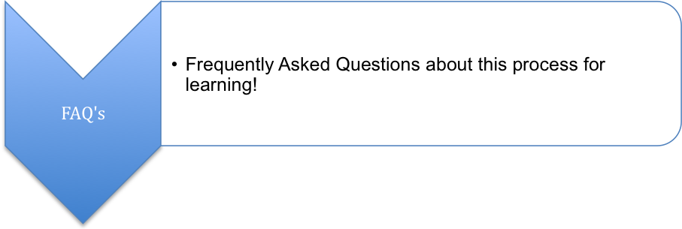

FAQ’s

1. What do you do with students who finish the program early…supplement, extension program, solos, ensemble work (something additional)

Having spent time working through the program, you can easily create additional tasks that will support the learning of your students that have completed the program. Students who have completed the program would also benefit from working on and performing solos with piano accompaniment or working in small ensembles.

2. How much of my program does this count towards?

Remember that the GPS are just one part of your balanced program, but should represent a good portion of the performance aspect of your program. You will also want to teach theory concepts that will support your students with their GPS tasks, and do creative work (e.g. composition) and listening that can support the work you and your students are doing with the GPS, or this might be separate.

It really depends upon how much time you allocate to the GPS and performance in your program. This ratio also may chance depending on what you are able to accomplish given the amount of time you have with your students, and which term you are thinking about. Your program might be organized like this:

60% Performance (GPS, small ensemble etc.)
20% Creative Work (composition assignment)
20% Theory and Listening

3. Where does the critical and creative process fit in?

The Creative and Critical processes are closely linked. If these tasks are addressing the Fundamental Concepts for each grade, you will find that these tasks are addressing specific expectations which relate to overall expectations (which should be demonstrated by the end of the year).

The Creative Process (http://www.edu.gov.on.ca/eng/curriculum/elementary/arts18b09curr.pdf )is addressed through overall expectation 1 (C1. Creating and Performing: apply the creative process (see pages 19–22) to create and perform music for a variety of purposes, using the elements and techniques of music). As GPS tasks are introduced, students should be guided through the stages of The Creative Process and consider what they should be considering at each stage (P. 21 and 22).

The Critical Analysis Process (http://www.edu.gov.on.ca/eng/curriculum/elementary/arts18b09curr.pdf )can be incorporated into the questions that are asked of students when they perform their GPS tasks.

4. How much time does it take to make this effective?

The more time that is made available to students to be able to learn, practice and refine their work, the more success students will experience. Some classes will be used to teach the concept to the whole class, others will be used for a quick review then time to practice and demonstrate. Others will be dedicated for students to provided feedback to one another while the teacher listens to students demonstrate their tasks.

Most schools that have implemented such a program, also offer students alternative times to demonstrate their learning. Scheduled recess and lunch times work well, as well as after school sessions help students consolidate their learning and have alternatives to performing during class time.

As this program requires students to demonstrate mastery of a task before moving on, this takes time. What students need from you is effective descriptive feedback relating to the task they are working on, and time to be able to demonstrate their understanding.

5. What happens if a student gets 100%?

“Students can reach any target they know about and that holds still for them.”(Stiggins, 2005). If you outline for students what they need to do to be successful, and you give them the time and support to be successful, 100% should be the one of the targets that holds still for your students.

Generally students that achieve 100% in the GPS portion of your program, are students that will be successful in other aspects of your program (it’s all connected). These are often students who are taking music lessons outside of

Home Page
school, and have a great deal of background knowledge that they bring to these
tasks. These also might be your students that are “musically intelligent” and are able to feel success in music.

It is best that you have a conversation with your administration about the program, and explain that 100% is possible (and explain why). There would be nothing more unfair to students than to find out when you submit your marks to the office that a student who has worked for 100% is not able to receive this mark because it is no permitted by the school. It’s best to be upfront with your administration and your students before starting the program about what is possible!

6. What happens if a student gets stuck?

We all have times where we get “stuck” with our learning, and need to step away from something, give it time, and return to it with a fresh outlook. This will happen to your students with some of these tasks.

If a student has made several genuine attempts to demonstrate mastery of a task, and they have not been able to achieve a level three, ask the student to move on noting that they will need to complete the task by the end of the term, and that you will be coming back to them on a regular basis to “check-in” with them about their progress.

During their attempts, they have probably learned enough to be able to apply their learning to the next GPS example and achieve success. If a large number of students are getting stuck on a task, it might be the task that is too difficult. If so, there is no problem in selecting a different example to play, or giving students options…or not even counting that task. It’s all about being flexible and fair!

7. How many times can a student demonstrate a task?

As many times as it takes! You will find that some students try to perform tasks for you minutes after you have provided them with feedback for improvement. You can explain to them that the changes that they need to make will take days, not minutes, and they would be best to demonstrate the task (if they really believe that they are ready), at the beginning of the next class.

You do need to be aware of students who are getting frustrated with the task. Doing the task too many times can also be detrimental to the students. If you feel that the student is close (it may not be what you would expect for that student), but they understand the concept, you might modify your expectations for that task, and that student, to help them move on.

8. How can I track my formative assessment?

For students that do not achieve the task when they perform for you, or are simply looking for feedback, it is best to make a note of what the student was able to do, and what their challenge was to help when you return to that student. You know where you left off, and what the feedback was that you offered.
This could simply be a class list with columns of the dates that you are listening
to GPS tasks, and the comment could be written into your mark book. Also, students could be given cards, the feedback noted on their card, and used as a starting point for conversation between teacher and student for the next opportunity.

9. Can a student skip a task?

This relates to question No. 6.

10. Trying to hear every student individually is taking a lot of time.....can I evaluate some tasks in groups?

There are some tasks that could be evaluated in small groups. These would be tasks where student understanding is observable, or where the performance of each student can be audible. If there is a task where students are playing in duets or trios, students can be evaluated based upon the role that they are performing within that group.

11. A student is not buying into the process....how can I engage them?

For students that get off to a slow start, or who are not buying into the GPS tasks, you will want to make modifications to the program to help them experience success (“play the first 2 bars”, “show me that you know what a slur is, and you can move on to the next task” etc..). Once students are able to experience success, they are more likely to engage in the process.

12. Student only wants to play the task but can 't explain what they are
doing and why they are doing it?

Even though you may have taught the GPS concept in class, modeled your thinking about how to approach learning this task, provided an example of what it will sound like by playing it or having it played by an advanced student, some students will say that they are ready to perform #6, but not take the time to re-read and understand the essence of what they are learning.

For most students, you would ask them to read through the task, ask a partner question for clarification, and ask to perform the task again at a later date when they can articulate what they are performing, and why they are performing it.
The what and why of the learning is important…it helps them understand the application of the skills being taught, and will help them apply these skills to new situations in the future.

13. There seems to be a big gap on my class in terms of the number of
tasks completed, what can I do to close the gap?

You could:

- work with groupings of students on their individual needs (High, Medium, Low = differentiating their instruction);
- pair students up and give opportunities for peer coaching; or
- modify some of the tasks to help the low group move forward, provide challenges within the tasks for the higher group.

14. All students seem to be having a challenge with one task, what do I do?

- Is there key learning that needs to happen before students are asked to perform this task?
- Simplify the performance example (choose a more simple example to perform that would demonstrate the same skill);
- Change the task; or
- Don’t count the task…let students move on.

15. Teaching the tasks to the point that most students can do the tasks independently is taking much longer than I thought…what do I do?

You will not necessarily be able to teach a task or offer enough time in class for all students to be able to demonstrate tasks all at the same time. You will want to review examples that have been taught whole class as much as possible, but you will need to move on.

This is a matter of readiness. Some students will be at a point with their learning that they will be able to demonstrate a task introduced in class soon after; However, for others, it may take more time to consolidate their learning with that task. This is the wonderful thing about this program; it provides students an opportunity to learn the task together, have your support, but allows them time to be able to learn the task on their own terms, at their own pace, and demonstrate the task when they are comfortable.

16. When do I hand out the program to students?

For students in Junior and Intermediate classrooms that are starting instruments, you will probably be able to hand out the GPS tasks in late October or early November. You will need time to establish classroom routines, give students an opportunity to learn about the instruments, or have time to experiment with the instruments. If you have a group of students that is doing this program for the 2nd year, you could hand out the GPS tasks on the first day of school. Having experienced the program and how it works, they will want to get started, and you will have a good sense of where they left off with the program from the year before and know their strengths and starting points as learners.

17. How much should I modify the program to accommodate the needs of my students?

Hear about the GPS can be modified to meet the needs of her students by clicking here.

18. It just does not seem to be working for my students and I, what do I do?

Persevere...it takes time. This program will be quite different for many teachers, and students who are comfortable learning music or instrumental music in a certain way. From our experience, there have been programs that have struggled with the implementation of this program for several years before realizing its full potential.

In many ways, it’s about finding balance. The balance of determining:

- how much time is required to make the process meaningful;
- how much modification of the performance examples to meet the needs of my students;
- how much assessment for learning (feedback etc.) is happening vs. assessment of learning, evaluation (there is far more assessment for learning than assessment of learning in this framework);
- how to give responsibility of the learning to my students; and
- the effect that these tasks will have in the long term on the performing abilities of my students and their enjoyment.

19. I have a new student in my class in March with no instrumental music experience, what do I do?

This is the advantage of these GPS tasks. This student could be given the 1st year program (or a modified Junior task book) that the student could work through with a student ambassador (who is ahead of the class with their tasks) that could help the student get started and could work at his/her own pace.

20. A student wants to give up, what do I do?

The key to this question is to modify the tasks so that the student will experience success. See question no. 6.

Home Page
21. How does this program work for my special education and ELL students?

Students work at their own pace. Students also have the tasks written for them in student friendly language that will be accessible (or could be easily translated). Students are also having multiple ways of learning demonstrated to them:

- orally (teacher instruction, teacher feedback, student feedback);
- aurally (examples played in class, hearing other students perform tasks, examples online that can be played as MP3’s); and/or
- written (GPS book, demonstrations on the board).

Different modes of delivery are very helpful for our special education and ELL learners. These students could also be paired with students in your class that can support them through the process.

22. How much time should be dedicated each class?

A few examples:
Class 1 | GPS task 3 | Whole class (reading through example, trying example, think aloud from teacher about how the example could be practiced etc..) with some practice time, and a whole class performance at the end of class.
Class 2 | GPS task 3 | Whole class review, teacher moves around room listening to students perform and provides feedback, a few students perform for the whole class who feel that they are ready (student hear what the process will be like, and the type of feedback they will receive).
Class 3 | GPS task 3 | Students practice (teacher circulates and evaluates students who are ready to demonstrate their GPS).
Class 4 |  | Theory and listening based upon GPS 3.
Class 5 | GPS task 3 review and introduce GPS task 4 | Students perform task that are ready for whole class, introduce GPS task 4 Whole class (reading through example, trying example, think aloud from teacher about how the example could be practiced etc..) with some practice time.

Hear about how the GPS will look from week to week by clicking here.

Home Page

23. Can students evaluate each other?

Students can provide feedback to each other, and can act as the teacher and model the process of asking questions about the task, listening to the task, and providing feedback.

Initially, the teacher should be the only one that evaluates (determines if a student has achieved mastery). Once students are in their 2nd or 3rd year of this program, they will find that they have a strong sense of what mastery is, and could be provided opportunities to recommend a student for a GPS task to the teacher.

You would not want to loose the opportunity as a teacher to hear your student perform and demonstrate their knowledge as you are the one who needs to provide a report card mark at the end of the term.

24. Where does a method book fit into this program?

You may choose to have students perform examples from a method book that demonstrate the Fundamental Concepts. Most of the examples that you will see in this program are Public Domain melodies that method books already use. You are welcome to change the performance examples to meet the needs to your program!

25. Can I make ensemble repertoire or small ensembles part of this program?

The challenge with ensemble repertoire is that not all parts are the same. If you look at a flute part compared to a Tuba part in most band pieces, those two parts are usually not the same level of challenge. You will find that students that work through this program will be well prepared to manage any challenge that may appear in ensemble repertoire (as they have a good grasp of the Fundamental Concepts for that grade with this process).

Duets work well, but trios or quartets become a challenge. You want to make sure that there is accountability within the performance, and that you can provide meaningful feedback to your students. The larger the ensemble, the greater the challenge will be for the teacher with evaluating their playing ability and understanding of the concept unless you hear them play individually.

26. I just don't feel (with the number of classes and students that I have) that I have enough time to listen to students individually?

This is always a challenge, but if you divide your class up into sections (or into 3rds) and focus on one group each class, you have a good chance of being able to provide meaningful feedback for that group of students on a regular basis.
28. Can this program be adapted?

If you have a vocal program and would like to adapt it for your school, please go ahead! You need to have a general knowledge of the skills that you would like to see developed in your students, and the tasks that you could ask students to do to demonstrate their understanding. The sky is the limit!

29. There are too many tasks for my students, what do I do?

Reduce the number. You want to make sure that students can have enough time and experience that would allow them to complete the program. If this is not possible given the amount of time you have with your students, and the amount of extra time that you can offer outside of class time to have them practice and perform, you will need to change the number of tasks to meet the needs of you and your students.

30. I have students who can't stay after school to practice and perform;
what do I do?

If students use their class time wisely, practice between classes, and are ready to perform in class when the opportunity arises, they should be able to complete the program during class time.

31. My administrator is unsure about the benefits of the program and is
unsure about how to respond to parent questions; what do I do?

Make arrangements to sit down with your administrator at the beginning of the school year to outline the program, how it fits into your long range plans, how you are providing specific feedback to students, how they are being evaluated etc…so that they are clear on what the program is, and what is has to offer your students and your school.

32. I have students who are so advanced that they are way ahead and don’t want to be in class while I’m teaching a particular task. What do I do with these students?

For students that have been taking private lessons and have a wealth of background knowledge that they are bringing to learning a new instrument, they will quickly learn the tasks and move through the GPS program quickly (regardless of the challenges you provide for them during their learning).

Home Page

These students could be challenged in a number of ways:

- work independently to prepare solo repertoire that they perform at school concerts and for other classes in your school;
- work on small ensemble material with students that are at the same level; or
- change their instrument to provide them with a challenge to apply their skills to a new and different instrument.

33. What do I do with students who take advantage of the “differentiated instruction” concept?

The only choice that students have about the task is when they perform it for you. It is your responsibility as the teacher to “check in” with those students who are being reluctant, and to encourage them to move forward in their learning. Ultimately, it is the responsibility of the student to invest in their learning.

You may need to contact the parents to explain that the student is being reluctant, and that he/she will need parent support at home, and possibly extra support at school, to move forward with their learning.

File Summary

Below are links to the GPS tasks and supporting documents:

Primary

Grade 1 Grade 1 GPS Tasks Grade 1 Tracking Sheet

Grade 2 Grade 2 GPS Tasks Grade 2 Tracking Sheet

Grade 3 Grade 3 GPS Tasks Grade 3 Tracking Sheet

Junior

Grade 4 Grade 4 GPS Tasks Grade 4 Teacher Pause and Ponder
Grade 5 Grade 5 GPS Tasks Grade 5 Teacher Pause and Ponder
Grade 6 Grade 6 GPS Task
Sample Junior Tracking Sheet

Junior Recorder

Grade 4 Grade 4 GPS Recorder Tasks

Grade 5 Grade 5 GPS Recorder Tasks

Grade 6 Grade 6 GPS Recorder Tasks

Home Page

Intermediate Band

Year 1 Year 1 GPS Band
Year 2 Year 2 GPS Band
Year 3 Year 3 GPS Band

Intermediate Strings

Year 1 Year 1 GPS Strings
Year 2 Year 2 GPS Strings
Year 3 Year 3 GPS Strings

Intermediate Vocal

Grade 7 Grade 7 GPS Vocal Year 1 Pause and Ponder

Grade 8 Grade 8 GPS Vocal Year 2 Pause and Ponder

Intermediate Recorder

Year 1 Year 1 GPS Recorder

Year 2 Year 2 GPS Recorder

Summary of Video Clips

Clip 1 – How this program is different! GPS Video 1
Clip 2 – Differentiating Content GPS Video 2
Clip 3 – Differentiating Process GPS Video 3
Clip 4 – Differentiating Product GPS Video 4
Clip 5 – Considering Learning Styles GPS Video 5
Clip 6 – Feedback GPS Video 6
Clip 7 – Assessment driving instruction GPS Video 7
Clip 8 – Week to week GPS Video 8
Clip 9 – Fundamental Concepts GPS Video 9
Clip 10 – Engagement GPS Video 10
Clip 11 – Tracking student progress GPS Video 11
Clip 12 – What quality work sounds like GPS Video 12
Clip 13 – Modifying the GPS GPS Video 13

Home Page
The following video clips will highlight what these tasks will look like. The Task Chart Grades 1-8 has these tasks highlighted to note that there are video clips available to support the teacher.

Grade 1 Video Samples | Grade 2 Video Samples
Grade 1 Task 3  Grade 1 Task 5  Grade 1 Task 9  Grade 1 Task 10 | Grade 2 Task 2  Grade 2 Task 4  Grade 2 Task 7  Grade 2 Task 9
Grade 3 Video Samples | Grade 4 Video Samples
Grade 3 Task 1  Grade 3 Task 3  Grade 3 Task 4  Grade 3 Task 7 | Grades 4-6 Task 1  Grade 4 Task 8  Grade 4 Task 10
Grade 5 Video Samples | Grade 6 Video Samples
Grades 4-6 Task 1  Grade 5 Task 2  Grade 5 Task 3  Grade 5 Task 6 | Grades 4-6 Task 1Grade 6 Task 8  Grade 6 Task 16
Year 1 Band Video Samples | Year 2 Band Video Sample
Band Task 5  Band Task 9 | Band Task 12
Year 1 Strings Video Sample | Year 2 Strings Video Sample
Strings Task 14 | Strings Task 8  Strings Task 16

Summary of Audio and Finale Files

Finale Files (these can be modified, used to play exemplars of the scores in class, or used to create Mp3’s that students can use to practice along with at home):

Primary | Junior | Intermediate Band | Intermediate Strings
Grade 1 Audio Files | Grade 4 Finale Files | Yr. 1 Finale Files | Yr. 1 Finale Files
Task 1 “Johnny” | Task 5 | Task 1 Winds | Task 2
Task 1 “Pease” | Task 8 | Task 2 Winds and P | Task 4
Task 2 “Snail” | Task 9 “Down” | Task 3 W and P | Task 7
Task 4 “Engine” | Task 9 “Solfege” | Task 5 W and P | Task 8
Task 6 “Bell” | Task 12 | Task 6 W and P | Task 9
Task 7 “See” | Task 13 | Task 7 W and P | Task 10
Task 8 “Who’s” |  | Task 8 W and P | Task 11
Task 9 “Five” | Grade 5 Finale Files | Task 9 W and P | Task 13
Task 9 “Lucy" | Task 2 | Task 10 P | Task 14
Task 10 “Teddy” | Task 5 (6/8) | Task 10 W | Task 15
Task 10 “Bow Wow” | Task 5 (3/4) | Task 11 | Task 16
Task 11 “Who” | Task 9 | Task 13 W and P | Task 17
Task 12 “Miss” | Task 10 | Task 14 W and P | Yr. 2 Finale Files
Grade 2 Audio Files | Task 11 | Task 15 | Task 1
Task 1 “Mulberry” | Task 13 | Task 17 W and P | Task 2
Task 2 “Bow” | Grade 6 Finale Files | Yr. 2 Finale Files | Task 3
Task 3 “Snail” | Task 5 | Task 1 W and P | Task 4
Task 3 “Rain” | Task 7 | Task 2 W and P | Task 8
Task 5 “Ha, ha” | Task 8 “NM" | Task 3 W and P | Task 9
Task 6 “Once” | Task 8 | Task 4 W and P | Task 10
Task 6 “Autumn” | Task 9 | Task 5 Clap | Task 11
Task 7 “Elevator” | Task 10 | Task 6 W and P | Task 13
Task 8 “Frere” | Task 11 | Task 7 W and P | Task 14
Task 9 “Slithergadee” | Grade 4 Recorder | Task 8 W and P | Task 17
Task 9 “Starlight” | Task 3 | Task 9 W and P | Task 18
Task 10 “Rain” | Task 4 | Task 10 W and P | Yr. 3 Finale Files
Task 12 “Rocky” | Task 6 | Task 11 W and P | Task 1
Grade 3 Audio Files | Task 7 | Task 14A W and P | Task 2
Task 1 “Opasana” | Task 8 | Task 14B W and P | Task 4
Task 2 “Wind” | Task 9 | Task 15 W and P | Task 5
Task 7 “Jing” | Grade 5 Recorder | Task 17 W and P | Task 6 Bin. & Ter.
Task 10 “Kaeru” | Task 3 | Task 18 W and P | Task 8
Task 11 “Step” | Task 4 | Task 19 W and P | Task 9
Task 12 “Rocky” | Task 5 | Yr. 3 Finale Files | Task 11
 | Task 6 | Task 1 | Task 12
 | Task 7 | Task 2 | Task 13 Part I/Part II
 | Task 8 | Task 3 | Task 14
 | Grade 6 Recorder | Task 4 | Task 15
 | Task 3 | Task 5 | Task 16
 | Task 4 | Task 6 Bin. & Ter. | Task 17
 | Task 5 | Task 8 | Task 18
 | Task 6 | Task 9 | Task 19
 | Task 7 | Task 11 | Task 20
 | Task 8 | Task 12
 | Task 9 | Task 13
 |  | Task 14
 |  | Task 15
 |  | Task 16
 |  | Task 17
 |  | Task 18
 |  | Task 19
 |  | Task 20

