Teachers, before you copy this booklet for your students...
⬰ Have you read the GPS Overview? The GPS Overview provides guidance about how these Recorder tasks can support and enhance the Grade 8 Vocal GPS Tasks.
⬰ Have you taught these students before? If not, please take the time to work with your students to determine their strengths and needs before deciding which tasks will be appropriate..
⬰ Have you gone through the appropriate start up steps with your students? For example; the basics on putting together their instrument, care and maintenance of their instrument, posture and breathing.
⬰ If you have taught these students before...go through the entire program task-by-task to confirm that the sequence and challenge level of the tasks, is appropriate.
⬰ Refer to the Q and A section of the GPS Overview.
⬰ Do you need to reduce the number of tasks...how will you need to change the evaluation by term?
⬰ The Junior Recorder GPS task progression chart is available by clicking here. You can see how these tasks align and can support the Grade 8 Vocal GPS Tasks.

⬰ If you have questions, please contact:
Lynnette Charters: lcharters@rogers.com

GPS (Grade Performance Steps)

The Road to Musical Success!
Year Two Recorder Performance Tasks




Ontario Music Educators’ Association
www.omea.on.ca
Task # 2
Task # 1
Task # 3
Task # 5
Task # 6
Task # 7
Task # 10
Task # 9
Task # 11
Task # 14
Task # 13
Task # 15
Task # 4
Task # 8
Task #12

NORTH EAST
Recorder Tracking Sheet

WEST SOUTH

C D E F F# G

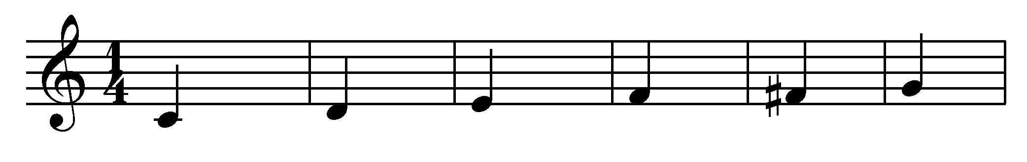
A B B^{à} C^{I} D^{I} E^{I **}

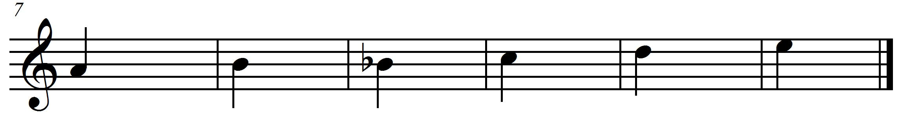
** E^{I} is played by covering only half of the thumbhole on the back.

Important steps to playing the recorder

- Blow lightly into the recorder.
- When you are practising, blowing lightly, if the sound isn’t coming out very well, blow a bit more, but never blow hard. Use a gentle stream of air at all times.
- Hold your recorder with your left hand at the top. Use your thumb to cover the back hole and your first three fingers to cover the top three holes on the recorder.
- Use your right hand at the bottom of the recorder. Use your thumb to hold the back and all four fingers to cover the bottom four holes on the recorder. Yes, you are covering two little holes with your third and fourth fingers at the bottom of the recorder.
- Keep your fingers flat when putting them across the holes.
- Cover the holes with the flat fleshy part of your fingers. Do not use your fingertips or air will leak out when you play.
- Press down on the holes firmly to seal up the holes.
- If the recorder is making a squeaking sound when you play, then you are either blowing too hard, or you are not covering the proper holes with the fleshy part of your fingers.
- Place the recorder on your lips not in your mouth. You will have better control over the sound that way.
- Use your tongue behind your teeth to make a “T” sound. This is called tonguing.
- Start each note by making the “T” sound at the beginning of your note. This is called tonguing your note.

1. KEEP THE BEAT! FOCUS: BEAT
NOTES: C, D, E, F, G, A, B, C^{I}

LEARNING GOAL: You will be keeping a steady beat while playing a long tone for 15 seconds.

MINDS ON! Every year we learn about beat. Beat is one of the basic components of music. It is a steady pulse that can be found in many musical forms. It is part of an element called duration. Being able to find the beat in a piece of music helps you perform that music and interpret it. Can you follow the beat and keep a steady pulse? Can you play one note for 15 beats without a breath? How long can you conserve your breath?
RECORDER ACTION! In order to be successful with this task, you will need to:
- Remember that for this activity, one beat will equal one second.
- Keep a steady beat by tapping your toe inside your shoe.
- Take in a deep (low) breath.
- Consistently let the air out in a steady but controlled stream.
- Keep a steady tone on the note B for as many seconds as you can.
- Refer to the “important steps” to making a good sound.
- Keep a steady tone on every note in the C major scale.
- When you able to hold a note for 15 seconds, go play for the teacher.
- It will be your teacher’s choice as to which notes you must play for this task.

CONSOLIDATION! In order to move on to the next task, you will need to show that you can keep a steady tone on a note in the C major scale. It is your teacher’s choice as to which note you will play so make sure you have practised all of the C major scale!

2. CREATE A RHYTHMIC COMPOSITION! FOCUS: RHYTHM
NOTES: C MAJOR SCALE

LEARNING GOAL: You will create a rhythmic composition and perform it.

MINDS ON! Rhythm is an aspect of the element called duration. It is similar to beat except that it is made up of patterns of long and short sounds and/or silences. It is different than beat because beat is made up of a steady repeated pulse. Rhythm changes everything up! Can you create a rhythm? Can a rhythm sometimes sound like the beat? What do you use to start and stop the sound on the recorder? How do you make long and short sounds and create silences when blowing through the recorder?
Try creating a rhythm with a friend and keep the pattern going for 30 seconds.

RECORDER ACTION! In order to be successful with this task, you will need to:
- Use your tongue to separate each note this will create the rhythm.
- Play the note B in quarter notes () for 8 beats. Repeat this with the notes A and G.
- Play the note C in eighth notes () for 8 beats. Repeat this with the notes D and E.
- When you are ready, use any notes you wish to create a pattern using quarter notes (),eighth notes () and sixteenth notes (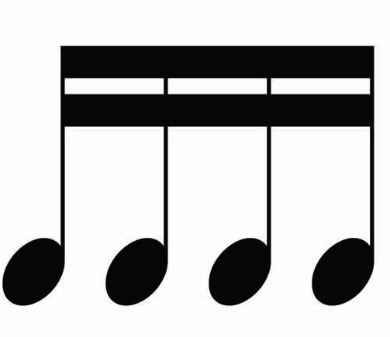) on any notes from the C major scale.
- Play your composition for a friend; ask them to clap a steady beat for you to help you practise.
- When you are ready, write down your composition on staff paper and play it for your teacher.

CONSOLIDATION! In order to move on to the next task, you will need to play your rhythmic composition for your teacher. Share your music you have written with your teacher. When you are done, complete the self-reflection below.
SELF-REFLECTION: What I found challenging about task two was...

3. WHAT MAKES A MELODY? FOCUS: PITCH/SYNCOPATION
NOTES: D, E, F#, G, A, B, D^{I}

LEARNING GOAL: You will be learning more about melody, syncopation and how the pitches move through time.

MINDS ON! What is a melody? What does it mean if the melody is syncopated? In a song, when the accented beat is not a strong beat, it creates syncopation. Can you hear the strong beat?
ACTION! In order to be successful with this task, you will need to:
- Look at the Recorder Fingering chart to make sure you know where your fingers need to go for this song.
- Practise playing “Bassez Down”.
- Play the entire song softly; watch your posture and how you blow through your instrument.
- Remember to tongue each note lightly especially when you are playing the eighth notes or sixteenth notes. Your tongue will need to move quickly to get the correct rhythm!
- D.C. al Fine means to go back to the beginning and play to the word Fine.
- Listen for the accented beats. There is some syncopation happening.

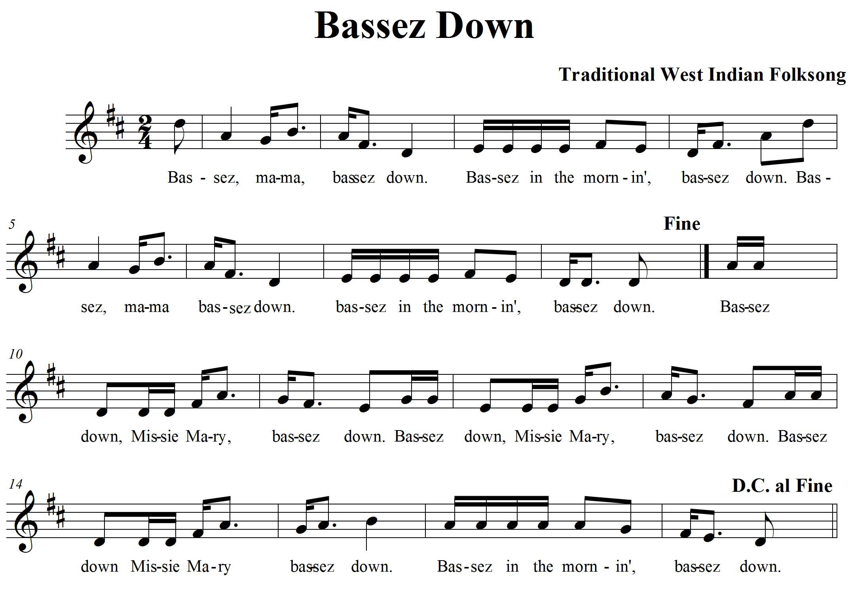

CONSOLIDATION! In order to move on to the next task, you will need to show that you can play “Bassez Down”. Keep the beat with your big toe and play with proper tonguing. Don’t forget to D.C. al Fine means to go back to the beginning and play to the word Fine.

4. LET’S PLAY THE SCALE IN A SONG! FOCUS: PITCH/REPEAT SIGN
NOTES: C, D, E, F, G, A, C^{I}, D^{I}, E^{I}

LEARNING GOAL: You will be playing a song that uses every note in the C major scale. You will be learning about repeat signs.

MINDS ON! Repeat signs help show us where notes are repeated and save on paper. Let’s learn how to read them! You know about the C major scale; now let’s have some fun playing a song with the notes from the scale. When you have repeats, how can you make the repeated section sound more interesting?
ACTION! In order to be successful with this task, you will need to:
- Learn to play “African Noel” with 90% accuracy.
- Watch the repeat signs; they are there to remind you to repeat the measures inside the repeat signs more than once.
- If there are no repeat signs, then only perform those measures once.
- Play each repeated section with different dynamics to bring more interest to your playing.
- There is a section in “African Noel” that isn’t repeated. Can you find the measures?
- Know the following rules for repeat signs:
  - If there is a repeat sign, then a section of the music is repeated.
  - If there is only a right repeat sign then go back to the beginning and repeat the music back to the repeat sign. 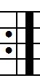 Then continue on...
  - If there are two repeat signs, one on the left and one on the right, then repeat the music inside the two signs. 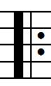

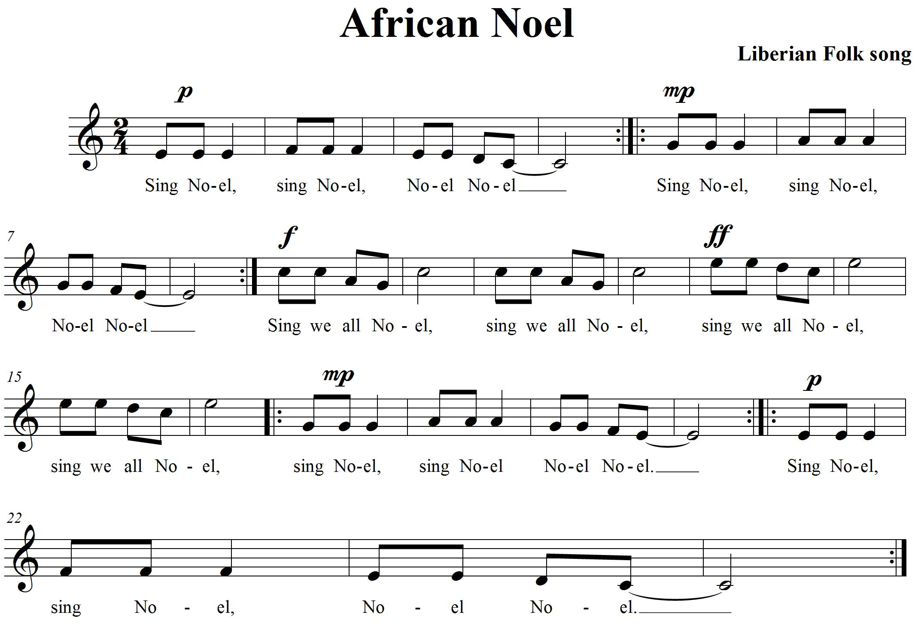

CONSOLIDATION! In order to move on to the next task, you will need to show that you can play “African Noel” while keeping a steady beat. Remember to play all the repeats in the song and then complete the self-reflection box below.

SELF-REFLECTION: What I think of my recorder playing... (explain your thinking with an example.)


Congratulations! You have reached your first GPS marker – NORTH!
Ask your teacher how you are to acknowledge this accomplishment on your GPS task tracker!
WAY TO GO!!

5. LET’S DUET! FOCUS: TEXTURE/HARMONY
NOTES: D, F#, G, A, B, C^{I}, D^{I}, E^{I}

LEARNING GOAL: You will demonstrate your understanding of pitch while playing “Alouette” with a steady beat. You will demonstrate the use of harmony to create texture.

MINDS ON! Texture in music can be created by adding instrumentation. Usually the sounds are not exactly the same so they create layers in the music that our ears are able to distinguish as different. Harmony is one way composers use to add more texture to music. Adding instrumentation is another way. Let’s learn a song that has a single line melody and create texture by adding instrumentation and harmony to it. Can you hear the difference between music that has one part and music that includes many parts?
RECORDER ACTION! In order to be successful with this task, you will need to:
- Learn either the first part (the melody) or the second part (the harmony) to “Alouette”.
- Practise playing “Alouette” on your recorder until you can play it smoothly with 90% accuracy.
- When you know how to play your part, match up with another student who can play the other part.
- Practise with your partner. Together you create harmony.
- Together with your partner, work out where you need to take a breath while playing this song.
- Keep the beat with your toe.
- Watch your repeat signs and play them with your partner.

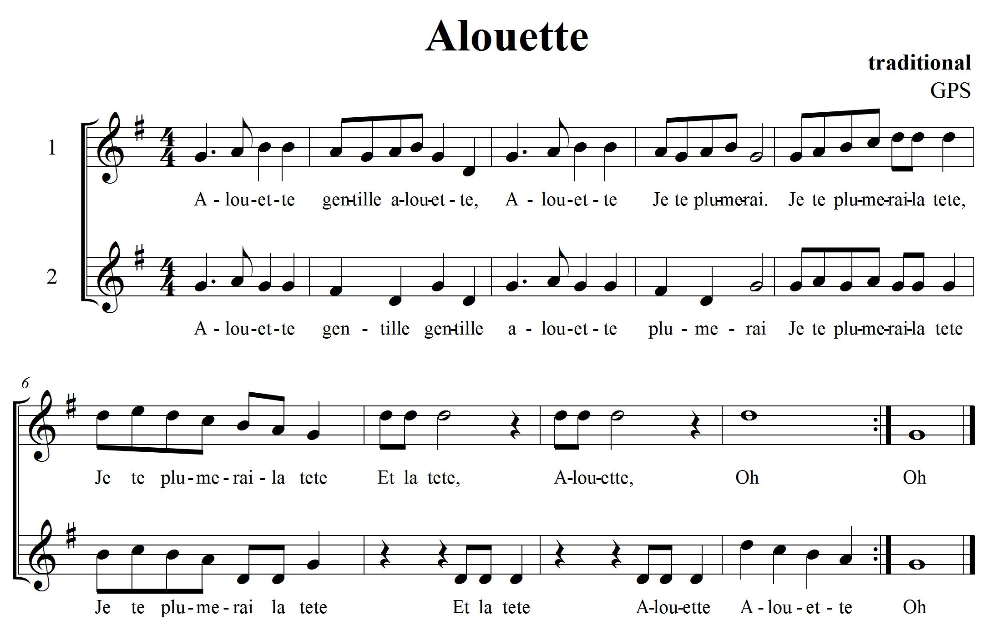

CONSOLIDATION! In order to move on to the next task, you will need to play “Alouette” with a partner for your teacher with accurate rhythm and a steady beat. Don’t forget to play with repeats.

6. MORE DYNAMICS FOCUS: DYNAMICS/EXPRESSIVE MARKINGS

LEARNING GOAL: Demonstrate dynamics in music that you are creating and learning.

MINDS ON! There are markings on standard notation that show us how loud or soft to play the music. There are also articulation markings that are added to tell us to play a note short or long. These are called staccato and tenuto. Look at different kinds of music. Look for the different expressive markings that can be found. Can you create a rhythmic composition that uses a variety of expressive markings?

ACTION! In order to be successful with this task, you will need to:
- Pick a song that you have learned from this year.
- Make some decisions on how you want to play it.
- Pick 2 different expressive markings that you would like to use in your performance (e.g. staccato, slur).
- Play your song piano then crescendo to forte.
- Practise playing your song with the expressive controls you have chosen to play.
CONSOLIDATION! In order to move on to the next task, you will need to show that you can perform a song while using two different expressive markings for your teacher. You should be able to articulate what the markings are and what they mean.

7. LET’S COMPOSE A PIECE OF RECORDER MUSIC FOCUS: COMPOSITION NOTES: D, E, F#, G, A, B, C

LEARNING GOAL: Create a piece of music 8 bars long using standard notation. Perform it for the class.

MINDS ON! We have been learning about music all year; we have looked at different pieces of music and now it’s time to put all that knowledge into creating our own piece of music that you get to perform for the class! What rhythms do you want to use? What kind of dynamics are you going to use to show contrasts? Do you have an idea for a how you want it to sound? Many composers have something that inspires them to write. What is your inspiration going to be? Think about the form your music is going to take... there is so much to think about! Let’s give composition a try!

RECORDER ACTION! In order to be successful with this task, you will need to:
- Take a look at The Creative Process chart in your class. This will help you focus your learning as you go through the steps of composition.
- Work with an elbow partner and brainstorm about what you want your composition to sound like.
- Use any of the notes D, E, F#, G, A, B and C on your recorder. If you want, you can add high or low notes, your choice.
- Use the notes and rhythms you know from your playing of the recorder. Use ta (, quarter notes), ti-ti (, eighth notes) and rests (). Start thinking about what you want it to sound like. Create rhythms and melodies using the notes above. Explore your ideas and experiment with them on your recorder. Play your ideas for a partner until you find something you both like.
- What form is your music going to take? How are you going to show the beginning, middle and end of your song? Try starting your composition and ending it on G or D.
- When you think you have a rhythm and melody that you like, think about the order and form you want your music to take. Start planning and focusing your thinking using the planning sheet. (see planning template with hearts below)
- Remember to ask for feedback from your peers and teacher as you work through this process. They will help give you ideas and open up new learning experiences for you as you are composing.
- Write down the rhythms you are going to use on the planning template underneath the beats shown. Remember each heart represents one beat.
- Once you have your rhythm worked out, add your melody by writing the letter names of the notes you want to use underneath your rhythm.
- Practise playing your composition with your partner until you can play it with a steady beat.
- When you think you have your preliminary work completed (that means your composition is pretty close to finished) then it is time to perform it for your class to get more feedback on how it sounds.
- Once you have performed think about the following questions and reflect on them, what did you like? What do you want to change? Now is your chance. Discuss the changes with your partner and change what you want, revise it and make it better!
- When you think you are ready, let your teacher know that you are now ready to present, perform, and share your composition with the class!

Composition Planning Template:
Place note names here
Place note names here
Place rhythm here
Place rhythm here
Place note names here
Place note names here
Place rhythm here
Place rhythm here

For task 7:
CONSOLIDATION! This is the last task! To accomplish it you must show that you can perform and share your recorder composition with the class. Write your composition down on the staff paper provided. When you are done, reflect and evaluate your learning. Write up a paragraph explaining the following:
- Do you like your composition?
- What would you change if you were to do this composition again?
- What were your challenges?
- What did you do that was lots of fun?
- What other GPS tasks helped prepare you for this one?

8. LET’S PUT IT TOGETHER! FOCUS: BEAT/RHYTHM/PICK-UP NOTES
NOTES: D, E, F#, A

LEARNING GOAL: Put the knowledge you have learned about beat, rhythm to work when playing pick-up notes. You will need to show both the beat and the rhythm of a song.

MINDS ON! You know about beat and rhythm as part of the element, duration. Last year, you started to learn about pick-up notes where the musical phrase starts on the last part of an unstressed beat leading us to a strong beat. Another name for pick-up notes is anacrusis. Can you keep the beat with your toe while playing the rhythm on your recorder?
ACTION! In order to be successful with this task, you will need to:
- Learn to play the song “John Kanakanaka” with 90% accuracy.
- Keep a steady beat by moving your toe inside your shoe.
- Look at your music below and highlight all the pick-up notes in this piece of music. You will need to share this with your teacher when you are consolidating this task.
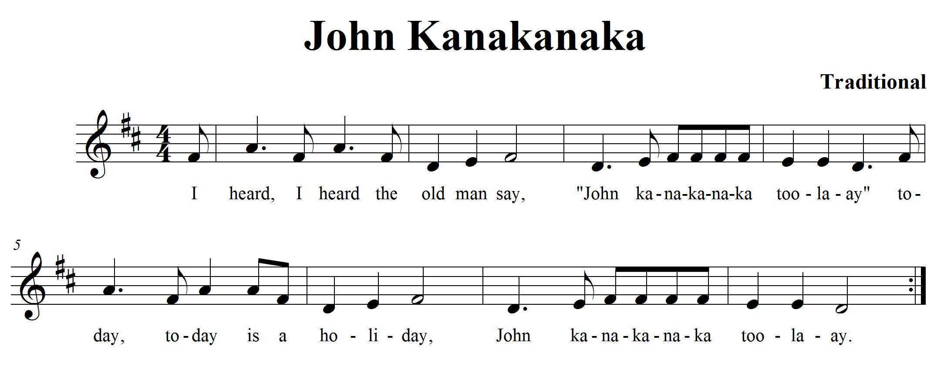

CONSOLIDATION! In order to move on to the next task, you will need to show that you can keep the beat in your toe while playing “John Kanakanaka”. Share your highlighted pick-up notes with your teacher.


Congratulations! You have reached your second GPS marker – EAST! Ask your teacher how you are to acknowledge this accomplishment on your GPS task tracker! WAY TO GO!!

9. E MINOR NATURAL SCALE FOCUS: PITCH
NOTES: E, F#, G, A, B, C^{I}, D^{I}, E^{I}

LEARNING GOAL: You will demonstrate how to play a minor scale in quarter notes.

MINDS ON! In music, there are always patterns that emerge. One type of pattern is the scale. This is a series of notes that move up or down in a stepwise motion. What is the difference between a major and minor scale? What is the relative major scale to E minor? Scales help to develop your understanding of how music is composed and your skill in playing notes. Work slowly on this to increase your accuracy.

RECORDER ACTION! In order to be successful with this task, you will need to:
- Practise playing the E minor scale on your recorder until you can play it smoothly with 90% accuracy.
- The Solfege names have been included to help you make connections to the vocal tasks.
- Keep a steady beat by moving your toe inside your shoe.
- Play the rhythm of the scale accurately and at a slow tempo.
- Use your tongue to separate your notes.

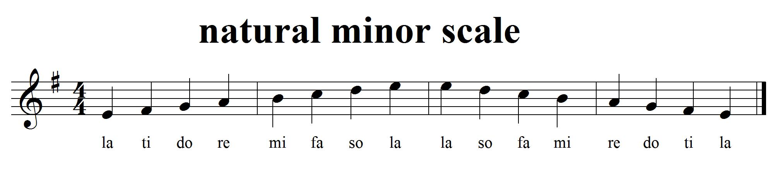

CONSOLIDATION! In order to move on to the next task, you will need to play the E minor scale for your teacher with accurate rhythm and a steady beat.

10. PICK IT UP! FOCUS: PICK-UP NOTE
NOTES:
LEARNING GOAL: You will be applying what you learned about anacrusis. You will demonstrate how to perform pick-up notes.
MINDS ON! How do you identify a pick-up note? How does the pick-up note change the “feel” of a piece? Pick-up notes are usually found on the last beat of a bar. They occur on a weak beat and lead us to a strong beat. How do you know when to start when the music starts with a pick-up note? Take a close look at the last bar... the pick note has done something to the number of beats. Can you tell what it is?
ACTION! In order to be successful with this task, you will need to:
- Learn to play the song, “Sarasponda”, with 90% accuracy.
- Identify in which beat the song starts.
- Perform this song with the correct rhythms and pitches.
- Remember what to do when you get to a repeat sign.

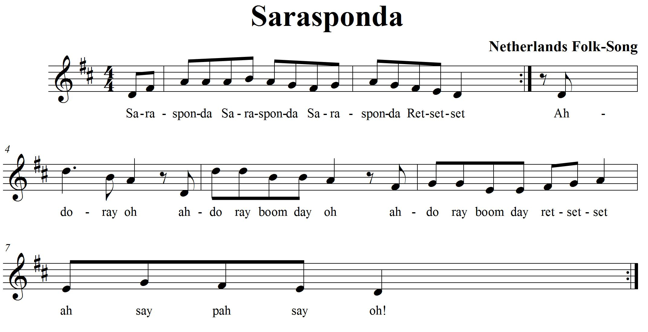
CONSOLIDATION! In order to move on to the next task, you will need to play “Sarasponda” for your teacher. Be able to show your teacher where the pick-up notes occur in the song.

11. A SONG IN A NATURAL MINOR FOCUS: PITCH
NOTES: D, F, G, A, B, C^{I}, D^{I}

LEARNING GOAL: Demonstrate your skill by playing a song based on a minor scale.

MINDS ON! Minor scales create a different mood in the music than major scales do. Some say that when a piece of music is written using a major scale it has a happier mood than a song written using a minor scale. Minor scales sometimes make music feel sad. How would you describe the mood of this song?

ACTION! In order to be successful with this task, you will need to:
- Learn to play “Land of the Silver Birch” with 90% accuracy.
- Make some decisions on how you want to play it.
- Describe the kind of expressive controls you can use to help portray the mood of the music.

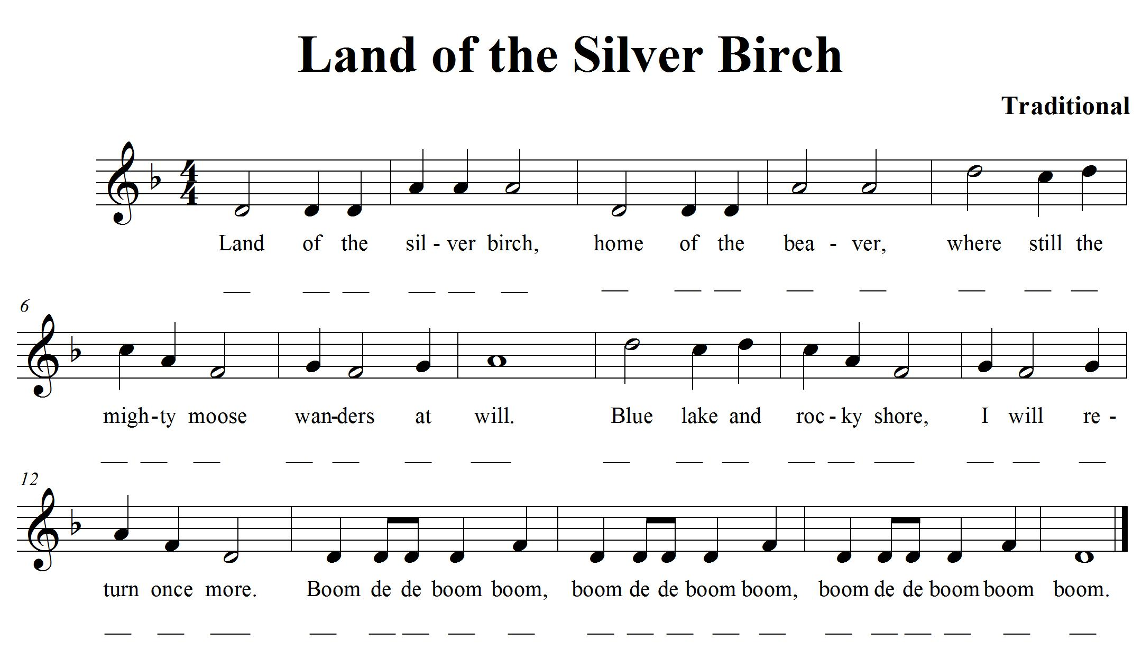
CONSOLIDATION! In order to move on to the next task, you will need to show that you can perform “Land of the Silver Birch” for your teacher. Be ready to explain what you think the mood of this song is.

12. ARTICULATION IS FUN! FOCUS: ARTICULATION/COMPOSITION
NOTES: D, E, F, G, A, B^{à}, D^{I}
LEARNING GOAL: You will learn to use expressive elements to create a variation in a song and perform your variation.

MINDS ON! Composers use dynamics and other articulations to help express a mood or to accent something they want people to notice in their music. There are so many articulations! Now is your chance to compose! Learn the song below and create a variation of it by adjusting articulations and the tempo.
ACTION! In order to be successful with this task, you will need to:
- Learn to play “Frere Jacques” with 90% accuracy.
- Using standard notation, write a variation of “Frere Jacques” in the space provided below.
- Change the tempo; add articulation and accents to vary it.
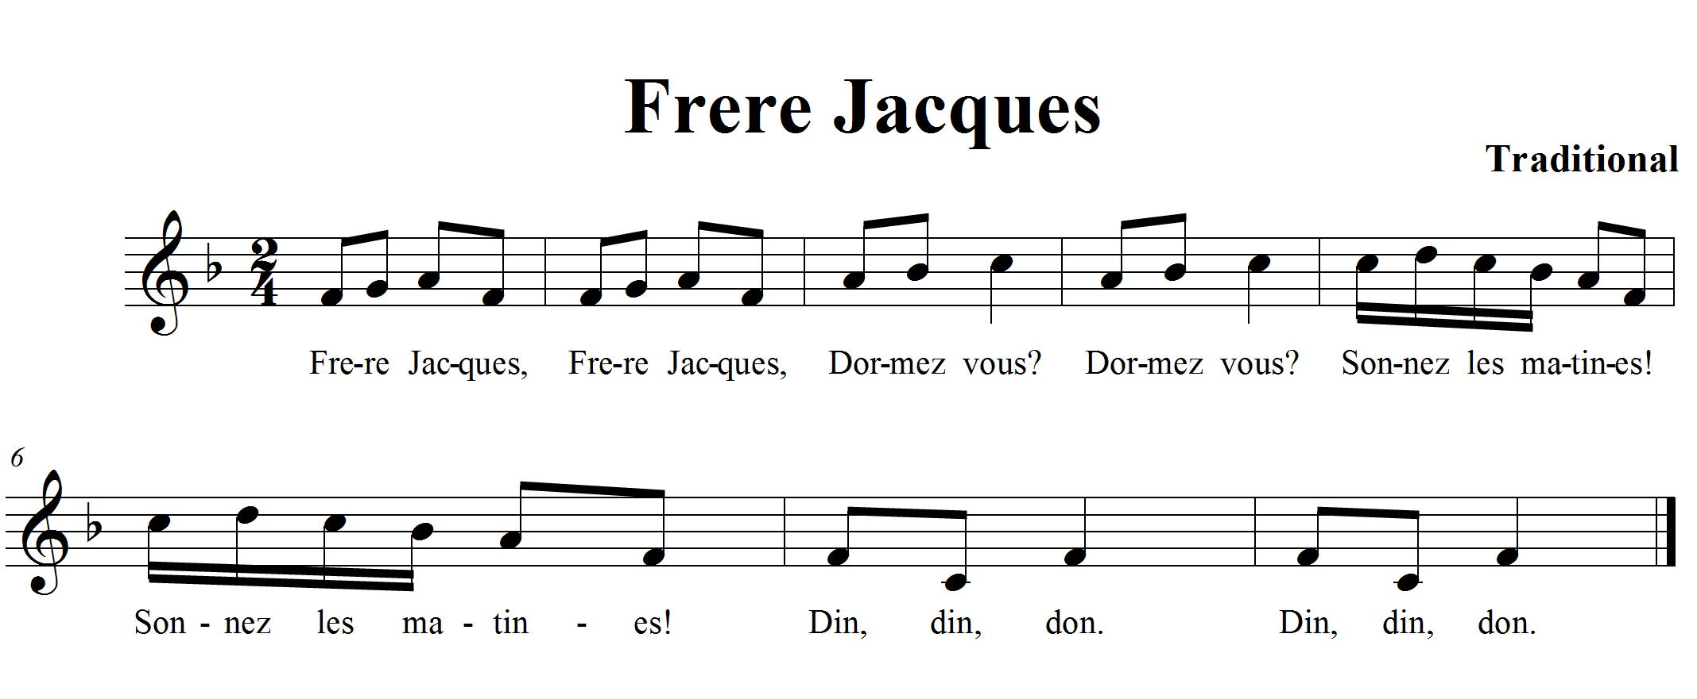

Use the following staff lines to create your variation of “Frere Jacques”:
Remember your clef sign, key signature and time signature.

CONSOLIDATION! In order to move on to the next task, you will need to write your variation of “Frere Jacques” and perform the original version and your variation for your teacher.


Congratulations! You have reached your third GPS marker – SOUTH! Ask your teacher how you are to acknowledge this accomplishment on your GPS task tracker! WAY TO GO!

13. WHAT MAKES A MELODY? FOCUS: PITCH/SYNCOPATION
NOTES: C, D, E, G, A, C^{I}

LEARNING GOAL: You will be learning more about melody, syncopation and how the pitches move through time.

MINDS ON! What is a melody? What does it mean if the melody is syncopated? In a song, when the accented beat is not a strong beat, it creates syncopation. Can you hear the strong beat?
ACTION! In order to be successful with this task, you will need to:
- Look at the Recorder Fingering chart to make sure you know where your fingers need to go for this song.
- Practise playing “Liza Jane”.
- Play the entire song softly; watch your posture and how you blow through your instrument.
- Remember to tongue each note lightly especially when you are playing the eighth notes.
- Listen for the accented beats. There is some syncopation happening.
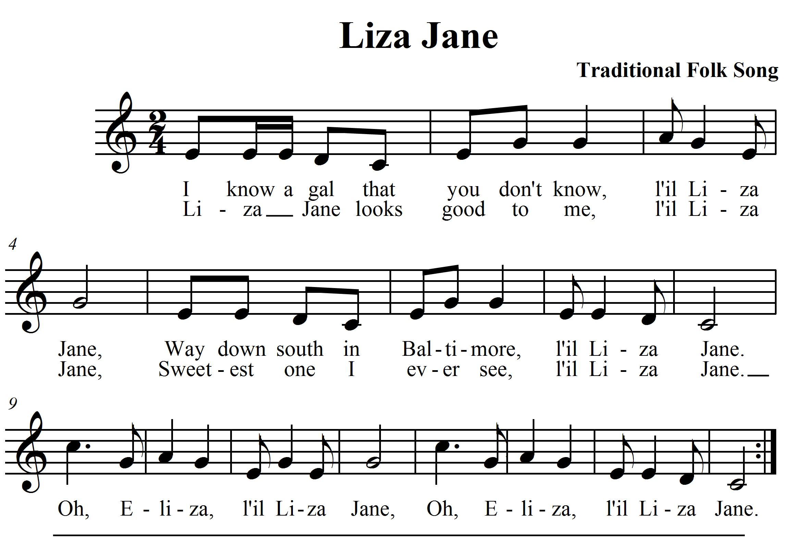

CONSOLIDATION! In order to move on to the next task, you will need to show that you can play “Liza Jane” for your teacher and write down your impressions of playing syncopation in the space below.

SELF-REFLECTION: My impressions of playing syncopation are… (Describe your thinking.)

14. LET’S DUET! FOCUS: TEXTURE/HARMONY/FORM
NOTES: C, D, E, F, G, A, B^{à}, C^{I}, D^{I}

LEARNING GOAL: You will demonstrate your understanding of pitch while playing Music alone Shall Live with a steady beat. You will demonstrate the use of harmony to create texture.

MINDS ON! Texture in music can be created by adding more voices or instruments. Usually the sounds are not exactly the same so they create layers in the music that we can distinguish as layers. Harmony is one way of adding more texture to music. Let’s learn a song that has a single line melody and create texture by playing the song in canon form which creates harmony. What is canon form?

RECORDER ACTION! In order to be successful with this task, you will need to:

- Practise playing “Music Alone Shall Live” on your recorder until you can play it smoothly with 90% accuracy.
- When you know how to play your part, partner up with another student.
- Practise with your partner. To play in canon, one partner starts at the beginning of the piece of music. The second partner begins to play from the beginning when the first partner reaches the number 2, both of you keep playing through to the end of the music. Together you create harmony.
- Together with your partner, work out where you need to take a breath while playing this song.
- Challenge: Add another partner to your group and play the song in canon with the third partner starting at the beginning when the first partner reaches the music at number 3.

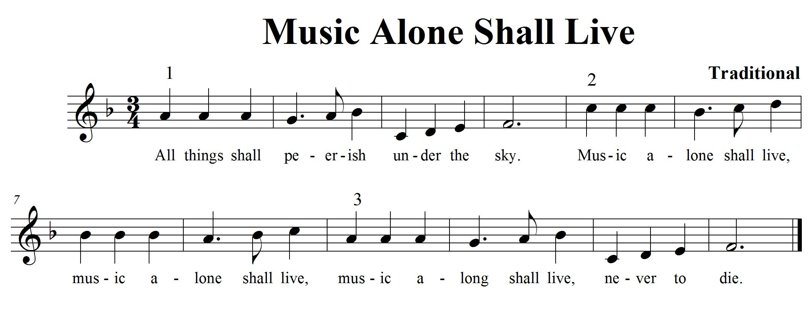

CONSOLIDATION! In order to move on to the next task, you will need to play “Music Alone Shall Live” in canon with a partner using accurate rhythm and a steady beat.

15. LET’S COMPOSE A PIECE OF RECORDER MUSIC FOCUS: COMPOSITION NOTES: C, D, E, F, G, A, B, C^{I}

LEARNING GOAL: Create a piece of music 12 bars long using standard notation. Perform it for the class.

MINDS ON! We have been learning about music all year, we have looked at different pieces of music and now it’s time to put all that knowledge into creating our own piece of music that you get to perform for the class! What rhythms do you want to use? What kind of dynamics are you going to use to show contrasts? Do you have an idea for a how you want it to sound? Many composers have something that inspires them to write. What is your inspiration going to be? Think about the form your music is going to take... there is so much to think about! Let’s give composition a try!

RECORDER ACTION! In order to be successful with this task, you will need to:
- Take a look at The Creative Process chart in your class. This will help you focus your learning as you go through the steps of composition.
- Work with an elbow partner and brainstorm about what you want your composition to sound like.
- Use any of the notes C, D, E, F, G, A, B and C on your recorder. If you want, you can add high or low notes, your choice.
- Use the notes and rhythms you know from your playing of the recorder. Use quarter notes (), eighth notes (), sixteenth notes () and rests (). Start thinking about what you want it to sound like. Create rhythms and melodies using the notes above. Explore your ideas and experiment with them on your recorder. Play your ideas for your partner until you find something you both like.
- What form is your music going to take? How are you going to show the beginning, middle and end of your song? Try starting your composition and ending it on C or G.
- When you think you have a rhythm and melody that you like, think about the order and form you want your music to take. Start planning and focusing your thinking using the planning sheet. (see planning template with hearts below)
- Remember to ask for feedback from your peers and teacher as you work through this process. They will help give you ideas and open up new learning experiences for you as you are composing.
- Write down the rhythms you are going to use on the planning template underneath the beats shown. Remember each heart represents one beat.
- Once you have your rhythm worked out, add your melody by writing the letter names of the notes you want to use underneath your rhythm.
- Practise playing your composition with a partner until you can play it with a steady beat.
- When you think you have your preliminary work completed (that means your composition is pretty close to finished) then it is time to perform it for your class to get more feedback on how it sounds.
- Once you have performed think about the following questions and reflect on them, what did you like? What do you want to change? Now is your chance. Discuss the changes with your partner and change what you want, revise it and make it better!
- When you think you are ready, let your teacher know that you are now ready to present, perform, and share your composition with the class!
Composition Planning Template:
Place note names here
Place note names here
Place rhythm here
Place rhythm here
Place note names here
Place note names here
Place rhythm here
Place rhythm here
Place note names here
Place note names here
Place rhythm here
Place rhythm here

CONSOLIDATION! This is the last task! To accomplish it you must show that you can perform and share your recorder composition with the class. Write your composition down on staff paper. When you are done, reflect and evaluate your learning. Write up a paragraph explaining the following:
- Do you like your composition?
- What would you change if you were to do this composition again?
- What were your challenges?
- What did you do that was lots of fun?
- What other GPS tasks helped prepare you for this one?


Congratulations! You have reached your final GPS marker – WEST!
Ask your teacher how you are to acknowledge this accomplishment on your GPS task tracker!
WAY TO GO!!

