Teachers, before you copy this booklet for your students...
⬰ Have you read the GPS Overview?
⬰ Have you taught these students before? If not, please take the time to work with your students to determine their strengths and needs before deciding which tasks will be appropriate..
⬰ Have you gone through the appropriate start up steps with your students? For example; the basics on putting together their instrument, care and maintenance of their instrument, posture and breathing.
⬰ If you have taught these students before...go through the entire program task-by-task to confirm that the sequence and challenge level of the tasks, is appropriate.
⬰ Refer to the Q and A section of the GPS Overview.
⬰ Do you need to reduce the number of tasks...how will you need to change the evaluation by term?
⬰ The Junior Recorder GPS task progression chart is available by clicking here. You can see how these tasks align and can support the Grade 7 Vocal GPS Tasks.

⬰ If you have questions, please contact:
Lynnette Charters: lcharters@rogers.com

GPS (Grade Performance Steps)

The Road to Musical Success!
Year One Recorder Performance Tasks




Ontario Music Educators’ Association
www.omea.on.ca
Task # 2
Task # 1
Task # 3
Task # 5
Task # 6
Task # 7
Task # 10
Task # 9
Task # 11
Task # 14
Task # 13
Task # 15
Task # 4
Task # 8
Task #12

NORTH EAST
Recorder Tracking Sheet

WEST SOUTH

C D E F F# G

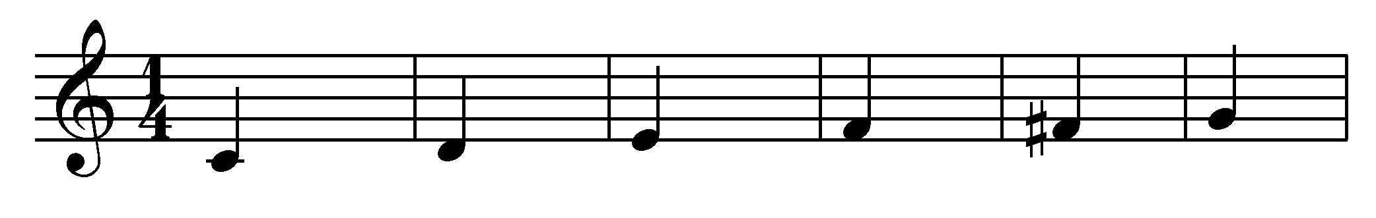
A B B^{à} C^{I} D^{I} E^{I **}

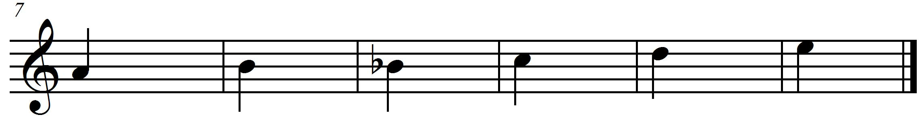
** E^{I} is played by covering only half of the thumbhole on the back.

Important steps to playing the recorder

- Blow lightly into the recorder.
- When you are practising, blowing lightly, if the sound isn’t coming out very well, blow a bit more, but never blow hard. Use a gentle stream of air at all times.
- Hold your recorder with your left hand at the top. Use your thumb to cover the back hole and your first three fingers to cover the top three holes on the recorder.
- Use your right hand at the bottom of the recorder. Use your thumb to hold the back and all four fingers to cover the bottom four holes on the recorder. Yes, you are covering two little holes with your third and fourth fingers at the bottom of the recorder.
- Keep your fingers flat when putting them across the holes.
- Cover the holes with the flat fleshy part of your fingers. Do not use your fingertips or air will leak out when you play.
- Press down on the holes firmly to seal up the holes.
- If the recorder is making a squeaking sound when you play, then you are either blowing too hard, or you are not covering the proper holes with the fleshy part of your fingers.
- Place the recorder on your lips not in your mouth. You will have better control over the sound that way.
- Use your tongue behind your teeth to make a “T” sound. This is called tonguing.
- Start each note by making the “T” sound at the beginning of your note. This is called tonguing your note.

1. KEEP THE BEAT! FOCUS: BEAT
NOTES: B A G

LEARNING GOAL: You will be learning to keep a steady beat. You will play a long tone for 8 beats (tempo = 60 *bpm)
*beats per minute
MINDS ON! Beat is one of the basic components of music. It is a steady pulse that can be found in many musical forms. It is part of an element called duration. Can you find the beat in a piece of music? Can you follow the beat and keep a steady pulse? How long can you conserve your breath? Why do you think that this might be important?
RECORDER ACTION! In order to be successful with this task, you will need to:
- Remember that for this activity one beat will equal one second.
- Keep a steady beat by moving your toe inside your shoe to the beat.
- Take in a deep (low) breath.
- Consistently let the air out in a steady but controlled stream.
- Keep a steady tone on the note B for 8 beats.
- Listen carefully to your group to hear if you are playing the same pitch.
- Refer to the “important steps” to making a good sound.
- Keep a steady tone on the note A for 8 beats.
- Keep a steady tone on the note G for 8 beats.

CONSOLIDATION! In order to move on to the next task, you will need to show your teacher that you can keep a steady tone for 8 beats on the notes, B, A and G.

2. CREATE A RHYTHM! FOCUS: RHYTHM
NOTES: B A G

LEARNING GOAL: You will keep a rhythmic pattern that you create using ta (), and ti ti ().

MINDS ON! Rhythm is an aspect of the element called duration. It is similar to beat except that it is made up of patterns of long and short sounds and/or silences. It is different than beat because beat is made up of a steady repeated pulse. Rhythm changes everything up! Can you create a rhythm? Can a rhythm sometimes sound like the beat? What do you need to do to make a rhythm when you are blowing through the recorder? What do you use to start and stop the sound on the recorder? How do you make long and short sounds and create silences when blowing through the recorder?
RECORDER ACTION! In order to be successful with this task, you will need to:

- Use your tongue to separate each note when playing the recorder. Remember the important steps when playing your notes.
- Remember to keep your beat steady and not too fast.
- Play the note B in ta (, quarter) notes for 8 beats. Repeat this with the notes A and G.
- Play the note B in ti ti (, eighth) notes for 8 beats. Repeat this with the notes A and G.
- When you are ready, create a pattern using ta (, quarter) and ti ti (, eighth) on the notes B, A and G for 8 beats. Write down your pattern below.
- Play your pattern for a friend; ask them to clap a steady beat to help you while you practise your rhythm.
- Practise your rhythm on the notes B, A and G.

Draw rhythm here

CONSOLIDATION! In order to move on to the next task, you will need to play your rhythmic pattern for the teacher on the notes B, A and G. Use your tongue to separate each note.

3. HOT CROSS BUNS FOCUS: RHYTHM
NOTES: B A G

LEARNING GOAL: You will demonstrate your understanding of quarter notes
(ta= ) and eighth notes (ti ti = ) while playing “Hot Cross Buns” with a steady beat.

MINDS ON! You have now been practising B, A and G. It’s time to work on the three notes together in the song. Remember to use your tongue to separate the notes. Take it slowly; keep a steady beat with your toe inside your shoe.

RECORDER ACTION! In order to be successful with this task, you will need to:
- Practise playing “Hot Cross Buns” on your recorder until you can play it smoothly with 90% accuracy.
- Keep a steady beat by tapping your toe inside your shoe.
- Play the rhythm of the song accurately and at a slow tempo.

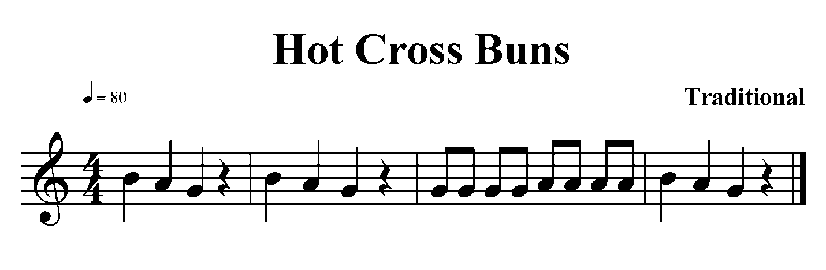

CONSOLIDATION! In order to move on to the next task, you will need to “Hot Cross Buns” for your teacher with accurate rhythm and a steady beat.

4. LET’S PUT IT TOGETHER FOCUS: BEAT/RHYTHM
NOTES: B A G

LEARNING GOAL: Put the knowledge you have learned about beat and rhythm together. You will need to show both the beat and the rhythm of a song.

MINDS ON! You have been learning about beat and rhythm as part of the element Duration. In music, both beat and rhythm occur simultaneously which is why some people confuse them. Can you keep the beat in your toe inside your shoe while playing the melody on your recorder?
RECORDER ACTION! In order to be successful with this task, you will need to:
- Practise playing “Au Claire de la Lune” on your recorder until you can play it smoothly with 90% accuracy.
- Play the rhythm of the song accurately while keeping a steady beat with your big toe inside your shoe.
- Play for a friend and ask them to listen and give you feedback that will help your playing. Do the same for them.

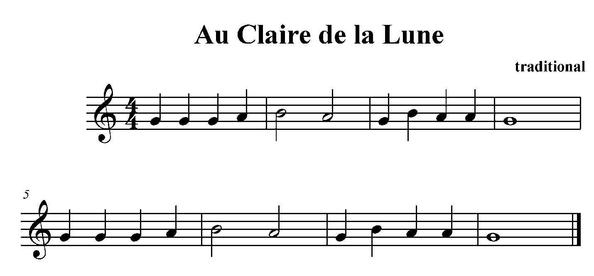

CONSOLIDATION! In order to move on to the next task, you will need to show that you can keep the beat with your toe inside your shoe and play “Au Claire de la Lune”.


Congratulations! You have reached your first GPS marker – NORTH!
Ask your teacher how you are to acknowledge this accomplishment on your GPS task tracker!
WAY TO GO!!

5. TEMPO! HOW FAST? FOCUS: TEMPO
NOTES: B A G

LEARNING GOAL: Let’s expand your knowledge about the recorder by learning about tempo in music.

MINDS ON! Tempo is a word used to describe the speed of a piece of music. There are many different speeds and each one has a musical term to describe it. Largo means play slowly, allegro means play quickly and in a lively way. When you change the tempo of a song it means you are changing the speed that you are playing it. Can you play a song largo? Can you play it allegro?

RECORDER ACTION! In order to be successful with this task, you will need to:
- Keep a steady beat by moving your toe inside your shoe.
- Practise a song you already know i.e.) “Au Claire de la Lune”
- Play the song at different tempos: largo, allegro
- Play the song smoothly with 90% accuracy at largo and allegro
- Make sure you know the difference between the two tempos.

CONSOLIDATION! In order to move on to the next task, you will need to show that you can play a song of your choice at a slow tempo (largo) and a fast tempo (allegro).

6. A NEW NOTE FOCUS: PITCH
NOTES: B A G D^{I}

LEARNING GOAL: You will demonstrate playing D^{I} on your recorder while continuing to work on improving your playing skills.

MINDS ON! Playing new notes is important to expand your knowledge about the recorder. There are many songs that you will be able to play when you know all the notes available on the recorder. How many notes can you play?

RECORDER ACTION! In order to be successful with this task, you will need to:
- Practise playing your new note D^{I} in the song, “Grandma Grunts”. The ^{I} tells you that the note is high on the recorder register.
- Look at the Recorder Fingering chart to make sure you know where your fingers need to go for this song.
- Play the entire song softly; watch your posture and how you blow through your instrument.
- Remember to tongue each note lightly especially when you are playing the eighth notes ().
- Use your tongue behind your teeth to make a “T” sound to start each note. This is called tonguing your note.

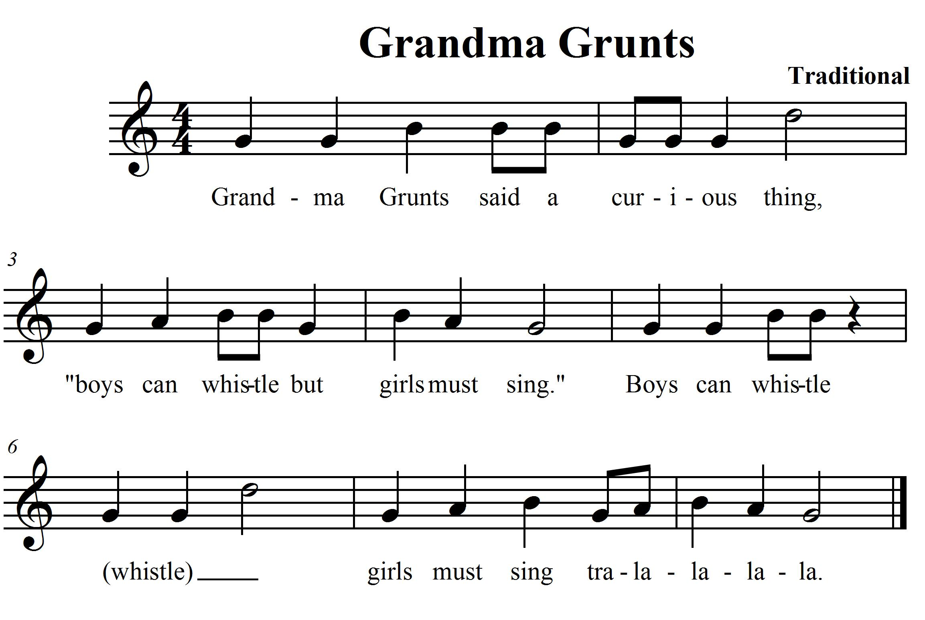

CONSOLIDATION! In order to move on to the next task, you will need to show that you can play “Grandma Grunts”. Keep the beat with your big toe inside your shoe and play with proper tonguing by separating each note with a “T” sound.

7. LET’S PLAY AN OCTAVE! FOCUS: PITCH
NOTES: D B A G D^{I}

LEARNING GOAL: You will demonstrate playing an octave jump. You will be learning how to differentiate between two notes with the same name.

MINDS ON! What is pitch? Can you hear when a sound is high or low? Music is made up of pitches. There are 7 pitch names in a scale. Can you name them all? When a pitch name is repeated in a series of notes, we use ^{I} to differentiate the notes. This tells us when one note is higher than another. There are two D’s that you are going to play for this task; D and D^{I}. We call the distance between these two notes an octave.

RECORDER ACTION! In order to be successful with this task, you will need to:
- Practise playing the jump between D and D^{I} on your recorder, this song will need it! Look at your fingering chart to learn how to play both of these notes.
- Practise playing “Down by the Station”. Remember to practise the jump between your left and right hand going from G down to D on your recorder.
- Keep a steady beat with your toe inside your shoe.
- Remember to tongue each note.
- Highlight where the octave jump occurs in your music.
- Write down your reflections on playing an octave jump in the space provided; share it with your teacher.

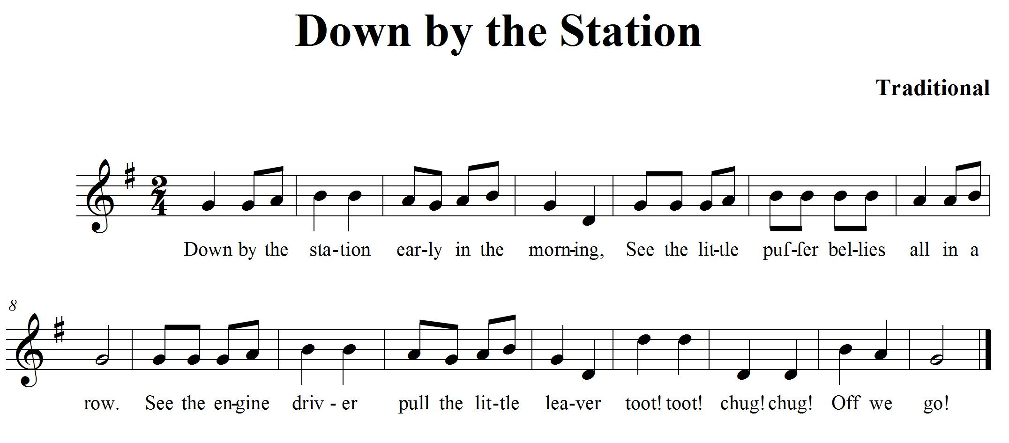
CONSOLIDATION! In order to move on to the next task, you will need to show that you can play “Down by the Station” keeping a steady beat. Show your teacher each of the notes you are going to play and name them accurately. Remember to show the octave jump to your teacher and complete the self-reflection box below.
SELF- REFLECTION: My impressions of playing an octave jump are… (Describe your thinking.)

8. LET’S LEARN A NEW NOTE! FOCUS: PITCH/EXPRESSIVE CONTROLS
NOTES: DE B A G

LEARNING GOAL: You will demonstrate your understanding of pitch while playing “Old MacDonald” with a steady beat. You will demonstrate where to take a breath to make your playing smooth.

MINDS ON! You have been playing BAG and D. Now let’s add a new note E. Where do your fingers need to be to play this note? Try to make your playing sound smooth. Where do you need to take a breath? How do you know that it is a good place to take a breath? What does a breath mark look like?
RECORDER ACTION! In order to be successful with this task, you will need to:
- Practise playing “Old MacDonald” on your recorder until you can play it smoothly with 90% accuracy.
- Keep a steady beat by moving your toe inside your shoe.
- Play the rhythm of the song accurately and at a steady tempo.
- Work out where you need to take a breath while playing this song.
- Place commas on your music to mark where you need to take a breath.

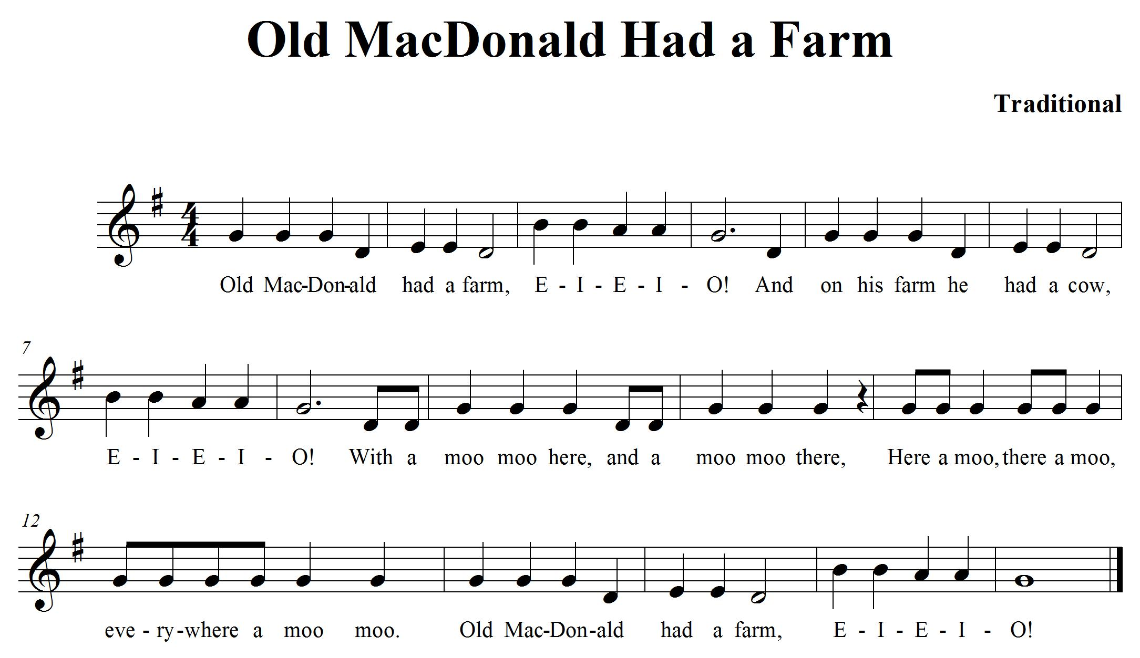

CONSOLIDATION! In order to move on to the next task, you will need to play “Old MacDonald” for your teacher with accurate rhythm and a steady beat. Make sure your breath marks are marked in and take your breaths at the proper times.

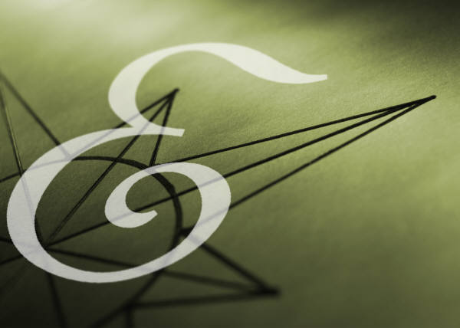
Congratulations! You have reached your second GPS marker – EAST! Ask your teacher how you are to acknowledge this accomplishment on your GPS task tracker! WAY TO GO!!

9. ONE MORE NOTE! FOCUS: PITCH/RHYTHM
NOTES: DE F# GAB D^{I}

LEARNING GOAL: You will demonstrate your understanding of pitch while playing “Michael Finnigan” with a steady beat. Everything you learned about rhythm this year will need to be used for this song.

MINDS ON! You have been playing DE GAB, now let’s add a new note F#. Where do your fingers need to be to play this note? Try to make your playing sound smooth.

RECORDER ACTION! In order to be successful with this task, you will need to:
- Practise playing “Michael Finnigan” on your recorder until you can play it smoothly with 90% accuracy.
- Keep a steady beat by tapping your toe inside your shoe.
- Your tonguing is very important to helping you keep up the rhythm of this song.
- Play the rhythm of the song accurately and at a steady tempo.
- Work out where you need to take a breath while playing this song.
- Place commas on your music to mark where you need to take a breath.

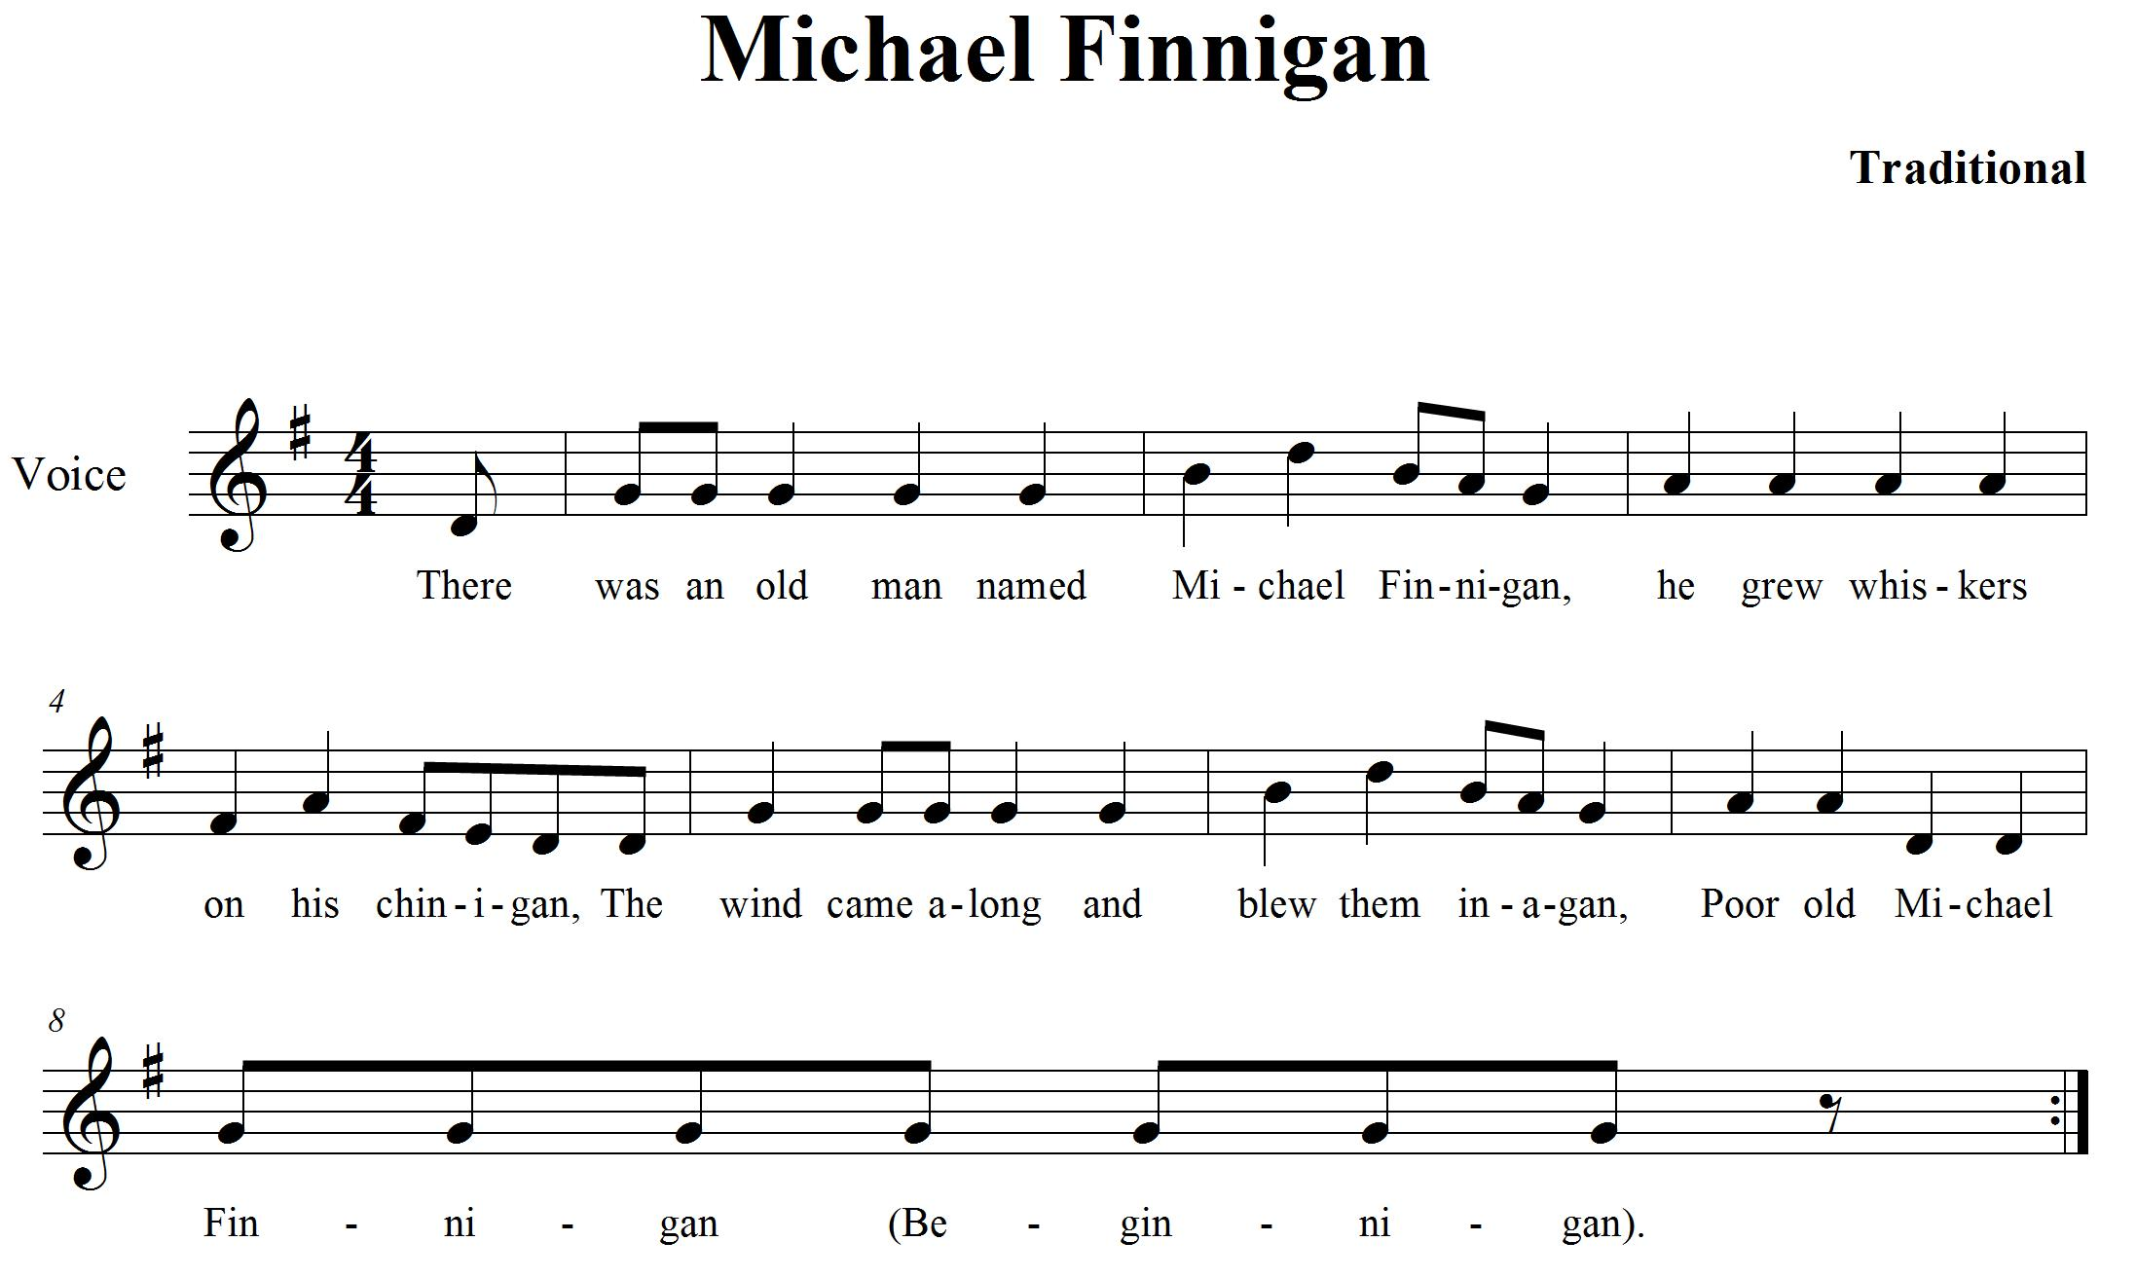

CONSOLIDATION! In order to move on to the next task, you will need to play “Michael Finnigan” for your teacher with accurate rhythm and a steady beat. Make sure your breath marks are marked in and take your breaths at the proper times.

10. KEEP THE BEAT! FOCUS: BEAT
NOTES: E, G, A, B, C^{I} D^{I}

LEARNING GOAL: You will be learning to keep a steady beat. While playing a long tone for 12 beats (tempo = 90 *bpm)
*beats per minute

MINDS ON! We learned about beat last year. Beat is one of the basic components of music. It is a steady pulse that can be found in many musical forms. It is part of an element called duration. Can you find the beat in a piece of music? Can you follow the beat and keep a steady pulse? How long can you conserve your breath? Why do you think that this might be important?

RECORDER ACTION! In order to be successful with this task, you will need to:
- Keep a steady beat by tapping your toe inside your shoe to the beat.
- Take in a deep (low) breath.
- Consistently let the air out in a steady but controlled stream.
- Keep a steady tone on the note B for 12 beats.
- Listen carefully to your group to hear if you are playing the same pitch.
- Remember all the important steps to making a good sound.
- Keep a steady tone on the notes E, G, A, B, C^{I} and D^{I} for 12 beats

CONSOLIDATION! In order to move on to the next task, you will need to show your teacher that you can keep a steady tone on the notes; E, G, A, B, C^{I} and D^{I} for 12 beats.

11. CREATE A RHYTHM! FOCUS: RHYTHM
NOTES: G, A, B, C^{I}, D^{I} and E^{I}

LEARNING GOAL: You will keep a rhythmic pattern consistent for 30 seconds.

MINDS ON! Rhythm is an aspect of the element called duration. It is similar to beat except that it is made up of patterns of long and short sounds and/or silences. It is different than beat because beat is made up of a steady repeated pulse. Rhythm changes everything up! Can you create a rhythm? Can a rhythm sometimes sound like the beat? What do you use to start and stop the sound on the recorder? How do you make long and short sounds and create silences when blowing through the recorder?
Try creating a rhythm with a friend and keep the pattern going for 30 seconds.

RECORDER ACTION! In order to be successful with this task, you will need to:
- Use your tongue to separate each note this will create the rhythm.
- Play the note B in ta (, quarter notes) for 8 beats. Repeat this with the notes A and G.
- Play the note C^{I} in ti ti (, eighth notes) for 8 beats. Repeat this with the notes D^{I} and E^{I}.
- When you are ready, use any notes you wish to create a pattern using ta (, quarter notes )and ti ti (, eighth notes) on the note B for 8 beats.
- Challenge: Use tika tika (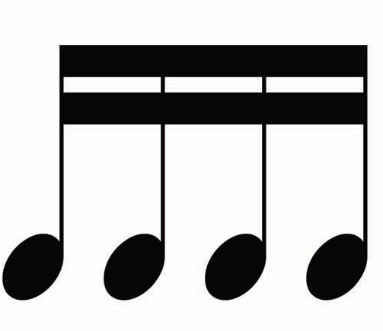, sixteenth notes) as part of your rhythm.
- Play your rhythm for a friend; ask them to clap a steady beat for you to help practise your rhythm.
- Play your rhythm on B and have your friend play their rhythm on G.
- Keep your 8 beat rhythms repeating for 30 seconds.
- Draw your rhythm in the space below.

Draw rhythm here

CONSOLIDATION! In order to move on to the next task, you will need to play your rhythmic pattern on one of the following notes: G, A, B, C^{I}, D^{I} and E^{I}. Play your rhythm with a friend. Choose two different notes to play together (B and G, G and D^{I}, C^{I} and E^{I} or A and C^{I}). Use your tongue to separate each note. When you are done, complete the self-reflection below.

SELF-REFLECTION: What I found challenging about task two was...

12. C MAJOR SCALE FOCUS: PITCH
NOTES: C, D, E, F, G, A, B, C^{I}

LEARNING GOAL: You will demonstrate how to play a major scale in quarter notes.

MINDS ON! You have now been practising many notes with rhythms. In music, there are always patterns that emerge. One type of pattern is the scale. This is a series of notes that move up or down in a stepwise motion. What do you think is the first and last note of the C major scale? Scales help to develop skill in playing notes. Work slowly on this to increase your accuracy.

RECORDER ACTION! In order to be successful with this task, you will need to:
- Practise playing the C major scale on your recorder until you can play it smoothly with 90% accuracy.
- Think of the Solfege names which have been included to help you make connections to the vocal tasks.
- Keep a steady beat by moving your toe inside your shoe.
- Play the rhythm of the scale accurately and at a slow tempo.
- Use your tongue to separate your notes.

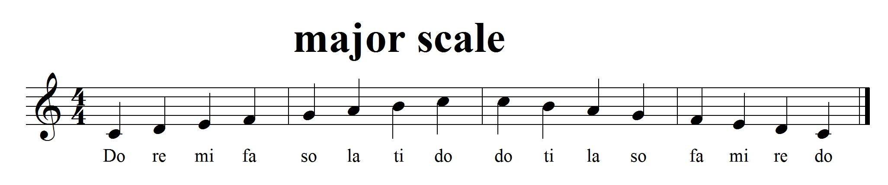

CONSOLIDATION! In order to move on to the next task, you will need to play the C major scale for your teacher with accurate rhythm and a steady beat.


Congratulations! You have reached your third GPS marker – SOUTH! Ask your teacher how you are to acknowledge this accomplishment on your GPS task tracker! WAY TO GO!

13. CAN YOU FIND THE STRONG BEATS? FOCUS: COMPOUND TIME
NOTES: D, E, F#, G, A, B

LEARNING GOAL: Put the knowledge you have learned about duration to work. You will be playing a song in compound time.

MINDS ON! You have been learning about beat and rhythm as part of the element, duration. Rhythm, beat, metre! In music, the beats are separated into groups to help the musician keep track of them (sometimes groups of 2, 3 or 4). Musicians create a strong accent on the first beat of each grouping. When we count beats in time, we are counting ti (eighth) notes. Counting in in words would be like this “one-and-a-two-and-a”, even though there are 6 eighth notes it feels like there are only 2 strong beats.
RECORDER ACTION! In order to be successful with this task, you will need to:
- Practise playing “Hickory Dickory Dock” on your recorder until you can play it smoothly with 90% accuracy.
- Keep the beat with your toe. Only accent 2 main beats with your toe.
- Play the rhythm of the song accurately while keeping a steady beat with your toe inside your shoe.
- Feel the sway of the music.
- Identify the pick-up notes in this song. Feeling how the music moves will help you when you are playing them. They will lead you to the strong beat in the next bar.

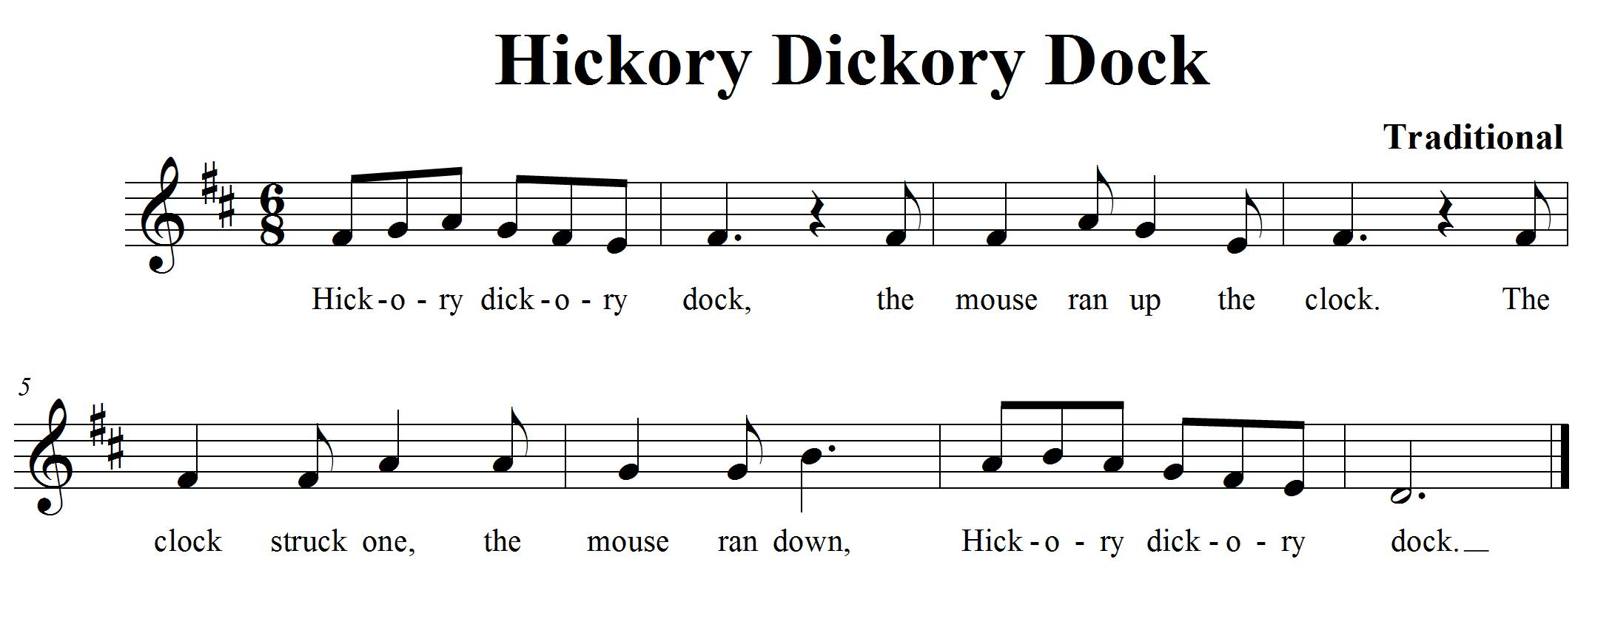
CONSOLIDATION! In order to move on to the next task, you will need to show that you can keep the strong beat (remember to only count two strong beats when playing in time) with your toe and play “Hickory Dickory Dock” on your recorder for your teacher.

14. PLAY IT HIGH! FOCUS: PITCH
NOTES: G, A, B, C^{I}, D^{I}, E^{I}

LEARNING GOAL: Let’s expand your knowledge about the recorder by learning how to make a gentle high sound.

MINDS ON! Playing instruments can sometimes be difficult. When you play notes in the higher range you don’t need to blow very hard to make a nice sound. It is important to understand how much air you need to make a good sound. Playing in the higher range requires you to blow lightly. How lightly do you need to blow to make a good sound?

RECORDER ACTION! In order to be successful with this task, you will need to:
- Keep a steady beat by tapping your toe inside your shoe.
- Practise “Twinkle, Twinkle Little Star”.
- Identify a new note E^{I}; look at the fingering chart to learn how to play it. You only cover half of the thumbhole when playing this high E.
- Blow gently; it doesn’t take a lot of air to play this high note.
- Play the song smoothly with 90% accuracy.

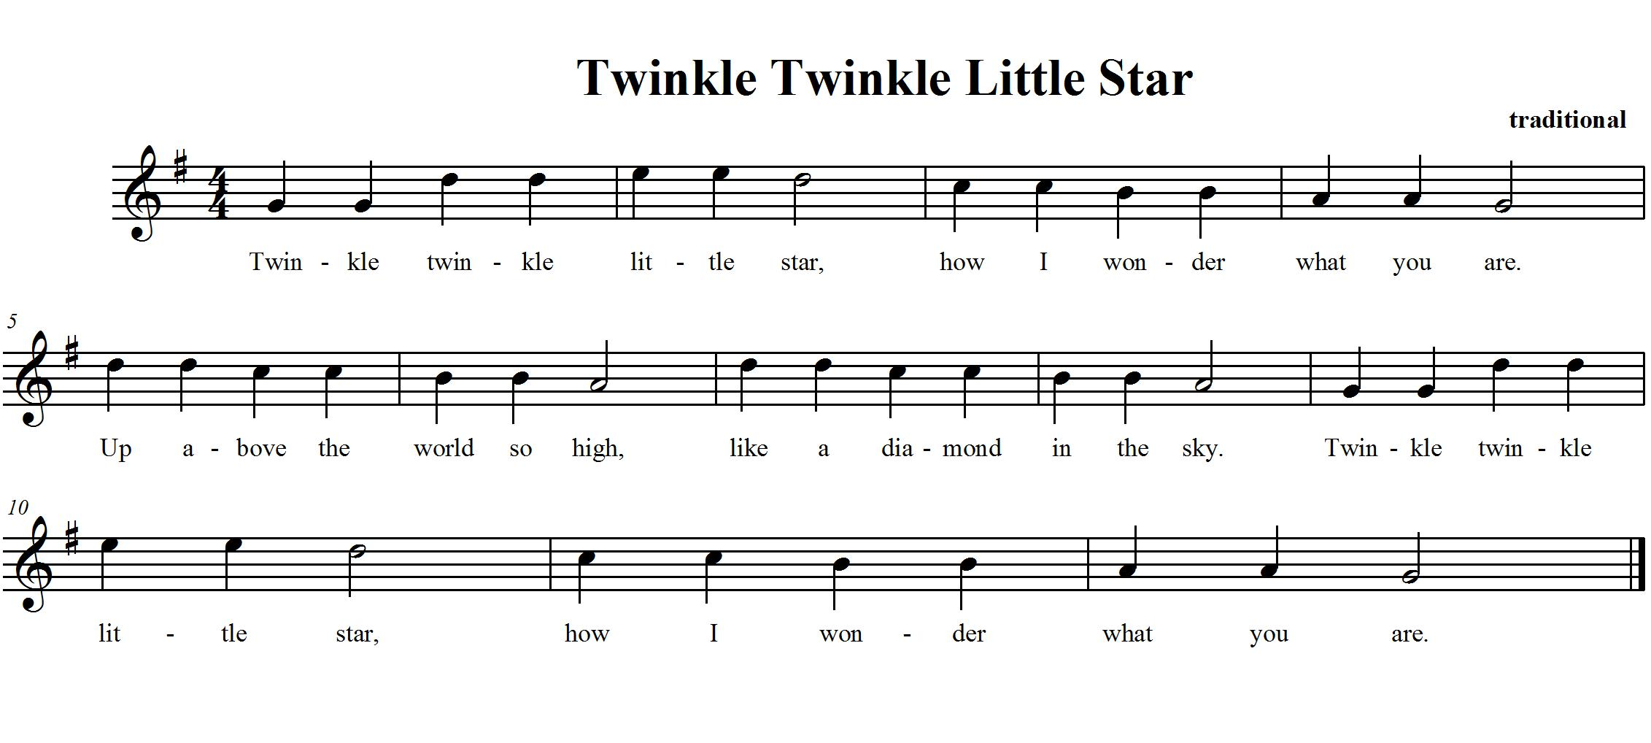

CONSOLIDATION! In order to move on to the next task, you will need to show that you can play “Twinkle, Twinkle Little Star” for your teacher.

15. LET’S COMPOSE A PIECE OF RECORDER MUSIC FOCUS: COMPOSITION NOTES: D GAB D

LEARNING GOAL: Create a piece of music 4 bars long using standard notation. Perform it for the class.

MINDS ON! We have been learning about music all year, we have looked at different pieces of music and now it’s time to put all that knowledge into creating our own piece of music that you get to perform for the class! What rhythms do you want to use? What kind of dynamics are you going to use to show contrasts? Do you have an idea for how you want it to sound? Many composers have something that inspires them to write. What is your inspiration going to be? Think about the form your music is going to take... there is so much to think about! Let’s give composition a try!

RECORDER ACTION! In order to be successful with this task, you will need to:
- Take a look at The Creative Process chart in your class. This will help you focus your learning as you go through the steps of composition.
- Work with an elbow partner and brainstorm about what you want your composition to sound like.
- Use the notes B, A and G on your recorder. If you want, you can add D (high or low your choice).
- Use the notes and rhythms you know from your playing of the recorder. Use ta (, quarter notes), ti-ti (, eighth notes) and rests ().
- Start thinking about what you want it to sound like. Create rhythms and melodies using the notes above. Explore your ideas and experiment with them on your recorder. Play your ideas for your partner until you find something you both like.
- What form is your music going to take? How are you going to show the beginning, middle and end of your song? Try starting your composition on G and ending it on G
- When you think you have a rhythm and melody that you like, think about the order and form you want your music to take. Start planning and focusing your thinking using the planning sheet. (see planning template with hearts below)
- Remember to ask for feedback from your peers and teacher as you work through this process. They will help give you ideas and open up new learning experiences for you as you are composing.
- Write down the rhythms you are going to use on the planning template underneath the beats shown. Remember each heart represents one beat.
- Once you have your rhythm worked out, add your melody by writing the letter names of the notes you want to use underneath your rhythm.
- Practise playing your composition with your partner until you can play it with a steady beat.
- When you think you have your preliminary work completed (that means your composition is pretty close to finished) then it is time to perform it for your class to get more feedback on how it sounds.
- Once you have performed think about the following questions and reflect on them, what did you like? What do you want to change? Now is your chance. Discuss the changes with your partner and change what you want, revise it and make it better!
- When you think you are both ready, let your teacher know that you are now ready to present, perform and share your composition with the class!

Composition Planning Template:
Place note names here
Place note names here
Place rhythm here
Place rhythm here

CONSOLIDATION! This is the last task! To accomplish it you must show that you can perform and share your recorder composition with the class. When you are done, reflect and evaluate your learning. Write up a paragraph explaining the following;
- Do you like your composition?
- What would you change if you were to do this composition again?
- What were your challenges?
- What did you do that was lots of fun?
- What other GPS tasks helped prepare you for this one?


Congratulations! You have reached your final GPS marker – WEST!
Ask your teacher how you are to acknowledge this accomplishment on your GPS task tracker!
WAY TO GO!!

