Teachers, before you copy this booklet for your students...
⬰ Have you read the GPS Overview?
⬰ Have you taught these students before? If not, please take the time to work with your students to determine their strengths and needs before deciding which tasks will be appropriate..
⬰ Have you gone through the appropriate start up steps with your students? For example; the basics on putting together their instrument, care and maintenance of their instrument, posture and breathing.
⬰ If you have taught these students before...go through the entire program task-by-task to confirm that the sequence and challenge level of the tasks, is appropriate.
⬰ Refer to the Q and A section of the GPS Overview.
⬰ Do you need to reduce the number of tasks...how will you need to change the evaluation by term?
⬰ Have you considered pulling out some of the parts that are not needed for your classes. A good example is Task 5 of this program – each instrument requires one page. You might consider making instrument specific books to save paper.
⬰ If you have questions, please contact:
Sarah Arcand: sarahwylie@hotmail.com

GPS Task Evaluation Chart
TEACHER REFERNCE
Year Three Band

This is assuming that this program starts in late October early November

Tasks  (Completion of “X” task number equals “Y” %) | Term 1 (September to February) | Term 2 (February to June)
1 | 52% | 32%(R)
2 | 55% | 35%(R)
3 | 58% | 38%(R)
4 | 62% | 42%(R)
5 | 65% | 45%(R)
6 | 68% | 48%(R)
7 | 72% | 52%
8 (taught to) | 75% | 55%
9 | 78% | 58%
10 | 82% | 62%
11 | 88% | 65%
12 | 92% | 68%
13 | 98% | 72%
14 (taught to) | 100% | 75%
15 |  | 78%
16 |  | 82%
17 |  | 88%
18 |  | 92%
19 |  | 98%
20 |  | 100%

Tasks 15 to 20 serve as extensions and culminating activities which encompass the concepts learned or introduced in Tasks 1 to 14. If you are following this evaluation scheme, you should teach the first 14 tasks by the end of the year.

GPS
(Grade Performance Steps)

The Road to Musical Success!

Intermediate Band Performance Tasks
YEAR THREE




Ontario Music Educators’ Association
www.omea.on.ca

In order to be successful this year, you will need to plan out how many tasks you think you can complete, and the mark you want to receive for performing on your instrument! Below is a summary of the number of tasks per term, and the mark you will receive for the tasks you complete:

Tasks  (Completion of “X” task number equals “Y” %) | Term 1 (September to February) | Term 2 (February to June)
1 | 52% | 32%(R)
2 | 55% | 35%(R)
3 | 58% | 38%(R)
4 | 62% | 42%(R)
5 | 65% | 45%(R)
6 | 68% | 48%(R)
7 | 72% | 52%
8 | 75% | 55%
9 | 78% | 58%
10 | 82% | 62%
11 | 88% | 65%
12 | 92% | 68%
13 | 98% | 72%
14 | 100% | 75%
15 |  | 78%
16 |  | 82%
17 |  | 88%
18 |  | 92%
19 |  | 98%
20 |  | 100%

Performance is just one part of your music evaluation this year. Your teacher will let you know what the other aspects of your program are on your two summative report cards.

Remember that with the GPS tasks:
- we will be learning concepts introduced as a class;
- you will have time in class to practice and receive feedback from your teacher and classmates;
- you will have multiple opportunities to demonstrate these tasks;
- you need to demonstrate at least a Level 3 performance (your teacher will talk with you about what a Level 3 demonstration would sound like); and
- in order to be successful, you will need to work independently in class, and outside of class time (recess, lunch, after school and practice at home).

GPS YEAR THREE BAND

THE NORTH SECTION
FOCUS: RHYTHM

1. REVIEW THE FAMILIAR FOCUS: QUARTER AND HALF NOTES
WIND INSTRUMENTS AND SD/BD/KIT

LEARNING GOAL: The purpose of this task is to review and demonstrate your understanding of quarter and half notes.

MINDS ON! When you play quarter and half notes, do you make sure that they fill the entire length of the beat? When you have the same rhythm repeated, how do you maintain an equal quality of sound?

ACTION! To be successful with this task, you will need to:

- Pick a tempo which will allow you to play with accuracy and a good quality of sound; and
- Identify the form of this piece.

CONSOLIDATION: In order to move on to the next task, you must perform the piece below for your teacher and receive feedback. 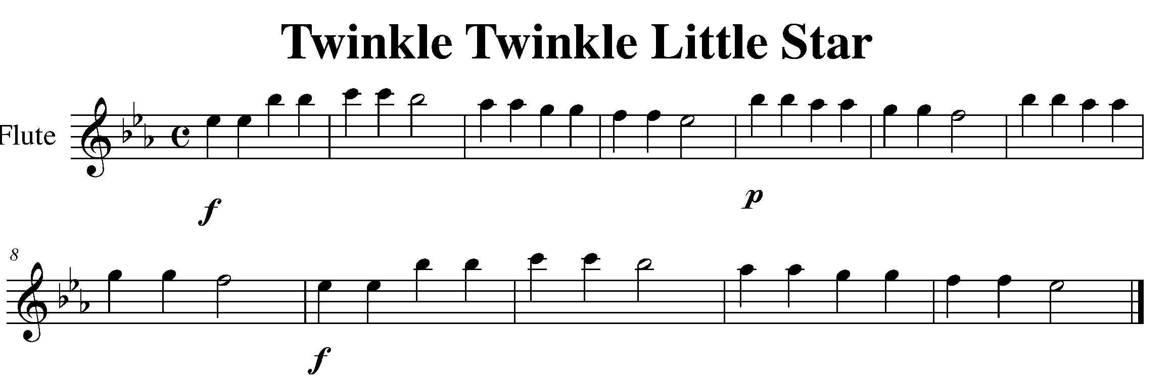

Task 1 Music Continued
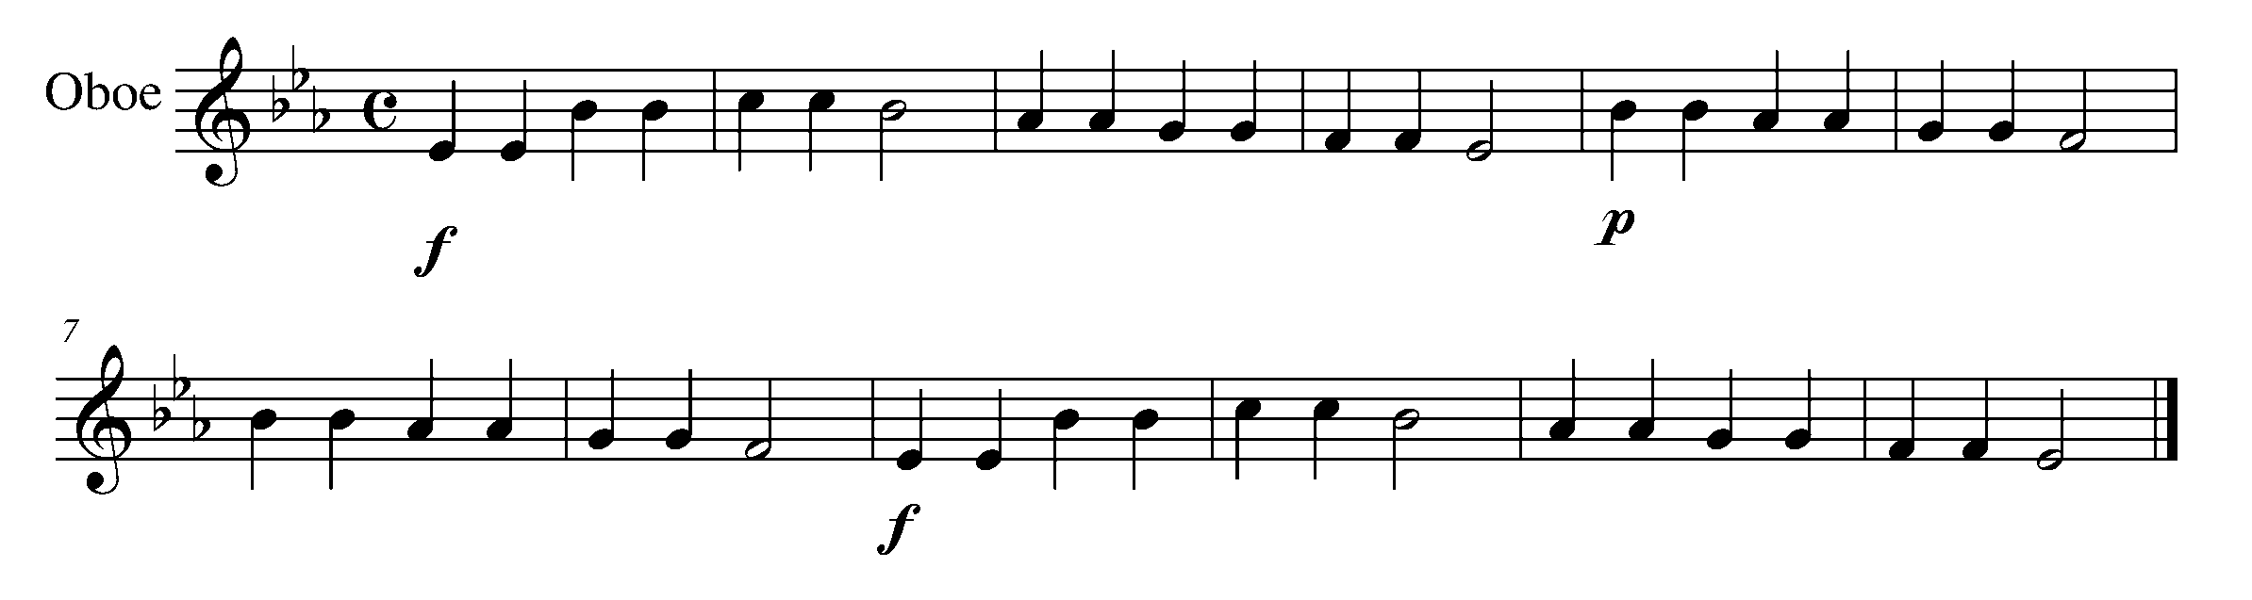
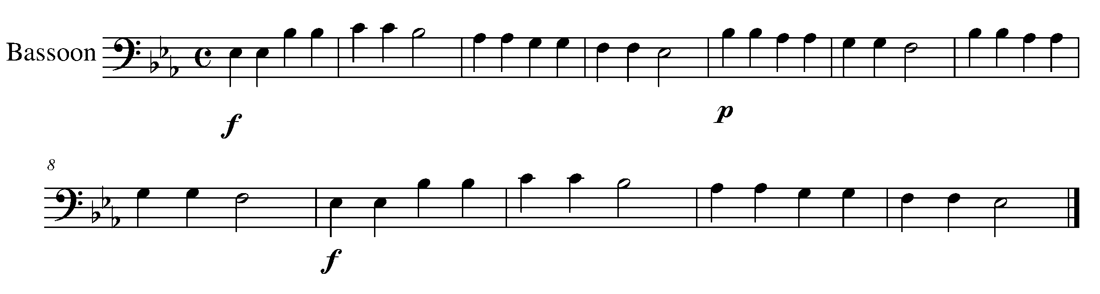
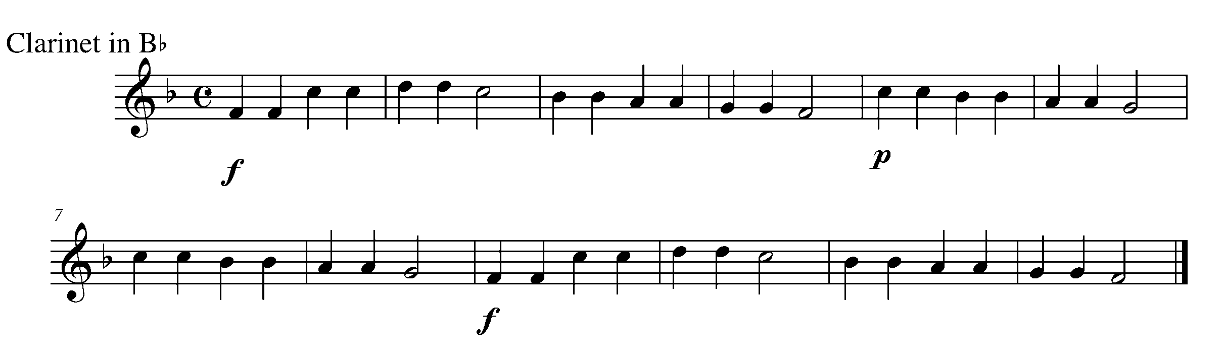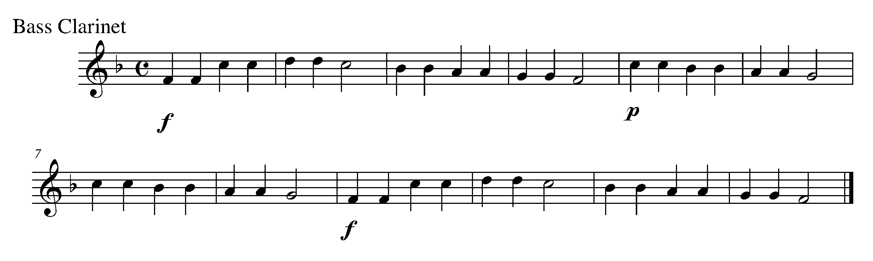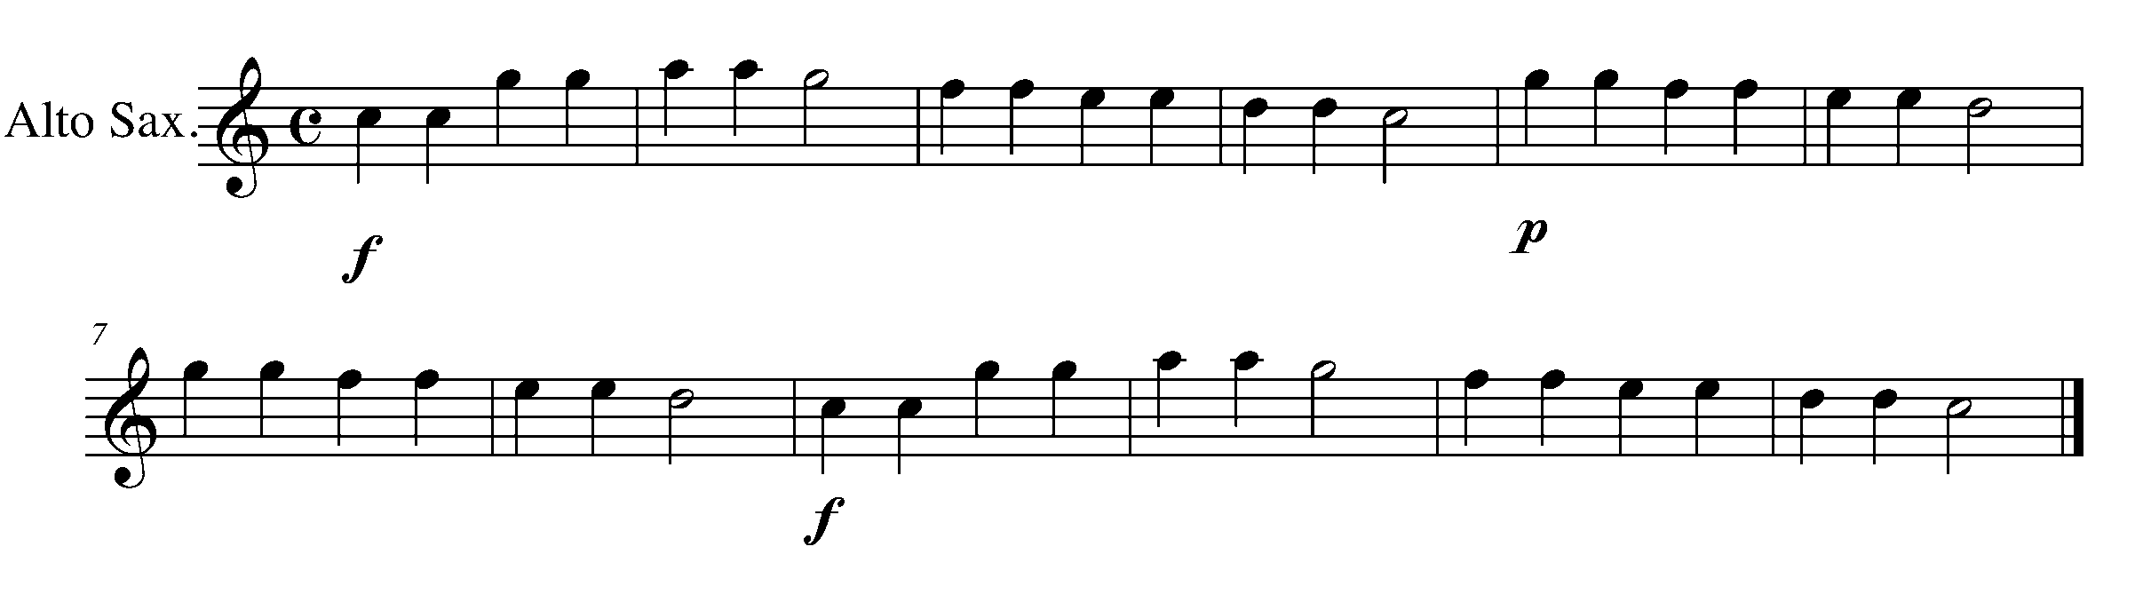

Task 1 Music Continued
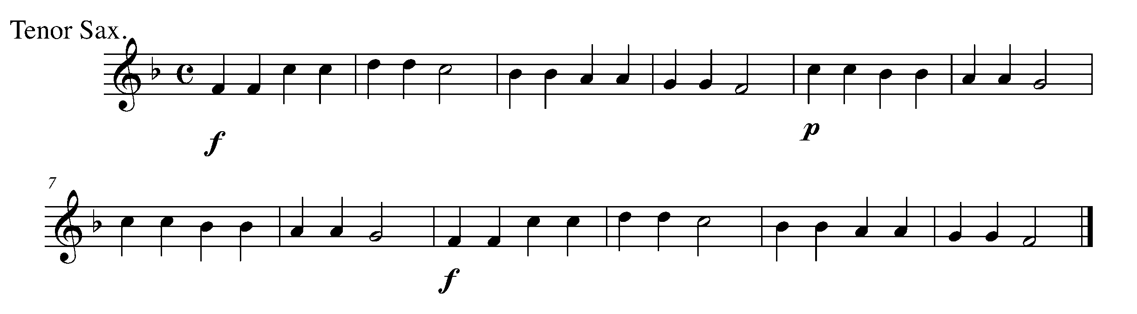
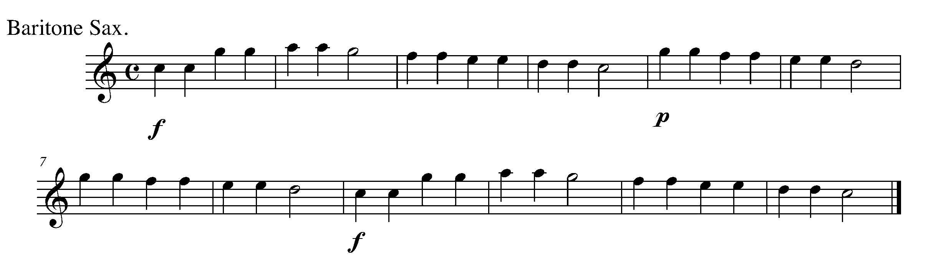
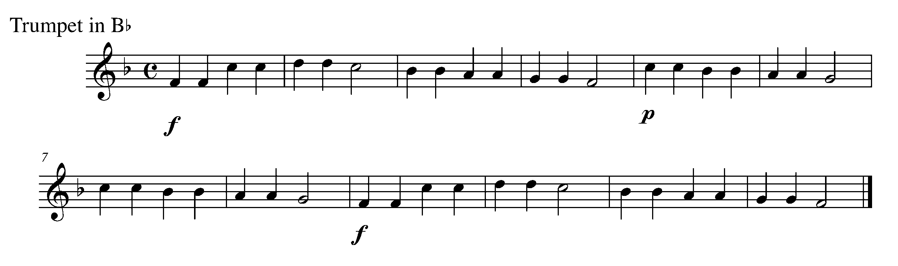
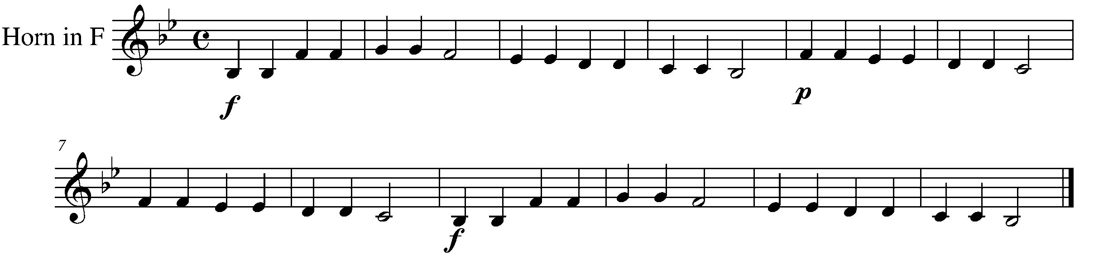
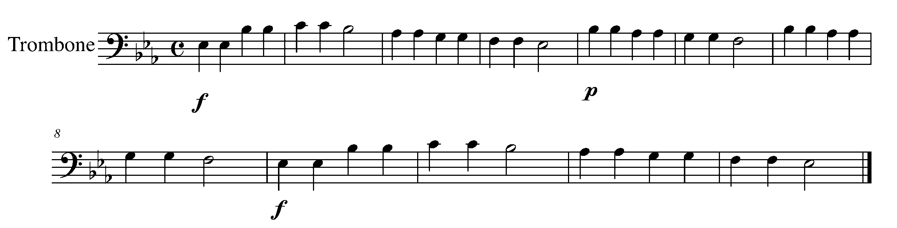

Task 1 Music Continued
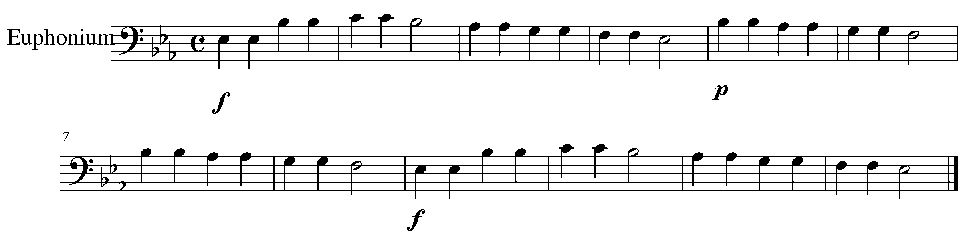
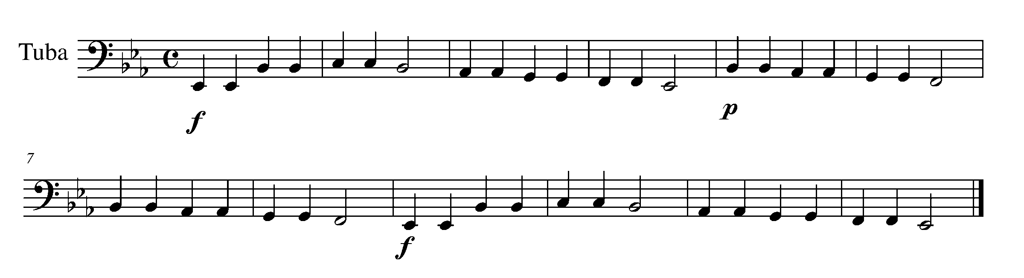
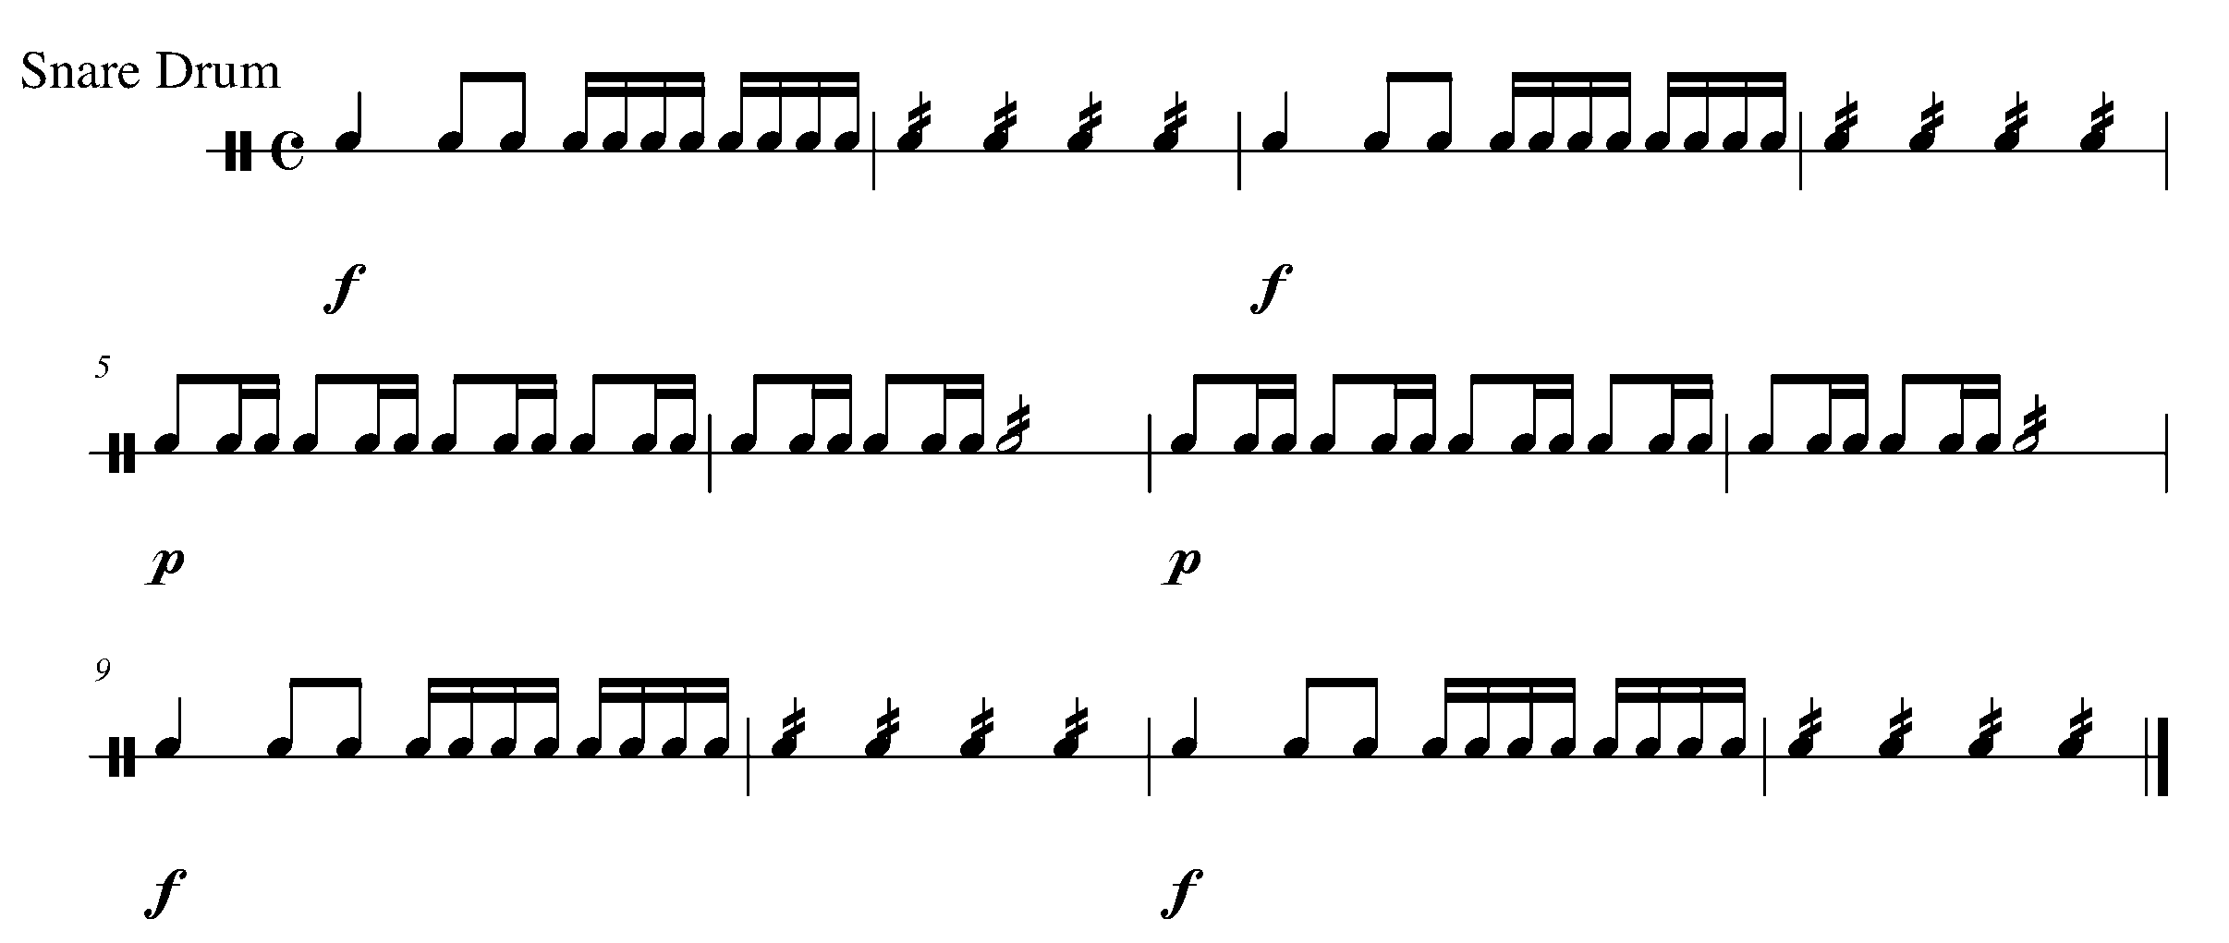
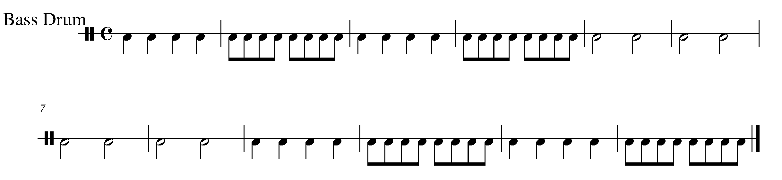

Task 1 Music Continued
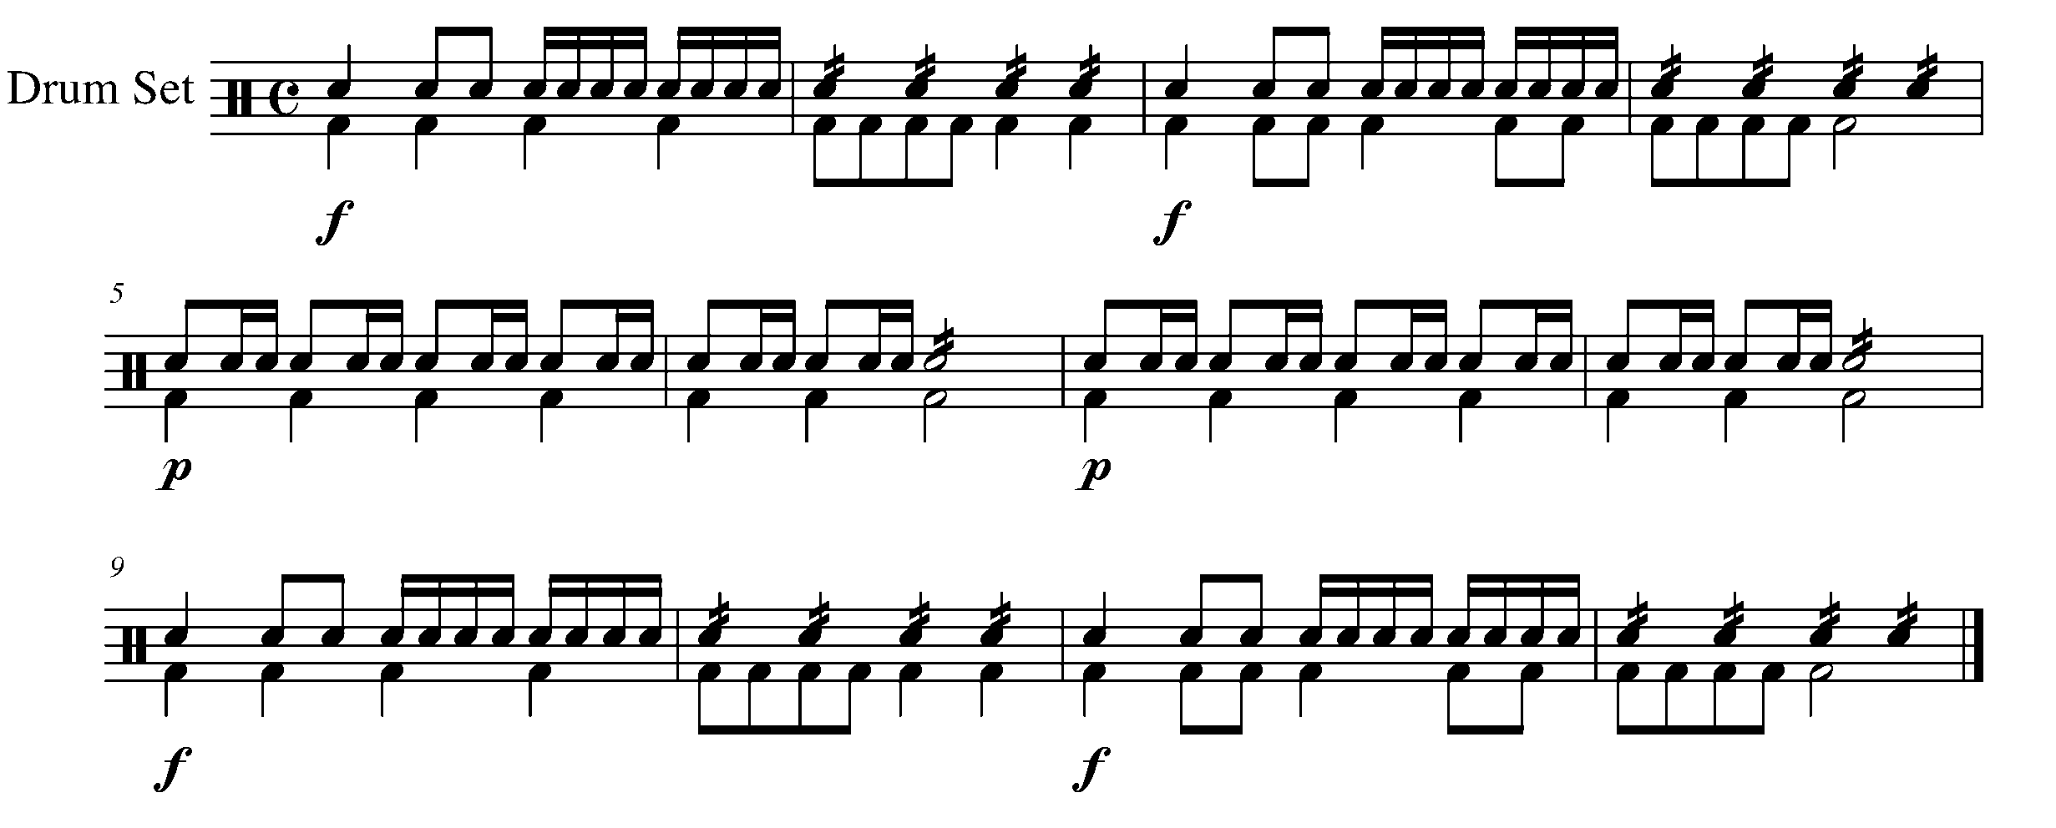

2. “SYN – CO – PA” FOCUS: EIGHTH/QUARTER/EIGHTH NOTES
ALL

LEARNING GOAL: The purpose of this task is to recognize an eighth note, quarter note, eighth note combo – known as syncopation.

MINDS ON! How do you count the rhythm labeled “syncopation”? How will you balance your quality of sound throughout the syncopation?

ACTION! In order to be successful with this task, you will need to:

- Circle all of the syncopations in the piece below; and
- Write in the beat numbers (1 + 2 + 3 + 4 +) for the piece below.

CONSOLIDATION: In order to move on to the next task, you must complete the above action items, show them to your teacher and receive feedback.

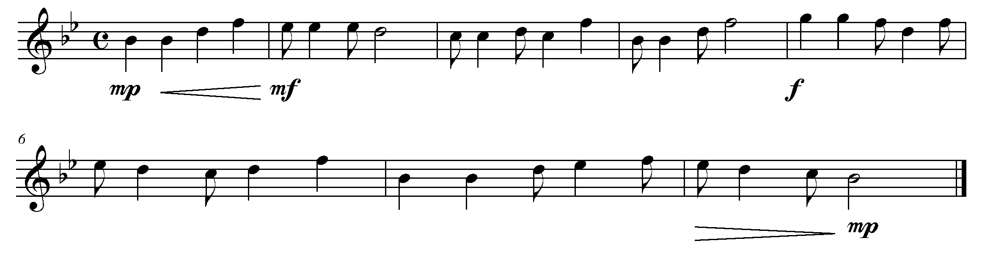

3. SHORT, LONG, SHORT FOCUS: SYNCOPATION
WIND INSTRUMENTS AND MALLETS

LEARNING GOAL: The purpose of this task is to perform the syncopated rhythm on your instrument.

MINDS ON! How do you articulate the syncopation below? Do all of your notes have a good quality of sound? Are you moving your toe inside of your shoe to help you keep a steady beat?

ACTION! To be successful with this task, you will need to:
- Take in a good, deep breath;
- Maintain proper posture when performing; and
- Play the above piece found in task 2, with good sound, rhythm and a consistent tempo.

CONSOLIDATION: In order to move on to the next task, for your teacher, you must perform the following piece and receive feedback.
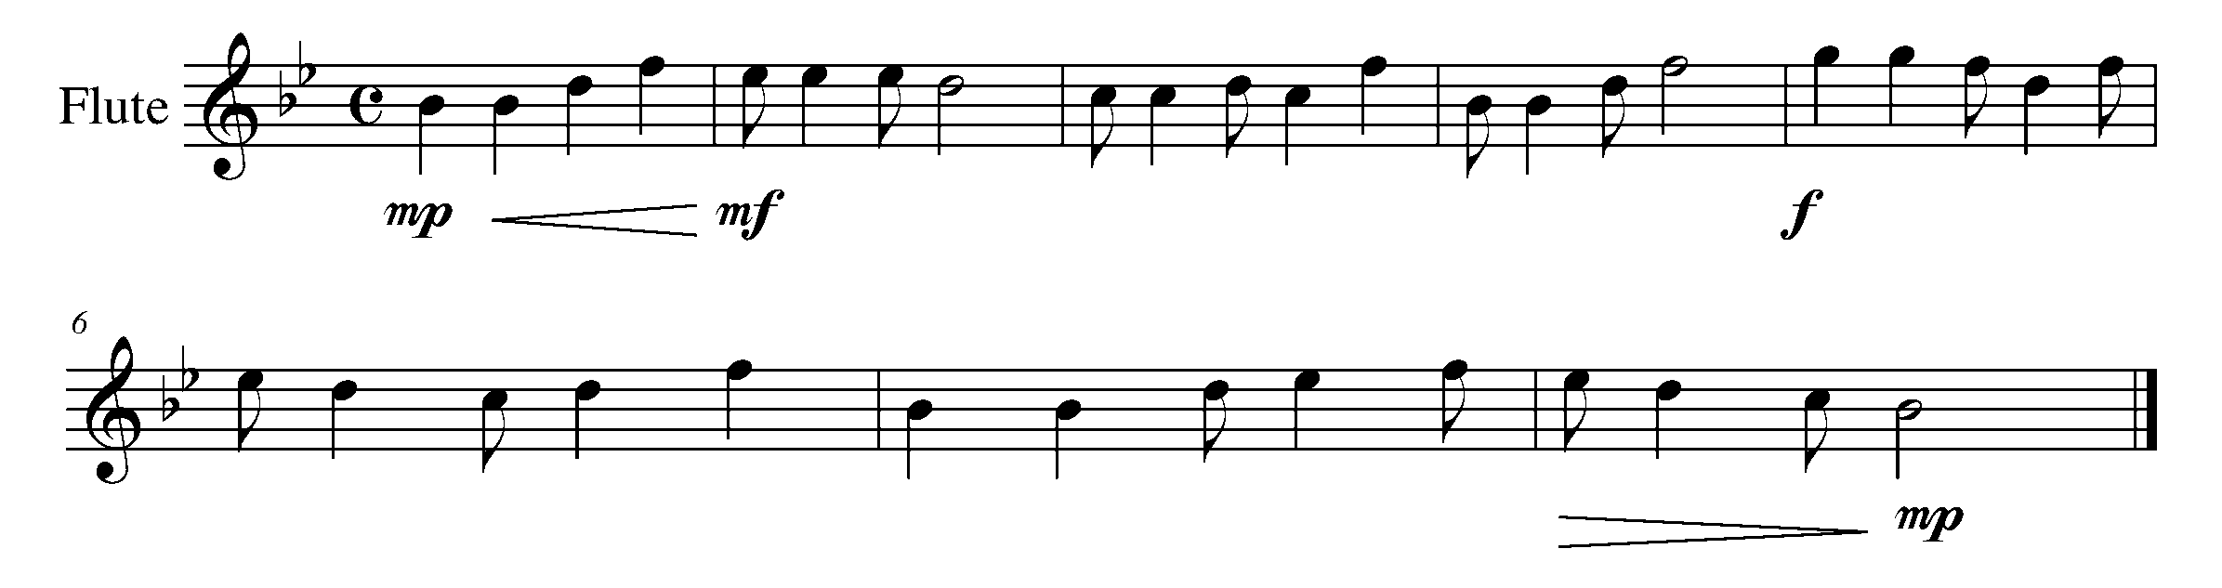
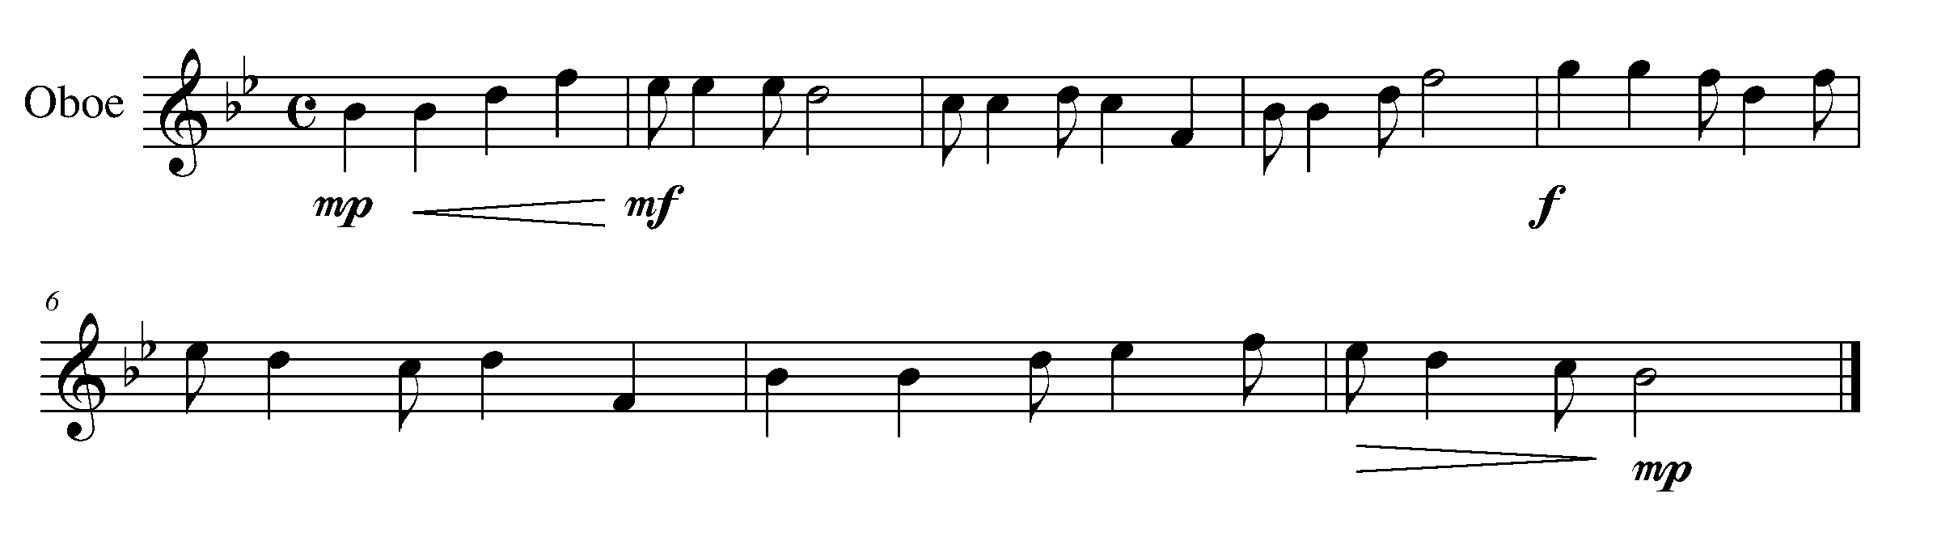

Task 3 Music Continued
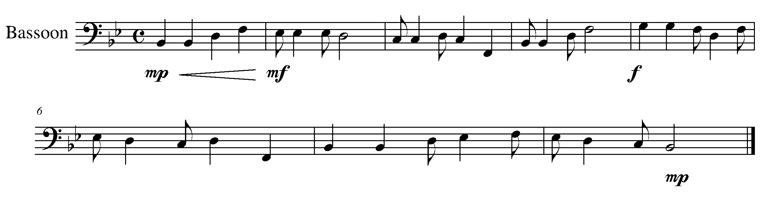
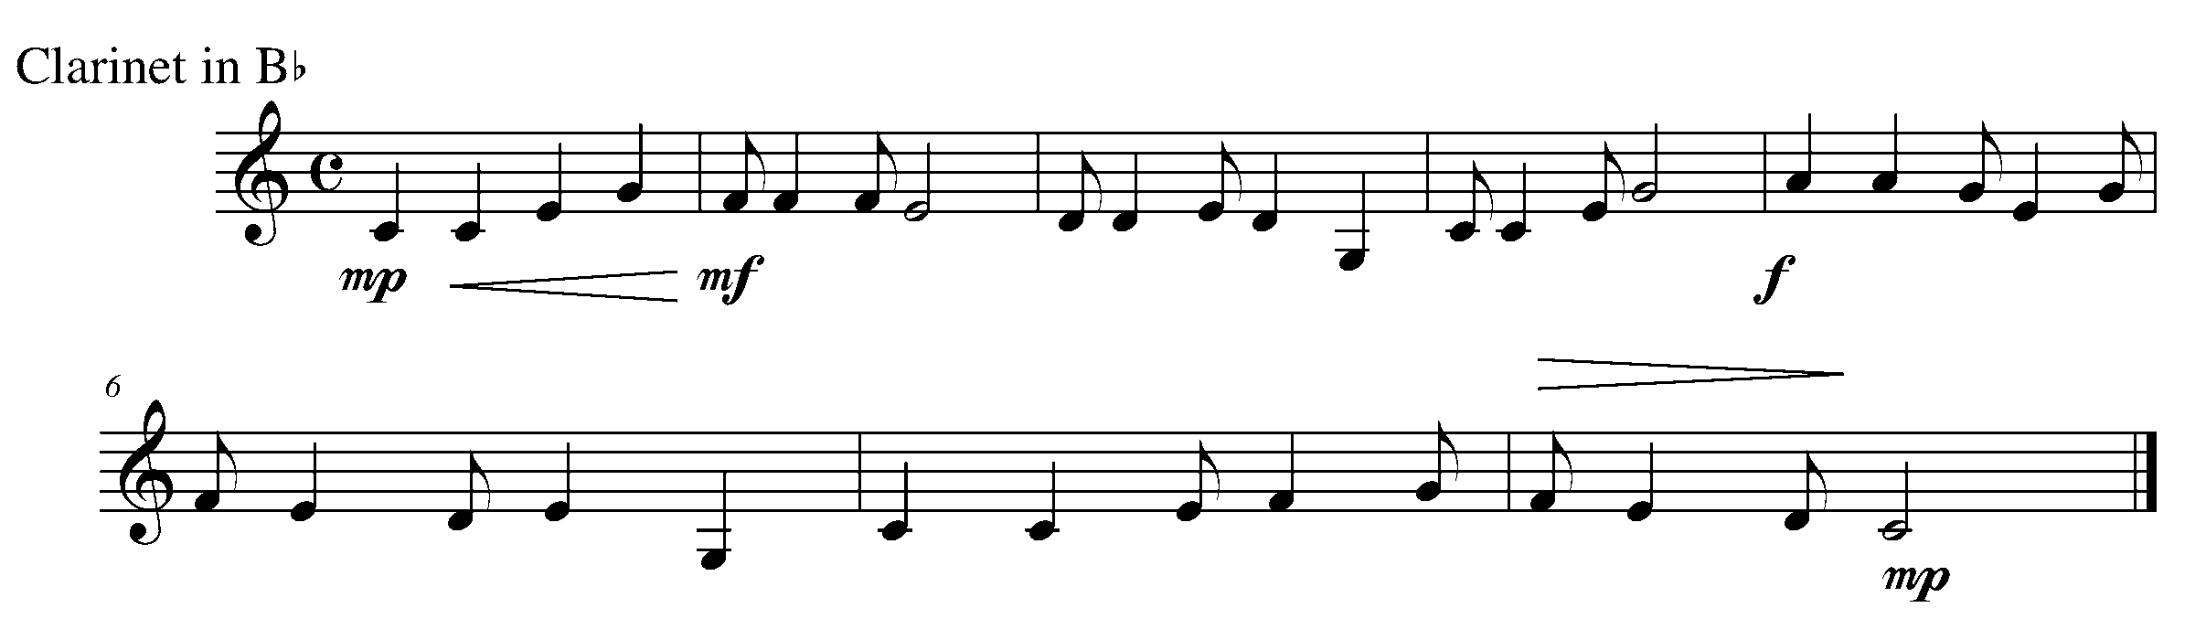
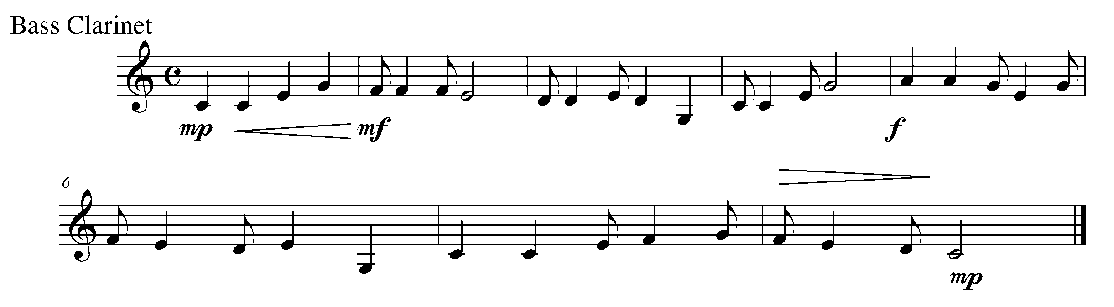
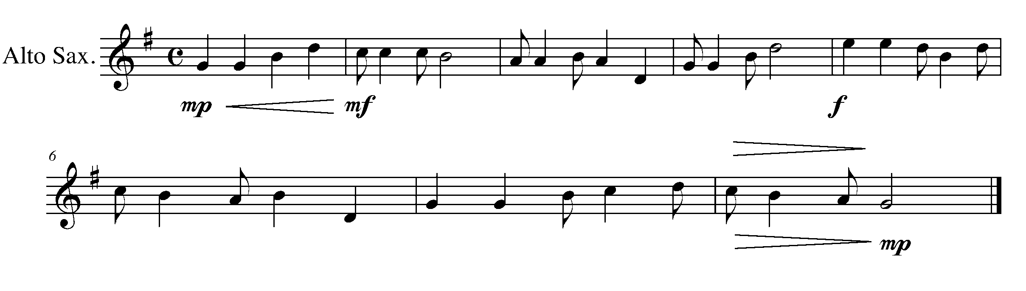
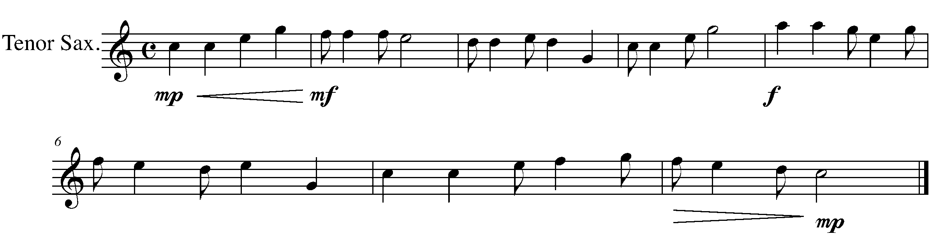
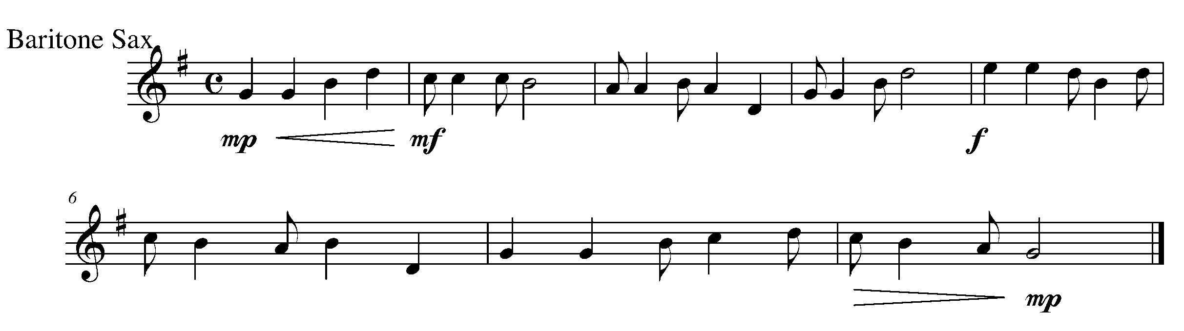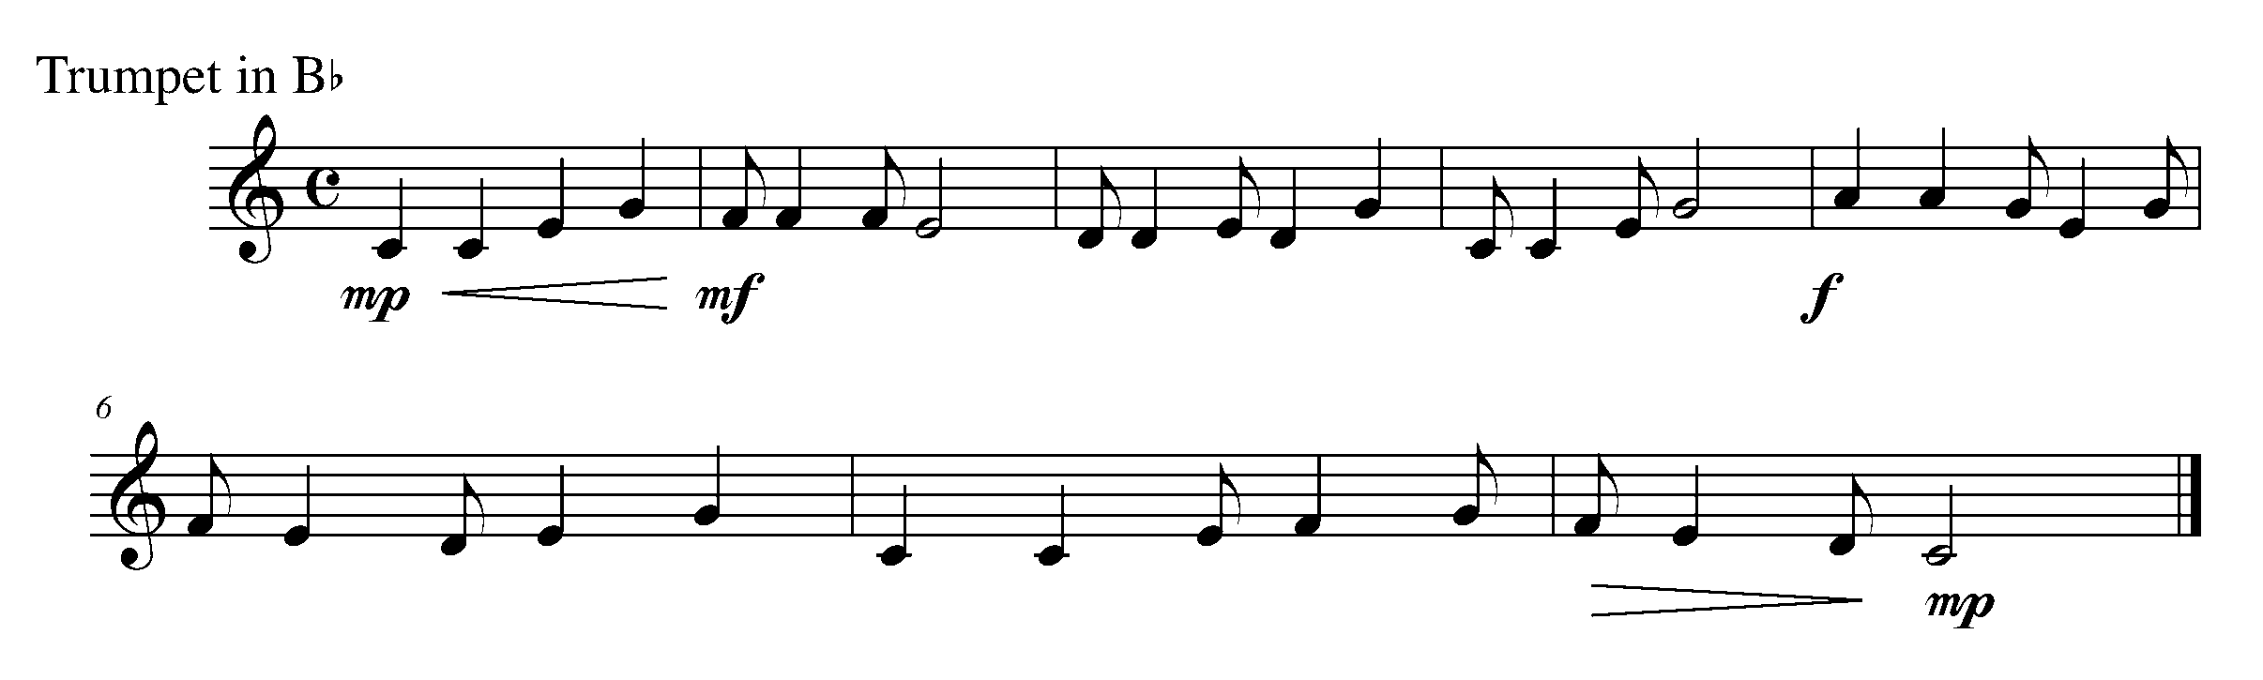
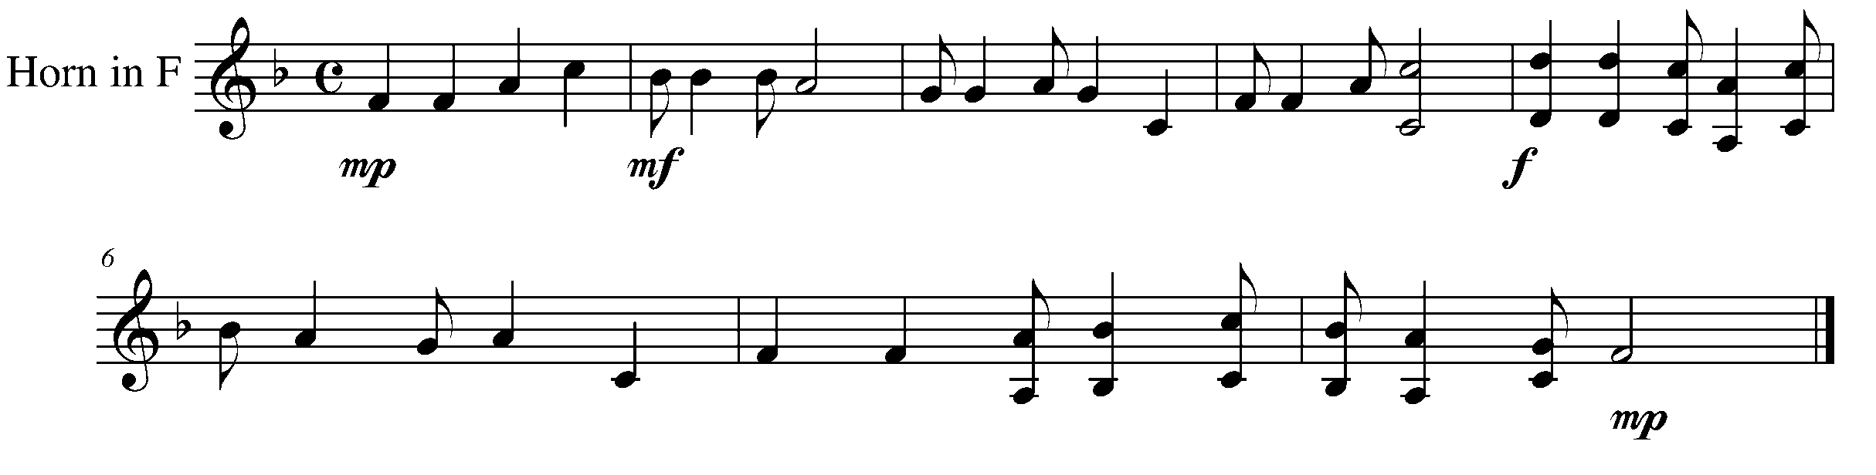
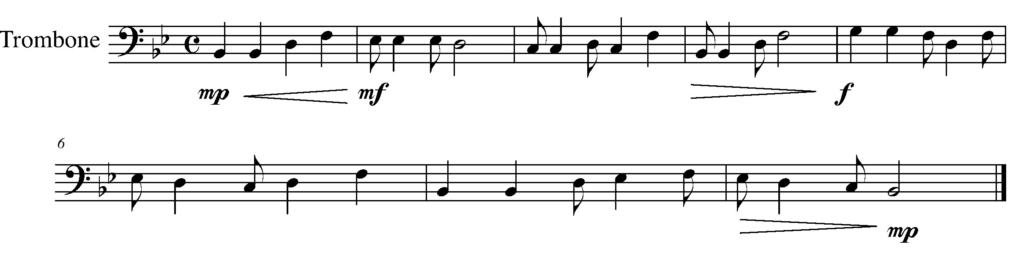
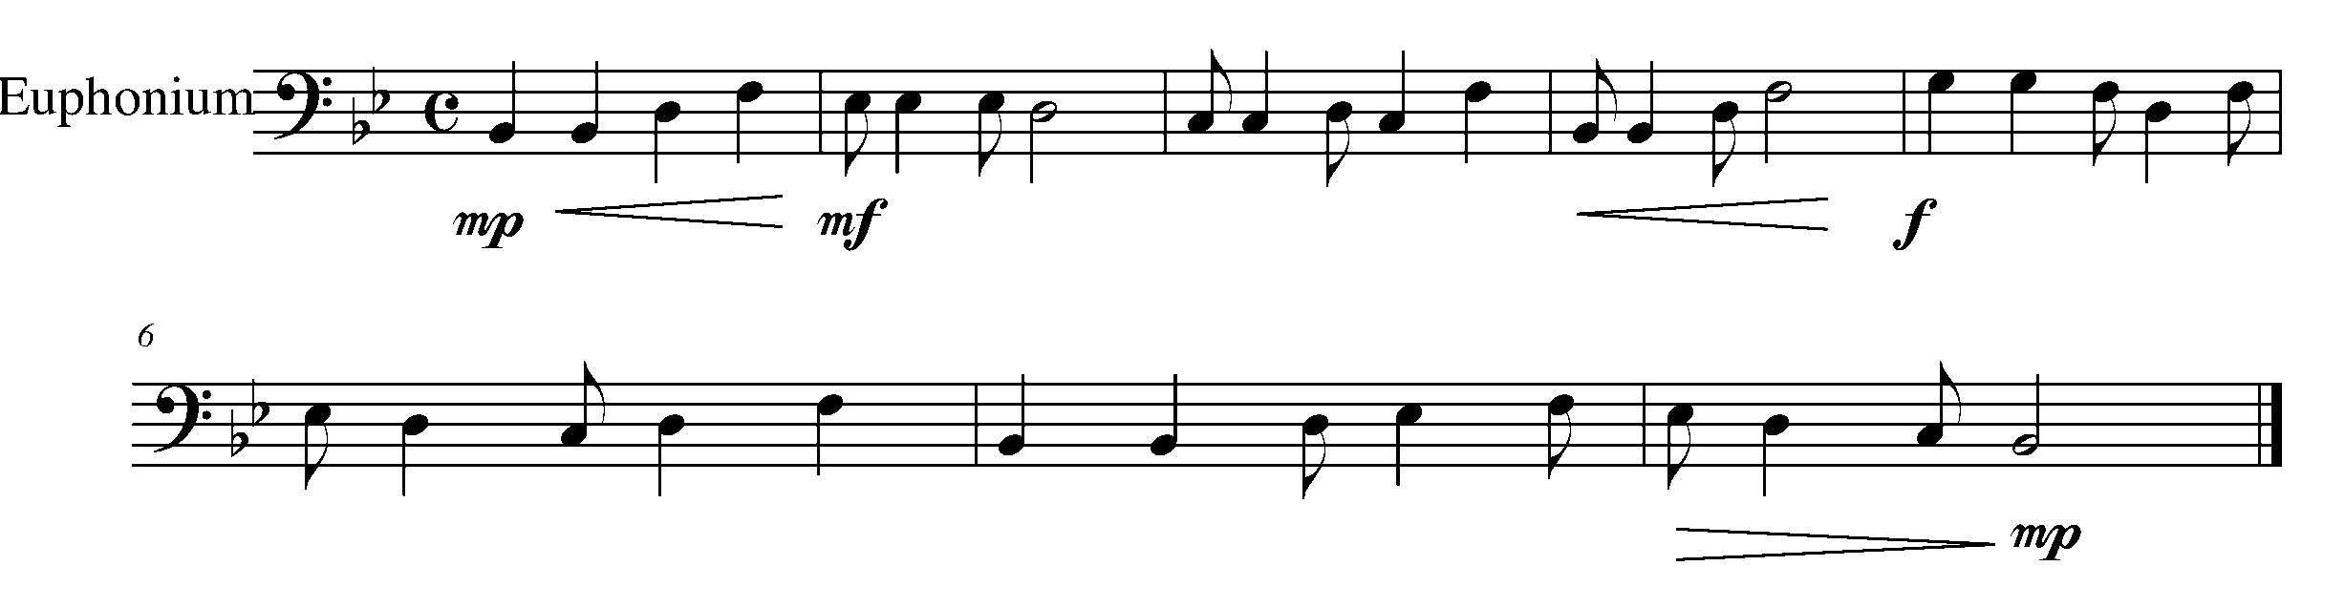

Task 3 Music Continued
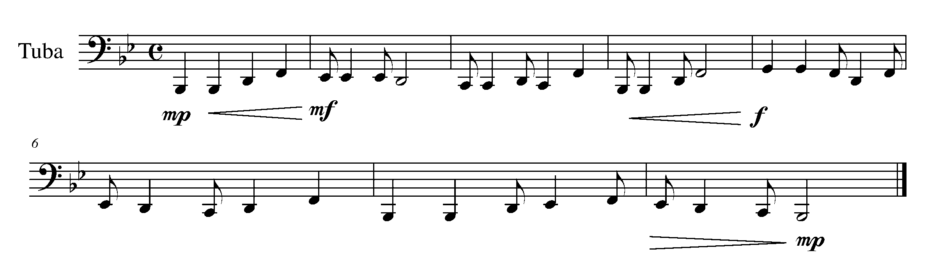
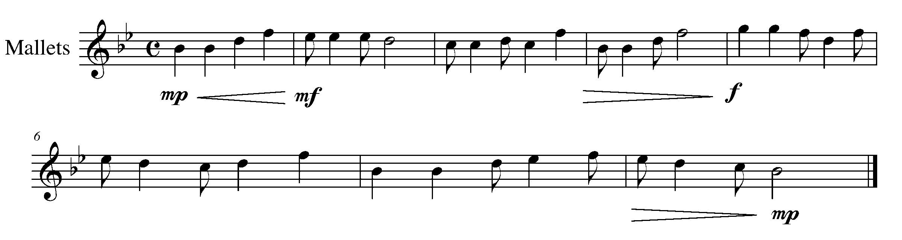

4. LONG, SHORT, LONG, SHORT FOCUS: DOTTED QUARTER/
EIGHTH NOTE COMBINATION
WIND INSTRUMENTS AND SD/BD/KIT

LEARNING GOAL: The purpose of this task is to review and perform the dotted quarter note, eighth note combination.
NEW TECHNIQUE: CONCERT BASS DRUM ROLL
Percussionists: If you are performing this task on the concert bass drum, you will be expected to play a roll on the concert bass drum. This will require two bass drum mallets. The roll is performed on one side of the bass drum. Your teacher may choose to eliminate the roll from this task.

MINDS ON! When you play the rhythm combination of a dotted quarter note and an eighth note, is the eighth note getting the full ½ beat value? How does this combination change the feel of a piece?

ACTION! To be successful with this task, you will need to:

- Scan the piece before you begin to play. Look for new rhythms, notes and symbols;
- Accurately place the rhythms on the appropriate beats or “off” beats; and
- Demonstrate an understanding of breath control and phrasing.

CONSOLIDATION: In order to move on to the next task, you will need to perform the following piece for your teacher and receive feedback.

Music for Task 4 is found on the next page.
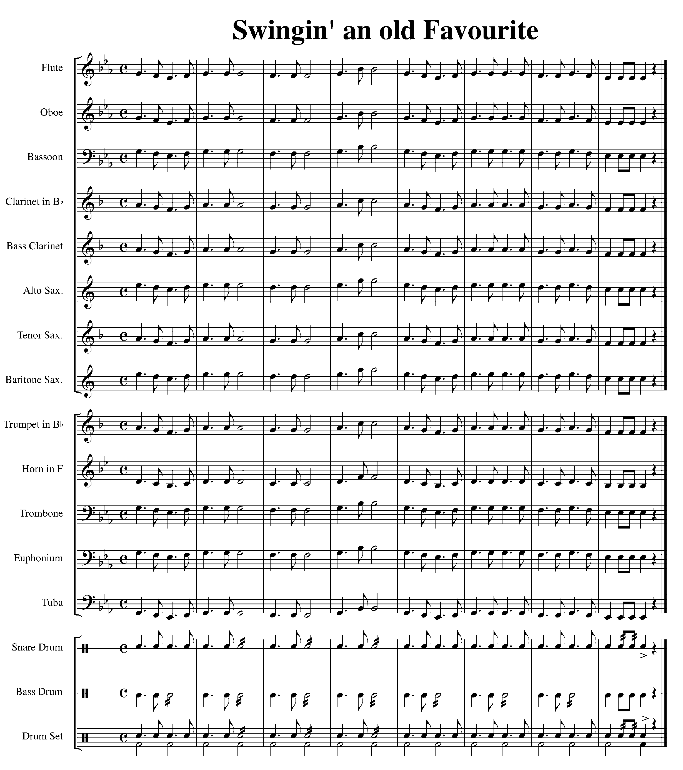

5. PUTTING IT TOGETHER FOCUS: CULMINATING TASK
WIND INSTRUMENTS, SD/BD/KIT AND MALLETS

LEARNING GOAL: The purpose of this task is to play, “Variations on Twinkle, Twinkle Little Star”. The variations will include the rhythms learned in Tasks 2, 3, and 4.

MINDS ON! What preparation do you need to do in order to have a successful performance? What does it mean when a piece is labeled “Theme and Variations”? How will you practice the rhythms in the variations of the piece below?

ACTION! To be successful with this task, you will need to:

- Review the variety of rhythms found in the below theme and variations;
- Realize what is a theme and variation; and
- Perform with good breath control, phrasing, articulation and accuracy.

CONSOLIDATION: In order to move on to the next section and task, you will need to perform the following “Variations on Twinkle, Twinkle Little Star” for your teacher and receive feedback.

Music for Task 5 is found on the following pages.
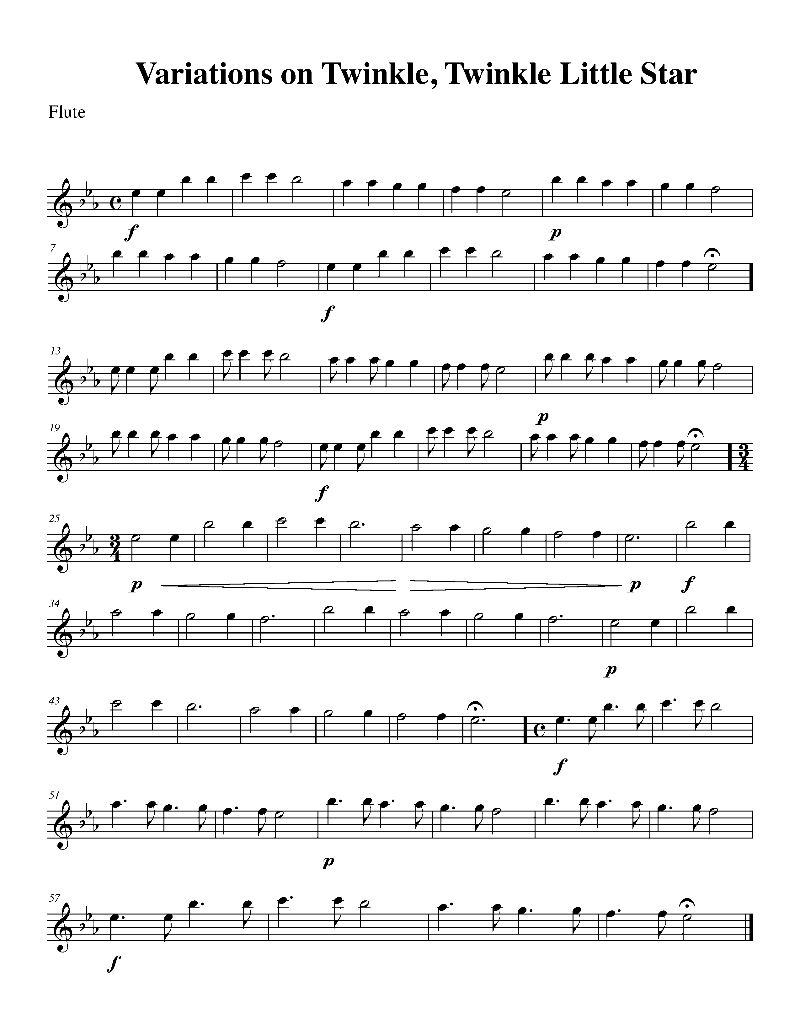
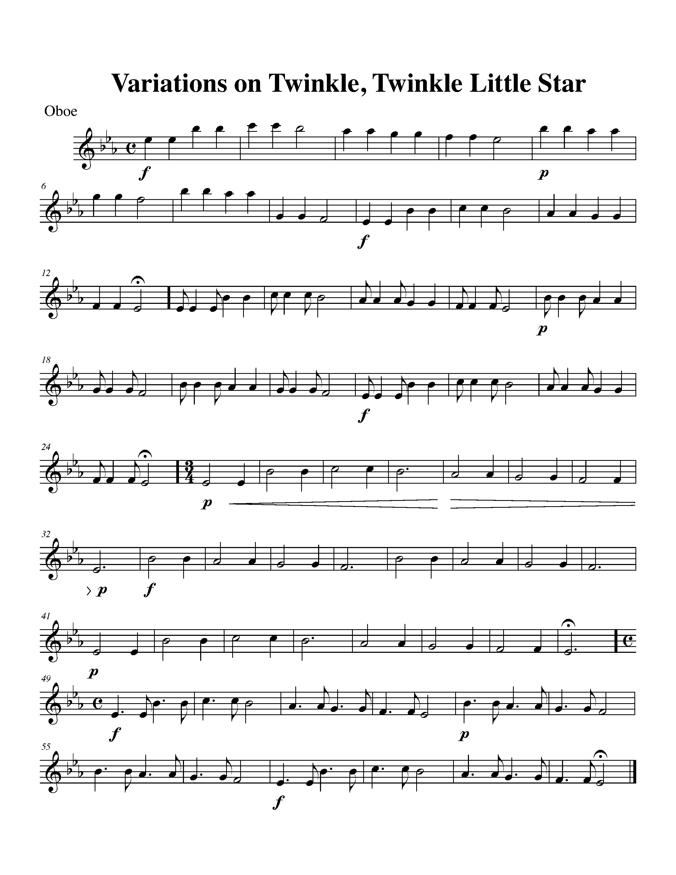
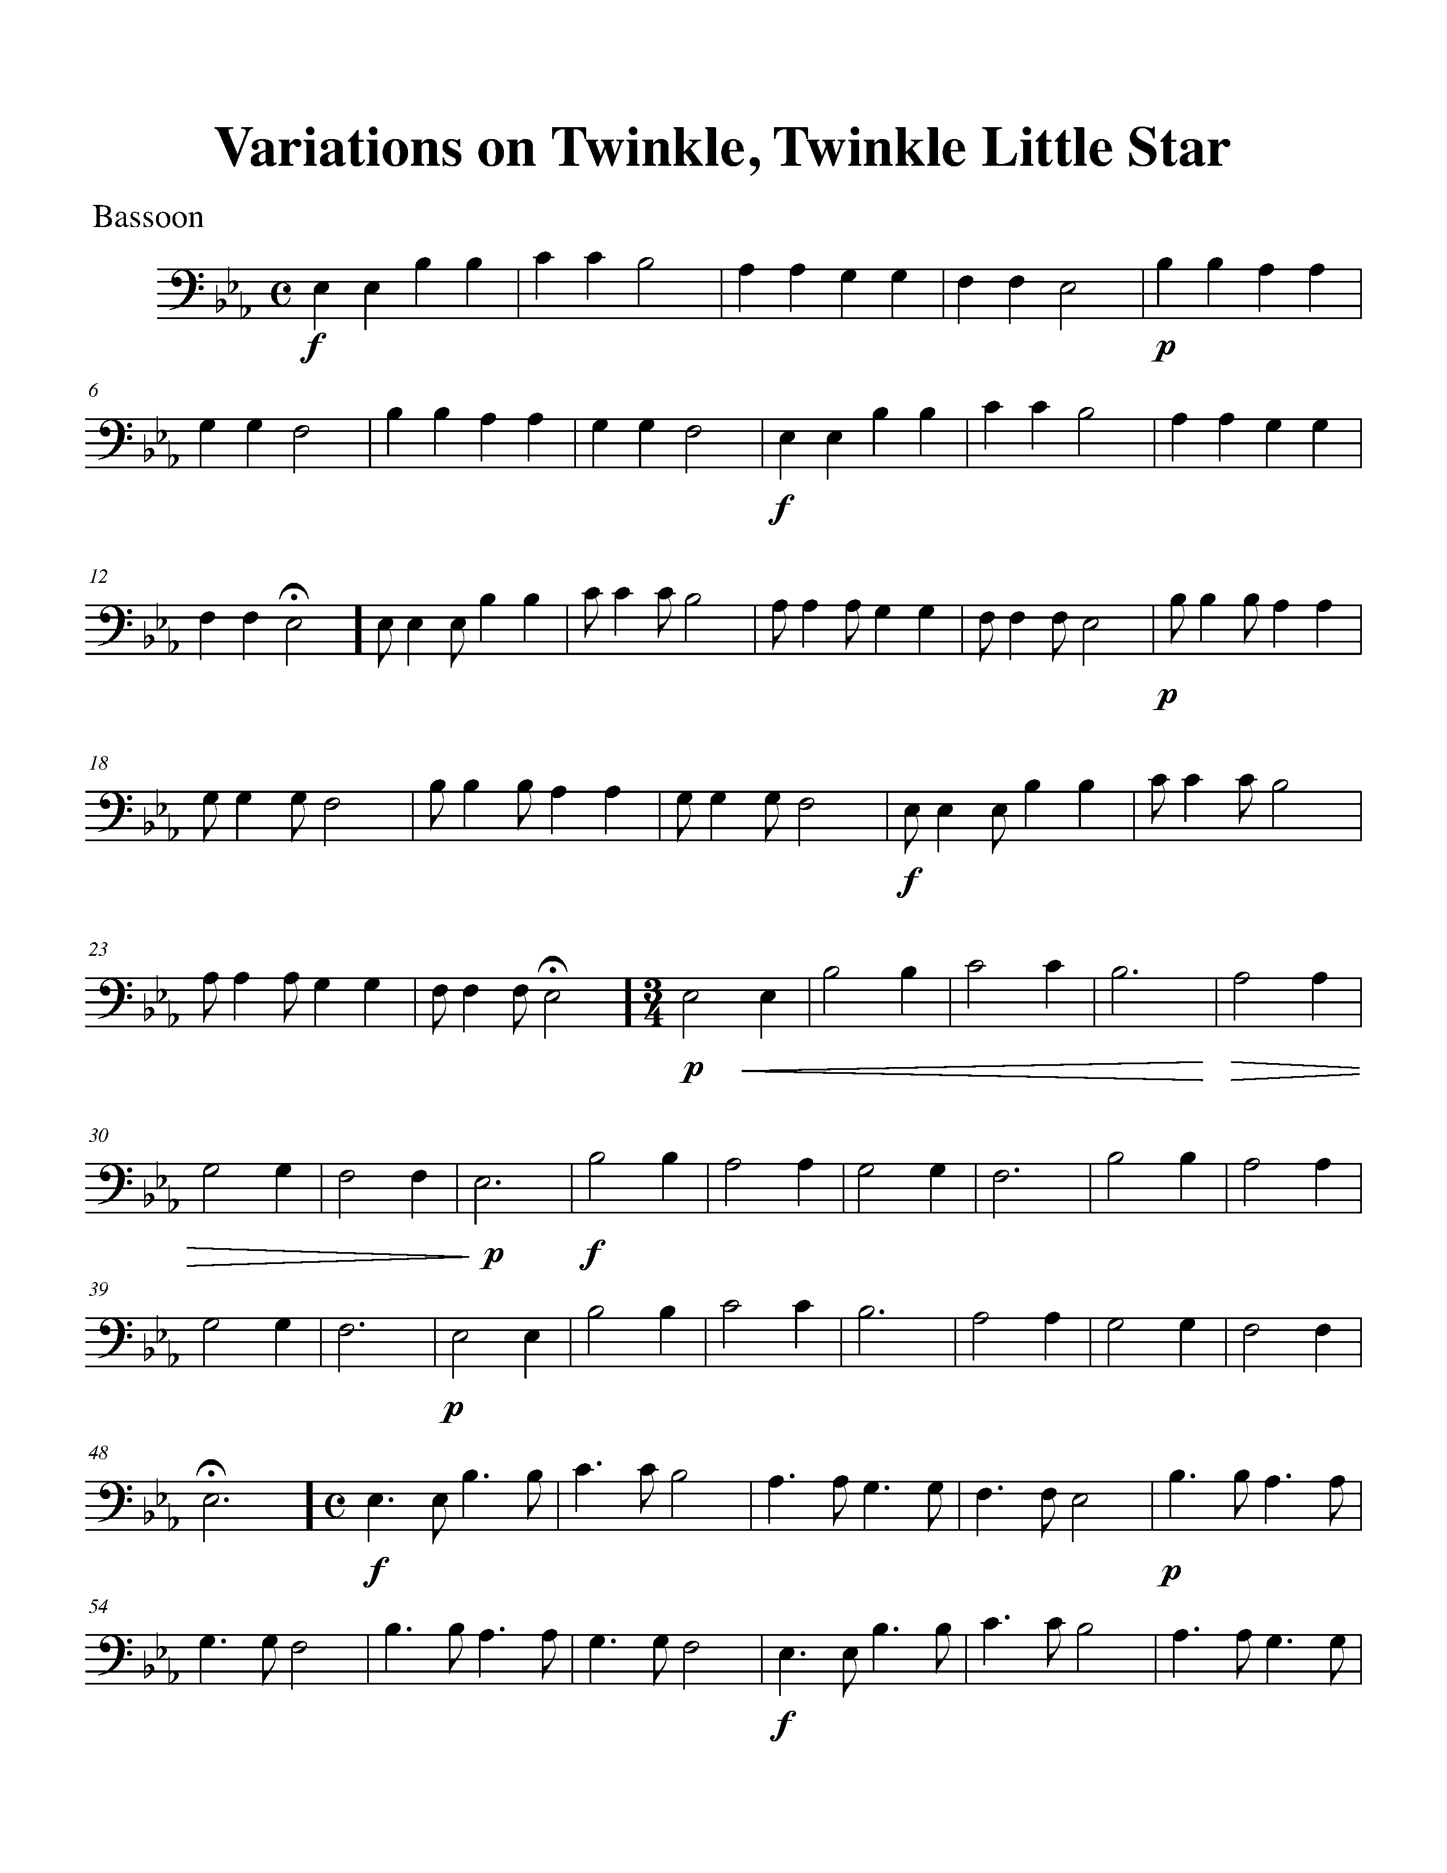
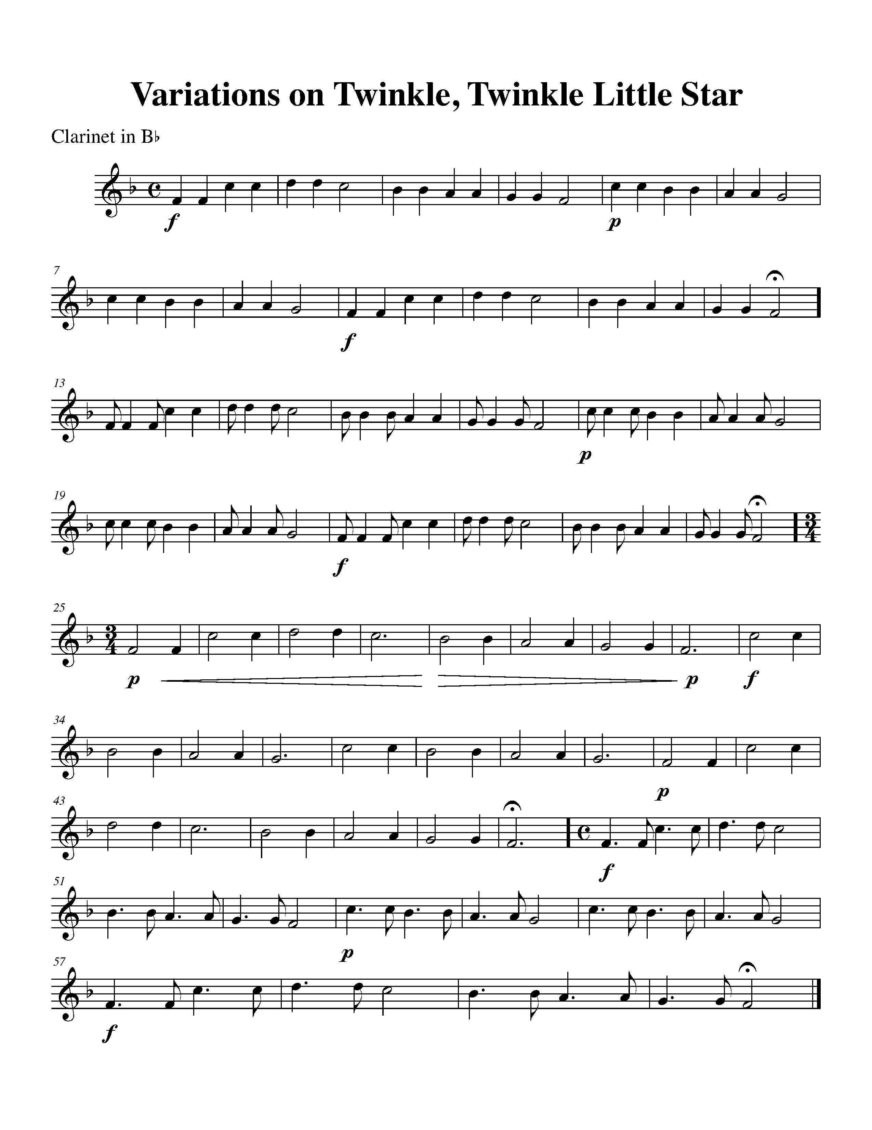
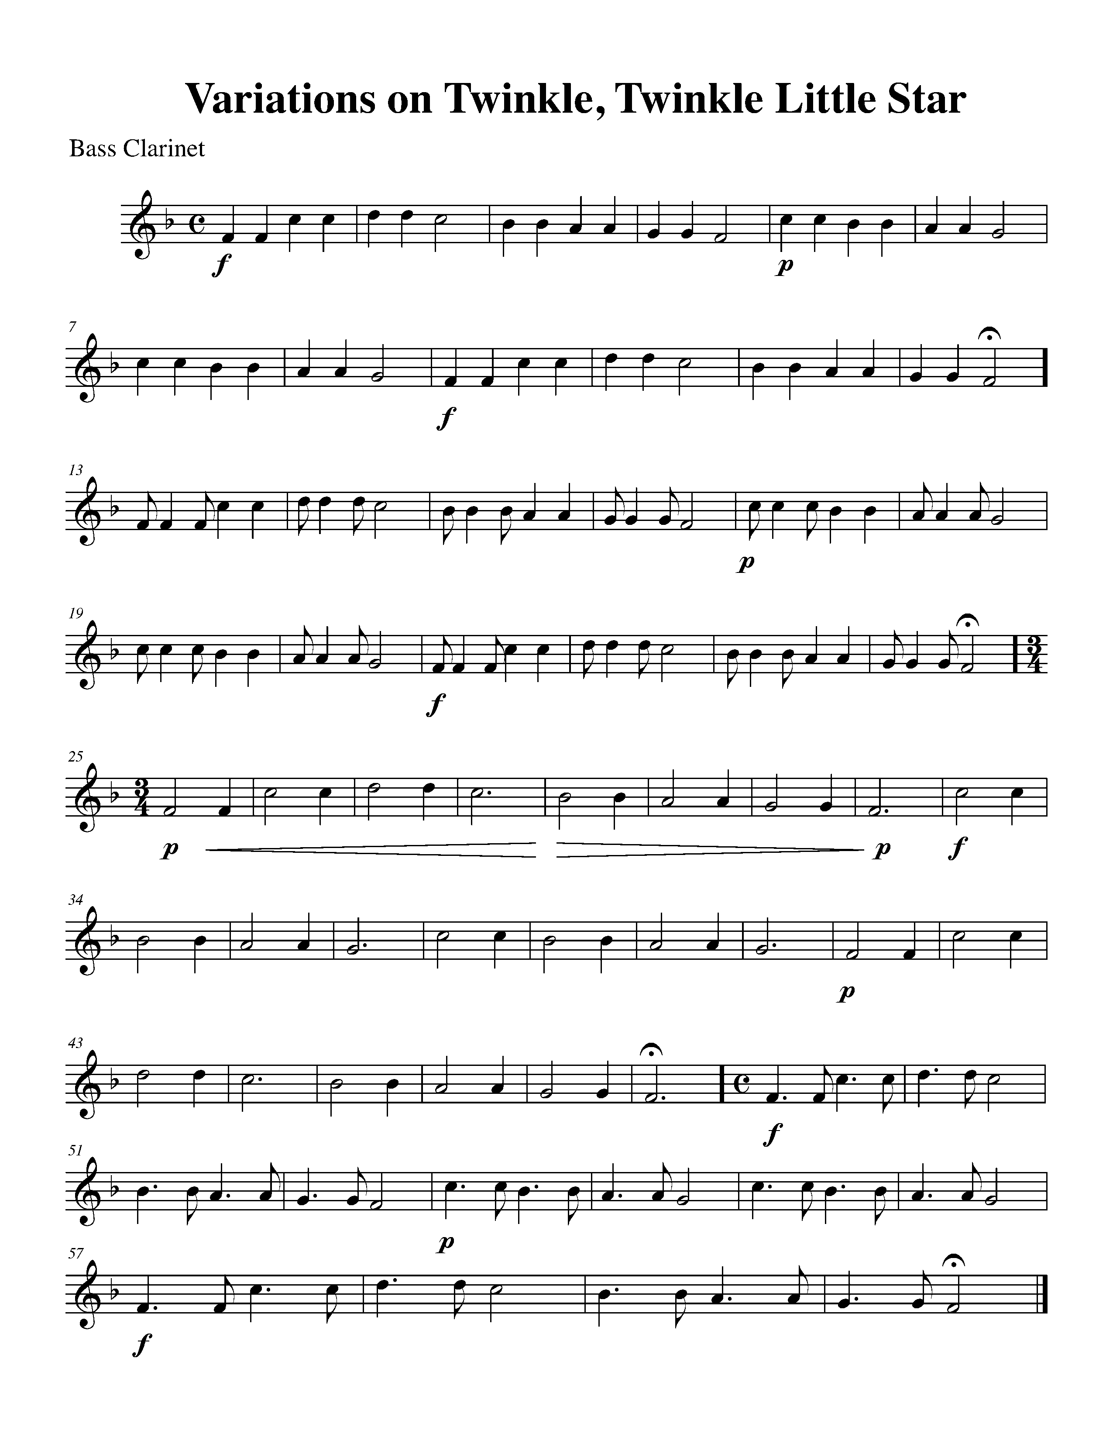
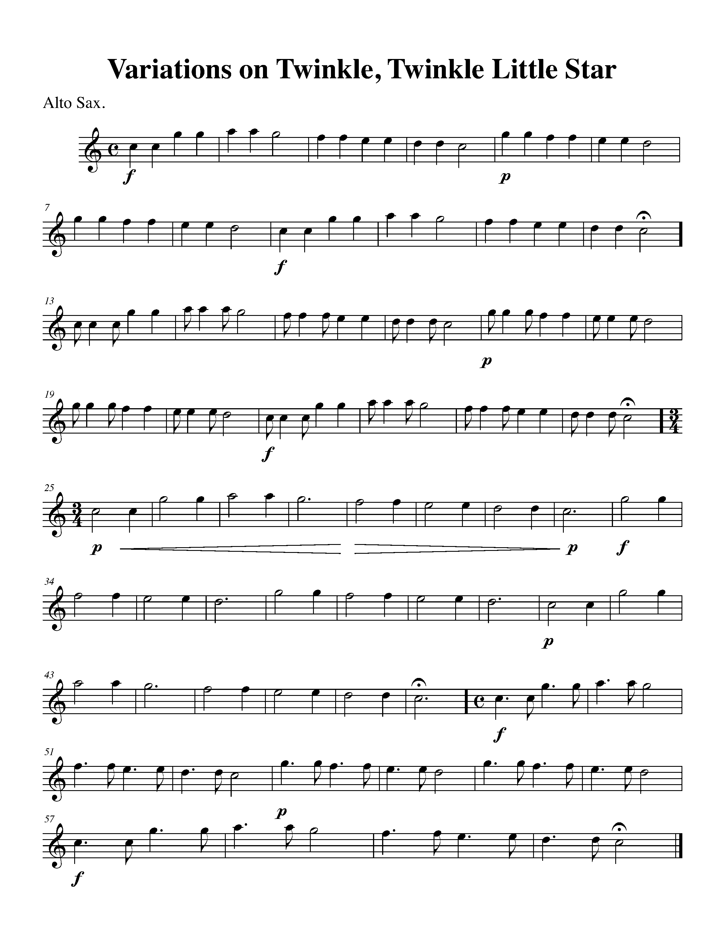
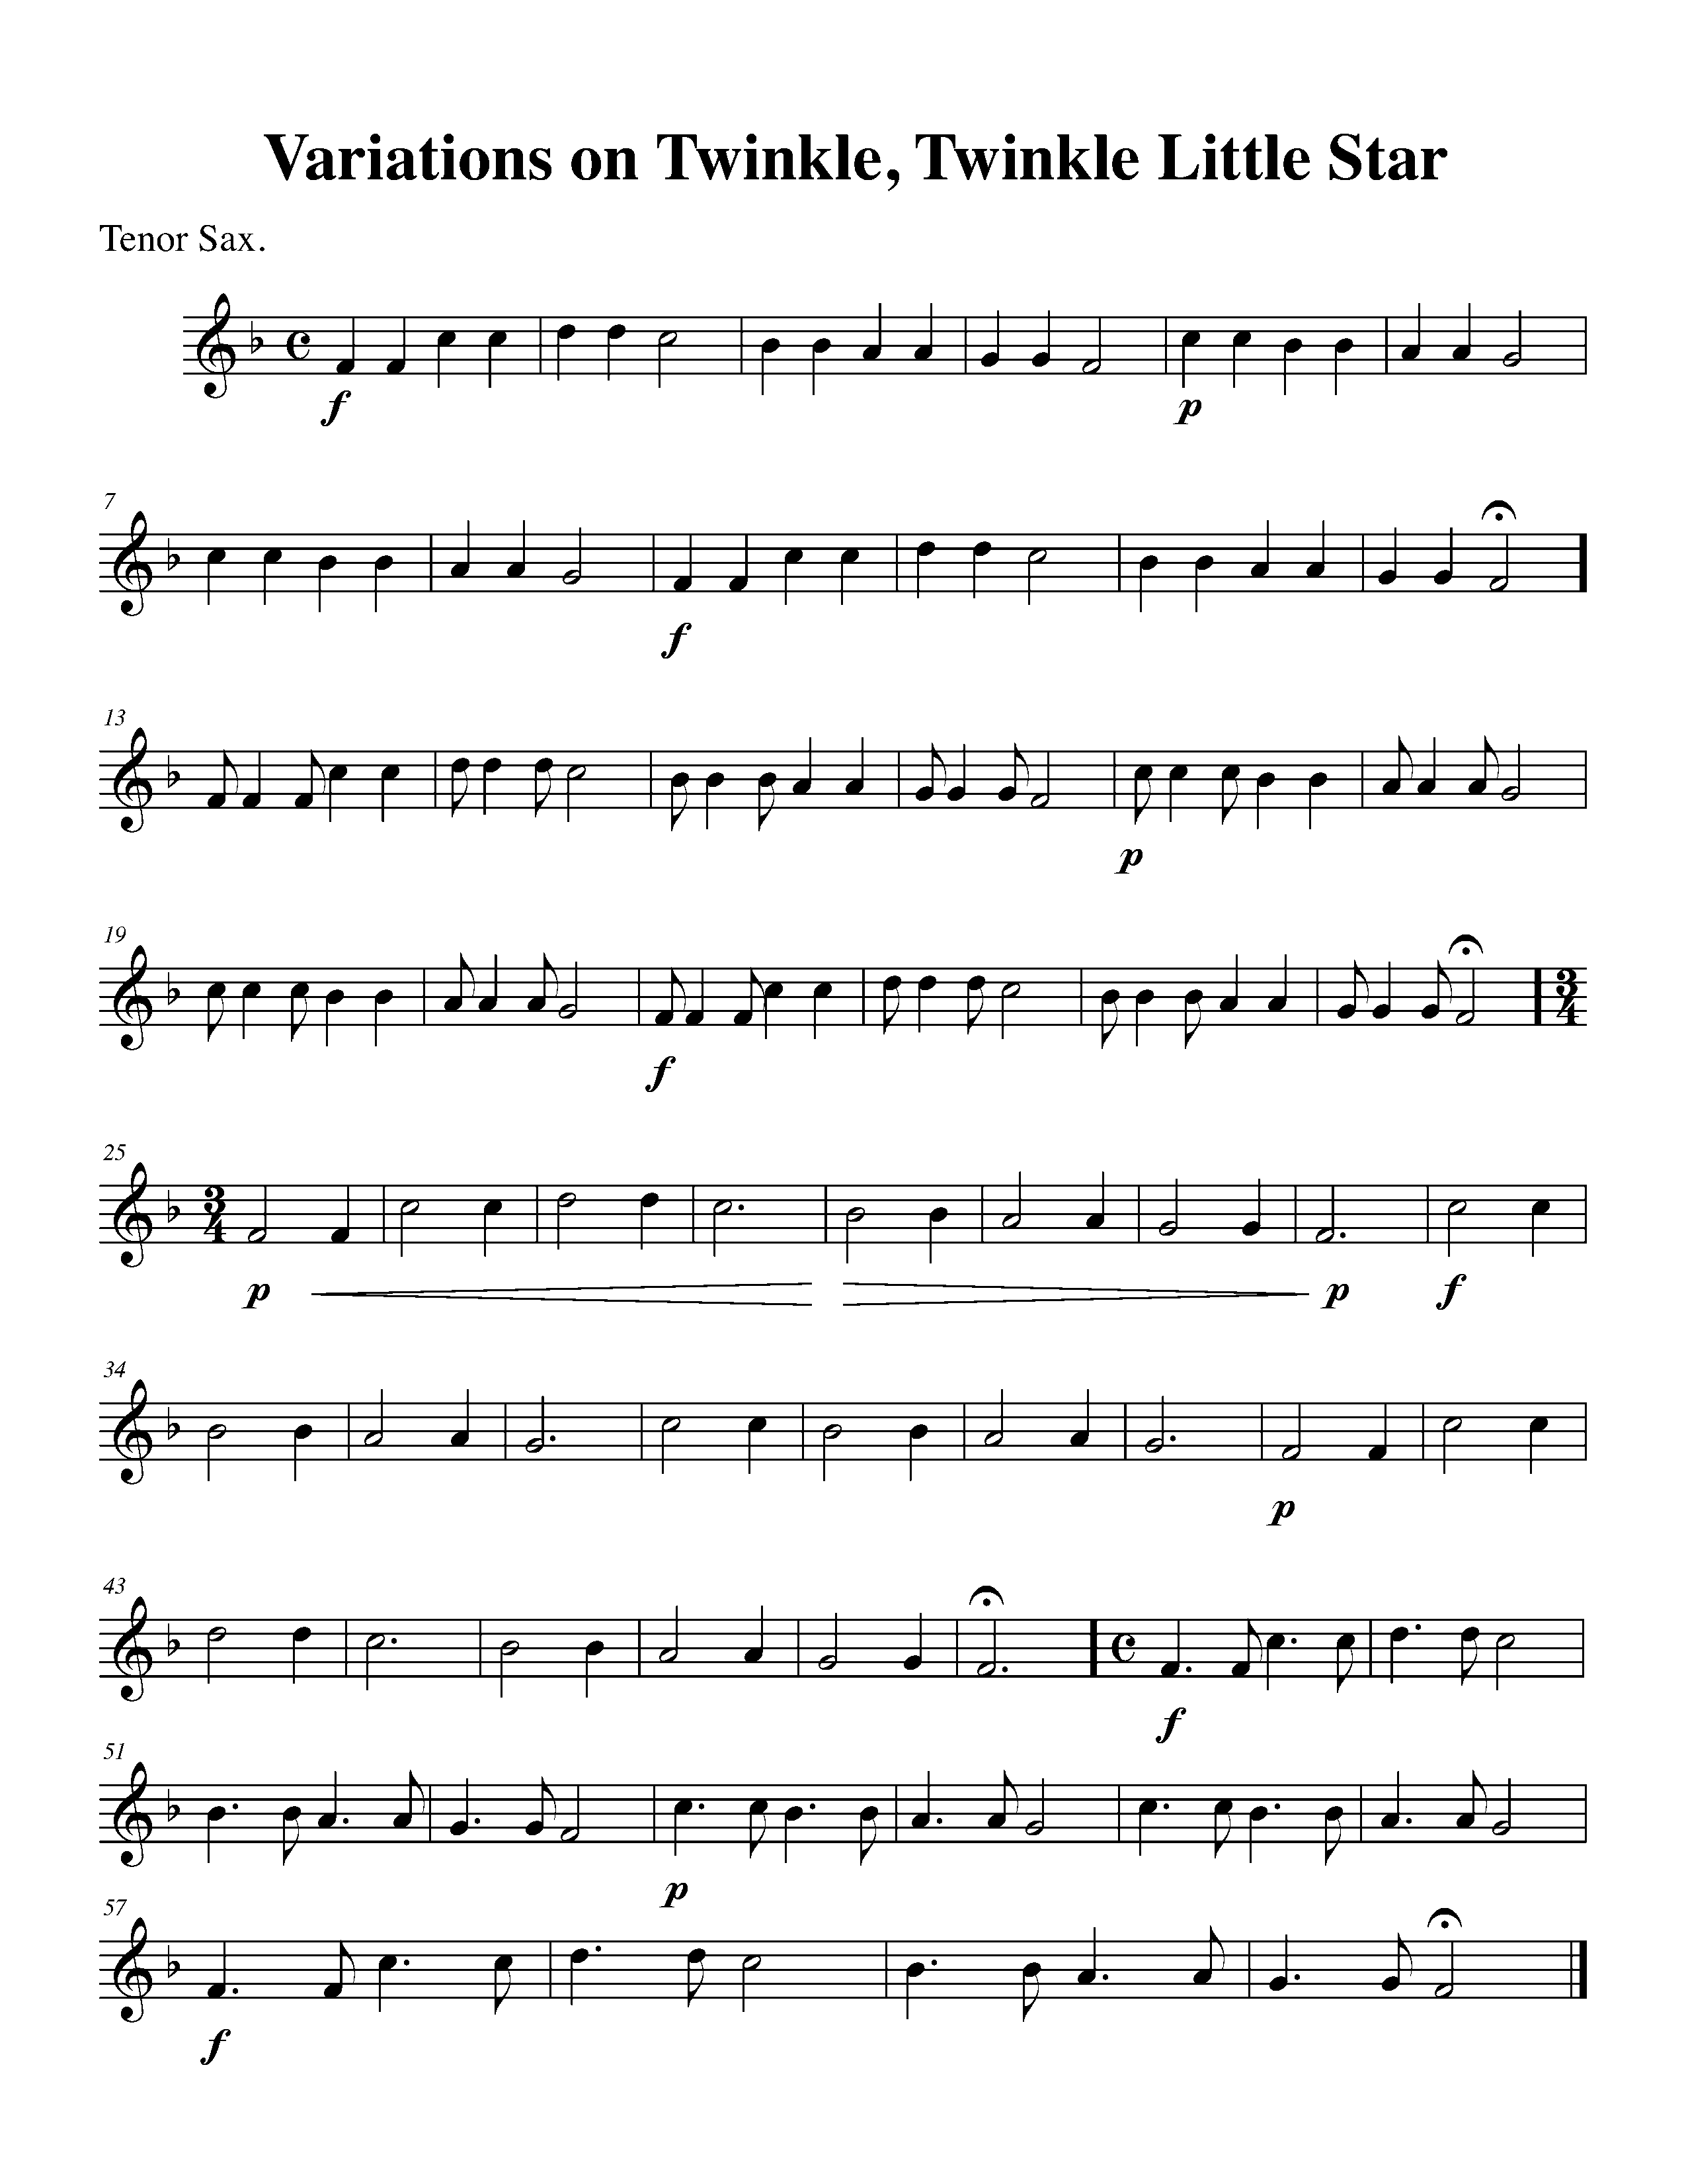
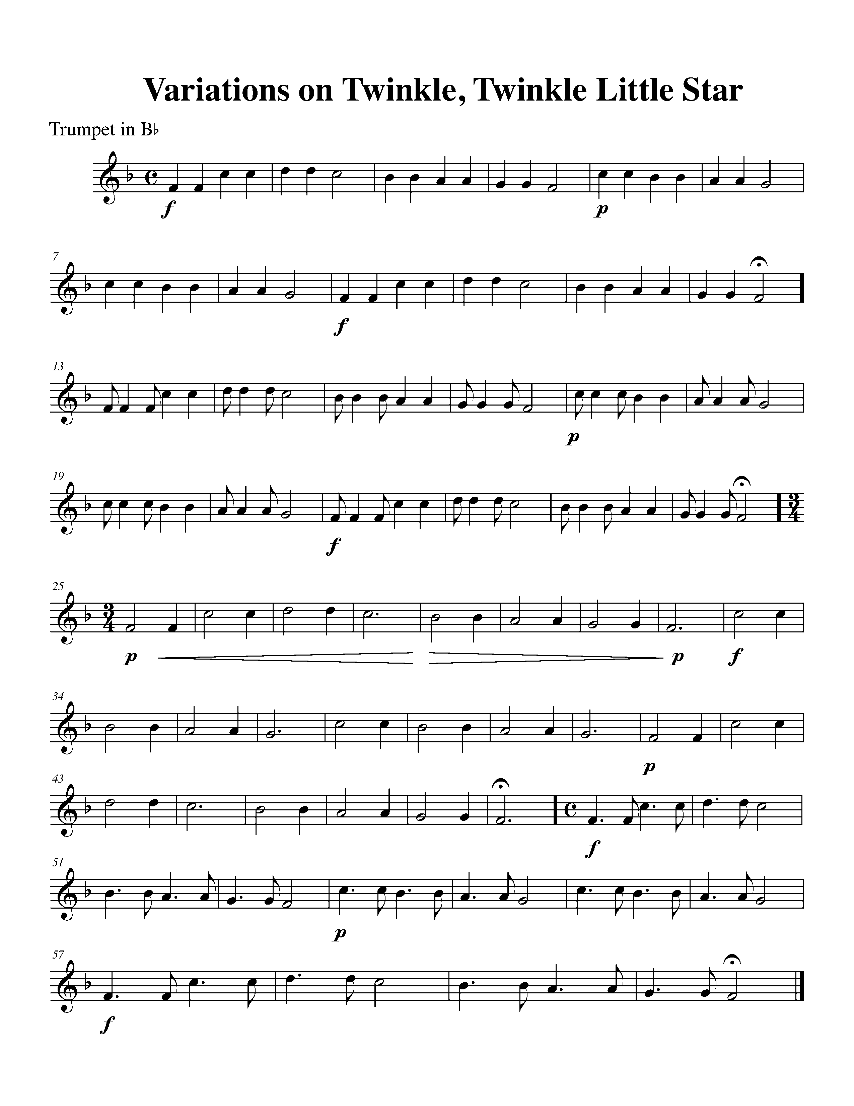
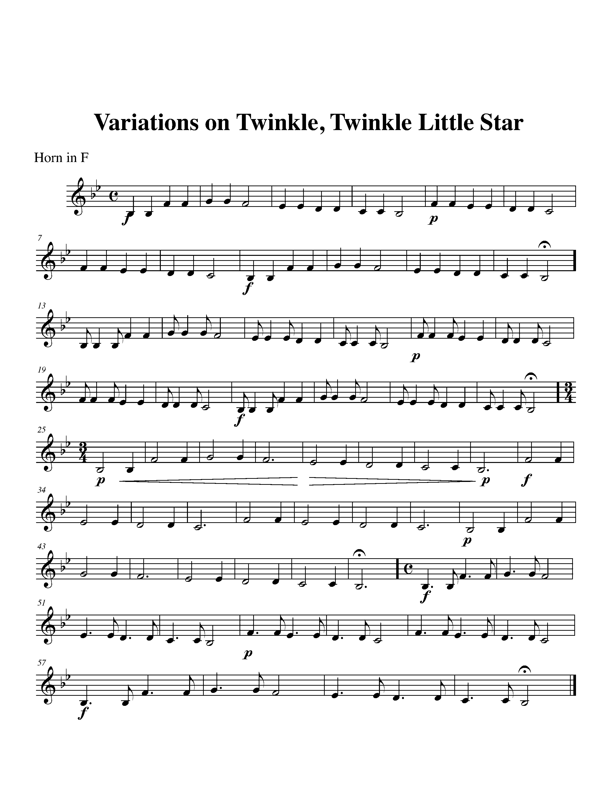
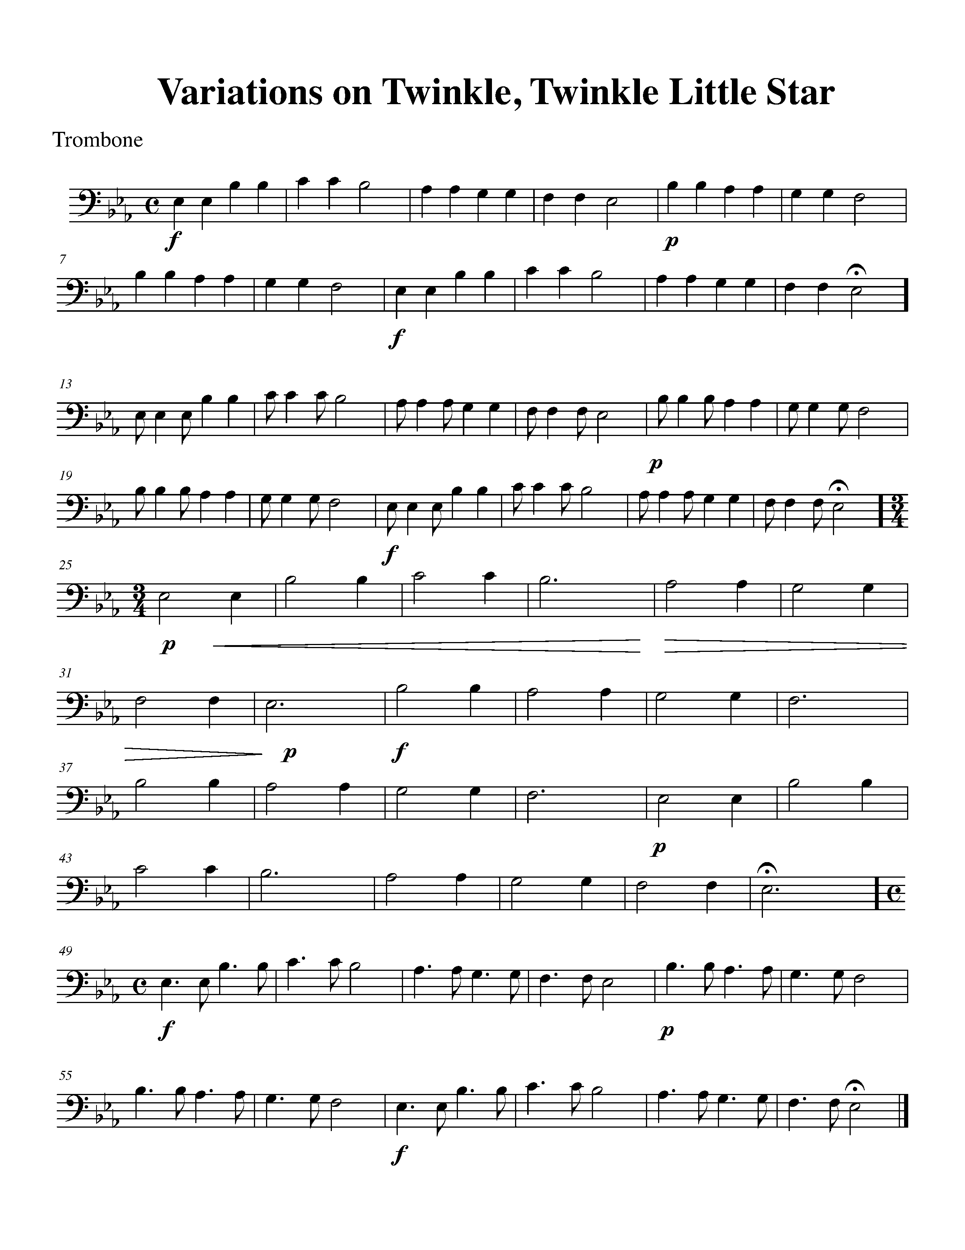

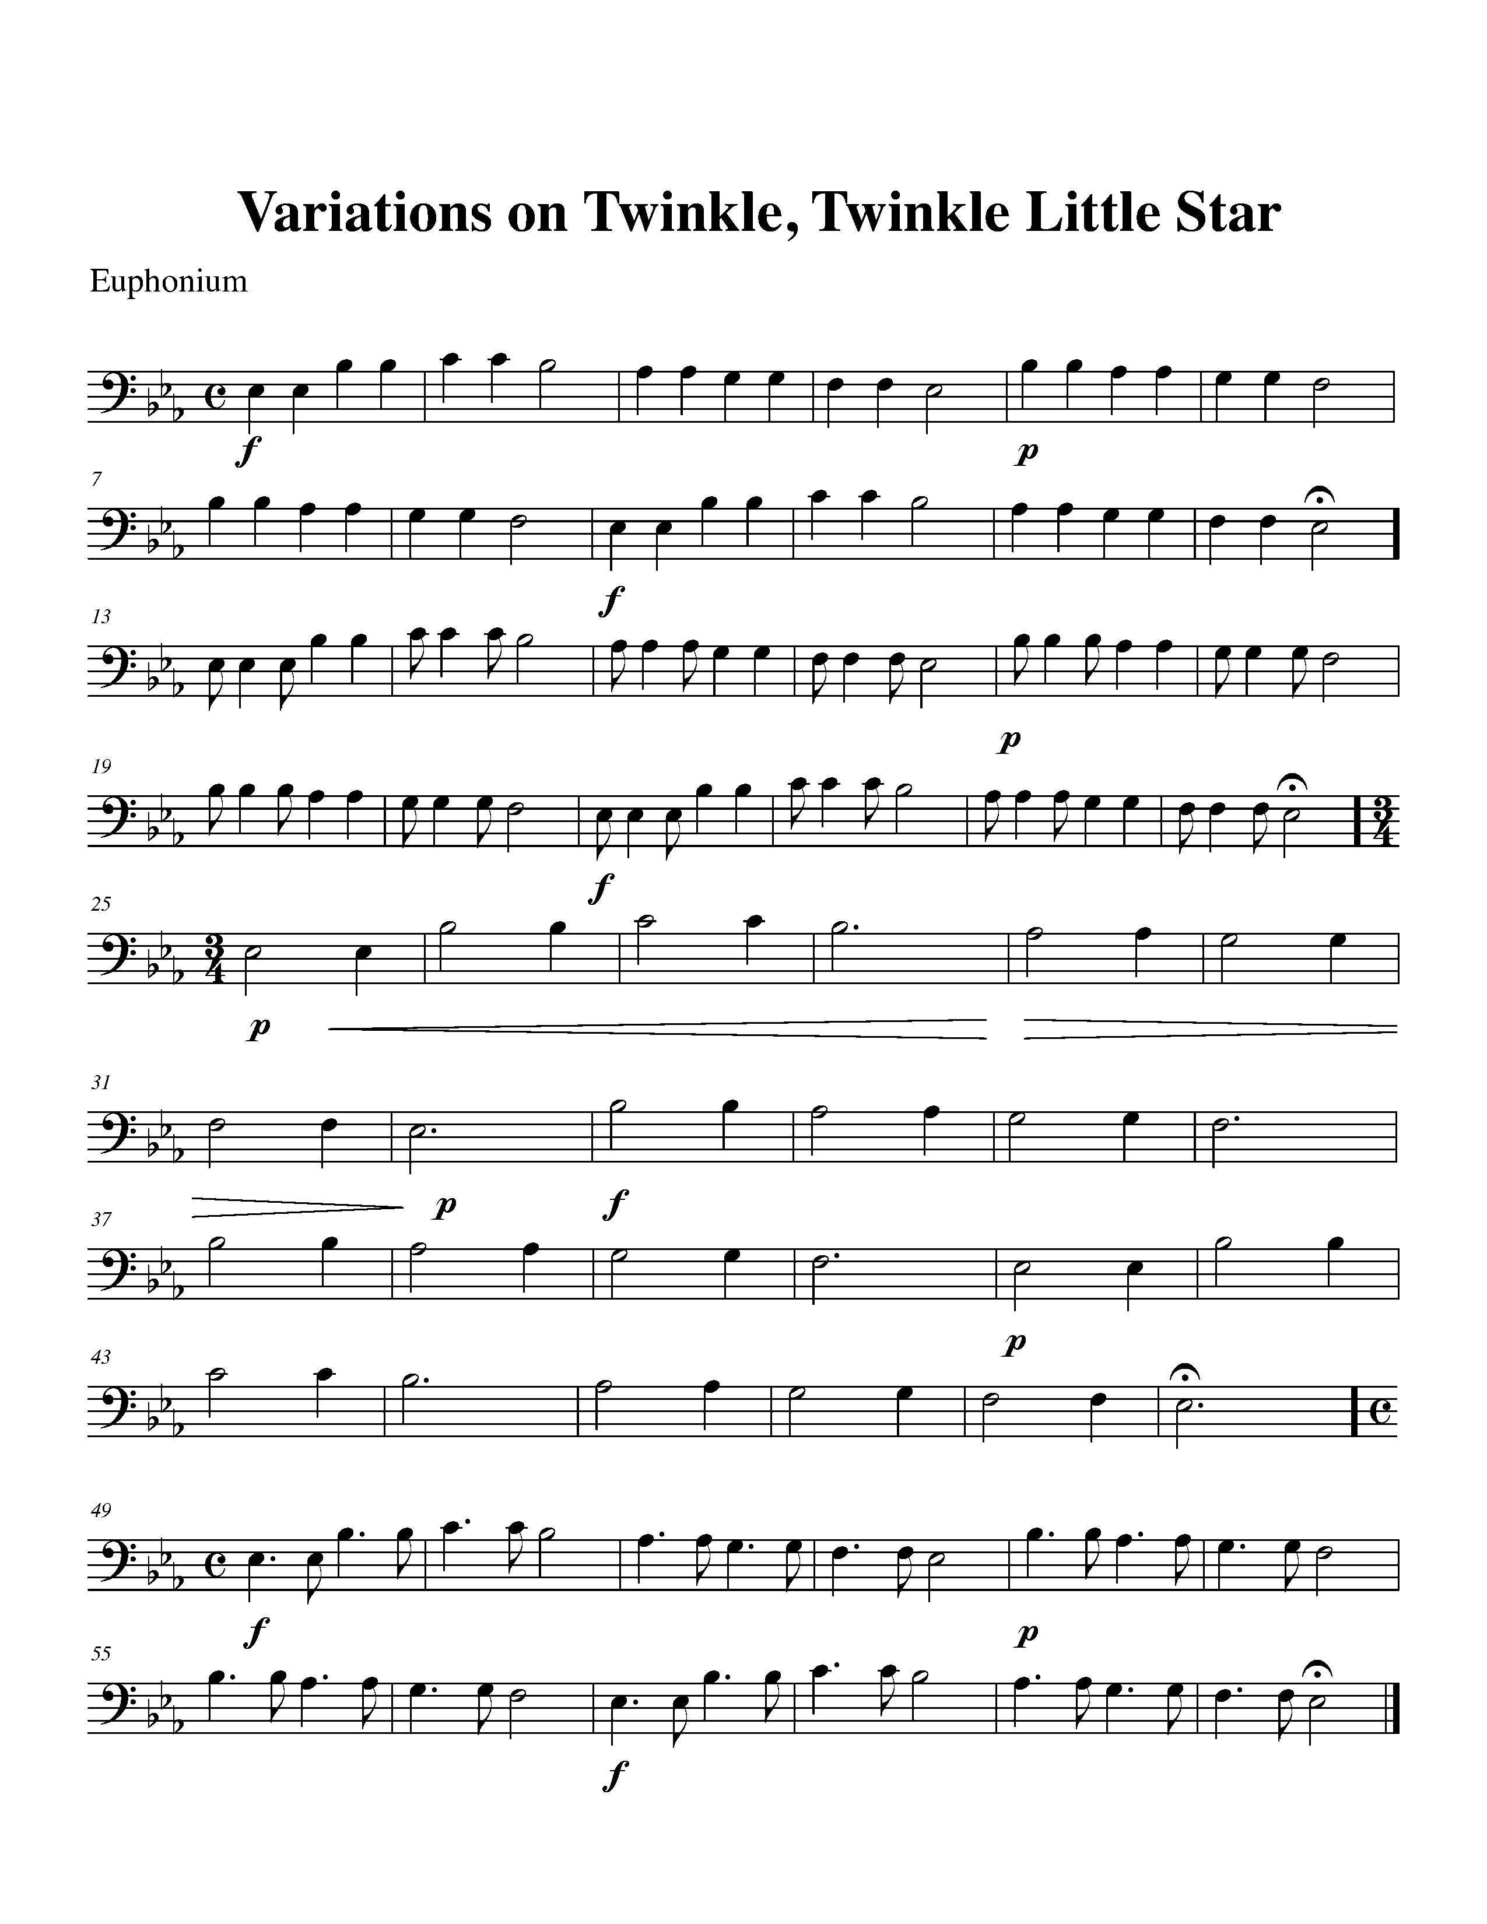
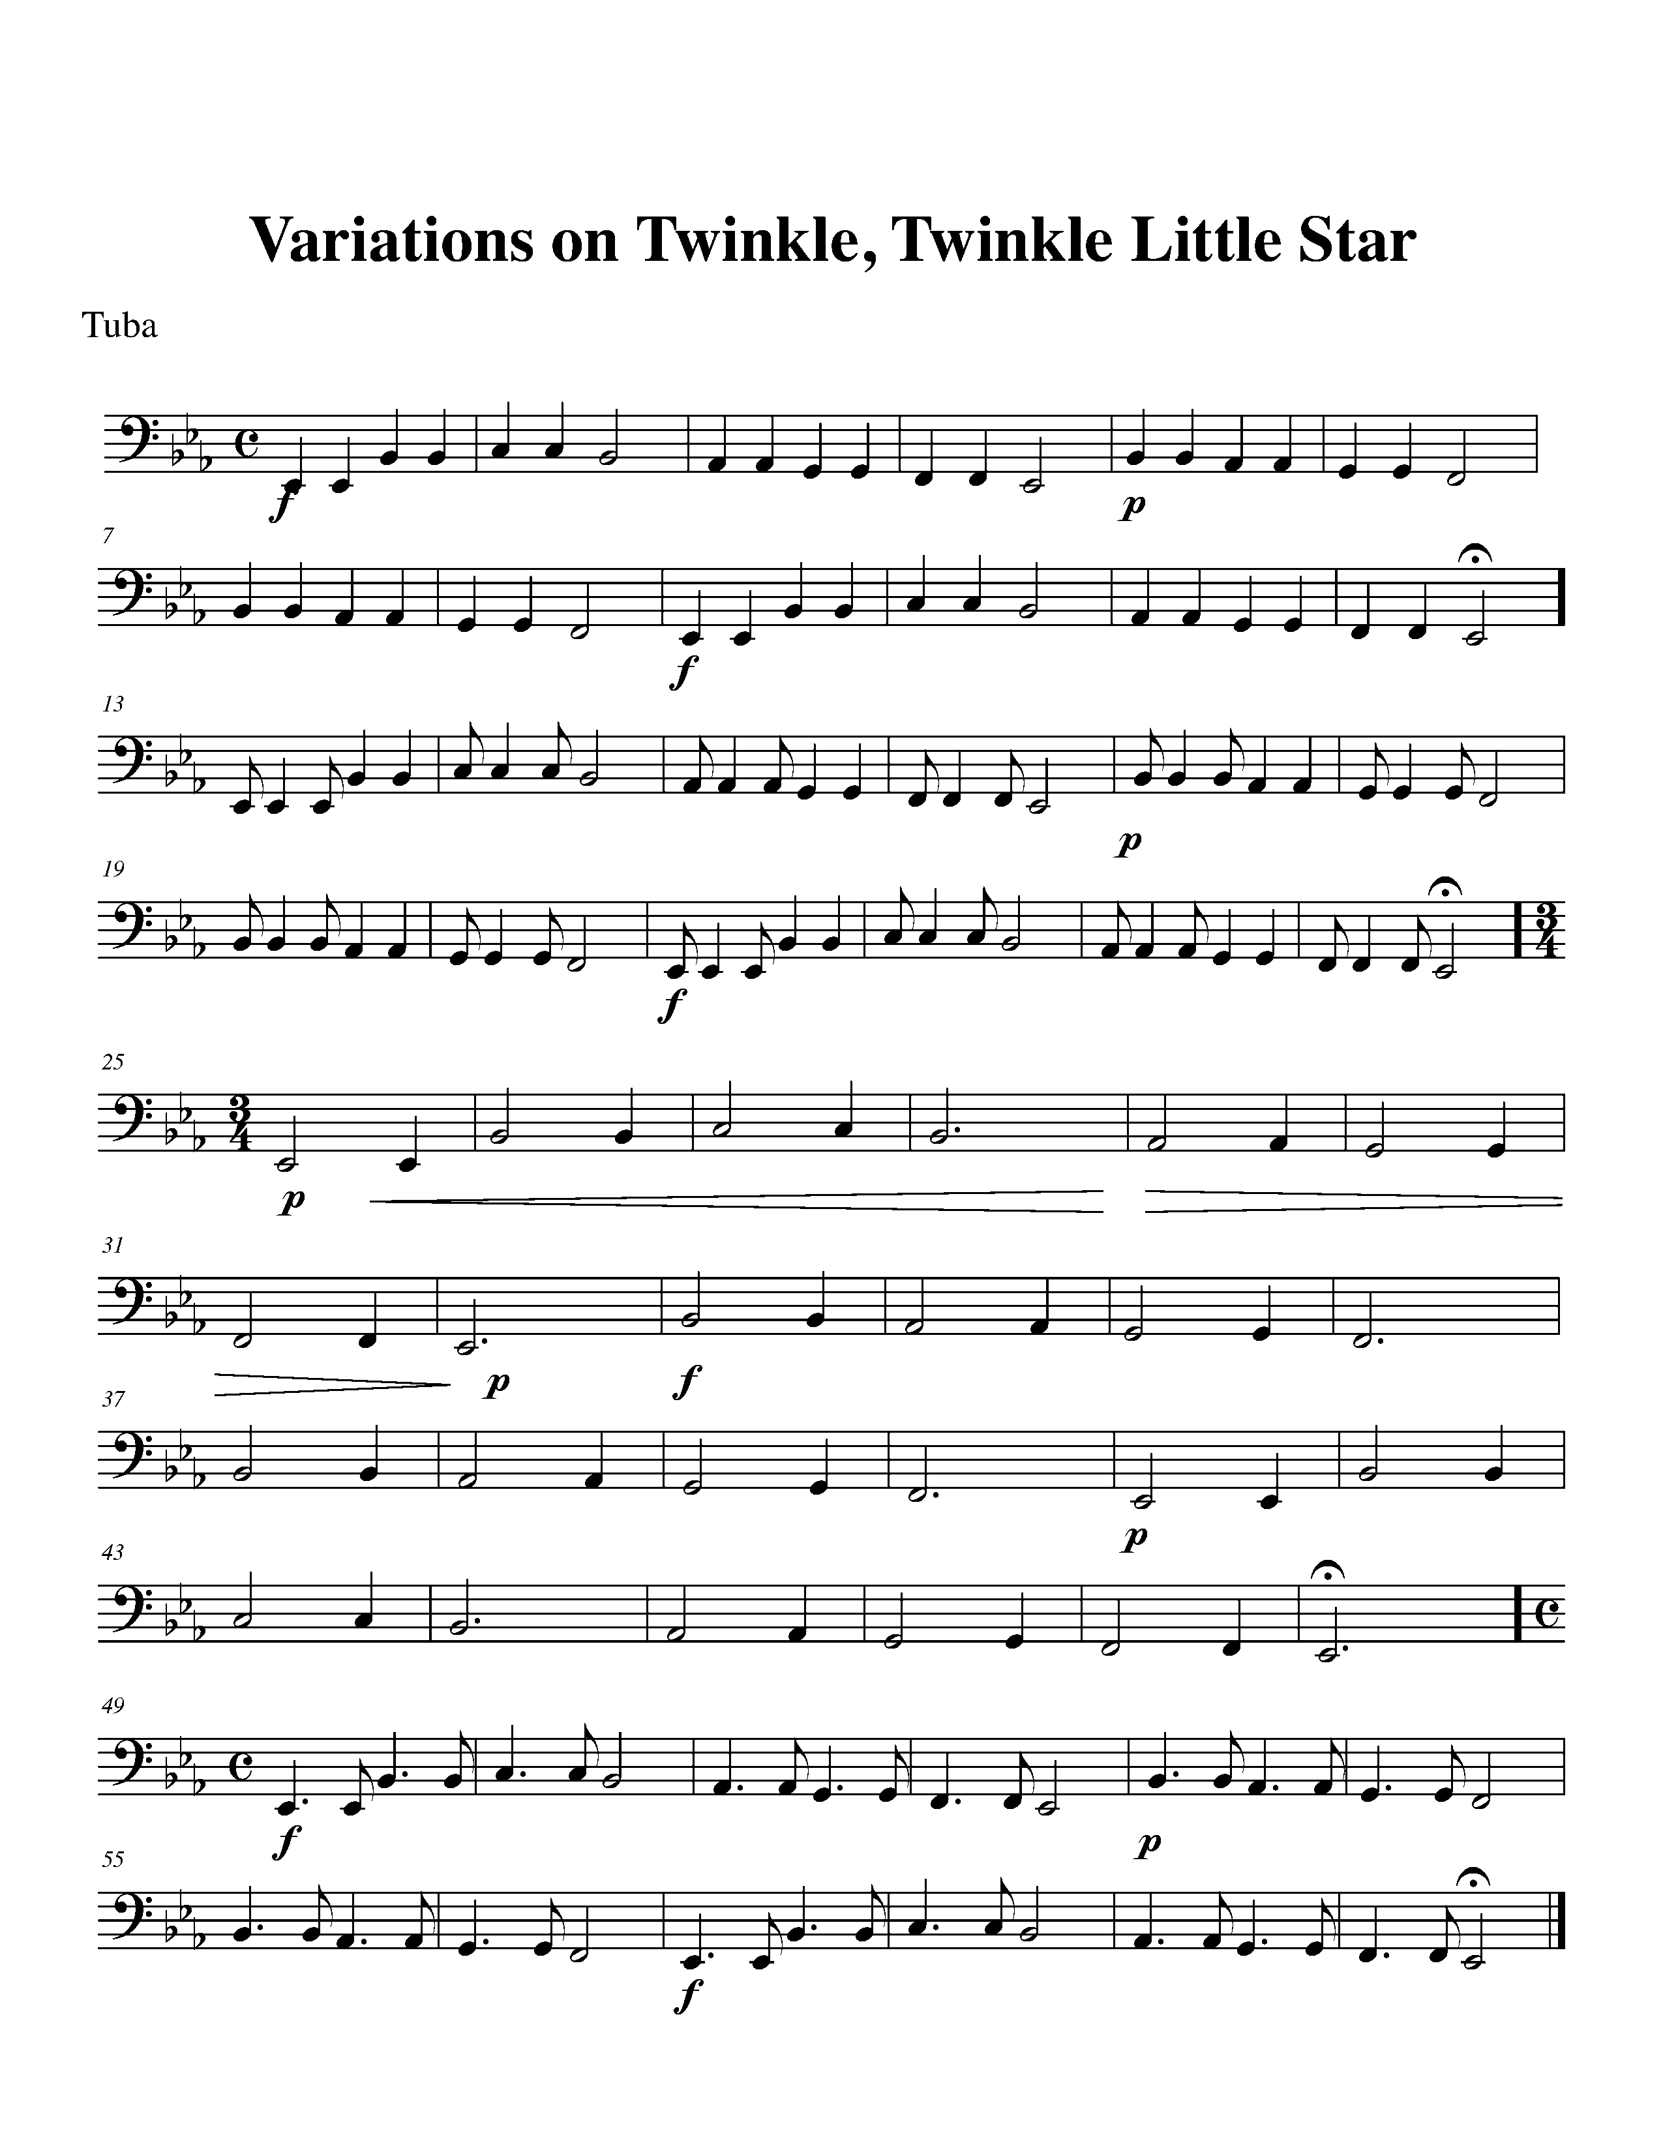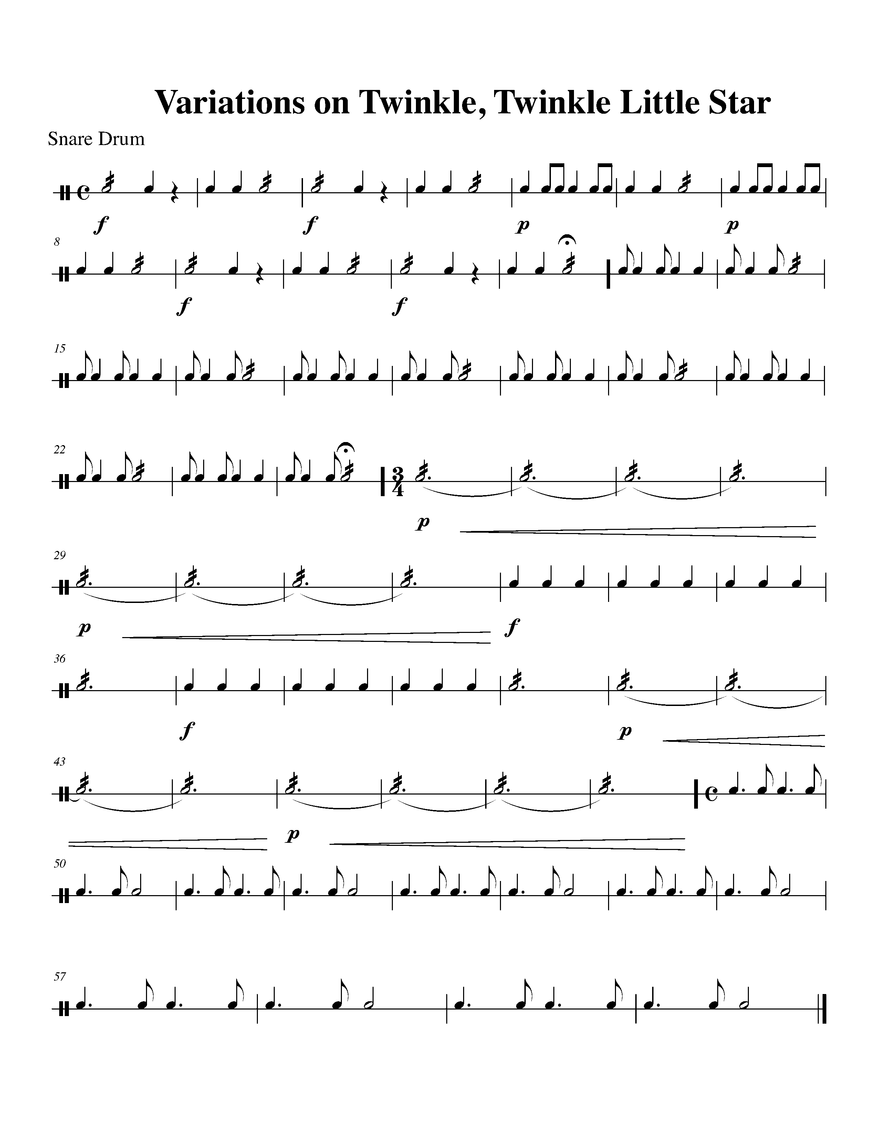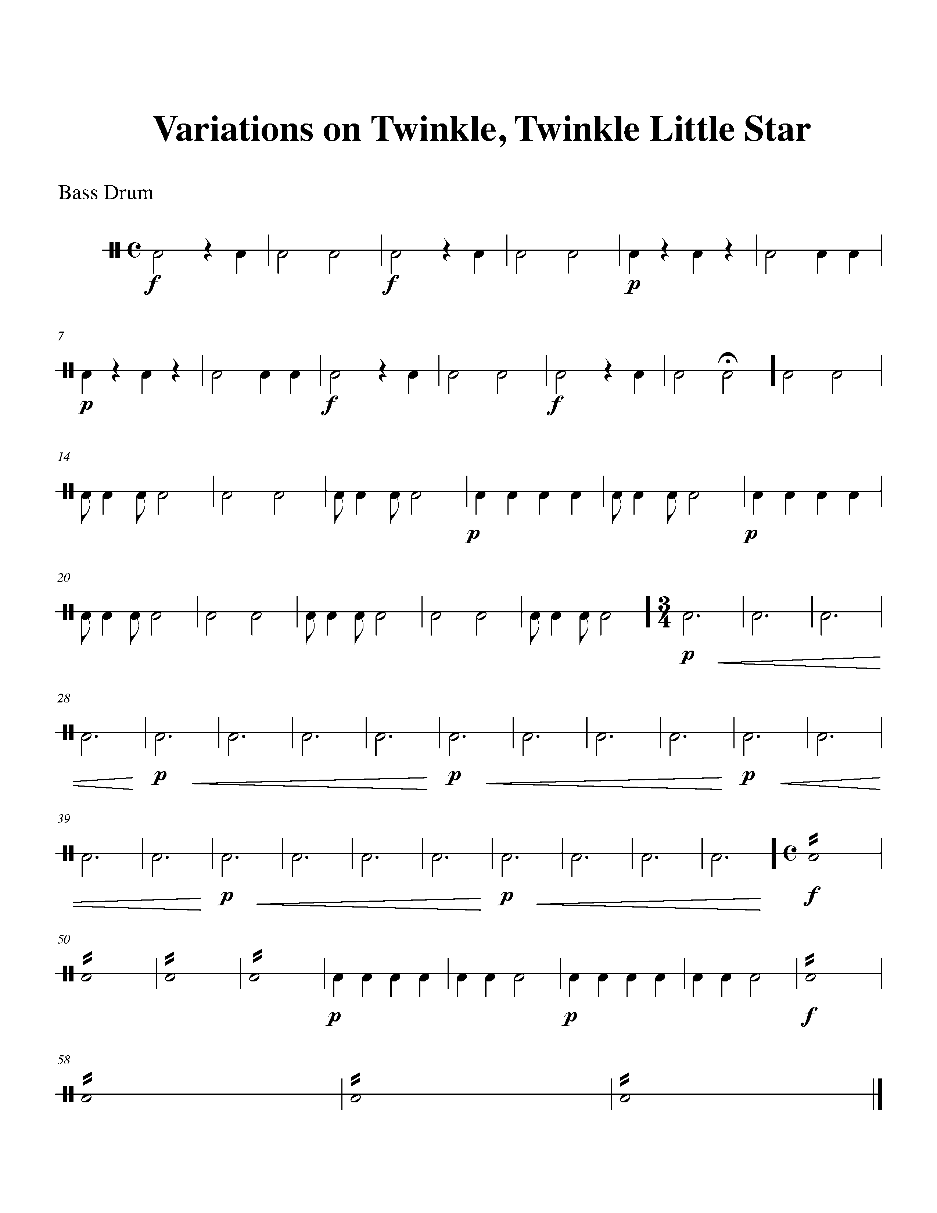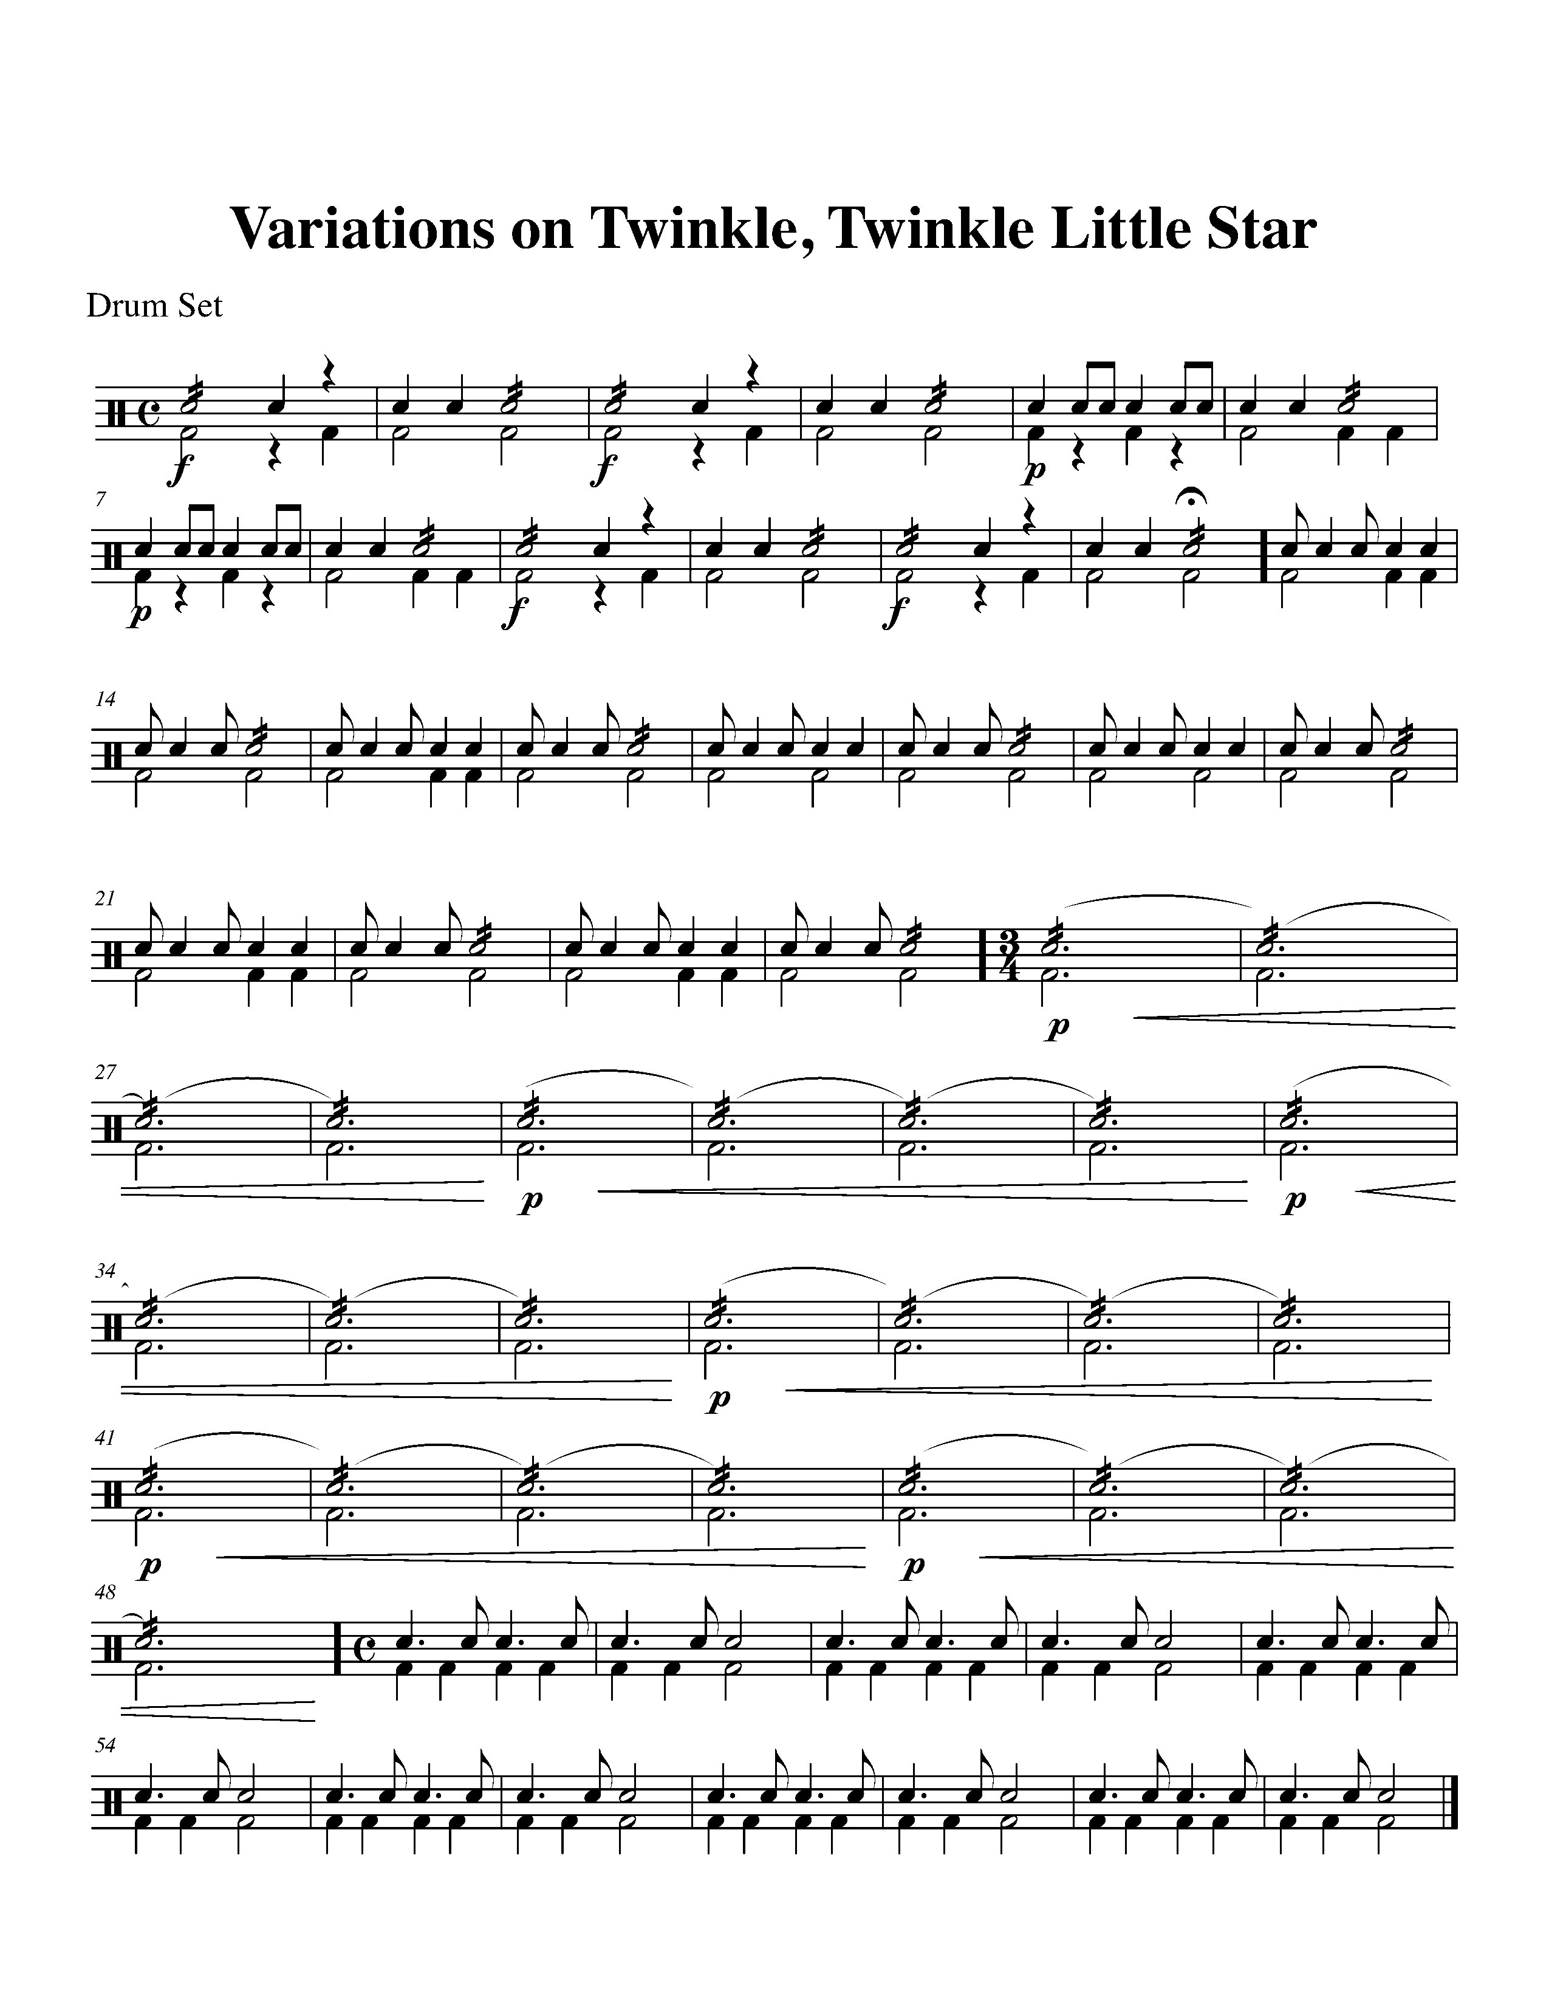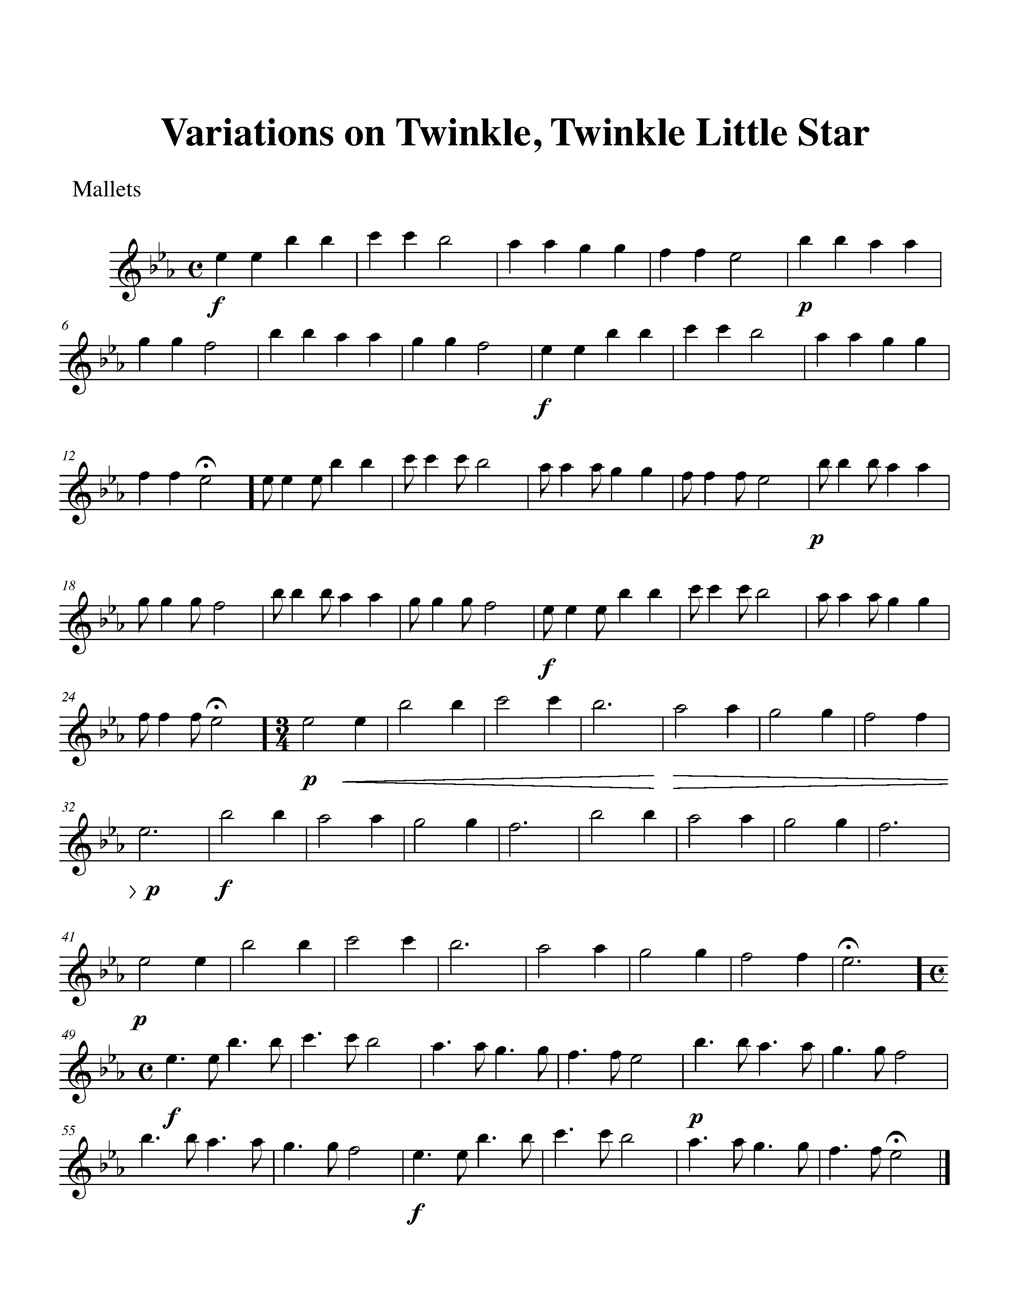CONGRATULATIONS – YOU HAVE REACHED THE FIRST GOAL AND COMPLETED THE NORTH SECTION! ASK YOUR TEACHER HOW YOU ARE TO RECOGNIZE THIS ACHIEVEMENT!

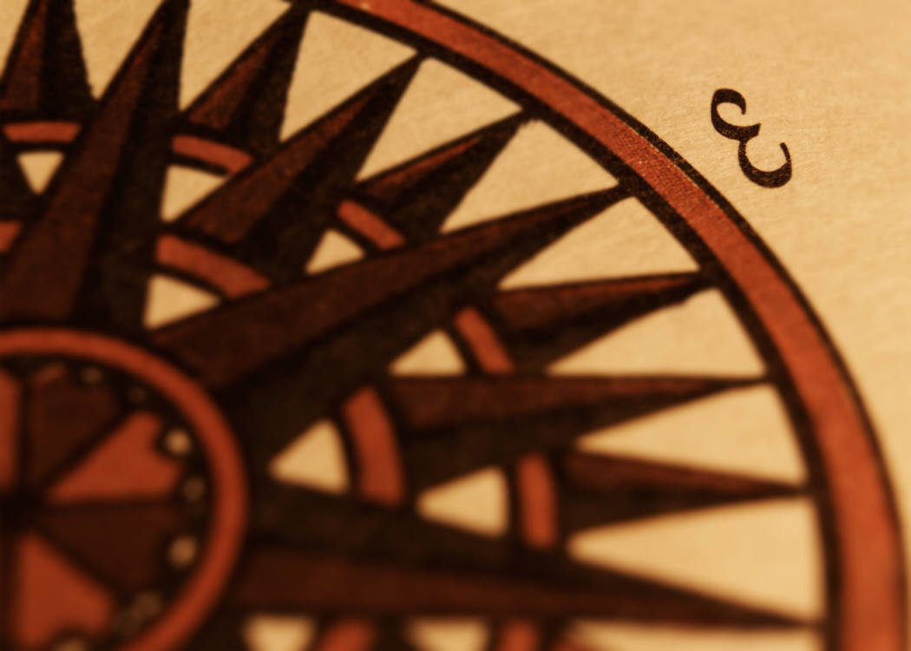
THE EAST SECTION
FOCUS: FORM

6. AB OR ABA? FOCUS: BINARY FORM VS. TERNARY FORM
ALL
LEARNING GOAL: The purpose of this task is to realize that most pieces of music have a particular structure or form.

MINDS ON! Why is it helpful to recognize the form of a piece? What is the difference between binary form and ternary form?

ACTION! To be successful with this task, you will need to:

- Learn the difference between binary form and ternary form;
- Explain the definitions for binary and ternary form to your teacher;
- Recognize the labels for binary (AB) and ternary (ABA) form;
- Compare the two pieces below;
- Label each piece below as either binary or ternary; and
- Label the A sections and the B sections within both pieces

CONSOLIDATION: In order to move on to the next task, you will need to complete the above action steps and show them to your teacher to receive feedback.

This is a __________________ piece (binary or ternary).
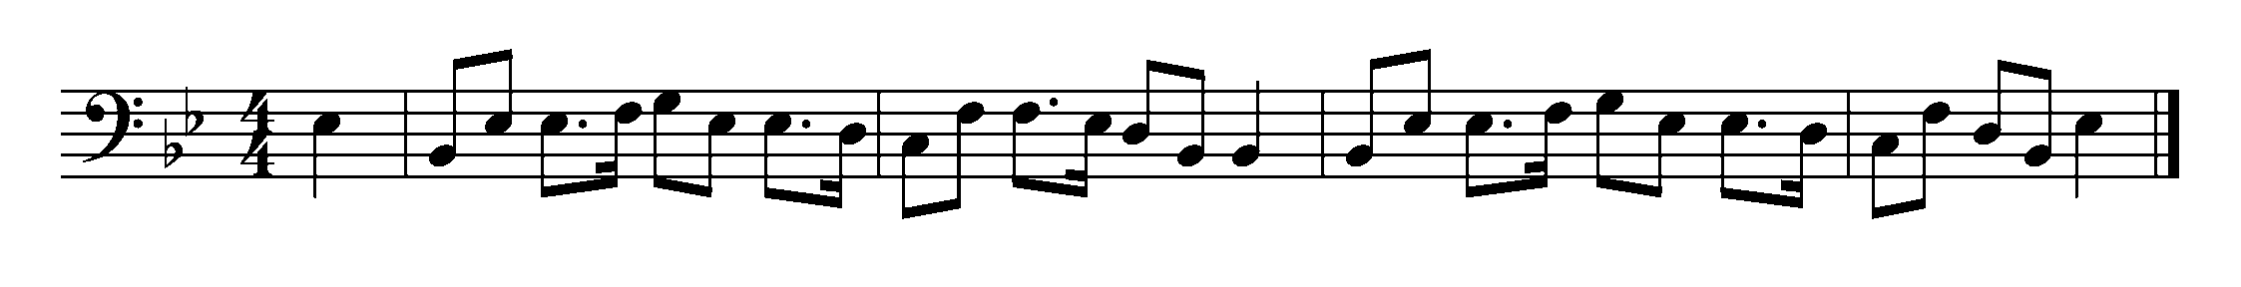
This is a __________________ piece (binary or ternary).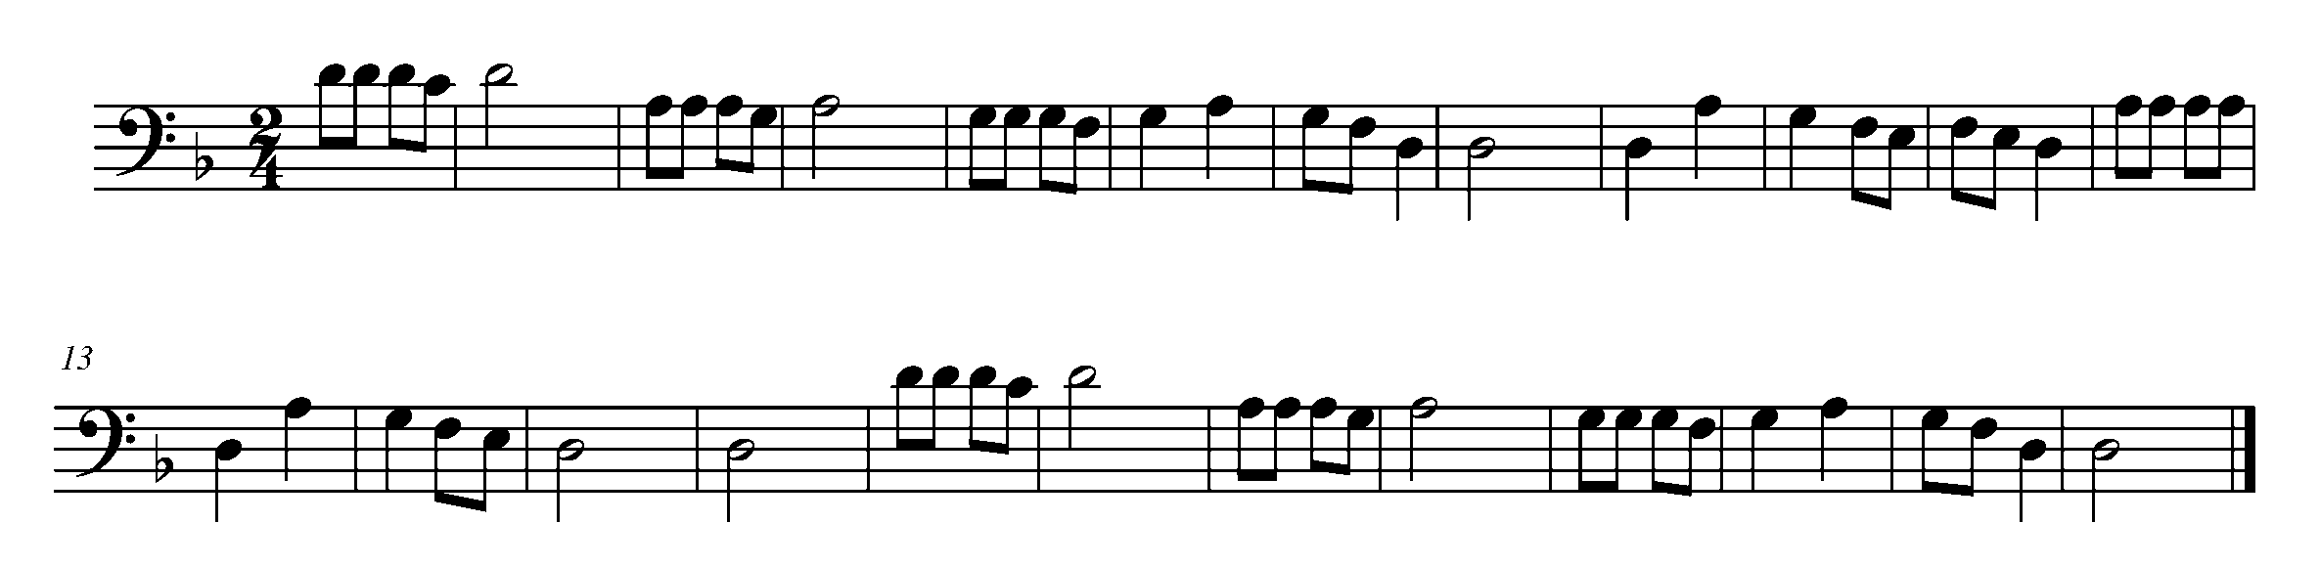

7. HEAR THE DIFFERENCE FOCUS: BINARY FORM VS. TERNARY FORM
WIND INSTRUMENTS, SD/BD/KIT AND MALLETS

LEARNING GOAL: The purpose of this task is to perform the piece from Task 6 so that you can hear the difference between binary and ternary form.

MINDS ON! Listen to the structure of this piece – can you hear the difference between binary and ternary form? Do you need to perform differently when you have a repeated section?

ACTION! To be successful with this task, you will need to:
- Scan through the piece and look for any potential “problem” areas (new notes, challenging rhythms, symbols);
- Realize how the form of a piece can affect a performance; and
- Demonstrate good musicianship (posture, phrasing and accuracy).

CONSOLIDATION: In order to move on to the next task, you will need to perform the pieces below for your teacher and receive feedback.

TASK 7 - TASK NUMBER ONE – BINARY FORM
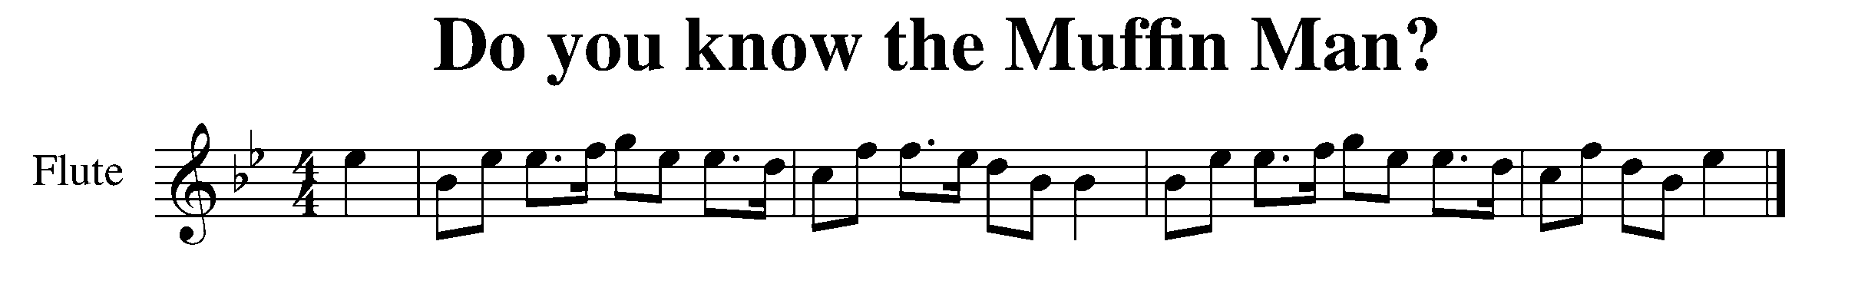
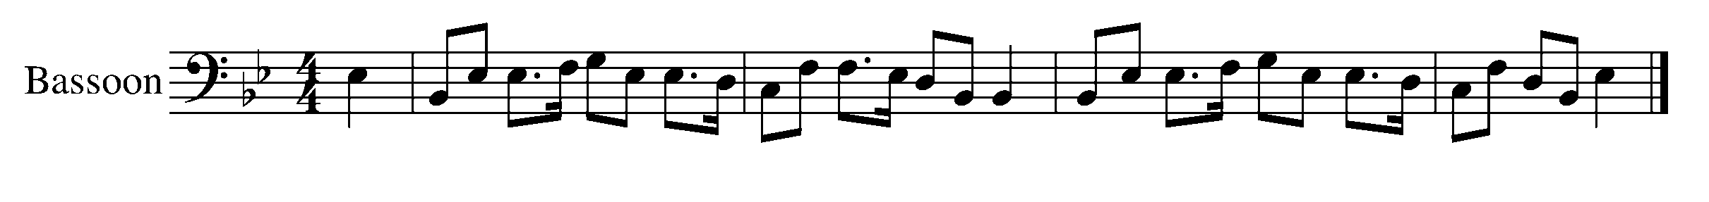
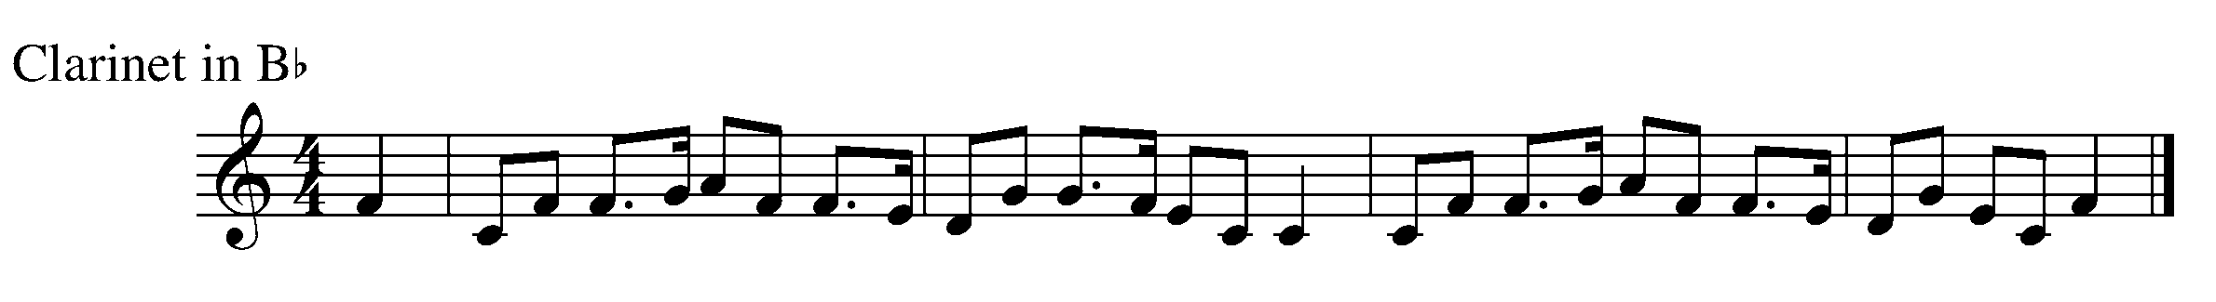

Task 7 Music Continued
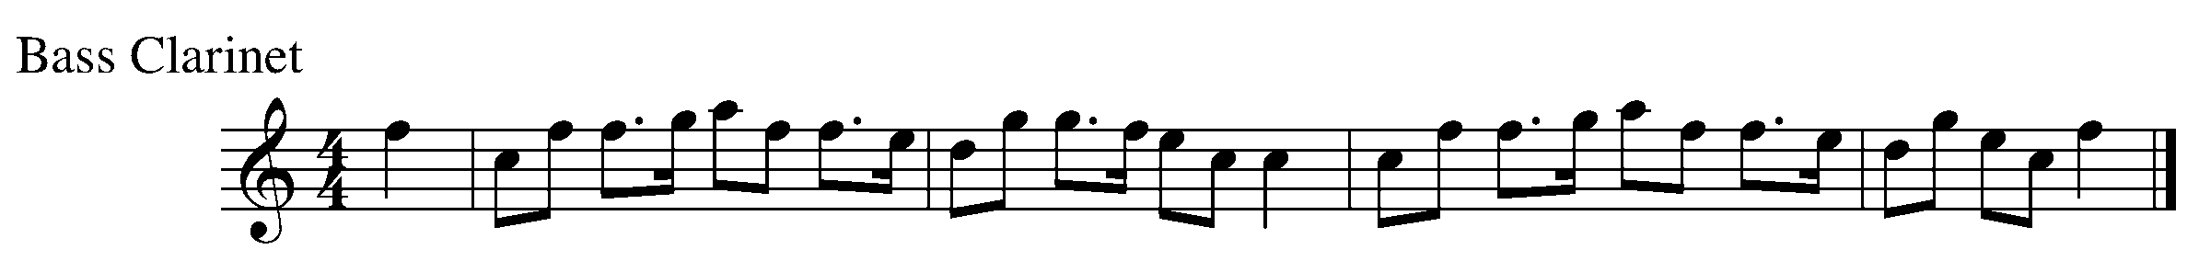
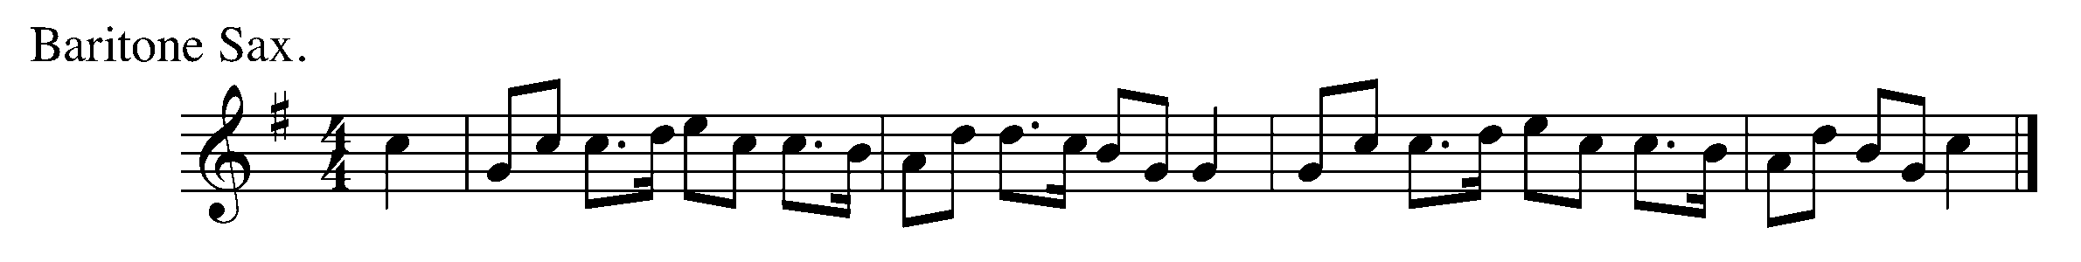
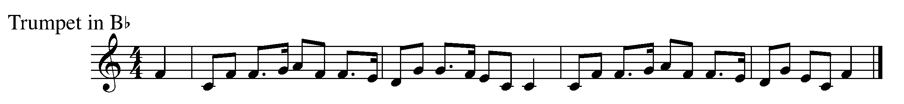
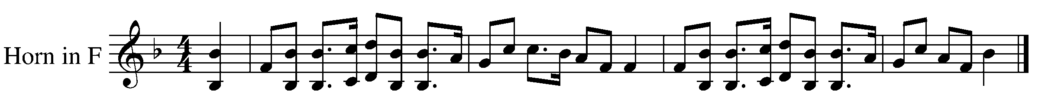
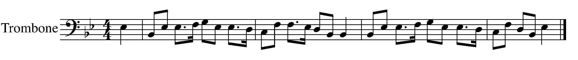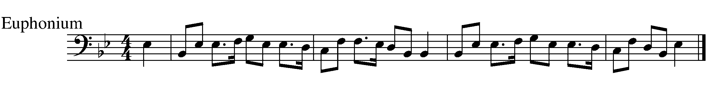
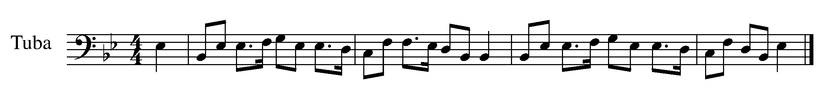
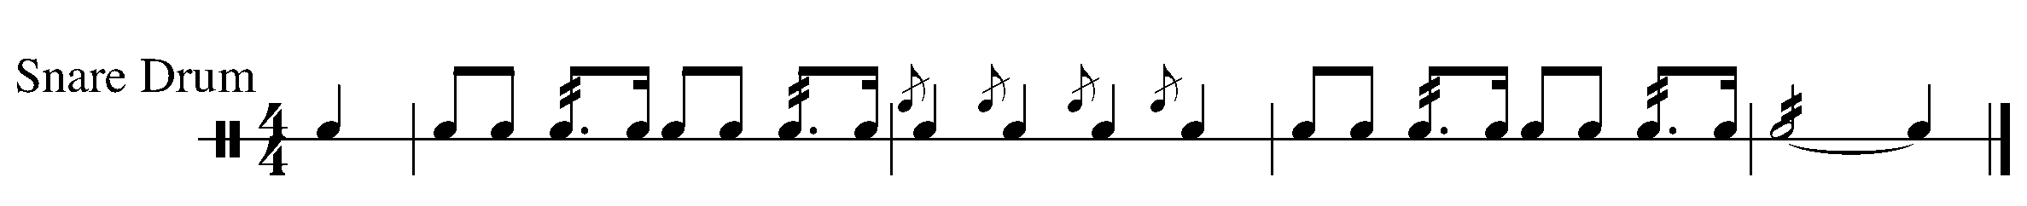

TASK 7 - PIECE NUMBER TWO – TERNARY FORM
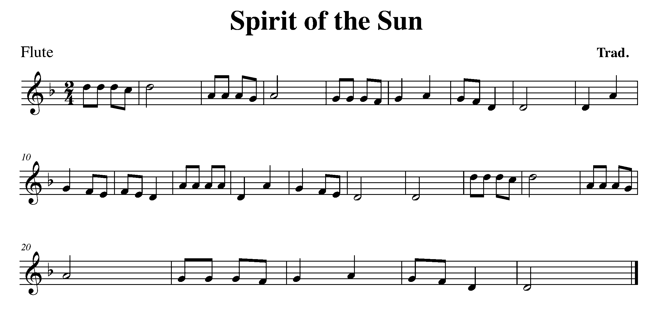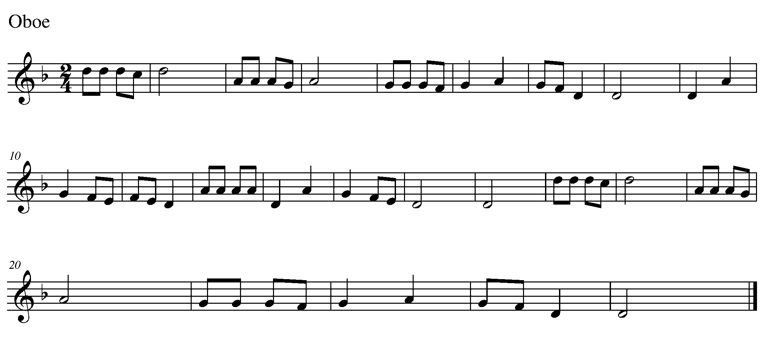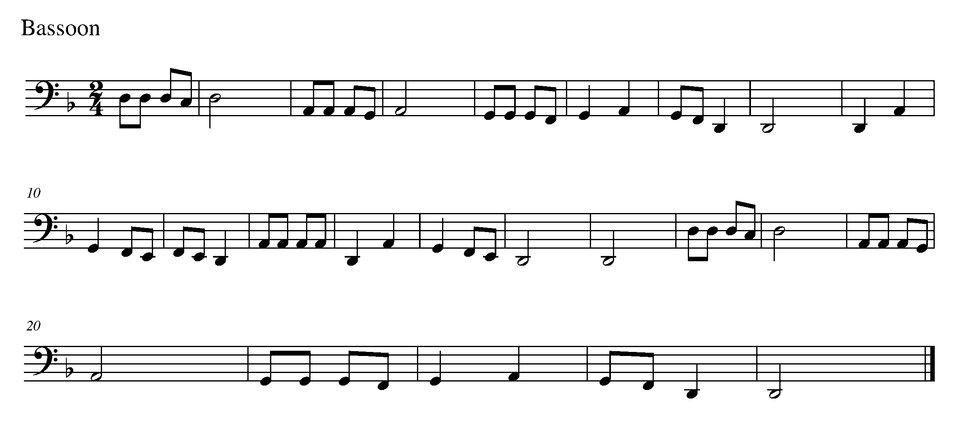
Task 7 Music Continued 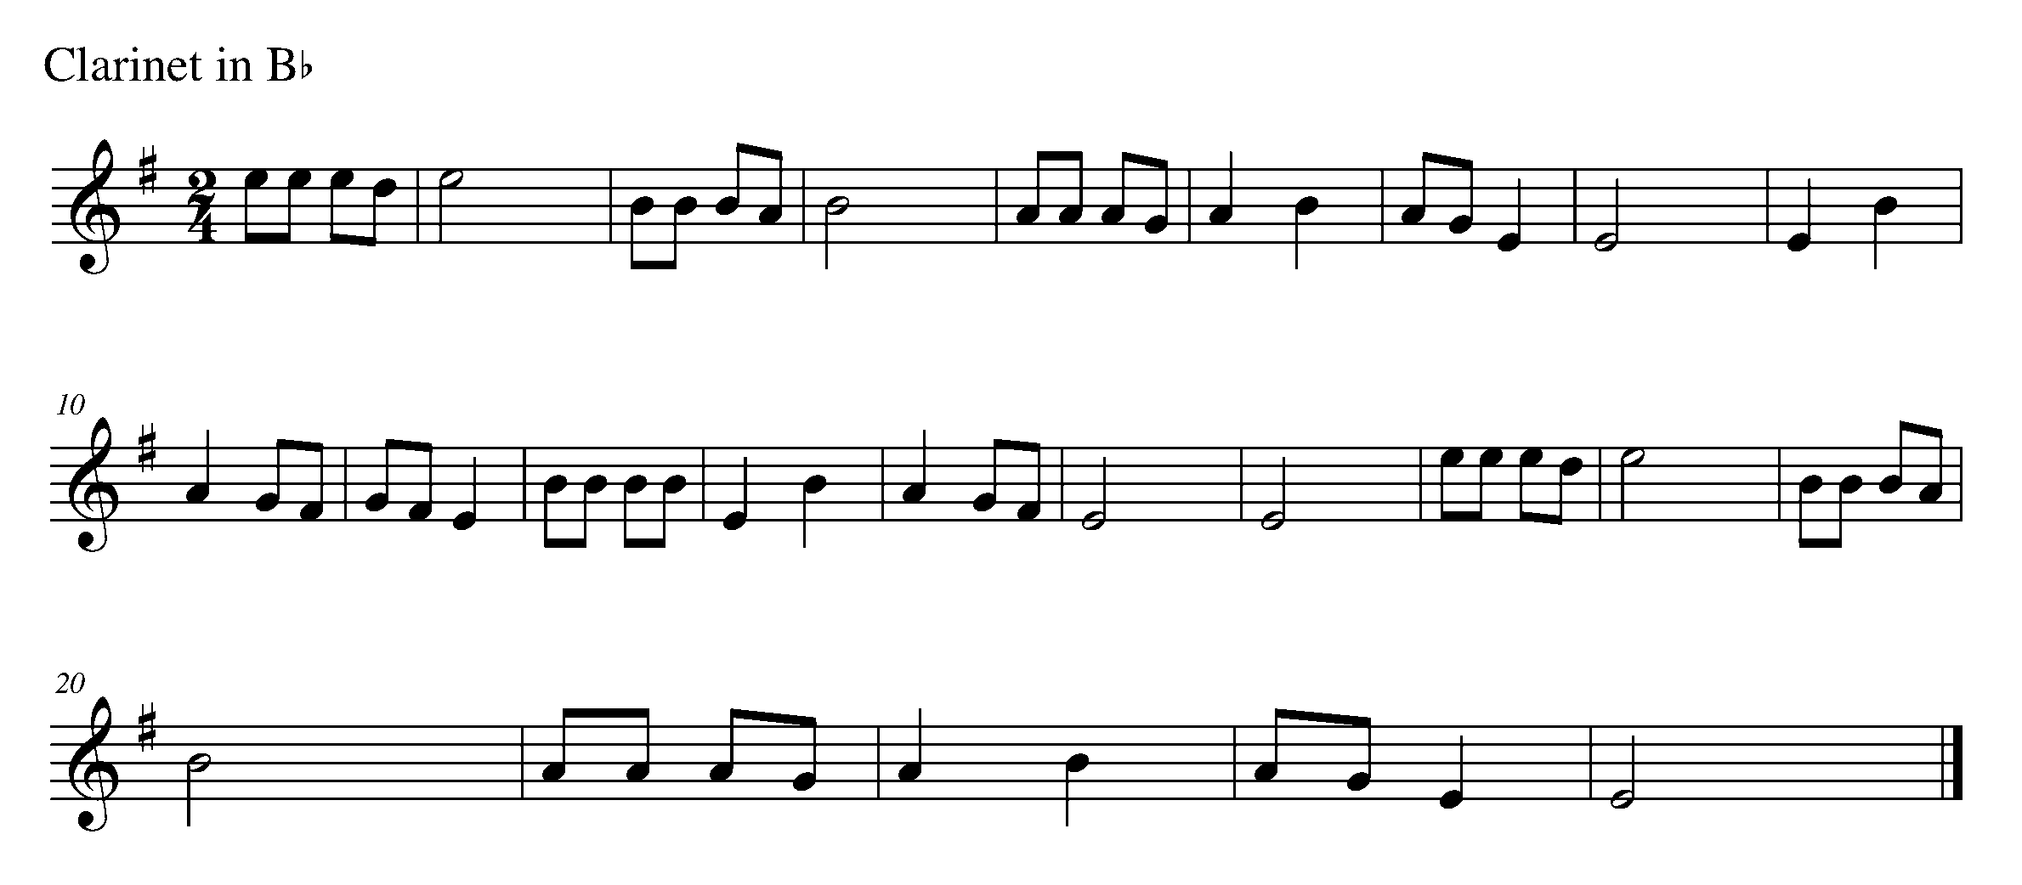
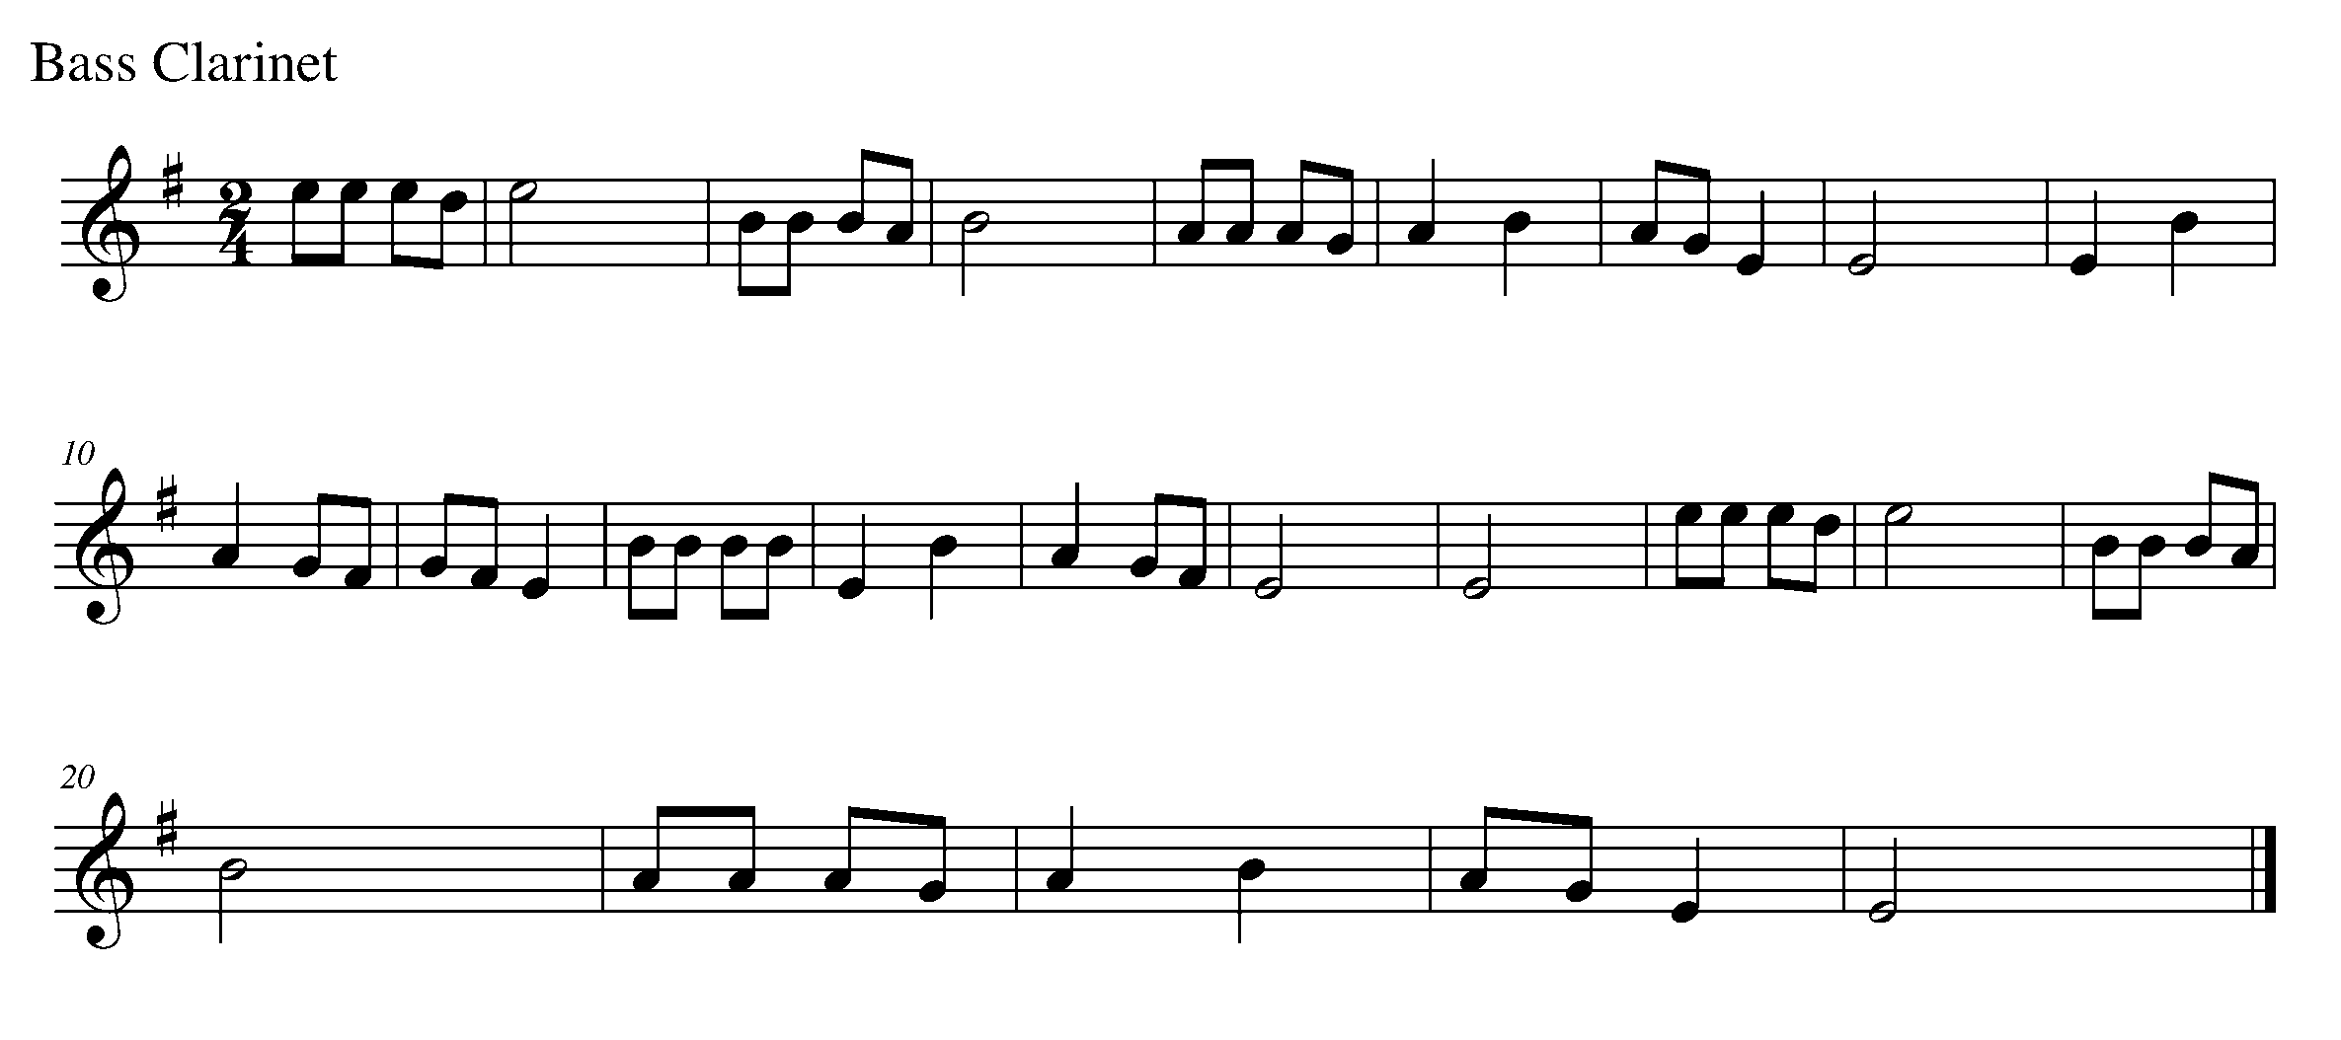
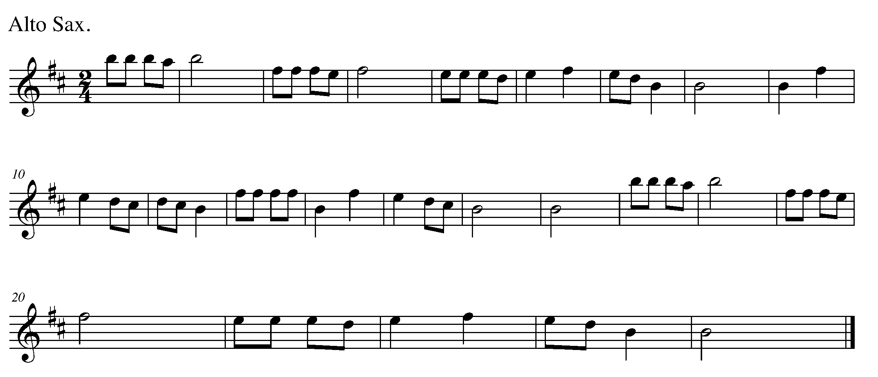
Task 7 Music Continued 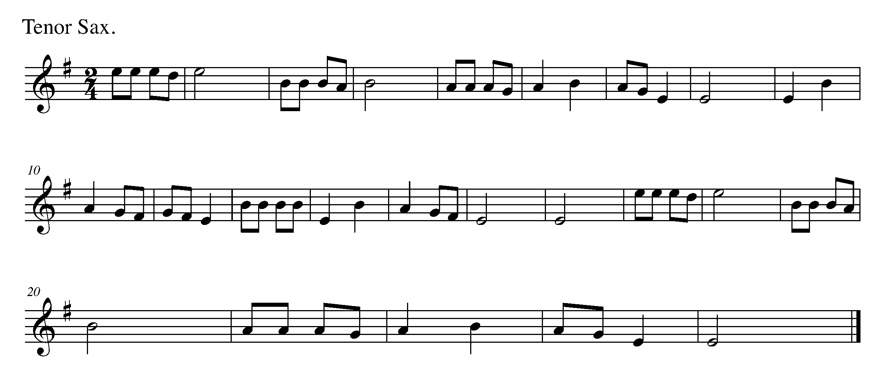

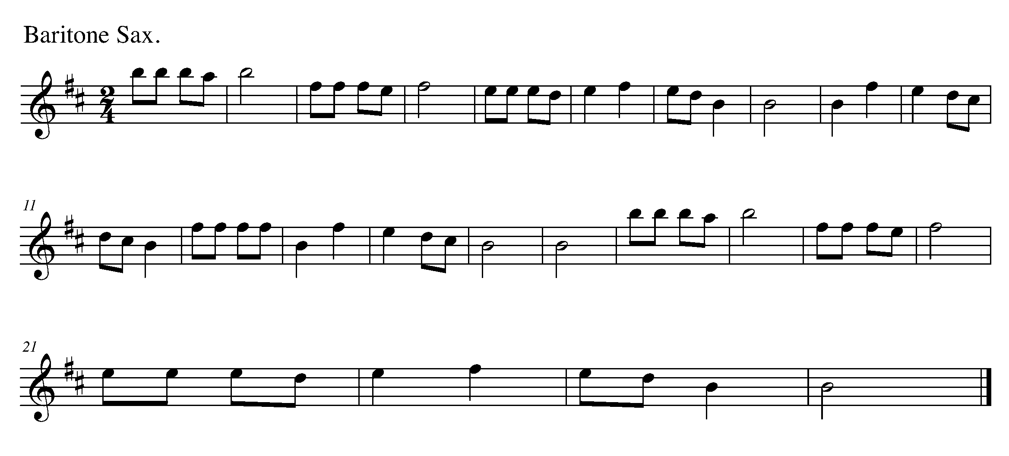
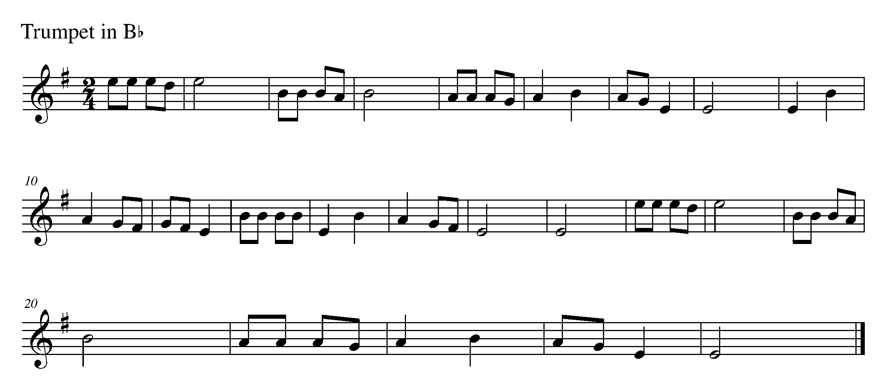
Task 7 Music Continued 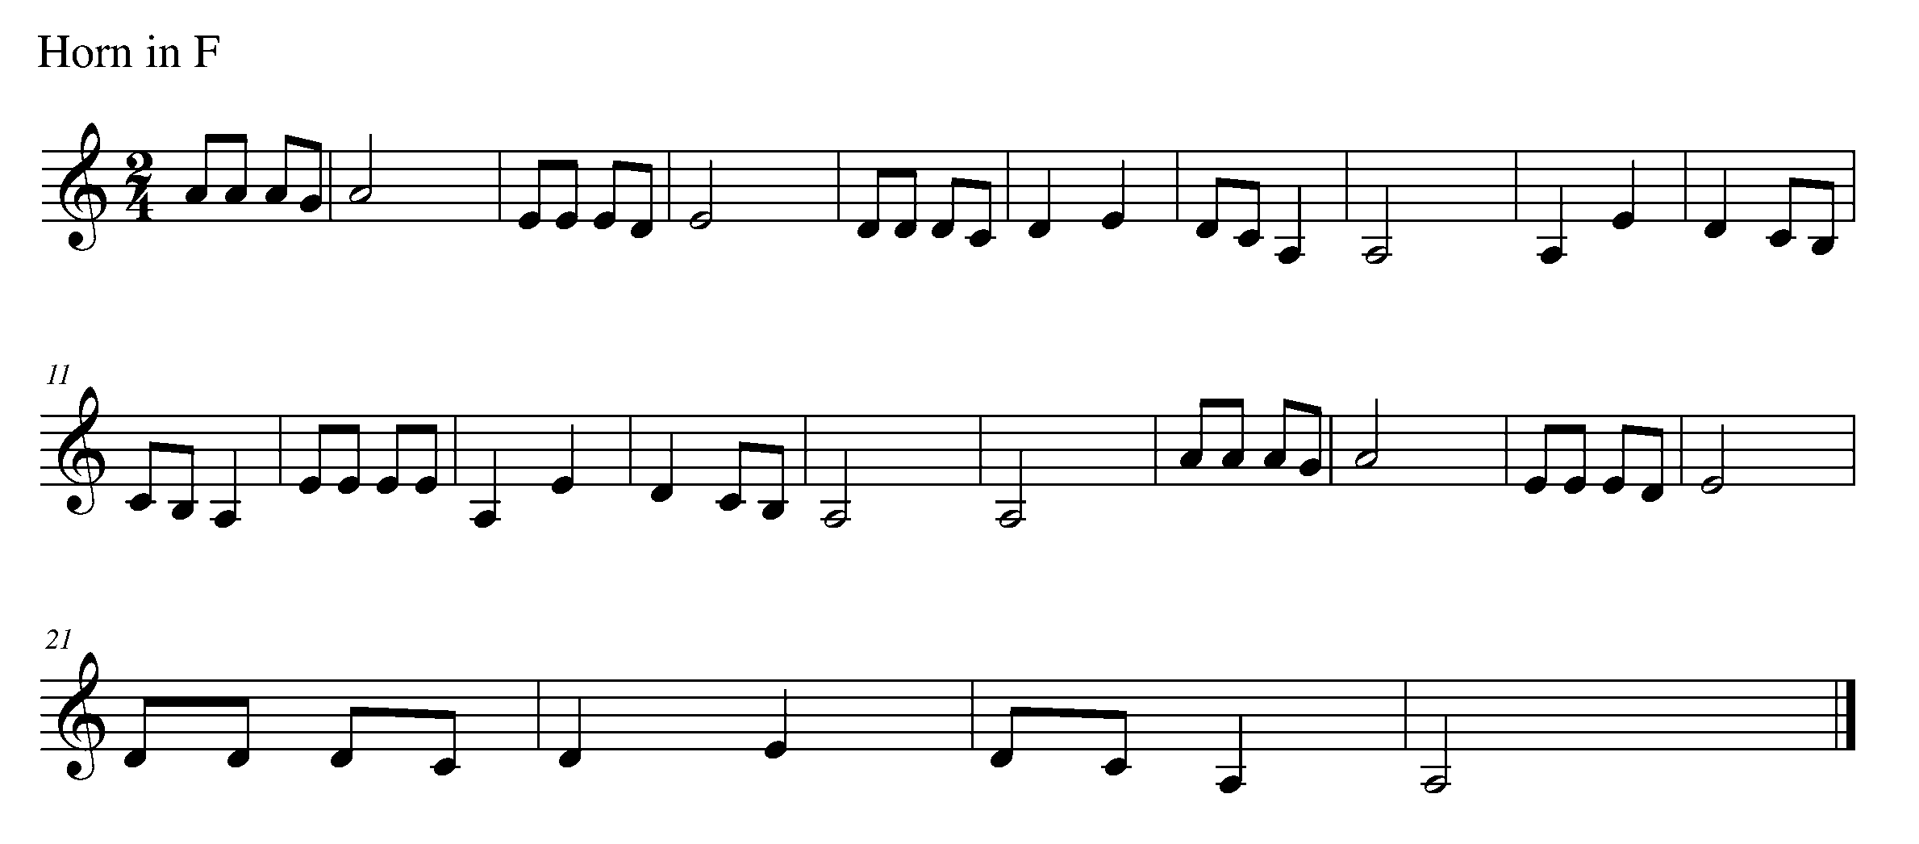

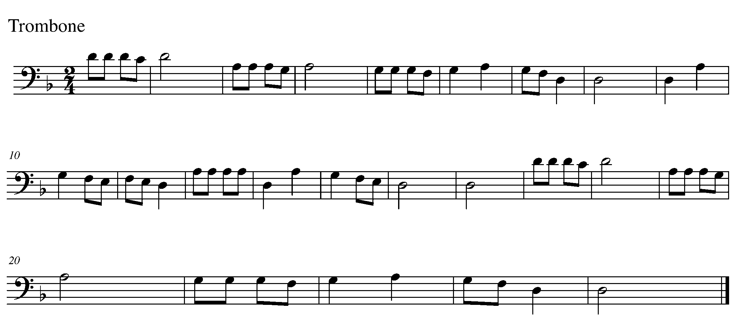
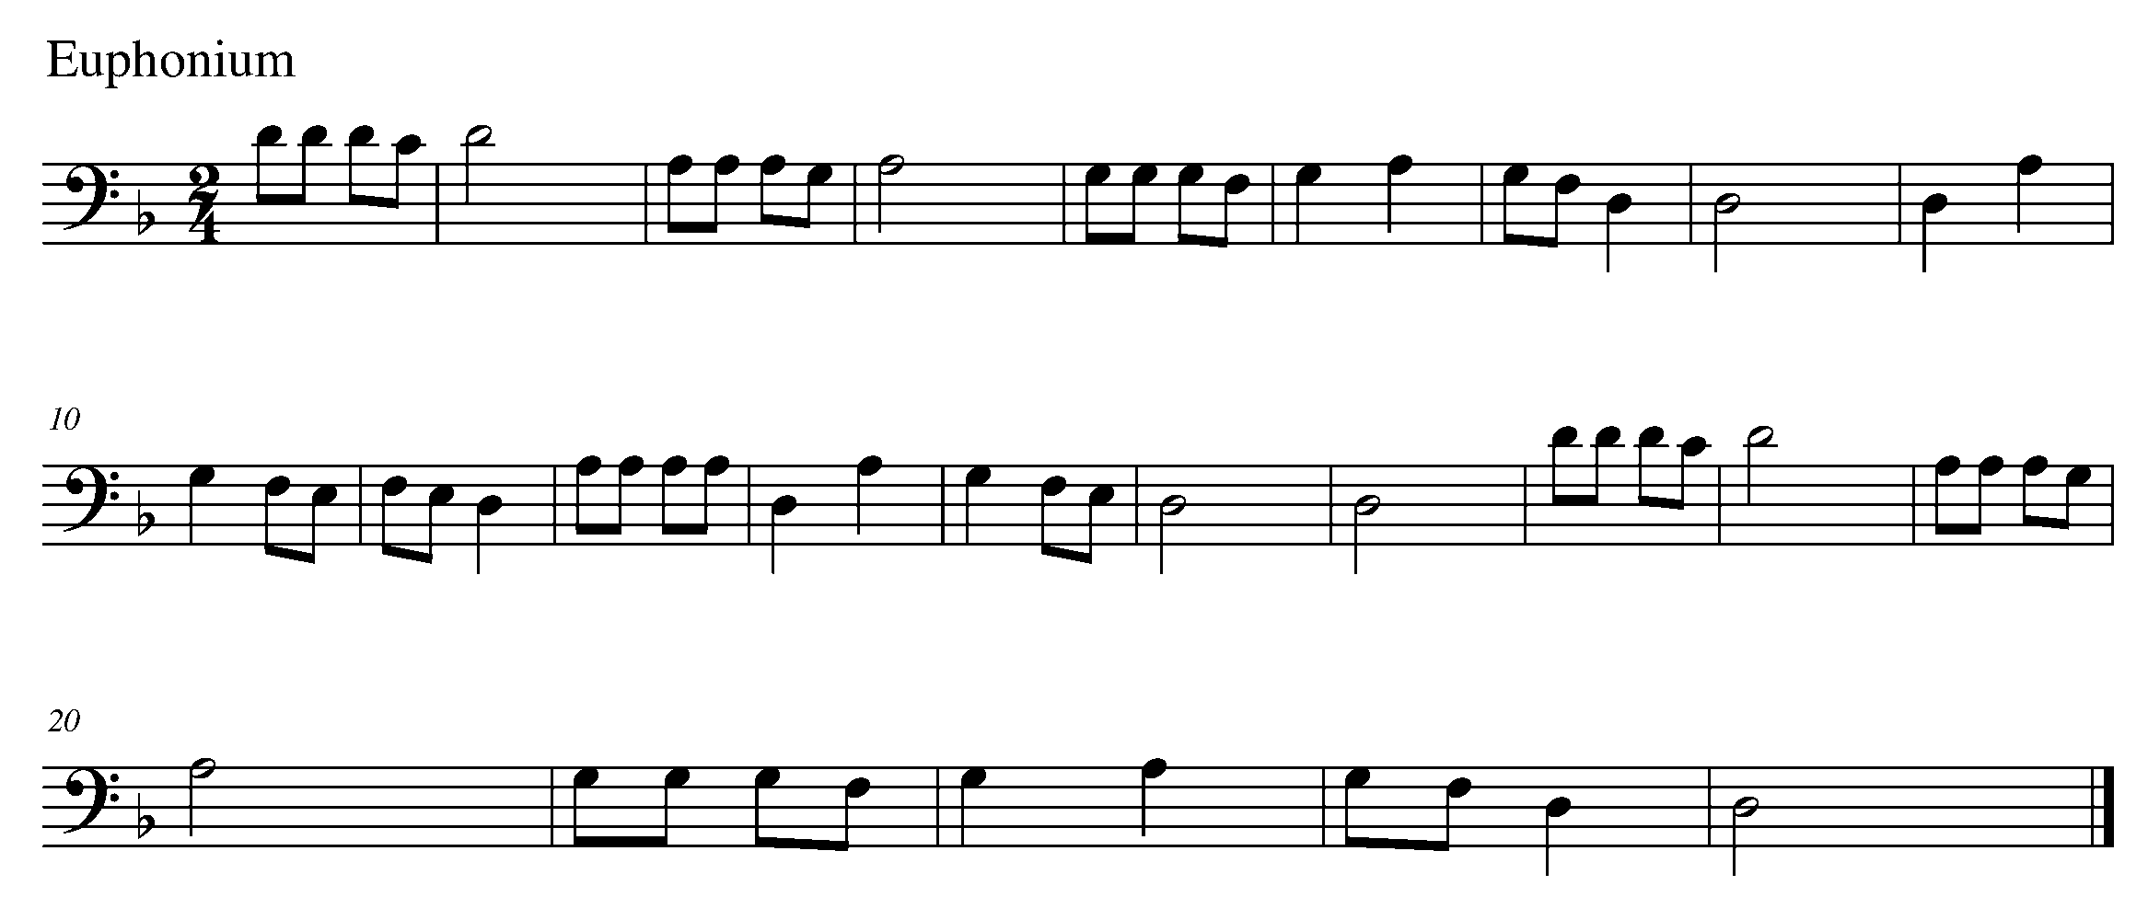

Task 7 Music Continued
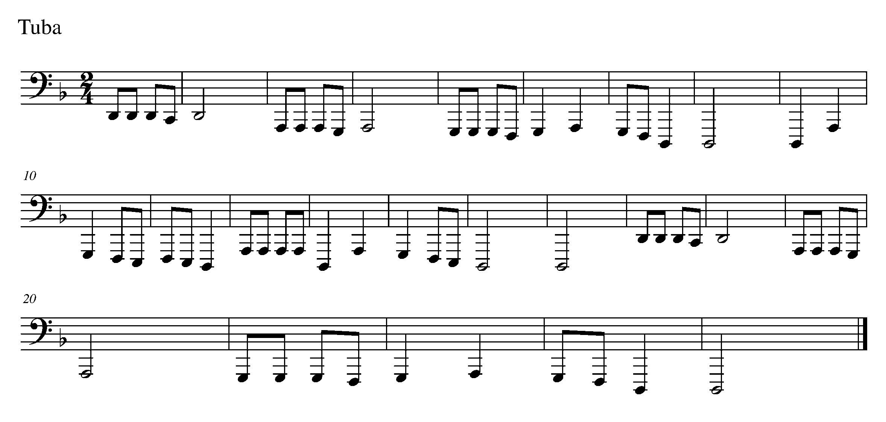
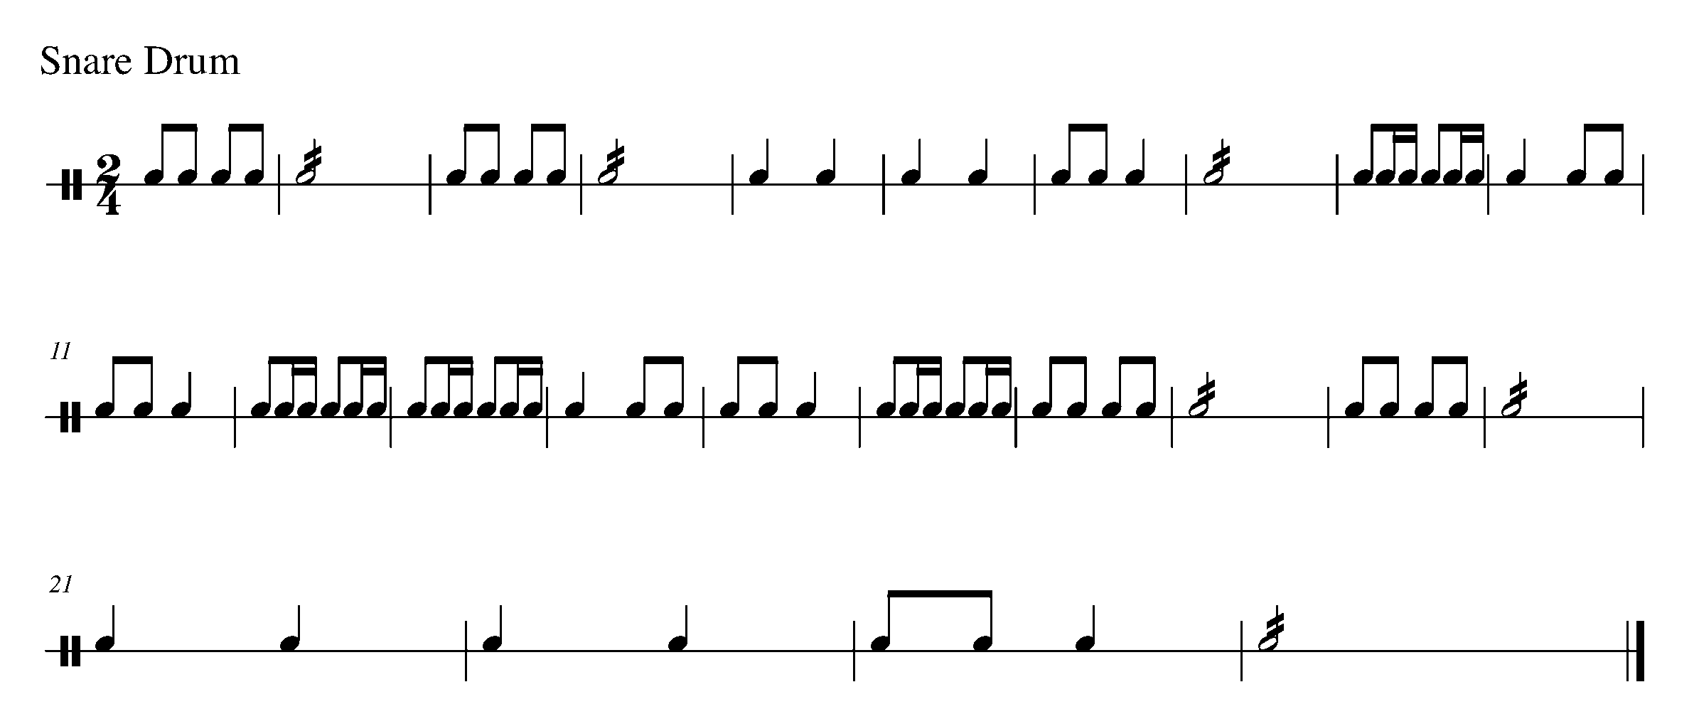
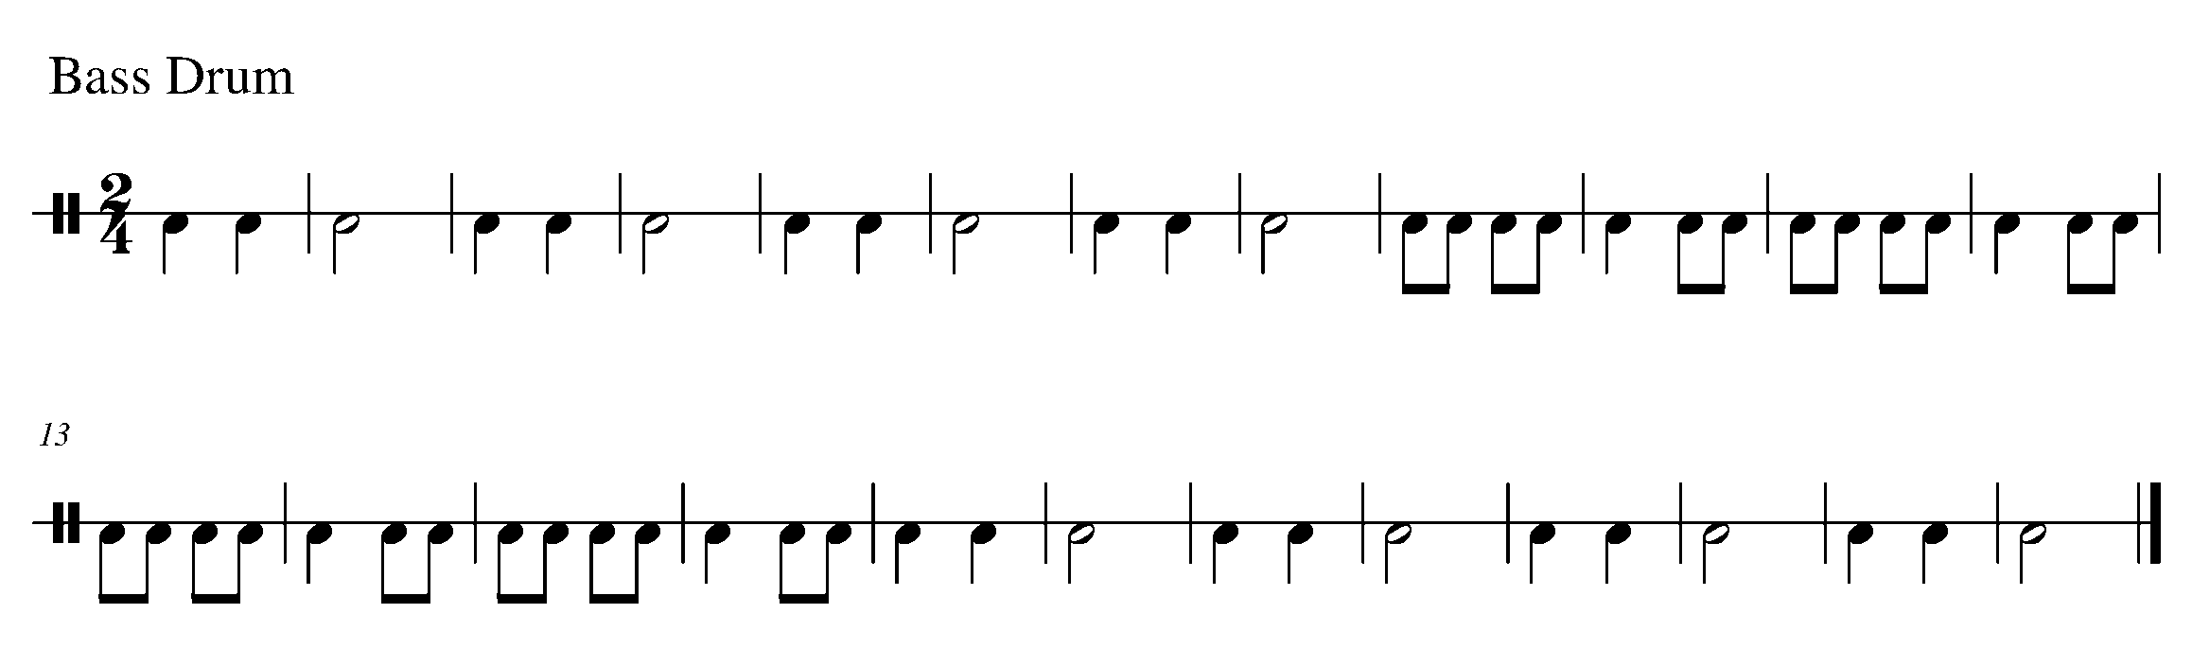

Task 7 Music Continued
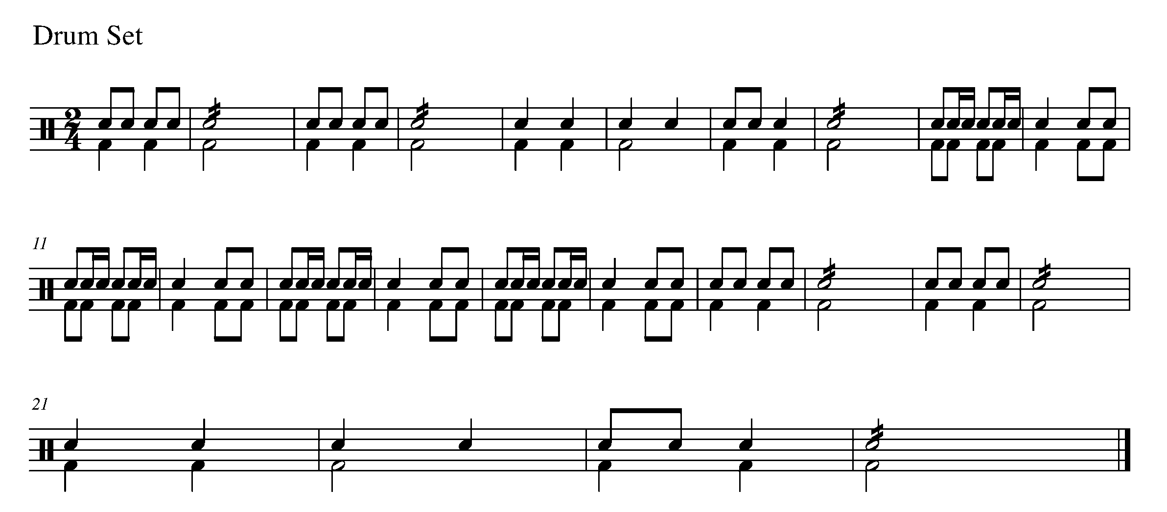

8. BECOME A TERNARY COMPOSER FOCUS: COMPOSITION
ALL

LEARNING GOAL: In this task, you will create a rhythmic composition in ternary form. You will then use this composition in task 9 to create a pitched ternary composition.

MINDS ON! What variety of rhythms can you play and will you use in this composition? How will you make the “A” section different from the “B” section?

ACTION! To be successful with this task, you will need to:
- Get a pencil – do not create this composition in anything other then pencil;
- Create only the rhythms for an eight-bar “A” section, which you write in twice in the given location;
- Create only the rhythm for an eight-bar “B” section, which is different from the “A” section; and
- Use a variety of rhythms that you know you can play.

CONSOLIDATION: In order to move on to the next task, you need to create a 24-bar rhythm, in ternary form. When completed, show this task to your teacher and receive feedback.
Empty Staves are found on the following page.
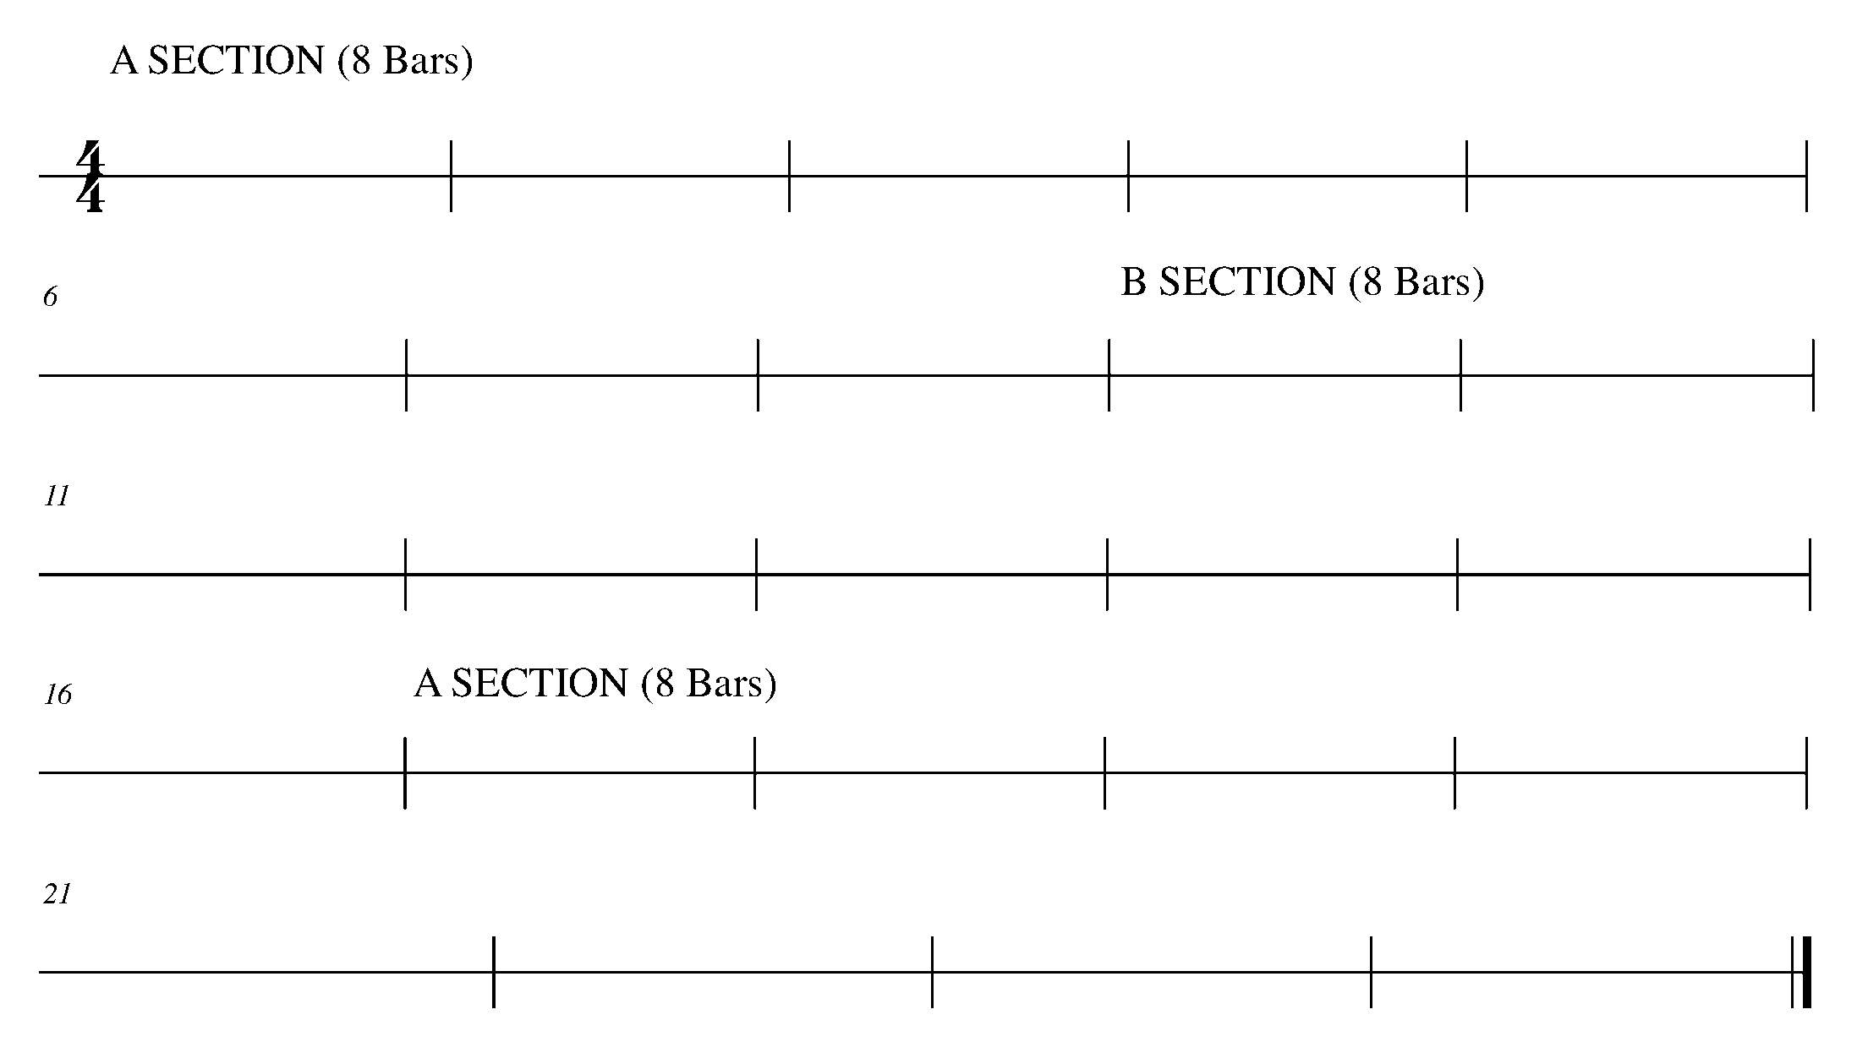

9. ADDING PITCH FOCUS: COMPOSITION
WIND INSTRUMENTS AND MALLETS

LEARNING GOAL: The purpose of this task is to add pitch to the rhythm created in Task 8.

MINDS ON! What decisions do you need to make when adding pitch to a rhythm? Knowing that you will need to perform this piece in Task 10, consider the following: range, first and last note and melodic line.

Key signature – B Flat Concert

You need to add the key signature to the below staff. Refer to the list below to figure out what the key signature is for your instrument.

Flute/Oboe/Bassoon/Trombone/Euphonium/Tuba/Mallets: B-flat, E-flat
Clarinet/Bass Clarinet/Tenor Sax/Trumpet: No flats or sharps
Alto Saxophone/Bari. Sax: F-sharp
French Horn: B-flat

ACTION! To be successful with this task, you will need to:

- Use a pencil;
- Draw your clef (treble or bass) at the beginning of the staff;
- Add the key signature as indicated above;
- Decide upon your starting and ending note;
- Start with Section A – Add pitch to your 8-bar rhythm created in Task 8;
- Move to Section B – Add pitch to your 8-bar rhythm created in Task 8;
- Make sure that the melody between Section A and Section B transition well;
- Complete the final 8 bars with Section A again;
- Make sure you have picked notes and a range that you can perform on your instrument;
- Give your composition a title; and
- Add articulation and/or dynamics if so desired.

CONSOLIDATION: In order to move on to the next task, show and perform your composition for your teacher and receive feedback.
____________________________
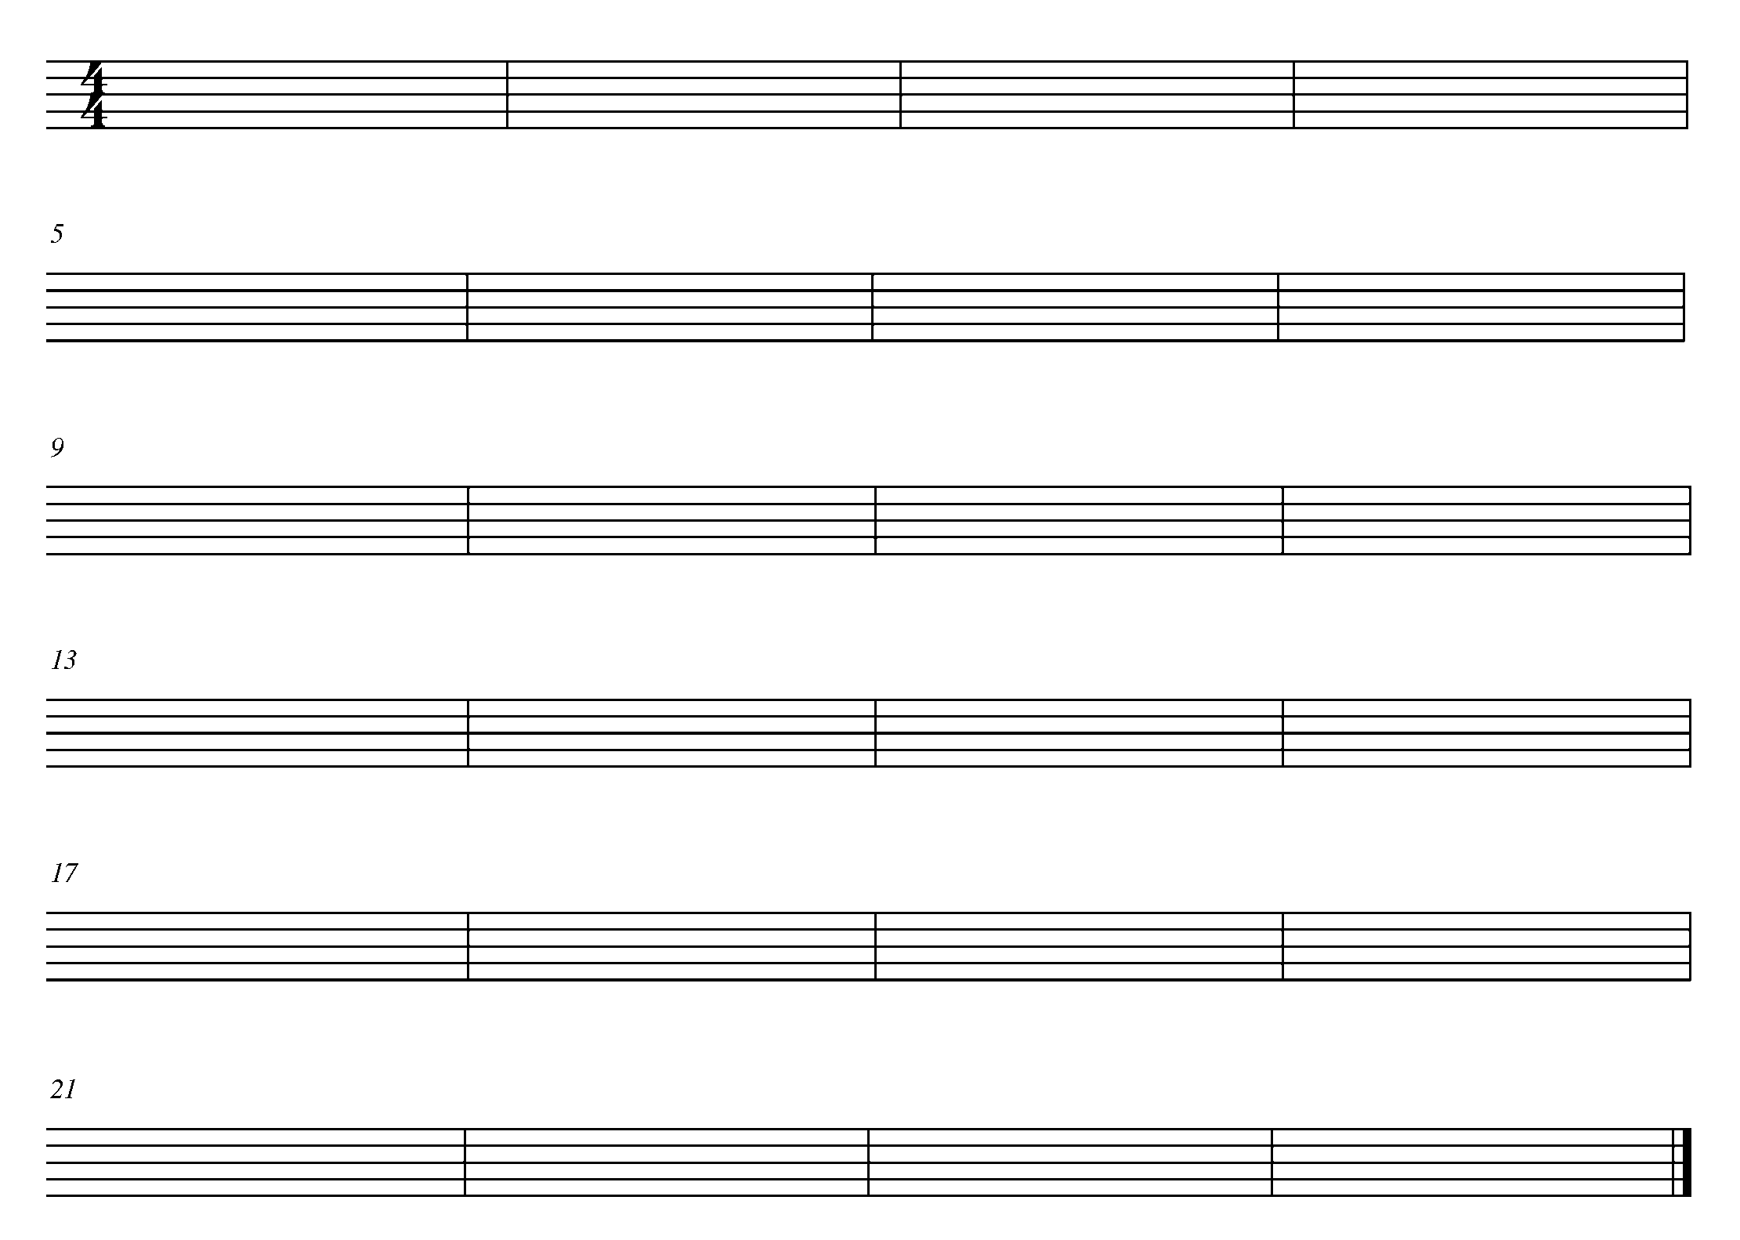
10. YOUR TERNARY COMPOSITION FOCUS: CULMINATING TASK
WIND INSTRUMENTS AND MALLETS

LEARNING GOAL: In this task, you will perform your ternary composition for your teacher and either a small peer group or a class.

MINDS ON! How must you prepare differently when performing your own composition? How will you introduce your composition to your audience? Where will you stand or sit?

ACTION! To be successful with this task, you will need to:

- Organize who your audience will be with your teacher;
- Introduce your composition to your audience;
- Demonstrate good musicianship throughout this piece; and
- Acknowledge the audience after your performance with either a nod of your head or a bow.

CONSOLIDATION: In order to move on to the next task, perform your ternary composition for your teacher and either a class or small peer group, complete the below self-reflection question and receive feedback.

SELF-REFLECTION: What I found challenging about this task was…
____________________________________________________________________________________________________________________________________________________________________________________________________________________________________________________________________

CONGRATULATIONS – YOU HAVE REACHED THE END OF THE SECOND GPS MARKER. BE SURE TO FILL IN YOUR TASK TRACKER.

THE SOUTH SECTION
FOCUS: EXPRESSIVE CONTROLS

11. DYNAMICLY SPEAKING…IN 6/8 TIME FOCUS: DYNAMICS
WIND INSTRUMENTS AND SD/BD/KIT

LEARNING GOAL: In this task you will review and demonstrate your understanding of a variety of dynamic markings through performance while learning to read and perform rhythms in 6/8 time.

MINDS ON! How do you maintain a good quality of sound while performing a variety of dynamics? How will you demonstrate a range of dynamic levels? What do the numbers in 6/8 time mean? In 6/8 time, how many beats does an eighth note receive? How about a quarter note? How about a dotted quarter note?

ACTION! To be successful with this task, you will need to:

- Think about and determine the rhythm of this piece;
- Decide what your forte and your piano sounds like;
- Practice all of the different dynamics and make sure there is an obvious and gradual difference between p, mp, mf and f;
- Demonstrate rhythmic and pitch accuracy; and
- Perform the below piece with dynamic and rhythmic accuracy.

CONSOLIDATION: In order to move on to the next task, perform the following Canadian folk song for your teacher and receive feedback.

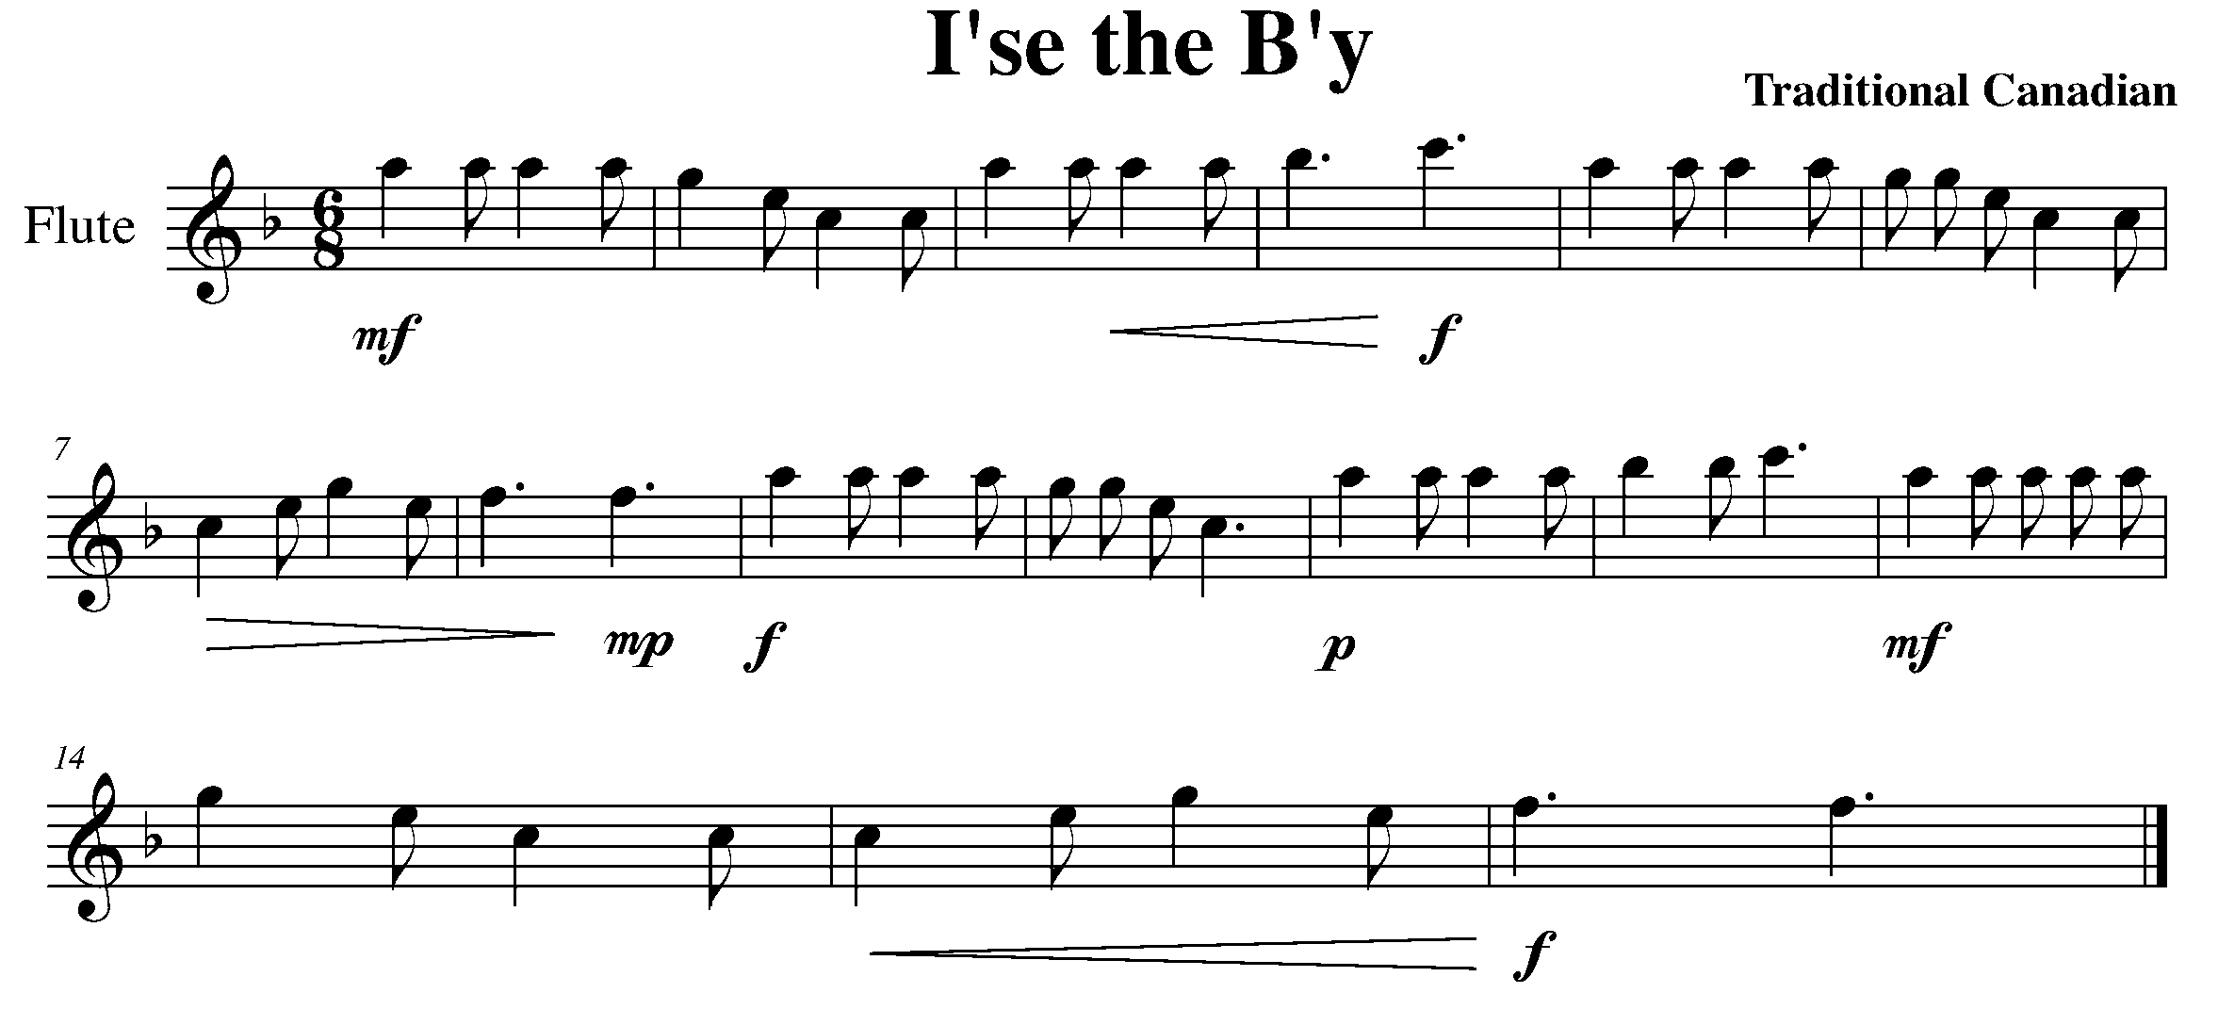
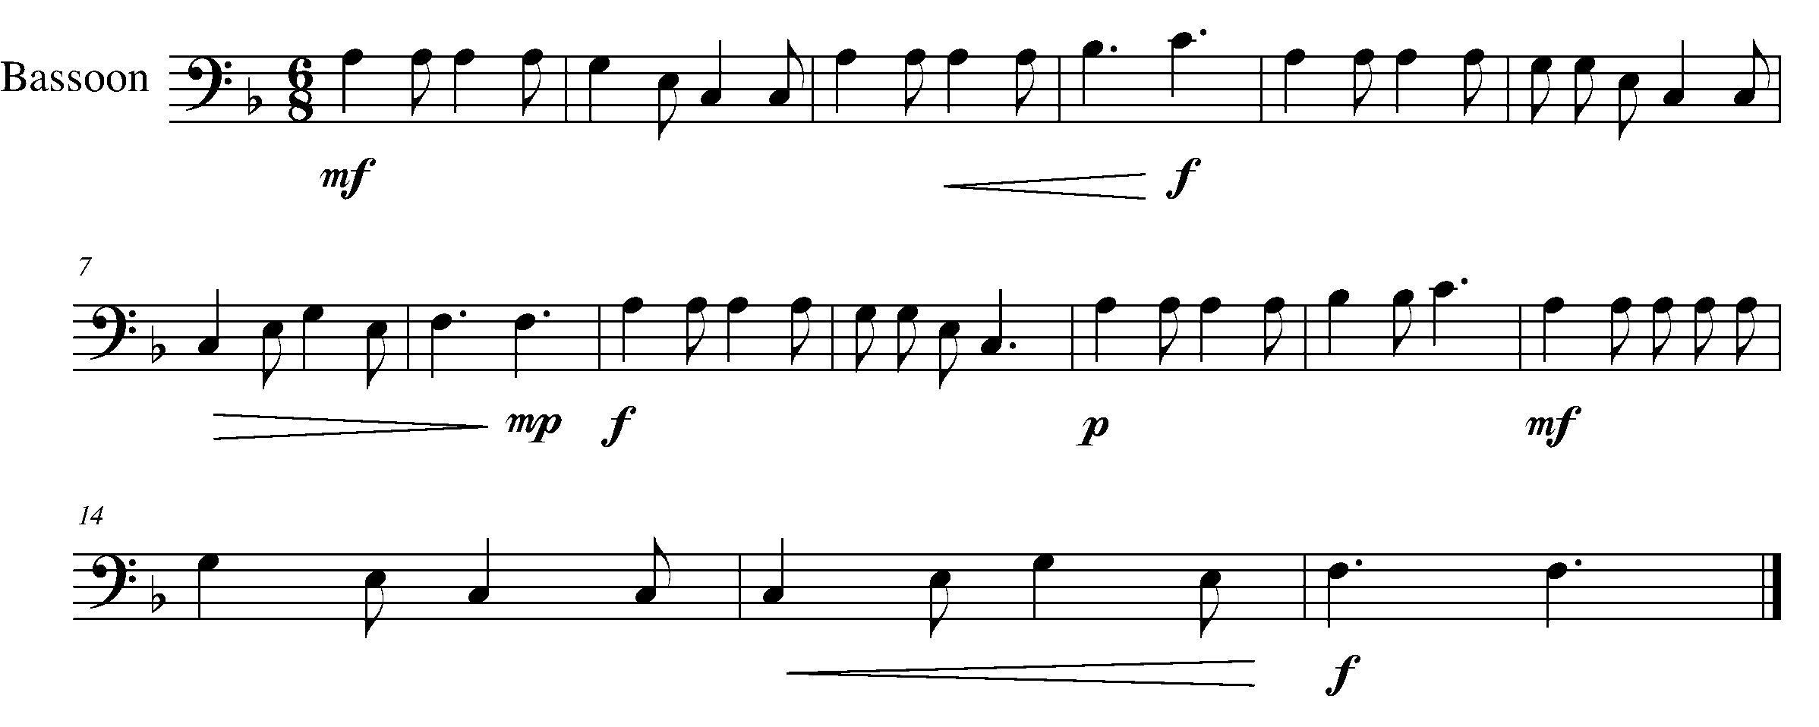

Task 11 Music Continued
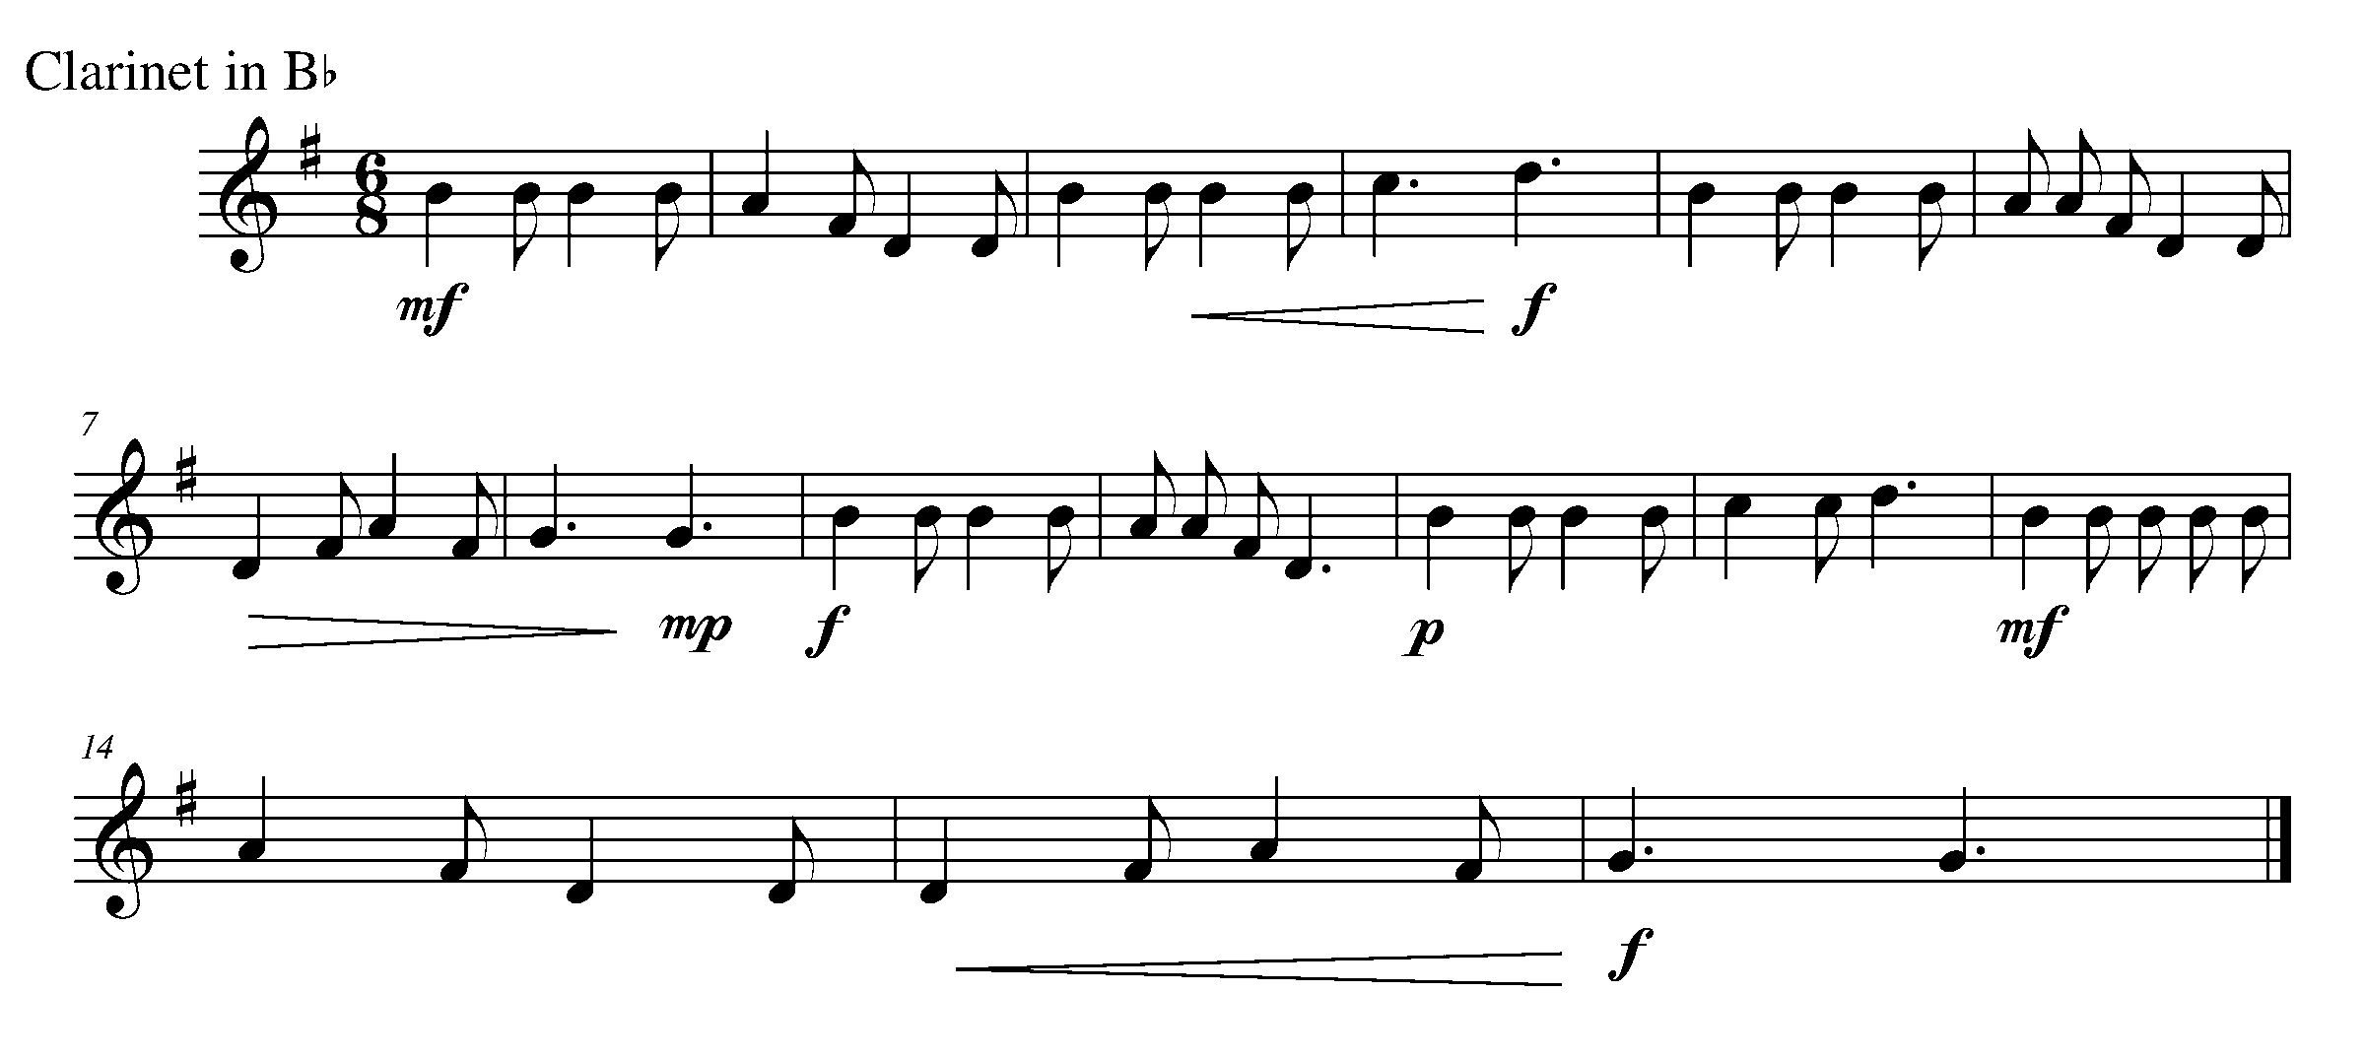
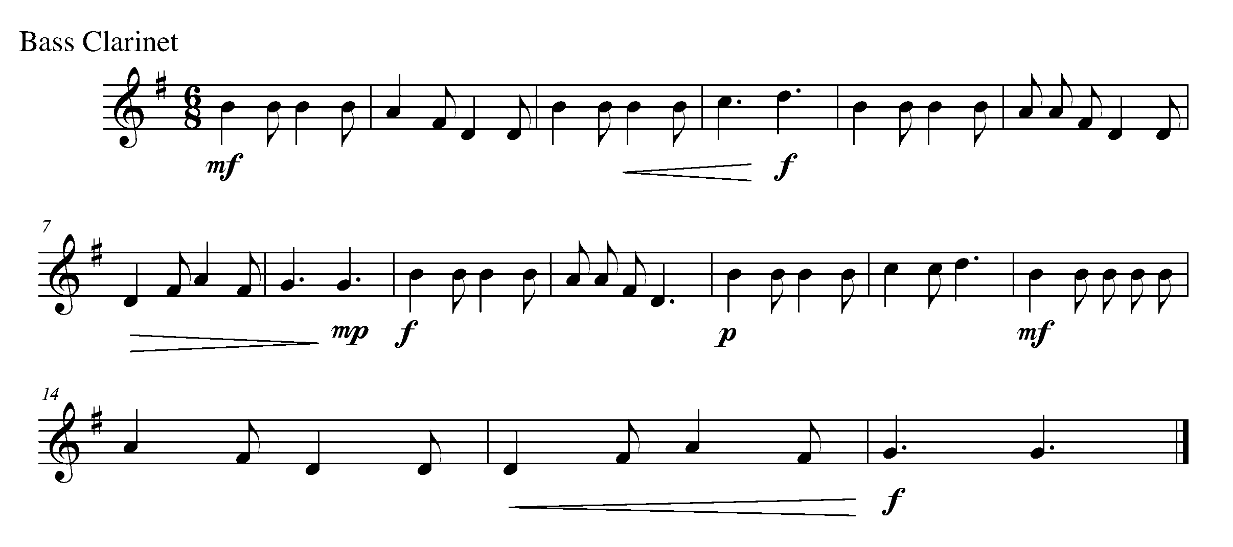
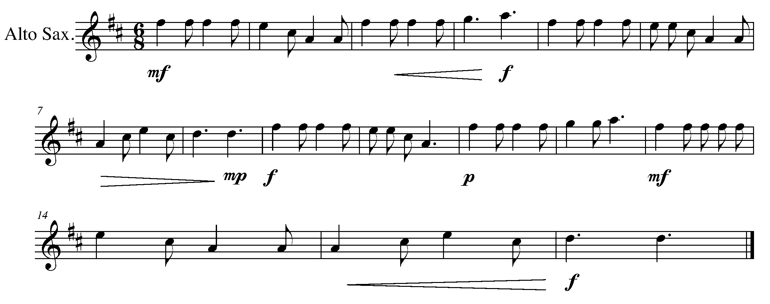

Task 11 Music Continued

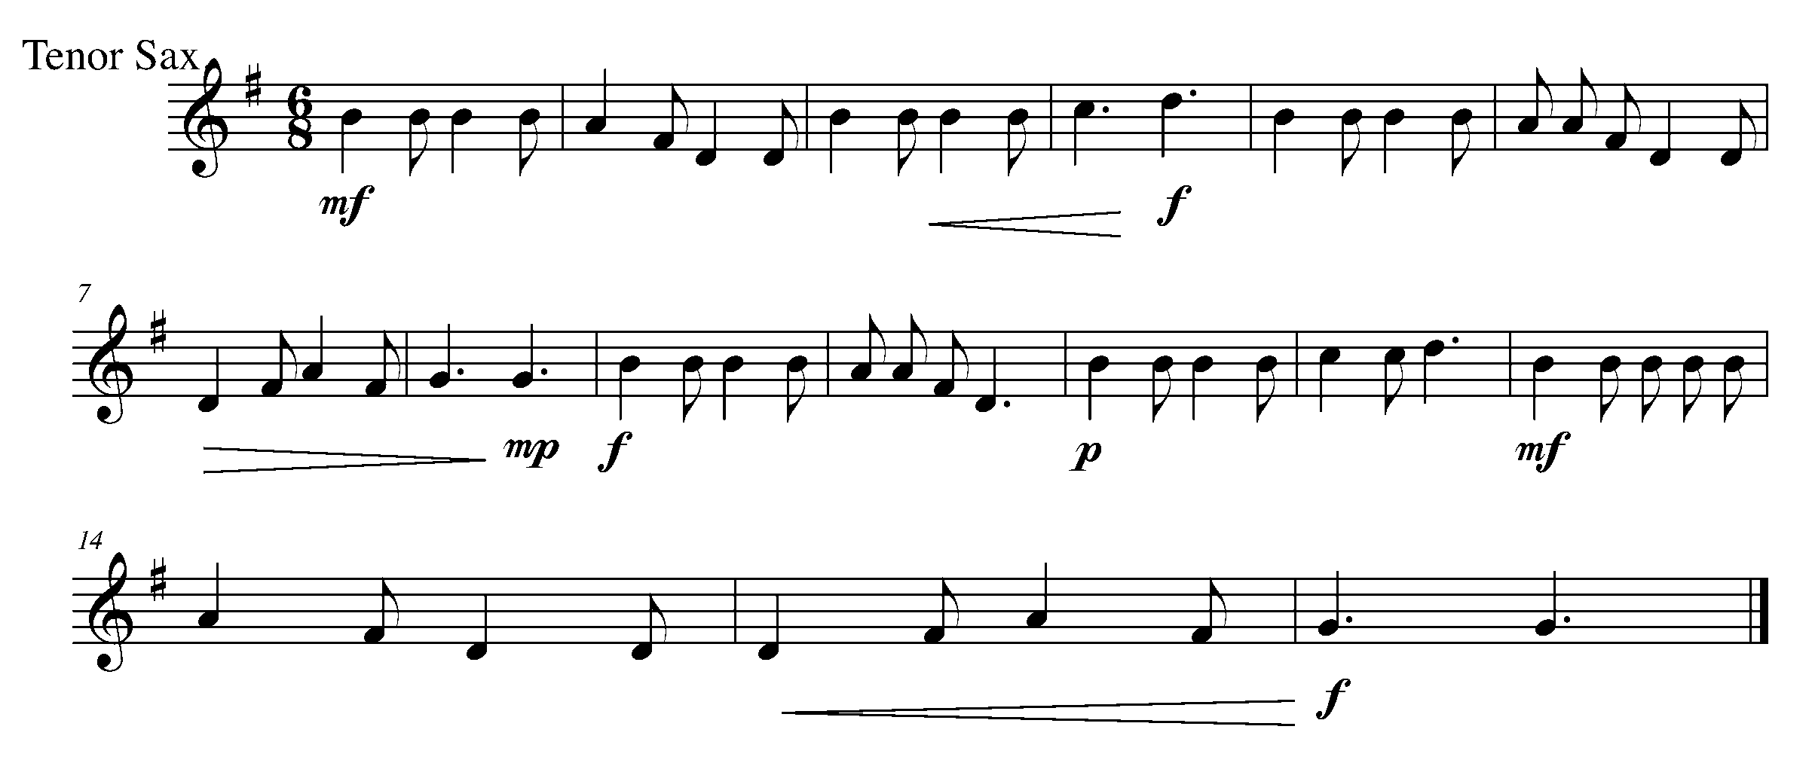
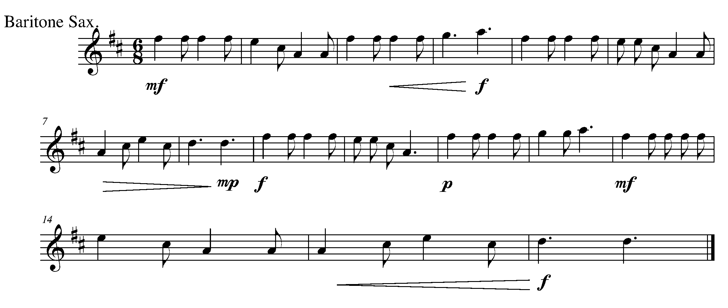
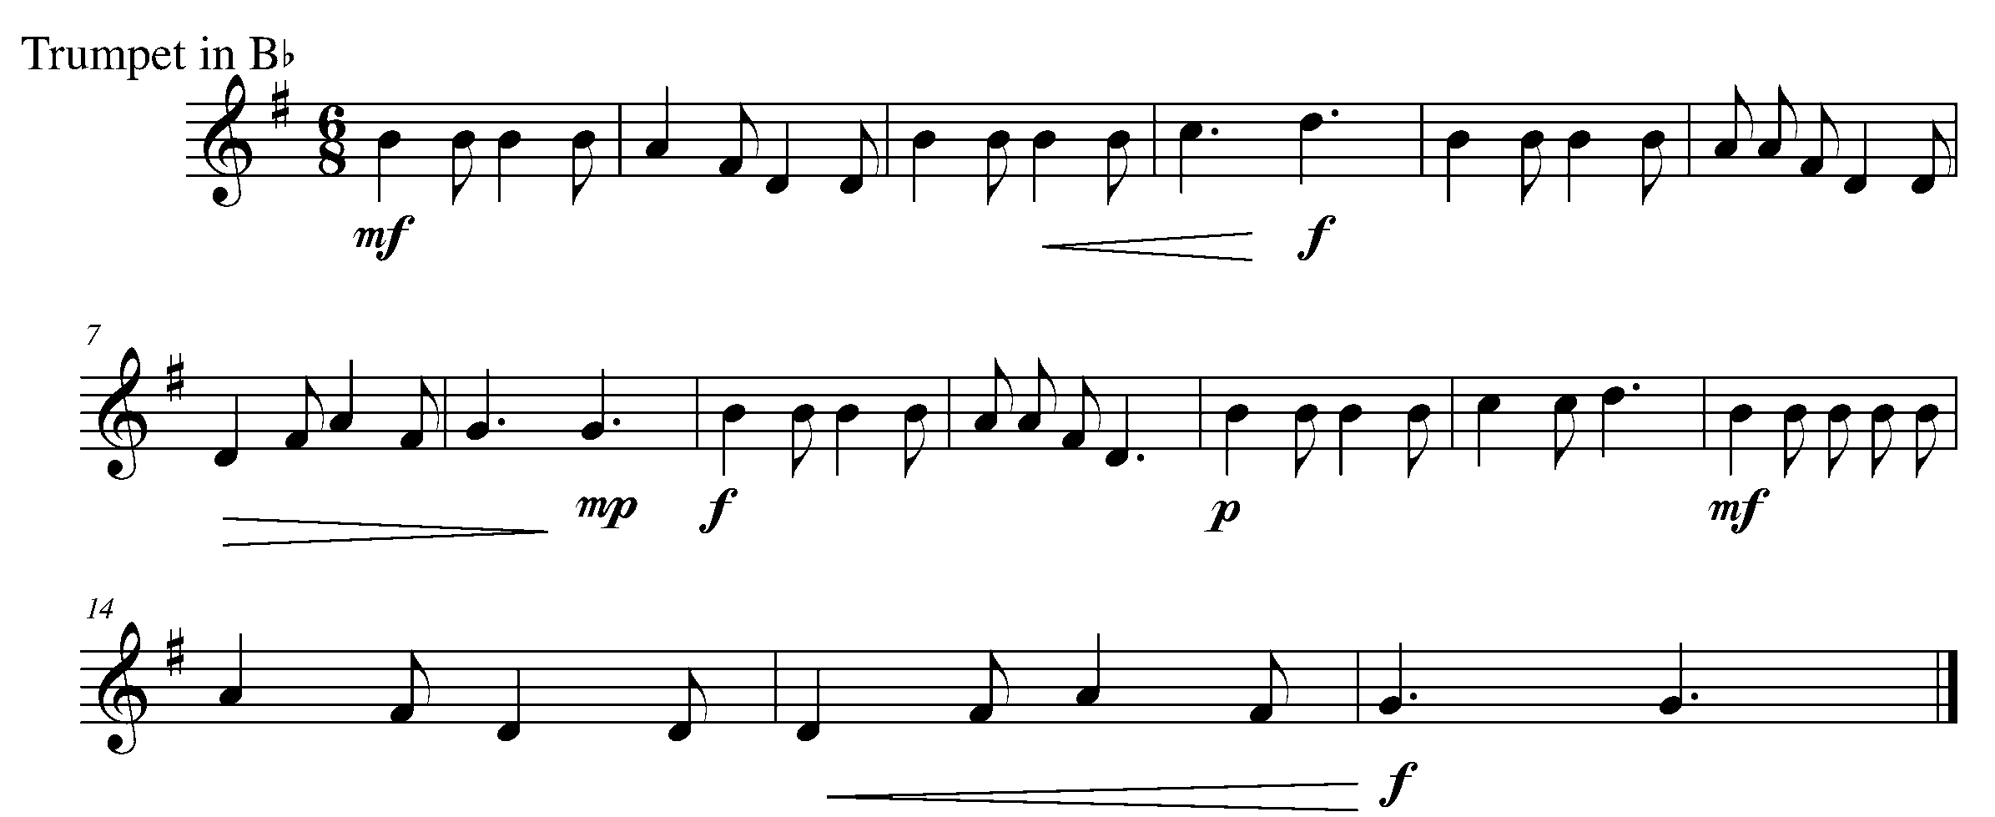

Task 11 Music Continued

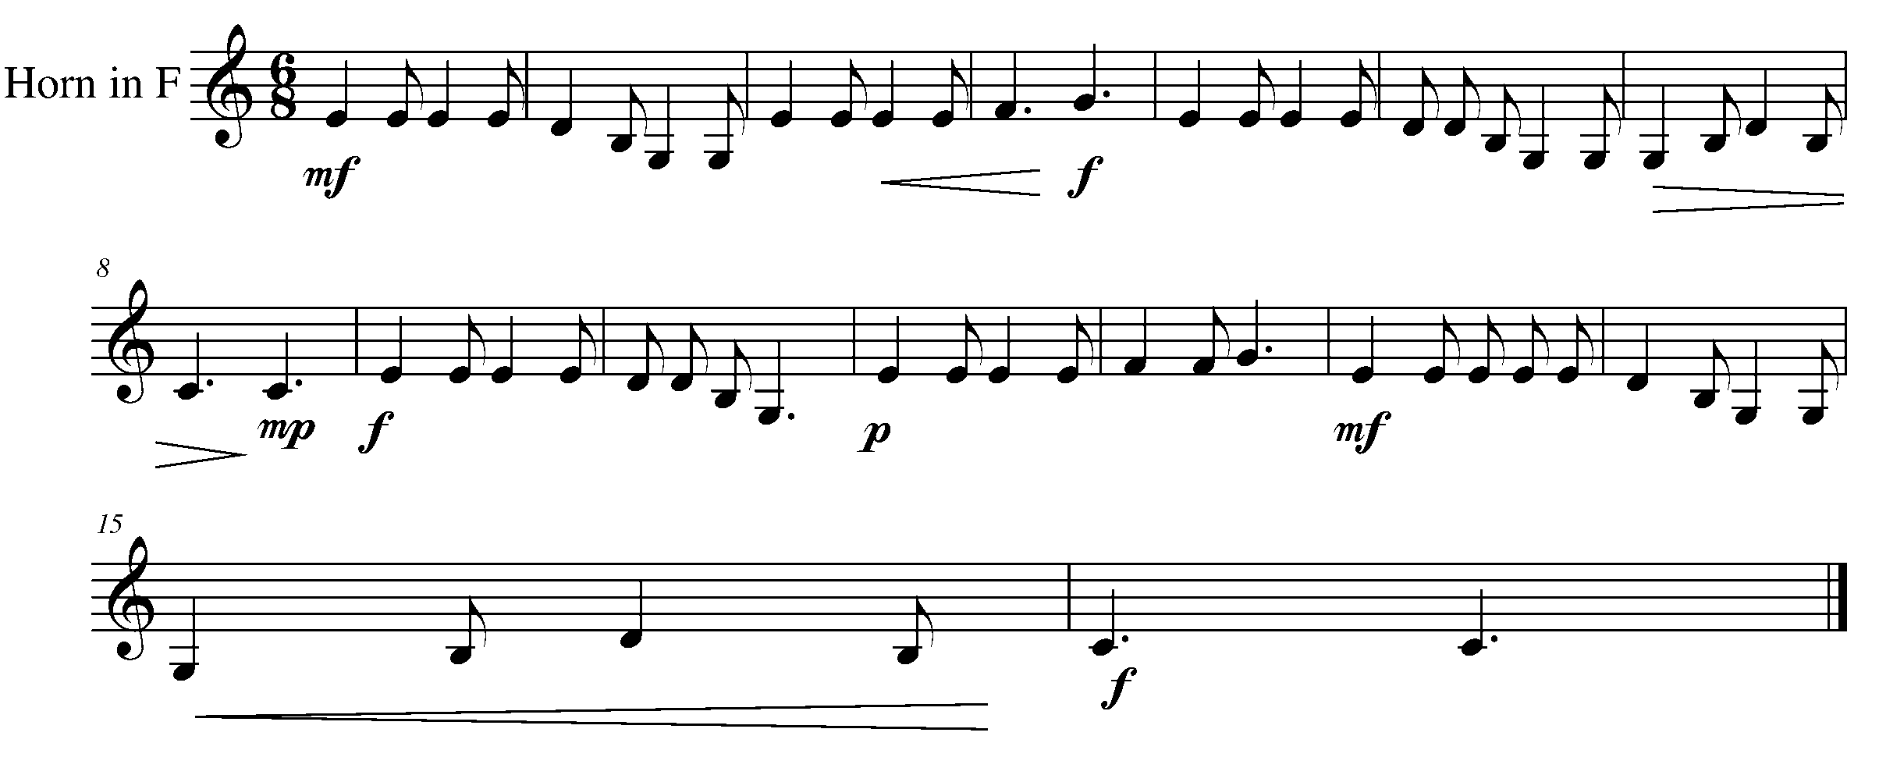
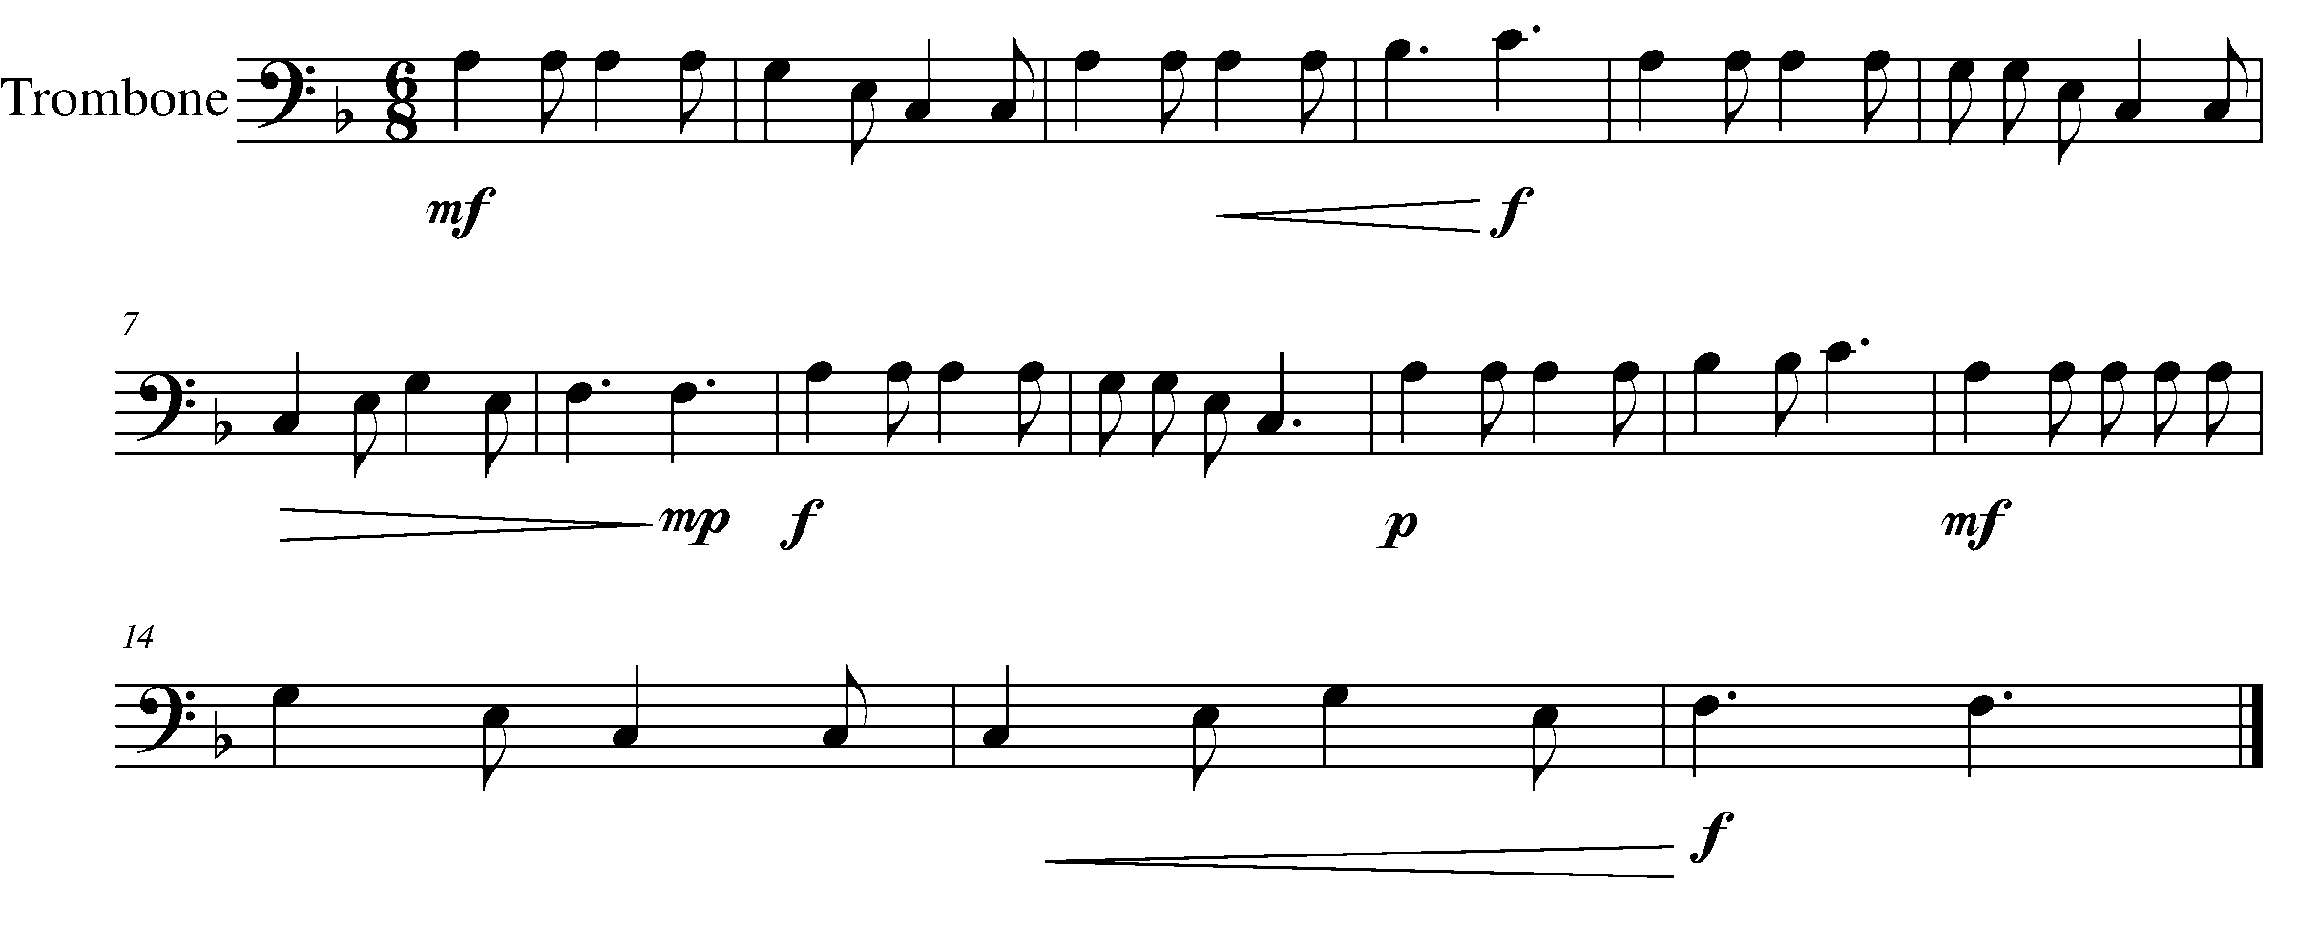
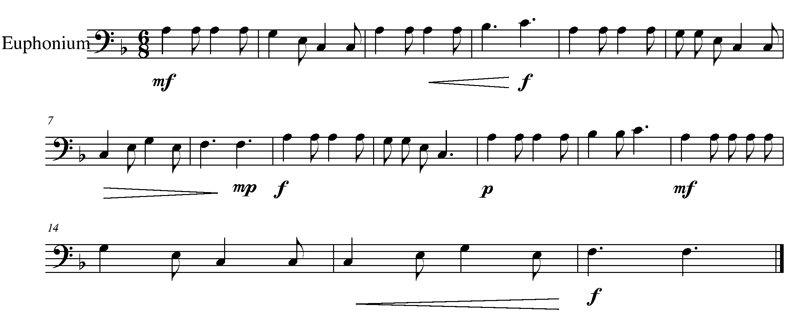

Task 11 Music Continued
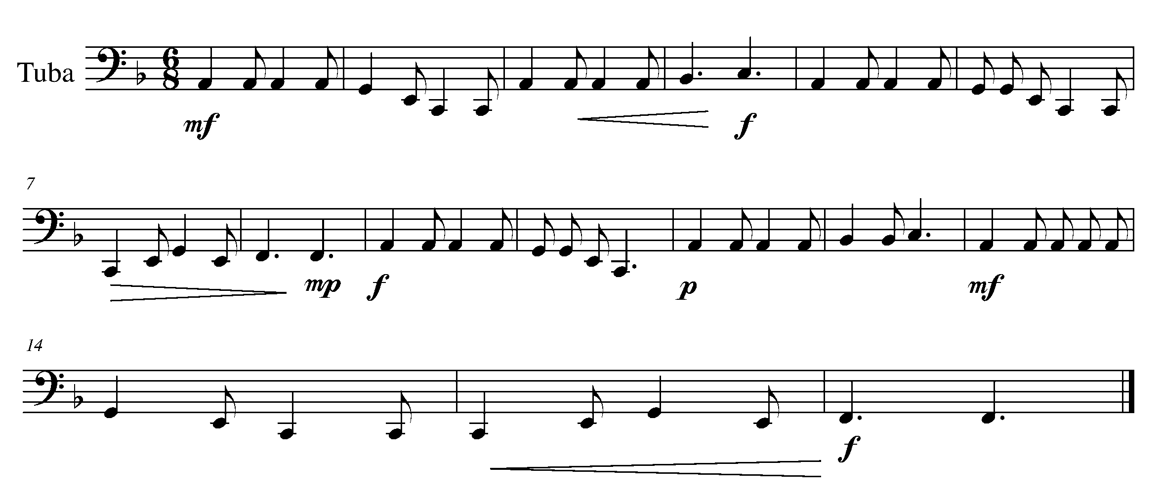
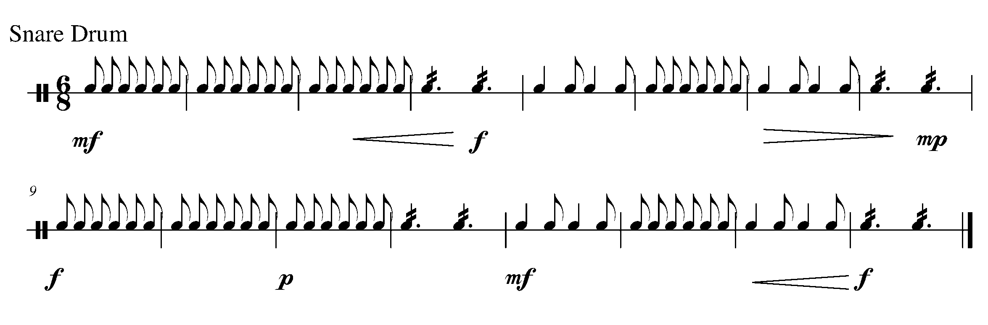
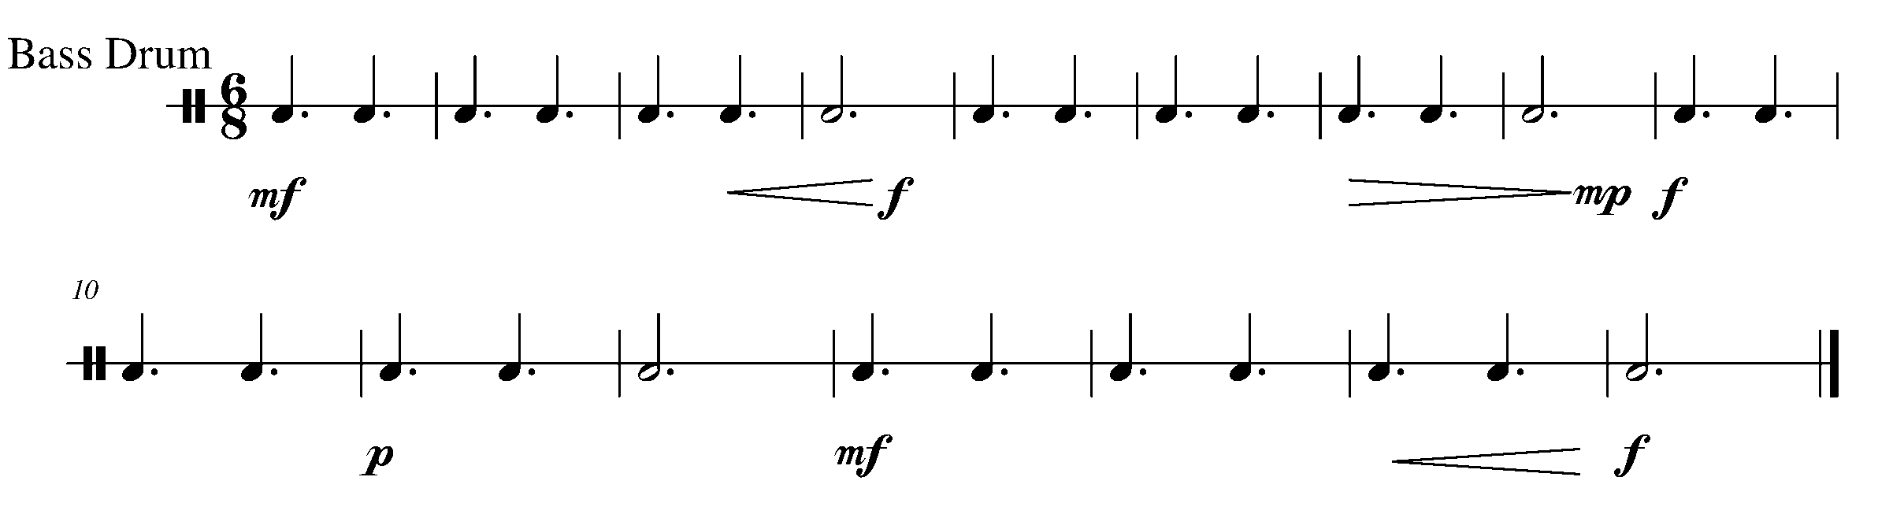
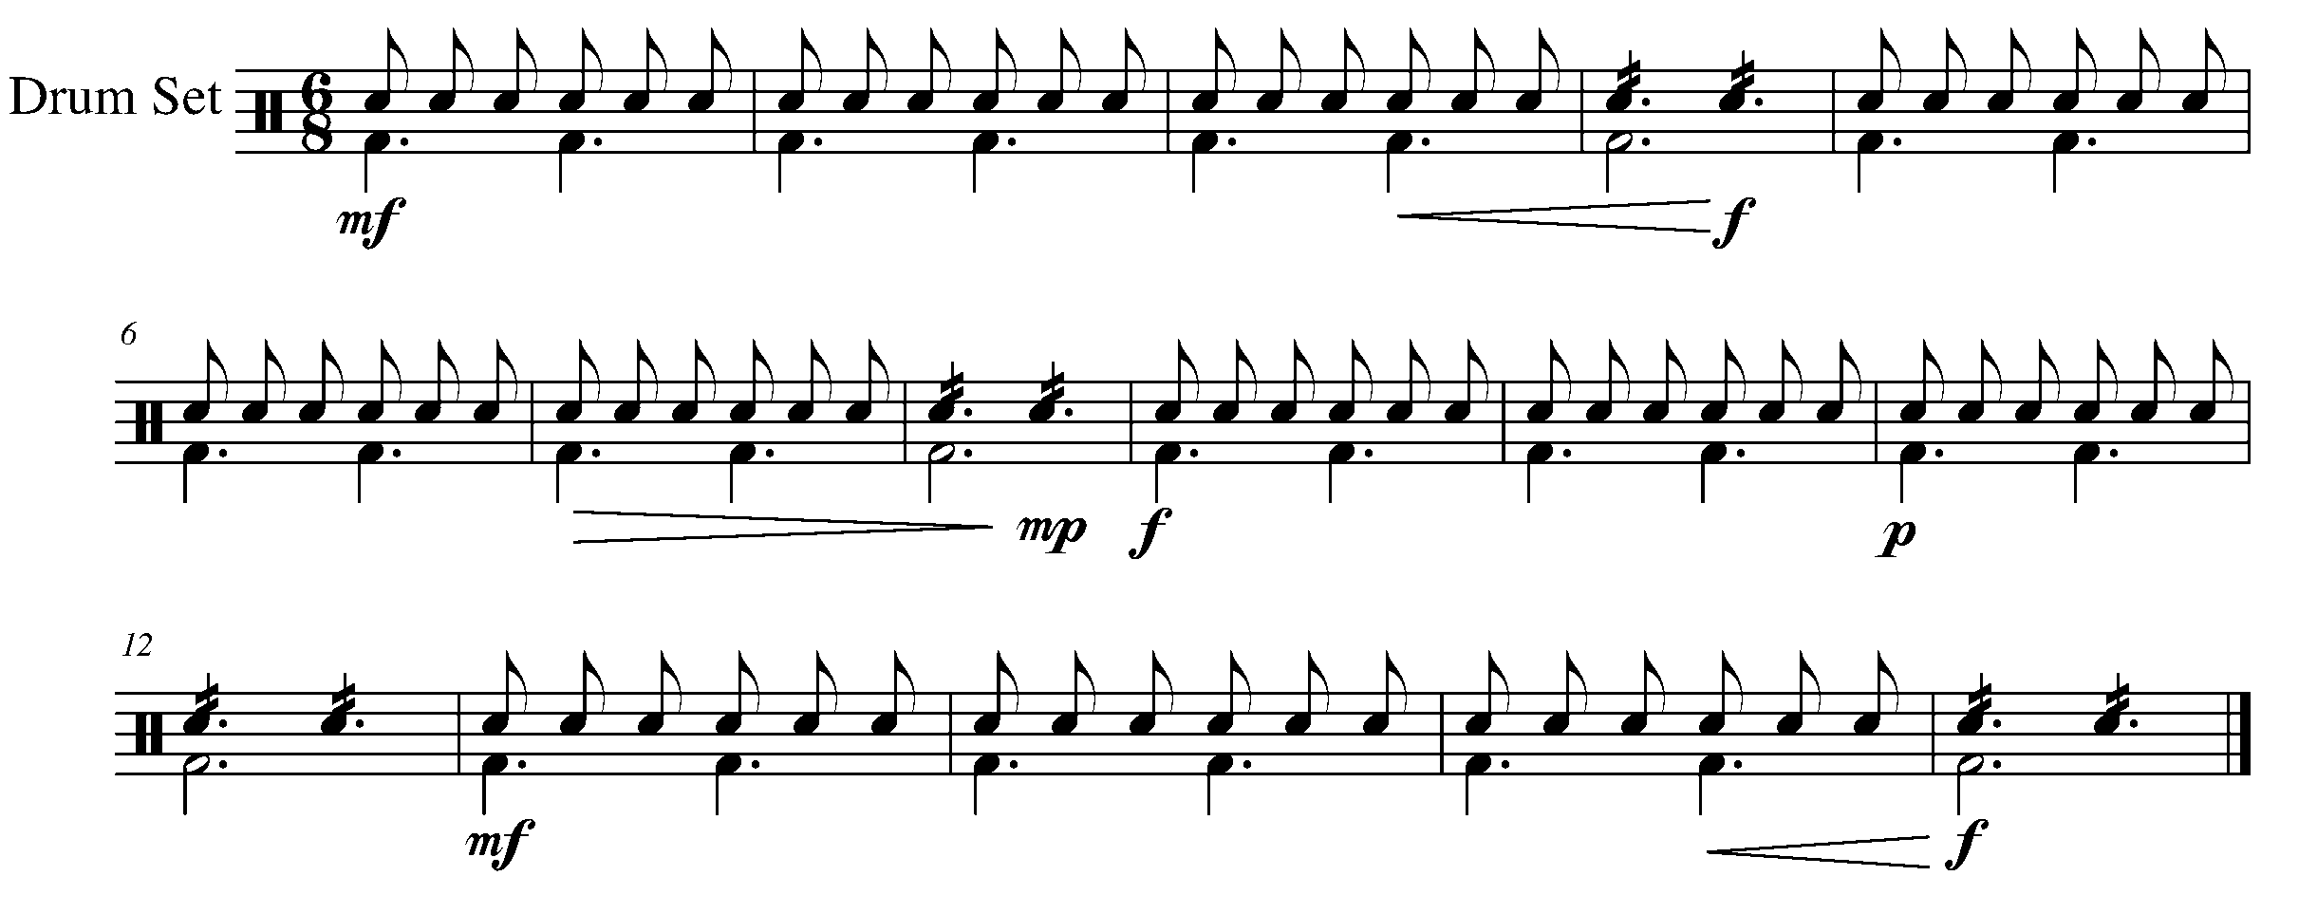
12. ARTICULATING THE DIFFERENCE FOCUS: ARTICULATION
WIND INSTRUMENTS AND SD/BD/KIT

LEARNING GOAL: In this task, you will review and demonstrate the difference of a variety of articulations.

MINDS ON! How does your breath or stick control need to vary for different articulation markings? For wind players/percussionists – what does your tongue/mallet need to do accurately to articulate the given markings?
A Concert Bass Drum Tip
Many concert bass drum articulations can be managed by the hand that does not hold the mallet. Think of the contact that your non–mallet hand has with the drum head. Experiment with the difference in sound between a staccato note and an accented note.

ACTION! To be successful with this task, you will need to:

- Recognize the different articulation markings in the piece below;
- Demonstrate an understanding of good breath control and phrasing;
- Perform with accuracy and good posture.

CONSOLIDATION: In order to move on to the next task, perform the following piece for your teacher and receive feedback.

Music for Task 12 is found on the following page.
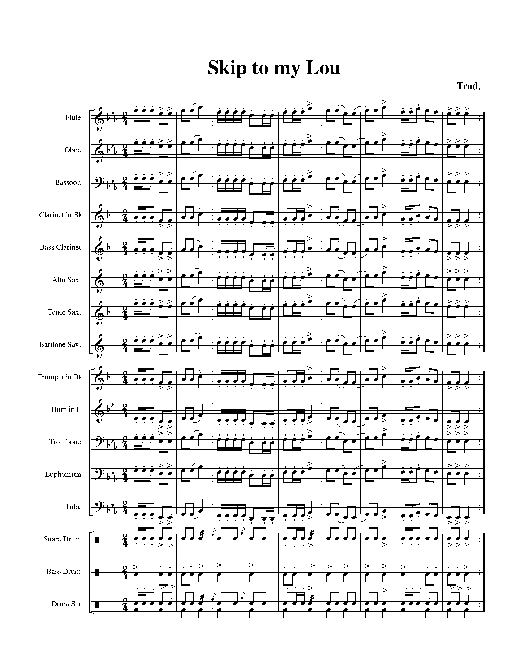

13. FLUID AND SENSIBLE…IN 3/8 TIME! FOCUS: PHRASING
WIND INSTRUMENTS AND MALLETS

LEARNING GOAL: The purpose of this task is to demonstrate your understanding of the importance of how phrasing shapes a piece of music.

MINDS ON! If you breathe every third word when you are speaking, the communication of what you are trying to say is lost. Why is it important to recognize the phrases within a piece? If you cannot make a phrase in one breath, how will you decide where to breathe?

Mallet Rolls
Percussionists are to note that, in this piece, there is a mallet roll found in measure number 7. Make sure that your roll uses both hands, which are even in strength and maintains a sound.

ACTION! To be successful with this task, you will need to:
- Determine where the phrases are within the below piece;
- Take in deep, controlled breaths – that are supported; and
- Listen to yourself – play in a musical way.

CONSOLIDATION: In order to move on to the next task, perform the following familiar piece for your teacher and receive feedback.

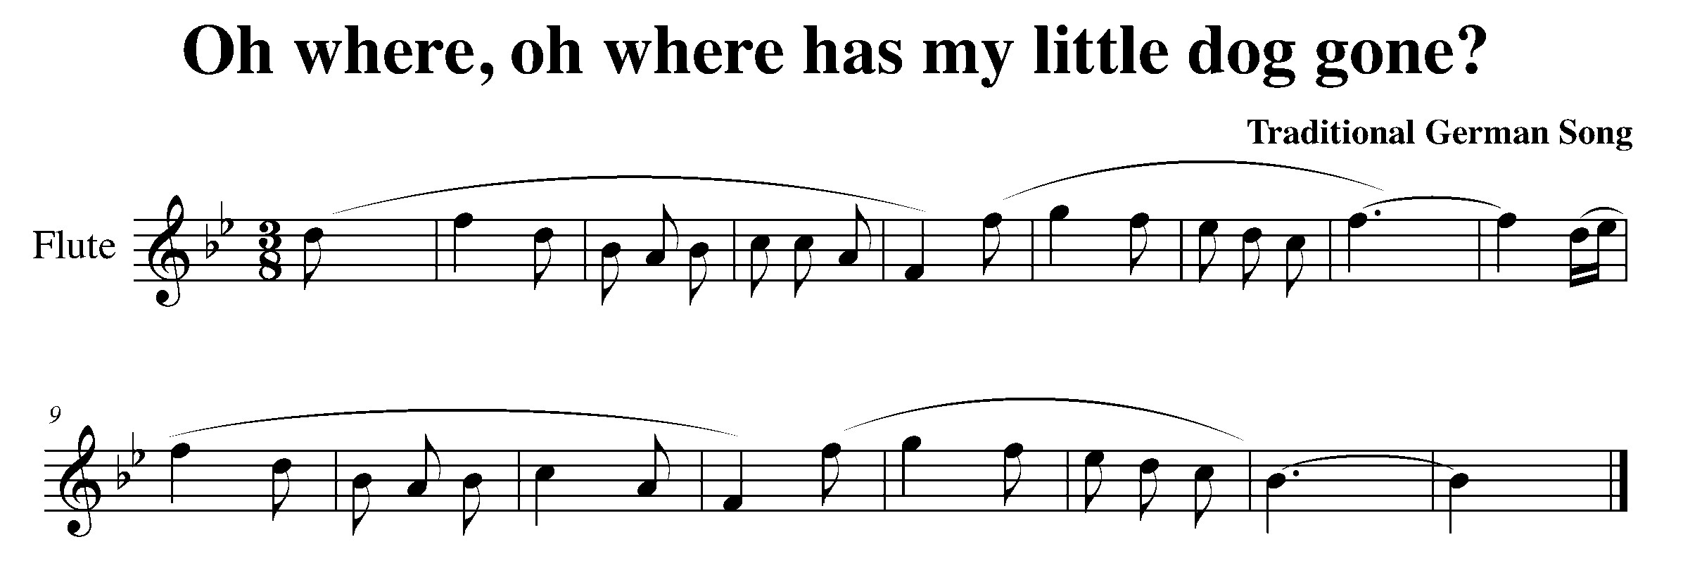

Task 13 Music Continued

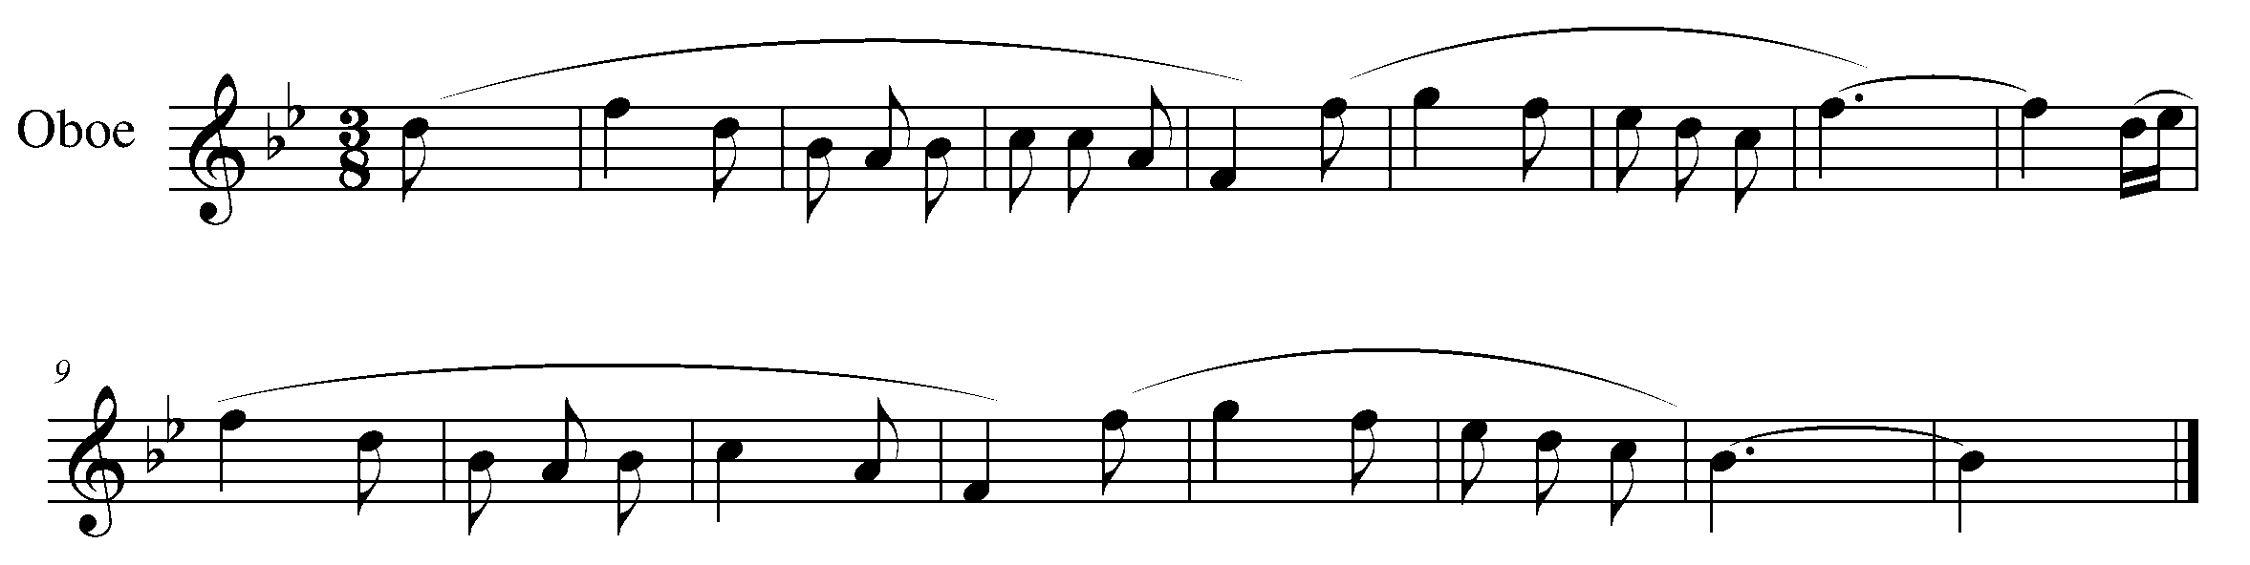
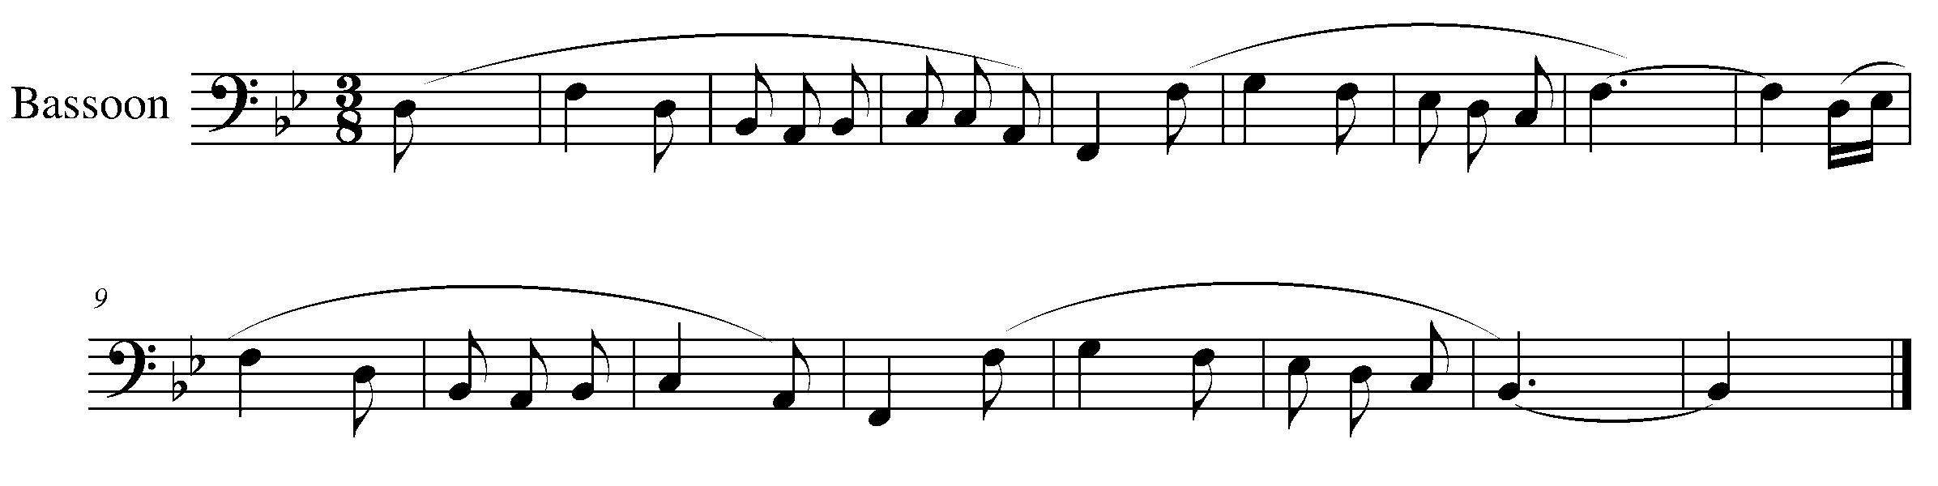
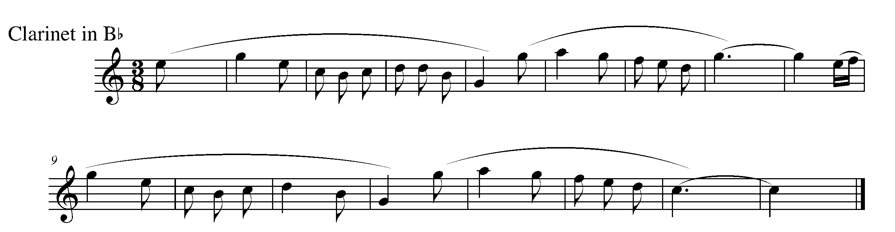
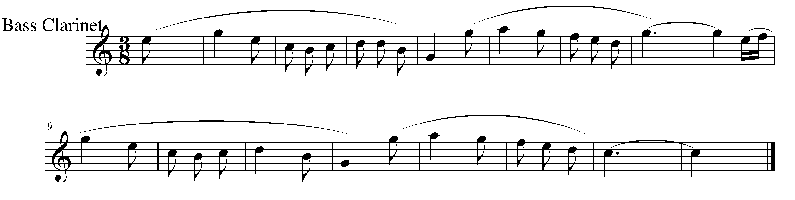
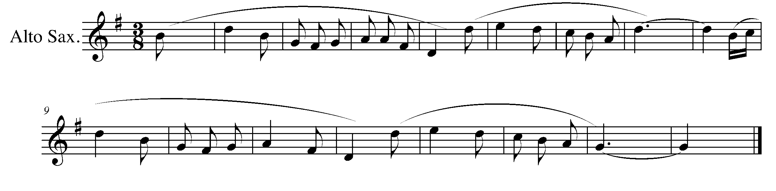

Task 13 Music Continued

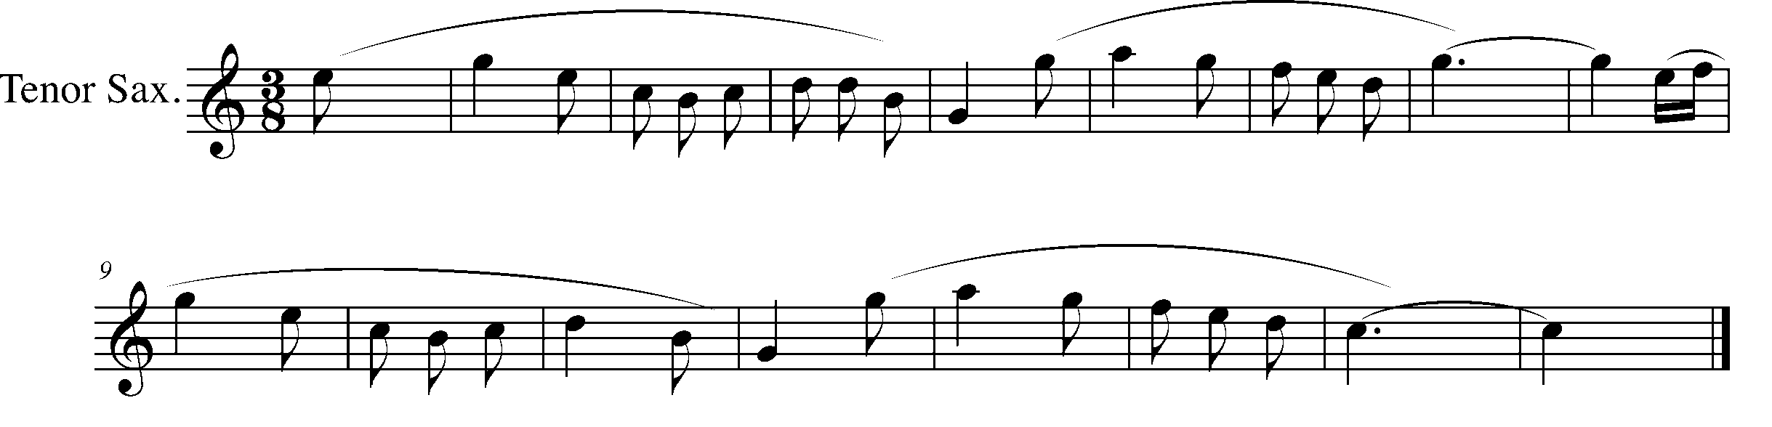
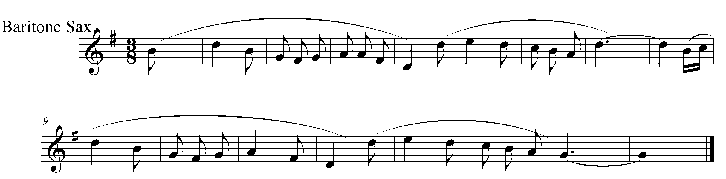
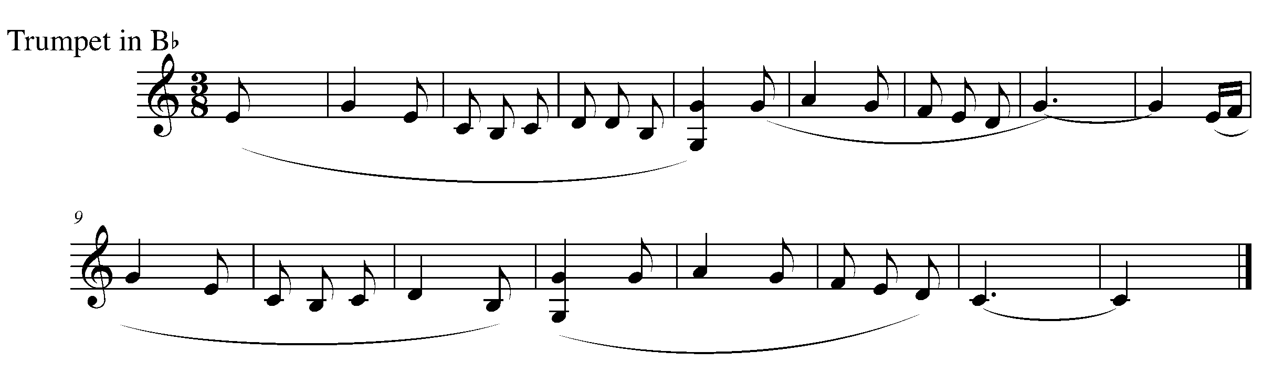
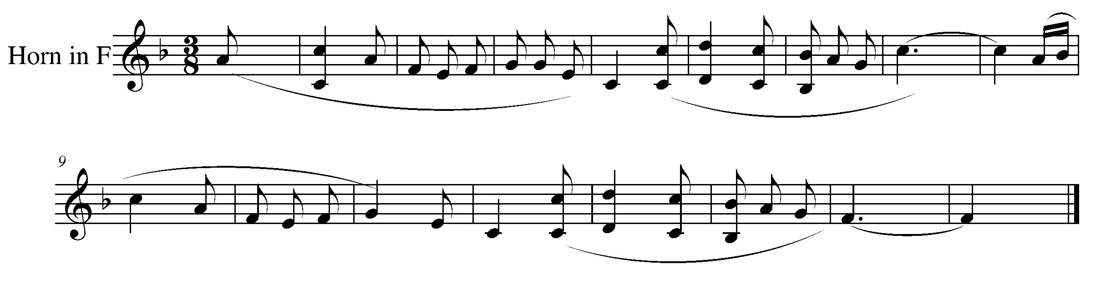
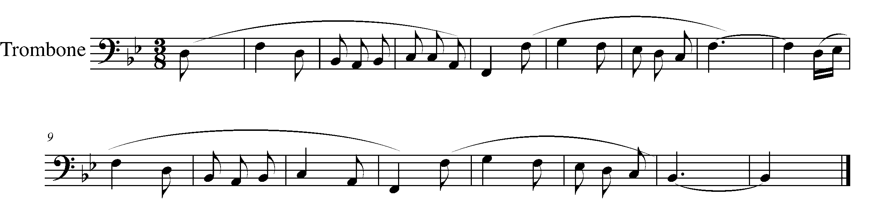

Task 13 Music Continued
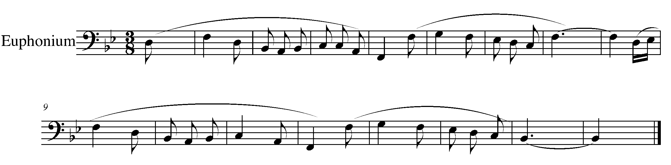
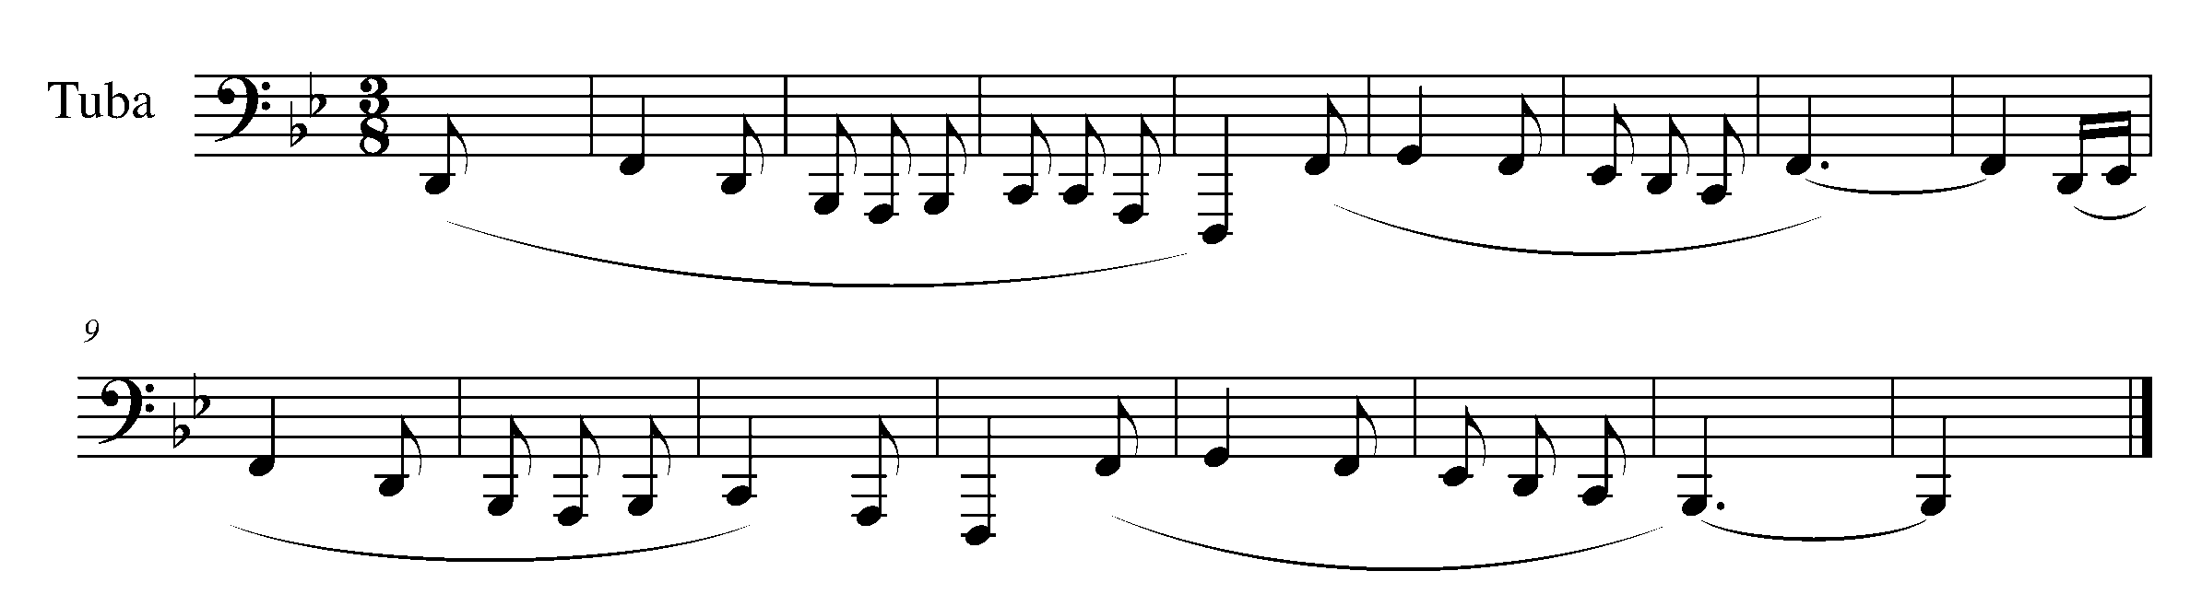
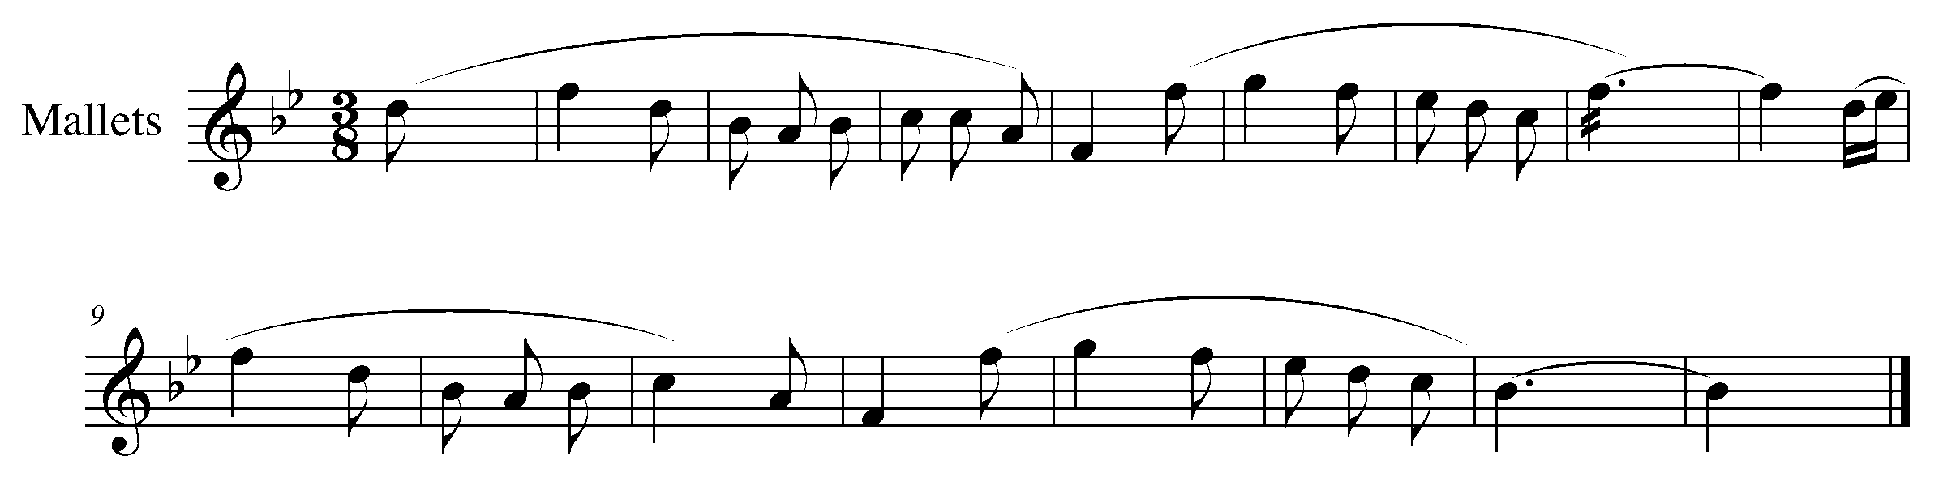

14. THE SKILL OF THE TRILL FOCUS: TRILLS
WIND INSTRUMENTS AND MALLETS

LEARNING GOAL: The purpose of this task is to introduce the “how to” of the trill. The rhythms within this task review a variety of rhythms which have been previously introduced.

MINDS ON! How do you perform a trill? To what note do you trill? Think about your air speed, how should you adjust your air for a trill? Is your trilling finger moving at a consistent speed throughout the trill? How do you start and finish a trill? Trombone players: how are trills executed differently for you? Percussionists: remember to use both hands when trilling – think about the placement of your mallets on the bars.

ACTION! To be successful with this task, you will need to:

- Identify the trills throughout the following piece;
- Realize to what note you are trilling;
- Review the rhythms of this piece – make sure your placement of the eighth notes and dotted quarter notes is accurate;
- Don’t forget to musically play the rest of the piece; and
- Demonstrate good posture and relaxed arms and fingers.

CONSOLIDATION: In order to move on to the next task, perform the following piece for your teacher and receive feedback.

Task 14 Music

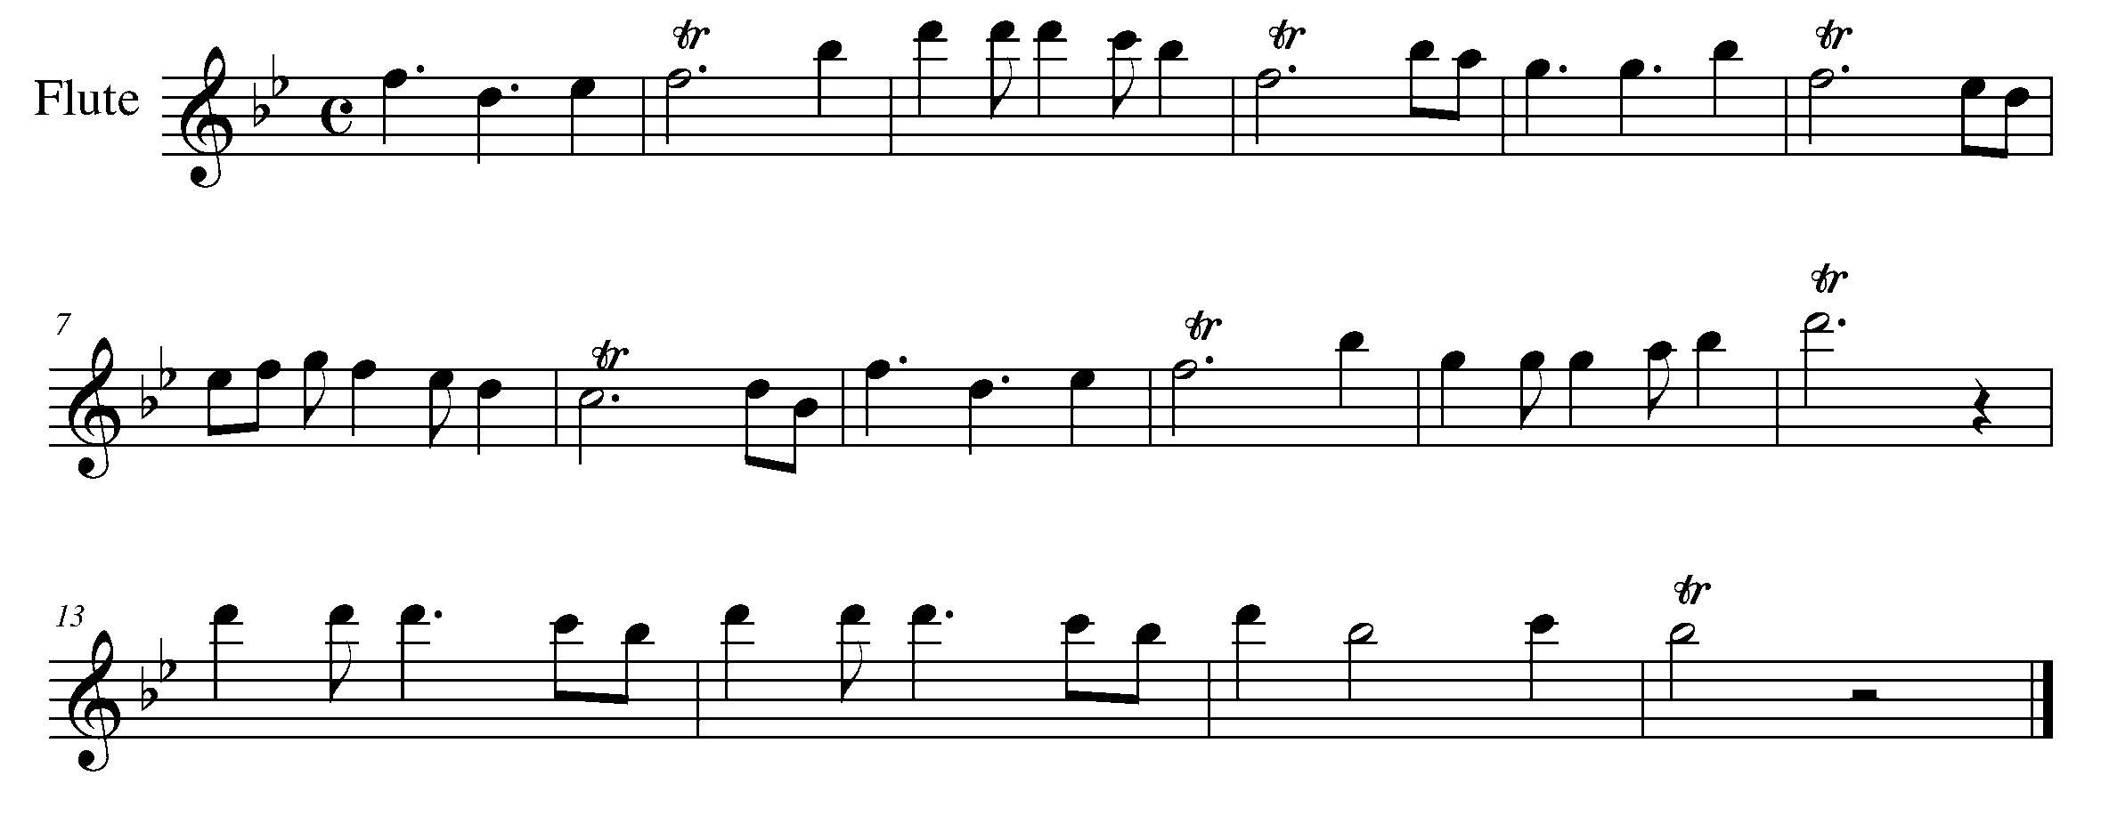
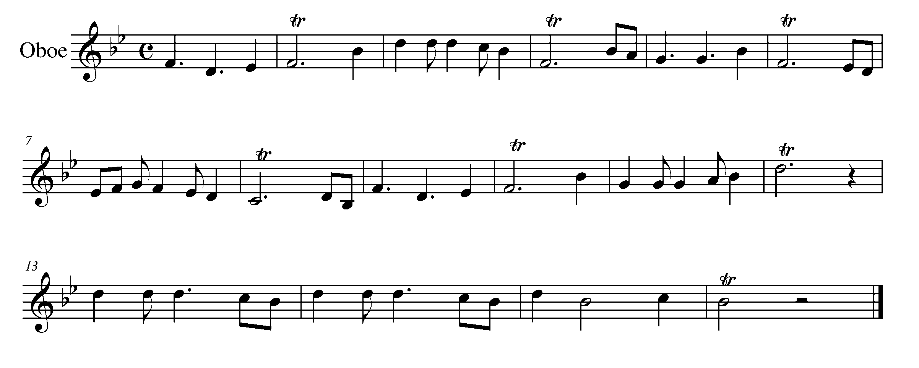

Task 14 Music Continued

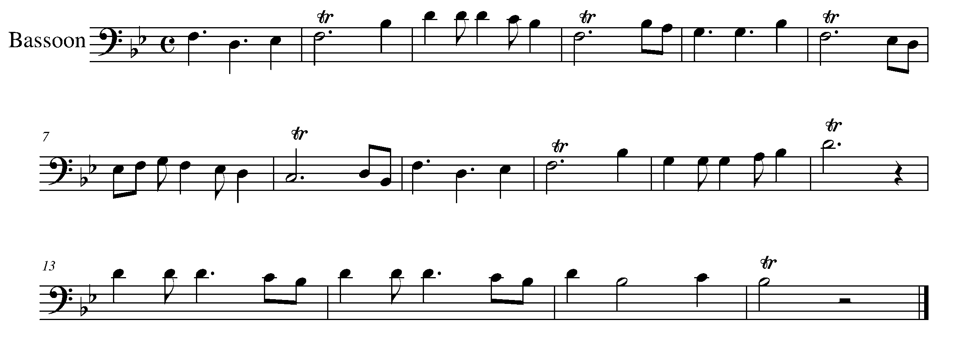
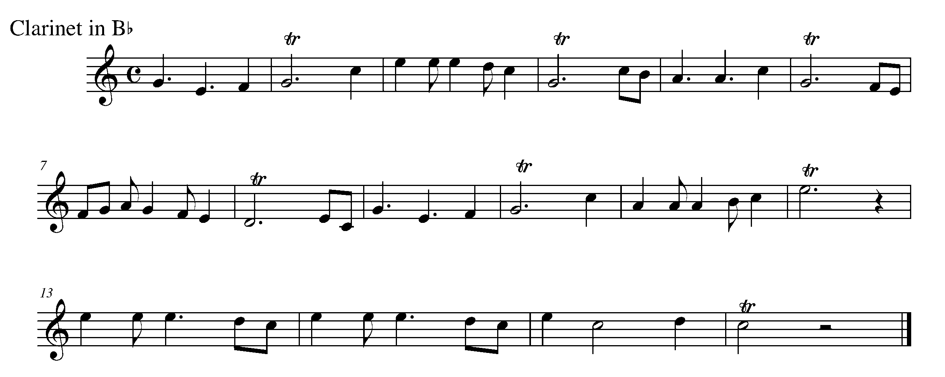
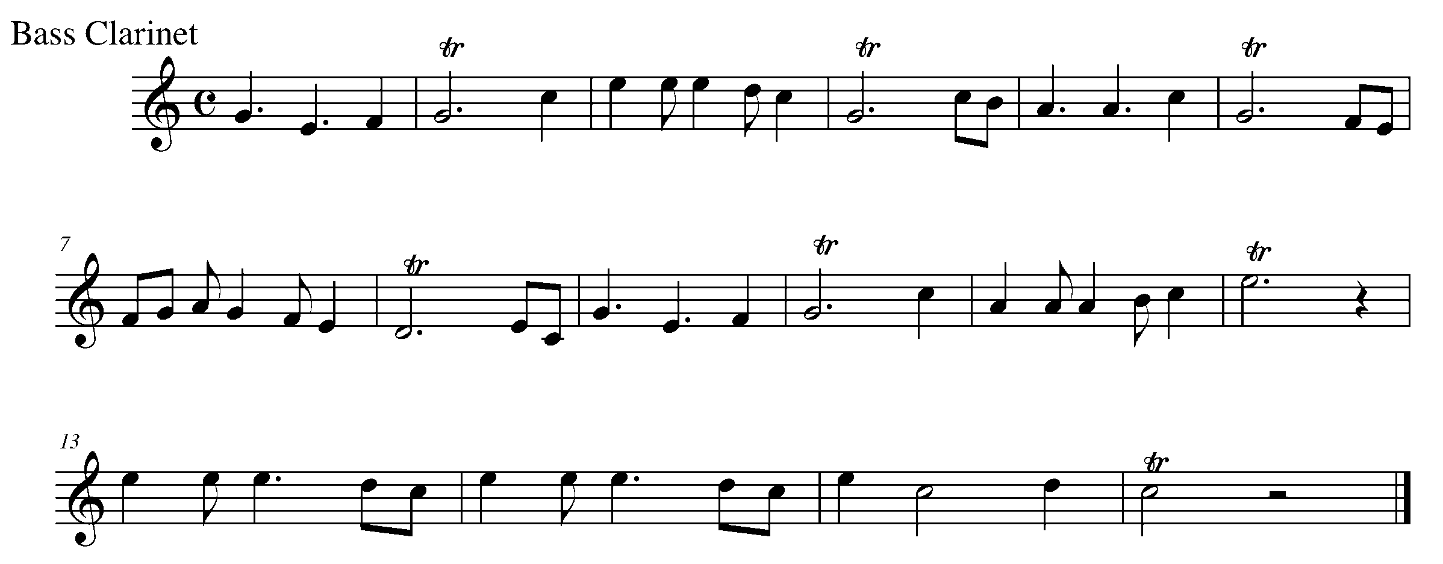

Task 14 Music Continued

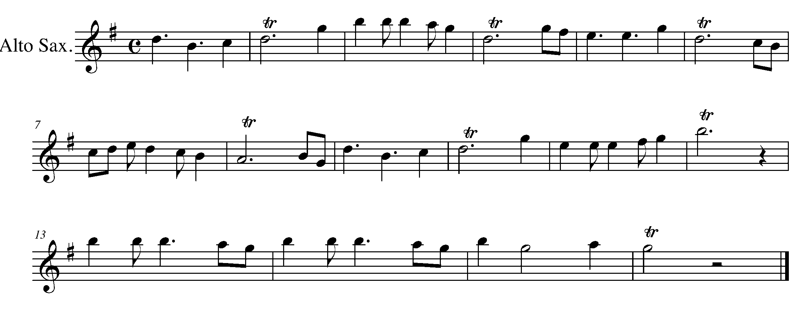
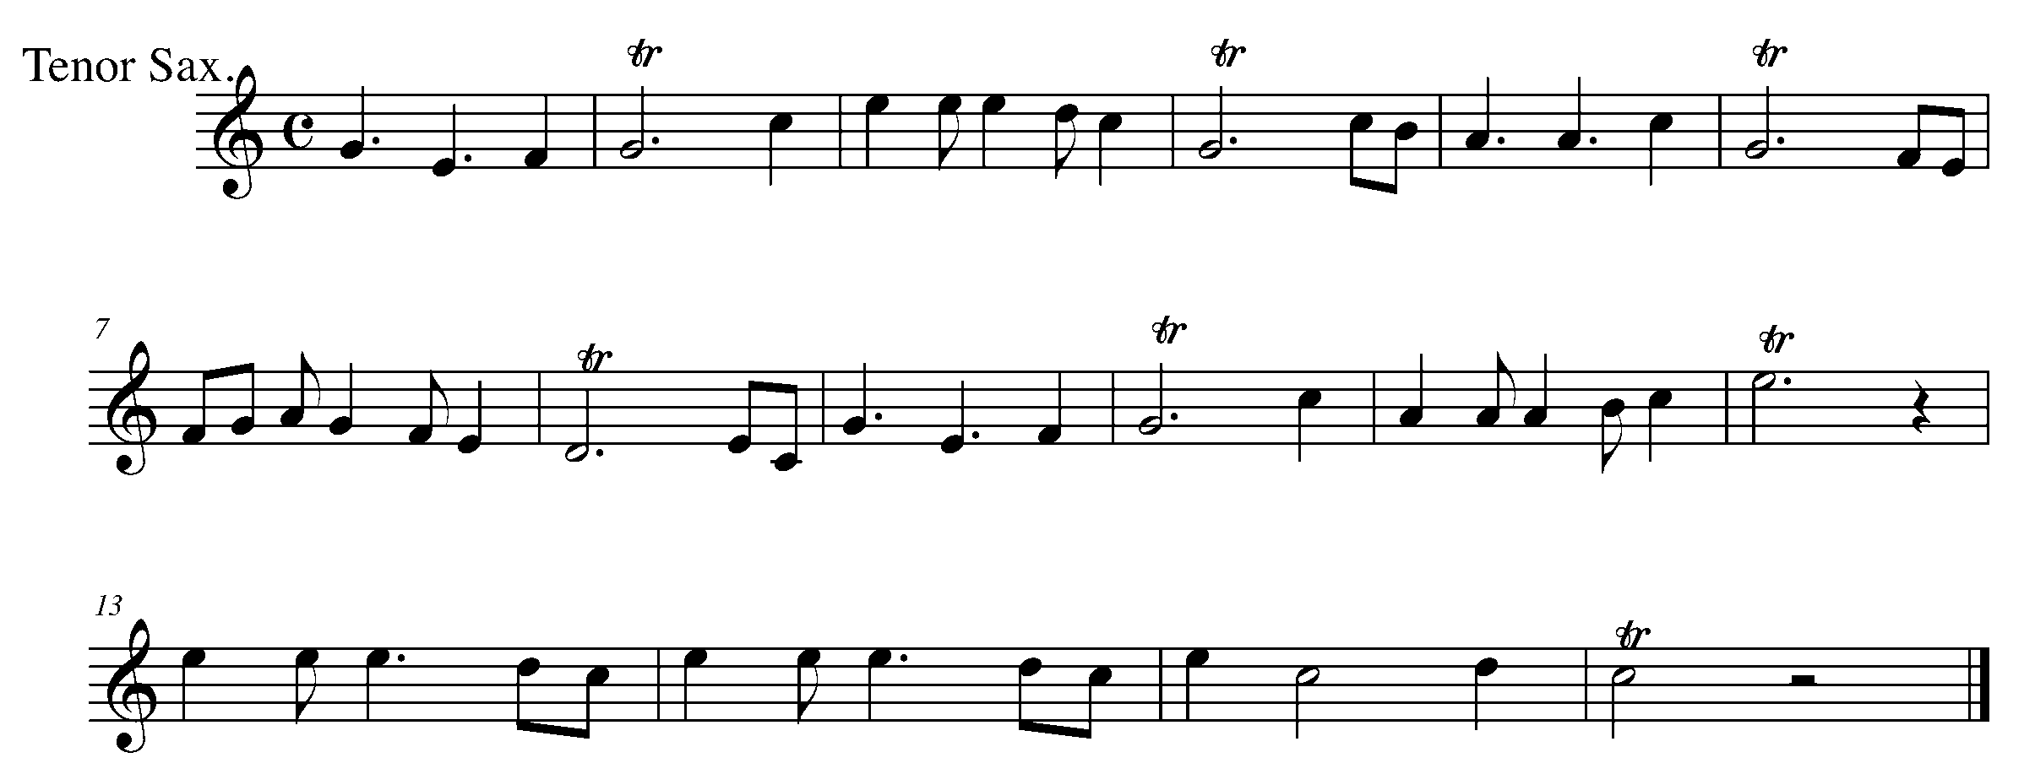
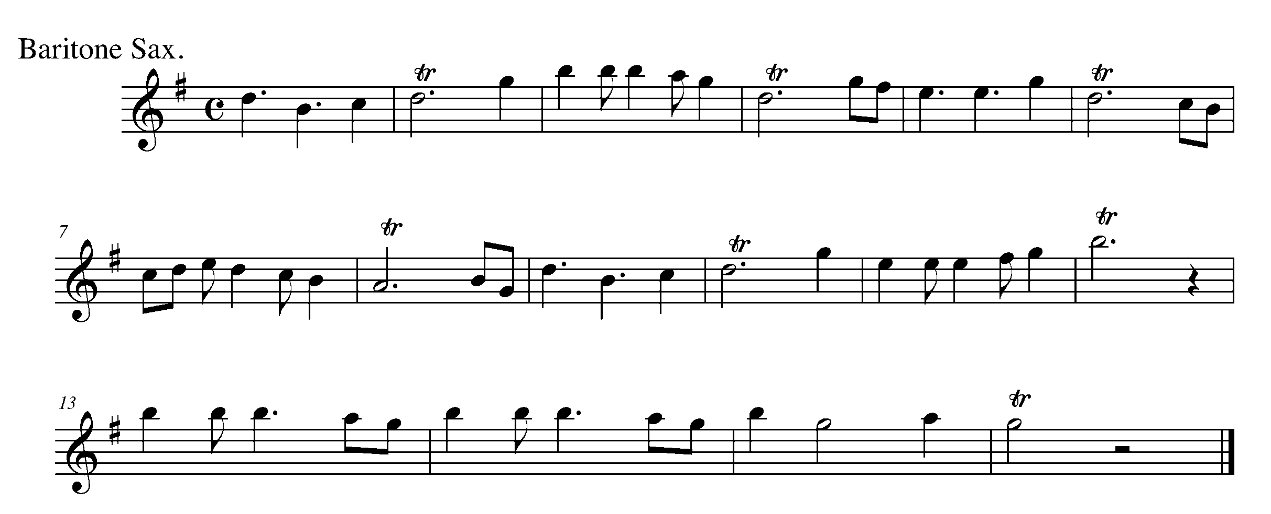

Task 14 Music Continued

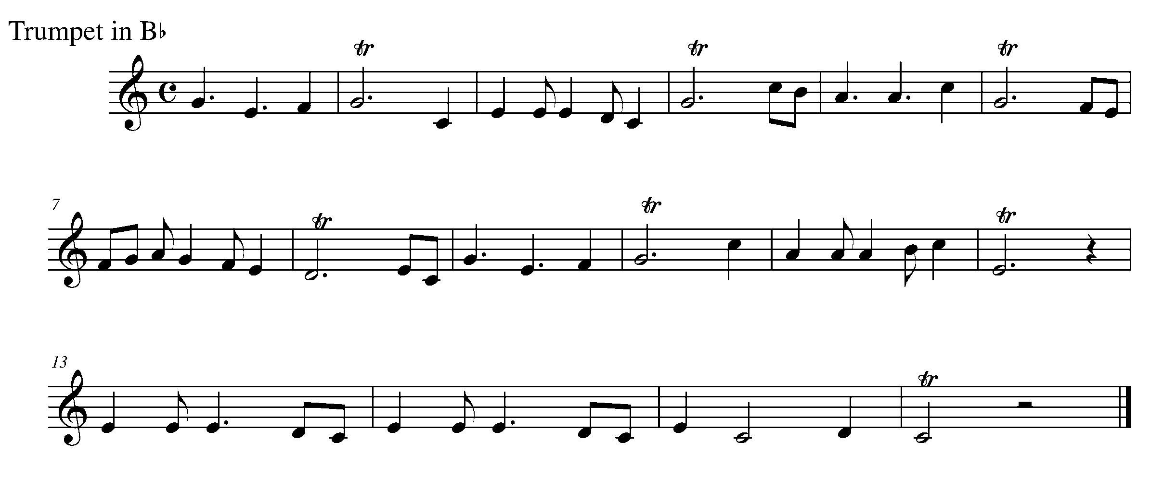
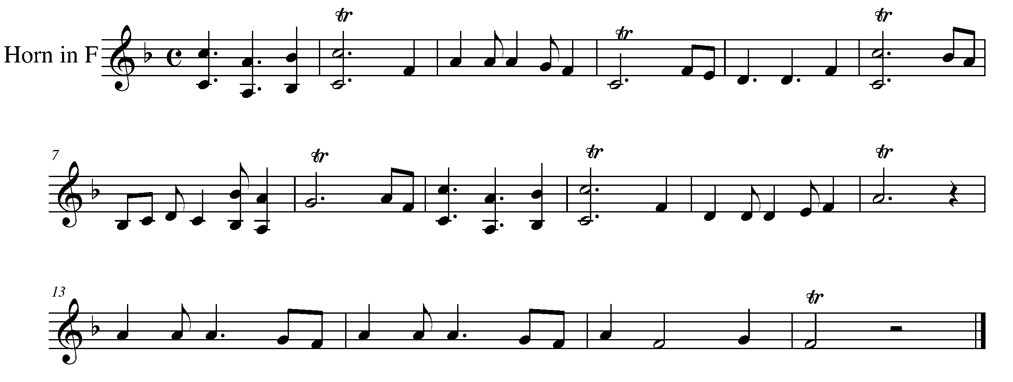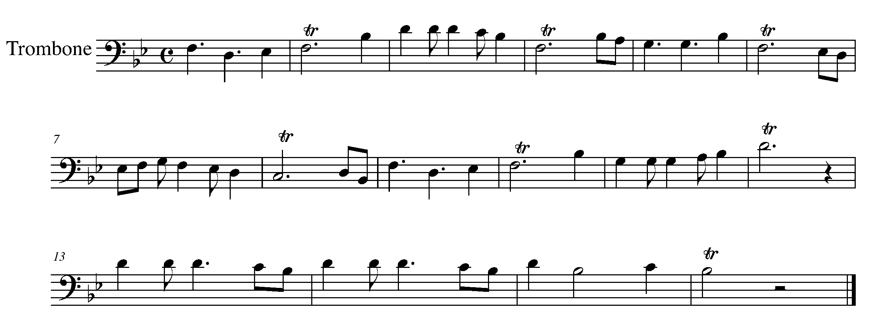

Task 14 Music Continued

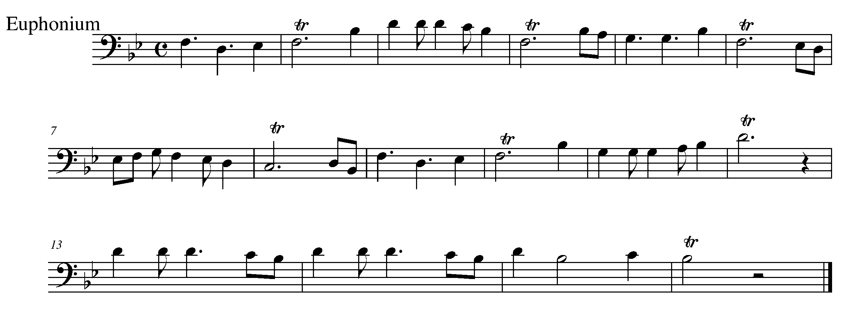
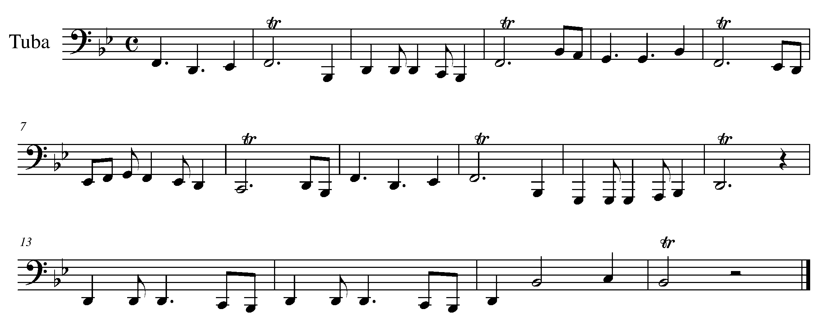
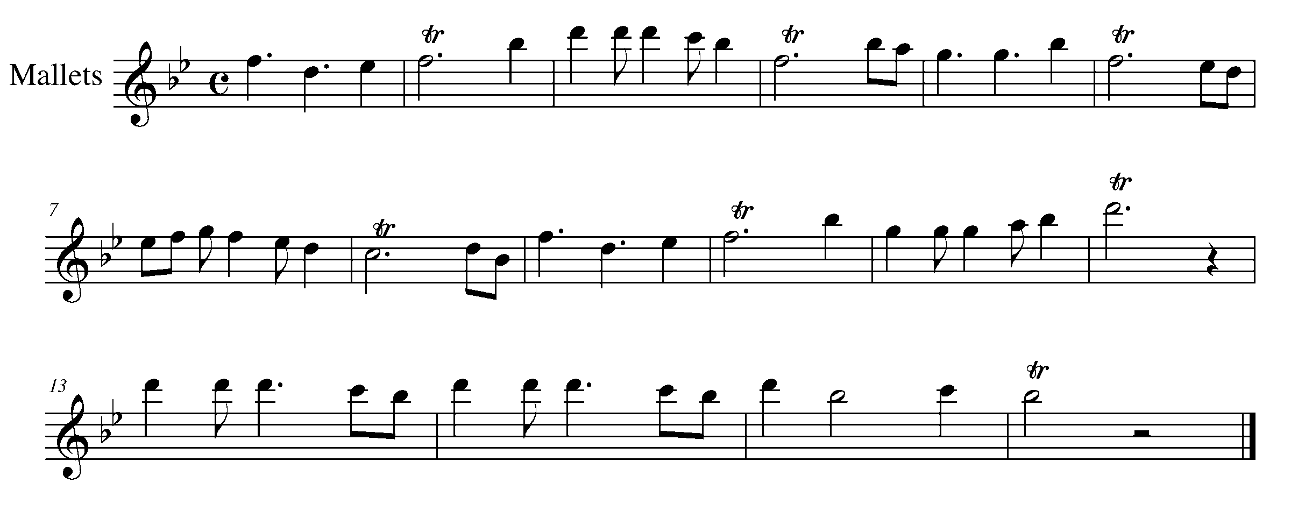

c

15. TIME TO PUT THINGS TOGETHER FOCUS: CULMINATING TASK
WIND INSTRUMENTS AND SD/BD/KIT

LEARNING GOAL: In this task, you will demonstrate your understanding of a variety of expressive controls introduced in the past 4 tasks.

MINDS ON! When rehearsing this piece, how will you remember to perform all of expressive controls markings? What should you do first? How important is your breath control within this task?

ACTION! To be successful with this task, you will need to:

- Identify the variety of expressive control markings;
- Decide on the phrasing of this piece;
- Choose a tempo at which you can manage all of the expressive controls;
- Practice in chunks, then put it all together; and
- Consider performing this piece for a friend before you perform for your teacher.

CONSOLIDATION: In order to move on to the next task and final GPS section, perform the following piece for your teacher and receive feedback.

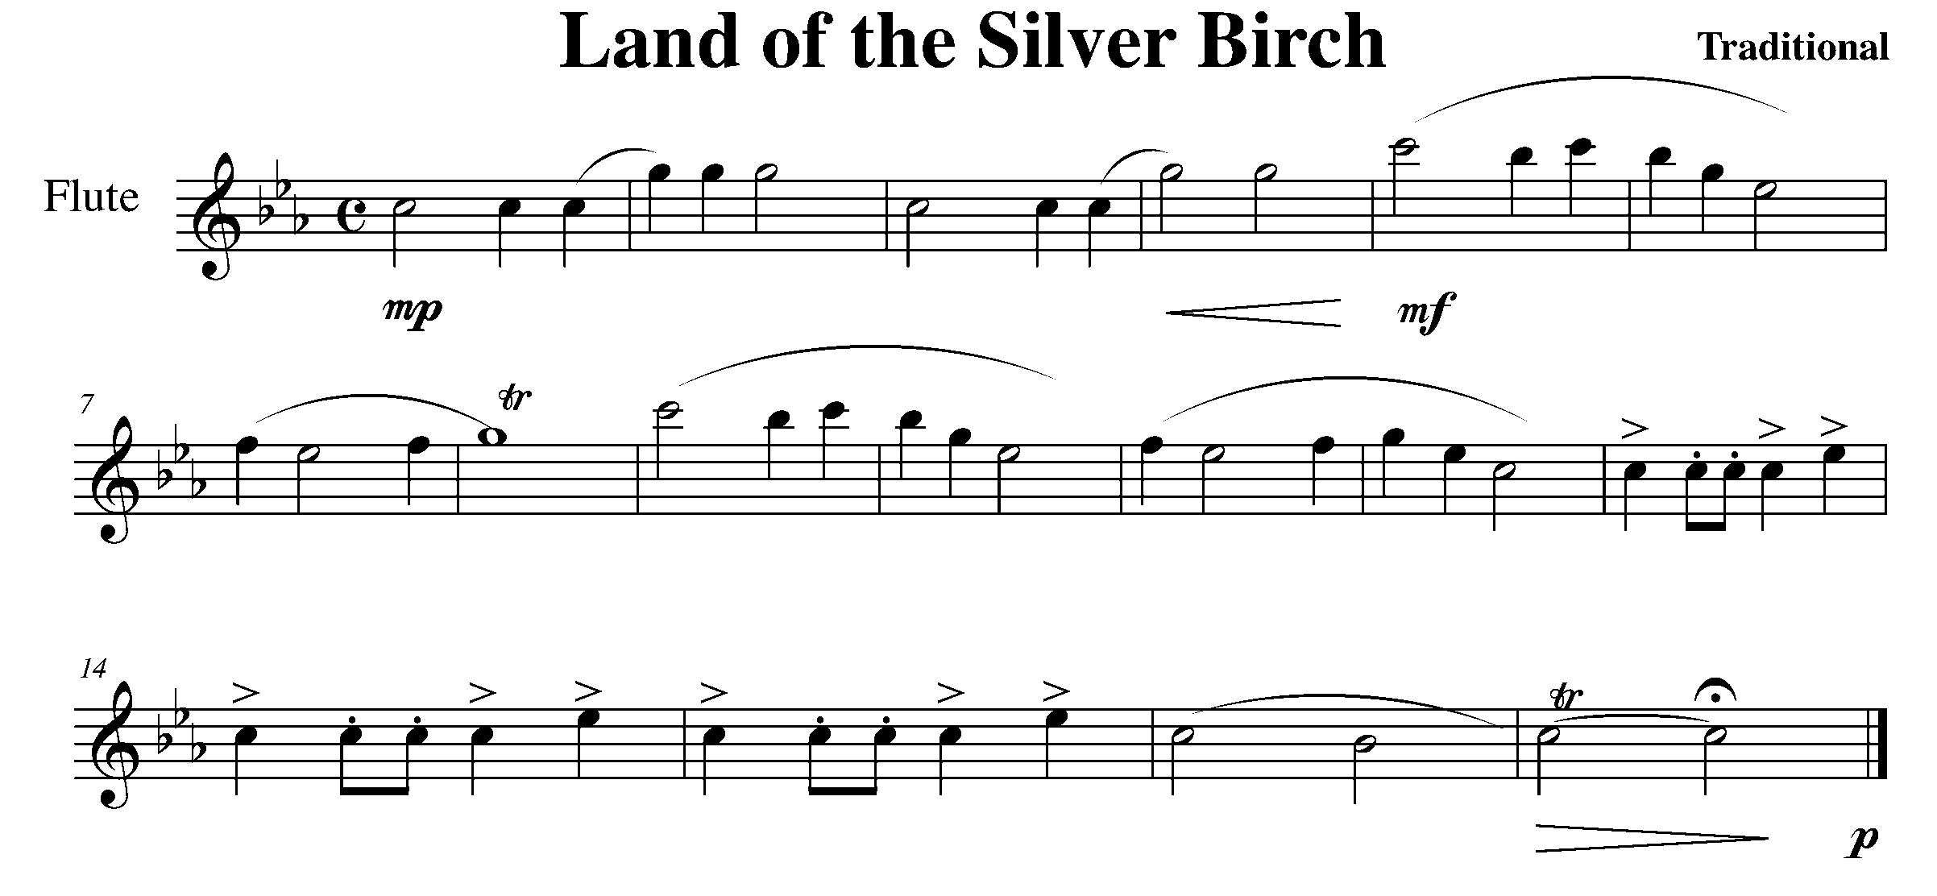

Task 15 Music Continued
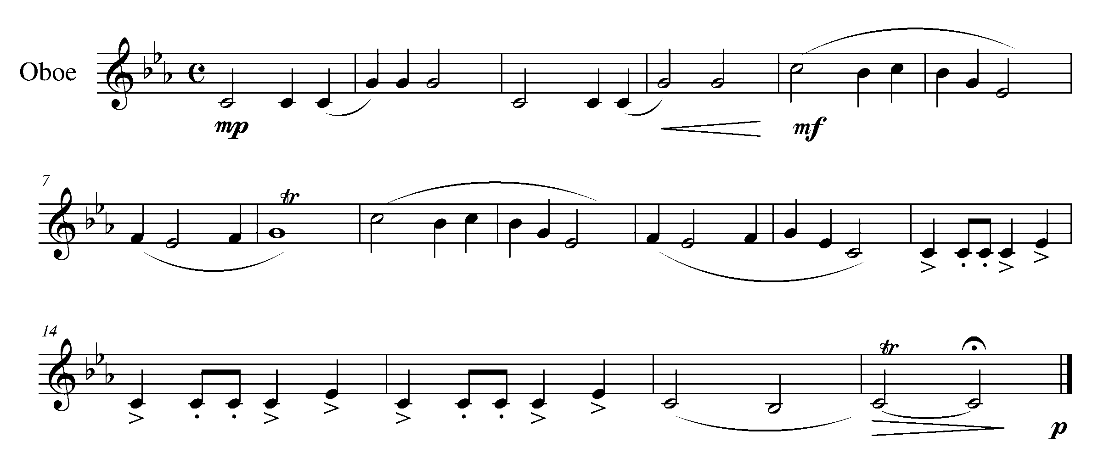
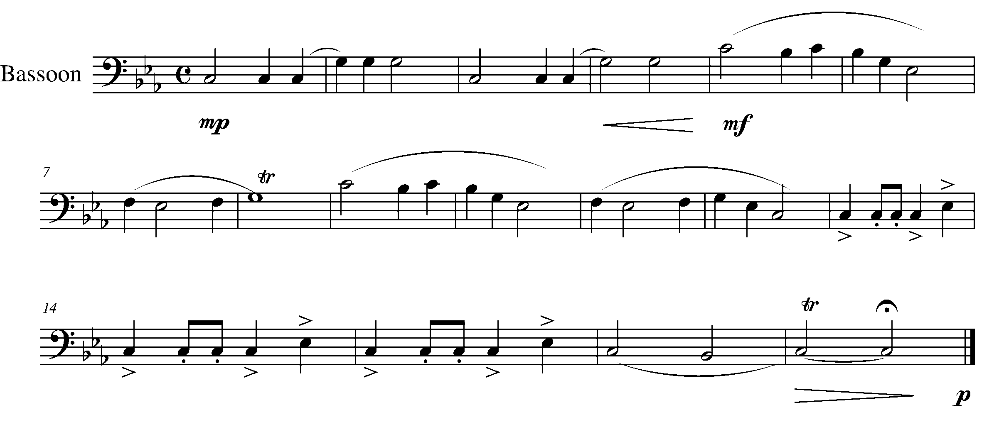
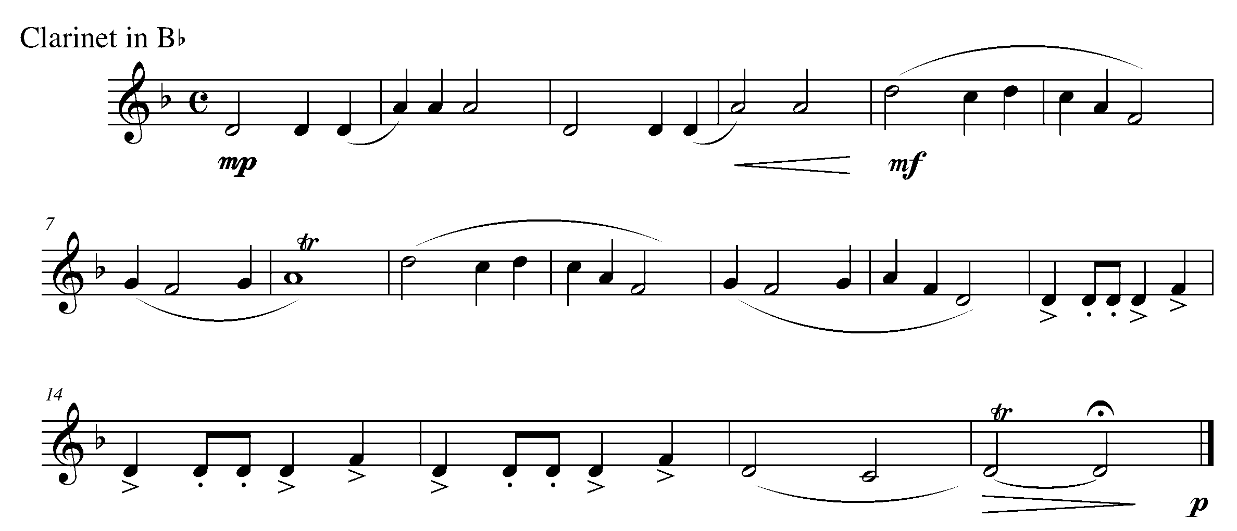

Task 15 Music Continued

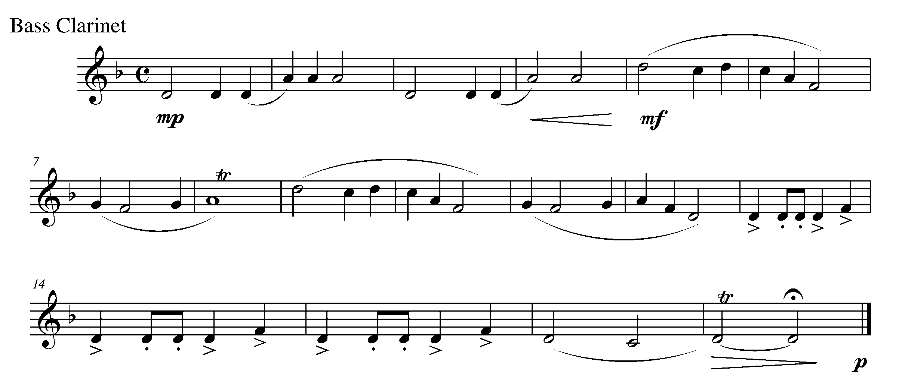
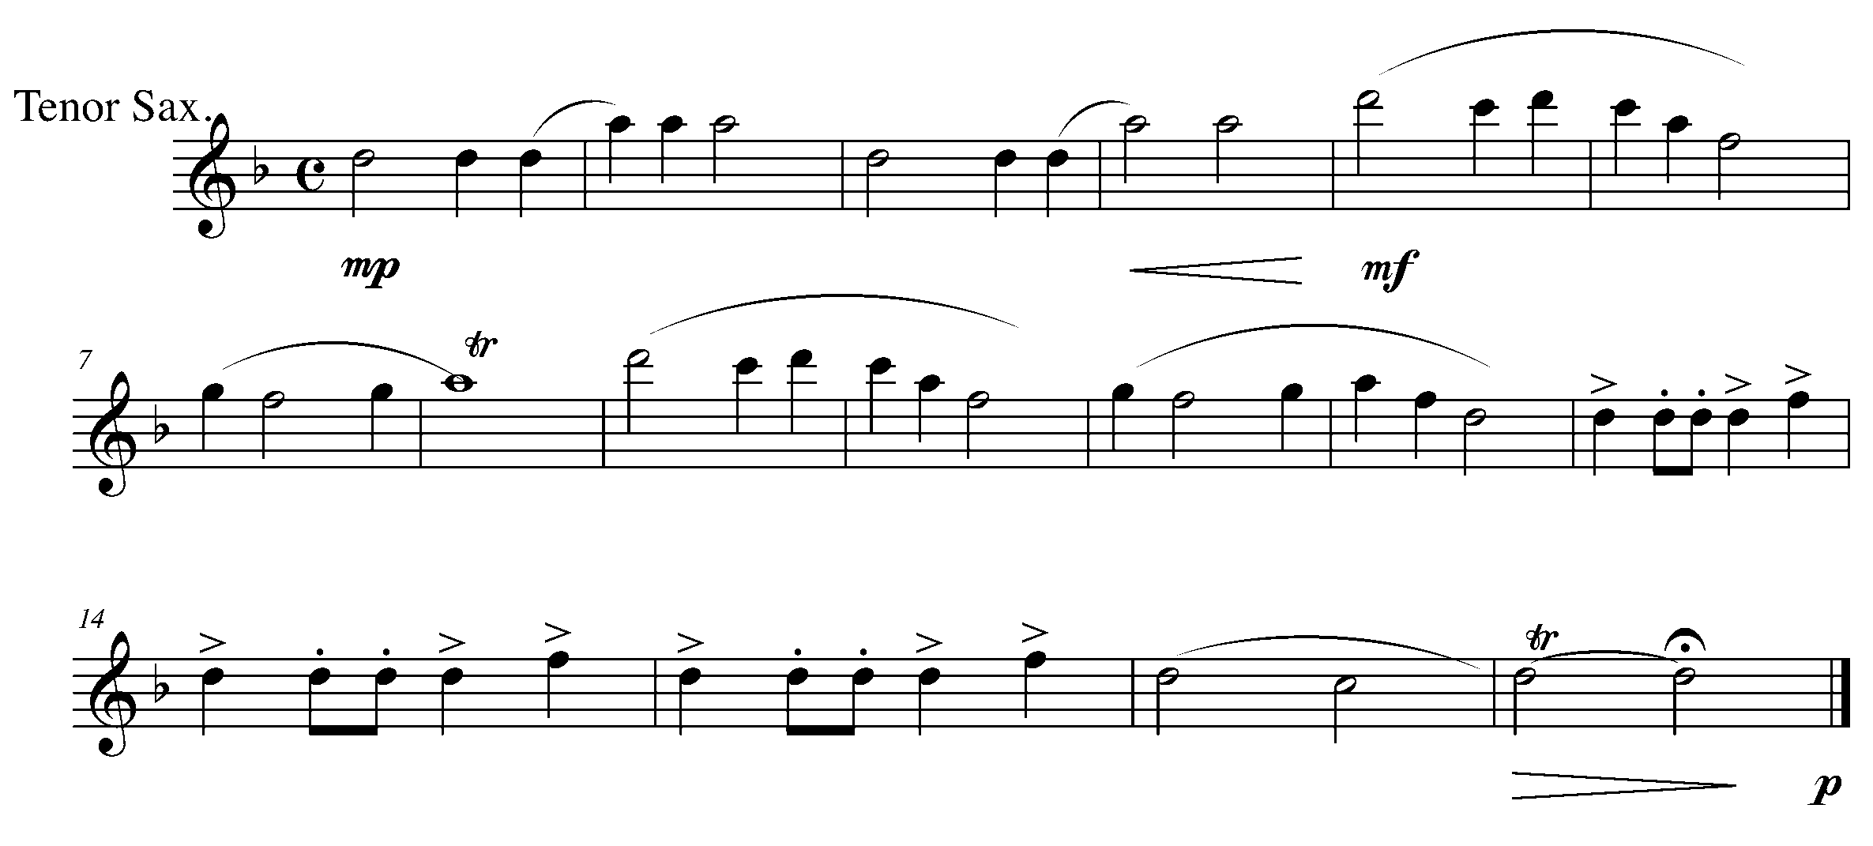
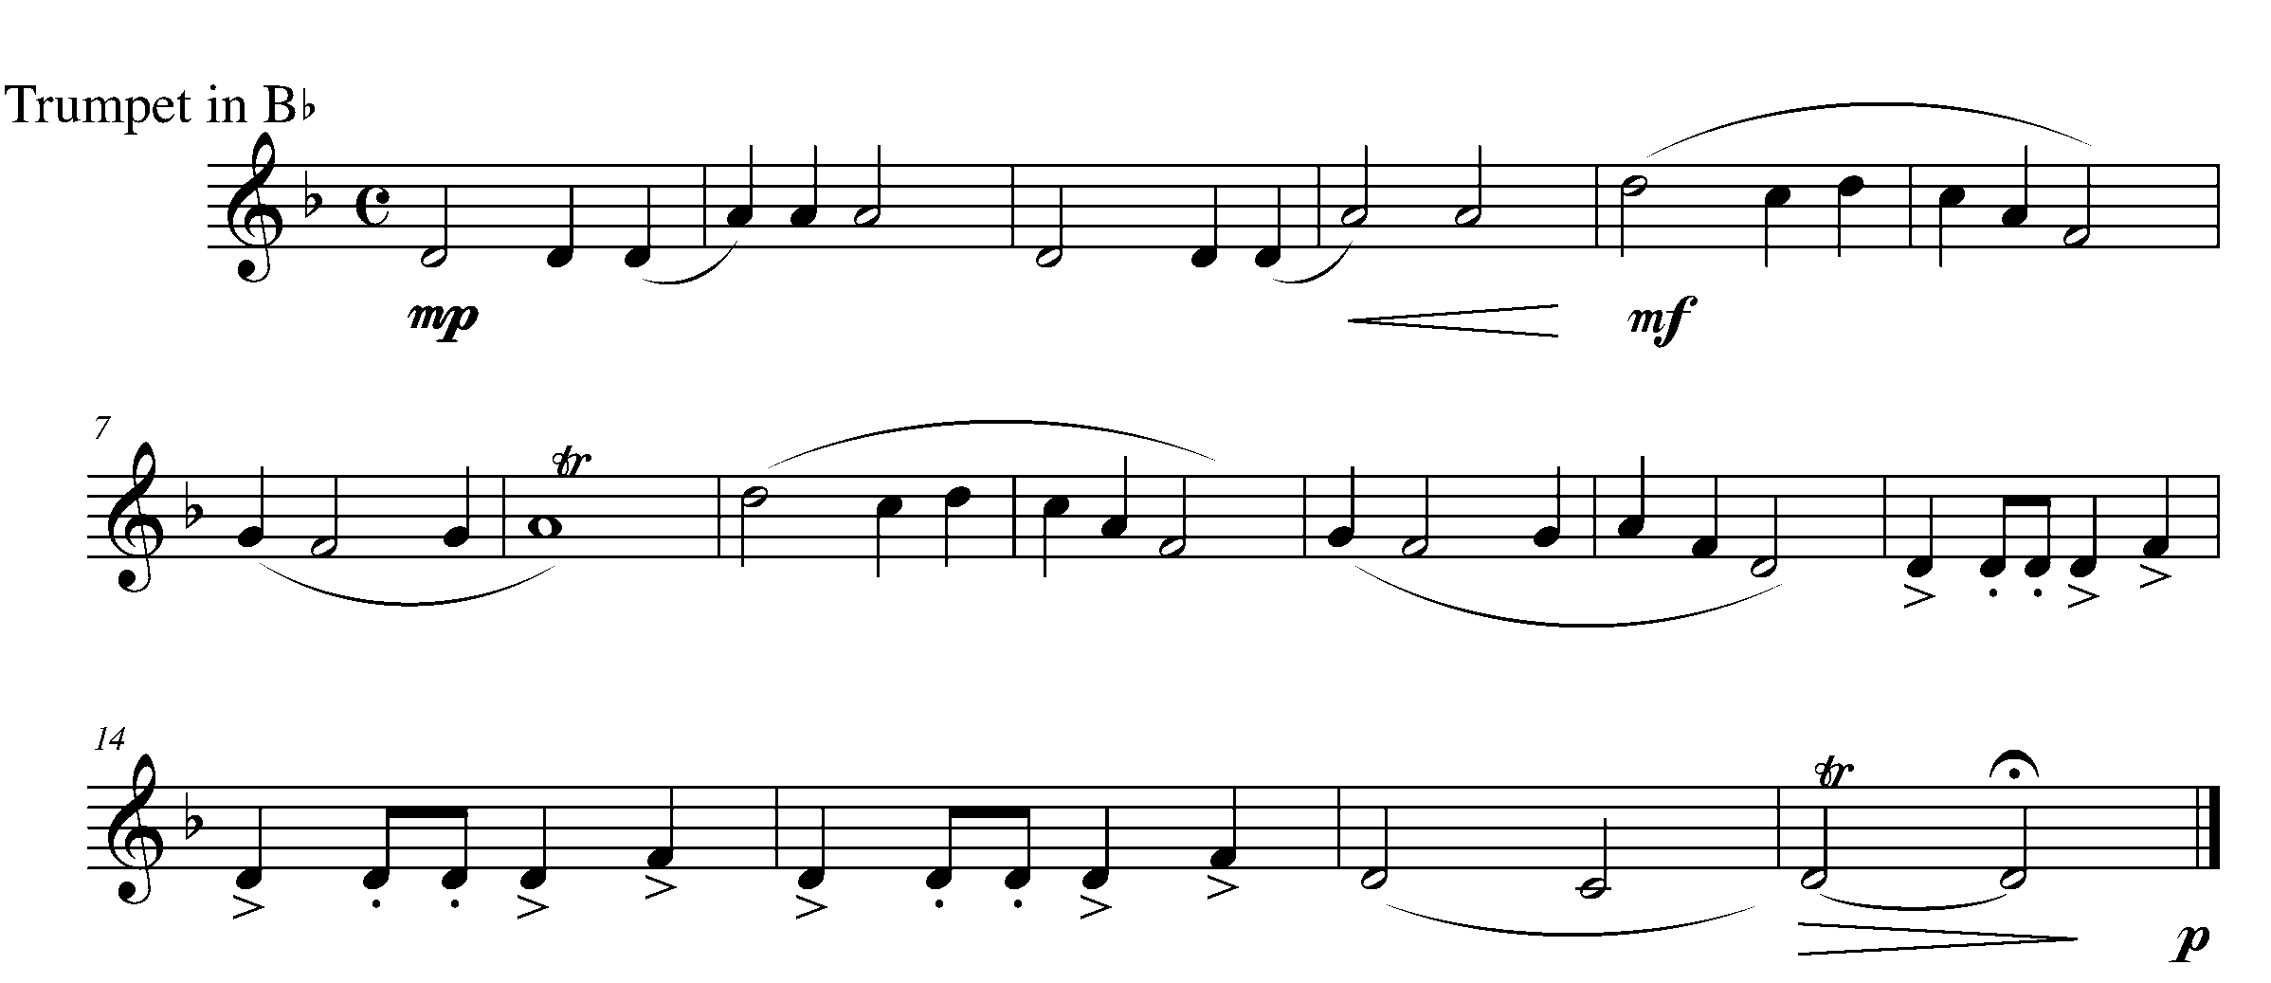

Task 15 Music Continued

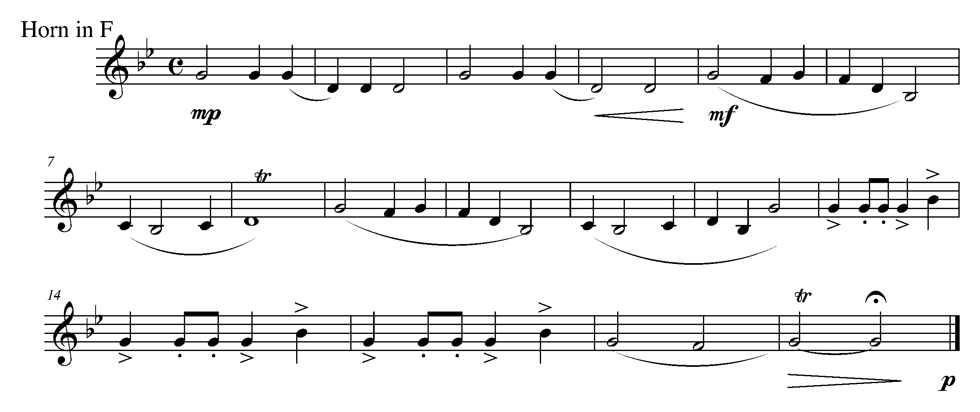
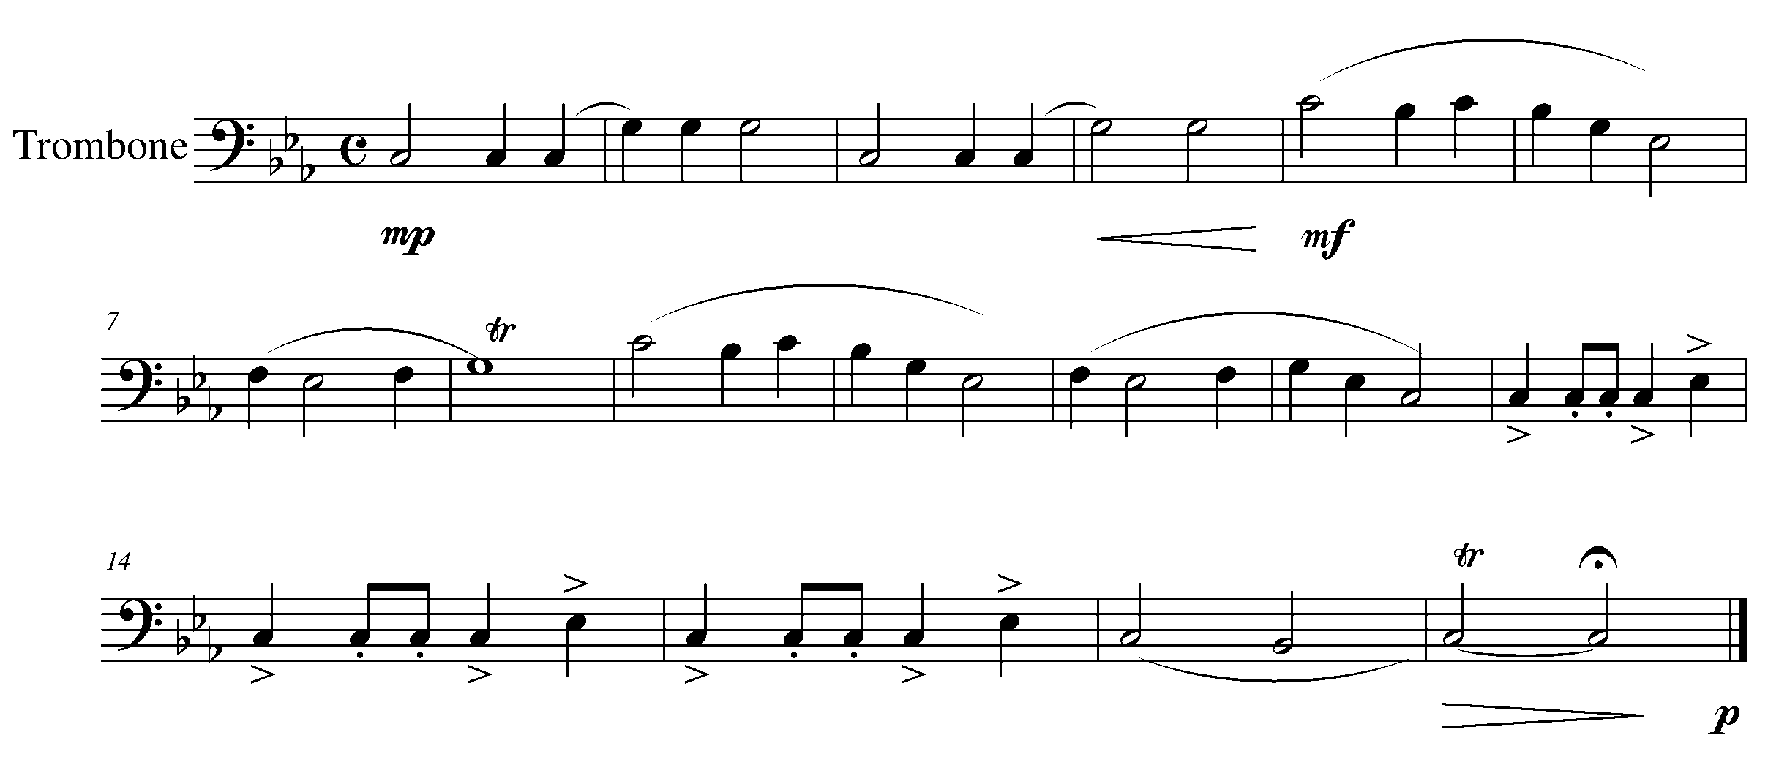
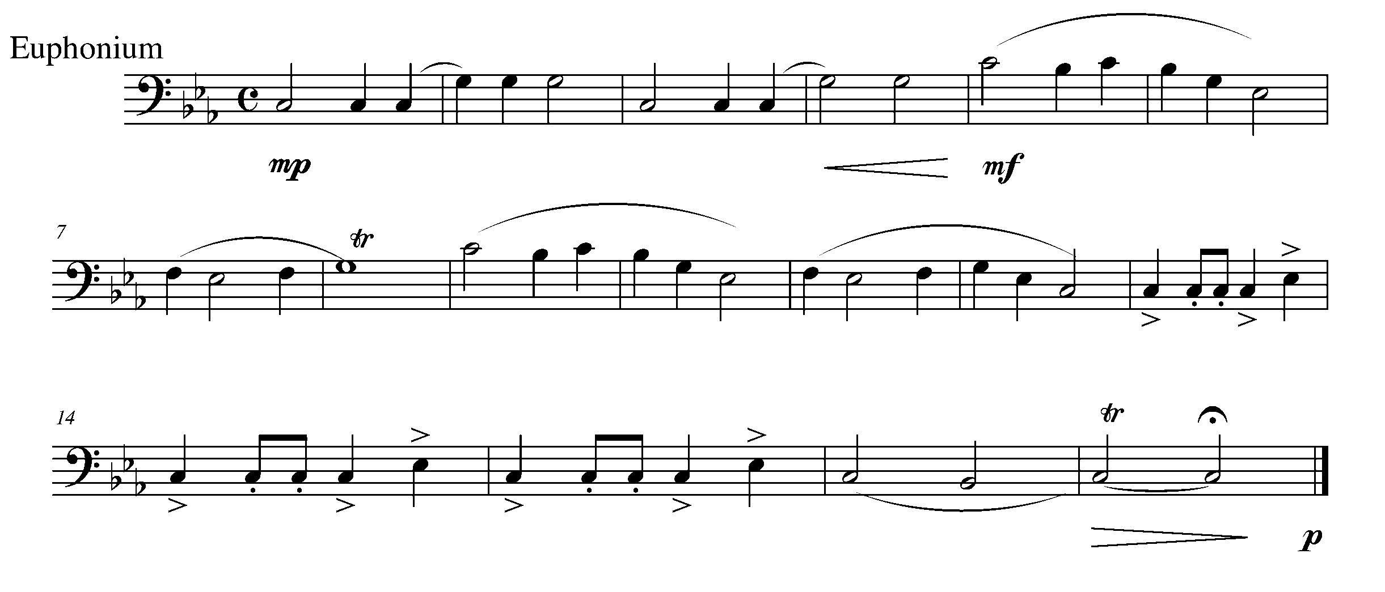

Task 15 Music Continued

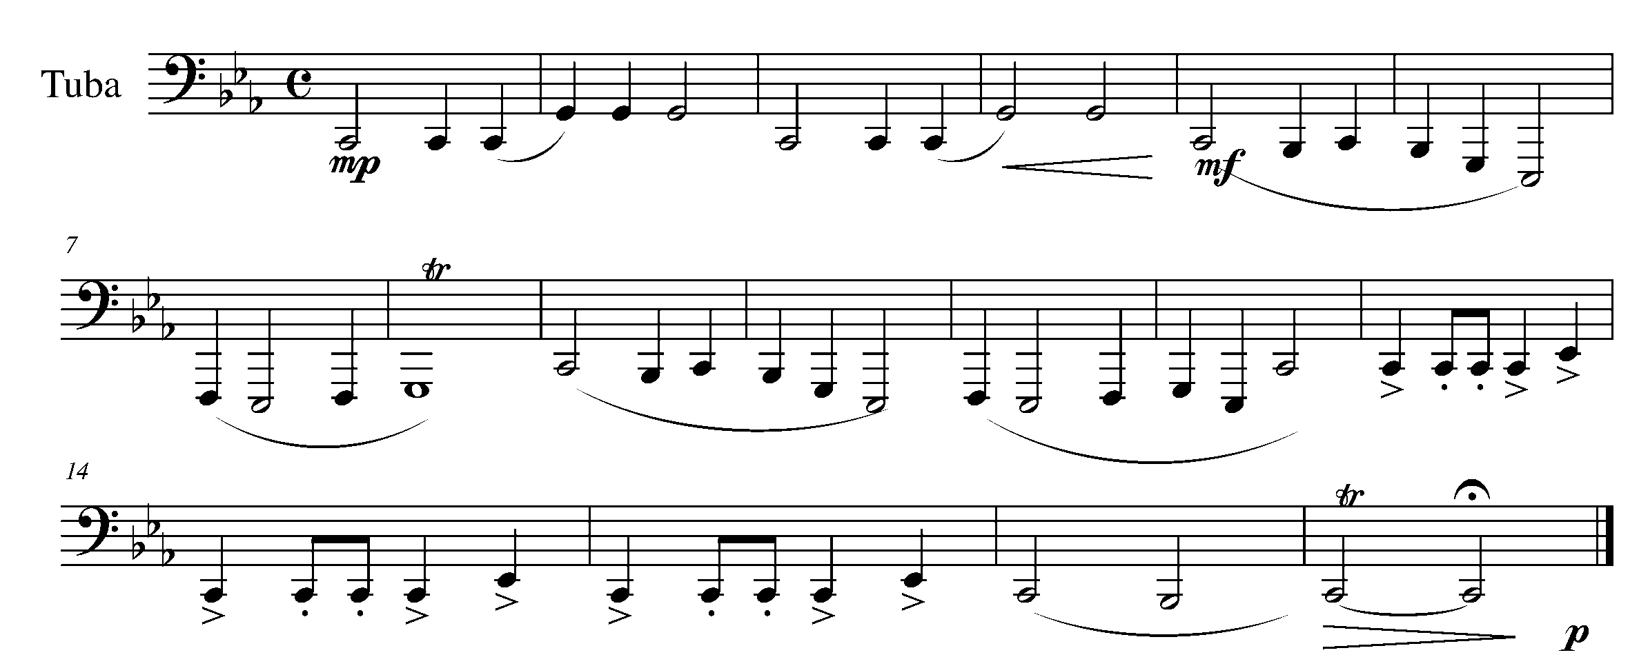
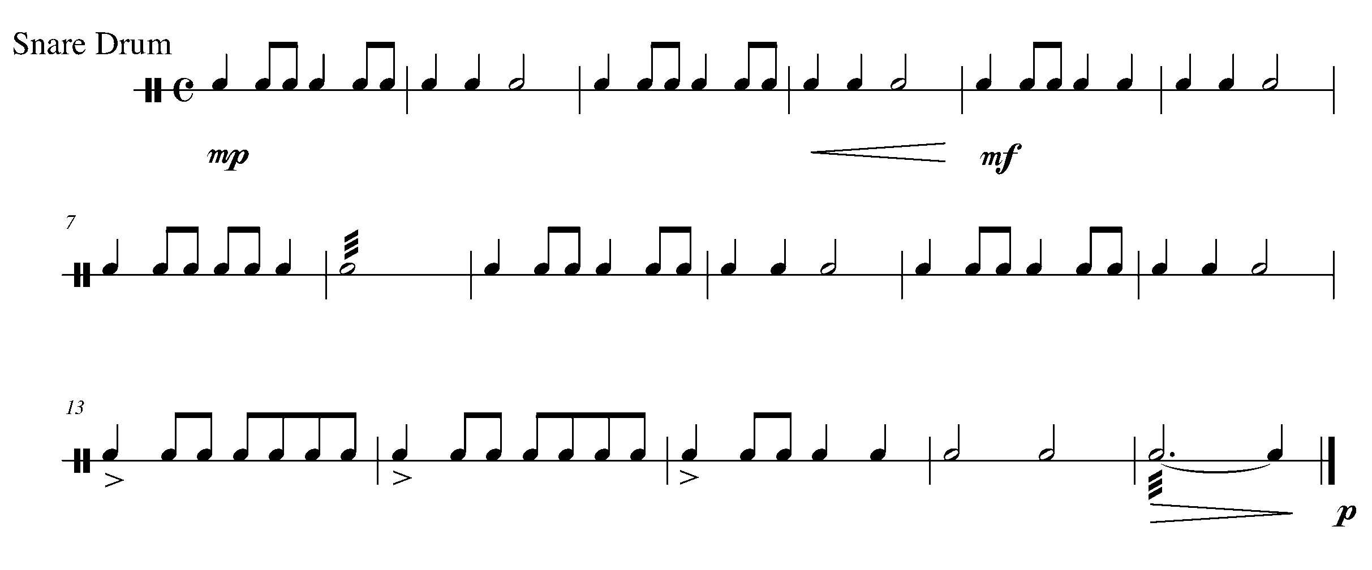
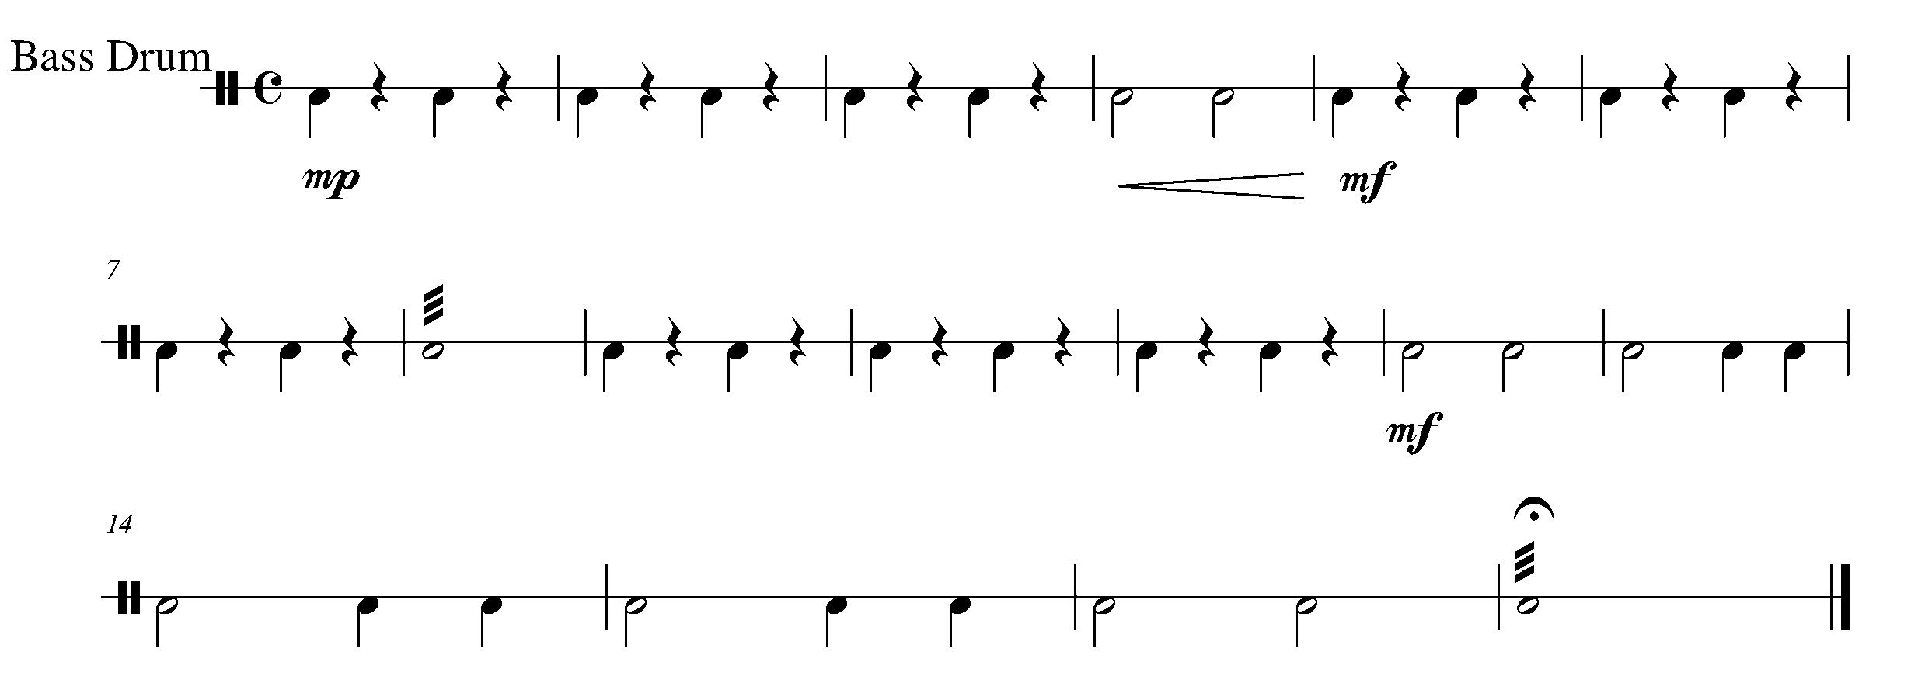

Task 15 Music Continued

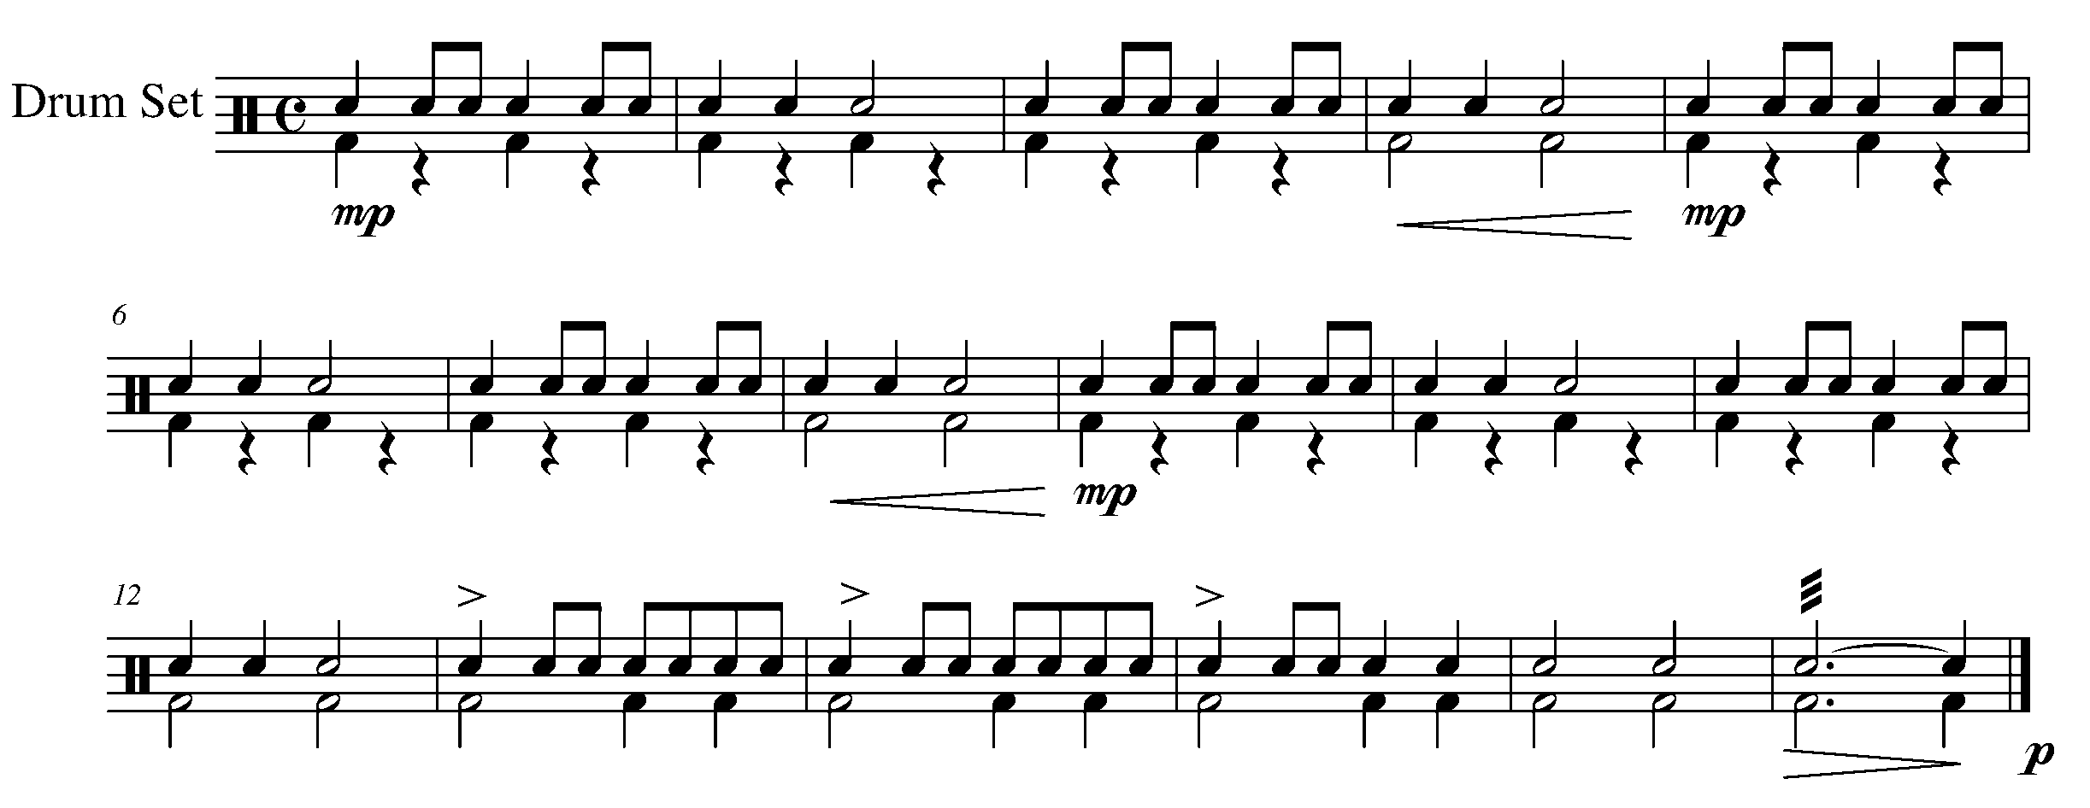

CONGRATULATIONS – YOU HAVE REACHED THE END OF THE THIRD GPS MARKER. CELEBRATE WITH A FAMILY MEMBER, CLASSMATE OR PEER. BE SURE TO FILL IN YOUR TASK TRACKER.

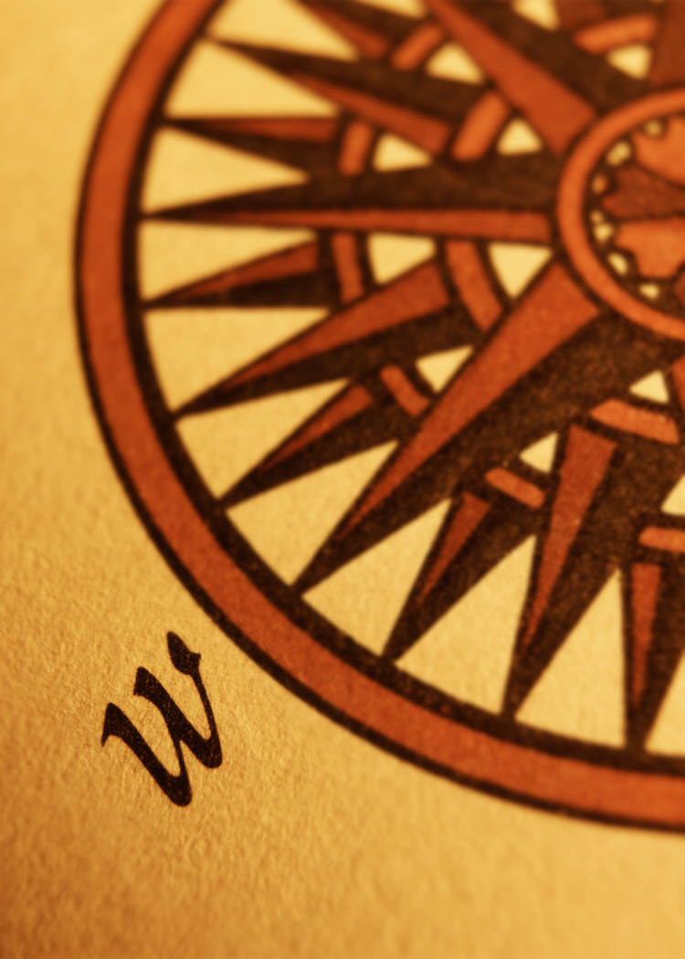
THE WEST SECTION
FOCUS: FORM (ENDINGS)

16. FOLLOWING THE ROAD MAP FOCUS: D.C. AL FINE
WIND INSTRUMENTS AND MALLETS

LEARNING GOAL: In this task, you will learn how to follow the instructions of “da capo” (D.C.) and “al fine”.

MINDS ON! What does “da capo” and “al fine” mean in English? Why would composers decide to use these terms in a piece of music? Consider highlighting these words on your music help you to follow the “road map”.

ACTION! To be successful with this task, you will need to:

- Conclude what “D.C. al fine” means to do;
- Identify where both the “D.C. al fine” is and the “fine” are in the piece;
- Perform the following piece with good breath control, posture, accuracy in rhythm and pitch; and
- Demonstrate and understanding of marked articulation and dynamics.

CONSOLIDATION: In order to move on to the next task, perform the following piece for your teacher and receive feedback.

Task 16 Music
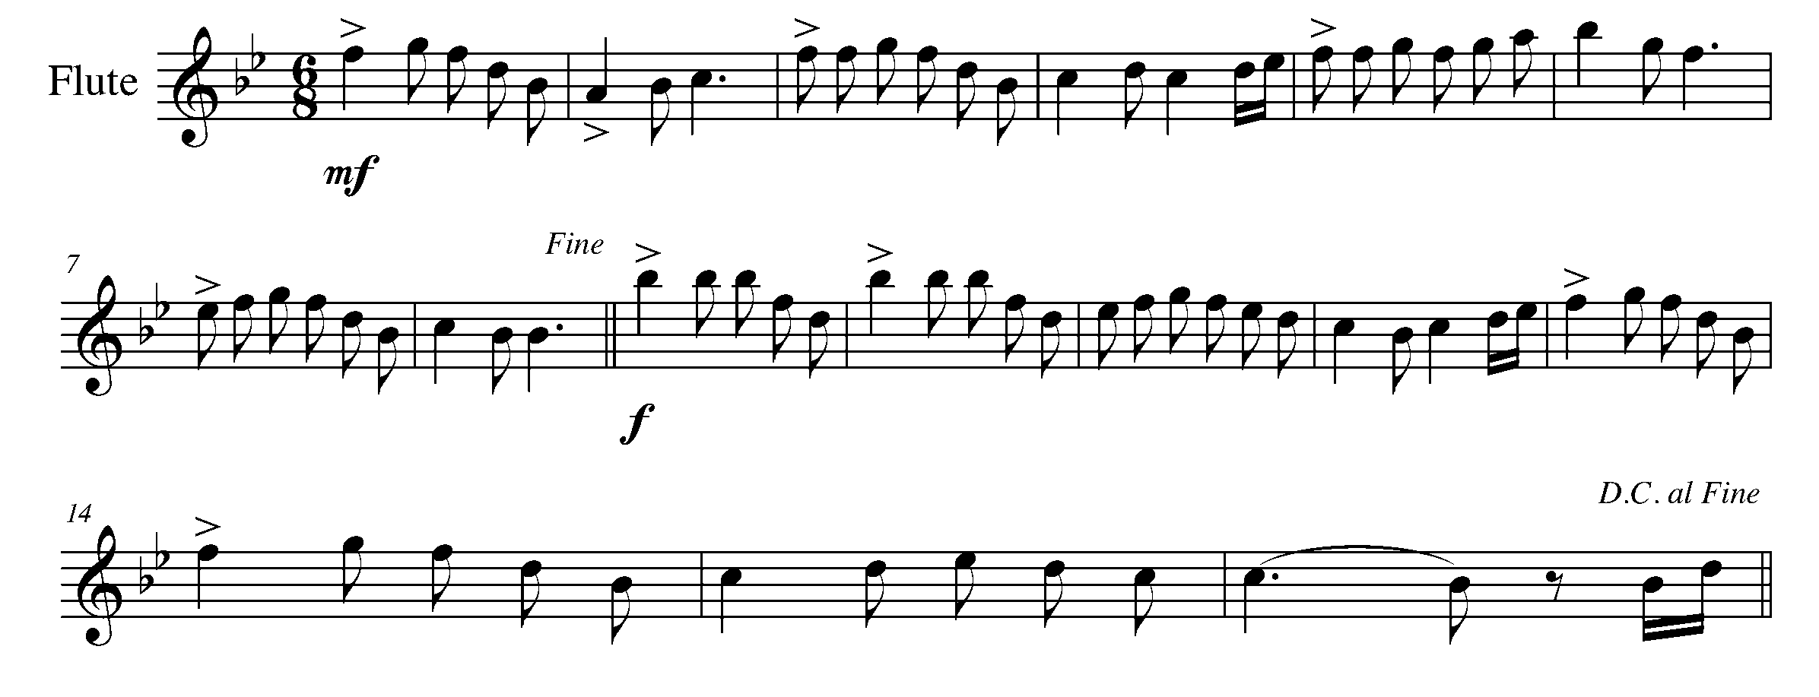
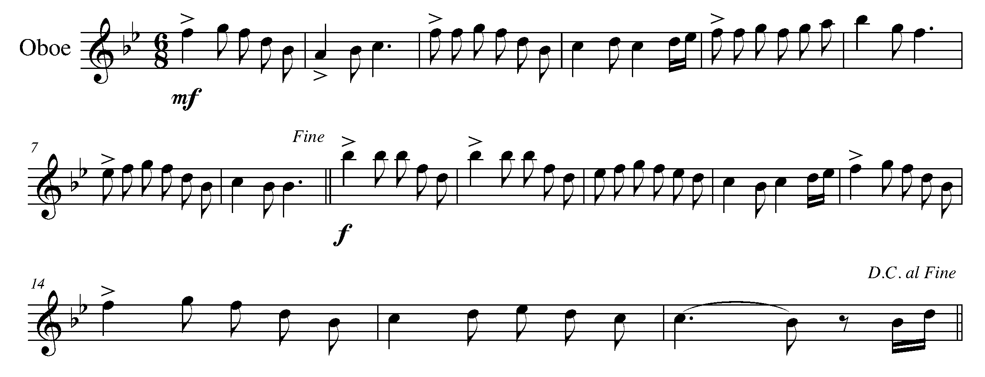
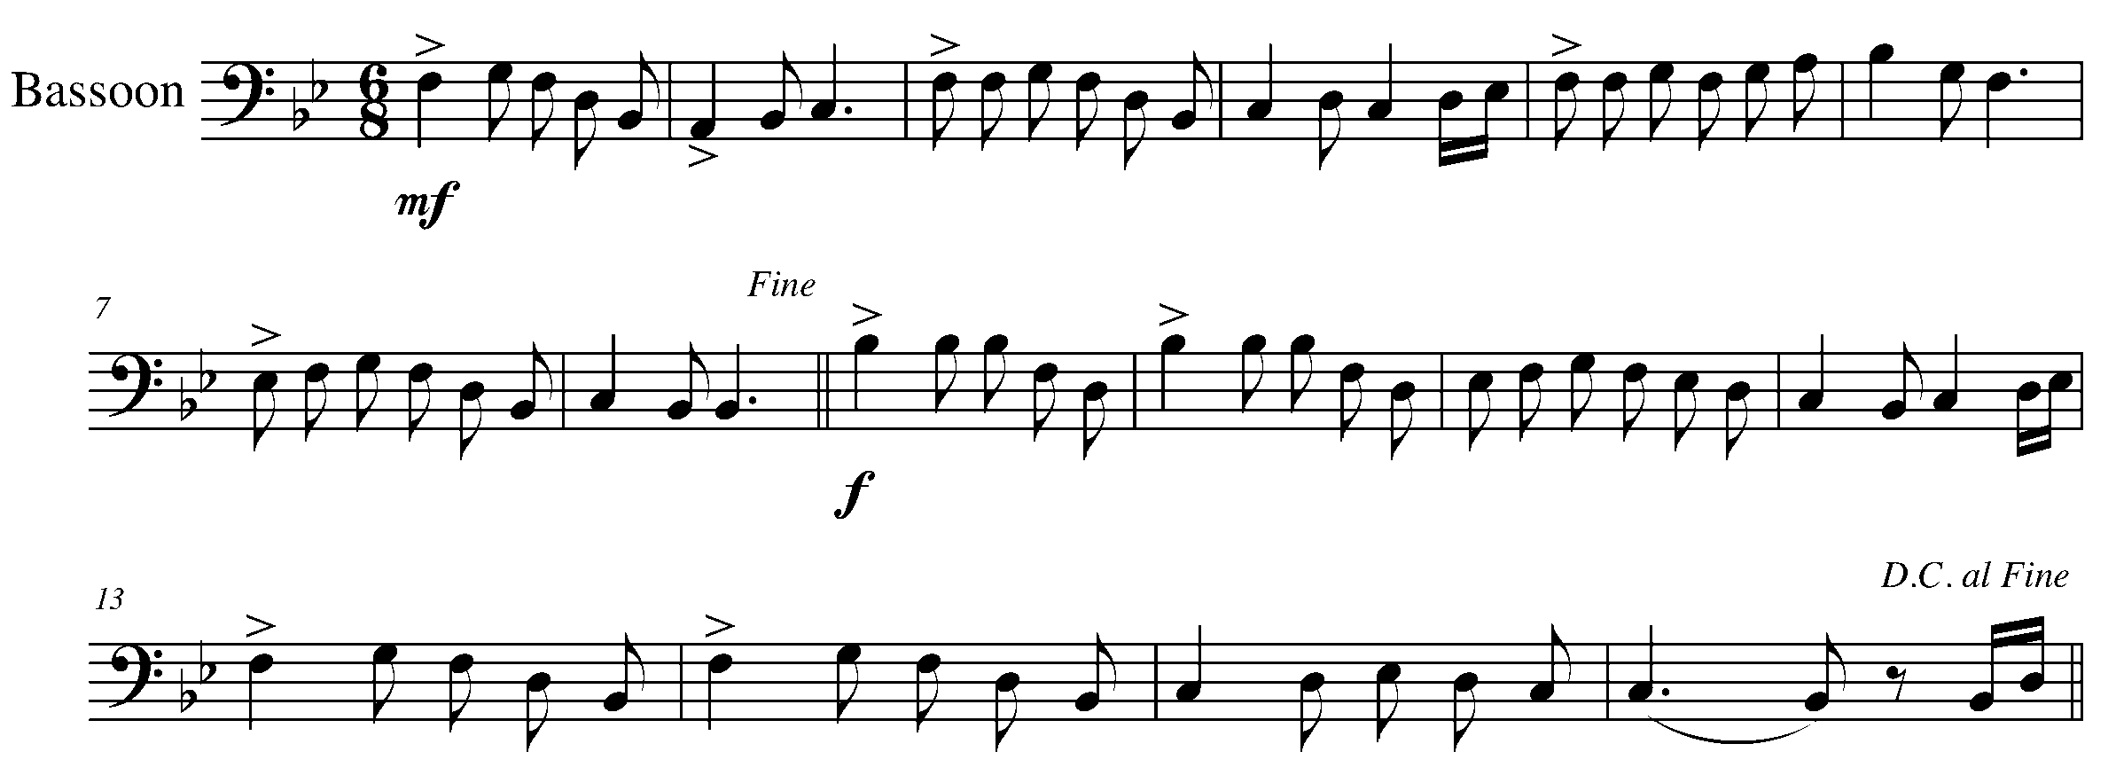

Task 16 Music Continued

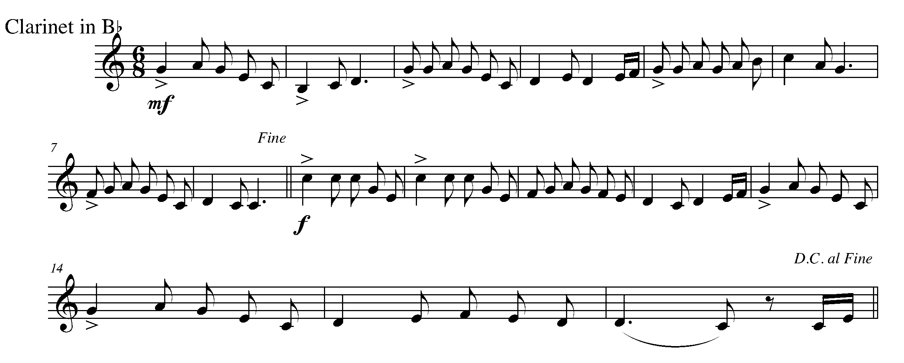
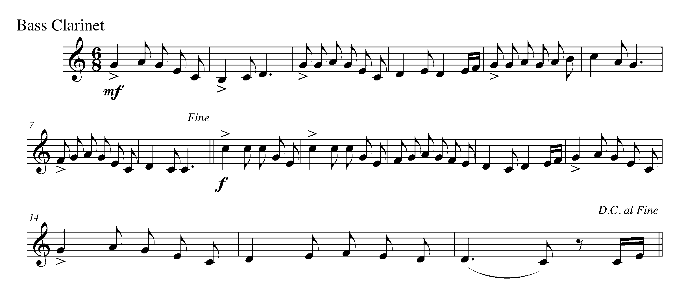
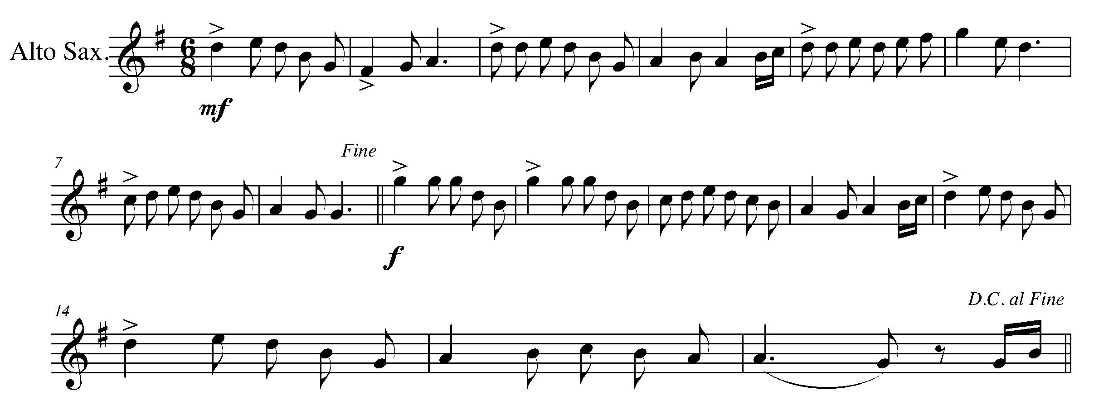

Task 16 Music Continued

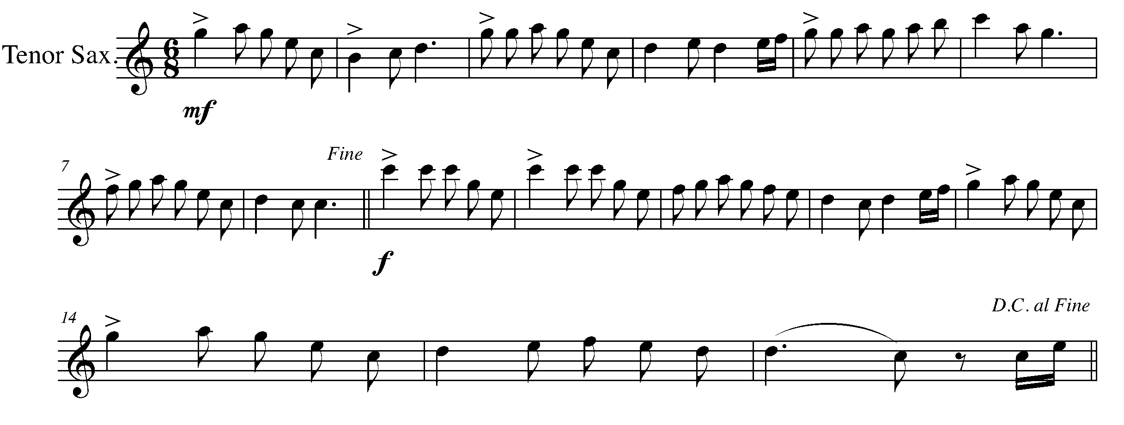
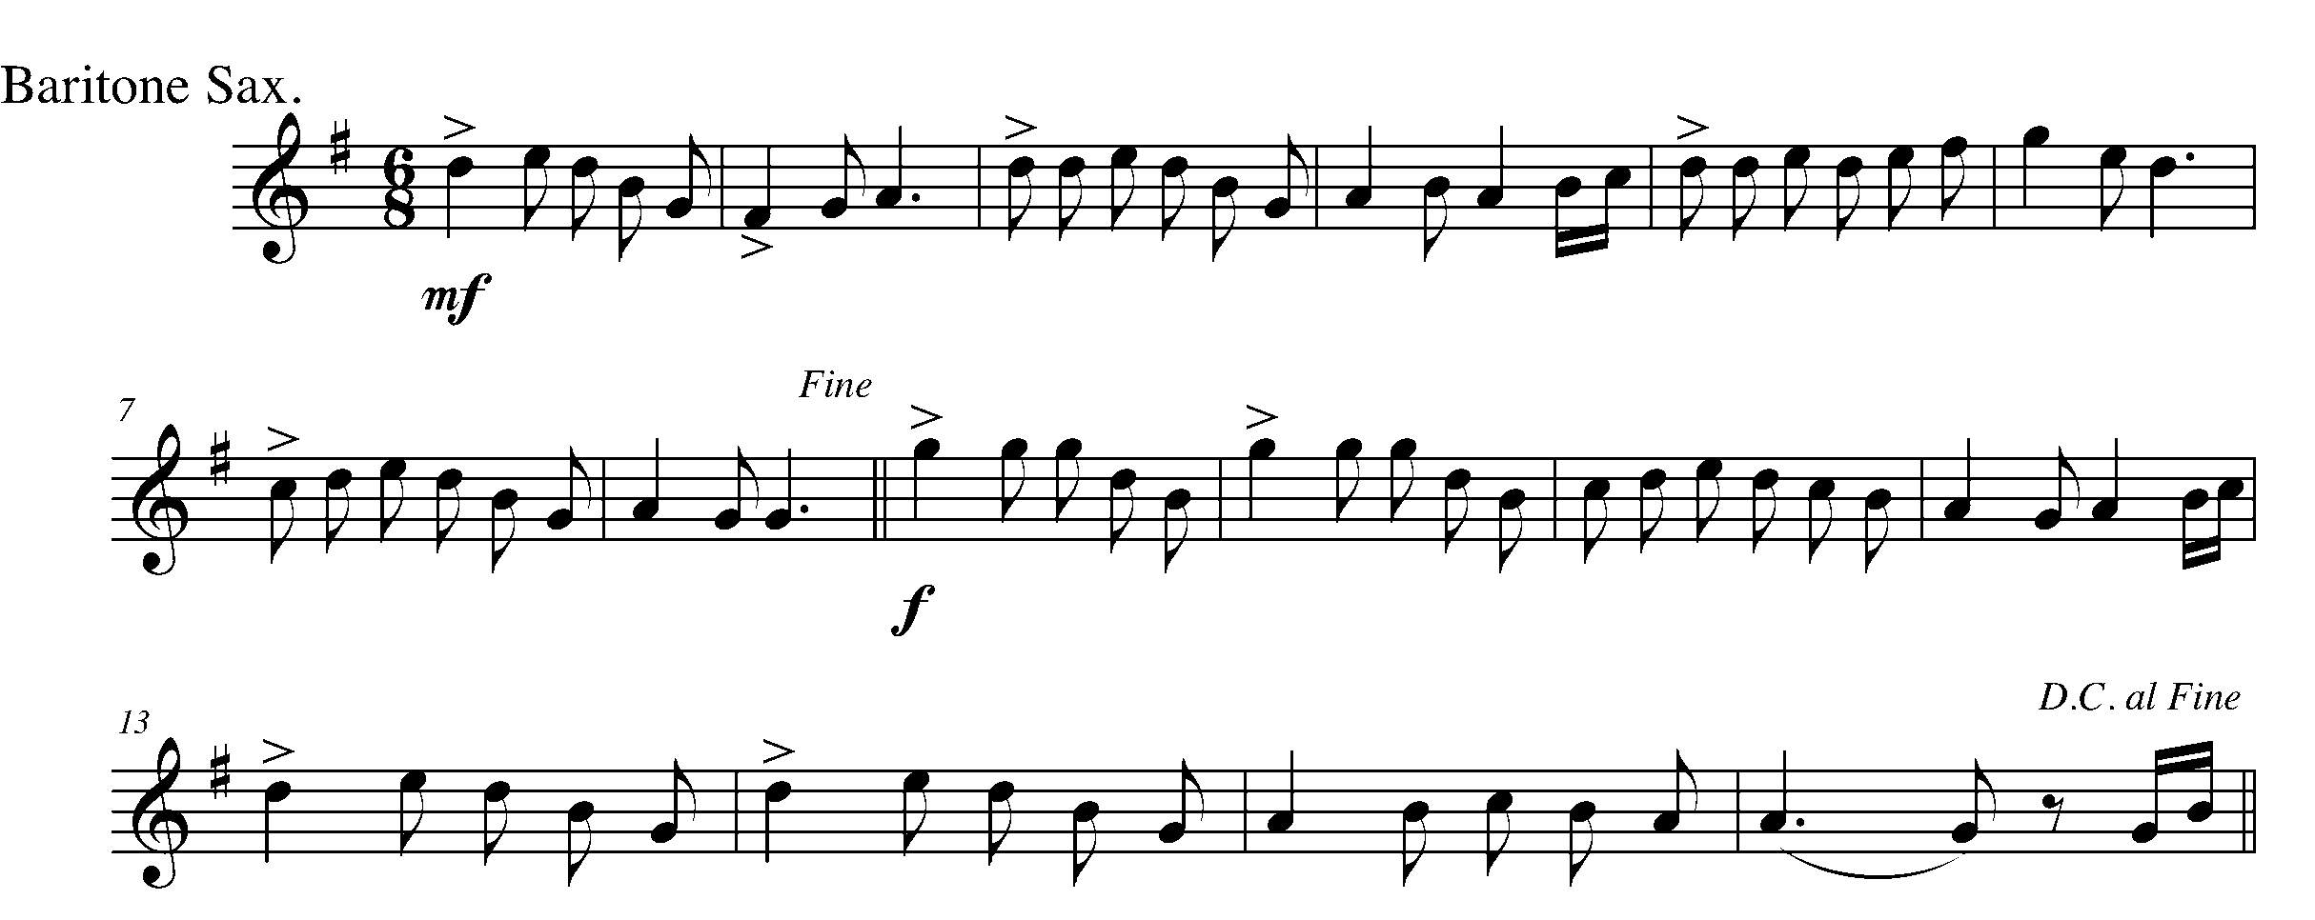
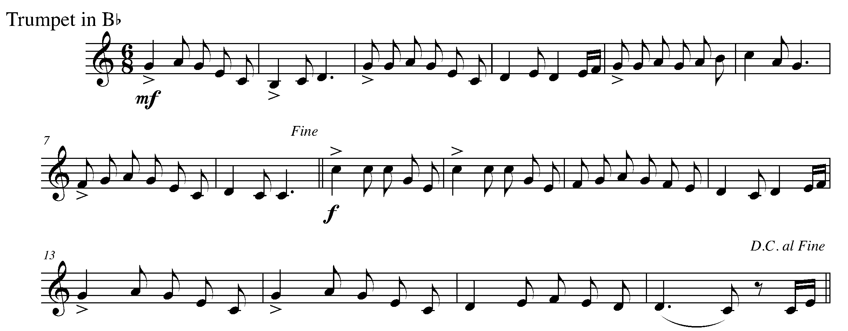

Task 16 Music Continued

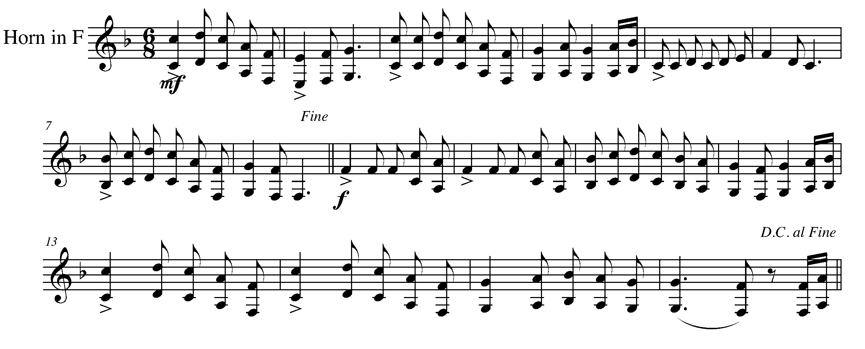
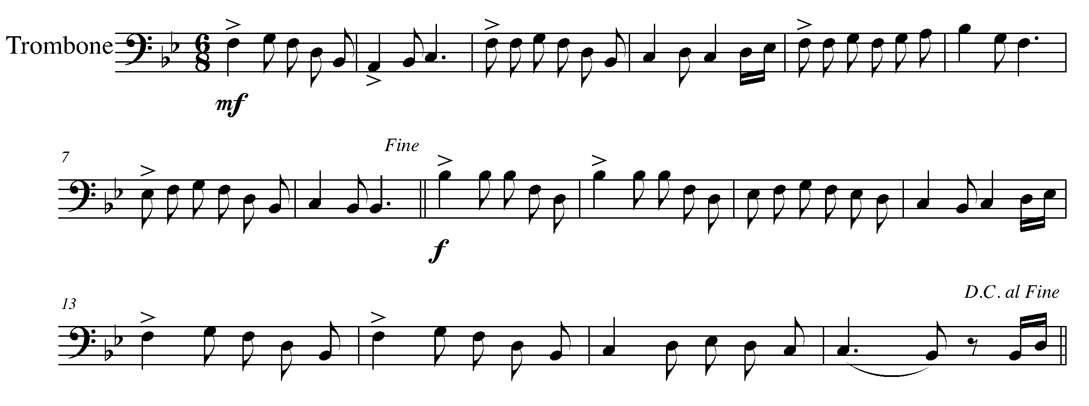
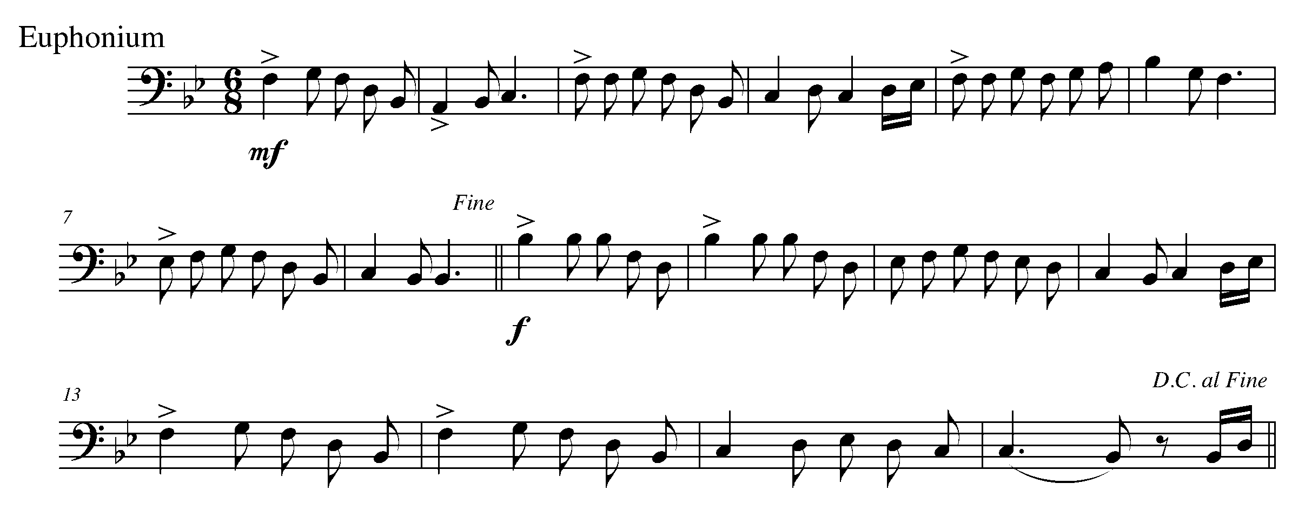

Task 16 Music Continued

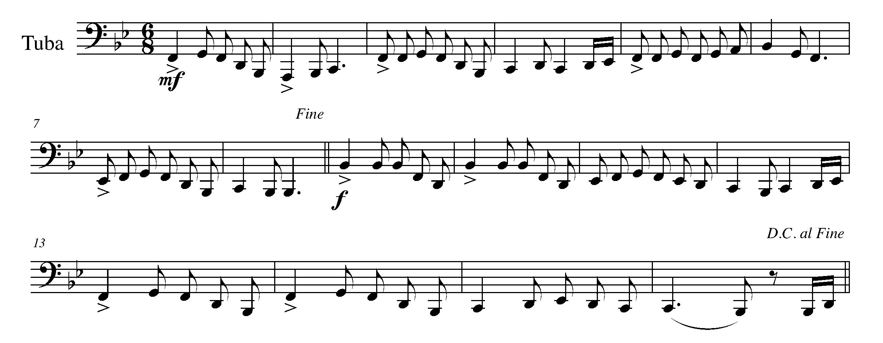
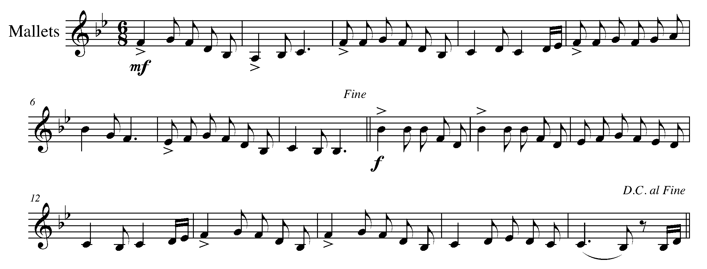

17. INTRODUCING…THE CODA! FOCUS: DC AL CODA
WIND INSTRUMENTS AND SD/BD/KIT

LEARNING GOAL: In this task, you will be introduced to a section of music called the “coda”. You will also learn how to perform a coda section following the instructions of “D.C. al coda”.

The symbol for the coda is: 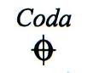

MINDS ON! Where is the coda in your music? What is the purpose of a coda? When a piece of music is marked, “D.C. al coda”, what is the composer asking you to do?

ACTION! To be successful with this task, you will need to:

- Identify the CODA in your music;
- Determine what is the expectation of “D.C. al coda”;
- Accurately demonstrate an understanding of all fundamental music concepts (rhythm, pitch, articulation, dynamics, posture etc); and
- Perform the following piece with the “D.C. al coda”.

CONSOLIDATION: In order to move on to the next task, perform “Drill ye
Tarriers” for your teacher and receive feedback.

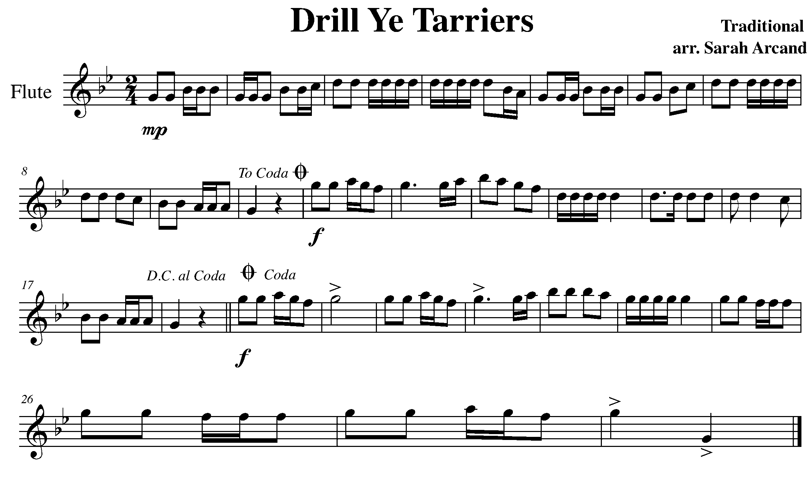

Task 17 Music Continued

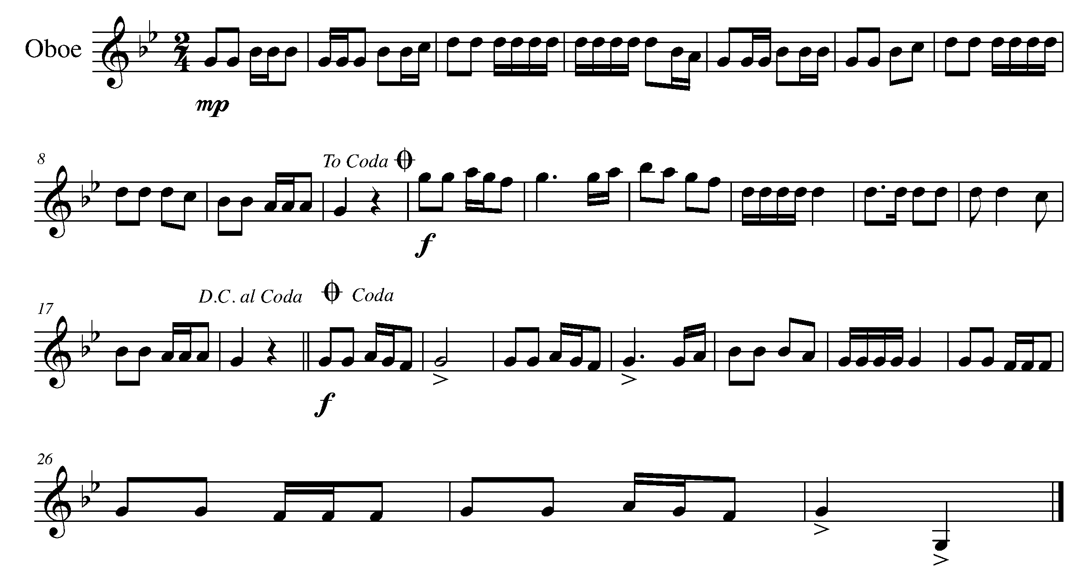
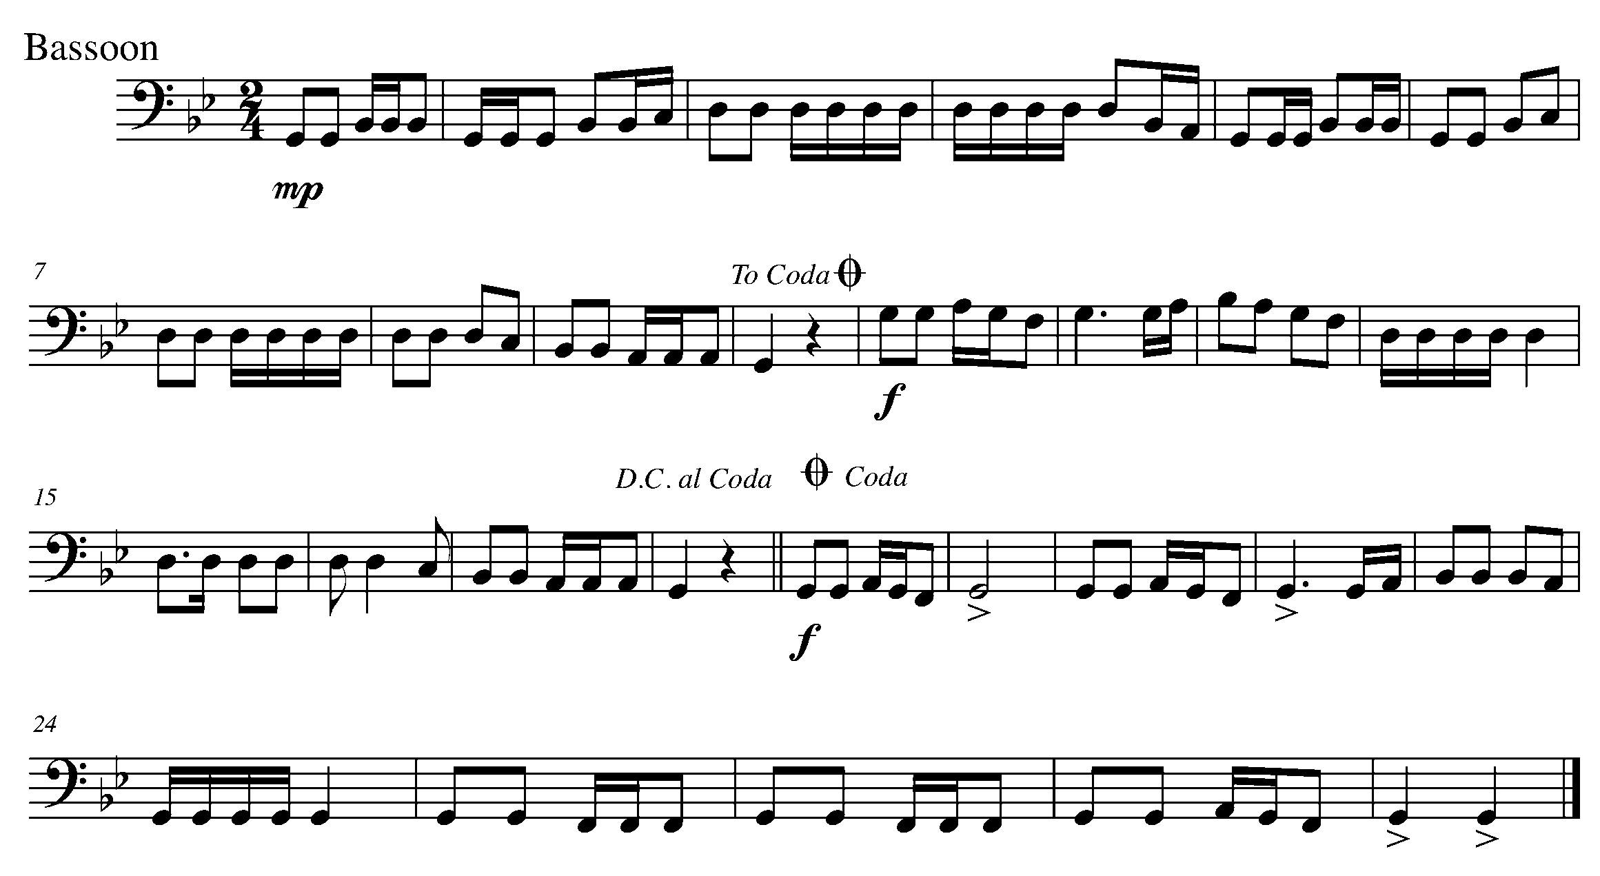

Task 17 Music Continued

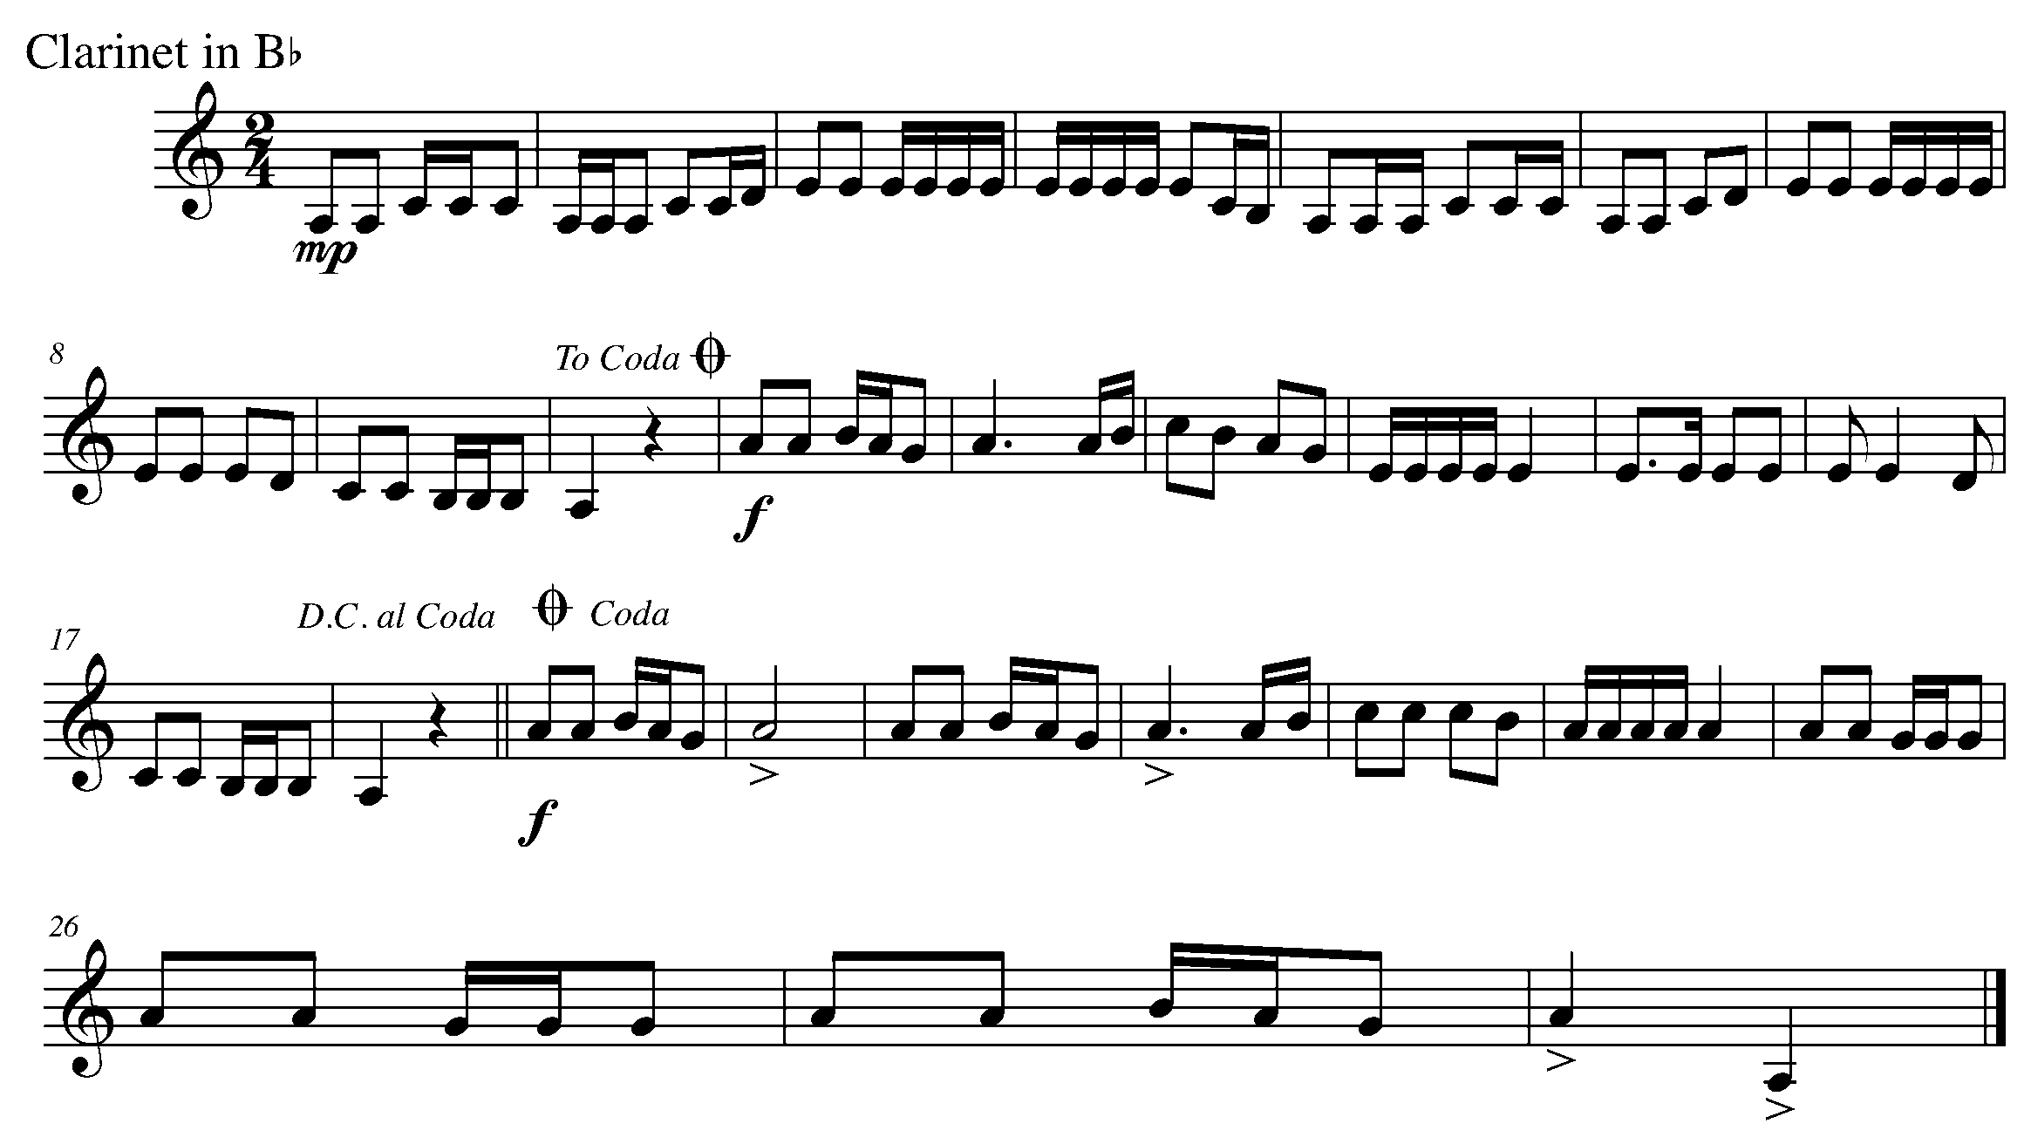
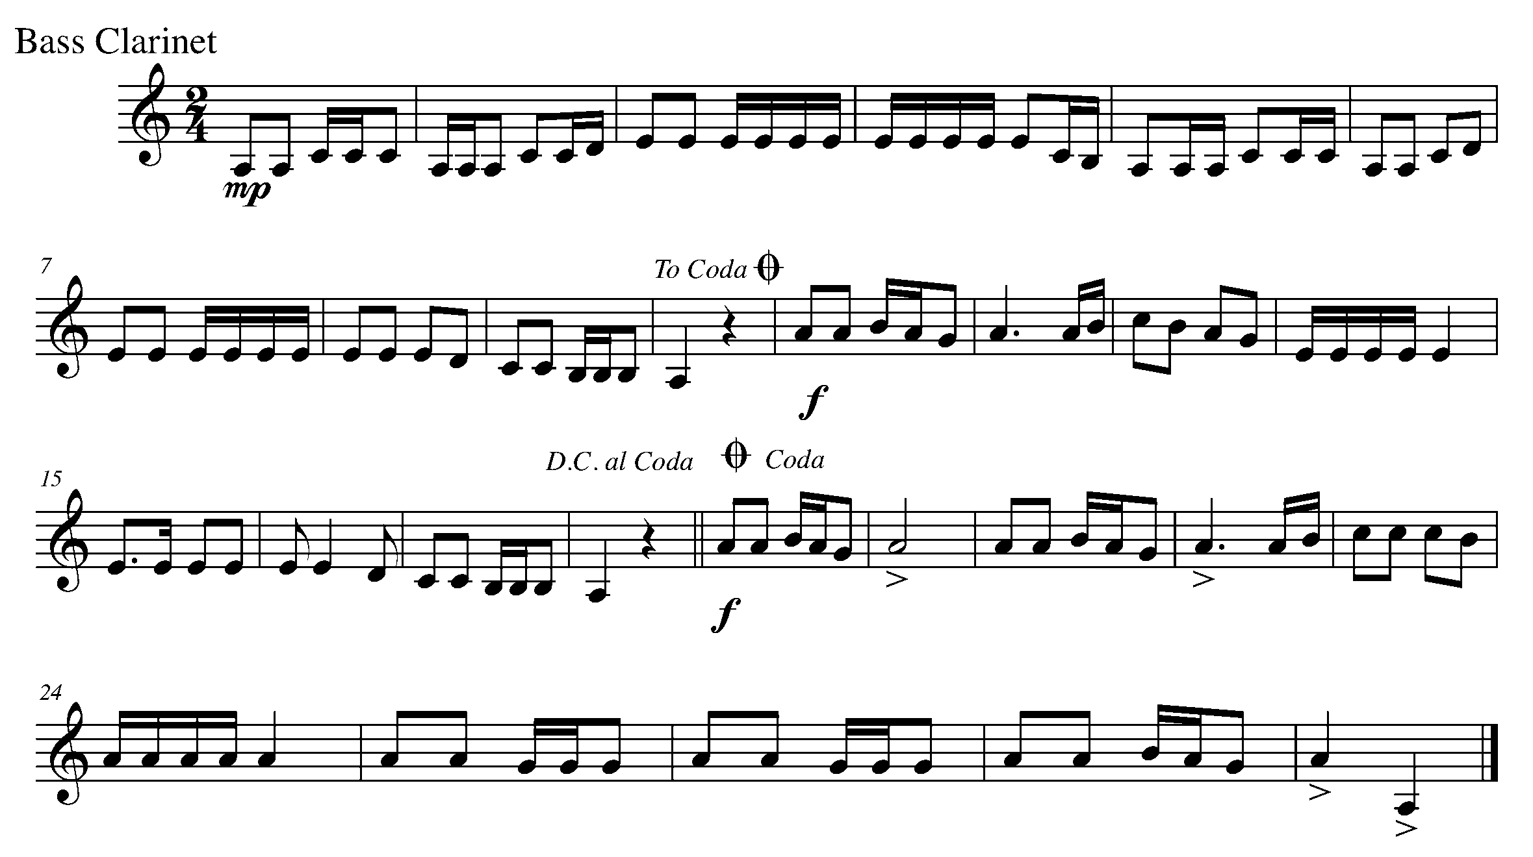

Task 17 Music Continued

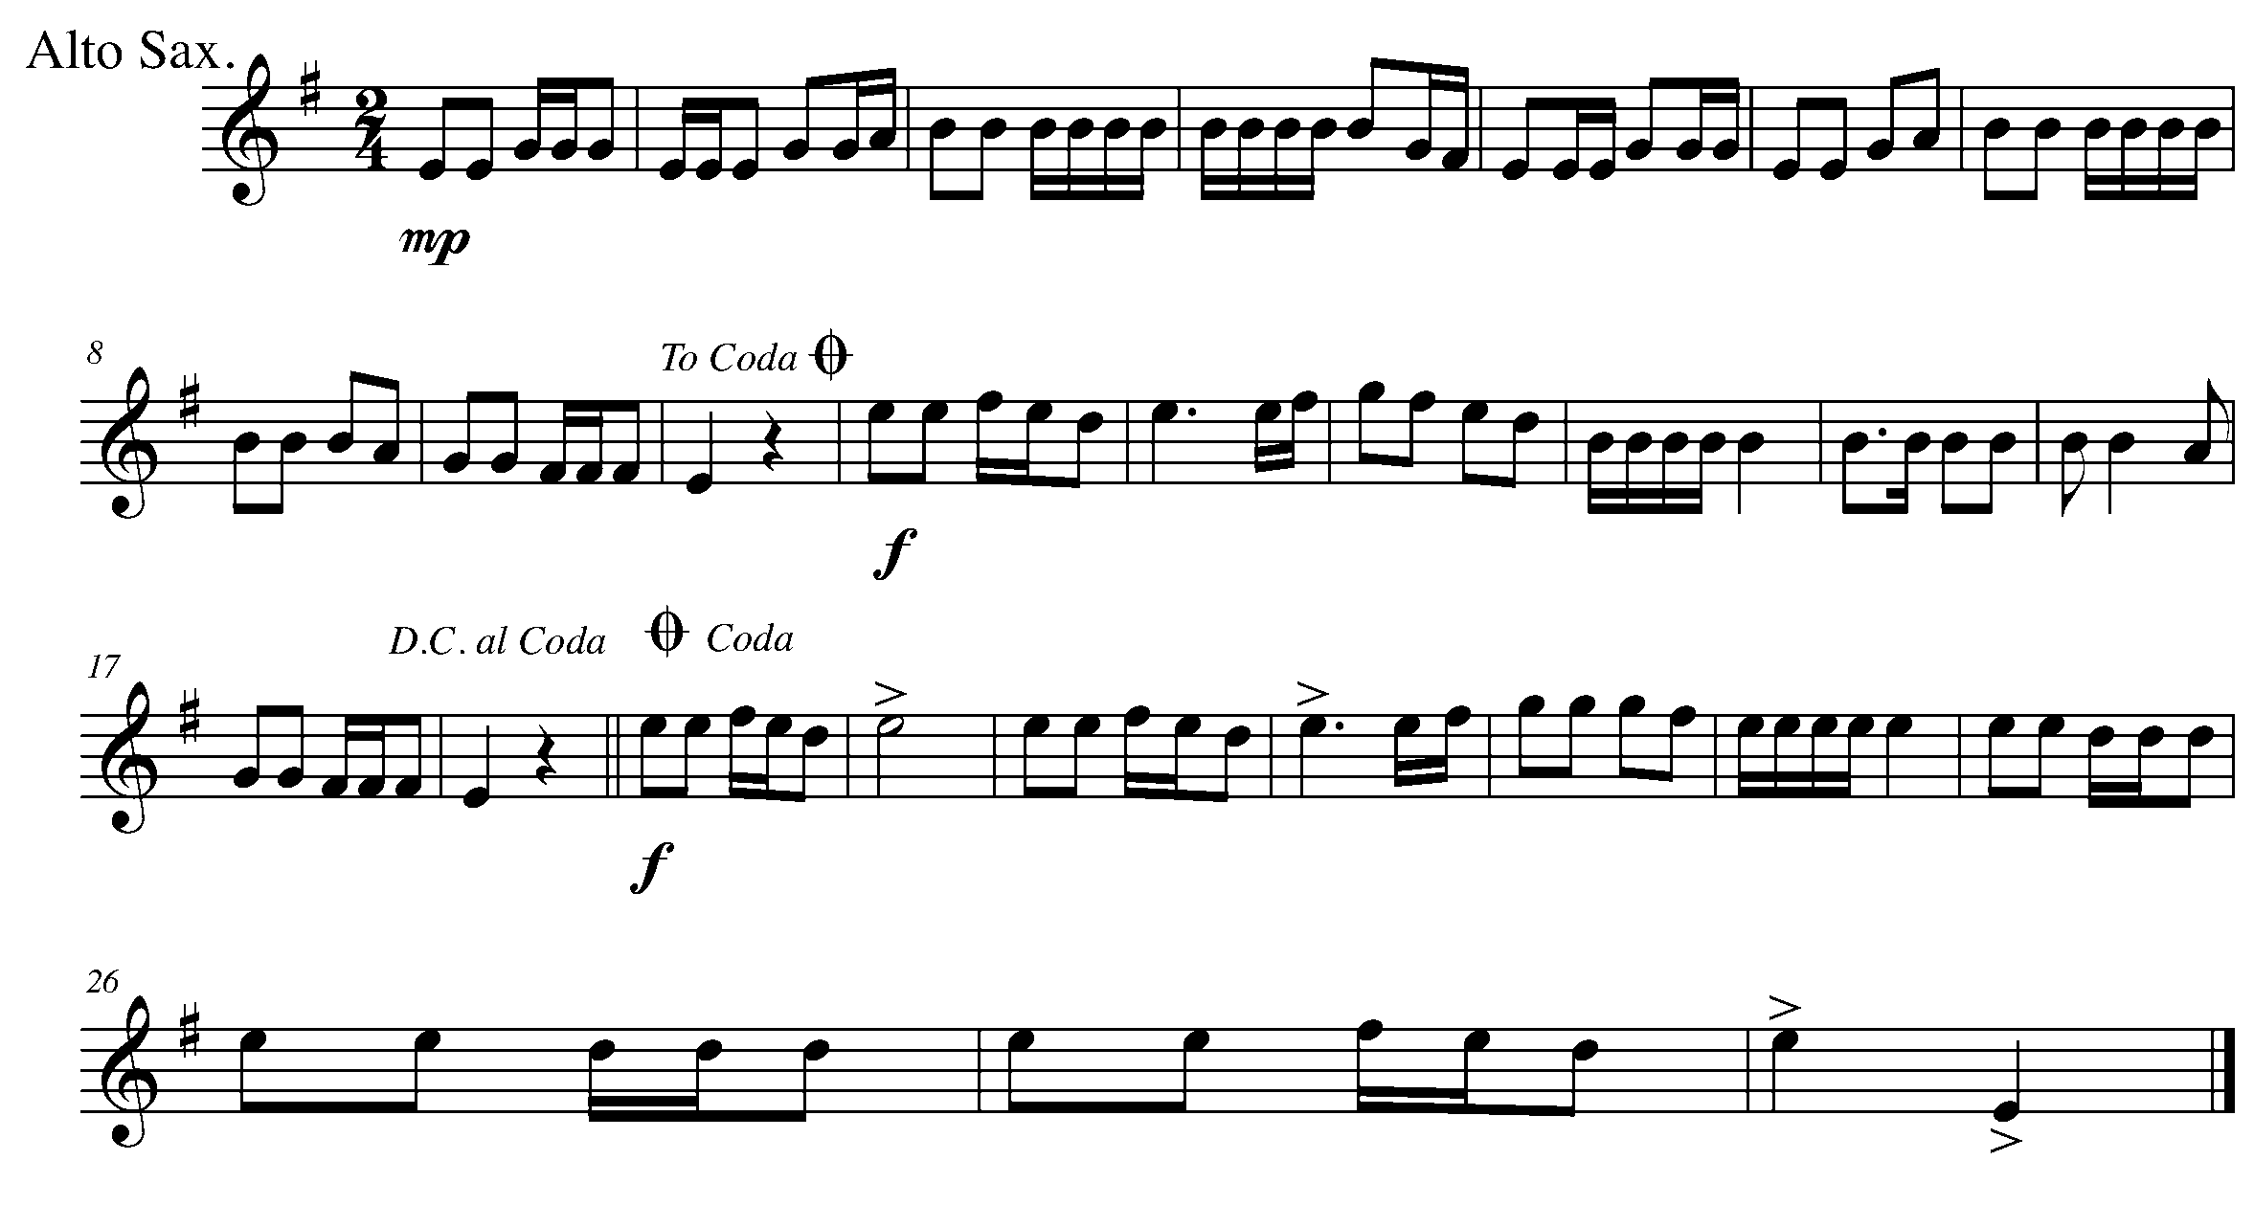
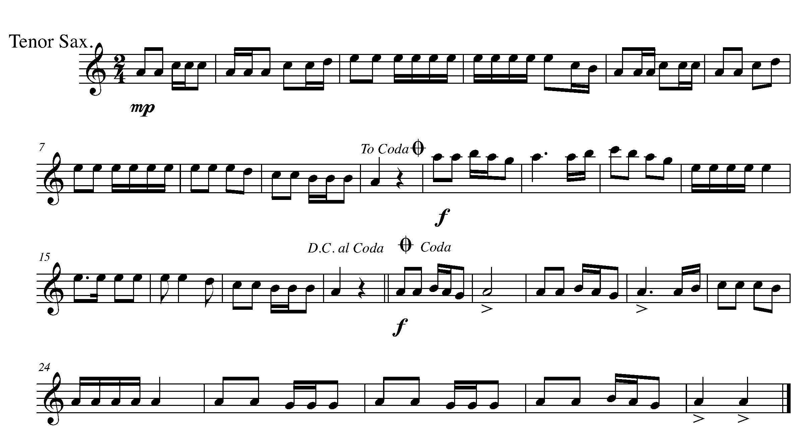

Task 17 Music Continued
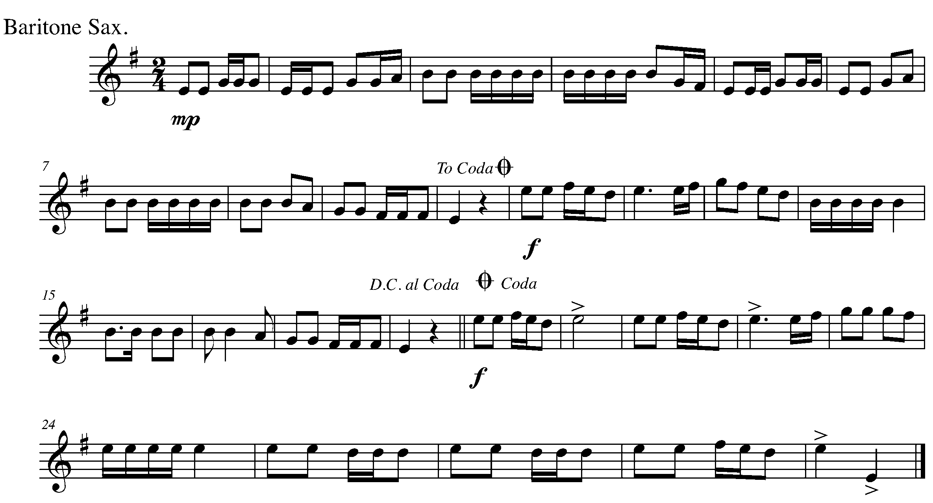
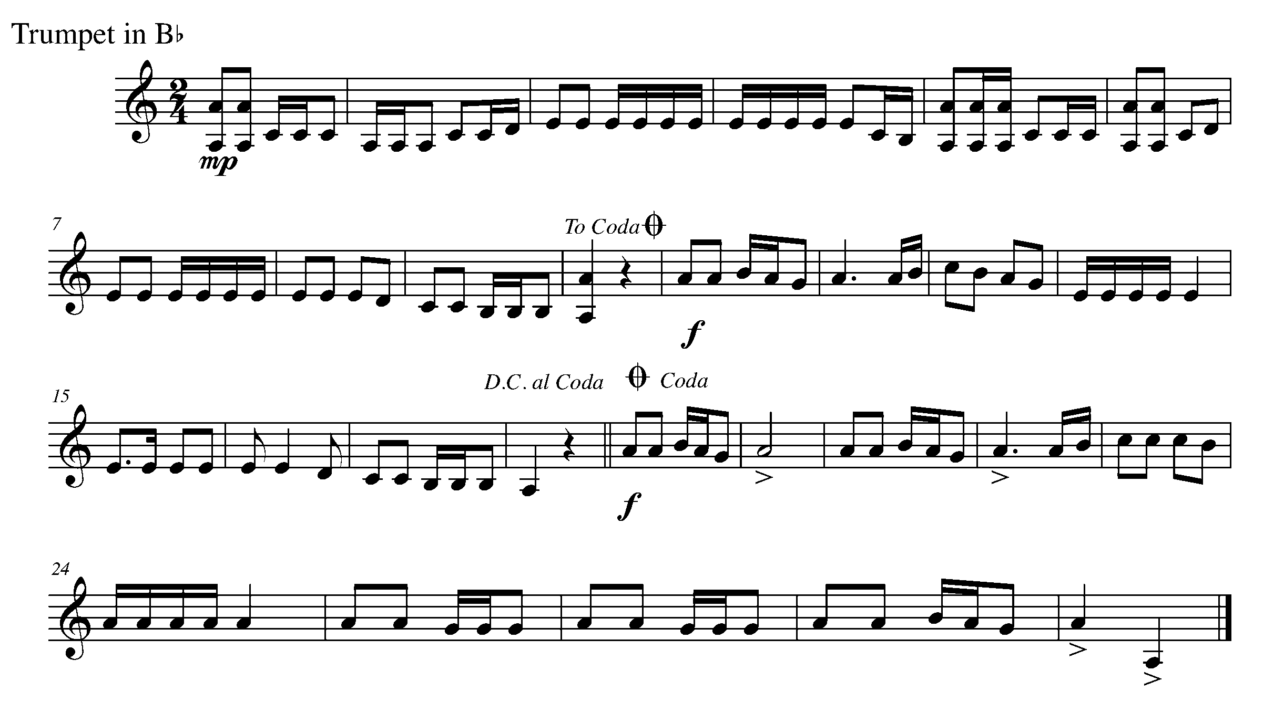

Task 17 Music Continued
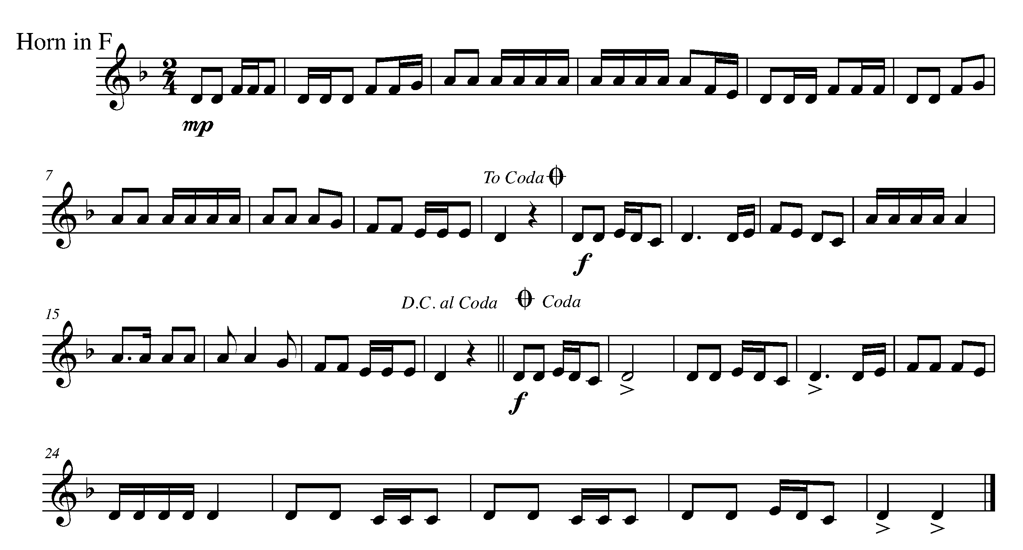
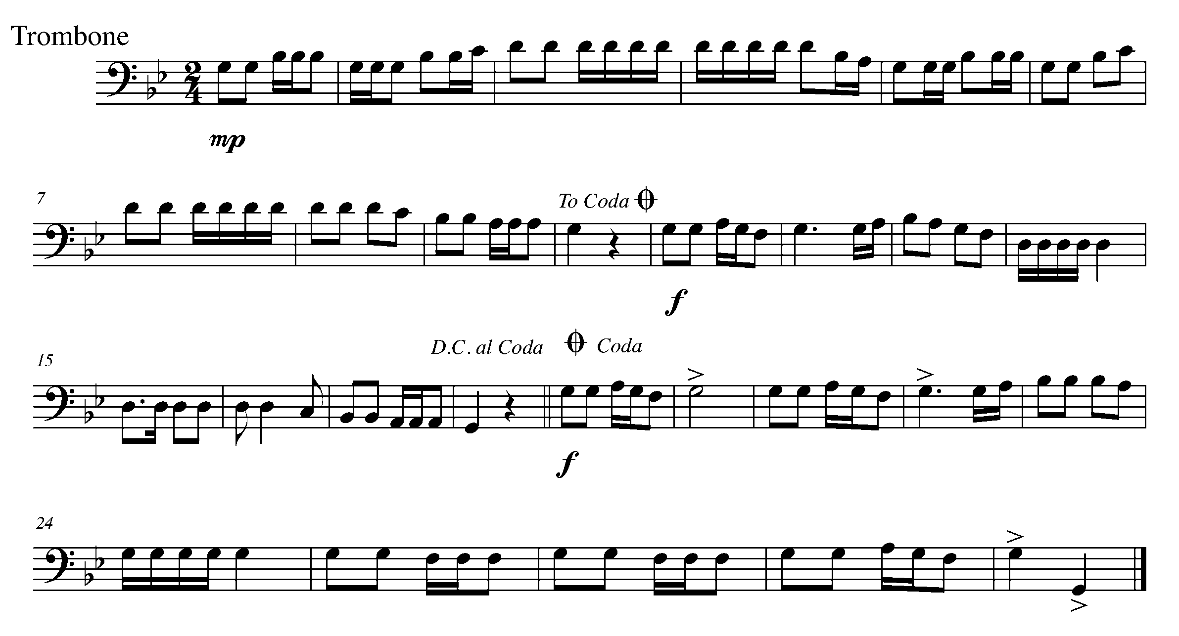

Task 17 Music Continued

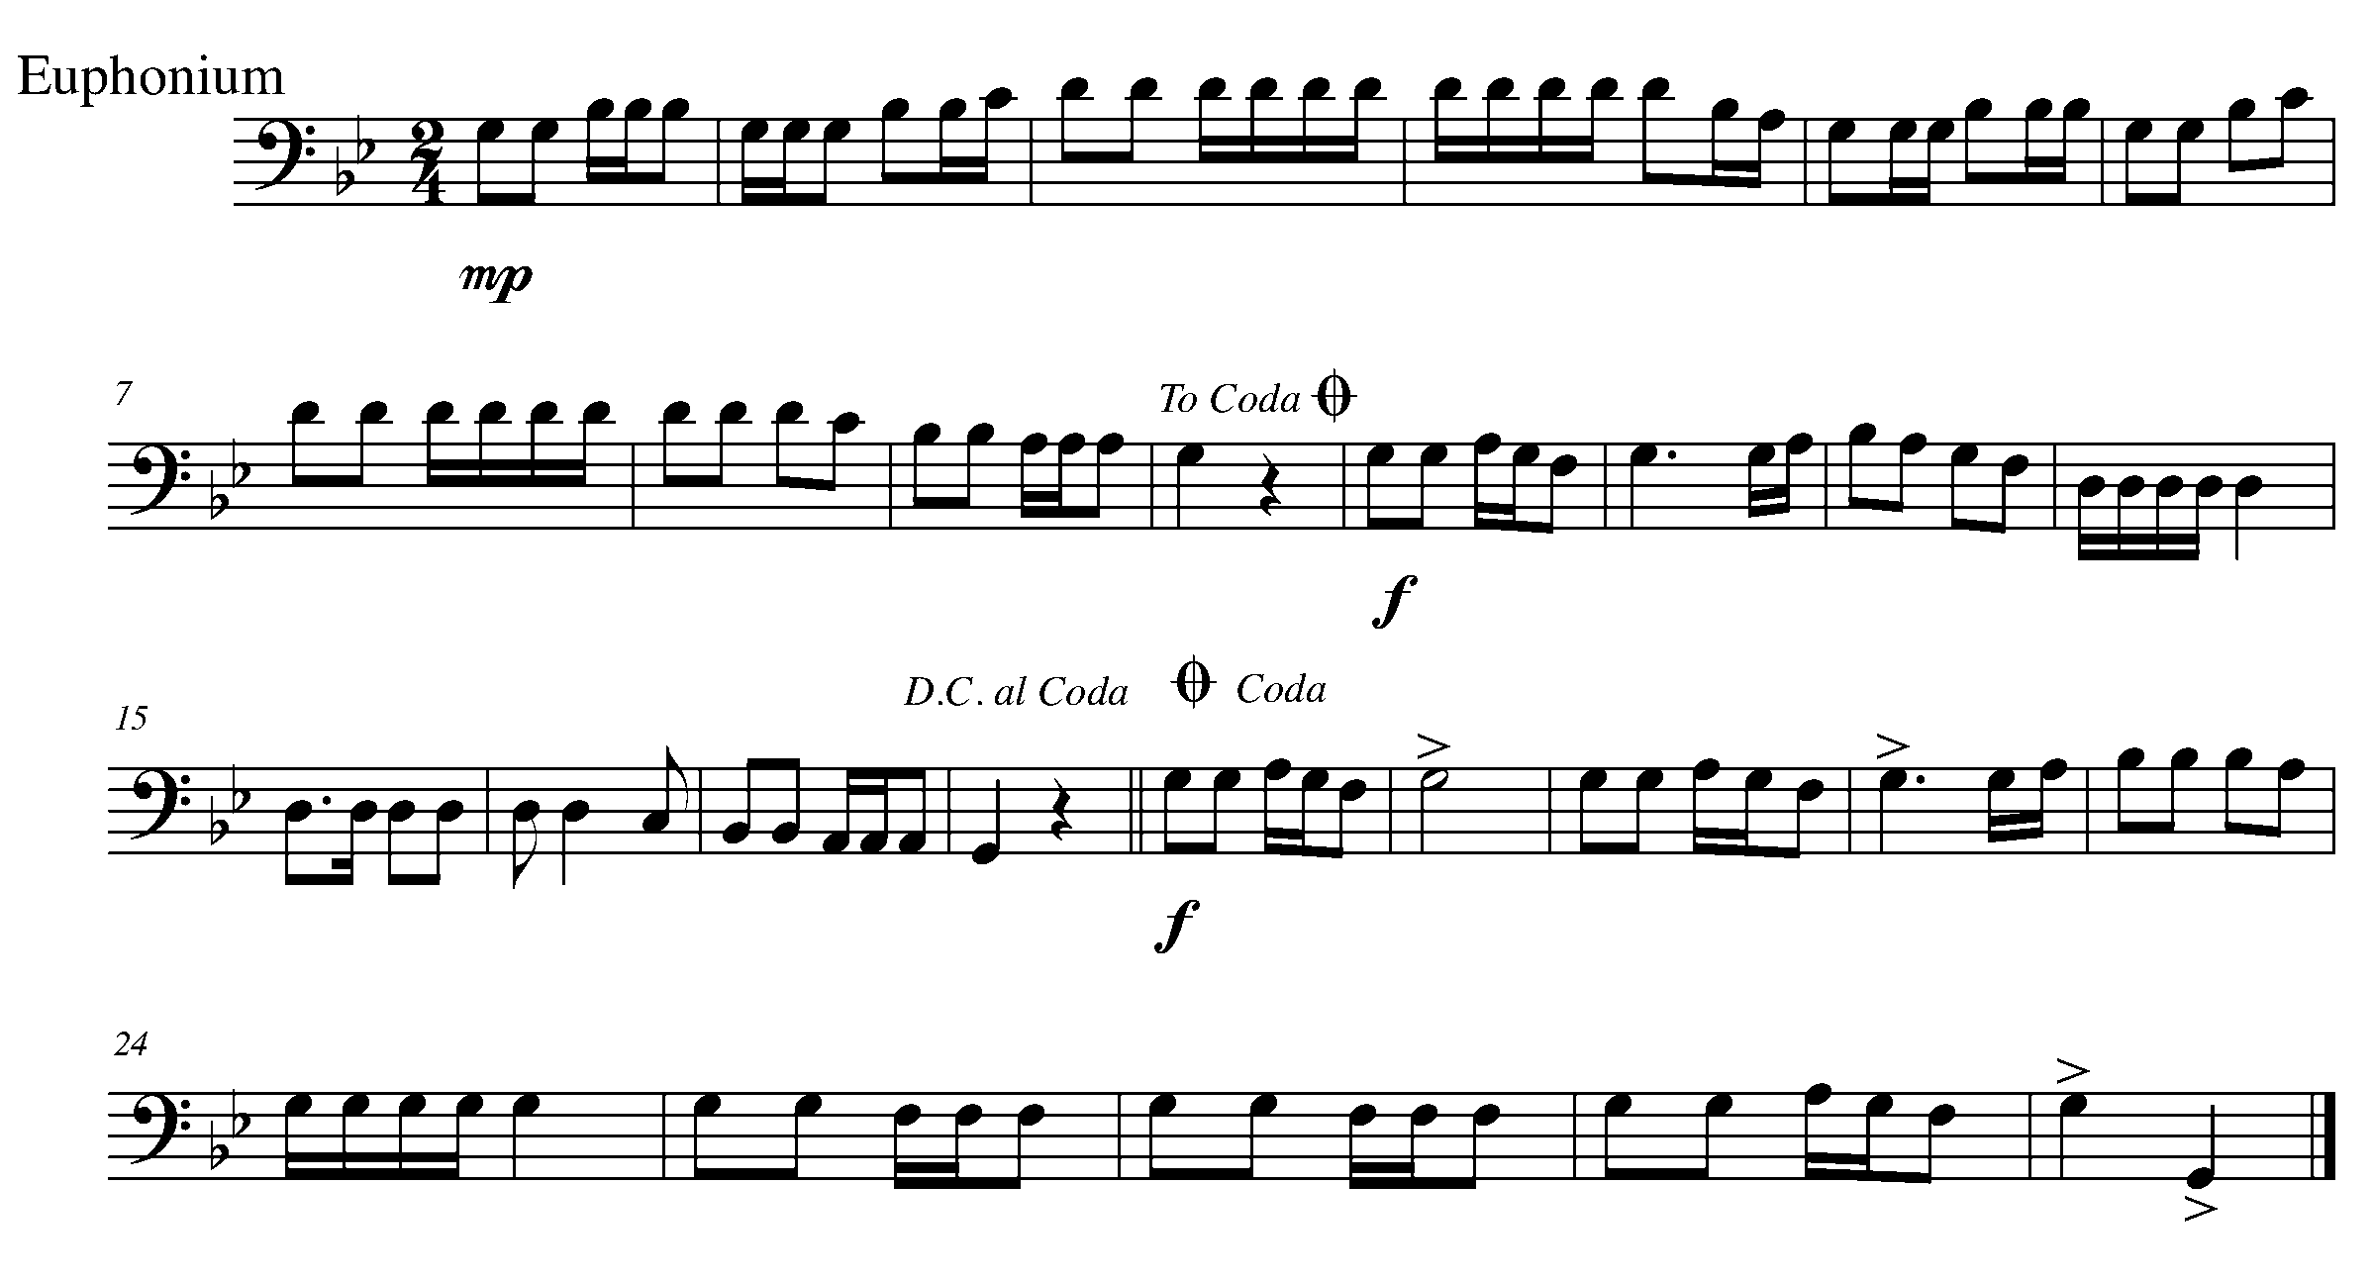
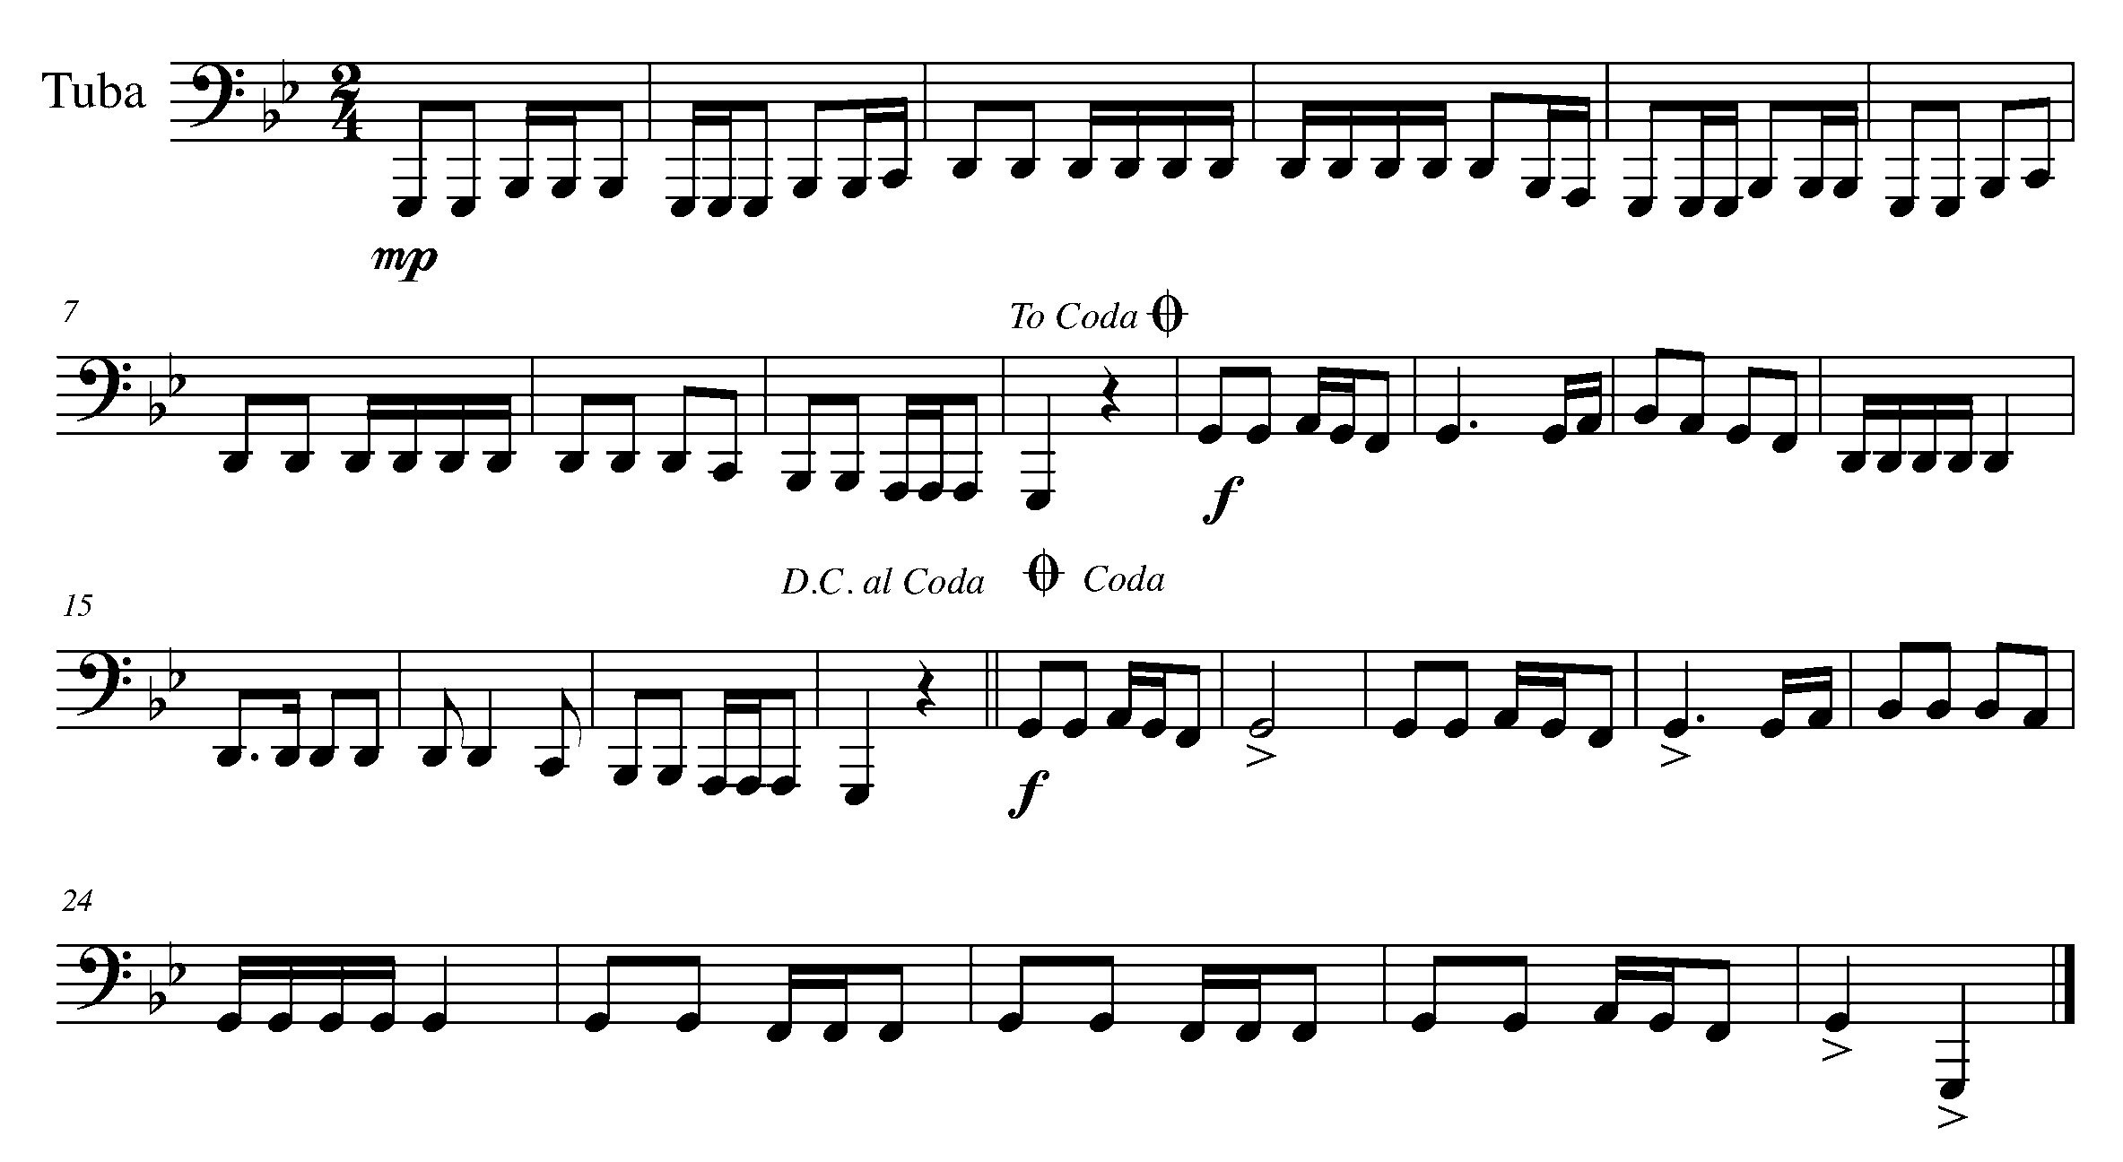

Task 17 Music Continued

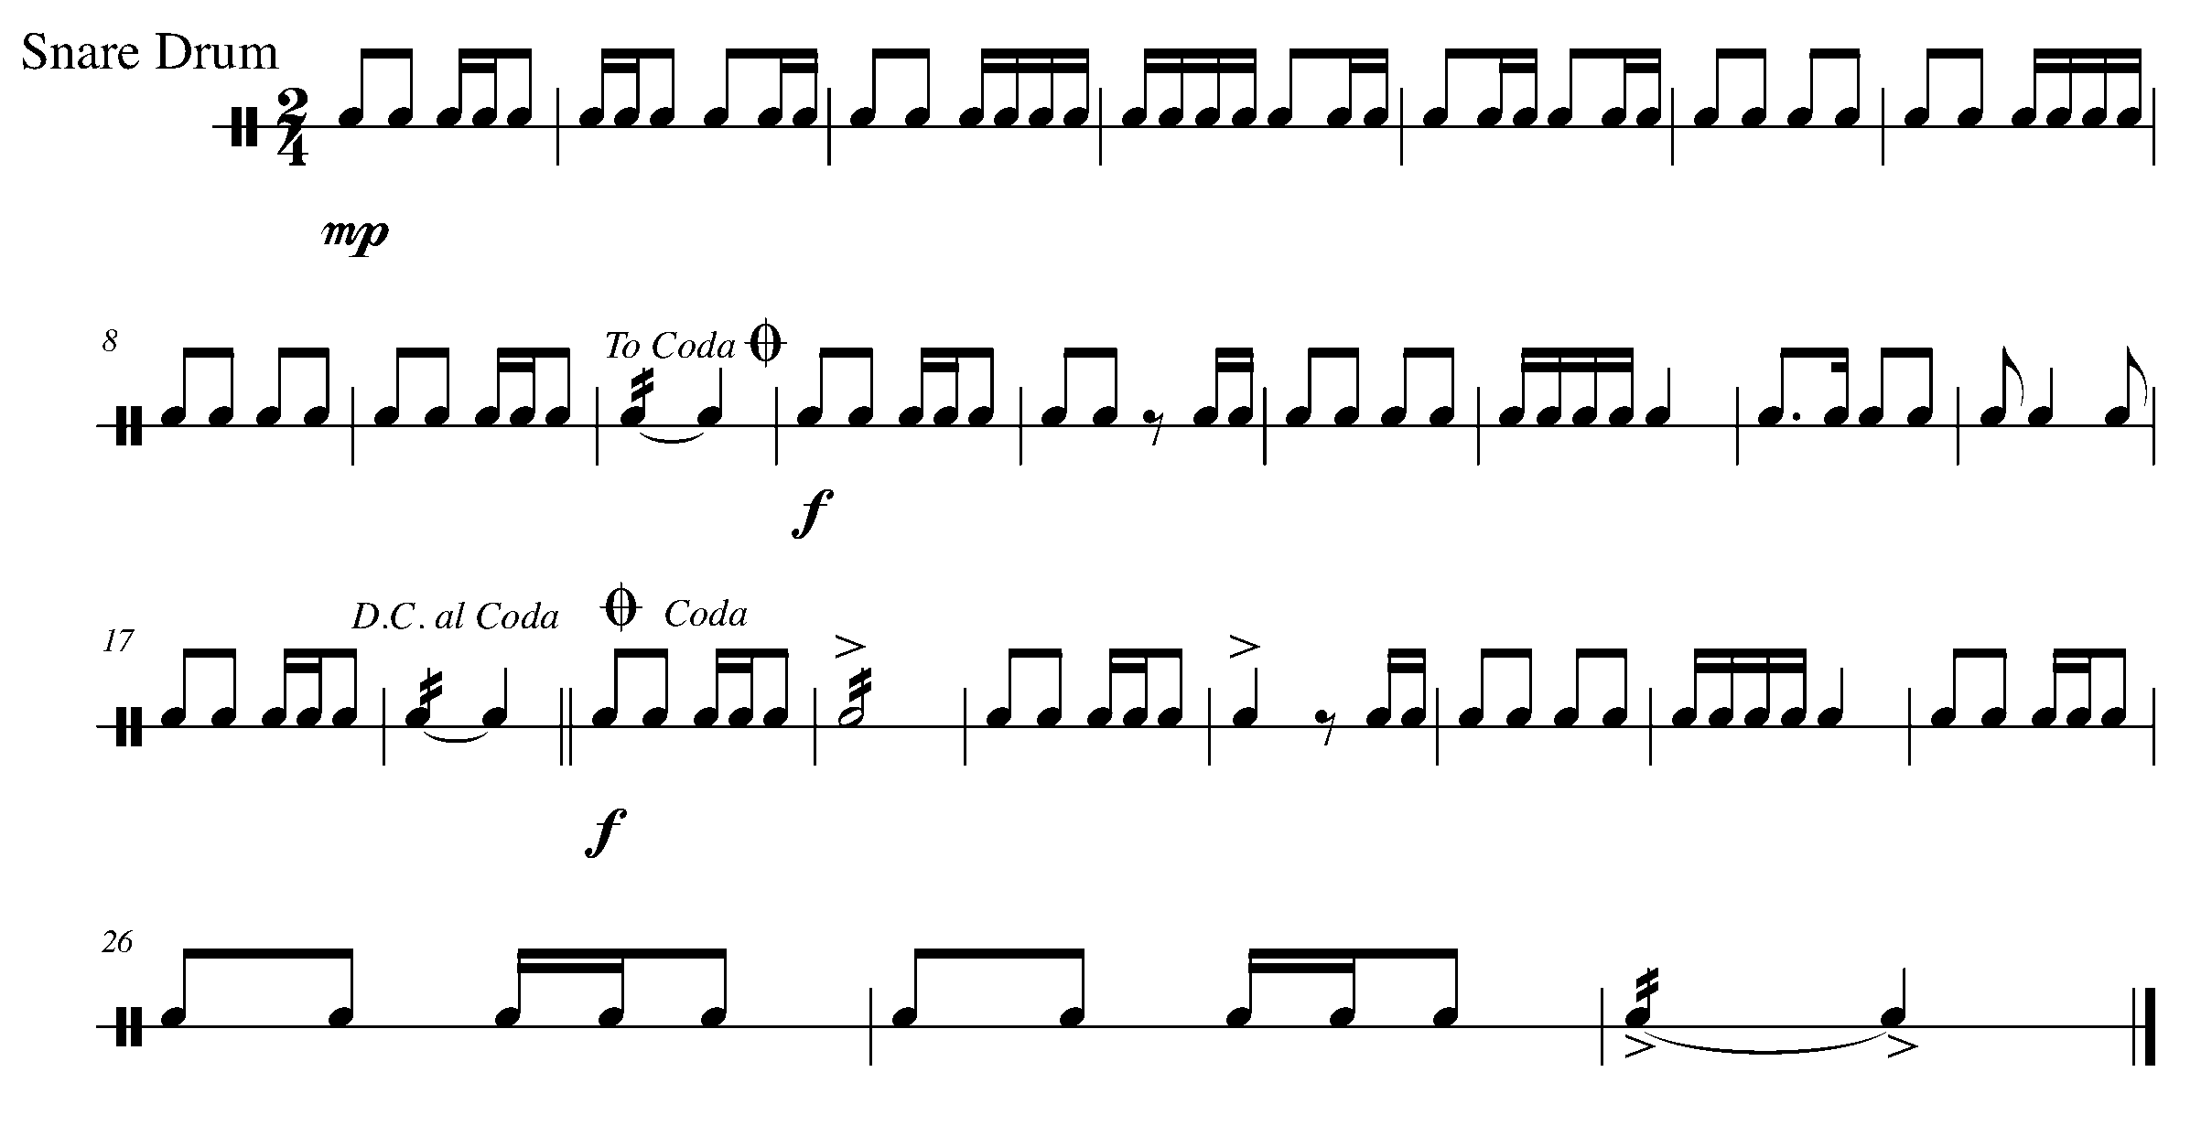
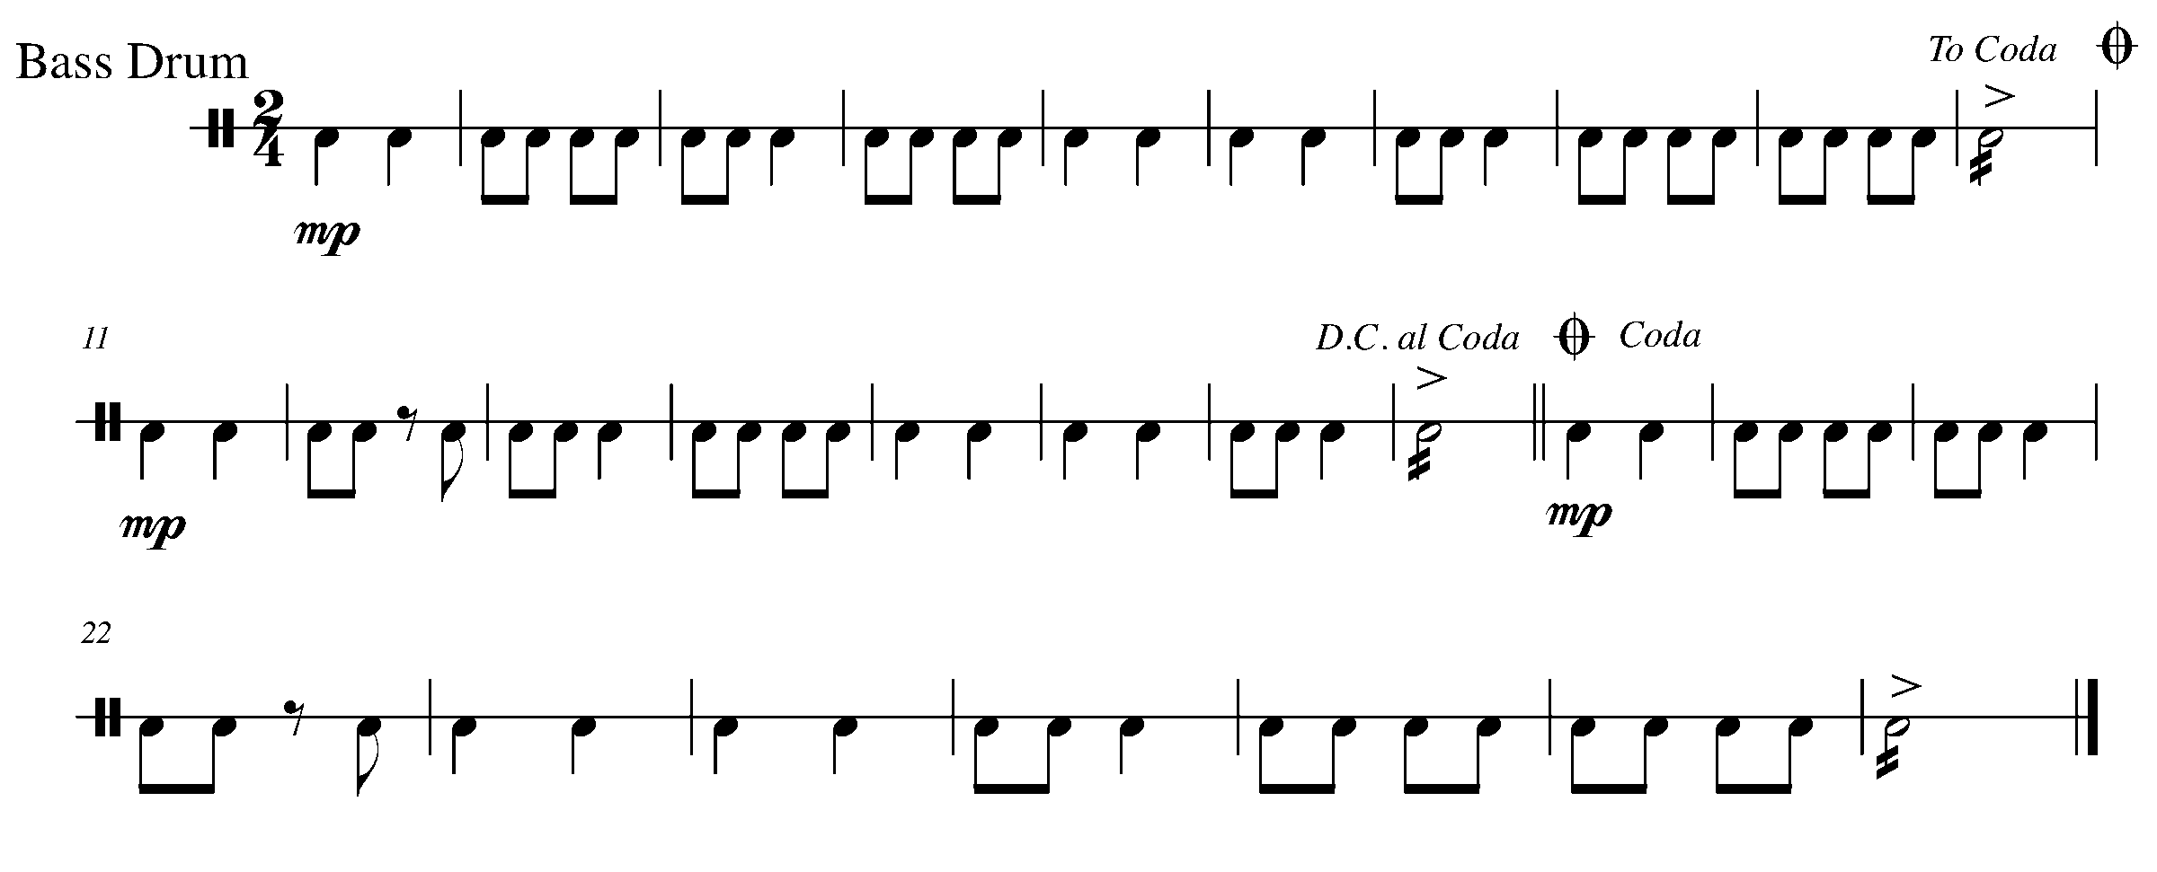
Task 17 Music Continued 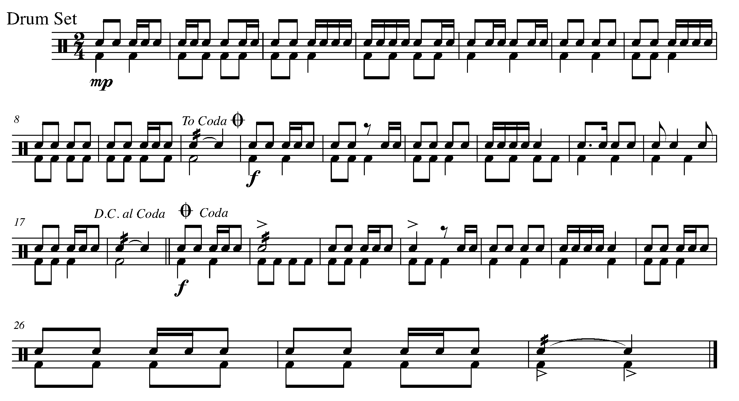

18. AND NOW..DAL SEGNO! (also known as D.S. ☺) FOCUS: D.S. AL FINE
WIND INSTRUMENTS AND MALLETS

LEARNING GOAL: In this task, you will learn about the “dal segno (D.S.)” and how it works when paired with “al fine”.

The sign that you return to when you get to a D.S. is:

MINDS ON! How is “D.S.” different from “D.C.”? Why might a composer choose “D.S.” instead of “D.C.”? How do you know when to stop playing? What is the common language that your teacher uses when asking you to observe the “D.S.” and/or the fine?

ACTION! To be successful with this task, you will need to:

- Figure out the “road map” of this piece, including “D.S. al fine”; and
- Perform the fundamentals of music with awareness and excellence.

CONSOLIDATION: In order to move on to the next task, perform the following piece for your teacher and receive feedback.

Music for Task 18

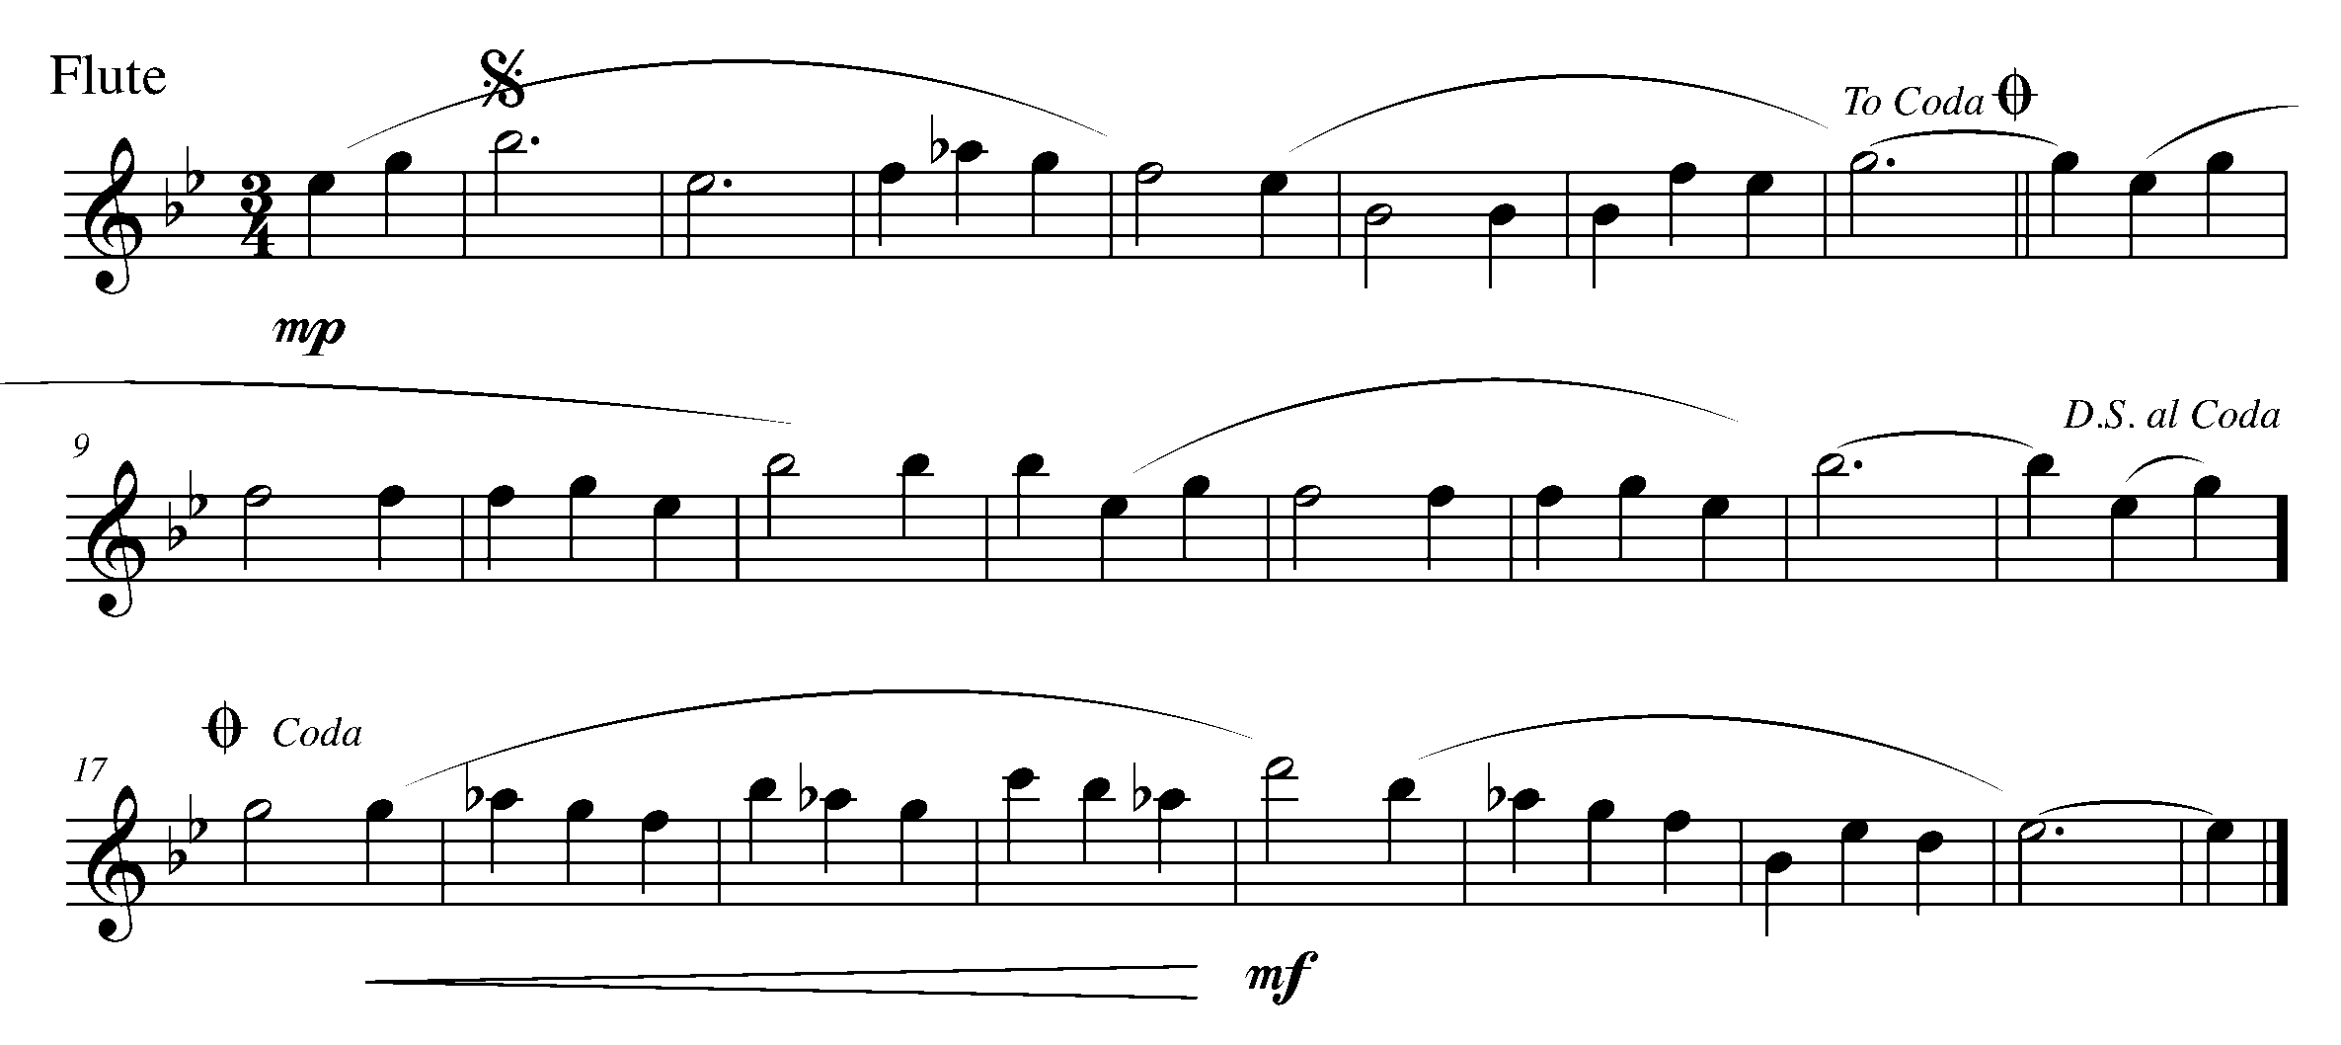
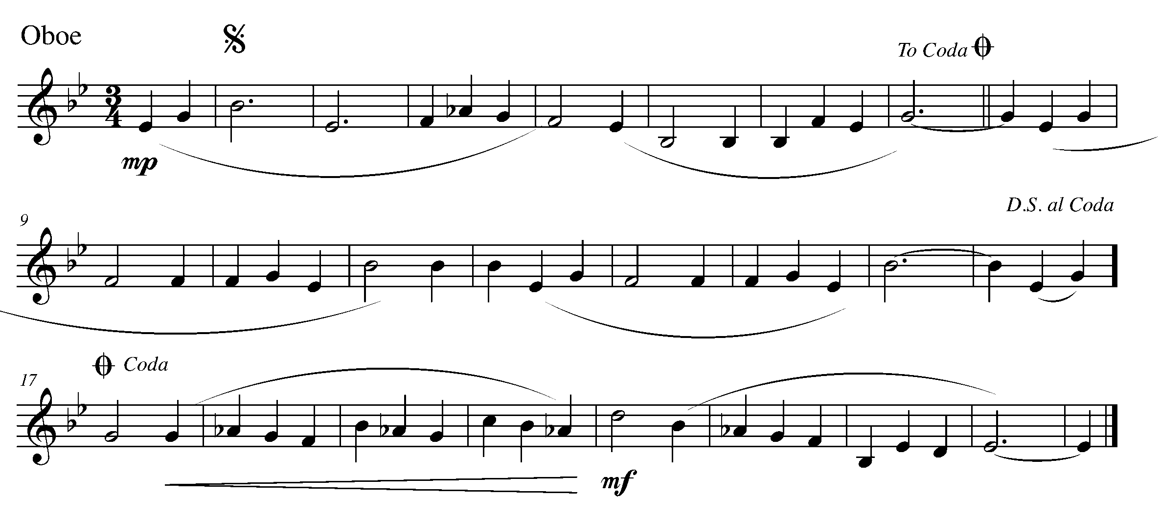
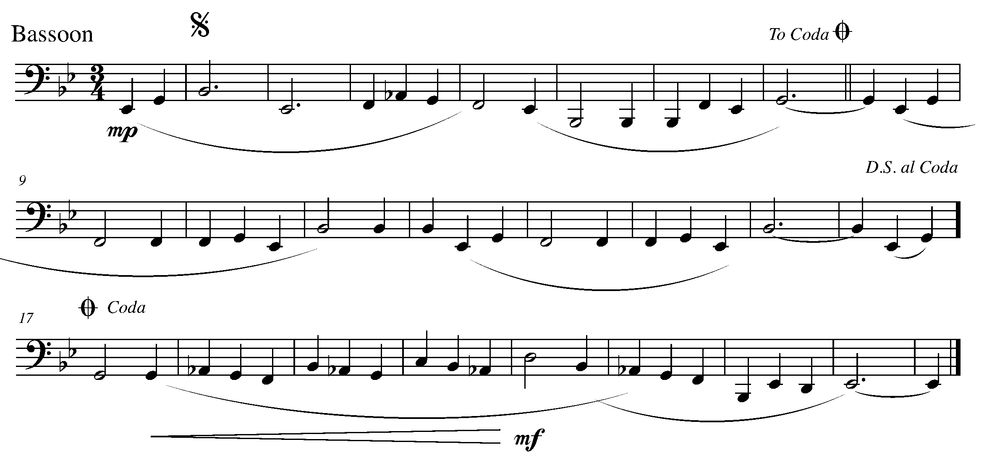
Task 18 Music Continued
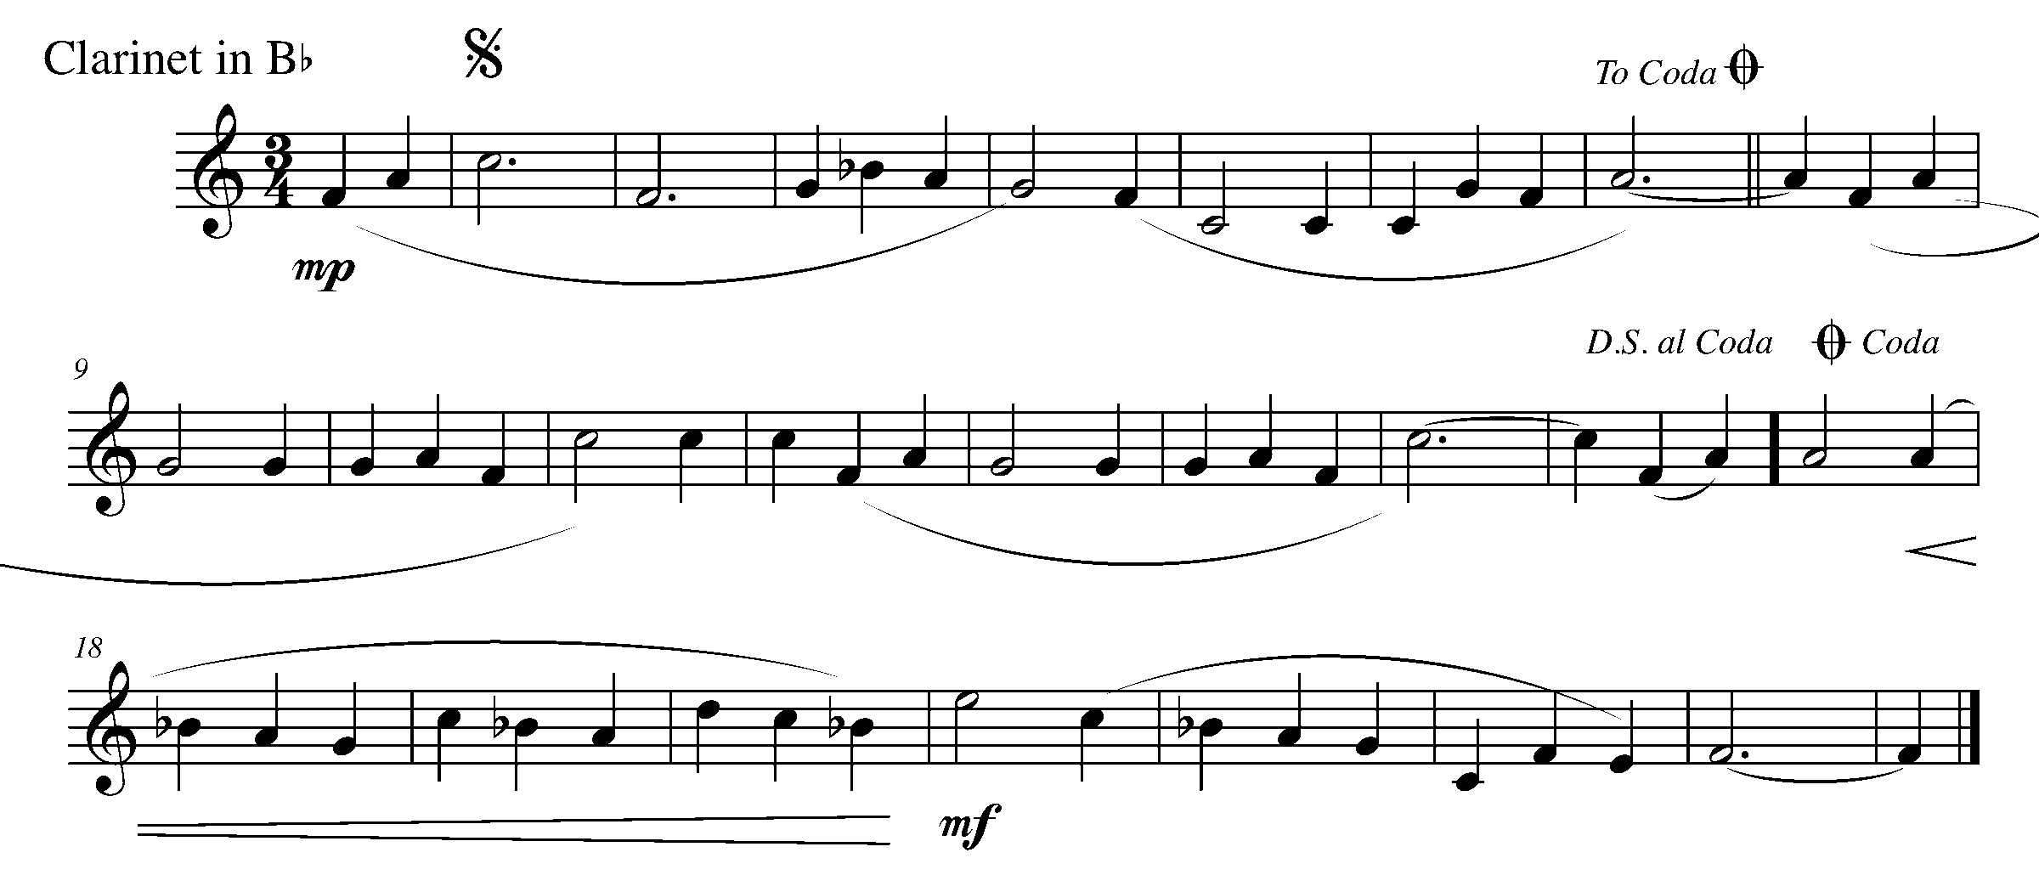
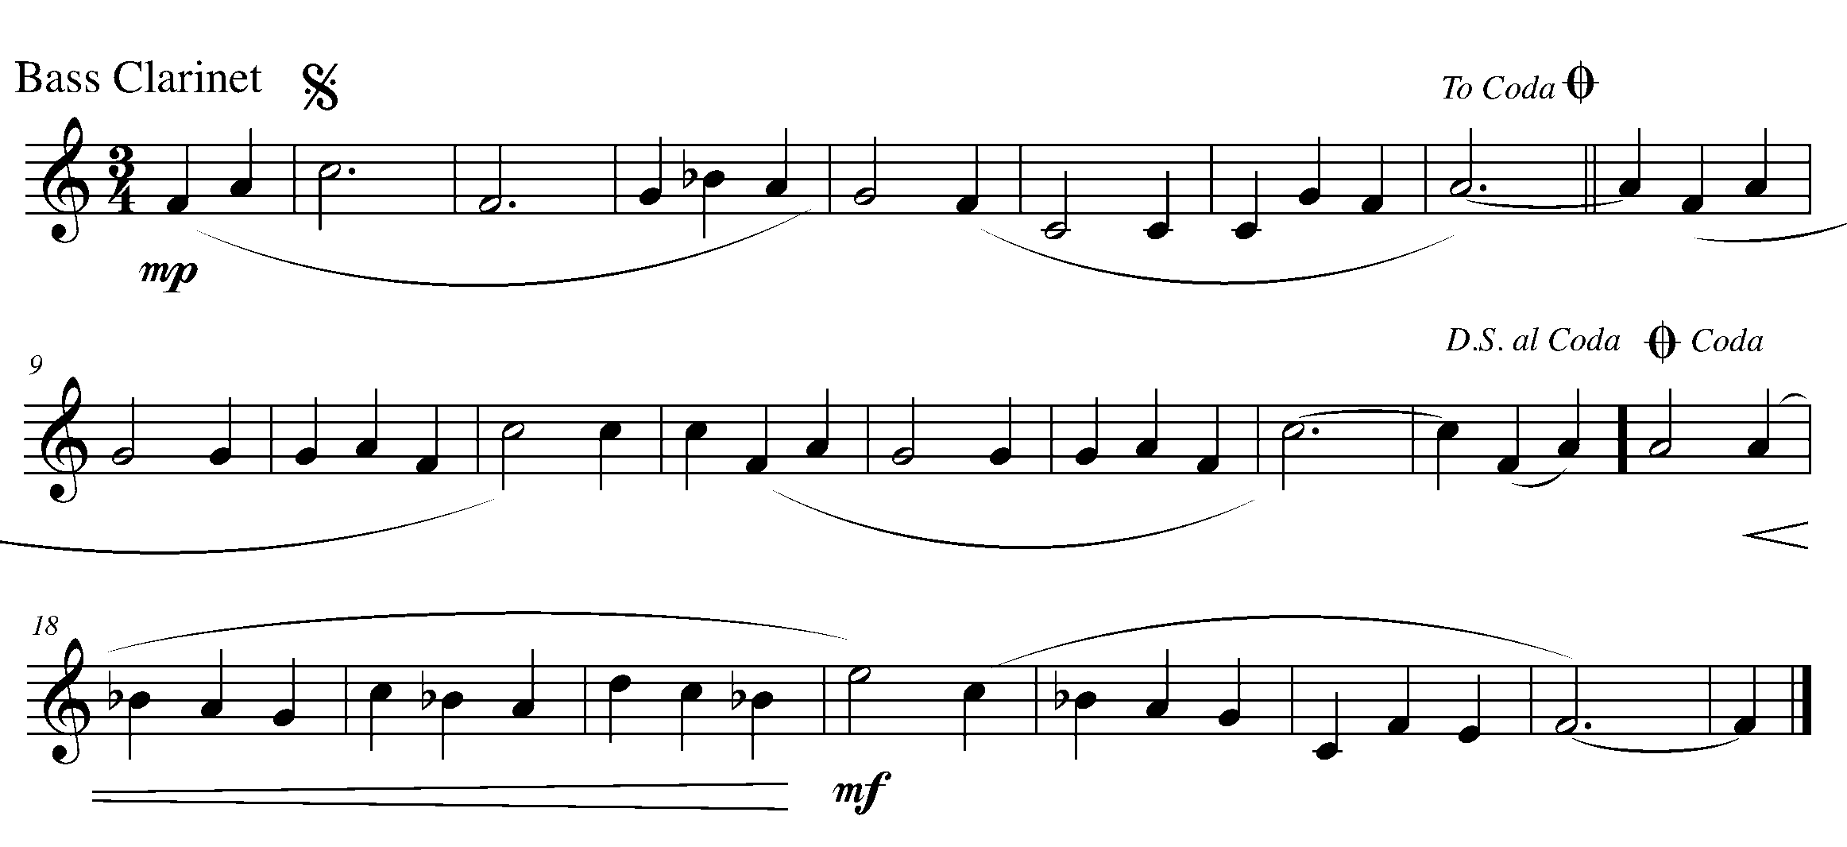
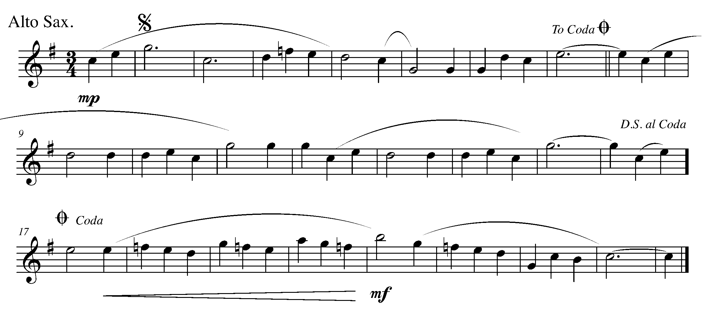

Task 18 Music Continued
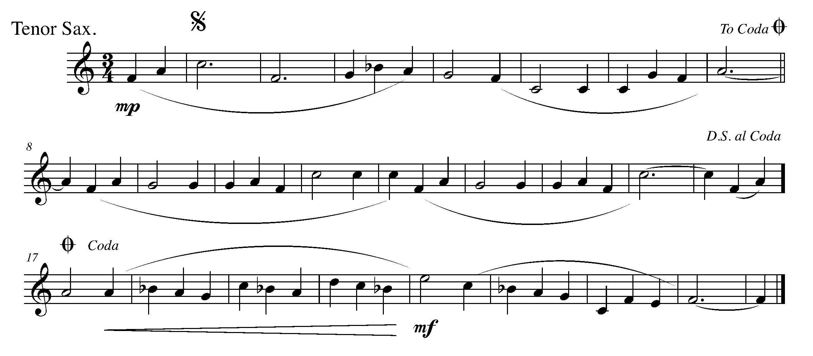
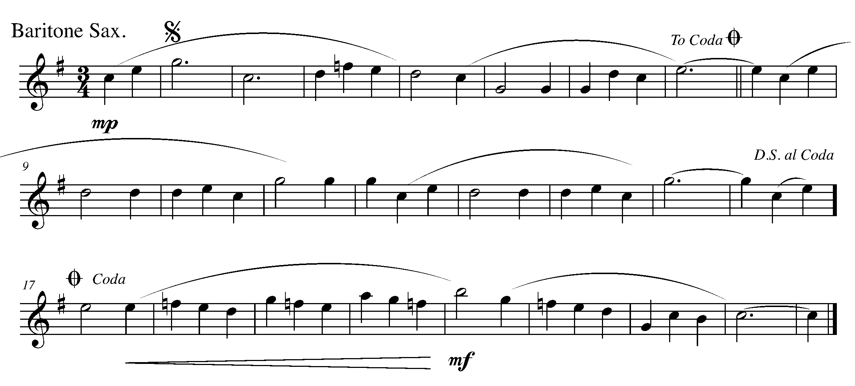
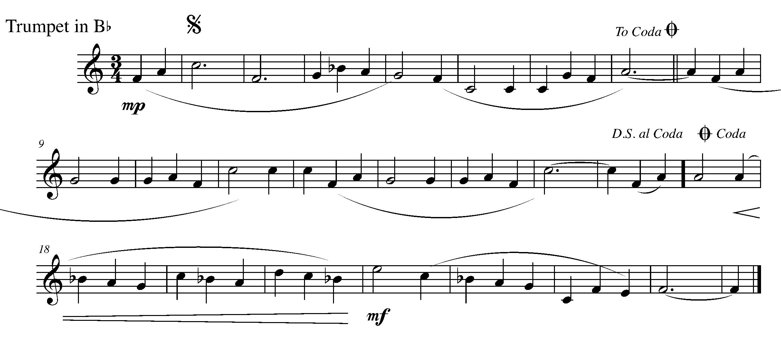

Task 18 Music Continued
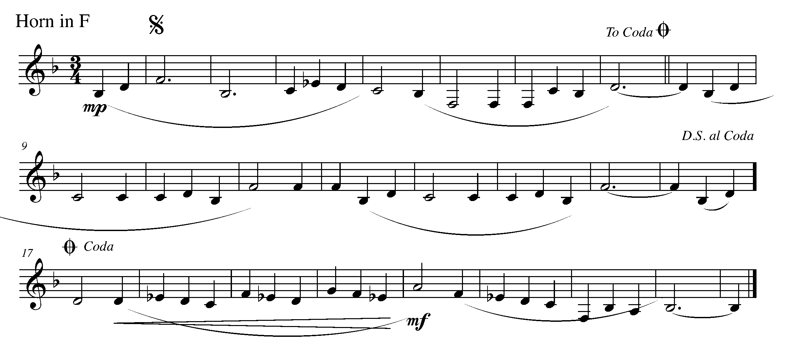
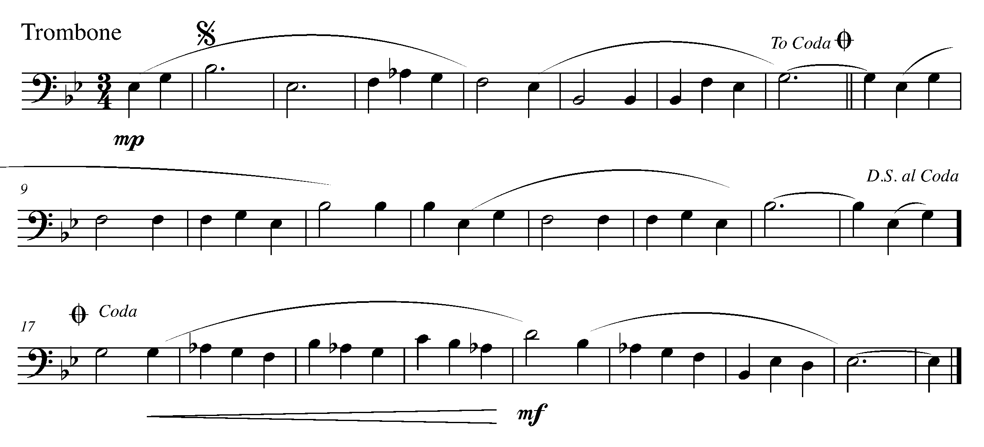
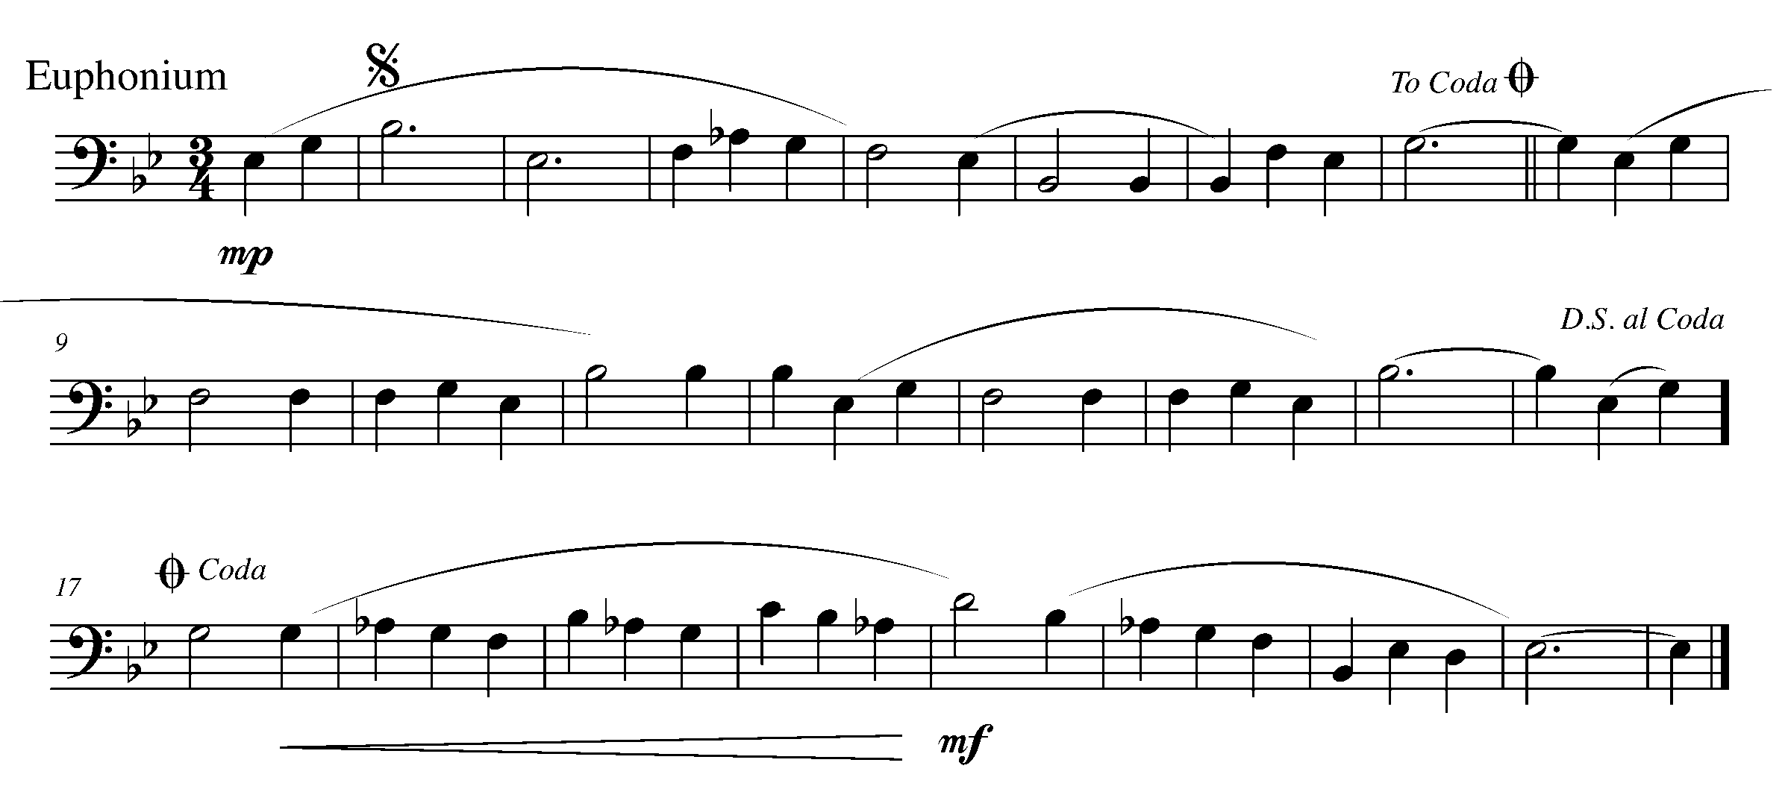

Task 18 Music Continued

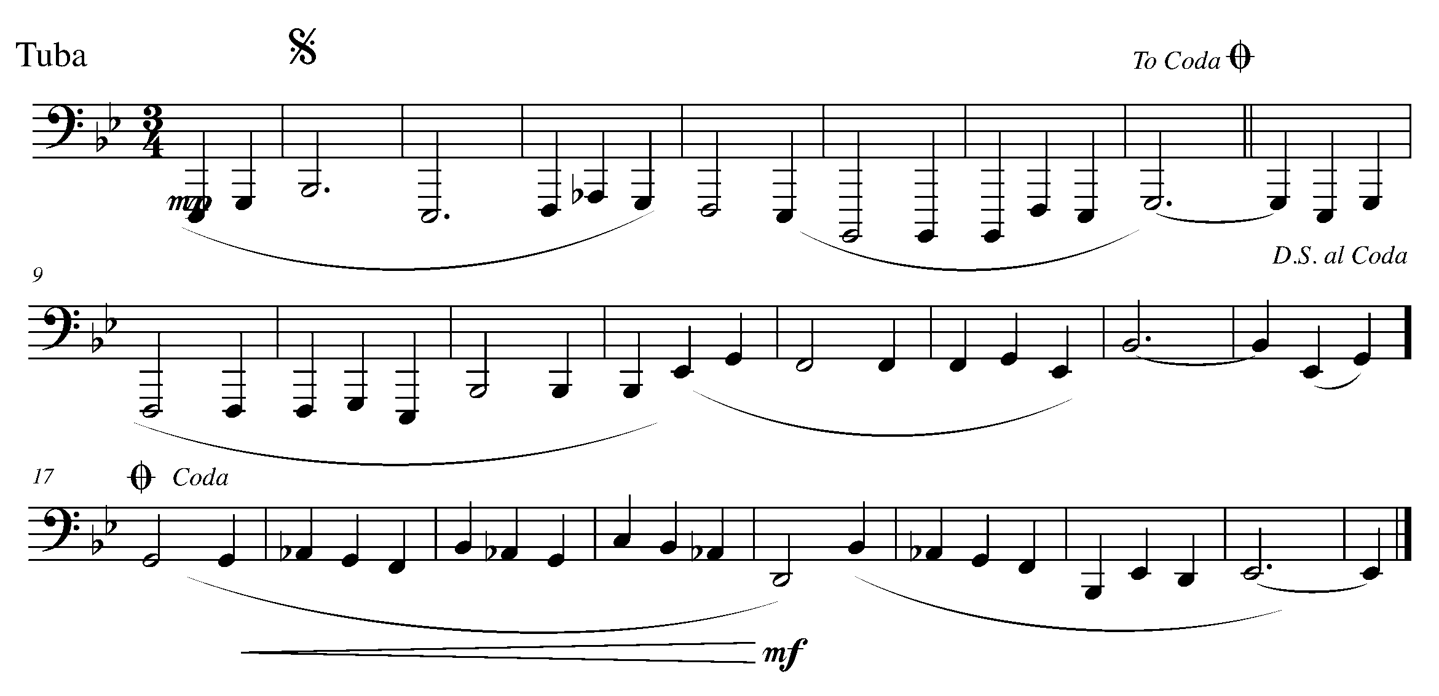
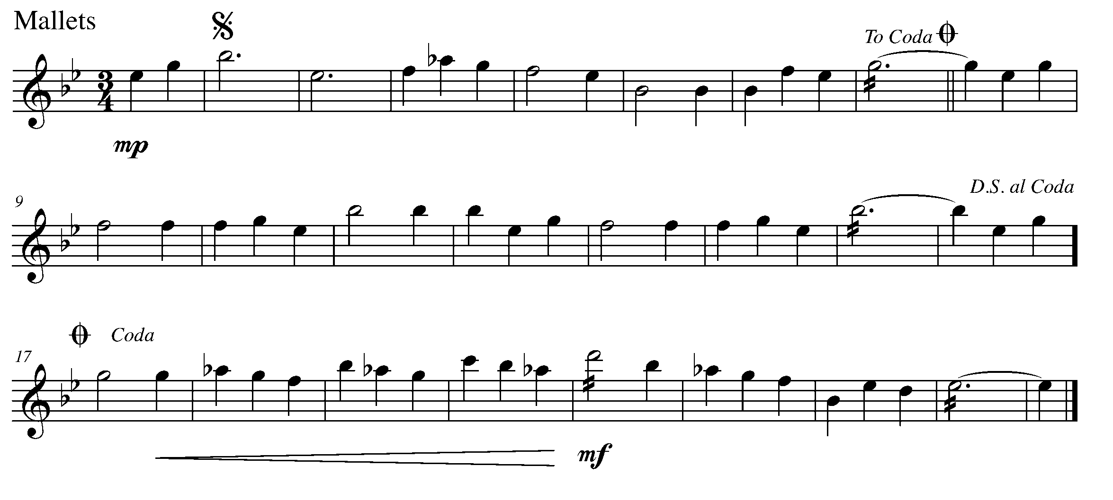

19. YES! ANOTHER ENDING OPTION! FOCUS: 1ST AND 2ND ENDINGS
WIND INSTRUMENTS AND SD/BD/KIT

LEARNING GOAL: In this task, you will review the concept of 1st and 2nd endings as introduced in the GPS Year Two Program.

MINDS ON! How do you perform 1st and 2nd endings? Why do you think this compositional “shortcut” was created?

ACTION! To be successful with this task, you will need to:

- Identify the 1st and 2nd endings in the following piece of music;
- Be able to explain in words how to perform a 1st and 2nd ending – you may look and even trace your music while explaining this to your teacher; and
- Perform the fundamentals of music with awareness and excellence.

CONSOLIDATION: In order to move on to the next task you must:

- Explain in words how to perform a 1st and 2nd ending – this might be easier if you look at the piece below and trace your music with your finger while explaining the road map; and
- Perform the following piece for your teacher and receive feedback.
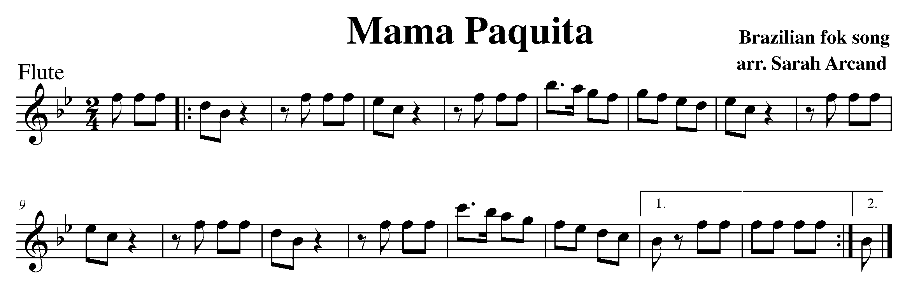
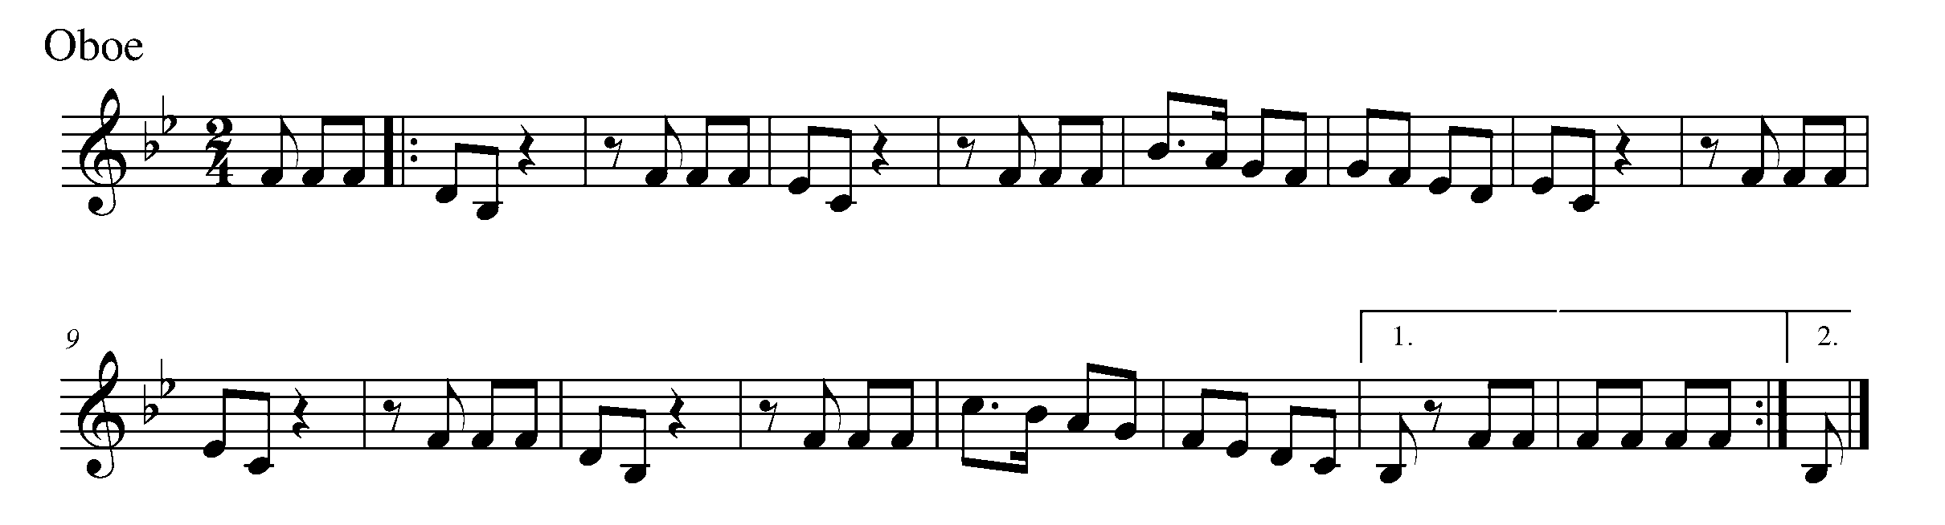
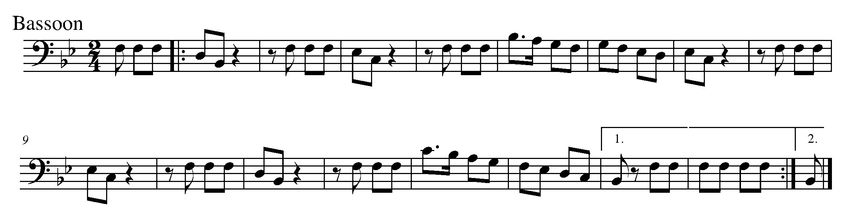

Task 19 Music Continued
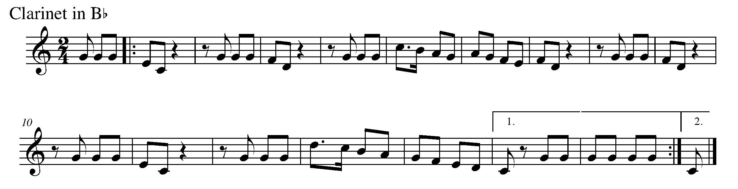
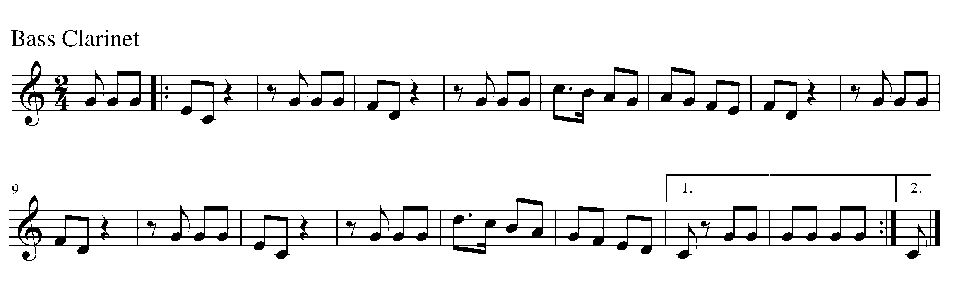
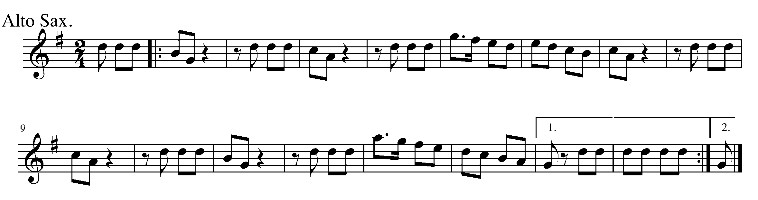
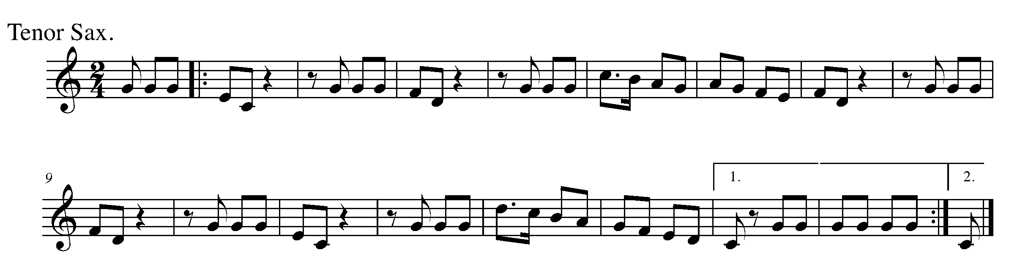
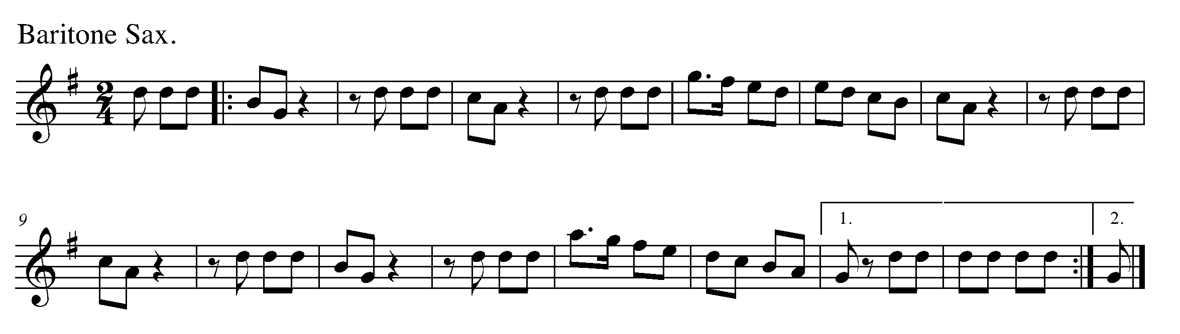

Task 19 Music Continued
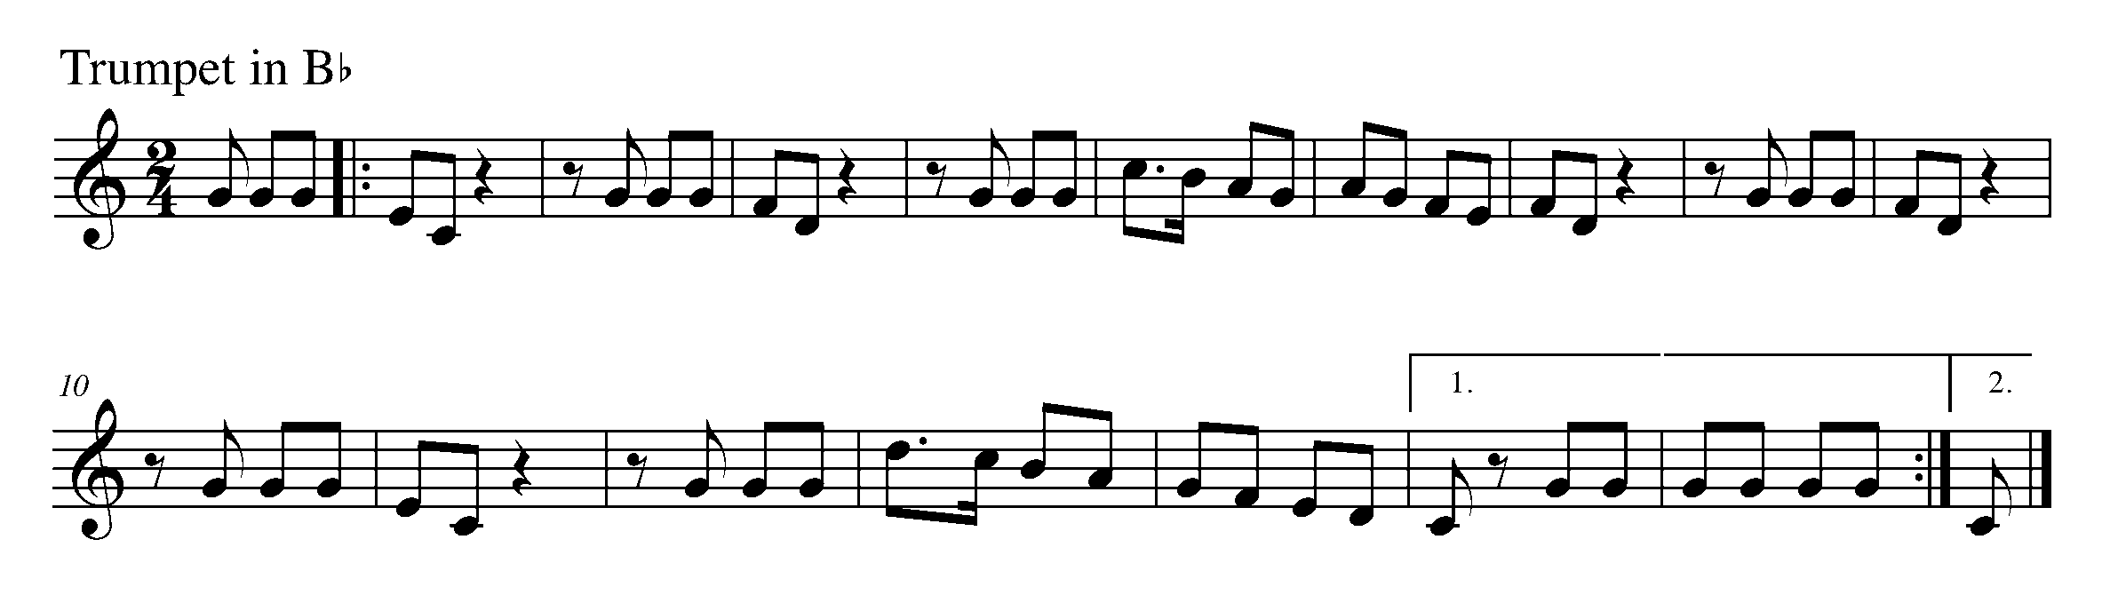
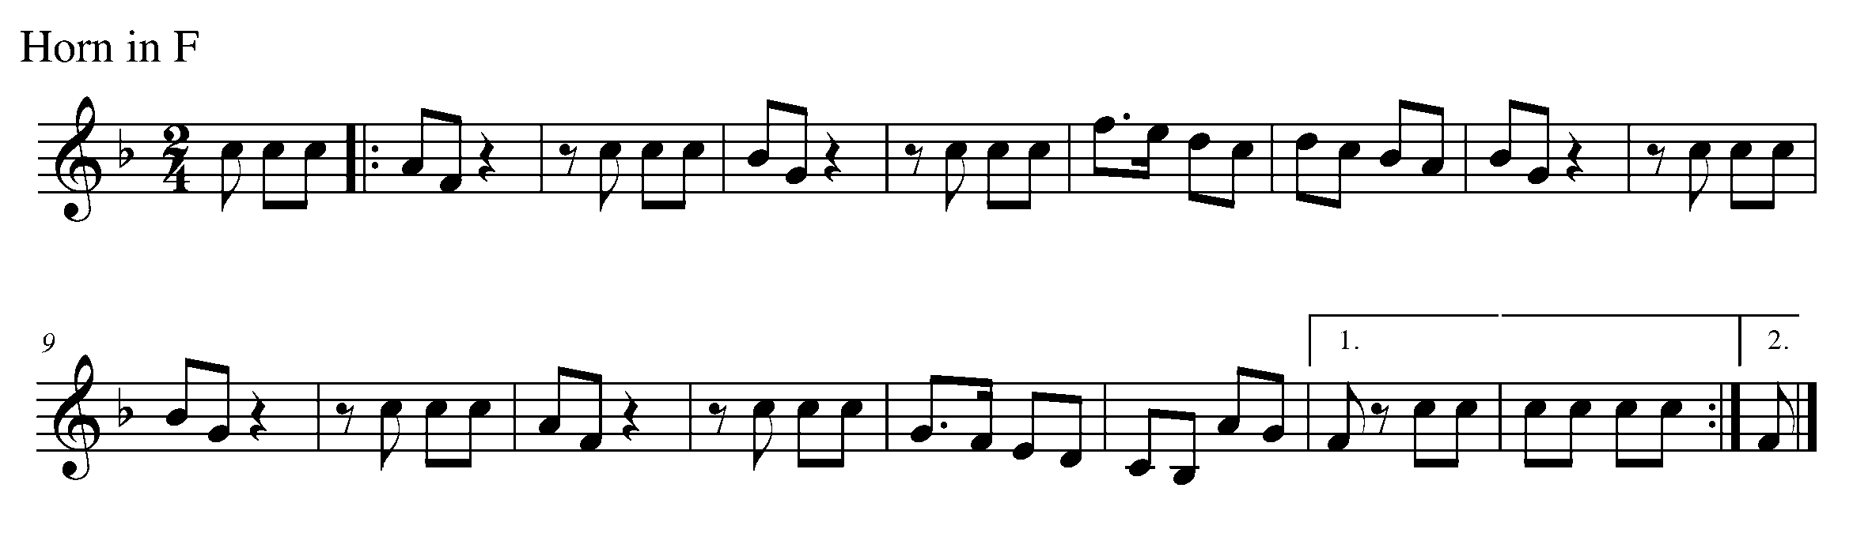
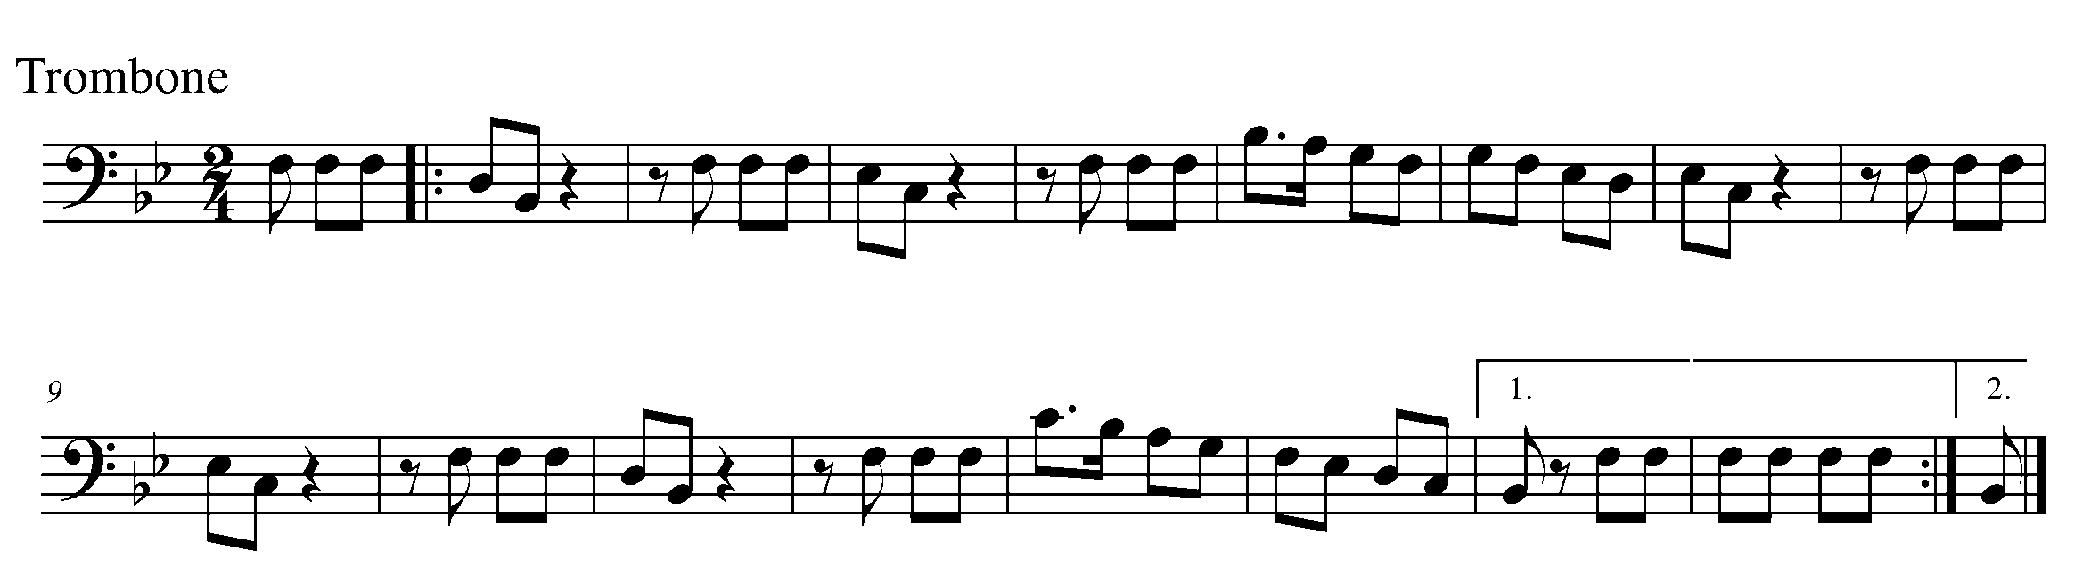
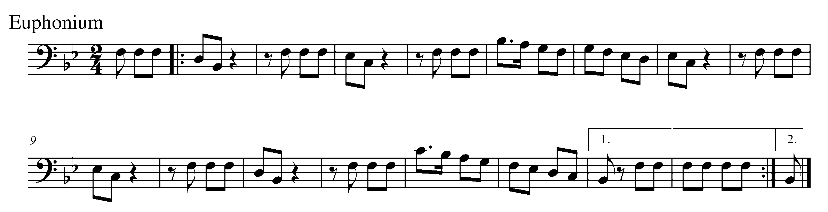
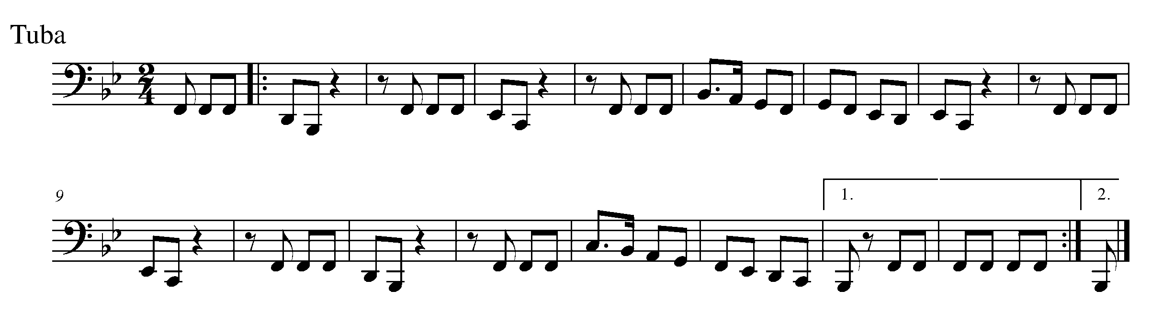
Task 19 Music Continued 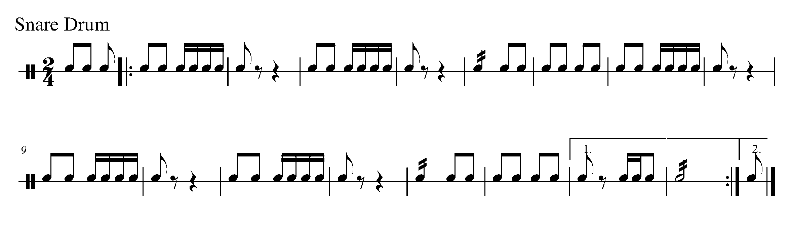

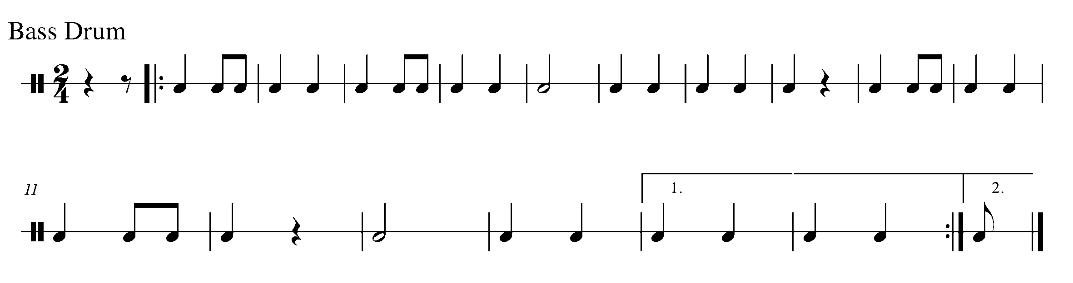
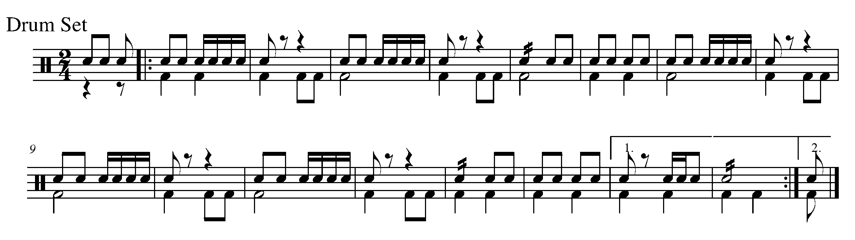

20. THE GPS FINISH LINE! FOCUS: CULMINATING TASK
WIND INSTRUMENTS, SD/BD/KIT or MALLETS

LEARNING GOAL: The purpose of this task is to perform a piece with a variety of endings as introduced in the final West section of GPS Year Three. You will perform this piece for your teacher and either one friend, a small group or a class.

MINDS ON! What is the road map of the below piece? Are there any rhythms or pitches, which you think might need extra attention? Are you familiar with how to perform all of the articulations and dynamics?

ACTION! To be successful with this task, you will need to:

- Determine the road map of this piece;
- Identify articulations and dynamics;
- Perform the fundamentals of music with excellence; and
- First perform this piece for your teacher and then for either a friend, a small group or a class – as decided by you and your teacher.

CONSOLIDATION: In order to complete the GPS Year Three Program you must:

- Perform the below piece for your teacher and receive feedback;

- With your teacher, organize a final performance time for a friend, a small group or a class; and

- Perform the following piece for the audience you decide on in the previous consolidation step.
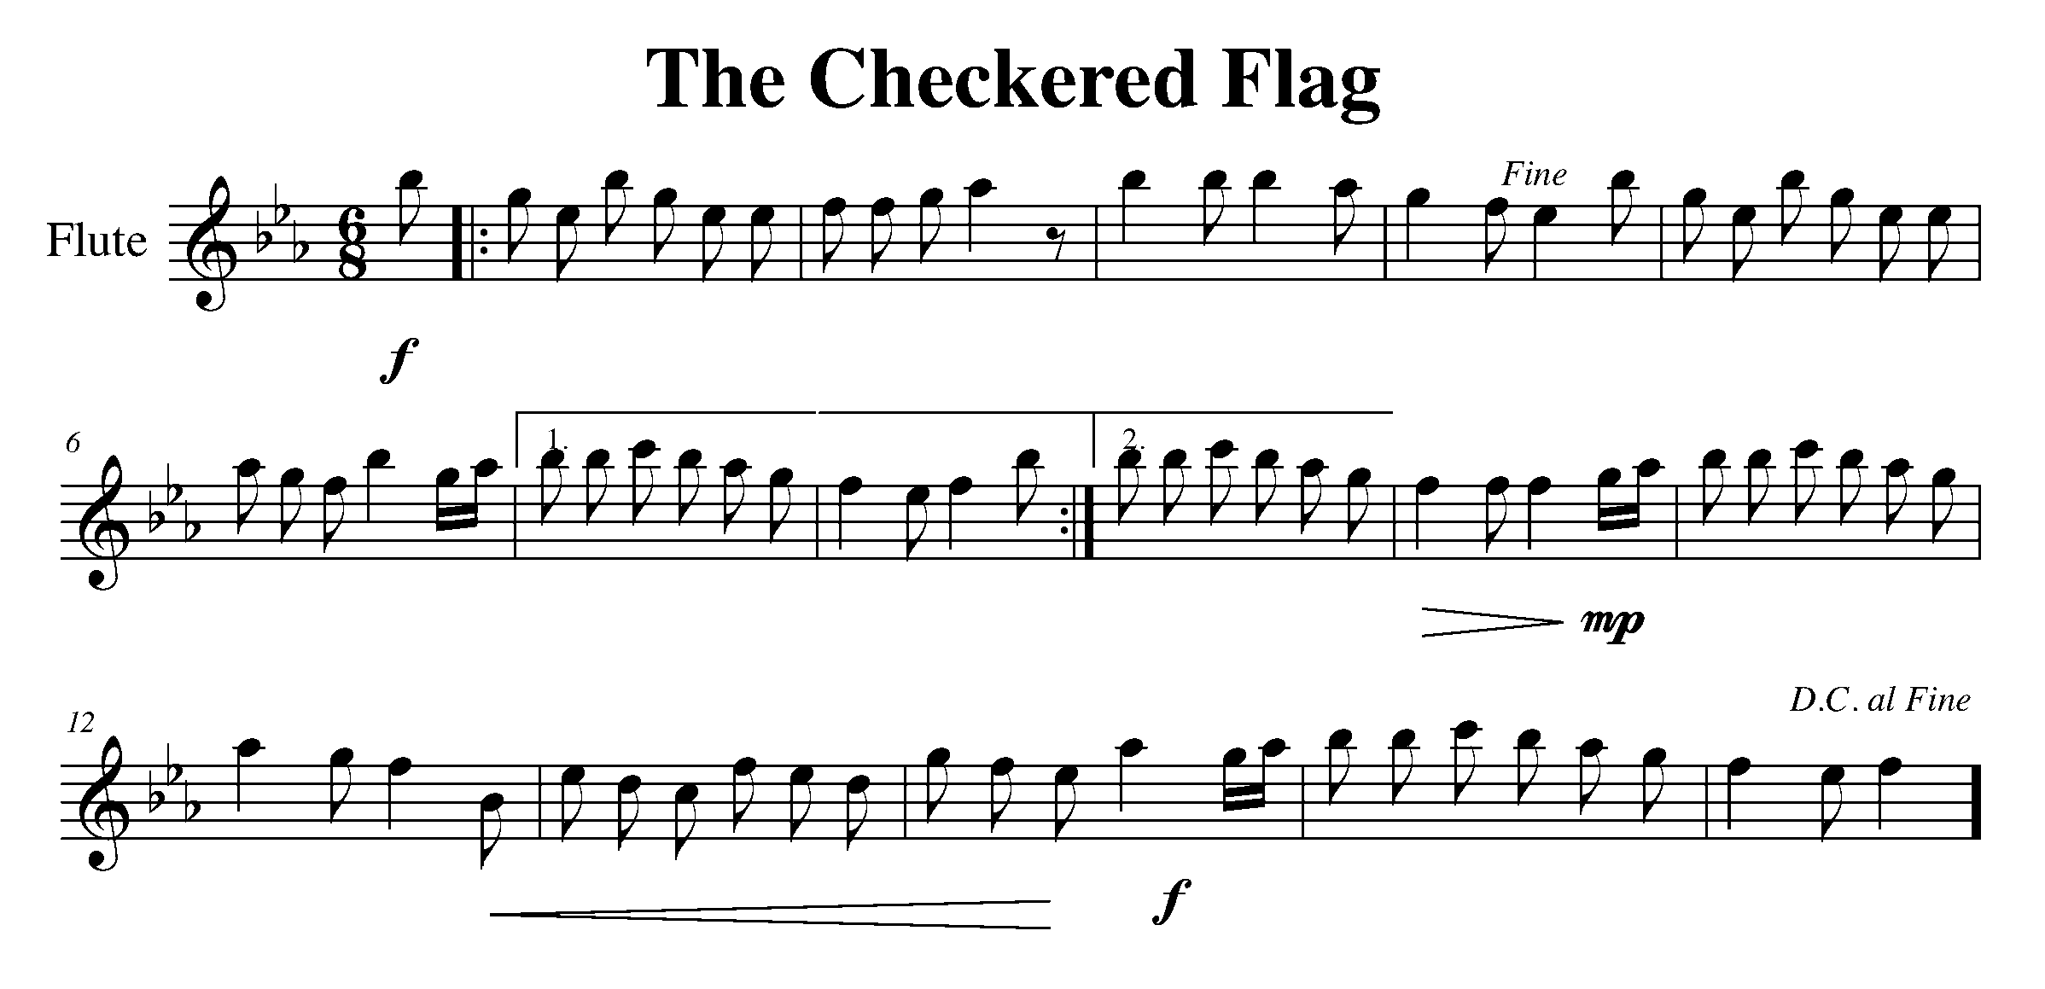
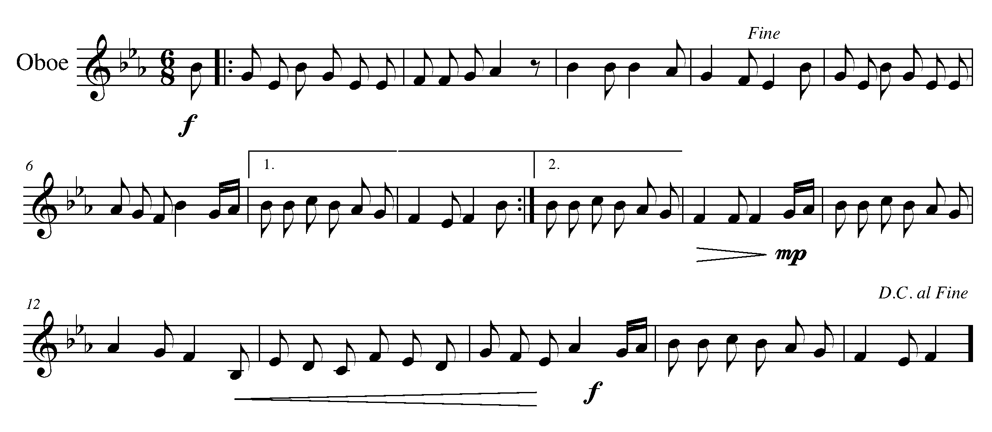
Task 20 Music Continued 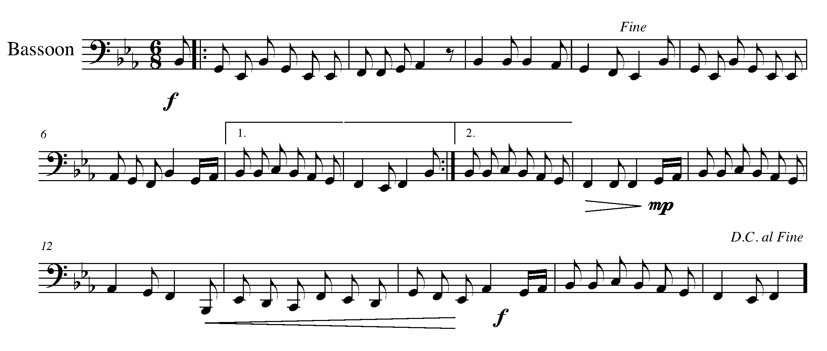

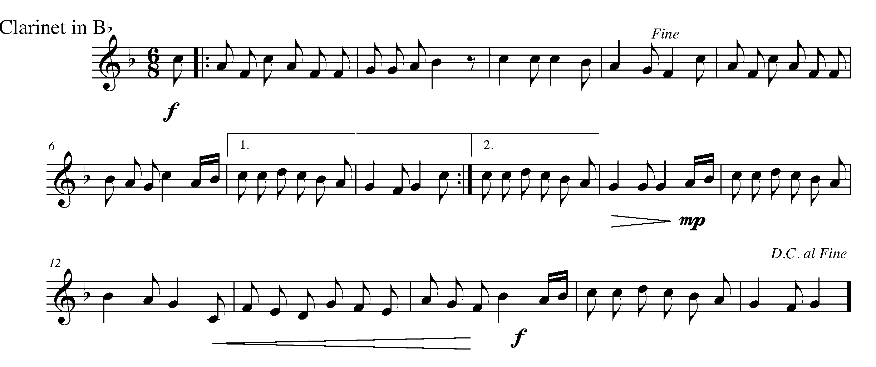
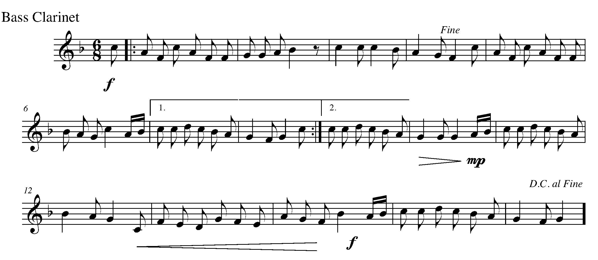
Task 20 Music Continued 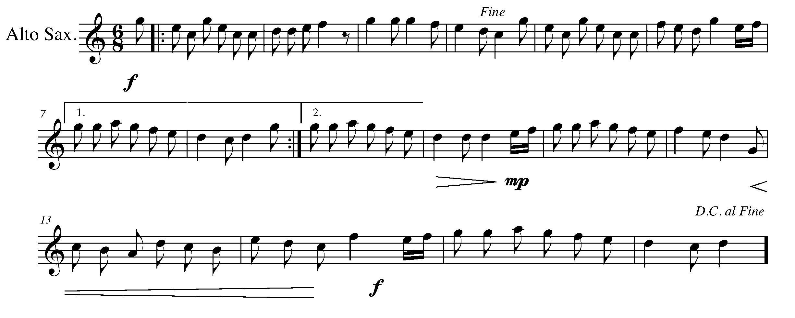
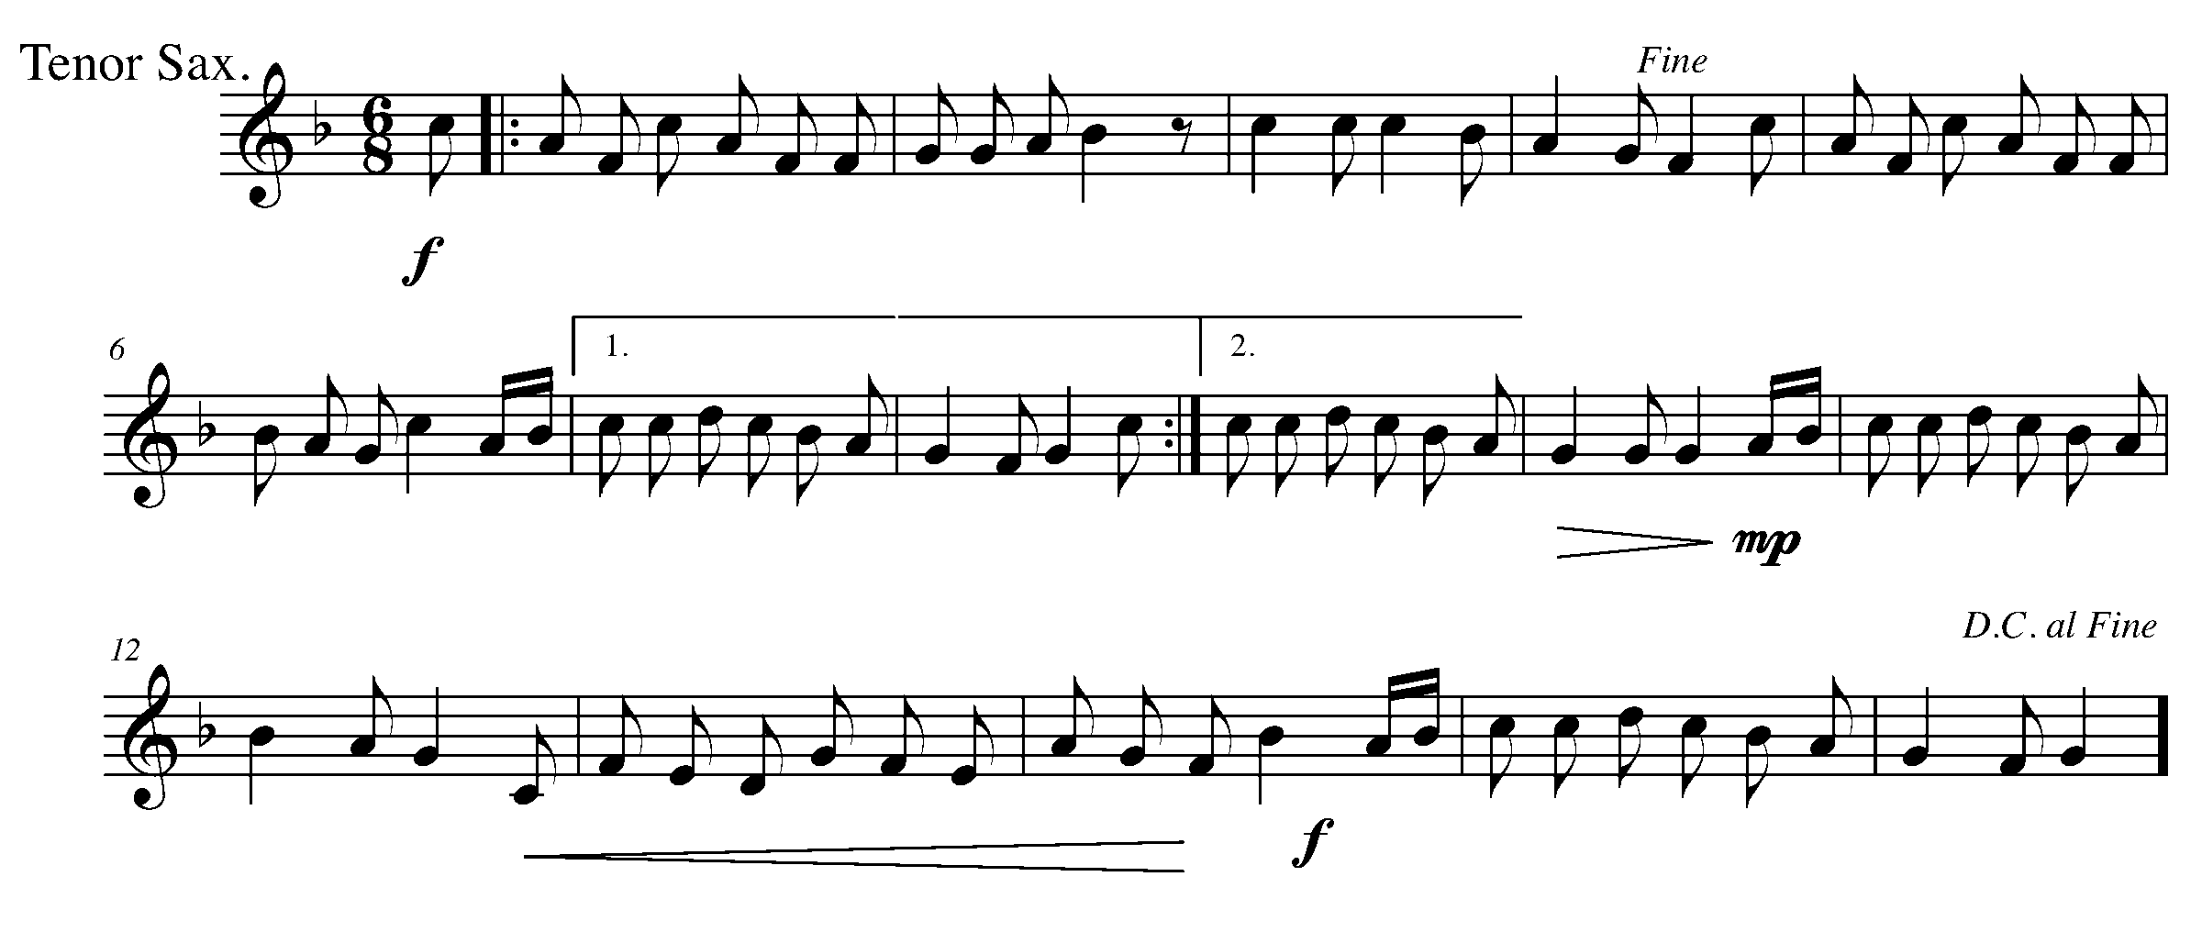
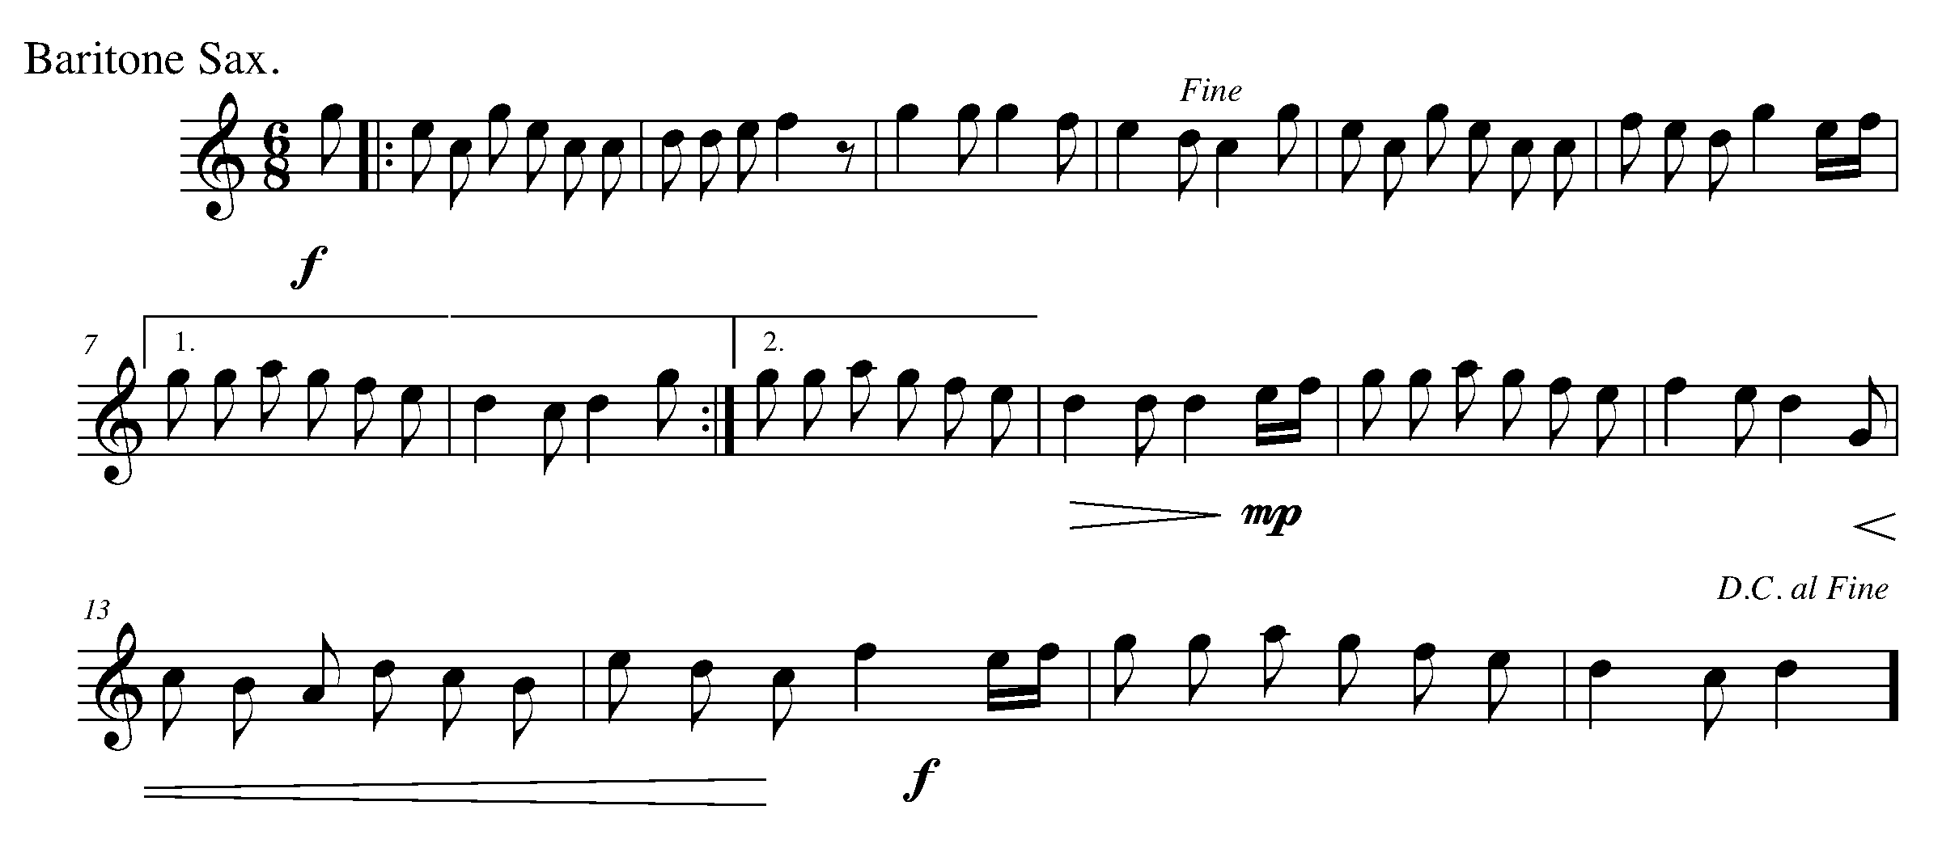
Task 20 Music Continued 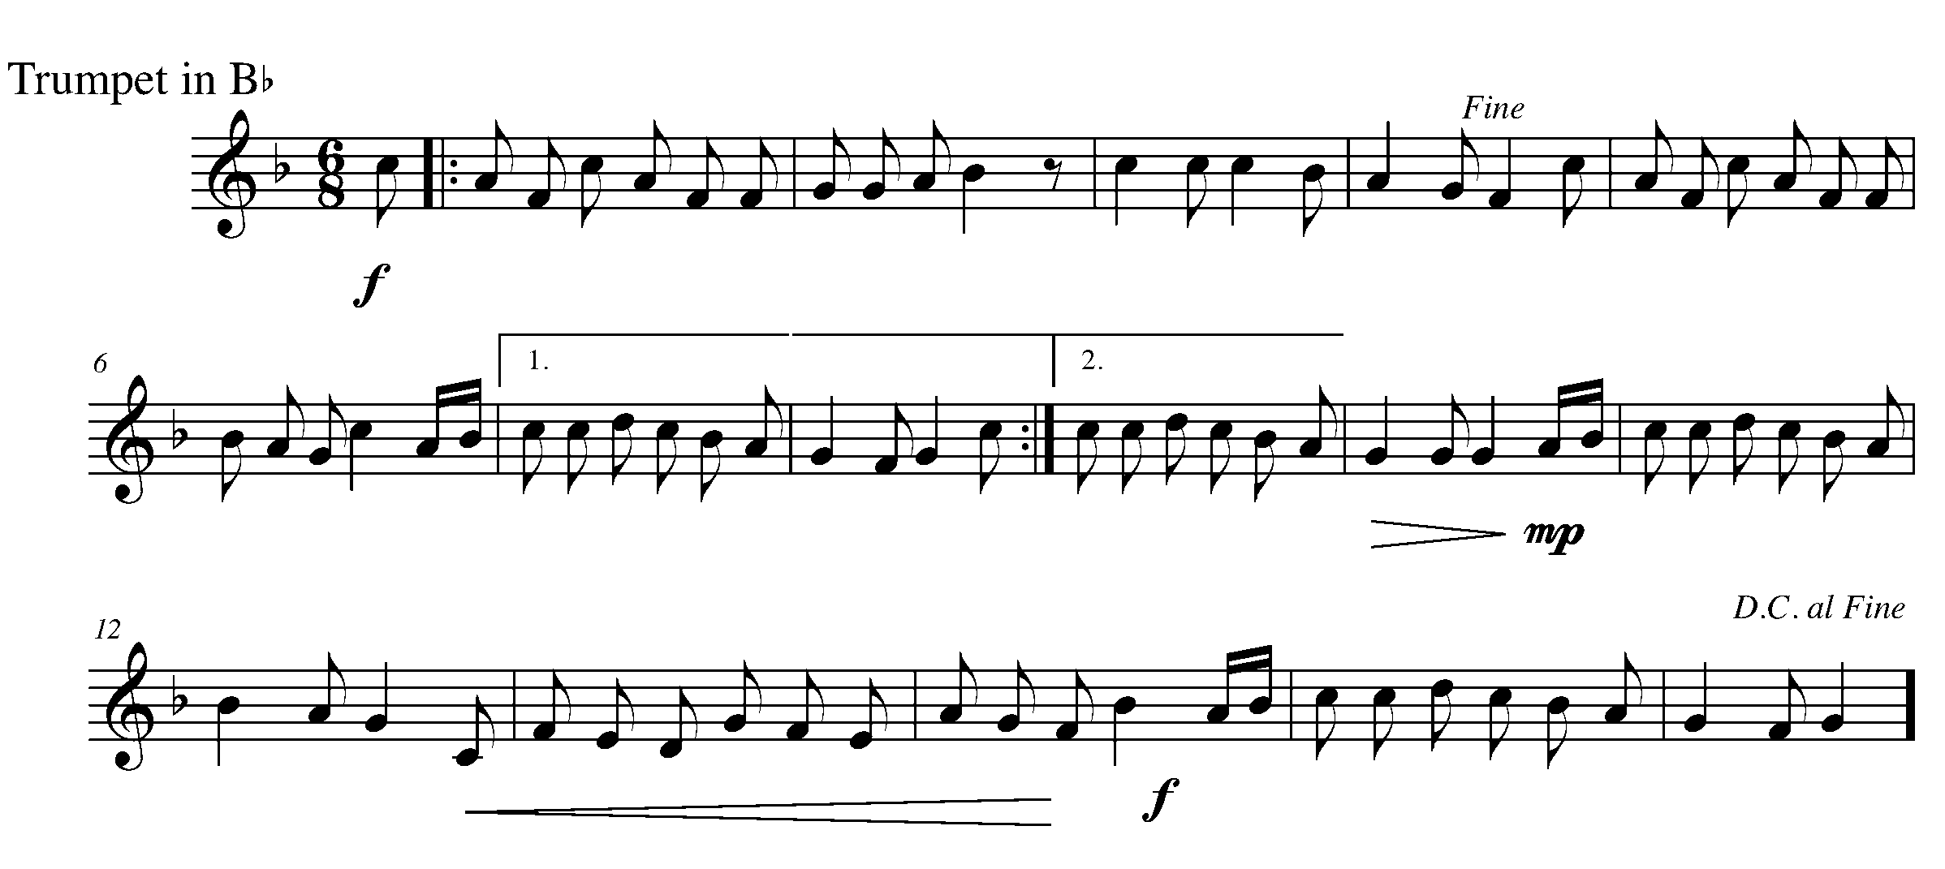
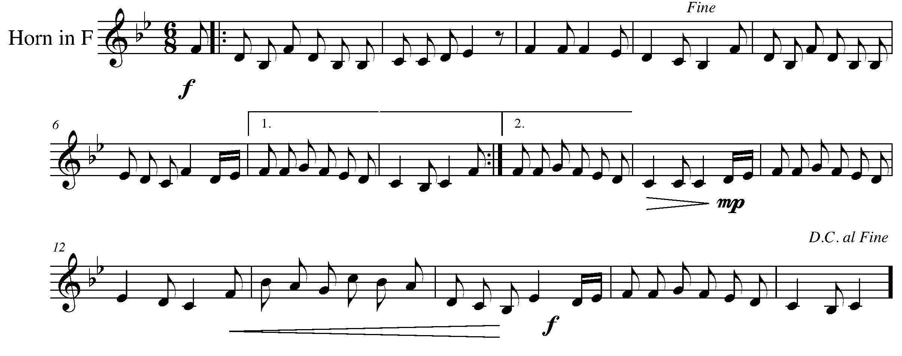
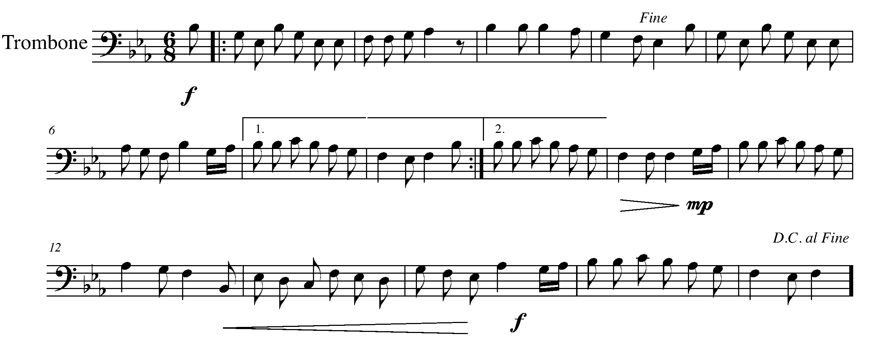
Task 20 Music Continued 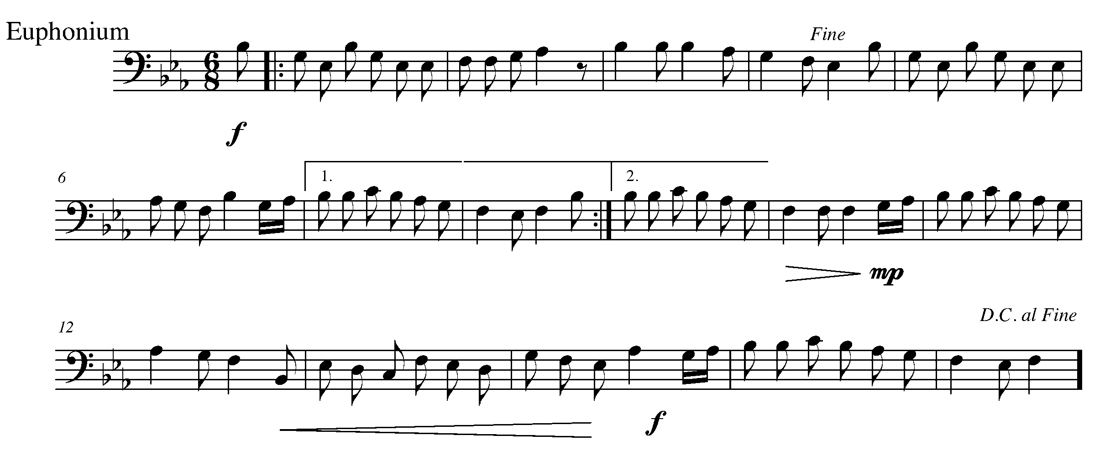

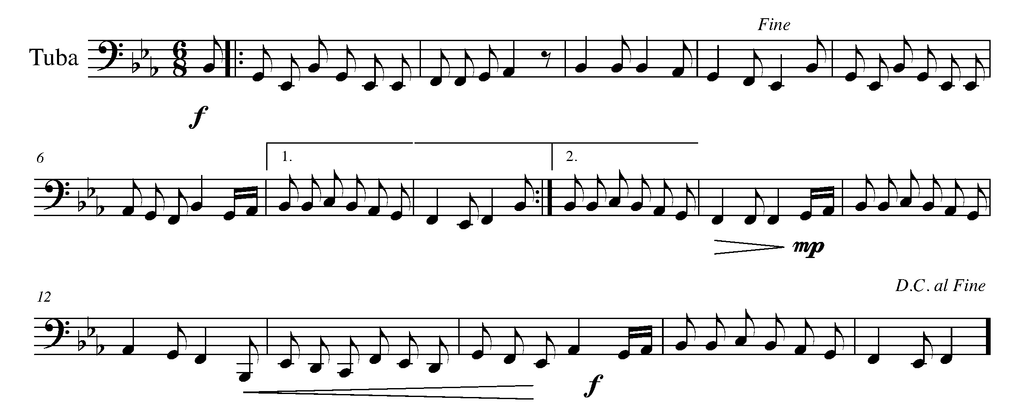
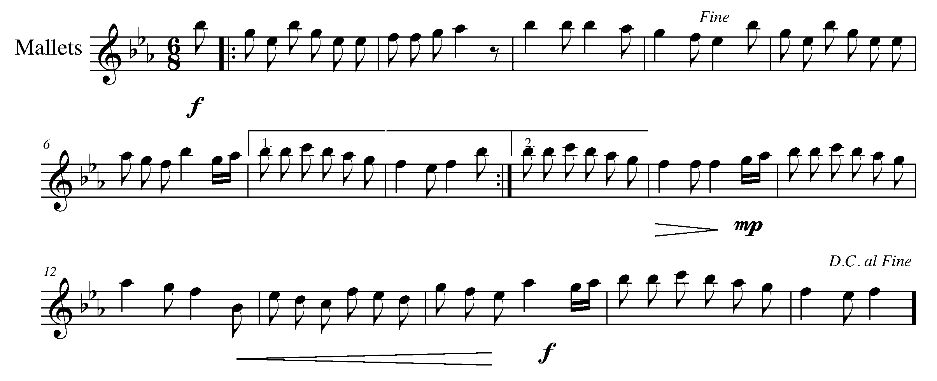
Task 20 Music Continued 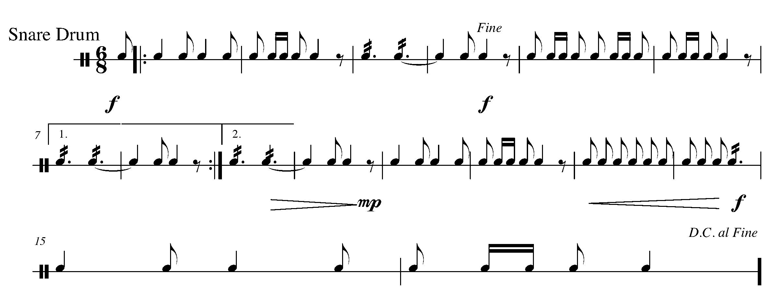
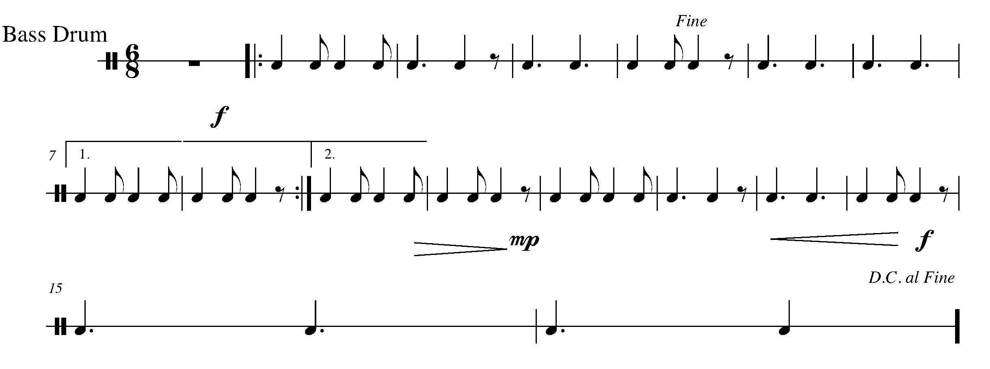
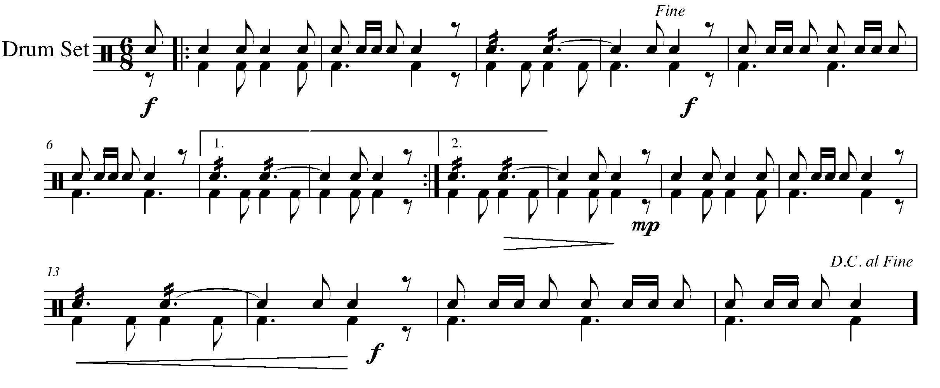

CONGRATULATIONS YOU HAVE COMPLETED THE WEST SECTION AND THE YEAR THREE GPS PROGRAM. BE SURE TO COMPLETE YOUR TASK TRACKER AND CELEBRATE YOUR ACCOMPLISHMENTS!!
Task # 5

North
East
South
West
Task # 3
Task # 1
Task # 2
Task # 4
Task # 6
Task # 7
Task # 8
Task # 9
Task # 13
Task # 12
Task # 11
Task # 14
Task # 18
Task # 17
Task # 16
Task # 19
Task # 20
Task # 10
Task #15

TASK TRACKER

Congratulations!

__________________ has reached the North GPS Marker in the 3rd Year Band Program.

_________________________________
Teacher Signature

_________________________________
Principal Signature

Congratulations!

__________________ has reached the East GPS Marker in the 3rd Year Band Program.

_________________________________
Teacher Signature

_________________________________
Principal Signature

Congratulations!

__________________ has reached the South GPS Marker in the 3rd Year Band Program.

_________________________________
Teacher Signature

_________________________________
Principal Signature

Congratulations!

__________________ has reached the FINAL (West) GPS Marker in the 3rd Year Band Program.

You’re Done!!

_________________________________
Teacher Signature

_________________________________
Principal Signature

