BLM #3 Exit Pass

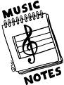 Name: ________________________

List two Elements of Design: ________________, ________________.

List four Elements of Music: ________________, ________________.

What surprised you as you compared the elements of music and the elements of design?

________________________________________________________________

________________________________________________________________

________________________________________________________________

