BLM 2 I’se the B’y Student Worksheet

Names: ___________________________________ Class: ___________

Using the language phrases below, choose a form (e.g., abba) and organize the phrases to create the form you have chosen in the space given. You may use a maximum of 3, and a minimum of 2 different phrases to create your own

hip yer partner catches the fish sails her

builds the boat Fogo Twillingate

I’se the B’y Rhythmic Composition

Phrases: __________________________________________________________

__________________________________________________________

__________________________________________________________

__________________________________________________________

Form: _______________________________ (use shapes or letters to show the form)

- Match the following rhythms to the words you have chosen for your chant.
- Write these rhythms above the words, and match them to the syllables for the words.

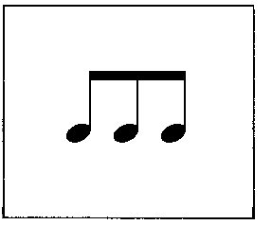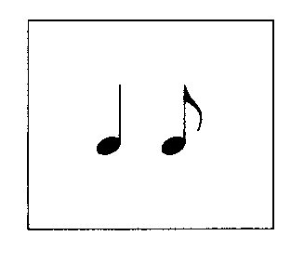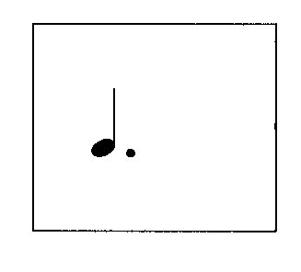
ti – ti - ti ta ti tam

