BLM # 12 page 1
Note Name | Note Shape  (standard notation) | Note Shape  (stick notation) | Description | Word Rhythm | Oral Prompt | Hear it!
whole note |  |  | a whole note lasts for four beats in simple time, this is a very long note; when many of these are used in a piece, the music may feel slow | plu-u-u-ums | ta-a-a-a | go to: http://www.youtube.com/watch?v=GcytNP4dMGo
whole rest |  |  | a whole note rests lasts for four beats in simple time, this is a very long rest; (imagine the sound of the note silently) | plu-u-u-ums | ta-a-a-a
dotted half note |  |  | a dotted half note lasts for three beats in simple time, this is a very long note | plu-u-ums | ta-a-a
half note |  |  | a half note lasts for two beats in simple time, this is a long note | p-e-a-r-s | ta-a | go to: http://www.youtube.com/watch?v=GcytNP4dMGo
half rest |  |  | a half note rest lasts for two beats in simple time, this is a long rest | plu-ums | ta-a | go to: http://www.youtube.com/watch?v=GcytNP4dMGo
quarter note |  |  | a quarter note lasts for one beat in simple time; a “walking” rhythm/pulse | plum | ta | go to: http://www.youtube.com/watch?v=GcytNP4dMGo
quarter rest | 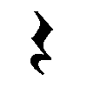 |  | a quarter rest lasts for one beat in simple time; a “walking” rhythm/pulse | plum or shhh | ta | go to: http://www.youtube.com/watch?v=GcytNP4dMGo

BLM #12 page 2
Note Name | Note Shape (standard notation) | Note Shape (stick notation) | Description | Word Rhythm | Oral Prompt | Hear it!
eighth note or pair of eighth notes | S |  | each eighth note lasts for half of a beat in simple time | ap-ple | ti-ti | go to: http://www.youtube.com/watch?v=GcytNP4dMGo
eighth rest |  |  | an eighth note rests lasts for half of a beat n 4/4 time; imagine the sound of the note silently | ap-ple or ap-ple
sixteenth note(s) | 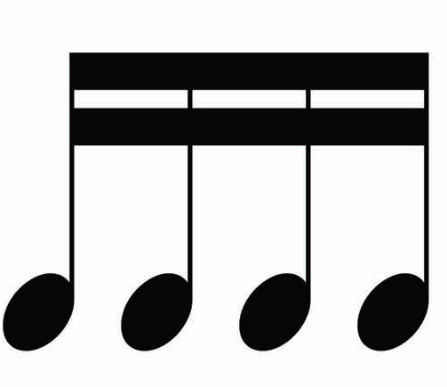 |  | each sixteenth note lasts for one quarter of a beat of musical time; four sixteenth notes take one beat in simple time | wa-ter-mel-on | tika-tika
an eighth note and two sixteenth notes | 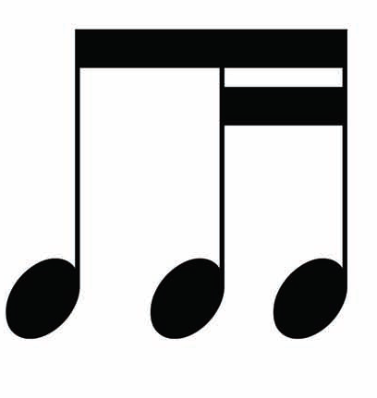 |  | an eighth note and two sixteenths sound like one loger and two shroter noes in one beat in simple time | pine-apple | ti-tika
two sixteenth notes and an eighth note | 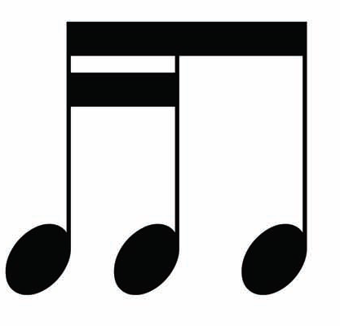 |  | two sixteenth notes and one eighth sound like two short notes and one longer note inone beat in simple time | can-te-loupe | tika-ti

