Below each staff of the song, “Siyahamba”, are blank lines to show where the bass notes are played.
1.Write the letter names of the bass notes
2.Write the Roman numeral/chord symbol that corresponds to the letter underneath (e.g. written in):

.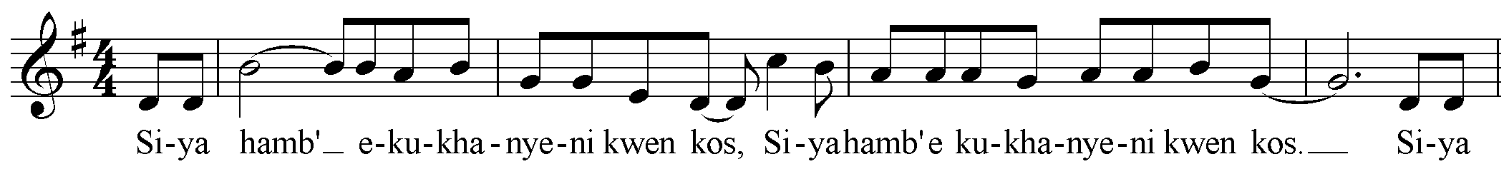 Solfège and
G __ __ __ __ __ __ __ Note Names
I __ __ __ __ __ __ __
do’ G’
ti F#
la E
so D
fa C
mi B
re A
do, G,
ti F#
la E
so, D
I=G+B+D

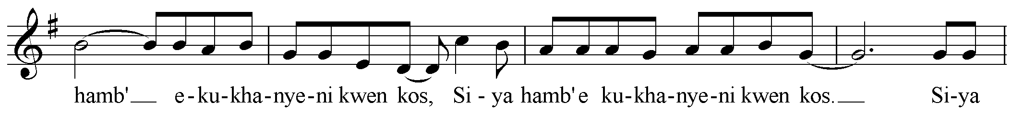
__ __ __ __ __ __ __ __
__ __ __ __ __ __ __ __

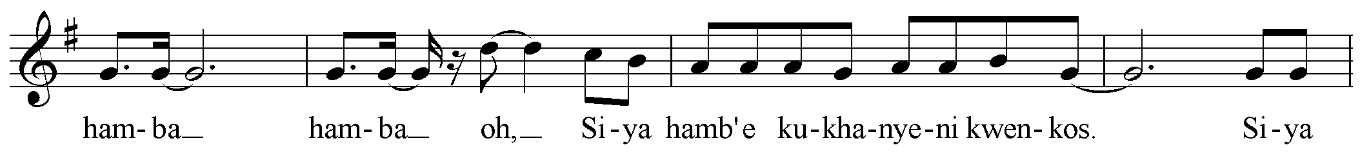
__ __ __ __ __ __ __ __
__ __ __ __ __ __ __ __

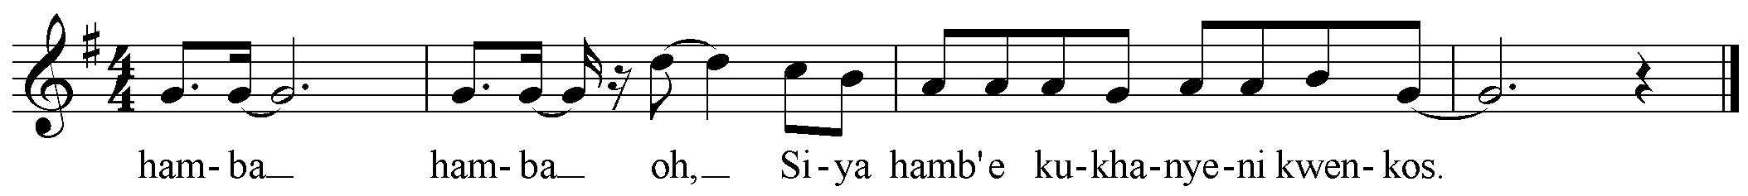
do’ G’
ti F#
la E
so D
fa C
mi B
re A
do, G,

V=__ __ __
__ __ __ __ __ __ __ __
__ __ __ __ __ __ __ __

Chords:
A chord (triad) has 3 notes, built in a pattern of: bass note, skip, note, skip, note
e.g., do mi so
e.g., G A B C D
3. Circle the 1st, 3rd, and 5th notes beginning with the bass note, on charts to the write and below:
do’ G’
ti F#
la E
so D
fa C
mi B
re A
do, G,

IV=__ __ __

I Chord: When the bass note is G: C D E F# G A B C D E F# G A
Therefore when G is do the I chord has ____________ in it.

V Chord: When the bass note is D: C D E F# G A B C D E F# G A
Therefore when D is so the V chord has ____________ in it.

IV Chord When the bass note is C: C D E F# G A B C D E F# G A
Therefore when C is fa the IV chord has ____________ in it.
4. Write the notes of the chord (from the bottom up) on the staff below.



